Timber harvest and tree size near nests explains variation in nest site occupancy but not productivity in northern goshawks (Accipiter gentilis)
Sabrina A. Rodriguez, Department of Biology, Whitman College, Walla Walla, WA 99362 USA
Patricia L. Kennedy, Eastern Oregon Agriculture and Natural Resource Program, Department of Fisheries and Wildlife, Oregon State University, Union, OR 97883, USA
Timothy H. Parker, Department of Biology, Whitman College, Walla Walla, WA 99362 USA. Corresponding Author: parkerth@whitman.edu

This is a published pre-print of a published paper:
Rodriguez, S., P. Kennedy, and T. H. Parker. 2016. Timber harvest and tree size explains site occupancy but not productivity in northern goshawks (Accipiter gentilis). Forest Ecology and Management. 374: 220-229. doi: 10.1016/j.foreco.2016.04.052.

ABSTRACT
Conservation concern for the northern goshawk (Accipiter gentilis) reflects evidence that goshawks may abandon nest sites or suffer from reduced nesting success in response to some forms of timber harvest. However, this evidence is mixed and has yet to be reviewed systemically and quantitatively. Therefore, we conducted a meta-analysis to assess the extent to which timber harvest and tree size explain variation in goshawk productivity and site occupancy. Goshawk productivity was not significantly explained by the presence of nearby timber harvest nor by the average size of nearby trees either in North America or in Eurasia or when averaged across all studies. Effect sizes differed dramatically among studies and the average effect size was close to zero (Zr = 0.04). However, timber harvest and tree size together more strongly explained goshawk occupancy of nest sites or territories. Within studies, goshawk nest sites or territories with less timber harvest nearby or relatively larger trees were, in most cases, more likely to be occupied. When we estimated average effect sizes separately for the two continents, the averages were moderate, consistent (Zr = 0.23-0.27), and significantly > 0. When we combined studies from North America and Eurasia, average effect sizes for timber harvest (Zr = 0.24) and tree size (Zr = 0.25) were similar in strength and both significantly > 0. Thus taken together, our results suggest that although both timber harvest and a lack of large trees are associated with lower occupancy by nesting goshawks, pairs that nest near timber harvest or in small trees have indistinguishable nesting success from pairs nesting in large trees or farther from timber harvest. We found substantial heterogeneity in results among studies, especially within North America, which is not surprising given that studies differed greatly in research methods, forest type, and forest management. In conclusion, our results suggest goshawk nest sites in populations of conservation concern, such as A.g. laingii, may need more protection from timber harvest than they are currently receiving. Equally important, to better understand effects of forest management on goshawks, we recommend additional studies designed to: 1) better identify the spatial and temporal extent of the effect of timber harvest on goshawk site occupancy; and 2) determine what goshawks do and where they go after a timber harvest.
Keywords: forest management; raptor; mature forest; meta-analysis; occupancy; productivity

1. INTRODUCTION
Forest management that influences habitat of at-risk wildlife species has been one of the principal challenges to forest managers and wildlife biologists for the last several decades (Stephens et al. 2014). Globally an ongoing debate is focused on several species that nest in old-growth forest, including the northern goshawk (Accipiter gentilis; hereafter referred to as goshawk), a forest raptor with a Holarctic distribution. The goshawk has become an icon in the debate over retention of large or old-growth trees and dense-canopy conditions (Greenwald et al. 2005; Reynolds et al. 2008; Saga and Selås 2012; Dickson et al. 2014). Several petitions to list the goshawk subspecies A. g. atricapillus as endangered in the US have been rejected due to lack of evidence of either population decline or restriction of nesting to older forests (Kennedy 1997; Squires and Kennedy 2006). However, in 2012 the British Columbia population of the laingi subspecies was designated by the US Fish and Wildlife Service as Threatened in both the United States and Canada, primarily because of continued timber harvest of low elevation, old-growth and suitable second-growth forests (http://globalraptors.org/grin/SpeciesResults.asp?specID=8132; last accessed 16 June 2015). This subspecies was also listed in 2013 as Threatened in Canada under the Species at Risk Act (http://www.registrelep-sararegistry.gc.ca/species/speciesDetails_e.cfm?sid=56; last accessed 7 April 2016). In Eurasia, the goshawk population may have declined in the 20th century because of reduced availability of breeding habitat (Rutz et al. 2006) but populations are currently stable or increasing (http://globalraptors.org/grin/SpeciesResults.asp?specID=8132; last accessed 16 June 2015). Nevertheless, goshawks are considered a sensitive or management indicator species in many places worldwide.
Commercial harvest of mature forest stands may threaten goshawk nesting habitat availability and quality. Goshawks can have high nest site fidelity which makes protecting their nest sites critical in managed territories (Reynolds et al. 1994; Penteriani et al. 2002; but see Boyce et al. 2006). Conservation efforts for goshawks have ranged from protection of individual nest sites by a range of public and private entities (Saga and Selås 2012; Santangeli et al. 2012), to forest management plans based largely on goshawk habitat relations and providing suitable habitat for prey (Reynolds et al. 1992; Reynolds et al. 2008).
Goshawk habitat relations have been assessed in a number of landscapes and this body of work is summarized in Penteriani (2002), Andersen et al. (2005), Boyce et al. (2006), Squires and Kennedy (2006), Reynolds et al. (2008), and Bruggeman et al. (2014). These qualitative assessments indicate goshawks breed in a wide variety of forested landscapes and use large trees with appropriate structure to support nests in mature forest patches with high canopy closure. However, these conclusions should be understood as tree size or age relative to trees in nearby forests because, depending on availability in the landscape, goshawks use trees of a wide range of sizes and ages. The species of trees used for nesting varies both within and among regions, as do forest type and primary prey (Squires and Kennedy 2006; Kennedy and Cartron 2010). However, goshawk nest sites tend to be embedded in home ranges that are a mixture of forest types, ages and structural characteristics (Boyce et al 2006; Squires and Kennedy 2006).
Many studies have investigated forest management effects on goshawk nesting site occupancy and reproduction but results are inconsistent across studies. In some studies, breeding pairs in timber-harvested areas have shown significantly reduced reproductive performance relative to pairs in non-harvested areas (Crocker-Bedford 1990, Patla 2005), but this pattern does not appear consistent (Penteriani et al. 2002, Mahon and Doyle 2005, Moser and Garton 2009). Similarly, some have found significant reduction in goshawk site occupancy near timber harvest (e.g., Crocker-Bedford 1990, Patla 2005, Santangeli et al. 2012), but these patterns are not universal either (Mahon and Doyle 2005, Moser and Garton 2009). Further, there is evidence of threshold responses in which territory occupancy does not cease until some level of harvest or proximity to harvest is exceeded (Penteriani and Faivre 2001, Moser and Garton 2009, Saga and Selås 2012, Santangeli et al. 2012). Season of harvest may also affect goshawk reproduction. For instance, in Wales, timber harvest after the fledgling phase did not cause breeding goshawks to relocate but timber harvest during the nestling phase notably reduced nesting success (Toyne 1997).
Similar to habitat summaries, numerous authors have qualitatively summarized timber-harvest effects on goshawk (Andersen et al. 2005, DeStefano 2005, Greenwald et al. 2005, Rutz et al. 2006, Squires and Kennedy 2006, Reynolds et al. 2008) and no clear pattern has emerged from these reviews suggesting a more quantitative approach is warranted. We therefore conducted a meta-analysis of results from this literature to specifically address two questions: 1) Does timber harvest affect goshawk site occupancy and/or productivity; and 2) Does tree size in the vicinity of nests affect goshawk site occupancy and/or productivity?
A meta-analysis combines all published effect sizes (regardless of statistical significance), weighted by sample size, to produce an average effect bounded by confidence intervals. We assembled all published studies that compared occupancy or productivity in timber-harvested and non-harvested areas or compared occupancy or productivity in relation to tree size near nests. We chose to assess statistical relationships with both timber harvest and tree size because, although we recognize that they are not identical variables, they are often related as timber harvest frequently reduces the number of large trees at a site. Further, it is typically hypothesized that if timber harvest harms goshawks this harm results, at least in part, in some way from reduction in availability of large trees. The published studies of goshawk occupancy and productivity come from a diverse array of habitats and geographic locations, and have been conducted with many different methodologies. Thus we expected there to be biologically relevant variation in statistical effects among studies. We both tested for heterogeneity in statistical effects among studies and compared statistical effects between subsets of studies that we thought might differ. The subsets we compared were studies from North America versus those from Eurasia, and studies that used timber harvest as an independent variable versus those that used tree size. If goshawks were influenced by timber harvest, then we predicted goshawk occupancy and productivity would be lower in areas with timber harvest or with small trees (relative to other sites within individual studies) compared to non-harvested areas and sites with relatively large trees.
2. METHODS
On Web of Science we searched “Accipiter gentilis” paired with each of the following terms in turn: “stand*”, “nest*”, “habitat*”, “timber*”, “fledgling”, “product*”, “reproduc*”, “occupan*”, “fidelity”, “territor*”, “presence”, “harvest”, “timber”, “abandon*”, and “site”. To augment our search we also examined the literature cited sections of the aforementioned reviews. We evaluated > 200 papers published in the peer-reviewed primary literature to determine which had data that could be included in the analysis. We completed our search 26 December 2014. To be included in our analysis each study had to meet one or more of the following criteria: 1) assessed occupancy or productivity as a function of proximity to nearby timber harvest, 2) compared occupancy or productivity between timber-harvested sites and non-harvested sites, 3) examined site occupancy or productivity as a function of measures of average tree size per site, or 4) compared occupied sites with random sites or with unoccupied sites in the vicinity as a function of average tree size. We defined occupancy as the presence of an adult goshawk associated with a nest structure. Steenhof and Newton (2007) define productivity as the number of young produced per pair, and we adhered to this definition to the extent allowed by the available data. In our analyses of productivity, we also included data on young produced per nest or per nesting attempt, and from one study, whether or not nests fledged any young.
The literature on goshawk nesting habitat used in this analysis reports data at two spatial scales: the nest site (< 1 ha area surrounding the nest tree) and nest stand (the 1-30 ha area surrounding the nest tree, often including alternative nest trees; per McGrath et al. 2003). In our study, site refers to both scales and because of the small number of studies we do not evaluate each scale separately. This is one of several plausible source of variability in our results.
Acceptable tree-size variables included diameter at breast height, canopy height, stand age, stand height, mean tree height, percent late seral forest, or forest structure calculated from diameter at breast height, canopy closure, and tree density. It is important to note that we are not assessing preference for particular ages or sizes of trees, only whether within each original study, local variation in tree size or age correlated with occupancy or productivity. We excluded measures of tree size that were confounded by measures of tree density (such as basal area per stand) because in some landscapes goshawks utilize open stands that could have lower basal area but larger-than-average trees.
To compare studies based on the standard effect size Fisher’s Z transformation (Zr) of the correlation coefficient (r), we first had to convert reported effect sizes from each study to r. If r itself was not reported, we converted means and SD to the standard effect size Hedge’s d (Rosenberg et al. 2013), and Hedge’s d to r. In some cases, we had to extract means and corresponding SE or SD from graphs using the digitizing software WebPlotDigitizer (Rohatgi 2014). If neither of these options were possible, we converted test statistics (χ², F, or t combined with sample size or d.f. and an indication of direction of relationship) to r using standard formulas. As a last option, we converted one-tailed p-values, combined with sample size and an indication of direction of effect, to r (Rosenberg et al. 2000). We designated positive values of r (and thus Zr) to indicate greater productivity or occupancy in locations with larger trees or without timber harvest and a negative r to indicate reduced productivity or occupancy in those locations (in other words, greater productivity or occupancy in areas with small or medium-sized trees relative to areas with large trees would be represented by a negative r). Our raw and transformed data are publicly available (Rodriguez et al. submitted).
We excluded some studies because they reported results insufficiently. Several studies did not report sufficient statistical information, as described in the previous paragraph, to allow us to calculate an effect size for inclusion in the meta-analyses. For instance, in some cases non-significant relationships were reported without details of strength or direction of relationship. In a few other cases, the authors clearly had information on both tree size and goshawk productivity, but had not compared these variables. In all cases of insufficient reporting, we contacted authors by email to ask if they could provide the missing results, or if they were willing to share raw data to allow us to calculate missing statistical effects. In all but one case (Bruggeman et al. 2014), authors either did not respond or responded but no longer had access to the information we needed, and so in those cases we were only able to use published data.
We visually assessed prevalence of publication bias through the use of funnel plots (Borenstein et al. 2009, Palmer 1999). In the absence of serious publication bias, the range of estimated effect sizes will typically be large when sample size is small and sampling error is thus large but this range of estimated effect sizes will typically shrink as sample size increases, sampling error decreases, and estimated effect sizes converge on the true effect size. Thus, in a plot with sample size (or transformed sample size) on the x-axis and effect size on the y-axis, the point distribution should form a horizontal funnel with points converging to the right. However, if there has been a bias against the publication of studies with findings counter to prediction, especially in cases of small sample size, the lower left-hand portion of the funnel will be sparse, and the points will better approximate a negative slope rather than a funnel. We followed convention and used for our x-axis sample size proxy 1/√vr (where vr is the variance of Zr and vr = 1/(n-3)) (Borenstein et al. 2009). We plotted all published individual effect sizes on our funnel plots rather than per-study averages, and so some studies are represented by more than one point per plot.
Multiple studies provided several tests of the same general hypothesis from the same data set (e.g., comparisons of occupancy to tree size both as tree dbh and tree height). In these cases, we calculated an average effect size (Zr) to represent each study prior to conducting meta-analyses. In one case (Lõhmus 2005), the authors presented occupancy data as a function of both tree-size and timber-harvest history. When comparing timber-harvest results with tree-size results, we included the two Lõhmus effect sizes separately, each in the appropriate category. Thus, although average effect size for tree-size studies and harvest studies are both valid, the overall average occupancy effect size combined across both independent variable types includes the Lõhmus data twice. However, we also produced an overall occupancy effect size in our analysis of geographic variation in which we first averaged the two Lõhmus effect sizes and thus created an overall average occupancy effect size based on one effect size per study.

As described above, the variance (vr) of Zr is a function only of sample size. In meta-analysis of Zr, effects are weighted by vr, and results from larger studies are thereby given more weight. In most of our studies, nest sites or territories were compared based on tree size or timber harvest. However, for some studies, nest sites or territories were compared with random locations or non-use areas. In one case (Bruggeman et al. 2014), 213 nest locations were compared with 23,776 random locations. Summing the number of nest locations with the number of random locations would have given substantial weight to the findings from this comparison. This weight would have been inappropriate because our confidence in the responses of goshawks is best represented by the 213 independent nest sites rather than the thousands of random locations to which they were compared. Thus, for studies that compared goshawk sites to random or never-used sites, we used the number of goshawk sites as our sample size for weighting effect sizes in our meta-analyses. If vegetation surrounding multiple alternative nests within a territory were treated as independent samples, we used the number of clusters of alternative nests (‘sites’), if available, as our sample size for weighting effects in our meta-analyses. This reduces the potential for non-independence that occurs from including multiple nests used by the same pair.

Because of the opportunistic nature of many goshawk studies, e.g., conducted as part of environmental assessments of proposed timber harvests, data spanned a wide range of sampling designs. Also, all estimates of occupancy were naïve estimates, unadjusted for imperfect detection, a potentially large source of confounding bias when comparing across widely varying treatments. Thus, we treated all studies identically in terms of their potential detection/capture bias as is commonly done in meta-analyses of vertebrate literature (Vanderwel et al. 2007, Schlossberg and King 2008, Fontaine and Kennedy 2012). Dramatic variation in tree-size and timber-harvest characteristics among studies, along with relatively small numbers of studies and often limited quantitative details regarding habitat and timber harvest prevented us from examining factors that might impact effect size variation among timber-harvest studies or among tree-size studies. Nearly all studies focused on relatively small areas surrounding nest trees, thus limiting our spatial inferences to the immediate vicinity of nests. Information about effects at larger scales was typically unknown and may or may not be correlated with these measurements.

We performed meta-analyses of productivity and occupancy data separately using the software OpenMEE (Dietz et al. 2015). For both data sets, we assessed potential differences between studies based on location (continent) and independent variable (timber harvest versus tree size) using subgroup analysis with random effects (option: DerSimonian-Laird) to account for expected differences in true effect size among the diverse studies included. Because we located only one usable study from Asia, and because Asian and European goshawk populations are mostly contiguous, we combined these studies into a Eurasian category. Although we were interested in geographic variation at spatial scales below that of the continent, we lacked a sufficiently large number of studies to explore differences among regions within continents. Similarly, we lacked power to explore effects of different timber-harvest types and extents so we treated harvest as a binomial variable in our analyses. If results differed among studies due to biological differences among populations or among sites, or due to methodological differences such as with timber harvest or spatial scale of sampling, then we expected to detect substantial heterogeneity among studies as measured by I², the proportion of total heterogeneity attributable to variance between studies (Rosenberg 2013). If an absence of timber harvest or presence of large trees (relative to the distribution of tree sizes on the local landscape) was associated with greater productivity or site occupancy, we expected meta-analytic average Zr to be positive with a 95% confidence interval that did not encompass zero. Following convention, we refer to effect sizes as small (r ≈ Zr ≈ 0.1), moderate (r ≈ Zr ≈ 0.3), and large (r ≈ Zr ≈ 0.5) (Cohen 1992, Nakagawa and Cuthill 2007).
3. RESULTS
3.1 Productivity Analysis
We located few (n = 7) studies that met our criteria for comparing goshawk productivity to either timber harvest or tree size (Table 1). An additional seven studies of nest productivity lacked appropriate comparisons for inclusion (Appendix 1). The funnel plots of the raw effect sizes (prior to taking per-study averages) appear symmetrical (there is no evidence of a negative relationship between1/√vr and Zr) and thus do not indicate publication bias (Figure 1), though with the small samples size, we cannot be confident of this conclusion. Points in the funnel plot are similarly frequent above and below zero (Figure 1), and meta-analytic cross-study averages confirm an average near zero.

The five North American and two Eurasian studies produced average effect sizes close to zero with confidence intervals broadly encompassed zero (North America: Zr = 0.094; 95% CI = -0.266 to 0.453; n = 5; Eurasia: Zr = -0.023; 95% CI = -0.345 to 0.299, n = 2; Figure 2a). Mean effect size across both continents was small (Zr = 0.045, 95% CI = -0.209 to 0.300, n = 7; Figure 2a), but we estimate large heterogeneity values among studies within both the full set and the within the North American data sets (all studies: I² = 55.9%, p = 0.034; North America: I² = 70.4%, p = 0.009; Eurasia: I² = 0.0%, p = 0.749).

Likewise, studies of neither tree size nor timber harvest produced mean effect sizes substantially >0, and confidence intervals broadly encompassed zero (timber harvest: Zr = 0.115, 95% CI = -0.197 to 0.426, N = 5; tree size: Zr = -0.219, 95% CI = -0.709 to 0.271, N = 2; Figure 2b). The average effect size across both independent variables was identical to the average across continents (Zr = 0.045, 95% CI = -0.209 to 0.300, N = 7; Figure 2b) because the constituent effect sizes were the same. We detected substantial and statistically significant heterogeneity among studies within both the full data set and the timber-harvest data set (all studies: I² = 55.9%, p = 0.034; timber harvest: I² = 68.9%, p = 0.012; tree size: I² = 0.0%, p = 0.812).

Table 1. Studies included in meta-analysis of the relationships between nest site tree size or timber harvest and northern goshawk (Accipiter gentilis) territory occupancy or productivity, ordered by author surname.
Study | Response Variable | Continent | Independent Variable
Abe et al. 2007 | Occupancy | Asia | Tree Size
Beier et al. 2008 | Productivity | North America | Tree Sizeª
Bielański 2006 | Occupancy | Eurasia | Tree Size
Bruggeman et al. 2014 | Occupancy | North America | Tree Size
Crocker-Bedford 1990 | Productivity and Occupancy | North America | Timber Harvest
Daw and DeStefano 2001 | Occupancy | North America | Tree Size
Desimone and DeStefano 2005 | Occupancy | North America | Tree Size
Dickson et al. 2014 | Occupancy | North America | Tree Size
Finn et al. 2002a | Occupancy | North America | Tree Size
Klaver et al. 2012 | Occupancy | North America | Tree Size
Lõhmus 2005 | Occupancy | Eurasia | Timber Harvest and Tree Size^{b}
Mahon and Doyle 2005 | Productivity and Occupancy | North America | Timber Harvest
McGrath et al. 2003 | Occupancy | North America | Tree Size
Morrison et al 2011 | Occupancy | North America | Tree Size
Moser and Garton 2009 | Productivity and Occupancy | North America | Timber Harvest
Patla 2005 | Productivity and Occupancy | North America | Timber Harvest
Penteriani and Faivre 1997 | Occupancy | Eurasia | Tree Size
Penteriani and Faivre 2001 | Productivity | Eurasia | Timber Harvest
Penteriani et al. 2001 | Occupancy | Eurasia | Tree Size
Penteriani et al. 2002 | Productivity | Eurasia | Tree Size
Saga and Selås 2012 | Occupancy | Eurasia | Timber Harvest
Santangeli et al. 2012 | Occupancy | Eurasia | Timber Harvest
Selås 1997 | Occupancy | Eurasia | Tree Size
Squires and Ruggiero 1996 | Occupancy | North America | Tree Size

ª With data from an electronic supplement we calculated average productivity as a function of conformity of sites to goshawk habitat guidelines from Reynolds et al. (1992). Sites must include large trees to conform to these guidelines.

^{b} See Methods for details on how the results of this paper were included in the analyses.

Figure 1

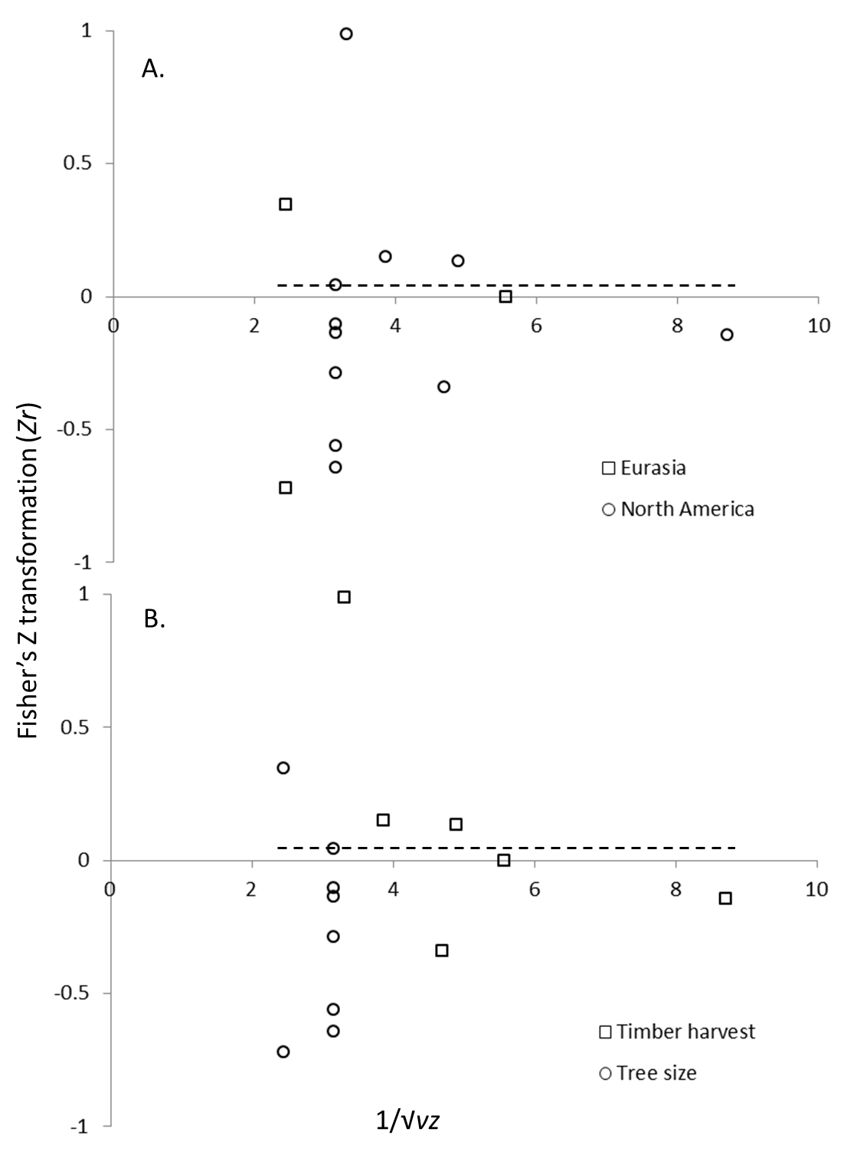

Figure 1. Funnel plots of published effect sizes (Zr) from the relationship between productivity of goshawk nests and tree size or timber harvest as a function of sample size as represented by 1/√vr. Effect sizes are segregated by (A) continent and (B) independent variable type. Note that these represent effect sizes prior to generating per-study averages, so some studies are represented more than once in each figure. The dashed line represents the average effect size derived from meta-analysis based on per-study average effect sizes. The symmetrical funnels, approximately centered on the dashed line, provide no evidence of major publication bias.

Figure 2

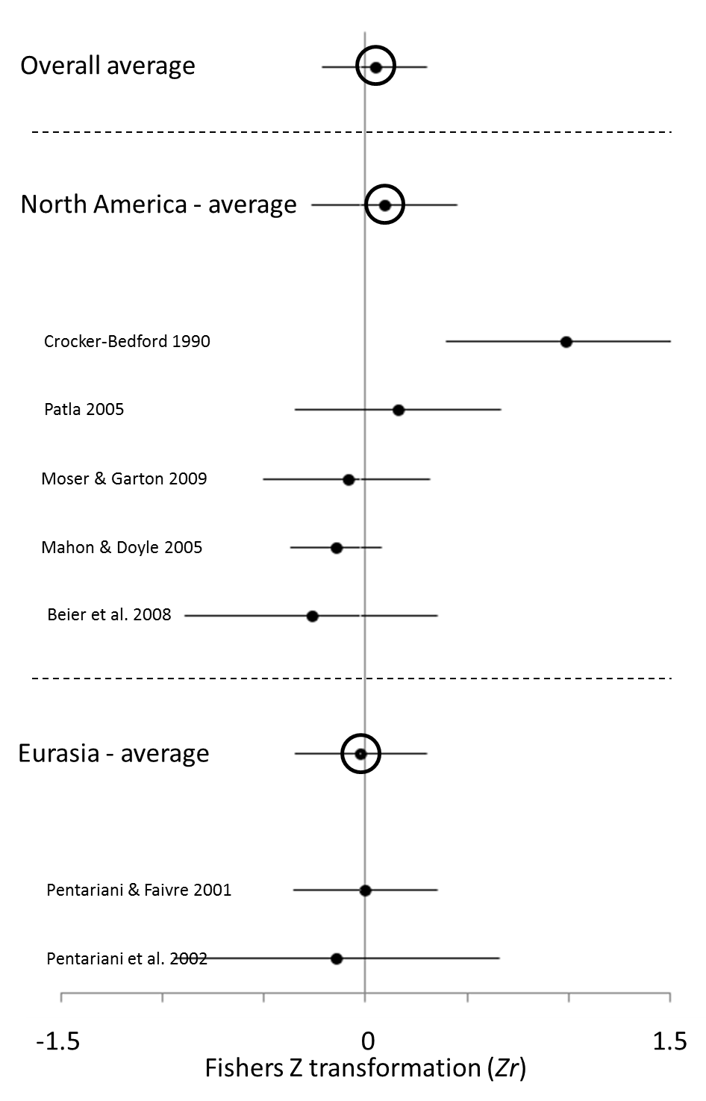
A.

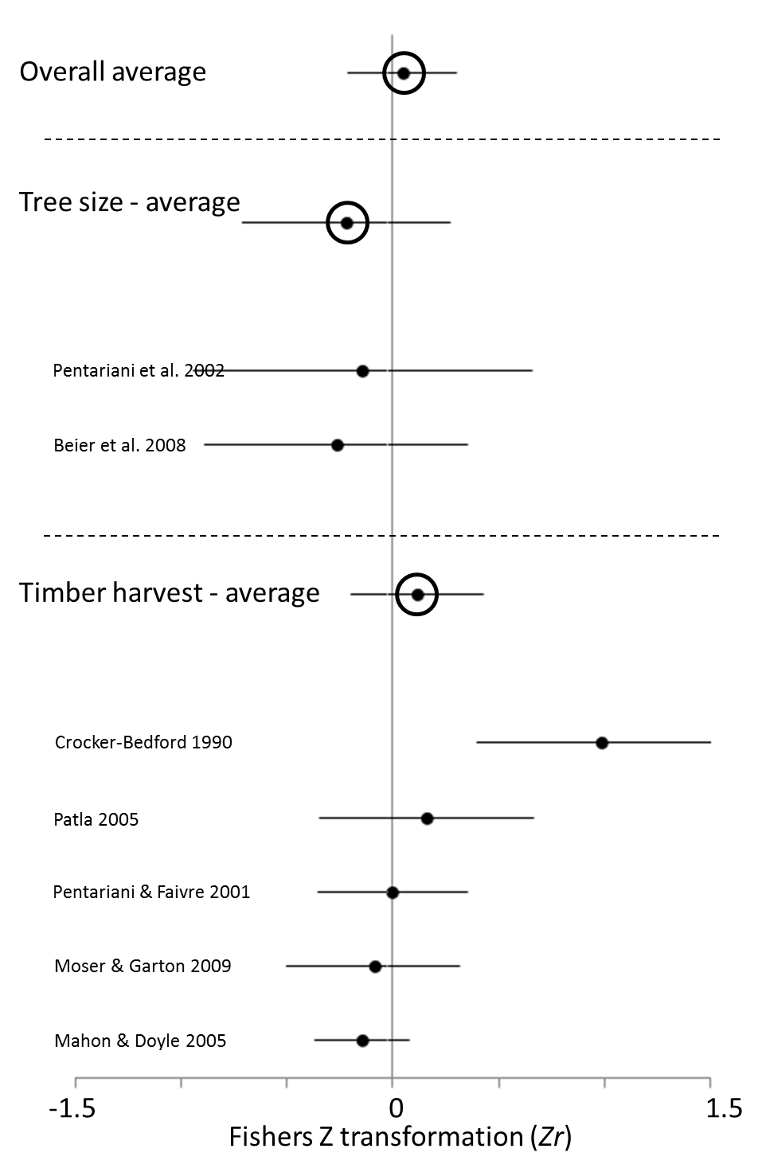
B.

Figure 2. Forest plots of goshawk productivity as a function of tree size or timber harvest indicating average effect size (Zr) ± 95% CI from each study included in meta-analysis and cross-study average effect sizes ± 95% CI for studies grouped by (A) continent and (B) independent variable type.

3.2 Occupancy Analysis
We located a larger number (n = 21) of studies which met our criteria for comparing goshawk site occupancy to either timber harvest or tree size (Table 1) and others (n = 15) with insufficient information for inclusion (Appendix 1). The funnel plots of the raw effect sizes (prior to taking per-study averages) are relatively symmetrical and do not indicate publication bias (Figure 3). For both continents analyzed, average effect sizes were similarly moderate and greater than zero (North America: Zr = 0.267, 95% CI = 0.132 to 0.401, n = 13; Eurasia: Zr = 0.227, 95% CI = 0.093 to 0.361, n = 8; Figure 4a). The overall mean effect size combining all studies was significantly greater than zero (Zr = 0.248; 95% CI = 0.147 to 0.348; n = 21; Figure 4a). We detected substantial heterogeneity among studies within the full data set and within North America, but not in Eurasia (all studies: I² = 56.5%, p < 0.001; North America: I² = 68.9%, p < 0.001; Eurasia: I² = 6.0%, p = 0.384).

The effect sizes from the relationships of both timber harvest and tree size with occupancy were similarly moderate and both significantly > 0 (timber harvest: Zr = 0.237, 95% CI = 0.007 to 0.466, n = 7; tree size: Zr = 0.252, 95% CI = 0.145 to 0.358, n = 15; Figure 4b), as was the combined effect size (Zr = 0.243, 95% CI = 0.145 to 0.342, n = 22; Figure 4b). We detected moderate and marginally significant heterogeneity among tree-size studies and substantial and significant heterogeneity among timber-harvest studies, and the heterogeneity estimate across all studies was intermediate to these (all studies: I² = 54.7%, p = 0.001; timber harvest: I² = 71.4%, p = 0.001; tree size: I² = 43.6%, p = 0.036).

Figure 3.
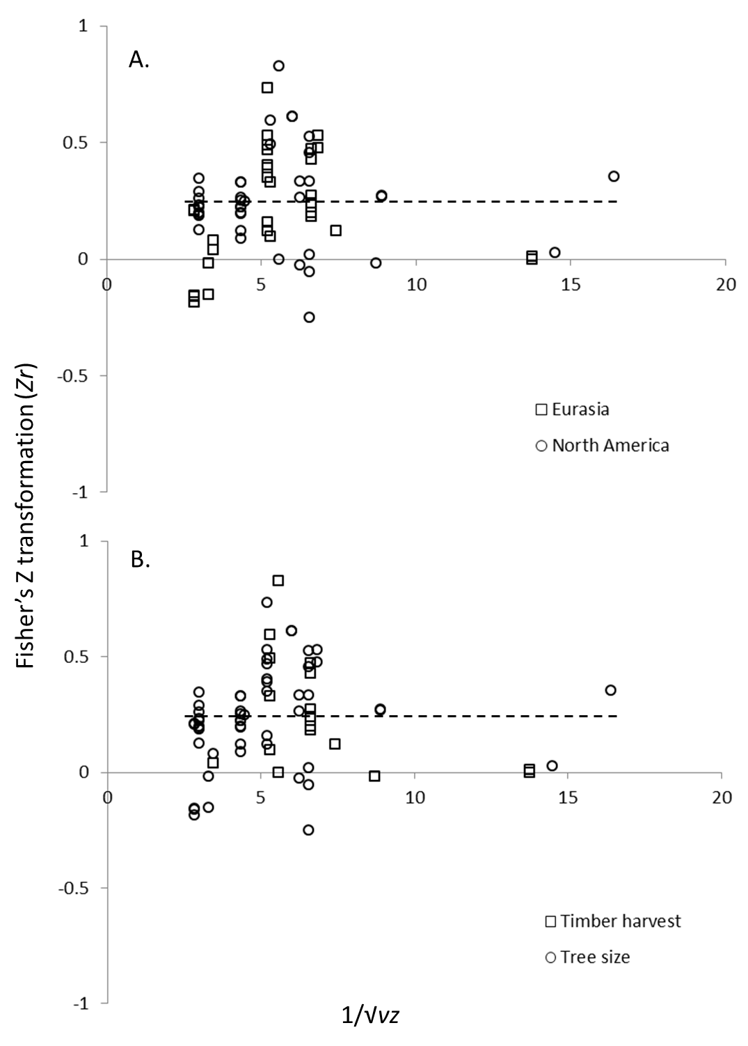
Figure 3. Funnel plots of published effect sizes (Zr) from the relationship between goshawk nest-site occupancy and tree size or timber harvest as a function of sample size as represented by 1/√vr. Effect sizes are segregated by (A) continent and (B) independent variable type. Note that these represent effect sizes prior to generating per-study averages, so some studies are represented more than once in each figure. The dashed line represents the average effect size derived from meta-analysis based on per-study average effect sizes. The symmetrical funnels, approximately centered on the dashed line, provide no evidence of major publication bias.

Figure 4

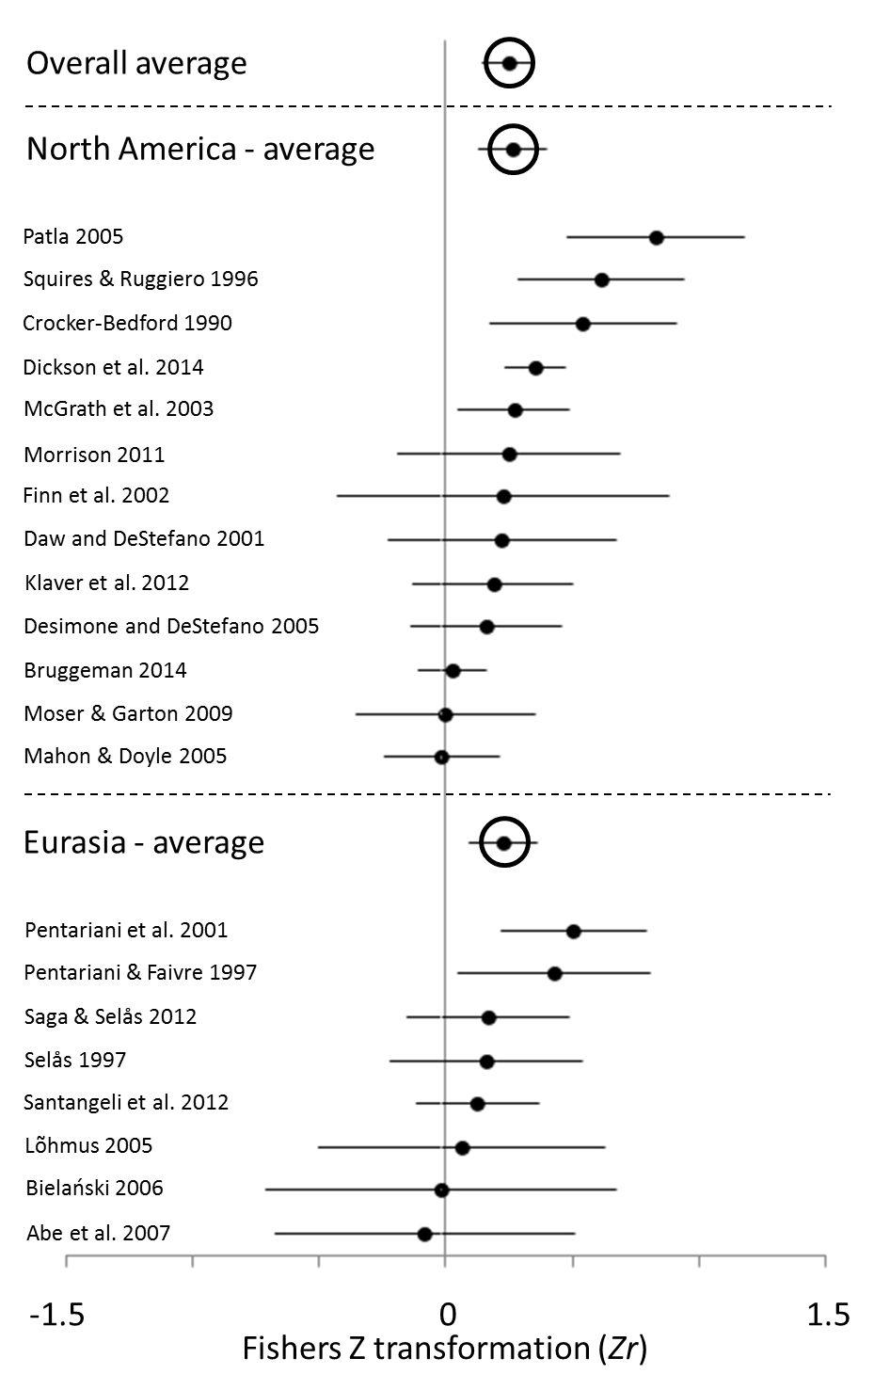
A.

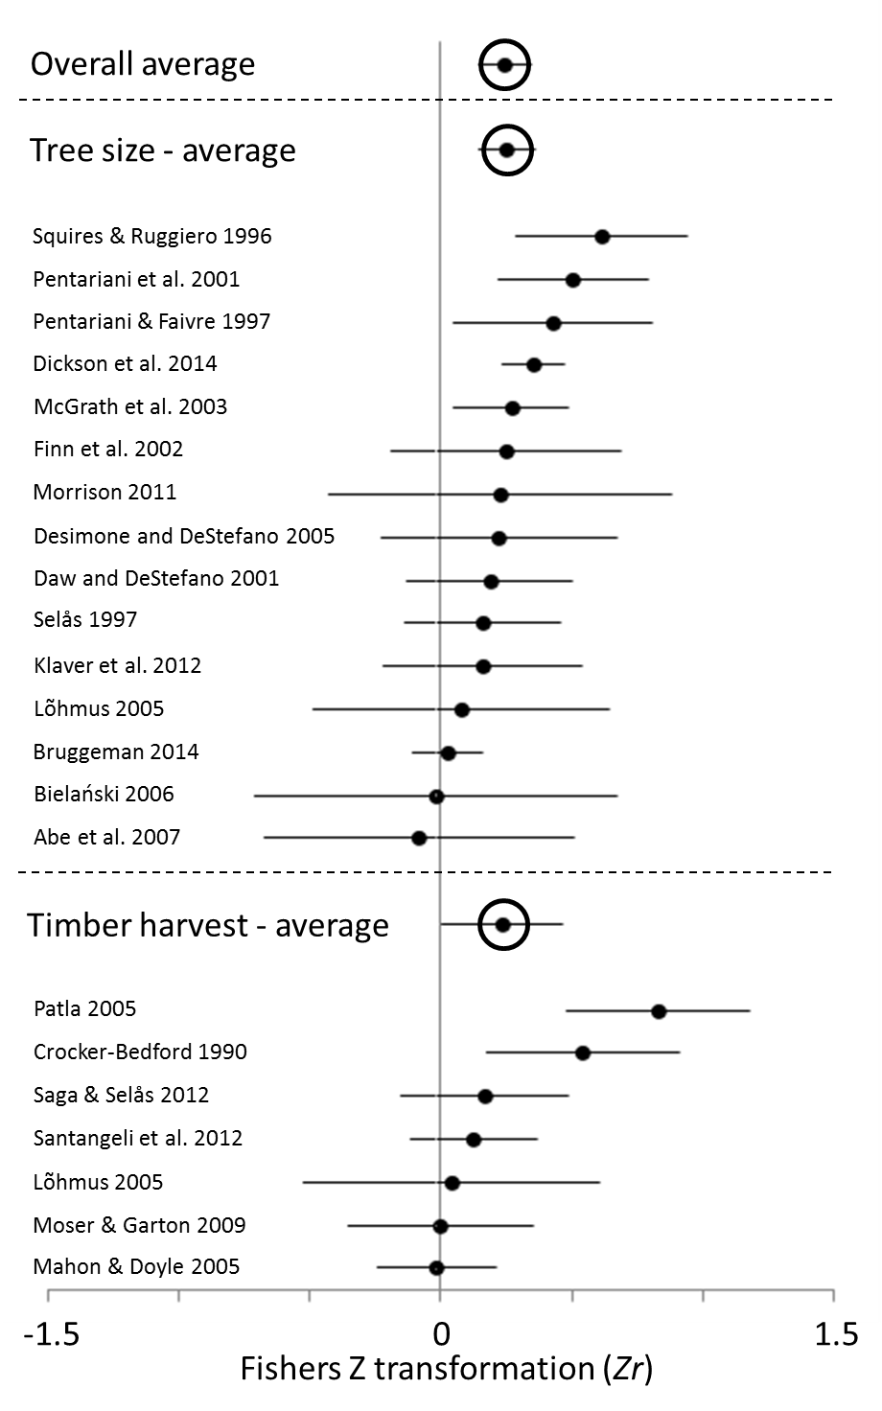
B.

Figure 4. Forest plots of goshawk occupancy as a function of tree size or timber harvest indicating average effect size (Zr) ± 95% CI from each study included in meta-analysis and cross-study average effect sizes ± 95% CI for studies grouped by (A) continent and (B) independent variable type.

4. DISCUSSION
Evidence from across the breeding distribution of the northern goshawk suggests that timber harvest as represented in these studies (Table 2) is associated with lower nest-site occupancy. However, if goshawk pairs do nest at timber-harvest sites, their reproduction appears unaffected by this harvest. Goshawks in these studies were also more likely to occupy sites with larger trees than the average available, but with only two studies comparing productivity to average tree size near nests, the lack of relationship between these variables must be considered provisional. Our results support conclusions of other reviews (e.g., Squires and Kennedy 2006) that, regardless of forest type, goshawks prefer patches of more mature trees, relative to availability, for situating nests. This pattern is consistent between continents. Although we are confident in these overall trends, we detected substantial heterogeneity in results within most of our subsets of studies. This heterogeneity suggests that strength of relationships, for instance between timber harvest and occupancy, differ among sites or among studies, likely influenced by differences in study design, habitat, and unaccounted geographic variation. Finally, the studies included in the analysis of timber harvest monitored reproduction or occupancy for a mean of 4.4 years and a median of 3 years (range = 1 – 15 years) after timber harvest so we cannot draw conclusions about longer-term effects of timber harvest.

Table 2 – Summary of types of harvest, median tree size and sample design of studies included in the meta-analysis of the relationship between timber harvest and northern goshawk (Accipiter gentilis) nest site occupancy and productivity, ordered by author surname.
Study | Non-harvest buffer | Type of Timber Harvest | Post Treatment Monitoring
Crocker-Bedford 1990 | Small:1.2 – 2.4 ha  Large: 16 – 200 ha | 1/3 of timber volume of live trees >23 cm dbh from 79% of area | 3 yrs
Lõhmus et al. 2005 | None stated | Recent (within past 15 yrs) thinning or sanitary cuttings. Distance unspecified, possibly within 30 m. | Opportunistic survey within 15 yrs after harvest
Mahon and Doyle 2005 | 25-200 m “to provide a mature forest buffer” | 5 – 95% clearcut of all “merchantable trees” within 24 ha nest area | 3 yrs (range = 1 – 7 yrs)
Moser and Garton 2009 | None stated | Clearcut of 85 – 95% tree volume of timber harvest unit sizes ranging from 16 ha – 74 ha surrounding nest | 2 yrs
Patla 2005 | None stated | In a related sample, average reduction of mature forest from 80% to 61% with loss concentrated near center of nesting area. Nesting area 2428 ha | Areas were harvested of timber from 1963 – 2001 and nest sites known to be occupied at least once since 1989 were monitored for 5 years starting in 1998
Penteriani and Faivre 2001 | None stated | Successive felling (10%, 3 stages of 20%, final 30% spread) of all trees over 10 – 15 yrs | Post-treatment monitoring not specified, but apparently monitored nests during entire 10-15 yr cutting cycle
Saga and Selås 2012 | Some clear cutting <50 m vs. 50 – 100 m | Remaining mature forest stand for small buffer nests averaged 1.9 ha; large buffer nests averaged 3.5 ha | 2 – 3 yrs
Santangeli et al. 2012 | Clear cutting within 100 m or not | Clear cuts involve two or three thinning phases then removal of all trees over1 – 2 ha. Most timber harvest occurs in stands aged 50-80 yrs. | Timber-harvested (‘low-buffer’) areas monitored on average 2.8 years; unharvested (“high buffer) areas monitored on average 2.5 years

Why do forest structure and impacts on this structure from timber harvest explain short-term occupancy but not productivity in goshawks? We will discuss two general hypotheses that may explain this divergence in relationships, one that hypothesizes food availability drives occupancy, and the other that hypothesizes nest security drives occupancy.

Although the resources goshawks require and the types of forest that support those resources are diverse (Wiens et al. 2006, Salafsky et al. 2007, Miller et al. 2014), such resources, including food, may be more readily available in older forests with minimal timber harvest (e.g., Reynolds et al. 1992, 2008, Squires and Kennedy 2006, Wiens et al. 2006). Raptors commonly do not occupy habitat with poor food availability. In peregrine falcons (Falco peregrinus; Bruggeman et al. 2015; 2016), ferruginous hawks (Buteo regalis; Wallace et al. 2015, 2016) and golden eagles, (Aquila chrysaetos; McIntyre et al. 2012) prey abundance or proximity of prey habitat near nests has been strongly associated with nest site occupancy but either not associated or only weakly associated with reproduction or recruitment. However, in goshawks, there is experimental evidence that reproduction can be limited by food availability (Ward and Kennedy 1996, Dewey and Kennedy 2001, Byholm and Kekkonen 2008), thus lack of a strong relationship in our productivity analyses seems to stand in contrast to experimental studies and to the relationship we saw in our occupancy analyses.

If food availability were lower in younger nest stands or in nest stands near timber harvest, why would some goshawks continue to nest in those stands, and why would their nests be no more likely to fail than nests in areas with larger trees and more prey available? Multiple explanations are possible. First, most of the studies considered in our meta-analysis assessed habitat at spatial scales much smaller than a goshawk territory (Squires and Kennedy 2006). Thus pairs that choose to nest despite close proximity to timber harvest might be those pairs that still have access to alternative nest sites and/or sufficient areas of forest unaffected by timber harvest in which to forage. Another, non-exclusive possibility is that if neighbors abandon territories in response to harvest or fail to nest and thus exhibit reduced territorial defense, other nesting pairs may be able to usurp undefended areas for foraging and thus access sufficient resources. This would be consistent with theoretical (Fretwell and Lucas 1970, Greene and Stamps 2001) and empirical (e.g., Newton 1986, Whitfield et al. 2006, Thériault et al. 2012) expectations of enlarged territories in habitats of reduced quality.

However, as we noted earlier, reduced goshawk occupancy of sites near timber harvest or sites with smaller trees need not result from changes in food availability. It is plausible that such patterns may result from goshawks selecting nests in areas that are shielded from predators or protected from inclement weather. When a nest tree is surrounded by small trees, or if surrounding trees are removed, the nest itself may become more visible to predators and less protected from inclement weather. If goshawks respond to greater nest exposure with nest abandonment, that could explain our occupancy results. There is no empirical support for this type of nest site selection in goshawks, but it is plausible given that in some other birds species individuals may adjust nest placement to enhance concealment and reduce predation risk (Lima 2009). This still begs the question, if exposure to inclement weather and predators were impacting occupancy, why would it not also impact productivity? Perhaps territories where structure is modified severely will not be occupied and thus produce no measure of productivity. This speculation needs further investigation.

If goshawks are less likely to occupy immature or partially timber-harvested stands, this raises important questions about what goshawks do once the structure of their nest site is modified by timber harvest. Theoretical expectation (e.g., Fretwell and Lucas 1970, Greene and Stamps 2001) and empirical evidence from a variety of systems (e.g., Holmes et al. 1996, Dreitz et al. 2001, Suryan et al. 2001,Gram et al. 2003) suggest that as habitat quality changes, individuals will re-distribute themselves on the landscape. Although this process can be limited by territoriality (Fretwell and Lucas 1970), this limitation will be less pronounced in unsaturated landscapes (Greene and Stamps 2001). Thus it could be that goshawks abandon territories after timber harvest and seek to occupy new territories in other areas with greater resource (food or nest site) availability or reduced predation risk. Penteriani et al.’s (2002) study of catastrophic wind-damaged stands in northern France suggests goshawk pairs moved to the closest suitable stands after the disturbance. In western Finland, goshawk occupancy declined by half and Hakkarainen et al. (2004) speculated that this decline could have been caused by intensive timber harvest. Likewise, in Wisconsin, USA, large clearcuts on land owned by local governments could have limited goshawk territory occupancy to less than five years whereas on the nearby national forest where timber harvest was more selective, goshawk territory occupancy was much longer at 25 years (Erdman et al. 1998). However, an equally plausible scenario is that territory occupants remain in the vicinity but simply do not nest. Distinguishing between these two possibilities has major implications. In the former case, reproduction is possible, but in the latter case, one or more years of reproduction would be completely lost. Thus we have not shown that stand characteristics and timber harvest do not influence goshawk reproduction. Instead we have found only a lack of evidence that stand characteristics and timber harvest influence the success of nesting attempts that occur in the presence of timber harvest. In other words, the relationships we detected with site occupancy could well be effects on nest initiation, and thus potentially lifetime reproduction and ultimately fitness.

Because occupancy rates were not adjusted for imperfect detection, lower occupancy rates in sites with nearby timber harvest could have occurred because goshawks were less detectable in timber-harvested sites as compared to non-harvested sites. Perhaps goshawks near timber-harvest sites were less likely to respond to survey protocol because they were less likely to be actively nesting or were more habituated to the survey protocols. Goshawks are secretive birds and can rotate between widely spaced alternative nests, some of which could be inhabited once every seven years (Reynolds et al. 2005). Accounting for detection probability in goshawk surveys is necessary because they are unlikely to be detected in every site visit (Boyce et al. 2005). Bioregional goshawk surveys that estimate occupancy adjusted for imperfect detection have been developed and evaluated (Hargis and Woodbridge 2006; Beck et al. 2011). Unfortunately, all the studies in our analyses failed to account for detection probability. Thus we cannot rule out the possibility that our occupancy relationships are actually detectability effects. There is no scientific or management rationale to continue to estimate naïve occupancy for goshawks (Hayward et al. 2015).

Our scope of inference is limited to the nest site and nest stand and to the types of timber harvest that occurred at these two spatial scales, but there remain considerable potential sources of variability among study results within this relatively narrow range of scales. For instance, even at this small scale, the spatial extent of sampling varied, as did the area of timber-harvest-restriction buffers around nests, and even whether such buffers existed (Table 2). Not only did proximity of timber harvest to the nest vary, but so did the extent of timber harvests, with cutting ranging from 5-95% of the nest site or nest stand.

With such variability among studies and little or no close replication of methods across studies, interesting findings of individual studies cannot be rigorously evaluated (Nakagawa and Parker 2015). For instance, two quasi-experimental studies indicated goshawks would abandon territories if >30% or >39% of a nest stand was harvested, respectively (Penteriani and Faivre 2001, Moser and Garton 2009). The similarity of these findings is tantalizing, but the generality of this threshold effect will require more research. Likewise, we are not in a strong position to draw conclusions about buffer size. One Eurasian study found that effects of timber harvest were undetectable if that harvest occurred >100 m from a nest, but were detectable at smaller buffer sizes (Santangeli et al. 2012). A buffer of 100 m radius is much smaller than the recommendation of Reynolds et al. (1992) for no timber harvest within 12 ha surrounding a nest. However, buffers this large were only included in Crocker Bedford’s 1990 study and so it remains mostly untested whether larger buffers might ameliorate negative effects of timber harvest on goshawk occupancy.

If goshawk conservation occurred pre-timber-harvest in the studies we examined, it was based on protecting individual nest sites with harvest buffers, not on managing landscapes for prey. Thus we recommend future investigations evaluate demographic response of goshawks to landscape management of prey populations as done by Beier et al. (2008) who found that goshawk productivity decreased with increasing similarity to the Reynolds et al. (1992) guidelines (an ecosystem management plan designed to manage landscapes for goshawk resources; but see Reynolds et al. 2012 rebuttal).

We have presented several plausible explanations for our results. However, there is currently insufficient information to rigorously evaluate the mechanisms behind the patterns we documented. Future research should focus on well-replicated experimental habitat manipulations with telemetered birds designed to investigate the mechanisms influencing occupancy and productivity in goshawks. Habitat manipulation may not be appropriate in populations of conservation concern, but tracking with telemetry could still be useful in those cases. Future studies should also be designed with the goal of explaining the heterogeneity we found among studies in the strength of relationships between, for instance, timber harvest and occupancy. This heterogeneity may be due to differences in methods, including type and extent of timber harvest, or to biological differences among sites or among populations. Distinguishing timber harvest effects from other methodological or biological effects will be most effectively accomplished by careful study designs that minimize methodological differences, including timber harvest, among studies. Better yet, studies should include multiple parallel methods or timber harvest treatments to explicitly assess their effects (Nakagawa and Parker 2015). Furthermore, it is worth noting that many studies included in our analyses, especially those that compared goshawk nesting success to tree size or timber harvest, were based on small samples. These small samples led to large confidence intervals around the average effect sizes reflecting low precision of the estimate. It is possible that the small and statistically non-significant effect sizes may be small but biologically relevant (Nakagawa and Cuthill 2007). Although we recognize that finding and monitoring large numbers of goshawk nests is difficult and expensive, gaining confidence in our understanding of goshawk responses to tree size and timber harvest will require these efforts.

ACKNOWLEDGEMENTS

We are grateful to the authors that carried out the studies that made our analyses possible. We would also like to thank the Society for Advancement of Chicanos and Native Americans in Science for the travel scholarship that allowed the first author to present preliminary findings from this study at the Undergraduate Poster Session at the 2014 National Conference. We thank John Goodell for a generous pre-submission review and two anonymous reviewers for excellent suggestions.

LITERATURE CITED

Abe, F., Hasegawa, O., Kudo, T., Higashi, S., 2007. Nest-site selection of northern goshawks and Eurasian sparrowhawks in a fragmented landscape in northern Japan. Journal of Raptor Research 41, 299 – 306.

Andersen, D.E., DeStefano, S., Goldstein, M.I., Titus, K., Crocker-Bedford, C., Keane, J.J., Anthony, R.G., Rosenfield, R.N., 2005. Technical review of the status of Northern Goshawks in the western United States. Journal of Raptor Research 39, 192 – 209.

Barrientos, R., Arroyo, B., 2014. Nesting habitat selection of Mediterranean raptors in managed pinewoods: searching for common patterns to derive conservation recommendations. Bird Conservation International 24, 138 – 151.

Beck, J.L., Skorkowsky, R.C., Hayward, G.D., 2011. Estimating occupancy to monitor northern goshawk in the central Rocky Mountains. Journal of Wildlife Management 75, 513 – 524.

Beier, P., Drennan, J.E., 1997. Forest structure and prey abundance in foraging areas of northern goshawks. Ecological Applications 7, 564 – 571.

Beier, P., Rogan, E.C., Ingraldi, M.F., Rosenstock, S.S., 2008. Does forest structure affect reproduction of northern goshawks in ponderosa pine forests? Journal of Applied Ecology 45, 342 – 350.

Bielański, W., 2006. Nesting preferences of common buzzard Buteo buteo and goshawk Accipiter gentilis in forest stands of different structure (Niepolomice Forest, Southern Poland). Biologia 61, 597 – 603.

Borenstein, M., Hedges, L. V., Higgins, J. P. T. & Rothstein, H. R., 2009. Introduction to Meta-Analysis. John Wiley & Sons, Chichester, UK.

Boyce, D. A., Jr., Kennedy, P. L, Beier, P., Ingraldi, M. F., MacVean, S. R., Siders, M. S., Squires, J. R., Woodbridge, B., 2005. When are Goshawks not there? Is a single visit enough to infer absence at occupied nest areas? Journal of Raptor Research 39, 296 - 302.

Boyce, D. A., Reynolds, R. T., Graham, R. T., 2006. Goshawk status and management: what do we know, what have we done, where are we going? Studies in Avian Biology 31:312-325.

Bruggeman, J. E., Andersen, D. E., Woodford, J. E., 2014. Factors related to Northern Goshawk landscape use in the Western Great Lakes Region. Journal of Raptor Research 48, 228 -239.

Bruggeman, J. E., Swem, T. Andersen, D. E., Kennedy, P. L, Nigro, D., 2015. Dynamics of a recovering Arctic bird population: the importance of climate, density dependence, and site quality. Ecological Applications 25, 1932 - 1943.

Bruggeman, J. E., Swem, T. Andersen, D. E., Kennedy, P. L., Nigro, D., 2016. Multi-season occupancy models identify abiotic and biotic factors influencing a recovering arctic Peregrine Falcon population Falco peregrinus tundrius. Ibis 158, 61 - 74.

Byholm, P., Kekkonen, M., 2008. Food regulates reproduction differently in different habitats: experimental evidence in the goshawk. Ecology 89, 1696 – 1702.

Cohen, J., 1992. A power primer. Psychological Bulletin 112, 155-159.

Crocker-Bedford, D.C., 1990. Goshawk reproduction and forest management. Wildlife Society Bulletin 18, 262 – 269.

Daw, S.K., DeStefano, S., 2001. Forest characteristics of northern goshawk nest stands and post-fledging areas in Oregon. Journal of Wildlife Management 65, 59 – 65.

Deng, W., 2006. Breeding habitat selection by sympatric Grey-faced Buzzards and Northern Goshawks in northeast China. Journal of Raptor Research 40, 264 – 269.

Desimone, S.M., DeStefano, S., 2005. Temporal patterns of Northern Goshawk nest area occupancy and habitat: a retrospective analysis. Journal of Raptor Research 39, 310 – 323.

DeStefano, S., 2005. A review of the status and distribution of Northern Goshawks in New England. Journal of Raptor Research 39, 342 – 350.

Dewey, S. R., Kennedy, P. L., 2001. Effects of supplemental food on parental care strategies and juvenile survival of Northern Goshawks. Auk 118, 352 - 365.

Dickson, B.G., Sisk, T.D., Sesnie, S.E., Reynolds, R.T., Rosenstock, S.S., Vojta, C.D., Ingraldi, M.F., Rundall, J.M., 2014. Integrating single-species management and landscape conservation using regional habitat occurrence models: the northern goshawk in the Southwest, USA. Landscape Ecology 29, 803 – 815.

Dietz, G., Dahabreh, I.J., Gurevitch, J., Lajeunesse, M.J., Schmid, C.H., Trikalinos, T.A., Wallace, B.C., 2015. OpenMEE: Software for Ecological and Evolutionary Meta-Analysis [Computer program]. Available at (http://www.cebm.brown.edu/open_mee). (accessed 2015.11.18).

Donner, D.M., Anderson, D., Eklund, D., St. Pierre, M., 2013. Large-scale forest composition influences northern goshawk nesting in Wisconsin. Journal of Wildlife Management 77, 495 – 504.

Dreitz, V. J., Bennetts, R.E., Toland, B., Kitchens, W.M., Collopy, M.W., 2001. Spatial and temporal variability in nest success of Snail Kites in Florida: a meta-analysis. Condor 103, 502 - 509.

Erdman, T.C., Brinker, D.F., Jacobs, J.P., Wilde, J., Meyer, T.O., 1998. Productivity, population trend, and status of northern goshawks, Accipter gentilis atricapillus, in northeastern Wisconsin. Canadian Field Naturalist 112, 17 – 27.

Fontaine, J. B., Kennedy, P. L., 2012. Avian and small mammal response to fire severity and fire surrogate treatments in U.S. fire-prone forests: a meta-analysis. Ecological Applications 22, 1547 - 1561.

Finn, S.P., Marzluff, J.M., Varland, D.E., 2002a. Effects of landscape and local habitat attributes on northern goshawk site occupancy in western Washington. Forest Science 48, 427 – 436.

Finn, S.P., Varland, D.E., Marzluff, J. M., 2002b. Does Northern Goshawk breeding occupancy vary with nest-stand characteristics on the Olympic Peninsula, Washington? Journal of Raptor Research 36, 265 – 279.

Fretwell, S. D., and H. L. Lucas., 1970. On territorial behavior and other factors influencing habitat distribution in birds. 1. Theoretical development. Acta Biotheoretica 19, 16 - 36.

Global Raptor Information Network (GRIN), 2015. Northern Goshawk Accipiter gentilis. The Peregrine Fund. http://globalraptors.org/grin/SpeciesResults.asp?specID=8132 (last accessed October 12, 2015).

Gram WK, Porneluzi PA, Clawson RL, Faaborg J, Richter SC., 2003.Effects of experimental forest management on density and nesting success of bird species in Missouri Ozark forests. Conservation Biology 17, 1324 – 1337.

Greene, C. M., J. A. Stamps., 2001. Habitat selection at low population densities. Ecology 82, 2091 - 2100.

Greenwald D.N., Crocker-Bedford, D.C., Broberg, L., Suckling, K.F., Tibbitts, T., 2005. A review of northern goshawk habitat selection in the home range and implications for forest management in the western United States. Wildlife Society Bulletin 33, 120 – 129.

Hakkarainen, H., Mykrä, S., Kurki, S., Tornberg, R. Jungell, S., 2004. Competitive interactions among raptors in boreal forests. Oecologia 141, 420 – 424.

Hargis, C. D., McCarthy, C., and Perloff, R. D. 1994. Home ranges and habitats of Northern Goshawks in eastern California. Studies in Avian Biology 16: 66-74.

Hargis, C.D., Woodbridge, B., 2006. A design for monitoring Northern Goshawks at the bioregional scale. Studies in Avian Biology 31, 274 – 287.

Hayward, M. W., Boitani, L., Burrows, N. D., Funston, P. J., Karanth, K. U., Mackenzie, D. I., Pollock, K. H., Yarnell, R. W., 2015. Ecologists need robust survey designs, sampling and analytical methods. Journal of Applied Ecology 52, 286 - 290.

Holmes, R. T., Marra, P.P., Sherry, T. W., 1996. Habitat-specific demography of breeding black-throated blue warblers (Dendroica caerulescens): implications for population dynamics. Journal of Animal Ecology. 65, 183 - 195.

Keller, M., Buczek, T., Różycki, A.L., 2008. Birds of prey habitat preferences vs. age structure of forest - Parczew Forest case study. Sylwan 2, 30 – 35.

Kennedy, P. L., 1997. The Northern Goshawk (Accipiter gentilis atricapillus): is there evidence of a population decline? Journal of Raptor Research 31, 95-106.

Kennedy. P. L., Cartron, J-L., 2010. Northern Goshawk (Accipiter gentilis). Pages 195 - 211 In Cartron. J-L. (Ed.). Raptors of New Mexico. University of New Mexico Press, Albuquerque, NM, USA.

Klaver, R.W., Backlund, D., Bartelt, P.E., Erickson, M.G., Knowles, C.J., Knowles, P.R., Wimberly, M.C., 2012. Spatial analysis of Northern Goshawk territories in the Black Hills, South Dakota. Condor 114, 532 – 543.

Kostrzewa, A., 1996. A comparative study of nest-site occupancy and breeding performance as indicators for nesting-habitat quality in three European raptor species. Ethology, Ecology and Evolution 8, 1 – 18.

Krüger, O., 2002. Analysis of nest occupancy and nest reproduction in two sympatric raptors: common buzzard Buteo buteo and goshawk Accipiter gentilis. Ecography 25, 523 – 532.

Krüger, O., Lindstrom, J., 2001. Habitat heterogeneity affects population growth in goshawk Accipiter gentilis. Journal of Animal Ecology 70, 173 – 181.

Kudo, T., Ozaki, K., Takao, G., Sakai, T., Yonekawa, H., Ikeda, K., 2005. Landscape analysis of northern goshawk breeding home range in northern Japan. Journal of Wildlife Management 69, 1229 – 1239.

Lima, S. L. 2009. Predators and the breeding bird: behavioral and reproductive flexibility under the risk of predation. Biological Reviews 84, 485 - 513.

Lõhmus, A., 2005. Are timber harvesting and conservation of nest sites of forest-dwelling raptors always mutually exclusive? Animal Conservation 8, 443 – 450.

Mahon, T.F., Doyle F.I., 2005. Effects of timber harvesting near nest sites on the reproductive success of Northern Goshawks (Accipiter gentilis). Journal of Raptor Research 39, 335 – 341.

McGrath, M.T. DeStefano, S., Riggs, R.A., Irwin, L.L. Roloff, G.J., 2003. Spatially explicit influences on northern goshawk nesting habitat in the interior Pacific Northwest. Wildlife Monographs 154, 1 – 63.

McIntyre, C. L., Schmidt, J. H., 2012. Ecological and environmental correlates of territory occupancy and breeding performance of migratory Golden Eagles Aquila chrysaetos in interior Alaska. Ibis 154, 124 – 135.

Miller, R. A., Carlisle, J. D., Bechard, M. J., 2014. Effects of prey abundance on breeding season diet of Northern Goshawks (Accipiter gentilis) within an unusual prey landscape. Journal of Raptor Research 48, 1 - 12.

Morrison, M.L., Young, R.J., Romsos, S., Golightly, R., 2011. Restoring forest raptors: influence of human disturbance and forest condition on northern goshawks. Restoration Ecology 19, 273 – 279.

Moser, B.W., Garton, E.O., 2009. Short-term effects of timber harvest and weather on Northern Goshawk reproduction in Northern Idaho. Journal of Raptor Research 43, 1 – 10.

Nakagawa, S., Cuthill, I. C. 2007. Effect size, confidence interval and statistical significance: a practical guide for biologists. Biological Reviews 82, 591 - 605.

Nakagawa, S., Parker, T. H. 2015. Replicating research in ecology and evolution: feasibility, incentives, and the cost-benefit conundrum. BMC Biology 13, 88.

Newton, I., 1986. The Sparrowhawk. T & AD Poyser, Ltd. Calton, England.

Palmer, A. R., 1999. Detecting publication bias in meta-analyses: a case study of fluctuating asymmetry and sexual selection. American Naturalist 154, 220–233.

Patla, S.M., 2005. Monitoring results of Northern Goshawk nesting areas in the greater Yellowstone Ecosystem: Is decline in occupancy related to habitat change? Journal of Raptor Research 39, 324 – 334.

Penteriani, V., 2002. Goshawk nesting habitat in Europe and North America: a review. Ornis Fennica 79, 149– 163.

Penteriani, V., Faivre, B., 1997. Breeding density and nest site selection in a Goshawk Accipiter gentilis population of the Central Apennines (Abruzzo, Italy). Bird Study 44, 136 – 145.

Penteriani, V., Faivre, B., 2001. Effects of harvesting timber stands on goshawk nesting in two European areas. Biological Conservation 101, 211 – 216.

Penteriani, V., Faivre, B., Frochot, B., 2001. An approach to identify factors and levels of nesting habitat selection: a cross-scale analysis of Goshawk preferences. Ornis Fennica 78, 159 – 167.

Penteriani, V., Faivre, B., Mazuc, J., Cezilly, F., 2002. Pre-laying vocal activity as a signal of male and nest stand quality in goshawks. Ethology, Ecology and Evolution 14, 9 – 17.

Penteriani, V., Mathiaut, M., Boisson, G., 2002. Immediate species responses to catastrophic natural disturbances: windthrow effects on density, productivity, nesting stand choice, and fidelity in Northern Goshawks (Accipiter gentilis). Auk 119, 1132 - 1137.

Reynolds, R. T., Graham, R. T., Reiser, M. H., Bassett, R. L., Kennedy, P. L., Boyce Jr, D. A., Goodwin, G., Smith, R., Fisher, E. F. (Northern Goshawk Scientific Committee, USDA Forest Service, Southwestern Region), 1992. Management recommendations for the northern goshawk in the southwestern United States. USDA For. Serv. Rocky Mtn. For. Range Exp. Sta. Gen. Tech. Rep. RM-217.

Reynolds, R.T., Joy, S.M., Leslie, D.G., 1994. Nest productivity, fidelity, and spacing of Northern Goshawks in northern Arizona. Studies in Avian Biology 16, 106 – 113.

Reynolds, R.T., Wiens, D.J., Joy, S.M., Salafsky, S.R., 2005. Sampling considerations for demographic and habitat studies of Northern Goshawks. Journal of Raptor Research 39, 274 – 285.

Reynolds, R.T., Graham, R.T., Boyce Jr, D.A., 2008. Northern goshawk habitat: an intersection of science, management, and conservation. Journal of Wildlife Management 72, 1047 – 1055.

Reynolds, R. T., Boyce, D. A., Graham, R. T., 2012. Ponderosa pine forest structure and northern goshawk reproduction: response to Beier et al. (2008). Wildlife Society Bulletin 36, 147-152.

Rodriguez, S., Kennedy, P. L., Parker, T.H., submitted. Data for meta-analysis derived from studies comparing timber harvest or tree size to nest-site occupancy or productivity in northern goshawks (Accipiter gentilis). Forest Ecology and Management. Data in Brief.

Rohatgi, A., 2014. WebPlotDigitizer, version 3.5 [Computer program]. Available at (http://arohatgi.info/WebPlotDigitizer/index.html). (Last accessed 16.02.08).

Rosenberg, M.S., Adams, D.C., Gurevitch, J., 2000. MetaWin: Statistical software for meta-analysis. Sinauer Associates, Inc. Sunderland, Massachusetts, USA.

Rosenberg, M.S., 2013. Moment and least-squares based approaches to meta-analytic inference. Pages 108 – 124 In Handbook of Meta-analysis in Ecology and Evolution, Koricheva, J, Gurevitch, J, and Megersen, K. [Eds.]. Princeton University Press, Princeton, USA.

Rosenberg, M.S., Rothstein, H. R., Gurevitch, J., 2013. Effect sizes: conventional choices and calculations. Pages 61 – 71 In Handbook of Meta-analysis in Ecology and Evolution, Koricheva, J, Gurevitch, J, and Megersen, K. [Eds.]. Princeton University Press, Princeton, USA.

Rosenfield, R.N., Bielefeldt, J., Trexel, D.R., Doolittle, T.C., 1998. Breeding distribution and nest-site habitat of Northern Goshawks in Wisconsin. Journal of Raptor Research 32, 189 – 194.

Rutz, C., Bijlsma, R.G., Marquiss, M., Kenward, R.E., 2006. Population limitation in the Northern Goshawk in Europe: a review with case studies. Studies in Avian Biology 31, 158 – 197.

Saga, O., Selås, V., 2012. Nest reuse by goshawks after timber harvesting: Importance of distance to logging, remaining mature forest area and tree species composition. Forest Ecology and Management 270, 66 – 70.

Salafsky, S. R., Reynolds, R. T., Noon, B. R., Wiens, J. A., 2007. Reproductive responses of northern goshawks to variable prey populations. Journal of Wildlife Management, 71, 2274 - 2283.

Santangeli, A., Lehtoranta, H., Laaksonen, T., 2012. Successful voluntary conservation of raptor nests under intensive forestry pressure in a boreal landscape. Animal Conservation 15, 571 – 578.

Schlossberg, S., King, D. I., 2008. Are shrubland birds edge specialists? Ecological Applications 18, 1325 - 1330.

Selås, V., 1997. Influence of prey availability on re-establishment of goshawk Accipiter gentilis nesting territories. Ornis Fennica 74, 113 – 120.

Speiser, R., Bosakowski, T., 1987. Nest site selection by Northern Goshawks in northern New Jersey and southeastern New York. Condor 89, 387 – 394.

Squires, J.R., Kennedy, P.L., 2006. Northern Goshawk ecology: an assessment of current knowledge and information needs for conservation and management. Studies in Avian Biology 31, 8 – 62.

Squires, J.R., Ruggiero, L.F., 1996. Nest-site preferences of northern goshawks in southcentral Wyoming. Journal of Wildlife Management 60, 170 – 177.

Steenhof, K. and I. Newton. 2007. Assessing raptor nesting success and productivity. Pages 181–192. In Bird, D. M. and K. L. Bildstein. [Eds.]. Raptor research and management techniques. Hancock House. Surrey, BC, Canada, and Blaine, WA U.S.A.

Stephens, S. L., Bigelow, S. W., Burnett, R. D., Collins, B. M., Gallagher, C. V., Keane, J., Kelt, D. A., North, M. P., Roberts, L. J., Stine, P. A., Van Vuren, D. H., 2014. California spotted owl, songbird, and small mammal responses to landscape fuel treatments. BioScience 64, 893 - 906.

Suryan, R. M., Irons, D. B., 2001. Colony and population dynamics of Black-legged Kittiwakes in a heterogeneous environment. Auk 118, 636 - 649.

Thériault, S., Villard M., Haché, S., 2012. Habitat selection in site-faithful ovenbirds and recruits in the absence of experimental attraction. Behavioral Ecology 23, 1289 - 1295.

Toyne, E.P., 1997. Nesting chronology of northern goshawks (Accipiter gentilis) in Wales: implications for forest management. Forestry 70, 121 – 127.

Vanderwel, M. C., Malcolm, J. R., Mills, S.C., 2007. A meta-analysis of bird responses to uniform partial harvesting across North America. Conservation Biology 21, 1230 - 1240.

Wallace Z. P., Kennedy, P. L., Squires, J. R., Oakleaf, R. J., Olson, L. E., Dugger, K. M. 2016. Re-occupancy of breeding territories by ferruginous hawks in Wyoming: relationships to environmental and anthropogenic factors. PLoS ONE 11(4): e0152977. doi:10.1371/journal.pone.0152977

Wallace, Z., Kennedy, P. L, Squires, J. R., Oakleaf, R. J., Olson, L. L., 2015. Nest survival and productivity of ferruginous hawks in Wyoming: influence of human-made structures, vegetation, and severe weather. Journal of Wildlife Management 80, 78 – 90.

Ward, J. M., Kennedy, P.L., 1996. Effects of supplemental food on growth and survival of juvenile Northern Goshawks. Auk 113, 200 - 208.

Whitfield, D. P., Fielding, A. H., McLeod, D. R. A., Haworth, P. F., Watson, J., 2006. A conservation framework for the golden eagle in Scotland: refining condition targets and assessment of constraint influences. Biological Conservation 130, 465-480.

Wiens, J. D., Noon, B. R., Reynolds, R. T., 2006. Post-fledging survival of northern goshawks: the importance of prey abundance, weather, and dispersal. Ecological Applications 16, 406 - 418.

Woodbridge, B., Detrich, P.J., 1994. Territory occupancy and habitat patch size of Northern Goshawks in the southern Cascades of California. Studies in Avian Biology 16, 83 – 87.

Appendix 1. Some studies excluded from meta-analysis of the relationships between timber harvest or nest-site tree size and northern goshawk (Accipiter gentilis) territory occupancy or productivity, ordered by author surname.
Study | Potential Independent Variable(s) | Potential Response Variable(s) | Reason for Exclusion
Barrientos et al. 2014 | Tree Size | Occupancy | Does not include tree size beyond nest tree and three trees closest to nest tree.
Beck et al. 2011 | Tree Size | Occupancy | Occupancy values compared between tree species
Beier and Drennan 1997 | Tree Size | Occupancy | Habitat use from telemetry, not nest site or nest occupancy
Deng 2006 | Tree Size | Occupancy | Only size of nest tree assessed, variables measured in surrounding area not proxies for tree size
Donner et al. 2013 | Tree Size | Occupancy | Forest cover by tree species, no tree size variables
Finn et al. 2002b | Tree Size | Productivity | Does not compare habitat variables between successful and unsuccessful nests
Hakkarainen et al. 2004 | Tree Size | Occupancy | Occupancy not assessed as a function of habitat
Hargis et al. 1994 | Tree Size | Occupancy | Tree size presented only as tree counts
Keller et al. 2008 | Tree Size | Occupancy | Insufficient statistical information regarding tree ages
Kostrzewa 1996 | Tree Size | Productivity | Cover estimates and nest tree data; does not compare habitat between unsuccessful and successful nests
Krüger 2002 | Timber Harvest | Occupancy | Distance from permanent disturbance is undefined
Krüger and Lindstrom 2001 | Tree Size | Occupancy, productivity | Occupancy correlated with productivity, neither compared with tree size.
Kudo et al. 2005 | Tree Size | Occupancy | Did not compare occupied to unoccupied sites based on tree size
McGrath et al. 2003 | Tree Size | Productivity | Insufficient data reported for tree size in productivity analysis
Morrison et al. 2011 | Tree Size | Productivity | Did not compare reproduction to habitat variables
Penteriani and Faivre 2001 | Timber Harvest | Occupancy | Occupancy changing over time with successive timber harvest, no comparison (non-harvest) data set
Rosenfield et al. 1998 | Tree Size | Occupancy | Habitat variables compared between biased (searching purposefully in habitat goshawks were likely to nest) and unbiased (found opportunistically) sites
Speiser and Bosakowski 1987 | Tree Size | Occupancy | Tree size reported only as tree counts and basal area
Toyne 1997 | Harvest | Productivity | Examining relationship between ongoing timber harvest near nests during breeding season and productivity of those nests
Woodbridge and Detrich 1994 | Tree Size | Occupancy, Productivity | No data on tree size

