Measuring impact: joint-species modelling of invaded plant communities
Running title: Quantifying non-native impact.
Authors: Andrew O’Reilly-Nugent¹, ElizabethWandrag¹, Jane A. Catford^{2,3,4}, Bernd Gruber¹, Don Driscoll⁵, Richard P. Duncan¹.
1. Institute for Applied Ecology, University of Canberra, Canberra, ACT 2617, Australia
2. Department of Geography, King’s College London, Strand, London WC2R 2LS, UK
3. School of BioSciences, The University of Melbourne, VIC 3010, Australia
4. Fenner School of Environment & Society, Australian National University, Canberra, ACT 2601, Australia.
5. Deakin University, Geelong, Australia. School of Life and Environmental Sciences, Centre for Integrative Ecology, Melbourne Burwood Campus, 221 Burwood Highway, Burwood, VIC 3125

Keywords: abundance, biotic interaction, grasslands, invasive species, impact, joint species distribution model, light competition, tobit regression.

Type of article: Research article
Manuscript contains: Abstract – 228 words
Main text – 4, 922 words
References – 60
Tables – 1
Figures – 5
Appendices – 2
Supplementary figures – 6

Contact details for corresponding author: Andrew O’Reilly-Nugent
Institute for Applied Ecology,
University of Canberra,
University Drive, Bruce, ACT 2617
+61 468 778 749
andrew.oreilly-nugent@canberra.edu.au

Abstract
- Non-native plant species can dominate communities by competitively excluding native species. However, quantifying the competitive impact of non-native species is difficult because they may simply be abundant where native species are not due to different environmental requirements, meaning that the effects of environmental and competitive variation are confounded.
- Joint-species distribution models (JSDMs) can potentially untangle the environmental and competitive drivers of community composition. Extending JSDMs to include abundance data would allow them to be used to answer questions of community composition and species dominance. We describe a modelling approach that incorporates abundance data within a JSDM framework to identify non-native species having strong competitive impacts.
- We applied this approach to Australian grassy-woodland communities and manipulated grazing along a fertility gradient. The JSDM identified two of 72 non-native species (Avena fatua and Bromus diandrus) as having strong competitive impacts at high fertility sites, particularly after grazing exclusion. Competitive impact was well explained by traits associated with the ability to compete for light.
- Synthesis. JSDMs hold promise for identifying problematic plant invaders, quantifying their impact, and determining where on the landscape impacts are greatest. Our study demonstrates how a carefully formulated JSDM can extract accurate information about the key interactions driving variation in community composition from observational data alone. We provide a thorough treatment of the modelling procedure and reproducible code examples to encourage further adoption.
Introduction
Globally, the number of non-native plant species invading native communities is rising (Seebens et al., 2017, 2018; Vellend et al., 2017), yet only a fraction of invaders are thought to impact communities by reducing the abundance and diversity of native plant species (Lai, Mayfield, Gay-des-combes, Spiegelberger, & Dwyer, 2015; Williamson & Fitter, 1996). It can be difficult to tell if invaders are directly excluding native species (ie. invaders are driving the change), or whether altered environmental conditions are simply more suitable for non-native species (invaders are the passengers of change; MacDougall et al., 2014; MacDougall & Turkington, 2005) because the effect of environmental variation on species distributions is often confounded with variation in competitive outcomes (Godsoe, Franklin, & Blanchet, 2017; Levine et al., 2003; Soberón, 2010). Plant community composition typically varies in response to multiple environmental gradients (Grace et al., 2016; Weiher et al., 2011), but the intensity of competition also varies along those gradients (Terry, Morris, & Bonsall, 2017; Tylianakis, Didham, Bascompte, & Wardle, 2008). Disentangling environmental from competitive effects is possible using carefully designed experiments (Kraft, Godoy, & Levine, 2015), but the number of potential interactions usually means that the time and resources required are prohibitive when assessing diverse communities (Letten et al. 2017). Methods that use readily available observational data to disentangle environmental from competitive effects would be valuable for identifying which non-native species have significant impacts, and where those impacts are most severe (Gallien, Münkemüller, Albert, Boulangeat, & Thuiller, 2010; Ricciardi, Hoopes, Marchetti, & Lockwood, 2013).

Recent advances in species distribution modelling provide a promising approach to disentangle the relative importance of environmental and competitive drivers of species distributions (Kissling et al., 2012; Nieto-Lugilde, Maguire, Blois, Williams, & Fitzpatrick, 2018). Joint species distribution models (JSDMs) relate the presence or absence of multiple species as a function of measured environmental conditions, coupled with a correlation matrix that captures unexplained patterns of species co-occurrence (Latimer, Banerjee, Sang, Mosher, & Silander, 2009; Ovaskainen, Hottola, & Shtonen, 2010; Pollock et al., 2014; Warton et al., 2015). If the major environmental variables controlling species occurrences have been included in the model, these correlations measure non-random associations due to other factors, such as species interactions. Negative correlation indicates that two species are less likely to co-occur than expected by chance, consistent with the competitive exclusion of one species by another. This approach could be used to identify non-native species that have a large competitive impact on other species, which would be indicated by strong residual negative correlations remaining after variation in environmental conditions has been accounted for.

To date, most JSDMs have focused on species co-occurrence, but presence-absence data may be too coarse to detect invader impacts if non-native species reduce native species abundance without competitively excluding them (Seabloom et al., 2013). Extending JSDMs to model abundance data is problematic, because these data are typically zero-inflated and contain a high proportion of zeros. Zero-inflation cannot be easily accommodated using standard statistical distributions positive count data and failure to properly account for zero-inflation can result in biased inferences (Martin et al., 2005). Clark et al. (2017) suggested using tobit regression (Tobin, 1958) to model species abundances in a JSDM framework by treating species absences as censored data. Treating zeros as censored is particularly useful for modelling abundances across sites where habitat suitability can decline beyond the point at which a species can persist (see: Joint species modelling in Methods, Fig.. S1). Using abundance data also means that residual correlations can be scaled as covariances such that, for a given residual correlation, a more abundant species would be identified as having greater impact than a rare species, as we would expect (Zurell, Pollock, & Thuiller, 2018).

Interpreting correlated residual variation as potential species interactions is contingent on having accounted for other factors that could cause species to be positively or negatively associated – notably environmental variation (Hui, Taskinen, Pledger, Foster, & Warton, 2015). Thus, application of JSDMs should be well suited to systems where we have a good understanding of the primary environmental drivers of species distributions (Giannini, Chapman, Saraiva, Alves-dos-Santos, & Biesmeijer, 2013; Wisz et al., 2013). Field experiments in grasslands, replicated around the world, have shown that non-native species often dominate at high soil fertility and where herbivores are excluded (HilleRisLambers, Yelenik, Colman, & Levine, 2010; Seabloom et al., 2015). Because dominant grassland invaders typically have traits associated with rapid growth and can attain high biomass (Ordonez, Wright, & Olff, 2010; Van Kleunen, Weber, & Fischer, 2010) they perform well at high fertility sites, but are often more susceptible to herbivory relative to slower growing native species (Lind, Borer, & Seabloom, 2013). However, it remains unclear whether these non-native invaders dominate under high resource, low-herbivory conditions because they outcompete native species (the driver model), or because the environmental conditions that favor non-native invaders are less suitable to native species (the passenger model).

We use data on plant community composition in grassland plots to demonstrate how a JSDM can be fitted to abundance data and used to identify non-native species having significant negative impacts on resident species. Specifically, we analyse data from a 7-year grassland experiment examining plant species responses to variation in soil fertility and grazing (Driscoll, 2017). We model species cover in our grassland plots to: 1) quantify how relative dominance by non-native species changed over time, and in response to variation in soil fertility and herbivore exclusion; 2) measure how the cover of individual species responded to fertility and grazing, using residual covariances to identify species that appeared to be negatively impacting the community; 3) determine whether the pattern of residual covariance, and hence likely competitive impact, changed when grazers were excluded; and 4) test whether the magnitude of residual covariation, and hence likely competitive impact, was predictable from species traits. We show how a JSDM can be used to identify which non-native species appear to be negatively impacting other species, to identify the species being most severely impacted, and to determine how the strength of invader impacts vary across the landscape.

Methods
Study system
This study was carried out in a box-gum grassy woodland reserve in southeastern Australia (Pinnacle Reserve, ACT. 35° 15’ S, 149° 02’ E; 620 - 708 m a.s.l.). The vegetation of the reserve comprised a scattered overstorey of trees, predominantly Eucalyptus blakelyi and E. melliodora, with a dense understorey of grasses and forbs. The vegetation has been extensively modified over the last 150 years, primarily by tree clearance and livestock grazing. Livestock grazing ceased in the reserve in 1993 and the dominant herbivore is now the native eastern grey kangaroo (Macropus giganteus), which occurs at moderately high density (1.8 – 2.2 ha⁻¹; Driscoll 2017). The understorey vegetation comprises a mix of native and non-native species, with many species introduced for pasture improvement (e.g. Dactylis glomerata and Trifolium subterraneum) or as pasture contaminants (e.g. Avena fatua and Bromus diandrus). Mean annual precipitation in the area is ~660 mm year⁻¹ and daily maximum temperatures range from 9°C to 33°C during the spring growing period (Australian Government Bureau of Meteorology, 2017). Soils are typically low fertility, shallow and rocky, although some deeper soils occur on slopes and in depressions.

Data collection
We use data from an experiment that tested whether different management interventions (including grazing exclusion) can increase native grassland species richness (Driscoll, 2017). In 2010 ten sites were established along a fertility gradient (see below). Sites ranged from relatively uninvaded communities to communities dominated by non-native species. Each site contained 10 permanently marked 5 m x 5 m plots separated by at least 1 m. From 2011, a range of experimental treatments were applied (see Appendix 1) whereby half of the 10 plots at each site were fenced in a single enclosure to exclude large mammalian herbivores (predominantly kangaroos but also rabbits). One treatment involved annual biomass removal by slashing, both inside and outside the fenced enclosures. Our analysis focused on these fenced and grazed, slashed and unslashed plots (Fig. S2). This paired design meant that we could compare species responses in fenced versus grazed plots to assess whether the competitive impact of non-native species was moderated by herbivores, and compare the effect of grazing by herbivores to general biomass removal (i.e. by slashing).

Vegetation surveys were conducted every year from 2010 to 2016, except for 2014. In late spring (October), the percent cover of all vascular plant species was visually estimated in four 1 m x 1 m quadrats, which were placed in the corners of each plot (only 3 quadrats per plot were surveyed in 2013 due to time constraints). Our dataset thus comprised 6 years of vegetation cover data from 160 quadrats across 40 plots. In total, we had 920 quadrat level vegetation measurements, comprising 10,780 cover estimates for 142 species (70 native and 72 non-native; Fig. S3) (see Appendix S1 for more details). In 2015 and 2016, we measured the traits of species that made up 80% of the cover at each site. At each site, we recorded traits associated with growth rate and light capture on 5-10 adult individuals in each of the unslashed plots following standard protocols (Harguindeguy et al. 2013), including canopy height (m), maximum height (m), canopy width (m), leaf length and width (cm) and specific leaf area (mm² mg⁻¹; SLA). We used 90th quantile values from all measured plants to estimate species maximum potential for each trait, avoiding the influence of outliers.

Total extractable nitrogen across the fertility gradient ranged from 615 ppm to 2420 ppm (Driscoll & Strong, 2017). Carbon, nitrogen and phosphorous levels in the soil all covary strongly across these sites (Driscoll & Strong, 2017, Appendix S1), and we used total extractable nitrogen as a proxy for overall soil fertility. Because grasslands in this region also respond strongly to variation in annual rainfall (Prober, Thiele, & Speijers, 2013) we obtained data on total rainfall in the four months prior to each survey (August – November) from the Australian Bureau of Meteorology (BOM, Appendix S1). Rainfall ranged from 185 – 414 mm over the 7 years of the study. Both total nitrogen and spring rainfall were centered and scaled prior to model fitting.

Analyses
- Relative dominance of non-native species.
We examined how the overall dominance of non-native species changed over time and in relation to soil fertility and experimental treatment (fencing and/or slashing). Our response variable was the proportion of non-native species cover in each plot in each year. This was calculated by taking the average cover of each species across quadrats in each year, summing these averages to get the total average cover of all species in each plot in each year, and calculating the proportion of total cover comprising non-native species. We logit-transformed this proportion and modelled it as a linear function of soil fertility, fitting a separate intercept and slope for each experimental treatment (grazed/fenced and slashed/unslashed) and for each year. We included rainfall as an explanatory variable, specifying a single coefficient for the effect of inter-annual rainfall variation on non-native dominance. The model structure is described in detail in Appendix 2.

- Joint-species tobit modelling
We first specified a JSDM that modelled the cover of each species in response to changes in soil fertility in each experimental treatment. We included a covariance matrix to capture unexplained residual variation, measured as covariances among species pairs, conditional on species responses to environmental variation. In a second model we allowed the residual covariances to differ between experimental treatments, to assess whether the strength of species interactions varied on the presence or absence of grazers or slashing. We restricted our analyses to species present in >20% of plots measured between 2013 and 2016 (N = 30; 14 native and 16 non-native species). These species were present at >50% of sites in each year and were thus sufficiently widespread to increase the likelihood that absences were due either to unsuitable environmental conditions or competitive exclusion by other species rather than dispersal limitation. We restricted our analyses to data from the years 2013-2016 to allow enough time for the experimental treatments to show an effect (see: Figs. 1 & S3b). Because we expected competitive interactions to occur at local scales, we used cover at the quadrat level, with zero cover recorded when a species was absent from a quadrat. Even after restricting our analysis to the 30 most common species, these absences comprised most of our data (~69%; 4,396 observed, 10,004 absences).
We used tobit regression to accommodate zero inflation by treating absences as censored data. Censored data occur when it is not possible to observe a value outside some range of observable values. In this case, we assume there is an unobserved latent variable that measures the ‘suitability’ of each quadrat for each species, where suitability encompasses all biotic and abiotic factors that might influence species abundance. When a species is present in a quadrat, we equate the latent suitability with cover, assuming that higher cover indicates higher suitability (Fig. S1). Quadrats where species are absent can be thought of as sufficiently low suitability that a species cannot persist. It nevertheless makes sense to think of quadrats below this threshold as still varying in their underlying suitability. We model the zero observations as censored data that come from this latent suitability distribution, which can take values less than zero:

$$y=\left\{\begin{matrix}y^{}, & ify^{}>0 \\ 0, & ify^{}≤0\end{matrix}\right.$$

where y is the observed cover and y* is the corresponding latent suitability value. To complete the model, we need to specify a distribution for the underlying latent variable. In this case, we fitted a model to the cover data for 30 species and specified the underlying distribution as multivariate normal.

To model the effects of environmental variables on species cover, we regressed latent suitability (y*) against soil fertility in each treatment and captured overall residual variation in a single covariance matrix. Rainfall was again included as an explanatory variable to account for inter-annual variation. We specified different regression coefficients for each experimental treatment, modelled hierarchically, and included normally distributed random effects to account for repeated measurements of plots nested within sites. Our model was:

Model 1:
$$y_{\left[ijkl\right]}^{}∼MultiNormal\left(μ_{\left[ijkl\right]},Σ\right)$$
$$μ_{\left[ijkl\right]}=\left(\begin{aligned}\begin{aligned}μ_{1_{\left[ijkl\right]}} \\ μ_{2_{\left[ijkl\right]}} \\ ⋮\end{aligned} \\ μ_{N_{\left[ijkl\right]}}\end{aligned}\right)$$
$$μ_{s_{\left[ijkl\right]}}=β_{{intercept}_{S\left[j\right]}}+β_{{slope}_{S\left[j\right]}}⋅{fertility}_{\left[jk\right]}+β_{{rain}_{S\left[j\right]}}⋅{rainfall}_{\left[i\right]}+β_{{plot}_{\left[jk\right]}}$$
$$β_{{plot}_{\left[jk\right]}}∼Normal\left(β_{{site}_{\left[k\right]}},σ_{plot}^{2}\right)$$
$$β_{{site}_{\left[k\right]}}∼Normal\left(0,σ_{site}^{2}\right)$$
where $y_{\left[ijkl\right]}^{}$ is an N-length vector of latent suitability values in year i (1-3), quadrat l (1-4), under treatment j (1-4), at site k (1-10). s indexes species (s = 1 … N) with intercept terms measuring the average suitability in each treatment, and slope and rain terms measuring how the suitability for each species varied with soil fertility and rainfall, in each treatment. Σ is an N x N covariance matrix with the diagonals describing the observed variance in suitability for each species, σ², and the off-diagonals describing the covariance between each species pair, conditional on the value of μ_{[ijkl].} This matrix has N * (N – 1) / 2 unique elements, with the covariance between two species defined as: Σ₁₂ = σ₁ σ₂ ρ₁₂ = Σ₂₁.
The covariances capture how species’ residual variation around the fitted environmental responses is correlated with the abundances of other species, including potential competitors. Because our latent suitability variable y* can take values below zero, this includes situations where a species has been competitively excluded from an otherwise suitable site. While it is popular to fit a low rank approximation to the covariance matrix using a latent variable model, we had sufficient data to model the full rank matrix. We included fertility and rainfall as the environmental factors known to strongly influence species abundances in these grasslands (Leishman & Thomson, 2005; Morgan et al., 2016; Prober, Thiele, & Speijers, 2016) and interpreted the full rank covariance matrix as most likely due to interactions between species. We took a conservative approach to identifying interactions by specifying in our model that we a priori expected those interactions to be weak and few (see prior specification below), meaning we required strong residual covariances supported by adequate data to identify potential interactions between species.
One advantage of capturing residual variation in a covariance matrix is that associations between species are scaled by their cover. The covariances can be decomposed into separate variance (σ²) and correlation (ρ) components. If one species was consistently more abundant in quadrats than expected from environmental conditions alone, while a second species was consistently less abundant in the same quadrats, the residuals of the two species would be negatively correlated. The strength of this correlation would measure how tightly residual variation in one species was associated with residual variation in the other. Negative residual correlations can be interpreted as potential competitive impact having accounted for environmental responses. Positive correlation indicates the opposite, but because of the positive-semidefinite nature of covariance matrices, strong negative correlations due to a competitor will induce compensatory positive correlations between species pairs that are both impacted by that competitor. The variance component describes how large a change in cover can be attributed to this interaction. This means that changes in the cover of one species will induce large changes in the cover of a second species when the variances are large and strongly correlated. Species with smaller residual variances will interact to a lesser degree, either because their cover is well explained by environmental conditions, or because low cover means there is little variation that could be attributed to co-occurring species.

- Change in species covariances by treatment
In the JSDM above, we specified a single covariance matrix describing the potential interactions among species. This means that any competitive effects present in this matrix are averaged across all sites and treatments. However, it is widely suggested that competition, particularly for light, should be more intense at grassland sites not subject to biomass removal, relative to sites where biomass is repeatedly removed (Borer et al., 2014; Hautier, Niklaus, & Hector, 2009). We therefore fitted a second JSDM:
Model 2:
$$y_{\left[ijkl\right]}^{}∼MultiNormal\left(μ_{\left[ijkl\right]},Σ_{\left[j\right]}\right)$$
$$μ_{s_{\left[ijkl\right]}}=β_{{intercept}_{S\left[j\right]}}+β_{{slope}_{S\left[j\right]}}⋅{fertility}_{\left[jk\right]}+β_{{rain}_{S\left[j\right]}}⋅{rainfall}_{\left[i\right]}+β_{{quadrat}_{\left[jkl\right]}}$$
where both the coefficients of species s and covariances Σ changed with treatment j (1-4).

We compared the fit of each model to the data by generating posterior predictions of cover for each quadrat and comparing predicted values to the observed data, with zero values where species were predicted to be absent. We used five posterior predictive metrics to identify the best fitting model: the root square mean error (RMSE) between predictions and data, mean Euclidean distance between predictions and data, the probability that a species presence was correctly predicted (true positive), the probability that a species absence was correctly predicted (true negative), and the coefficient of determination (R²) of predicted and observed cover. We considered the best fitting model to be the one that minimised RMSE and Euclidean distance, but maximised the accuracy of predicted presences, absences and cover. We also evaluated models on the number of parameters as an indication of model complexity.

We fitted the two JSDM models to the data using adaptive Hamiltonian Monte Carlo with the probabilistic programming language Stan (Carpenter et al., 2017) and the rstan interface (Guo et al., 2016) in R, version 3.4 (R Core Team, 2016). For both JSDMs, we specified a LKJ prior of 25 for the covariance matrices (Lewandowski, Kurowicka, & Joe, 2009), which meant that our expectations of correlations between species concentrated around zero. Weakly informative priors were used for all other parameters. Further details can be found in Appendix 2 and model code can be found at https://github.com/aornugent/impact2.

- Predicting impact from functional traits
We expect that if a particular trait is associated with competitive impact, such as the ability to outcompete other species for light, then the strength of the negative covariance between two species (i.e., the potential competitive impact of one species on another) should be associated with the magnitude of the trait difference between those species. We therefore tested whether variation in the covariances among species could be explained in terms of functional trait differences. Using the posterior means of the covariances estimated in Model 2, we regressed the covariance between pairs of species against the absolute difference in their trait values. We normalized both the covariances and trait values to simplify interpretation and specified separate intercept and slope coefficients for each combination of trait and experimental treatment, drawn from hierarchical normal distributions for each trait.

Results
- Relative dominance of non-native species
Overall, the proportion of non-native species cover was greater than that of native species in plots with higher soil fertility (Figs. 1, S3a). Prior to and immediately after fencing (2010 & 2011), the relationship between fertility and the proportion of non-native cover was similar in the fenced and grazed plots, and in both slashed and unslashed treatments. However, from 2012 onwards non-native dominance increased in fenced plots that did not receive any biomass removal (from either grazing or slashing), with larger increases at high fertility sites. There was no clear change over time in non-native dominance across the fertility gradient in the grazed or slashed plots (Fig. S3b). A small positive relationship between non-native dominance and spring rainfall was observed (Fig. S5a)

- Joint species tobit modelling
In Model 1, species responded differently to fertility, with latent habitat suitability strongly increasing with soil fertility for two native and five non-native species (95% credible intervals above zero in at least one treatment; Fig. 2). The remaining species, both native and non-native, declined in cover with increasing fertility. Species generally showed a similar relationship with fertility across the experimental treatments. Exceptions were three non-native species, Avena fatua, Bromus diandrus and Acetosella vulgaris, which had a much stronger positive relationship with fertility in the unslashed fenced plots than in other treatments. At high fertility some unslashed fenced plots contained only these non-native species. Most species displayed small positive relationships with rainfall, with the exception of Trifolium subterraneum and Aira sp. in the grazed treatment (Fig. S5b). We hereafter focus on fertility alone.

After accounting for species’ environmental responses, Model 1 identified 69 positive covariances (Fig. S6) and 72 negative covariances (Fig. 3a) that differed significantly from zero (their 95% credible intervals were all positive or negative, respectively), from 435 possible pairwise interactions. Of the three species that were dominant in the unslashed, fenced plots at high fertility, A. fatua and B. diandrus had significantly negative covariances (95% credible interval below zero) with 10 and 7 species, respectively (Fig. 3a), while A. vulgaris only strongly negatively covaried with A. fatua. Other non-native species, including Chondrilla juncea, Plantago lanceolata, Hypochaeris radicata and Hypochaeris glabra negatively covaried with native species, but both the magnitude of residual variation (Fig. 3b) and the strength of the interactions on the correlation scale (Fig. 3c) was lower for these species, implying much lower impact. Small-statured non-native species (eg. Aira and Vulpia sp. Figs. 3c, S4) were typically positively associated with each other.

- Change in species covariances by treatment
Model 2, in which species’ environmental responses and potential interactions both varied with experimental treatment, provided a similar fit to the data as Model 1(Table 1). Estimating separate covariance matrices for each treatment was expensive in terms of the number of added parameters, but allowing interactions to vary with fencing and slashing improved the fit of the model to species cover. In both models the total amount of variation explained was low (11-19%).

In Model 2, A. fatua had the strongest negative covariance with other species in the unslashed, fenced treatment, with its negative covariance reduced under both grazing and slashing (Fig. 4). A similar effect was evident for B. diandrus. However, the distribution of covariances for A. vulgaris was skewed to the right, with the majority (50% interquartile range) centered around zero. The strong negative covariance with A. fatua in the unslashed, fenced treatment was an outlier for A. vulgaris. Slashing was reduced the magnitude of all covariances (on average: 75% for A. fatua, 82% for B. diandrus and 63% overall).

- Predicting impact from functional traits
Overall, the strongest negative covariances occurred in unslashed, fenced plots between species with large height differences (Fig. 5). This effect was present but lower in grazed, unslashed, and slashed plots, but absent in fenced, slashed plots. Differences in canopy width, leaf dimensions and SLA had no significant relationship with impact in any treatment.

Discussion
A major challenge to identifying the impact of non-native species is disentangling the confounded roles of environmental and competitive variation. Our study demonstrates how JSDMs can help quantify the competitive impact of invasive species in diverse plant communities where environmental drivers influence species abundances. Fitting a JSDM to data from a 7-year grassland experiment enabled us to identify two dominant non-native species (the annual grasses Bromus diandrus and particularly Avena fatua) that appeared to competitively impact other species and act as drivers of change in community composition (MacDougall & Turkington, 2005). Moreover, we identified where these impacts were greatest: strong negative covariance was evident only when grazers were excluded, suggesting the degree to which these species negatively impact the community is strongly mediated by trophic interactions (Terry et al., 2017). Our findings are consistent with previous observational and experimental studies in these grasslands (Driscoll, 2017; Driscoll & Strong, 2017; Prober, Thiele, Lunt, & Koen, 2005), suggesting that a JSDM can reliably identify the impactful invaders –and the conditions under which impacts are most severe– from observational abundance data.

Ultimately, the confounded drivers of species interactions can only be truly separated in an experimental setting (Barner, Coblentz, Hacker, & Menge, 2018). Nevertheless, three features of our approach enabled us to validate our established understanding of invader impacts in grasslands using observational cover data alone. First, adapting a JSDM to model abundance data captured more natural variation in habitat suitability and species impacts than presence/absence data alone. Second, modeling suitability along a fertility gradient meant that we could predict suitability where species were absent (Clark et al., 2017). Using tobit regression was important to account for zero inflation and make unbiased inferences about environmental limitation, but regressing latent suitability along a gradient meant we could also identify exclusion where a superior competitor exclusively occupies a set of environmentally equivalent sites (Connor, Collins, & Simberloff, 2013; Connor & Simberloff, 1983). Third, combining data along environmental gradients with experimental manipulations generated additional variation to disentangle the effects of environmental and competitive outcomes. Fertility, grazing and water availability are known to strongly influence species abundances in the Australian grassy ecosystems we studied (Leishman & Thomson, 2005; Morgan et al., 2016; Prober et al., 2016), and in grasslands elsewhere (Hallett et al., 2014; Harpole, Potts, & Suding, 2007). An understanding of the important environmental gradients influencing cover, combined with experimental manipulation of biomass removal, increased our confidence that the residual covariances of our model likely reflected species interactions (Giannini et al., 2013; Wisz et al., 2013).

Any model comes with inherent assumptions and limitations. Our joint-species analyses focused only on common species. Though data limited, including rare species may have strengthened our findings given that less common species may be severely impacted by invaders. Information could be pooled using approximation methods that group species by their responses to unmeasured axes of variation, such as dimensionality reduction (Taylor-Rodríguez, Kaufeld, Schliep, Clark, & Gelfand, 2017) or latent factor analysis (eg. Hui et al., 2015; Thorson et al., 2015). It is difficult to attribute such axes to either competitive impacts or unmeasured environmental variation, thus we preferred to interpret the full residual covariance matrix of fewer species. Further, covariance matrices remain computationally expensive to estimate, even with approaches that scale well to high dimensions (Carpenter et al., 2017). The structure used to capture associations between species grows multiplicatively with each additional species. This same structure imposes important limitations in analyses of more than two species: positive interactions may be induced when two species both negatively covary with a third competitor. Thus, while we observed 69 positive covariances (Figs. 3, S4), we caution against interpreting these positive associations as reflecting biological processes such as facilitation. We expect positive covariances where many species decline in response to two dominant invaders, and these positive covariances might identify situations where removal of dominant invaders would favor more diverse communities.

In our system, two non-native species had large impacts on other species, which resulted in non-native dominated communities at high fertility sites, a relationship that has been observed in grasslands globally (MacDougall et al., 2014; Seabloom et al., 2015). The covariances between these invaders and resident species at high fertility was more negative in plots with no biomass removal, suggesting that competitive impacts were due to increased intensity of light competition (Borer et al., 2014; Hautier et al., 2009, 2014). Avena fatua and B. diandrus are fast growing, tall species and lack of biomass removal (i.e. no grazing or slashing), likely allowed them to grow tall and compete for light (Lind et al., 2013). The strength of covariance between species pairs was best explained by the absolute difference in maximum height in unslashed fenced plots, meaning the species most impacted by competition following grazer removal were shorter-statured species. This follows our understanding of the effect of herbivores on community composition (Díaz et al., 2007) and that impact depends on the attributes of both the invader and the resident community (Hejda & Pyšek, 2009). Our approach identified which invaders had major impacts on grassland communities and where this impact occurred in a complex landscape. Grazing and experimental biomass removal resulted in more diverse communities, most likely because the competitive impact of the two dominant invaders was reduced under these conditions.

Conclusion.
We demonstrated how a JSDM applied to abundance data can be used to identify the subset of non-native species that appear to negatively impact a plant community, and to quantify that impact and how it varies across a relatively complex landscape. Fundamentally, this method aims to separate confounded environmental and biotic processes, which is important for both ecological investigation and practical application. We provide our dataset and code as a reproducible example in an R package (https://github.com/aornugent/impact2) to stimulate further applications and developments of this kind.

Acknowledgements
We thank ACT Territory and Municipal Services' Parks, the Friends of the Pinnacle community group and the many volunteers that have contributed to the ongoing collection of this dataset. The project was funded by an ACT Government Environment grant, the Australian Government's Caring for our Country program, and the Belconnen Labor Club. This work was supported by an Australian Research Council grant to RPD and JAC (DP150101839).

Author contributions
DD designed and established the experiment. AO and DD collected data. AO developed the JSDM models. AO, EW and RD analysed data and model output. AO wrote the first draft of the manuscript, and all authors contributed substantially to revisions.
Data accessibility
Data and code used in this manuscript are freely available at https://github.com/aornugent/impact2

References
Barner, A. K., Coblentz, K. E., Hacker, S. D., & Menge, B. A. (2018). Fundamental contradictions among observational and experimental estimates of non-trophic species interactions. Ecology, 99(3), 557–566. doi:10.1002/ecy.2133
Borer, E. T., Seabloom, E. W., Gruner, D. S., Harpole, W. S., Hillebrand, H., Lind, E. M., … Yang, L. H. (2014). Herbivores and nutrients control grassland plant diversity via light limitation. Nature, 508(7497), 517–20. doi:10.1038/nature13144
Carpenter, B., Gelman, A., Hoffman, M. D., Lee, D., Goodrich, B., Betancourt, M., … Riddell, A. (2017). Stan: A Probabilistic Programming Language. Journal of Statistical Software, 76(1). doi:10.18637/jss.v076.i01
Clark, J. S., Nemergut, D., Seyednasrollah, B., Turner, P. J., & Zhang, S. (2017). Generalized joint attribute modeling for biodiversity analysis: median-zero, multivariate, multifarious data. Ecological Monographs, 87(1), 34–56. doi:10.1002/ecm.1241
Connor, E. F., Collins, M. D., & Simberloff, D. (2013). The checkered history of checkerboard distributions. Ecology, 94(11), 2403–2414. doi:10.1890/12-1471.1
Connor, E. F., & Simberloff, D. (1983). Interspecific competition and species co-occurrence patterns on islands: null models and the evaluation of evidence. Oikos, 41(3), 455. doi:10.2307/3544105
Díaz, S., Lavorel, S., McIntyre, S., Falczuk, V., Casanoves, F., Milchunas, D. G., … Campbell, B. D. (2007). Plant trait responses to grazing - a global synthesis. Global Change Biology, 13(2), 313–341. doi:10.1111/j.1365-2486.2006.01288.x
Driscoll, D. A. (2017). Disturbance maintains native and exotic plant species richness in invaded grassy woodlands. Journal of Vegetation Science, 28(3), 573–584. doi:10.1111/jvs.12513
Driscoll, D. A., & Strong, C. (2017). Covariation of soil nutrients drives occurrence of exotic and native plant species. Journal of Applied Ecology, 38(1), 42–49. doi:10.1111/1365-2664.12984
Gallien, L., Münkemüller, T., Albert, C. H., Boulangeat, I., & Thuiller, W. (2010). Predicting potential distributions of invasive species: Where to go from here? Diversity and Distributions, 16(3), 331–342. doi:10.1111/j.1472-4642.2010.00652.x
Gelman, A., Rubin, D. B., Gelman, A., & Rubin, D. B. (1992). Inference from iterative simulation using multiple sequences. Statistical Science, 7(4), 457–472.
Giannini, T. C., Chapman, D. S., Saraiva, A. M., Alves-dos-Santos, I., & Biesmeijer, J. C. (2013). Improving species distribution models using biotic interactions: a case study of parasites, pollinators and plants. Ecography, 36(6), 649–656. doi:10.1111/j.1600-0587.2012.07191.x
Godsoe, W., Franklin, J., & Blanchet, F. G. (2017). Effects of biotic interactions on modeled species’ distribution can be masked by environmental gradients. Ecology and Evolution, 7(2), 654–664. doi:10.1002/ece3.2657
Grace, J. B., Anderson, T. M., Seabloom, E. W., Borer, E. T., Adler, P. B., Harpole, W. S., … Smith, M. D. (2016). Integrative modelling reveals mechanisms linking productivity and plant species richness. Nature, 529(7586), 390–393. doi:10.1038/nature16524
Guo, J., Lee, D., Sakrejda, K., Gabry, J., Goodrich, B., De Guzman, J., … Fletcher, J. (2016). rstan: R Interface to Stan. R Package Version, 2, 0–3.
Hallett, L. M., Hsu, J. S., Cleland, E. E., Collins, S. L., Dickson, T. L., Farrer, E. C., … Suding, K. N. (2014). Biotic mechanisms of community stability shift along a precipitation gradient. Ecology, 95(6), 1693–1700. doi:10.1890/13-0895.1
Harpole, W. S., Potts, D. L., & Suding, K. N. (2007). Ecosystem responses to water and nitrogen amendment in a California grassland. Global Change Biology, 13(11), 2341–2348.
Hautier, Y., Niklaus, P. A., & Hector, A. (2009). Competition for light causes plant biodiversity loss after eutrophication. Science (New York, N.Y.), 324(2009), 636–638. doi:10.1126/science.1169640
Hautier, Y., Seabloom, E. W., Borer, E. T., Adler, P. B., Harpole, W. S., Hillebrand, H., … Hector, A. (2014). Eutrophication weakens stabilizing effects of diversity in natural grasslands. Nature, 508(7497), 521–5. doi:10.1038/nature13014
Hejda, M., & Pyšek, P. (2009). Impact of invasive plants on the species richness , diversity and composition of invaded communities, 393–403. doi:10.1111/j.1365-2745.2009.01480.x
HilleRisLambers, J., Yelenik, S. G., Colman, B. P., & Levine, J. M. (2010). California annual grass invaders: The drivers or passengers of change? Journal of Ecology, 98(5), 1147–1156. doi:10.1111/j.1365-2745.2010.01706.x
Hui, F. K. C., Taskinen, S., Pledger, S., Foster, S. D., & Warton, D. I. (2015). Model-based approaches to unconstrained ordination. Methods in Ecology and Evolution, 6(4), 399–411. doi:10.1111/2041-210X.12236
Kissling, W. D., Dormann, C. F., Groeneveld, J., Hickler, T., Kühn, I., McInerny, G. J., … O’Hara, R. B. (2012). Towards novel approaches to modelling biotic interactions in multispecies assemblages at large spatial extents. Journal of Biogeography, 39(12), 2163–2178. doi:10.1111/j.1365-2699.2011.02663.x
Kraft, N. J. B., Godoy, O., & Levine, J. M. (2015). Plant functional traits and the multidimensional nature of species coexistence. Proceedings of the National Academy of Sciences, 112(3), 797–802. doi:10.1073/pnas.1413650112
Lai, H. R., Mayfield, M. M., Gay-des-combes, J. M., Spiegelberger, T., & Dwyer, J. M. (2015). Distinct invasion strategies operating within a natural annual plant system. Ecology Letters, 18(4), 336–346. doi:10.1111/ele.12414
Latimer, A. M., Banerjee, S., Sang, H., Mosher, E. S., & Silander, J. A. (2009). Hierarchical models facilitate spatial analysis of large data sets: A case study on invasive plant species in the northeastern United States. Ecology Letters, 12(2), 144–154. doi:10.1111/j.1461-0248.2008.01270.x
Leishman, M. R., & Thomson, V. P. (2005). Experimental evidence for the effects of additional water, nutrients and physical disturbance on invasive plants in low fertility Hawkesbury Sandstone soils, Sydney, Australia. Journal of Ecology, 93(1), 38–49. doi:10.1111/j.1365-2745.2004.00938.x
Levine, J. M., Vilà, M., D’Antonio, C. M., Dukes, J. S., Grigulis, K., & Lavorel, S. (2003). Mechanisms underlying the impacts of exotic plant invasions. Proceedings. Biological Sciences / The Royal Society, 270(1517), 775–781. doi:10.1098/rspb.2003.2327
Lewandowski, D., Kurowicka, D., & Joe, H. (2009). Generating random correlation matrices based on vines and extended onion method. Journal of Multivariate Analysis, 100(9), 1989–2001. doi:10.1016/j.jmva.2009.04.008
Lind, E., Borer, E., & Seabloom, E. (2013). Life history constraints in grassland plant species: a growth defence trade‐off is the norm. Ecology. Retrieved from http://onlinelibrary.wiley.com/doi/10.1111/ele.12078/full
MacDougall, A. S., Bennett, J. R., Firn, J., Seabloom, E. W., Borer, E. T., Lind, E. M., … Stevens, C. J. (2014). Anthropogenic-based regional-scale factors most consistently explain plot-level exotic diversity in grasslands. Global Ecology and Biogeography, 23(7), 802–810. doi:10.1111/geb.12157
MacDougall, A. S., & Turkington, R. (2005). Are invasive species the drivers or passengers of change in degraded ecosystems? Ecology, 86(1), 42–55. doi:10.1890/04-0669
Martin, T. G., Wintle, B. A., Rhodes, J. R., Kuhnert, P. M., Field, S. A., Low-Choy, S. J., … Possingham, H. P. (2005). Zero tolerance ecology: Improving ecological inference by modelling the source of zero observations. Ecology Letters, 8(11), 1235–1246. doi:10.1111/j.1461-0248.2005.00826.x
Morgan, J. W., Dwyer, J. M., Price, J. N., Prober, S. M., Power, S. A., Firn, J., … Camac, J. S. (2016). Species origin affects the rate of response to inter-annual growing season precipitation and nutrient addition in four Australian native grasslands. Journal of Vegetation Science, 1–13. doi:10.1111/jvs.12450
Nieto-Lugilde, D., Maguire, K. C., Blois, J. L., Williams, J. W., & Fitzpatrick, M. C. (2018). Multiresponse algorithms for community-level modelling: Review of theory, applications, and comparison to species distribution models. Methods in Ecology and Evolution, 9(4), 834–848. doi:10.1111/2041-210X.12936
Ordonez, A., Wright, I. J., & Olff, H. (2010). Functional differences between native and alien species: a global-scale comparison. Functional Ecology, 24(6), 1353–1361. doi:10.1111/j.1365-2435.2010.01739.x
Ovaskainen, O., Hottola, J., & Shtonen, J. (2010). Modeling species co-occurrence by multivariate logistic regression generates new hypotheses on fungal interactions. Ecology, 91(9), 2514–2521. doi:10.1890/10-0173.1
Pollock, L. J., Tingley, R., Morris, W. K., Golding, N., O’Hara, R. B., Parris, K. M., … Mccarthy, M. A. (2014). Understanding co-occurrence by modelling species simultaneously with a Joint Species Distribution Model (JSDM). Methods in Ecology and Evolution, 5(5), 397–406. doi:10.1111/2041-210X.12180
Prober, S. M., Thiele, K. R., Lunt, I. D., & Koen, T. B. (2005). Restoring ecological function in temperate grassy woodlands: Manipulating soil nutrients, exotic annuals and native perennial grasses through carbon supplements and spring burns. Journal of Applied Ecology, 42(6), 1073–1085. doi:10.1111/j.1365-2664.2005.01095.x
Prober, S. M., Thiele, K. R., & Speijers, J. (2013). Management legacies shape decadal-scale responses of plant diversity to experimental disturbance regimes in fragmented grassy woodlands. Journal of Applied Ecology, 50(2), 376–386. doi:10.1111/1365-2664.12036
Prober, S. M., Thiele, K. R., & Speijers, J. (2016). Competing drivers lead to non-linear native–exotic relationships in endangered temperate grassy woodlands. Biological Invasions, 18(10), 3001–3014. doi:10.1007/s10530-016-1194-2
R Core Team. (2016). R: A language and environment for statistical computing. Vienna, Austria. Retrieved from https://www.r-project.org/
Ricciardi, A., Hoopes, M. F., Marchetti, M. P., & Lockwood, J. L. (2013). Progress toward understanding the ecological impacts of nonnative species. Ecological Monographs, 83(3), 263–282. doi:10.1890/13-0183.1
Seabloom, E. W., Borer, E. T., Buckley, Y., Cleland, E. E., Davies, K., Firn, J., … Yang, L. (2013). Predicting invasion in grassland ecosystems: is exotic dominance the real embarrassment of richness? Global Change Biology, 19(12), 3677–3687. doi:10.1111/gcb.12370
Seabloom, E. W., Borer, E. T., Buckley, Y. M., Cleland, E. E., Davies, K. F., Firn, J., … Yang, L. (2015). Plant species’ origin predicts dominance and response to nutrient enrichment and herbivores in global grasslands. Nature Communications, 6, 7710. doi:10.1038/ncomms8710
Seebens, H., Blackburn, T. M., Dyer, E. E., Genovesi, P., Hulme, P. E., Jeschke, J. M., … Essl, F. (2017). No saturation in the accumulation of alien species worldwide. Nature Communications, 8, 1–9. doi:10.1038/ncomms14435
Seebens, H., Blackburn, T. M., Dyer, E. E., Genovesi, P., Hulme, P. E., Jeschke, J. M., … Essl, F. (2018). Global rise in emerging alien species results from increased accessibility of new source pools. Proceedings of the National Academy of Sciences, 115(10), 201719429. doi:10.1073/pnas.1719429115
Soberón, J. M. (2010). Niche and area of distribution modeling: A population ecology perspective. Ecography, 33(1), 159–167. doi:10.1111/j.1600-0587.2009.06074.x
Taylor-Rodríguez, D., Kaufeld, K., Schliep, E. M., Clark, J. S., & Gelfand, A. E. (2017). Joint species distribution modeling: dimension reduction using Dirichlet processes. Bayesian Analysis, 12(4), 939–967. doi:10.1214/16-BA1031
Terry, J. C. D., Morris, R. J., & Bonsall, M. B. (2017). Trophic interaction modifications: an empirical and theoretical framework. Ecology Letters, 20(10), 1219–1230. doi:10.1111/ele.12824
Thorson, J. T., Scheuerell, M. D., Shelton, A. O., See, K. E., Skaug, H. J., & Kristensen, K. (2015). Spatial factor analysis: A new tool for estimating joint species distributions and correlations in species range. Methods in Ecology and Evolution, 6(6), 627–637. doi:10.1111/2041-210X.12359
Tobin, J. (1958). Estimation of Relationships for Limited Dependent Variables. Econometrica, 26(1), 24. doi:10.2307/1907382
Tylianakis, J. M., Didham, R. K., Bascompte, J., & Wardle, D. A. (2008). Global change and species interactions in terrestrial ecosystems. Ecology Letters, 11(12), 1351–1363. doi:10.1111/j.1461-0248.2008.01250.x
Van Kleunen, M., Weber, E., & Fischer, M. (2010). A meta-analysis of trait differences between invasive and non-invasive plant species. Ecology Letters, 13(2), 235–245. doi:10.1111/j.1461-0248.2009.01418.x
Vellend, M., Baeten, L., Becker-Scarpitta, A., Boucher-Lalonde, V., McCune, J. L., Messier, J., … Sax, D. F. (2017). Plant biodiversity change across scales during the Anthropocene. Annual Review of Plant Biology, 68(1), 563–586. doi:10.1146/annurev-arplant-042916-040949
Warton, D. I., Blanchet, F. G., O’Hara, R. B., Ovaskainen, O., Taskinen, S., Walker, S. C., & Hui, F. K. C. (2015). So many variables: joint modelling in community ecology. Trends in Ecology & Evolution, 30(12), 766–779. doi:10.1016/j.tree.2015.09.007
Weiher, E., Freund, D., Bunton, T., Stefanski, A., Lee, T., & Bentivenga, S. (2011). Advances, challenges and a developing synthesis of ecological community assembly theory. Philosophical Transactions of the Royal Society of London. Series B, Biological Sciences, 366(1576), 2403–2413. doi:10.1098/rstb.2011.0056
Williamson, M., & Fitter, A. (1996). The Varying Success of Invaders. Ecology, 77(6), 1661–1666. doi:10.2307/2265769
Wisz, M. S., Pottier, J., Kissling, W. D., Pellissier, L., Lenoir, J., Damgaard, C. F., … Svenning, J. C. (2013). The role of biotic interactions in shaping distributions and realised assemblages of species: Implications for species distribution modelling. Biological Reviews, 88(1), 15–30. doi:10.1111/j.1469-185X.2012.00235.x
Zurell, D., Pollock, L. J., & Thuiller, W. (2018). Do joint species distribution models reliably detect interspecific interactions from co-occurrence data in homogenous environments? Ecography, 125(3), 336–342. doi:10.1111/ecog.03315

Table 1: Posterior predictive checks of JSDMs with constant (M1) and treatment specific (M2) covariance matrices.

 | # parameters  (30 species) | RSME*  (censored) | Euclidean dist. (censored) | P(Presence)  accuracy | P(Absence)  accuracy |  | R² of observed cover
M1 | 884 | 10.02 | 1202 | 0.76 |  | 0.77 | 0.11
M2 | 2,279 | 10.07 | 1208 | 0.74 |  | 0.78 | 0.19
*RMSE = root square mean error

Figures:
Figure 1. Logistic regression of plot-level relative abundance (proportion) of non-native species along a fertility gradient, in slashed (top) and unslashed treatments (bottom). Filled circles and solid lines represent fenced plots, open circles and dashed lines represent grazed plots. Fertility is scaled and standardized as described in Appendix 1.

Figure 2. Estimated latent suitability for 30 species in relation to a soil fertility gradient under treatments of fencing and slashing, fitted using tobit regression. Dashed lines represent native species (14), solid lines represent non-natives (16). Lines are coloured from dark to light corresponding to a shift from negative to positive slopes, respectively (minimum/max slope: -18.7/20.5)

Figure 3. Residual covariances between species abundances. a) Significantly negative covariances between species pairs (95% credible interval below zero; 62 in total), with thicker lines indicating stronger covariances which we interpret as greater competitive impact. Native species are coloured grey, non-native black. Covariances can be partitioned into b) variance and c) correlation components. Strong correlations, shown in deep red (negative) or blue (positive), suggest the abundances of two species are tightly linked having accounted for environmental variation; large variances indicate the potential for a change in the abundance of one species to impact another given the degree of correlation. Note: variance and covariance scales are directly related to cover, which ranges between 0 and 100

Figure 4. Distributions of covariances for three non-native species under treatments of fencing and slashing. These are typically centered around zero, requiring strongly negative covariances to shift the overall distribution. Points indicate the median covariance, blue lines the 50% inter-quantile and black lines the 95% inter-quantile range of the distribution. Filled circles represent fenced plots, open circles represent grazed plots.

Figure 5. Mean and 95% credible intervals for the relationship between covariance and trait differences between species. Negative relationships indicate stronger negative covariance, suggesting greater competitive impact, with increasing differences in trait values. Filled circles represent fenced plots, open circles represent grazed plots. Trait differences were normalized to aid comparison between traits with different scales.
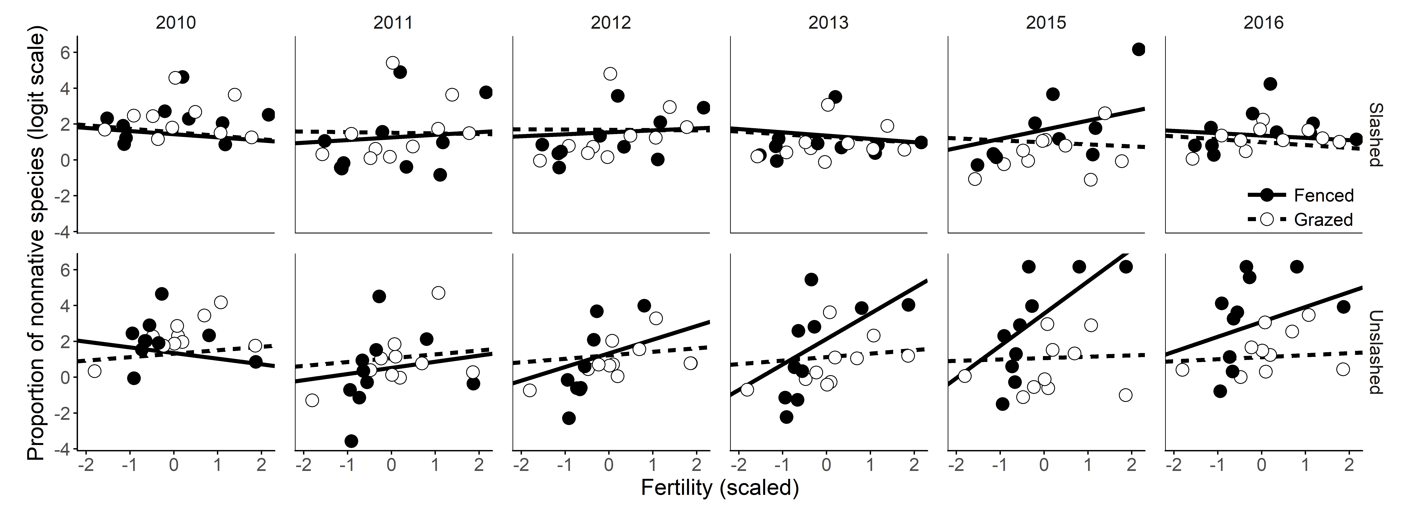
Figure 1.

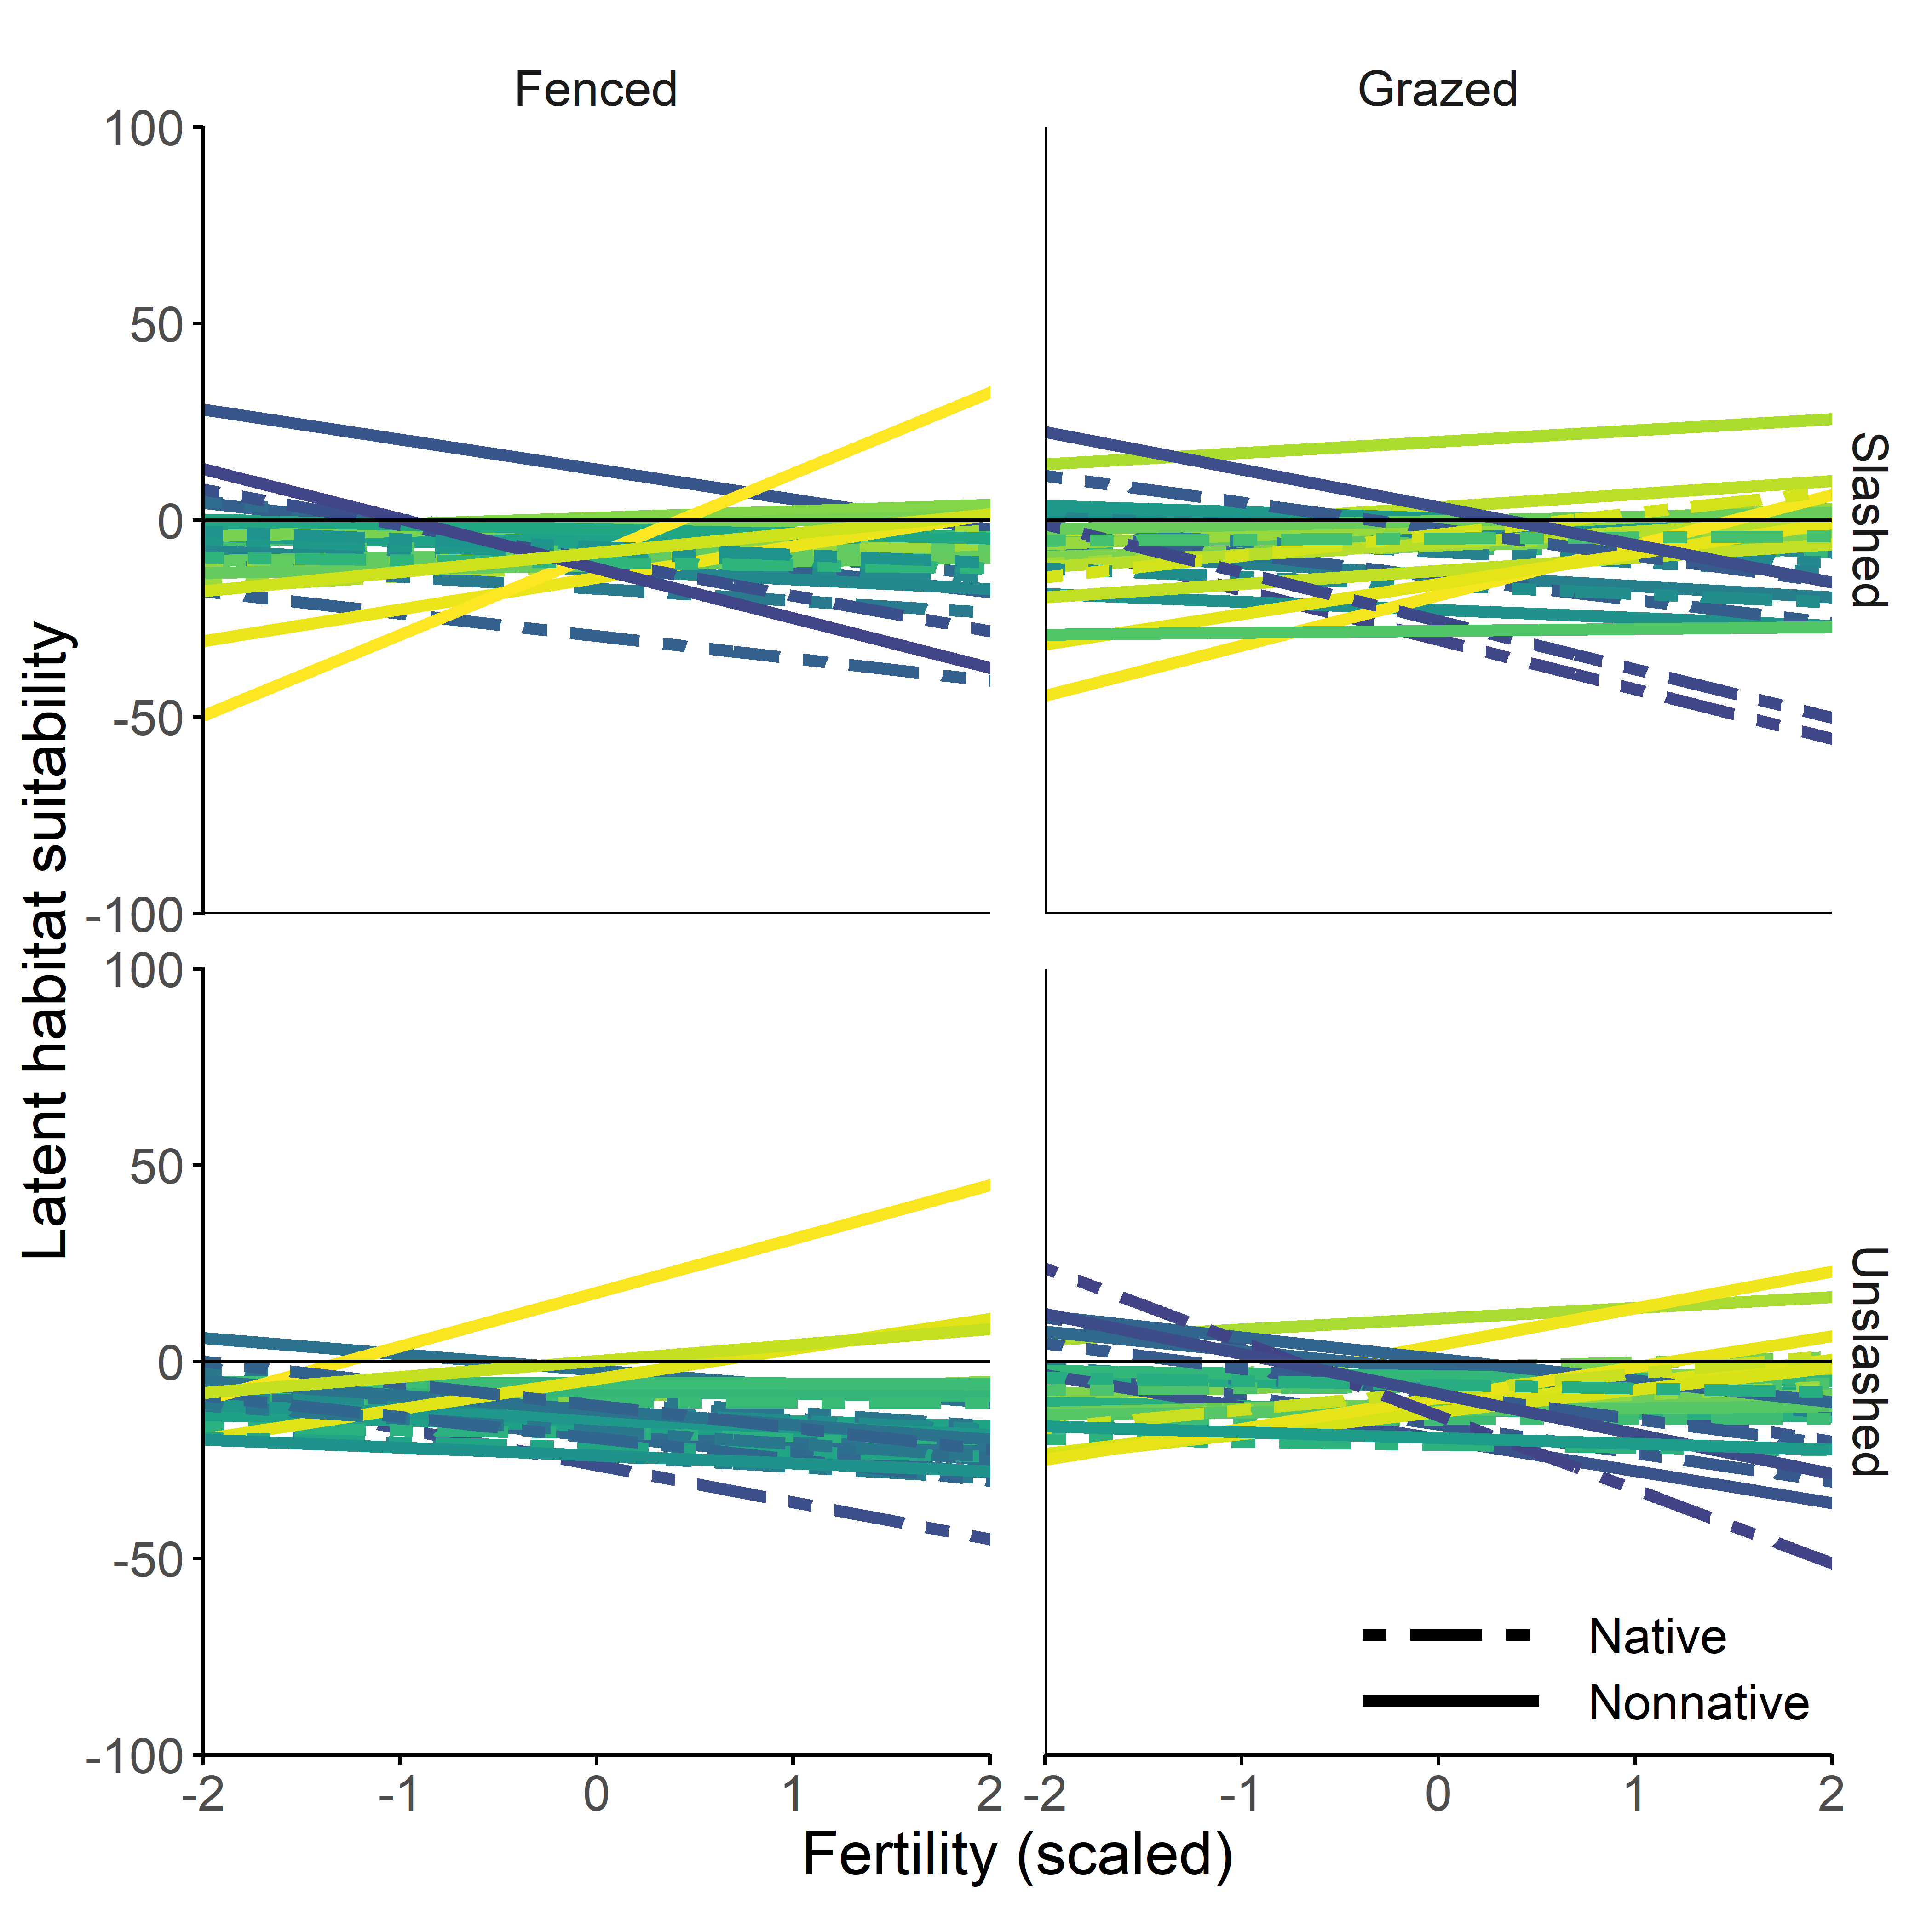
Figure 2.

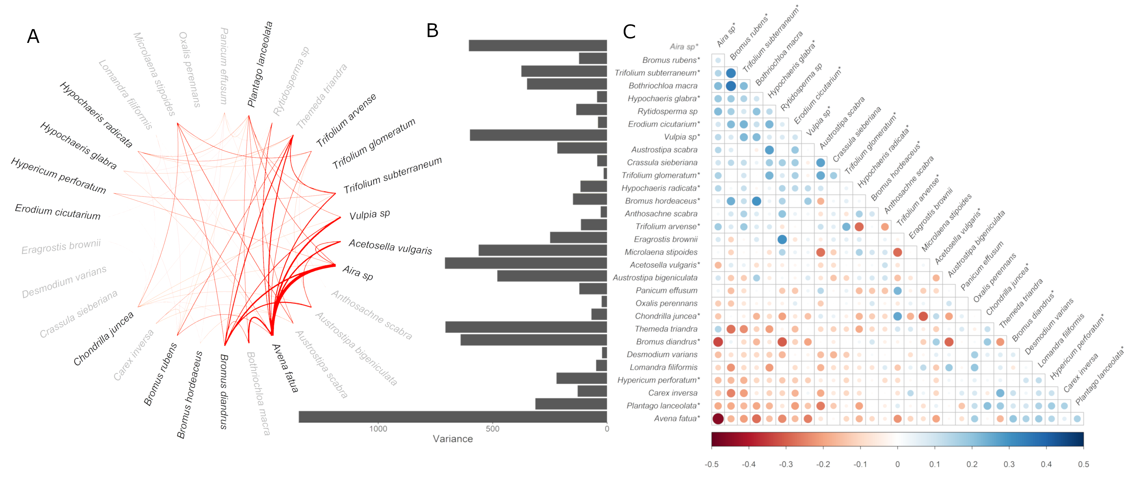
Figure 3.
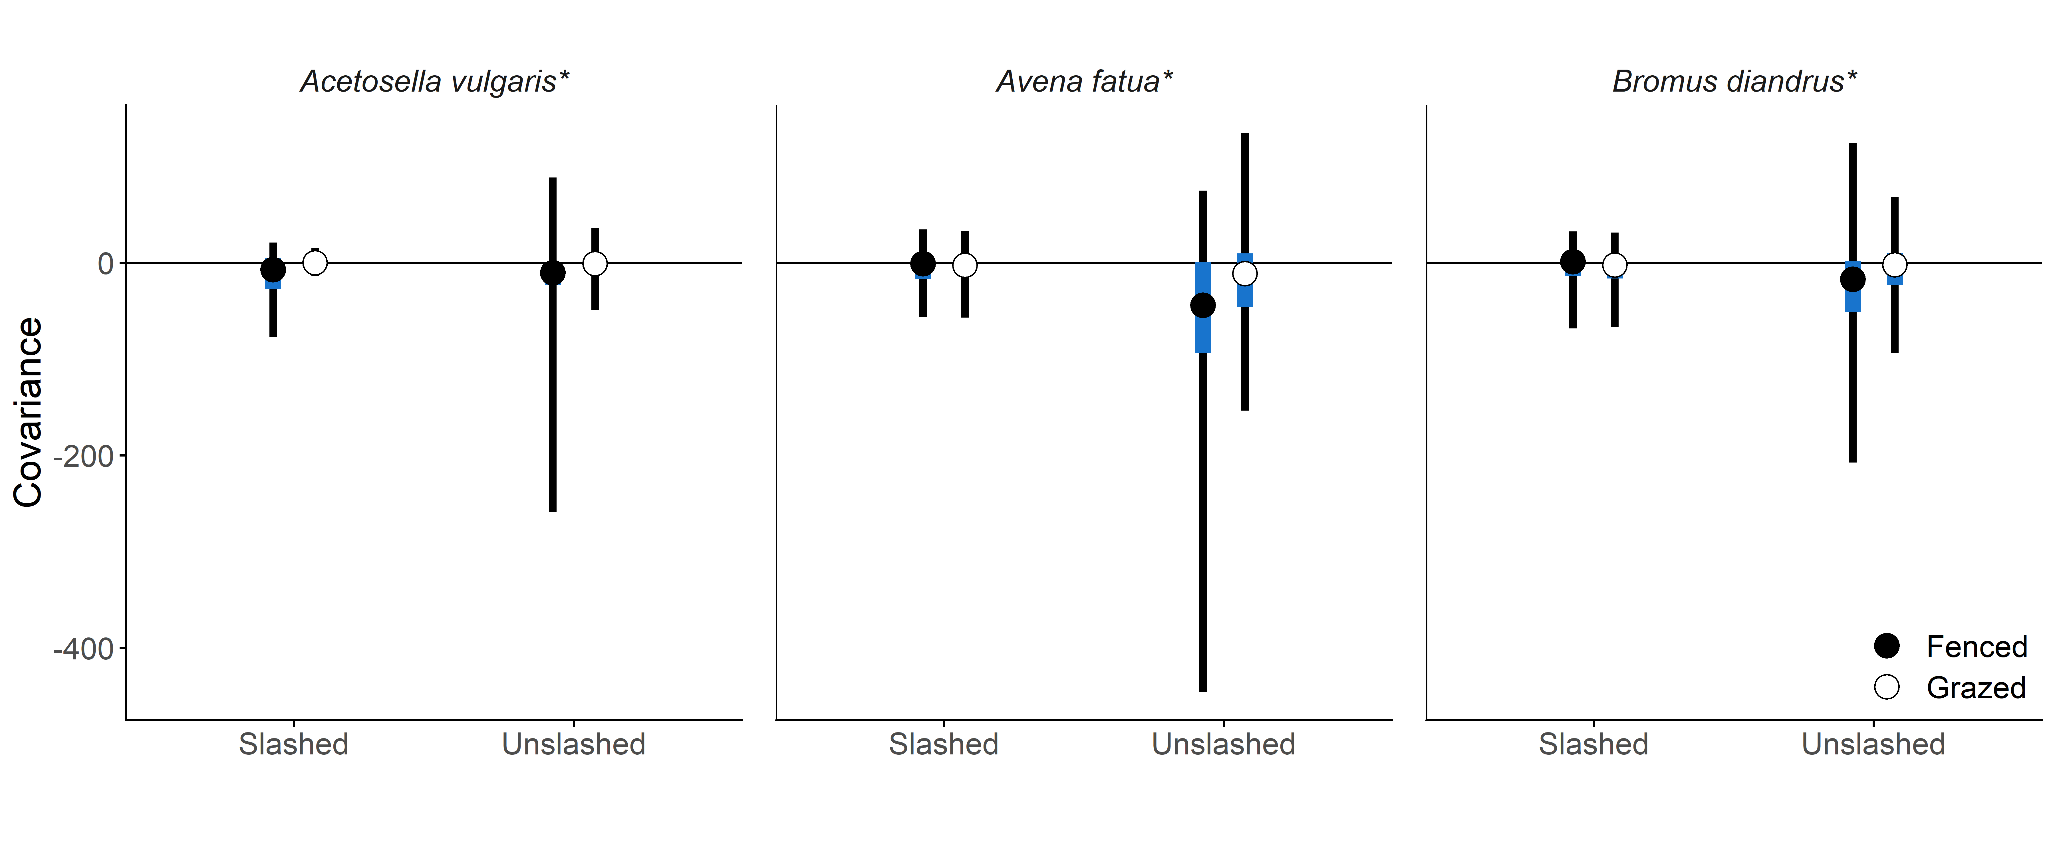
Figure 4.
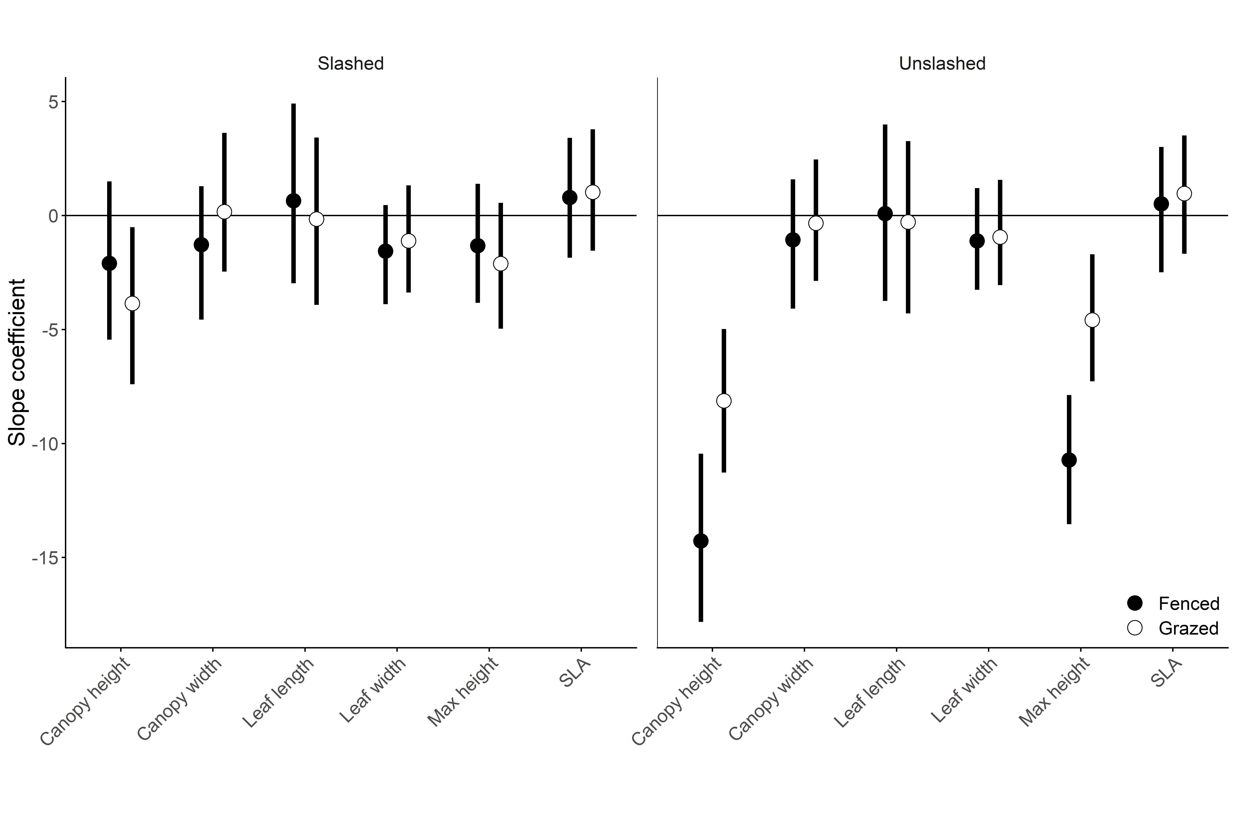
Figure 5.

Appendix 1.
Data collection
The data in this study are from an experiment designed to test if different management interventions could increase species richness of native grasses and forbs (Driscoll, 2017). Ten sites were established in 2010 in relatively uniform areas of unshaded grassy vegetation that encompassed the range of grassland communities in the reserve, from relatively uninvaded communities to communities dominated by non-native species. Sites were 20 m x 25 m in size, and situated 200 m – 600 m apart. At each site, 10 permanently marked 5 m x 5 m plots were laid out, with each plot separated by at least 1 m. In late spring (October) 2010, the vegetation in each 5 m x 5 m plot was surveyed by placing four 1 m x 1 m quadrats in the corners of each plot and recording all vascular plant species present in each quadrat along with their cover, estimated visually as the proportion of each quadrat covered by the canopy of each species. Total cover of all species in a quadrat could sum to greater than one if plant canopies overlapped. Plants were identified to species, and any plants that could not be reliably identified in the field were collected and pressed, with identifications subsequently determined by referring to collections at the Australian National Herbarium. Three genera in which species were difficult to distinguish were grouped and treated as species complexes: Vulpia (3 species; non-native), Rytidosperma (4 species; native) and Aira (2 species; non-native).

In 2011 experimental treatments were applied to each plot. First, five of the 10 plots at each site were chosen and a fence constructed around these to exclude large mammalian herbivores (predominantly kangaroos but also rabbits). Second, an experimental treatment was assigned to each of the five plots inside and outside each fence: unslashed, vegetation removal by slashing, vegetation removal by burning, nutrient reduction by sugar addition, and biomass suppression by planting a barley crop (see Driscoll, 2017). For this study, we restricted our analysis to the unslashed and slashed plots, because we were primarily interested in how biomass removal by herbivores might alter competitive interactions and the impact of non-native species across the landscape. The unslashed plots inside and outside the fence allowed us to compare vegetation responses in the presence and absence of herbivores. Slashing provided an additional biomass removal treatment that we could contrast with herbivory to assess whether it was biomass removal per se that moderated non-native impact.

We therefore analyzed data from four plots at each site: the fenced and grazed unslashed plots, and the fenced and grazed slashed plots. Slashing was carried out annually at the beginning of the growing season using a brush cutter to remove all vegetation above a height of about 2 cm. The slashing treatment was applied each year from 2011-2016, except for 2014. Vegetation surveys were repeated in all plots from 2011-2016, except for 2014. Our dataset thus comprised 6 years of vegetation cover data from 160 quadrats in 40 plots (4 quadrats per plot, 4 plots per site, and 10 sites), although due to time constraints only 3 quadrats per plot were surveyed in 2013. This meant we had a total of 920 quadrat level vegetation measurements, comprising 10,780 individual cover estimates for 142 species (70 native and 72 non-native; Fig. S2).

We measured traits associated with growth rate and light capture in 2015 and 2016 following standard protocols (Harguindeguy et al. 2013). Canopy height (m) was measured as the distance from the base of a plant to the highest leaf, and maximum height (m) was measured as the distance from the base to the highest point of the plant. Canopy width (m) was measured as the horizontal distance between the two furthest points. Whole adult leaves were collected, scanned to obtain their surface area, dried and weighed to measure leaf dry matter content (mg; LDMC) and to calculate specific leaf area (mm² mg⁻¹; SLA). Traits were measured on at least five adult individuals of the species that comprised at least 80% of the total cover in all 20 unslashed plots in the fenced and grazed treatments. Species level trait data was aggregated across plots and years, and traits for less abundant species that were not sampled in the field were taken from the TRY database (TRY-db.org). We used 90th quantile values as a species maximum potential for each trait to avoid the outcome being overly influenced by outliers.

In autumn 2011 and 2015, five 75 mm x 100 mm soil cores were taken from each plot, the soil from each plot was bulked, and then analyzed for total carbon, nitrogen and phosphorus, and available phosphorus, nitrate and ammonium. Available phosphorus and nitrate were measured with Colwell and KCl extractions, respectively, and organic carbon was measured with wet oxidation and colorimetric determination (Driscoll & Strong, 2017). Nitrogen, phosphorus and carbon levels were strongly correlated in these soils (Spearman rho: 0.53-0.62) and previous studies have shown that covariation in these two nutrients comprises the dominant fertility gradient (Driscoll & Strong, 2017). No treatment specific effects were detected between 2011 and 2015, thus we opted to use total extractable nitrogen (ppm) measured in 2011 as an overall measure soil fertility.

Water availability can also strongly influence non-native species abundances in Australian grasslands (Morgan et al., 2016). To account for inter-annual variation in species cover due to rainfall variation, we obtained rainfall data from the two weather stations closest to the reserve (3-6 km distance) that had records for the period 2010-2016 (Ainslie #70242 and Melba #70277; Australian Government Bureau of Meteorology, 2017). Vegetation surveys were undertaken in late October and completed in November. We used the cumulative rainfall total in the four months prior to each survey (August – November) as a measure of water availability that might explain inter-annual variation in cover, with rainfall averaged between the two stations in each year. This ranged from 185 – 414 mm during the study period.

Appendix 2.
Proportional logistic regression of non-native dominance:
Our response variable was the logit-transformed proportion of introduced species cover within a plot, constrained to be greater than 0 and less than 1 following the protocol of (Smithson, 2006). Covariates of fertility and rainfall were centered and scaled.

$$logit\left(y_{\left[ijk\right]}\right)∼Normal\left(μ_{\left[ijk\right]},σ^{2}\right)$$
$$μ_{\left[ijk\right]}=β_{{intercept}_{\left[ij\right]}}+β_{{slope}_{\left[ij\right]}}⋅{fertility}_{\left[jk\right]}+β_{rain}⋅{rainfall}_{i}+β_{{plot}_{\left[jk\right]}}$$
$$β_{{plot}_{\left[jk\right]}}∼Normal\left(β_{{site}_{\left[k\right]}},σ_{plot}^{2}\right)$$
$$β_{{site}_{\left[k\right]}}∼Normal\left(0,σ_{site}^{2}\right)$$
where y_{ijk} is the proportion of non-native cover (240 observations) in year i (1–6), under treatment j (1–4), at site k (1 – 10). The intercept and slope coefficients were modelled hierarchically, with each value drawn from normal distributions with means and variances estimated from the data. We included random effect parameters for each plot to account for the repeated measurements across years, modelling these parameters as drawn from a hierarchical normal distribution with a different mean for each site to allow for the nested structure of plots within sites. Additionally, we included a random effect for each plot to account for repeated measurements, which were drawn from a hierarchical normal distribution at each site to incorporate the nested nature of plots within sites.
All analyses in this paper were run using Hamiltonian Monte Carlo. Models were run with an adaptation delta of 0.8 and a maximum tree-depth of 15. For each model, we ran four Markov chains to generate 1,000 posterior samples after discarding 1,000 warmup samples. We looked for adequate sampling depth using the number of effective samples, and checked for model convergence using the Rubin-Gelman statistic, which was less than 1.01 for all models indicating adequate convergence (Gelman, Rubin, Gelman, & Rubin, 1992).
Supplementary figures.

Figure S1. An example of tobit regression for zero inflated data. Treating observed data (black points) as censored below zero, a regression (red line) is instead fit to latent continuous values (open points) that allow for estimated suitability at a site to be below zero.

Figure S2. Four plots at each of 10 sites were subject to experimental treatments result in one unslashed fenced plot, one slashed fenced plot, one unslashed grazed plot and one slashed grazed plot at each site. Fences were erected in 2011 and slashing treatments were applied from 2011-2016, except for 2014.

Figure S3. Species abundance distribution from 2013-2016. 30 common species (black) were observed 20% of plots in all years. The remaining species in this dataset have the potential to be dispersal limited or be rare or transient species which are only observed in one or two years.
Figure S4. a) Overall relationship between the proportion of non-native species and an environmental gradient of fertility between 2010 and 2016, under treatments of fencing and grazing. Filled points indicate fenced plots, while open points indicate grazed plots. Circles correspond to unslashed plots and triangles correspond to grazed plots. Treatments are also indicated by line type. Points are coloured from dark to light with increasing fertility b) Annual changes in the relationship between the proportion of non-native species and fertility. The posterior mean of a logistic regression intercept is shown for each year, with the 95% credible interval shown by the shaded areas. Points are coloured from dark to light with increasing posterior means of a logistic regression slope, indicating greater dominance at high fertility. Filled points again correspond to fenced plots, while open points correspond to grazed plots.

Figure S5. a) Logistic regression of plot-level relative abundance (proportion) of non-native species shows a slight positive trend in response to spring rainfall. The effect of fertility (coloured from low in blue to high in yellow) is described in Figure 2. b) Estimated latent suitability for 30 species in relation to spring rainfall under treatments of fencing and slashing fitted using tobit regression. Most species have small positive responses, however a few nonnative species (solid lines) show stronger relationships. Lines are coloured from dark to light corresponding to a shift from negative to positive slopes.

Figure S6. Network diagram of significant apositive covariances between species, with 95% credible intervals that do not contain zero. The magnitude of the covariances is indicated by linewidth.

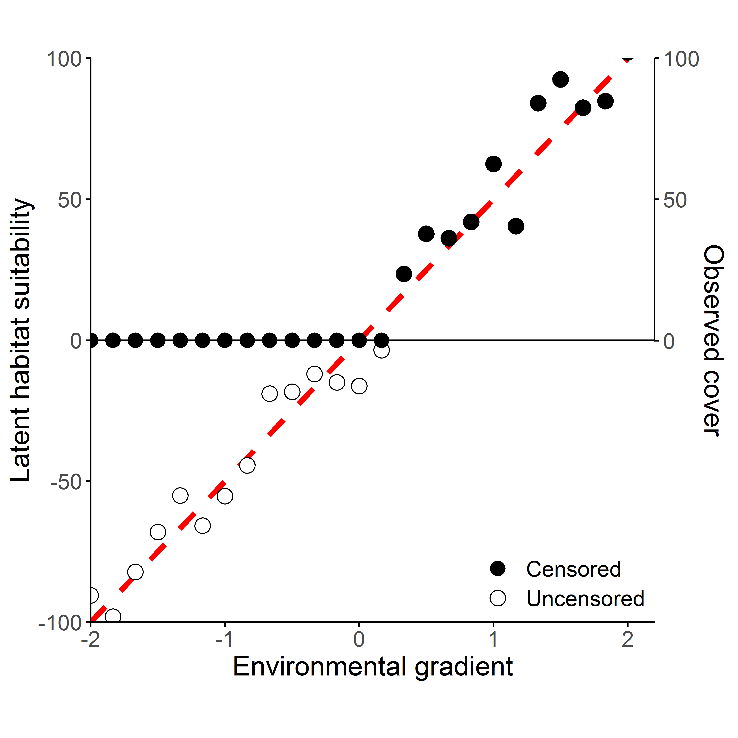Figure S1.

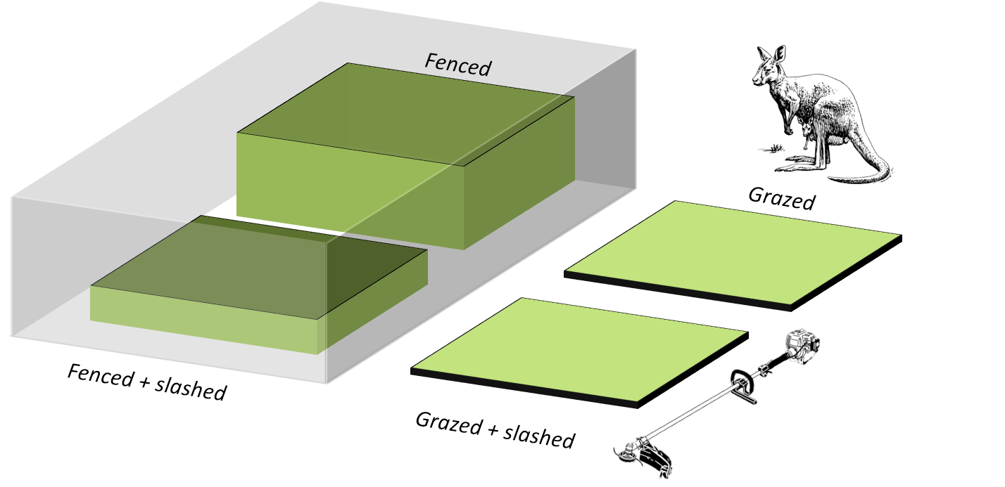
Figure S2.
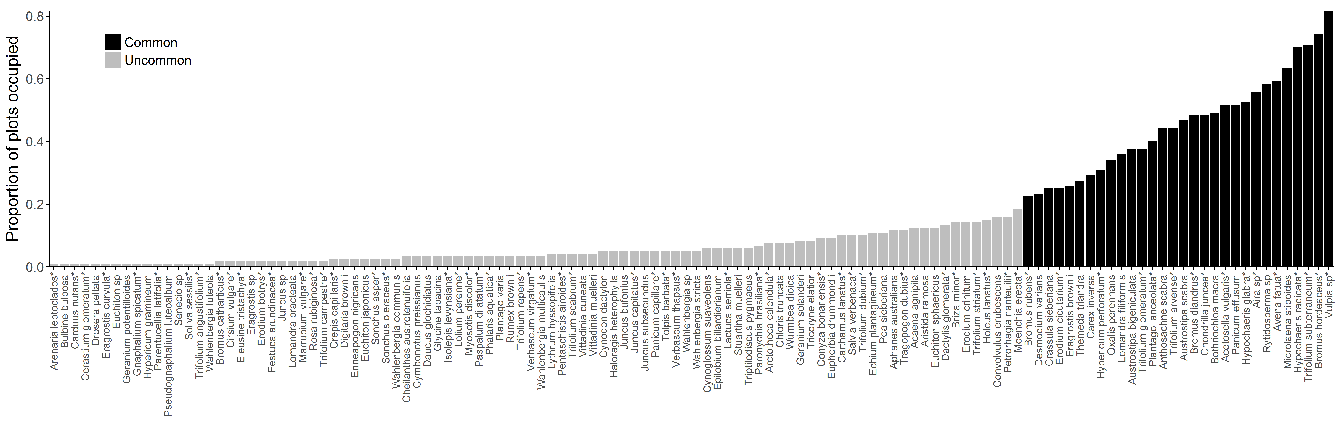
Figure S3.
Figure S4.

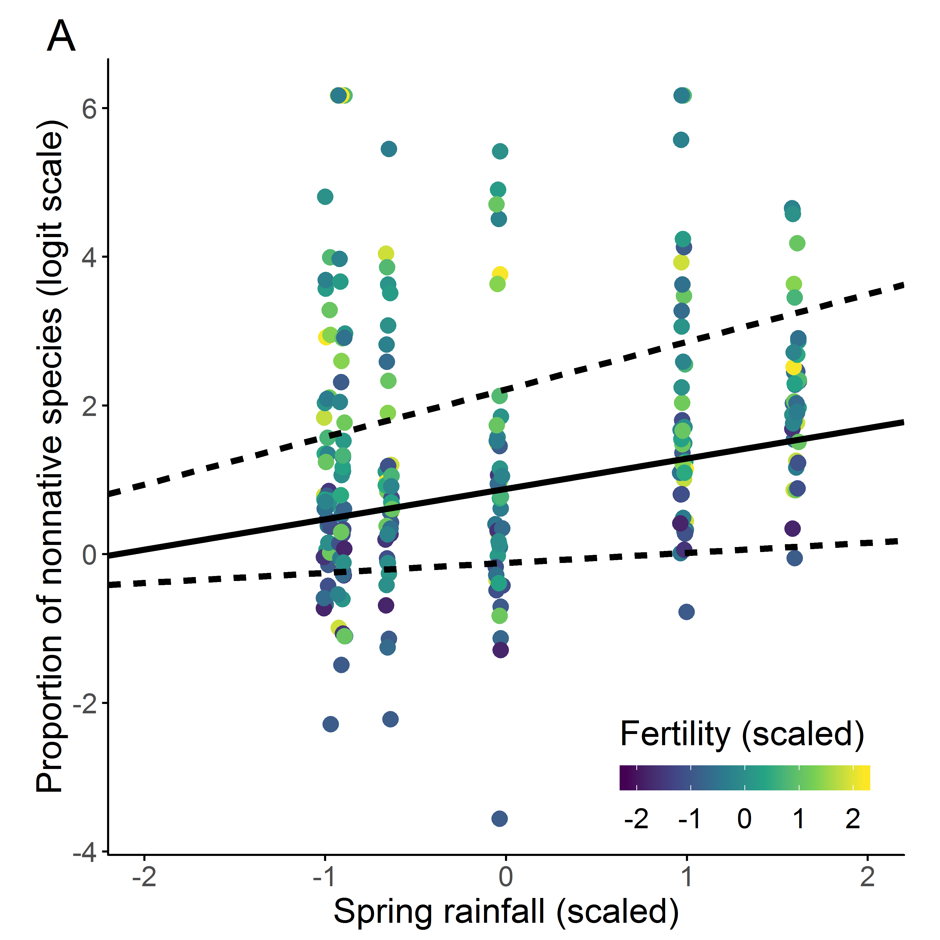
Figure S5.

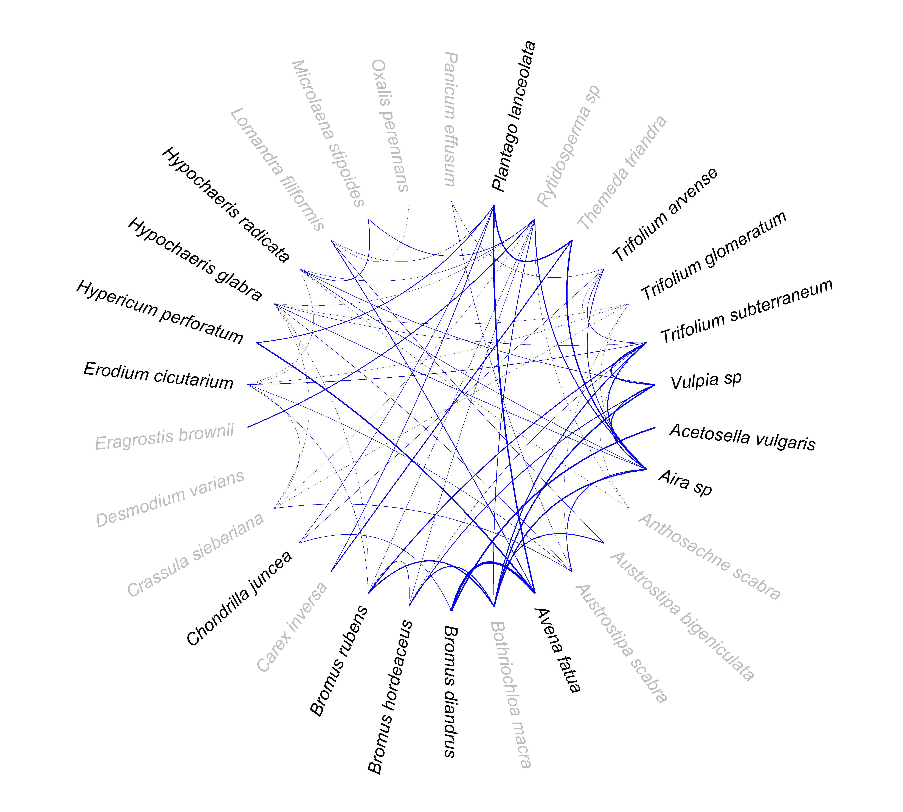

Figure S6.

