Dominance of key species determines fish community biomass in a temperate seagrass ecosystem

Aaron M. Eger^{1,3}, Rebecca J. Best², Julia K. Baum^{1*}
1 University of Victoria, Department of Biology, V8P 5C2, Victoria, BC, Canada.
2 Northern Arizona University, School of Earth and Sustainability, 86011, Flagstaff, AZ, USA
3 Present Address: University of New South Wales, School of Biological, Earth, and Environmental Sciences, 2033, Sydney, NSW, Australia
*Corresponding author: Julia Baum, baum@uvic.ca, t: 250-721-7146, f: 250-721-7120
ORCID IDs:
Aaron M. Eger: 0000-0003-0687-7340
Rebecca J. Best: 0000-0003-2103-064X

Acknowledgements
We are grateful to the Gitxaala, Git’agaat, Metlakatla, Kitselas, Kitsumkalum and Lax Kw’alaams First Nations for granting access to their territory as well as insights into their local ecosystems. We additionally thank the Metlakatla and Gitxaala Nation for providing research vessels and field researchers, and especially Bruce Watkinson, Ross Wilson, Colin Nelson, Cordell Nelson, and Colton Nelson for their support. Next, we thank the Department of Fisheries and Oceans Canada and the Northwest Community College for providing a field boat. Gratitude is also owed to our field assistants Tella Osler, Quinn Lowen, and Sarah Friesen, as well as to Peter Freeman for his advice and support in keeping our field boat running. Finally, we thank the editor and reviewers for their work.
Funding
We acknowledge funding from the Natural Sciences and Engineering Research Council of Canada in the form of a graduate scholarship and Discovery Grant and Engage Grants. Finally, we thank Mike Ambach, James Casey, and Bettina Saier from the World Wildlife Fund of Canada for collaboration and financial support.
Conflict of Interest
The authors declare that they have no conflict of interest.
Research Involving Animals
All applicable international, national, and/or institutional guidelines for the care and use of animals were followed. Fish were collected under: a Department of Fisheries of Canada Scientific Fishing Permit (XR 10 2016), a University of Victoria Animal Health and Welfare Permit (2016-011), a Prince Rupert Port Authority Work Permit, and with consultations with local First Nations on whose traditional territory the work took place.

Abstract
Biodiversity frequently increases ecosystem function, but there are multiple divergent hypotheses about the mechanisms underlying this relationship. Functions such as primary or secondary production may be maximized by species richness, evenness in species abundances, or the presence or dominance of species with particular traits. Here, we used surveys of natural fish communities (collected from July 1st to August 5th, 2016) and morphological trait data to examine the relationship between diversity and function (standing stock biomass) across 14 eelgrass meadows in the Northeast Pacific (54° N 130° W). We combined taxonomic and functional trait measures of diversity to investigate if ecosystem function is driven by species diversity (complementarity hypothesis) or by the presence or dominance of species with particular trait values (selection or dominance hypotheses). After controlling for environmental variation, we found that fish community biomass is maximized when taxonomic richness and functional evenness is low, and in communities dominated by species with particular trait values – those associated with benthic habitats and prey capture. While previous work on fish communities has found that species richness is positively correlated with function, our results instead highlight the ability of regionally prevalent and locally dominant species to drive ecosystem function in moderately diverse communities. We discuss these alternate hypotheses about the links between community composition and ecosystem function considering their divergent implications for ecosystem valuation and conservation prioritization.

Introduction
With an accelerating loss of species globally (Ceballos et al. 2017), it is increasingly important to understand the link between biodiversity and ecosystem function (Srivastava and Vellend 2005; Hooper et al. 2012). Research in this area has advanced from focusing simply on the number of species present in a community, to measuring their relative abundances, to quantifying differences in functional traits constraining both community assembly and ecosystem function (Hoehn et al. 2008; Griffin et al. 2009; Villeger et al. 2010; Thompson et al. 2015). Concurrently, the taxonomic scope and the scale of biodiversity – ecosystem function (BEF) research has increased. Whereas many early studies focused on experimental communities of plants to investigate impacts of species richness on ecosystem function, recent experimental work suggests a stronger BEF relationship in higher trophic levels than in primary producers (Lefcheck et al. 2015; O’Connor et al. 2017). A recent review also suggested that BEF relationships are stronger in natural ecosystems than in small-scale experiments (Duffy et al. 2017). As such, current approaches in this field emphasize the importance of understanding links between the forces structuring community assembly across natural environmental gradients and the forces that translate realistic community composition into ecosystem function (Bannar-Martin et al. 2018).
Understanding the relationships between community structure and ecosystem function is, however complicated by the existence of multiple underlying mechanisms, which have distinct implications for the “value” of species diversity to an ecosystem. The “complementarity hypothesis” (Tilman et al. 2001) posits that more species within a system will occupy more niche space, resulting in a greater range of functions performed or more biomass present (Davies et al. 2011; Jenkins 2015). Alternatively, the “selection hypothesis” suggests that increased species richness only results in greater function by increasing the probability that a system will contain one or several highly productive species (Loreau and Hector 2001; Cardinale et al. 2006). According to this hypothesis, the presence of a few important species determines the function of the system, and additional species contribute only marginal gains in ecosystem function. The selection hypothesis can also be extended to the “biomass ratio” or “dominance” hypothesis – herein dominance (Grime 1998), which predicts that ecosystem function will be related to the relative abundance or dominance of particularly important species, rather than simply their presence (Finegan et al. 2015; Zhu et al. 2016). Such distinctions have clear implications for applied ecology and conservation biology: in cases where complementarity is important, the loss of any single species has realized negative impacts on an ecosystem’s function, whereas under the selection and dominance hypotheses, only losses of particular species will significantly impact functioning. Understanding the relative importance of these mechanisms is therefore essential for accurately quantifying previous losses of ecosystem function, prioritizing future conservation efforts (Steffen et al. 2007; Cardinale et al. 2012) and planning restoration efforts that achieve ecosystem function goals (Laughlin 2014).
As BEF research extends into more complex, unmanipulated, and large-scale ecosystems, there is also a need to consider the observed and predicted relationships between ecosystem function and multiple diversity metrics. While traditional metrics such as taxonomic richness and diversity can sometimes be proxies for the niche space occupied by community members, they do not directly quantify niche diversity or overlap, which is central to BEF hypotheses (Hooper et al. 2005; Farigone et al. 2007). Functional diversity metrics have the potential to better illuminate the relationships between species, their niche, and their function. These metrics encompass multiple dimensions of diversity, including functional richness, which measures the size of trait space occupied by a community (Villéger et al. 2008), functional evenness, which measures how abundance is distributed amongst those trait values (Villéger et al. 2008), and functional dispersion, which measures the dissimilarity of trait values (Laliberté and Legendre 2010; McPherson et al. 2018). In addition, the community weighted mean (CWM) value of a single trait (Swenson 2014) gives the average value of that trait across all individuals in that community. In cases where selection or dominance effects are strong, CWM values can be used to identify features of those species making particularly large contributions to ecosystem function. By better understanding exactly which aspects of biodiversity link to function, we improve our ability to target species and ecosystems for management while also considering their implications.
Different biodiversity metrics are predicted to show distinct relationships with ecosystem function depending on the importance of the complementarity, selection, and dominance mechanisms (Table 1). If ecosystem function (EF) is driven by the complementarity effect, we expect that more diversity (taxonomic or functional) will result in greater functioning and that more evenly distributed communities will have higher functioning than communities dominated by a few species. As such, under this hypothesis we expect to see positive, non-saturating relationships between EF and biodiversity, whether it is measured as richness (Mora et al. 2014), taxonomic diversity (Cavanaugh et al. 2014), functional dispersion (Gagic et al. 2015), or functional evenness (Mason et al. 2005) (Table 1). If EF is instead driven only by the presence of particular species, we expect positive but saturating relationships between EF and functional and taxonomic richness, taxonomic diversity, and functional dispersion (Mora et al. 2014), and no relationship between EF and evenness (Table 1). This result is expected because EF is nearly maximized as soon as those species are included in the community. Finally, if it is not just the presence but the dominance (as determined by relative abundance of certain species) that drives EF, then diversity and evenness should be associated with decreased function because they increase the relative abundance of species that are not important contributors (Table 1). In this case we expect negative relationships between EF and functional evenness (Grime 1998), taxonomic diversity, and functional dispersion. We also expect strong relationships between EF and particular CWM values as found with the “dominance hypothesis” (Finegan et al. 2015; Zhu et al. 2016), with the direction of these relationships informing our understanding of which types of species’ traits drive ecosystem functioning in particular systems.
In this study, we apply a multi-metric taxonomic and functional approach to understand the mechanisms linking community composition and ecosystem functioning in fish communities inhabiting temperate eelgrass (genus: Zostera) ecosystems. Globally, eelgrass and other seagrasses provide vitally important ecosystem functions and services (Orth et al. 2006; Cullen-Unsworth and Unsworth 2013), and directly support high levels of algal, invertebrate, fish, and bird biodiversity (Phillips 1984; Gilby et al. 2018), but also show recent areal declines and subsequent alterations of the species residing in them (Waycott et al. 2009). Because fish living in eelgrass habitats are quite mobile (Fonseca et al. 1990), community composition of these habitats is highly responsive to both anthropogenic and natural environmental gradients (Schaffler et al. 2013; Iacarella et al. 2018), as well as to habitat variation and prey composition (Reynolds et al. 2018). Thus, ecosystem function in these communities inherently depends on community assembly processes, and uncovering the links between fish diversity and ecosystem function requires large-scale observations across multiple study sites, rather than simplified manipulative experiments where community composition is artificially constrained. We therefore focus on relationships between diversity and ecosystem function in naturally assembled eelgrass fish communities, situating our study on Canada’s Pacific Northwest coast (Iacarella et al. 2018). Our results provide insights into the roles that complementarity, selection, or dominance of species or traits play in structuring community biomass and function in a marine ecosystem of high economic and conservation importance.

Materials and Methods

Fish community surveys
We surveyed the fish communities in fourteen subtidal eelgrass meadows in Northern British Columbia (Fig. 1) between July 1 and August 5, 2016. To access the subtidal portion of each meadow, we surveyed at the day’s low-low tide and only on days with a tidal height of less than 1-meter depth as measured by chart datum at mean low-low water. Surveying consisted of duplicate beach seines (Guest et al. 2003) using a seine that measured 10 m in length, 3 m deep at the center, tapered to 1 meter deep at each end, and with a mesh size of 6 mm as measured along the diagonal. After each seine haul, we collected the fish in totes on shore. To avoid re-counting released individuals we conducted both hauls before any identification. Once both sets were completed, we measured the fork length (to the nearest millimeter) of the first 20 individuals of each species at each site. To obtain morphometric trait measures, we photographed representative individuals of each species (although not every species was photographed at every site). The environmental variables temperature and pH were measured at each site using a Hanna HI® meter, and salinity was extracted from a GIS layer at a 500 x 500 m spatial resolution (Foreman et al. 2008).

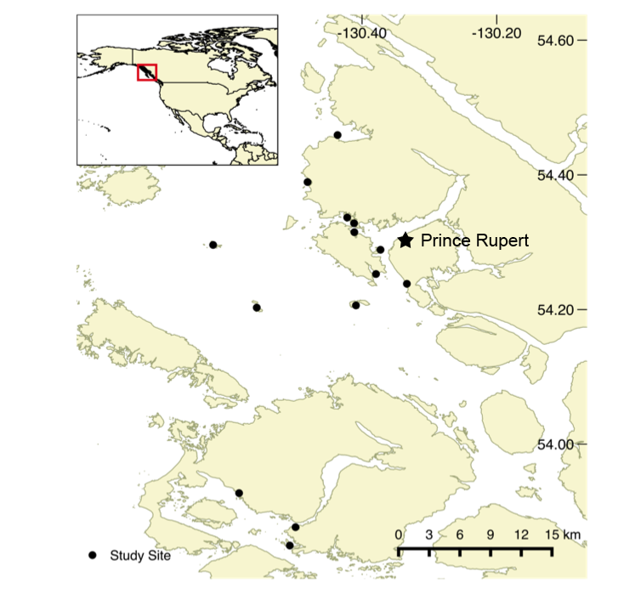

Fig 1 Study area with sampling sites on the northern coast of British Columbia, Canada. Source: Canadian Hydrographic Service

Functional trait measures
We used the image processing software ImageJ to measure morphometric traits for each species from the photos (Villéger et al. 2010), and then used these measurements to calculate seven size-standardized functional traits: body length, mouth length, oral gape position, eye size, eye position, pectoral fin position, and caudal peduncle throttling (Fig. 2). We chose these specific traits because their influence in resource acquisition, either through size, visual acuity, mobility, or position in the water column should combine to determine each species’ niche within the community (Villéger et al. 2010). Species-level functional trait values were obtained by taking the mean value of each trait across all individuals measured for each species. One species, Cymatogaster aggregate, was an exception in that, unlike other species, it was found in both juvenile and adult stages. As a result, a single mean would mask bimodal variation in traits and we therefore considered these two stages as functionally distinct and calculated separate morphological metrics for them. Photos and trait measures were unobtainable for five of the rarest species (Myoxocephalus polyacanthocephalus (n = 3), Rimicola muscarum (n =1), Ascelichthys rhodorus (n = 1), Sebastes miniatus (n = 1), and Rhacochilus vacca (n = 1), so they were dropped from the taxonomic and functional analyses.
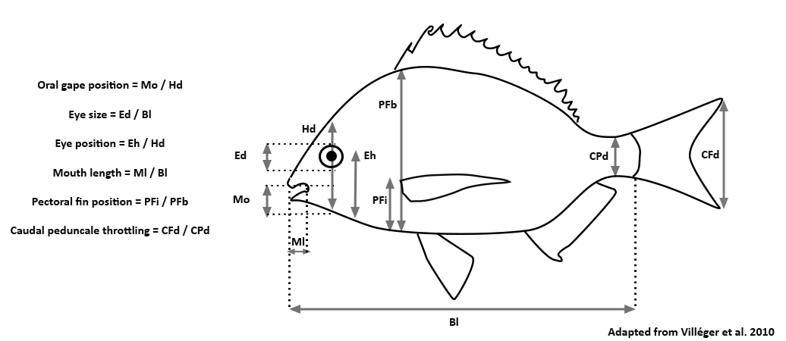
Fig 2 Morphometric traits measured from photographs of individuals of each of the 34 species. All traits are expressed relative to total head or body size, and are therefore independent of variation in total size. Trait abbreviations are as follows: Ed: Eye depth Mo: Mouth opening; Ml: Mouth length; Hd: Head depth; Eh: Eye height; PFb: Body depth at pectoral fin; PFi: Height of pectoral fin; Cpd: Caudal peduncale depth; CFd: Caudal fin depth; Bl: Body length

Functional diversity
We quantified multivariate functional richness, functional evenness, and functional dispersion in the “FD” package (Laliberté and Legendre 2010) in R. Calculation of each of these multivariate functional diversity metrics first involved performing a Principal Coordinates Analysis (PCoA). Functional richness is the volume of the polygon that connects the exterior points of this transformation (Villéger et al. 2008). Functional evenness, which is independent of functional richness, is a measure of how regularly traits are distributed throughout the trait space and how abundance is distributed across those traits (Mason et al. 2005). Functional dispersion is calculated as the average distance to the abundance weighted centroid with the traits represented in n-dimensional space (Laliberté and Legendre 2010). The calculations for evenness and dispersion were done using the abundance weighted Gower’s dissimilarity measure and included all the traits. The calculation for functional richness was not weighted by abundance and included six of the seven traits: caudal peduncle throttling was dropped from this calculation because it was found to be redundant in the PCoA. Prior to conducting the PCoA, we standardized the morphometric traits to a mean of zero and standard deviation of one and gave all traits equal weighting. The dimensional reduced space representation quality was 0.90.
We also calculated two metrics based on individual traits: functional evenness and the community weighted mean of a trait (CWM, Swenson 2014). First, past work has shown that multidimensional metrics can obscure the importance of single traits within a community (Butterfield and Suding 2013), so we calculated univariate indices of and functional evenness to better understand dominance vs. evenness of individual traits. Second, because we wanted to understand the directional influence of specific trait values on community biomass, we calculated the CWM of each trait by taking its abundance-weighted average at each site.
Taxonomic diversity

We assessed taxonomic diversity using two metrics, Chao’s species richness and Chao’s Shannon’s diversity. Both metrics are rarefied measures of diversity, which use sample-based rarefaction that incorporate abundance data. The final values reported are the asymptotic estimates of diversity at each site. The calculations were done using the “iNEXT” function in the “iNEXT” (Hsieh et al. 2016) package in R. We rarefied our diversity metrics to account for the non-random distribution of fishes in the water column and for differences in species’ abundance at each site (Gotelli et al. 2011; Colwell et al. 2012).

Ecosystem function
Following Mora et al. (2011) and Duffy et al. (2016) we used community standing stock biomass (SSBM) as our measure of ecosystem function because fisheries landings are viewed as a type of ecosystem function or service (Holmlund and Hammer 1999) and because the biomass of an individual frequently predicts its contribution to a range of other ecosystem functions such as and suspension feeding, nutrient uptake, and gross productivity (Davies et al. 2011; Jenkins 2015). We estimated each individual’s mass using its recorded length and published length-weight relationships. The majority of the length-weight relationships were specific to fishes in eelgrass meadows in British Columbia (Siegle et al. 2014), but five species’ weight-length relationships were not available and were obtained from Fishbase.org (Froese and Pauly 2012). Lengths were measured from the first 20 individuals of each species at each site, as such, lengths were not available for all individuals, so truncated density distributions based on maximum and minimum observed fish lengths were created using the “fitdistrplus” package in R (Delignette-Muller and Dutang 2015) and the unmeasured individual lengths then were randomly sampled from these distributions. Biomass was then summed at each site and logged to normalize its variance.

Statistical analyses
We fitted generalized linear models with a gamma distribution to examine the relationships between fish community biomass and each measure of taxonomic and functional biodiversity in turn (“base” package in R). To account for potential environmental influences on fish biomass, we included the geographic location (longitude) of the survey sites as a second fixed effect in each model. Longitude was chosen because it had a strong correlation with the abiotic variables but did not significantly predict SSBM. Moreover, we did not want to over-parameterize our model by including multiple correlated fixed effects with a low sample size (Online Appendix 1), and we found no significant (P > 0.05) relationships between SSBM and any of the environmental variables. We also tested for spatial autocorrelation in the biotic and abiotic variables amongst the surveyed sites using the Durbin-Watson test, but found no significant effects of spatial autocorrelation. The models were then evaluated for relative fit using the proportion of the deviance explained, which is measured in comparison to a null model that includes only the intercept (D²). This measure of fit was calculated using the R package “modEvA” (Márcia Barbosa et al. 2016) and variables were assessed for statistical significance based on their P value (P < 0.05).
All data and associated code for graphing and analysis are archived in a GitHub repository (https://github.com/baumlab).

Results
Species richness and community biomass both varied significantly across study sites. Unrarefied richness ranged from 7 to 23 species per site, with a regional pool of 34 species. Of these 34 species, 26 were found at more than one site within the region. Community biomass ranged from 1 216 to 12 774 grams (logged, 3.08 to 4.10) per site (approximately 60 m²). All sites were dominated (>50% of abundance) by three or fewer species (Online Appendix 2) and only 16 of the 34 species had median site biomass proportion values above 0.01 (Online Appendix 3). Of these 16 species, the two with the highest median proportion of site biomass were Cymatogaster aggregata (0.34) followed by Leptocottus armatus (0.21, Online Appendix 3).
Diversity metrics and ecosystem function
We found that the sites with the lowest species richness had the highest site biomass (P = 0.03, Fig. 3). Conversely taxonomic diversity, functional richness, and functional dispersion were not significant predictors of site biomass (P = 0.26, P = 0.30, and P = 0.74 respectively, Fig. 3) and explained much less deviance (Fig. 3).
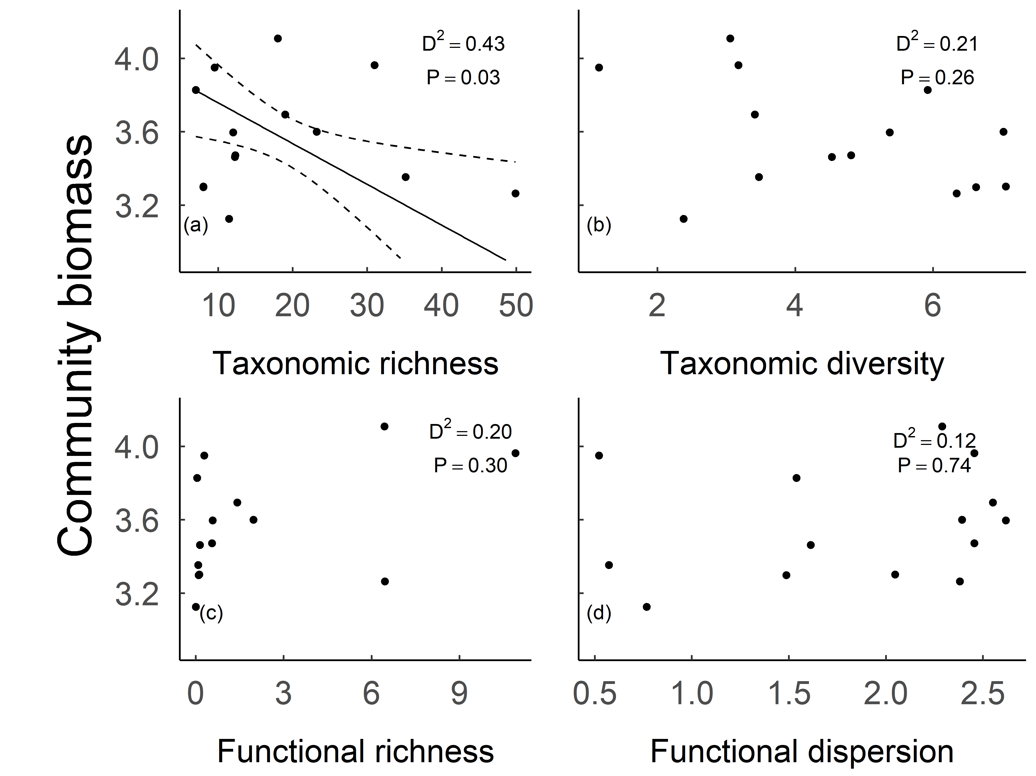
Fig 3 Relationships between fish community biomass and a) taxonomic richness b) taxonomic diversity c) functional richness d) functional dispersion. The solid line (shown only for the significant relationship in a) is the regression line and the dashed lines are twice the standard error. Note log scale of Y-axis

Standing stock biomass was negatively related to functional evenness (P = 0.01, Fig. 4), which explained the most deviance of any metric considered (D² = 0.51, Fig. 4). Furthermore, this relationship appeared to be driven by particular traits. Of the seven evenness trait values considered individually, lower evenness of eye position and oral gape position were both significant predictors of higher SSBM (P = 0.04 and D² = 0.40 for both, Fig. 4). This result indicates that SSBM was maximized in communities dominated by particular values of these traits, and this is consistent with the CWM results. The CWM for eye position and oral gape position were both negatively related to SSBM (P = 0.02, D² = 0.46 and 0.47, Fig. 4). This CWM result suggests that SSBM was highest in communities composed of species with traits that are better adapted to feeding in benthic habitats as shown by having lower eye and gape positions (Gatz 1979; Karpouzi and Stergiou 2003).
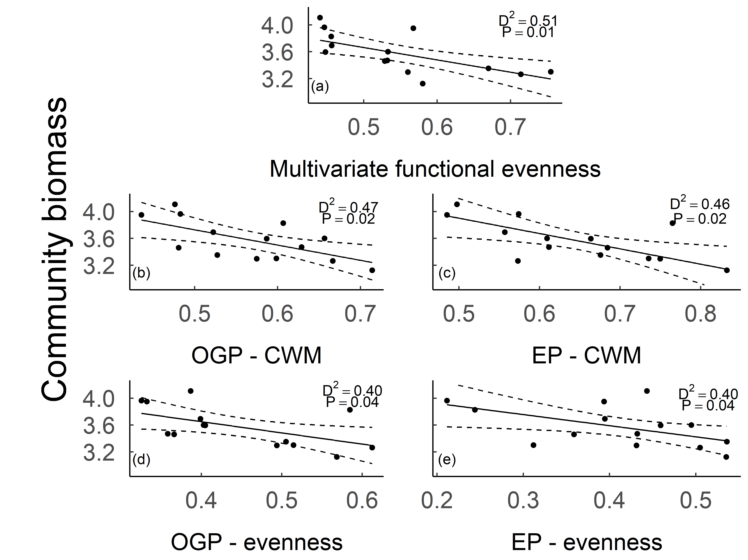
Fig 4 The relationships between community biomass a)multivariate functional evenness b) CWM of OGP c) CWM of EP d) evenness of OGP e) evenness of EP. Solid lines are regression lines; dashed lines are twice the standard error. OGP (oral gape position), EP (eye position), CWM (community weighted mean). Note log scale of Y-axis

Discussion
We found that the low species diversity and dominance of species with particular traits best explained the relationship between biodiversity and ecosystem function (total biomass) in the examined eelgrass-associated fish communities. This conclusion is supported by five out of six of the relationships predicted in Table 1; specifically, SSBM decreased with increasing taxonomic richness and functional evenness (both multivariate and two univariate measures) and was strongly related with particular CWM trait measures. These results are contrary to similar studies of fishes in marine environments, which found positive relationships between SSBM and taxonomic and functional diversity metrics. As such, our results provide support for testing multiple relationships between biodiversity and ecosystem function in ecosystem scale studies and support for considering additional metrics of biodiversity in these analyses.

Dominance vs. diversity as drivers of ecosystem function
Communities with few species had the highest levels of ecosystem function in our communities (Fig. 3). In fact, the abundance and distribution of dominant species played a critical role at two spatial scales. First, at the level of an individual community, communities with the highest function had the highest local dominance of high-contributing species. Second, under the selection hypothesis we would have predicted increased biomass with increased species richness, due to the increased chances of including those species. However, the particularly important species, namely Cymatogaster aggregata and Leptocottus armatus, had a very high degree of regional occupancy (Online Appendix 3), meaning that additional species richness at the community level largely corresponded to substituting dominant species for rarer low biomass (i.e. less important) species. Our results suggest that many species can contribute very little to certain components of ecosystem function and increased richness correlates with fewer dominant highly functioning.
Our main result, namely that low levels of species richness and evenness best predict function in marine fishes, is contrary to past quantitative work that suggests that more species should equate to more biomass (Mora et al. 2011; Duffy et al. 2016). These results are particularly surprising because the work by Duffy et al. (2016) found the strongest relationship between fish richness and community biomass to be in temperate regions such as ours. We suggest two main differences between the two studies that may explain the divergent conclusions. First, our sampling method employed beach seines, which are more likely to detect rare, singleton species than surveys conducted by visual surveys (Baker et al. 2016). These rare, singleton species would have contributed very little biomass while driving up the species count and thus possibly negating a relationship between species richness and community biomass. Second, the range in species richness was quite different: Duffy et al.’s (2016) surveys in temperate regions ranged from ~ 1 to 10 species whereas our surveys ranged from 7 to 23 species. Therefore Duffy et al. (2016) might have found such a strong relationship because they were considering communities with very few species, in which the addition of even a single extra species resulted in a substantial fulfillment of niche space (Stuart-Smith et al. 2013). This result could occur if species that are important contributors to community biomass are not regionally well distributed and are not reliably found in almost all communities at minimum species richness levels, as is the case in our system. Because our study contained moderately species rich ecosystems we might have been past the saturation point on the richness-function curve that is often seen in BEF relationships (Morris et al. 2014). Temperate marine ecosystems with lower regional diversity or more fragmented habitat connectivity may therefore find alternative results, such as complementarity.
Functional traits structuring standing stock biomass
In support of the dominance hypothesis we found that two traits, in this case those related to the species’ position in the water column, were influential in determining the biomass of a community. This result suggests that there are optimal trait values in this ecosystem and communities that best occupy those niches are the most productive. The communities that have traits best suited for occupying these niches are consistently the most productive, whereas communities that possess traits far from the optima contribute little to the function of the ecosystem at the community scale. Prior studies have shown the importance of dominance marine producers and invertebrates (Dolbeth et al. 2015; Zhu et al. 2016), the importance of the environment and disturbance in structuring functional traits in fish (Keck et al. 2016), the role of functional redundancy in ecosystem function for fish (Teichert et al. 2017) but the taxonomic and functional dominance hypothesis has not been specifically tested with fish communities. Consequently, much more work is required on the role of dominance in fish, a species group that holds large socioeconomic importance.
Both eye position and oral gape position were negatively correlated with community biomass, suggesting that the optimal community within eelgrass meadows tends toward species that are more adapted for a benthic environment. Fish with high values for the eye position metric have more dorsally located eyes and are adapted to capturing prey from the pelagic environment, whereas fish with low scores for eye position have more laterally located eyes and are more adapted for capturing prey from the benthic environment (Gatz 1979). Similarly, fish with high gape position scores have dorsally located mouths and those with low scores have ventrally located mouths and are best adapted to capturing prey from the benthic environment (Karpouzi and Stergiou 2003). Importantly, given the lack of a relationship with body length we conclude that it is not simply larger bodied communities that contain more biomass, but rather these specific ecologically relevant traits. While we chose to focus on traits related to species’ feeding abilities, it is possible that other traits related to other life history characteristics or environmental tolerances could also influence a species’ dominance within a community (e.g. metabolic rate, parental care habits, pollution tolerance), and this provides grounds as an area for further research.
Given that the optimal trait of a species is likely to change depending on the local environmental conditions (McGill et al. 2006; Keck et al. 2014), it is important to consider which of our results are widely applicable and which are likely restricted to application within similar, coastal, temperate aquatic ecosystems. Across habitats, functional traits of fish species in coral, mangrove, and seagrass habitats from Caribbean and Australian locales were best explained by habitat rather than geographic region (Hemingson and Bellwood 2018), and as such, we expect our findings should be transferable to other eelgrass habitats. Specifically, prey in eelgrass systems are known to be benthic and epifanual (Phillips 1984), which corresponds with our findings that communities with trait values associated with more benthic prey capture were found to contain the highest SSBM. Adaptations to feed in highly structured benthic habitats are common in seagrass-associated fish species (Hovel et al. 2016) and may include both morphological and behavioral components. If prey were to be distributed higher in the water column, alternative eye and oral gape positions would likely be favoured. Therefore, aside from eelgrass systems, our findings with regards to eye and oral gape positions are most likely translatable into systems with similar prey distributions. Future studies could use this finding to question if these same trait values structure communities within different habitats or at different scales.

Implications and Conclusions
The importance of a select few species within a community has significant implications for the conservation priorities of these systems. If we wish to prioritize the preservation of biomass as a function within this ecosystem, it appears we need only focus on a few species that contribute most of that function. Such an optimization would simplify the conservation process but also raises important questions about employing a BEF approach to conservation. For instance, if dominant species are unaffected by human disturbance, there would be little concern for such disturbances. Alternatively, if dominant species are impacted by disturbance, it could be argued that we need only focus on their conservation to protect ecosystem function. In both scenarios, many rare, low biomass species would be deemed expendable, as their contribution to ecosystem function is low. However, we must also acknowledge the limitations of only considering a single function: while one or a few species may drive a particular function, as was found in our study, those same species may not be responsible for other functions in the ecosystem (Isbell et al. 2011). For example, eelgrass ecosystems have well-established links between fish predators, invertebrate grazers, epiphytic algae, and the eelgrass itself. Certain fish predators can prevent herbivorous invertebrates from grazing epiphytic algae off the eelgrass, and the resulting increased epiphyte loads reduce the fitness of the eelgrass (Heck and Valentine 2006; Moksnes et al. 2008). Thus, while fish community assemblages dominated by certain species might maximize SSBM, those same assemblages might result in grazer communities that do not maximize epiphyte control and eelgrass growth. Lastly, it is also salient to consider how we might manage for only one or a few species all sharing the same habitat. If it were more resource intensive to only protect these highly functional species, a more prudent approach might be to simply protect the habitat, protect all species, and potentially protect the most number of unconsidered functions. How we value the intrinsic and utilitarian existence of species as well as how we apply that value will be important questions in future conservation of these systems, especially as more governments and NGOs adopt conservation and management frameworks based around ecosystem function (Batáry et al. 2015).
While our results highlight the importance of dominance and relative abundance in driving ecosystem function in fish communities with eelgrass ecosystems, they also have implications for other ecosystems. First, past research has found support for the dominance hypothesis in producers and invertebrates (Gilbert et al. 2009; Tardif and Shipley 2012; Winfree et al. 2015), and our results suggest this pattern spans different taxa and could be replicated in other vertebrate communities. Second, there is a predominance of steep rank abundance curves in nature (Ulrich et al. 2010) and these results are likely to be replicated in other ecosystems with similar distributions to ours. Third, given that communities are far more liable to change in relative abundances as opposed to absolute richness (Ceballos et al. 2017), changes to ecosystem function are more likely to be realized in this manner, and our results suggest these declines will have negative impacts on ecosystem function, even without the loss of whole species form an area. As such, we suggest an increased value be placed on studying and maintaining species abundances within a community as opposed to species richness alone. This line of reasoning is also much more tractable for management as it is simpler to track relative declines in species populations compared to exhaustively surveying an area to prove a species extinction (Boakes et al. 2015) and even more so for mobile species.
We have highlighted the importance of dominant species, their traits, and their distribution within a community for driving ecosystem function in a real-world ecosystem. Our work stresses the importance of examining multiple facets of biodiversity when considering its relationship with function, and including abundance weighted measures of diversity in those examinations. Specific to functional diversity metrics we have also shown the potential uses of the currently under utilized one-dimensional functional evenness CWM metric and how it can be used to understand which functional traits and which values of those traits best explain ecosystem function. Finally, given the importance of dominant species in determining overall ecosystem function in our system, we conclude that a BEF approach to conservation may not always maximize diversity, and a greater understanding of how different dimensions of diversity contribute to different dimensions of ecosystem functioning and value is needed.

References
Baker DGL, Eddy TD, McIver R, et al (2016) Comparative analysis of different survey methods for monitoring fish assemblages in coastal habitats. PeerJ 4:e1832

Bannar‐Martin KH, Kremer CT, Ernest SKM, et al (2018) Integrating community assembly and biodiversity to better understand ecosystem function: the Community Assembly and the Functioning of Ecosystems (CAFE) approach. Ecol Lett 21:167–180

Batáry P, Dicks L V, Kleijn D, Sutherland WJ (2015) The role of agri‐environment schemes in conservation and environmental management. Conserv Biol 29:1006–1016
Boakes EH, Rout TM, Collen B (2015) Inferring species extinction: the use of sighting records. Methods Ecol Evol 6:678–687

Butterfield BJ, Suding KN (2013) Single‐trait functional indices outperform multi‐trait indices in linking environmental gradients and ecosystem services in a complex landscape. J Ecol 101:9–17

Cardinale BJ, Duffy JE, Gonzalez A, et al (2012) Biodiversity loss and its impact on humanity. Nature 486:59

Cavanaugh KC, Gosnell JS, Davis SL, et al (2014) Carbon storage in tropical forests correlates with taxonomic diversity and functional dominance on a global scale. Glob Ecol Biogeogr 23:563–573
Ceballos G, Ehrlich PR, Dirzo R (2017) Biological annihilation via the ongoing sixth mass extinction signaled by vertebrate population losses and declines. Proc Natl Acad Sci 114:E6089–E6096

Chanteloup P, Bonis A (2013) Functional diversity in root and above-ground traits in a fertile grassland shows a detrimental effect on productivity. Basic Appl Ecol 14:208–216

Clare DS, Spencer M, Robinson LA, Frid CLJ (2016) Species densities, biological interactions and benthic ecosystem functioning: an in situ experiment. Mar Ecol Prog Ser 547:149–161

Cullen-Unsworth L, Unsworth R (2013) Seagrass meadows, ecosystem services, and sustainability. Environ Sci Policy Sustain Dev 55:14–28

Danovaro R, Gambi C, Dell’Anno A, et al (2008) Exponential decline of deep-sea ecosystem functioning linked to benthic biodiversity loss. Curr Biol 18:1–8

Davies TW, Jenkins SR, Kingham R, et al (2011) Dominance, biomass and extinction resistance determine the consequences of biodiversity loss for multiple coastal ecosystem processes. PLoS One 6:e28362

Delignette-Muller ML, Dutang C (2015) fitdistrplus: An R package for fitting distributions. J Stat Softw 64:1–34
Dolbeth M, Dolédec S, Pardal MÂ (2015) Relationship between functional diversity and benthic secondary production in a disturbed estuary. Mar Ecol Prog Ser 539:33–46

Duffy JE (2002) Biodiversity and ecosystem function: the consumer connection. Oikos 99:201–219

Duffy JE, Godwin CM, Cardinale BJ (2017) Biodiversity effects in the wild are common and as strong as key drivers of productivity. Nature 549:261

Duffy JE, Lefcheck JS, Stuart-Smith RD, et al (2016) Biodiversity enhances reef fish biomass and resistance to climate change. Proc Natl Acad Sci 113:6230–6235

Edwards KF, Aquilino KM, Best RJ, et al (2010) Prey diversity is associated with weaker consumer effects in a meta‐analysis of benthic marine experiments. Ecol Lett 13:194–201
Fargione J, Tilman D, Dybzinski R, et al (2007) From selection to complementarity: shifts in the causes of biodiversity–productivity relationships in a long-term biodiversity experiment. Proc R Soc London B Biol Sci 274:871–876

Finegan B, Peña‐Claros M, de Oliveira A, et al (2015) Does functional trait diversity predict above‐ground biomass and productivity of tropical forests? Testing three alternative hypotheses. J Ecol 103:191–201

Fonseca MS, Kenworthy WJ, Colby DR, et al (1990) Comparisons of fauna among natural and transplanted eelgrass Zostera marina meadows: criteria for mitigation. Mar Ecol Prog Ser 65:64

Foreman MGG, Crawford WR, Cherniawsky JY, Galbraith J (2008) Dynamic ocean topography for the northeast Pacific and its continental margins. Geophys Res Lett 35:

Froese R, Pauly D (2010) FishBase, fishbase.org

Gagic V, Bartomeus I, Jonsson T, et al (2015) Functional identity and diversity of animals predict ecosystem functioning better than species-based indices. Proc R Soc London B Biol Sci 282:20142620

Gatz AJ (1979) Community organization in fishes as indicated by morphological features. Ecology 60:711–718
Gilbert B, Turkington R, Srivastava DS (2009) Dominant species and diversity: linking relative abundance to controls of species establishment. Am Nat 174:850–862

Gilby BL, Olds AD, Connolly RM, et al (2018) Seagrass meadows shape fish assemblages across estuarine seascapes. Mar Ecol Prog Ser 588:179–189

Godbold JA, Rosenberg R, Solan M (2009) Species-specific traits rather than resource partitioning mediate diversity effects on resource use. PLoS One 4:e7423
Gotelli NJ, Colwell RK (2011) Estimating species richness. Biol Divers Front Meas Assess 12:39–54
Granek EF, Polasky S, Kappel C V, et al (2010) Ecosystem services as a common language for coastal ecosystem‐based management. Conserv Biol 24:207–216

Griffin JN, Méndez V, Johnson AF, et al (2009) Functional diversity predicts overyielding effect of species combination on primary productivity. Oikos 118:37–44

Grime JP (1998) Benefits of plant diversity to ecosystems: immediate, filter and founder effects. J Ecol 86:902–910

Guest MA, Connolly RM, Loneragan NR (2003) Seine nets and beam trawls compared by day and night for sampling fish and crustaceans in shallow seagrass habitat. Fish Res 64:185–196
Heck Jr KL, Valentine JF (2006) Plant–herbivore interactions in seagrass meadows. J Exp Mar Bio Ecol 330:420–436

Hemingson CR, Bellwood DR (2018) Biogeographic patterns in major marine realms: function not taxonomy unites fish assemblages in reef, seagrass and mangrove systems. Ecography (Cop) 41:174–182

Hillebrand H, Bennett DM, Cadotte MW (2008) Consequences of dominance: a review of evenness effects on local and regional ecosystem processes. Ecology 89:1510–1520

Hoehn P, Tscharntke T, Tylianakis JM, Steffan-Dewenter I (2008) Functional group diversity of bee pollinators increases crop yield. Proc R Soc London B Biol Sci 275:2283–2291

Holmlund CM, Hammer M (1999) Ecosystem services generated by fish populations. Ecol Econ 29:253–268

Hooper DU, Chapin FS, Ewel JJ, et al (2005) Effects of biodiversity on ecosystem functioning: a consensus of current knowledge. Ecol Monogr 75:3–35

Hovel KA, Warneke AM, Virtue-Hilborn SP, Sanchez AE (2016) Mesopredator foraging success in eelgrass (Zostera marina L.): relative effects of epiphytes, shoot density, and prey abundance. J Exp Mar Bio Ecol 474:142–147
Iacarella JC, Adamczyk E, Bowen D, et al (2018) Anthropogenic disturbance homogenizes seagrass fish communities. Glob Chang Biol 24:1904–1918

Isbell F, Calcagno V, Hector A, et al (2011) High plant diversity is needed to maintain ecosystem services. Nature 477:199

Jenkins DG (2015) Estimating ecological production from biomass. Ecosphere 6:1–31
Karpouzi VS, Stergiou KI (2003) The relationships between mouth size and shape and body length for 18 species of marine fishes and their trophic implications. J Fish Biol 62:1353–1365

Keck BP, Marion ZH, Martin DJ, et al (2014) Fish functional traits correlated with environmental variables in a temperate biodiversity hotspot. PLoS One 9:e93237

Laliberté E, Legendre P (2010) A distance‐based framework for measuring functional diversity from multiple traits. Ecology 91:299–305

Laughlin DC (2014) Applying trait‐based models to achieve functional targets for theory‐driven ecological restoration. Ecol Lett 17:771–784

Lefcheck JS, Byrnes JEK, Isbell F, et al (2015) Biodiversity enhances ecosystem multifunctionality across trophic levels and habitats. Nat Commun 6:6936
Loreau M, Hector A (2001) Partitioning selection and complementarity in biodiversity experiments. Nature 412:72

Mason NWH, Mouillot D, Lee WG, Wilson JB (2005) Functional richness, functional evenness and functional divergence: the primary components of functional diversity. Oikos 111:112–118

McGill BJ, Enquist BJ, Weiher E, Westoby M (2006) Rebuilding community ecology from functional traits. Trends Ecol Evol 21:178–185

McPherson JM, Yeager LA, Baum JK (2018) A simulation tool to scrutinise the behaviour of functional diversity metrics. Methods Ecol Evol 9:200–206

Moksnes P, Gullström M, Tryman K, Baden S (2008) Trophic cascades in a temperate seagrass community. Oikos 117:763–777

Mora C, Aburto-Oropeza O, Bocos AA, et al (2011) Global human footprint on the linkage between biodiversity and ecosystem functioning in reef fishes. PLoS Biol 9:e1000606

Morris EK, Caruso T, Buscot F, et al (2014) Choosing and using diversity indices: insights for ecological applications from the German Biodiversity Exploratories. Ecol Evol 4:3514–3524
O’Connor MI, Gonzalez A, Byrnes JEK, et al (2017) A general biodiversity–function relationship is mediated by trophic level. Oikos 126:18–31

Orth RJ, Carruthers TJB, Dennison WC, et al (2006) A global crisis for seagrass ecosystems. Bioscience 56:987–996

Phillips RC (1984) Ecology of eelgrass meadows in the Pacific Northwest: a community profile. Seattle Pacific Univ., WA (USA). School of Natural and Mathematical Sciences

Reynolds PL, Stachowicz JJ, Hovel K, et al (2018) Latitude, temperature, and habitat complexity predict predation pressure in eelgrass beds across the Northern Hemisphere. Ecology 99:29–35

Schaffler JJ, Montfrans J van, Jones CM, Orth RJ (2013) Fish species distribution in seagrass habitats of Chesapeake Bay are structured by abiotic and biotic factors. Mar Coast Fish 5:114–124

Siegle MR, Robinson CLK, Yakimishyn J (2014) The effect of region, body size, and sample size on the weight-length relationships of small-bodied fishes found in eelgrass meadows. Northwest Sci 88:140–154

Srivastava DS, Vellend M (2005) Biodiversity-ecosystem function research: is it relevant to conservation? Annu Rev Ecol Evol Syst 36:267–294
Steffen W, Crutzen PJ, McNeill JR (2007) The Anthropocene: are humans now overwhelming the great forces of nature. AMBIO A J Hum Environ 36:614–621

Stuart-Smith RD, Bates AE, Lefcheck JS, et al (2013) Integrating abundance and functional traits reveals new global hotspots of fish diversity. Nature 501:539

Swenson NG (2014) Functional and phylogenetic ecology in R. Springer
Tardif A, Shipley B (2012) Using the biomass-ratio and idiosyncratic hypotheses to predict mixed-species litter decomposition. Ann Bot 111:135–141

Thompson PL, Davies TJ, Gonzalez A (2015) Ecosystem functions across trophic levels are linked to functional and phylogenetic diversity. PLoS One 10:e0117595

Tilman D, Reich PB, Knops J, et al (2001) Diversity and productivity in a long-term grassland experiment. Science (80- ) 294:843–845

Ulrich W, Ollik M, Ugland KI (2010) A meta‐analysis of species–abundance distributions. Oikos 119:1149–1155

Villéger S, Mason NWH, Mouillot D (2008) New multidimensional functional diversity indices for a multifaceted framework in functional ecology. Ecology 89:2290–2301
Villéger S, Miranda JR, Hernández DF, Mouillot D (2010) Contrasting changes in taxonomic vs. functional diversity of tropical fish communities after habitat degradation. Ecol Appl 20:1512–1522

Waycott M, Duarte CM, Carruthers TJB, et al (2009) Accelerating loss of seagrasses across the globe threatens coastal ecosystems. Proc Natl Acad Sci 106:12377–12381

Winfree R, W. Fox J, Williams NM, et al (2015) Abundance of common species, not species richness, drives delivery of a real‐world ecosystem service. Ecol Lett 18:626–635

Zhu J, Jiang L, Zhang Y (2016) Relationships between functional diversity and aboveground biomass production in the Northern Tibetan alpine grasslands. Sci Rep 6:34105

