Dominance determines fish community biomass in a temperate seagrass ecosystem

Aaron M. Eger*¹,³, Rebecca J. Best², Julia K. Baum¹
1 University of Victoria, Department of Biology, V8P 5C2, Victoria, BC, Canada.
2 Northern Arizona University, School of Earth and Sustainability, 86011, Flagstaff, AZ, USA
3 Present Address: University of New South Wales, School of Biological, Earth, and Environmental Sciences, 2033, Sydney, NSW, Australia
*Corresponding author: Aaron Eger, aaron.eger@unsw.edu.au. +610487523824
ORCID IDs:
Aaron M. Eger: 0000-0003-0687-7340
Rebecca J. Best: 0000-0003-2103-064X
Julia K. Baum: 0000-0002-9827-1612

Keywords: biodiversity, ecosystem function, eelgrass, functional diversity, community ecology
Running head: Ecosystem function in eelgrass fish communities
Abstract
Biodiversity and ecosystem function are often correlated, but there are multiple hypotheses about the mechanisms underlying this relationship. Ecosystem functions such as primary or secondary production may be maximized by species richness, evenness in species abundances, or the presence or dominance of species with certain traits. Here, we combined surveys of natural fish communities (conducted in July and August, 2016) with morphological trait data to examine relationships between diversity and ecosystem function (quantified as fish community biomass) across 14 subtidal eelgrass meadows in the Northeast Pacific (54° N 130° W). We employed both taxonomic and functional trait measures of diversity to investigate if ecosystem function is driven by species diversity (complementarity hypothesis) or by the presence or dominance of species with particular trait values (selection or dominance hypotheses). After controlling for environmental variation, we found that fish community biomass is maximized when taxonomic richness and functional evenness is low, and in communities dominated by species with particular trait values – those associated with benthic habitats and prey capture. While previous work on fish communities has found that species richness is positively correlated with ecosystem function, our results instead highlight the capacity for regionally prevalent and locally dominant species to drive ecosystem function in moderately diverse communities. We discuss these alternate links between community composition and ecosystem function and consider their divergent implications for ecosystem valuation and conservation prioritization.
Introduction
Understanding the mechanisms underlying biodiversity – ecosystem function (BEF) relationships is both critical for developing predictive ecological theory and effective ecosystem management. Each hypothesis has a distinct implication about the “value” of a species to an ecosystem. For instance, high ecosystem functioning can result from the distinct actions of all species present in a diverse community. Under this “complementarity hypothesis” (Tilman et al. 2001), a greater number of species with distinct traits will be able to utilize a greater range of resources and perform a greater range of functions (Davies et al. 2011, Jenkins 2015). Thus, the loss of any single species would negatively impact ecosystem function. In contrast, other hypotheses suggest that a few species contribute disproportionately to ecosystem function due to their large population size or ecological impacts. Under the “selection hypothesis”, for example, higher species richness increases ecosystem function only because it increases the chance that a community will include one of these high-impact species, with additional species contributing only marginal gains to ecosystem function (Loreau & Hector 2001). Extending this mechanism from presence-absence to relative abundance, the “biomass ratio” or “dominance” hypothesis (Grime 1998), predicts that ecosystem function will increase with the relative abundance or dominance of those particularly important species (Finegan et al. 2015, Zhu et al. 2016). If ecosystem management seeks to maximize function, the implication of either of these latter hypotheses is that the identification and protection of specific species is more important than maintaining the greatest number of species. Finally, the effects of species diversity may be outweighed by direct effects of abiotic factors on ecosystem functioning (Huston & McBride 2002). In this case, management actions would need to focus on mitigating stressors like temperature or pollution (Srivastava & Vellend 2005) or selecting areas with preferable abiotic conditions (Keppel et al. 2012). Because of their distinct implication for management, quantifying the relative importance of these proposed mechanisms is important for accurately assessing losses of ecosystem function, prioritizing future conservation efforts (Steffen et al. 2007, Cardinale et al. 2012) and planning restoration efforts that achieve ecosystem function goals (Laughlin 2014).

One way to improve our ability to identify mechanisms linking species diversity and ecosystem function is to incorporate organismal traits to BEF analyses, in addition to taxonomic metrics. Although taxonomic metrics can be proxies for the niche space occupied by community members, they do not directly quantify niche diversity or overlap, a central element of BEF hypotheses (Hooper et al. 2005, Fargione et al. 2007). In contrast, functional (i.e. trait-based) metrics such as functional richness (the size of trait space occupied by a community), functional evenness (how abundance is distributed amongst trait values), and functional dispersion (the dissimilarity of trait values) directly incorporate niche overlap among species (Villéger et al. 2008, Laliberté & Legendre 2010, McPherson et al. 2018). In addition, examining the community weighted mean (CWM) values of individual traits (Swenson 2014) allows us to infer how EF is related to particular trait values.

The use of both functional and taxonomic metrics to differentiate between BEF mechanisms has been widely applied in terrestrial systems (particularly plant communities), but much less is known about these relationships in marine ecosystems. Past BEF work in terrestrial systems has found differing results, with some studies’ findings supporting the selection hypothesis (Wasof et al. 2018), others supporting complementarity (Duffy et al. 2017), and still others supporting abiotic factors as the main drivers of ecosystem function (Van Eekeren et al. 2010). BEF work in coastal marine systems has been particularly limited (only 13 publications in van der Plas' 2019 review) and the evidence is dominated by one study with thousands of data points (Duffy et al. 2016). These results and others (Danovaro et al. 2008, Mora et al. 2011) currently suggest that complementarity is the main driver of ecosystem function in marine ecosystems. Further, in both terrestrial and marine systems, there is also recognition that more work is needed to assess BEF relationships in natural ecological communities, which have real species assemblages and environmental variability, unlike controlled experiments, which randomize species compositions and remove abiotic drivers (Bannar‐Martin et al. 2018).

Globally, coastal seagrass systems provide many important ecosystem functions and services that often depend on biodiversity at multiple trophic levels. In addition to water filtration, carbon capture, and sediment stabilisation (Larkum et al. 2006, Cullen-Unsworth & Unsworth 2013), these habitats provide important fish and invertebrate nursery habitats (McDevitt-Irwin et al. 2016) and directly or indirectly support additional levels of algal, invertebrate, fish, and bird biodiversity (Phillips 1984, Gilby et al. 2018). Fishes are key components of seagrass ecosystems, which can directly promote healthy habitats by deterring herbivores (Eger & Baum 2020) or indirectly promote grazers of epiphytic algae colonizing seagrass blades (Moksnes et al. 2008); their secondary production also feeds higher trophic levels that support commercial fisheries (Unsworth et al. 2019). Despite their global distribution and contribution to fisheries, there are few studies that test BEF mechanisms in seagrass ecosystems (Allgeier et al. 2015, Duffy et al. 2015), particularly for fish communities. Thus, while there is evidence that genetic diversity within some seagrasses can promote productivity and stability (Hughes & Stachowicz 2004, Abbott et al. 2017), as can species diversity in invertebrates such as snails and crustaceans (Duffy et al. 2015), we know much less about the mechanisms driving secondary production in the diverse fish communities found in seagrasses.

In this study, we address these gaps in understanding for a critical marine ecosystem by testing the importance of contrasting BEF mechanisms of fish communities in temperate eelgrass (genus: Zostera) ecosystems. We achieve this goal by considering both functional and taxonomic diversity metrics and using the shape and direction of BEF relationships (Table 1) to identify the underlying mechanisms in communities that reflect natural variation in fish species composition and environmental conditions. If ecosystem function (EF) is driven by the complementarity effect, we expect to see positive, non-saturating relationships between EF and biodiversity, whether it is measured as richness (Mora et al. 2014), taxonomic diversity (Cavanaugh et al. 2014), or through measures of morphological traits such as functional dispersion (Gagic et al. 2015) or functional evenness (Mason et al. 2005) (Table 1). If EF is instead driven only by the presence of particular species, we expect positive but saturating relationships between EF and functional and taxonomic richness, taxonomic diversity, and functional dispersion (Mora et al. 2014), and no relationship between EF and evenness (Table 1). If it is not just presence but dominance (i.e. high relative abundance of certain species) that drives EF, then high diversity and evenness should instead be associated with decreased function due to lower contributions from those particularly important species (Table 1). In this case we expect negative relationships between EF and functional evenness (Grime 1998), taxonomic metrics, and functional dispersion, and strong relationships with CWM trait values (Finegan et al. 2015, Zhu et al. 2016). Lastly, if EF is driven by abiotic or habitat factors, we expect to find null relationships between EF and the diversity metrics and strong relationships between EF and the environmental metrics.
Table 1. Predicted relationships between biodiversity (B) metrics and ecosystem function (EF) under each BEF hypothesis.
 |  | Selection
Predictor variable | Complementarity | Presence | Dominance (Mass Ratio)
Taxonomic richness
Taxonomic diversity
Functional richness
Functional dispersion
Functional evenness (multi- or one-dimensional)
CWM traits |  |  | or

Materials and Methods
Fish community surveys
In the summer of 2016, we surveyed fish communities in fourteen subtidal eelgrass meadows on Canada’s west coast in northern British Columbia (Fig. 1). To minimize seasonal variability, we completed all surveys within a five-week period (July 1 to August 5). To access the subtidal portion of each meadow, we surveyed at the day’s low-low tide and only on days with a tidal height of less than 1-meter depth as measured by chart datum at mean low-low water. Surveying consisted of duplicate beach seines (Guest et al. 2003) using a seine that measured 10 m in length, 3 m depth at the centre, tapered to 1 meter depth at each end, and with a mesh size of 6 mm as measured along the diagonal. The area sampled was approximately 60 m² per site. After each seine haul, we collected the fish in tubs on shore. To avoid re-counting released individuals we conducted both hauls before identification. Once both sets were completed, we measured the fork length (to the nearest millimetre) of the first 20 individuals of each species at each site. We quantified site-level eelgrass density at 11 sites by collecting all shoots within 9 haphazardly thrown 25x25 cm quadrats at a site and counting them in the lab. We also quantified temperature and pH at each site using a Hanna HI® meter, and extracted site-level salinity from a GIS layer at a 500 x 500 m spatial resolution (Foreman et al. 2008).
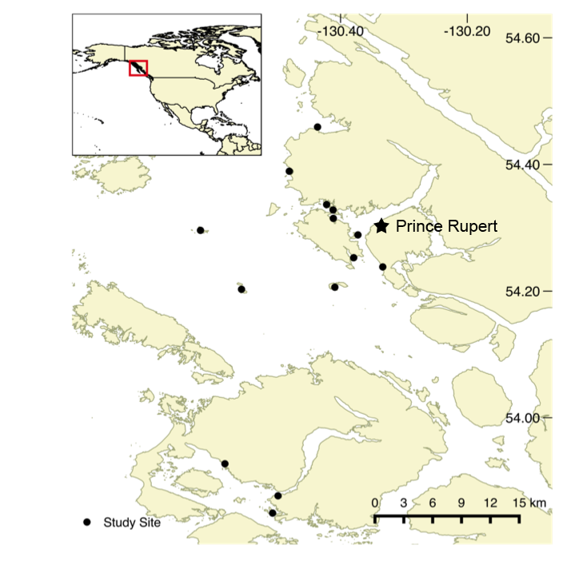
Fig 1 Study area with surveyed sites on the northern coast of British Columbia, Canada. Source: Canadian Hydrographic Service

Functional trait measures
We calculated seven species-level functional traits: mouth length, oral gape position, eye size, eye position, pectoral fin position, caudal peduncle throttling, and body length (Fig. 2). We chose these specific traits because of their connection to resource acquisition, either through size, visual acuity, mobility, or position in the water column, which should combine to determine each species’ niche within the community (Villéger et al. 2010). To obtain these morphometric trait measures, we photographed representative individuals of each species (although not every species was photographed at every site) and used the image processing software ImageJ (Rasband 1997) to make the measurements (Villéger et al. 2010). Each trait (except for body length) is size-standardized and thus constrained between zero and one. Species-level functional trait values were obtained by taking the mean value of each trait across all individuals measured for each species (372 total measures, mean per species = 9.57, standard deviation = 11.91). One species, Cymatogaster aggregata, was an exception because it was found in both juvenile and adult stages. As a result, a single mean would mask bimodal variation in traits and we therefore considered these two stages as functionally distinct and calculated separate morphological metrics for them. Photos and trait measures were unobtainable for five of the rarest species (Myoxocephalus polyacanthocephalus (N = 3), Rimicola muscarum (N =1), Ascelichthys rhodorus (N = 1), Sebastes miniatus (N = 1), and Rhacochilus vacca (N = 1), so they were dropped from the taxonomic and functional analyses.
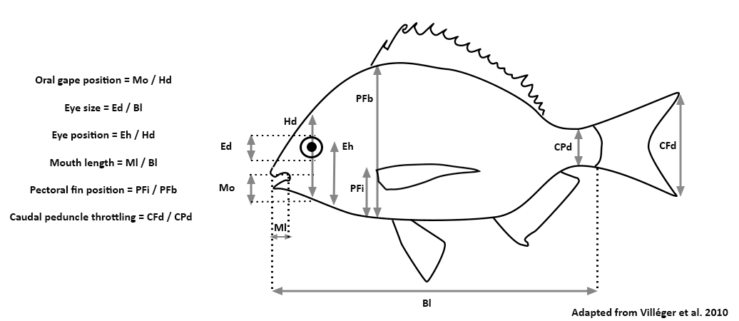
Fig 2 Morphometric traits measured from photographs of individuals of each of the 34 species. All traits (except for body length) are expressed relative to other body parts (total head, body size, or caudal peduncle depth) and are therefore independent of variation in total size. Trait abbreviations are as follows: Ed: Eye depth Mo: Mouth opening; Ml: Mouth length; Hd: Head depth; Eh: Eye height; PFb: Body depth at pectoral fin; PFi: Height of pectoral fin; Cpd: Caudal peduncle depth; CFd: Caudal fin depth; Bl: Body length

Functional diversity
We quantified three metrics of multivariate functional diversity (functional richness, functional evenness, and functional dispersion) using the “FD” package (Laliberté & Legendre 2010) in R. Calculation of each of these multivariate metrics first involved performing a Principal Coordinates Analysis (PCoA). Functional richness is the volume of the polygon that connects the exterior points of this transformation (Villéger et al. 2008). Functional evenness, which is independent of functional richness, is a measure of how regularly traits are distributed throughout the trait space and how abundance is distributed across those traits (Mason et al. 2005). Functional dispersion is calculated as the average distance to the abundance weighted centroid with the traits represented in n-dimensional space (Laliberté & Legendre 2010). The calculations for evenness and dispersion were done using the abundance weighted Gower’s dissimilarity measure and included all the traits. The calculation for functional richness was not weighted by abundance and included six of the seven traits: caudal peduncle throttling was dropped from this calculation because it was found to be redundant in the PCoA. The resulting quality of the reduced space representation, which is analogous to R², was 0.93. Prior to conducting the PCoA, we standardized the morphometric traits to a mean of zero and standard deviation of one and gave all traits equal weighting.

To better understand which individual traits underlay the relationships between biomass and the multivariate functional diversity metrics, we also calculated two univariate metrics. We focused on understanding the evenness (and conversely the dominance) of individual traits because functional evenness was the only functional diversity metric to show a significant relationship with ecosystem function. First, we calculated univariate indices of functional evenness (i.e. functional regularity (Mouillot et al. 2005). Second, because we also wanted to understand the directional influence of specific trait values on community biomass, we calculated the community weighted mean (CWM, Swenson 2014) of each trait. The CWM is calculated by taking the average trait value of the individuals at each site (e.g. S₁ = 10cm, S₂ = 15 cm, S₃ = 20 cm, CWM = 15 cm).

Taxonomic metrics
We used two taxonomic metrics, Chao’s species richness and Chao’s Shannon’s diversity (hereafter ‘taxonomic diversity’). Both metrics are rarefied measures of taxonomic diversity, which use sample-based rarefaction that incorporate abundance data. We rarefied our diversity metrics to account for the non-random distribution of fishes in the water column and for differences in species’ abundance at each site (Gotelli & Colwell 2011, Colwell et al. 2012). The final values reported are the asymptotic estimates of diversity at each site. The calculations were done using the “iNEXT” function in the “iNEXT” (Hsieh et al. 2016) package in R.
Ecosystem function
Following Mora et al. (2011) and Duffy et al. (2016) we used community standing stock biomass (hereafter ‘community biomass’) as our measure of ecosystem function. Though this is not a rate, fisheries landings are often viewed as a type of ecosystem function or service (Holmlund & Hammer 1999) and the biomass of an individual frequently predicts its contribution to a range of other ecosystem functions such as suspension feeding, nutrient uptake, and gross productivity (Davies et al. 2011). We estimated each individual’s mass using its recorded length and published length-weight relationships, most of which were specific to fishes in eelgrass meadows in British Columbia (Siegle et al. 2014); data for five species were only available from Fishbase.org (Froese & Pauly 2010). Lengths were measured for the first 20 individuals of each species at each site. As such, lengths were not available for all individuals, so truncated density distributions based on maximum and minimum observed fish lengths were created using the “fitdistrplus” package in R (Delignette-Muller & Dutang 2015). The unmeasured individual lengths were then randomly sampled from these distributions. Lastly, biomass was summed at each site and logged to normalize its variance.

Statistical analyses
To examine the relationships between fish community biomass and each taxonomic and functional metric we fitted generalized linear models (GLM) with a gamma distribution. We chose a gamma distribution because the data were non-normal and contained positive non-zero values. We examined the univariate relationships between each of four environmental variables (temperature, salinity, pH, eelgrass density) and fish community biomass, but did not include these in our GLMs to avoid over-parameterizing our model (i.e. by including multiple correlated fixed effects with a low sample size; Appendix 1). Instead, we included the geographic location (longitude) of the survey sites as a second fixed effect in each GLM. Because longitude was strongly correlated with the abiotic variables (Appendix 1), with sites farther from the coast tending to have lower temperature, higher salinity, higher eelgrass density, and less human disturbance, we considered it a proxy for the environmental relationships with fish biomass. We also tested for spatial autocorrelation in the biotic and abiotic variables amongst the surveyed sites using the Durbin-Watson test, but found no significant effects of spatial autocorrelation. The models were then evaluated for relative fit using the proportion of the deviance explained, which is measured in comparison to a null model that includes only the intercept (D²). This measure of fit was calculated using the R package “modEvA” (Barbosa et al. 2016) and variables were assessed for statistical significance based on their P value (P < 0.05). All other statistical operations were also performed using the R programming language (R Core Development Team V 4.0, 2020). All data and associated code for graphing and analysis are archived in a GitHub repository and on Open Science Framework (https://github.com/baumlab, DOI 10.17605/OSF.IO/6SQRF).

Results
Species richness and community biomass varied substantially across study sites. Unrarefied richness ranged from 7 to 23 species per site, with a regional pool of 34 species. Of these 34 species, over three-quarters (N = 26) were found at more than one site within the region. Community biomass ranged ten-fold across sites, from 1,216 to 12,774 grams (log₁₀, 3.08 to 4.10) per site (approximately 60 m²). All sites were dominated (>50% of abundance) by three or fewer species (Appendix 2), and only 16 of the 34 species had median site biomass proportion values above 0.01 (Appendix 3). Of these 16 species, the two with the highest median proportion of site biomass were the surfperch, Cymatogaster aggregata (0.34) and the sculpin, Leptocottus armatus (0.21, Appendix 3).

Biodiversity – ecosystem function
Fish community biomass was negatively related to functional evenness (P = 0.01, Fig. 3), and this relationship explained the most deviance of any biodiversity metric considered (D² = 0.51, Fig. 3). The only other statistically significant relationship was between species richness and community biomass, with sites with the lowest species richness having the highest biomass (P = 0.03, D² = 0.43, Fig. 3). Taxonomic diversity, functional richness, and functional dispersion were not significant predictors of fish community biomass (P = 0.26, P = 0.30, and P = 0.74 respectively, Fig. 3) and explained much less deviance (D² < 0.22, Fig. 3). Additionally, none of the four environmental variables were significant predictors of fish community biomass in the univariate regressions (and all of them explained very little variance, D² < 0.2, Fig. 4); longitude (our environmental proxy) was only significant in the species richness model (P = 0.02), where sites with lower longitude (i.e. those further from the coast) had greater community biomass.
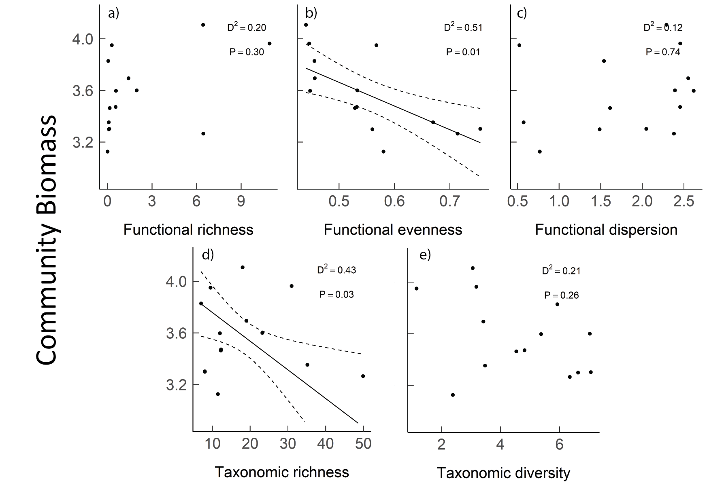
Fig 3 Relationships between the log site-level fish community biomass and a) functional richness b) functional evenness c) functional dispersion d) taxonomic richness and e) taxonomic diversity. The solid line (shown only for the significant relationships) is the regression line and the dashed lines are twice the standard error.

The relationship between functional evenness and fish community biomass appeared to be driven by particular morphological trait values. Of the seven evenness trait values considered individually, only two, lower evenness of eye position and oral gape position, were significant predictors of higher community biomass (P = 0.04 and D² = 0.40 for both, Fig. 5). These results indicate that community biomass was maximized in communities dominated by certain values of these traits. Similarly, the community weighted mean of these two traits were the only CWM values that were significant predictors of fish community biomass. The CWM for eye position and oral gape position were both negatively related to community biomass (P = 0.02, D² = 0.46 and 0.47, Fig. 5). Lastly, we found no relationship between the average CWM length and community biomass at our sites (P > 0.05).
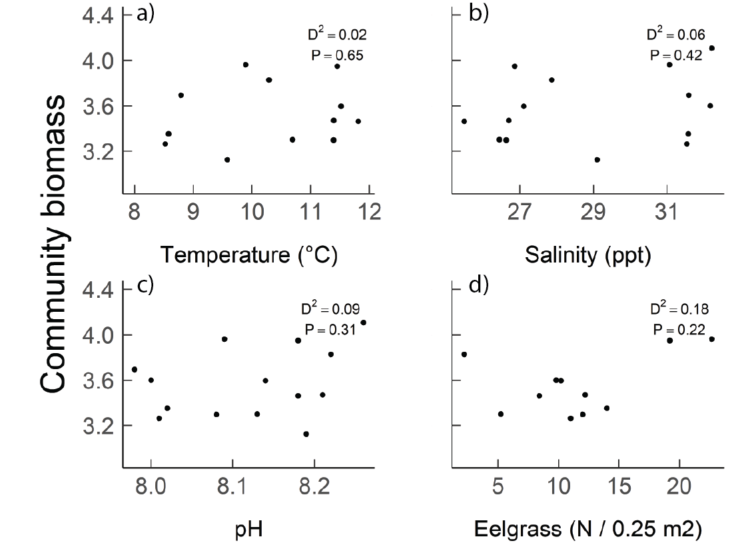
Fig 4 Relationships between the log site-level fish community biomass and site-level abiotic variables: a) temperature b) salinity c) pH and d) eelgrass density.
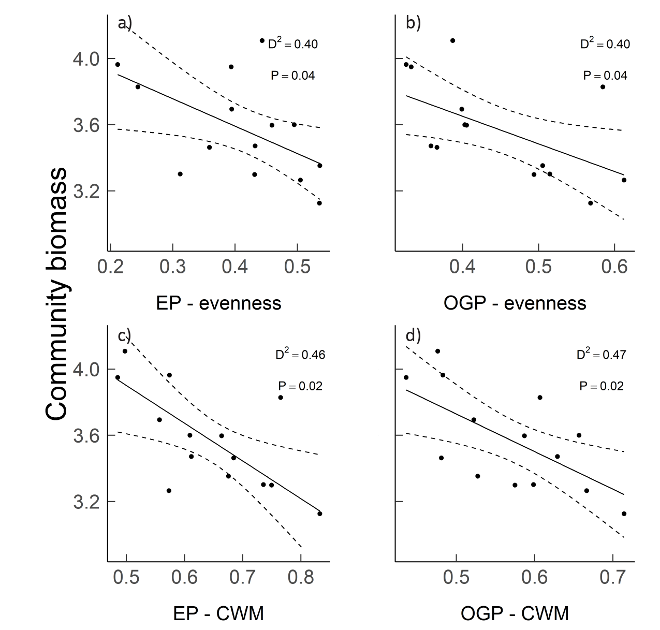
Fig 5: Relationships between the log site-level community biomass and a) evenness of eye
position (EP) b) evenness of oral gape position (OGP), c) Community Weighted Mean (CWM) of CWM of eye position d) CWM of oral gape position. Solid lines are regression lines; dashed lines are twice the standard error.

Discussion
We found clear evidence that, in our system, high standing stock biomass of fish in eelgrass meadows was predicted by the dominance of species with particular trait values rather than complementary resource use of a diverse species assemblage. Sites with low species diversity and high dominance of species with certain traits had the highest ecosystem function (total fish community biomass) of eelgrass-associated fish communities. This conclusion is supported by five out of six of the relationships predicted in Table 1; specifically, community biomass decreased with increasing taxonomic richness and functional evenness (both the multivariate and the two univariate measures) and was strongly related to two CWM trait measures. Community biomass was also not well predicted by the environmental factors. These results are contrary to similar studies of fishes in coastal marine environments (Mora et al. 2011, Duffy et al. 2016), which found positive relationships between community biomass and taxonomic and functional diversity metrics, and a strong influence from environmental variables.

Dominance vs. diversity as drivers of ecosystem function
Communities with fewer species had the highest levels of ecosystem function among our study sites (Fig. 3). In fact, the abundance and distribution of dominant species played a role at two spatial scales. First, at the level of an individual community (i.e. a site), communities with the highest function had the highest local dominance of high-contributing species. Second, the two most dominant species (Cymatogaster aggregata and Leptocottus armatus) had a high degree of regional occupancy (Appendix 3), such that greater species richness at the community level corresponded to substituting individuals of these dominant species for individuals of rare species with overall low biomass that contributed less to ecosystem function. This mechanism helps explain why we failed to find a positive relationship between function and taxonomic richness, as predicted under the complementary hypothesis. Our results suggest that many species contribute very little to certain components of ecosystem function and increased species richness correlates with fewer dominant individuals.

Our main result, namely that low levels of species richness and evenness best predict high biomass in eelgrass fish communities, is contrary to past research suggesting that more marine fish species equates to more biomass (Mora et al. 2011, Duffy et al. 2016). In an extensive analysis of 1,844 sites on shallow hard substrate, Duffy et al. (2016) found an overall positive effect of species richness on community biomass; more so they found this effect was strongest in temperate ecosystems such as ours. Though they studied rocky reefs and we studied a seagrass on soft substrate, we do not believe this distinction is enough to explain our contrasting results. Instead, we suggest two differences between the two studies that may explain the different conclusions. First, the range in species richness was quite different: Duffy et al.’s (2016) surveys in temperate regions ranged from ~ 1 to 10 species whereas our surveys ranged from 7 to 23 species. Therefore Duffy et al.’s (2016) might have arisen because their communities had very few species, in which the addition of even a single species resulted in a substantial fulfillment of niche space (Stuart-Smith et al. 2013). This could occur if species that are important contributors to community biomass are not regionally well distributed and are not reliably found in almost all communities at minimum species richness levels. Because our study contained moderately species rich ecosystems, the species count may have been past the saturation point on the richness-function curve that is often seen in BEF relationships (Morris et al. 2014). Second, we used beach seines to survey, which are more likely to detect rare, singleton species (Baker et al. 2016) than the visual surveys used in Duffy et al. (2016). These rare, singleton species would have contributed very little biomass, but still increased the species count, and thus possibly prevented a relationship between species richness and community biomass. While our results are representative of eelgrass ecosystems in the Pacific Northwest (Robinson & Yakimishyn 2013), other temperate marine ecosystems with lower local or regional diversity or more fragmented habitat connectivity may therefore find alternative results, such as complementarity.
Functional traits structuring standing stock biomass
We found support for the dominance hypothesis, specifically that two traits related to fish species’ position in the water column predicted the biomass of a community. This result suggests certain community level trait values can enhance EF. Here, both eye position and oral gape position were negatively correlated with community biomass, suggesting that the most productive eelgrass fish communities were those dominated by species such as Leptocottus armatus, which are more adapted for a benthic environment. Fish with high values for the eye position metric have more dorsally located eyes and are adapted to capturing prey from the pelagic environment, whereas fish with low scores for eye position have more laterally located eyes and are more adapted for capturing prey from the benthic environment (Gatz 1979). Similarly, fish with high gape position scores have dorsally located mouths, whereas those with low scores, such as those in the sculpin family (Cottoidea), have ventrally located mouths and are best adapted to capturing prey from the benthic environment (Karpouzi & Stergiou 2003). Importantly, there was no relationship between body length and community biomass, indicating that it is not simply larger bodied communities that contain more biomass, but rather these specific ecologically relevant traits. While we focused on traits related to species’ feeding abilities, it is possible that traits related to other life history characteristics or environmental tolerances could also influence a species’ dominance within a community (e.g. metabolic rate, parental care habits, pollution tolerance), and this area provides grounds for further research.

The trait values that permit maximum growth and productivity will vary across ecosystems, depending on the distribution of available food and habitat resources within them (McGill et al. 2006, Keck et al. 2014). Previous work on fish species in coral, mangrove, and seagrass habitats from the Caribbean and Australian showed that habitat rather than geographic region was most related to functional traits (Hemingson & Bellwood 2018). The authors reasoned that differences in habitat structure, such as mangrove roots compared to seagrass leaves, their related predation risk, and food availability, outweighed the evolutionary distinctiveness found between ocean regions. As such, we would expect our findings to be transferable to other eelgrass habitats but not to other habitats within the same region. Specifically, prey in eelgrass systems are known to be benthic and epifanual (Phillips 1984), which corresponds with our findings that communities with trait values associated with more benthic prey capture were found to contain the highest community biomass. Adaptations to feed in highly structured benthic habitats are common in seagrass-associated fish species (Hovel et al. 2016) and may include both morphological and behavioural components. An important future opportunity would be to test if habitats with more pelagic prey distributions have a positive relationship between community biomass and traits like eye and oral gape position. Alternatively, differences in other traits related to predator avoidance or abiotic stress tolerance could drive BEF relationships in other ecosystems. In either case, centring our understanding of diversity mechanisms on traits allows us to make informative comparisons across systems based on quantifiable features of organisms and their environment.

Management Implications and Conclusions
The importance of a select few species within a community has significant implications for the management priorities of these systems. If we wish to prioritize conserving fish biomass as a function within this ecosystem, it appears we need to focus on a few species that contribute the greatest function. This optimization would simplify the conservation process but also raises important questions about applying a BEF approach to conservation. For instance, if dominant species are unaffected by human disturbance, there would be little concern for such disturbances which may negatively affect other, less productive species. Alternatively, if dominant species are impacted by disturbance, it could be argued that we need only focus on their conservation to protect ecosystem function. In both scenarios, many rare, low biomass species would be deemed expendable, as their contribution to ecosystem function is low. The ethical considerations of this approach are considerable, and conservationists should be aware of unexpected outcomes when promoting BEF in management and conservation frameworks. It is also salient to consider how we might manage for only one or a few species all sharing the same habitat. If it were more resource intensive to only protect these highly functional species, a more prudent approach might be to simply protect the habitat, protect all species, and potentially protect the greatest number of species and functions.

We must also acknowledge the limitations of only considering a single function: while one or a few species may drive a particular function, as was found in our study, those same species may not be responsible for other functions in the ecosystem (Isbell et al. 2011). Seagrass ecosystems have well-established links between fish predators, invertebrate grazers, epiphytic algae, and the eelgrass itself. For example, certain fish predators can prevent herbivorous invertebrates from grazing epiphytic algae off the eelgrass, and the resulting increased epiphyte loads reduce the fitness of the seagrass (Heck Jr & Valentine 2006, Moksnes et al. 2008). Thus, while fish community assemblages dominated by certain species might maximize community biomass, those same assemblages might result in grazer communities that do not maximize epiphyte control and seagrass growth.

While our results highlight the importance of dominance and relative abundance in driving ecosystem function in eelgrass fish communities, they also have implications for other ecosystems. First, past research has found support for the dominance hypothesis in producers in forests and pollination services in bees (Gilbert et al. 2009, Tardif & Shipley 2012, Winfree et al. 2015), and our results suggest this relationships spans across taxa and could be replicated in other vertebrate communities. Second, many systems have steep rank-abundance curves, where one or a few species dominate community abundance and most species are rare (Ulrich et al. 2010). If these patterns in relative abundance are inherent to the distribution of resources in the system and not a recent feature of system disturbance or invasion, then the contributions of these few species may be central to ecosystem functioning and deserve greater attention (Eisenhauer et al. 2016). Third, communities are more likely to change in relative abundance than to lose richness, at least in the short term (Ceballos et al. 2017). Our results suggest these declines can negatively impact ecosystem function even without complete species loss. As such, we suggest that ecologists place an increased value on studying and maintaining species abundances within a community as opposed to species richness alone.

In this study, we highlight the importance of dominant species, their traits, and their distribution within a community for driving ecosystem function in a real-world ecosystem. Our work stresses the importance of testing BEF theory in multiple natural ecosystems and under different contexts as different mechanisms may underlie BEF relationships in different systems. We also stress the importance of examining multiple facets of biodiversity, including abundance weighted measures of diversity, in BEF analyses. Specific to functional diversity, we have also shown the relevance of the currently underutilized one-dimensional functional evenness and CWM metrics, and how they can be used to understand which traits and which trait values best explain ecosystem function. Finally, given the importance of dominant species in determining ecosystem function in our system, we conclude that conservation that prioritizes single ecosystem functions may not always maximize diversity, and a greater understanding of how different dimensions of diversity contribute to different dimensions of ecosystem functioning and value is needed.
Funding
We acknowledge funding from the Natural Sciences and Engineering Research Council of Canada in the form of a graduate scholarship and Discovery Grant and Engage Grants. Finally, we thank Mike Ambach, James Casey, and Bettina Saier from the World Wildlife Fund of Canada for collaboration and financial support.
Competing Interests
The authors declare that they have no conflict of interest.
Research Involving Animals
All applicable international, national, and/or institutional guidelines for the care and use of animals were followed. Fish were collected under: a Department of Fisheries of Canada Scientific Fishing Permit (XR 10 2016), a University of Victoria Animal Health and Welfare Permit (2016-011), a Prince Rupert Port Authority Work Permit, and with consultations with local First Nations, Gitxaala, Git’agaat, Metlakatla, Kitselas, Kitsumkalum and Lax Kw’alaams, on whose traditional territory the work took place.
Author contributions section
All authors conceived the study design, AE led the field data collection and analysis, AE wrote the first version of the manuscript, all authors commented and edited subsequent versions of the manuscript.
Data accessibility section
All the data and the scripts for running the analysis are deposited on Open Science Framework at the link: DOI 10.17605/OSF.IO/6SQRF
Acknowledgements
We are grateful to the Gitxaala, Git’agaat, Metlakatla, Kitselas, Kitsumkalum and Lax Kw’alaams First Nations for granting access to their territory as well as insights into their local ecosystems. We additionally thank the Metlakatla and Gitxaala Nation for providing research vessels and field researchers, and especially Bruce Watkinson, Ross Wilson, Colin Nelson, Cordell Nelson, and Colton Nelson for their support. Next, we thank the Department of Fisheries and Oceans Canada and the Northwest Community College for providing a field boat. Gratitude is also owed to our field assistants Tella Osler, Quinn Lowen, and Sarah Friesen, as well as to Peter Freeman for his advice and support in keeping our field boat running.

References
Abbott JM, Grosberg RK, Williams SL, Stachowicz JJ (2017) Multiple dimensions of intraspecific diversity affect biomass of eelgrass and its associated community. Ecology 98:3152–3164.
Allgeier JE, Layman CA, Mumby PJ, Rosemond AD (2015) Biogeochemical implications of biodiversity and community structure across multiple coastal ecosystems. Ecol Monogr 85:117–132.
Baker DGL, Eddy TD, McIver R, Schmidt AL, Thériault M-H, Boudreau M, Courtenay SC, Lotze HK (2016) Comparative analysis of different survey methods for monitoring fish assemblages in coastal habitats. PeerJ 4:e1832.
Bannar‐Martin KH, Kremer CT, Ernest SKM, Leibold MA, Auge H, Chase J, Declerck SAJ, Eisenhauer N, Harpole S, Hillebrand H (2018) Integrating community assembly and biodiversity to better understand ecosystem function: the Community Assembly and the Functioning of Ecosystems (CAFE) approach. Ecol Lett 21:167–180.
Barbosa AM, Brown J, Jiménez-Valverde A, Real R (2016) ModEvA: model evaluation and analysis.
Cardinale BJ, Duffy JE, Gonzalez A, Hooper DU, Perrings C, Venail P, Narwani A, Mace GM, Tilman D, Wardle DA (2012) Biodiversity loss and its impact on humanity. Nature 486:59.
Cavanaugh KC, Gosnell JS, Davis SL, Ahumada J, Boundja P, Clark DB, Mugerwa B, Jansen PA, O’Brien TG, Rovero F (2014) Carbon storage in tropical forests correlates with taxonomic diversity and functional dominance on a global scale. Glob Ecol Biogeogr 23:563–573.
Ceballos G, Ehrlich PR, Dirzo R (2017) Biological annihilation via the ongoing sixth mass extinction signaled by vertebrate population losses and declines. Proc Natl Acad Sci 114:E6089–E6096.
Colwell RK, Chao A, Gotelli NJ, Lin S-Y, Mao CX, Chazdon RL, Longino JT (2012) Models and estimators linking individual-based and sample-based rarefaction, extrapolation and comparison of assemblages. J plant Ecol 5:3–21.
Cullen-Unsworth L, Unsworth R (2013) Seagrass meadows, ecosystem services, and sustainability. Environ Sci Policy Sustain Dev 55:14–28.
Danovaro R, Gambi C, Dell’Anno A, Corinaldesi C, Fraschetti S, Vanreusel A, Vincx M, Gooday AJ (2008) Exponential decline of deep-sea ecosystem functioning linked to benthic biodiversity loss. Curr Biol 18:1–8.
Davies TW, Jenkins SR, Kingham R, Kenworthy J, Hawkins SJ, Hiddink JG (2011) Dominance, biomass and extinction resistance determine the consequences of biodiversity loss for multiple coastal ecosystem processes. PLoS One 6:e28362.
Delignette-Muller ML, Dutang C (2015) Fitdistrplus: An R package for fitting distributions. J Stat Softw 64:1–34.
Duffy JE, Godwin CM, Cardinale BJ (2017) Biodiversity effects in the wild are common and as strong as key drivers of productivity. Nature 549:261.
Duffy JE, Lefcheck JS, Stuart-Smith RD, Navarrete SA, Edgar GJ (2016) Biodiversity enhances reef fish biomass and resistance to climate change. Proc Natl Acad Sci 113:6230–6235.
Duffy JE, Reynolds PL, Boström C, Coyer JA, Cusson M, Donadi S, Douglass JG, Eklöf JS, Engelen AH, Eriksson BK (2015) Biodiversity mediates top–down control in eelgrass ecosystems: a global comparative‐experimental approach. Ecol Lett 18:696–705.
Van Eekeren N, De Boer H, Hanegraaf M, Bokhorst J, Nierop D, Bloem J, Schouten T, De Goede R, Brussaard L (2010) Ecosystem services in grassland associated with biotic and abiotic soil parameters. Soil Biol Biochem 42:1491–1504.
Eger AM, Baum JK (2020) Trophic cascades and connectivity in coastal benthic marine ecosystems: a meta-analysis of experimental and observational research. Mar Ecol Prog Ser ITRS:ITRSav3.
Eisenhauer N, Barnes AD, Cesarz S, Craven D, Ferlian O, Gottschall F, Hines J, Sendek A, Siebert J, Thakur MP (2016) Biodiversity–ecosystem function experiments reveal the mechanisms underlying the consequences of biodiversity change in real world ecosystems. J Veg Sci 27:1061–1070.
Fargione J, Tilman D, Dybzinski R, Lambers JHR, Clark C, Harpole WS, Knops JMH, Reich PB, Loreau M (2007) From selection to complementarity: shifts in the causes of biodiversity–productivity relationships in a long-term biodiversity experiment. Proc R Soc London B Biol Sci 274:871–876.
Finegan B, Peña‐Claros M, de Oliveira A, Ascarrunz N, Bret‐Harte MS, Carreño‐Rocabado G, Casanoves F, Díaz S, Velepucha PE, Fernandez F (2015) Does functional trait diversity predict above‐ground biomass and productivity of tropical forests? Testing three alternative hypotheses. J Ecol 103:191–201.
Foreman MGG, Crawford WR, Cherniawsky JY, Galbraith J (2008) Dynamic ocean topography for the northeast Pacific and its continental margins. Geophys Res Lett 35.
Froese R, Pauly D (2010) FishBase.
Gagic V, Bartomeus I, Jonsson T, Taylor A, Winqvist C, Fischer C, Slade EM, Steffan-Dewenter I, Emmerson M, Potts SG (2015) Functional identity and diversity of animals predict ecosystem functioning better than species-based indices. Proc R Soc London B Biol Sci 282:20142620.
Gatz AJ (1979) Community organization in fishes as indicated by morphological features. Ecology 60:711–718.
Gilbert B, Turkington R, Srivastava DS (2009) Dominant species and diversity: linking relative abundance to controls of species establishment. Am Nat 174:850–862.
Gilby BL, Olds AD, Connolly RM, Maxwell PS, Henderson CJ, Schlacher TA (2018) Seagrass meadows shape fish assemblages across estuarine seascapes. Mar Ecol Prog Ser 588:179–189.
Gotelli NJ, Colwell RK (2011) Estimating species richness. Biol Divers Front Meas Assess 12:39–54.
Grime JP (1998) Benefits of plant diversity to ecosystems: immediate, filter and founder effects. J Ecol 86:902–910.
Guest MA, Connolly RM, Loneragan NR (2003) Seine nets and beam trawls compared by day and night for sampling fish and crustaceans in shallow seagrass habitat. Fish Res 64:185–196.
Heck Jr KL, Valentine JF (2006) Plant–herbivore interactions in seagrass meadows. J Exp Mar Bio Ecol 330:420–436.
Hemingson CR, Bellwood DR (2018) Biogeographic patterns in major marine realms: function not taxonomy unites fish assemblages in reef, seagrass and mangrove systems. Ecography (Cop) 41:174–182.
Holmlund CM, Hammer M (1999) Ecosystem services generated by fish populations. Ecol Econ 29:253–268.
Hooper DU, Chapin FS, Ewel JJ, Hector A, Inchausti P, Lavorel S, Lawton JH, Lodge DM, Loreau M, Naeem S (2005) Effects of biodiversity on ecosystem functioning: a consensus of current knowledge. Ecol Monogr 75:3–35.
Hovel KA, Warneke AM, Virtue-Hilborn SP, Sanchez AE (2016) Mesopredator foraging success in eelgrass (Zostera marina L.): relative effects of epiphytes, shoot density, and prey abundance. J Exp Mar Bio Ecol 474:142–147.
Hsieh TC, Ma KH, Chao A (2016) INEXT: an R package for rarefaction and extrapolation of species diversity (H ill numbers). Methods Ecol Evol 7:1451–1456.
Hughes AR, Stachowicz JJ (2004) Genetic diversity enhances the resistance of a seagrass ecosystem to disturbance. Proc Natl Acad Sci 101:8998–9002.
Huston MA, McBride AC (2002) Evaluating the relative strengths of biotic versus abiotic controls on ecosystem processes. Biodivers Ecosyst Funct Synth Perspect Oxford Univ Press Oxford:47–60.
Isbell F, Calcagno V, Hector A, Connolly J, Harpole WS, Reich PB, Scherer-Lorenzen M, Schmid B, Tilman D, Van Ruijven J (2011) High plant diversity is needed to maintain ecosystem services. Nature 477:199.
Jenkins DG (2015) Estimating ecological production from biomass. Ecosphere 6:1–31.
Karpouzi VS, Stergiou KI (2003) The relationships between mouth size and shape and body length for 18 species of marine fishes and their trophic implications. J Fish Biol 62:1353–1365.
Keck BP, Marion ZH, Martin DJ, Kaufman JC, Harden CP, Schwartz JS, Strange RJ (2014) Fish functional traits correlated with environmental variables in a temperate biodiversity hotspot. PLoS One 9:e93237.
Keppel G, Van Niel KP, Wardell‐Johnson GW, Yates CJ, Byrne M, Mucina L, Schut AGT, Hopper SD, Franklin SE (2012) Refugia: identifying and understanding safe havens for biodiversity under climate change. Glob Ecol Biogeogr 21:393–404.
Laliberté E, Legendre P (2010) A distance‐based framework for measuring functional diversity from multiple traits. Ecology 91:299–305.
Larkum AWD, Orth RJ, Duarte CM (2006) Seagrasses. Springer.
Laughlin DC (2014) Applying trait‐based models to achieve functional targets for theory‐driven ecological restoration. Ecol Lett 17:771–784.
Loreau M, Hector A (2001) Partitioning selection and complementarity in biodiversity experiments. Nature 412:72.
Mason NWH, Mouillot D, Lee WG, Wilson JB (2005) Functional richness, functional evenness and functional divergence: the primary components of functional diversity. Oikos 111:112–118.
McDevitt-Irwin JM, Iacarella JC, Baum JK (2016) Reassessing the nursery role of seagrass habitats from temperate to tropical regions: a meta-analysis. Mar Ecol Prog Ser 557:133–143.
McGill BJ, Enquist BJ, Weiher E, Westoby M (2006) Rebuilding community ecology from functional traits. Trends Ecol Evol 21:178–185.
McPherson JM, Yeager LA, Baum JK (2018) A simulation tool to scrutinise the behaviour of functional diversity metrics. Methods Ecol Evol 9:200–206.
Moksnes P, Gullström M, Tryman K, Baden S (2008) Trophic cascades in a temperate seagrass community. Oikos 117:763–777.
Mora C, Aburto-Oropeza O, Bocos AA, Ayotte PM, Banks S, Bauman AG, Beger M, Bessudo S, Booth DJ, Brokovich E (2011) Global human footprint on the linkage between biodiversity and ecosystem functioning in reef fishes. PLoS Biol 9:e1000606.
Mora C, Danovaro R, Loreau M (2014) Alternative hypotheses to explain why biodiversity-ecosystem functioning relationships are concave-up in some natural ecosystems but concave-down in manipulative experiments. Sci Rep 4:1–9.
Morris EK, Caruso T, Buscot F, Fischer M, Hancock C, Maier TS, Meiners T, Müller C, Obermaier E, Prati D (2014) Choosing and using diversity indices: insights for ecological applications from the German Biodiversity Exploratories. Ecol Evol 4:3514–3524.
Mouillot D, Mason WHN, Dumay O, Wilson JB (2005) Functional regularity: a neglected aspect of functional diversity. Oecologia 142:353–359.
Phillips RC (1984) Ecology of eelgrass meadows in the Pacific Northwest: a community profile. Seattle Pacific Univ., WA (USA). School of Natural and Mathematical Sciences.
van der Plas F (2019) Biodiversity and ecosystem functioning in naturally assembled communities. Biol Rev 94:1220–1245.
Rasband WS (1997) ImageJ.
Robinson CLK, Yakimishyn J (2013) The persistence and stability of fish assemblages within eelgrass meadows (Zostera marina) on the Pacific coast of Canada. Can J Fish Aquat Sci 70:775–784.
Siegle MR, Robinson CLK, Yakimishyn J (2014) The effect of region, body size, and sample size on the weight-length relationships of small-bodied fishes found in eelgrass meadows. Northwest Sci 88:140–154.
Srivastava DS, Vellend M (2005) Biodiversity-ecosystem function research: is it relevant to conservation? Annu Rev Ecol Evol Syst 36:267–294.
Steffen W, Crutzen PJ, McNeill JR (2007) The Anthropocene: are humans now overwhelming the great forces of nature. AMBIO A J Hum Environ 36:614–621.
Stuart-Smith RD, Bates AE, Lefcheck JS, Duffy JE, Baker SC, Thomson RJ, Stuart-Smith JF, Hill NA, Kininmonth SJ, Airoldi L (2013) Integrating abundance and functional traits reveals new global hotspots of fish diversity. Nature 501:539.
Swenson NG (2014) Functional and phylogenetic ecology in R. Springer.
Tardif A, Shipley B (2012) Using the biomass-ratio and idiosyncratic hypotheses to predict mixed-species litter decomposition. Ann Bot 111:135–141.
Tilman D, Reich PB, Knops J, Wedin D, Mielke T, Lehman C (2001) Diversity and productivity in a long-term grassland experiment. Science (80- ) 294:843–845.
Ulrich W, Ollik M, Ugland KI (2010) A meta‐analysis of species–abundance distributions. Oikos 119:1149–1155.
Unsworth RKF, Nordlund LM, Cullen‐Unsworth LC (2019) Seagrass meadows support global fisheries production. Conserv Lett 12:e12566.
Villéger S, Mason NWH, Mouillot D (2008) New multidimensional functional diversity indices for a multifaceted framework in functional ecology. Ecology 89:2290–2301.
Villéger S, Miranda JR, Hernández DF, Mouillot D (2010) Contrasting changes in taxonomic vs. functional diversity of tropical fish communities after habitat degradation. Ecol Appl 20:1512–1522.
Wasof S, Lenoir J, Hattab T, Jamoneau A, Gallet‐Moron E, Ampoorter E, Saguez R, Bennsadek L, Bertrand R, Valdès A (2018) Dominance of individual plant species is more important than diversity in explaining plant biomass in the forest understorey. J Veg Sci 29:521–531.
Winfree R, W. Fox J, Williams NM, Reilly JR, Cariveau DP (2015) Abundance of common species, not species richness, drives delivery of a real‐world ecosystem service. Ecol Lett 18:626–635.
Zhu J, Jiang L, Zhang Y (2016) Relationships between functional diversity and aboveground biomass production in the Northern Tibetan alpine grasslands. Sci Rep 6:34105.

Appendix
Appendix 1: Correlation values (Pearson’s R) amongst the variables considered.
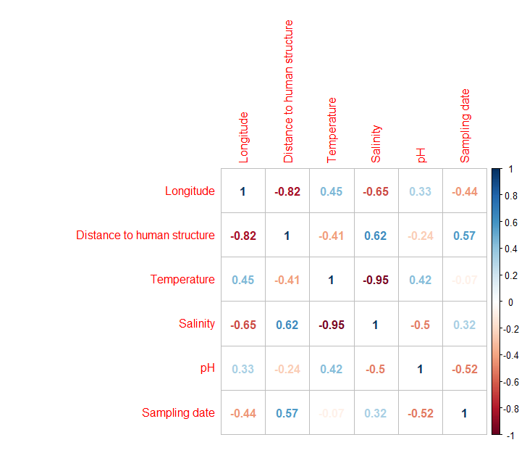

Appendix 2: Species rank abundance plots for the survey sites. Different coloured lines represent the different models used to fit the curves; the fits were done using the radfit function in the “vegan” package in R.
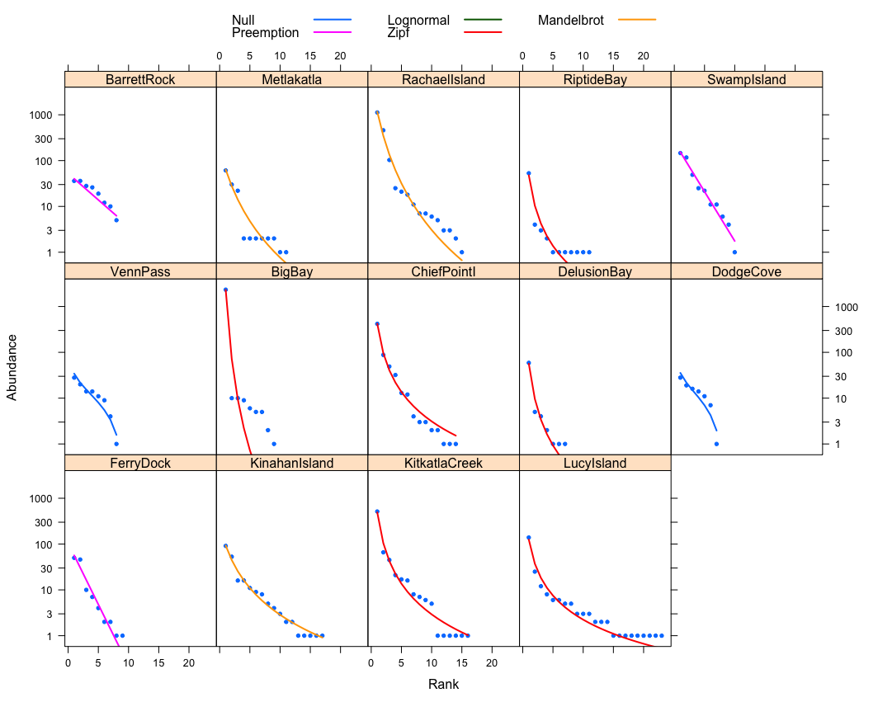

Appendix 3: All species caught and photographed along with the number of sites where species was observed (Regional occupancy, maximum of 14), the median proportion that species contributed to a site’s biomass, and the species’ morphological measurements used to calculate trait values (abbreviations as in. Fig 2). Species are ordered from highest to lowest median proportion of site biomass.

