No honesty in warning signals across life stages in an aposematic bug

Iliana Medina^{1*}, Thomas Wallenius², Constanza León², Daniela Perez² and Megan Head²
¹ School of BioSciences, University of Melbourne, Parkville, VIC, 3010, Australia
² Division of Ecology and Evolution, Australian National University, ACT, 0200, Australia
*corresponding author: iliana.medina@unimelb.edu.au, +61 0452606860, BioSciences 4, Parkville, VIC, 3010, Australia.
Word count: 6115 words
Declarations of interest: none

Abstract
Theory predicts that warning signals should exhibit low variation to increase learning efficiency in predators. However, many species exhibit variation in warning colours within species and even within populations. An understudied example of within species variation is that between life stages, where animals change warning colouration throughout ontogeny. Understanding how warning signals change throughout life can help us identify the different ecological pressures that affect the evolution of warning signals. We used the Australasian Harlequin Cotton bug (Tectocoris diophthalmus) to explore how adults and nymphs differ in toxicity and colouration. We performed spectrophotometric colour measurements, toxicity bioassays and field predation experiments. Our results show that colour acts as an honest signal only in males, who present the highest contrast against backgrounds, highest internal contrast, and highest toxicity. However, there was no clear pattern for females and nymphs, and attack rates were similar for both. Moreover, there was no association between colour and toxicity within males, nymphs or females. Our results suggest weak signal honesty in warning signals across life stages and sexes, and demonstrate that variation in colour within species is not necessarily linked to changes in toxicity or predation rates.

Keywords: aposematism, ontogeny, toxicity, predation, colour

Introduction
Warning (or aposematic) colours are employed by many animals to advertise toxicity, unpalatability or general unprofitability to their predators (Poulton, 1890). Predators learn to associate these colours with a negative reaction, and subsequently avoid prey with warning colouration (Stevens & Ruxton, 2012). In theory, warning colouration should exhibit low variation, because consistent signals are easily remembered by potential predators that learn to avoid these colour patterns (Joron & Mallet, 1998). Field experiments have shown that local aposematic prey have lower attack rates than novel models, supporting a role for predator learning in the maintenance of warning signals (Chouteau & Angers, 2011; Lindström, Alatalo, Lyytinen, & Mappes, 2001; Noonan & Comeault, 2009). Moreover, there are many examples of convergence in colouration (mimicry) between toxic and non-toxic species or between different toxic species (Amézquita et al., 2017; Stuckert, Venegas, & Summers, 2014; Twomey, Vestergaard, & Summers, 2014), which also supports the idea that low variation and convergence in warning signals is beneficial for aposematic prey.

Aposematism is a positive frequency dependent strategy, where rare individuals are disadvantaged because they are unprotected from potential predators trained with the most common signal (Endler, 1988; Sword, 1999). Field studies have confirmed the view that polymorphism in warning signals should be selected against (Chouteau, Arias, & Joron, 2016). However, there is ample evidence of variation in warning signals in several aposematic taxa, such as frogs, ladybirds, moths and butterflies (Emmanuelle S. Briolat et al.; Hegna, Galarza, & Mappes, 2015; Mallet & Joron, 1999; Medina, Wang, Salazar, & Amézquita, 2013; Rojas & Endler, 2013; Wang & Shaffer, 2008), which is puzzling and often considered a paradox. In some of these cases, where different morphs are allopatric, colour polymorphisms can potentially be explained by differences in predation pressure. For instance, populations of the Harlequin frog (Oophaga histrionica) are usually separated by several km, and there is the possibility that different sets of predators maintain different morphs in each population (Medina et al., 2013). Nevertheless, in other cases, such as in the wood tiger moth (Arctia plantaginis) the same population can have both yellow and white aposematic males (Hegna et al., 2015), and the presence of polymorphism in the same population remains unexplained.

A common but poorly studied phenomenon is ontogenetic colour change in aposematic signals. Many insects exhibit differences in aposematic colouration through their life. They can exhibit warning colours at single or multiple life stages and if at multiple life stages the signal may be the same or different (Booth, 1990; Lindstedt, Schroderus, Lindström, Mappes, & Mappes, 2016). As seen earlier, changes in warning signals within a population are often considered paradoxical (Emmanuelle S. Briolat et al.; Joron & Mallet, 1998), which makes changes in warning signals across an individual’s life difficult to explain. Why would the same individual exhibit different warning signals when selection should favour convergence and uniformity in sympatric warning colours? There is very little information on how colour and toxicity vary through the life of aposematic species, and whether colour acts as an honest signal of toxicity consistently through the life of an individual.

One potential explanation for colour changes between life stages is that each occupies a different ecological niche. Species with complete metamorphosis (holometabolous), like tadpoles and frogs, or caterpillars and butterflies, are exposed to very different ecological pressures through their life, and variation in selective pressures on each life stage could explain why colour varies between adults and young (Booth, 1990). However, other insects have much less dramatic changes in ecology across life (e.g. hemimetabolous insects, such as bugs), which makes variation in warning signals across life stages more puzzling. For instance, jewel bugs (Scutelleridae), have adults and nymphs that resemble each other in shape, share the same microhabitat, and exhibit maternal care (Javahery, Schaefer, & Lattin, 2000). However, nymphs and adults often have different colours. One possibility is that such differences in colouration are honest, and reflect actual differences in toxicity. For example, if there is a decrease in toxicity during adulthood, we would expect it to be accompanied by a decrease in conspicuousness. Moreover, changes in warning signals could also be associated with differences in predation rates between life stages.

In this study we use the model system of the Cotton Harlequin bug (Tectocoris diophthalmus, Scutelleridae), an Australasian jewel bug, to help understand why warning signals change through the ontogeny of many aposematic insects. Specifically, we test whether changes in warning colours and conspicuousness are associated with changes in toxicity. We use spectral colour measurements and bioassays with Daphnia to characterize the ontogenetic change in aposematism in this species. We complement our findings with a field experiment that explores the attack rates on both nymphs and adult females in a naïve population of wild birds.

Methods
Study species
Jewel bugs (Hemiptera: Scutelleridae) are hemimetabolous insects (i.e. metamorphosis into the adult form is gradual - eggs hatch into nymphs which resemble adults except that they are smaller and lack wings). They are known as jewel bugs, because they exhibit bright and conspicuous coloration (Javahery et al., 2000). They feed on plant sap and are closely related to stink bugs. Like stink bugs, jewel bugs possess odour glands that confer protection from predators (Staddon, Thorne, & Knight, 1987; Wink, Grimm, Koschmieder, Sporer, & Bergeot, 2000). Many jewel bugs are considered to be aposematic, including the Harlequin cotton bug (Tectocoris diophthalmus), a species widely distributed in Australia which has been shown to be avoided by avian predators (Scott A Fabricant & Smith, 2014). Adult Harlequin cotton bugs are bright red/orange with metallic blue spots and in some adults (mostly males) the metallic blue spots occupy most of the shield. First instar nymphs emerge as bright red and transition into a metallic blue pattern with red spots in later instars (Figure 1A), similar to that of most adult males. Importantly, like other Scutelleridae, this species exhibits maternal care, and females usually take care of their progeny for several weeks after the eggs hatch (Giffney & Kemp, 2014). Usually, all life stages live on the same tree, and it is not rare to observe aggregations of both adults and nymphs together.

Study site and insect collection
We collected 4/5th instar nymphs (N= 33) and adults (F= 23, M=16) from Narrabeen, NSW, Australia (33.72 S, 151.29 E) during January and February and December 2018. During each trip we collected both nymphs and adult females and males. Insects were taken to the Australian National University and immediately used for colour and toxicity analyses. Insects for field experiments were kept in a greenhouse for up to six weeks under natural light conditions and were fed only branches of Lagunaria patersonia brought from the collection site and ornamental Hibiscus, which are the most common plants in the natural diet of the insect.

Colour measurements
We measured colour of nymphs (N= 33) and adults (F= 23, M=16) using an Ocean Optics JAZ spectrophotometer (Pulsed Xenon lamp, 300 to 700 nm) and a custom made 2mm probe extension. To euthanise the insects we put them in a container in a -20 C freezer for 15 minutes and then immediately measured colouration on a background patch and the spots. In some cases it was too difficult to measure spot colour for the nymphs, because the spots were very small and the measures were not accurate, so many nymphs only have a background measurement (23 out of 33). We also measured the colour of five leaves and five fruits of the main plant where insects were found (Lagunaria patersonia), to provide information on the visual background where these bugs live. Measures were done with an automatic integration time and a boxcar width of 10. The spectra obtained was then processed in the R package pavo (Maia, Eliason, Bitton, Doucet, & Shawkey, 2013), where we used a smoothing parameter of 0.37, negative values were transformed to zero and wavelengths from 300 to 700 nm were used.

To analyse the colour of the bugs we used a visual model of an average passerine with UV cone type which is the visual system of most passerines (analyses were repeated with only V cone type and they were qualitatively identical). For achromatic receptor stimulation we used the sensitivity data of a blue tit (Cyanistes caeruleus). This was chosen because the most likely predators of these bugs are urban passerines such as Magpies (Gymnorhina tibicen), Noisy miners (Manorina melanocephala) and Currawongs (Strepera graculina). We also chose a standard daylight illumination (D65) and a quantum catch metric that follows Fechner law. To quantify the contrast (chromatic and achromatic) between the bug and the background we used the command coldist in the R package Pavo (Maia et al., 2013) and used as background the average spectral measures of the leaves and fruits of L. Patersonia. Since each individual had two colour patches, we summarised contrast by adding the contrast of both colour patches against each background.

We also calculated internal contrast for each individual, which could be interpreted as a measure of signal strength, if patterns with higher contrast are more easily learned by predators (Arenas, Walter, & Stevens, 2015). To do this we extracted the xyz coordinates of the tetrahedral colour space calculated above and then computed the Euclidean distance between the background point and spot point for each individual using the three coordinates. This measure represents the distance in colour space between the spots and the background colour of each insect.

Toxicity assays
After measuring colour, we tested toxicity of the Harlequin bugs collected using water fleas (Daphnia lineata) as our test organism, since these have been shown to be excellent test subjects in ecotoxicology studies, and have been used effectively in biotoxicity assays with other aposematic insects (Arenas et al., 2015; Harmon & Mousseau, 2007). Daphnia were obtained locally from two different providers (University of Melbourne and aquaticlivelood.com.au). After being in the freezer for 15 minutes, each Harlequin bug was weighed to the nearest 0.01 g using a microbalance and colour measurements were taken (see above) before placing the bug in methanol. To extract the toxins we followed the protocol described in Arenas et al. (2015) and macerated each individual in a 1.5ml Eppendorf with a plastic pestle for one minute. After maceration we added 1.5 ml Methanol 99% (EMSURE®) and vortexed the tube. We put the Eppendorf tube in a -4 C fridge overnight to allow further extraction of toxins. The next day we centrifuged the tube at 13,000 rpm for ten minutes. The supernatant was extracted into a new Eppendorf tube using a micropipette and the pellet and previous tubes were discarded. To obtain the extracted toxins we evaporated the excess methanol using a Vacuum concentrator set at 45 C for two hours, until there was no visible methanol in the sample. Once the methanol was evaporated, we added 1.5ml ultrapure water and we homogenised the sample using a vortex. Initial pilot assays showed that a 100% concentration provided enough variation across samples to detect repeatable differences between individuals, so all subsequent assays were conducted at this concentration. To check for reproducibility, we repeated the bioassays in a subsample of 30 samples and found high repeatability (r² =0.82). We also prepared a methanol control using a 5% methanol solution to ensure that residual methanol was not affecting the results of the bioassay. This solution is an overestimation of the possible residual left from the process, since samples were left in the evaporator until no methanol was visibly detectable (less than 1% in the sample).
The toxicity of the extracts was tested by placing 10 adult D. lineata in 0.5ml of a 100% solution in a glass test tube. We checked results after one, three and six hours. However, for two of the four trials it was necessary to use a different Daphnia supplier. Although all Daphnia were the same species (D. lineata), the individuals from our second supplier were more sensitive. Hence, for the third and fourth trials we checked the tubes after 30 min and 1 hour. Trial number was included in the statistical analysis to control for differences between Daphnia batches and other conditions that might change with the date of the assays. Each trial included nymphs, males and females.

Field predation experiments
To explore how predators respond to the warning signals of the Harlequin bug when they see them for the first time, we presented the bugs to wild naïve White-winged choughs (Corcorax melanorhamphos) in Canberra, Australia, between April 30th and May 8th, 2018. Harlequin bugs are not distributed naturally in Canberra, so they represent a novel stimulus to the birds used. Choughs are insectivorous passerines that co-occur naturally with Harlequin bugs in their northern range (New South Wales and Queensland), and are thus potential predators of this species. To measure attack rates by choughs we used a banded population of more than 100 individuals. This ensured that the individuals measured were naïve to the stimulus and individual choughs were not used more than once. Given that choughs live in social groups of 4-20 individuals (Rowley, 1978) we setup a hexagon with six bugs tied to a nail on each on the corners of the hexagon. For each presentation we used either orange females (6 groups, 33 choughs), nymphs (8 groups, 48 choughs), or commercially obtained crickets (as positive control, 5 groups, 48 choughs). We also used a negative control (white 1x1 cm cubes) to test whether choughs were likely to attack any novel stimuli. There were no attacks towards the white cubes. We did not use male bugs for this experiment (which are sometimes blue) because we did not have enough for both toxicity assays and field experiments. We looked for banded chough groups from 8:00 to 11:00 am and presented each group that we found with a set of bugs. Choughs were attracted to the setup using a small amount of cheese (this banded population has been trained to eat cheese for other studies). We quantified information on the band number of the choughs in the experiment and how many attacks occurred. We considered attacks only those instances where the beak of the bird touched the insect. For all experiments there were three researchers and each researcher was in charge of supervising with binoculars if there were attacks directed toward two of the six nails. Experiments lasted 5 minutes and we started counting when the first member of the group entered the hexagon.

Ethical note
This research adheres to the ASAB/ABS guidelines for the use of animals in research and was approved by the Animal Experimentation Ethics Committee at the Australian National University under permit A2017/42. For the predation rate experiments choughs were exposed to live Harlequin bugs, but these are unlikely to cause any harm to birds, as they have previously shown to be unpalatable and not toxic to chickens (Scott A Fabricant & Smith, 2014). Toxicity assays of bugs were lethal, so individual insects were euthanised via cooling, decreasing invertebrate activity. Insects were collected in the field proportionately to their abundance, and ensuring to not collect mothers protecting eggs to reduce any effect on the population persistence.

Statistical analyses
To test whether nymphs and adults present differences in contrast against backgrounds we used linear models with five different response variables: chromatic contrast against leaves or fruits (dS leaves, dS fruits), achromatic contrast against leaves or fruits (dL leaves, dL fruits) and internal contrast. All these variables were log-transformed to increase normality. As predictor variables we included the life stage and sex of the bug (adult female, adult male, or nymph).

To quantify the differences in toxicity between nymphs and adults we used a linear mixed model (LMM) in the lme4 package (Bates, Maechler, Bolker, & Walker, 2014). We used the number of dead Daphnia per assay as our response variable and we used the type of insect (adult female, adult male or nymph), the number of measure (1st, 2nd or 3rd), the weight of the bug and the trial number –since experiments were separated in time and Daphnia provider changed (see above) – as predictor variables. We used bug ID as a random factor in the model to account for multiple measures for each individual. We log transformed the number of dead Daphnia (log₁₀+1) to increase the normality of the residuals, but results remain qualitatively unchanged without using the log transformation. To complement this analysis, we conducted a separate model in which we used the number of dead Daphnia divided by the size of the bug (to have a measure of toxicity that takes size into account). The model was similar to that described above except that it did not include the weight of the bug as a predictor variable.

To explore whether differences in colouration could predict toxicity levels within nymphs or adults we tested across all data whether absolute and relative toxicity (i.e. toxicity divided by weight) could be predicted by either internal contrast or the contrast against backgrounds. We also included trial number as a predictor in the model. Since internal contrast and contrast against backgrounds were highly correlated (LM, r²=0.60, P < 0.001), we ran separate models with internal contrast and background contrast as predictors. To test whether within life stage categories there was an association between colour and toxicity we ran a linear model similar to the one described above but separately for nymphs and females, and males.

To test whether naïve predators were more likely to attack nymphs or adult females we used a GLMM with a binomial distribution, where each of the six bugs presented to a group had an attack value of 1 or 0 (i.e. yes or no). We included in the model the size of the bird group in which the insect was presented and the type of insect (i.e. nymphs or adult bugs) as predictor variables. Since each group was presented with six bugs, we also included the ID of the chough group as a random factor.

Results
Colour differences
Overall, all stages were more contrasting against the fruits than the leaves of L. patersonia (Table 1). Males and nymphs were in general significantly more contrasting against fruits and leaves than females (Table 1). Nymphs presented significantly lower internal contrast than females and males (Figure 1B, T-value= -2.212, P= 0.03), which had similar internal contrasts (T-value=1.470, P=0.148).
Table 1. Differences in colour contrast between bugs and fruits (top) and leaves (bottom), for the two different colours present in each bug.

 |  | RED |  |  |  | BLUE
 | Achromatic |  | Chromatic |  | Achromatic |  | Chromatic
Against fruit | T-value | P-value | T-value | P-value | T-value | P-value | T-value | P-value
Male vs Female | -3.37 | 0.001 | -2.515 | 0.0154 | 2.141 | 0.0362 | 2.952 | 0.004
Female vs Nymph | -3.342 | 0.001 | -1.413 | 0.164 | 2.636 | 0.01 | -2.958 | 0.004
Male vs Nymph | 0.123 | 0.902 | 0.881 | 0.383 | -0.109 | 0.913 | 0.441 | 0.66
Against leaves
Male vs Female | -0.485 | 0.63 | -1.347 | 0.184 | 2.684 | 0.009 | 2.236 | 0.028
Female vs Nymph | 1.59 | 0.118 | -0.215 | 0.831 | 2.979 | 0.004 | 2.097 | 0.04
Male vs Nymph | 1.015 | 0.315 | -0.958 | 0.343 | 0.147 | 0.883 | 0.459 | 0.648

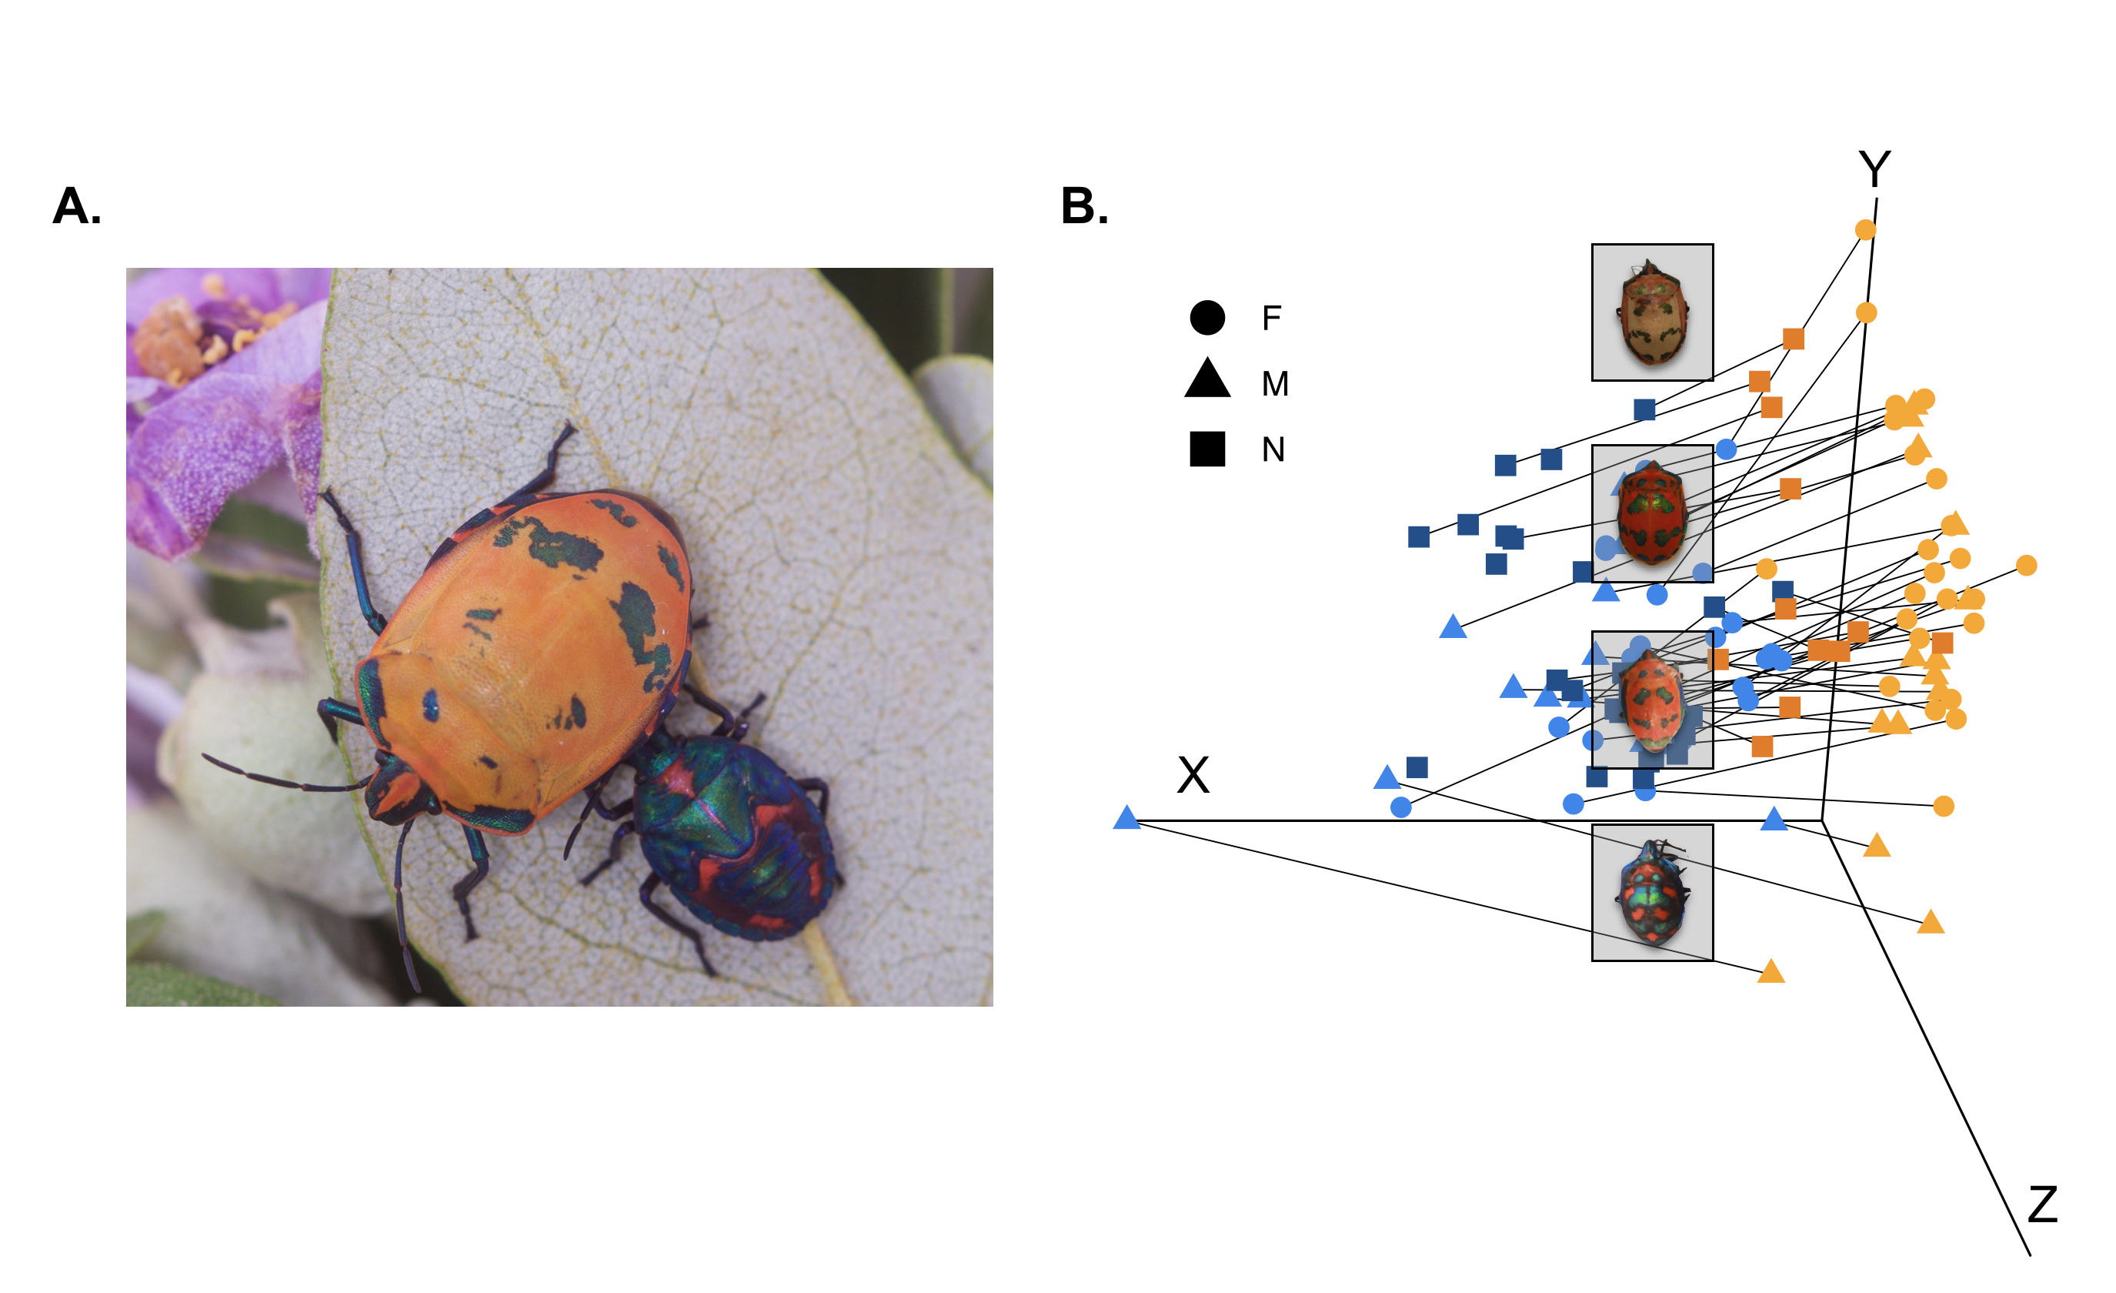
Figure 1. A. T. diophthalmus adult female (orange) and nymph (blue) on their host plant (L. patersonia). Males sometimes look like the females and in other instances they have a colouration more similar to the nymphs. B. Colour space with all individuals for which colour was measured: triangles indicate males, circles indicate females and squares indicate nymphs. Blue colours represent the blue patches measured and orange indicate the red/orange patches in each individual. Black lines join colours measured in the same individual, and shorter lines represent lower internal contrast while long black lines show higher internal contrast.

Toxicity differences
Larger individuals were more toxic than smaller individuals (Figure 2A, Table 2) and after controlling for the effect of weight, males were the most toxic followed by nymphs and females (Figure 2B, Table 2). Pairwise analyses indicate that males and nymphs have similar toxicity levels after controlling for weight (X²=3.38, P= 0.06).

Table 2. Results of LMM testing differences in toxicity between life stages, taking into account hours of exposure and bug body weight. A. When using as response variable the logarithm of toxicity (dead Daphnia) and B. When using the ratio of number of dead (toxicity/weight).
Response | a. log₁₀ (toxicity +1) |  | b. toxicity/weight
Predictors | Chi-square | P-value | Chi-square | P-value
Sex and stage | 10.331 | 0.006 | 10.67 | 0.0048
Weight | 27.006 | < 0.001
Batch | 71.36 | < 0.001 | 48.63 | < 0.001
Hour | 163.1 | < 0.001 | 119.34 | < 0.001

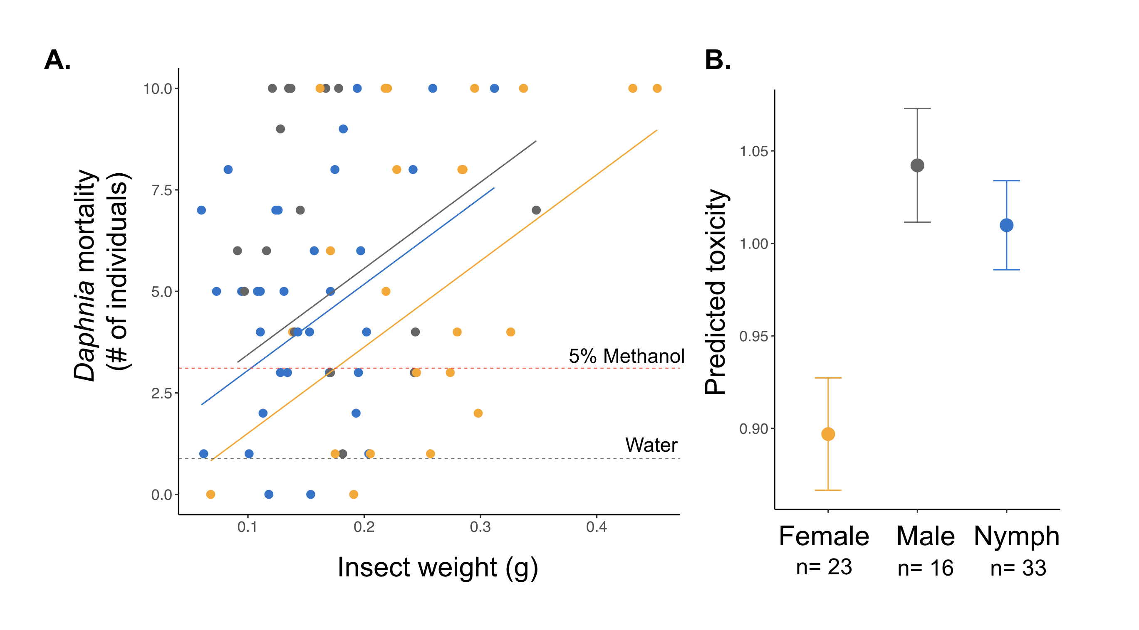
Figure 2. Results of toxicity assays. A. Association between insect size and toxicity, lines represent predicted values from GLMM (Table 2). B. Predicted toxicity from model in Table 2, controlling for the effect of size, trial number and hour measured. Circle shows mean and bars show 95% confidence interval of the mean.

Association between colour and toxicity
Across all individuals there was no association between colour and absolute toxicity (Figure 3A and B; Background contrast against fruits: T-value= 0.468, P=0.642, against leaves: T-value= 0.371, P=0.712, Internal contrast: T-value=0.360, P=0.720) or between colour and relative toxicity (Background contrast fruits: T-value= 1.586, P=0.120, against leaves: T-value= 1.501, P=0.140,Internal contrast: T-value= 0.203, P=0.840). There was also no association between colour saturation or colour contrast and toxicity when the analysis was done within females, males or nymphs (Table S1).
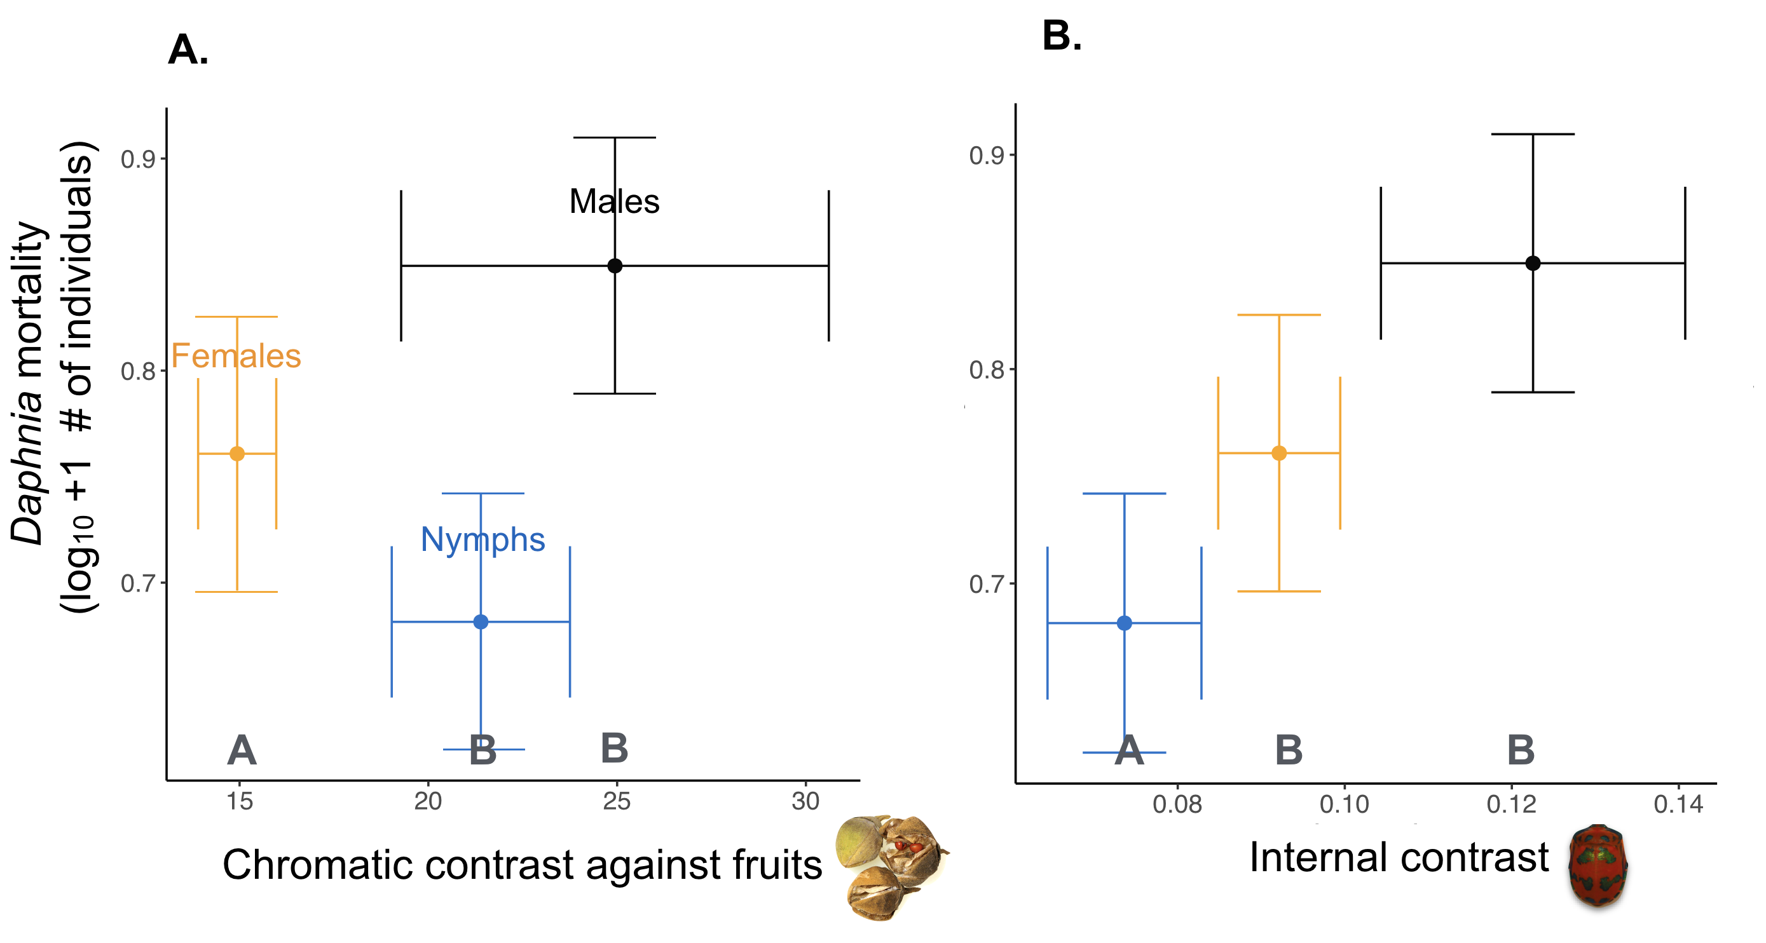
Figure 3. Association between average colour and average absolute toxicity across life stages. Lines represent standard errors. Letters at the bottom represent groups with significant differences in colour contrast. A. Chromatic contrast against fruits and B. Internal contrast calculated as the colour distance between the two colours present in each individual.

Field experiment
We were able to locate 19 different groups of choughs with a mean group size of 6.73 individuals. In total we observed 10 attacks on the bugs (11% of the 84 presentations, 4 females, 6 nymphs) and 30 attacks (100%) on the cricket presentations. Four attacks on bugs (40%) were carried out by young individuals (< 2 years). There were no differences in the probability of attack of nymphs or females (Z-value= -0.191, P= 0.848) and group size had a marginal effect on the attack rate, with larger groups attacking more prey (Z-value= 0.427, P= 0.053).

Discussion
There is mixed evidence that warning colouration provides honest signals of toxicity, and that there is a concomitant evolution of toxicity and colouration (Summers, Speed, Blount, & Stuckert, 2015). Ladybird adults and eggs present positive correlations between colour (contrast, saturation) and number of dead Daphnia or coccinelline concentration across species (Arenas et al., 2015; Anne E Winters, Stevens, Mitchell, Blomberg, & Blount, 2014). Nudibranchs and poison frogs present significant associations between colour brightness and toxicity against brine shrimp and mice, respectively (Anne E. Winters et al., 2018). However, in other cases, there is no signal honesty, for example there is no consistent association between colour and toxicity across burnet moth species (Emmanuelle Sophie Briolat, Zagrobelny, Olsen, Blount, & Stevens, 2018). Although several studies have explored signal honesty across species, very few have studied variation throughout ontogeny. Our results suggest that there is broad signal honesty within the Cotton Harlequin bug, and that males are both the most toxic and the most contrasting compared to nymphs and females. However, nymphs and females present no consistent association between colour and toxicity. Moreover, within morphs, there is no association between colour contrast or saturation and toxicity, suggesting that signal honesty is only weakly present in this species.

Colour contrast for all stages was higher against fruits than leaves. Harlequin bugs spend a lot of time feeding on the fruits of L. pattersonia, so having higher contrast against fruits could be beneficial for the bugs, since predators are less likely to attack and learn to avoid more easily colours that are more contrasting against their background (Arenas et al., 2015; Aronsson & Gamberale-Stille, 2009). In general, males and nymphs had similar contrast levels, and in most cases (Table 1) contrast values were higher than those for females. This difference in contrast was not manifested in the field experiment, given that we found no difference in attack rates between females and nymphs. In fact, naïve choughs rarely attacked coloured prey compared to crickets. To our knowledge there are no other insects similar to the Harlequin females or nymphs in Canberra, so previous experience is unlikely to explain the low attack rate in our experiment. However, we detected that several attacks were performed by recent fledglings in the group (which represent ~20% of the groups), suggesting that aversion to brightly coloured prey in choughs may not be innate, or that young individuals are more likely to try novel foods (e.g. (Biondi, Bó, & Vassallo, 2010; Greenberg & Mettke-Hofmann, 2001).

Differences in luminosity (achromatic contrast) between insects and background and differences in hue (chromatic contrast) were significantly higher in males. Males also had higher internal contrast, because usually the red and blue colours in males were more saturated than in nymphs or in females. There is some evidence suggesting that high internal contrast could be beneficial in predator learning (Barnett, Scott-Samuel, & Cuthill, 2016), although other studies have found no effect (Aronsson & Gamberale-Stille, 2008, 2009). In combination, our results suggest that the colour signal is stronger in males than in the other two categories. Iridescent patches in the Harlequin Cotton bug are more common in males, and are suggested to offer a benefit in predator learning (Scott A. Fabricant, Exnerová, Ježová, & Štys, 2014). These patches are unlikely to play a role in mating, since there is no evidence that Scutellerid bugs use colour as sexual signals and, in general, vision is not central in sexual selection in heteropterans that are not predators and live in dense vegetation, instead, these use body size and vibrational cues in courtship (Čokl, 2008; McLain, 1998).

Toxicity bioassays revealed that both males and nymphs were more toxic than female bugs, after taking into account body size. This suggests that, although the absolute toxicity of individuals does not differ, nymphs and males are more toxic per unit of weight, because they are smaller than females. Our findings support previous evidence showing that the number of epicuticular ductules is higher in nymphs than in adults of T. diophthalmus (Staddon et al., 1987). It also confirms what has been found in other true bugs, where chemicals such as 3-methyl pentanol and hexane are found in higher concentrations in nymphs than in adults (Abad, Azhari, Djozan, & Hejazi, 2012; Prudic, Noge, & Becerra, 2008). Prudic et al. found that individuals of the giant Mesquite bug (Thasus neocalifornicus) that had a higher concentration of chemicals were also better at deterring invertebrate predators. Contrary to what occurs in larvae of coleoptera and diptera, where aposematism is less common in larval stages (Heinrich, 1993), heteropteran larvae show the opposite pattern, where nymphs are more chemically defended than adults. This could be due to the higher resemblance in size, shape, ecology and microhabitat between larvae and adults in hemimetabolous insects, which may select for protection at both life stages.

Conclusion
Our study suggests that honesty of colour signals can vary both between sexes and across life stages. Both colour and toxicity change significantly between life stages in the Cotton Harlequin bug, but these do not change in parallel and there are significant sex effects. Males seem to be more protected than females and nymphs. One possibility is that males are more active or disperse longer distances than females and nymphs, and selection could favour a stronger and more effective aposematic signal in these. Males of other members of Pentatomorpha disperse significantly larger distances than females (English-Loeb & Collier, 1987; Lee & Leskey, 2015). Further experiments could explore whether this is the case for the Harlequin Cotton bug.

Females and nymphs of T. diophthalmus look very different (Fig 1), but the absolute toxicity levels are similar (i.e. without controlling for weight), and the attack rates in the field were the same. All this suggests that both phenotypes can deter predators equally effectively. This leaves open the question of why selection has favoured the evolution of such different colouration within the same species, if these changes are not linked to changes in toxicity. Future studies could explore in detail the effect of changes in colour during ontogeny in predator learning processes.

References
Abad, R., Azhari, S., Djozan, D., & Hejazi, M. (2012). Compounds in abdominal and metathoracic scent glands of nymphs and adults of Graphosoma lineatum (Linnaeus, 1758)(Het., scutelleridae) under laboratory conditions. Mun. Ent. Zool, 7(2), 870-880.
Amézquita, A., Ramos, Ó., González, M. C., Rodríguez, C., Medina, I., Simões, P. I., & Lima, A. P. (2017). Conspicuousness, color resemblance, and toxicity in geographically diverging mimicry: The pan‐Amazonian frog Allobates femoralis. Evolution, 71(4), 1039-1050.
Arenas, L. M., Walter, D., & Stevens, M. (2015). Signal honesty and predation risk among a closely related group of aposematic species. Scientific reports, 5, 11021.
Aronsson, M., & Gamberale-Stille, G. (2008). Domestic chicks primarily attend to colour, not pattern, when learning an aposematic coloration. Animal Behaviour, 75(2), 417-423. doi: https://doi.org/10.1016/j.anbehav.2007.05.006
Aronsson, M., & Gamberale-Stille, G. (2009). Importance of internal pattern contrast and contrast against the background in aposematic signals. Behavioral Ecology, 20(6), 1356-1362. doi: 10.1093/beheco/arp141
Barnett, J. B., Scott-Samuel, N. E., & Cuthill, I. C. (2016). Aposematism: balancing salience and camouflage. Biology Letters, 12(8), 20160335. doi: doi:10.1098/rsbl.2016.0335
Bates, D., Maechler, M., Bolker, B., & Walker, S. (2014). lme4: Linear mixed-effects models using Eigen and S4. R package version, 1(7), 1-23.
Biondi, L. M., Bó, M. S., & Vassallo, A. I. (2010). Inter-individual and age differences in exploration, neophobia and problem-solving ability in a Neotropical raptor (Milvago chimango). [journal article]. Animal Cognition, 13(5), 701-710. doi: 10.1007/s10071-010-0319-8
Booth, C. L. (1990). Evolutionary significance of ontogenetic colour change in animals. Biological Journal of the Linnean Society, 40(2), 125-163. doi: 10.1111/j.1095-8312.1990.tb01973.x
Briolat, E. S., Burdfield-Steel, E. R., Paul, S. C., Rönkä, K. H., Seymoure, B. M., Stankowich, T., & Stuckert, A. M. M. Diversity in warning coloration: selective paradox or the norm? Biological Reviews, 0(0). doi: doi:10.1111/brv.12460
Briolat, E. S., Zagrobelny, M., Olsen, C. E., Blount, J. D., & Stevens, M. (2018). No evidence of quantitative signal honesty across species of aposematic burnet moths (Lepidoptera: Zygaenidae). Journal of evolutionary biology.
Chouteau, M., & Angers, B. (2011). The role of predators in maintaining the geographic organization of aposematic signals. The American Naturalist, 178(6), 810-817.
Chouteau, M., Arias, M., & Joron, M. (2016). Warning signals are under positive frequency-dependent selection in nature. Proceedings of the national Academy of Sciences, 113(8), 2164-2169.
Čokl, A. (2008). Stink bug interaction with host plants during communication. Journal of Insect Physiology, 54(7), 1113-1124. doi: https://doi.org/10.1016/j.jinsphys.2008.06.004
Endler, J. A. (1988). Frequency-dependent predation, crypsis and aposematic coloration. Phil. Trans. R. Soc. Lond. B, 319(1196), 505-523.
English-Loeb, G. M., & Collier, B. D. (1987). Nonmigratory movement of adult harlequin bugs Murgantia histrionica (Hemiptera: Pentatomidae) as affected by sex, age and host plant quality. American Midland Naturalist, 189-197.
Fabricant, S. A., Exnerová, A., Ježová, D., & Štys, P. (2014). Scared by shiny? The value of iridescence in aposematic signalling of the hibiscus harlequin bug. Animal Behaviour, 90, 315-325. doi: https://doi.org/10.1016/j.anbehav.2014.01.021
Fabricant, S. A., & Smith, C. L. (2014). Is the hibiscus harlequin bug aposematic? The importance of testing multiple predators. Ecology and evolution, 4(2), 113-120.
Giffney, R. A., & Kemp, D. J. (2014). Does it pay to care?: Exploring the costs and benefits of parental care in the Hibiscus Harlequin Bug Tectocoris diophthalmus (Heteroptera: Scutelleridae). Ethology, 120(6), 607-615.
Greenberg, R., & Mettke-Hofmann, C. (2001). Ecological aspects of neophobia and neophilia in birds Current ornithology (pp. 119-178): Springer.
Harmon, S. M., & Mousseau, T. A. (2007). Toxicity of the Lovebug Plecia nearctica (Diptera: Bibionidae) in Two Common Indicator Organisms, Caenorhabditis elegans and Daphnia pulex. Entomologia Generalis/Journal of General and Applied Entomology, 32(4), 311.
Hegna, R. H., Galarza, J. A., & Mappes, J. (2015). Global phylogeography and geographical variation in warning coloration of the wood tiger moth (Parasemia plantaginis). Journal of Biogeography, 42(8), 1469-1481.
Heinrich, B. (1993). How avian predators constrain caterpillar foraging. In N. E. Stamp & T. M. Casey (Eds.), Caterpillars: Ecological and Evolutionary Constraints of Foraging (pp. 224-247). New York: Chapman and Hall.
Javahery, M., Schaefer, C. W., & Lattin, J. D. (2000). Shield bugs (Scutelleridae). Heteroptera of economic importance. CRC Press, Boca Raton, 475-503.
Joron, M., & Mallet, J. L. (1998). Diversity in mimicry: paradox or paradigm? Trends in Ecology & Evolution, 13(11), 461-466.
Lee, D.-H., & Leskey, T. (2015). Flight behavior of foraging and overwintering brown marmorated stink bug, Halyomorpha halys (Hemiptera: Pentatomidae). Bulletin of entomological research, 105(5), 566-573.
Lindstedt, C., Schroderus, E., Lindström, L., Mappes, T., & Mappes, J. (2016). Evolutionary constraints of warning signals: A genetic trade-off between the efficacy of larval and adult warning coloration can maintain variation in signal expression. Evolution, 70(11), 2562-2572. doi: doi:10.1111/evo.13066
Lindström, L., Alatalo, R. V., Lyytinen, A., & Mappes, J. (2001). Strong antiapostatic selection against novel rare aposematic prey. Proceedings of the National Academy of Sciences, 98(16), 9181-9184.
Maia, R., Eliason, C. M., Bitton, P. P., Doucet, S. M., & Shawkey, M. D. (2013). pavo: an R package for the analysis, visualization and organization of spectral data. Methods in Ecology and Evolution, 4(10), 906-913.
Mallet, J., & Joron, M. (1999). Evolution of diversity in warning color and mimicry: polymorphisms, shifting balance, and speciation. Annual Review of Ecology and Systematics, 30(1), 201-233.
McLain, D. K. (1998). Non-genetic benefits of mate choice: fecundity enhancement and sexy sons. Animal Behaviour, 55(5), 1191-1201. doi: https://doi.org/10.1006/anbe.1997.0681
Medina, I., Wang, I. J., Salazar, C., & Amézquita, A. (2013). Hybridization promotes color polymorphism in the aposematic harlequin poison frog, O ophaga histrionica. Ecology and evolution, 3(13), 4388-4400.
Noonan, B. P., & Comeault, A. A. (2009). The role of predator selection on polymorphic aposematic poison frogs. Biology Letters, 5(1), 51-54.
Poulton, E. B. (1890). The colours of animals: their meaning and use, especially considered in the case of insects: D. Appleton.
Prudic, K. L., Noge, K., & Becerra, J. X. (2008). Adults and Nymphs Do Not Smell the Same: The Different Defensive Compounds of the Giant Mesquite Bug (Thasus neocalifornicus: Coreidae). [journal article]. Journal of Chemical Ecology, 34(6), 734. doi: 10.1007/s10886-008-9480-9
Rojas, B., & Endler, J. A. (2013). Sexual dimorphism and intra-populational colour pattern variation in the aposematic frog Dendrobates tinctorius. Evolutionary Ecology, 27(4), 739-753.
Rowley, I. (1978). Communal activities among white‐winged choughs Corcorax melanorhamphus. Ibis, 120(2), 178-197.
Staddon, B., Thorne, M., & Knight, D. (1987). The Scent Glands and Their Chemicals in the Aposematic Cotton Harlequin Bug, Tectocoris-Diophthalmus (Heteroptera, Scutelleridae). Australian journal of zoology, 35(3), 227-234.
Stevens, M., & Ruxton, G. D. (2012). Linking the evolution and form of warning coloration in nature. Proc. R. Soc. B, 279(1728), 417-426.
Stuckert, A. M., Venegas, P. J., & Summers, K. (2014). Experimental evidence for predator learning and Müllerian mimicry in Peruvian poison frogs (Ranitomeya, Dendrobatidae). Evolutionary ecology, 28(3), 413-426.
Summers, K., Speed, M., Blount, J., & Stuckert, A. (2015). Are aposematic signals honest? A review. Journal of evolutionary biology, 28(9), 1583-1599.
Sword, G. A. (1999). Density-dependent warning coloration. Nature, 397(6716), 217.
Twomey, E., Vestergaard, J. S., & Summers, K. (2014). Reproductive isolation related to mimetic divergence in the poison frog Ranitomeya imitator. Nature communications, 5, 4749.
Wang, I. J., & Shaffer, H. B. (2008). Rapid color evolution in an aposematic species: a phylogenetic analysis of color variation in the strikingly polymorphic strawberry poison‐dart frog. Evolution: International Journal of Organic Evolution, 62(11), 2742-2759.
Wink, M., Grimm, C., Koschmieder, C., Sporer, F., & Bergeot, O. (2000). Sequestration of phorbolesters by the aposematically coloured bug Pachycoris klugii (Heteroptera: Scutelleridae) feeding on Jatropha curcas (Euphorbiaceae). Chemoecology, 10(4), 179-184.
Winters, A. E., Stevens, M., Mitchell, C., Blomberg, S. P., & Blount, J. D. (2014). Maternal effects and warning signal honesty in eggs and offspring of an aposematic ladybird beetle. Functional ecology, 28(5), 1187-1196.
Winters, A. E., White, A. M., Dewi, A. S., Mudianta, I. W., Wilson, N. G., Forster, L. C., . . . Cheney, K. L. (2018). Distribution of Defensive Metabolites in Nudibranch Molluscs. [journal article]. Journal of Chemical Ecology, 44(4), 384-396. doi: 10.1007/s10886-018-0941-5

