Title: Elevated nest predation risk promotes offspring size variation in birds with prolonged parental care.
Authors and affiliations:
Gretchen F. Wagner^{1,2*} g.wagner@nioo.knaw.nl
¹ Department of Anthropology, University of Zürich, Zürich, Switzerland
² Department of Animal Ecology, Netherlands Institute of Ecology (NIOO-KNAW), Wageningen, The Netherlands
*corresponding author
Emeline Mourocq¹ emeline.mourocq@uzh.ch
¹ Department of Anthropology, University of Zürich, Zürich, Switzerland
Michael Griesser^{1,3} michael.griesser@uzh.ch
¹ Department of Anthropology, University of Zürich, Zürich, Switzerland
³ Department of Evolutionary Biology and Environmental Studies, University of Zürich, Zürich, Switzerland
Running head: Reproductive strategy under high risk
Key-words: egg size variation, nest predation, reproductive allocation, reproductive flexibility, reproductive success
Acknowledgements: We thank Carlota Gutiérrez Arce, Javier Cotín Martínez, Juan Diego Ibáñez-Álamo, Francisco Espinosa Alemany, Álvaro de las Heras Pardo, Marta Peris Cabré, Sharon Schillewaert, Patrick Kelly, Margherita Bandini, John Kronenberger, Tania Bobbo, Victor Jiménez García, Matteo Belpinati, Juan Naredo Turrado, Daniel Colette and Hailey Scofield for assistance in the field; Manuel Soler and Alberto Redondo for support at the study sites; Szymon Drobniak, Juan Diego Ibáñez-Álamo, Andrew Russell, Liana Zanette and Carel Van Schaik for helpful discussions and/or comments on the manuscript. This study was supported by the Swiss National Science Foundation (PPOOP3_123520, PP00P3_150752). Permits for field work in Spain were provided by the Junta de Andalucía and the Bird Migration Center (CMA) of the Spanish Ornithological Society (SEO).
Abstract
Predation of offspring is the main cause of reproductive failure in many species, and the mere fear of offspring predation shapes reproductive strategies. Yet, natural predation risk is ubiquitously variable and can be unpredictable. Consequently, the perceived prospect of predation early in a reproductive cycle may not reflect the actual risk to ensuing offspring. An increased variance in investment across offspring has been linked to breeding in unpredictable environments in several taxa, but has so far been overlooked as a maternal response to temporal variation in predation risk. Here, we experimentally increased the perceived risk of nest predation prior to egg-laying in seven bird species. Species with prolonged parent-offspring associations increased their intra-brood variation in egg, and subsequently offspring, size. High risk to offspring early in a reproductive cycle can favour a risk-spreading strategy particularly in species with the greatest opportunity to even out offspring quality after fledging.
Predation of eggs and dependent young is a major cause of reproductive failure in many systems, affecting the evolution of reproductive allocation strategies¹⁻³. Effects of fear of predation can even surpass the lethal effects of direct predation⁴⁻⁶. Therefore, fear of offspring predation likely shapes reproductive decisions to increase the probability of successful reproduction^{2,7,8}. However, benefits derived from fear can be offset by costs, such as reduced reproductive success, even in the absence of direct predation^{5,9,10}.
Predation risk is ubiquitously variable and can change rapidly in time and space. Accordingly, field studies have investigated changes in parental decisions over natural risk gradients^{10,11} and in response to experimental modifications of perceived risk^{12,13}. In birds, field experiments have demonstrated that parents can alter their reproductive investment depending on the perceived nest predation risk^{10,14,15}. However, these studies have yielded contrasting results, suggesting that species differ in their responses ¹⁶, which was confirmed by a recent comparative study¹⁷. This research line has hitherto focused on mean traits (i.e., mean clutch size and/or egg size), while variance in investment across offspring has been overlooked, despite that it may play an important role in maternal responses to environmental changes²⁵.
A widespread response to variable and/or unpredictable environments in general is an increased variance in investment across offspring²¹⁻²⁴. Observational and experimental studies in invertebrates, fish, and amphibians have shown that environmental uncertainty can lead to an increased within-clutch variation in egg or larva size (reviewed in ²⁵). Similarly, in birds, within-clutch variation in offspring size has been suggested to be a risk-spreading strategy in variable environments²⁶. Intra-clutch differences in egg size can contribute to nestling size hierarchies²⁷, allowing parents to selectively raise the strongest offspring if poor conditions persist, but maintain the possibility of raising all offspring if conditions improve²⁸. Although this strategy is usually linked to fluctuations in food availability^{27,29}, it could similarly be a response to fluctuations in predation risk. Effects on reproduction of predation risk may even be mistaken for effects of food limitation in numerous taxa⁹. Against this background, we speculated that females may increase the variance in egg size in response to increased nest predation risk.
Here we investigate differences in the reproductive responses of seven bird species to an experimentally increased perceived risk of nest predation prior to egg laying. We examined how life-history and ecological factors influence the risk sensitivity of breeding birds in ecological time. Following life-history theory, we assume that species with a slow life history pace are the most sensitive to adverse breeding conditions^{32,33} and are expected to adjust their allocation in a risky environment compared to species with a fast pace of life. In addition, species with naturally high nest predation rates are expected to be most sensitive^{13,17}. Finally, species with extended post-fledging parent-offspring associations (i.e., family-living ³⁴) are predicted to lay smaller eggs and/or increase the variance in egg size when faced with high nest predation risk, as these species have a greater opportunity to compensate for poor offspring condition than species with prompt offspring dispersal³⁵.
Results and Discussion
Analyses were based on 156 nests of seven species (Table 1). Our comparative experiment corroborates that species vary in their responses to an increased perceived risk of nest predation^{13,17} and demonstrates that a temporarily increased nest predation risk prior to egg-laying can have detrimental downstream effects on reproductive success (see also Supplementary Results and Discussion). Although responses varied across species (Fig. 1) none of the included factors explain interspecific differences in treatment effects on the number of eggs, nestlings, or fledglings (Table 2), or the egg or clutch volume (Table 3). However, our experiments revealed that birds generally decreased their clutch volume in response to an increased perceived risk of nest predation (Table 3). Moreover, high-risk nests were marginally less likely to fledge offspring than control nests (log-odds = 0.78, 95% CI= -0.07 – 1.61, p=0.06, Fig. 3), particularly due to significantly higher failure during the nestling stage (log-odds = 1.38, CI= 0.05 – 2.69, p=0.02, Fig. 3). Yet, the proportion of nest failures caused by direct nest predation did not differ between the predator and control nests (29.6% vs. 23.7% respectively, z=0.90, p=0.38), suggesting that abandonment or starvation is responsible for increased failure of experimental nests.
Previous studies that increased predation risk throughout the entire breeding cycle have also found decreased reproductive success^{10,15,17}, which has been attributed to combined effects of parental decisions under high risk during egg-laying, incubation and provisioning. In contrast, our experimental treatment was removed at the onset of egg-laying, and therefore one could expect highest nest abandonment early on in the breeding cycle. Yet, our results highlight that the conditions, and resulting investment decisions, at the laying stage impact reproductive success at later stages, even if conditions improve. The here observed decrease in reproductive success may be a delayed consequence of reduced investment at the laying stage or may be a result of a prolonged heightened sensitivity to predation risk to nestlings. Further studies are necessary to elucidate what mechanisms may influence nest success following temporarily increased nest failure risk prior to breeding.
An increased within-clutch variation in egg volume was associated with a prolonged association between offspring and parents in the nest predator treatment group only (Fig. 2), suggesting that these species alter the distribution of their reproductive allocation across their eggs under high nest predation risk. No other factor explained differences in the within-clutch variation in egg volume (Table 3). Egg size variation may result in increased or decreased variation among nestlings, depending on the timing of hatching. Although we could not link nestling size with its corresponding egg size, post-hoc examination of 10-day old nestling data (from nests with at least two hatchlings) indicated that this increased variation in egg size led to an increased variation in nestling mass among siblings in nests that were exposed to a high perceived risk of predation prior to egg-laying (mean coefficient of variation ± SD, predator vs. control: O. leucura: 0.09±0.03 vs. 0.05±0.02; M. apiaster: 0.17±0.09 vs. 0.08±0.07; A. caudatus: 0.12±0.05 vs. 0.07±0.02).
Variation in offspring size may be an adaptive strategy to cope with unpredictable environments^{24,36}. In various taxa, increased within-clutch variation in offspring size is found in mothers that face environmental uncertainty (reviewed in ²⁵). Similarly, in birds, brood reduction, which is facilitated by within-clutch variation in egg size²⁷, is suggested to be an adaptive strategy to cope with unpredictable environments^{24,26}. Predation risk is an environmental feature that fluctuates considerably in space and time^{18,20}, and can be unpredictable³⁷. Consequently, the perceived risk of nest predation early in a reproductive cycle may not reflect the actual risk to offspring later on. If high predation risk prevails throughout the nesting period, a smaller number of nestlings may reduce the risk of whole brood failure through reduced nest attentiveness^{13,30}. However, if all offspring survive, parents may compensate for offspring condition asymmetry through prolonged post-fledging care and/or providing preferential care to lesser offspring once the high-risk period has passed³⁸.
Conclusions
Although our data do not allow a direct test of this hypothesis, our results suggest that family-living species use diversification and compensation strategies to cope with fluctuating predation risk to offspring. Indeed, these species have longer and more variable durations of post-fledging parental care, which has important consequences for offspring survival^{39,40}. Thus, parents of family-living species have a greater opportunity to balance out offspring quality after their offspring have fledged, which may allow for greater flexibility in reproductive allocation during egg-laying and nestling care. Inclusion of an additional long-lived, family-living species (Siberian jay Perisoreus infaustus) in our analyses, using the data from a similar experiment¹⁴, yielded the same patterns of results (Extended Data Tables 3-6) as we report here. Similarly, the coefficient of variation of nestling mass of perceived high-risk nests in that study was double that of control nests (0.84 vs. 0.40), suggesting that our findings may be generally extended across bird species.
Our results confirm that increased nest predation risk at the time of egg-laying had delayed detrimental effects on reproductive success, emphasizing the need for assessment of how variable risk levels at different times during the breeding cycle ultimately affect fitness. Furthermore, the novel link between within-clutch egg size variation and predation risk highlights that family-living species may use a diversified bet-hedging strategy³⁶ when breeding under high risk conditions. As the mean and variance of a trait are inextricably linked, and adjustments to each may arise independently or jointly^{41,42}, they should be considered concurrently. Previous findings of experimentally-induced changes to mean offspring size may even reflect a byproduct of shifts in the variance of offspring size, rather than an adaptive strategy per se ²⁵. Additional comparative studies will help us to understand the evolved mechanisms for coping with changes to offspring predation risk and to develop a broader framework of interspecific differences. In particular, considering both the mean and variance of reproductive traits will paint a clearer picture of maternal strategies for coping with variable predation risk to offspring.
Methods
Experimental design
Data for this study were collected from seven bird species, which differ in life history traits and natural nest predation pressure (Table 1), in southern Spain in 2011-2014. We manipulated the perceived risk of nest predation by simulating an increased presence of nest predators prior to females laying eggs of their first breeding attempt of the year through presentation of playbacks of avian predator calls or live brown rats (Rattus norvegicus). We selected the common nest predators for each species based on multiple years of nest monitoring. Control treatments consisted of a playback of locally occurring non-threatening bird calls or the presence of a juvenile European rabbit (Oryctolagus cuniculus). For each species, treatment areas were randomly assigned to either a predator treatment or a control treatment. Playbacks were presented daily from 07:00-19:00 local time, with 12 hours of silence played overnight. Each 12-hour period of calls was comprised of a unique combination of 15-30 seconds of calls, separated by 4 minutes of silence. Live animals were kept in transparent enclosures equipped with food, water, and bedding (fresh and dried grasses), and were continuously present in sheltered areas of the territory. All treatment areas were visited every 1-3 days to maintain the treatments (change batteries, provide care for animals) and to check nest contents. The location of playbacks and mammals were changed during each visit. We began the experiment approximately 10 days prior to egg laying in all species, which was estimated based on behaviour, the phenology of previous breeding seasons, and/or nest-building progress. Treatments were removed as soon as an egg was observed in the nest. Nests were exposed for a mean (±SD) of 9.6±0.14 days.
Once a clutch was complete, we measured the length and width of all eggs using dial callipers (0.1mm accuracy). Individual egg volume was calculated using the formula⁴³ volume=0.51*(length)*(breadth)². Nests were monitored throughout the entire breeding cycle. The number of eggs, hatchlings and fledglings, and any nest failures, were recorded for each nest. The number of fledglings was assessed based on the number of nestlings in the nest prior to fledging (<3 days) and/or observations of juveniles after fledging. Nest failures were assumed to be caused by predators if the entire clutch or brood disappeared prematurely, or evidence, such as punctured eggs, or albumen or blood on nest material, was discovered.
Statistical Analyses
All statistical tests were conducted with R 3.1.0 ⁴⁴. We first ran a principal components analysis (PCA; package 'psych' ⁴⁵) on continuous species traits of interest (adult survival probability, body mass, nesting time, and post-fledging parent-offspring association time; see Table 1). We extracted 2 components which cumulatively accounted for 89% (60 and 29%, respectively) of the total variance (Extended Data Table 1). The first component, labelled “life-history pace”, included positive loadings of adult body mass, nesting time (from egg-laying until fledging), and mean annual adult survival. The second component, labelled “time post-fledging”, included only the post-fledging association time of offspring with their parents.
To examine among-species patterns of experimental effects on clutch size, egg volume, clutch volume, within-clutch variation of egg volume, number of hatchlings and number of fledglings we ran separate (generalized) linear mixed models (GLMM) in the package ‘nlme’ ⁴⁶. All models included the experimental treatment (predator, control), and its interaction with ambient predation risk (percent of non-experimental nests lost to predation in the year of the experiment), re-nesting potential (single- or multiple-brooded), and the two PCs (life-history pace, time post-fledging) as explanatory variables. In addition, we included several nest-specific variables as potential co-variates, to control for individual differences between nests and treatments, including: relative laying date (the number of days since the first egg of the year for each species), stimulus type (mammalian, avian), the mean distance between each nest and the experimental stimuli, and clutch size (except in the model assessing clutch size itself). To ensure that differences in responses were not based on the stimulus type per se, we also included the stimulus type and its interaction with the treatment as a factor in all analyses. Because multiple nests of densely-nesting/colonial species were sometimes exposed to the same treatment unit, unit ID was included as a random factor. Year and species identity were also included as random factors in all models, and nest identity was additionally included as a random factor in the model of egg volume. Models of clutch size, number of hatchlings and number of fledglings were fitted with a Poisson distribution, residuals from all other models assumed a reasonably Gaussian distribution. Non-significant interactions between main effects were sequentially removed from models to attain a minimized adequate model⁴⁷, but main effects were retained to control for potentially important biological and experimental influences. Aikaike information criteria (AIC) and Bayesian information criteria (BIC) were examined to ensure that removal of terms did not weaken model fit. Appropriate model fits were confirmed with chi-square tests of the residual deviance and inspection of the residual distributions.
We examined whether nests were more likely to fail or succeed according to the experimentally increased risk of nest predation prior to egg laying. We fit binary (logit link) GLMMs using Markov Chain Monte Carlo methods (package 'MCMCglmm' ⁴⁸) for overall nest success, and nest success at each stage of nesting. The binary models were run for 200’000 iterations, with a burn-in period of 2’000 iterations and a thinning interval of 200, resulting in ca. 1’000 samples from the posterior distributions for each model parameter. We specified a prior following normal distribution N(0; σ2units + π2/3) for the fixed effects⁴⁸. For the random effects we used a parameter expanded prior with a variance of 1 and a degree of belief of 0.002, with the parameter expansion set to a mean of 0, and a covariance matrix of 1000. Residual variance cannot be calculated in analyses of binary traits and accordingly, we fixed the residual error to 1. Model convergence was confirmed by visual examination of MCMC chains⁴⁸ and diagnostics via the coda package⁴⁹. Autocorrelation among consecutive observations was low (<0.05).
Data accessibility
All data supporting the results presented herein will be archived in Dryad and the data DOI will be included in the article.
References
1 Ricklefs, R. E. An analysis of nesting mortality in birds. (Smithsonian Institution Press, 1969).
2 Martin, T. E. & Briskie, J. V. Predation on dependent offspring. Ann. N. Y. Acad. Sci. 1168, 201-217 (2009).
3 Martin, T. E. Avian life history evolution in relation to nest sites, nest predation, and food. Ecological monographs 65, 101-127 (1995).
4 Lima, S. L. Nonlethal Effects in the Ecology of Predator-Prey Interactions. Bioscience 48, 25-34, doi:10.2307/1313225 (1998).
5 Preisser, E. L., Bolnick, D. I. & Benard, M. F. Scared to death? The effects of intimidation and consumption in predator-prey interactions. Ecology 86, 501-509, doi:10.1890/04-0719 (2005).
6 Cresswell, W. Non-lethal effects of predation in birds. Ibis 150, 3-17, doi:10.1111/j.1474-919X.2007.00793.x (2008).
7 Sih, A. Predation risk and the evolutionary ecology of reproductive behaviour. J. Fish Biol. 45, 111-130 (1994).
8 Coslovsky, M. & Richner, H. Predation risk affects offspring growth via maternal effects. Functional Ecology 25, 878-888 (2011).
9 Creel, S. & Christianson, D. Relationships between direct predation and risk effects. Trends Ecol. Evol. 23, 194-201 (2008).
10 Zanette, L. Y., White, A. F., Allen, M. C. & Clinchy, M. Perceived predation risk reduces the number of offspring songbirds produce per year. Science 334, 1398-1401 (2011).
11 Thomson, R. L., Forsman, J. T. & Mönkkönen, M. Risk taking in natural predation risk gradients: support for risk allocation from breeding pied flycatchers. Anim. Behav. 82, 1443-1447, doi:http://dx.doi.org/10.1016/j.anbehav.2011.09.029 (2011).
12 Fuller, R. & Berglund, A. Behavioral responses of a sex-role reversed pipefish to a gradient of perceived predation risk. Behav. Ecol. 7, 69-75, doi:10.1093/beheco/7.1.69 (1996).
13 Ghalambor, C. K., Peluc, S. I. & Martin, T. E. Plasticity of parental care under the risk of predation: how much should parents reduce care? Biol. Lett. 9, 20130154 (2013).
14 Eggers, S., Griesser, M., Nystrand, M. & Ekman, J. Predation risk induces changes in nest-site selection and clutch size in the Siberian jay. Proceedings of the Royal Society of London B: Biological Sciences 273, 701-706 (2006).
15 Hua, F., Sieving, K. E., Fletcher, R. J. & Wright, C. A. Increased perception of predation risk to adults and offspring alters avian reproductive strategy and performance. Behav. Ecol. 25, 509-519, doi:10.1093/beheco/aru017 (2014).
16 Ibáñez-Álamo, J. et al. Nest predation research: recent findings and future perspectives. J. Ornithol., 1-16 (2015).
17 LaManna, J. A. & Martin, T. E. Costs of fear: behavioural and life-history responses to risk and their demographic consequences vary across species. Ecol. Lett. 19, 403-413, doi:10.1111/ele.12573 (2016).
18 Lima, S. L. & Bednekoff, P. A. Temporal variation in danger drives antipredator behavior: the predation risk allocation hypothesis. The American Naturalist 153, 649-659 (1999).
19 Sih, A. & McCarthy, T. M. Prey responses to pulses of risk and safety: testing the risk allocation hypothesis. Animal Behaviour 63, 437-443 (2002).
20 Ferrari, M. C., Sih, A. & Chivers, D. P. The paradox of risk allocation: a review and prospectus. Anim. Behav. 78, 579-585 (2009).
21 Crump, M. L. Variation in propagule size as a function of environmental uncertainty for tree frogs. Am. Nat., 724-737 (1981).
22 Koops, M. A., Hutchings, J. A. & Adams, B. K. Environmental predictability and the cost of imperfect information: influences on offspring size variability. Evolutionary Ecology Research 5, 29-42 (2003).
23 Marshall, D. J., Bonduriansky, R. & Bussière, L. F. Offspring size variation within broods as a bet-hedging strategy in unpredictable environments. Ecology 89, 2506-2517 (2008).
24 Caro, S. M., Griffin, A. S., Hinde, C. A. & West, S. A. Unpredictable environments lead to the evolution of parental neglect in birds. Nat Commun 7, doi:10.1038/ncomms10985 (2016).
25 Crean, A. J. & Marshall, D. J. Coping with environmental uncertainty: dynamic bet hedging as a maternal effect. Philosophical Transactions of the Royal Society of London B: Biological Sciences 364, 1087-1096 (2009).
26 Laaksonen, T. Hatching asynchrony as a bet‐hedging strategy–an offspring diversity hypothesis. Oikos 104, 616-620 (2004).
27 Slagsvold, T., Sandvik, J., Rofstad, G., Lorentsen, Ö. & Husby, M. On the adaptive value of intraclutch egg-size variation in birds. Auk, 685-697 (1984).
28 Lack, D. The significance of clutch‐size. Ibis 89, 302-352 (1947).
29 Lack, D. The natural regulation of animal numbers. The Natural Regulation of Animal Numbers. (1954).
30 Eggers, S., Griesser, M. & Ekman, J. Predator-induced plasticity in nest visitation rates in the Siberian jay (Perisoreus infaustus). Behav. Ecol. 16, 309-315 (2005).
31 Mutzel, A. et al. Temporal trade-offs between nestling provisioning and defence against nest predators in blue tits. Anim. Behav. 85, 1459-1469 (2013).
32 Roff, D. Evolution of life histories: theory and analysis. (Springer Science & Business Media, 1993).
33 Erikstad, K. E., Fauchald, P., Tveraa, T. & Steen, H. On the cost of reproduction in long-lived birds: the influence of environmental variability. Ecology 79, 1781-1788 (1998).
34 Drobniak, S. M., Wagner, G., Mourocq, E. & Griesser, M. Family living: an overlooked but pivotal social system to understand the evolution of cooperative breeding. Behav. Ecol. (2015).
35 Griesser, M., Drobniak, S. M., Nakagawa, S. & Botero, C. A. Family living sets the stage for cooperative breeding and ecological resilience in birds. PLoS Biology 15, e2000483 (2017).
36 Philippi, T. & Seger, J. Hedging one's evolutionary bets, revisited. Trends in Ecology & Evolution 4, 41-44 (1989).
37 Ferrari, M. C., Rive, A. C., MacNaughton, C. J., Brown, G. E. & Chivers, D. P. Fixed vs. random temporal predictability of predation risk: an extension of the risk allocation hypothesis. Ethology 114, 238-244 (2008).
38 Shizuka, D. & Lyon, B. E. Family dynamics through time: brood reduction followed by parental compensation with aggression and favouritism. Ecol. Lett. 16, 315-322 (2013).
39 Green, D. J. & Cockburn, A. Post-fledging care, philopatry and recruitment in brown thornbills. J. Anim. Ecol. 70, 505-514, doi:10.1046/j.1365-2656.2001.00503.x (2001).
40 Griesser, M., Nystrand, M. & Ekman, J. Reduced mortality selects for family cohesion in a social species. Proceedings of the Royal Society of London B: Biological Sciences 273, 1881-1886, doi:10.1098/rspb.2006.3527 (2006).
41 De Jong, G. Evolution of phenotypic plasticity: patterns of plasticity and the emergence of ecotypes. New Phytol. 166, 101-118 (2005).
42 Ghalambor, C. K., McKay, J. K., Carroll, S. P. & Reznick, D. N. Adaptive versus non‐adaptive phenotypic plasticity and the potential for contemporary adaptation in new environments. Funct. Ecol. 21, 394-407 (2007).
43 Hoyt, D. F. Practical methods of estimating volume and fresh weight of bird eggs. The Auk, 73-77 (1979).
44 R: A language and environment for statistical computing. (R Foundation for Statistical Computing, Vienna, Austria, 2018).
45 psych: Procedures for Personality and Psychological Research v. 1.5.8 (Northwestern University, Evanston, Illinois, USA, 2015).
46 nlme: Linear and Nonlinear Mixed Effects Models v. 3.1-118 (2014).
47 Crawley, M. J. Statistical computing: an introduction to data analysis using S-Plus.–J. Statistical computing: an introduction to data analysis using S-Plus (2002).
48 Hadfield, J. D. MCMC methods for multi-response generalized linear mixed models: the MCMCglmm R package. Journal of Statistical Software 33, 1-22 (2010).
49 Plummer, M., Best, N., Cowles, K. & Vines, K. CODA: convergence diagnosis and output analysis for MCMC. R news 6, 7-11 (2006).

Table 1. Life history and ecology of study species; ‘adult survival’ is the estimated average percentage of adults that survive from one breeding season to the next, ‘re-nest’ indicates the probability to breed again in the same season after a successful attempt, ‘nest time’ is the average number of days from egg-laying until fledging, ‘post-fledging time’ is the average number of days offspring spend in association with parents after fledging.
species |  | N (nests) |  | species traits
common name | scientific name | predator | control | Body ¹ mass (g) | adult ² survival (%) | re- ¹ nest | mean ¹ clutch size | nest ¹ time (d) | post- ² fledging time (d) | nest ¹ predation (%)
Black wheatear | Oenanthe leucura | 8 | 9 | 36 | 49.5 | High | 4.0 | 31 | 200 | 28.6
Common blackbird | Turdus merula | 8 | 19 | 94 | 56.0 | High | 2.9 | 27 | 21 | 21.7
European bee-eater | Merops apiaster | 11 | 12 | 52 | 49.8 | Low | 5.7 | 57 | 250 | 22.8
Great  tit | Parus  major | 10 | 10 | 17 | 48.6 | High | 7.5 | 37 | 30 | 36.9
Long-  tailed tit | Aegithalos caudatus | 9 | 11 | 7 | 55.0 | Low | 7.3 | 32 | 300 | 77.8
Red-billed chough | Pyrrhocorax pyrrhocorax | 13 | 16 | 310 | 80.0 | Low | 4.7 | 56 | 42 | 7.7
Spotless starling | Sturnus unicolor | 13 | 8 | 74 | 49.9 | High | 4.6 | 34 | 7 | 26.3

¹ Values obtained from the study population
² Values obtained from published data (del Hoyo et al. 2016)
Table 2. Poisson-distributed Generalized Linear Mixed Model estimates (est.), corresponding standard errors (SE) and p-values (p) for predictors of the number of offspring in successful nests at each nest stage. Significant fixed effects (p<0.05) are denoted in bold. Random effects are standard deviation.
 | clutch size |  |  |  | number of nestlings |  |  |  | number of fledglings
fixed effects | est. | SE | p |  | est. | SE | p |  | est. | SE | p
intercept | 1.58 | 0.22 | <0.01 |  | 0.70 | 0.83 | 0.40 |  | 0.80 | 1.10 | 0.47
treatment (predator)¹ | -0.04 | 0.07 | 0.62 |  | 0.06 | 0.09 | 0.54 |  | 0.11 | 0.13 | 0.38
life-history pace | -0.10 | 0.25 | 0.68 |  | -0.40 | 0.53 | 0.45 |  | -0.25 | 0.70 | 0.72
time post-fledging | -0.01 | 0.21 | 0.96 |  | -0.68 | 0.86 | 0.42 |  | -0.43 | 1.12 | 0.70
re-nesting potential (low)¹ | 0.33 | 0.58 | 0.57 |  | 1.33 | 1.53 | 0.38 |  | 0.99 | 2.03 | 0.62
predation risk | 0.22 | 0.07 | <0.01 |  | 0.03 | 0.15 | 0.84 |  | 0.07 | 0.17 | 0.69
laying date | -0.03 | 0.05 | 0.47 |  | -0.02 | 0.06 | 0.81 |  | -0.01 | 0.07 | 0.87
predator type (mammalian)¹ | 0.01 | 0.26 | 0.95 |  | 0.65 | 0.89 | 0.47 |  | 0.39 | 1.15 | 0.73
proximity to nest | 0.04 | 0.05 | 0.37 |  | -0.03 | 0.08 | 0.70 |  | -0.02 | 0.11 | 0.83
clutch size | na | na | na |  | 0.37 | 0.09 | <0.01 |  | 0.24 | 0.12 | 0.04
random effects
species | <0.01 |  |  |  | <0.01 |  |  |  | <0.01
year | <0.01 |  |  |  | <0.01 |  |  |  | <0.01
unit | <0.01 |  |  |  | <0.01 |  |  |  | <0.01

¹ Reference levels of categorical variables (i.e., treatment: control, re-nesting potential: high, and predator type: avian) have an estimate of 0.

 | egg volume |  |  | clutch volume |  |  | egg volume variation
fixed effects | est. | SE | p | est. | SE | p | est. | SE | p
intercept | -1.75 | 1.08 | 0.11 | -2.94 | 1.96 | 0.14 | 2.86 | 1.03 | 0.01
treatment (predator)¹ | 0.01 | 0.02 | 0.64 | -0.06 | 0.03 | 0.03 | 0.09 | 0.15 | 0.55
life-history pace | -0.11 | 0.63 | 0.89 | 0.62 | 1.16 | 0.65 | 1.56 | 0.51 | 0.09
time post-fledging | -1.99 | 0.87 | 0.26 | -2.88 | 1.60 | 0.21 | 2.52 | 0.95 | 0.11
re-nesting potential (low)¹ | 2.87 | 1.83 | 0.36 | 2.20 | 2.99 | 0.54 | -4.54 | 1.57 | 0.10
predation risk | 0.12 | 0.06 | 0.28 | -0.03 | 0.07 | 0.76 | -0.14 | 0.22 | 0.63
laying date | -0.04 | 0.02 | <0.01 | -0.07 | 0.02 | <0.01 | -0.05 | 0.09 | 0.56
predator type (mammalian)¹ | 2.40 | 1.41 | 0.34 | 0.57 | 0.66 | 0.45 | -3.44 | 1.30 | 0.12
proximity to nest | 0.05 | 0.04 | 0.19 | 0.01 | 0.02 | 0.51 | -0.09 | 0.09 | 0.33
clutch size | 0.02 | 0.01 | 0.27 | 0.34 | 0.02 | <0.01 | -0.06 | 0.15 | 0.69
treatment (predator)¹ x time post-fledging |  |  |  |  |  |  | 0.49 | 0.15 | <0.01
random effects
species | 0.33 |  |  | 0.63 |  |  | 0.43
year | <0.01 |  |  | <0.01 |  |  | <0.01
unit | <0.01 |  |  | 0.02 |  |  | <0.01
nest | 0.09 |  |  | na |  |  | na
Table 3. Linear Mixed Model estimates (est.), corresponding standard errors (SE) and p-values (p) for predictors of allocation into eggs. Significant fixed effects (p<0.05) are denoted in bold. Random effects are standard deviation.
¹ Reference levels of categorical variables (i.e., treatment: control, re-nesting potential: high, and predator type: avian) have an estimate of 0.

Fig. 1. Reproductive allocation responses to an experimental increase in perceived risk of nest predation prior to egg-laying in 7 species. Responses are standardized effect sizes (Cohen’s d ± 1 SE) of responses within species. Negative values reflect a decrease in the treatment group compared to the control group. Species are arranged in order of increasing post-fledging association time with parents; grey bars represent non-family-living species, black bars represent family-living species. When faced with an increased perceived risk, females either did not adjust, or marginally reduced, (a) clutch size and (b) egg volume. These factors combined to generate a more general decrease in (c) clutch volume. (d) An increased within-clutch variation of egg volume (coefficient of variation) was found in family-living species.
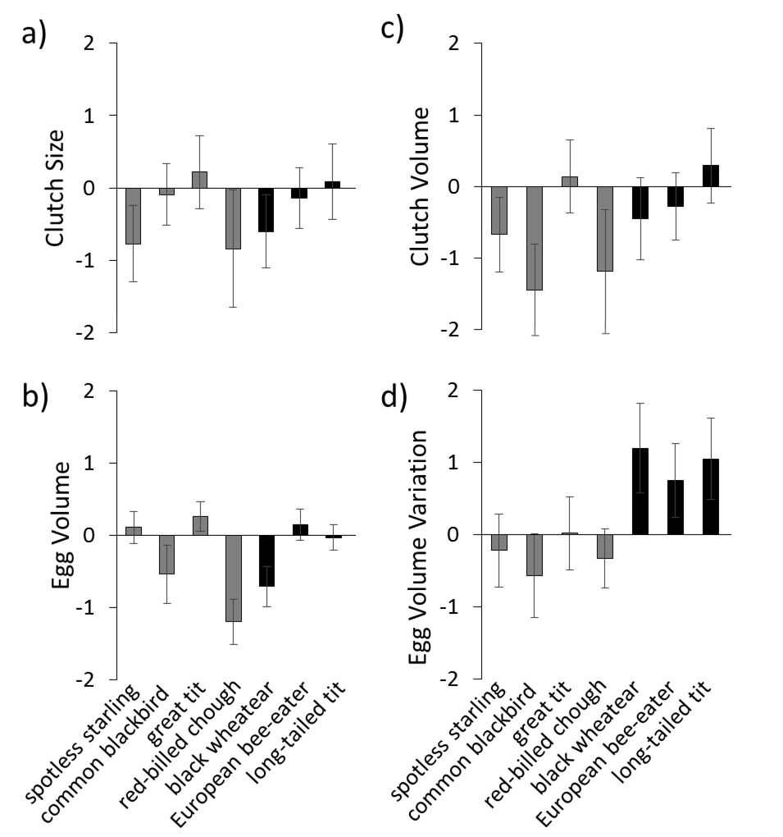
Fig. 2 Species with a long post-fledging association with their parents had greater intraclutch egg size variation when breeding under high perceived predation risk. Plotted values are standardized and centered; grey bars indicate 95% confidence intervals.
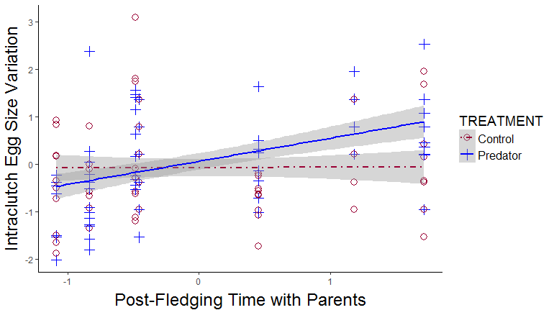
Fig. 3. Nests exposed to an increased perceived risk of predation were more likely to fail. Treatment and control means (± 1 SE) at the egg stage, nestling stage, and overall. *p<0.05; °p<0.10.
