Experimentally increased costs of parental care are shunted to offspring in species with extended care

Gretchen F. Wagner ^{1,2}, Emeline Mourocq¹, Michael Griesser^{1,3}

¹ Department of Anthropology, University of Zürich, Zürich, Switzerland
² Department of Animal Ecology, Netherlands Institute of Ecology (NIOO-KNAW), Wageningen, The Netherlands
³ Department of Evolutionary Biology and Environmental Studies, University of Zürich, Zürich, Switzerland
Abstract
Biparental care systems are a valuable model to examine conflict, cooperation, and coordination between unrelated individuals, as the product of the interactions between the parents influences the fitness of both individuals. A common experimental technique for testing coordinated responses to changes in the costs of parental care is to temporarily handicap one parent, inducing a higher cost of providing care. However, dissimilarity in experimental designs of these studies has hindered interspecific comparisons of the patterns of cost distribution between parents and offspring. Here we apply a comparative experimental approach by handicapping a parent at nests of five bird species using the same experimental treatment. In some species, a decrease in care by a handicapped parent was compensated by its partner, while in others the increased costs of care were shunted to the offspring. Parental responses to an increased cost of care primarily depended on the total duration of care that offspring require. However, life history pace (i.e., adult survival and fecundity) did not influence parental decisions when faced with a higher cost of caring. Our study highlights that a greater attention to intergenerational trade-offs is warranted, particularly in species with a large burden of parental care. Moreover, we demonstrate that parental care decisions may be weighed more against physiological workload constraints than against future prospects of reproduction, supporting evidence that avian species may devote comparable amounts of energy into survival, regardless of life history strategy.
Introduction
Parental care is widespread in animals, but its expression varies greatly among and within species (Cockburn 2006, Royle et al. 2012) as well as within individuals (Eggers et al. 2008, Ghalambor et al. 2013, Caro et al. 2016). In biparental care systems, the fitness of both parents is jointly affected by the reproductive decisions of each as well as how they coordinate with each other. Birds are unique among the taxonomic classes in regard to the prevalence of biparental care: both parents contribute care to the offspring in an estimated 90% of bird species (Cockburn 2006), while in other clades biparental care is much rarer (percentage of genera with bi-parental care: anurans: 1%, squamate reptiles: 0%, teleost fish: 3%, mammals: 9%, Gross and Sargent 1985; insects: 22% of species with any parental care, Suzuki 2013).
Biparental care relies on cooperation between parents to ensure the survival of their offspring, but is also a source of conflict. Both parents face a trade-off between current and future reproduction and should strive to reduce their own effort, in balance with their partner’s effort, to ensure that offspring receive enough total care to survive while lessening current costs of parental care for themselves (Trivers 1972, Drent and Daan 1980). A pioneering model suggested that investment in parental care of both parents can be an evolutionary stable strategy (ESS) if one parent reduces its effort, its partner partially compensates and the increased costs are distributed between the partner and the offspring (Houston and Davies 1985). More recent models have predicted that negotiation between the parents could lead to partial, full or no compensation by partners, depending on the costs and benefits associated with care (Jones et al. 2002, Johnstone and Hinde 2006). Accordingly, researchers have suggested that parental behavior lies on a ‘negotiation continuum’ (Hinde and Kilner 2007) across, and even within, species. This continuum is proposed to range from no partner response, where behavioral rules are independent of the behavior and needs of other family members, to highly flexible, where a behavioral change in one family member directly influences the behavior of others. This negotiation process is likely to be influenced by several species traits, such as brood size, developmental mode (Olson et al. 2008) and lifespan, however experimental tests of these ideas are lacking.
A common experimental technique for testing changes in the costs of parental care is to temporarily handicap one parent, thereby increasing the cost of providing care. In birds, this is often accomplished through the removal of flight feathers. These handicapping experiments have demonstrated large between-species variation in responses to changes in one parent’s physical condition, across both parents and their offspring (Table 1). Handicapped birds may maintain or reduce their physical condition and/or their parental effort. Non-experimental individuals may fully compensate their partner’s decrease in care, partially compensate, or copy the behavior of their partner (i.e., decrease care if their partner decreases care). Similarly, the condition of offspring may improve, decline, or stay constant.
Although there have been many experimental manipulations of parental care, to our knowledge only one meta-analysis has previously examined the responses comparatively (Harrison et al. 2009). However, due to variation in the types of manipulation (e.g. clipping feathers vs. adding weight), the behavior examined (e.g., feeding vs. incubation) and the types of responses recorded (e.g., parental behavior vs. parental condition), a thorough examination of the mitigating factors for patterns of parental care across species has not been possible. Indeed, this meta-analysis showed that the type of manipulation played a key role in explaining heterogeneity in parental responses to manipulation of care and that responses differed depending on the behavior being focused on, while species traits that may have accounted for interspecific differences were largely excluded from the analyses.
A drawback of many handicapping studies is that they measure effects on a single trait or individual, by focusing only on the condition or behavioral changes of the handicapped parent, its partner or their offspring (see Table 1). Consequently, it is difficult to determine how experimental effects are distributed between parents and offspring in many cases. Furthermore, the most common measure taken has been changes in the condition of the handicapped individual (Table 1), usually in terms of body mass, which are frequently attributed to an increased reproductive effort. However, these responses may reflect functional corrections to wing loading rather than adverse effects of handicapping (Norberg 1981, Lind and Jakobsson 2001), confounding whether there are any changes in reproductive effort. Because changes in the body mass of handicapped birds are difficult to interpret, it is important to measure parental effort directly, via behavioral responses, in combination with the condition of the offspring, so that relative effects can be properly estimated across all of the family members.
Here we handicapped parents in five bird species with bi-parental care, resulting in one partner facing higher costs of offspring provisioning, which must be paid by the treated bird, its partner, or their offspring. We analyzed the results comparatively to examine differences in parental care behavior of each parent and any effects on nestling condition. Life-history theory predicts that long-lived species should prioritize survival (and thus future reproduction) over current reproduction, and they are consequently expected to be less willing to increase their parental effort compared to short-lived species (Williams 1966, Drent and Daan 1980). However, a more recent comparative analysis on costs of care suggests that all individuals may allocate the same amount of energy to survival, regardless of their life-history pace (Santos and Nakagawa 2012). Thus, we expected that responses will vary across a life-history spectrum, but that life history pace alone will not account for interspecific differences.
Methods
Study species
We handicapped individuals of five bird species with biparental care in southern Spain during the breeding seasons of 2013 and 2014. The experiment was conducted in populations of great tits (Parus major), blue tits (Cyanistes caeruleus), and woodchat shrikes (Lanius senator) in the Cordoba region (37°95’N, 4°40'W), and black wheatears (Oenanthe leucura) and European bee-eaters (Merops apiaster) in the Guadix region (37°25’N, 3°05’W). All nests used in the analyses had two adults, presumably the mother and father, attending to the nestlings. At least one parent was marked for individual identification prior to the experiment, with a combination of plastic colored rings or a temporary mark on their feathers. Because European bee-eaters sometimes have helpers at the nest, both parents were marked early in the nest stages (building or incubating) to reduce the chances of marking a non-breeder, and each nest included in this study was checked for the presence of only 2 adults attending the nest at the time of the experiment.
Experimental Design
Experiments were started at each nest based on the developmental stage of the nestlings (as feather growth begins), rather than absolute age, to allow for a better comparison between species with different development schedules. The experimental procedure spanned five days. Each nest was recorded with a video camera to obtain the feeding rate for 2-4 hours on the first, second, fourth and fifth days of the experiment. The duration of recording was determined prior to the experiment through observations of each species, and was based on the natural feeding rate to conservatively ensure a minimum of ten feeding visits per observational bout. Recordings were made at the same time for each nest, and nests were assigned to morning, midday or afternoon recordings using a balanced random design.
On the third day of the experiment one of the adults at each nest was caught and either handicapped, by removing the 7th and 9th primary feathers on each wing, or was handled (with simulated feather removal) and released as a control. Removal of flight feathers has been demonstrated to increase the energetic demands of flight by increasing wing loading (Pennycuick 1989, Hedenström and Sunada 1999), thus increasing the cost of parental care during foraging for provisioning.
After recording on the first day, all nestlings were marked for individual identification with a non-toxic permanent marker on one leg. Each nestling was weighed with a digital scale and its wing and tarsus length were measured with dial calipers (0.1mm accuracy) on the first, third and fifth day of the experiment. All nestling measurements within a nest were taken by the same experimenter to maintain consistency across days.
Statistical Analyses
We predicted that the visitation rates of parents after one parent is handicapped may be influenced by the adult survival rate, body mass, the body mass–scaled initial reproductive allocation (total mass of eggs produced annually divided by adult body mass, following Sibly et al. 2012), the duration that offspring require provisioning, and the duration that offspring stay with their parents subsequent to nutritional independence. We used a principal component analysis (PCA) to reduce the dimensionality of these predictors, as most of them exhibited moderate to strong correlations (Table S1). Because the units of measurement for traits differed, we relied on the correlation matrix among variables to generate PCA scores rather than the covariance matrix (Graham 2003). Both the inspection of a Scree plot and Eigenvalues suggested the extraction of 2 principal components (PCs). To simplify the factor structure by maximizing the variances of loadings and hence facilitate their interpretation, we first performed an oblique (oblimin) rotation of the components, which indicated that the resulting factors were not substantially correlated (r=0.21). We then applied a varimax rotation to the original components. Differences in results of the rotation techniques were negligible, and did not affect the overall pattern of loadings, so we retained the varimax rotation in further analyses (Kieffer 1998).
The principal components analysis resulted in the extraction of two PC variables (Table S1) which cumulatively explained 79% of the variance. The first component, hereafter labelled “duration of care”, included the number of days that offspring are provisioned by their parents (‘care time’), body mass, and the number of days that offspring stay with their parents post-nutritional independence ('family time', Drobniak et al. 2015). A high value of this component signifies species with long periods of parental care. The second component, hereafter labelled “life history pace”, included adult survival rate and the index of reproductive allocation (see above). A high value of this component signifies parents with long expected lifespans and low annual reproductive investment.
We fit linear mixed models using a Bayesian framework with Markov chain Monte Carlo (MCMC) methods with the package MCMCglmm (Hadfield 2010) in R 3.1.0 (R Core Team 2014) to examine among-species responses to the handicapping procedure. All models were run for 100’000 iterations, with a burn-in phase of 2’000 iterations and a thinning interval of 100, which resulted in approximately 1’000 samples from the posterior distributions for each model parameter. A reasonably normal distribution of residuals was confirmed for all models. Model convergence was confirmed by visual examination of trace plots and calculation of autocorrelation between iterations. Because initial models included several 2- and 3-way interactions (see below), non-significant interactions (p>0.05) were removed from initial models using a backwards elimination procedure, except for the interaction between treatment and phase. The interaction between treatment and phase was expected a priori and is the main result of our experiment, as we only expect an experimental effect during the post-treatment phase. Results of all initial models, prior to removal of any non-significant terms, are included in the Supplementary Material, to facilitate comparison of models and effect sizes for both significant and non-significant factors.
Visitation rates
Visitation rates were measured as the number of nest visits per hour per nestling. Although we did not confirm that every visit involved food delivery, visitation during the nestling phase is a common proxy for offspring provisioning (Mariette et al. 2011, Mutzel et al. 2013). These rates were averaged for experimental days 1 and 2, i.e, ‘pre-treatment’ phase, and experimental days 4 and 5, i.e., ‘post-treatment’ phase. We first analyzed sources of variation in visitation rates among the tested species using linear mixed-effect models with the total feeding rate at the nest as the response variable. Brood size, duration of care, life history pace, phase, and treatment were included as fixed effects, with random intercepts for species and nest identity. Because of the experimental design, changes in chick provisioning after the treatment could potentially be confounded by an effect of time, if feeding rates naturally change over the nesting period. Therefore, treatment effects were also examined by including three-way interactions, and their contained two-way interactions, of phase and treatment with each principal component. Non-significant main effects were retained in the final model while non-significant interactions were removed from final models, except for the interaction between treatment and phase.
Our analyses revealed a significant 3-way interaction between phase, treatment and duration of care for the total visitation rate (see Results). To interpret this interaction, we carried out two additional models, examining treatment effects in the pre-treatment phase and the post-treatment phase separately. These models included brood size, duration of care, life history pace, and the two-way interaction between duration of care and treatment as fixed effects, with species as a random factor.
We then examined treatment effects on the feeding rates of the focal individuals (i.e. handicapped or control-caught). We included brood size and separate three-way interactions between treatment, phase, and each principal component (and their contained two-way interactions and main effects) as fixed effects, with species and nest identity as random factors. Non-significant interactions were sequentially removed from final models, but non-significant main effects were retained. Because we found no significant 3-way interactions in this model, no additional models were run.
Nestling Growth
We analyzed sources of variation in nestling growth among all of the tested species using separate linear mixed-effect models of nestling changes in mass, tarsus length, and wing length. Each response variable was measured as the difference in each parameter between the pre-treatment phase (days 1-2), and the difference in each measurement of the post-treatment phase (days 4-5). Brood size, duration of care, life history pace, phase, and treatment were included as fixed effects. Random intercepts were specified for species, nest identity, nestling identity (unique combinations of nest identity and nestling number), and nest phase (unique combinations of nest identity and phase). Changes in chick growth after the treatment could potentially be confounded by an effect of time, if growth rates naturally change over the nesting period. Therefore, treatment effects were examined by including three-way interactions, and their contained two-way interactions, of phase, treatment and each principal component. Because a significant interaction between phase and treatment was expected a priori, this interaction was maintained in all models regardless of significance. All other non-significant interactions were removed from final models, but non-significant main effects were retained.
Our analyses revealed a significant 3-way interaction between phase, treatment and duration of care for changes in nestling body mass (see Results). To interpret this interaction, we carried out 2 additional models, examining the treatment effects of nestling mass change separately in the pre-treatment phase and the post-treatment phase. These models included brood size, adult survival rate, and the two-way interaction between duration of care and treatment as fixed effects, with species as a random factor.
Results
Visitation rates
Results of visitation rates (visits per hour and nestling) are based on 72 nests (Table 2). Independent of the treatment, a long duration of care was related to higher individual parental visitation rates (Table 3) and marginally related to higher total visitation rates (Table 4). Neither the brood size nor life history pace were related to individual (Table 3) or total (Table 4) visitation rates. The visitation rate of focal individuals did not change between experimental phases in control nests, while focal parents reduced their visits after being handicapped (Table 3, Fig. 1). Although the individual rates were significantly lower in the handicapped group, this effect did not interact with any other explanatory variables. Total visitation rates were significantly affected by a 3-way interaction between treatment, phase and duration of care (Table 4). Post-hoc examination of this relationship revealed that there was no difference between the pre-treatment phase of the control and the handicapped groups in total visitation rate (estimate= -0.13 95%CI= -0.40, 0.16, p=0.36; Fig. 2A), nor any effects of any of the explanatory variables (Table A4). In contrast, the total visitation rates in the post-treatment phase were lower in handicapped individuals than control individuals (estimate= -0.46, 95%CI=-0.81,-0.12, p=0.008, Table S5). Duration of care interacted with the treatment, indicating that the experimental effect was strongest in species with long parental care periods (estimate= -0.35, 95%CI=-0.70, -0.03; p=0.040; Fig. 2B).
Nestling Growth
Nestling growth data was based on 384 nestlings (Table 2). Changes in nestling mass (Table 5) mirrored the results of visitation rates and was influenced by a 3-way interaction between duration of care, phase, and treatment. The change in nestling mass did not differ in the pre-treatment phase according to any of our explanatory variables (Fig. 3A, Table S7). In the post-treatment phase (Table S8), the change in body mass of nestlings in the handicapped group decreased with an increasing duration of care, while the mass change of nestlings in the control group increased with an increasing duration of care (Fig. 3B). Changes in nestling mass also depended on life history pace, independent of the treatment, but was not related to any other explanatory variable.
Analyses of changes in nestling tarsus and wing growth (detailed in Tables S9-S12) indicated no treatment effects on either response variable. Both wing and tarsus growth changed over time, irrespective of treatment group, with nestlings having larger tarsus growth in the pre-treatment phase (estimate=0.59, 95%CI=0.26, 0.94, p<0.001), and larger wing growth during the post-treatment phase (estimate=-0.39, 95%CI=-0.78,-0.05, p=0.042). Tarsus growth also significantly decreased with an increasing duration of care (estimate=-0.58, 95%CI=-0.76,-0.43, p=0.004), independent of the treatment.
Discussion
Parental care is costly, and parents of iteroparous species are predicted to strive to minimize the costs that they incur in a current reproductive event to ensure future reproductive events (Williams 1966, Stearns 1992, Gross 2005). Our experiments demonstrate that, across 5 species, an increased cost of parental care generally results in a reduced visitation rate by the manipulated parent, and that the additional costs are shared by its partner and their offspring. The strength of this effect was mediated by the duration of care that the offspring require; in large species with long care periods, the offspring were passed the largest share of the additional cost, while the partner increased their effort more in species with relatively short parental care periods. This result was evident in both changes to nest visitation rates of the parents and the body mass gain of the offspring.
Given the limited number of samples and species in this study, it faced several limitations. Responses may have varied according to factors we were unable to include due to a lack of statistical power and a lack of variation within the species included here. In particular, the scope of this study did not allow for examination of ecological factors; environmental unpredictability and a species’ niche are likely to affect parental care decisions in ways that we were unable to test. For example, European bee-eaters are the only specialized aerial foragers among the species we tested, and consequently handicapped individuals may have accrued higher costs of foraging, particularly because gaps in flight feathers reduce flight maneuverability (Swaddle and Witter 1997). However, among the species included here, we only found differences in the compensatory behavior of partners rather than in the reduction of care by handicapped individuals. Thus, the effects of the handicapping treatment per se appeared to similarly influence the species included in this study. Moreover, it is possible that parents altered the quality or quantity of the food that they delivered to the nestlings, rather than the number of visits (Wright et al. 1998). Yet, changes in the condition of the nestlings matched the changes to total provisioning rates at the nest, indicating that costs were in fact accrued by nestlings with a handicapped parent. The findings of this study give novel empirical insight into the different strategies employed across species to deal with increased costs of parental care, but should be verified with larger-scale comparative studies. Such studies will be made possible with targeted experimental tests that manipulate parental care in a standardized way, so that comparable effect sizes are obtainable.
Little is known about the physiological effects of workload during parental care in free-living birds (Williams and Fowler 2015), but previous studies suggest that costs of parental care can be cumulative over a breeding cycle. Many bird species have been shown to rely, at least partially, on nutrient reserves built-up prior to breeding and/or during incubation (Drent and Daan 1980, Martin 1987, Moreno 1989), in preparation for the costly provisioning stage of parenting. Thus, the workload during provisioning may be at or higher than the maximum sustainable workload (Weiner 1992, Low et al. 2012). If the maximum sustainable workload is exceeded over a long period, the risk of mortality is expected to increase (Drent and Daan 1980). Accordingly, parents are predicted to make decisions about parental care based on maintaining their physical condition above a threshold determined by the trade-off between offspring survival and their expected reproductive value at the end of breeding (Webb et al. 2002). Indeed, theory demonstrates that an increase in the daily energetic costs of care leads to a decrease in the duration of care in birds (Webb et al. 2002), and field data shows that species with long provisioning periods often have a greater loss of body mass than species with short durations of provisioning (Moreno 1989). Moreover, costs associated with extended parental care have been shown to have important carryover effects; for example, geese (Branta bernicla) with families in a given season are less likely to breed successfully in the following season (Inger et al. 2010). Taken together, these findings indicate that both the daily energy expenditure and the duration that expenditure must be sustained contribute to the overall costs of parental care.
Across all birds, large-bodied species with long care periods generally have low adult mortality (Speakman 2005, Valcu et al. 2014). However, in the set of species that we investigated, these traits were not highly correlated, thus we were able to tease apart where species lie on the spectrum of the trade-off between survival and reproduction. Here, the species with the largest opportunity for future reproduction differed from those with the longest burden of parental care. We expected that parents with a slow life history would be most sensitive to costs of reproduction (Williams 1966, Drent and Daan 1980, Linden and Møller 1989). However, only the duration of care but not life-history pace predicted the observed patterns in our study. The latter determined whether costs were passed to offspring while the former did not affect parental care decisions when faced with an increased cost of care. In accordance with our findings, a meta-analysis that looked explicitly at energy expenditure of handicapped birds found that a species’ life history was independent of whether individuals reduced investment into their own energy stores or their offspring’s growth (Elliott et al. 2014).
Parents with low baseline costs of parental care may have more leeway to increase their parental behavior without incurring deleterious consequences, and thus costs allocated to offspring can be minimized in these species. In contrast, parents with generally high costs of parental care are more likely to be at their maximum energetic capacity in a given reproductive event, and any increase in the costs associated with caring may have severe consequences in terms of future fitness and survival. Larger species do indeed expend more energy per day toward parental care than small species, however the ratio of energy expenditure to body mass tends to be smaller in large species (Masman et al. 1989). Thus, our results appear contrary to the prediction that large species expend the smallest share of their energy during parental care (Masman et al. 1989). However, this prediction is based on per-day calculations of energy expenditure relative to energy intake, and does not take into account the duration of care, which is generally longer for large species and thus may accrue higher reproductive costs over the whole breeding cycle.
Most studies of the costs of parental care focus on the trade-off between current and future reproduction or survival (intraindividual trade-offs, e.g., Owens and Bennett 1994, Webb et al. 2002, Alonso-Alvarez and Velando 2012, Santos and Nakagawa 2012), while relatively few studies have addressed the fitness consequences of parental decisions on current offspring (intergenerational trade-off, as discussed in Stearns 1989). Our results suggest that greater attention to intergenerational trade-offs is warranted, particularly in large species with long developmental (and thus parental care) periods. Moreover, our results indicate that, across species, parental care decisions may be weighed more against physiological workload constraints than against future prospects of reproduction, and support recent evidence that all bird species may devote comparable amounts of energy into survival, regardless of life history strategy (Santos and Nakagawa 2012, Elliot et al. 2013).
Acknowledgements
We thank Álvaro de las Heras Pardo and Carlota Gutiérrez Arce for their invaluable help both in and out of the field; Francisco Espinosa Alemany, Liliana Ferreira Borges, Emma Northcote-Smith, Katie Merewether, John Kronenberger, Victor Jiménez García, Matteo Belpinati, Juan Naredo Turrado, Frederico Leite, Daniel Colette, Hailey Scofield and Filipe Cunha for assistance in the field; Yang Liu, Mengjie Jin, Kai Chen, Yicong Yang, Qiongsi Zhang, and Yi Lin for their contribution to video analyses; and Szymon Drobniak and Erik Willems for helpful statistical advice. Funding for this study was provided by the Georges and Antoine Claraz Stiftung and the Swiss National Research Foundation (grant numbers PPOOP3_123520 and PPOOP3_150752).

Species | Condition |  |  | Care Behavior |  | Reference
Species | Focal | Partner | Offspring | Focal | Partner | Reference
blue tit  Cyanistes caeruleus | - | - | ≈ | - | ≈ | (Slagsvold and Lifjeld 1990)
coal tit  Parus ater | - |  |  |  |  | (Slagsvold and Lifjeld 1990)
great tit  Parus major | - | ≈ | - |  |  | (Slagsvold and Lifjeld 1990)
tree swallow  Tuchycineta bicolor |  |  | ≈ | ≈ | + | (Whittingham et al. 1994)
Leach's storm-petrel  Oceanodroma leucorhoa | ≈ |  | - | - |  | (Mauck and Grubb Jr 1995)
thin-billed prion  Pachyptila belcheri | - |  | ≈ |  |  | (Weimerskirch et al. 1995)
tree swallow  Tuchycineta bicolor | - |  |  | - |  | (Winkler and Allen 1995)
pied flycatcher  Ficedula hypoleuca | ≈ | ≈ | - | ≈ | ≈ | (Moreno et al. 1999)
great tit  Parus major | ≈ | ≈ | ≈ | - | + | (Sanz et al. 2000)
blue-footed boobie  Sula nebouxii | - |  | - |  |  | (Velando 2002)
blue-footed boobie  Sula nebouxii | ≈ | - | - |  |  | (Velando and Alonso‐Alvarez 2003)
common tern  Sterna hirundo | - |  | + |  |  | (Nisbet et al. 2004)
Cory's shearwater  Calonectris diomedea | ≈ |  | - | - |  | (Navarro and González-Solís 2007)
cape gannet  Morus capensis | - | ≈ | - | - | + | (Bijleveld and Mullers 2009)
little auk  Alle alle | - | - | - |  |  | (Harding et al. 2009)
black-legged kittiwake  Rissa tridactyla | - | ≈ | ≈ | ≈ | - | (Leclaire et al. 2011)
thick-billed murre  Uria lomvia | ≈ |  | - |  |  | (Jacobs et al. 2013)
great tit  Parus major | - |  | - | - |  | (Wegmann et al. 2015)
Table 1. Results from previous studies that increased the costs of parental care through feather removal.

common name | scientific name | treatment n |  | control n
common name | scientific name | nests | nestlings | nests | nestlings
Blue tit | Cyanistes caeruleus | 6 | 44 | 7 | 52
Black wheatear | Oenanthe leucura | 8 | 28 | 7 | 25
European bee-eater | Merops apiaster | 8 | 39 | 7 | 28
Great tit | Parus major | 7 | 52 | 7 | 51
Woodchat shrike | Lanius senator | 7 | 26 | 8 | 38
Table 2. Sample sizes of nests and nestlings for each species.

Table 3. Selected mixed model results of effects on focal individual visitation rate. Significant effects
(p<0.05) are denoted in bold. Full model results are presented in Table S2.
 |  | 95% CI
Effects | Estimate (β) | lower | upper | pMCMC
fixed effects
intercept | 0.350 | -0.310 | 0.842 | 0.151
duration of care | 1.059 | 0.509 | 1.560 | 0.016
life history pace | 0.341 | -0.092 | 0.829 | 0.120
brood size | 0.266 | -0.224 | 0.693 | 0.325
pre-treatment phase | -0.140 | -0.539 | 0.230 | 0.471
treatment | -0.619 | -1.021 | -0.245 | <0.001
treatment x pre-treatment phase | 0.535 | 0.032 | 1.072 | 0.047
random effects
species | 0.295 | <0.001 | 1.361
nest | 0.006 | <0.001 | 0.051

Table 4. Selected mixed model results of effects on total visitation rate at the nest. Significant effects (p<0.05) are denoted in bold. Full model results are presented in Table S3.
 |  | 95% CI
Effects | Estimate (β) | lower | upper | pMCMC
fixed effects
Intercept | 0.217 | -0.540 | 0.887 | 0.443
duration of care | 0.699 | -0.129 | 1.411 | 0.065
life history pace | 0.315 | -0.096 | 0.737 | 0.120
brood size | -0.094 | -0.326 | 0.168 | 0.444
pre-treatment phase | -0.100 | -0.319 | 0.075 | 0.310
Treatment | -0.424 | -0.711 | -0.162 | 0.006
treatment x pre-treatment phase | 0.312 | 0.055 | 0.564 | 0.016
duration of care x pre-treatment phase | 0.076 | -0.163 | 0.294 | 0.495
duration of care x treatment | -0.287 | -0.601 | 0.006 | 0.053
duration of care x pre-treatment phase  x treatment | 0.334 | 0.050 | 0.613 | 0.020
random effects
Species | 0.785 | <0.001 | 2.642
Nest | 0.186 | 0.087 | 0.291

 |  | 95% CI
Effects | Estimate (β) | lower | upper | pMCMC
fixed effects
intercept | 0.167 | -0.120 | 0.460 | 0.233
duration of care | 0.050 | -0.218 | 0.315 | 0.724
life history pace | 0.227 | 0.035 | 0.412 | 0.036
brood size | 0.030 | -0.181 | 0.222 | 0.779
pre-treatment phase | -0.175 | -0.433 | 0.099 | 0.234
treatment | -0.309 | -0.682 | 0.075 | 0.108
treatment x pre-treatment phase | 0.309 | -0.073 | 0.680 | 0.122
duration of care x pre-treatment phase | 0.138 | -0.135 | 0.412 | 0.330
duration of care x treatment | -0.345 | -0.688 | 0.019 | 0.057
duration of care x pre-treatment phase  x treatment | 0.429 | 0.017 | 0.776 | 0.026
random effects
species | 0.003 | <0.001 | 0.010
nest | 0.281 | 0.132 | 0.474
nestling | 0.001 | <0.001 | 0.007
nest phase | 0.238 | 0.131 | 0.374
Table 5. Selected mixed model results of changes in nestling mass. Significant effects (p<0.05) are denoted in bold. Full model results are presented in Table S6.

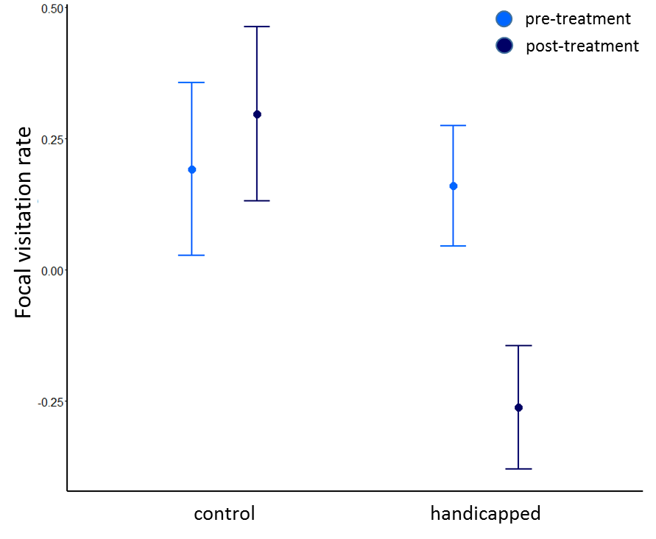
Figure 1. Standardized predicted values (+/- SE) from mixed model of focal bird per-nestling visitation rates. Prior to the treatment, visitation rates did not differ between the control group and treatment group. After the treatment, handicapped birds reduced their visitation rate.

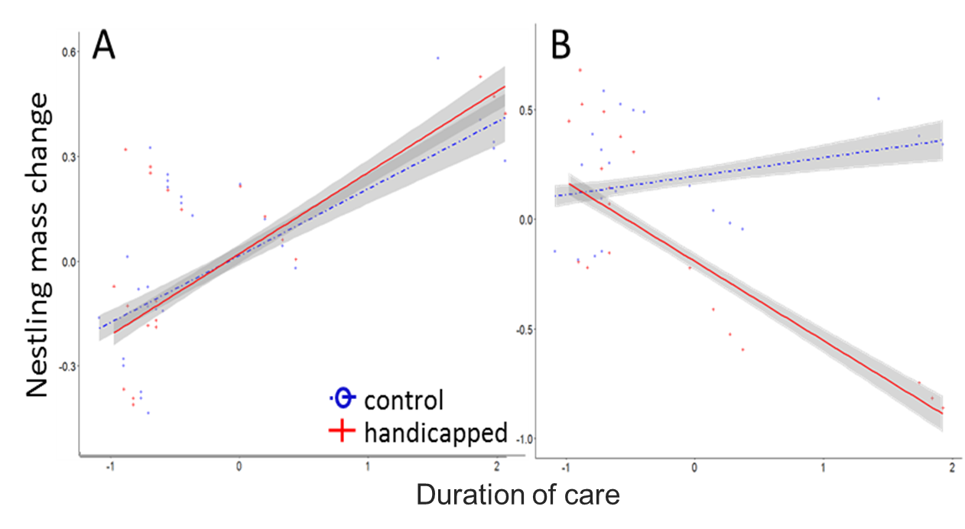
Figure 2. Standardized model-predicted total visitation rates varied according to duration of care. (A) Handicapped and control groups had similar visitation rates during the pre-treatment phase (B) Total visitation rates were lower in the handicapped group during the post-treatment phase, particularly for species with long durations of care. Shaded area represents 95% confidence interval.

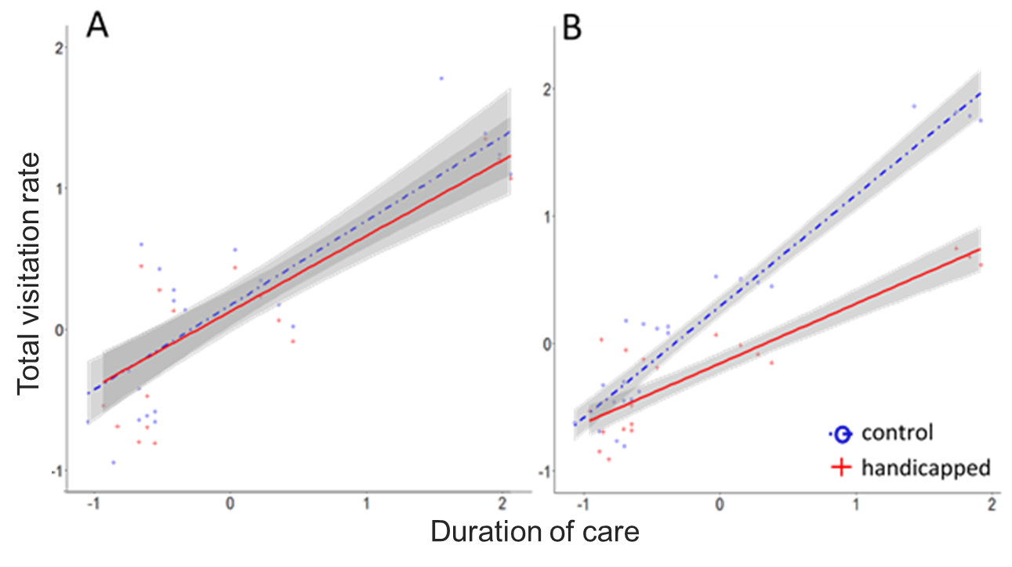
Figure 3. Standardized model-predicted changes in nestling mass varied according to duration of care: (A) The change in nestling mass did not differ between the handicapped and control groups in the pre-treatment phase (B) In the post-treatment phase, the mass of nestlings in the handicapped group decreased with an increasing duration of care, while the mass of nestlings in the control group increased with the duration of care. Shaded area represents 95% confidence interval.

