A comparative study of differential selection pressure over the nesting cycle in birds
Gretchen F. Wagner ^{1,2*}, Szymon M. Drobniak^{1,3}, Michael Griesser^{1,4}
¹ Department of Anthropology, University of Zürich, Zürich, Switzerland
² Department of Animal Ecology, Netherlands Institute of Ecology (NIOO-KNAW), Wageningen, The Netherlands
³ Institute of Environmental Sciences, Jagiellonian University, Kraków, Poland
⁴ Department of Evolutionary Biology and Environmental Studies, University of Zürich, Zürich, Switzerland

*corresponding author g.wagner@nioo.knaw.nl

Acknowledgements: We thank Dieter Oschadleus and the South African Nest Record Scheme (NERCS) of the University of Cape Town Animal Demography Unit for data of South African species and the numerous field workers and funding agencies that have contributed to the studies included here. We thank Carlota Gutierrez Arce, Marie Cochet and Yang Liu for assistance with data collation.
Funding: This study was supported by the Swiss National Science Foundation (PP00P3_123520, PP00P3_150752).

Abstract
Reproductive allocation varies greatly across species and is determined by their life-history and ecology. This variation is usually assessed as the number of eggs or propagules (hereafter: fecundity). However, in species with parental care, individuals face trade-offs that affect the allocation of resources among the stages of reproduction as well as to reproduction as a whole. Thus, it is critical to look beyond fecundity to understand the evolution of life-histories and how investment into different reproductive components interact with each other. Here we assessed the influence of species-specific traits and ecological factors on interspecific variation in reproductive performance at each nesting stage of 72 avian populations. Annual productivity was unrelated to annual fecundity. Annual fecundity correlated positively with a fast life-history pace, precociality and non-migratory habits, but these traits were unrelated to reproductive success. Rather, the breeding ecology of a species determined productivity at each stage of nesting, but did not influence fecundity. These results challenge prevailing theory and emphasize that conclusions of interspecific variation in fitness based on numbers of eggs may be equivocal. Moreover, parental decisions regarding reproductive allocation face diverse constraints at different stages of reproduction, influencing the evolution of reproductive tactics in species with parental care.
Introduction
Life history theory provides a framework to understand interspecific variation in the energy individuals allocate to reproduction. Given that individuals have limited resources to allocate among growth, survival and reproduction (Williams 1966, Stearns 1992), they must trade-off the energy they allocate to different vital functions. Theoretical work has made great strides in predicting optimal allocation to reproduction under diverse conditions and life history trajectories across organisms and lineages (e.g., Schaffer 1974, Kozłowski 1992, Brommer 2000). Comparative studies of avian clutch sizes have particularly been a foundation for the investigation of life history evolution in general (Martin 2004, Jetz et al. 2008). Lack (1947, 1954) proposed that clutch size should be optimized to produce the maximum number of offspring that parents can raise. As allocation into the number of offspring increases, allocation per offspring decreases, highlighting a trade-off between maternal fecundity and the probability of juvenile survival, thereby stabilizing selection on offspring number (Smith and Fretwell 1974, Mangel et al. 1994). While fecundity is expected to correlate positively with total reproductive allocation, it is only one component of allocation and will depend on how parental investment into offspring affects the probability of juvenile survival (Morris 1987). Thus, individuals have to decide on both the total amount of energy allocated into a reproductive event and the distribution of that energy into each component of reproduction (e.g., egg production, incubation, offspring provisioning) to optimize their investment (Winkler and Walters 1983, Martin 2004).
In egg-laying animals, clutch size clearly sets the upper limit for the number of successful offspring in a reproductive attempt, but may not reflect actual differences in realized productivity (Murray Jr 2000, Etterson et al. 2011). For example, most tropical birds have minimal variation in clutch size from a mode of two, but there is large variation in nesting success (Skutch 1985, Martin 1996, Robinson et al. 2000). Field studies of individual species have demonstrated that individuals can trade-off their reproductive effort between stages (Heaney and Monaghan 1996, Russell et al. 2007), supporting the view that the level of allocation at one reproductive stage does not necessarily translate into realized reproductive success (Murray Jr 2000). Furthermore, comparative work has indicated that clutch size is positively related to parental energy expenditure and length of the nestling period (Martin et al. 2000). These findings indicate that the environmental and reproductive demands at later stages of nesting can feed-back to affect the evolution of clutch sizes (Morris 1987).
Many biological and ecological factors have been shown to constrain avian clutch size (Table 1). Considering that selection acts on individual breeders, not their nests or eggs, measures of annual productivity are more pertinent to demographic and evolutionary studies than those of single reproductive events, yet they are relatively uncommon in avian studies. Interestingly, some studies have demonstrated that the same factors that explain differences in clutch size can have no or opposing effects on annual fecundity (e.g., nest predation pressure, Table 1). Moreover, there have been numerous calls to extend measures of fitness in birds beyond the number of eggs (Martin 2004, Anders and Marshall 2005, Etterson et al. 2011), yet few studies have examined sources of interspecific variation in the survival of eggs or dependent offspring. Those that have (see Table 1) have been limited in their scope and only one controlled for phylogenetic non-independence among species (Spottiswoode and Møller 2004). Thus, to our knowledge, no comparative test of the factors that affect reproductive investment differentially across nest stages has previously been carried out.
Following life history theory, we expect an inverse relationship between annual fecundity and the probability of offspring survival across species (Morris 1987). We predict that the factors that positively correlate with high fecundity (see Table 1) will negatively correlate with productivity. For example, the low fecundity of long-lived species is expected to be balanced by a higher investment into parental care, resulting in a higher proportion of offspring surviving. Similarly, high costs of parental care are expected to foster low fecundity but high nesting success in species with altricial young and/or an extended association between parents and independent offspring (“family-living”, Drobniak et al. 2015). However, in cooperative breeders, we expect high fecundity and productivity, because helpers may reduce the costs of parental care (Koenig and Dickinson 2004). In contrast, environmental factors that are expected to have a negative influence on productivity, such as high nest predation rates, a narrow ecological niche, and low breeding latitudes, are predicted to support selection for greater fecundity. Here, we test these hypotheses across 72 populations of birds (N=68 species), by comparing factors which contribute to interspecific differences in annual fecundity, the proportions of eggs and nestlings that survive until the subsequent stage, and the proportion of eggs that survive to fledging.

Material and Methods

Data Collection
We searched for long-term bird studies reporting mean numbers of eggs, nestlings and fledglings over multiple years (mean number of years: 8.05, range: 3-41 years) in a given location using online databases (N=58 species). In addition, we obtained data from nest card records (N=10 species; see Table S1 in Supplementary Materials for complete data source list). For each species in our dataset, we collected the following life history and ecological data that have been previously associated with interspecific differences in clutch size or annual fecundity: average lifespan, body mass, egg volume, developmental mode (precocial, altricial), social system (non-family living, family living, cooperative breeder), nest predation rate, nest type (open, closed), habitat niche breadth (generalist, specialist), latitude of the study population, and migratory habits (migratory, sedentary). Detailed definitions are given in the Supplementary Material. These data were taken from the source from which we acquired the breeding data when available, or it was obtained from handbooks (Maclean and Robert 1985, Cramp et al. 1994, Poole 2005, Higgins et al. 2007, Del Hoyo et al. 2011) or other publications (see Supplementary Material).
We calculated the annual reproductive allocation at each nest stage of each population by multiplying the mean number of eggs, hatchlings, and fledglings each by the mean number of clutches per year. When annual numbers of clutches were not provided for a population, we classified them to the nearest 0.5 clutches according to reported species-level averages (following Martin 1995). As a measure of productivity at each nest stage, we calculated the proportion of eggs which hatched (hereafter called hatching success), the proportion of hatchlings which fledged (hereafter called fledging success), and the proportion of eggs which fledged (hereafter called breeding success) to denote overall success relative to initial allocation.

Statistical Analyses

We used a principal components analysis (PCA; package 'psych' (Revelle 2015)) to reduce the dimensionality of our original set of continuous predictors (lifespan, body mass, and nest predation rate), because traits within a species are often correlated (Stearns 1992). We relied on the correlation matrix among variables to generate PCA scores rather than the covariance matrix (Graham 2003) because the units of measurement for traits differed. The inspection of a scree plot and eigenvalues (package 'nFactors' (Raiche 2010)) suggested the extraction of 2 components, cumulatively accounting for 76% (43 and 33%, respectively) of the total variance in the included variables (Table S2). The first component, labelled “pace of life”, includes adult body mass and lifespan. High values of this component represent large-bodied, long-lived species. The second component, labelled “nest predation”, loaded strongly with nest predation rate. We tested for multicollinearity between explanatory variables by calculating the generalized variance inflation factors (GVIF; package ‘car’ (Fox and Weisberg 2011)) with the full set of predictors and each subset of predictors after model selection. GVIF values for all predictors were less than 2.5 in all cases.
We used MCMCglmm (Hadfield 2010) in R 3.1.0 (R Core Team 2014) to run phylogenetically controlled linear mixed models (LMM) on transformed (if necessary), scaled (to unit variance) and centered variables (Schielzeth 2010). Non-significant (p<0.05) fixed effect variables and their interactions were removed using a backward elimination procedure. We included in all models a maximum clade credibility supertree from the best resolved phyla-wide phylogeny (Jetz et al. 2012). In all runs we have employed weakly informative priors for fixed effects (normal with large (>10⁶) variance) and for variance components (inverse Wishart distribution for residual variance; parameter-expanded priors with large variance for other random effects; Hadfield 2014). Models were run for 200,000 iterations with a burn-in period of 25,000 iterations and thinning interval of 100 iterations. Proper mixing of MCMC chains was confirmed by reasonable (~1,000) effective sample sizes of posterior distribution samples for all estimated parameters and negligible autocorrelations (package ‘coda’ (Plummer et al. 2008)).
Each model was based on the subset of species for which the respective data were available. This restriction had an important consequence: while all studies included here reported mean annual fecundity, some studies did not provide numbers for either hatchlings (N=7), fledglings (N=15) or both (N=6), thus reducing the data available for comparing across nest stages. Therefore, we do not report on the basic number of hatchlings or fledglings between species, as different subsets of species would be represented within each model’s results, limiting our ability to compare across stages. Instead, we report the ratios of values between stages (hatching success, fledging success, breeding success), as these models include the full set of species for which we have values of both stages in question and thus enable more robust comparisons. We first examined the effects of the explanatory variables and their interactions on annual fecundity. In addition, we tested egg investment in terms of body mass-adjusted annual productivity (following Sibly et al. 2012). These results (Table S3) were similar in direction and strength to annual fecundity. We then examined the relationship between the above-mentioned species and ecological traits and hatching success, fledging success and breeding success. Finally, we tested whether each measure of success related to annual fecundity in separate linear mixed models, including the measure of success as a fixed term.
All analyses were based on species-typical attributes that were averaged across annual population-level observations. To facilitate interspecific comparisons, we averaged the data into single, species-specific values, with the advantage that the resultant values average annual reproductive parameters over several years. If within-population (intraspecific) variation in reproductive parameters and/or environmental factors differs significantly across years, it may bias observed patterns of interspecific variation, so we tested inter-annual variation in breeding parameters within the study populations. To achieve this, we have analyzed analogous models using respective (log-transformed) variances (inter-annual variance in annual fecundity/nestling numbers/fledgling numbers) as response variables, retaining the same set of fixed-effects (with the addition of respective means as fixed covariates to account for possible mean-variance relationships).

Results
Interspecific variation in annual fecundity was best explained by life history pace, migration, developmental mode and an interaction between nest predation rate and developmental mode (Fig. 1a). Annual fecundity was inversely related to life history pace and migratory habits. Precocial species laid more eggs than altricial species, but the developmental mode interacted with nest predation rate, such that precocial species had a negative relationship with nest predation rate while there was no significant relationship for altricial species (Fig. 1b).
Hatching success was 0.77±0.16 (mean±SD) across studies (N=59). Variation in hatching success was best explained by nest predation rate, absolute latitude, and an interaction between life history pace and social system (Fig. 1c). Not surprisingly, hatching success decreased with increasing nest predation rates but increased with absolute latitude. In cooperatively breeding species, hatching success was lowest in species with a slow life history pace, while family living and pair breeding species showed no relationship between pace of life and hatching success (Fig. 1d). Fledging success (mean±SD = 0.72±0.22, N=44) depended on pace of life, nest predation rate, habitat use and absolute latitude (Fig. 1e). Species breeding at high absolute latitudes and habitat specialists had the greatest fledging success, while species with a high nest predation rate and a slow pace of life had the lowest fledging success. Breeding success (mean±SD = 0.56±0.21, N=51) was linked to the combined effects of habitat specialization, absolute latitude, and nest predation rate. Habitat specialists, those breeding at high absolute latitudes, and those with low nest predation rates were most successful (Fig. 1f).
Mean annual fecundity was unrelated to hatching success (Estimate= -0.10, 95% CI= -0.39 – 0.19, pMCMC=0.54), fledging success (Estimate= -0.01, 95% CI= -0.39 – 0.41, pMCMC=0.96), and breeding success (Estimate= -0.06, 95% CI= -0.35 – -0.18, pMCMC=0.68; Fig. 3). Between-year intraspecific variance in annual fecundity depended on nest type and absolute latitude. The highest variance in annual fecundity was found in species breeding at low absolute latitudes (Estimate= -0.014, 95% CI= -0.024 – -0.003, pMCMC=0.018, Table S4) and open-nesting species (Fig. 2, Table S4). Open-nesting species also had higher between-year variance in the number of hatchlings (Fig. 2, Table S5) and number of fledglings (Fig. 2, Table S6).

Discussion
Life history theory asserts that individuals face trade-offs that affect the allocation of resources into reproduction and among the stages of reproduction (Williams 1966, Stearns 1976). Our results confirm that variation in annual fecundity correlates with key intrinsic traits of species (i.e., pace of life, developmental mode, migratory habits), but demonstrate that these traits are not related to the realized reproductive productivity (Fig. 4). Rather, ecological factors (i.e., latitude, nest predation rate and habitat niche breadth) determined productivity at each nesting stage (Fig. 4). Our results suggest that reproductive success is independent of annual fecundity (Fig. 3) and that the constraints to successful reproduction differ from constraints to egg production (Fig. 4). Thus, our hypotheses for trade-offs in allocation between nest stages were not supported. Instead, our results demonstrate that the factors selecting for variation in reproductive allocation vary among components of reproduction, highlighting the need to assess productivity independently at each reproductive stage or only once offspring become independent from their parents.
Annual fecundity
Our analysis of annual fecundity confirms the findings of previous comparative avian studies, namely that a fast pace of life is a key predictor for high annual egg production (Zammuto 1986, Ricklefs 2000, Ghalambor and Martin 2001), and that migratory species are less fecund than non-migratory species (Böhning-Gaese et al. 2000, Bruderer and Salewski 2009). Moreover, our results suggest that birds trade-off parental care with fecundity (Jetz et al. 2008, Sibly et al. 2012), as evidenced by the high fecundity of precocial species, but we found no relationship between fecundity and social system. While family living species have been previously shown to have lower annual fecundity than non-family living species (Drobniak et al. 2015), our results do not support this idea. This difference may reflect that we controlled here for a number of other species traits, such as lifespan and developmental mode, or reflect a lower sample size due to the multi-year data used in the present study.
Nest predation rates only influenced annual fecundity in precocial species. This supports the often dismissed (Winkler and Walters 1983, but see Arnold et al. 1987) nest predation hypothesis (Perrins 1977), which proposes that fecundity is particularly limited by predation pressure in precocial birds due to increased incubation time for the longer laying period associated with a large clutch. As precocial chicks evacuate the nest soon after hatching, limiting incubation time under high predation pressure may be a more effective response for precocial species, since only this phase is sensitive to whole brood loss. In contrast, it may be more advantageous for altricial species to increase the number of clutches, with fewer eggs in each, spreading the risk of whole-brood loss across multiple breeding attempts (Martin 1995). Such an effect in altricial species would not be evident from our analysis of annual fecundity, in which we combined mean clutch sizes with annual number of clutches.
Nesting success
The pace of life was the only intrinsic trait that related to both fecundity and nesting success, however it only appeared as a significant predictor for success at the nestling stage, and only for cooperative breeders at the egg stage, but ultimately did not play a role in breeding success. Species with a slow pace of life have long developmental periods, which can expose offspring to a higher risk of predation and starvation. Furthermore, cooperatively breeding species tend to have greater within-population genetic similarity than other birds, which may result in reduced egg hatchability (Spottiswoode and Møller 2004). Such a deleterious effect of cooperative systems would be most detrimental to short-lived species, as any increase in reproductive failure could have a substantial impact on fitness, while in long-lived species this effect may be mitigated by a large number of breeding attempts (Spottiswoode and Møller 2004).
Explanations for interspecific differences in breeding success, and how differences in breeding success relate to differences in fecundity, have so far received little attention. Remarkably, none of the intrinsic traits that influenced fecundity across species were related to breeding success (Fig. 3). Instead, breeding success depended on the species’ breeding ecology. Unsurprisingly, a low nest predation rate and high absolute latitude correlated with high breeding success, and were important to success at both the egg and nestling stages. The seasonality of high latitudes is predicted to limit population density over harsh winters, which generates lower competition during the relatively high resource productivity of spring and summer (Ashmole 1963, Ricklefs 1980). Furthermore, the habitat niche breadth appears critical in determining the relative reproductive success beyond hatching: habitat specialists had greater breeding success than habitat generalists, despite similar fecundity. This effect is puzzling, as populations of habitat specialists are declining at a faster rate than habitat generalists (Jiguet et al. 2007). While populations of habitat specialists appear more sensitive to changes in the environment (Keinath et al. 2017), our results suggest that their breeding success is higher compared to habitat generalists, requiring further investigation to understand the effect of habitat specialization on population vulnerability.
Nest predation rates are temporally variable and sensitive to local ecological conditions at study sites. Thus, current estimates of nest predation may not reflect a species’ evolutionary history of nest predation pressure (Martin 1995). Nest type may be a better indicator of nest predation pressure over evolutionary time, but can also reflect other factors such as climate fluctuations, population density, or parasite abundance (Collias and Collias 2014). In contrast to a previous comparative study (Martin 1995), our results did not indicate a link between nest type and reproductive success. This discrepancy may reflect that the previous study was phylogenetically and geographically restricted to Passeriformes and Piciformes of North America. Nevertheless, our results show that open nests have significantly higher between-year variance of both fecundity and successful offspring. This finding suggests that population means of annual productivity are most sensitive to predation pressure in ecological time, while the evolutionary processes involved in determining a species’ nest type are associated with variation in productivity. Open nesting species have more choice in the location of their nest than closed nesting species, and this flexibility may be beneficial when dealing with variable environmental factors such as weather conditions and predation pressure (Collias and Collias 2014). However, open nests are more exposed to these factors than closed nests (Godard et al. 2007). Consequently, open nesting species may be more sensitive to fluctuations in the environment, leading to greater interannual variation in reproduction.
Trade-offs between nest stages
Contrary to our expectations, success at either stage of nesting (and overall) was unrelated to annual fecundity (Fig. 3), despite a high variance of success across species. For example, species in our dataset with an annual fecundity between 3 and 4 eggs ranged in breeding success from 0.38-0.86 fledglings/egg (mean±SD= 0.59±0.19, N=20). Thus, the mean yield of fledglings for these species differs more than twofold (range 1.2-2.8 fledglings), despite comparable fecundity. This result demonstrates that clutch size is not directly moderated by the probability of offspring survival to independence, nor vice versa, and suggests that females of most species may not be able to regulate clutch size according to the actual breeding conditions (Erikstad et al. 1998, but see Griesser et al. 2017). The inconsistency of results regarding nest success in clutch size manipulations within species (Dijkstra et al. 1990) further supports this view. Moreover, this result emphasizes that measures of fecundity relate differentially to breeding success among species and thus inferences of fitness based on numbers of eggs, especially in comparative studies, may be of limited usefulness and should be approached with care.
Conclusions
Across-taxa comparisons of life history strategies require that comparable measures are recorded among species. Yet, reproductive productivity is often measured at different stages of a reproductive cycle, which may differ in their selective pressures, among species. In species with obligate parental care, reproductive effort does not terminate until offspring attain independence from their parents. If the number of independent offspring varies independently of the number potential offspring (fecundity), and if constraints to success after egglaying or birth differ from those that affect fecundity, erroneous conclusions may be drawn for explanations of general patterns of life history evolution.
Our comparative study emphasizes that studies investigating measures of fitness and the evolution of reproductive strategies should focus on the selective pressures throughout an entire breeding cycle and reproductive productivity be compounded once the full effort has been invested. Ideally, in birds, reproductive productivity would be measured once the offspring attain independence rather than fledging, but we concede that it is often challenging to follow the success of fledged offspring in natural populations, making these data sparse. Nevertheless, our results indicate that intrinsic constraints best explain variation in fecundity of birds, but that the (often fluctuating) conditions of a species’ breeding environment is a better predictor of interspecific variation in reproductive productivity in ecological time. Thus, parental decisions regarding the allocation of effort can face diverse constraints at different stages of reproduction, likely influencing the evolution of reproductive tactics in species with parental care.

References
Anders, A. D. and Marshall, M. R. 2005. Increasing the accuracy of productivity and survival estimates in assessing landbird population status. - Conserv. Biol. 19: 66-74.
Arnold, T. W. et al. 1987. Egg viability, nest predation, and the adaptive significance of clutch size in prairie ducks. - Am. Nat.: 643-653.
Ashmole, N. P. 1963. The regulation of numbers of tropical oceanic birds. - Ibis 103: 458-473.
Böhning-Gaese, K. et al. 2000. Factors influencing the clutch size, number of broods and annual fecundity of North American and European land birds. - Evol. Ecol. Res. 2: 823-839.
Bruderer, B. and Salewski, V. 2009. Lower annual fecundity in long-distance migrants than in less migratory birds of temperate Europe. - J. Ornithol. 150: 281-286.
Collias, N. E. and Collias, E. C. 2014. Nest building and bird behavior. - Princeton University Press.
Cramp, S. et al. 1994. Handbook of the birds of Europe, the Middle East and North Africa. - Oxford University Press.
Del Hoyo, J. et al. 2011. Handbook of the Birds of the World. - Lynx Editions.
Dijkstra, C. et al. 1990. Brood Size Manipulations in the Kestrel (Falco tinnunculus): Effects on Offspring and Parent Survival. - J. Anim. Ecol. 59: 269-285.
Drobniak, S. M. et al. 2015. Family living: an overlooked but pivotal social system to understand the evolution of cooperative breeding. - Behav. Ecol.
Erikstad, K. E. et al. 1998. On the cost of reproduction in long-lived birds: the influence of environmental variability. - Ecology 79: 1781-1788.
Etterson, M. A. et al. 2011. Modeling fecundity in birds: conceptual overview, current models, and considerations for future developments. - Ecol. Model. 222: 2178-2190.
Fox, J. and Weisberg, S. 2011. Car: companion to applied regression Available at: http://CRAN. - R-project. org/package= car Accessed 20.
Ghalambor, C. K. and Martin, T. E. 2001. Fecundity-survival trade-offs and parental risk-taking in birds. - Science 292: 494-497.
Godard, R. D. et al. 2007. The effects of exposure and microbes on hatchability of eggs in open‐cup and cavity nests. - Journal of Avian Biology 38: 709-716.
Graham, M. H. 2003. Confronting multicollinearity in ecological multiple regression. - Ecology 84: 2809-2815.
Griesser, M. et al. 2017. Reproductive trade-offs in a long-lived bird species: condition-dependent reproductive allocation maintains female survival and offspring quality. - J. Evol. Biol. 30: 782-795.
Hadfield, J. 2014. MCMCglmm course notes.
Hadfield, J. D. 2010. MCMC methods for multi-response generalized linear mixed models: the MCMCglmm R package. - Journal of Statistical Software 33: 1-22.
Heaney, V. and Monaghan, P. 1996. Optimal allocation of effort between reproductive phases: the trade-off between incubation costs and subsequent brood rearing capacity. - Proc. R. Soc. Lond., B: Biol. Sci. 263: 1719-1724.
Higgins, P. J. et al. 2007. Handbook of Australian, New Zealand & Antarctic Birds. - Oxford University Press.
Jetz, W. et al. 2008. The worldwide variation in avian clutch size across species and space. - PLoS Biol. 6: e303.
Jetz, W. et al. 2012. The global diversity of birds in space and time. - Nature 491: 444-448.
Jiguet, F. et al. 2007. Climate envelope, life history traits and the resilience of birds facing global change. - Global Change Biol. 13: 1672-1684.
Keinath, D. A. et al. 2017. A global analysis of traits predicting species sensitivity to habitat fragmentation. - Global Ecol. Biogeogr. 26: 115-127.
Koenig, W. D. and Dickinson, J. L. 2004. Ecology and evolution of cooperative breeding in birds. - Cambridge University Press.
Kozłowski, J. 1992. Optimal allocation of resources to growth and reproduction: implications for age and size at maturity. - Trends Ecol. Evol. 7: 15-19.
Lack, D. 1947. The significance of clutch‐size. - Ibis 89: 302-352.
Lack, D. 1954. The natural regulation of animal numbers. - The Natural Regulation of Animal Numbers.
Maclean, G. L. and Robert, A. 1985. Roberts' birds of southern Africa. - Trustees of the John Voelcker Bird Book Fund Cape Town.
Mangel, M. et al. 1994. Clutch size, offspring performance, and intergenerational fitness. - Behav. Ecol. 5: 412-417.
Martin, T. E. 1995. Avian life history evolution in relation to nest sites, nest predation, and food. - Ecol. Monogr. 65: 101-127.
Martin, T. E. 1996. Life History Evolution in Tropical and South Temperate Birds: What Do We Really Know? - J. Avian Biol. 27: 263-272.
Martin, T. E. 2004. Avian life-history evolution has an eminent past: does it have a bright future? - Auk 121: 289-301.
Martin, T. E. et al. 2000. Parental care and clutch sizes in North and South American birds. - Science 287: 1482-1485.
Morris, D. W. 1987. Optimal allocation of parental investment. - Oikos: 332-339.
Murray Jr, B. G. 2000. Measuring annual reproductive success in birds. - Condor 102: 470-473.
Plummer, M. et al. 2008. coda: Output analysis and diagnostics for MCMC. - R package version 0.13-3, URL http://CRAN. R-project. org/package= coda.
Poole, A. 2005. The birds of North America online. - Cornell Laboratory of Ornithology, Ithaca, NY. Available via http://bna.birds.cornell.edu/BNA.
R: a language and environment for statistical computing. 2018. R Foundation for Statistical Computing, Vienna, Austria.
Raiche, G. 2010. nFactors: an R package for parallel analysis and non graphical solutions to the Cattell scree test.
Revelle, W. 2015. psych: Procedures for Personality and Psychological Research. - Northwestern University.
Ricklefs, R. E. 1980. Geographical variation in clutch size among passerine birds: Ashmole's hypothesis. - Auk: 38-49.
Ricklefs, R. E. 2000. Density dependence, evolutionary optimization, and the diversification of avian life histories. - Condor 102: 9-22.
Robinson, W. D. et al. 2000. Nesting success of understory forest birds in central Panama. - J. Avian Biol. 31: 151-164.
Russell, A. et al. 2007. Reduced egg investment can conceal helper effects in cooperatively breeding birds. - Science 317: 941-944.
Schaffer, W. M. 1974. Optimal reproductive effort in fluctuating environments. - Am. Nat.: 783-790.
Schielzeth, H. 2010. Simple means to improve the interpretability of regression coefficients. - Methods Ecol. Evol. 1: 103-113.
Sibly, R. M. et al. 2012. Energetics, lifestyle, and reproduction in birds. - Proc. Natl. Acad. Sci. 109: 10937-10941.
Skutch, A. F. 1985. Clutch Size, Nesting Success, and Predation on Nests of Neotropical Birds, Reviewed. - Ornithol. Monogr.: 575-594.
Smith, C. C. and Fretwell, S. D. 1974. The optimal balance between size and number of offspring. - Am. Nat. 108: 499-506.
Spottiswoode, C. and Møller, A. P. 2004. Genetic similarity and hatching success in birds. - Proc. R. Soc. Lond., B: Biol. Sci. 271: 267-272.
Stearns, S. C. 1976. Life-history tactics: a review of the ideas. - Q. Rev. Biol.: 3-47.
Stearns, S. C. 1992. The evolution of life histories. - Oxford University Press Oxford.
Williams, G. C. 1966. Natural Selection Costs of Reproduction and a Refinement of Lacks Principle. - Am. Nat. 100: 687-690.
Winkler, D. W. and Walters, J. R. 1983. The determination of clutch size in precocial birds. In: Current Ornithology. - Springer, pp. 33-68.
Zammuto, R. M. 1986. Life histories of birds: clutch size, longevity, and body mass among North American game birds. - Can. J. Zool. 64: 2739-2749.

Table 1 Demonstrated relationships between reproductive traits and biological/ecological factors in birds.
Reproductive Trait | Factor | Relationship | Studies
clutch size | lifespan/survival | short > long | 1-4
 | developmental mode | precocial > altricial | 5, 6
 | body mass | small > large | 5-7
 | migration | sedentary > migratory | 6, 8, 9
 | absolute latitude | high > low | 5, 10-12
 | nest predation | rare > frequent | 2, 13, 14
 | nest type | closed > open | 2, 5, 6
annual fecundity | lifespan/survival | short > long | 1, 2
 | developmental mode | precocial > altricial | 6, 15
 | body mass | small > large | 6
 | migration | sedentary > migratory | 2, 6
 | absolute latitude | none | 6
 | nest predation | frequent>rare | 2
 | nest type | closed > open | 6, 13
 | social system | prompt dispersal > prolonged parent-offspring association | 16
hatching success | nest predation | rare > frequent | 17
 | absolute latitude | high > low | 18
 | nest type | closed > open | 19
 | social system | non-cooperative breeding > cooperative breeding | 20
breeding success | nest type | closed > open | 19

Figure legends
Fig. 1: Coefficient estimates and 95% credible intervals of the estimates of phylogenetically controlled linear mixed models predicting reproductive performance in 67 populations of birds. (a) Effects on annual fecundity of predictor variables (scaled) and the significant interaction between nest predation rate and developmental mode. (b) Model predictions of the relationship between annual fecundity, nest predation, and developmental mode. (c) Effects on hatching success of predictor variables (scaled) and the significant interaction between life history pace and social system. (d) Model predictions of the relationship between hatching success, life history pace, and social system. (e) Effects on fledging success and (f) breeding success of each of the predictors (scaled).
Fig. 2: Model predictions of the relationship between within-species between-year variance in number of offspring (log-transformed and scaled) and nest type at each nesting stage while controlling for phylogeny and mean numbers of offspring at each stage. *p=0.01, ***p<0.001
Fig. 3: Average annual breeding success (the proportion of eggs which fledged) was independent of average annual fecundity (p=0.68).
Fig. 4: Synthesis of the factors that constrain reproductive performance at each nest stage. Intrinsic traits largely inhibit reproductive performance through reduced annual fecundity. Ecological factors primarily influence nesting success. Thick arrows represent direct relationships between the factor and reproductive performance; dashed arrows indicate interactions, where the factor only effects breeding performance in species with the indicated trait.
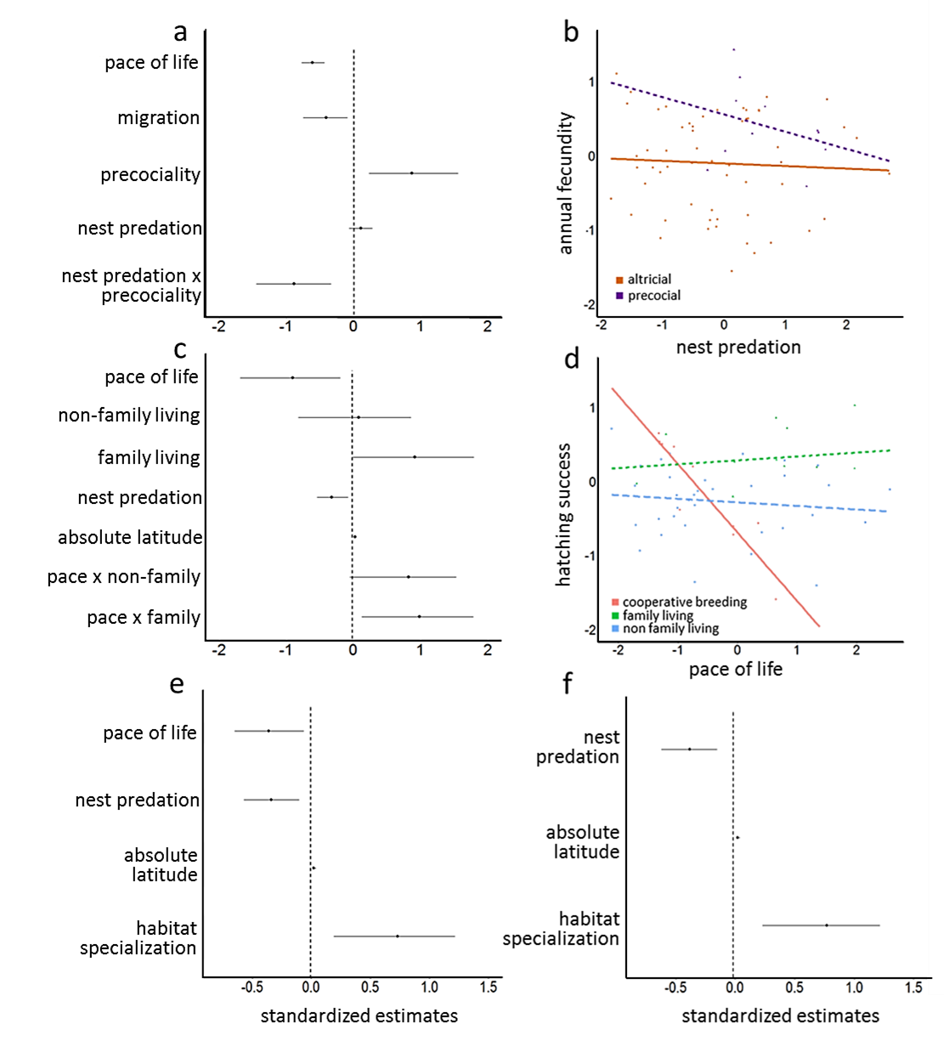
Fig. 1

Fig. 2

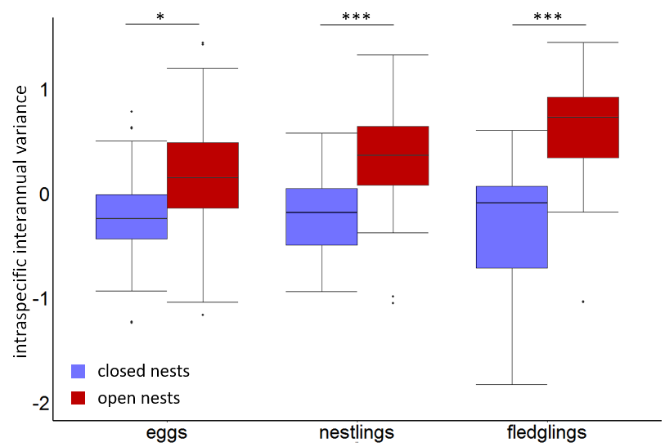

Fig. 3
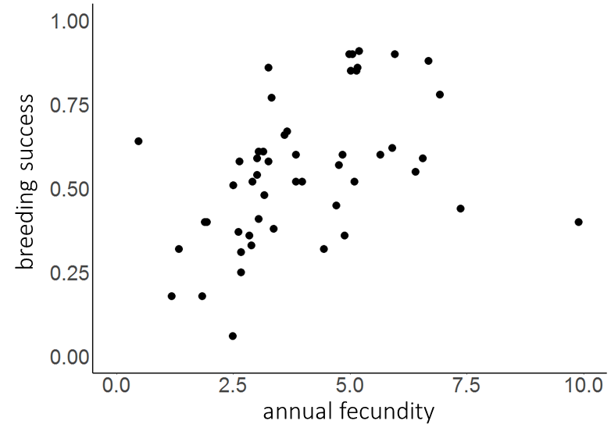
Fig. 4
