Ecosystem services networks: an accessible framework for decision-making
Manu E. Saunders^{1,2*}, Romina Rader², Darren Ryder², Oscar J. Cacho¹

¹UNE Business School, University of New England, Armidale NSW 2351
²School of Environmental and Rural Sciences, University of New England, Armidale NSW 2351
* Corresponding author: c/- UNE Business School, University of New England Armidale NSW 2351, Phone: +61267731794, Fax: +61267732769, Email: manu.saunders@une.edu.au

Abstract
Multifunctional landscapes provide multiple ecosystem services and are managed collaboratively to preserve biodiversity and ecosystem function and support human wellbeing. Linking ecological patterns across systems is essential to advance ecosystem services research and inform ecologically-sustainable landscape management. Network theory provides a robust, accessible framework to build knowledge of ecosystem services, engage with stakeholders, and link disciplinary knowledge and system processes across multiple scales. But two major knowledge gaps need to be overcome to facilitate a unified framework for quantifying ecosystem services via integrated social, ecological and economic networks: (i) methods to link social actors with biodiversity and ecosystem function across different systems (terrestrial—aquatic and social—ecological); and (ii) a simple ecosystem services network typology that is relevant across disciplines and systems, and is accessible to practitioners. We advocate an interdisciplinary approach to ecosystem services networks that is grounded in ecological theory. Research and practice should prioritise understanding critical connections between systems, particularly terrestrial—aquatic energy flows and relationships between biodiversity, ecosystem function and human wellbeing.

Keywords: ecosystem services, multifunctional landscapes, network analysis, systems ecology
Introduction
Multifunctional landscapes provide multiple ecosystem services and need to be managed collaboratively to preserve biodiversity and natural processes and support human wellbeing (Bennett 2017; Fischer et al. 2017). Delivery of ecosystem services depends on ecological processes and interactions between species and their environments; therefore, understanding ecosystem services depends on explicit investigation of complex interactions between social, ecological and economic systems. Ecosystem-scale approaches to research and practice account for ecological complexity and improve decision-making to achieve multifunctional outcomes. Yet disciplinary silos have resulted in a range of disparate methodologies that address isolated components of ecosystem services supply and delivery. There is still no consensus on how to link knowledge of ecological interactions across different systems that have traditionally been studied and managed separately, particularly aquatic and terrestrial ecosystems, and ecological and social systems. Addressing these limitations is critical to move beyond simple valuation of isolated ecosystem service components to a powerful framework for sustainable management of multifunctional landscapes (Limburg et al. 2002; Ostrom 2009).

Network approaches are a proven method for visualising and analysing multiple types of complex ecological and social systems (May et al. 2008; Dormann et al. 2017). Network theory provides a robust and accessible framework to explicitly link multiple ecosystem services to the underlying spatial distributions of natural and social capital, and consider the interactions between them (Bohan et al. 2016; Raffaelli 2016; Dee et al. 2017; Field & Parrott 2017). Importantly, network approaches have the analytical power to transcend disciplinary boundaries and achieve the necessary unified structure for ecosystem services research and decision-making (Bohan et al. 2016). Network approaches have immense potential to help communicate and solve ecosystem services problems, but a number of knowledge gaps still need to be addressed before we can meaningfully link biodiversity, ecosystem function and ecosystem services across multiple systems and scales.

Here we highlight two key priorities for advancing research and application of ecosystem services networks. First, knowledge and methods from multiple disciplines need to be integrated to understand functional links between systems and scales. Of particular importance are aquatic-terrestrial and social-ecological linkages. Aquatic and terrestrial biomes are traditionally studied in isolation (Soininen et al. 2015), even though aquatic systems are key drivers of terrestrial ecosystem function (Polis et al. 1997; Dreyer & Gratton 2014). Agricultural land management also influences ecosystem function and services in nearby aquatic systems and further downstream (Davis et al. 2016). Similarly, while ecosystem services literature is replete with discussions claiming to link social and ecological components within systems, the term ‘ecological’ is often used to refer to natural capital stocks (e.g. resources) and rarely includes knowledge of biodiversity and ecosystem function measured in situ (i.e. species-species and species-habitat interactions) (Lavorel et al. 2017). Second, a unified framework for ecosystem services network approaches requires a standardised network typology that is accessible to a broad range of researchers and practitioners. A confusing range of indicators are currently used in the literature to measure individual services and their relationships, partly influenced by the many ways to define and classify ecosystem services, e.g. Millennium Ecosystem Assessment 2005; TEEB (European Communities 2008); CICES (Haines-Young & Potschin 2018)). Overcoming these knowledge gaps is essential to forge a path for a unified framework for ecosystem services research and practice, one that transcends disciplinary boundaries and focuses on the interactions that structure multifunctional landscapes.

Functional links across scales and systems
Recent work from multiple research groups argues for the utility of network approaches as a unifying framework for communicating and solving ecosystem services problems (e.g. Bodin & Tengö 2012; Bohan et al. 2016; Dee et al. 2017; Field & Parrott 2017). However, overcoming the hurdles of disciplinary silos is critical to developing a practical unified framework for ecosystem services networks. Current literature advocating network approaches for ecosystem services problems is dominated by social network theory and resource governance systems. Yet sustainable management of ecosystem services depends on understanding the relationships between biodiversity and ecosystem function underlying the supply and delivery of those services (Kremen 2005; Bennett et al. 2009). Movement of organisms and energy flows bridge physical boundaries between spatially and/or temporally segregated habitats and systems (Lundberg & Moberg 2003; Kremen et al. 2007), yet empirical research on functional linkages between different types of systems is lacking. For example, the extent to which ecological communities are connected with biogeochemical processes is poorly studied, and we have little understanding of how disturbances or management actions can alter the structure of networks and the flow of ecosystem services (e.g. Russo & Shea 2016). This lack of ecological knowledge limits our ability to predict changes in ecosystem service delivery as scenarios change.

A key goal for advancing ecosystem services research and practice is to build greater understanding of functional links that supply ecosystem services across land—water boundaries. There is a large body of historical literature on resource subsidies linking terrestrial and aquatic systems (Polis et al. 1997), as well as increasing evidence that energy flows (via species-species and species-environment interactions) across land-water boundaries influence ecosystem function (Knight et al. 2005; Dreyer & Gratton 2014). Yet there is still limited understanding of how these functional links influence ecosystem services (but see Stewart et al. 2017). Recent network analyses of social-ecological systems that connect land and water components have focused on how social networks influence water resource governance or ecosystem service valuation (e.g. Rathwell & Peterson 2012; Hicks et al. 2013; Baggio et al. 2016), but no ecosystem services network studies have integrated terrestrial and aquatic ecological interactions relevant to ecosystem services supply within a system.

River systems pose a particular challenge for developing integrated network models of ecosystem services. From a network analysis perspective, rivers have traditionally been treated as continuous dendritic networks with different patterns of flow and structure compared to terrestrial networks (Campbell Grant et al. 2007; Peterson et al. 2013). However, actual river systems are patchy and discontinuous, with distinct changes in ecological communities and biophysical properties along the network (Poole 2002). For ecosystem services networks, a practical way to address this may be to divide aquatic systems into habitat patches relative to the focal landscape, using knowledge of functional links or ecological communities to determine habitat transitions. For example, the River Styles framework uses geomorphological boundaries to divide rivers into ecologically-relevant sections to inform river management (Brierley et al. 2002). Alternatively, patches can be defined by sub-catchments, or physical transitions between different types of water bodies (e.g. Jones 2010). Modularity analysis, a network tool to identify communities of interacting nodes within a network, may also be useful to identify how habitat transitions between structurally different habitats affect network structure (Dormann et al. 2017).

Linking terrestrial and aquatic systems also helps in defining the system boundary, which is a key first step in any systems analysis (Limburg et al. 2002). To date, there is no consensus on a standard boundary for landscape-scale ecosystem services models, which is essential for developing a unified framework for ecosystem services research. Most freshwater-related services naturally follow hydrologic flows. Upstream activities and land uses influence downstream benefits, including coastal/marine ecosystem services, and many natural resource policies and organisations operate at the catchment scale. Therefore, an overall boundary at the catchment (or watershed) scale is an ecologically-realistic standard for ecosystem services network models.

Another key challenge is understanding how to realistically link ecological interactions across social and biophysical systems, which have different dynamics, interaction structures and properties. Most ecosystem services modelling studies that claim to link social and ecological components use environmental proxy variables with weak links to ecological processes and interactions (Lavorel et al. 2017). Within the ecosystem services network theory literature, no studies have realistically linked social and ecological interactions within a system. Many studies take a social network theory approach, where ecological nodes are defined as broad categories of natural resources or land uses linked by relationships between resource users (Bodin & Tengö 2012; Hicks et al. 2013). Only a few studies proposing network approaches identify ecological interactions between taxonomic groups of species and/or their habitat as key components of an ecosystem services network (Bohan et al. 2016; Dee et al. 2017; Harvey et al. 2017). Despite these conceptual advances, there is still no clear path for how network approaches can be used in practice to integrate biodiversity and ecosystem function with social or economic systems, and with the depth necessary to advance knowledge of ecosystem services.

Bohan et al. (2016) propose a useful method of linking ecological interaction networks with social and economic networks by building the latter two as layers on top of the core layer of ecological interactions. Frameworks for analysing multilayer networks exist (De Domenico et al. 2013; Kivelä et al. 2014; Pilosof et al. 2017), demonstrating the capacity to link different systems across network layers for ecosystem services research. However, a key research priority is to build empirical understanding of the relative utility of bipartite (two-mode), single-layer (one-mode), or multilayer networks for dealing with the complexity of ecosystem services. Bipartite and single-layer networks are easier to apply, are more accessible to non-specialists and may be useful as communication tools, whereas multilayer networks may be more useful for research on complex systems. In multilayer networks, layers can be defined as different types of interactions, e.g. ecological, social and economic interactions, as Bohan et al. (2016) suggest. Alternatively, they can be defined by temporal or spatial scales, whereby all direct links between social, ecological and economic components within a system are retained, and cross-scale links are made to adjacent spatial (e.g. another landscape) or temporal (e.g. seasons, years) layers. Ecological knowledge is essential to reduce the complexity inherent in large networks of interactions across space and time and identify how biodiversity-ecosystem function relationships influence network structure and ecosystem services delivery (Kissling et al. 2012). But the appropriate data resolution depends on the project goals and scale, and trait-based approaches (such as interaction currencies or trait linkage frameworks) may be useful to shift focus from interactions between individuals to community-level functional dynamics (Lavorel et al. 2017).

An accessible network typology
The myriad ways of classifying and measuring ecosystem services present a real obstacle for conceptual unification across multiple systems and make it difficult for practitioners to use ecosystem services frameworks for real-world decision-making. We propose a more accessible approach to classifying ecosystem services for network approaches (Table 1). To standardise ecosystem services components when adopting network approaches across systems, this network typology can be used in conjunction with current classification schemes. We differentiate between goods, experiences, and processes, because the function of each of these categories illustrates how humans interact with, and benefit from, ecosystems. This approach focuses on interactions between nature and beneficiaries and, importantly, provides a more practical way to measure individual components of a social-ecological network across scales and contexts.

Table 1: Ecosystem services can be classified into three simple categories for network analysis.
 | Goods | Experiences | Processes
Benefit | Tangible goods for human use or consumption, either bought from vendors/producers, or extracted directly. | Personal experiences, usually intangible and often difficult to quantify. | Ecological processes and functions that produce goods and experiences, often intangible and indirect.
Examples | Crops and livestock, seafood, wild harvest of plants and animals, firewood, rainwater etc. | Recreation, aesthetic beauty, cultural and spiritual values etc. | Water quality maintenance, disease control, salinity reduction, weathering processes, climate regulation etc.

Standardising analysis of interaction benefits across different networks can help identify patterns of connection as unifying structures across systems. We propose a foundational structure for ecosystem services networks (Figure 1) that has broad application across a variety of systems and can be used as a visual tool for communication and engagement, as well as a methodological framework for testing future hypotheses and informing environmental decision-making. An ecosystem services network (Figure 1a) is structured by directed links between social and ecological nodes, allowing the flow of ecosystem services to beneficiaries. Nodes can be defined as social and ecological components relevant to the system (e.g. land uses, species groups, social or political actors), while links can be defined as the relationships between those entities (e.g. information exchange, spatial movement, species interactions).

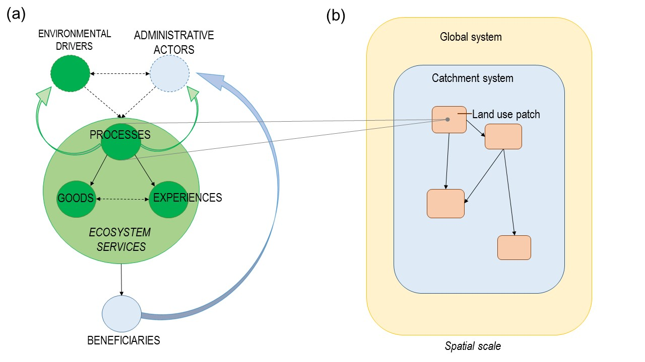
Figure 1: The underlying structure of ecosystem services networks in multifunctional landscapes. (a) Structural foundation of an ecosystem services network linking social (pale blue) and ecological (green) nodes. Broken arrows indicate the direction of direct effects for mediating drivers and solid arrows indicate the direction of ecosystem services flows. (b) Processes are linked to spatially explicit locations (i.e. land use patches) within the catchment system.

A basic interaction structure underlies ecosystem services flows, whereby processes deliver goods and experiences, and all three may indirectly mediate each other’s value (see Table 1). Each of these three components can deliver benefits to beneficiaries individually, or as bundles of ecosystem services. Environmental drivers and administrative actors can potentially mediate processes through disturbances or management decisions. Environmental drivers (e.g. drought) can directly mediate administrative actor behaviour (e.g. policy or adaptive management decisions), which will have flow-on effects to the supply of ecosystem services. Actor behaviour may also influence environmental drivers indirectly and effects will be seen at a later time period. The potential influence of feedback can also be included as a network link: social feedback (blue curved arrow; Figure 1a) occurs when beneficiary needs or behaviours influence administrative actor behaviour via information exchange; ecological feedback (green curved arrows; Figure 1a) occurs when processes influence environmental drivers or actor behaviour via environmental or biophysical changes. The ecosystem services network can be linked to spatially explicit locations within the broader system via processes (Figure 1b). Processes arise from interactions occurring within land use (or habitat) patches and deliver goods and experiences to beneficiaries within and beyond the system boundary. For example, pollination of crop plants is an ecological process that occurs via animals (e.g. bees and flies) interacting with crop flowers in a spatially-explicit location (e.g. an apple orchard). This process will subsequently produce goods (fruit after harvest) that will be sold to beneficiaries within the local community and to markets outside the local system (Figure 2). A process can also provide experiences; for example, an apple orchard may open its gates to the public at harvest time for a ‘pick-your-own’ farm experience.

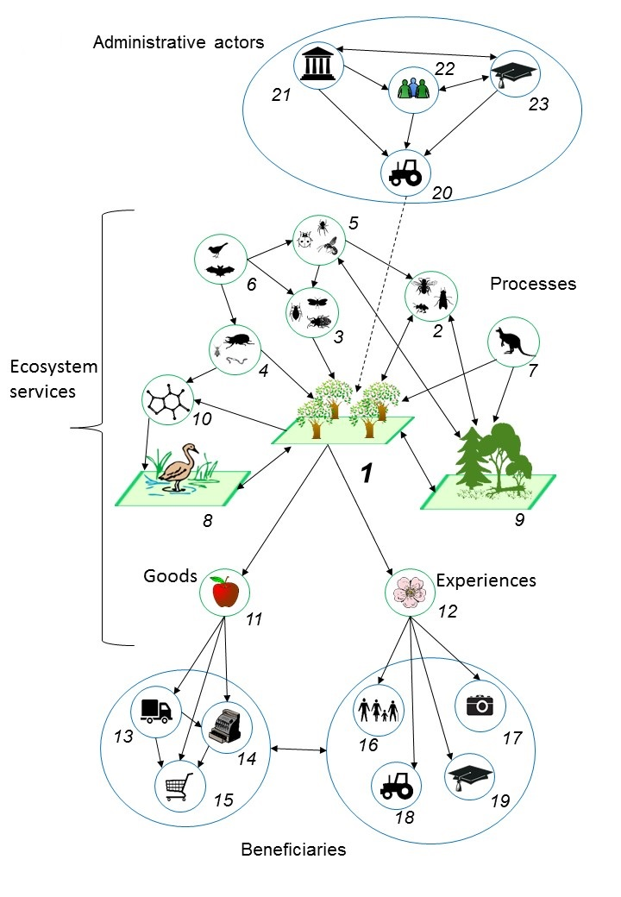
Figure 2: An ecosystem services network example based on a hypothetical apple production system. Within the apple orchard (1), functional groups of animal species interact with apple trees: pollinators enhance fruit set (2); pests damage fruit and affect tree health (3); soil invertebrates affect tree health indirectly (4); insect natural enemies (5) and insectivorous vertebrates (6) control insect pests (5); herbivorous wild mammals eat vegetation (7). The orchard is linked to other land uses in the system (8, 9) through shared animal communities (2, 5, 7), or biogeochemical interactions, e.g. through nitrogen runoff into waterways (10). Processes create goods (11) and experiences (12), which flow to beneficiaries. Fruit (11) is sold to wholesale distributors (13), retailers (14), and consumers (15), either within the catchment system, or as exported benefits. Experiences (12) enhance human wellbeing, e.g. through employment (16), aesthetic appeal (17), grower’s livelihood (18), and scientific value of the orchard as a study system (19). The orchard owner (20) makes daily decisions about land management (e.g. spray application, orchard floor management) that affect assemblages of ecological communities in the orchard and their interactions. The owner’s decisions are influenced by information from lawmakers, natural resource consultants, agronomists and researchers (21-23). Feedback loops and environmental drivers are not shown (see Figure 1).

This basic network structure has many applications for research and collaborative decision-making. For individual networks, nodes can be removed, or expanded to show subsets of interactions, depending on the system being described and the goal of the application. This basic model can be adapted to illustrate a system at a single point in time or space; multiple networks can be created for one system to understand how node interactions change across time, or from effects of different drivers; or multiple networks can be created for multiple interacting systems to link ecosystem services networks in space. For example, effects of environmental drivers and administrative actors can originate within and beyond the system boundary. Land use patches can be linked through networks of species-environment interactions and ecosystem services flows. Fluxes across space and time can occur at any level; for example, drivers and actors can influence later processes, and processes can deliver goods or experiences in the future.

The existing methodological literature on network analysis is segregated between disciplines, and for different types of network interactions (e.g. social, mutualistic, parasitic, trophic), leading to varying interpretations of network structure analysis across disciplines and fields (Borrett et al. 2014; Fontaine et al. 2011; Dormann et al. 2017). Ecosystem services networks potentially integrate all types of network interactions, yet knowledge and tools to analyse and interpret complex networks involving multiple interaction types remains limited. Empirical research is needed to build knowledge of how standard network structure metrics relate to ecosystem services systems. This will assist researchers and practitioners to analyse and interpret links between network structure and ecosystem function within an ecosystem services context. For example, network-level metrics like modularity and connectance are generally associated with resilience and stability of networks (Dormann et al. 2017), which can potentially influence ecosystem service delivery. Therefore, network-level metrics may be useful to assess how environmental changes influence structure and function in a multifunctional landscape network. Node-level metrics, like node strength or betweenness centrality, identify a node’s influence on network structure. For example, an influential social node (e.g. a farming community) could be key beneficiaries of services, or key actors in land management, while an influential node representing a functional taxonomic group (e.g. bee pollinators) could be a key service providing unit in the network.

Conclusions
Ecosystem services is a scientific concept that provides a functional link between nature, human society, and economics, and a powerful research and decision-making framework. Greater institutional and disciplinary support is essential for ecologists, economists, social scientists and community stakeholders to work together to integrate ecological knowledge of population and community dynamics with economic and resource governance approaches. Network approaches provide a unified methodological framework with relevance to multiple disciplines, and have great promise as an accessible, realistic tool for ecosystem services research, communication and decision-making. To achieve full potential for ecosystem services network approaches, knowledge synthesis across disciplines and greater empirical effort to understand cross-system energy flows need to be prioritised.

We advocate for the adaptation of network approaches to standardise ecosystem services research and decision-making. We highlight critical links between biodiversity, ecosystem function and human wellbeing and illustrate the need for a standardised, accessible typology for ecosystem services networks that provides a foundational structure for linking ecosystem services components across scales and systems.

Acknowledgements
This research was supported by a University of New England Postdoctoral Fellowship awarded to MES.
References
Baggio JA, BurnSilver SB, Arenas A, Magdanz JS, Kofinas GP, De Domenico M. 2016. Multiplex social ecological network analysis reveals how social changes affect community robustness more than resource depletion. Proc. Natl. Acad. Sci. USA 113:13708–13713.
Bennett EM. 2017. Changing the agriculture and environment conversation. Nature ecology & evolution 1: 0018.
Bennett EM, Peterson GD, Gordon LJ. 2009. Understanding relationships among multiple ecosystem services. Ecology Letters, 12: 1394-1404.
Bodin Ö, Tengö M. 2012. Disentangling intangible social–ecological systems. Glob. Environ. Change 22:430–439.
Bohan DA, et al. 2016. Networking our way to better ecosystem service provision. Trends Ecol. Evol. (Amst.) 31:105–115.
Borrett SR, Moody J, Edelmann A. 2014. The rise of Network Ecology: Maps of the topic diversity and scientific collaboration. Ecological Modelling 293: 111–127.
Brierley G, Fryirs K, Outhet D, Massey C. 2002. Application of the River Styles framework as a basis for river management in New South Wales, Australia. Applied Geography 22:91–122.
Campbell Grant EH, Lowe WH, Fagan WF. 2007. Living in the branches: population dynamics and ecological processes in dendritic networks. Ecol. Lett. 10:165–175.
Davis AM, Pearson RG, Brodie JE, Butler B. 2016. Review and conceptual models of agricultural impacts and water quality in waterways of the Great Barrier Reef catchment area. Mar. Freshwater Res. 68:1–19.
Dee LE, Allesina S, Bonn A, Eklöf A, Gaines SD, Hines J, Jacob U, McDonald-Madden E, Possingham H, Schröter M, et al. 2017. Operationalizing network theory for ecosystem service assessments. Trends Ecol. Evol. (Amst.) 32:118–130.
De Domenico M, Solé-Ribalta A, Cozzo E, Kivelä M. 2013. Mathematical formulation of multilayer networks. Physical Review X.
Dormann CF, Fründ J, Schaefer HM. 2017. Identifying causes of patterns in ecological networks: opportunities and limitations. Annual Review of Ecology, Evolution & Systematics, 48: 559-584.
Dreyer J, Gratton C. 2014. Habitat linkages in conservation biological control: Lessons from the land–water interface. Biological Control 75:68–76.
European Communities. 2008. The Economics of Ecosystems & Biodiversity (TEEB). Available from www.teebweb.org
Field RD, Parrott L. 2017. Multi-ecosystem services networks: A new perspective for assessing landscape connectivity and resilience. Ecological Complexity 32:31–41.
Fischer J, Meacham M, Queiroz C. 2017. A plea for multifunctional landscapes. Front. Ecol. Environ. 15:59–59.
Fontaine C, Guimarães PR, Kéfi S, Loeuille N, Memmott J, van der Putten WH, van Veen FJF, Thébault E. 2011. The ecological and evolutionary implications of merging different types of networks. Ecol. Lett. 14:1170–1181.
Haines-Young, R. and M.B. Potschin (2018) Common International Classification of Ecosystem Services (CICES) V5.1 and Guidance on the Application of the Revised Structure. Available from www.cices.eu
Harvey E, Gounand I, Ward CL. 2017. Bridging ecology and conservation: from ecological networks to ecosystem function. Journal of Applied ….
Hicks CC, Graham NAJ, Cinner JE. 2013. Synergies and tradeoffs in how managers, scientists, and fishers value coral reef ecosystem services. Glob. Environ. Change 23:1444–1453.
Jones NE. 2010. Incorporating lakes within the river discontinuum: longitudinal changes in ecological characteristics in stream-lake networks. Canadian Journal of Fisheries and Aquatic Sciences, 67: 1350-1362.
Kivelä M, Arenas A, Barthelemy M, Gleeson JP, Moreno Y, Porter MA. 2014. Multilayer networks. J Complex Netw 2:203–271.
Kissling WD, Dormann CF, Groeneveld J, Hickler T, Kühn I, McInerny GJ, Montoya JM, Römermann C, Schiffers K, Schurr FM, et al. 2012. Towards novel approaches to modelling biotic interactions in multispecies assemblages at large spatial extents. Journal of Biogeography 39: 2163–2178.
Knight TM, McCoy MW, Chase JM, McCoy KA, Holt RD. 2005. Trophic cascades across ecosystems. Nature, 437: 880-883.
Kremen C. 2005. Managing ecosystem services: what do we need to know about their ecology? Ecol. Lett. 8:468–479.
Kremen C, Williams NM, Aizen MA, Gemmill-Herren B, LeBuhn G, Minckley R, Packer L, Potts SG, Roulston T, Steffan-Dewenter I, Vazquez DP, Winfree R, Adams L, Crone EE, Greenleaf SS, Keitt TH, Klein A-M, Regetz J, Ricketts TH. 2007. Pollination and other ecosystem services produced by mobile organisms: a conceptual framework for the effects of land use change. Ecology Letters 10: 299-314.
Lavorel S, Bayer A, Bondeau A, Lautenbach S, Ruiz-Frau A, Schulp N, Seppelt R, Verburg P, Teeffelen A van, Vannier C, et al. 2017. Pathways to bridge the biophysical realism gap in ecosystem services mapping approaches. Ecol. Indic. 74:241–260.
Limburg KE, O’Neill RV, Costanza R, Farber S. 2002. Complex systems and valuation. Ecological Economics 41: 409–420.
Lundberg J, Moberg F. 2003. Mobile link organisms and ecosystem functioning: implications for ecosystem resilience and management. Ecosystems, 6: 87-98.
May RM, Levin SA, Sugihara G. 2008. Complex systems: Ecology for bankers. Nature 451: 893–895.
Millennium Ecosystem Assessment, 2005. Ecosystems and Human Well-being: Synthesis.
Island Press, Washington, DC.
Ostrom E. 2009. A general framework for analyzing sustainability of social-ecological systems. Science 325: 419–422.
Peterson EE, Ver Hoef JM, Isaak DJ, Falke JA, Fortin M-J, Jordan CE, McNyset K, Monestiez P, Ruesch AS, Sengupta A, et al. 2013. Modelling dendritic ecological networks in space: an integrated network perspective. Ecology Letters 16: 707–719.
Pilosof S, Porter MA, Pascual M, Kéfi S. 2017. The multilayer nature of ecological networks. Nat. Ecol. Evol. 1:101.
Polis GA, Anderson WB, Holt RD. 1997. Toward an integration of landscape and food web ecology: the dynamics of spatially subsidized food webs. Annu. Rev. Ecol. Syst. 28:289–316.
Poole GC. 2002. Fluvial landscape ecology: addressing uniqueness within the river discontinuum. Freshwater Biology 47: 641-660.
Raffaelli, D. 2016. Ecosystem structures and processes: characterising natural capital stocks and flows. In: Routledge Handbook of Ecosystem Services (eds. Potschin, M., Haines-Young, R., Fish, R. & Turner, R.K.). pp. 62–73.
Rathwell KJ, Peterson GD. 2012. Connecting Social Networks with Ecosystem Services for Watershed Governance: a Social-Ecological Network Perspective Highlights the Critical Role of Bridging Organizations. Ecology and Society 17.
Russo L, Shea K. 2016. Deliberately increased network connectance in a plant-pollinator community experiment. Journal of Complex Networks 5: 473-485.
Soininen J, Bartels P, Heino J, Luoto M, Hillebrand H. 2015. Toward More Integrated Ecosystem Research in Aquatic and Terrestrial Environments. Bioscience 65:174–182.
Stewart RIA, Andersson GKS, Brönmark C, Klatt BK, Hansson L-A, Zülsdorff V, Smith HG. 2017. Ecosystem services across the aquatic-terrestrial boundary: linking ponds to pollination. Basic and Applied Ecology, 18: 13-20.

