Forest management effects on survival of a long-lived bird

Paul Haverkamp^{1*}, Julian Klein², Michael Griesser^{1,3}

¹Department of Evolutionary Biology and Environmental Studies, University of Zurich, Winterthurerstrasse 190, 8057 Zurich, Switzerland
² Department of Ecology, Swedish University of Agricultural Sciences, Box 7044, 750 07 Uppsala, Sweden

³ Department of Anthropology, University of Zurich, Winterthurerstrasse 190, 8057 Switzerland
* Corresponding author: Paul J. Haverkamp, Department of Evolutionary Biology and Environmental Studies, University of Zurich, Winterthurerstrasse 190, 8057 Zurich, Switzerland,

paul.haverkamp@ieu.uzh.ch
Abstract
- A high number of reproductive events is a critical fitness correlate for long-lived species. Thus, individuals of these species should be sensitive to factors that increase their mortality. Living in habitats with high exposure to predators can decrease lifespan, but the ecological drivers of longevity within populations remain poorly studied. Forest management in boreal forests can increase the predation risk by creating edges and open forests, which facilitate prey detection for visual hunters.
- We assessed the impact of forest structure on breeding lifespan and lifetime reproductive success on a population of Siberian jays (Perisoreus infaustus) in northern Sweden located in managed and natural landscapes.
- We used survival analyses to assess the influence of life history and ecological correlates on lifespan after attaining breeder status. The analyses included N=133 individuals within 38 territories in the managed landscape, and N=74 individuals within 25 territories in the natural landscape. The same correlates were used to investigate influences on the number of surviving offspring, as a measure of lifetime reproductive success.
- Breeder lifespan was longest when individuals attained breeder status at an older age, in territories with dense understory, and few linear edges and natural openings, which reduce the risk of detection by primary predators (accipiter hawks). Moreover, a late onset of reproduction was associated with a higher lifetime reproductive success. Remarkably, these effects were only found in the managed landscape.
- These results suggest that forestry shapes risk gradients in landscapes that particularly affect individuals that begin to breed at an earlier age. Thus, experience may be more critical to survive in managed than natural landscapes, making populations less resilient to disturbance and affecting life history evolution.

Keywords: human altered landscapes, forestry, predation, longevity, reproductive success

Introduction
Long lifespans are associated with increased fitness in long-lived species as they provide more reproductive opportunities (Williams 1966; Stearns 1976; Stearns 1992). Thus, individuals of these species should avoid factors that increase their mortality risk to ensure future reproduction (Bradley, Wooller & Skira 2000; Ghalambor & Martin 2001). Previous research identified several main sources of mortality in long-lived species, including predation and reproductive costs. Mortality in birds is particularly driven by predation, often by other birds (Valcu et al. 2014). Accordingly, species evolved a range of behavioural strategies to reduce the risk of predation, such as avoiding risky habitats or times of the day, or by increasing their investment in anti-predator behaviours (Kaitala, Lindström & Ranta 1989; Lima & Dill 1990; Caro 2005). Moreover, reproduction is costly, particularly for young breeders of long-lived species that take time to develop efficient foraging skills and other skills needed for successful reproduction (Williams 1966; Curio 1983). However, studies rarely examine the ecological correlates of predation risk in landscapes, and how this links to costs of reproduction.
While the link between reproductive allocation and longevity is well investigated within and across species (Roff 1992; Stearns 1992), ecological correlates of longevity within populations are largely unstudied (Hakkarainen et al. 2008; Jones et al. 2014). In many species, the risk posed by predators can vary across habitats and landscapes (Laundré, Hernández & Altendorf 2001). Consequently, animals foraging in riskier parts of the landscape are likely to increase their antipredator investment or avoid these parts (Hilton, Ruxton & Cresswell 1999; Laundré, Hernández & Altendorf 2001; Caro 2005). Due to the costs associated with antipredator behaviour (Biro et al. 2006), it is reasonable to assume that individuals living in high-risk parts of a landscape may experience reduced longevity.
Few studies have investigated how specific environmental factors impact longevity in natural populations. Male boreal owls (Aegolius funereus) have higher survival when living in territories with a high proportion of natural forests compared to managed forests, because natural forests provide more cover from predators (Hakkarainen et al. 2008). Similarly, juvenile Siberian jays (Perisoreus infaustus) in managed forests are more likely to be detected and killed by hawks (Griesser et al. 2017a). While these studies suggest that habitat management can increase the predation risk of forest-dwelling birds, it remains unclear which specific habitat and landscape measures have a detrimental effect on survival. This knowledge is critical to modify management schemes in order to enhance habitats of endangered species.
Here we examine how age at first reproduction and habitat features influence breeding lifespan and lifetime reproductive success in a group-living bird, using longitudinal data from a population of Siberian jays (Ekman & Griesser 2016). This species is territorial year-round and can live up to 18 years (Griesser et al. 2017b). Most individuals in the study population die due to predation, particularly by goshawks (Accipiter gentilis) and sparrowhawks (A. nisus) (Griesser et al. 2017a). These predators are visual hunters that benefit from open habitats (Kenward 1982; Post & Götmark 2006), and previous work suggested that habitat structure can affect mortality in Siberian jays (Griesser et al. 2017a). We take advantage of discrete return Airborne Laser Scanning (ALS; LiDAR data) of forest structure (several measures of vegetation distribution and density in different vertical layers) and landscape data to assess their influence on breeding lifespan and lifetime reproductive success in Siberian jay breeders.

Methods
Study site and species
Data were collected from a long-term study population of Siberian jays near Arvidsjaur (65° 40′ N, 19° 0′ E), northern Sweden (Ekman & Griesser 2016). Here we use data collected between 1998 and 2017 of N=207 individuals from N=64 territories. All birds in the study population were color-ringed for individual recognition. Jays are sexually monomorphic and thus, the sex of all individuals was determined with molecular methods (Griffiths et al. 1998). Birds were handled under the license of Umeå ethics board (license nr. A 80-99, A45-04, and A 50-11).
Forests at the study site are typical of the northern European boreal zone, with Scots pine (Pinus sylvestris) and Norway spruce (Picea abies) being the dominant tree species. The study site includes two parts that differ in their management. One part is located in a reserve where forests have not been managed for over 200 years (hereafter, natural part). The other part includes both intensively managed patches and largely unmanaged patches (hereafter, managed part). Forest management includes clear-cutting, replanting, and, in older forests, thinning, where most small spruces and deciduous trees are removed every 20-40 years to increase timber production (Griesser & Lagerberg 2012). Thus, managed forests are initially often very dense, but are more open and provide little visual cover when reaching about 40-50 years.
Assessment of territory locations
Siberian jay groups occupy stable year-round territories that only rarely shift their location (N=4 instances in this study; Nystrand et al. 2010). Territories do not have clearly defined borders but groups spend most of their time in the core of the territory around the breeding site (Nystrand et al. 2010). Thus, we calculated the centre of each territory based on the mean nest locations over the study years, using the Mean Center tool in the Spatial Statistics toolbox in ESRI ArcGIS Desktop 10.1 (ESRI 2011). Nest locations were recorded with handheld GPS units between 1989-2004, and 2011-2013. These locations vary only locally between years (mean ± SE = 173.10 ± 11.30 m, min = 23.19 m, max = 648.00 m). The mean centre point was then used for habitat assessment (see below).
Assessment of social rank, sex, and survival
Territories were visited repeatedly each year in March, before the onset of breeding, and in September, after the juvenile dispersal phase. These visits allowed us to track the life history and social rank of all individuals in the study population. The social rank (breeder, non-breeder) was established by following the breeding events or based on observations of jays on a feeding device, using a standardized behavioural assessment (Griesser et al. 2015). Breeders are always dominant over other same-sex group members, allowing us to unambiguously determine the rank of all group members (Griesser et al. 2015). Breeder lifespan was assessed using the mark-re-observation method (Griesser et al. 2014). Breeders only rarely disperse to attain a breeding position in a different territory (here N = 1 incidents) and if they do, they only move to a neighbouring territory (Griesser et al. 2007). Thus, this method provides a robust measure of breeder lifespan.
Lifetime reproductive success
We used breeding success and census data to assess the lifetime reproductive success (LRS) of all breeders. Following previous work, we used the number of retained offspring in autumn as a proxy for the reproductive success of a territory in a given year (Griesser et al. 2014; Layton-Matthews, Ozgul & Griesser 2018). While this measurement does not include the number of early dispersing offspring, retained juveniles have both a higher first winter survival (Griesser, Nystrand & Ekman 2006), and leave more offspring throughout their lives than early dispersing juveniles (Ekman & Griesser 2016). Thus, this is a robust proxy that also reflects offspring mortality at a very late nesting stage and during the first summer of life. Since Siberian jays do not engage in extra-pair mating (Ekman & Griesser 2016), all offspring contribute to the fitness of a breeder.
Assessment of forest parameters
To extract landscape parameters and forest composition of a territory, we applied circular buffers of 30 ha (310 m radius) and 66 ha (460 m radius) around the mean territory point using the Buffer tool in ArcGIS. While the 30 ha buffer captures the core of a territory, the 66 ha buffer represents the mean extent of a territory (Nystrand et al. 2010).
ALS-based forest measurements
Discrete return Airborne Laser Scanning (ALS; LiDAR) data were collected at the study site 29-30 September 2010 by the Swedish Land Survey (Lantmäteriet 2016). The laser footprint had a diameter of 0.4 - 0.8 m with a point density of 0.5 – 1.0 points/m², 3.1 cm vertical precision and 25 cm horizontal precision. The resulting point cloud was normalized and relevant ALS metrics were extracted with a pixel size of 12.5 m, using Fusion software (McGaughey 2015). Extracted forest measurements were based on the “forested” pixels in each territory, i.e., pixels that had at least one laser reflection (return) above 2 m. Mean and standard deviation (SD) measurements were calculated for the density (percentage of all returns) from 0.5 - 5 m (hereafter, understory), density from 5 - 10 m, height (height at which 95% of all returns are below, to exclude cloud reflection), and forest openness (percent of all returns below 0.5 m). Definitions of all measurements are detailed in Supplementary Information Table S1. Additionally, we determined the percentage of non-forested area within the territory buffer. As ALS data represent only a snapshot of the forest vegetation, questions arise regarding the time period for which the data are valid. As vegetation growth is very low in northern Sweden (Appendix Table S-2, NFI 2015) we regard the ALS data reliable for all years of the study (1998 – 2017). Natural events changing the vegetation at a larger scale did not occur during this period.
Assessing the effect of management on ALS forest parameters
All forest patches that were affected by thinning and clear-cutting have been recorded in the field from 1997 to 2017. These patches were traced in Google Earth and imported into ArcGIS. Thinning reduces the forest volume and thus, we excluded individuals whose lifespans overlapped thinning events both before and after the 2010 ALS data acquisition (N = 60). For clear cuts that occurred after autumn 2010, we modelled vegetation data based on random samples from clear cuts that had occurred at maximum 10 years before 2010 and calculated a weighted averaged of these values with prior territory values to estimate territory measurements over individual jay lifespan. We consider this a robust approach based on a linear model showing the vegetation height of a ten-year-old forest clear cut does not significantly differ from those only one year old (p = 0.872).
Landscape parameters
The main predators of Siberian jays (Accipiter hawks) preferentially hunt along prolonged straight forest edges, including those created by roads, railroad tracks, and power lines (Kenward 1982). Thus, we traced these locations in Google Earth and imported them into ArcGIS to calculate their total length within each territory buffer. Within the study site, 27 year-round inhabited settlements are located within or near jay territories. Humans here provide food for birds (including Siberian jays) during winter, which may influence survival, particularly in harsh winters. Thus, we calculated the distance of each territory centre to the closest year-round settlement. The proportion of wetlands in a territory was derived from the vegetation classification maps produced by the Swedish Land Survey (Lantmäteriet 2006). We calculated the proportion of both the core territory and the extended territory that were covered by polygons that had been assigned any wetland category.

Statistical analyses
All statistical analyses were done in the R statistical environment (R Core Team 2016). To prevent issues with collinearity of predictor variables, we calculated the variance inflation factor, VIF (Dormann et al. 2013), from a linear model including all the predictors using the “vif” function in the car package (Fox et al. 2012) and removed predictors with VIF values greater than 4 (i.e., forest height and age, and SD of mean forest densities at different heights, except for the SD of understory density in the natural part). All continuous variables were cantered and scaled using the “scale” function in R to facilitate the comparison of covariates across different scales (Schielzeth 2010).
Preliminary analyses consistently showed a significant influence of management type (managed, natural parts of study site) on breeder lifespan. Previous studies identified several processes that differ between the two parts. In the managed part, predator attacks occur more frequently (Griesser et al. 2017a), nest predation rates are higher (Eggers et al. 2006), and population productivity is lower compared to territories in the natural part (Griesser et al. 2007; Layton-Matthews, Ozgul & Griesser 2018). Jays rarely move between the different parts, thus, we ran separate models for the territories in the managed and natural parts of the study site to account for these fundamental differences.
Model selection and averaging
We used a model selection approach based on the initial model with all parameters and interactions for all different analyses. We averaged the best fitting models (ΔAICc < 2) using the “model.avg” function in the MuMIn package (Bartoń 2012) to identify the models that best explain survival. We identified significant factors as those with a sum of Akaike weights larger than 0.5 and whose unconditional standard error of estimates did not overlap 0 (Grueber et al. 2011). We evaluated the significance of the random effect using a Likelihood-ratio test, where -2 * Δ log-likelihood of the model, with and without the random factor, is tested against a χ²-distribution with df = 1. We used the raw data from significant variables identified in model averaging to draw box plots and survival curves to understand how the variables influenced survival. The box plots where plotted in the package ggplot2 (Wickham 2010), while survival curves were plotted using the “survfit” function in survival (Therneau 2014) and ggplot2 (Wickham 2010). The same model selection and averaging approach was used to evaluate the influence of ecological and individual-related parameters on the age of achieving breeding status and lifetime reproductive success.
Effect of forest structure on breeder lifespan
To evaluate how ALS measurements influenced breeder lifespan, we used a mixed-effect Cox proportional hazard model using the coxme package (Therneau 2015). These models evaluate how covariates influence the hazard function h(t), which evaluates the risk of mortality at time t. These models do not assume normally distributed response variables and can incorporate censored data (see Table S1 for the details on the predictors used). Survival models were evaluated for both the core territory (30 ha) and the whole territory (66 ha). We tested whether the hazard ratio was constant over time using the “cox.zph” function in the survival package (Therneau 2014). The mean VIF were less than 3.5 in all models, indicating a low degree of covariance among predictors. We used the number of months from the time an individual achieved breeder status until death or autumn 2017 as time to event. These models also included mean distance to human settlements, length of linear edges, and the age (in months) at which an individual achieved breeder status. We included territory as a random factor to control for repeated measurements of multiple individuals in some territories.
The influence of management on breeder lifespan was examined with generalized linear mixed models (GLMM) in the glmmTMB package (Brooks et al. 2017). The number of months from the time an individual achieved breeder status until death or autumn 2017 was the dependent variable, with study site part and sex as independent variables in an interaction, with territory included as a random effect. Model fit was evaluated with the “simulateResiduals” function from the DHARMa package (Hartig 2017) and the final model was adjusted to a zero-inflated model with a negative binomial distribution.
Age of attaining breeder status
We assessed the life history and environmental correlates that influence the age of attaining breeder status using a GLMM with the “glmer” function in the “lme4” package (Bates et al. 2014), with a binary response variable (0: become breeder in first or second year; 1: become breeder after the second year). We used this split given that the median age at first attaining breeder status is 1.9 years. We included the same landscape, ALS, and life history variables used in the survival analysis and included territory as a random effect (see above).
Lifetime reproductive success
We evaluated the factors that influence the lifetime reproductive success in both parts of the study site with a GLMM (including territory as the random effect) using the “glmer” function in the lme4 package (Bates et al. 2014). The “simulateResiduals” function in the DHARMa package (Hartig 2017) indicated the managed part should use the random effect and was zero-inflated. In the natural part of the study site, we removed the random effects and one outlier, an individual with 12 surviving offspring throughout its lifetime (mean of 1.99), from the final analysis as models that included this individual did not converge. We included the same landscape, ALS, and life history variables used in the survival analysis, but had to remove the forest height, SD of height, and density from 5-10 m due to high VIFs. We also included tarsus length as a proxy for body size to understand how bird and forest variables could interact to influence reproductive success.
To examine the influence of management on LRS we used the same analytical approach as for the analyses of breeder lifespan (see above). The number of surviving offspring in autumn was the dependent variable, and study site part (managed or natural) and sex were independent variables in an interaction, with territory included as a random effect. One outlier was removed from the analysis to be consistent with the influence of landscape parameters on LRS analysis (see above). The “simulateResiduals” function in DHARMa revealed zero-inflation and thus, the final model was adjusted to a zero-inflated model.

Results
The survival analyses based on the territory core (30 ha) and extended territory (66 ha) resulted in comparable results. Thus, we present here only the results from the territory core analyses.
Effect of management
Individuals in the natural part of the study site lived longer than those in the managed part of the study site (Table 1, Figure 1a), but forest management was not found to influence LRS (Table 2, Figure 1b).
Correlates of breeder lifespan
In the managed part, breeders in territories with shorter distances to human settlements have longer survival (Table 3, Figure 2a). Also, breeders that attained a breeding position later in life had increased longevity in both forests with high and low understory density (Table 3, Figure 2b). Interactions between the percent of non-forested area in the territory and forest openness, and percent of non-forested area in the territory and understory density (0.5 – 5 m) influenced longevity (Table 3, Figure 2 c and d). Breeders living in territories with low forest openness had increased longevity in territories with both high and low percent non-forested area (Figure 2c). Individuals living in forests with a high understory density had increased longevity, in territories with both high and low non-forested areas (Figure 2d). Finally, individuals living in territories with smaller lengths of linear edges and higher density from 5 – 10 m had increased longevity (Figures S-1, S-2).
In the natural part, standard deviation of the understory density and proportion of the territory that is non-forested influenced longevity, with breeders in territories with low variability in the understory density having increased longevity, while proportion non-forested showed mixed influence (Table S-3; Figures S-3, S-4).
Correlates of the age of attaining breeder position and of lifetime reproductive success (LRS)
No forest or landscape parameters influenced the age of attaining breeding position in managed and natural parts (Table S-4). In managed parts, individuals with longer tarsi and that attained breeder status when older had a higher LRS than individuals that had shorter tarsi and attained breeding status early on in life (Figure 3a; Table 4). In the natural area, forest openness was positively associated with LRS (Figure 3b; Table 5).

Discussion
It is well established that longevity increases individual fitness in long-lived species (Williams 1966), and that an early onset of reproduction reduces breeder lifespan in these species (Mourocq et al. 2016). This latter effect is likely to reflect that young individuals lack skills required to deal with the direct costs of reproduction (Curio 1983; Hawn, Radford & du Plessis 2007). Moreover, breeders often engage in costly antipredator behaviours (predator mobbing, nest defence, costly signalling), increasing their indirect costs (Caro 2005; da Cunha, Fontenelle & Griesser 2017). Young breeders often lack antipredator skills (Griesser & Suzuki 2017) and are therefore more likely to be killed by predators. Our results support this idea and highlight that both ecological and life history factors can influence breeding lifespan. Siberian jays have increased longevity when living in territories with a dense understory that provides visual protection from predators, and when attaining a breeding position at a later age, which in turn increases their lifetime reproductive success. Interestingly, these effects were only found in managed parts. The amount of larger, alternative prey (e.g., capercaillie, black grouse) is higher in the natural part than in the managed part. Thus, understory density is more important in the managed part where Siberian jays draw more focus from predators. This suggest that forestry affects the hunting behaviour of hawks, thereby creating risk gradients within managed landscapes and affecting life history evolution.
Age of attaining breeding position and longevity
Our results suggest that a lack of antipredator skills (Griesser & Suzuki 2017) decrease survival in individuals that become a breeder earlier in life (Williams 1966). Siberian jays are almost exclusively killed by hawks (Griesser et al. 2017a) that use ambush attacks (Kenward 1982). Younger Siberian jays often fail to respond to perched predators and respond much slower during attacks (Griesser 2013). In contrast, breeders actively approach and mob perched predators (Ekman & Griesser 2016). These activities expose breeders to a higher risk of injury or predation, making experience critical to behave appropriately in these situations (Sordahl 1990). This link should be explored in other species, as it may further explain why attaining breeding status at a young age is costly in long-lived species.
Habitat structure and longevity
A large number of studies show that habitat structure influences predation risk (Caro 2005), thereby affecting the decision making of individuals (Laundré, Hernández & Altendorf 2001). Our study shows that these habitat effects may have fundamental evolutionary implications that influence life history decisions. In the managed part, Siberian jay breeders have longer lifespans when living in territories with a dense understory and fewer linear landscape elements. These features influence the hunting behaviour of the main predators of Siberian jays, goshawks and sparrowhawks. These hawks are visual hunters that benefit from open habitats that facilitate prey detection, and from extended forest edges that allow for ambush attacks (Kenward 1982; Post & Götmark 2006), such as the man-made forest edges that are more frequent and longer in managed forests, caused by roads, railroads, power lines, and clear-cutting.
Breeders living in the managed part of the study site with high understory density but low forest openness also had increased longevity. Siberian jays spend most of their time foraging on the ground. Thus, a high-density understory provides more visual protection from hawks (Kenward 1982; Post & Götmark 2006; McDermott & Wood 2010), reducing their risk of predation. In contrast, high forest openness indicates high visibility for hawks, thus increasing predation risk for Siberian jays. Interestingly, survival of breeders living in the natural part of the study site was only influenced by a variable related to forest heterogeneity, suggesting that predation there is largely independent of habitat structure. There are more alternative prey in the natural area, decreasing predation pressure on the jays and thus decreasing the importance of dense understory.
Previous research found that distance to human settlements does not affect Siberian jay mortality (Nystrand et al. 2010). Other studies have found that supplemental feeding can increase overwinter survival in a range of species (Jansson et al. 1981, Brittingham and Temple 1988). Bird feeders at these settlements can provide important resources, particularly in deep snow when jays may have difficulty finding cached resources.
In the natural part, a low standard deviation of understory density and a high percent of non-forested area in a territory are associated with higher survival. A low standard deviation of understory is associated with more homogenous, less patchy forests, which occur in the natural parts in older, more continuous patches. Models on resource distribution suggest this may reduce how frequently jays change patches (Carlo & Morales 2008), thus reducing the exposure to predators. Moreover, in natural forests, non-forested areas mostly correspond to marshes with a high abundance of food (insects, berries). This further reduces the need to change patches frequently, and limits traveling time (Rodewald & Vitz 2007). Interestingly, open areas in the managed part of the study site often correspond to clear-cuts, which increase exposure to predators. Thus, this difference further highlights how the landscape effects caused by forest management can create different risk gradients within similar habitats.
Lifetime reproductive success
The age of achieving breeder status influenced lifetime reproductive success in the managed part, while forest structure did not. Siberian jays that became breeders after their second year of life had greater numbers of surviving offspring than those who became breeders before this. Similar to increased survival seen in high quality forests, this could be due to increased experience gained in the landscape and in learning to deal with both adult and nest predators. Tarsus length (a correlate of body size) was also found to act in combination with breeding age, further increasing the number of surviving offspring. This may further suggest that older, more experienced individuals have greater knowledge of their environment and can obtain greater resources to grow faster than younger, less knowledgeable individuals. In the natural area, forest openness had a positive influence on LRS. This finding is in line with the unobserved effects of understory density on longevity in the natural area. More light reaching the forest floor results in higher amounts of the crucial bilberry (Vaccinum mytillus) (Hedwall et al. 2013). While feeding in open areas is too risky in the managed area, it is less so in the natural one where alternative prey is more abundant.

Conclusions
Our study shows that forest management, environmental parameters, and age interact to influence the breeding lifespan of Siberian jays. This finding suggests that forest management creates landscapes that are more suited to hawk hunting, thereby increasing the risk of being killed in specific parts of the landscape (Kenward 1982). The landscape structure of the managed part provides conditions highly suited to the hunting behaviour of hawks. Thus, these landscape features create a gradient of predation risk for Siberian jays, being lower in the natural part and higher in the managed part. It is important, therefore, to evaluate other systems to identify how structural changes due to forestry may be affecting species of conservation concern, as well as differences in predator and prey behaviours in these modified habitats (Whittingham & Evans 2004; Fontaine & Martin 2006).
Our results also confirm basic assumptions of life history theory (breeding later in life increases longevity and lifetime reproductive success), but highlight that a lack of antipredator skills may also lead to increased mortality of young breeders. Accordingly, experience is critical to survive in managed landscapes, making populations less resilient to disturbance and affecting life history evolution.

Acknowledgements
Funding: Swiss National Research Council grants nr. PP00P3_123520, PP00P3_150752, and ERA-Net BiodivERsA grant nr. 31BD30_172465. JK was funded by The Swedish Research Council Formas grant nr. 942-215-57. We would like to thank M. Pesendorfer for valuable comments on previous versions.

Author contributions
PJH and MG developed and designed the study, and wrote the manuscript. PJH processed data and completed the analyses. MG collected and processed data. JK processed data and provided feedback on all aspects of the study.

Literature cited
Bartoń, K. (2012) MuMIn: multi-model inference. R package version, 1.
Bates, D., Maechler, M., Bolker, B. & Walker, S. (2014) lme4: Linear mixed-effects models using Eigen and S4. R package version 1.1-7.
Biro, P.A., Abrahams, M.V., Post, J.R. & Parkinson, E.A. (2006) Behavioural trade-offs between growth and mortality explain evolution of submaximal growth rates. Journal of Animal Ecology, 75, 1165-1171.
Bradley, J., Wooller, R. & Skira, I. (2000) Intermittent breeding in the short‐tailed shearwater Puffinus tenuirostris. Journal of Animal Ecology, 69, 639-650.
Brooks, M.E., Kristensen, K., van Benthem, K.J., Magnusson, A., Berg, C.W., Nielsen, A., Skaug, H.J., Machler, M. & Bolker, B.M. (2017) glmmTMB balances speed and flexibility among packages for zero-inflated generalized linear mixed modeling. The R journal, 9, 378-400.
Carlo, T.A. & Morales, J.M. (2008) Inequalities in fruit‐removal and seed dispersal: consequences of bird behaviour, neighbourhood density and landscape aggregation. Journal of Ecology, 96, 609-618.
Caro, T. (2005) Antipredator defenses in birds and mammals. Chicago University Press, Chicago.
Curio, E. (1983) Why do young birds reproduce less well? Ibis, 125, 400-404.
da Cunha, F.C.R., Fontenelle, J.C.R. & Griesser, M. (2017) The presence of conspecific females influences male-mobbing behavior. Behavioral Ecology and Sociobiology, 71, 52.
Dormann, C.F., Elith, J., Bacher, S., Buchmann, C., Carl, G., Carré, G., Marquéz, J.R.G., Gruber, B., Lafourcade, B. & Leitão, P.J. (2013) Collinearity: a review of methods to deal with it and a simulation study evaluating their performance. Ecography, 36, 27-46.
Eggers, S., Griesser, M., Nystrand, M. & Ekman, J. (2006) Predation risk induces changes in nest-site selection and clutch size in the Siberian jay. Proceedings of the Royal Society B-Biological Sciences, 273, 701-706.
Ekman, J. & Griesser, M. (2016) Siberian jays: delayed dispersal in absence of cooperative breeding. Cooperative breeding in vertebrates: Studies of ecology, evolution, and behavior (eds W.D. Koenig & J. Dickinson), pp. 6-18. Cambridge University Press, Cambridge.
ESRI (2011) ArcGIS desktop, Version 10.1. Environmental Systems Research Institute Redlands, CA.
Fontaine, J.J. & Martin, T.E. (2006) Parent birds assess nest predation risk and adjust their reproductive strategies. Ecology Letters, 9, 428-434.
Fox, J., Weisberg, S., Adler, D., Bates, D., Baud-Bovy, G., Ellison, S., Firth, D., Friendly, M., Gorjanc, G. & Graves, S. (2012) Package ‘car’. Vienna: R Foundation for Statistical Computing.
Ghalambor, C.K. & Martin, T.E. (2001) Fecundity-survival trade-offs and parental risk-taking in birds. Science, 292, 494-497.
Griesser, M. (2013) Do warning calls boost survival of signal recipients? Evidence from a field experiment in a group-living bird species. Frontiers in Zoology, 10, 49.
Griesser, M., Halvarsson, P., Drobniak, S.M. & Vila, C. (2015) Fine-scale kin recognition in the absence of social cues in the Siberian jay, a monogamous bird species Molecular Ecology, 24, 5726-5738.
Griesser, M., Halvarsson, P., Sahlman, T. & Ekman, J. (2014) What are the strengths and limitations of direct and indirect assessment of dispersal? Insights from a long-term field study in a group-living bird species. Behavioral Ecology and Sociobiology, 68, 485-497.
Griesser, M. & Lagerberg, S. (2012) Long-term effects of forest management on territory occupancy and breeding success of an open-nesting boreal bird species, the Siberian jay. Forest Ecology and Management, 271, 58-64.
Griesser, M., Mourocq, E., Barnaby, J., Bowgen, K.M., Eggers, S., Fletcher, K., Kozma, R., Kurz, F., Laurila, A., Nystrand, M., Sorato, E. & Ekman, J. (2017a) Experience buffers extrinsic mortality in a group-living bird species. Oikos, 126, 1258-1268.
Griesser, M., Nystrand, M., Eggers, S. & Ekman, J. (2007) Impact of forestry practices on fitness correlates and population productivity in an open-nesting bird species. Conservation Biology, 21, 767-774.
Griesser, M., Nystrand, M. & Ekman, J. (2006) Reduced mortality selects for family cohesion in a social species. Proceedings of the Royal Society B-Biological Sciences, 273, 1881-1886.
Griesser, M. & Suzuki, T.N. (2017) Naïve juveniles are more likely to become breeders after witnessing predator mobbing. American Naturalist, 189, 58-66.
Griesser, M., Wagner, G.F., Drobniak, S.M. & Ekman, J. (2017b) Reproductive trade-offs in a long-lived bird species: condition-dependent reproductive allocation maintains female survival and offspring quality. Journal of Evolutionary Biology, 30, 782-795.
Griffiths, R., Double, M.C., Orr, K. & Dawson, R.J.G. (1998) A DNA test to sex most birds. Molecular Ecology, 7, 1071-1075.
Grueber, C., Nakagawa, S., Laws, R. & Jamieson, I. (2011) Multimodel inference in ecology and evolution: challenges and solutions. Journal of Evolutionary Biology, 24, 699-711.
Hakkarainen, H., Korpimäki, E., Laaksonen, T., Nikula, A. & Suorsa, P. (2008) Survival of male Tengmalm's owls increases with cover of old forest in their territory. Oecologia, 155, 479-486.
Hartig, F. (2017) DHARMa: residual diagnostics for hierarchical (multi-level/mixed) regression models. R package version 0.1. 5.
Hawn, A.T., Radford, A.N. & du Plessis, M.A. (2007) Delayed breeding affects lifetime reproductive success differently in male and female green woodhoopoes. Current Biology, 17, 844-849.
Hedwall, P.O., Brunet, J., Nordin, A. & Bergh, J. (2013) Changes in the abundance of keystone forest floor species in response to changes of forest structure. Journal of vegetation science, 24, 296-306.
Hilton, G.M., Ruxton, G.D. & Cresswell, W. (1999) Choice of foraging area with respect to predation risk in redshanks: the effects of weather and predator activity. Oikos, 87, 295-302.
Jones, O.R., Scheuerlein, A., Salguero-Gómez, R., Camarda, C.G., Schaible, R., Casper, B.B., Dahlgren, J.P., Ehrlén, J., García, M.B. & Menges, E.S. (2014) Diversity of ageing across the tree of life. Nature, 505, 169.
Kaitala, V., Lindström, K. & Ranta, E. (1989) Foraging, vigilance and risk of predation in birds--a dynamic game study of ESS. Journal of Theoretical Biology, 138, 329-345.
Kenward, R.E. (1982) Goshawk Hunting Behavior, and Range Size as a Function of Food and Habitat Availability. Journal of Animal Ecology, 51, 69-80.
Lantmäteriet (2006) Swedish Land Survey. (ed. Lantmäteriet). Lantmäteriet.
Lantmäteriet (2016) Laser data (LiDAR). (ed. Lantmäteriet). Lantmäteriet.
Laundré, J.W., Hernández, L. & Altendorf, K.B. (2001) Wolves, elk, and bison: reestablishing the" landscape of fear" in Yellowstone National Park, USA. Canadian Journal of Zoology, 79, 1401-1409.
Layton-Matthews, K., Ozgul, A. & Griesser, M. (2018) The interacting effects of forestry and climate change on the demography of a group-living bird population. Oecologia, 1-12.
Lima, S.L. & Dill, L.M. (1990) Behavioral decisions made under the risk of predation: a review and prospectus. Canadian Journal of Zoology, 68, 619-640.
McDermott, M.E. & Wood, P.B. (2010) Influence of cover and food resource variation on post-breeding bird use of timber harvests with residual canopy trees. The Wilson Journal of Ornithology, 122, 545-555.
McGaughey, R. (2015) FUSION/LDV: Software for LiDAR Data Analysis and Visualization [Computer program]. Washington: USDA, Forest Service Pacific Northwest Research Station, 2014. 150 p.
Mourocq, E., Bize, P., Bouwhuis, S., Bradley, R., Charmantier, A., de la Cruz, A., Drobniak, S., Espie, R., Herényi, M., Hötker, H., Krüger, O., Marzluff, J., Møller, A., Nakagawa, S., Phillips, R., Radford, A., Roulin, A., Török, J., Valencia, J., van de Pol, M., Warkentin, I., Winney, I., Wood, A. & Griesser, M. (2016) Lifespan and reproductive costs explain interspecific variation in the optimal onset of reproduction. Evolution, 70, 296–313.
NFI, S. (2015) Forest statistics. (ed. S.N.F. Inventory). Swedish National Forest Inventory.
Nystrand, M., Griesser, M., Eggers, S. & Ekman, J. (2010) Habitat-specific demography and source-sink dynamics in a population of Siberian jays. Journal of Animal Ecology, 79, 266-274.
Post, P. & Götmark, F. (2006) Seasonal changes in Sparrowhawk Accipiter nisus predation: prey vulnerability in relation to visibility in hunting habitats and prey behaviour. Ardea, 94, 77-86.
R Core Team (2016) R: A language and environment for statistical computing. R Foundation for Statistical Computing, Vienna, Austria. .
Rodewald, A.D. & Vitz, A.C. (2007) Vegetative and Fruit Resources as Determinants of Habitat use by Mature-Forest Birds During the Postbreeding Period. The Auk: Ornithological Advances, 124, 494-507.
Roff, D.A. (1992) The evolution of life histories. Chapman and Hall, New York.
Schielzeth, H. (2010) Simple means to improve the interpretability of regression coefficients. Methods in Ecology and Evolution, 1, 103-113.
Sordahl, T.A. (1990) The risks of avian mobbing and distraction behavior: an anecdotal review. The Wilson Bulletin, 102, 349-352.
Stearns, C.C. (1992) The evolution of life histories. Oxford University Press, Oxford.
Stearns, S.C. (1976) Life-history tactics: a review of the ideas. Quarterly Review of Biology, 3-47.
Therneau, T. (2014) A package for survival analysis in S. R package version 2.37-4. See http://CRAN. R-project. org/package= survival.
Therneau, T. (2015) Mixed effects Cox models. R package version, 2.
Valcu, M., Dale, J., Griesser, M., Nakagawa, S. & Kempenaers, B. (2014) Global gradients of avian longevity support the classic evolutionary theory of ageing. Ecography, 37, 930-938.
Whittingham, M.J. & Evans, K.L. (2004) The effects of habitat structure on predation risk of birds in agricultural landscapes. Ibis, 146, 210-220.
Wickham, H. (2010) ggplot2: elegant graphics for data analysis. J Stat Softw, 35, 65-88.
Williams, G.C. (1966) Natural selection costs of reproduction and a refinement of lacks principle. American Naturalist, 100, 687-690.

Tables
Table 1. Influence of management type (managed vs. natural) and sex on Siberian jay breeder survival. Model selection and model averaging approach according to the AICC (∆AICc < 2). Factors with a sum of Akaike weights (Σ AICC weights) larger than 0.5 and standard error (SE) of estimates do not overlap 0 are highlighted in italics. N models=number of models that include the factor.
Factor | Estimate | SE | z-Value | P-Value | Σ AICC weights | N models
(Intercept) | 3.53 | 0.15 | 23.57 | < 0.0001
(Zero-inflation (Intercept)) | -2.06 | 0.23 | 8.92 | < 0.0001
Management type | 0.36 | 0.24 | 1.50 | 0.13 | 0.67 | 2
Sex | 0.30 | 0.16 | 1.82 | 0.07 | 0.39 | 1
Management type x Sex | -0.58 | 0.27 | 2.15 | 0.03 | 0.39 | 1

Table 2. Influence of management type (managed vs. natural) and sex on Siberian jay lifetime reproductive success. Model selection and model averaging approach according to the AICC (∆AICc < 2). N models=number of models that include the factor.

Factor | Estimate | SE | z-Value | P-Value | Σ AICC weights | N models
(Intercept) | 2.39 | 0.25 | 9.454 | < 0.0001
(Zero-inflation (Intercept)) | -0.57 | 0.17 | 3.33 | 0.0009
Management type | -0.21 | 0.43 | 0.49 | 0.62 | 0.22 | 1
Sex | -0.11 | 0.30 | 0.38 | 0.71 | 0.21 | 1

Table 3. Factors associated with breeding lifespan of Siberian jay in managed parts, based on the territory core area (30 ha). Model selection and model averaging approach according to the AICC (∆AICc < 2). Factors with a sum of Akaike weights (Σ AICC weights) larger than 0.5 and standard error (SE) of estimates do not overlap 0 are highlighted in italics. N models=number of models that include the factor.

Factor | Estimate | SE | z-Value | P-Value | Σ AICC weights | N models
Mean density 5-10m | 0.10 | 0.04 | 2.48 | 0.01 | 1.00 | 12
Distance to settlement | 0.0005 | 0.0002 | 2.21 | 0.03 | 1.00 | 12
Mean forest openness | -0.04 | 0.06 | 0.65 | 0.52 | 1.00 | 12
Mean understory density | -0.12 | 0.09 | 1.27 | 0.21 | 1.00 | 12
Age at first breed | 0.47 | 0.67 | 0.70 | 0.48 | 0.91 | 11
Length of linear edges | 0.001 | 0.001 | 1.45 | 0.15 | 0.87 | 10
Mean understory density x Proportion non-forested | 1.48 | 0.56 | 2.66 | 0.01 | 0.86 | 10
Proportion non-forested x  Mean forest openness | 1.31 | 0.53 | 2.48 | 0.01 | 0.86 | 10
Proportion non-forested | -98.37 | 38.28 | 2.57 | 0.01 | 0.86 | 10
Age at first breed x  Mean understory density | -0.05 | 0.02 | 1.89 | 0.06 | 0.69 | 8
Age at first breed x  Proportion non-forested | -2.46 | 1.77 | 1.39 | 0.16 | 0.30 | 4
Age at first breed x  Length of linear edges | -0.001 | 0.0004 | 1.46 | 0.14 | 0.29 | 3
Age at first breed x  Distance to settlement | -0.0003 | 0.0002 | 1.57 | 0.12 | 0.05 | 1
Age at first breed x  Mean forest openness | -0.02 | 0.03 | 0.66 | 0.51 | 0.05 | 1

Table 4. Factors associated with the lifetime reproductive success of Siberian jay in managed parts, based on the territory core area (30 ha). Model selection and model averaging approach according to the AICC (∆AICc < 2). Factors with a sum of Akaike weights (Σ AICC weights) larger than 0.5 and standard error (SE) of estimates do not overlap 0 are highlighted in italics. N models=number of models that include the factor.
Factor | Estimate | SE | z-Value | P-Value | Σ AICC weights | N models
(Intercept) | 0.18 | 0.33 | 0.56 | 0.58
Zero-inflated (Intercept) | -0.31 | 0.26 | 1.18 | 0.24
Age at first breed | 0.26 | 0.12 | 2.10 | 0.04 | 1.00 | 7
Age at first breed x  Tarsus length | 0.31 | 0.13 | 2.39 | 0.02 | 0.87 | 6
Tarsus length | -0.51 | 0.25 | 2.03 | 0.04 | 0.87 | 6
%Wetland | -0.14 | 0.13 | 1.03 | 0.31 | 0.15 | 1
Mean density 5-10m | -0.12 | 0.13 | 0.87 | 0.38 | 0.13 | 1
Sex | 0.18 | 0.24 | 0.73 | 0.46 | 0.11 | 1
Proportion non-forested | -0.09 | 0.13 | 0.71 | 0.48 | 0.11 | 1
Mean understory density | -0.07 | 0.11 | 0.61 | 0.54 | 0.10 | 1

Table 5. Factors associated with the lifetime reproductive success of Siberian jay in natural parts, based on the territory core area (30 ha). Model selection and model averaging approach according to the AICC (∆AICc < 2). Factors with a sum of Akaike weights (Σ AICC weights) larger than 0.5 and standard error (SE) of estimates do not overlap 0 are highlighted in italics. N models=number of models that include the factor.
Factor | Estimate | SE | z-Value | P-Value | Σ AICC weights | N models
(Intercept) | 0.58 | 0.15 | 3.94 | 0.00008
Mean forest openness | 0.18 | 0.10 | 1.82 | 0.07 | 0.62 | 4
Sex | -0.24 | 0.17 | 1.38 | 0.17 | 0.48 | 4
Proportion non-forested | -0.13 | 0.14 | 0.88 | 0.38 | 0.21 | 2
Distance to settlement | 0.13 | 0.09 | 1.44 | 0.15 | 0.19 | 2

Figures

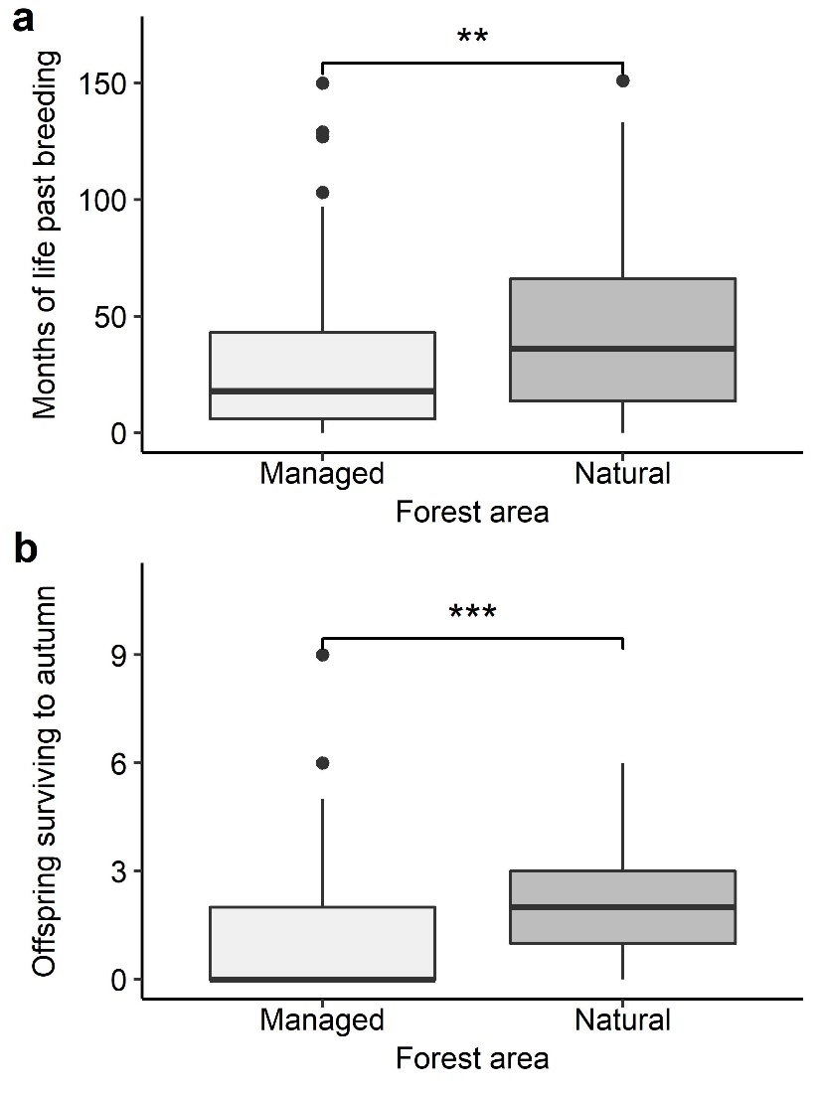
Figure 1. Impact of forest management on Siberian jay (a) lifespan after achieving breeder status, and (b) lifetime reproductive success. Significance level: ** = 0.01, *** = 0.001.
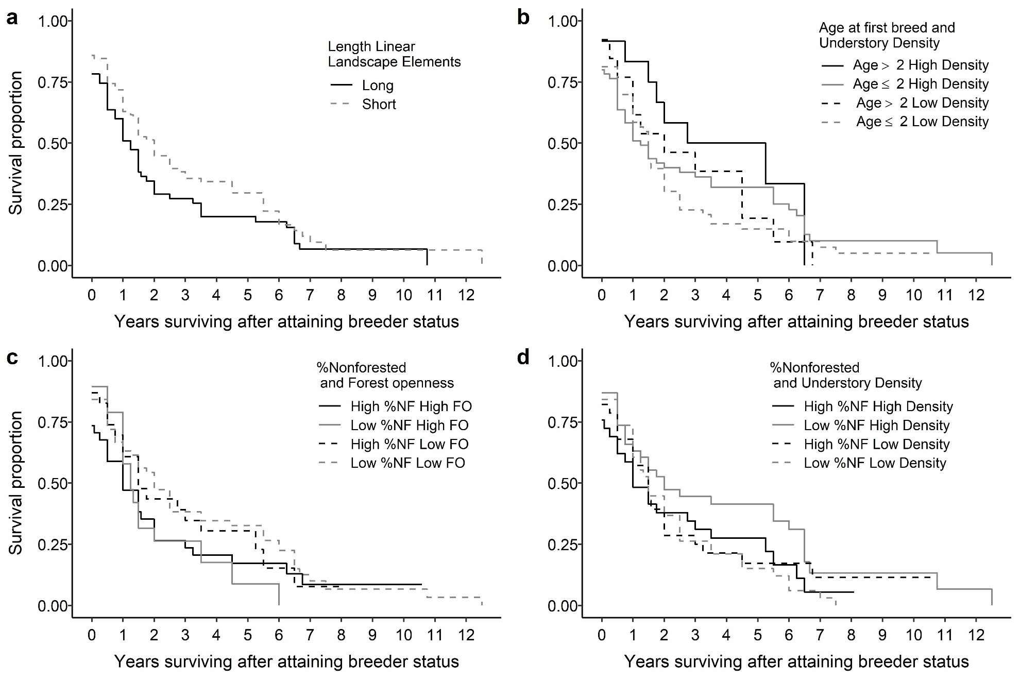
Figure 2. Survival curves for breeders in managed areas showing a) that territories with shorter edges created by railroads, roads, and powerlines had higher survival than those with longer elements; b) the interaction between the age at first breeding and understory density. Individuals that start to breed at a later age (> 2 years) have higher survival than individuals that achieve breeder status at age ≤2 in both in high quality (high forest understory density) and low quality (low understory density) forests. c) the interaction between % non-forested area of a territory and the forest openness. Individuals in territories with low forest openness tend to have higher survival, regardless of the percent of non-forested territory. d) the interaction between % non-forested area of a territory and understory density. High understory density increases survival, regardless of the percent of non-forested territory.

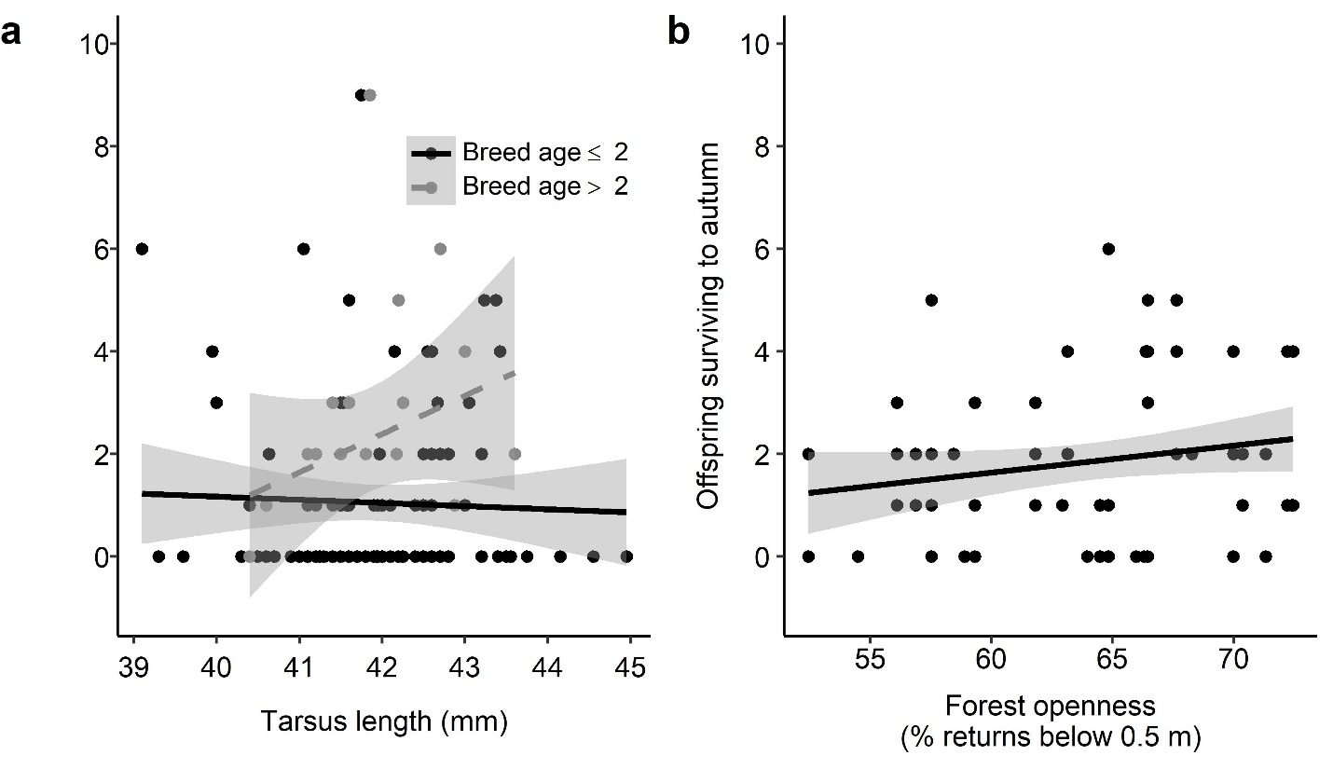
Figure 3. Influences on lifetime reproductive success in a) managed and b) natural parts. In managed parts, older individuals, particularly when having a larger body size (assessed with tarsus length) had a greater number of offspring surviving until autumn, while in natural parts, individuals in territories with high forest openness had more surviving offspring in autumn.

Supplemental Information
Table S-1. Siberian jay individual, and forest territory variables included in analyses.
Parameter name | Description | Source
Sex | Sex | Siberian jay database
Age at first breeding | Age an individual achieves breeder status | Siberian jay database
Tarsus length | Length of tarsus | Siberian jay database
Management | Territory located within managed or natural part of study site | Siberian jay database
Length linear edges | Length of roads, railroads tracks, and powerlines within territory | Traced in Google Earth and distances per territory extracted in ArcGIS
%Wetland | % of territory defined as wetland | Swedish landcover map
Distance to settlement | Mean distance to permanently inhabited human settlement | Distance to center point of territory measured in ArcGIS
Proportion non-forested | Proportion of the territory that is non-forested. Proportion of pixels within territory with no returns >= 2m. Forested pixels are considered pixels with at least 1 return >= 2m | LiDAR data, R
Mean understory density | Mean % of LiDAR returns between 0.5-5m within forested pixels in territory | LiDAR data, R
Mean density 5-10m | Mean % of LiDAR returns between 5-10m within forested pixels in territory | LiDAR data, R
SD understory density | SD of % of LiDAR returns between 0.5-5m within forested pixels in territory | LiDAR data, R
SD density 5-10m | SD of LiDAR returns between 5-10m within forested pixels in territory | LiDAR data, R
Mean height | Mean value of highest LiDAR return within the top 95% of returns per forested pixels in territory | LiDAR data, R
SD height | SD of highest LiDAR return within the top 95% of returns per forested pixels in territory | LiDAR data, R
Mean forest openness | Mean % of LiDAR returns below 0.5 m within forested pixels in territory. High values indicate forests with high ground visibility from above. | LiDAR data, R
SD forest openness | SD of the % of LiDAR returns –below 0.5 m within forested pixels in territory. | LiDAR data, R

Table S-2. Volume change on productive (> 1m³/ha/year) stands in Arvidsjaur in 2015.
Age class: | 0-20 | 21-40 | 41-60 | 61-80 | 81-100 | 101-120 | 121+ | Total
Change in m³/ha: | 0.5 | 2.6 | 3.6 | 3.1 | 2.8 | 1.9 | 1.6 | 2.4
Table S-3. Factors associated with breeding lifespan of Siberian jay in natural parts, based on the territory core area (30 ha). Model selection and model averaging approach according to the AICC (∆AICc < 2). Factors with a sum of Akaike weights (Σ AICC weights) larger than 0.5 and standard error (SE) of estimates do not overlap 0 are highlighted in italics. N models=number of models that include the factor.

Factor | Estimate | SE | z-Value | P-Value | Σ AICC weights | N models
SD understory density | 0.52 | 0.28 | 1.87 | 0.06 | 0.82 | 8
Proportion non-forested | -6.51 | 3.46 | 1.88 | 0.0597 | 0.55 | 5
Sex | 0.41 | 0.27 | 1.52 | 0.13 | 0.34 | 3
Mean forest openness | -0.03 | 0.03 | 1.31 | 0.19 | 0.25 | 3
Mean understory density | -0.06 | 0.07 | 0.88 | 0.38 | 0.16 | 2
Age at first breed | -0.12 | 0.15 | 0.79 | 0.43 | 0.07 | 1

Table S-4. Factors associated with the time of becoming breeder (earlier or later than year 2) of Siberian jay in managed parts, based on the territory core area (30 ha). Model selection and model averaging approach according to the AICC (∆AICc < 2). N models=number of models that include the factor.

Factor | Estimate | SE | z-Value | P-Value | Σ AICC weights | N models
(Intercept) | -1.50 | 0.29 | 5.12 | 0.00
SD height | 0.22 | 0.21 | 1.06 | 0.29 | 0.18 | 1
Distance to settlement | 0.57 | 0.57 | 0.99 | 0.32 | 0.17 | 1
Length of linear edges | -0.20 | 0.29 | 0.69 | 0.49 | 0.13 | 1
Proportion non-forested | 0.12 | 0.21 | 0.58 | 0.56 | 0.12 | 1
Mean understory density | -0.12 | 0.20 | 0.60 | 0.55 | 0.12 | 1

Table S-5. Factors associated with the time of becoming breeder (earlier or later than year 2) of Siberian jay in natural parts, based on the territory core area (30 ha). Model selection and model averaging approach according to the AICC (∆AICc < 2). N models=number of models that include the factor.
Factor | Estimate | SE | z-Value | P-Value | Σ AICC weights | N models
(Intercept) | -0.69 | 0.35 | 1.95 | 0.05
Mean forest openness | -0.56 | 0.55 | 1.02 | 0.31 | 0.26 | 2
Mean understory density | -0.84 | 0.91 | 0.91 | 0.36 | 0.25 | 2
Mean understory density x  Mean forest openness | -1.50 | 0.76 | 1.94 | 0.05 | 0.15 | 1
Sex | -0.42 | 0.50 | 0.83 | 0.41 | 0.14 | 1
Length of linear edges | -0.17 | 0.29 | 0.60 | 0.55 | 0.12 | 1
Proportion non-forested | -0.12 | 0.31 | 0.39 | 0.70 | 0.10 | 1

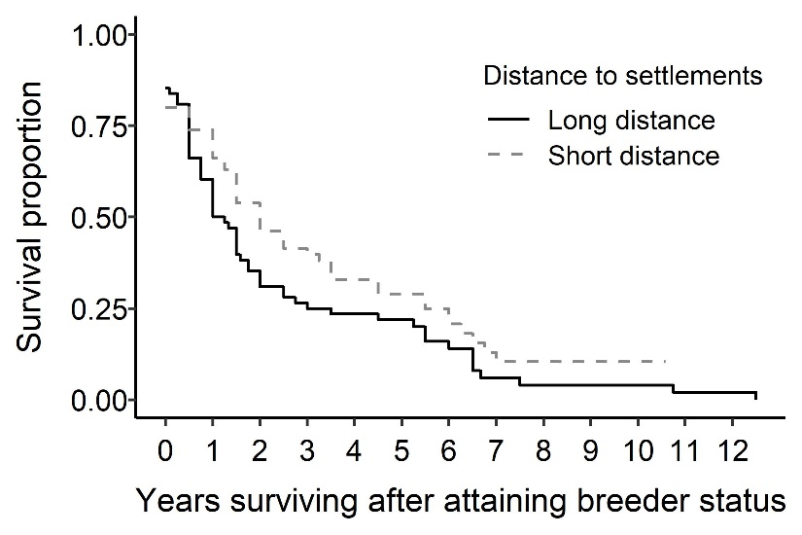
Figure S-1. Survival curves showing that individuals in territories closer to human settlements had higher survival than those on territories further away within the managed parts.

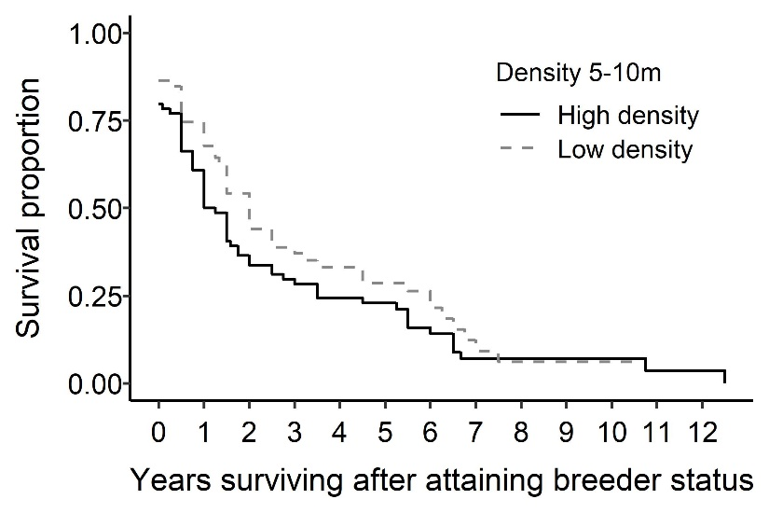
Figure S-2. Survival curves showing that breeders in territories with a low forest density 5-10 m have marginally higher survival compared to those in territories with high forest density 5-10 m within the managed parts.

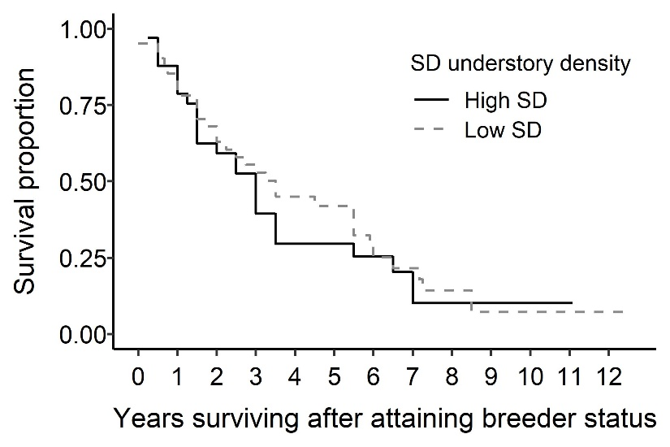
Figure S-3. Survival curves showing standard deviation of understory density suggest less heterogeneous (low SD) forests appear to have some survival benefits for Siberian jays in natural parts.

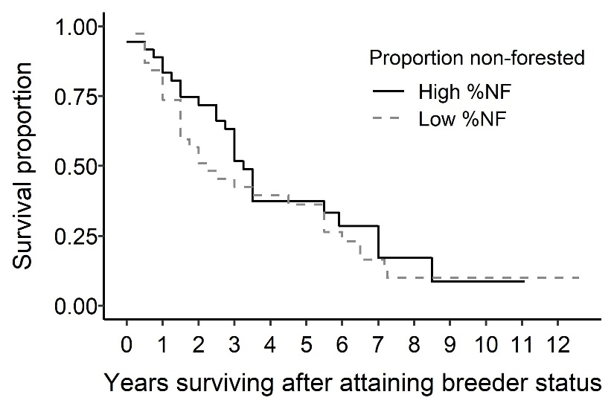
Figure S-4. Survival curves showing that territories with higher percent of non-forested areas may slightly increase survival benefits for Siberian jays in natural parts.

