Title: Replicating Nature’s Fabric: High Information Markets and the Sustainability of Global Seafood

Authors: Timothy J. Bartley^{1,2,*}, Kevin S. McCann², Carling Bieg², and Robert H. Hanner²
Affiliations:
¹ Department of Biology, University of Toronto Mississauga, Mississauga, ON, Canada L5L 1C6
² Department of Integrative Biology, University of Guelph, Guelph ON, Canada N1G 2W1
*Correspondence to: Timothy J. Bartley, timothy.bartley@gmail.com

Abstract: The global seafood market places humans as apex predators within the marine food web, linking species and ecosystems around the world. Here, we argue that the structure of these seafood systems is in opposition to nature’s common stabilizing structures. We first describe a remarkably repeated structure in nature’s food webs: generalist foraging by large, mobile predators that can make rapid and informed switches between resources in space. Then, we discuss how recent technological developments (e.g., DNA barcoding) have revealed a misinformation market characterized by rampant seafood fraud, substitution and mislabeling that has serious negative repercussions for sustainability. We end by arguing that these same tools have to the potential to grant consumers the ability create a high information market that allows consumers to make more informed decisions. The roles that predators play in nature’s food webs strongly indicate that information is critical to aid global seafood sustainability and the maintenance of marine biodiversity.

Main Text: Ecosystems contain some of nature’s most baroque networks of interactions¹. Incredibly, these tangled webs of interacting species exist within a highly “noisy” world in which abiotic conditions can vary wildly². Yet underneath this maze of interactions is a surprisingly general and regular framework (i.e., biological structure) that transports energy and carbon between all species and thus breathes life into ecosystems in spite of the noise³. Indeed, recent food web theory and empirical work agree: these repeated core structures are fundamental to preserving the stability of highly diverse ecological systems in a noisy world^{2–4}. This surprisingly non-random structure may be ubiquitous because it plays a key role in stabilizing complex systems⁵. Importantly, humans have constructed an immensely complex global seafood market, one in which humans are apex predators within the global marine food web. Yet here we argue that the structure of this seafood system does not conform with nature’s common stabilizing structures. If core structural elements in complex systems do indeed impart stability, the consequences of this nonconformity for species and ecosystems may be severe⁶.
One critical aspect of this multifaceted global seafood system is that it is plagued by misinformation, which likely interferes with consumer choice⁷. Current market practices obscure species identities and provenance (e.g., seafood fraud, mislabeling, and vague naming conventions), creating a misinformation market for consumers⁷ that drives human-species interaction strengths⁸ that are in direct opposition to nature’s structure. In turn, renaming and mislabeling species have cascading negative repercussions for human health, food security, sustainability and economics⁹. Importantly, the consumer choice that is undermined by misinformation has the potential to mediate this problem; when species are at low densities or at risk, informed consumer choice ought to decline for that same species and thus alter the interaction strength between humans and a given species in a given geographical region at key times.
While the potential for fraud in the global seafood market has long existed⁹, recent technological developments, such as DNA barcoding, provide a clear empirical tools for highlighting the presence and extent of misinformation¹⁰. These tools have been used in many independent surveys, which in combination unveil seafood mislabeling ubiquitously throughout the supply chain (e.g., a mean of 34% in 34 separate surveys/studies ¹⁰). Vague naming conventions add to this substantive problem, impeding seafood traceability while creating a void for illegal, unreported and unregulated (IUU) fisheries activities to thrive ^{11–13}. Current advances in biotechnology coupled to a transparent global policy that increases the transfer of scientific information in the food supply chain promise to add information to the system. This increased information may allow human seafood consumption to more closely mimic nature’s stabilizing food web structures.
Here, we briefly review nature’s stabilizing structures in food webs. Then, we consider how the current biotechnologies and proper seafood labelling can drive a high information market that allows humans to reinsert themselves within the food web in a manner consistent with nature’s stabilizing structures. While we concentrate on the global seafood market, the problem of misinformation may be prevalent many global natural resource markets.

Nature’s Structure and Stability in a Noisy World
What is Nature’s Structure?

Food webs tend to have a remarkably repeated structure: generalist foraging by larger, more mobile organisms that feed across space on less mobile resource compartments ^{14–16} (Fig. 1a). This same structure—as revealed by numerous tools including stable isotopes and stomach contents—is present across vastly different scales, from soils webs comprised of miniscule organisms to marine webs with giant organisms that can move across the globe¹⁴ (Fig. 1c). For years, ecologists have argued that this form of resource compartmentation coupled by mobile generalists is a fundamental stabilizing mechanism in ecosystems^{3,17,18}.

How does this structure stabilize in a noisy world?
This pervasive generalist structure allows nature’s mobile predators to, in a greatly simplified sense, play whack-a-mole. That is, as distinct spatial resource compartments experience productivity differentially in time (e.g., one resource is high productivity and the other low) the mobile well-informed predator rapidly responds (Fig. 1b)³. Like a skilled whack-a-mole player, these predators consume the abundant resource and prevent its runaway growth. Simultaneously, the predator alleviates the compartment that is experiencing low productivity (Fig 1b). This release of the low-abundance resource from predation and the culling of the high productivity resource is precisely what is needed for stability³. The mobile larger predators thus interact with this landscape of variability in resources in a way that prevents any single species from monopolizing space and energy. Nature can thus maintain an intricate balance of bottom-up (driven by variation in habitat productivity over time and space) and top-down (driven by predators and their portfolio response) forces. This means that the predator promotes the balance and maintenance of a diverse and variable assemblage of organisms, which in turn buffers against an ever-changing world³.
The stabilizing generalist structure therefore has three key ingredients: (1) top predators are generalized and capable of consuming from different species and different habitats; (2) the different prey in different habitats are responding differentially through time (i.e., the resources are not synchronized in their responses to abiotic conditions, which is generally true as habitats separate further in space and so often experience differential abiotic histories); (3) these same predators capable of rapid (note lagged behavioral responses are generally destabilizing¹⁹) and informed (smart) and behavioral responses. Taken altogether we have an organism–the top predator–that can utilize a “portfolio effect” like a market analyst does, averaging prey harvest over all habitats ^{20,21}.
This stabilizing ability requires these same mobile higher trophic level organisms to be smart enough to rapidly respond to differential conditions in a way that is informed by the landscape of resources^{3,22}. Higher trophic level, more mobile generalists should therefore possess high cognitive abilities. Curiously, and consistent with this, the relative brain size of fish grows with both trophic position and the degree of generalist coupling of spatially distinct habitats^{23,24} (Fig. 1d). This increased cognitive ability occurs precisely where it ought to be in nature’s food webs, allowing mobile organisms the ability to average over a spatially noisy world. Importantly, misinformation in the seafood market directly undermines this third criterion of informed choices by consumers, disconnecting consumer choices from tracking resources as they vary in space and time.

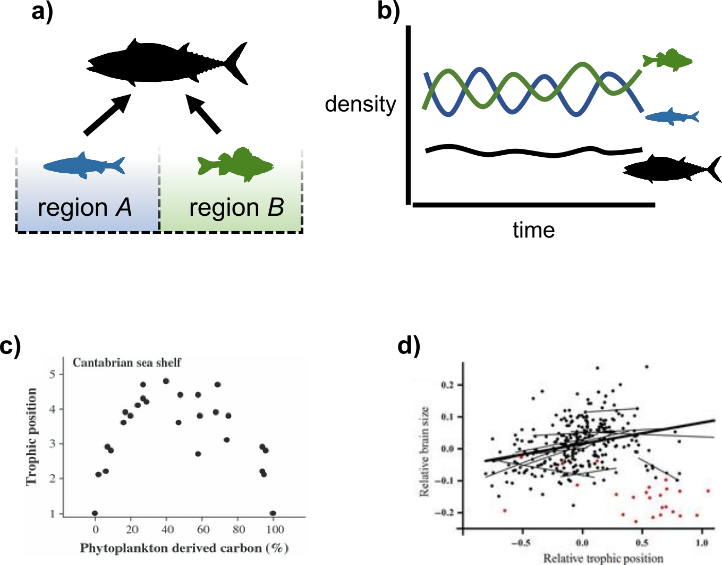

Fig. 1. Nature’s remarkably repeated structure: generalist foraging by larger, more mobile organisms that navigate through space and link resource compartments. (A) Conceptual diagram of the gross architecture of food webs, whereby a generalist mobile higher order predator or consumer moves between spatially distinct regions. (B) Conceptual diagram of densities through time, with asynchronous and spatially distinct resources and the mobile generalist predator (C) Isotopic evidence that follows the fate of carbon from two different regions into the Cantabrian Sea food web, forming a hump-shaped structure that mimics the generalist module feeding predictions in A (from ³). (D) Brain size tends to correlate with trophic position in fish from Georgian Bay in Lake Huron (from ²⁵).

Seafood Systems as Food Webs
Seafood harvests occur globally across major relatively distinct spatial regions. For example, sockeye salmon fisheries occur in Russia, Canada, and the United States of America. Thus, harvests that come to the market are taken from relatively spatially distinct resource compartments This spatial resource compartmentation, which is akin to the natural web above, remains true of most seafood, suggesting this aspect of humans as apex predators is consistent with nature. Simultaneously, the historical apex predators in these ecosystems are in precipitous decline due at least in part due to human activities^{26,27}.Our seafood markets make us operate as highly mobile consumers at the global scale, forming a generalist like food web module that parallels natures food webs (Fig. 2a) with the potential to strongly impact marine and freshwater ecosystems.
The presence of a complex seafood supply chain has the potential to obscure the landscape of resources from human consumers, fundamentally decoupling our responses as from various seafood resource compartments. Seafood fraud (either fraudulent representation of species or fraudulent representation of region), mislabeling, and vague naming conventions actively conceal the identity and origin of harvested fish. These activities, unfolding throughout a complex supply chain, drive disinformation that thwarts consumers at all levels from making informed decisions, destroying the analog to nature’s stabilizing structure (Fig. 2b, c). Recently, there have been calls for internationally harmonized approaches to seafood labelling and improved seafood authenticity testing²⁸. Increased information throughout the supply chain ought to re-establish relatively rapid switches between species and locations (altering human-species interactions) allowing consumers to exercise a consumptive portfolio effect (Fig. 1e).

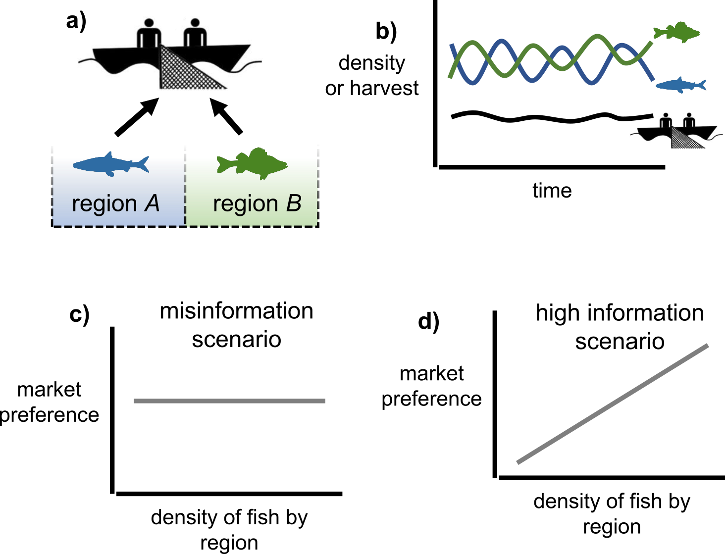

Fig. 2. The seafood systems as a food web, replicating nature’s structure. (A) Conceptual diagram of how human seafood systems mimic generalist module by linking resources across the globe; (B) Conceptual diagram of how human harvesting effort can stabilizing variable resources through time. (C) The poor transfer of information interferes with the ability for smart highly mobile human community to make informed choices at market; (D) How market preference is predicted to change in a high information world, allowing the structure to make informed rapid choices that are stabilizing.

Biotracers and Market Information: Reinserting Humans in the Food Web
Arguably, one of the longstanding critical impediments to a high information seafood market stems from the historical inability to rapidly and efficiently monitor both species identities and the region of catch²⁹. Recently, DNA barcoding–a technique for identifying species using tiny tissue samples from market species–has opened the doors for sampling many individuals anywhere throughout the supply chain^{29,30}. Other biotracers (stable isotopes, fatty acids), used alone or in combination with genomic tools, are also becoming increasingly capable of identifying seafood provenance, in effect acting as traceable “geographical fingerprints” that species absorb while foraging and living in different regions of the world. Importantly, the requisite biotechnology for identifying and preventing fraud is therefore in place and continually developing. Additionally, the technology of block chain promises to hone information transfer throughout the supply chain in general. Combining this technology (biological and supply chain) should allow the seafood market to operate more transparently, ultimately allowing consumers to make informed decisions (Fig. 2d).
Given that we can trace and follow food throughout the complex supply chain enhancing bioinformation transfer, it behooves us to also begin to produce policy that promotes a high information market for consumers, This policy could include labelling in grocery stores that allow consumers the ability to make clear informed decisions. Given that consumer preference is even modestly negatively correlated with species risk (Fig. 2d), then we are in position to reinsert humans into a global food web in a manner that is more consistent with nature’s structure. Indeed, information does appear to play a role in human consumers’ behavior. Human-species interaction strengths weakening when a species in a given region is increasingly impacted (i.e., shows greater risk of local extinction). Rather than an uninformed market that tends to drive marine species imbalance, the addition of a high information market for consumers has the potential to let the free market operate as the checks and balances that aid global seafood sustainability and the maintenance of marine biodiversity.

References and Notes:
1. Travis, J. et al. Integrating the invisible fabric of nature into fisheries management. Proc. Natl. Acad. Sci. U. S. A. 111, 581–4 (2014).
2. Levin, S. A. Ecosystems and the biosphere as complex adaptive systems. Ecosystems 1, 431–436 (1998).
3. McCann, K. S. & Rooney, N. The more food webs change, the more they stay the same. Philos. Trans. R. Soc. Lond. B. Biol. Sci. 364, 1789–1801 (2009).
4. McMeans, B. C. et al. The adaptive capacity of lake food webs: From individuals to ecosystems. Ecol. Monogr. 86, (2016).
5. May, R. M. Stability and Complexity in Model Ecosystems. (Princeton University Press, 1973).
6. Burney, D. A. & Flannery, T. F. Fifty millennia of catastrophic extinctions after human contact. Trends Ecol. Evol. 20, 395–401 (2005).
7. Logan, C. A., Alter, S. E., Haupt, A. J., Tomalty, K. & Palumbi, S. R. An impediment to consumer choice: Overfished species are sold as Pacific red snapper. Biol. Conserv. 141, 1591–1599 (2008).
8. Bieg, C. et al. Linking humans to food webs: a framework for the classification of global fisheries. Front. Ecol. Environ. 16, 412–420 (2018).
9. Lowell, B., Mustain, P., Ortenzi, K. & Warner, K. One Name, One Fish: Why Seafood Names Matter. (2015).
10. Warner, K., Mariani, S. & Carolin, C. D. Seafood Mislabeling Incidence and Impacts. Seaf. Authent. Traceability 3–26 (2016). doi:10.1016/B978-0-12-801592-6.00001-2
11. Jacquet, J. L. & Pauly, D. Trade secrets: Renaming and mislabeling of seafood. Mar. Policy 32, 309–318 (2008).
12. Cawthorn, D.-M. & Mariani, S. Global trade statistics lack granularity to inform traceability and management of diverse and high-value fishes. Sci. Rep. 7, 12852 (2017).
13. Pramod, G., Nakamura, K., Pitcher, T. J. & Delagran, L. Estimates of illegal and unreported fish in seafood imports to the USA. Mar. Policy 48, 102–113 (2014).
14. Rooney, N., McCann, K., Gellner, G. & Moore, J. C. Structural asymmetry and the stability of diverse food webs. Nature 442, 265–269 (2006).
15. McCann, K. S., Rasmussen, J. B. & Umbanhowar, J. The dynamics of spatially coupled food webs. Ecol. Lett. 8, 513–523 (2005).
16. Krause, A. E., Frank, K. a, Mason, D. M., Ulanowicz, R. E. & Taylor, W. W. Compartments revealed in food-web structure. Nature 426, 282–285 (2003).
17. Neutel, A.-M. et al. Stability in real food webs: weak links in long loops. Science 296, 1120–3 (2002).
18. Moore, J. C. & Hunt, W. H. Resource compartmentation and the stability of real ecosystems. Nature 333, 261–263 (1988).
19. May, R. M. Simple mathematical models with very complicated dynamics. Nature 261, 459–467 (1976).
20. Tilman, D. Biodiversity: population versus ecosystem stability. Ecology (1996).
21. Tilman, D., Lehman, C. L. & Bristow, C. E. Diversity-stability relationships: statistical inevitability or ecological consequence? Am. Nat. 151, 277–82 (1998).
22. Rooney, N., McCann, K. S. & Moore, J. C. A landscape theory for food web architecture. Ecol. Lett. 11, 867–881 (2008).
23. Edmunds, N. B., Laberge, F. & McCann, K. S. A role for brain size and cognition in food webs. Ecol. Lett. 19, (2016).
24. Edmunds, N. B., McCann, K. S. & Laberge, F. Food web structure shapes the morphology of teleost fish brains. Brain. Behav. Evol. 87, (2016).
25. Edmunds, N. B. N. B., Laberge, F. & McCann, K. S. K. S. A role for brain size and cognition in food webs. Ecol. Lett. 19, 948–955 (2016).
26. Worm B et al. Global catches, exploitation rates, and rebuilding options for sharks. Mar. Policy 40, 194–204 (2013).
27. Ferretti, F., Worm, B., Britten, G. L., Heithaus, M. R. & Lotze, H. K. Patterns and ecosystem consequences of shark declines in the ocean. Ecol. Lett. 13, 1055–1071 (2010).
28. Reilly, A. Overview of food fraud in the fisheries sector. Fisheries and Aquaculture Circular FIAM/C1165 (En) 1165, (2018).
29. Wong, E. H.-K. & Hanner, R. H. DNA barcoding detects market substitution in North American seafood. Food Res. Int. 41, 828–837 (2008).
30. Shehata, H. R., Bourque, D., Steinke, D., Chen, S. & Hanner, R. Survey of mislabelling across finfish supply chain reveals mislabelling both outside and within Canada. Food Res. Int. (2018). doi:10.1016/J.FOODRES.2018.12.047

Acknowledgments: Acknowledgments follow the references and notes but are not numbered. Acknowledgments should be gathered into a paragraph after the final numbered reference. This section should start by acknowledging non-author contributions and then should provide information under the following headings:

Funding: This project was in part funded by the University of Guelph’s Canada First Research
Excellence Fund project ‘Food from Thought’ awarded to K.S.M.

Author contributions: T.J.B. and R.H.H. conceptualized the study, T.J.B. and K.S.M. wrote the original draft, T.J.B. and C.B. created the visualizations, and all authors provided substantial reviews and edits.

Competing interests: Authors declare no competing interests.

