Replicating Nature’s Fabric: High Information Markets and the Sustainability of Global Seafood

Authors: Timothy J. Bartley^{1,2,*}, Kevin S. McCann², Carling Bieg², and Robert H. Hanner²
Affiliations:
¹ Department of Biology, University of Toronto Mississauga, Mississauga, ON, Canada L5L 1C6
² Department of Integrative Biology, University of Guelph, Guelph ON, Canada N1G 2W188

*Correspondence to: Timothy J. Bartley, timothy.bartley@gmail.com

Abstract: Misinformation currently plagues our global seafood market. Because this globally interconnected, complex and dynamic market parallels food webs and places humans as apex predators, we can apply our understanding of nature’s structure to better understand the consequences of misinformation in the global seafood system. Here, we argue that this misinformation undermines the sustainability of our global seafood system because it obscures consumers from making informed, responsible—and potentially stabilizing—decisions. it opposes a common stabilizing structure of nature’s food webs. We first describe how food webs contain a remarkably repeated structure: the generalist module, characterized by a flexible mobile generalist predator that can adapt to resource variability by making rapid smart foraging switches between resources in space. Next, we discuss how the global seafood system parallels nature’s food webs. We end by arguing that these same tools combined with proper seafood labelling have the potential to grant consumers the ability to create a high information market that allows consumers to make rapid and informed decisions. The roles that predators play in nature’s food webs strongly indicate that information is critical to aid global seafood sustainability and the maintenance of marine biodiversity.
Main Text: The global seafood system is plagued by misinformation. This “misinformation market” is brought about by current market practices, including fraud, mislabeling, and vague naming conventions, which obscure species identities and provenance¹. Misinformation in the global seafood market is not a new problem²; however, recent technological developments have provided clear pragmatic tools for uncovering misinformation³. These new tools have now been used in many independent surveys and collectively unveil seafood mislabeling both ubiquitously throughout the supply chain and at surprisingly high rates (e.g., a mean of 34% in 34 separate surveys/studies³). This misinformation is problematic because it likely interferes with consumer choice¹, with cascading negative repercussions for human health, food security, economics, and sustainability².
Interestingly, our immensely complex and dynamic global seafood market parallels nature’s food webs, with humans akin to apex predators^{4,5}. For this reason, we can apply our understanding of nature’s structure to better understand the consequences of misinformation in the global seafood system. Recent food web theory and empirical studies agree: repeated core structures are present in food webs and are fundamental to preserving the stability of highly diverse ecological systems in a noisy world^{6–9}. However, the global seafood system does not conform with these common stabilizing structures because misinformation disallows human seafood consumption to respond in the informed way that food web’s predators do¹⁰. If such core structural elements in complex systems do indeed impart stability, the consequences of this nonconformity in seafood systems for species and ecosystems may be severe¹¹.
Here, we argue that the structure of our global seafood system is currently in opposition to the known stabilizing structures of food webs because misinformation obscures consumers from making informed, responsible—and potentially stabilizing—decisions. First, we briefly review nature’s stabilizing structures in food webs. Next, we discuss the parallels between the structure of food webs and the global seafood system. Then, we consider how current biotechnologies and proper seafood labelling can drive a “high information market” that allows humans to integrate themselves within the food web in a manner consistent with nature’s stabilizing structures. While we concentrate on the global seafood market, the problem of misinformation may be prevalent in many global natural resource markets.

Nature’s Structure Imparts Stability in a Noisy World
Incredibly, ecosystems contain some of nature’s most baroque networks of interactions and also persist within a world in which conditions can wildly vary^{7,12}. Underneath these complex mazes of interactions is a surprisingly general and regular framework (i.e., biological structure) that maintains energy and carbon transport between all species and thus breathes life into ecosystems in spite of the noise⁸. One remarkably repeated structure in food webs is the generalist module (Fig. 1a)⁶, which consists of a relatively large and mobile generalist that forages across space on less mobile resource compartments^{13–16}. This structure—as revealed by numerous tools including stable isotopes and stomach contents—is consistent across vastly different scales, from soil webs comprised of minute organisms occupying miniscule microhabitats to marine webs with giant organisms that move across the globe and connect vastly distant ecosystems^{13,16}. For years, ecologists have argued that this form of hierarchical resource compartmentation and coupling by mobile generalists is a fundamental stabilizing mechanism in ecosystems^{8,17,18}.
The generalist structure pervasive in food webs imparts the potential for flexibility that allows mobile predators to—in a greatly simplified sense—play whack-a-mole with their resources. A predator’s resources are often not synchronized (Fig 1a), in many cases because these resources are in spatially distinct habitats that experience differential abiotic histories. As one resource peaks in density and the other bottoms out, a mobile well-informed predator can rapidly respond (Fig. 1a)⁸. Like a skilled whack-a-mole player, these predators move to consume the abundant resource, preventing its runaway growth. Simultaneously, the predator alleviates the low abundance resouce from predation pressure that may otherwise suppress the resource to precariously low densities. The predator’s response also sustains the predator by ensuring continuous resource availability, making their response “smart” or “adaptive”¹⁰. This concurrent release of the low-abundance resource, culling of the high-abundance resource and preservation of the predator is precisely what is needed for stability⁸. The mobile predators thus interact with this landscape of variability in resources in a way that prevents any single species from monopolizing space and energy. Nature can thus maintain an intricate balance of bottom-up forces (driven by variation in habitat productivity over time and space) and top-down forces (driven by predators and their portfolio response). This means that the predator promotes the balance and maintenance of a diverse and variable assemblage of organisms, which in turn buffers against an ever-changing and noisy world^{8,19}.
The ability of this generalist structure to promote stability requires these same mobile predators to be smart enough to respond to the landscape of resources in a way that is both informed and rapid^{8,10,20}. The responses must be rapid because lagged behavioral responses are generally destabilizing^{21,22}; when predators are unable to optimize their predation over these “peaks” of resources across the landscape, they can drive the loss of species²³. Higher trophic level, more mobile generalists appear to possess high cognitive abilities. For example, the relative brain size of fish grows with both trophic position and the degree of generalist coupling of spatially distinct habitats ^{24,25} (Fig. 1c). This increased cognitive ability occurs precisely where it ought to be in nature’s food webs, allowing mobile organisms to take actions that mute a noisy world.
This stabilizing generalist structure therefore has three key ingredients: (1) differential responses by different prey or habitats through time; (2) generalist top predators that are capable of crossing into different habitats to consume different species; (3) these same predators are capable of rapid and informed behavioral responses. Taken altogether we have a top predator that can utilize a “portfolio effect” much like a market analyst does, averaging prey harvest over all habitats^{26,27}. But importantly, misinformation in the seafood market directly undermines this third criterion of informed choices by consumers, ultimately disconnecting consumer choices from tracking resources as they vary in space and time.

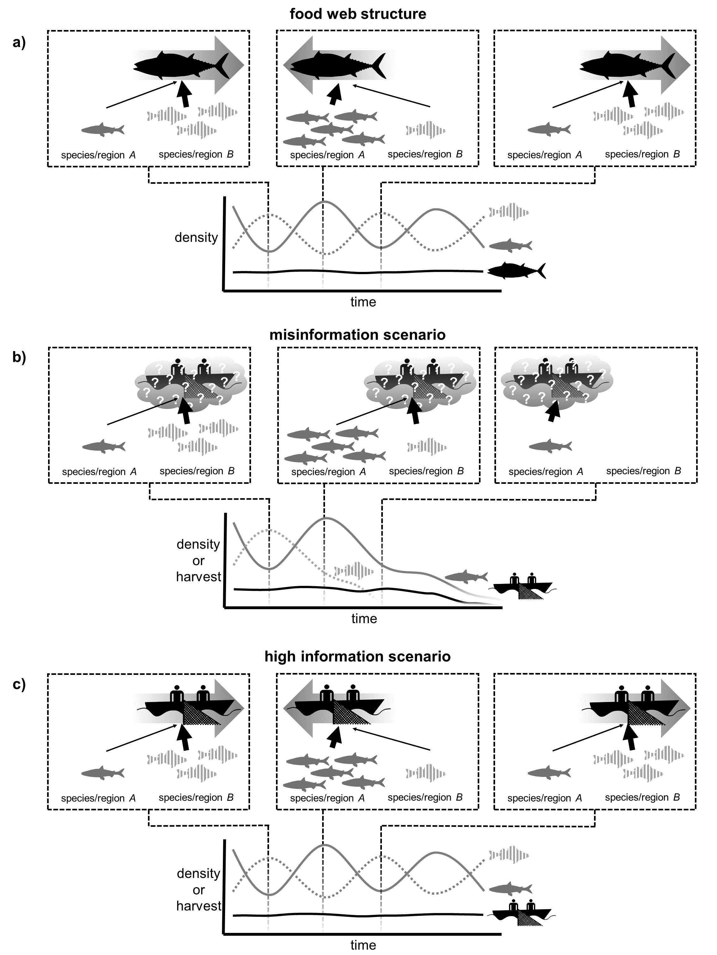

Fig. 1. Conceptual diagrams of how the action of a consumer that consumes or harvests two resources impacts stability through time; (A) Nature’s remarkably repeated structure (i.e., the generalist module) stabilizes in food webs, in which a large, mobile generalist forages by navigating through space and linking otherwise distinct species or regions. The rapid foraging shift of the generalist away from low-density resources and toward high-density resources prevents any species from being lost; (B) The seafood system as a food web mimics the generalist module by linking resources across the globe. The presence of rampant misinformation interferes with the ability for smart highly mobile human community from switching in concert with resource densities, causing resources to be lost; (C) The seafood system with a high information market, in which the smart highly mobile human community can make informed rapid choices that can stabilize variable resources through time.

Seafood Systems as Food Webs
The value of viewing fisheries or seafood markets through the lens of food webs is increasingly acknowledged by researchers from various domains²⁸. One strong parallel between food webs and our seafood system is that they link species and ecosystems that are distant in space. Our seafood system is global, with harvests taking place across major spatial regions²⁹. Thus, harvests that come to market are taken from relatively spatially distinct resource “compartments”, often spanning borders and jurisdictions³⁰ (Fig 2b), mirroring the large-scale movement of historical apex predators in these systems³¹. Sockeye salmon, for example, are harvested from Russia, Canada, and the United States of America, with each of these regions containing populations that differ in terms of their conservation status³². This spatial resource compartmentation is analogous to the natural food webs and remains true of most seafood, suggesting this aspect of humans as apex predators is consistent with nature. Our seafood markets make us operate as highly mobile consumers at the global scale, forming a generalist like food web module that parallels nature’s food webs (Fig. 1b) with the potential to strongly impact marine and freshwater ecosystems. Importantly, the historical apex predators in these ecosystems are in precipitous decline due at least in part due to human activities, reducing these ecosystems’ inherent stabilizing capacity^{33,34}.
Misinformation of any kind causes our analogy to fall apart. Regardless of whether it takes the form of fraud (of either species or region), mislabeling, and vague naming conventions, misinformation actively conceals the identity and origin of harvested fish and so obscures the landscape of resources from human consumers³⁰. In addition, the global seafood supply chain is complex and nebulous, creating many opportunities for fraudulent labeling and lack of traceability throughout the global seafood supply chain that dilute signals of changing resource abundances³⁰. As supply chains get longer over time with fish passing between more and more hands before reaching the final consumer, the number of opportunities to lose and/or alter information, intentional or otherwise, increases³⁰. Misinformation therefore thwarts both managers and consumers at all levels from making informed decisions³⁰. Vague naming conventions add to this substantive problem, impeding seafood traceability while also creating a void for illegal, unreported and unregulated (IUU) fisheries activities to thrive^{35–37}. This obfuscation fundamentally divorces our ability to make informed responses based on information about various seafood resource compartments. Importantly, the consumer choice that is undermined by misinformation could have the potential to mediate many of these problems. For example, consumers could actively opt against consuming low-density or at-risk species, but only if they are well informed. This sort of choice has the potential to reduce demand and lower harvesting efforts on a given species in a given geographical region at key times.
Recently, there have been calls for internationally harmonized approaches to seafood labelling and improved seafood authenticity testing³⁸. Increased information throughout the supply chain ought to re-establish relatively rapid switches between species and locations, allowing consumers to exercise a stabilizing consumptive portfolio effect by altering the strengths of human-resource interactions (Fig. 1c). Reassuringly, current advances in biotechnology coupled to a transparent global policy that increases the transfer of scientific information in the food supply chain promise to add information to the system. This influx of information would allow consumers and managers to once again see the landscape in resources and adapt through informed decision-making in ways that and once again mimic those flexible and stabilizing structures found in food webs.
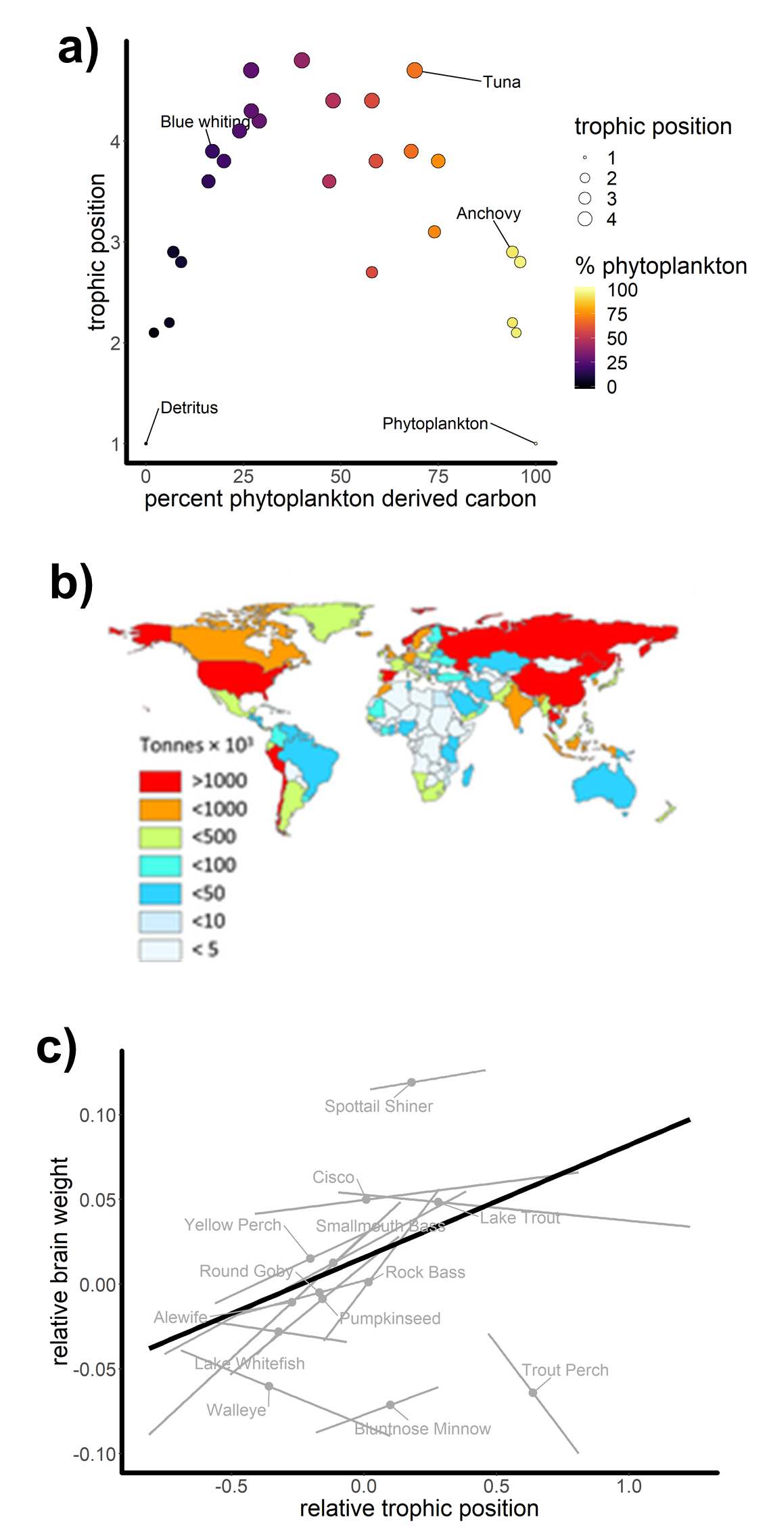

Fig. 2. (A) The gross architecture of food webs, whereby a generalist mobile higher order predator or consumer moves between spatially distinct regions. These stable isotopic data show the fate of carbon from two different regions into the Cantabrian Sea food web, forming a hump-shaped structure that is typical of many food webs (from⁸); (B) Map of global seafood exports (data for 2009) illustrating that the seafood system draws from and links spatially distinct resources across the globe in a way that mimics the role of higher-order consumers in food webs (from²⁹); (C) Brain size tends to correlate with trophic position within and across species of fish from Georgian Bay in Lake Huron, consistent with the notion that consumers possess the cognitive capacity necessary to make informed responses to changes in resource availability (from³⁹).

Biotracers and Market Information: Reintegrating Humans in the Food Web
Arguably, one of the longstanding critical impediments to a high information seafood market stems from the historical inability to rapidly and efficiently monitor both species identities and the region of catch⁴⁰. An array of new technologies has now been applied to show fraud and mislabeling of seafood⁴¹. DNA barcoding, a technique for identifying species using tiny tissue samples from market fish, has recently opened the doors for sampling many individuals anywhere throughout the supply chain^{40,42}. Other biotracers, such as stable isotopes and fatty acids (which can be used alone or in combination with genomic tools), have continuously increasing capabilities for identifying seafood provenance⁴¹. This new suite of biotracers can essentially act as traceable “geographical fingerprints” that species absorb while foraging and living in different regions of the world. The explosion of these biotechnologies therefore means that the tools required for identifying and preventing misinformation are in place and continually improving. Additionally, the technology of block chain promises to further hone information transfer throughout the supply chain in general^{43,44}. Combining these biological and information technologies should allow the seafood market to operate more transparently, ultimately allowing granting consumers the sort of information necessary to make informed sustainably decisions about seafood purchases and consumption.
Given that we can trace and follow food throughout the complex supply chain enhancing bioinformation transfer, it behooves us to produce policy that promotes a high information market. Such policy could include labelling in grocery stores that allow consumers the ability to make clear informed decisions. Eco labeling, such as MSC certification, seems to have a positive influence on consumer choice in that consumers are willing to pay more for seafood perceived as more sustainable^{45,46}, though this effect does differ based on the type of seafood, certifying agency, and shows international heterogeneity⁴⁵. It is not yet clear if this result transmits to price premiums at the producer level, which would influence fishing practices, however enough consumer demand and transparency throughout the supply chain does seem to show promise⁴⁷. Given that consumer preference is even modestly negatively correlated with species risk, then we are in position to reinsert humans into a global food web in a manner that is more consistent with nature’s structure. Indeed, information does appear to play a role in human consumers’ behavior: human-species interaction strengths weaken when a species in a given region is increasingly impacted (i.e., shows greater risk of local extinction). Rather than a misinformation market that tends to drive marine species imbalance, we can bring about a high information market for consumers has the potential to let checks and balances operate within the seafood market, aiding global seafood sustainability and the maintenance of marine biodiversity.

References
1. Logan, C. A., Alter, S. E., Haupt, A. J., Tomalty, K. & Palumbi, S. R. An impediment to consumer choice: Overfished species are sold as Pacific red snapper. Biol. Conserv. 141, 1591–1599 (2008).
2. Lowell, B., Mustain, P., Ortenzi, K. & Warner, K. One Name, One Fish: Why Seafood Names Matter. (2015).
3. Warner, K., Mariani, S. & Carolin, C. D. Seafood Mislabeling Incidence and Impacts. Seaf. Authent. Traceability 3–26 (2016). doi:10.1016/B978-0-12-801592-6.00001-2
4. Darimont, C. T., Fox, C. H., Bryan, H. M. & Reimchen, T. E. The unique ecology of human predators. Science (80-. ). 349, 858–860 (2015).
5. Worm, B. & Paine, R. T. Humans as a Hyperkeystone Species. Trends Ecol. Evol. 31, 600–607 (2016).
6. McMeans, B. C. et al. The adaptive capacity of lake food webs: From individuals to ecosystems. Ecol. Monogr. 86, (2016).
7. Levin, S. A. Ecosystems and the biosphere as complex adaptive systems. Ecosystems 1, 431–436 (1998).
8. McCann, K. S. & Rooney, N. The more food webs change, the more they stay the same. Philos. Trans. R. Soc. Lond. B. Biol. Sci. 364, 1789–1801 (2009).
9. May, R. M. Stability and Complexity in Model Ecosystems. (Princeton University Press, 1973).
10. Valdovinos, F. S., Ramos-Jiliberto, R., Garay-Narváez, L., Urbani, P. & Dunne, J. A. Consequences of adaptive behaviour for the structure and dynamics of food webs. Ecol. Lett. 13, 1546–1559 (2010).
11. Burney, D. A. & Flannery, T. F. Fifty millennia of catastrophic extinctions after human contact. Trends Ecol. Evol. 20, 395–401 (2005).
12. Travis, J. et al. Integrating the invisible fabric of nature into fisheries management. Proc. Natl. Acad. Sci. U. S. A. 111, 581–4 (2014).
13. Rooney, N., McCann, K., Gellner, G. & Moore, J. C. J. C. Structural asymmetry and the stability of diverse food webs. Nature 442, 265–269 (2006).
14. McCann, K. S., Rasmussen, J. B. & Umbanhowar, J. The dynamics of spatially coupled food webs. Ecol. Lett. 8, 513–523 (2005).
15. Krause, A. E., Frank, K. a, Mason, D. M., Ulanowicz, R. E. & Taylor, W. W. Compartments revealed in food-web structure. Nature 426, 282–285 (2003).
16. Bartley, T. J. et al. Food web rewiring in a changing world. Nat. Ecol. Evol. 1 (2019). doi:10.1038/s41559-018-0772-3
17. Neutel, A.-M. et al. Stability in real food webs: weak links in long loops. Science 296, 1120–3 (2002).
18. Moore, J. C. & Hunt, W. H. Resource compartmentation and the stability of real ecosystems. Nature 333, 261–263 (1988).
19. Hammerschlag, N. et al. Ecosystem Function and Services of Aquatic Predators in the Anthropocene. Trends Ecol. Evol. xx, 1–15 (2019).
20. Rooney, N., McCann, K. S. & Moore, J. C. A landscape theory for food web architecture. Ecol. Lett. 11, 867–881 (2008).
21. May, R. M. Time-Delay Versus Stability in Population Models with Two and Three Trophic Levels. Ecology 54, 315–325 (1973).
22. Maynard-Smith, J. Models in ecology. (Cambridge University Press, 1978).
23. May, R. M. Simple mathematical models with very complicated dynamics. Nature 261, 459–467 (1976).
24. Edmunds, N. B., Laberge, F. & McCann, K. S. A role for brain size and cognition in food webs. Ecol. Lett. 19, (2016).
25. Edmunds, N. B., McCann, K. S. & Laberge, F. Food web structure shapes the morphology of teleost fish brains. Brain. Behav. Evol. 87, (2016).
26. Tilman, D. Biodiversity: population versus ecosystem stability. Ecology (1996).
27. Tilman, D., Lehman, C. L. & Bristow, C. E. Diversity-stability relationships: statistical inevitability or ecological consequence? Am. Nat. 151, 277–82 (1998).
28. Bonhommeau, S. et al. Eating up the world’s food web and the human trophic level. Proc. Natl. Acad. Sci. 110, 20617–20620 (2013).
29. Watson, R. A., Green, B. S., Tracey, S. R., Farmery, A. & Pitcher, T. J. Provenance of global seafood. Fish Fish. 17, 585–595 (2016).
30. Crona, B. I. et al. Masked, diluted and drowned out: how global seafood trade weakens signals from marine ecosystems. Fish Fish. 17, 1175–1182 (2016).
31. Queiroz, N. et al. Global spatial risk assessment of sharks under the footprint of fisheries. Nature 4, (2019).
32. Rand, P. S. et al. Global assessment of extinction risk to populations of Sockeye salmon Oncorhynchus nerka. PLoS One 7, (2012).
33. Worm B et al. Global catches, exploitation rates, and rebuilding options for sharks. Mar. Policy 40, 194–204 (2013).
34. Ferretti, F., Worm, B., Britten, G. L., Heithaus, M. R. & Lotze, H. K. Patterns and ecosystem consequences of shark declines in the ocean. Ecol. Lett. 13, 1055–1071 (2010).
35. Jacquet, J. L. & Pauly, D. Trade secrets: Renaming and mislabeling of seafood. Mar. Policy 32, 309–318 (2008).
36. Cawthorn, D.-M. & Mariani, S. Global trade statistics lack granularity to inform traceability and management of diverse and high-value fishes. Sci. Rep. 7, 12852 (2017).
37. Pramod, G., Nakamura, K., Pitcher, T. J. & Delagran, L. Estimates of illegal and unreported fish in seafood imports to the USA. Mar. Policy 48, 102–113 (2014).
38. Reilly, A. Overview of food fraud in the fisheries sector. Fisheries and Aquaculture Circular FIAM/C1165 (En) 1165, (2018).
39. Edmunds, N. B., Laberge, F. & McCann, K. S. A role for brain size and cognition in food webs. Ecol. Lett. 19, 948–955 (2016).
40. Wong, E. H.-K. & Hanner, R. H. DNA barcoding detects market substitution in North American seafood. Food Res. Int. 41, 828–837 (2008).
41. Leal, M. C., Pimentel, T., Ricardo, F., Rosa, R. & Calado, R. Seafood traceability: Current needs, available tools, and biotechnological challenges for origin certification. Trends Biotechnol. 33, 331–336 (2015).
42. Shehata, H. R., Bourque, D., Steinke, D., Chen, S. & Hanner, R. Survey of mislabelling across finfish supply chain reveals mislabelling both outside and within Canada. Food Res. Int. 121, 723–729 (2019).
43. Galvez, J. F., Mejuto, J. C. & Simal-Gandara, J. Future challenges on the use of blockchain for food traceability analysis. TrAC - Trends Anal. Chem. 107, 222–232 (2018).
44. Cook, B. Blockchain : Transforming the Seafood Supply Chain. 1–41 (2018).
45. Johnston, R. J., Wessells, C. R. & Asche, F. Measuring Consumer Preferences for Ecolabeled Seafood : An International Comparison by Holger Donath. Res. Econ. 26, 20–39 (2000).
46. Chen, X., Alfnes, F. & Rickertsen, K. Consumer preferences, ecolabels, and effects of negative environmental information. AgBioForum 18, 327–336 (2015).
47. Blomquist, J., Bartolino, V. & Waldo, S. Price premiums for eco-labelled seafood: effects of the MSC certification suspension in the Baltic Sea cod fishery. Eur. Rev. Agric. Econ. 1–21 (2018). doi:10.1093/erae/jby047

Funding: This project was in part funded by the University of Guelph’s Canada First Research
Excellence Fund project ‘Food from Thought’ awarded to K.S.M.

Author contributions: T.J.B. and R.H.H. conceptualized the study, T.J.B. and K.S.M. wrote the original draft, T.J.B. and C.B. created the visualizations, and all authors provided substantial reviews and edits.

Competing interests: Authors declare no competing interests.

