Does internal egg carrying impair foraging ability as much as external egg carrying in a neotropical spider?

PIETRO POLLO^{1,*}, CLAUDIA S. SPINDLER² and LUIZ E. COSTA-SCHMIDT^{2,3}

¹Evolution & Ecology Research Centre, School of Biological, Earth & Environmental Sciences, University of New South Wales, Sydney 2052 NSW, Australia
²Programa de Pós-Graduação em Biologia, Universidade do Vale do Rio dos Sinos, São Leopoldo 93022-000 RS, Brazil
³Departamento de Ecologia, Zoologia e Genética, Universidade Federal de Pelotas, Pelotas 96010-900 RS, Brazil
*Corresponding author: Pietro Pollo, Evolution & Ecology Research Centre, School of Biological, Earth & Environmental Sciences, University of New South Wales, Sydney 2052 NSW, Australia (E-mail: pietro_pollo@hotmail.com)

ABSTRACT
Females not only produce costly gametes, but also store the eggs until oviposition, a period called pregnancy. The volume that eggs occupy in the female abdomen may decrease female foraging ability by making females slow. Although females of all species are subjected to these potential costs, it remains an unexplored matter in invertebrates. Females of the spider Paratrechalea ornata carry their egg sac after oviposition and thus represent a unique opportunity to evaluate pregnancy costs because females carry an extra volume before and after laying eggs. We conducted foraging ability experiments using P. ornata females on different treatments regarding pregnancy and maternal care. We first hypothesized that internal egg load and egg sac carrying decrease female foraging ability. We also hypothesized that greater egg sac size decreases female foraging ability. We found that both internal egg load and egg sac carrying decreased female foraging ability, and females about to oviposit had a similar foraging ability to females carrying an egg sac. Egg sac size did not influence female foraging ability. Our results show that pregnancy can impose high costs to female foraging ability, likely increasing their mortality during this period. The little support for our second hypothesis may also suggest that the decrease in foraging ability is not due to the volume being carried per se, but possibly an associated physiological state.

KEY-WORDS: fecundity, gravid, life-history evolution, parental care, physical burden, reproductive cost.

INTRODUCTION
Life-history theory posits that organisms are under a trade-off between reproduction and survivorship because they have a limited amount of resources to allocate (Reznick 1992; Boggs 2009). It is well known that females spend more energy in gamete production than males (Hayward & Gillooly 2011). Yet, it is often neglected that females also pay another unavoidable energetic cost that males do not: females store eggs internally until oviposition or birth—a period called “pregnancy”. This period is widely recognized as energetically demanding and is considered a type of maternal care in viviparous animals (Clutton-Brock 1991; Smiseth et al. 2012). In contrast, except for the specific case of some reptiles (reviewed in Schwarzkopf 1994), pregnancy in oviparous species is rarely acknowledged as a potential source of costs for females. Pregnancy may negatively affect females through the same mechanism in a variety of taxa: the additional weight from internal egg load may decrease female locomotor performance (e.g., Cooper et al. 1990; Lee et al. 1996; Isaacs & Byrne 1998; Shine 2003a, 2003b) and consequently impair their ability to forage. This effect should increase with egg maturation and reach their maximum when females are close to oviposition, in which ovigerous females may be called “gravid” because their abdomen is visibly enlarged (Shine 2003a). The potential cost of carrying eggs pre-oviposition to female foraging ability may ultimately increase female mortality and consequently be important for female life-history evolution.
In several species, maternal care is expressed in the form of the mother externally carrying eggs (also called “egg brooding” sensu Smiseth et al. 2012; e.g. Seibel et al. 2005). Just like internal egg carrying, external egg carrying may impair the caregiver due to the physical burden to locomotion that the egg load represents (e.g., Crowl & Alexander 1989; Kight & Ozga 2001). Thus, one can expect that egg carrying, regardless if external or internal, incurs costs due to the extra-weight from the eggs. A comparison between egg brooding and pregnancy costs, then, may reveal the magnitude of the costs that a common reproduction process can generate for females.
Females of the spider Paratrechalea ornata (Carico 2005) (Araneae, Trechaleidae) are able to mate multiply and produce several clutches of eggs in a single reproductive season. They lay their eggs in a silky structure called an egg sac. After oviposition, females carry their egg sac attached to their silk-making organs (i.e., spinnerets) until the spiderlings hatch and disperse (Carico 1993; Carico 2005), a parental care period that can last approximately 25 days. Similar to other animals, P. ornata females experience abdomen volume expansion due to increasing internal egg mass until eggs are laid (this study). Thus, P. ornata females carry an extra weight both before and after oviposition that can impair them and consequently influence important life history components. Here, we tested two hypotheses about the costs of carrying eggs on the foraging ability of P. ornata females. First, we expect that both internal and external egg carrying produces similar costs to female foraging ability. Second, we expect that the greater the female reproductive investment in a clutch of eggs (in terms of volume or mass), the greater should be the costs of the extra weight paid by the female.

MATERIAL AND METHODS

Study species and collection site
Paratrechalea ornata spiders are nocturnal and semi-aquatic, occurring in Southern Brazil, Uruguay, and Northern Argentina (Carico 2005; Costa-Schmidt et al. 2008). We collected 60 adult P. ornata females on the margins of the Rio do Ouro river (29°35'06.7"S 50°16'57.3"W), in Southern Brazil, between 8PM and 11PM on 17 October 2015, at the beginning of their reproductive season (Costa-Schmidt & Machado 2012). We obtained 35 females that were carrying an egg sac and 25 females that did not have an egg sac. We maintained the specimens individually in plastic containers of approximately 200 cm³ until we used them in our experimental trials on the next day (see details in the Foraging ability experiment section below). The interval between the spiders' collection and the experimental trials was no longer than 24 hours. We did not provide food to the captured spiders before the experimental trials, as their hunger state and nutritive needs may be associated with their reproductive state.

Foraging ability experiment
We conducted experimental trials to test for the potential effect of the extra weight on the foraging ability of P. ornata females. As a trial arena, we used a 6.5 cm x 6 cm plastic container coupled with a small receptacle (Eppendorf® 1.5 mL) with a piece of cardboard in it (Fig. 1). In each trial, we put a domestic fly (Musca domestica) inside the receptacle and a P. ornata adult female in the plastic container. For the females that were collected carrying their egg sac in the field, we carefully transferred them to the plastic container, so the egg sac would still be attached to their spinnerets. After setting both the fly and the spider, we put the trial arena over a white light (LED lamp 5W 6500K) to induce the fly to go to the bottom of the container during trials, where the spider would be able to catch it. We waited one minute for acclimatization before starting the trials, and then we removed the cardboard that held the fly inside the receptacle. Each trial began when the fly entered the plastic container where the spider was. We recorded all trials using a digital camera (Sony Nex-5R) and noted how long it took for the spider to capture the fly. Trials ended (i) at the moment that the spider captured the fly or (ii) five minutes after the fly entered the plastic container (i.e., maximum time allowed for prey capture). We maintained tested spiders for four days after the trial day to evaluate which females were close to oviposition. There was no difference in the body length of flies used in trials with females carrying an egg sac (N = 35, x̄ = 6.19 mm, SD = 0.99) and in trials with females that did not have an egg sac (N = 25, x̄ = 6.28 mm, SD = 0.59) (t₅₈ = 0.395, p = 0.69).

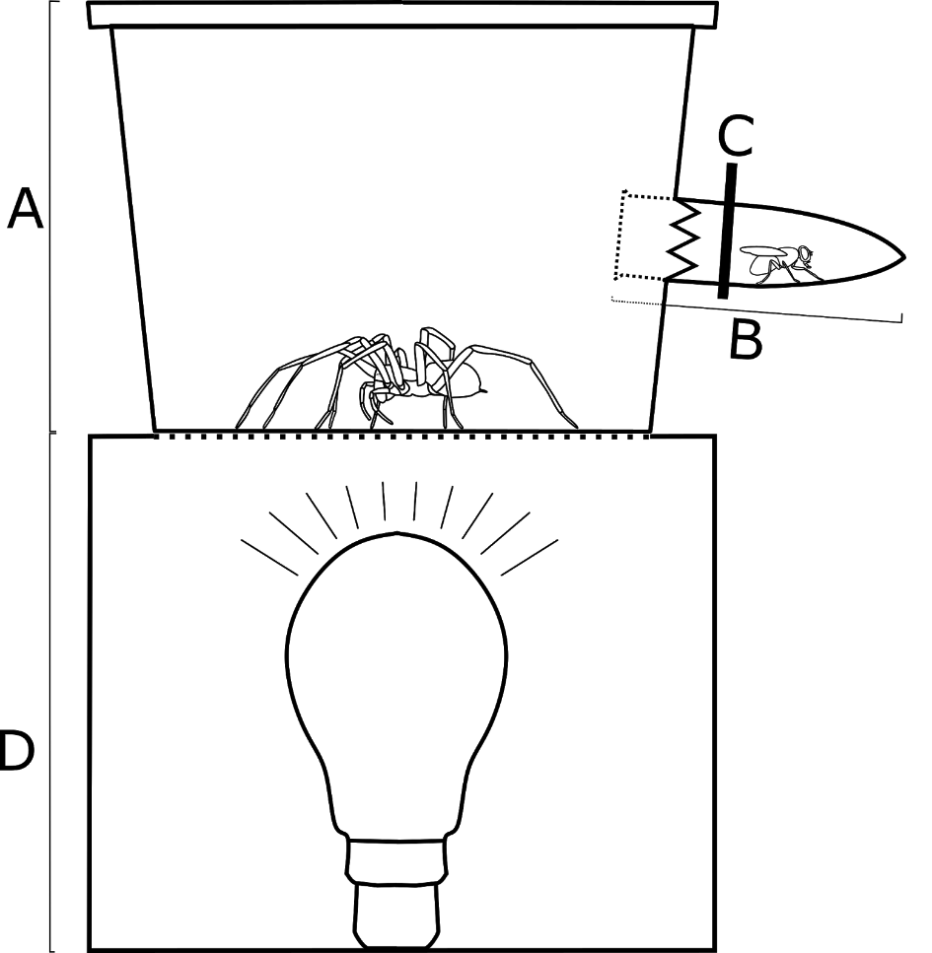
Fig. 1 ― Experimental arena: a plastic container (A) coupled with a small receptacle (B; Eppendorf® 1.5 mL) with a small piece of cardboard (C) in it. A lamp inside a box (D) illuminated the arena from underneath.

Morphometric measurements and categorization
We used photographs and the experiments’ video recordings to measure females’ cephalothorax width (mm), abdomen width (mm) and egg sac area (mm²) using ImageJ (US National Institutes of Health, Bethesda, MD, http://imagej.nih.gov/ij). We replicated measures three times and used their mean to reduce measurement error. We assume that the costs of the extra weight depended on female size: for the same egg load, larger females are better able to carry that weight than small females. It was not possible to find a comparable way to measure the cost of carrying an internal or external egg load, so we created two indices to measure egg load carrying that controlled for female size for each female. First, we calculated the “internal egg load index” for every female using the residuals of a regression between the abdominal width and the cephalothorax width. This index can assume positive and negative values and it represents whether each female has a larger or smaller abdominal width, respectively, than predicted by her cephalothorax width. Second, we calculated the “external egg load index” only for females that were carrying an egg sac, using the residuals of a regression between the square root of egg sac area and the cephalothorax width. This index can assume positive and negative values and it represents whether each female’s egg sac has a larger or smaller area, respectively, than predicted by female cephalothorax width.
We classified adult females used in the experimental trials in different categories. First, we classified females that were carrying an egg sac during the trial as maternal females (N = 35 females) and females without an egg sac as non-maternal females (N = 25 females). To better explain the effect of internal egg carrying as the moment of oviposition approaches, we also divided non-maternal females into two groups: pre-gravid and gravid. Pre-gravid females (N = 16 females) did not lay their eggs up to four days after the trial, while gravid females (N = 9 females) laid eggs up to four days after the trial. As expected, gravid females had greater internal egg load index values than pre-gravid females and maternal females (Fig. 2). Pre-gravid females also had greater internal egg load index values than maternal females.

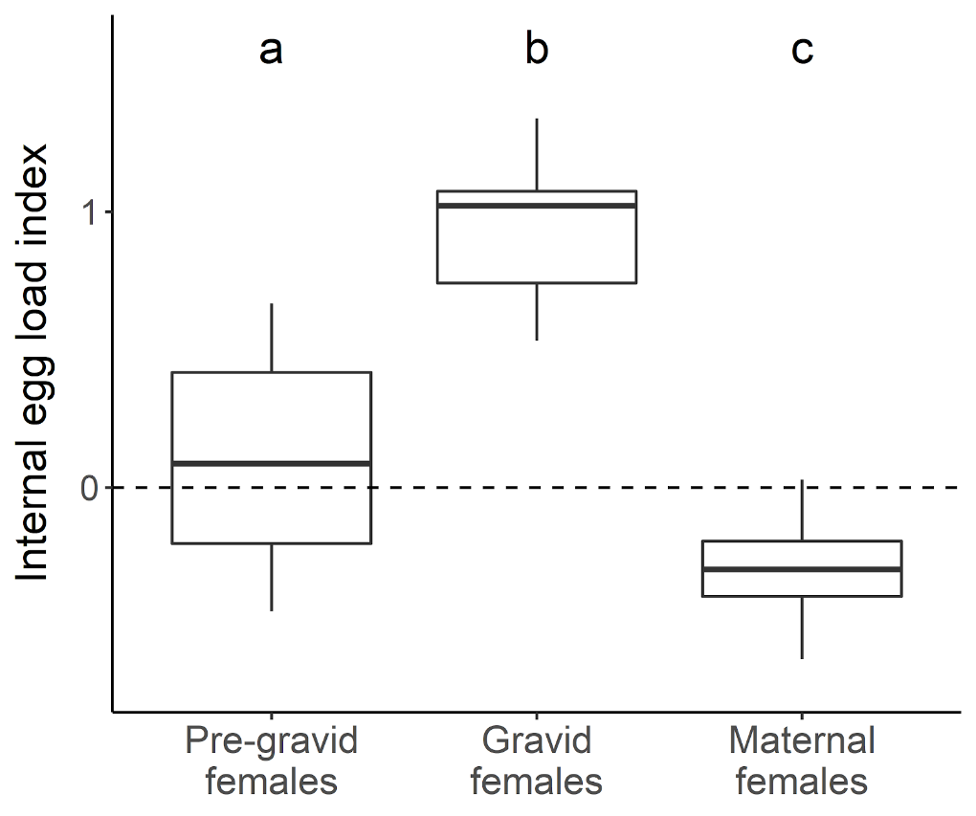
Fig. 2 ― Internal egg load index according to female group. The boxes enclose 50% of the data (inter-quantile range), the whiskers contain values up to 1.5 times the inter-quantile range, the solid line within the boxes represents the median. Internal egg load index represents whether each female has a larger or smaller abdominal width than predicted by her cephalothorax width (positive and negative values, respectively). Pre-gravid females were not carrying an egg sac during the experiment nor oviposited after four days. Gravid females were not carrying an egg sac during the experiment but oviposited within four days. Maternal females were carrying an egg sac during the experiment. Different letters represent statistical differences between groups (t-tests with p < 0.05).

Statistical analysis
We used survival analysis methods to investigate our hypotheses because data from our experiment was right-censored (spiders had a time limit to capture prey). We used prey survival probability as a proxy of female foraging ability in all our statistical analyses. It is important to note that greater prey survival probability translates into lower female foraging ability.
For our first hypothesis, we tested whether pregnancy and maternal care imposed costs to the foraging ability of P. ornata females. We built a Cox-Proportional Hazards model to investigate the effect of both internal egg load and maternal care expression. In this model, prey survival probability was the response variable, while internal egg load index (continuous) and egg sac carrying status (categorical: carrying or not carrying an egg sac) were the predictor variables. We predicted that coefficients related to both of these predictor variables would be negative, translating into greater prey survival probability when females had greater egg load index values and were carrying an egg sac. Furthermore, we used mean values related to our female categories (pre-gravid, gravid and maternal females; see details in the Morphometric measures section above) to quantify the influence of the model’s predictor variables on prey survival probability in a realistic manner (see details in Appendix 1). We predicted that females carrying extra weight due to either internal eggs (i.e., gravid females) or external egg sacs (i.e., maternal females) would have worse foraging ability than pre-gravid females. In this sense, prey survival would be greatest with gravid females, intermediate with maternal females and lowest with pre-gravid females.
Our second hypothesis is that greater female reproductive investment decreases female foraging ability. Greater values of internal egg load index may represent greater proximity to oviposition instead of greater reproductive investment. Thus, we focused only on our external egg load index as a proxy of female reproductive investment. We built another Cox-Proportional Hazards model using only maternal females, as non-maternal females do not have external egg load index values. In this model, prey survival probability was the response variable and external egg load index was the predictor variable. We predicted that greater values of external egg load index would positively influence prey survival probability.
We performed all our analyses in the software R 3.4.1 (R Core Team 2017) using the package survival (Therneau 2015). Prior to model fitting we standardized all continuous predictor variables (internal and external egg load indices) to zero mean and then divided by two times their standard deviation (following Gelman 2008). Egg sac status was set as 0 (not carrying an egg sac) and 1 (carrying an egg sac). Both of our Cox-Proportional Hazards models respected the proportional hazards assumption (first model: global χ² = 0.94, p = 0.62; second model: χ² = 1.17, p = 0.28). In our models, we considered coefficients to be different than zero when 95% confidence intervals (95% CI) did not overlap zero.

RESULTS
All pre-gravid females captured prey within the time limit given (16/16), while maternal and gravid females captured prey in 77.14% (27/35) and 77% (7/9) of the trials, respectively (Fig. 3). We found evidence that increases in female internal egg load index increase prey survival probability according to our first Cox-Proportional Hazard model (β coefficient mean = -0.98, 95% CI: lower = -1.72, upper = -0.23). The same model indicates increases in prey survival probability when females carry an egg sac (β coefficient mean = -1.23, 95% CI: lower = -1.96, upper = -0.5). Based on the coefficients of this model and mean measurements of female categories, we may infer that the prey capture risk is 57% lower within the maternal group than within the pre-gravid group, and 55% lower within the gravid group than within the pre-gravid group. Moreover, prey capture risk is only 3% lower within the maternal group than within the gravid group. Our results supported our predictions for the first hypothesis, as prey survival was highest within the maternal group and similar to the gravid group, and substantially lowest within the pre-gravid group.
Regarding our second hypothesis, we found little evidence that female external egg load index influenced prey survival probability, according to our second Cox-Proportional Hazards model (β coefficient mean = -0.28, 95% CI: lower = -1.01, upper = 0.43).

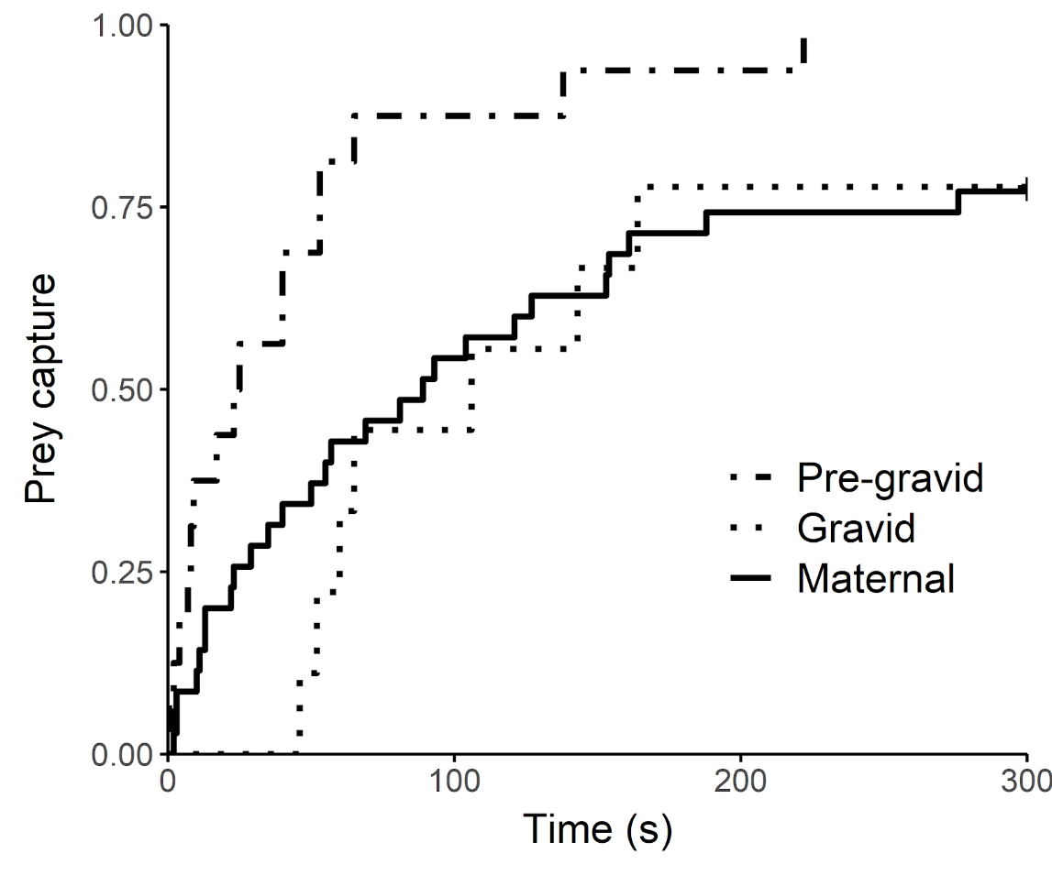
Fig. 3 ― Prey capture in the presence of Paratrechalea ornata females of different categories. Dot-dashed line represents females that were not carrying an egg sac during the experiment nor oviposited after four days (i.e., pre-gravid females). Dotted line represents females that were not carrying an egg sac during the experiment but oviposited within four days (i.e., gravid females). Solid line represents females that were carrying an egg sac during the experiment (i.e., maternal females).

DISCUSSION
In this study, we first investigated the costs of pregnancy and maternal care to foraging ability in P. ornata females. We found evidence that these processes have a negative influence on female foraging ability, and in a similar magnitude. Both greater internal egg load and the act of carrying an egg sac decreased female foraging ability in our experiments. Ultimately, females that were about to oviposit (gravid females) showed a similar foraging ability to females carrying an egg sac (maternal females), which was lower than females that were far from ovipositing and were not carrying an egg sac (pre-gravid females). We found little evidence to support our hypothesis that greater female reproductive investment negatively influences female foraging ability.
The simplest mechanistic explanation for a decrease in female foraging ability due to pregnancy and egg brooding is that the egg load would represent a physical burden that slows females’ movements (Shine 2003b). If that is so, then why did we not find evidence that P. ornata females suffer increased costs when carrying larger egg sacs proportional to their bodies? It may be that egg sac volume does not vary enough in P. ornata (likely due to stabilizing selection on brood size) so that the largest egg sac does not produce significantly more costs than the smallest egg sac. Yet Colancecco et al. (2007), using the wolf spider Pardosa milvina, found that females carrying an egg sac and females with a larger bead attached to their body did not differ in foraging ability, thus requiring an additional explanation for impairment during the maternal care stage. One possibility—that can co-occur with physical burden costs—is that females become more cautious when they are carrying eggs (internally or externally) to avoid the risk of injury by the prey, similar to jumping spiders close to their molting period (Elias et al. 2010). A mechanistic explanation in this case is that females become impaired because they decrease their metabolic activity as they get closer to oviposition and maintain this low metabolic level throughout the maternal care stage. This would explain why we did not observe an effect of the reproductive investment of maternal females on their foraging ability. An analogous situation occurs in the scorpion Centruroides sculpturatus, in which females carrying their offspring do not capture prey, but removing the offspring from females after 24 hours of birth did not increase their foraging ability (Webber & Rodríguez-Robles 2013). This may suggest that the burden (i.e., eggs or offspring) does not directly affect females’ foraging ability, but can influence female physiological state that regulates foraging ability. The initial burden costs may act as a trigger to decrease female metabolic rate and to change female behaviors to compensate for being impaired. For instance, gravid females of the lizard Eumeces laticeps reduce their activity supposedly to escape foragers relying on crypsis (Cooper et al. 1990). In P. ornata, females carrying an egg sac are found frequently hidden under rocks while females not carrying an egg sac are abundant on the surface (Spindler & Costa-Schmidt, unpublished data). Here, we only speculate direct mechanistic causes to pregnancy and maternal costs, but further investigations on the subject can allow us to reveal patterns in different taxa that may be crucial to life-history evolution.

ACKNOWLEDGMENTS
We thank Alexandre Kuhn for helping on the collection of spiders and on the experiments. We are thankful for insightful comments and ideas on this project by Gustavo “Billy” Requena. We also thank Louise M Alissa, Solimary García-Hernández, Eduardo SA Santos, Nathan Burke and Michael Kasumovic for feedback on the manuscript. We are thankful for inspiring thoughts during the development of this work by Aldo M de Araújo.

DISCLOSURE STATEMENT
The authors declare no conflict of interest.

FUNDING
CSS received a grant from Fundo Padre Milton Valente de Apoio Acadêmico/UNISINOS. LECS received a postdoctoral grant from Capes/Brazil (PNPD 20132737).

ETHICAL STANDARD
This research was approved by Chico Mendes Biodiversity Conservation Institute (permit 32291-3).

AUTHORS’ CONTRIBUTIONS
PP, CSS, and LECS conceived the idea of the study; PP and CSS collected the data; PP analysed the data; PP wrote the manuscript with input from LECS.

ORCID
Pietro Pollo: https://orcid.org/0000-0001-6555-5400
Luiz Ernesto Costa-Schmidt: https://orcid.org/0000-0002-0223-8587

DATA ACCESSIBILITY
Data and analysis scripts are available at https://osf.io/thmx6/.

REFERENCES
Boggs CL. 2009. Understanding insect life histories and senescence through a resource allocation lens. Funct Ecol. 23:27-37. doi:10.1111/j.1365-2435.2008.01527.x.
Carico JE. 1993. Revision of the genus Trechalea Thorell (Araneae, Trechaleidae) with a review of the taxonomy of the Trechaleidae and Pisauridae of the western hemisphere. J Arachnol. 21:226-257.
Carico JE. 2005. Descriptions of two new spider genera of Trechaleidae (Araneae, Lycosoidea) from South America. J Arachnol. 33:797-812. doi:10.1636/H03-71.1.
Clutton-Brock TH. 1991. The evolution of parental care. Princeton, New Jersey: Princeton University Press.
Colancecco M, Rypstra AL, Persons MH. 2007. Predation and foraging costs of carrying eggsacs of different mass in the wolf spider Pardosa milvina. Behaviour. 144:1003-1018. doi:10.1163/156853907781871888.
Cooper WE, Vitt LJ, Hedges R, Huey RB. 1990. Locomotor impairment and defense in gravid lizards (Eumeces laticeps): behavioral shift in activity may offset costs of reproduction in an active forager. Behav Ecol Sociobiol. 27:153-157. doi:10.1007/BF00180298.
Costa-Schmidt LE, Carico JE, de Araújo AM. 2008. Nuptial gifts and sexual behavior in two species of spider (Araneae, Trechaleidae, Paratrechalea). Naturwissenschaften. 95:731–739. doi:10.1007/s00114-008-0379-7.
Costa-Schmidt LE, Machado G. 2012. Reproductive interference between two sibling species of gift-giving spiders. Anim Behav. 84:1201-1211. doi:10.1016/j.anbehav.2012.08.026.
Crowl TA, Alexander JE. 1989. Parental care and foraging ability in male waterbugs (Belostoma flumineum). Can J Zool. 67:513-515. doi:10.1139/z89-074.
Elias DO, Botero CA, Andrade MCB, Mason AC, Kasumovic MM. 2010. High resource valuation fuels “desperado” fighting tactics in female jumping spiders. Behav Ecol. 21:868-875. doi:10.1093/beheco/arq073.
Gelman A. 2008. Scaling regression inputs by dividing by two standard deviations. Stat Med. 27:2865-2873. doi:10.1002/sim.3107.
Hayward A, Gillooly JF. 2011. The cost of sex: quantifying energetic investment in gamete production by males and females. PLoS One. 6: e16557. doi:10.1371/journal.pone.0016557.
Isaacs R, Byrne DN. 1998. Aerial distribution, flight behaviour and eggload: their inter-relationship during dispersal by the sweetpotato whitefly. J Anim Ecol. 67:741-750. doi:10.1046/j.1365-2656.1998.00236.x.
Kight SL, Ozga M. 2001. Costs of reproduction in the terrestrial isopod Porcellio laevis Latreille (Isopoda: Oniscidea): brood-bearing and locomotion. J Kansas Entomol Soc. 74:166-171.
Lee SJ, Witter MS, Cuthill IC, Goldsmith AR. 1996. Reduction in escape performance as a cost of reproduction in gravid starlings, Sturnus vulgaris. Proc R Soc B Biol Sci. 263:619-623. doi:10.1098/rspb.1996.0093.
R Core Team. 2017. R: a language and environment for statistical computing.
Reznick D. 1992. Measuring the costs of reproduction. Trends Ecol Evol. 7:42–45. doi:10.1016/0169-5347(92)90104-J.
Schwarzkopf L. 1994. Measuring trade-offs: a review of studies of costs of reproduction in lizards. In: Vitt LJ, Pianka E, editors. Lizard ecology: historical and experimental perspectives. Princeton, New Jersey: Princeton University Press; p. 7-30.
Seibel BA, Robison BH, Haddock SHD. 2005. Post-spawning egg care by a squid. Nature. 438:929. doi:10.1038/438929a.
Shine R. 2003a. Locomotor speeds of gravid lizards: placing “costs of reproduction” within an ecological context. Funct Ecol. 17:526-533. doi:10.1046/j.1365-2435.2003.00756.x.
Shine R. 2003b. Effects of pregnancy on locomotor performance: an experimental study on lizards. Oecologia. 136:450-456. doi:10.1007/s00442-003-1281-9.
Smiseth PT, Kölliker M, Royle NJ. 2012. What is parental care? In: Royle NJ, et al., editors. The evolution of parental care. Oxford, UK: Oxford University Press; p. 1-17.
Therneau T. 2015. A package for survival analysis in S.
Webber MM, Rodríguez-Robles JA. 2013. Reproductive tradeoff limits the predatory efficiency of female Arizona Bark Scorpions (Centruroides sculpturatus). BMC Evol Biol. 13:197. doi:10.1186/1471-2148-13-197.

