Pet or pest? Stable isotope methods for the early detection of invasive alien species
KGW Hill¹, KE Nielson², JJ Tyler², FA McInerney², ZA Doubleday³, GJ Frankham⁴, RN Johnson⁴, BM Gillanders¹, S Delean¹, P Cassey¹
¹School of Biological Sciences and the Environment Institute, The University of Adelaide, Adelaide, South Australia, Australia
²School of Physical Sciences, The University of Adelaide, Adelaide, South Australia, Australia
³Future Industries Institute, University of South Australia, Adelaide, South Australia, Australia
⁴Australian Centre for Wildlife Genomics, Australian Museum Research Institute, Sydney, New South Wales, Australia

Running title: Isotopes for alien species detection
Corresponding Author: Katherine Hill
Postal address: G24b Benham Building, The University of Adelaide, North Terrace, Adelaide, South Australia, 5000
Email: katherine.hill@adelaide.edu.au
Phone: (+61) 8 8313 2546

Abstract
The illegal pet trade facilitates the global dispersal of invasive alien species (IAS), providing opportunities for new pests to establish in novel recipient environments. Despite the increasing threat of IAS to the environment and economy, biosecurity efforts often lack suitable, scientifically-based methods to make effective management decisions; such as identifying an established IAS population from a single incursion event. We present a new application of a stable isotope technique to identify wild and captive histories of an invasive pet species. Twelve red-eared slider turtles (Trachemys scripta elegans) from Australian incursions with putative wild and captive origins were analyzed to: (1) present best-practice methods for sampling T.s.elegans incursions; (2) effectively discriminate between wild and captive groups using stable isotope ratios; and (3) present a framework to expand the methodology for use on other IAS species. A sampling method was developed to obtain carbon (δ¹³C‰) and nitrogen (δ¹⁵N‰) stable isotope ratios from the keratin layer of the carapace (shells), which identify differences in dietary plant material and trophic level respectively. Both δ¹³C‰ and δ¹⁵N‰ exhibited the potential to distinguish between the wild and captive origins of the samples. Power simulations demonstrated that isotope ratios were consistent across the carapace, and a minimum of 8 individuals were required to effectively discriminate wild and captive groups, reducing overall sampling costs. Statistical classification effectively separated captive and wild groups by δ¹⁵N‰ (captive: δ¹⁵N‰ ≥ 9.7‰, minimum of 96% accuracy), which suggested that captive individuals consumed greater proportions of terrestrial meat than wild individuals. This study outlines a practical and accessible method for detecting IAS incursions, providing biosecurity staff and decision makers with the tools to quickly identify and manage future IAS incursions.
Key words. Biosecurity, invasive species, pet trade, provenancing, stable isotopes, Trachemys scripta elegans, wildlife trade

Introduction
Wildlife trade, in particular the legal and illegal pet trade, facilitates the worldwide movements of invasive alien species (IAS), providing novel introduction pathways into new environments (Russello et al. 2008, Lockwood et al. 2019). Once sold, accidental escapes or intentional release of alien pets provide numerous opportunities for these species to establish, and if new populations are not detected early, complete eradication is unlikely and often extremely costly and resource-intensive (Mack et al. 2000, Tingley et al. 2015, Vall-Ilosera and Cassey 2017). IAS are a key threatening process globally, thus the prevention of further establishment is critical to protecting biodiversity (Lodge et al. 2006, Baillie et al. 2010). Current methods for discriminating between a recently escaped or released captive individual and an individual from an established population are ineffective, and rarely identify the threat early enough for effective eradication (Schmidt et al. 2017). Here, we explore the potential for a novel application of carbon and nitrogen geochemistry for early detection of a vertebrate IAS incursion.
Stable isotopes are efficient at tracing origins of natural products, and are a strong candidate for identifying the origin of IAS incursions (Cerling et al. 2016). The relative abundance of stable isotopes within a material is a function of its synthesis and environmental history, which, in the case of vertebrate animals, predominantly relates to diet (Camin et al. 2016). In vertebrate animal tissue, stable carbon isotope ratios (¹³C/¹²C, reported as δ¹³C‰) are linked to the δ¹³C‰ of the animal’s diet, which, in turn, is strongly influenced by the relative proportion of the C4 plants an animal consumes. Nitrogen stable isotope ratios (¹⁵N/¹⁴N, reported as δ¹⁵N‰) are also influenced by the animal’s diet; specifically, the trophic position of the animal. Given that a difference in the diet between wild and captive animals is extremely likely, stable isotopes can potentially utilize these differences to provide information on the origin and life history of the animal.
Previous studies have begun to explore stable isotope tools to distinguish between wild and captive animals with success, including, but not limited to: short-beaked echidnas (Tachyglossus aculeatus) (Brandis et al.2018), wolves (Canis lupis) (Kays and Feranec 2011), African grey parrots (Psittacus erithacus) (Alexander et al. 2019, Symes et al. 2017), reticulated pythons (Python reticulatus) (Natusch et al. 2017) and crocodile lizards (Shinisaurus crocodilurus) (van Schingen et al. 2016, Ziegler et al. 2018). In all of these cases, stable isotopes have proved efficient at identifying environmental histories and diets; however, with the exception of insects (Holder et al. 2014, Hood-Nowotny et al. 2016), the use of stable isotopes for early detection of IAS is relatively unexplored.
Red-eared slider turtles (Trachemys scripta elegans) were selected as a case study to test the efficacy of carbon and nitrogen stable isotope ratios as a tool in biosecurity. As one of the world’s top 100 most invasive species, T.s.elegans have the potential to establish and spread in urban and semi-rural areas worldwide (IUCN 2000, Rodder et al. 2009, Banha et al. 2017). T.s.elegans are the most traded turtle species in the world, where more than 50 million individuals were exported from USA between 1989 to 1997 to supply the pet trade (Telecky 2001), and the trade continues illegally despite being banned in most regions (Kitowski and Pachol 2009; García‐Díaz et al. 2015). These animals quickly grow to large sizes and become aggressive, resulting in often being intentionally released into waterways as they become undesirable as pets. As a consequence, T.s.elegans have established nearly 200 identified breeding populations worldwide (Kikillus et al. 2010). They are a significant threat to biodiversity, as they compete with native turtles for food and shelter (Pearson et al. 2013, Balzani et al. 2016), and carry exotic diseases including Ranavirus and Chlamydia spp. (Johnson et al. 2007, Mitura et al. 2017). As T.s.elegans are omnivorous, the proportions of meat and plant material that may vary between wild and captive diets are likely to drive differences in δ¹³C‰ and δ¹⁵N‰, making them ideal case study candidates.
New detection technologies are urgently needed to provide early identification of infrequent incursions as distinct from established populations, to allow for quick and effective eradication (Lodge et al. 2006). Here, we present a new application of carbon and nitrogen stable isotopes using historical Australian incursion samples of T.s.elegans of putative wild and captive origins to: (1) determine best-practice methods for sampling T.s.elegans incursions; (2) evaluate the use of carbon and nitrogen isotope ratios to discriminate between wild captive individuals; and (3) provide a framework to expand the methodology for use on other IAS species.

Methods

Sample collection
T.s.elegans post-mortem specimens were loaned from the Queensland Museum, the Department of Primary Industries and Regions, South Australia, and the Australian Museum Research Institute Herpetology Collection. These animals were collected by state wildlife compliance agencies under their powers to seize animals being kept in contradiction to legislation, or found at-large in wild environments. All animals were euthanized as per state and territory IAS protocols, and stored frozen. The national collection contains a large number of seized T.s.elegans incursions from various locations across Australia. Due to the nature of the limited sample collection, ten animals from various Australian locations (Figure 1) with sufficient details to determine environmental histories were selected, which were: (i) seized from illegal captive holding or commercial sale; (ii) surrendered by members of the public; or (iii) found at-large in wild-states. Furthermore, two turtles with unknown histories were selected to test the potential of the final decision tool at discriminating between wild and captive origins.
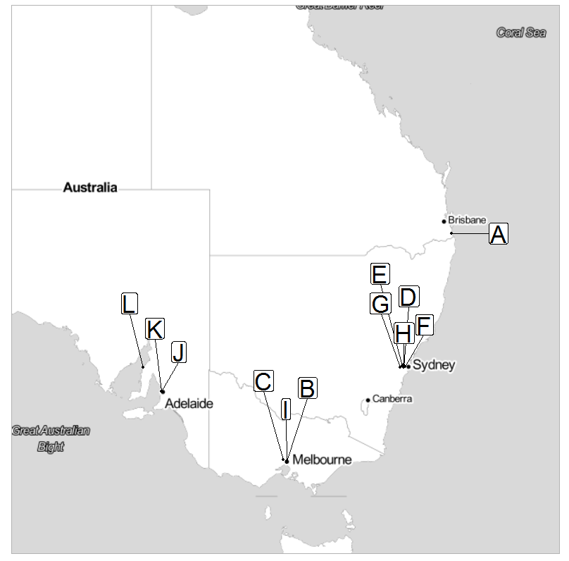
Figure 1: Locations of Australian T.s.elegans incursion samples used in this study. Letters A to L refers to the identification of each turtle. Identified established populations exist in Sydney, New South Wales (Burgin 2006, Mo 2018), and multiple locations in Queensland (O'Keeffe 2005).
Based on the assumed environmental history of the individual turtles, we assigned the variable “status”, and classified individuals as “wild”, “captive” or “unknown”. While the animals used in this study had relatively high confidence of their origin, there remains uncertainty in the status of individuals being correctly assigned by authorities. Therefore, we created an index to determine the percent confidence of correct classification based on how many secondary characteristics matched the original assessment by authorities, including: (i) proximity to a known established population; (ii) presence of algae or wild features on the carapace; (iii) proximity to known established populations; and (iv) seized by authorities or surrendered by a member of the public. This provided a confidence scale for selecting the individuals used for a decision model (Appendix S1). Almost all original status classifications contained some degree of uncertainty. Four individuals seized from captivity were the only individuals determined to have 100% certainty in status, while remaining individuals contained degrees of uncertainty, ranging from 0-75% confidence.

Isotopic analysis
Measuring stable isotope ratios from a slow-turnover and inert tissue provides a long-term record of an animal’s environmental history (Dalerum and Angerbjörn 2005). The keratin covering a turtles’ carapace in scale-like sections (scutes) was selected due to its slow (annual) growth and ease of sampling (Schneider et al. 2015). Scutes grow by adding new layers to the base, whilst widening in each layer from the perimeter to account for growth. Old scutes are then shed from the perimeter of the shell (Clinical Anatomy and Physiology of Exotic Species 2005). Assuming T.s.elegans scute growth is similar to Chrysemys picta from the same sub-family, a new layer of scute grows in warmer months of spring to summer, while the previous year’s growth is shed (Alibardi 2005).
Carapaces were washed, removed from the body and freeze-dried to separate partially shed scutes and to exclude water contamination. Samples on shed scutes were cut using sterile dissecting scissors, while filings were collected on attached scutes using sterile scalpels. Scute samples were weighed and placed in tin capsules for continuous-flow isotope ratio mass spectrometry (CF-IRMS) using an Elementar elemental analyzer coupled to a Nu Horizon mass spectrometer at the University of Adelaide. Standards of glycine, glutamic acid and USGS41 (L-glutamic acid; (Reston Stable Isotope Laboratory 2011)) were run periodically to correct for mass effects and instrumental drift during and between runs. Isotope ratios are reported in per mil (‰), following the standard delta notation, where:
$δX‰=\left[\frac{R_{sample}}{R_{standard}}−1\right]×1000$
Where X was the element, R was the relative abundance of the heavy to the light isotope (¹³C/¹²C; ¹⁵N/¹⁴N) of the sample or standard. All carbon isotope ratios are reported relative to the Vienna Pee Dee Belemnite (VPDB) and all nitrogen isotope ratios are reported relative to air. Carbon and nitrogen were measured during the same analysis.

Sampling design
To improve the detectable stable isotope ratio separation between captive and wild groups (or to increase effect size differences), the variance of each hierarchal level of sampling (individual > scute > sample) needed to be minimized without oversampling (Nicholson and Holmes 2017). We adopted a pilot analysis to provide estimates of the variances of each hierarchal level of sampling. We used these variances, along with proposed measures of detectable differences in isotope ratios, to compare different sampling designs that we generated through simulation (Green and MacLeod 2016) with the aim to determine a suitable sample size of individual animals, and number of scutes and samples within scutes per individual. The most practical sampling method was determined as that with power > 80% with minimum sampling (Appendix S2) to detect the minimum observed difference of δ¹⁵N‰ between animals from different status groups.

Data analysis
Differences in mean isotope ratios among individual turtle specimens were evaluated using linear mixed effects models. Carbon isotope ratios (δ¹³C‰) and nitrogen isotope ratios (δ¹⁵N‰) were fitted independently as response variables, with individual turtles as a fixed effect and scute as a random effect to allow for variation between repeated measurements within a scute. The models explicitly allowed for differences in variation between individuals, because heterogeneity within individuals violated the constant variance assumption of the linear mixed effect models. The effects of sex on stable isotope ratios were investigated using likelihood ratio tests. We were unable to investigate other variables of interest, such as location and climate, due to the broad variety of the small number of representative samples. Instead, these contribute to the between-individual variation.
The overall objective was to evaluate if a decision rule could be developed that allowed wild and captive individuals to be identified based on their δ¹³C‰ and δ¹⁵N‰ values. To assess this, a classification tree approach was adopted by introducing the status as a response variable. Because the data consisted of multiple observations from the same individual turtles, a structured cross-validation approach was used to evaluate prediction error, with all observations from the same individual included in the ‘hold-out’ set for prediction; and to avoid over-fitting. The optimal classification tree was selected using the classification parameter; where misclassification errors were not significantly improved with the penalty of adding further nodes. A classification tree was developed using this process, including all individual observations across all turtles to allow for variation within individuals.
Due to the inert and annual growth of the carapace, shed scutes may provide dietary information on previous active seasons, and retained scutes for the most recent active season (Alibardi 2005). Differences between shed and attached scutes within an individual may provide information on annual dietary changes within an individual. Shed scute was available for three turtles, with primary scutes retained on the carapace and secondary scute peeled off after freeze-drying. On one individual, a tertiary layer was available as a second layer of peeling scute. As each individual was seized during different years with different environmental histories, each individual’s temporal profile was examined separately. To analyze the temporal variability across the shed and retained scutes, separate linear models for each isotope were fitted, to assess changes in stable isotope ratios, and thus diet, over different active seasons.
All analyses were conducted in the R software environment for statistical and graphical computing (V 3.5.3; R Core Team 2019). Linear mixed effects models were fitted with R package “lme4” (Bates et al. 2014), and classification trees with “rpart” (Trevor et al. 2009, Therneau et al. 2018).

Results

Sampling design
Power simulations indicated nine samples across two separate scutes on the carapace was sufficient to capture individual variation, while retaining a detectable difference between wild and captive individuals. Furthermore, increased numbers of individuals in both wild and captive groups increased the power of detecting a difference between groups. Variation between scutes of the same layer (primary and secondary) was minimal when compared to variation between individuals. Sampling four individuals per status group (“captive” and “wild” groups, 8 individual turtles in total) provided the greatest power at a minimum of 96%. The position of the samples within the scute had no significant effect on δ¹⁵N‰ ($Χ_{6}^{2}$ = 1.76, p > 0.05) nor δ¹³C‰ ($Χ_{6}^{2}$= 0.84, p > 0.05).

Analysis of turtle provenance
Status (wild versus captive) was the main factor underlying differences in isotope values. There was evidence for an effect of status on isotopic ratios ($Χ_{1}^{2}$ = 4.02, p = 0.0451), but no clear differences among the sexes ($Χ_{2}^{2}$ = 3.66, p = 0.160).
Individual turtles had their own, unique carbon and nitrogen isotope ratios, and within-individual variation was generally less than between-individual variation. Wild turtles exhibited lower δ¹⁵N‰ values and a greater spread in δ¹³C‰ compared to captive turtles (Figure 2).
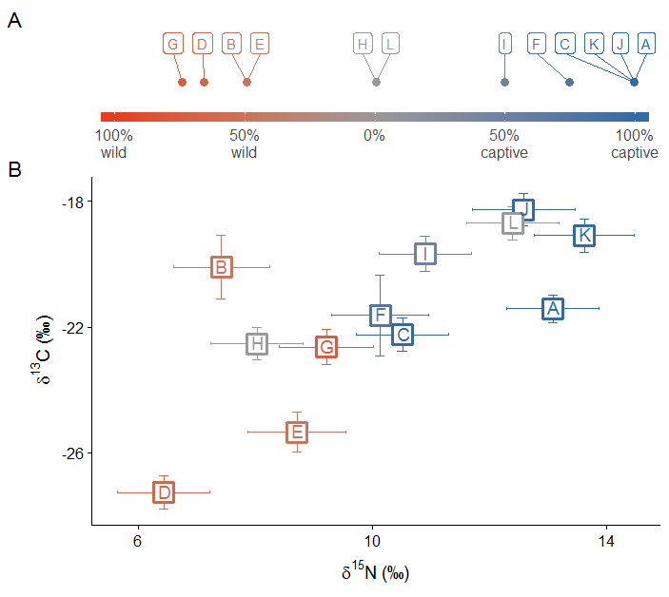
Figure 2: (a) Confidence in original status assignment based on select characteristics (Appendix S1) (b) Plot of means and 95% confidence intervals for captive and wild T.s.elegans individuals accounting for assignment confidence.
The classification tree showed clear differences between captive and wild groups associated with nitrogen isotope ratios. Only nitrogen was required to separate captive and wild groups, with captive samples identified by δ¹⁵N‰ ≥ 9.7‰, with a success rate of at least 96%. If nitrogen information was not included, groups were poorly separated with captive identified by δ¹³C‰ ≥ -22‰ with success of only 86%. Using the generated classification tree, the unknown turtles “H” and “L” were classified as wild and captive respectively (Figure 3).
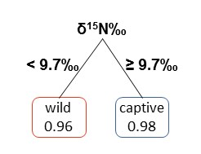
Figure 3: Classification tree for separating wild and captive T.s.elegans, excluding individuals with 0% status confidence. Nodes include predicted class (captive or wild), and probability of a correct classification.
Of the three turtles with shed scutes available, all revealed significant differences between layers; however, there was no consistency in the direction of change between ‘years’ (Figure 4). Furthermore, the nitrogen isotopic ratio values for each scute layer remained within the classification range of their assigned status.

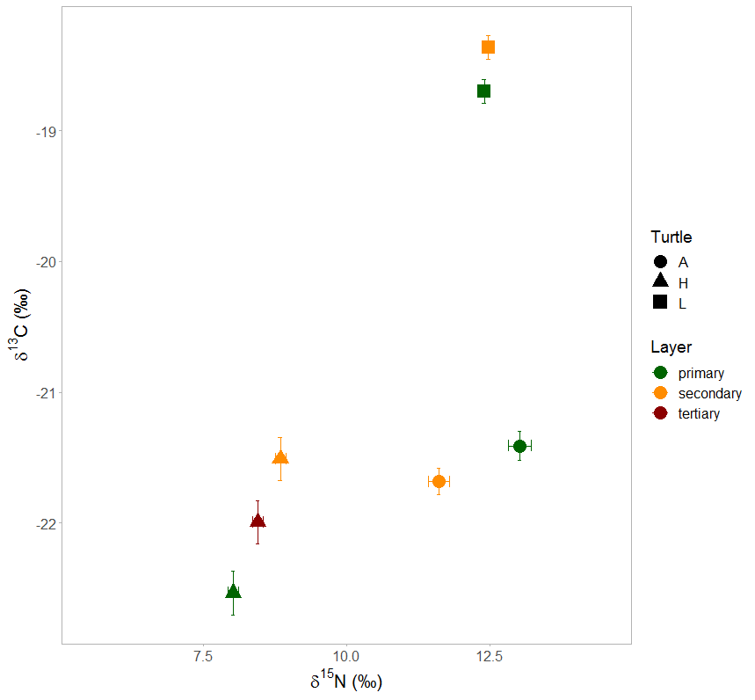
Figure 4: Isotopic ratio means for carbon and nitrogen on shed and retained scutes. Shed scutes were available on three individuals were available: captive turtle (A) and unknown turtles (H) and (L). Layers are labelled as primary (newest growth; retained on carapace) to oldest (secondary; shed). A third, older layer of scute (tertiary) was available on turtle H.

Discussion
Captive and wild T.s.elegans are effectively differentiated by their nitrogen stable isotope ratios. Sampling scute proved to be a simple method; no specialist equipment was required for collection, and samples could be taken anywhere on the scute and across multiple scutes with minimal variation within the individual. Although individuals were dissected for this study, scute sampling is potentially a non-invasive method. This makes the technology accessible for non-specialist practitioners – such as biosecurity or veterinary staff – and for samples to be collected and sent to a laboratory for analysis and determination of their origins. Furthermore, the power simulations demonstrated that minimal sampling per individual is required, reducing the overall sampling costs in time, effort and welfare, as well as monetary cost.
Because material of high biosecurity risk is inherently difficult to obtain, the availability of T.s.elegans and other reptile IAS is extremely limited in Australia, while information surrounding an animal’s history is not always accessible. Wild T.s.elegans specimens are rare in Australia, as at-large populations have only been confirmed in Sydney (Burgin 2006, Robey et al. 2011; Mo 2018) and Queensland (O'Keeffe 2005). Furthermore, T.s.elegans are illegal to import or keep in Australia without a license, limiting available samples to those confiscated from illegal keeping (Department of Agriculture and Water Resources 2017). Here, we used a selection of samples where we were relatively confident in the assignment of status to an individual. Furthermore, the use of a power analysis demonstrated that a minimum of eight (N > 8) individuals of known origin was sufficient to obtain a detectable effect size to effectively separate wild and captive groups.
Separation of wild and captive groups used a simple classification tree model, which effectively differentiated wild and captive individuals with minimal misclassification error. As only samples with relatively high status confidence were used, this classification tree can be adopted as a set of best-practice methods and model to determine the origins of T.s.elegans individuals found in wild-states. The differences in the carbon and nitrogen isotope composition of scutes from different status groups are likely due to different proportions and sources of plant and meat within a turtle’s diet, as well as varied sources of these food groups (Balzani et al. 2016). The trophic level of captive turtles, as inferred from δ¹⁵N‰, is consistently higher than for wild populations, suggesting a higher consumption of terrestrial meat-based products, including commercial turtle food (Mazumder et al. 2018). A similar result has been identified in studies on other reptiles, such as crocodile lizards (Shinisaurus crocodilurus) and monitor lizards (Varanus spp.), where captive animals possessed enriched δ¹⁵N‰ (van Schingen et al. 2016, Ziegler et al. 2018). Interestingly, previous studies have identified the opposite effect in reticulated pythons (Python reticulatus), with captive individuals showing lower δ¹⁵N‰ than wild individuals (Natusch et al. 2017). Therefore, δ¹⁵N‰ is a strong candidate for the expansion of this forensic technique into other reptile groups, but likely requires species-specific models.
The δ¹³C‰ exhibited little power for separating wild and captive groups, suggesting that captive T.s.elegans may not be fed as much C4 plant material in Australia, in comparison to other countries where δ¹³C‰ is a common indicator of domestication (Burleigh and Brothwell 1978, Hu et al. 2009). However, the carbon isotope ratio was identified as the most significant separator for wild and captive juvenile T.s.scripta by Aresco and James (2005). While carbon isotope ratios (δ¹³C‰) had some separating power and may be applied for a more detailed analysis of T.s.elegans dietary behavior in wild and captive states, our data suggests it is not required currently for use as a biosecurity tool in adult IAS incursions.
For each turtle where shed scute was available, the δ¹⁵N‰ and δ¹³C‰ exhibited significant differences between successive active seasons. However, as there was no consistent direction of change in the isotope data, it is unlikely the changes are due to tissue degradation, and instead likely reflected temporal variability in the turtle’s diet. The variance in δ¹⁵N‰ was sufficiently small to ensure that the specimen remained within the same status group, based on the δ¹⁵N‰ ≥ 9.7‰ discrimination value (Figure 4).
It is important to note that the status assignment refers to the confidence that the turtle was wild or captive for the entirety of the scute growth period. The natal origin (birthplace) of the turtle cannot be determined using scute growth alone as scutes are shed yearly (Alibardi 2005). Natal origin determination requires sampling of a tissue which has remained inert since hatching, as explored by Holder et al. (2014). Determining a tissue which has remained inert since hatching in T.s.elegans and a comparison to scute material will be extremely useful for future biosecurity efforts.
The exploration of additional geochemical tracers may be useful to create a more diverse set of methods and potentially obtain greater evidence of environmental origin. Stable isotopes relating to the animal’s water source such as hydrogen (²H/¹H) and oxygen (¹⁷O/¹⁶O or ¹⁸O/¹⁶O) may provide useful information on the animal’s geographical origin (Bowen et al. 2005). Furthermore, controlled experiments to determine the scute-diet fractionation factor in T.s.elegans may provide greater information on the animals’ diets.
In conclusion, carbon and nitrogen isotope ratios are effective at filling the requirement for the urgent need for effective forensic techniques to quickly identify the origin of red-eared slider turtle (T.s.elegans) incursions, and has promising potential for applications on other high-risk IAS species (Lodge et al. 2006, McFadden et al. 2017). Stable isotope ratios in the scutes of T.s.elegans provide long-term information on individual environmental histories, and thus provide an effective forensic method for identifying the origins of individuals found in wild-states. This study provides a set of best-practice, relatively accessible methods for sampling IAS incursions and subsequent analysis, including a classification tree, to determine the risk of future incursions. These approaches using an emerging and effective forensic technique contribute to the continuing development of various forensic techniques that are crucial for effective biosecurity efforts.

Acknowledgements
Turtle carcasses were kindly provided through scientific loans by the Queensland Museum (Patrick Couper), Department of Primary Industries and Regions, South Australia (Lindell Andrews) and Australian Museum’s Herpetology Collection (Jodi Rowley and Stephen Mahoney). For sample collection and seizure information we thank the Primary Industries and Regions SA (Lindell Andrews), the Department of Primary Industry, NSW (Alyssa Trotter, Nathan Cutter), the Elizabeth Macarthur Agricultural Institute (Brendon O’Rourke, Naomi Porter), and Department of Jobs, Precincts and Regions/Agriculture Victoria (Jesse Miller). We are extremely grateful to Mark Rollog for assistance with CF-IRMS data collection, Jennifer Pistevos for her work on pilot analyses, and Talia Wittmann for research assistance. This research was supported by the University of Adelaide Environment Institute, by ARC FT110100793 to F.A. McInerney, and by Invasive Animals CRC (Project 1L4) and Centre for Invasive Species Solutions (Project PO1-I-002) funding to P. Cassey. An ARC LIEF grant (LE120100054) funded the IRMS used for analyses.

Literature Cited
Alexander, J., C. T. Downs, M. Butler, S. Woodborne, and C. T. Symes. 2019 Stable isotope analyses as a forensic tool to monitor illegally traded African grey parrots. Animal Conservation 22:134-143.
Alibardi, L. 2005. Proliferation in the epidermis of chelonians and growth of the horny scutes. Journal of Morphology 265:52-69.
Aresco, M. J., and F. C. James. 2005. Ecological relationships of turtles in northern Florida lakes: a study of omnivory and the structure of a lake food web. Florida State University Tallahassee, Florida, USA.
Baillie, J., J. Griffiths, S. Turvey, J. Loh, and B. Collen. 2010. Evolution lost: status and trends of the world's vertebrates. Zoological Society of London, London.
Balzani, P., S. Vizzini, G. Santini, A. Masoni, C. Ciofi, E. Ricevuto, and G. Chelazzi. 2016. Stable isotope analysis of trophic niche in two co-occurring native and invasive terrapins, Emys orbicularis and Trachemys scripta elegans. Biological Invasions 18:3611-3621.
Banha, F., M. Gama, and P. M. Anastacio. 2017. The effect of reproductive occurrences and human descriptors on invasive pet distribution modelling: Trachemys scripta elegans in the Iberian Peninsula. Ecological Modelling 360:45-52.
Bates, D., M. Mächler, B. Bolker, and S. Walker. 2015. Fitting linear mixed-effects models using lme4. Journal of Statistical Software 67:1-48.
Bowen, G. J., L. I. Wassenaar, and K. A. Hobson. 2005. Global application of stable hydrogen and oxygen isotopes to wildlife forensics. Oecologia 143:337-348.
Brandis, K. J., P. J. B. Meagher, L. J. Tong, M. Shaw, D. Mazumder, P. Gadd, and D. Ramp. 2018. Novel detection of provenance in the illegal wildlife trade using elemental data. Scientific Reports 8:1-8.
Burgin, S. 2006. Confirmation of an established population of exotic turtles in urban Sydney. Australian Zoologist 33:379-384.
Burleigh, R., and D. Brothwell. 1978. Studies on amerindian dogs, 1: carbon isotopes in relation to maize in the diet of domestic dogs from early Peru and Ecuador. Journal of Archaeological Science 5:355-362.
Camin, F., L. Bontempo, M. Perini, and E. Piasentier. 2016. Stable isotope ratio analysis for assessing the authenticity of food of animal origin. Comprehensive Reviews in Food Science and Food Safety 15:868-877.
Cerling, T. E., J. E. Barnette, G. J. Bowen, L. A. Chesson, J. R. Ehleringer, C. H. Remien, P. Shea, B. J. Tipple, and J. B. West. 2016. Forensic stable isotope biogeochemistry. Annual Review of Earth and Planetary Sciences 44:175-206.
Clinical Anatomy and Physiology of Exotic Species. 2005. Chapter 3 - tortoises and turtles. Pages 41-56 in B. O'Malley, editor. Clinical Anatomy and Physiology of Exotic Species. W.B. Saunders Ltd., Edinburgh.
Dalerum, F., and A. Angerbjörn. 2005. Resolving temporal variation in vertebrate diets using naturally occurring stable isotopes. Oecologia 144:647-658.
Department of Agriculture and Water Resources. 2017. Biosecurity Regulation 2016. Biosecurity Act 2015. Australian Government, Canberra, Australia.
García‐Díaz, P., Ross, J.V., Ayres, C. and Cassey, P., 2015. Understanding the biological invasion risk posed by the global wildlife trade: propagule pressure drives the introduction and establishment of Nearctic turtles. Global Change Biology 21:1078-1091.
Green, P., and C. J. MacLeod. 2016. SIMR: an R package for power analysis of generalized linear mixed models by simulation. Methods in Ecology and Evolution 7:493-498.
Holder, P. W., K. Armstrong, R. Van Hale, M. A. Millet, R. Frew, T. J. Clough, and J. A. Baker. 2014. Isotopes and Trace Elements as Natal Origin Markers of Helicoverpa armigera - an experimental model for biosecurity pests. Plos One 9:e92384.
Hood-Nowotny, R., L. Mayr, N. Saad, R. K. Seth, G. Davidowitz, and G. Simmons. 2016. Towards incorporating insect isotope analysis using cavity ring-down spectroscopy into area-wide insect pest management programs. Florida Entomologist 99:177-184.
Hu, Y., F. Luan, S. Wang, C. Wang, and M. P. Richards. 2009. Preliminary attempt to distinguish the domesticated pigs from wild boars by the methods of carbon and nitrogen stable isotope analysis. Science in China Series D: Earth Sciences 52:85-92.
IUCN. 2000. IUCN guidelines for the prevention of biodiversity loss caused by alien invasive species in International Union for the Conservation of Nature, Gland, Switzerland.
Johnson, A. J., A. P. Pessier, and E. R. Jacobson. 2007. Experimental transmission and induction of ranaviral disease in western ornate box turtles (Terrapene ornata ornata) and red-eared sliders (Trachemys scripta elegans). Veterinary Pathology 44:285-297.
Kays, R., and R. Feranec. 2011. Using Stable Carbon Isotopes to Distinguish Wild from Captive Wolves.
Kikillus, K. H., K. M. Hare, and S. Hartley. 2010. Minimizing false-negatives when predicting the potential distribution of an invasive species: a bioclimatic envelope for the red-eared slider at global and regional scales. Animal Conservation 13:5-15.
Kitowski, I., and D. Pachol. 2009. Monitoring the trade turnover of red-eared terrapins (Trachemys scripta elegans) in pet shops of the Lublin region, east Poland. North-Western Journal of Zoology 5:34-39.
Lockwood, J.L., D. Welbourne, C. Romagosa, P. Cassey, N. Mandrak, A. Strecker, B. Leung, O. Stringham, B. Udell, D. Episcopio-Sturgeon, M. Tlusty, J. Sinclair, M. Springborn, E. Pienaar, A. Rhyne, and R. Keller. 2019. When pets become pests: the role of the exotic pet trade in producing invasive vertebrate animals. Frontiers in Ecology and the Environment.
Lodge, D. M., S. Williams, H. J. MacIsaac, K. R. Hayes, B. Leung, S. Reichard, R. N. Mack, P. B. Moyle, M. Smith, and D. A. Andow. 2006. Biological invasions: recommendations for US policy and management. Ecological Applications 16:2035-2054.
Mack, R. N., D. Simberloff, W. M. Lonsdale, H. Evans, M. Clout, and F. A. Bazzaz. 2000. Biotic invasions: causes, epidemiology, global consequences, and control. Ecological Applications 10:689-710.
Mazumder, D., M. P. Johansen, B. Fry, and E. Davis. 2018. Muscle and carapace tissue–diet isotope discrimination factors for the freshwater crayfish Cherax destructor. Marine and Freshwater Research 69:56-65.
McFadden, M. S., P. Topham, and P. S. Harlow. 2017. A Ticking Time Bomb: Is the illegal pet trade a pathway for the establishment of Corn Snake (Elaphe guttata) populations in Australia? Australian Zoologist 38:499-504.
Mitura, A., K. Niemczuk, K. Zareba, M. Zajac, K. Laroucau, and M. Szymanska-Czerwinska. 2017. Free-living and captive turtles and tortoises as carriers of new Chlamydia spp. Plos One 12:15.
Mo, M. In print. Red-eared Sliders Trachemys scripta elegans in southern Sydney, including new incursions. Australian Zoologist.
Natusch, D. J. D., J. F. Carter, P. W. Aust, N. V. Tri, U. Tinggi, Mumpuni, A. Riyanto, and J. A. Lyons. 2017. Serpent's source: determining the source and geographic origin of traded python skins using isotopic and elemental markers. Biological Conservation 209:406-414.
Nicholson, G., and C. Holmes. 2017. A note on statistical repeatability and study design for high-throughput assays. Statistics in Medicine 36:790-798.
O'Keeffe, S. 2005. Investigating in conjecture: eradicating the red-eared slider in Queensland in 13th Australasian Vertebrate Pest Conference, Te papa, Wellington, New Zealand.
Pearson, S. H., H. W. Avery, S. S. Kilham, D. J. Velinsky, and J. R. Spotila. 2013. Stable isotopes of C and N reveal habitat dependent dietary overlap between native and introduced turtles Pseudemys rubriventris and Trachemys scripta. Plos One 8:e62891.
R Core Team. 2019. R: a language and environment for statistical computing. R Foundation for Statistical Computing, Vienna, Austria.
Reston Stable Isotope Laboratory. 2011. Report of stable isotopic composition. Reference material USGS41. United States Geological Survey, Reston, Virginia.
Robey, J., S. Burgin, D. J. Hitchen, and G. Ross. 2011. Status of an urban feral red-eared slider (Trachemys scripta elegans) population in Sydney a decade on. Australian Zoologist 35:822-825.
Rodder, D., S. Schmidtlein, M. Veith, and S. Lotters. 2009. Alien invasive slider turtle in unpredicted habitat: a matter of niche shift or of predictors studied? Plos One 4:9.
Russello, M. A., M. L. Avery, and T. F. Wright. 2008. Genetic evidence links invasive monk parakeet populations in the United States to the international pet trade. Bmc Evolutionary Biology 8:11.
Schmidt, B., K. Stevenson, and C. Bloink. 2017. Surveys for the smooth newt (Lissotriton vulgaris) in south-east Melbourne. Ecology Australia Pty Ltd, Melbourne.
Schneider, L., S. Eggins, W. Maher, R. C. Vogt, F. Krikowa, L. Kinsley, S. M. Eggins, and R. Da Silveira. 2015. An evaluation of the use of reptile dermal scutes as a non-invasive method to monitor mercury concentrations in the environment. Chemosphere 119:163-170.
Symes, C., F. Skhosana, M. Butler, B. Gardner, and S. Woodborne. 2017. Isotope (δ13C, δ15N, δ2H) diet-tissue discrimination in African grey parrot Psittacus erithacus: implications for forensic studies. Isotopes in Environmental and Health Studies 53:580-596.
Telecky, T. M. 2001. United States import and export of live turtles and tortoises.
Therneau, T., B. Atkinson, B. Ripley, and M. B. Ripley. 2018. rpart: recursive partitioning and regression trees.
Tingley, R., Weeks, A.R., Smart, A.S., van Rooyen, A.R., Woolnough, A.P. and McCarthy, M.A., 2015. European newts establish in Australia, marking the arrival of a new amphibian order. Biological invasions 17:31-37.
Trevor, H., T. Robert, and F. JH. 2009. The elements of statistical learning: data mining, inference, and prediction. New York, NY: Springer.
Vall-Ilosera, M., and P. Cassey. 2017. Leaky doors: pprivate captivity as a prominent source of bird introductions in Australia. Plos One 12:18.
van Schingen, M., T. Ziegler, M. Boner, B. Streit, T. Q. Nguyen, V. Crook, and S. Ziegler. 2016. Can isotope markers differentiate between wild and captive reptile populations? A case study based on crocodile lizards (Shinisaurus crocodilurus) from Vietnam. Global Ecology and Conservation 6:232-241.
Ziegler, S., K. Giesen, M. van Schingen, A. Rauhaus, and T. Ziegler. 2018. Testing the applicability of 15 N isotopic marker in skin tissue to distinguish between captive and wild monitor lizards. Biawak 12:73-83.

