Experimentally altered rainfall regimes and host root traits affect grassland arbuscular mycorrhizal fungal communities
Coline Deveautour^{1*}, Suzanne Donn¹, Sally Power¹, Alison E. Bennett² and Jeff R. Powell¹

¹Hawkesbury Institute for the Environment, Western Sydney University, Penrith NSW 2751, Australia
²The James Hutton Institute, Invergowrie, Dundee DD2 5DA, UK

*Corresponding author: C.Deveautour@westernsydney.edu.au

Keywords: community assembly, plant-microbe interactions, climate change, root chemistry, root morphology

Abstract
Future climate scenarios predict changes in rainfall regimes. These changes are expected to affect plants via effects on the expression of root traits associated with water and nutrient uptake. Associated microorganisms may also respond to these new precipitation regimes, either directly in response to changes in the soil environment or indirectly in response to altered root trait expression. We characterised arbuscular mycorrhizal (AM) fungal communities in an Australian grassland exposed to experimentally altered rainfall regimes. We used Illumina sequencing to assess the responses of AM fungal communities associated with four plant species sampled in different watering treatments and evaluated the extent to which shifts were associated with changes in root traits. We observed that altered rainfall regimes affected the composition but not the richness of the AM fungal communities, and we found distinctive communities in the increased rainfall treatment. We found no evidence of altered rainfall regime effects via changes in host physiology because none of the studied traits were affected by changes in rainfall. However, specific root length was observed to correlate with AM fungal richness, while concentrations of phosphorus and calcium in root tissue and the proportion of root length allocated to fine roots were correlated to community composition. Our study provides evidence that climate change and its effects on rainfall may influence AM fungal community assembly, as do plant traits related to plant nutrition and water uptake. We did not find evidence that host responses to altered rainfall drive AM fungal community assembly in this grassland ecosystem.

Introduction
Grasslands cover one-fifth of Earth’s terrestrial surface (Leith 1975), exhibit high biodiversity, and provide many ecosystem services including forage production, carbon storage and soil stabilization (Sala & Paruelo 1997). Both the diversity and productivity of these ecosystems are highly influenced by rainfall regimes (Campbell et al. 1997) and are, therefore, sensitive to changes in the seasonality, frequency and intensity of rainfall events predicted by climate models (IPCC 2014). The response of plant communities to altered rainfall has been extensively studied with demonstrated effects on productivity (Knapp et al. 2001; Fay et al. 2003) and community composition (Grime et al. 2000; Morecroft et al. 2004), and has focused on aspects relating to environmental filtering of species as well as trait variation within species (Larson & Funk 2016). Plasticity of root traits related to resource acquisition might have an important role to predict species response to environmental stress (Padilla et al. 2013).
While most research has focused on plant community responses, less is known with respect to how altered rainfall in grasslands will influence belowground plant-associated organisms. This is particularly true for an important plant symbiont, the arbuscular mycorrhizal (AM) fungi (Miller et al. 2012). AM fungi form symbiotic associations with the majority of plant species and depend on the photosynthetic carbon (C) provided by the plant (Smith & Read 2008). In return, they can enhance plant fitness, primarily via improved nutrient uptake (Smith & Smith 2011), but also by contributing to defence against pathogens (Borowicz 2001) and tolerance of environmental stresses such as drought (Augé 2001). The mechanisms by which AM fungi can increase drought-tolerance are poorly understood but include maintained nutritional status (Augé 2001), increased access to water (Marulanda et al. 2003; Diaz-Zorita et al. 2002) and altered host physiology affecting water use efficiency and root hydraulic conductivity (Sánchez-Blanco et al. 2004; Wu et al. 2006). The fact that these responses can vary among plant species (Augé 2001) and AM fungal species (Marulanda et al. 2003) contributes uncertainty to the outcomes of interactions between AM fungi and plants in grasslands, as does the possibility that AM fungi respond to altered rainfall independently of the requirements of the host. Therefore, an improved understanding of how AM fungal communities are likely to respond to altered rainfall may aid predictions of how grassland ecosystems will be affected by climate change.
Most of the studies that have addressed the question of AM fungal responses to altered rainfall focus on interactions between one plant and its associated fungi in pot experiments (reviewed by Augé 2001), although a few exceptions exist. Five to seven years of alterations of rainfall in field studies have resulted in effects on root colonization, abundance of arbuscules (involved in nutrient exchange between partners (Peterson et al. 2004)), vesicles (involved in energy storage (Peterson et al. 2004)), and the extraradical mycelium (Martínez-García et al. 2012; Staddon et al. 2003). Two recent studies have found that manipulating soil water conditions can affect the composition of AM fungi communities in roots (Deepika & Kothamasi 2015; Li et al. 2015). In general, effects on AM fungal responses are largely inferred in relation to changes in plant community composition (Staddon et al. 2003; Li et al. 2015), and the direct effects of reduced soil moisture (Deepika & Kothamasi 2015). However, considering the effects that rainfall regimes have on host physiology (Larson & Funk 2016; Padilla et al. 2013), it is surprising that researchers have not studied whether changes in host traits in response to altered rainfall might be responsible for effects on AM fungi.
Examining plasticity in root traits in response to rainfall manipulation and in relation to AM fungal communities represents a promising opportunity to evaluate the indirect effects of rainfall on AM fungi via host physiology. Root morphology has been hypothesized to be an indicator of the capacity of plants to forage for resources and their dependency on AM fungi (Brundrett 2002), although a meta-analysis by Maherali (2014) found no relationship between the root architecture and the plant growth benefits from the AM fungi. A few studies have shown that plants with a high proportion of thick roots, low specific root length (SRL) and low branching rates tend to have high rates of AM fungal colonization (Eissenstat et al. 2015; Comas et al. 2014) and it has also been suggested that roots with large diameter can support more AM fungi because they provide a larger cortical volume for colonization (Brundrett 2002). Under altered precipitation regimes, these root morphological traits can be affected, although the response varies among plant species and depending on drought intensity (reviewed in Franco et al. 2011). Low soil moisture also limits soil nutrient availability and, thus, root chemistry, while these chemical traits (particularly the concentrations of phosphorus, nitrogen and potassium) have been demonstrated to affect levels of AM fungal root colonization (Nouri et al. 2014).
Here, we studied the response of AM fungal communities associated with roots of four plant species to experimentally altered rainfall patterns in replicated field plots established within an Australian grassland. Specifically, we estimated the effects of altered rainfall and/or host species on AM fungal communities, the extent to which effects occurred via changes in root traits, and the importance of root morphological and chemical traits in mediating these responses. To do this, we characterized AM fungal communities, using Illumina MiSeq, and morphological and chemical root traits from the same individual plants. We hypothesized that altered rainfall regimes would affect AM fungal communities. We expect this effect to be partly because of changes in root traits of their host as a function of changing host plant resource requirements under altered rainfall. If so, we expected that traits responsive to altered rainfall regimes would also shape AM fungal communities in the roots.
Materials and methods
Site and experimental design
The ‘Drought and Root Herbivore Impacts on Grasslands’ (DRI-Grass) experimental platform was established in 2013 at the Hawkesbury Campus of Western Sydney University in Richmond, NSW, Australia. The average annual precipitation at the site is 806 mm, and it is characterized by a high inter-annual variability (between 500 mm and over 1400 mm in the last 30 years; Australian Government Bureau of Meteorology), with winter being generally the driest and summer the wettest season. The soil at the site has a sand or loamy sand texture, with water holding capacity of 20-22%. Full details are described in Power et al. (2016) but, briefly, DRI-Grass was established to study the effect of drought and root herbivory on grassland community structure and ecosystem function. Here, we describe only the sampled plots. The experiment consists of 2 x 2 m plots covered with shelters that exclude natural rainfall and have automated, controlled application of water underneath the shelters. Water is applied to the plots at 1h00 each morning based on the amount of rainfall in the previous 24h and according to the following watering treatments: 1) control (same amount as ambient rainfall), 2) reduced (50% less rainfall than ambient), 3) increased rainfall (50% more rainfall than ambient), 4) summer drought (total rainfall exclusion from December to March) and 5) altered frequency (ambient rainfall, applied only once every three weeks) (Fig. S1). Treatments were selected to represent model predictions of reductions in the amount and frequency of rainfall, alongside an extreme summer drought, and a contrasting increase in rainfall to represent well-watered conditions. All treatments have six replicates and are arranged in a randomized block design.
Root sampling
Roots were collected from individual plants harvested from 30 plots in September 2015, 28 months after the experiment was established. We targeted four plant species that were observed in plots within all of the watering treatments. Microlaena stipoides and Paspalum dilatatum are C3 and C4 grasses, respectively, while Hypochaeris radicata and Senecio madagascariensis are two C3 forb species displaying a tap root system and a fibrous root system, respectively.
Two subplots, each measuring 10 x 25 cm in area were excavated to a depth of 10cm in each plot. Plants were not present in every subplot, resulting in the sampling of 82 individual plants obtained by disentangling the roots from soil and other plants, and collecting all attached lateral roots. We sampled 20 H. radicata, 23 M. stipoides, 27 P. dilatatum and 12 S. madagascariensis individuals. The latter species was less represented than the others because it was less frequently observed across the plots. For each individual root system, we sampled two root fragments of approximately 2 cm in length to allow morphological root traits to be measured on the same root system. Each root fragment was processed separately, resulting in 164 root fragments that were then stored at -80⁰C for analysis of AM fungal communities, before pooling them by plant individual for Illumina sequencing. The rest of the root system was dried at 60⁰C prior to trait analysis.
Analysis of root traits
Several root traits related to morphology and chemical content were evaluated. The morphological traits were estimated by scanning the rehydrated root samples with WinRHIZO 2015Pro (Regent Instruments Inc., Quebec, Canada) to obtain the root length, in multiple size classes (based on diameter) within each sample. We then calculated the specific root length (SRL; length (cm) / dry weight of the roots (mg)), ratio between the length of the fine roots (<1mm diameter) and coarse roots (>1mm diameter), and average diameter of the root system (mm).
Subsamples of lateral roots from each individual were selected randomly, pooled, dried at 40⁰C to facilitate the grinding of the root subsample to a fine powder using stainless steel beads in a TissueLyser (Qiagen, Germany). Concentrations of zinc (Zn), phosphorus (P), manganese (Mn), magnesium Mg, potassium (K), calcium Ca (ppm) and silicon (Si; %) were determined by X-ray fluorescence spectrometry using a Epsilon 3 EDXRF (PANalytical, The Netherlands), using 150 mg of loose, powdered tissue on foil. The concentration of carbon (C) and nitrogen (N; ppm) were determined using an Elementar vario EL cube, CHNOS Elemental analyser (Hanau, Germany), using between 5-6 mg ground samples mixed with tungsten oxide for combustion. In total, we processed 78 plants, however five samples had poor nutrient estimates and were excluded from further analysis.
Extraction and amplification of AM fungal DNA
DNA was extracted from each root sample using a PowerSoil DNA isolation kit (MO BIO, Carlsbad, USA) following the manufacturer’s instructions. An additional step involving root tissue disruption was conducted prior to the extraction, using 5 mm stainless steel beads for 1 min at 30 Hz in a TissueLyser (Qiagen, Germany). Extracted DNA was quantified using a NanoDrop 2000/2000c Spectrophotometer (Thermo Scientific, Wilmington, USA), and then diluted to 2 ng/μL in 10μL prior to polymerase chain reaction (PCR) amplification. All PCRs were performed in PTC-200 thermal cyclers (Bio-Rad, California, USA).
DNA samples were amplified using PCR primers described in Krüger et al. (2009), which target specifically AM fungi and provide coverage of all AM fungal lineages. Each reaction used 5 μL KAPA mix (Kapa Biosystem, Wilmington, USA), 0.4μL LSU_Ar (10μM), 0.4μL SSU_Af (10μM) and 4.2μL of diluted DNA template. Thermocycling conditions for this first step were: 95⁰C for 3 min, 30 cycles of 98⁰C for 20 s, 60⁰C for 30 s and 72⁰C for 50 s, followed by 72⁰C for 2 min. In the second PCR round, each reaction contained 9 μL of master mix and 1 μL diluted PCR product (2 μL DNA / 98 μL water). The master mix contained: 5 μL KAPA mix, 0.4 μL LSU_Br (10μM), 0.4 μL SSU_Cf (10μM), 3.2 μL water. Thermocycling conditions for this first step were: 95⁰C for 3 min, 30 cycles of 98⁰C for 20 s, 60⁰C for 30 s and 72⁰C for 50 s, followed by 72⁰C for 2 min.
Characterisation of AM fungal communities
The PCR products were purified using Agencourt AMPure XP system (Beckman Coulter, Lane Cove, NSW, Australia) and diluted with PCR-grade water to 5 ng/μL in 20 μL. Samples were pooled by plant individual by mixing 10μL of each sample. The ITS2 region was sequenced by Illumina MiSeq at the Ramaciotti Centre for Genomics (NSW, Australia), using fITS7 (5’-GTGARTCATCGAATCTTTG-3’; (Ihrmark et al. 2012) and ITS4 (5'-TCCTCCGCTTATTGATATGC-3'; White et al. 1990), and genomic libraries were prepared using the Nextera XT Index Kit (Illumina, San Diego, CA, USA). Paired-end (2 x 251 bases) sequencing was performed on the Illumina MiSeq platform.
The DNA sequencing data were processed using the approach described by Bissett et al. (2016) with a few modifications; the following is a brief description. Contigs were generated from paired-end reads using the ‘make.contigs’ command in mothur (version 1.36.1) (Schloss et al. 2009). Initial quality filtering removed DNA sequences containing any ambiguous bases and/or a homopolymer greater than eight bases in length. De novo operational taxonomic units (OTUs) at 97% sequence similarity were initially picked using numerically dominant sequences (observed at least four times) using the ‘-cluster_otus’ command in USEARCH (version v8.1.1803) (Edgar 2013). All quality-filtered sequences were mapped at 97% sequence similarity against representative sequences of these OTUs using the ‘-usearch_global’ command in VSEARCH (version v2.3.4) (Rognes et al. 2016). Non-mapped sequences were subjected to a second round of de novo OTU picking, as above but only using sequences observed at least two times. All initially non-mapped sequences were then mapped against these newly picked OTUs, as above. Non-mapped sequences at this step represent singleton OTUs and were excluded from further analysis.
Putative taxonomic identities for fungal OTUs were generated using the ‘classify.seqs’ command in mothur (method=’wang’, cutoff=60) on representative sequences for each OTU, using a reference database of fungal ITS sequences and taxonomic annotations obtained from UNITE (version 7.0) (Abarenkov et al. 2010). In addition, OTUs identified as significant indicator taxa (see below) were classified based on submitting representative sequences against the NCBI nucleotide database using the Basic Local Alignment Search Tool (BLAST; Altschul et al. 1990).
Statistical analysis
All analyses were performed in R version 3.2.5 (R Core Development Team 2016).
The analyses were performed with the 73 individuals that had both DNA successfully amplified and corresponding root trait data: 18 H. radicata, 18 M. stipoides, 25 P. dilatatum and 12 S. madagascariensis individuals All root trait variables were standardized to a constant mean and variance using the ‘decostand’ function (‘vegan’; Oksanen et al. 2017). We estimated the effects of plant species, watering treatment and their interaction on variation of root traits using permutational multivariate analysis of variance (PerMANOVA) with the ‘adonis’ function (‘vegan’). For all statistical analyses involving trait measurements, we examined the residuals for each trait variable and square root- or log-transformation was applied when appropriate.
For fungal community analyses, normalization of sequence reads across all samples was not performed because rarefaction curve (‘rarecurve’ function in ‘vegan’) indicated that sequencing effort for the majority of the samples was sufficient to reach saturation (Fig. S2; range = 5253 to 32975 reads/sample) and, when normalization was performed, we observed similar patterns (not shown here). Weiss et al. (2015) observed that lack of normalisation could impact the detection of effects when sequencing depth varied among samples and when effect sizes were small, but their simulations were relevant for communities with lower diversity and lower sequencing depth. We used a Jaccard distance based on presence/absence data, rather than relative abundances, as the nested nature of the PCRs required for AM fungal characterisation may have introduced biases to the estimates of relative abundances among taxa. We tested the effect of plant species and watering treatment on the fungal community composition with PerMANOVA using the ‘adonis’ function (‘vegan’). We estimated significant indicator OTUs using ‘indval’ function (‘labdsv’; Roberts 2016). Indicator OTUs (OTUs that are characteristic of an environment) were identified when comparing samples from the increased rainfall treatment with those from the reduced, altered frequency and summer rainfall treatments because we found the largest difference in composition among these treatment groups (see results). Indicators values (IV) range from 0 to 1, where highest values are associated with stronger indicators of an environment. OTUs with IV > 0.3 and P < 0.05 (raw, not corrected for multiple testing) were considered good indicators (Dufrene and Legendre 1997).
We then estimated fungal richness for each sample using the Chao index with ‘estimateR’ function (‘vegan’). We assessed the response of fungal richness to plant species and watering treatment as well as their interaction in linear mixed effect models using ‘lmer’ function (‘lme4’; Bates et al. 2015), modelling ‘subplot’ nested in ‘plot’ as random effects; statistical significance was determined using ANOVA (Analyses of Variance) based on Kenward-Roger approximated degrees of freedom, calculated using ‘Anova’ from the ‘car’ package (Fox & Weisberg 2011). Multiple mean comparisons using Turkey’s test was used to determine how AM fungal richness differed among plant species, with ‘glht’ function (‘multcomp’; Hothorn et al. 2008).
To study the effect of root traits on expected fungal richness, we tested different types of traits (chemical, morphology) by fitting four linear mixed effect models including 1) all traits as predictors (‘Global model’), 2) only chemical traits N, P, C and K as predictors (‘Chemical model’), 3) only morphological traits as predictors (‘Morphological model’), and 4) no traits as predictors (‘Intercept-only model’). In order to account for the experimental design and the variation in traits explained by plant species, all the models included ‘subplot’ nested in ‘plot’, and ‘plant species’ as random effects; ‘plant species’ was considered a random effect in this particular analysis because we were mainly interested in accounting for interspecific differences in root traits, not in the effects of the species themselves. The adequacy of the models was determined by visually examining the residuals for normality and homoscedasticity. We then evaluated the relative importance of the morphological and chemical traits of the roots on AM fungal richness by model selection based on an information-theoretic approach. The four models described above were compared using the second order Akaike Information Criterion (AICc), which corrects for small sample sizes, using the function ‘sem.model.fits’ (‘MuMIn’; Barton, 2016). The total variance explained by the fixed effects (marginal R²) was obtained using the function ‘r.squaredGLMM’ (‘MuMIn’). We further explored the importance of individual morphological traits (and not chemical traits, see results) as predictors of the fungal richness using a multimodel inference and model averaging approach. We used the ‘dredge’ function (‘MuMIn’) on the ‘Morphological model’ to generate several models containing random subsets of variables, followed by ‘model.avg’ (‘MuMIn’) to obtain the relative variable importance and the confidence interval of each individual parameter.
To evaluate the correlation between plant traits and AM fungal community composition, we performed a mantel test using the ‘mantel’ function (‘vegan’). The dissimilarity matrix of the plant traits was obtained using Euclidean distances of the transformed trait matrix (see above) prior to mantel test. To identify significant root traits that explain variation among AM fungal communities, we first verified whether there was multicollinearity between traits using the ‘vif.cca’ function (‘vegan’) and then performed a stepwise model selection using permutation tests with ‘ordistep’ function (‘vegan’). We assessed the amount of variation explained by the significant traits with a partial distance-based Redundancy Analysis (db-RDA) using the ‘capscale’ function (‘vegan’), accounting for watering treatment and plant species effects before testing the constraints (by including them as sources of ‘conditional’ variation in the analysis).

Results
Plant species and watering treatment effects on AM fungal communities
We evaluated the relative importance of the watering treatments and host characteristics on root-associated AM fungal communities. In total, we observed 774 OTUs across 81 plants. We first evaluated whether AM fungal community richness was influenced by the watering treatment and whether it differed among the different plant species. However, we found no evidence that the fungal richness was affected by watering treatment (linear mixed-effect model, P=0.20; Fig. S3) nor an interaction between watering treatment and plant species (linear mixed-effect model, P=0.58). Fungal richness was, however, found to differ significantly between plant species (linear mixed-effect model, P=0.02; Fig. 1).
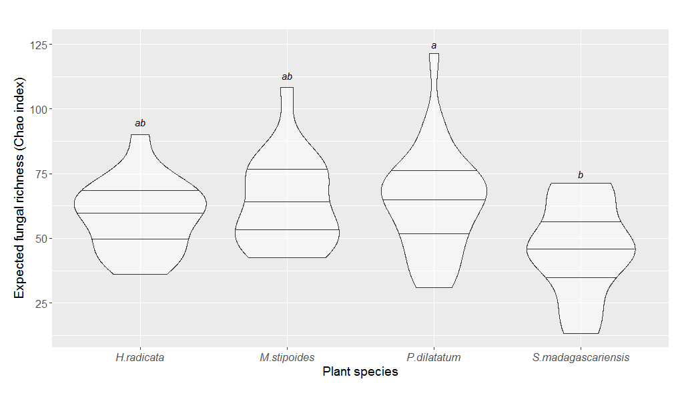
Figure 1. Violin plot showing the estimated (Chao) richness of AM fungal communities associated with the four plant species. Horizontal lines in the violin plots represent the median, 25% and 75% quantiles, while the width of the violin plots represents data densities at the different fungal richness. Letters indicates mean contrasts using Tukey’s test, differences are significant at P <0.05.
We then evaluated the influence of watering treatment and plant species on AM fungal community composition. We found a significant but small effect of both watering treatment (PerMANOVA, F_{4,53}=1.40 R²=0.07; P<0.01) and plant species (PerMANOVA, F_{3,53}=1.19, R²=0.05; P=0.05) on the community composition, but no significant interaction between watering treatment and plant species (PerMANOVA, F_{12,53}=0.88 P=0.99). We observed that S. madascariensis and H. radicata had distinctive communities along the first and second axes, respectively, of the ‘plant species’-constrained db-RDA (Fig. 2a). For the ‘watering treatment’-constrained db-RDA, we observed some overlap between communities sampled from the control treatment and those exposed to some type of drought (reduced, altered frequency and summer drought treatments), while the communities from the increased rainfall treatment were distinctly different (Fig. 2b).
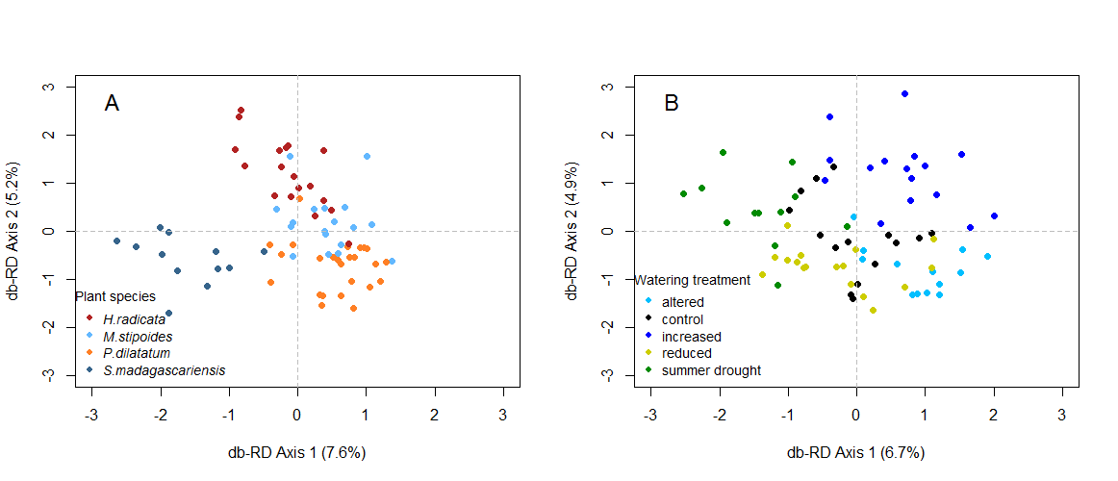
Figure 2. Distance based-Redundancy Analysis (db-RDA) ordination of AM fungal communities constrained by plant species (A) and by watering treatment (B) based on Jaccard distances. Each point represents a fungal community described from samples pooled at the level of an individual root system.

To identify specific OTUs associated with environments experiencing either any type of drought or experiencing increased rainfall, we estimated OTU indicator values in comparisons between these two groups (‘reduced’, ‘summer’ and ‘reduced frequency’ treatments; ‘increased’ treatment). We found 24 significant indicator OTUs, of which 10 had an indicator value > 0.3 and were all identified as Glomerales (Table 1; Fig. S4).
Table 1. Indicator OTUs associated with either reduced, altered, summer treatments or increased treatment. The table includes the name of the OTU, indicator value (IV), treatments associated, and, based on the sequence comparison using BLAST, the taxonomy, percentage of sequence covered (query cover), percentage of aligned residues (ID %) and accession number of the best matched database sequence. Indicators values (IV) range from 0 to 1, where highest values are associated with stronger indicators of an environment.
OTU ID | IV | P | Treatments | Best matched taxa using BLAST
 |  |  |  | Taxonomy | Query cover | ID % | Accession
ITSall_OTUa_562 | 0.65 | 0.001 | Reduced, altered, summer | Glomus custos | 97% | 93% | GQ205073.1
ITSall_OTUb_10 | 0.62 | 0.002 | Reduced, altered, summer | Glomus intraradices | 100% | 92% | AF185685.1
ITSall_OTUa_8591 | 0.59 | 0.014 | Reduced, altered, summer | Glomus intraradices | 100% | 92% | AF185685.1
ITSall_OTUa_862 | 0.40 | 0.037 | Reduced, altered, summer | Glomus intraradices | 100% | 93% | AF185686.1
ITSall_OTUa_2876 | 0.38 | 0.050 | Reduced, altered, summer | Claroideoglomus claroideum | 100% | 83% | GQ388713.1
ITSall_OTUa_491 | 0.48 | 0.001 | Increased | Glomus sp. | 100% | 98% | FJ769290.1
ITSall_OTUa_4807 | 0.34 | 0.029 | Increased | Rhizoglomus sp. | 100% | 93% | KY555056.1
ITSall_OTUb_195 | 0.34 | 0.030 | Increased | Glomus sp. | 100% | 90% | AJ504633.1
ITSall_OTUa_423 | 0.33 | 0.012 | Increased | Dominikia bernensis | 100% | 88% | HG938301.1
ITSall_OTUa_4067 | 0.31 | 0.011 | Increased | Rhizophagus sp. | 100% | 85% | KY362438.1

Interactions between root traits and AM fungal communities
We first evaluated the extent that the measured root traits differed among the plant species and whether the watering treatments influenced these traits by estimating trait variation between plants, based on Euclidean distances. We observed significant interspecific variation in the measured root traits (PerMANOVA: F_{3,53} = 17.02, R²=0.45, P<0.01; Fig. 3), but there was no evidence that the set traits were affected by the watering treatment (PerMANOVA: F_{4,53} = 0.03, R²=0.02, P=0.81; Fig. 3) or by the interaction between species and watering treatment (PerMANOVA: F_{12,53} = 1.02, R²=0.10, P=0.36; Fig. 3).
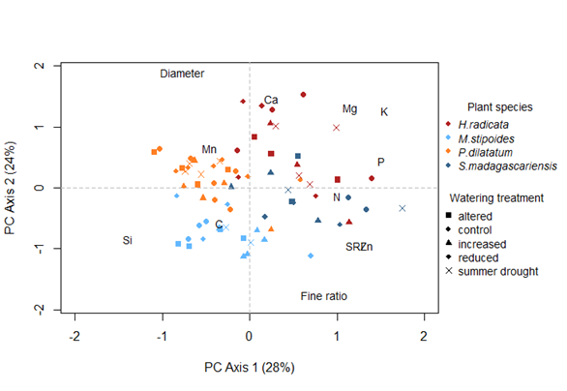
Figure 3. Principal Component Analysis (PCA) ordination of plant individuals based on Euclidean distances. Each point represents measurements taken on an individual plant. The text indicates the loadings associated with each root trait: Specific Root Length (‘SRL’), average diameter of the roots (‘Diameter’), fine (<1mm diameter) to coarse (>1mm diameter) roots length ratio (‘Fine ratio’) and elemental composition Nitrogen (‘N’), Carbon (‘C’), Phosphorus (‘P’), Silicon (‘Si’), Zinc (‘Zn’), Potassium (‘K’), Magnesium (‘Mg’), Calcium (‘Ca’), Manganese (‘Mn’).

We hypothesized that variation in root traits, both within and among host plant species, was responsible for variation in fungal richness, so we used model selection to evaluate the relative importance of morphological and chemical root trait effects. We found that morphological traits were better predictors of fungal richness than chemical traits, based on the lower Akaike weights of models including chemical variables (‘Global model’ and ‘Chemical model’; Table 2). However, low explanatory power (Marginal R²=0.13) and Akaike weight (w_{i}=0.68) was observed for the model including morphological traits as predictors and the model fit was marginally better than the model excluding all variables (‘Intercept only model’; ΔAIC_{c}=1.86), suggesting that either morphological traits, in general, were not strong predictors of fungal richness or that only a subset of the morphological traits included in the model were useful.
Table 2. Model fit statistics for the ‘Global model’ (including both morphological and chemical variables), models including either morphological or chemical variables, and the model with intercept only, testing the effect of the root traits on AM fungal richness. Table includes the number of estimated parameters (K), proportion of variance explained by fixed factors (Marginal R²), AIC_{c} value, the AIC_{c} difference between the best fitted model and the corresponding model (ΔAIC_{c}) and ‘Akaike weight’ (w_{i}) for each model. Models are ranked by increasing AIC_{c} value. All linear mixed-effect models include plot and species as random effects.
Model | Variables | K |  | Marginal R² | AICc | ΔAICc | Akaike weight (w_{i})
‘Morphological traits’ | SRL | 4 |  | 0.13 | 248.9 | 0 | 0.68
‘Morphological traits’ | Fine to coarse root length ratio | 4
‘Morphological traits’ | Diameter | 4
‘Intercept-only’ | None | 1 |  | 0 | 250.7 | 1.86 | 0.27
‘Global model’ | All | 8 |  | 0.17 | 254.9 | 6 | 0.03
‘Chemical traits’ | N | 5 |  | 0.05 | 256.5 | 7.58 | 0.02
‘Chemical traits’ | P | 5
‘Chemical traits’ | K | 5
‘Chemical traits’ | C | 5

When comparing models containing all combinations of the measured morphological traits as predictors, SRL was the best predictor of fungal richness (Table 3) with moderate importance (sum of Akaike weights = 0.79). To quantify this relationship while also accounting for variation among plant species, we fitted a new model including SRL as the only explanatory variable with plot and plant species as random effects and observed a negative relationship between SRL and fungal richness (linear mixed-effects model; P <0.01, Marginal R²= 0.11, Fig. 4). This result may indicate that the relationship between SRL and fungal richness represents a sampling effect, with smaller diameter roots containing less cortical tissue and, therefore, less fungal biomass for a given length.
Table 3. Relative importance of morphological root traits variables for predicting variation in AM fungal richness in roots. Table includes the relative variable importance (corresponds to the sum of ‘Akaike weights’ across models including each variable) and the model-averaged confidence interval for each estimated parameter. Linear mixed model includes ‘plot’ and ‘species’ as random effects.
Variable | Relative variable importance | Confidence intervals
Variable | Relative variable importance | 2.5% | 97.5%
SRL | 0.79 | -0.68 | -0.10
Diameter | 0.38 | -0.18 | 0.64
Fine to coarse root length ratio | 0.26 | -0.44 | 0.36

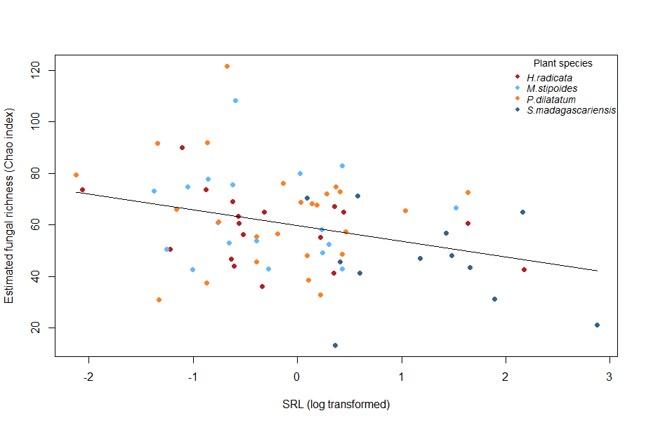
Figure 4. Correlation between (natural log transformed) SRL and estimated (Chao) AM fungal richness. The relationship was evaluated in a linear mixed model including subplot nested in plot and plant species as random effects.

We expected the AM fungal community composition to be affected by the root traits of their host. When evaluating the overall effect of the root traits, we found a significant correlation between the AM fungal community composition and all the root traits (Mantel test; r = 0.15, P<0.01). We then identified relevant root traits and tested their importance on the AM fungal community, after accounting for the conditional effects of the watering treatment and plant species. When comparing models including different sets of traits, we observed that phosphorus (ordistep; P<0.01), calcium (ordistep; P=0.02), and fine to coarse root length ratio (ordistep; P=0.02, Fig. 5) were traits significantly correlated with AM fungal community composition. In total, those traits explained 5.6% of variation in community composition (partial db-RDA, F_{3,62}=1.41, P<0.01), while plant species and the water treatment together explained 12.6% of this variation.
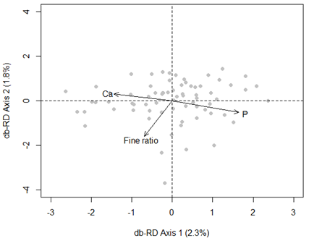
Figure 5. Distance based-Redundancy Analysis (db-RDA) showing root traits significantly correlated with AM fungal communities after accounting for conditional effects of host species and watering treatments. Each point represents a fungal community described from samples pooled at the level of an individual root system and the arrows and text indicate the loadings associated with each root trait: phosphorus (‘P’), calcium (‘Ca’) and fine (<1mm diameter) to coarse (>1mm diameter) root length ratio (‘Fine ratio’). Significant root traits were identified performing a forward model selection using permutation tests.

Discussion
We found that modified rainfall regimes affected the composition, but not the richness, of AM fungal communities in this experimental grassland. We also found that the proportion of variation associated with these effects was similar to that associated with host species. In particular, our results showed distinctive communities when grassland plots were exposed to increased rainfall, compared to those experiencing drought treatments. Other studies have observed changes in the composition and richness of AM fungal communities from semi-arid environments due to an increase in rainfall amount (Deepika & Kothamasi 2015; Li et al. 2015). In contrast, rainfall reduction, change in frequency or summer drought did not form as distinctly divergent communities from the ambient treatment, possibly because these fungi exhibit adaptation to the high intra- and inter-annual rainfall variability that is characteristic of our site (Power et al. 2016). If this is the case, their frequent exposure and adaptation to low amounts of rainfall and high variability in the frequency and timing of these rainfall events may shape their response to future changes in rainfall.
The studied AM fungal communities also differed depending on the plant species that they were associated with, and these responses were partly due to the root traits expressed by the hosts. Others have observed relationships between plant traits and fungal communities, and have related these observations to variation in plant-derived resources available for those soil communities (Sayer et al. 2017; Liu et al. 2015; Koorem et al. 2017). The AM fungal communities found in roots may also be expected to be related to the plant dependency on AM fungi to acquire particular limiting nutrients (Brundrett 2002). We found that traits involved in plant nutrition and dependence on their symbionts were shaping our AM fungal communities. The best predictors of AM fungal community composition were root P and Ca concentrations, both nutrients associated with AM fungal transfer to host plants (Rhodes & Gerdemann 1978). Interestingly, Ca is also an important signal molecule for plant-AM fungi communication as it is involved in the establishment of the symbiosis (reviewed by Oldroyd 2013). The proportion of fine roots was also involved in shaping the community composition, while SRL influenced AM fungal richness, where plants with higher SRL had less diverse communities.
Despite the observed relationships between root traits and AM fungal communities, we did not find evidence for rainfall manipulation affecting the AM fungal community via effects on root traits. This is because none of the studied root traits were significantly affected by the manipulations to rainfall, which is surprising because changes in rainfall have been found to affect root traits in different species measured in other studies (Larson & Funk 2016; Padilla et al. 2013). The lack of effect on root traits may be a result of selecting plant species present across all watering treatments and, in this type of grassland with highly variable rainfall (Power et al. 2016), abundant plant species might possess traits adapted to these variable conditions and, thus, have low plasticity. Our results may also reflect the fact that our data represent a snapshot at one point in time, and additional time points might reveal more variation associated with the rainfall manipulations. Despite this, AM fungal communities are responsive to root trait variation within and between plant species, indicating that this mechanism should be considered in further studies, particularly in more responsive species and in ecosystems where plasticity may be more likely.
It is also possible that investigation into other root traits may provide more insight into the processes associated with AM fungal community assembly and host responses to altered rainfall. Architectural traits important for plant access to water such as rooting depth, root length density and root branching have been observed to respond to changes in rainfall regimes (Brunner et al. 2015) with, for example, some of the other grassland species from this local site exhibiting shallower rooting profiles when exposed to reduced rainfall inputs under controlled, polytunnel conditions (Gibson-Forty et al., 2016). Reduction in rainfall has been shown to result in the accumulation of sugars, sugar alcohols, proline and proteins in plants (Farooq et al. 2009), which could, in turn, affect the AM fungal community. In addition, root lifespan and turnover have been observed to be affected by changes in rainfall (Brunner et al. 2015) and AM fungal community composition and richness can vary depending on the age of the roots (Kil et al. 2014; but see Donn et al. 2017). We could not account for most of these traits in this field study due to our focus on matching community and trait data at the individual plant level, which limited the amount of material that we could analyse and prevented measurements of traits linked to phenology.
We found a few indicator OTUs distinctly associated to either drought treatments or increased rainfall, suggesting that the AM fungal communities could be more responsive in years with higher rainfall. All of the indicator OTUs belonged to the Glomerales order. Others have found that not only Glomerales spp. but also Acaulospora sp. (Diversisporales order) have been affected by changes in watering regime (Deepika & Kothamasi 2015). In our experiment, Glomerales spp. was the most abundant taxa, whereas Acaulospora spp. only represented 0.9% of the taxa detected in our samples (Table S1). It is possible that the dominance of Glomerales spp. is due to bias in the methods to characterise AM fungi (Berruti et al 2017), which may be addressed by further developments in primer design and sequencing approaches. The role of particular OTUs in plant nutrition and tolerance to water stress is unknown, limiting our understanding on how plants will respond to the loss of those OTUs under altered rainfall regimes. Additionally, we observed over 700 OTUs using our sequencing and data processing approach; the loss of OTUs and their associated services due to changes in rainfall might therefore be more significant in less diverse ecosystems. In addition, grassland responses to climate change may also be associated with altered abundance of the AM fungi both inside and outside the plant instead of shifts in composition. The sample limitations mentioned in relation to alternative root traits also prevented us from accurately characterising AM fungal colonisation or another measure of absolute abundance, and further work in this experimental system would be needed to answer this question.
A noteworthy observation is that variability among AM fungal communities was high, even among communities sampled from the same treatments, and a large proportion of the variation remained unexplained. This is similar to observations by Li et al. (2015), who reported that rainfall was the most important predictor of AM fungal communities in roots despite only explaining 6.7% of the variation. This high variability inherent of the AM fungal communities is increasingly being recognized as an important characteristic of their ecologies (Powell & Bennett 2016; Hart et al. 2016; Donn et al. 2017) and creates further difficulties for predicting changes in those communities and associated functions. Current research is ongoing in this experimental system and is aiming to evaluate whether consideration of variation in soil properties - both natural and that associated with rainfall treatments - and changes in plant communities in analyses of AM fungal community variation improve our understanding of their responses to altered rainfall regimes.
In conclusion, our results suggest that AM fungal communities in grasslands, especially those similar to the one studied here, are likely to change under future rainfall scenarios. However, the magnitude of these predicted effects is still unclear as effect sizes in this case were small relative to the high level of variation among AM fungal communities observed here. Although we found no evidence of effects of altered rainfall regimes via changes in host physiology, this potential indirect effect should still be tested in further work. The effects of inter- and intraspecific root trait variation on AM fungal communities observed here provides insight into the ways that AM fungi associated with more plastic plant species might respond to variable rainfall in different systems.

Acknowledgements
This work was supported by grants from the Australian Research Council (DP140103936) to JRP and the Hermon Slade Foundation to SP. AEB received support from the OECD Co-operative Research Programme Secretariat and Trade and Agriculture Directorate, the Stapledon Memorial Trust Travelling Fellowship, the Hawkesbury Institute for the Environment Research Exchange Program, the Royal Entomological Society Outreach Fund, a British Ecological Society Grant, and the Scottish Government Rural and Environment Science and Analytical Services Division (2016-2021 Work 533 Packages 1.3, 2.1, and 2.3). We thank Marcel Torode, Josh Vogelzang, William Balmont, Lanila Hiltpold, Kirk Barnett, Jianguang Yu, and Burhan Amiji for help with lab and/or field work. We also thank Laura Wegener Parfrey and anonymous reviewers for helpful and constructive comments that improved the quality of the manuscript.

Bibliography
Abarenkov K, Nilsson RH, Larsson K-H et al. (2010) The UNITE database for molecular identification of fungi – recent updates and future perspectives. New Phytologist, 186, 281–285.
Altschul SF, Gish W, Miller W, Myers EW, Lipman DJ (1990) Basic Local Alignment Search Tool. Journal of Molecular Biology, 215, 403–410.
Augé RM (2001) Water relations, drought and vesicular-arbuscular mycorrhizal symbiosis. Mycorrhiza, 11, 3–42.
Australian Government Bureau of Meteorology (2017) Climate Data Online, Richmond – UWS Hawkesbury Station. http://www.bom.gov.au
Bates D, Mächler M, Bolker B, Walker S (2015) Fitting Linear Mixed-Effects Models Using lme4. Journal of Statistical Software, 67, 1–48.
Barton K (2016) MuMIn: Multi-Model Inference. R package version 1.15.6. https://CRAN.R-project.org/package=MuMIn
Bissett A, Fitzgerald A, Meintjes T et al. (2016) Introducing BASE: the Biomes of Australian Soil Environments soil microbial diversity database. GigaScience, 5, 5–21.
Borowicz, VA (2001). Do arbuscular mycorrhizal fungi alter plant-pathogen relations? Ecology, 82, 3057-3068.
Brundrett MC (2002) Coevolution of roots and mycorrhizas of land plants. New Phytologist, 275–304.
Brunner I, Herzog C, Dawes MA, Arend M, Sperisen C (2015) How tree roots respond to drought. Frontiers in Plant Science, 6, 1–16.
Berruti A, Desirò A, Visentin S, Zecca O, Bonfante P (2017) ITS fungal barcoding primers versus 18S AMF-specific primers reveal similar AMF-based diversity patterns in roots and soils of three mountain vineyards. Environmental Microbiology Reports, 9, 658–667.
Campbell BD, Stafford Smith DM, McKeon GM (1997) Elevated CO2 and water supply interactions in grasslands: A pastures and rangelands management perspective. Global Change Biology, 3, 177–87.
Comas LH, Callahan HS, Midford PE (2014) Patterns in root traits of woody species hosting arbuscular and ectomycorrhizas: Implications for the evolution of belowground strategies. Ecology and Evolution, 4, 2979–2990.
Deepika S, Kothamasi D (2015) Soil moisture - a regulator of arbuscular mycorrhizal fungal community assembly and symbiotic phosphorus uptake. Mycorrhiza, 25, 67–75.
Díaz-Zorita M, Perfect E, Grove J (2002) Disruptive methods for assessing soil structure. Soil and Tillage Research, 64, 3–22.
Donn S, Kawasaki A, Delroy B, Chochois V, Watt M, Powell JR. (2017) Root type is not an important driver of mycorrhizal colonisation in Brachypodium distachyon. Pedobiologia, 65, 5–15.
Dufrene M, Legendre P (1997) Species Assemblages and Indicator Species : The Need for a Flexible Asymmetrical Approach. Ecological Monographs, 67(3), 345–366.
Edgar RC (2013) UPARSE: highly accurate OTU sequences from microbial amplicon reads. Nature Methods, 10, 996–998.
Eissenstat DM, Kucharski JM, Zadworny M, Adams TS, Koide RT (2015) Linking root traits to nutrient foraging in arbuscular mycorrhizal trees in a temperate forest. New Phytologist, 208, 114–124.
Farooq M, Wahid A, Kobayashi N, Fujita D, Basra SM. (2009) Plant Drought Stress: Effects, Mechanisms and Management. Agronomy for Sustainable Development, 29, 145-149.
Fay PA, Carlisle JD, Knapp AK, Blair JM, Collins SL (2003) Productivity responses to altered rainfall patterns in a C4-dominated grassland. Oecologia, 137, 245–251.
Fox J, Weisberg S (2011) An {R} Companion to Applied Regression, Second Edition. Thousand Oaks CA: Sage. http://socserv.socsci.mcmaster.ca/jfox/Books/Companion
Franco J, Banón S, Vicente MJ, Miralles J, Martínez-Sánchez J (2011) Root development in horticultural plants grown under abiotic stress conditions – a review. Journal of Horticultural Science & Biotechnology, 86, 543–556.
Gardes M, Bruns TD (1993) ITS primers with enhanced specificity for basidiomycetes-application to the identification of mycorrhizae and rusts. Molecular Ecology, 2, 113–118. doi:10.1111/j.1365-294X.1993.tb00005.x
Gibson-Forty EVJ, Barnett KL, Tissue DT, Power SA (2016) Reducing rainfall amount has a greater negative effect on the productivity of grassland plant species than reducing rainfall frequency. Functional Plant Biology, 43, 380–391.
Grime JP, Brown VK, Thompson K et al. (2000) The Response of Two Contrasting Limestone Grasslands to Simulated Climate Change. Science, 289, 762–766.
Hart MM, Zaitsoff PD, van der Heyde M, Pither J (2016) Testing life history and trait-based predictions of AM fungal community assembly. Pedobiologia, 59, 203–213.
Hothorn T, Bretz F, Westfall P (2008) Simultaneous Inference in General Parametric Models. Biometrical Journal 50(3), 346-363.
Ihrmark K, Bödeker ITM, Cruz-Martinez K et al. (2012) New primers to amplify the fungal ITS2 region - evaluation by 454-sequencing of artificial and natural communities. FEMS Microbiology Ecology, 82, 666–677.
Intergovernmental Panel on Climate Change (2014). Climate Change 2013 – The Physical Science Basis: Working Group I Contribution to the Fifth Assessment Report of the Intergovernmental Panel on Climate Change. Cambridge: Cambridge University Press. doi: 10.1017/CBO9781107415324.
Kil YJ, Eo JK, Lee EH, Eom AH (2014) Root age-dependent changes in arbuscular mycorrhizal fungal communities colonizing roots of Panax ginseng. Mycobiology, 42, 416–421.
Knapp AK, Briggs JM, Koelliker JK (2001) Frequency and Extent of Water Limitation to Primary Production in a Mesic Temperate Grassland. Ecosystems, 4, 19–28.
Koorem K, Tulva I, Davison J et al. (2017) Arbuscular mycorrhizal fungal communities in forest plant roots are simultaneously shaped by host characteristics and canopy-mediated light availability. Plant and Soil, 410, 259–271.
Larson JE, Funk JL (2016) Seedling root responses to soil moisture and the identification of a belowground trait spectrum across three growth forms. New Phytologist, 210, 827–838.
Leith H (1975) Primary production of the majority of vegetation units of the world. In: Primary Productivity of the Biosphere, H. Leith, R.H. Whittaker (eds), Springer, New York, pp. 203–215.
Li X, Zhu T, Peng F et al. (2015) Inner Mongolian steppe arbuscular mycorrhizal fungal communities respond more strongly to water availability than to nitrogen fertilization. Environmental Microbiology, 17, 3051–3068.
Liu Y, Mao L, Li J et al. (2015) Resource availability differentially drives community assemblages of plants and their root-associated arbuscular mycorrhizal fungi. Plant and Soil, 386, 341–355.
Maherali (2014) Is there an association between root architecture and mycorrhizal growth response? New Phytologist, 204, 192-200.
Martínez-García LB, de Dios Miranda J, Pugnaire FI (2012) Impacts of changing rainfall patterns on mycorrhizal status of a shrub from arid environments. European Journal of Soil Biology, 50, 64–67.
Marulanda A, Azcón R, Ruiz-Lozano JM (2003) Contribution of six arbuscular mycorrhizal fungal isolates to water uptake by Lactuca sativa plants under drought stress. Physiologia Plantarum, 119, 526–533.
Miller RM, Wilson GWT, Johnson NC (2012) Arbuscular Mycorrhizae and Grassland Ecosystems. In: Biocomplexity of Plant-Fungal Interactions (ed Southworth D), pp. 59–84. Wiley-Blackwell.
Morecroft MD, Masters GJ, Brown VK et al. (2004) Changing precipitation patterns alter plant community dynamics and succession in an ex-arable grassland. Functional Ecology, 18, 648–655.
Nouri E, Breuillin-Sessoms F, Feller U, Reinhardt D (2014) Phosphorus and Nitrogen Regulate Arbuscular Mycorrhizal Symbiosis in Petunia hybrida. PLoS ONE, 9, 1–14.
Oksanen J, Blanchet FG, Friendly M, Kindt R, Legendre P, McGlinn D, …Wagner H (2017) vegan: Community Ecology Package. R package version 2.4-2. https://CRAN.R-project.org/package=vegan
Oldroyd GED (2013) Speak, friend, and enter: signalling systems that promote beneficial symbiotic associations in plants. Nature Reviews Microbiology, 11, 252–263.
Padilla FM, Aarts BHJ, Roijendijk YOA et al. (2013) Root plasticity maintains growth of temperate grassland species under pulsed water supply. Plant and Soil, 369, 377–386.
Peterson RL, Massicotte HB, Melville LH (2004) Mycorrhizas: Anatomy and Cell Biology. NRC Research Press, Ottawa, Canada.
Powell JR, Bennett AE (2016) Unpredictable assembly of arbuscular mycorrhizal fungal communities. Pedobiologia, 59, 11–15.
Power SA, Barnett KL, Ochoa-hueso R et al. (2016) DRI-Grass : A New Experimental Platform for Addressing Grassland Ecosystem Responses to Future Precipitation Scenarios in South-East Australia. Frontiers in Plant Science, 7, 1–14.
Rhodes L, Gerdemann J (1978) Translocation of calcium and phosphate by external hyphae of vesicular-arbuscular mycorrhizae. Soil Science, 126, 125–126.
Roberts DW (2016) labdsv: Ordination and Multivariate Analysis for Ecology. R package version 1.8-0. https://CRAN.R-project.org/package=labdsv
Rognes T, Flouri T, Nichols B, Quince C, Mahé F (2016) VSEARCH: a versatile open source tool for metagenomics. PeerJ.
Sala OE, Paruelo JM (1997). Ecosystem Services in Grasslands. In: Nature’s Services: Societal Dependence on Natural Ecosystems. (ed Daily GC), pp 237–252. Island Press: Washington, DC, USA.
Sánchez-Blanco MJ, Ferrández T, Morales MA, Morte A, Alarcón JJ (2004) Variations in water status, gas exchange, and growth in Rosmarinus officinalis plants infected with Glomus deserticola under drought conditions. Journal of plant physiology, 161, 675–682.
Sayer EJ, Oliver AE, Fridley JD et al. (2017) Links between soil microbial communities and plant traits in a rich grassland under long- term climate change. Ecology and Evolution, 1–8.
Schloss PD, Westcott SL, Ryabin T et al. (2009) Introducing mothur: Open-source, platform-independent, community-supported software for describing and comparing microbial communities. Applied and Environmental Microbiology, 75, 7537–7541.
Smith SE, Read D (2008) Mineral nutrition, toxic element accumulation and water relations of arbuscular mycorrhizal plants. In: Mycorrhizal Symbiosis, pp. 145–187.
Smith SE, Smith FA (2011) Roles of arbuscular mycorrhizas in plant nutrition and growth: new paradigms from cellular to ecosystem scales. Annual review of plant biology, 62, 227–250.
Staddon PL, Thompson K, Jakobsen I et al. (2003) Mycorrhizal fungal abundance is affected by long-term climatic manipulations in the field. Global Change Biology, 9, 186–194.
Weiss SJ, Xu Z, Amir A et al. (2015) Effects of library size variance, sparsity, and compositionality on the analysis of microbiome data. PeerJ PrePrints, 3.
White T, Bruns T, Lee S, Taylor J (1990) Amplification and direct sequencing of fungal ribosomal RNA genes for phylogenetics. In: PCR Protocols: A guide to Methods and Applications, pp. 315–322. Academic Press, Inc., New York.
Wu QS, Zou YN, Xia RX (2006) Effects of water stress and arbuscular mycorrhizal fungi on reactive oxygen metabolism and antioxidant production by citrus (Citrus tangerine) roots. European Journal of Soil Biology, 42, 166–172.

Data accessibility
All data have been archived with the Western Sydney University Data Repository (doi: http://dx.doi.org/10.4225/35/5a24cbf955391) and the scripts and data can be accessed at https://bitbucket.org/Coline_Dev/roottraits_amf. Raw DNA sequencing data are available under NCBI BioProject ID PRJNA420909.

Author contribution
CD, AEB, JRP and SP designed the study. CD, SP and SD collected and processed samples. CD and JRP analysed the data and wrote the manuscript. All the authors revised the manuscript.

Tables and Figures

Table 1. Indicator OTUs associated with either reduced, altered, summer treatments or increased treatment. The table includes the name of the OTU, indicator value (IV), treatments associated, and, based on the sequence comparison using BLAST, the taxonomy, percentage of sequence covered (query cover), percentage of aligned residues (ID %) and accession number of the best matched database sequence. Indicators values (IV) range from 0 to 1, where highest values are associated with stronger indicators of an environment.

Table 2. Model fit statistics for the ‘Global model’ (including both morphological and chemical variables), models including either morphological or chemical variables, and model with intercept only, testing the effect of the root traits on the AM fungal richness. Table includes the number of estimated parameters (K), proportion of variance explained by fixed factors (Marginal R²), AIC_{c} value, the AIC_{c} difference between the best fitted model and the corresponding model (ΔAIC_{c}) and ‘Akaike weight’ (w_{i}) for each model. Models are ranked by increasing AIC_{c} value. All linear mixed-effect models include plot and species as random effects.

Table 3. Relative importance of morphological root traits variables for predicting variation in AM fungal richness in roots. Table includes the relative variable importance (corresponds to the sum of ‘Akaike weights’ across models including each variable) and the model-averaged confidence interval for each estimated parameter. Linear mixed model includes ‘plot’ and ‘species’ as random effects.

Figure 1. Violin plot showing the estimated (Chao) richness of AM fungal communities in the four plant species. Horizontal lines in the violin plots represent the median, 25% and 75% quantiles, while the width of the violin plots represents data densities at the different fungal richness. Letters indicates mean contrasts using Tukey’s test, differences are significant at P <0.05.

Figure 2. Distance based-Redundancy Analysis (db-RDA) ordination of AM fungal communities constrained by plant species (A) and by watering treatment (B) based on Jaccard distances. Each point represents a fungal community described from samples pooled at the level of an individual root system.

Figure 3. Principal Component Analysis (PCA) ordination of plant individuals based on Euclidean distances. Each point represents measurements taken on an individual plant. The text indicates the loadings associated with each root trait: Specific Root Length (‘SRL’), average diameter of the roots (‘Diameter’), fine (<1mm diameter) to coarse (>1mm diameter) roots length ratio (‘Fine ratio’) and elemental composition Nitrogen (‘N’), Carbon (‘C’), Phosphorus (‘P’), Silicon (‘Si’), Zinc (‘Zn’), Potassium (‘K’), Magnesium (‘Mg’), Calcium (‘Ca’), Manganese (‘Mn’).

Figure 4. Correlation between (natural log transformed) SRL and estimated (Chao) AM fungal richness. The relationship was evaluated in a linear mixed model including subplot nested in plot and plant species as random effects.

Figure 5. Distance based-Redundancy Analysis (db-RDA) showing root traits significantly correlated with AM fungal communities after accounting for conditional effects of host species and watering treatments. Each point represents a fungal community described from samples pooled at the level of an individual root system and the arrows and text indicate the loadings associated with each root trait: phosphorus (‘P’), calcium (‘Ca’) and fine (<1mm diameter) to coarse (>1mm diameter) root length ratio (‘Fine ratio’). Significant root traits were identified performing a forward model selection using permutation tests.

