Parental breeding age effects on descendants’ longevity interact over two generations in matrilines and patrilines
Zachariah Wylde¹, Foteini Spagopoulou², Amy K. Hooper¹, Alexei A. Maklakov^{2,3}, Russell Bonduriansky¹
1. Evolution & Ecology Research Centre, University of New South Wales, Sydney, NSW, Australia
2. Uppsala Centre for Evolution and Genomics, Uppsala University, Uppsala, Sweden
3. School of Biological Sciences, University of East Anglia, Norwich Research Park, Norwich, UK
Corresponding author:
Zachariah Wylde
Email: wyldescience@gmail.com
Phone: +61-2-9385-3439

ABSTRACT
Individuals within populations vary enormously in mortality risk and longevity, but the causes of this variation remain poorly understood. A potentially important and phylogenetically widespread source of such variation is maternal age at breeding, which typically has negative effects on offspring longevity. Here, we show that paternal age can affect offspring longevity as strongly as maternal age does, and that breeding age effects can interact over two generations in both matrilines and patrilines. We manipulated maternal and paternal ages at breeding over two generations in the neriid fly Telostylinus angusticollis. To determine whether breeding age effects can be modulated by the environment, we also manipulated larval diet and male competitive environment in the first generation. We found separate and interactive effects of parental and grandparental ages at breeding on descendants’ mortality rate and lifespan in both matrilines and patrilines. These breeding age effects were not modulated by grandparental larval diet quality or competitive environment. Our findings suggest that variation in maternal and paternal ages at breeding could contribute substantially to intra-population variation in mortality and longevity.
Keywords: Senescence, lifespan, parental age, maternal effect, paternal effect, diet, social environment

In many species, offspring of older mothers have a reduced mean lifespan, a phenomenon known as the ‘Lansing’ effect [1] or maternal age effect. Maternal age effects have been observed in a great variety of organisms, including yeast, plants, nematodes, rotifers, insects, birds and mammals [2–5]. While most studies have focused on offspring lifespan, some studies show that maternal age at breeding can also affect offspring juvenile viability and adult reproductive performance [6–10]. A few studies have also reported effects of paternal age at breeding on offspring performance [2,5]. Parental age effects represent a potentially important source of variation in individual mortality risk, longevity, and fitness, but many aspects of these effects remain poorly understood.
Parental age effects could be caused by the accumulation of mutations in the germline [11]. In humans, mutations accumulate at a constant rate in the male germline, and at an accelerating rate in the female germline [12]. Parental age effects could also be mediated by nongenetic factors. Recent studies on mice, monkeys and humans have shown that patterns of DNA methylation across the genome change with age—a pattern known as the ‘epigenetic clock’ [13–17], and some of these altered epigenetic factors could be transmitted across generations [18–22]. Older parents could also transmit altered microRNAs, or other factors such as proteins, to offspring via the gametes [23,24]. For example, in mice, the transmission of proteins in the egg cytoplasm is thought to mediate maternal age effects on offspring [25], and more recent evidence suggests a role for sperm micro-RNAs in paternal effects [26–30]. While such effects are best characterised in mammals, age-related changes in gamete quality also occur in arthropods, and such effects could contribute to parental age effects. For example, in the parasitoid wasp Eupelmus vuilletti, increasing maternal age is associated with reduced egg size and altered egg composition [31]. Likewise, in Daphnia pulex, maternal age is associated with changes in egg provisioning, with effects on offspring longevity and life history [32]. The transmission of dysregulated epigenetic or cytoplasmic factors from old-breeding parents to their offspring could mediate parental age effects in many species [33].
Maternal and paternal effects are likely to be mediated by different factors, and can have distinct effects on offspring [34,35]. However, relatively few studies have tested experimentally for effects of paternal age at breeding, and even fewer studies have directly compared the effects of maternal and paternal age at breeding on offspring performance. Experimental evidence in mice shows that offspring of older fathers have a reduced lifespan, and suggests that this effect could be mediated by epigenetic (DNA methylation) changes within sperm of gene promoters involved in evolutionarily conserved pathways of lifespan regulation [36]. In Drosophila melanogaster, both maternal and paternal age effects have been reported [5]. Similar effects may occur in other species (including humans), although much of the evidence is correlational. For example, in the wandering albatross, paternal but not maternal age affected juvenile survival of offspring [10]. In humans, advanced paternal age at breeding is associated with reduced sperm quality and testicular functions, and such effects appear to be mediated by both epigenetic changes and genetic mutations [37]. Advanced paternal age is also associated with reduced performance on standardized tests in children, while the effect of maternal age was more complex [38]. Likewise, parental age, and the difference between maternal and paternal ages, are associated with risk of autism spectrum disorder [39].
Parental age effects could interact with environmental factors such as diet and stress [7,40]. For example, a restricted maternal diet mitigated the effects of advanced maternal age at breeding on offspring longevity in rotifers [41]. In mice, a fat-restricted maternal diet did not influence maternal age effects [15], but maternal age effects were mitigated by rapamycin [42]. In the butterfly Pieris brassicae, effects of parental age at breeding on offspring performance were influenced by stress [2]. However, the role of environment in modulating effects of parental age remains largely unexplored.
Perhaps the most important gap in understanding of parental age effects is the potential for such effects to accumulate and interact over multiple generations. In Drospohila serrata, offspring juvenile viability decreased with increasing maternal and grand-maternal ages at breeding [7], but it remains unclear whether such cumulative effects can occur in partrilines, or in other species. If such multi-generational effects are widespread, they could make an important contribution to variation in mortality and longevity and, potentially, play a role in the evolution of ageing [5,33].
Here, we addressed three aspects of parental age effects that have received little attention in previous research: (1) we investigated and compared the effects of both male and female age at breeding on descendants, (2) we investigated interactions of age at breeding with key environmental factors (diet and competitive environment), and (3) we investigated the potential for effects of age at breeding to accumulate over generations. We addressed these questions in the neriid fly Telostylinus angusticollis (Enderlein), a species endemic to New South Wales and Southern Queenland, Australia. Both larval and adult nutrition affect mortality rate and lifespan in this species [43,44]. Larval access to dietary protein has a nonlinear effect on adult longevity [43], but high overall macronutrient (protein and carbohydrate) abundance at the larval stage accelerates larval growth and development while also promoting rapid ageing in males [45,46]. Adult protein restriction extends life [44] and can interact with larval diet to influence reproductive ageing [47]. However, effects of parental age at breeding on offspring performance have not been investigated previously in this species.
We reared individuals of the grandparental (F₁) generation on either a high-nutrient or low-nutrient larval diet and then allowed adult females and males from these larval diet treatments to breed at 15 and 35 days of age. Neriid males fight other males for access to territories and females, and such male-male interactions could affect male ageing [46]. We therefore investigated the potential for male-male interactions to affect paternal age effects by manipulating F₁ male competitive environment. Female and male offspring (F₂) were reared on a standard larval diet (with a nutrient concentration intermediate between the high-nutrient and low-nutrient diets) and then allowed to breed at 15-day age intervals between ages 15 and 60 days. We quantified the adult longevity of grand-offspring (F₃) and used these data to test for grandparental ages at breeding and environment as well as parental ages at breeding on offspring lifespan, mortality rate, and actuarial ageing rate.
MATERIALS AND METHODS
SOURCE OF EXPERIMENTAL FLIES
Experiments were performed using a lab-reared stock of T. angusticollis that originated from individuals collected from Fred Hollows Reserve, Randwick, NSW, Australia (33°54′44.04″S 151°14′52.14″E). This stock was maintained as a large, outbred population with overlapping generations, and periodically supplemented with wild-caught individuals from the same source population to maintain genetic diversity.

LARVAL REARING AND DIET MANIPULATION
All larvae were reared in climate chambers at 25°C ± 2°C with a 12:12 photoperiod and moistened with deionised water every two days. We manipulated the quantity of resources available to larvae during development by rearing flies on either a high-nutrient, standard-nutrient or low-nutrient larval diet. Diets were based on [48] and were selected to generate considerable body size differences between treatment groups while minimising larval mortality, and to preserve the protein to carbohydrate ratio of ~ 1:3 across diets. All diets consisted of a base of 170g of coco peat moistened with 600mL of reverse osmosis-purified water. The high-nutrient larval diet consisted of 32.8g of protein (Nature’s Way soy protein isolate; Pharm-a-Care, Warriewood, Australia) and 89g of brown sugar (Woolworths Essentials Bonsucro® brand); the standard larval diet consisted of 10.9g of protein and 29.7g sugar; the low-nutrient larval diet consisted of 5.5g of protein and 14.8g sugar. These nutrients were mixed into the cocopeat and water using a hand-held blender and frozen at -20°C until the day of use. Males and females of the F₁ generation were reared on either a high or low-nutrient larval diet and standardised for larval density (40 eggs per 200g of larval food). All larvae of the F₂ and F₃ generations were reared on a ‘standard’ larval diet (see ⁴⁵ for further details). Following the first adult emergence from each larval container, adult flies were collected for 10 days, and the rest were discarded.

F₁ ADULT HOUSING AND COMPETITIVE ENVIRONMENT
F₁ males were subjected to a “low” or “high” competition environment. Each adult focal male was paired with a competitor male reared on a ‘standard’ larval diet inside an enclosure containing a petri dish with larval medium (which stimulates territory defence behaviours in T. angusticollis males). Males in the “high” competition environment were able to move freely around the arena and engage in combat interactions with the competitor male, whereas males in the “low” competition environment were separated by mesh so that they could perceive the competitor’s chemical and perhaps visual cues but have no physical contact. All focal F₁ females were kept in a similar housing as the “low” competitive environment males where each focal female was paired with a female reared on a ‘standard’ larval diet. All housing containers had a layer of moistened cocopeat on the bottom, and dishes of oviposition medium (on which adult flies also feed) to stimulate ovary development in females.

F₁ ADULT MALE AND FEMALE AGE-AT-BREEDING MANIPULATION
The age at breeding was manipulated for F₁ focal individuals by pairing at ‘young’ (15 ± 1 days old) and ‘old’ (35 ± 1 days old) ages with an opposite-sex individual standardised for larval diet (reared on the ‘standard’ larval diet) and age (15 ± 1 days old). Each focal F₁ adult was thus paired twice, each time with a different mate, to produce broods of F₂ offspring at ‘young’ and ‘old’ ages (Figure 1). Mating pairs were kept in 60 mL glass vials under standardised light and temperature (~23°C) for one hour, and females were then placed into 250 mL enclosures with mesh coverings and a moistened cocopeat substrate and were allowed to oviposit for 96h into a petri dish containing oviposition medium. After 48h a fresh oviposition dish was provided. 20 eggs were sampled randomly from each female, transferred to 100g of standard larval medium.

F₂ ADULT MALE AND FEMALE AGE-AT-BREEDING MANIPULATION
One F₂ male and one F₂ female focal individual was randomly sampled for breeding from each F₁ larval container. Thus, where possible, each F₁ focal individual contributed one F₂ offspring of each sex from a reproductive bout at 15 days of age and one F₂ offspring of each sex from a reproductive bout at 35 days of age. Each F₂ focal individual was paired with a partner of the opposite sex (raised on a standard diet and 15 ± 1 days old on the day of pairing) at four ages (where possible): 15d, 30d, 45d and 60d. The flies were allowed 1 hour to mate, after which eggs were collected from each female and maintained as described above.

F₃ REARING AND QUANTIFICATION OF LIFESPAN
From each reproductive bout of each F₂ individual, one male and female of the F₃ generation were obtained (where possible) and housed individually in a 120mL container fitted with a feeding tube containing a sugar-yeast mixture and drinking tube containing water (with both food and water provided ad libitum), and a substrate of moistened cocoa peat to maintain humidity. F₃ housing containers were maintained at ambient room temperature (23 ± 4°C) and checked daily for mortality until all individuals had died. To minimize spatial effects, containers were randomly moved to different locations every two days.

For all focal individuals, development time and body size were also recorded to investigate their possible roles in mediating treatment effects on lifespan and mortality rate. All F₁ and F₂ focal individuals were frozen at -20°C after their final reproductive bout (or prior natural death before day 60), and all F₃ individuals were frozen after natural death. For all focal F₁, F₂ and F₃ individuals, egg to adult development time was recorded as time from oviposition to adult emergence in days (± 1 day). Thorax length is a reliable proxy for body size in this species [49] and was measured for each F₁, F₂ and F₃ focal individual from images taken using a Leica MS5 stereoscope equipped with a Leica DFC420 digital microscope camera. Measurements were made using FIJI open source software [50].
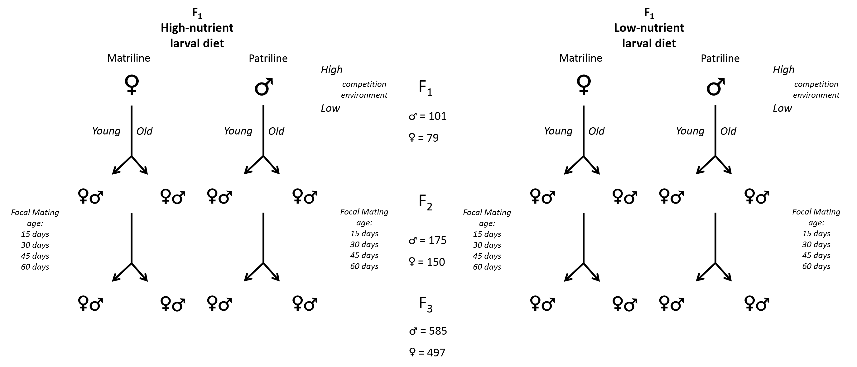
Figure 1: Experimental design: F₁ individuals were reared on either a high- or low-nutrient larval diet. Adult F₁ males were also maintained in ‘high-’ or ‘low’-competition social environments. F₁ males and females were then mated at a ‘young’ (15 days) or ‘old’ (35 days) age and all offspring (F₂) were reared on a ‘standard’ larval diet. From each F₁ breeding bout, one male and one female of the F₂ generation were paired with a standard mate at 15d intervals up to 60 days of age. Grand-offspring (F₃) were all reared on ‘standard’ larval diet and housed individually until death.

LIFESPAN ANALYSIS
We investigated treatment effects on F₃ lifespan using R 3.3.2 [51] and the R package “lme4” [52]. These analyses facilitate hypothesis testing by making it possible to test interactions within mixed-effects models. Because the lifespan of every individual was known, no censoring was required. Gaussian linear mixed models (LMM) were used, and all analyses were carried out separately for matrilines (i.e. descendants of F₁ females) and patrilines (i.e. descendants of F₁ males). Any effects of F₁ age at breeding, larval diet or male competitive environment therefore represent grand-maternal effects within matrilines and grand-paternal effects within patrilines. Within both matrilines and patrilines, we tested for effects of F₂ age at breeding for both female parents (maternal age effects) and male parents (paternal age effects) and compared effects on F₃ males and females (i.e., effect of F₃ sex). For the patriline dataset, (F₁) male competitive environment and its 2-way interactions were tested by a likelihood ratio test (LRT) and were found to have no effect on any dependent variables. The patriline models were then re-fitted without F₁ competitive environment. This resulted in identical model structure for patrilines and matrilines, facilitating comparison of matrilineal and patrilineal results. Qualitatively identical results are obtained with F₁ competitive environment as a predictor in the patriline models (Table S1).
Our final models thus included F₁ (grandparental) larval diet and age at breeding, F₂ parental age at breeding, F₂ sex and F₃ sex as fixed effects. F₂ breeding age was fitted as a continuous predictor, while the other factors were fitted as categorical predictors. F₁ and F₂ individual ID, replicate F₁ larval container, and emergence date were included as random effects. We also fitted models with F₁, F₂ and F₃ body sizes and development times as fixed covariates in order to determine whether these traits mediate treatment effects on F₃ lifespan (Table S1). Treatment effects on F₃ body size and development time were also tested using similar models to those described above and are reported in the Supplementary Material. All effects were tested by F-tests based on the Satterthwaite approximation using the package “lmerTest” [53].

MORTALITY RATE ANALYSIS
To gain a better understanding of treatment effects on F₃ lifespan, we also investigated effects on F₃ mortality rates. We used the Bayesian Survival Trajectory Analysis, implemented with the package “BaSTA” [54]. BaSTA utilises a Bayesian approach based on Markov Chain Monte Carlo (MCMC) estimation of age-specific mortality rate distributions. Our data are uncensored and the date of adult emergence is known for all individuals, allowing us to obtain reliable population estimates of the mortality distribution [55]. In order to find the mortality rate distribution that best fits our data, we first used the package “flexsurv” [56] on a combined dataset comprising both patrilines and matrilines. We compared the simple and Makeham versions of the Gompertz and Weibull models, as well as the logistic and exponential models, using the Akaike Information Criterion (AIC). This analysis showed that a simple Gompertz distribution provided the best fit to our data (Table S2). Mortality rate was therefore modeled as:
Survival probability was modeled as:
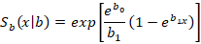
The Gompertz mortality rate function includes a scale parameter, b₀ (often called the “baseline mortality rate”), and a shape parameter, b₁, that describes the dependency of mortality on age () and is often interpreted as the rate of actuarial ageing, which reflects the rate of increase in mortality rate with age [57–60].
We used BaSTA to estimate and compare parameters of the simple Gompertz model for our experimental treatment groups. We performed four parallel BaSTA simulations, each proceeding for 2 200 000 iterations, with a burn-in of 200,000 chains, and took an MCMC chain sample every 4,000 iterations. Our models generated parameter estimates that converged with low serial autocorrelations (<5%) and robust posterior distributions of b_{o} and b₁ (N = 2 000) allowing for robust comparisons between treatment groups.
We compared parameter estimates for various treatment groups based on differences between their posterior distributions, using the Kullback-Leibler divergence calibration (KLDC) implemented in BaSTA. Values near 0.5 suggest nominal differences between distributions, whereas values close to 1 indicate a sizeable divergence. KLDC thresholds can vary depending on interpretation and can range between 0.65 and 1 [61–63]. We considered a relatively conservative KLDC value > 0.85 to indicate a difference between the posterior distributions of the treatment groups being compared. We report Gompertz b_{o} parameter estimates on a log scale and refer to F₁ treatment combinations as High-nutrient/Old-breeding (HO), High-nutrient/Young-breeding (HY), Low-nutrient/Old-breeding (LO), and Low-nutrient/Young-breeding (LY).

RESULTS AND DISCUSSION

LIFESPAN
F₃ individuals (grand-offspring) from both matrilines and patrilines suffered similar negative effects of F₁ (grandparental) and F₂ (parental) ages at breeding on lifespan (Table 1; Figs. 2-4). F₃ individuals descended from old-breeding grandmothers and grandfathers had 37.8% and 39.8% shorter lifespans, respectively, than F₃ individuals descended from young-breeding grandmothers and grandfathers. There was no effect of F₁ larval diet on F₃ lifespan in either matrilines or patrilines, nor an F₁ larval diet × F₁ age interaction. There were also no main or interactive effects of F₁ male competitive environment within patrilines (Table S1). However, we detected an F₁ × F₂ age interaction within both matrilines and patrilines, whereby the negative effect of F₁ age at breeding was diminished as F₂ age at breeding increased (Fig. 3). Within matrilines, we also detected an interaction of F₁ age at breeding and F₃ sex, whereby the negative effect of grandmothers’ age at breeding was stronger for F₃ males than for F₃ females. In patrilines, we also detected an F₂ age × F₂ sex interaction, such that F₃ lifespan declined more steeply with increasing paternal (F₂ male) age than with increasing maternal (F₂ female) age. Results were qualitatively similar for models including development time and body size (Supplementary Information).
Table 1. Linear mixed effects models of F₃ lifespan for patrilines and matrilines. Significant effects are highlighted in bold. Negative effects of F₁ and F₂ age indicate that old grandparents and parents produced offspring with reduced lifespans.

Effects on F₃ lifespan | Patrilines |  | Matrilines
Fixed effects: | Estimate | SE | Estimate | SE
(Intercept) | 37.308 | 5.039*** | 50.78 | 4.148***
F₁ Larval diet | -1.539 | 3.385 | -4.851 | 2.541.
F₁ Age | -22.324 | 5.246*** | -20.256 | 4.414***
F₂ Sex | 7.443 | 5.240 | -0.477 | 3.794
F₂ Age | -0.416 | 0.108*** | -0.669 | 0.095***
F₃ Sex | -10.254 | 4.247* | -22.039 | 3.762***
F₁ Age × F₂ Age | -0.265 | 0.112* | -0.253 | 0.101*
F₁ Larval diet × F₁ Age | -3.482 | 3.459 | -0.792 | 2.518
F₁ Larval diet × F₂ Sex | -1.533 | 3.010 | -1.068 | 2.605
F₁ Age × F₂ Sex | 0.438 | 3.221 | 1.021 | 2.620
F₂ Sex × F₂ Age | -0.204 | 0.103* | -0.153 | 0.092.
F₁ Age × F₃ Sex | -3.796 | 2.731 | -5.360 | 2.36*
F₂ Sex × F₃ Sex | -3.549 | 2.613 | 4.209 | 2.419.
F₂ Age × F₃ Sex | 0.120 | 0.078 | 0.425 | 0.079***
F₁ Larval diet × F₃ Sex | 4.482 | 2.49 | 3.741 | 2.384
∗P-value < 0.05, ∗∗P-value < 0.01, ∗∗∗P-value < 0.001.

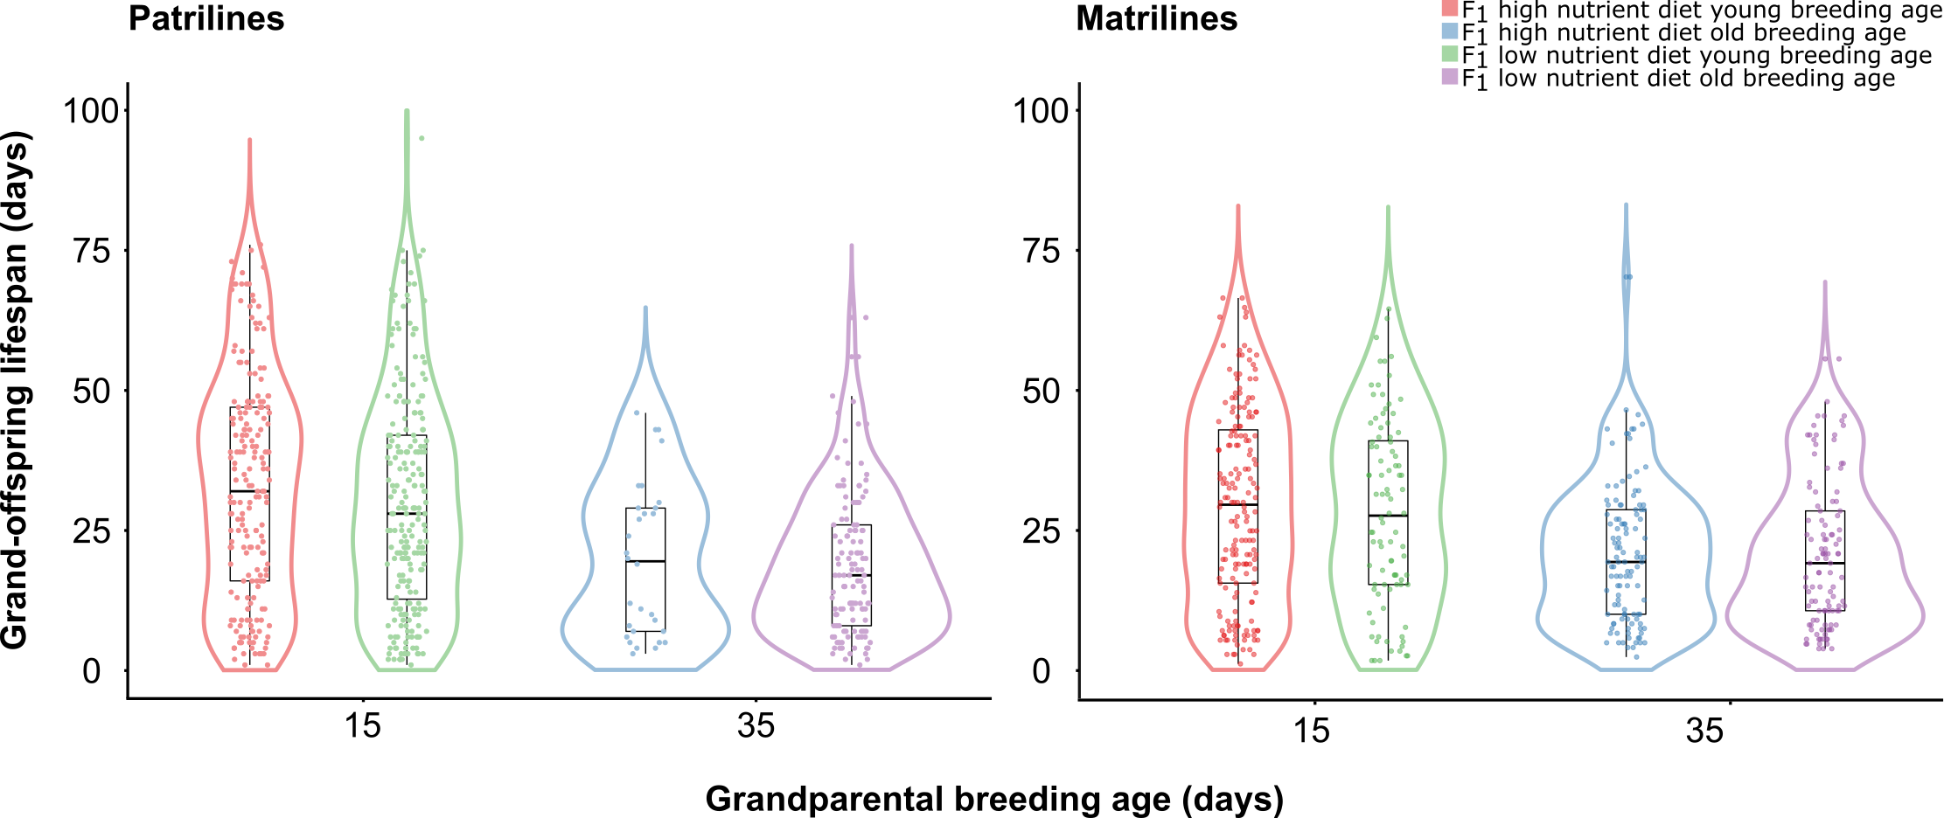
Figure 2. Effects of grandparental (F₁) breeding age and larval diet on grand-offspring (F₃) lifespan in patrilines and matrilines. The violin plot outline illustrates kernel probability density (width represents proportion of data located there). Within violin plots are boxplots with median and interquartile range to illustrate data distribution. Circular points within violin plots represents individual lifespan data points.
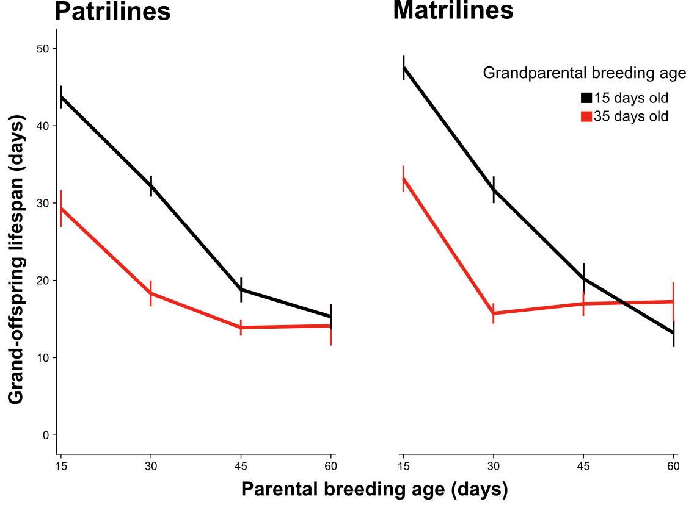
Figure 3. Interaction between effects of grandparental and parental breeding ages on grand-offspring lifespan in patrilines and matrilines. Black lines represent the lifespans of F₃ descendants of F₁ individuals paired at 15 days of age, and red lines represent the lifespans of F₃ descendants of F₁ individuals paired at 35 days of age. Bars represent SEM.

MORTALITY RATE
Consistent with our results for lifespan, we found that baseline mortality rate (Gompertz b_{o} parameter) of F₃ individuals from both matrilines and patrilines was affected positively and similarly by F₁ age at breeding, but not affected by F₁ larval diet (Fig. 4). Individuals descended from grandparents that bred at age 35 d had higher baseline mortality rates, regardless of F₁ larval diet treatment (patrilines b_{0 HO} = -3.5, b_{0 LO} = -3.6; matrilines b_{0 HO} = -3.8, b_{0 LO} = -3.7) than individuals descended from grandparents that bred at age 15 d (patrilines b_{0 HY} = -4.4, b_{0 LY} = -4.2; matrilines b_{0 HY} = -4.6, b_{0 LY} = -4.4). An effect of F₁ age at breeding on the baseline mortality rate was supported by Kullback-Leibler discrepancy calibration (KLDC) values, which exceeded 0.98 for all comparisons of b₀ parameters for F₃ descendants of young-breeding versus old-breeding F₁ individuals within and across larval diet treatments in both patrilines and matrilines (Tables S4, S6).
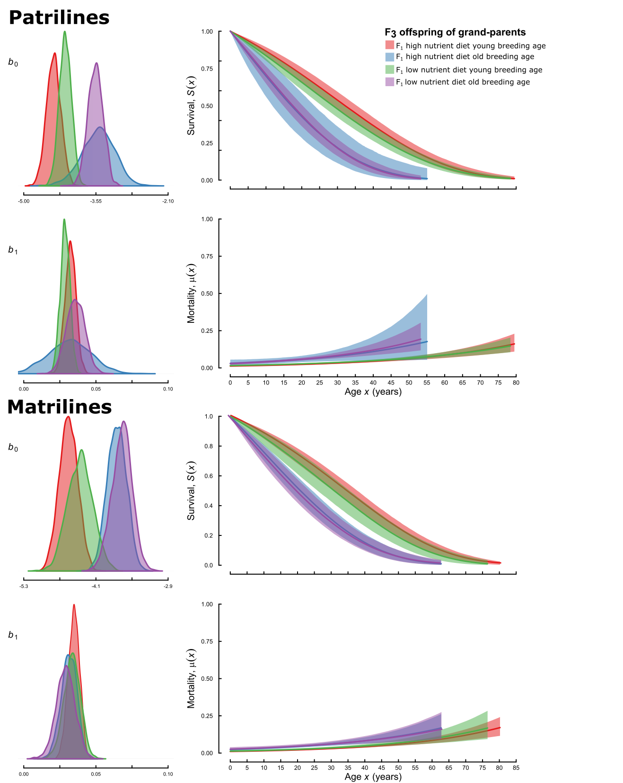

Figure 4. Effects of grandparental larval diet and breeding age on estimated age-specific survival and mortality rates with 95% confidence intervals for grand-offspring of patrilines and matrilines as fitted by the simple Gompertz mortality model where b₀ is the baseline mortality rate (scale) parameter and b₁ is the rate of actuarial ageing (shape) parameter.

Grandparental and parental breeding ages interacted in their effects on F₃ baseline mortality rates (b₀), particularly within patrilines (Fig. 5). F₃ individuals descended from young grandparents (F₁) experienced increasingly high baseline mortality as parental (F₂) age at breeding increased, and this effect was especially strong in patrilines (Table S6, S8). By contrast, for F₃ individuals descended from old-breeding grandparents, there were no consistent effects of parental age at breeding.
For actuarial ageing rates (Gompertz b₁ parameter), evidence of treatment effects was weaker, and patterns were less consistent. Individuals descended from grandparents that bred at age 35 days had similar actuarial ageing rates, regardless of F₁ larval diet treatment (patrilines b_{1 HO} = 0.032, b_{1 LO} = 0.036; matrilines b_{1 HO} = 0.031, b_{1 LO} = 0.029), to individuals descended from grandparents that bred at age 15 d (patrilines b_{1 HY} = 0.032, b_{1 LY} = 0.029; matrilines b_{1 HY} = 0.035, b_{1 LY} = 0.034). In matrilines, KLDC values were < 0.85 for all comparisons of b₁ parameters for F₃ descendants of young-breeding versus old-breeding F₁ females (Table S6). In patrilines, KLDC values marginally exceeded 0.85 for some comparisons of F₃ descendants of young-breeding versus old-breeding F₁ males within and across larval diet treatments, but the effect of F₁ age at breeding on b₁ was not consistent across larval diet treatments (Table S4). There was little evidence that grandparental and parental ages at breeding interacted in their effects on actuarial ageing rate (b₁) in either matrilines or patrilines (Fig. 5).

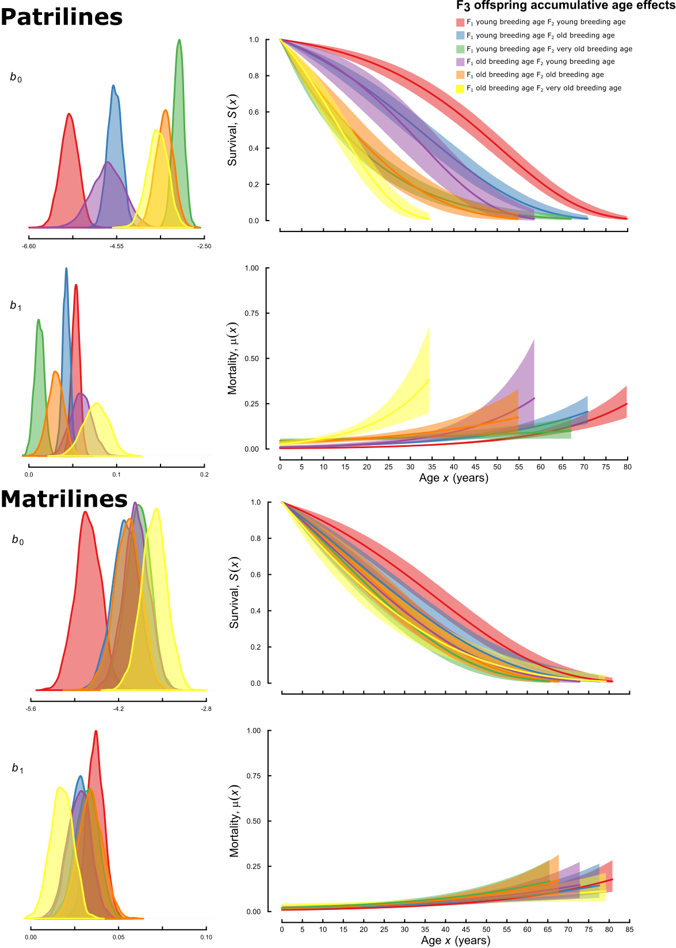
Figure 5. Effects of F₁ breeding age and F₂ breeding age on estimated age-specific survival and mortality rates with 95% confidence intervals for grand-offspring. (A) patrilines and (B) matrilines as fitted by the simple Gompertz mortality model where b₀ is the baseline mortality rate (scale) parameter and b₁ is the rate of actuarial ageing (shape) parameter.

A recent model suggests that negative effects of parental age on offspring performance can readily evolve [64], but many aspects of such effects have received little attention in empirical research. Our results show that paternal age effects can be similar in magnitude to maternal age effects. The magnitude of the grand-maternal and grand-paternal effects detected in our study is comparable to longevity changes observed in multi-generational selection experiments in Drosophila melanogaster [65,66]. Our mortality rate analyses suggest that decreased lifespan of grand-offspring of older grandparents and parents results largely from elevated baseline mortality rather than from a higher rate of increase in mortality rate with age (i.e. actuarial ageing). Actuarial ageing could result from the accumulation of somatic damage with age [67]. Indeed, T. angusticollis males reared on a high-nutrient larval diet accumulated damage more rapidly with age than males reared on a low-nutrient larval diet [45] and exhibited more rapid actuarial and reproductive ageing [46]. Here, we show that declining offspring longevity and increasing offspring mortality rate represent additional manifestations of ageing in T. angusticollis males and females. However, breeding age effects on offspring lifespan and mortality were unaffected by grandparental larval diet. Interestingly, while we found largely similar effects of grandpaternal versus grandmaternal and paternal versus maternal ages at breeding on offspring baseline mortality rate, we also found some evidence of effects on actuarial ageing rate in patrilines but not in matrilines. These differences suggest that male and female breeding age effects could be mediated by different factors and could have different effects on offspring life history.
Our findings suggest that the effect of ancestors’ age at breeding could contribute substantially to within-population variation in longevity. However, the importance of these effects in natural populations remains unclear. T. angusticollis has a much shorter mean lifespan in the wild than in the laboratory, and wild males also exhibit very rapid actuarial ageing [68]. The short average lifespan and rapid ageing observed in natural populations of this species is consistent with findings for other insects in the wild [69–71]. Given the very high background mortality rate experienced by T. angusticollis in the wild, it is possible that longevity of flies in natural populations is not strongly affected by parental age effects. However, it is also possible that maternal and paternal age effects are accelerated along with the overall rate of ageing in wild populations as a result of environmental stresses such as parasites and temperature fluctuations. If so, then parental age effects could have a substantial effect on fitness in natural populations, despite a short life expectancy. It is also possible that offspring of old-breeding parents or grandparents might respond by increasing their early-life reproductive effort, thereby partly mitigating the effects of reduced lifespan. For example, in Daphnia pulex, older mothers produce offspring with shortened lifespans but these offspring achieve increased early-life reproductive output [32]. We found little evidence that age at breeding effects on lifespan were mediated by body size or development time, since inclusion of these traits as covariates in lifespan models did not qualitatively alter the results.
The grandparental and parental age effects that we observed could be mediated by the accumulation of germline mutations with age. Because male and female germline cells develop differently in animals, including flies [72–74], the male and female germlines could accumulate mutations at different rates [75,76]. In particular, the rate of age-dependent mutation accumulation is likely to reflect the number of germline cell divisions, and it has long been thought that males transmit more germline mutations because the male germline undergoes a larger number of cell divisions [77]. Interestingly, however, in Drosophila, the number of germline cell divisions is larger in females than in males at young ages, but larger in males than in females at old ages [78]. This suggests that mutation-mediated maternal and paternal age effects could differ in relative magnitudes as a function of male and female age. If T. angusticollis exhibits a similar pattern of germline cell division to Drosophila, this could explain the somewhat stronger negative effect of grand-paternal age at breeding on grand-offspring lifespan, relative to the effect of grand-maternal age at breeding (Fig. 2).
The rate of cell proliferation in the female germline also increases on a protein-rich diet in D. melanogaster [79], and dietary protein strongly stimulates female fecundity in T. angusticollis as well [44]. A protein-rich adult diet could therefore be expected to accentuate negative maternal breeding age effects on offspring performance and could also accentuate paternal breeding age effects if cell division in the male germline is also enhanced on a high-protein diet. Germline mutation rate can also be affected by investment in DNA repair, and D. melanogaster reared on low nutrient food as larvae have lower rates of repair that result in increased germline mutation rate [80]. However, we found little evidence of effects of F₁ larval diet on grand-offspring mortality and survival (Figs. 2, 4). Likewise, we did not detect an effect of male competitive environment (opportunity for combat interactions) or any interaction between this treatment and grand-paternal breeding age. This finding is consistent with the lack of any effect of male combat on male reproductive ageing [46] and suggests that agonistic interactions with other males do not affect the maintenance of the male germline.
A different (but non-exclusive) explanation for our findings is age-dependent transmission of epigenetic or cytoplasmic factors through the female and male germlines. DNA (cytosine) methylation contributes to the regulation of gene expression in many organisms [81], but flies have little cytosine methylation and its role in this group remains unclear [82–85]. In D. melanogaster, DNA methylation is largely limited to the early stages of embryogenesis [86,87], but two studies suggest that DNA methylation can also persist in the germline [88,89]. In mammals, DNA methylation patterns undergo changes with age throughout the genome [90,91]. Such age-related changes in methylation (known as the ‘epigenetic clock’) could mediate parental age effects, since some DNA methylation patterns can be transmitted to offspring via both sperm and eggs (for a review, see [92]). It is not known whether a DNA methylation ‘clock’ also occurs in flies.
Other epigenetic or cytoplasmic factors that change with age could also mediate the observed age-at-breeding effects. There is evidence of age-related cellular changes in the male and female germline. For example, as Drosophila males age, germline stem cells (GSCs) divide less frequently due to misorientation of centromeres [93]. Similarly, GSC division in female Drosophila declines with age, and this is accompanied by an increased rate of cell death in developing eggs [94]. RNA-mediated transmission of shortened telomeres could mediate breeding age effects in flies and other animals. Shortened telomeres are associated with cellular senescence in some taxa [95], and telomere length can be affected by non-coding telomeric repeat-containing RNAs (TERRA), which are transcriptionally active in Drosophila [96]. TERRAs are present in animal (including human) oocytes [97] and, in female Drosophila, they affect blastoderm formation [98]. Other types of non-coding RNAs could also be involved. Flies maintain chromosome length through retro-transcription [99], which requires complex and specific chromatin structures [100]. Retrotransposon proliferation can promote mutagenesis [101]. RNA interference (RNAi) mechanisms control the silencing of retrotransposons in germline cells [102,103], and parental age effects could be mediated by the transmission of such small non-coding RNAs, with effects on chromatin states and gene expression in embryos [22]. Early development in Drosophila is thought to be governed by maternally inherited RNAs and proteins [104], but less is known about the effects of male-derived RNAs on offspring development. While T. angusticollis males do not transmit nutritional nuptial gifts during copulation [105], males transfer a variety of micro-RNAs in the ejaculate (unpublished data). The complement of seminal and egg micro-RNAs could change with male and female age and affect embryo development.
Another possibility is that flies change their investment in gametes in response to the age of their partner. A female may decrease investment per offspring when mated to an older male, while a male may reduce the quality or quantity of accessory gland proteins or sperm produced when mated with an older female, resulting in negative effects of parental age on offspring performance. Such responses to mate quality have been reported in Drosophila and other insects [106–109], and might be mediated through cuticular hydrocarbons (CHCs) that are known to change with age in flies [110,111].
The observed interactive effects of grand-parental and parental ages at breeding suggest that the factors mediating these effects are stable across at least two generations. Priest et al. [5] suggested that parental age effects could play a role in the evolution of ageing by contributing to age-related decline in performance and generating selection for earlier reproduction. Bonduriansky and Day [33] argued that, if such effects can accumulate over generations, an environmental change that brings about delayed breeding or causes a more rapid decline in offspring performance with parental age could result in a progressive decline in performance over several generations, resulting in phenotypic changes that resemble the evolution of accelerated ageing. The role of parental age effects in the evolution of ageing warrants further empirical and theoretical investigation.

AUTHOR CONTRIBUTIONS
F.S, A.H, Z.W, A.M. and R.B designed the study. Z.W, F.S. and A.H. performed the experiment. Z.W and R.B analysed the data and wrote the manuscript. F.S., A.H. and A.M contributed to data interpretation, visualisation, and editing of the manuscript.

ACKNOWLEDGMENTS
The authors would thank E. Macartney, N. W. Burke and F. Zajitschek for their helpful comments and discussions of earlier drafts of the manuscript. This research was funded by the Australian Research Council through a Future Fellowship and Discovery Grant to RB.

DATA ARCHIVING
The data will be deposited in Dryad.

LITERATURE CITED
1. Lansing AI. A transmissible, cumulative and reversible factor in aging. Gerontology. 1947;2: 228–239.
2. Ducatez S, Baguette M, Stevens VM, Legrand D, Fréville H. Complex Interactions Between Paternal And Maternal Effects: Parental Experience And Age At Reproduction Affect Fecundity And Offspring Performance In A Butterfly. Evolution. 2012;66: 3558–3569. doi:10.1111/j.1558-5646.2012.01704.x
3. Gavrilov LA, Gavrilova NS. Parental age at conception and offspring longevity. Rev Gerontol. 1997;7: 5–12.
4. Mousseau T, Fox CW. Maternal effects as adaptations. New York: Oxford University Press; 1998.
5. Priest N, Mackowiak B, Promislow DEL. The role of parental age effects on the evolution of aging. Evolution. 2002;56: 927–935. doi:10.1111/j.0014-3820.2002.tb01405.x
6. Mousseau T. Maternal Effects In Insect Life Histories. Annu Rev Entomol. 1991;36: 511–534. doi:10.1146/annurev.ento.36.1.511
7. Hercus MJ, Hoffmann AA. Maternal and grandmaternal age influence offspring fitness in Drosophila. Proc R Soc B Biol Sci. 2000;267: 2105–2110. doi:10.1098/rspb.2000.1256
8. Koch RE, Phillips JM, Camus MF, Dowling DK. Maternal age effects on fecundity and offspring egg-to-adult viability are not affected by mitochondrial haplotype. Ecol Evol. 2018;8: 10722–10732. doi:10.1002/ece3.4516
9. Lippens C, Faivre B, Lechenault C, Sorci G. Aging parasites produce offspring with poor fitness prospects. Biol Lett. 2017;13. doi:10.1098/rsbl.2016.0888
10. Fay R, Barbraud C, Delord K, Weimerskirch H. Paternal but not maternal age influences early-life performance of offspring in a long-lived seabird. Proc R Soc B Biol Sci. 2016;283. doi:10.1098/rspb.2015.2318
11. Kirkwood TB, Austad SN. Why do we age? Nature. 2000;408: 233–238.
12. Wong WSW, Solomon BD, Bodian DL, Kothiyal P, Eley G, Huddleston KC, et al. New observations on maternal age effect on germline de novo mutations. Nat Commun. 2016;7: 1–10. doi:10.1038/ncomms10486
13. Horvath S. DNA methylation age of human tissues and cell types. Genome Biol. 2013;14. doi:10.1186/gb-2013-14-10-r115
14. Koch CM, Wagner W. Epigenetic-aging-signature to determine age in different tissues. Aging. 2011;3: 1018–1027. doi:100395 [pii]
15. Stubbs TM, Bonder MJ, Stark AT, Krueger F, Bolland DJ, Butcher GA, et al. Multi-tissue DNA methylation age predictor in mouse. Genome Biology. 2017.
16. Hannum G, Guinney J, Zhao L, Zhang L, Hughes G, Sadda SV, et al. Genome-wide Methylation Profiles Reveal Quantitative Views of Human Aging Rates. Mol Cell. 2013;49: 359–367. doi:10.1016/j.molcel.2012.10.016
17. Bocklandt S, Lin W, Sehl ME, Sanchez FJ, Sinsheimer JS, Horvarth S, et al. Epigenetic Predictor of Age. PLoS One. 2011;6. doi:10.1371/Citation
18. Curley JP, Mashoodh R, Champagne FA. Epigenetics and the origins of paternal effects. Horm Behav. 2011;59: 306–14. doi:10.1016/j.yhbeh.2010.06.018
19. Crews D, Gore AC, Hsu TS, Dangleben NL, Spinetta M, Schallert T, et al. Transgenerational epigenetic imprints on mate preference. Proc Natl Acad Sci U S A. 2007;104: 5942–5946. doi:10.1002/andp.19654710109
20. Franklin TB, Russig H, Weiss IC, Grff J, Linder N, Michalon A, et al. Epigenetic transmission of the impact of early stress across generations. Biol Psychiatry. 2010;68: 408–415. doi:10.1016/j.biopsych.2010.05.036
21. Holeski LM, Jander G, Agrawal AA. Transgenerational defense induction and epigenetic inheritance in plants. Trends Ecol Evol. 2012;27: 618–626. doi:10.1016/j.tree.2012.07.011
22. Pauli A, Rinn JL, Schier AF. Non coding RNAs regulation in embryogenesis. Nat Rev Genet. 2011;12: 136–149. doi:10.1038/nrg2904.Competing
23. Chen Q, Yan W, Duan E. Epigenetic inheritance of acquired traits through sperm RNAs and sperm RNA modifications. Nat Rev Genet. 2016;17: 733. Available: https://doi.org/10.1038/nrg.2016.106
24. Szyf M. Nongenetic inheritance and transgenerational epigenetics. Trends Mol Med. 2015;21: 134–144. doi:10.1016/j.molmed.2014.12.004
25. Díaz H, Esponda P. Ageing-induced changes in the cortical granules of mouse eggs. Zygote. 2004;12: 95–103. doi:10.1017/S0967199404002680
26. Rodgers AB, Morgan CP, Leu NA, Bale TL. Transgenerational epigenetic programming via sperm microRNA recapitulates effects of paternal stress. Proc Natl Acad Sci. 2015;112: 13699–13704. doi:10.1073/pnas.1508347112
27. Immler S. The sperm factor: paternal impact beyond genes. Heredity. 2018;121: 239–247. doi:10.1038/s41437-018-0111-0
28. Chen Q, Yan M, Cao Z, Li X, Zhang Y, Shi J, et al. Sperm tsRNAs contribute to intergenerational inheritance of an acquired metabolic disorder. Science. 2016;351: 397–400. doi:10.1126/science.aad7977
29. Klosin A, Lehner B. Mechanisms, timescales and principles of trans-generational epigenetic inheritance in animals. Curr Opin Genet Dev. 2016;36: 41–49. doi:10.1016/j.gde.2016.04.001
30. Blake GET, Watson ED. Unravelling the complex mechanisms of transgenerational epigenetic inheritance. Curr Opin Chem Biol. 2016;33: 101–107. doi:10.1016/j.cbpa.2016.06.008
31. Giron D, Casas J. Mothers reduce egg provisioning with age. Ecol Lett. 2003;6: 273–277. doi:10.1046/j.1461-0248.2003.00429.x
32. Plaistow SJ, Shirley C, Collin H, Cornell SJ, Harney ED. Offspring provisioning explains clone-specific maternal age effects on life history and life span in the water flea, Daphnia pulex. Am Nat. 2015;186: DOI: 10.1086/682277. doi:10.1086/682277
33. Bonduriansky R, Day T. Extended Heredity: A New Understanding of Inheritance and Evolution. Press PU, editor. 2018.
34. Crean A, Bonduriansky R. What is a paternal effect? Trends Ecol Evol. 2014;29: 554–559. doi:10.1016/j.tree.2014.07.009
35. Lock JE. Transgenerational effects of parent and grandparent gender on offspring development in a biparental beetle species. Biol Lett. 2012;8: 408–411. doi:10.1098/rsbl.2011.0920
36. Xie K, Ryan DP, Pearson BL, Henzel KS, Neff F, Vidal RO, et al. Epigenetic alterations in longevity regulators, reduced life span, and exacerbated aging-related pathology in old father offspring mice. Proc Natl Acad Sci. 2018;115: E2348–E2357. doi:10.1073/pnas.1707337115
37. Sharma DA, Chevidikunnan MF, Khan FR, Gaowgzeh RA. Effectiveness of knowledge of result and knowledge of performance in the learning of a skilled motor activity by healthy young adults. J Phys Ther Sci. 2016;28: 1482–1486. doi:10.1589/jpts.28.1482
38. Saha S, Barnett AG, Foldi C, Burne TH, Eyles DW, Buka SL, et al. Advanced paternal age is associated with impaired neurocognitive outcomes during infancy and childhood. PLoS Med. 2009;6: 0303–0311. doi:10.1371/journal.pmed.1000040
39. Sandin S, Schendel D, Magnusson P, Hultman C, Surén P, Susser E, et al. Autism risk associated with parental age and with increasing difference in age between the parents. Mol Psychiatry. 2016;21: 693–700. doi:10.1038/mp.2015.70
40. Lynch M, Ennis R. Resource availability, maternal effects, and longevity. Exp Gerontol. 1983;18: 147–165. doi:10.1016/0531-5565(83)90008-6
41. Gribble KE, Jarvis G, Bock M, Mark Welch DB. Maternal caloric restriction partially rescues the deleterious effects of advanced maternal age on offspring. Aging Cell. 2014;13: 623–630. doi:10.1111/acel.12217
42. Carnes BA, Riesch R, Schlupp I. The delayed impact of parental age on offspring mortality in Mice. J Gerontol A Biol Sci Med Sci. 2012;67 A: 351–357. doi:10.1093/gerona/glr116
43. Runagall-McNaull A, Bonduriansky R, Crean AJ. Dietary protein and lifespan across the metamorphic boundary: protein-restricted larvae develop into short-lived adults. Sci Rep. 2015;5.
44. Adler MI, Cassidy EJ, Fricke C, Bonduriansky R. The lifespan-reproduction trade-off under dietary restriction is sex-specific and context-dependent. Exp Gerontol. 2013;48: 539–548. doi:10.1016/j.exger.2013.03.007
45. Adler MI, Telford M, Bonduriansky R. Phenotypes optimized for early-life reproduction exhibit faster somatic deterioration with age, revealing a latent cost of high condition. J Evol Biol. 2016;29: 2436–2446. doi:10.1111/jeb.12968
46. Hooper AK, Spagopoulou F, Wylde Z, Maklakov AA, Bonduriansky R. Ontogenetic timing as a condition-dependent life history trait: High-condition males develop quickly, peak early and age fast. Evolution. 2017; 1–15. doi:10.1111/evo.13172
47. Macartney E, Crean A, Bonduriansky R. Adult dietary protein has age- and context-dependent effects on male post-copulatory performance. J Evol Biol. 2017;
48. Sentinella AT, Crean AJ, Bonduriansky R. Dietary protein mediates a trade-off between larval survival and the development of male secondary sexual traits. Funct Ecol. 2013;27: 1134–1144.
49. Bonduriansky R. Convergent evolution of sexual shape dimorphism in Diptera. J Morphol. 2006;267: 602–611.
50. Schindelin J, Arganda-Carreras, I. Frise E, Kaynig V, Longair M, Pietzsch T, Preibisch S, et al. Fiji: an open-source platform for biological-image analysis. Nat Methods. 2012;9: 676–682.
51. Team RC. R: A language and environment for statistical computing. R Foundation for Statistical Computing, Vienna, Austria. [Internet]. 2012. Available: http://www.r-project.org/
52. Bates D, Maechler M, Bolker B, Walker S. Fitting Linear Mixed-Effects Models Using lme4. Journal of Statistical Software. J Stat Softw. 2015;67: 1–48.
53. Kuznetsova A, Brockhoff PB, Christensen RHB. {lmerTest} Package: Tests in Linear Mixed Effects Models. J Stat Softw. 2017;82: 1–26. doi:10.18637/jss.v082.i13
54. Colchero F, Jones OR, Rebke M. BaSTA: an R package for Bayesian estimation of age-specific mortality from incomplete mark-recapture/recovery data with covariates. Methods Ecol Evol. 2012; 466–470.
55. Colchero F, Clark JS. Bayesian inference on age-specific survival for censored and truncated data. J Anim Ecol. 2012;81: 139–149.
56. Jackson C. flexsurv: A Platform for Parametric Survival Modeling in R. J Stat Softw. 2016;70: 1–33. doi:10.18637/jss.v070.i08
57. Zou S, Carey JR, Liedo P, Ingram DK, Yu B. Prolongevity effects of a botanical with oregano and cranberry extracts in Mexican fruit flies: Examining interactions of diet restriction and age. Age (Omaha). 2012;34: 269–279. doi:10.1007/s11357-011-9230-8
58. Carey JR, Liedo P. Sex-specific life table aging rates in large medfly cohorts. Exp Gerontol. 1995;30: 315–325.
59. Styer LM, Carey JR, Wang J-L, Scott TW. Mosquitoes do sensece: Departure from the paradigm of constant mortality. Am J Trop Med Hyg. 2007;76: 111–117. doi:10.1016/0168-5597(85)90001-2
60. Wu D, Cysper JR, Yashin AI, Johnson TE. Multiple Mild Heat-Shocks Decrease The Gompertz Component of Mortality in C. elegans. Exp Gerontol. 2009;44: 607–612. doi:10.1016/j.pestbp.2011.02.012.Investigations
61. Polačik M, Tomášek O, Kačer P, Methling C, Vrtílek M, Terzibasi Tozzini E, et al. Repeated intraspecific divergence in life span and aging of African annual fishes along an aridity gradient. Evolution. 2016;71: 386–402. doi:10.1111/evo.13127
62. Boonekamp JJ, Salomons M, Bouwhuis S, Dijkstra C, Verhulst S. Reproductive effort accelerates actuarial senescence in wild birds: an experimental study. Ecol Lett. 2014;17: 599–605. doi:10.1111/ele.12263
63. Zajitschek F, Jin T, Colchero F, Maklakov AA. Aging differently: Diet-and sex-dependent late-life mortality patterns in Drosophila melanogaster. J Gerontol A Biol Sci Med Sci. 2014;69: 666–674. doi:10.1093/gerona/glt158
64. Moorad JA, Nussey DH. Evolution of maternal effect senescence. Proc Natl Acad Sci. 2016;113: 362–367. doi:10.1073/pnas.1520494113
65. Zwaan B, Bijlsma R, Hoekstra RE. Direct selection on life span in Drosophila melanogaster. Evolution. 1995;49: 649–659.
66. Rose MR. Laboratory evolution of postponed senescence in Drosophila melanogaster. Evolution. 1984;38: 1004–1010.
67. Kirkwood TBL, Holliday R. The Evolution of Ageing and Longevity. Proc R Soc B Biol Sci. 1979;205: 531–546. doi:10.1098/rspb.1979.0083
68. Kawasaki N, Brassil CE, Brooks RC, Bonduriansky R. Environmental effects on the expression of life span and aging: an extreme contrast between wild and captive cohorts of Telostylinus angusticollis (Diptera: Neriidae). Am Nat. 2008;172: 346–357. doi:10.1086/589519
69. Bonduriansky R, Brassil CE. Rapid and costly ageing in wild male flies. Nature. 2002;420: 2002.
70. Zajitschek F, Brassil CE, Bonduriansky R, Brooks RC. Sex effects on life span and senescence in the wild when dates of birth and death are unknown. Ecology. 2009;90: 1698–1707. doi:10.1890/08-0048.1
71. Rodriguez-Munoz R, Bretman A, Slate J, Walling CA, Tregenza T. Natural and Sexual Selection in a Wild Insect Population. Science (80- ). 2010;328: 1269–1272. doi:10.1126/science.1188102
72. Danserau DA, Lasko PF. Germline Stem Cells. 2008;450. doi:10.1007/978-1-60327-214-8
73. Hennig W. Spermatogenesis in Drosophila. Int J Dev Biol. 1996;40: 167–176.
74. Bastock R, St Johnston D. Drosophila oogenesis. Curr Biol. 2008;18: 1082–1087. doi:10.1016/j.cub.2008.09.011
75. Gao J-J, Pan X-R, Hu J, Ma L, Wu J-M, Shao Y-L, et al. Highly variable recessive lethal or nearly lethal mutation rates during germ-line development of male Drosophila melanogaster. Proc Natl Acad Sci. 2011;108: 15914–15919. doi:10.1073/pnas.1100233108
76. Bachtrog D. Evidence for male-driven evolution in Drosophila. Mol Biol Evol. 2008;25: 617–619. doi:10.1093/molbev/msn020
77. Haldane JBS. The rate of spontaneous mutation of a human gene. J Genet. 1935;31: 317–326. doi:10.1007/BF02982403
78. Bauer VL, Aquadro CF. Rates of DNA Sequence Evolution are Not Sex-Biased in Drosophila melanogaster and D. simulans. Mol Biol Evol. 1997;14: 1252–1257.
79. Drummond-Barbosa D, Spradling AC. Stem cells and their progeny respond to nutritional changes during Drosophila oogenesis. Dev Biol. 2001;231: 265–278. doi:10.1006/dbio.2000.0135
80. Agrawal AF, Wang AD. Increased transmission of mutations by low-condition females: Evidence for condition-dependent DNA repair. PLoS Biol. 2008;6: 0389–0395. doi:10.1371/journal.pbio.0060030
81. Jung M, Pfeifer GP. Aging and DNA methylation. BMC Biol. 2015;13. doi:10.1186/s12915-015-0118-4
82. Regev A, Lamb MJ, Jablonka E. The Role of DNA Methylation in Invertebrates: Developmental Regulation\ror Genome Defense? Mol Biol Evol. 1998;15: 880–891.
83. Mandrioli M, Borsatti F. DNA methylation of fly genes and transposons. Cell Mol Life Sci. 2006;63: 1933–1936. doi:10.1007/s00018-006-6039-1
84. Field LM, Lyko F, Mandrioli M, Prantera G. DNA methylation in insects. Insect Mol Biol. 2004;13: 109–115. doi:10.1111/j.0962-1075.2004.00470.x
85. Lyko F, Ramsahoye BH, Jaenisch R. DNA methylation in Drosophila melanogaster. Nature. 2000;408.
86. Ferres-Marco D, Gutierrez-Garcia I, Vallejo DM, Bolivar J, Gutierrez-Aviño FJ, Dominguez M. Epigenetic silencers and Notch collaborate to promote malignant tumours by Rb silencing. Nature. 2006;439: 430–436. doi:10.1038/nature04376
87. Xing Y, Shi S, Le L, Lee CA, Silver-Morse L, Li WX. Evidence for transgenerational transmission of epigenetic tumor susceptibility in Drosophila. PLoS Genet. 2007;3: 1598–1606. doi:10.1371/journal.pgen.0030151
88. Singh ND, Arndt PF, Petrov DA. Genomic heterogeneity of background substitutional patterns in Drosophila melanogaster. Genetics. 2005;169: 709–722. doi:10.1534/genetics.104.032250
89. Keller I, Bensasson D, Nichols RA. Transition-transversion bias is not universal: A counter example from grasshopper pseudogenes. PLoS Genet. 2007;3: 0185–0191. doi:10.1371/journal.pgen.0030022
90. Horvarth S. DNA methylation age of human tissues and cell types. Genome Biol. 2013;14.
91. Law JA, Jacobsen SE. Establishing , maintaining and modifying DNA methylation patterns in plants and animals. Nat Rev Genet. 2010;11: 204–220. doi:10.1038/nrg2719
92. Ho DH, Burggren WW. Epigenetics and transgenerational transfer: a physiological perspective. J Exp Biol. 2010;213: 3–16. doi:10.1242/jeb.019752
93. Cheng J, Türkel N, Hemati N, Fuller MT, Hunt AJ, Yamashita YM. Centrosome misorientation reduces stem cell division during ageing. Nature. 2008;456: 599–604. doi:10.1038/nature07386
94. Zhao R, Xuan Y, Li X, Xi R. Age-related changes of germline stem cell activity, niche signaling activity and egg production in Drosophila. Aging Cell. 2008;7: 344–354. doi:10.1111/j.1474-9726.2008.00379.x
95. Harley CB. Telomerase is not an oncogene. Oncogene. 2002;21: 494–502. doi:10.1038/sj/onc/1205076
96. Azzalin, C.M., Reichenbach, P., Khoriauli, L., Giulotto E. Telomeric repeat containing RNA and RNA surveillance factors at mammalian chromosome ends. Science (80- ). 2007;318: 798–801.
97. Reig-Viader R, Brieño-Enríquez MA, Khoriauli L, Toran N, Cabero L, Giulotto E, et al. Telomeric repeat-containing RNA and telomerase in human fetal oocytes. Hum Reprod. 2013;28: 414–422. doi:10.1093/humrep/des363
98. Olovnikov IA, Morgunova V V, Mironova AA, Kordyukova MY, Radion EI, Olenkina OM, et al. Interaction of Telomeric Retroelement HeT A Transcripts and Their Protein Product Gag in Early Embryogenesis of Drosophila. Bioschemistry (Mosc). 2016;81. doi:10.1134/S000629791609011X
99. Pardue M-L, DeBaryshe PG. Retrotransposons Provide an Evolutionarily Robust Non-Telomerase Mechanism to Maintain Telomeres. Annu Rev Genet. 2003;37: 485–511. doi:10.1146/annurev.genet.38.072902.093115
100. Mason JM, Frydrychova RC, Biessmann H. Drosophila telomeres: an exception providing new insights. 2Bioessays. 2008;30: 25–37. doi:10.3816/CLM.2009.n.003.Novel
101. Eickbush TH, Furano A V. Fruit flies and humans respond differently to retrotransposons. Curr Opin Genet Dev. 2002;12: 669–674. doi:10.1016/S0959-437X(02)00359-3
102. Vagin V V., Sigova A, Li C, Seitz H, Gvozdev V, Zamore PD. A distinct small RNA pathway silences selfish genetic elements in the germline. Science (80- ). 2006;313: 320–324. doi:10.1126/science.1129333
103. Yin H, Lin H. An epigenetic activation role of Piwi and a Piwi-associated piRNA in Drosophila melanogaster. Nature. 2007;450: 304–308. doi:10.1038/nature06263
104. Salvany L, Aldaz S, Corsetti E, Azpiazu N. A new role for hth in the early pre-blastodermic divisions in Drosophila. Cell Cycle. 2009;8: 2748–2755. doi:10.4161/cc.8.17.9388
105. Bonduriansky R, Head M. Maternal and paternal condition effects on offspring phenotype in Telostylinus angusticollis (Diptera: Neriidae). J Evol Biol. 2007;20: 2379–2388. doi:10.1111/j.1420-9101.2007.01419.x
106. Avent TD, Price TAR, Wedell N. Age-based female preference in the fruit fly Drosophila pseudoobscura. Anim Behav. 2008;75: 1413–1421. doi:10.1016/j.anbehav.2007.09.015
107. Fox CW. The influence of maternal age and mating frequency on egg size and offspring performance in Callosobruchus maculatus (Coleoptera: Bruchidae). Oecologia. 1993;96: 139–146. doi:10.1007/BF00318042
108. Mcnamara KB, van Lieshout E, Jones TM, Simmons LW. Age-dependent trade-offs between immunity and male, but not female, reproduction. J Anim Ecol. 2013;82: 235–244. doi:10.1111/j.1365-2656.2012.02018.x
109. Gray DA. Intrinsic factors affecting female choice in house crickets: Time cost, female age, nutritional condition, body size, and size-relative reproductive investment. J Insect Behav. 1999;12: 691–700. doi:10.1023/A:1020983821436
110. Desena MS, Clark JM, Edman JD, Symington SB, Scott TW, Clark GG, et al. Potential for aging female Aedes aegypti (Diptera: Culicidae) by gas chromatographic analysis of cuticular hydrocarbons, including a field evaluation. J Med Entomol. 1999;36: 811–823.
111. Braga MV, Pinto ZT, de Carvalho Queiroz MM, Blomquist GJ. Effect of age on cuticular hydrocarbon profiles in adult Chrysomya putoria (Diptera: Calliphoridae). Forensic Sci Int. 2016;259: e37–e47. doi:10.1016/j.forsciint.2015.11.006

