The causes and consequences of ornament variation in a natural population
Annabel Ralph¹, Terence Burke², Shinichi Nakagawa³, Alfredo Sánchez-Tójar^{4, 5}, Julia Schroeder¹

Affiliations:
¹Department of Life Sciences, Imperial College London, Silwood Park, Ascot, UK
²Department of Animal and Plant Sciences, University of Sheffield, UK
³Evolution & Ecology Research Centre and School of Biological, Earth and Environmental Sciences, University of New South Wales, Sydney, Australia
⁴Max Planck Institute for Ornithology, Research Group Evolutionary Biology, Seewiesen, Germany
⁵Department of Evolutionary Biology, Bielefeld University, Germany

Correspondence: Annabel Ralph- annabel.ralph18@imperial.ac.uk
Running title: Ornament variation in a natural population

Abstract
The role of sexual selection in natural populations has long been the subject of debate in evolutionary biology. Ornaments are sexually selected traits, which means they should vary within a population, have a genetic basis, and be associated with fitness. Despite evidence of ornaments meeting these criteria, evolutionary responses to sexual selection are rare in nature. This study focuses on two ornaments in a population of house sparrows; the plumage badge has been well-studied but remains poorly understood and the mask has been largely neglected in the literature. Using quantitative genetic techniques, we estimate the heritability of both traits and test for age-dependency of the heritability estimates. We also estimate the strength and direction of any selection acting upon the traits. We found that both ornaments have low, significant heritability, which does not vary with age. Selection only occurs in a small number of years, although when it does it is positive in both ornaments. We also found that early social environment plays a role in badge size variation. The results of this study suggest that an evolutionary response in the ornaments of this population is unlikely, but we highlight the importance of long-term research to improve our understanding of evolution in natural populations. Studies like these will add to our understanding of sexual selection, the causes of trait variation and the evolutionary potential of traits, which could help us to predict how populations will evolve.

Key words: heritability, sexual selection, ornament, trait variation, fitness, quantitative genetics, evolvability, passerines

Introduction
Sexually selected traits, known as ornaments, can drive variation in reproductive success within a population through their roles in competition or mate choice. Individuals choose mates with ornaments that signal high quality or fitness, which is related to their survival or reproduction (Clutton-Brock & McAuliffe, 2009; Hill, 1991). Most often females choose males, preferring the largest or most elaborate ornaments, such as the house finch, Haemorhous mexicanus, with the brightest plumage (Hill, 1991) or the peacock, Pavo cristatus, with the most elaborate train (Petrie, Halliday, & Sanders, 1991). In order to evolve, a trait must have a genetic basis, making it heritable, and be under selection. When ornaments meet these criteria, we expect an evolutionary response, an increase in population fitness and a decrease in variation (Fisher, 1930). However, evidence of the predicted response is rare and ornament variation is often maintained in natural populations (Merilä, Sheldon, & Kruuk, 2001; Ramakers, Culina, Visser, & Gienapp, 2018). Understanding sexual selection in nature is difficult as empirical data often conflicts with evolutionary theory.

Heritability is the proportion of trait variation that is determined by additive genetic effects and estimates in natural populations can be complex. Studies have found conflicting ornament heritabilities; some displaying high heritability (Brooks & Endler, 2001; Michel, Demarais, Strickland, Smith, & Dacus, 2016; Sheldon, Merila, Qvarnstrom, Gustafsson, & Ellegren, 1997) while others are more determined by environmental effects (Griffith, Owens, & Burke, 1999a; Hadfield et al., 2006). In some cases, heritability estimates are inflated by confounding effects, which increase the apparent similarity between relatives (Kruuk & Hadfield, 2007). Inflated similarity can be a result of social brood effects if individuals share an early environment, such as birds in a nest (Kruuk & Hadfield, 2007). In addition, sharing a mother can inflate similarity through maternal effects. These non-genetic contributions from a mother to her offspring can impact evolution in natural populations (Räsänen & Kruuk, 2007) and affect ornament development (Strasser and Schwabl, 2004). A method to separate confounding effects from heritability estimates is using cross-fostering to separate related individuals, which can disentangle genetic and environmental variation. Few studies of natural populations have the necessary data to reliably estimate heritability, which may have contributed to the gap between sexual selection theory and evidence.

The assumption that trait heritability is constant across environments and age classes can also limit estimates. Heritability can change according to environmental conditions in controlled studies (Hoffmann and Schiffer, 1998) as well as in natural populations (Charmantier & Garant, 2005; Gebhardt-Henrich & Noordwijkt, 1994). Age can also affect estimates, increasing trait heritability in modelled and laboratory populations of Drosophila melanogaster (Charlesworth & Hughes, 1996) and in a natural population of mute swans, Cygnus olor, laying date heritability was lower at intermediate ages (Charmantier, Perrins, McCleery, & Sheldon, 2006). Environment and age both play a role in ornament heritability in a population of collared flycatchers, Ficedula albicollis, where heritability decreases with age in poor environments (Garant, Sheldon, & Gustafsson, 2004). Studies of trait variation should always account for the effects of environment and age on heritability.

Here, we focus on ornament variation in a natural population of house sparrows, Passer domesticus. Male house sparrows have distinctive black patches on their throats (badges) and above their eyes (masks). The badge is a well-studied plumage trait and researchers have found various, conflicting heritability estimates. Badge size has been found to be highly heritable (Møller, 1989), to have a low, significant heritability (Jensen et al., 2008) and to be more environmentally determined (Griffith et al., 1999a). With its heritability in question, the selection acting on the house sparrow badge is also the subject of debate. Thought to be a sexually-selected ornament, large-badged males have been found to achieve more nest sites (Veiga, 1993) and be preferred by females (Møller, 1988), or in some cases small badges are preferred (Griffith, Owens, & Burke, 1999b). However, researchers altering badge size with dye found no effect on reproduction (Nakagawa, Ockendon, Gillespie, Hatchwell, & Burke, 2007a) and a meta-analysis of many studies found that overall, any selection for badge size is weak (Nakagawa, Ockendon, Gillespie, et al., 2007b). Despite the depth of research, both the heritability and selection of the house sparrow badge remain poorly understood.

While the drivers of badge size variation remain unclear, the black mask of male house sparrows is largely neglected in studies, despite being a better indicator of age (Nakagawa & Burke, 2008). Signalling age is key in female choice in house sparrows, as older males have a greater chance of extra-pair paternity and a resulting higher reproductive output (Wetton, Burke, Parkin, & Cairns, 1995). However, it has also been shown that older males produce offspring of lower quality, so the role of age is equally ambiguous (Schroeder, Nakagawa, Rees, Mannarelli, & Burke, 2015). The remaining questions surrounding badge size variation and the potential role of the mask in sexual selection highlight the need to further study both the badge and mask of house sparrows.

In this study we will test three hypotheses. First, that both badge and mask size are heritable traits. Second, that their heritability varies with age. Third, that both traits are under selection. Finding the true causes and consequences of ornament variation could improve understanding of sexual selection and allow us to predict how natural populations will evolve in a changing environment.

Materials and Methods
Field work
Data were collected between 2000 and 2017 from a population of house sparrows on Lundy Island, a small island in the Bristol Channel, UK, 19km from the mainland (Lattore, Nakagawa, Burke, Plaza, & Schroeder, in press). The low dispersal rate of house sparrows means there is a high resighting
probability in this isolated population and almost every individual is caught, measured and marked with a unique combination of colour rings (Schroeder et al., 2015). As a result we know the age and survival of every individual, with birds being presumed dead after two years without a sighting (Schroeder, Cleasby, Nakagawa, Ockendon, & Burke, 2011).

Each bird is assigned genetic parents using 13 genetic microsatellite markers to create a complete genetic pedigree (Schroeder et al., 2015). We compared the full pedigree to one containing only
Table 1. Pedigree summary statistics of the full genetic pedigree from the Lundy Island house sparrow population and the informative pedigree, containing only individuals that have been measured for the traits of interest or those related to measured individuals.
Item | Pedigree
 | Full | Informative
Records | 9 048 | 867
Maternities | 7 427 | 801
Paternities | 7 561 | 809
Full siblings | 35 845 | 637
Maternal sibs | 96 894 | 1 622
Maternal half sibs | 61 049 | 985
Paternal sibs | 110 746 | 1 767
Paternal half sibs | 74 901 | 1 130
Maternal grandmothers | 6 605 | 705
Maternal grandfathers | 6 817 | 721
Paternal grandmothers | 6 506 | 674
Paternal grandfathers | 6 546 | 690
Maximum pedigree depth | 17 | 16
Founders | 1 434 | 49
Mean pairwise relatedness | 0.039 | 0.062
informative individuals, which have either been measured for the traits of interest or are related to measured individuals (Table 1). The informative pedigree here is large and has a high average relatedness between individuals, which can improve heritability estimates (Wilson et al., 2010). Estimates are also improved by the cross-fostering structure of this population (Winney, Nakagawa, Hsu, Burke, & Schroeder, 2015), which can reduce the inflation of heritability by confounding effects.

We measure three male plumage traits in the house sparrows. The first is the visible badge size but the feather tips wear away over time and alter the visible extent of the badge (Møller & Erritzøe, 1992). As a result, the second trait is the hidden badge, which is measured from the base of the bill to the point at which dark feathers cease to grow (Griffith et al., 1999a). The third trait is the mask, which is measured as the maximum extent of black feathers on the face (Nakagawa & Burke, 2008).

Age-corrected heritability
To test the hypothesis that the plumage traits are heritable, we ran age-corrected animal models. These linear mixed models estimate the trait similarity between relatives using Markov Chain Monte Carlo (MCMC) methods. Like any mixed model, animal models consist of a fixed and a random part. The fixed part contains factors which alter the trait mean. Variables are included as fixed factors to account for their effects and to remove known variation from the model. The random part of the model separates total trait variance into its components. Animal models include the inverse matrix of relatedness between measured individuals, which is computed from a pedigree and gives the additive genetic variance component (Kruuk & Hadfield, 2007; Lynch & Walsh, 1998).

To estimate the age-corrected heritability of each trait, we included age in the animal models as a multi-level fixed factor, as carried out by Kruuk et al. (2002). The overall heritability estimates are then corrected for the known effects of age on both badge and mask size (Nakagawa et al., 2007a; Nakagawa and Burke, 2008). We calculated age using the birth and capture year of each male, assigning an age of one year from their first October after birth, two from the following October and onwards. During October and November birds are in moult so this annual boundary ensures that age corresponds to the breeding season and that repeated measurements within a year correspond to the same feathers. As well as age, moult status was included as a two-level fixed factor (in moult: “YES”/”NO”) to account for plumage variation caused by moulting season in October and November.

The age-corrected animal models included five random effects. First, the genetic pedigree to find additive genetic variance. Second, bird identity to estimate the within-individual variation caused by permanent environment effects. Third, birth year as a factor to account for the environmental conditions shared by males born in the same year. Fourth, observer identity to account for variation caused by the individual taking measurements and fifth was capture year, to account for variation in measurements between years. The model results were then used to estimate heritability.

Heritability (h₂) is the proportion of a trait’s total measurable variation, or its total phenotypic variance (V_{P}), that is explained by additive genetic effects (V_{A}).
$$h_{2}=\frac{V_{A}}{V_{P}}$$
Animal models partition V_{P} according to the random effects included so in the age-corrected models:
$$V_{P}=V_{A}+V_{PE}+V_{BY}+V_{Obs}+V_{Year}+V_{R}$$
Where V_{PE} is the permanent environmental variance, V_{BY} the birth year effects, V_{Obs} the observer effects, V_{Year} the capture year effects and V_{R} the residual environmental variance not included in the model. However, as the variation caused by observer and capture year is artificially introduced rather than natural, we excluded it from heritability estimates. Instead we calculated heritability as:
$$h_{2}=\frac{V_{A}}{V_{P}∗}$$
Where V_{P}* is an adjusted V_{P}, excluding the effects of observer and capture year:
$$V_{P}∗V_{A}+V_{PE}+V_{BY}+V_{R}$$
It is difficult to determine if capture year effects are natural or artificially introduced (Villemeruil, Morrissey, Nakagawa, & Schielzeth, 2018). However, including both birth year and age accounts for annual environmental variation so capture year variation here is likely from methodical differences.

In addition to estimating age-corrected heritability as a proportion of variance, we also calculated the overall evolvability of each trait. Evolvability is a mean-standardised measure of additive genetic variance, meaning it is relative to the trait of interest and can be compared between traits or age groups (Hansen, Pélabon, & Houle, 2011; Houle, 1992). The evolutionary potential of a trait can be masked by environmental variance altering the proportion of additive genetic variance in heritability estimates, meaning that heritability is not always indicative of evolvability (Hansen et al., 2011). In contrast, the mean-standardised evolvability allows direct comparisons of the magnitude of additive genetic variance between traits without the impact of other variance components (Dochtermann & Royauté, 2019). Here, we estimated evolvability by dividing additive genetic variance by the square of the trait mean (Dochtermann & Royauté, 2019):
$$I_{A}=100×\frac{V_{A}}{{\overline{x}}^{2}}$$
Where I_{A} is evolvability and x̅ the trait mean. Finding evolvability alongside heritability allows for more informative comparisons of additive genetic variance within and between studies and a more complete understanding of evolutionary potential in natural populations.

Variation in trait heritability with age
To test the hypothesis that heritability varies with age, we separated the datasets for each trait into several datasets by age. Due to low numbers of older birds, we grouped birds between the ages of four and eight into single datasets for each trait to allow reasonable sizes for analysis. The resulting groups contained 134 visible badge measurements of 68 older males, 141 hidden badge measurements of 70 older males and 87 mask measurements of 51 older males.

Following a similar structure to the age-corrected models, all animal models in this analysis included the five random effects of pedigree, bird identity, birth year, observer and capture year. The age-separated visible badge models included moult status as a fixed effect and the analysis of the older group included age as a fixed effect. Hidden badge models were intercept-only, meaning they included no fixed effects but they did include a sixth random effect of social brood identity. The mask models included moult status as a fixed factor and no additional random effects. We estimated the trait heritability of each age class by dividing the additive genetic variance by the adjusted measure of total phenotypic variance that excluded observer and capture year effects (V_{P}*). We also estimated the trait evolvability (I_{A}) of each age class to allow relative comparisons between ages.

Selection for traits
To test the hypothesis that the traits are under selection, we estimated annual selection gradients to account for temporal fluctuations in the strength and direction of selection (Siepielski, Dibattista, & Carlson, 2009). We calculated selection gradients using linear regressions of the relationship between each trait and fitness (Lande & Arnold, 1983). As a measure of individual fitness, we used the annual number of recruits, that is, the number of offspring that go on to join the breeding population by starting a brood (Schroeder et al., 2011). Prior to analysis, we used z-scores to standardise the distributions of both the number of recruits and the trait values within each year so that they had a mean of zero and a standard deviation of one. As fitness is relative to the population, standardisation ensures that selection gradients are relative to the selection within each given year, thus allowing comparisons between years (Lande & Arnold, 1983).

Each linear model included annual fitness as the response variable and the individual trait means within that year as the explanatory variable. The resulting slope estimate gives the strength and direction of the selection gradient (Lande & Arnold, 1983). We multiplied the associated standard errors by 1.96 to find the 95% confidence intervals, considering selection statistically significant when the intervals did not span zero.

Statistical analysis
All analyses were carried out in the R environment, version 3.5.1 (R Core Team, 2018). We removed all badge size measurements of one observer (“AS”) as they were significantly higher than the trait means, suggesting a systematic difference in measurements (visible badge: +8.4mm, t₇₆=13, p≤0.001; hidden badge: +8.4mm, t₃₄=7.6, p≤0.001). This meant removing 35 visible badge measurements (3.1% of all measurements) and 34 hidden badge measurements (2.6%).

We prepared the pedigree for analysis and derived pedigree summary statistics using the ‘pedantics’ package (Morrissey, 2018). Subsequent animal models were run using ‘MCMCglmm’ (Hadfield, 2010), which estimates variance components with associated 95% credible intervals. Here, we interpret credible intervals analogous to 95% confidence intervals and considered differences in heritability statistically significant if their credible intervals did not overlap one another.

Animal models were run for 1000000 iterations, discarding the first 10000 as a ‘burn in’ and using a thinning interval of 1000, meaning every thousandth estimate was saved. These values were selected after testing models, as outlined in Wilson et al. (2010). First, we visually inspected the distributions of the fixed and random parameter estimates. Second, we checked that the autocorrelation values between samples were low, which ensures that subsequent estimates are independent of one another.

Every model also has an associated Deviation Information Criterion (DIC) which assesses how well the model fits the data. We used the DICs to assess whether each variable improved the model. If the DIC differed by a value lower than three, we considered the models unaffected by the additional variable and it was not included in the final model, unless relevant to the hypothesis. Maternal identity was found to only improve one model (hidden badge at age three) so it was excluded from all analyses to allow comparisons of heritability between age classes. We also tested the inclusion of the foster and genetic fathers in models, due to their role in previous studies (Griffith et al., 1999a; Møller, 1989).

Results
Descriptive statistics
The dataset contained 798 males, 35% of which had not been raised by their genetic parents. There were 1081 visible badge size measurements (487 males), with a mean of 39.2mm (range: 11.2-60.3mm). For hidden badge, 1252 measurements were taken (520 males) and the mean was 36.5mm (21.1-52.4mm). There were 821 mask measurements (374 males), with a mean of 16.0mm (8.00-25.6mm). The frequency of repeated measures varied between males (Table 2).
Table 2. The frequency of males measured multiple times for each trait.
 | Number of measurements
Trait | 1 | 2 | 3 | 4 | 5 | 6 | 7 | 8 | 9 | 10 | 11
Visible badge | 212 | 123 | 67 | 41 | 21 | 16 | 4 | 1 | 0 | 1 | 1
Hidden badge | 210 | 133 | 71 | 44 | 24 | 19 | 11 | 1 | 4 | 1 | 2
Mask | 162 | 97 | 57 | 28 | 14 | 9 | 3 | 2 | 0 | 1 | 1
The number of males with both recruitment information and trait measurements fluctuates annually and so the number of males used in selection gradient analysis also varies, being most apparent during a population decline in 2008 (Fig. 1).
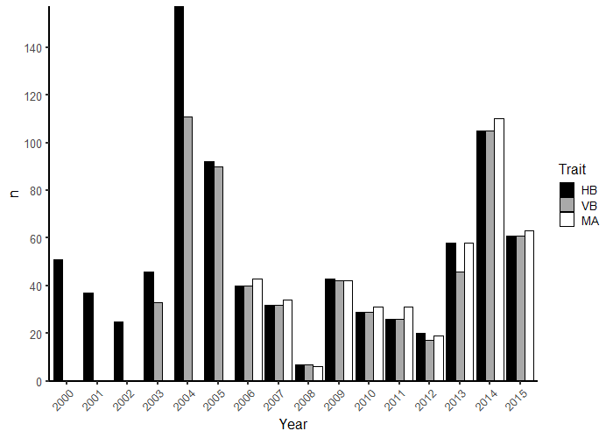
Figure 1. The number of male house sparrows (n) on Lundy Island used in selection gradient analysis for each year, separated by trait. HB=hidden badge, VB= visible badge and MA=mask size.

Age-corrected heritability
All age-corrected heritability estimates were statistically significant, ranging from 4% to 9% (Table 3). The hidden badge had both the highest heritability and the lowest evolvability. Identities of the social and genetic fathers did not explain any variation in the traits and were not included in the final models as a result (Supplementary Information: Tables S1, S2 & S3). The largest component of the adjusted total variance (V_{P}*) was residual environmental variance in all three traits.

Table 3. Age-corrected heritability (h₂) estimates, with their associated 95% credible intervals (CI) and the mean-standardised evolvability (I_{A}) estimates for each trait.
Trait | h₂ | CI | I_{A}
Visible badge | 0.04 | 0.03-0.08 | 0.12
Hidden Badge | 0.09 | 0.05-0.16 | 0.06
Mask | 0.06 | 0.04-0.16 | 0.16
Variation in trait heritability with age
There are no statistically significant heritability changes with age because all the credible intervals are overlapping. Visible badge heritability appears higher in older males, which is reflected by their high evolvability (Fig. 2a). Both hidden badge heritability and evolvability are higher at intermediate ages (Fig. 2b), while mask heritability and evolvability appear highest in age two birds (Fig. 2c).

Selection for traits
Most of the annual selection gradients are not statistically significant (Fig. 3). Visible badge selection was statistically significant in 2003 (0.39, SE: ±0.17), 2006 (0.36, SE: ±0.15) and 2015 (0.49, SE: ±0.11). There was one statistically significant selection gradient for hidden badge size (2006: 0.35, SE: ±0.16) and two for mask size (2007: 0.59, SE: ±0.15; 2009: 0.38, SE: ±0.15).
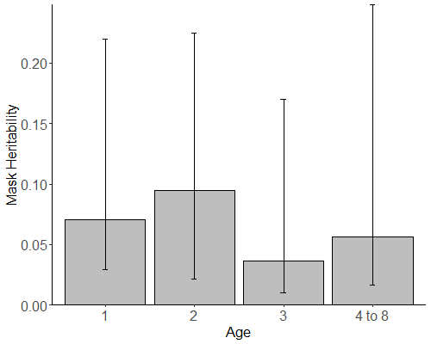
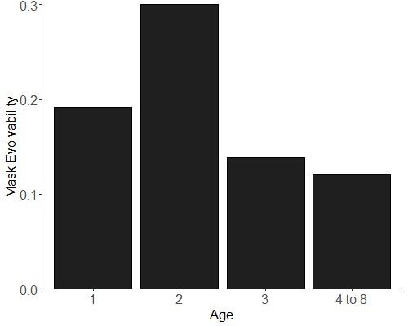
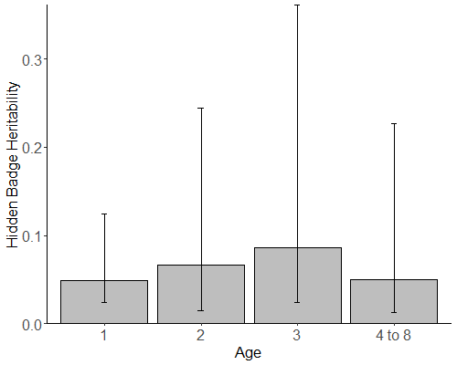
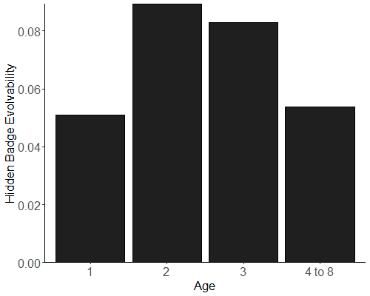
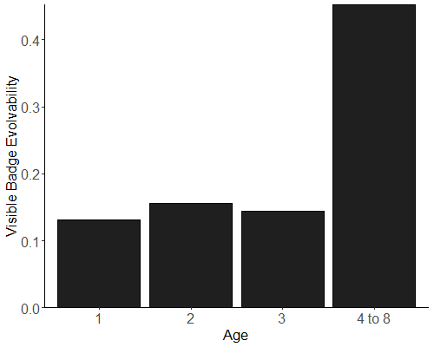
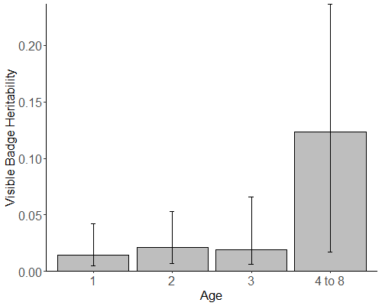
n=214
Figure 2. The heritability and mean-standardised evolvability estimates of a) visible badge, b) hidden badge and c) mask, separated by age group. The error bars on the heritability plots represent the 95% credible intervals. The number of males measured for each trait per age group (n) is shown on the evolvability plots.
c)
a)
b)
n=102
n=190
n=416
n=68
n=70
n=106
n=474
n=316
n=149
n=63
n=51

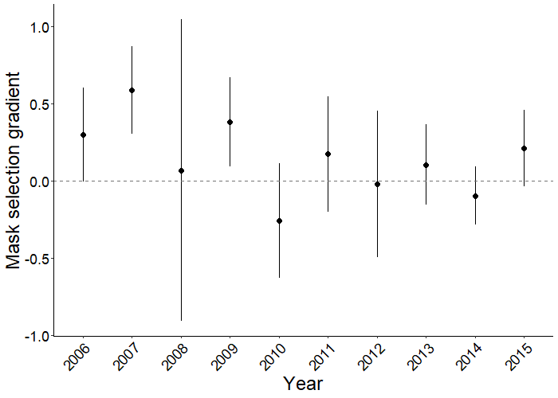
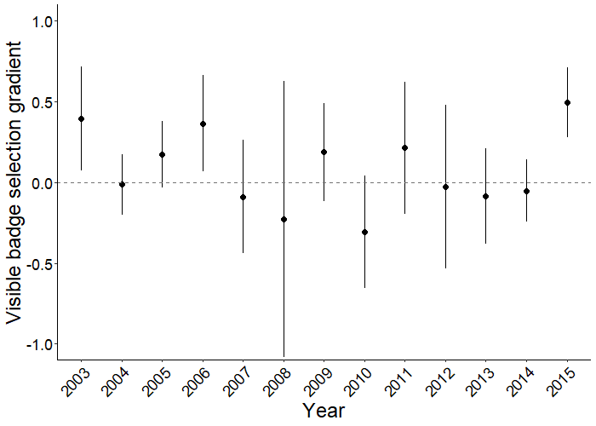
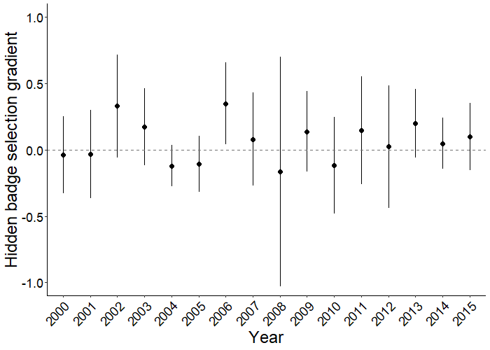
Figure 3. Annual selection gradients for visible badge, hidden badge and mask size in the house sparrow population on Lundy Island. Error bars show the 95% confidence intervals. Selection gradients are considered statistically significant if the confidence intervals do not span zero.
Discussion
Every trait in this study has statistically significant heritability. The estimates are similar to the low badge size heritability estimates from a previous study (Jensen et al., 2008) and to ornament heritability of another passerine population (Hadfield et al., 2006). As populations respond to selection, additive genetic variance in fitness-related traits is expected to erode (Fisher, 1930), which has been shown to occur in wild bird populations (Teplitsky, Mills, Yarrall, & Merilä, 2009). However, the low but significant heritabilities estimated here suggest that additive genetic variance has not eroded and the ornaments in this population may still have the potential to evolve.

Despite the lack of statistical significance in the heritability-by-age analysis, some apparent changes are reflected in the evolvability estimates, suggesting that the additive genetic variance itself may not be constant with age class. Visible badge heritability and evolvability increase substantially in older males, which was the case in laying date of mute swans (Charmantier et al., 2006). This increase with age could be due to males more similar to their relatives having a higher chance of survival or it could simply be a result of the reduced number of males in the older group. Low sample sizes of older males are often found in studies of natural populations due to survival rates decreasing with age (Kirkwood & Austad, 2000) and this can reduce the statistical power for analysis.

Unlike in visible badge, the heritabilities of hidden badge and mask size are not reflected by their evolvabilities. Instead both of their evolvabilities are highest at age two and then decrease with age. A decreasing heritability could suggest increasing environmental variation with age. However, as evolvability is mean-standardised and unaffected by environmental variance, it appears that the additive genetic variance component itself decreases after the age of two. The relationship of age and additive genetic variance should be further considered in house sparrow ornaments based on the changing evolvabilities. However, evolvability does not account for environmental effects and does not represent the true evolutionary potential of a population because environmental variation cannot be removed in nature. This importance of considering environmental effects is demonstrated by the substantial residual environmental variance found in all models in this study (Tables S1, S2 & S3). Estimating evolvability is useful in comparative studies but should always be considered alongside traditional variance-standardised heritability estimates to compare both the magnitudes and proportions of additive genetic effects. While heritability does not change significantly with age here, estimating additive genetic effects on multiple scales allowed us to gain a more complete understanding of the evolutionary potential of traits.

The social brood effects on hidden badge variation in the age-separated models were statistically significant in all age classes (Table S2). Social interactions associated with the dominance hierarchy have been shown to affect badge development in the house sparrow (Laucht & Dale, 2012) and stress in the early social environment can decrease badge size (Dupont, Grace, Brischoux, & Angelier, 2019). This previous research supports our finding that social brood has a consistent contribution to hidden badge variation throughout a male’s lifetime. While social brood effects were key in hidden badge size variation, the effect of the genetic and social fathers were not statistically significant and did not improve any models. This contradicts previous research on their importance in determining badge size (Griffith et al., 1999a; Møller, 1989). We can separate the true causes of trait variation using long-term study populations with cross-fostering structures as used here.

While there is heritability in both visible and hidden badge size, there does not appear to be strong selection acting on them. Although the badge has long been thought to be under sexual selection (Møller, 1988; Veiga, 1993), this study supports the findings that any selection for badge size is weak (Nakagawa et al., 2007b). Between 1995 and 1997 small-badged males in the Lundy Island house sparrow population were found to be preferred by females and to have higher reproductive success (Griffith et al., 1999b). In contrast, all the significant selection gradients in this study are positive. These results support a more recent study of this population that found a weak but positive relationship between badge size and the number of recruits (Sánchez-Tójar, 2018). Our study supports the theory that any badge size selection in this population is weak but positive.

There are several possible causes for conflicting estimates of selection. First, selection could depend on environmental conditions. Natural selection based on environmental conditions acting alongside sexual selection has been known to impact ornaments in passerines (Olsen et al., 2010) and can result in evolution acting in the opposite direction to sexual selection (Garant, Kruuk, McCleery, & Sheldon, 2004). Second, the strength and direction of selection can fluctuate temporally in natural populations, preventing any overall response (Siepielski et al., 2009), which could be the case here given variation in significance of the annual selection gradients. Third, selection can be age-dependent, as seen in ornaments of collared flycatchers, Ficedula albicollis (Garant, Sheldon, et al., 2004) and in common yellowthroats, Geothlypis trichas, age affects selection strength and direction as well as the ornament targeted (Freeman-Gallant et al., 2010). Badge and mask size both vary with age and it is possible that the strength and ornament targeted for selection vary sufficiently during a male’s lifetime to mask any overall selection. Future studies should consider the roles of fluctuating and age-dependent selection in maintaining ornament variation in natural populations.

The positive selection gradients in this study could also be a result of a reduced population. The Lundy Island house sparrow population declined dramatically due to predation, with the loss most apparent in 2008 when the dataset contained only ten males (Fig. 1). Most years with statistically significant selection occurred around this decline. This is important for two reasons. First, it may be that the reduced numbers in these years have limited the power for analysis. Second, it may be that during this period, selection moved to favour males with larger ornaments. Females could alter their preferences during periods of stress or males with large ornaments could have an increased chance of survival, which is possible considering the relationship of the ornaments with age (Nakagawa & Burke, 2008; Nakagawa et al., 2007b). Older males being more experienced or larger could give them a survival advantage over younger males, skewing the average badge and mask sizes within the population during this time of decline. The positive selection gradients found here emphasise the importance of fluctuating selection in natural populations and highlight the need to consider survival as well as reproductive success when studying the relationship between ornaments and fitness.

The heritability of mask size and its significant relationship with age (Table S3) support the suggested role of the mask in sexual selection (Nakagawa & Burke, 2008). Any significant mask selection here is positive, which could be due to a role in female choice. Females choose older males for extra-pair paternity (Wetton et al., 1995) and could use larger masks to distinguish age. If so, the significant heritability could determine offspring mask size and thus fitness. This role in sexual selection seems likely in the mask despite most of the selection gradients being non-significant. In penduline tits, Remiz pendulinus, male mask size determines number of mates without affecting overall reproductive success (Kingma et al., 2008), demonstrating how sexually-selected ornaments may not have clear and direct fitness benefits. Offspring fitness could further be optimised if females select for both badge and mask size because badge size alone is an insufficient signal of age (Nakagawa et al., 2007a). Badge and mask may then act together in sexual selection, with multiple ornaments for use in female choice being common (Candolin, 2003). This study supports the role of the house sparrow mask as an ornament and further research should consider its role in female choice.

In conclusion, both badge and mask size are heritable in this population but the positive selection acting upon them fluctuates. Heritability and selection rarely co-occur in natural populations and even where they do, evolutionary responses are rare (Ramakers et al., 2018). Consequently, an evolutionary response in this population seems unlikely. The results of this study contribute to the debate surrounding badge size variation and highlight the importance of including the mask in studies of sexual selection in house sparrows. We also demonstrate the need to consider age-dependent heritability and to compare additive genetic variance across multiple scales. Investigating the drivers of fluctuating selection and the role of environment and age in sexual selection could improve understanding of how ornament variation is maintained in nature. As more long-term studies of natural populations accumulate, further research will help to answer some long-standing questions of sexual selection. Understanding selection and the evolutionary potential of ornaments could improve predictions of how populations will respond to a rapidly changing environment.

Data and Code Availability Statement
The dataset used was provided to me by my supervisor Dr. Julia Schroeder and will not be made available until formal publication. The R script used to carry out analysis is available at: https://github.com/acralph/MSc_EEC_script.

References
Brooks, R., & Endler, J. A. (2001). Direct and indirect sexual selection and quantitative genetics of male traits in guppies (Poecilia reticulata). Evolution, 55(5), 1002–1015. https://doi.org/10.1111/j.0014-3820/2001/tb00617.x
Candolin, U. (2003). The use of multiple cues in mate choice. Biological Reviews of the Cambridge Philosophical Society, 78(4), 575–595. https://doi.org/10.1017/S1464793103006158
Charlesworth, B., & Hughes, K. A. (1996). Age-specific inbreeding depression and components of genetic variance in relation to the evolution of senescence. Proceedings of the National Academy of Sciences, 93(June), 6140–6145. https://doi.org/10.1073/pnas.93.12.6140
Charmantier, A., & Garant, D. (2005). Environmental quality and evolutionary potential : lessons from wild populations. Proceedings of the Royal Society B: Biological Sciences, 272(June), 1415–1425. https://doi.org/10.1098/rspb.2005.3117
Charmantier, A., Perrins, C., McCleery, R. H., & Sheldon, B. C. (2006). Age-dependent genetic variance in a life-history trait in the mute swan. Proceedings of the Royal Society B: Biological Sciences, 273(1583), 225–232. https://doi.org/10.1098/rspb.2005.3294
Clutton-Brock, T., & McAuliffe, K. (2009). Female mate choice in mammals. The Quarterly Review of Biology, 84(1), 3–27. https://doi.org/10.1086/596461
Dochtermann, N. A., & Royauté, R. (2019). The mean matters: going beyond repeatability to interpret behavioural variation. Animal Behaviour, 153, 147–150. https://doi.org/10.1016/j.anbehav.2019.05.012
Dupont, S. M., Grace, J. K., Brischoux, F., & Angelier, F. (2019). Post-natal corticosterone exposure affects ornaments in adult male house sparrows (Passer domesticus). General and Comparative Endocrinology, 276(March), 45–51. https://doi.org/10.1016/j.ygcen.2019.02.021
Fisher, R. A. (1930). The Genetical Theory of Natural Selection. Clarendon Press, Oxford. https://doi.org/http://dx.doi.org/10.5962/bhl.title.27468
Freeman-Gallant, C. R., Taff, C. C., Morin, D. F., Dunn, P. O., Whittingham, L. A., & Tsang, S. M. (2010). Sexual selection, multiple male ornaments, and age- and condition-dependent signaling in the common yellowthroat. Evolution, 64(4), 1007–1017. https://doi.org/10.1111/j.1558-5646.2009.00873.x
Garant, D., Kruuk, L. E. B., McCleery, R. H., & Sheldon, B. C. (2004). Evolution in a Changing Environment: A Case Study with Great Tit Fledging Mass. The American Naturalist, 164(5), E115–E129. https://doi.org/10.1086/424764
Garant, D., Sheldon, B. C., & Gustafsson, L. (2004). Climatic and Temporal Effects on the Expression of Secondary Sexual Characters : Genetic and Environmental Components. Evolution, 58(3), 634–644. https://doi.org/10.1554/03-356
Gebhardt-Henrich, S. G., & Noordwijkt, A. J. V. (1994). The Genetical Ecology of Nestling Growth in the Great Tit. Environmental Influences on the Expression of Genetic Variances During Growth. Functional Ecology, 8(4), 469–476. https://doi.org/2390071
Griffith, S. C., Owens, I. P. F., & Burke, T. (1999a). Environmental determination of a sexually selected trait. Nature, 400(6742), 358–360. https://doi.org/10.1038/22536
Griffith, S. C., Owens, I. P. F., & Burke, T. (1999b). Female choice and annual reproductive success favour less-ornamented male house sparrows. Proceedings of the Royal Society B: Biological Sciences, 266(1421), 765–770. https://doi.org/10.1098/rspb.1999.0703
Hadfield, J. D. (2010). MCMC Methods for Multi-Response Generalized Linear Mixed Models: The MCMCglmm R Package. Journal Of Statistical Software, 33(2). https://doi.org/10.18637/jss.v033.i02
Hadfield, J. D., Burgess, M. D., Lord, A., Phillimore, A. B., Clegg, S. M., & Owens, I. P. F. (2006). Direct versus indirect sexual selection : genetic basis of colour, size and recruitment in a wild bird. Proceedings of the Royal Society B: Biological Sciences, 273(February), 1347–1353. https://doi.org/10.1098/rspb.2005.3459
Hansen, T. F., Pélabon, C., & Houle, D. (2011). Heritability is not Evolvability. Evolutionary Biology, 38(3), 258–277. https://doi.org/10.1007/s11692-011-9127-6
Hill, G. E. (1991). Plumage coloration is a sexually selected indicator of male quality. Nature, 350, 337–339. https://doi.org/10.1038/350337a0
Hoffmann, A A, & Schiffer, M. (1998). Changes in the heritability of five morphological traits under combined environmental stresses in Drosophila melanogaster. Evolution, 52(4), 1207–1212. https://doi.org/10.2307/2411250
Hoffmann, Ary A., & Merilä, J. (1999). Heritable variation and evolution under favourable and unfavourable conditions. Trends in Ecology & Evolution, 14(3), 96–101. https://doi.org/10.1016/S0169-5347(99)01595-5
Houle, D. (1992). Comparing Evolvability and Variability. Genetics, 130(1), 195–204. https://doi.org/citeulike-article-id:10041224
Jensen, H., Steinsland, I., Ringsby, T. H., & Sæther, B. E. (2008). Evolutionary dynamics of a sexual ornament in the house sparrow (Passer domesticus): The role of indirect selection within and between sexes. Evolution, 62(6), 1275–1293. https://doi.org/10.1111/j.1558-5646.2008.00395.x
Kingma, S. A., Szentirmai, I., Székely, T., Bókony, V., Bleeker, M., Liker, A., & Komdeur, J. (2008). Sexual selection and the function of a melanin-based plumage ornament in polygamous penduline tits Remiz pendulinus. Behavioral Ecology and Sociobiology, 62(8), 1277–1288. https://doi.org/10.1007/s00265-008-0556-x
Kirkwood, T. B. L., & Austad, S. N. (2000). Why do we age? Nature, 408(November), 233–238. https://doi.org/10.1038/35041682
Kruuk, L. E. B., & Hadfield, J. D. (2007). How to separate genetic and environmental causes of similarity between relatives. Journal of Evolutionary Biology, 20(5), 1890–1903. https://doi.org/10.1111/j.1420-9101.2007.01377.x
Kruuk, L. E. B., Slate, J., Pemberton, J. M., Brotherstone, S., Guinness, F., & Clutton-Brock, T. (2002). Antler size in red deer: heritability and selection but no evolution. Evolution, 56(8), 1683–1695. https://doi.org/10.1111/j.0014-3820.2002.tb01480.x
Lande, R., & Arnold, S. (1983). The Measurement of Selection on Correlated Characters. Evolution, 37(6), 1210–1226. https://doi.org/10.2307/2408842
Lattore, M., Nakagawa, S., Burke, T., Plaza, M., & Schroeder, J. (in press). No evidence for kin recognition in a passerine bird. PLoS ONE. https://doi.org/https://doi.org/10.1101/560870
Laucht, S., & Dale, J. (2012). Development of Badges of Status in Captive Male House Sparrows (Passer domesticus) in Relation to the Relative Ornamentation of Flock-Mates. Ethology, 118(7), 644–653. https://doi.org/10.1111/j.1439-0310.2012.02053.x
Lynch, M., & Walsh, B. (1998). Genetics and Analysis of Quantitative Traits. Sunderland: Sinauer Associates.
Merilä, J., Sheldon, B. C., & Kruuk, L. E. B. (2001). Explaining stasis: Microevolutionary studies in natural populations. Genetica, 112–113(1), 199–222. https://doi.org/10.1023/A:1013391806317
Michel, E. S., Demarais, S., Strickland, B. K., Smith, T., & Dacus, C. M. (2016). Antler characteristics are highly heritable but influenced by maternal factors. Journal of Wildlife Management, 80(8), 1420–1426. https://doi.org/10.1002/jwmg.21138
Møller, A. P. (1988). Badge size in the house sparrow Passer domesticus - Effects of intra- and intersexual selection. Behavioral Ecology and Sociobiology, 22(5), 373–378. https://doi.org/10.1007/BF00295107
Møller, A. P. (1989). Natural and sexual selection on a plumage signal of status and on morphology in house sparrows, Passer domesticus. Journal of Evolutionary Biology, 2(2), 125–140. https://doi.org/10.1046/j.1420-9101.1989.2020125.x
Møller, A. P., & Erritzøe, J. (1992). Acquisition of breeding coloration depends on badge size in male house sparrows Passer domesticus. Behavioral Ecology and Sociobiology, 31(4), 271–277. https://doi.org/10.1007/BF00171682
Morrissey, M. (2018). pedantics: Functions to Facilitate Power and Sensitivity Analyses for Genetic Studies of Natural Populations. R package version 1.7. https://CRAN.R-project.org/package=pedantics
Muller, M., & Groothuis, T. G. G. (2013). Within-Clutch Variation in Yolk Testosterone as an Adaptive Maternal Effect to Modulate Avian Sibling Competition: Evidence from a Comparative Study. The American Naturalist, 181(1), 125–136. https://doi.org/10.1086/668601
Nakagawa, S., & Burke, T. (2008). The mask of seniority? A neglected age indicator in house sparrows Passer domesticus. Journal of Avian Biology, 39(2), 222–225. https://doi.org/10.1111/j.2008.0908-8857.04171.x
Nakagawa, S., Ockendon, N., Gillespie, D. O. S., Hatchwell, B. J., & Burke, T. (2007a). Does the badge of status influence parental care and investment in house sparrows? An experimental test. Oecologia, 153(3), 749–760. https://doi.org/10.1007/s00442-007-0765-4
Nakagawa, S., Ockendon, N., Gillespie, O. S., Hatchwell, B. J., & Burke, T. (2007b). Assessing the function of house sparrows’ bib size using a flexible meta-analysis method. Behavioral Ecology, 18(5), 831–840. https://doi.org/10.1093/beheco/arm050
Olsen, B. J., Walters, J. R., Greenberg, R., Olsen, B. J., Liu, I. A., & Felch, J. M. (2010). Interactions between sexual and natural selection on the evolution of a plumage badge. Evolutionary Ecology, 24(4), 731–748. https://doi.org/10.1007/s10682-009-9330-4
Petrie, M., Halliday, T., & Sanders, C. (1991). Peahens prefer peacocks with elaborate trains. Animal Behaviour, 41(2), 323–331. https://doi.org/10.1016/S0003-3472(05)80484-1
R Core Team. (2018). R: A language and environment for statistical computing. R Foundation for Statistical Computing, Vienna, Austria. Retrieved from https://www.r-project.org/
Ramakers, J. J. C., Culina, A., Visser, M. E., & Gienapp, P. (2018). Environmental coupling of heritability and selection is rare and of minor evolutionary significance in wild populations. Nature Ecology and Evolution, 2(7), 1093–1103. https://doi.org/10.1038/s41559-018-0577-4
Räsänen, K., & Kruuk, L. E. B. (2007). Maternal effects and evolution at ecological time-scales. Functional Ecology, 21(3), 408–421. https://doi.org/10.1111/j.1365-2435.2007.01246.x
Sánchez-Tójar, A. (2018). The evolution of social dominance in house sparrows (unpublished doctoral dissertation). University of Konstanz, Germany.
Schroeder, J., Cleasby, I. R., Nakagawa, S., Ockendon, N., & Burke, T. (2011). No evidence for adverse effects on fitness of fitting passive integrated transponders (PITs) in wild house sparrows Passer domesticus. Journal of Avian Biology, 42(3), 271–275. https://doi.org/10.1111/j.1600-048X.2010.05271.x
Schroeder, J., Nakagawa, S., Rees, M., Mannarelli, M.-E., & Burke, T. (2015). Reduced fitness in progeny from old parents in a natural population. Proceedings of the National Academy of Sciences, 112(13), 4021–4025. https://doi.org/10.1073/pnas.1422715112
Schwabl, H., Holmes, D., Strasser, R., & Scheuerlein, A. (2012). Embryonic exposure to maternal testosterone influences age-specific mortality patterns in a captive passerine bird. Age, 34(1), 87–94. https://doi.org/10.1007/s11357-011-9222-8
Sheldon, B. C., Merila, J., Qvarnstrom, A., Gustafsson, L., & Ellegren, H. (1997). Paternal genetic contribution to offspring condition predicted by size of male secondary sexual character. Proceedings of the Royal Society B: Biological Sciences, 264(1380), 297–302. https://doi.org/10.1098/rspb.1997.0042
Siepielski, A. M., Dibattista, J. D., & Carlson, S. M. (2009). It’s about time: The temporal dynamics of phenotypic selection in the wild. Ecology Letters, 12(11), 1261–1276. https://doi.org/10.1111/j.1461-0248.2009.01381.x
Strasser, R., & Schwabl, H. (2004). Yolk testosterone organizes behavior and male plumage coloration in house sparrows (Passer domesticus). Behavioral Ecology and Sociobiology, 56(5), 491–497. https://doi.org/10.1007/s00265-004-0810-9
Teplitsky, C., Mills, J. A., Yarrall, J. W., & Merilä, J. (2009). Heritability of fitness components in a wild bird population. Evolution, 63(3), 716–726. https://doi.org/10.1111/j.1558-5646.2008.00581.x
Veiga, J. P. (1993). Badge Size, Phenotypic Quality, and Reproductive Success in the House Sparrow: A Study on Honest Advertisement. Evolution, 47(4), 1161–1170. http://doi.org/10.2307/2409982
Villemereuil, P., Morrissey, M., Nakagawa, S., & Schielzeth, H. (2018). Fixed effect variance and the estimation of heritability: Issues and solutions. Journal of Evolutionary Biology, 31, 621-632. http://doi.org/10.1111/jeb.13232
Wetton, J. H., Burke, T. A., Parkin, D. T., & Cairns, E. (1995). Single-locus DNA fingerprinting reveals that male reproductive success increases with age through extra-pair paternity in the house sparrow (Passer domesticus). Proceedings of the Royal Society B: Biological Sciences, 260(1357), 91–98. https://doi.org/10.1098/rspb.1995.0064
Wilson, A. J., Réale, D., Clements, M. N., Morrissey, M. M., Postma, E., Walling, C. A., … Nussey, D. H. (2010). An ecologist’s guide to the animal model. Journal of Animal Ecology, 79(1), 13–26. https://doi.org/10.1111/j.1365-2656.2009.01639.x
Winney, I., Nakagawa, S., Hsu, Y. H., Burke, T., & Schroeder, J. (2015). Troubleshooting the potential pitfalls of cross-fostering. Methods in Ecology and Evolution, 6(5), 584–592. https://doi.org/10.1111/2041-210X.12341
Table S1. Animal model results for visible badge. Both the fixed and random effects are listed with their associated 95% credible intervals. N.A. is used for effects that were not included in the final model.
Posterior mode
(95% credible intervals)
Parameter | Age-corrected | Age 1 | Age 2 | Age 3 | Age 4-8
Fixed
Intercept | 44.3  (38.8 to 48.5) | 42.8  (32.7 to 49.7) | 43.4  (36.3 to 53.6) | 44.7  (36.0 to 52.3) | 56.0  (47.1 to 74.2)
Moult: YES | -9.67  (-10.9 to -8.78) | -2.79  (-4.85 to 0.28) | -3.85  (-7.26 to 1.05) | -5.28  (-11.5 to 1.09) | -17.7  (-21.0 to -13.6)
Age | 0.20  (-0.23 to 0.68) | N.A. | N.A. | N.A. | -2.43  (-5.22 to -0.26)
Random
V_{A} | 1.84  (1.07 to 3.35) | 1.82  (1.18 to 3.88) | 2.78  (1.56 to 5.60) | 2.49  (1.36 to 6.56) | 7.26  (2.30 to 15.4)
V_{PE} | 1.59  (0.93 to 2.82) | 2.06  (1.09 to 3.34) | 2.76  (1.37 to 4.44) | 3.15  (1.37 to 6.16) | 5.36  (2.14 to 14.9)
V_{BY} | 7.13  (3.58 to 20.2) | 83.3  (41.0 to 223) | 101  (50.7 to 256) | 69.2  (31.7 to 239) | 11.7  (3.31 to 106)
V_{Obs} | 35.5  (15.3 to 92.7) | 16.1  (5.94 to 47.0) | 30.6  (11.2 to 105) | 8.45  (1.81 to 66.6) | 19.9  (4.34 to 117)
V_{Year} | 14.8  (5.86 to 38.6) | 66.8  (29.3 to 180) | 50.6  (26.7 to 190) | 77.5  (25.1 to 223) | 56.8  (18.7 to 235)
V_{R} | 29.8  (27.4 to 32.7) | 13.0  (11.0 to 14.9) | 6.01  (3.97 to 7.50) | 11.4  (7.21 to 15.0) | 21.4  (14.7 to 29.6)
V_{P} | 102  (75.5 to 166) | 221  (126 to 391) | 234  (154 to 456) | 219  (117 to 424) | 192  (115 to 386)
V_{P}* | 43.0  (36.4 to 54.7) | 102  (58.9 to 241) | 128  (58.9 to 263) | 109  (46.6 to 251) | 49.7  (35.6 to 140)
The components of variance are: V_{A} = additive genetic, V_{PE} = permanent environment, V_{BY} = birth year, V_{Obs} = observer, V_{Year} = capture year and V_{R} = residual environmental. V_{P} is the total phenotypic variance, while V_{P}* is the adjusted value excluding the effects of observer and capture year used to estimate heritability.

Supplementary Information

Table S2. Animal model results for hidden badge. Both the fixed and random effects are listed with their associated 95% credible intervals. N.A. is used for effects that were not included in the final model.
Posterior mode
(95% credible intervals)
Parameter | Age-corrected | Age 1 | Age 2 | Age 3 | Age 4-8
Fixed
Intercept | 33.9  (31.6 to 36.5) | 34.6  (33.1 to 37.8) | 37.1  (34.6 to 39.3) | 36.9  (34.8 to 39.5) | 38.9  (35.4 to 41.7)
Moult: YES | 0.97  (0.54 to 1.47) | N.A. | N.A. | N.A. | N.A.
Age | 0.69  (0.51 to 0.86) | N.A. | N.A. | N.A. | N.A.
Random
V_{A} | 0.83  (0.39 to 1.50) | 0.64  (0.33 to 1.52) | 1.25  (0.29 to 3.12) | 1.18  (0.39 to 4.65) | 0.82  (0.23 to 2.85)
V_{PE} | 0.90  (0.57 to 1.86) | 0.56  (0.27 to 1.53) | 0.87  (0.21 to 2.79) | 1.25  (0.27 to 4.29) | 1.02  (0.25 to 3.09)
V_{BY} | 0.40  (0.19 to 1.05) | 2.31  (0.57 to 9.35) | 3.63  (0.65 to 11.3) | 0.81  (0.30 to 6.62) | 0.89  (0.19 to 17.9)
V_{Obs} | 8.53  (3.97 to 24.9) | 7.01  (3.03 to 22.1) | 6.56  (1.39 to 18.9) | 2.67  (0.45 to 15.0) | 6.94  (1.16 to 29.7)
V_{Year} | 5.61  (2.84 to 14.2) | 1.14  (0.22 to 5.11) | 1.73  (0.28 to 7.58) | 1.67  (0.28 to 11.0) | 1.63  (0.24 to 15.1)
V_{R} | 6.71  (6.06 to 7.29) | 6.28  (5.31 to 7.13) | 4.03  (3.29 to 6.16) | 3.23  (2.16 to 5.48) | 4.28  (3.22 to 6.18)
V_{CE} | N.A. | 0.54  (0.24 to 1.26) | 0.92  (0.23 to 1.97) | 1.00  (0.28 to 4.19) | 0.73  (0.29 to 2.99)
V_{P} | 28.4  (18.9 to 44.0) | 22.0  (15.8 to 37.9) | 22.3  (15.3 to 37.3) | 21.5  (13.5 to 32.5) | 31.9  (17.5 to 53.5)
V_{P}* | 9.11  (8.50 to 10.3) | 10.5  (8.94 to 18.3) | 11.6  (9.18 to 20.3) | 11.0  (8.39 to 17.0) | 10.7  (7.52 to 26.4)
The components of variance are reported as the following: V_{A} = additive genetic, V_{PE} = permanent environment, V_{BY} = birth year, V_{Obs} = observer, V_{Year} = capture year, V_{R} = residual environmental and V_{CE} = common environment. V_{P} is the total phenotypic variance, while V_{P}* is the adjusted value excluding the effects of observer and capture year used to estimate heritability.
Table S3. Animal model results for mask size. Both the fixed and random effects are listed with their associated 95% credible intervals. N.A. is used for effects that were not included in the final model.
Posterior mode
(95% credible intervals)
Parameter | Age-corrected | Age 1 | Age 2 | Age 3 | Age 4-8
Fixed
Intercept | 16.1  (15.1 to 17.8) | 15.9  (14.6 to 17.5) | 16.6  (14.9 to 18.4) | 17.1  (15.7 to 19.6) | 17.2  (15.1 to 18.6)
Moult: YES | -1.13  (-1.59 to -0.59) | -1.26  (-2.09 to -0.67) | -1.64  (-3.19 to -0.70) | -2.79  (-4.16 to -0.42) | -1.28  (-2.70 to 1.13)
Age | 0.20  (0.00 to 0.37) | N.A. | N.A. | N.A. | N.A.
Random
V_{A} | 0.41  (0.27 to 1.06) | 0.46  (0.15 to 1.47) | 0.80  (0.18 to 1.77) | 0.40  (0.12 to 1.75) | 0.35  (0.13 to 2.03)
V_{PE} | 0.40  (0.20 to 1.00) | 0.75  (0.17 to 1.56) | 0.39  (0.11 to 1.63) | 0.36  (0.12 to 1.76) | 0.59  (0.14 to 2.09)
V_{BY} | 0.44  (0.12 to 1.39) | 0.79  (0.20 to 3.44) | 1.45  (0.46 to 5.72) | 2.89  (0.43 to 7.87) | 0.41  (0.13 to 2.92)
V_{Obs} | 2.56  (1.10 to 6.67) | 2.70  (1.07 to 7.96) | 2.14  (0.72 to 7.91) | 0.44  (0.17 to 5.97) | 0.90  (0.18 to 7.47)
V_{Year} | 0.65  (0.19 to 2.67) | 0.33  (0.12 to 1.94) | 0.66  (0.14 to 2.82) | 0.38  (0.14 to 3.87) | 0.43  (0.15 to 2.71)
V_{R} | 5.06  (4.38 to 5.54) | 4.30  (3.50 to 5.20) | 3.63  (2.68 to 4.99) | 4.81  (3.13 to 7.00) | 5.21  (3.34 to 7.63)
V_{P} | 10.1  (8.21 to 15.3) | 10.8  (8.06 to 16.7) | 11.3  (8.58 to 18.8) | 12.2  (8.14 to 20.1) | 10.4  (8.16 to 18.0)
V_{P}* | 6.58  (5.86 to 7.69) | 6.58  (5.74 to 9.49) | 7.79  (5.60 to 11.5) | 9.22  (6.22 to 15.1) | 7.05  (5.61 to 11.2)
The components of variance are reported as the following: V_{A} = additive genetic, V_{PE} = permanent environment, V_{BY} = birth year, V_{Obs} = observer, V_{Year} = capture year and V_{R} = residual environmental. V_{P} is the total phenotypic variance, while V_{P}* is the adjusted value excluding the effects of observer and capture year for use in estimating heritability.

