Thermal ecology or interspecific competition: what drives the warm and cold distribution limits of mountain ectotherms?
Distribution limits in mountain ectotherms

Octavio Jiménez-Robles¹*, Ignacio De la Riva¹
¹ Department of Biodiversity and Evolutionary Biology, Museo Nacional de Ciencias Naturales, Consejo Superior de Investigaciones Científicas (CSIC), Madrid, Spain.
*Correspondence: Octavio Jiménez Robles, Department of Ecology and Evolution, Research School of Biology, The Australian National University, Canberra, Australia
E-mail: octavio.jimenez.robles@gmail.com

Abstract
Current climate change-forced local extinctions of ectotherms in their warmer distribution limits have been linked to a reduction in their activity budgets by excess of heat. However, warmer distribution limits of species may be determined by biotic interactions as well. We aimed to understand the role of thermal activity budgets as drivers of the warmer distribution limit of cold-adapted mountain ectotherms, and the colder distribution limit of partially sympatric thermophilous species.
In the southern slopes of the Sierra de Guadarrama, Madrid, Spain, (1800–2200 m asl) we collected data from surveys of active individuals, thermal preferences, thermoregulation effectiveness, and activity budgets across 12 different sites exposed to different microclimates and habitats. We assessed how abundances of each species were predicted by activity budgets, restriction time, temperature deviation, habitat covers and date.
We found that Iberolacerta cyreni abundances are not predicted by heat-restricted activity time as they were absent or rare in the areas where its activity budgets are broader. Conversely, the abundances of the other lizards were positively predicted by the potential activity time. Habitat preferences and date explained also part of the occurrences of the four species.
Our results suggest that realized niches of lizards in the Sierra de Guadarrama are a consequence of niche partitioning by temperature-mediated competitive exclusion. The more thermophilous species were physiologically limited by the reduced chances of being active due to the cold, while the cold-adapted species was abundant in those areas where its potential activity is limited by cold-temperatures, but the thermophilous species cannot inhabit. We provide new insights on the ecological processes affecting the distribution of ectotherm mountain organisms, the assemblage of their communities and how climate change could affect them.
Keywords: competitive exclusion, fundamental niche, Iberolacerta, Podarcis, range margin, realized niche, thermoregulation, thermal ecophysiology

Introduction
The rise in greenhouse gas emissions from human activities in the last centuries has increased atmospheric temperatures across the planet (Stoker et al., 2013). There is mounting evidence that organisms are being affected by these changing temperatures, in many cases resulting in population extinctions, range shifts, and phenological changes (Pecl et al., 2017). Physiological adaptation — the evolution of temperature tolerances— represents another way species may respond to increased temperatures; however, warm temperature tolerances are strongly conserved across organisms (Araujo et al., 2013).
The distribution limits, or range margins, of organisms can be delineated by physiological constraints that mean the species cannot tolerate conditions beyond that limit (i.e., the fundamental niche), or by biotic interactions such as competition (i.e., the realized niche; Tingley, Vallinoto, Sequeira, & Kearney, 2014). It has been hypothesized that cold distribution limits (those generally facing poleward or uphill) are generally driven by intolerance to abiotic conditions, while warm distribution limits are usually delineated by species interactions (Alexander, Diez & Levine 2015; Brown, Stevens, & Kaufman, 1996; MacArthur, 1972). This would mean that under global warming, cold-adapted species at their warm distribution limit would have to cope as well with increased competition with other thermophilous species for which the climate may become more suitable. However, a considerable number of studies have found correlations of abiotic constraints with warm distribution limits (reviewed in Cahill et al., 2014), although biotic factors could also play a significant role.
The idea of species interactions limiting species in their warm distribution limits has been particularly applied to mountain biological communities, hypothesizing that montane taxa are confined to high elevations due to competitive exclusion with lowland species (Jankowski et al., 2010; McArthur, 1972). Mountain ranges host very different climatic conditions in a reduced space (Dobrowski, Abatzoglou, Greenberg, & Schladow, 2009). The main climatic variation associated with mountains is the decrease of temperature with elevation (Dobrowski et al., 2009). There is evidence that organisms in mountains are shifting their distribution upwards, tracking their historical climatic niche (Pecl et al., 2017; Wilson, Gutiérrez, Gutiérrez, & Montserrat, 2007). However, local modifications of energy flows (solar radiation, movement of air masses) by complex topographies affect temperature, decoupling it from elevation (Dobrowksi et al., 2009). This climatic heterogeneity promotes the existence of different biological communities in close proximity (Jiménez-Robles & De la Riva, 2019; Opedal, Ambruster, & Graae, 2014), and is responsible for climatic refugia where some species can survive during periods of unfavourable regional climate (Scherrer & Körner, 2011; Morelli et al., 2016).
Mountains in Europe are known to have particularly high levels of endemism due to their isolation along latitude (Schmitt, 2009). As a consequence of the northwards and upwards movements of organisms tracking the climates after glaciations, southern European mountains host many evolutionary unique lineages, and relict populations of species that currently live further to the north (Hewitt, 1999). The susceptibility of these montane commnunities to Pleistocene glacial cycles suggests they are highly affected by climate change (e.g.: more than 60 % of European montane flora could be extinct by 2080; Thuiller et al., 2005).
Ectotherms are specially affected by climate change because of their dependence on environmental temperatures to be active and invest energy and resources into reproduction (Adolph & Porter, 1993). This dependence is already causing worldwide declines of ectotherms such as lizards, due to excess heat during the breeding season restricting activity periods (Sinervo et al., 2010). Cold-adapted mountain lizards are considered to have a high risk of decline, because their forced range contraction towards mountaintops and the competition they may have with other lizards that may shift their ranges uphill (Sinervo et al., 2010, García-Porta et al., 2019).
In southern Europe, the genus Iberolacerta is composed by several saxicolous lizards, mostly endemic to mountains (Carranza, Arnold, & Amat, 2004). The restricted distribution of Iberolacerta species has been related to their cold-adapted thermal physiology (Aguado & Braña, 2014; Monasterio, Salvador, Iraeta, & Díaz, 2009; Monasterio, Shoo, Salvador, Silíceo, & Díaz, 2011; Monasterio, Verdú-Ricoy, Salvador, Díaz, 2016; Ortega, Mencía, & Pérez-Mellado, 2016a; Osojnik, Žagar, Carretero, García-Muñoz, & Vrezec, 2013; Žagar, Carretero, Marguč, Simčič, & Vrezec, 2018). However, another hypothesis for the restriction of Iberolacerta to mountains is competitive exclusion with another more recent evolutionary lineage of lizards, the genus Podarcis (Carranza et al., 2004). Several studies assessed how species of both genera interact, most of them suggesting that competition with Podarcis might affect the existence of Iberolacerta (Ortega, Mencía, & Pérez-Mellado, 2016b; Žagar, Carretero, Osojnik, Sillero, & Vrezec, 2015; Žagar, Carretero, Vrezec, Drašler, & Kaliontzopoulou, 2017; Žagar, Simčič, Carretero, & Vrezec, 2015; but see Monasterio, Salvador, & Díaz, 2010a). Despite of this research, there is hardly any information on past distributions of Iberolacerta species (except in northwest Iberia; Galán, Vila, Remón, & Naveira, 2007), whether climate change is contracting its range, and how temperatures moderate its interactions with other more thermophilous lizards.
We here use a species of Iberolacerta and sympatric Lacertidae species to test whether climate or biotic interactions are the primary driver of cold and warm distribution limits. We present a study case of the lizard communities that inhabit the highlands of the Sierra de Guadarrama, in Central Spain. This area is a stronghold for Iberolacerta cyreni, one of the southernmost species of its genus, endemic of the Sistema Central mountain ranges (Carranza et al., 2004). Other Lacertidae occur in the area, especially at lower elevations (Amo, López & Martín, 2008; Martín-Vallejo, García-Fernández, Pérez-Mellado, & Vicente-Villardón, 1995; Ortega-Rubio, 1989). Several organisms in the Sierra de Guadarrama are shifting their distribution upwards, such as the case of butterflies (Nieto-Sánchez, Gutiérrez, & Wilson, 2015; Wilson et al., 2007) or plants (García-Romero, Muñoz, Andrés, & Palacios, 2010). By combining information on the abundances and activity patterns of each species across different microclimates with species-specific aspects of the thermal physiology, we provide new insights on the ecological processes affecting the distribution of ectotherm mountain organisms, the assemblage of their communities, and how climate change could affect them.

Methods

Study area
The Sierra de Guadarrama belongs to the Sistema Central mountains, which latitudinally splits the central Iberian plateau in half. The Sierra de Guadarrama extends over 80 km in a SE-NW direction, and reaches a maximum elevation of 2428 m asl at Peñalara peak. With a continental climate of marked seasonality, the summits are covered in snow during the cold winters, contrasting with the warm summers with hardly any rain. Mean temperatures of the coldest and warmest months are -1.8 ºC (February) and 18.5 ºC (July), respectively (Puerto de Navacerrada Meteorological Station, 1860 m asl, 2011–2015, AEMET, tutiempo.net) (Appendix S1). Mean annual precipitation is 1229 mm (Durán et al., 2013). The vegetation is approximately stratified according to approximate elevational belts, which at 1200 m are composed by Quercus pyrenaica forests that are replaced by Pinus sylvestris with increasing elevation. Above the treeline (1900–2000 m), the most characteristic plants are perennial shrubs (mostly Cytisus oromediterraneus and Juniperus communis), which alternate with patches of alpine meadows (with Festuca and other grass genera) and rocky formations (rock outcrops, boulders and screes; mostly granite) where vegetation becomes sparser (Rivas-Martínez, Fernández-González, & Sánchez-Mata,1987).

Field data collection
We selected 12 200-m transects above 1800 m asl on the southern slopes near three different summits in the Sierra de Guadarrama: Alto de Guarramillas (also known as Bola del Mundo), Peñalara and La Najarra (Figure 1). Apart from the high-elevation specialist Iberolacerta cyreni, three other lizard species with lower distribution could be found in the studied elevation range: Podarcis muralis, P. guadarramae and Lacerta schreiberi. The former is a common species in Europe that reaches its southwestern distribution limit in the Sierra de Guadarrama (Martín-Vallejo et al., 1995), while the other two species are endemic from the centre and northwest of the Iberian Peninsula, probably because of the Atlantic climate influence, with the southern distribution of L. schreiberi confined to isolated mountain and humid riparian habitats (De la Riva, 1987; Geniez, Sa-Sousa, Guillaume, Cluchier, & Crochet, 2014; Marco & Pollo, 1993).
In each area, four transects were distributed within two different elevation levels in order to cover sites with abundant I. cyreni (2000–2150 m asl, cores of its distribution) and sites where it is present at low abundances or even absent (1800–1900 m asl, I. cyreni lower distribution limits). Taking into account the habitat preferences of I. cyreni (Monasterio, Salvador & Díaz 2010b), we chose the areas with more rock cover within the habitat heterogeneity of every elevation level (including from open pine forest and shrubs to pure rock outcrops and screes).
Each transect was visited at least seven times between the end of May and the beginning of August of 2013 and 2014. In each visit, a previously trained observer (OJR) walked along the transect recording all observed active lizards within 10 m at both sides. Once a lizard was detected, its species identity and sex where determined from distance using binoculars, and were later confirmed by direct approach. Whenever possible, lizards were caught by noose to record their snout-vent length (SVL) and body temperature (T_{b}; within 10 seconds of capture). Walking speed was relatively constant so that survey time across the transect was approximately 40 minutes (excluding stops for catching and handling lizards).
We recorded operative temperatures (T_{e}) with two dataloggers (Onset HOBO U23-003) placed near 50 and 150 m along each transect. Each datalogger was attached to two thermal models that were set on rock substrate in two standard basking conditions: full sun and half shade, in order to record the most extreme T_{e} conditions for active lizards in each site every 6 minutes. Models were designed to mimic thermal properties of basking lizards with polyvinylchloride tubing (8.8 cm length x 1.6 cm diameter x 0.2 cm thickness), sealed with cork in one side, and with the wire of the sensor penetrating the other side sealed with silicon. The whole models were painted with matte grey primer spray paint. Models similar in materials and dimensions have been used in other studies (e.g. Jiménez-Robles & De la Riva, 2019; Sinervo et al., 2010). We verified that there were no significant differences in heat exchange between the models and live lizards (Appendix S2).
Habitat structure was measured every 20 m along the transects, following the same protocol as Monasterio, Salvador & Díaz (2010b). At each point we determined the habitat features (such as stone, bare ground, shrubs, etc.) that coincided with every meter radiating up to 5 m in the four cardinal directions. This allowed the calculation of the cover value for each microhabitat.

Thermal preferences
To measure the preferred temperatures of lizards in the laboratory, we caught individuals from areas more than 100 m from our transects. The laboratory was installed in El Ventorrillo Biological Station at 1470 m asl, where we measured thermal preferences (usually the following day or maximum two days after capture) and kept the lizards until we could release them (approx. one week after capture, with water ad libitum and one cricket every three days). Lizards were placed in running tracks with a 100-W heating lamp and aluminium foil at one end to create a thermal gradient from approximately 25 ºC to more than 50 ºC. Body temperature of lizards was continuously recorded for 2 hours at 1 minute intervals, by means of ultrathin thermocouples (0.076 mm of diameter; 40 AWG gauge; Omega 5SC-TT-T-40-36; with tip coated in nail-polish) inserted 1 cm in the cloaca, and fastened to the cloacal lips and tail base with plastic paraffin film. Lizards were visually inspected every 15 minutes, taking care to avoid behavioural disturbances, in order to check that thermocouples were inside the cloaca and allowed free movement of the lizards along the gradient. By visualizing the recorded time series, we discarded the initial minutes in which T_{b} of lizards reached the first maximum peak (Aguado & Braña, 2014), and obtained the values corresponding to their median (preferred temperature, T_{pref}), maximum (voluntary maximum T_{Vmax}), and the interquantile range bounds (set point range temperatures, T_{set}: upper and lower selected temperatures, T_{upSel} and T_{lowSel})

Thermoregulation effectiveness
Using the values of field T_{b}, we calculated the individual thermoregulation accuracy (d_{b}; absolute deviance between T_{b} and T_{set} ) (Hertz, Huey, & Stevenson, 1993). Using the local T_{e} recorded at the same time that every active individual,was observed, we calculated the thermal quality of the environment (d_{e}; absolute deviance between T_{e} and T_{set}) (Hertz et al., 1993). Effectiveness of thermoregulation (E), was calculated from the averages of d_{b} and d_{e} with the equation E = 1 - (d_{b}/d_{e}) (Hertz et al., 1993). When thermoregulation is the most effective, E values equal to 1, while thermoconformer behaviour results in E values close to 0. The index d_{e}-d_{b} was assessed as an additional measure of how much an animal departs from thermoconformity (Blouin-Demers & Weatherhead, 2001).

Activity budgets
We defined the upper and lower thermal thresholds for activity of each species as the T_{Vmax} and the 10th percentile of field T_{b} (emergence temperature T_{emerge}), respectively. With these species-specific activity thresholds we generated three indexes of the thermal quality of each sampling site from the T_{e} time series: a) the average deviance of operative temperatures d_{e} (Hertz et al., 1993) for each survey; b) the daily potential time for activity (summing all the time in which any of the T_{e} were within the mean T_{Vmax} and the T_{emerge}); and c) the daily time of heat-restricted activity (cumulative sum of the time in which all T_{e} exceeded the T_{Vmax}).
In each site we recorded additional operative temperatures for one day (from 8:00 to 20:00 approximately) from other 24 physical models placed at different substrates and sun exposures, to check that the activity and restriction times that we were measuring with only four T_{e} time series at each site were not biased by small sample size (Appendix S3).

Statistical Analyses
Interspecific differences in thermal preferences (T_{pref}, T_{Vmax}, T_{upSel}, T_{lowSel}) and thermoregulation (T_{b}, T_{e}, d_{b}, d_{e}) were assessed by means of linear models (such as analysis of variance, ANOVA). The effect of source locality, sexual condition (i.e., males, non-pregnant females and pregnant females) and time of the day on thermal preferences was also tested within each species. Post-hoc Tukey HSD tests were performed after detecting statistically significant differences with ANOVAs. Inter-species differences in thermoregulation effectiveness were assessed by comparing 1000 bootstrap resamplings of the indexes E and d_{e}-d_{b} for each species, generated by the boot package (Canty & Ripley, 2008). When one species had the highest value in 95% or more of the paired comparisons between its own estimates and those of another species, we considered that index significantly larger (Hertz et al., 1993). Differences among species in potential and heat-restricted activity times and how much of their variability was explained by elevation and zones were assessed by means of linear models.
We selected habitat variables by exploring co-linearity through redundancy analysis (RDA) using the maximum observed counts of every species of lizard in every transect, including temperature variables (mean daily maximum temperature, mean daily minimum temperature, and average diurnal mean temperature per transect). We chose the habitat covers with strongest scores in the RDA eigenvectors. We ran Zero Inflated Generalized Mixed Effects Models (ZIGLMM) for the active individuals detected in the surveys, because lizards’ counts included many kinds of zeros (e.g.: not present, present but not active, active but not detected). ZIGLMMs were run in the R package glmmADMB (Skaug et al., 2016), including the following fixed effects: the average deviance of operative temperatures recorded during each visit, the average daily activity budget and heat-restricted time in each transect, the date along the sampling campaigns, and the selected habitat variables explained above (assuming they are constant along the study). We verified that none of the selected habitat variables had a variation inflation factor higher than 2 (Zuur, Ieno, & Elphick, 2010). Predictor values were standardized, in order to get comparable standard coefficients in the ZIGLMMs (Schieltzeth, 2010). Sampling sites (12 transects) nested within area (Guarramillas, Peñalara or Najarra), together with the crossed factor of year (2013 or 2014), were included as random effects. The logarithm of the duration of each survey was included in all the models as an offset, to control the effect that survey length could have on the total observed individuals for each visit.
Different candidate nested ZIGLMM models for individual counts of every species were compared based in their AICc by means of multimodel inference performed in the package MuMIn (Barton, 2016). All the models whose AICc was below the AICc of the null models (including only random effect and offset) were selected to evaluate all significantly plausible effects. Standardized coeficients ß for the selected models for every species were averaged accounting for their relative AICc-based weights (Burnham & Anderson, 2002). Residual plots did not show deviations from homocedasticity or normality.

Results
We carried out a total of 98 surveys in the sampling sites. During those visits we registered 477 lizard activity events (292 I. cyreni, 124 P. muralis, 48 P. guadarramae, and 13 L. schreiberi). Iberolacerta cyreni was the dominant species in all the high elevation transects, while it appeared in smaller densities in some of the low elevation transects of the three areas (Appendix S4). Podarcis muralis appeared in the lower sites of Alto de las Guarramillas, in the lower and one of the higher sites of Peñalara, and in one of the lower sites of La Najarra. Podarcis guadarramae appeared only in one of the lower sites of Alto de las Guarramillas and all the sites of La Najarra. Finally, Lacerta schreiberi was found at low densities in the lower sites of Alto de las Guarramillas, at a lower and a high site in Peñalara and at a low site in La Najarra.

Thermal preferences and thermal thresholds of activity
The emergence temperature (T_{emerge}), median of preferred temperatures (T_{pref}), voluntary maximum (V_{Tmax}), and the upper and lower bounds of the set-point range (T_{upSel}, T_{lowSel}) of the four species estimated in our laboratory are shown in Table 1. ANOVA and post-hoc Tukey’s test revealed significant differences among species, with generally warmer thermal preferences for P. guadarramae (Table 1). There were significant differences due to sexual condition within I. cyreni (Appendix S5); however we assumed they did not have implications concerning our biogeographic hypotheses, and therefore data were pooled at species level in subsequent analyses. Locality did not have significant effects on the thermal preference parameters (Appendix S5.1). Median T_{pref} and T_{upSel} increased along the day in I. cyreni, but not the T_{Vmax} (Appendix S5.2).

Activity patterns and thermoregulatory behaviour
In both I. cyreni and P. muralis, activity increased along the morning, peaking at noon, and declining in the first hours of the afternoon, with a secondary peak at mid-afternoon. An activity pattern was not detectable for P. guadarramae or L. schreiberi, due to the lower number of occurrences of both species during the surveys. Additionally, T_{b} of active individuals of all species was within or close to the T_{set} most of the day, especially between 9:00 and 20:00 (Figure 2). Some animals achieved a temperature near their T_{set} even at times when operative temperatures are usually lower.
Values and statistical significances for thermoregulation parameters are shown in Table 1. Iberolacerta cyreni showed lower field body temperatures than P. muralis and P. guadarramae, and operative temperatures simultaneous to observed active I. cyreni were also lower than those for P. guadarramae and L. schreiberi (Figure 3). Deviances of operative temperatures (d_{e}) of I. cyreni were lower than those of P. muralis and P. hispanica (Figure 3). There were no differences in thermoregulation accuracy (d_{b}) (Table 1; Figure 3). Bootstrap resampling revealed that I. cyreni had significantly lower values than P. muralis, P.guadarramae and L. schreiberi for Hertz et al.’s (1993) thermoregulation effectiveness index E (99.5%, 99.1% and 98.2% of simulations, respectively) and for the Blouin-Demers & Weatherhead’s (2001) index (100%, 100% and 79.3% of simulations, respectively). The thermoregulatory efficiency of P. muralis was higher than that one of P. guadarramae and L. schreiberi. (98.1% and 76.4 % of simulations with E, and 69.4% and 86.9% with d_{e}-d_{b}, respectively). With the latter index, 94% of comparisons between P. guadarramae and L. schreiberi resulted in higher values for P. guadarramae (56.8% with E).

Activity budgets
The daily potential activity times ranged from 0 to 12.1 hours, while restriction times were 0–4 h. (although averages were 5.6–7.6 and 0–0.3, respectively). Controlling per site and date, daily potential activity times were significantly different for each species being I.cyreni the one with wider activity budgets, followed by L. schreiberi (R² = 0.91, F_{83,3276} = 385.6, P < 0.001; Appendix S6). The same predictors explained significantly less variation of the restriction time (R² = 0.27, F_{83,3276} = 14.45, P < 0.001). Elevation explained 0.87–0.89 of variation in the average activity budgets of all species (F_{1,10} = 66.4–81.1, P < 0.001 in all cases) but it was not significant for the restriction time (F_{1,10} = 0.6–1.1, P = 0.3–0.4 in all cases).

Habitat relationships
The exploratory RDA with habitat covers yielded four eigenvectors that accounted for 77.8% of the variance (Appendix S7). Two of the most influential habitat elements were stones and shrubs, which have previously been identified as important for I. cyreni (Monasterio et al., 2010b). We discarded other habitat variables such as percent cover of bare ground, grasses or leaf litter, because there was no clear association with the occurrence of I. cyreni or any other lizard, or because they were highly correlated with some of the selected variables, increasing VIFs above 2 (Zuur et al., 2010).

Inference on the realized niches
In the ZIGLMMs we used negative binomial distribution, excepting for L. schreiberi, in which we used a Poisson distribution due to its lower overdispersion (variance similar to mean) as a consequence of the low densities of this species in our transects. The number of plausible models (those with AICc below the one of the respective null model) varied between species: 50for I. cyreni, 30 for P. muralis, 20 for P. guadarramae and 3 models for L. schreiberi. Their weighted averaged standardized coefficients ß and the sum of the AICc-based weights of the models containing each variable ΣW_{i} are represented in Figure 4. Details on all the plausible nested candidate models for each species are given in the Supplementary material (Appendix S8). There was a significant negative effect of potential activity time on I. cyreni abundances, with a negative effect of the deviance of operative temperatures during surveys. In P. muralis, potential activity time affected positively, while restriction time and date had a negative effect on their occurrences. In P. guadarramae the most important variable was the potential activity time, with a positive significant effect, while the a priori selected habitat features did not seem to have a significant effect. Counts of L. schreiberi were mostly positively explained by potential activity time and stone cover.

Discussion
We found high correlations of temperature-defined activity budgets with the abundances of different species of lizards above 1800 m of elevation in the Sierra de Guadarrama. The most striking finding is that Iberolacerta cyreni activity was not apparently restricted by warm temperatures in the lower sampling sites, where the species is absent or in very low densities. In theory, this means that I. cyreni would be able to allocate more resources and therefore potentially have more abundant populations in lower sites (Adolph & Porter 1993). The same methodology applied to other lizards communities (e.g., Jiménez-Robles & De la Riva 2019, Jiménez-Robles & De la Riva unpub.) has never shown such a significant negative effect of the potential activity hours on the occurrences of any species, so we do not believe we are overestimating the potential time of activity. In fact, it is clear that potential activity time was beneficial for the other three lizard species (Figure 4). Other studies have shown that I. cyreni is able to live and even improve their physical condition when captive in open enclosures at lower elevations in the summer (e.g. Megía-Palma et al., in prep.). , These results contributes to the increasing body of evidence that realized niches and distribution of organisms may mismatch the thermal aspect of their fundamental niche by biotic interactions (Bocsi et al., 2016; Bush et al., 2018).
There are several hypotheses for why I. cyreni does not take advantage of living in warmer sites given the species’ broad activity budget. One of them is that biotic interactions with other species that are more abundant warmer sites, might affect the existence of Iberolacerta. Certain levels of coexistence seems possible with all the other three species but there seems to be some temperature-mediated competitive exclusion that favours Iberolacerta in the colder sites and the other lizards in the warmer sites. Other lizard communities in mountains with Iberolacerta species seem to have a similar pattern (Carranza et al., 2004; Galán, Nieto Santín, Vázquez Graña, & Fernández Pérez, 2013; Ortega et al., 2016b; Osojnik et al., 2013; Žagar, Carretero et al., 2015; Žagar, Simčič, et al., 2015). Distribution of species in other mountain biological communities is influenced by interspecific competition (Jankowski et al., 2010). Our finding also supports the hypothesis that biotic interactions drive warmer distribution limits (Brown et al., 1996; McArthur, 1972). Because climate change will more severely affect organisms at their warmer distribution limits, in some cases biotic interactions might be more important than physiological stress when explaining range-shifts and climate-forced extinctions.
However, there are cases in which abiotic factors may seem to set warmer distribution limits (e.g., reviewed in Cahill et al., 2014). If temperature is mediating competition between species along the temperature gradients in mountains, there are some physiological traits that could have a role in the fitness variation of the organisms. For example, another possible reason why Iberolacerta may not take advantage of living in warmer places is because it is limited by temperatures at other crucial moments of its life cycle, such as embryonic development (Monasterio et al., 2011). Underground temperatures during egg incubation might explain warmer distribution limits of montane lizards (Monasterio et al., 2011; 2016; Monasterio, Shoo, Salvador, Iraeta, & Díaz, 2013; Telemeco, Elphick, & Shine, 2009). Embryonic development and hatchling survival of I. cyreni and L. schreiberi in the Sierra de Guadarrama are impaired at incubation temperatures above 24 ºC (Monasterio et al., 2011; 2013). A similar pattern has been documented for P. muralis in Asturias above 29ºC (Van Damme, Bauwens, Braña, & Verheyen, 1992; Braña & Ji, 2000). Although the embryonic development of P. guadarramae has not been studied under a range of temperatures, incubation at 27.5ºC yields quite elevated hatching rates (Ortega, Pellitteri-Rosa, López, & Martín, 2015). Therefore, it seems that embryos of both Podarcis species in the Sierra de Guadarrama could develop well at temperatures that are deleterious for I. cyreni and L. schreiberi. The costs of finding cooler conditions, excavating or finding a nest deeper in the soil, under larger rocks or under shrubs (Huey, Peterson, Arnold, & Porter, 1989; Telemeco et al., 2009), may prevent survival in warmer environments. Iberolacerta cyreni seems to prefer open rocky habitats (Monasterio et al., 2009; 2010a), so it is unlikely to benefit from the underground cooling provided by shrub cover, as L. schreiberi does (Monasterio et al., 2013). However, other Iberolacerta species are known to live in forested habitats (Arribas, 2005; Galán et al., 2007; Žagar et al., 2013), so avoidance of this habitat in the Sierra de Guadarrama could be a consequence of habitat partitioning by competitive exclusion. Under the same laboratory incubation temperatures, hatching success and embryo survivorship was lower for clutches of I. cyreni caught in low-elevations (Monasterio et al., 2016). This suggests that resource allocation in marginal populations of I. cyreni might be reduced, affecting its reproductive investment and fitness. Therefore, we conclude that the effects of temperature on embryonic development by themselves, although crucial for population viability, are not sufficient to explain the distribution of lizards species in the Sierra de Guadarrama, and other processes such as competitive exclusion, habitat segregation, and resource allocation of adults, play a role at determining species occurrences.
Apart from temperatures, other physiological aspects, such as water balance may affect the distribution patterns of lizards (Carneiro, García-Muñoz, Žagar, Pafilis, & Carretero, 2017). The general pattern in Lacertidae, is that cold-adapted species tend to have higher evaporative rates than thermophilous species (García-Porta et al., 2019). However, water loss rates in other Iberolacerta species are not clearly different to those of Podarcis (García-Porta et al., 2019), and in some cases such as Iberolacerta horvathi, they are even smaller than those ones of sympatric Podarcis muralis (Osojnik et al., 2013). If I. cyreni has a lower water loss rate than P. guadarramae and P. muralis, that could be an advantage for competing in the open habitats at high elevations in the Sierra de Guadarrama, where radiation and wind can compromise water balance. Water loss of L. schreiberi was also more reduced than in P. guadarramae in northern Portugal (Ferreira, Santos, & Carretero, 2016). However, water loss rates might be important for Podarcis muralis (Osojnik et al., 2013). In fact, our analysis reveals a significant reduction of occurrences of P. muralis along the study period, as humidity decreases in Mediterranean mountain ecosystems during the summer. Therefore, water balance probably does not play a significant role explaining the realized niches of I. cyreni, although it should be studied as a key component of fundamental niche, and it may reveal other particularities of realized niches of the lizards in the Sierra de Guadarrama.
The thermoregulation efficiency we have measured for I. cyreni falls within the values found in previous studies (Monasterio et al., 2009; Aguado & Braña 2014; Ortega et al., 2016a), which identified it as an accurate and efficient thermoregulator adapted to cold climates. The body temperatures we recorded in the field from active I. cyreni were higher than those recorded in previous studies (Monasterio et al., 2009; Aguado & Braña 2014; Ortega et al., 2016a), yielding also lower d_{b} values, which means they thermoregulate more accurately than previously thought. In our study, I. cyreni was a poorer thermoregulator than the two sympatric Podarcis species. This result is supported by previous studies (Monasterio et al. 2009; Žagar, Carretero et al., 2015; Ortega et al., 2016b), all of which identify Iberolacerta species as less efficient thermoregulators than sympatric Podarcis species. This behavioural difference could make their competitive interaction more asymmetric in detriment of Iberolacerta.
Other studies looked for insights about the consequences of competition between I. cyreni and P. muralis in the Sierra de Guadarrama, without obtaining any strong conclusion (Monasterio et al., 2009; 2010a). Both species are considered to be restricted to mountain habitats in the Iberian Peninsula. Podarcis muralis is abundant in rocky habitats in neighbour mountains, where I. cyreni is not present (Arribas, 1983). We believe that I. cyreni in the Sierra de Guadarrama excludes P. muralis from high elevation rocky habitats (O. Jiménez-Robles, obs. pers.). However, we have not detected the same habitat segregation between I. cyreni and P. guadarramae, because in La Najarra (and other high elevation areas of the Sierra de Guadarrama; Jiménez-Robles, pers. obs), both species inhabit the same rocky habitats. Their abundances change oppositely along the elevation gradient, suggesting that fitness of both species is optimised at different temperature regimes. Contrarily to P. muralis, P. guadarramae seems to be more specialized in open rocky habitats (Martín-Vallejo et al., 1995). Podarcis muralis in the Sierra de Guadarrama seems to have its highest densities in Pinus sylvestris forests and Cytisus formations (Amo et al., 2008; Monasterio et al., 2009), probably by competition release with P. guadarramae and I. cyreni. Therefore, we would expect that as the Sierra de Guadarrama summits get warmer, and P. muralis and P. guadarramae disperse uphill, their interaction with I. cyreni could determine different success establishing populations at higher elevations.
Another species that could increase its occurrences uphill with contemporary climate change is Lacerta schreiberi. Within the sites we sampled, it showed preference for habitats with higher rock cover, including scree slopes, probably because they benefit from the possibility of receiving more solar radiation. In spite of predating occasionally smaller lizards (Marco & Pérez-Mellado, 1988), due to its current low densities L. schreiberi probably does not have a significant effect on the abundances of the other three Lacertidae at high elevations in the Sierra de Guadarrama. Although the ideal nest temperatures for L. schreiberi have been associated to forest cover at lower elevations (Monasterio et al., 2013), the finding of a nest in open montane habitat suggests that at least some females are already laying eggs above the treeline (Monasterio & Beukema, 2014). Therefore, the alpine habitats in the Sierra de Guadarrama could be considered a potential refuge for climate warming for the threatened southern populations of L. schreiberi.
The exact mechanisms determining distribution ranges of lizards in the Sierra de Guadarrama are still not fully understood, but undoubtedly species interactions and environmental temperatures play a key role. Although our study does not take into account temperature regimes and activity patterns the rest of the year, our sampling effort was centred in the most critical season for the life cycle of these mountain Lacertidae. Late spring, summer, and early autumn, are the main temporal window that these ectotherms have to allocate resources into reproduction. The number of operative temperature time series in our study was a limitation, but the design covering both core and marginal populations of I. cyreni in southern slopes along its range in the Sierra de Guadarrama, probably gathered a fair representation of the ecological limitations that this species and its sympatric competitors confront. Considering this, our results are relevant for inferring the suitability of local microclimates and habitats for mountain ectotherm communities, and for evaluating the role of biotic and abiotic mechanisms delimiting species distribution ranges.
Many studies regarding distribution of organisms use correlations of environmental variables with the realized niche (Peterson et al., 2011). Mechanistic approaches start with the establishment of the limitations that come from the fundamental niche (Kearney & Porter 2004) and allow understanding the constraints in the realized niche and the actual drivers of distribution ranges. For example, the abundance pattern of I. cyreni in our study area would show a high positive correlation with environmental temperatures, while in our approach, we could see it is actually not limited by excess of heat. Therefore, predictions including species physiology (e.g. Kearney, Shine & Porter, 2009; Sinervo et al., 2010) and the community context (such as this study) are key to understand the effects of the anthropogenic global warming, while correlative predictions, although useful and easy to perform, should be interpreted with caution as they could be producing misleading conclusions. These insights allow understanding global change threats on biological communities in mountains and other environmental gradients, and together with monitoring of species landscape distributions could be useful for conservation.

Acknowledgements
We are grateful for the support of the Parque Nacional de la Sierra de Guadarrama and the rangers of the Comunidad de Madrid (Agentes Forestales) in the area. Several people provided help during field and laboratory work: Juan A. Hernández, Héctor Bintanel, Gayetri Ramachandran, Wouter Beukema, Filipe Serrano, Jesús Ortega, Rodrigo Megía, Ariadna Jiménez Robles, Gemma Palomar. Barry Sinervo assessed in technical aspects of the methods for recording T_{e}. We also thank El Ventorrillo Biological Station (MNCN) for use of their facilities. Renee Catullo suggested considerable improvements to the manuscript. This research was carried out under permits from Consejería de Medio Ambiente y Ordenación del Territorio of the Comunidad Autónoma de Madrid (10/040449.9/13 and 10/091949.9/14). Financial support was provided by the Spanish Ministry of Economy and Competitiveness project CGL2011-30393 (Principal Investigator, I. De la Riva). O. Jiménez Robles was awarded a PhD grant (JAEpre2011-033-1) from the Spanish Scientific Research Council (CSIC).

References
Adolph, S.C. & Porter, W.P. (1993) Temperature, activity, and lizard life histories. American Naturalist, 142, 273–295.
Aguado, S. & Braña, F. (2014) Thermoregulation in a cold-adapted species (Cyren’s Rock Lizard, Iberolacerta cyreni): influence of thermal environment and associated costs. Canadian Journal of Zoology, 92, 955–964.
Alexander, J. M., Diez, J. M. & Levine, J. M. (2015) Novel competitors shape species’ responses to climate change. Nature, 525, 515.
Amo, L., López, P. & Martín, J. (2008) Natural oak forest vs. ancient pine plantations: lizard microhabitat use may explain the effects of ancient reforestations on distribution and conservation of Iberian lizards. Biodiversity and Conservation, 16, 3409–3422.
Araújo, M.B., Ferri-Yáñez, F., Bozinovic, F., Marquet, P.A., Valladares, F. & Chown, S.L. (2013) Heat freezes niche evolution. Ecology Letters, 16, 1206–1219.
Arribas, O. (1983) Nota preliminar de los anfibios y reptiles de la provincia de Soria en cartografía reticular UTM (Universal Transverse Mercator). Butlletí de la Societat Catatalana d’Ictiologia i Herpetologia, 4, 8–12.
Arribas, Ó.J. (2005) Nuevos datos sobre la distribución de la lagartija batueca: Iberolacerta martinezricai. Boletín de la Asociación Herpetológica Española, 15, 96–97.
Barton, K. (2019) MuMIn: Multi-Model Inference. R package version 1.43.6.
Blouin-Demers, G. & Weatherhead, P.J. (2001) Thermal ecology of black rat snakes (Elaphe obsoleta) in a thermally challenging environment. Ecology, 82, 3025–3043.
Bocsi, T., Allen, J.M., Bellemare, J., Kartesz, J., Nishino, M. & Bradley, B.A. (2016) Plants’ native distributions do not reflect climatic tolerance. Diversity and Distributions, 22, 615–624.
Braña, F. & Ji, X. (2000) Influence of incubation temperature on morphology, locomotor performance, and early growth of hatchling wall lizards (Podarcis muralis). Journal of Experimental Zoology, 286, 422–433.
Brown, J.H., Stevens, G.C. & Kaufman, D.M. (1996) The geographic range: size, shape, boundaries, and internal structure. Annual Review of Ecology and Systematics, 27, 597–623.
Burnham, K.P. & Anderson, D.R. (2002) Model selection and multimodel inference: a practical information-theoretic approach. Springer Verlag, New York, USA.
Bush, A., Catullo, R.A., Mokany, K., Thornhill, A.H., Miller, J.T. & Ferrier, S. (2018) Truncation of thermal tolerance niches among Australian plants. Global Ecology and Biogeography, 27, 22–31.
Cahill, A.E., Aiello-Lammens, M.E., Fisher-Reid, C.M., Hua, X., Karanewsky, C.J., Ryu, H.Y., Sbeglia, G.C., Spagnolo, F., Waldron, J.B. & Wiens, J.J. (2014) Causes of warm-edge range limits: systematic review, proximate factors and implications for climate change. Journal of Biogeography, 41, 429–442.
Canty, A. & Ripley, B. (2019) boot: Bootstrap Functions (Originally by Angelo Canty for S). R package version 1.3-23.
Carneiro, D., García-Muñoz, E., Žagar, A., Pafilis, P. & Carretero, M. (2017) Is ecophysiology congruent with the present-day relictual distribution of a lizard group? Evidence from preferred temperatures and water loss rates. Herpetological Journal, 27, 47–56.
Carranza, S., Arnold, E. & Amat, F. (2004) DNA phylogeny of Lacerta (Iberolacerta) and other lacertine lizards (Reptilia: Lacertidae): Did competition cause long-term mountain restriction? Systematics and Biodiversity, 2, 57–77.
De la Riva, I. (1987) Zoogeografía de Lacerta schreiberi Bedriaga, 1878. Revista Española de Herpetología, 2, 49–69.
Dobrowski, S.Z., Abatzoglou, J.T., Greenberg, J.A. & Schladow, S. (2009) How much influence does landscape-scale physiography have on air temperature in a mountain environment? Agricultural and Forest Meteorology, 149, 1751–1758.
Durán, L., Sánchez, E. & Yagüe, C. (2013) Climatology of precipitation over the Iberian Central System mountain range. International Journal of Climatology, 33, 2260–2273.
Ferreira, C.C., Santos, X. & Carretero, M.A. (2016) Does ecophysiology mediate reptile responses to fire regimes? Evidence from Iberian lizards. PeerJ, 4, e2107.
Galán, P., Nieto Santín, J.E., Vázquez Graña, R. & Fernández Pérez, J. (2013) Simpatría y sintopía de cinco especies de lacértidos en una zona de los Montes Aquilianos (León). Boletín de la Asociación Herpetológica Española, 24: 27–33.
Galán, P., Vila, M., Remón, N. & Naveira, H.F. (2007) Caracterización de las poblaciones de Iberolacerta monticola en el Noroeste ibérico mediante la combinación de datos morfológicos, ecológicos y genéticos. Munibe, 25, 34–43.
García-Porta, J. Irisarri, I., Kirchner, M., Rodríguez, A., Kirchhof, S., Brown, J.L., MacLeod, A., Turner, A.P., Ahmadzadeh, F., Albaladejo, G., Crnobrnja-Isailovic, J., De la Riva, I., Fawzi, A., Galán, P., Göçmen, B., Harris, D.J., Jiménez-Robles, O., Joger, U., Jovanović Glavaš, O., Karış, H., Koziel, G., Künzel, S., Lyra, M., Miles, D., Nogales, M., Oğuz M.A., Pafilis, P., Rancilhac, L., Rodríguez, N., Rodríguez Concepción, B., Sanchez, E., Salvi, D., Slimani, T., S’khifa, A., Qashqaei, A.T., Žagar, A., Lemmon, A., Moriarty Lemmon, E., Carretero, M.A., Carranza, S., Philippe, H., Sinervo, B., Müller, J., Vences, M., & Wollenberg Valero, K.C. (2019) Environmental temperatures shape thermal physiology as well as diversification and genome-wide substitution rates in lizards. Nature Communications, 10, 4077.
García-Romero, A., Muñoz, J., Andrés, N. & Palacios, D. (2010) Relationship between climate change and vegetation distribution in the Mediterranean mountains: Manzanares Head valley, Sierra De Guadarrama (Central Spain). Climatic Change, 100, 645–666.
Geniez, P., Sa-Sousa, P., Guillaume, C.P., Cluchier, A. & Crochet, P.-A. (2014) Systematics of the Podarcis hispanicus complex (Sauria, Lacertidae) III: valid nomina of the western and central Iberian forms. Zootaxa, 3794, 1–51.
Kearney, M. & Porter, W.P. (2004) Mapping the fundamental niche: physiology, climate, and the distribution of a nocturnal lizard. Ecology, 85, 3119–3131.
Kearney, M., Shine, R. & Porter, W.P. (2009) The potential for behavioral thermoregulation to buffer “cold-blooded” animals against climate warming. Proceedings of the National Academy of Sciences, 106, 3835–3840.
Hertz, P.E., Huey, R.B. & Stevenson, R.D. (1993) Evaluating temperature regulation by field-active ectotherms: the fallacy of the inappropriate question. The American Naturalist, 142, 796.
Huey, R.B., Peterson, C.R., Arnold, S.J. & Porter, W.P. (1989) Hot rocks and not-so-hot rocks: retreat-site selection by garter snakes and its thermal consequences. Ecology, 70, 931–944.
Jankowski, J.E., Robinson, S.K. & Levey, D.J. (2010) Squeezed at the top: interspecific aggression may constrain elevational ranges in tropical birds. Ecology, 91, 1877–1884.
Jiménez-Robles O. & De la Riva, I. (2019) Lizards in the mist: Thermal niches constrained by habitat and microclimates in the Andes of southern Bolivia. Journal of Biogeography, 46, 1676–1686.
MacArthur, R.H. (1972) Geographical ecology: patterns in the distribution of species. Harper & Row, New York.
Marco, A. & Pérez-Mellado, V. (1988) Alimentación de Lacerta schreiberi Bedriaga, 1878 (Sauria: Lacertidae) en el Sistema Central. Revista Española de Herpetología, 3, 133–141.
Marco, A. & Pollo, C. (1993) Análisis biogeográfico de la distribución del lagarto verdinegro (Lacerta schreiberi Bedriaga 1878). Ecología, 7, 457–466.
Martín-Vallejo, J., García-Fernández, J., Pérez-Mellado, V. & Vicente-Villardón, J. (1995) Habitat selection and thermal ecology of the sympatric lizards Podarcis muralis and Podarcis hispanica in a mountain region of central Spain. Herpetological Journal, 5, 181–188.
Megía-Palma, R., Jiménez-Robles, O., Hernández-Agüero, J.A., De la Riva, I. (under review). Plastic ecophysiological changes in a cold-adapted lizard reveal restrictions to life at high elevation: a transplant experiment.
Monasterio, C. & Beukema, W. (2014) Lacerta schreiberi (Schreiber's Green Lizard). Natural nest. Herpetological Review, 45, 329.
Monasterio, C., Salvador, A. & Díaz, J.A. (2010a) Competition with wall lizards does not explain the alpine confinement of Iberian rock lizards: an experimental approach. Zoology, 113, 275–282.
Monasterio, C., Salvador, A. & Díaz, J.A. (2010b) Altitude and rock cover explain the distribution and abundance of a Mediterranean alpine lizard. Journal of Herpetology, 44, 158–163.
Monasterio, C., Salvador, A., Iraeta, P. & Díaz, J.A. (2009) The effects of thermal biology and refuge availability on the restricted distribution of an alpine lizard. Journal of Biogeography, 36, 1673–1684.
Monasterio, C., Shoo, L.P., Salvador, A., Siliceo, I. & Díaz, J.A. (2011) Thermal constraints on embryonic development as a proximate cause for elevational range limits in two Mediterranean lacertid lizards. Ecography, 34, 1030–1039.
Monasterio, C., Shoo, L.P., Salvador, A., Iraeta, P. & Díaz, J. (2013) High temperature constrains reproductive success in a temperate lizard: implications for distribution range limits and the impacts of climate change. Journal of Zoology, 291, 136–145.
Monasterio, C., Verdú-Ricoy, J., Salvador, A. & Díaz, J.A. (2016) Living at the edge: lower success of eggs and hatchlings at lower elevation may shape range limits in an alpine lizard. Biological Journal of the Linnean Society, 118, 829–841.
Morelli, T.L., Daly, C., Dobrowski, S.Z., Dulen, D.M., Ebersole, J.L., Jackson, S.T., Lundquist, J.D., Millar, C.I., Maher, S.P. & Monahan, W.B. (2016) Managing climate change refugia for climate adaptation. PLoS One, 11, e0159909.
Nieto-Sánchez, S., Gutiérrez, D. & Wilson, R.J. (2015) Long-term change and spatial variation in butterfly communities over an elevational gradient: driven by climate, buffered by habitat. Diversity and Distributions, 21, 950–961.
Opedal, Ø.H., Armbruster, W.S. & Graae, B.J. (2014) Linking small-scale topography with microclimate, plant species diversity and intra-specific trait variation in an alpine landscape. Plant Ecology & Diversity, 8, 305–315.
Ortega, J., Pellitteri-Rosa, D., López, P. & Martín, J. (2015) Dorsal pattern polymorphism in female Iberian wall lizards: differences in morphology, dorsal coloration, immune response, and reproductive investment. Biological Journal of the Linnean Society, 116, 352–363.
Ortega, Z., Mencía, A. & Pérez-Mellado, V. (2016a) Behavioral buffering of global warming in a cold-adapted lizard. Ecology and Evolution, 6, 4582–4590.
Ortega, Z., Mencía, A. & Pérez-Mellado, V. (2016b) Are mountain habitats becoming more suitable for generalist than cold-adapted lizards thermoregulation? PeerJ, 4, e2085.
Ortega-Rubio, A. (1989) Lizard spatial organization and habitat partitioning in La Sierra de Guadarrama, Spain. Herpetology, 19, 85–92.
Osojnik, N., Žagar, A., Carretero, M.A., García-Muñoz, E. & Vrezec, A. (2013) Ecophysiological dissimilarities of two sympatric lizards. Herpetologica, 69, 445–454.
Pecl, G.T., Araújo, M.B., Bell, J.D., Blanchard, J., Bonebrake, T.C., Chen, I.-C., Clark, T.D., Colwell, R.K., Danielsen, F., Evengård, B., Flaconi, L., Ferrier, S., Frusher, S., Garcia, R.A., Griffis, R.B., Hobday, A.J., Janion-Scheepers, C., Jarzyna, M.A., Jennings, S., Lenoir, J., Linnetved, H.I., Martin, V.Y., McCormack, P.C., McDonald, J., Mitchell, N.J., Mustonen, T., Pandolfi, J.M., Pettorelli, N., Popova, E., Robinson, S.A., Scheffers, B.R., Shaw, J.D., Sorte, C.J.B., Strugnell, J.M., Sunday, J.M., Tuanmu, M.-N., Vergés, A., Villanueva, C., Wernberg, T., Wapstra, E. & Williams, S.E. (2017) Biodiversity redistribution under climate change: Impacts on ecosystems and human well-being. Science, 355, eaai9214.
Peterson, A.T., Soberón, J., Pearson, R.G., Anderson, R.P., Martínez-Meyer, E., Nakamura, M. & Araújo, M.B. (2011) Ecological Niches and Geographic Distributions. Princeton University Press, New Jersey, USA.
Rivas-Martínez, S., Fernández-González, F. & Sánchez-Mata, D. (1987) El Sistema Central: de la Sierra de Ayllón a Serra da Estrela. La vegetación de España (ed. by M. Peinado-Lorca and S. Rivas-Martínez), pp. 419–451. Universidad de Alcalá de Henares, Madrid.
Scherrer, D. & Körner, C. (2011) Topographically controlled thermal-habitat differentiation buffers alpine plant diversity against climate warming. Journal of Biogeography, 38, 406–416.
Schielzeth, H. (2010) Simple means to improve the interpretability of regression coefficients. Methods in Ecology and Evolution, 1, 103–113.
Schmitt, T. (2009) Biogeographical and evolutionary importance of the European high mountain systems. Frontiers in Zoology, 6, 9.
Sinervo, B., Méndez De la Cruz, F., Miles, D.B., Heulin, B., Bastiaans, E., Villagrán-Santa Cruz, M., Lara-Resendiz, R., Martínez-Méndez, N., Calderón-Espinosa, M.L., Meza-Lázaro, R.N., Gadsden, H., Ávila, L.J., Morando, M., De la Riva, I.J., Sepúlveda, P.V., Rocha, C.F.D., Ibarguengoytia, N., Aguilar Puntriano, C., Massot, M., Lepetz, V., Oksanen, T.A., Chapple, D.G., Bauer, A.M., Branch, W.R., Clobert, J. & Sites, J.W. (2010) Erosion of lizard diversity by climate change and altered thermal niches. Science, 328, 894–899.
Skaug, H., Fournier, D., Bolker, B., Magnusson, A. & Nielsen, A. (2016) Generalized Linear Mixed Models using 'AD Model Builder'. R package version 0.8.3.3.
Stocker, T.F., Qin, D., Plattner, G.-K., Tignor, M., Allen, S.K., Boschung, J., Nauels, A., Xia, Y., Bex V. & Midgley P.M. (2013) Climate change 2013: the physical science basis. Contribution of Working Group I to the Fifth assessment report of the Intergovernmental Panel on Climate Change. Cambridge University Press, Cambridge, United Kingdom.
Telemeco, R.S., Elphick, M.J. & Shine, R. (2009) Nesting lizards (Bassiana duperreyi) compensate partly, but not completely, for climate change. Ecology, 90, 17–22.
Thuiller, W., Lavorel, S., Araújo, M.B., Sykes, M.T. & Prentice, I.C. (2005) Climate change threats to plant diversity in Europe. Proceedings of the National Academy of Sciences of the united States of America, 102, 8245–8250.
Tingley, R., Vallinoto, M., Sequeira, F. & Kearney, M.R. (2014) Realized niche shift during a global biological invasion. Proceedings of the National Academy of Sciences, 111, 10233–10238.
Van Damme, R., Bauwens, D., Braña, F. & Verheyen, R.F. (1992) Incubation temperature differentially affects hatching time, egg survival, and hatchling performance in the lizard Podarcis muralis. Herpetologica, 48, 220–228.
Wilson, R.J., Gutiérrez, D., Gutiérrez, J. & Monserrat, V.J. (2007) An elevational shift in butterfly species richness and composition accompanying recent climate change. Global Change Biology, 13, 1873–1887.
Žagar, A., Cafuta, V., Drašler, K., Jagar, T., Krofel, M., Lužnik, M., Ostanek, E., Petkovska, V., Planinc, G. & Sopotnik, M. (2013) A review of eleven short-term reptile surveys in the western Balkans. Hyla, 2013, 3–21.
Žagar, A., Carretero, M.A., Marguč, D., Simčič, T. & Vrezec, A. (2018) A metabolic syndrome in terrestrial ectotherms with different elevational and distribution patterns. Ecography, 41, 1728-1739.
Žagar, A., Carretero, M.A., Osojnik, N., Sillero, N. & Vrezec, A. (2015) A place in the sun: interspecific interference affects thermoregulation in coexisting lizards. Behavioral Ecology and Sociobiology, 69, 1127–1137.
Žagar, A., Carretero, M.A., Vrezec, A., Drašler, K. & Kaliontzopoulou, A. (2017) Towards a functional understanding of species coexistence: ecomorphological variation in relation to whole-organism performance in two sympatric lizards. Functional ecology, 31, 1780-1791.
Žagar, A., Simčič, T., Carretero, M.A. & Vrezec, A. (2015) The role of metabolism in understanding the altitudinal segregation pattern of two potentially interacting lizards. Comparative Biochemistry and Physiology Part A: Molecular & Integrative Physiology, 179, 1–6.
Zuur, A.F., Ieno, E.N. & Elphick, C.S. (2010) A protocol for data exploration to avoid common statistical problems. Methods in Ecology and Evolution, 1, 3–14.

Table 1. Estimated metrics for assessing thermal preferences and thermoregulatory parameters for the four Lacertidae species found at 1800–2150 m elevation in the Sierra de Guadarrama, Spain. Median preferred temperature (T_{pref}), voluntary maximum (T_{Vmax}), the upper and lower bounds of the set point range (T_{upSel} and T_{lowSel}), emergence temperature (Temerge), body (T_{b}) and operative (T_{e}) temperatures, deviation of T_{e} from T_{set} (d_{e}) and deviation of T_{b} from T_{set} (d_{b}) and the two complimentary indices of thermoregulation effectiveness d_{e}-d_{b} (Blouin-Demers & Weatherhead, 2001) and E (Hertz et al., 1993). Mean ± standard deviation, range (in parenthesis) and sample size (N; in parenthesis the number of males, non-pregnant females and gravid females). ). Pairwise difference significances were assesed by post hoc Tukey tests and a boostrap comparison in the case of E and de-db. cyr refers to I. cyreni, mur to P. muralis, gua to P. guadarramae and sch to L. schreiberi.

 | E |  | 0.7 ± 0.5 | (-2.3-1) | N =135 (82+31+22) |  | 0.9 ± 0.2 | (-0.2-1) | N =87 (42+16+29) |  | 0.9 ± 0.2 | (0.3-1) | N =32 (19+7+6) |  | 0.8 ± 0.3 | (0-1) | N =11 (7+2+2) |  | _{F3, 273} = 3.9 | P = 0.009 | cyr< {sch,gua} <mur |  | bootstrap results | cyr<mur 99.5% | cyr<gua 99.1% | cyr<sch 98.2% | mur>gua 98.1% | mur>sch 76.4% | sch<gua 56.8%
 | d_{e}-d_{b} (ºC) |  | 4 ± 2.7 | (-2.5-13.6) | N =135 (82+31+22) |  | 6.2 ± 3.2 | (-0.4-15.3) | N =87 (42+16+29) |  | 5.5 ± 1.8 | (0.9-8.7) | N =32 (19+7+6) |  | 5.6 ± 2.9 | (-0.1-8.7) | N =11 (7+2+2) |  | F_{3, 273} = 11.22 | P < 0.001 | cyr<sch< {gua,mur} |  | bootstrap results | cyr<mur 100% | cyr<gua 100% | cyr<sch 79.3% | mur>gua 69.4% | mur>sch 86.9% | gua>sch 94%
 | d_{e} (ºC) |  | 5 ± 2.5 | (0.2-16.8) | N =198 (128+41+29) |  | 6.7 ± 3.2 | (1.6-18) | N =118 (54+29+35) |  | 6.3 ± 1.9 | (2.9-13.2) | N =52 (30+13+9) |  | 6.3 ± 1.7 | (3.2-9) | N =17 (9+5+3) |  | F_{3, 557} = 14.01 | P < 0.001 | cyr<{mur, gua} |  |  | cyr<mur p<0.001 | cyr<gua p=0.02
Thermoregulation parameters | T_{e} (ºC) |  | 28.8 ± 4.1 | (15-39) | N =198 (128+41+29) |  | 29.2 ± 5.3 | (13.7-40.9) | N =118 (54+29+35) |  | 31.3 ± 4.4 | (18.8-38.6) | N =52 (30+13+9) |  | 32.1 ± 4.9 | (23.6-39.5) | N =17 (9+5+3) |  | F_{3, 558} = 7.05 | P < 0.001 | cyr<gua |  |  |  | cyr<gua p<0.001
Thermoregulation parameters | d_{b} (ºC) |  | 1.1 ± 1.7 | (0-13.2) |  |  | 1 ± 1.5 | (0-9.4) |  |  | 0.8 ± 1.3 | (0-5.8) |  |  | 1.2 ± 1.8 | (0-6.5) |  |  | F_{3, 599} = 1.1 | P = 0.353 | {cyr, mur, sch, gua}
Thermoregulation parameters | T_{b} (ºC) |  | 31.9 ± 2.6 | (18.6-37) | N =310 (194+59+57) |  | 33.2 ± 2.6 | (22.2-37.6) | N =191 (79+48+64) |  | 33.1 ± 2.4 | (26.2-36.8) | N =57 (33+11+13) |  | 31.8 ± 2.9 | (24.8-35.6) | N =30 (18+8+4) |  | F_{3, 599} = 13.6 | P < 0.001 | cyr<{mur, gua} |  |  | cyr<mur p<0.001 | cyr<gua p=0.002 |  |  | mur>sch p=0.02
Activity thresholds | T_{emerge} (ºC) |  | 28.21 |  | N =310 (194+59+57) |  | 29.73 |  | N =191 (79+48+64) |  | 29.87 |  | N =57 (33+11+13) |  | 28.5 |  | N =30 (18+8+4)
Activity thresholds | T_{Vmax} (ºC) |  | 37.1 ± 1.2 | (33.1-40.3) |  |  | 36.9 ± 1.2 | (33.3-39.6) |  |  | 37.9 ± 1.5 | (34.2-42) |  |  | 35.9 ± 1.3 | (33.9-37.7) |  |  | F_{3, 320} = 10.57 | P < 0.001 | sch<{cyr, mur}<gua |  |  |  | cyr<gua p=0.02 | cyr>sch p<0.001 | mur<gua p=0.002 | mur>sch p=0.005 | sch<gua p<0.001
 | T_{lowSel} (ºC) |  | 31.8 ± 1.8 | (25.5-34.8) |  |  | 31.6 ± 1.9 | (22.5-34.9) |  |  | 32 ± 1.7 | (27.4-35.2) |  |  | 31.3 ± 1.5 | (28.9-34.1) |  |  | F_{3, 320} = 0.87 | P = 0.457 | {cyr, mur, sch, gua}
Thermal prefences | T_{upSel} (ºC) |  | 34 ± 1.6 | (28.6-36.3) | N =176 (105+29+42) |  | 34.1 ± 1.4 | (28.8-37) | N =99 (37+29+33) |  | 34.8 ± 1.5 | (30.8-36.5) | N =29 (15+5+9) |  | 33.7 ± 1.3 | (31.6-36.1) | N =20 (11+7+2) |  | F_{3, 320} = 2.79 | P = 0.041 | {cyr, sch}< gua} |  | Tukey tests |  | cyr<gua p=0.05 |  |  |  | sch<gua p=0.05
Thermal prefences | Tpref (ºC) |  | 32.9 ± 1.7 | (27.2-35.7) | N =176 (105+29+42) |  | 32.9 ± 1.7 | (24-35.8) | N =99 (37+29+33) |  | 33.5 ± 1.6 | (29.5-35.9) | N =29 (15+5+9) |  | 32.5 ± 1.3 | (30-34.7) | N =20 (11+7+2) |  | F3_{, 320} = 1.5 | P = 0.214 | {cyr, mur, sch, gua} |  | Paiwise comparisons
 | Species |  | Iberolacerta | cyreni |  |  | Podarcis | muralis |  |  | Podarcis | guadarramae |  |  | Lacerta | schreiberi |  |  | Statistics | p-value | Groups |  | Paiwise comparisons | cyr vs. mur | cyr vs. gua | cyr vs. sch | mur vs. gua | mur vs. sch | gua vs. sch
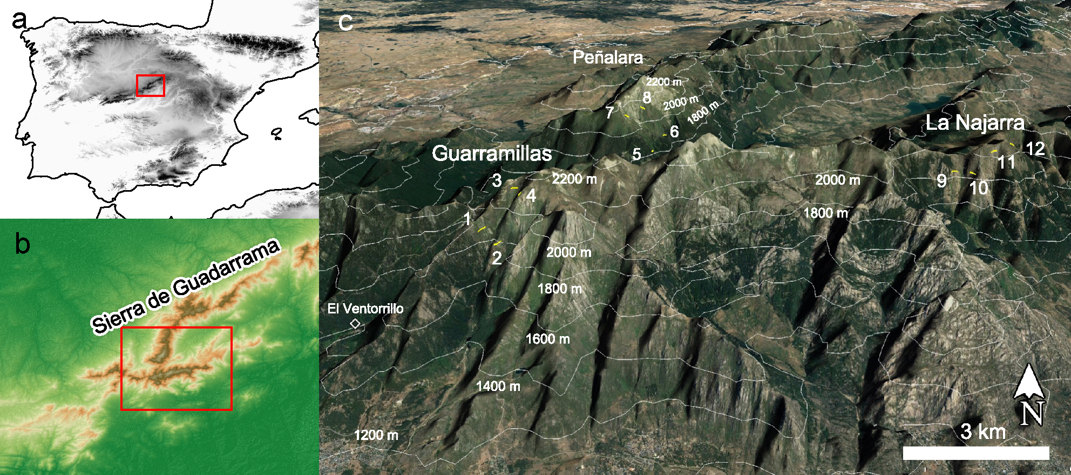
Figure 1. Study area. A) Location of Sierra de Guadarrama in the Central System and the Iberian Peninsula. B) Study area within the Sierra de Guadarrama. C) Location of line transects of 200 m where we surveyed the lizard communities repeatedly during the springs of 2013 and 2014. Image modified from Google Earth

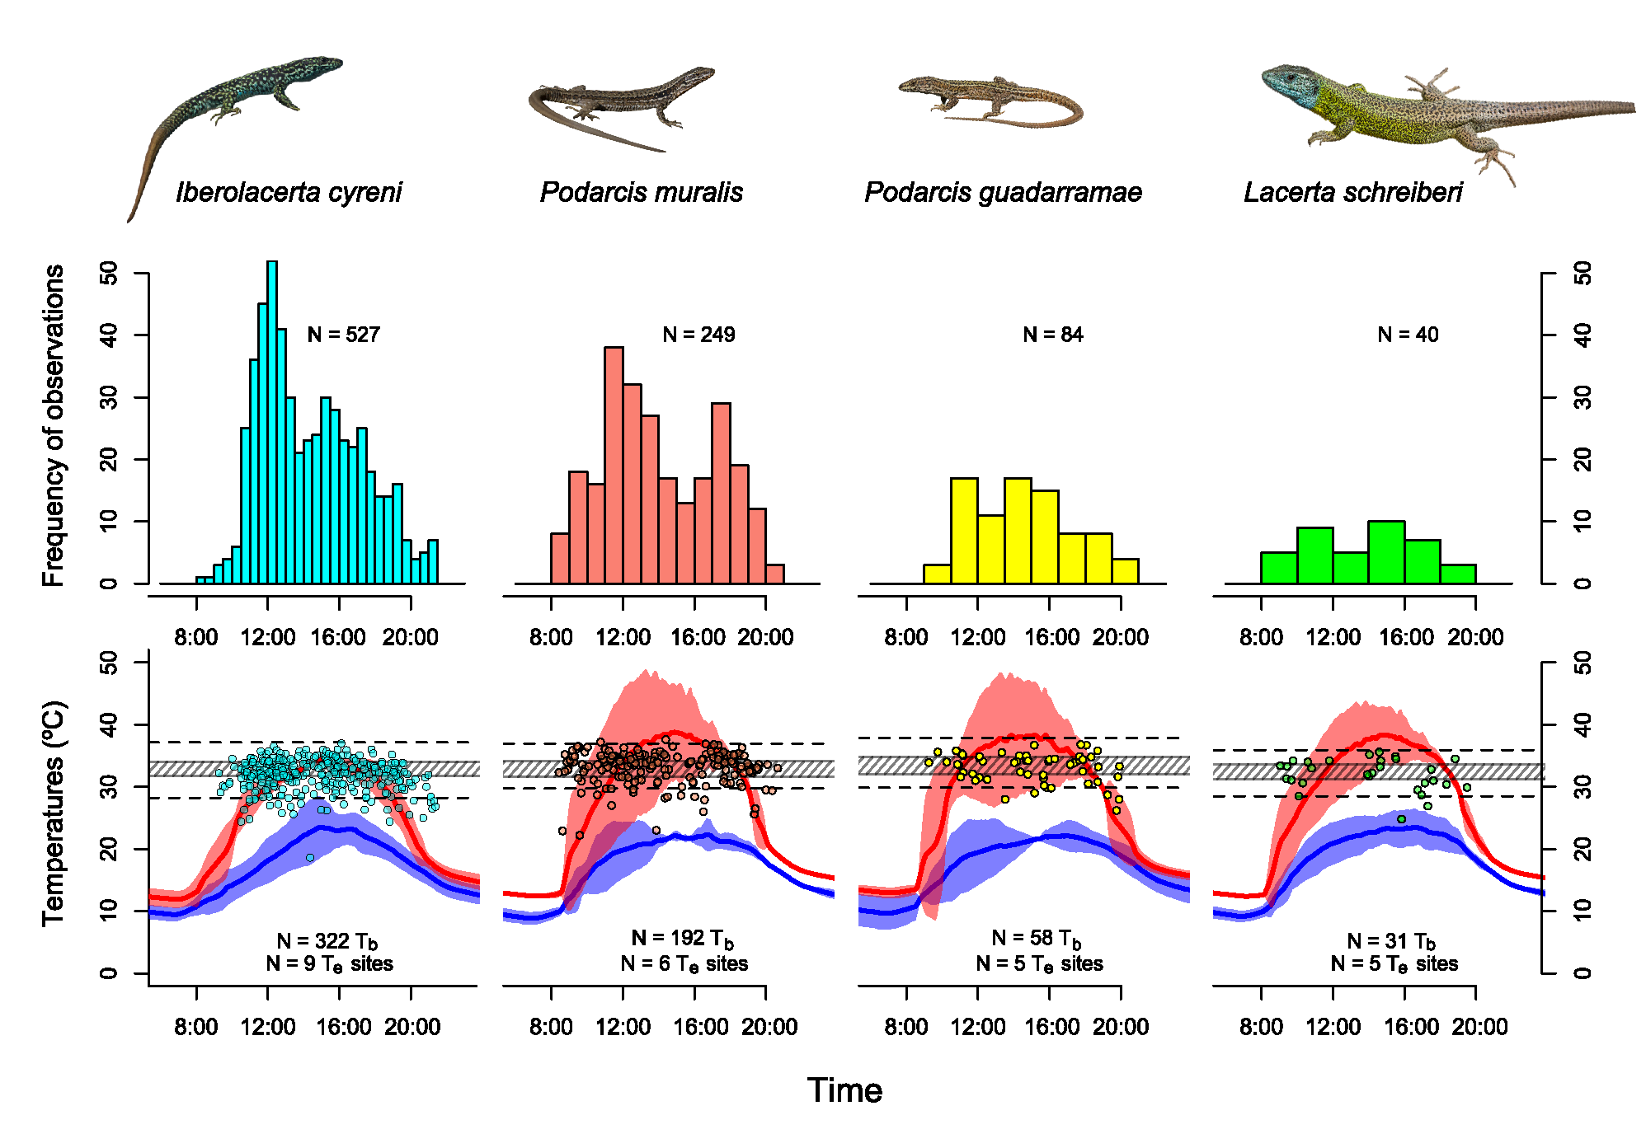
Figure 2. Daily activity patterns of four Lacertidae and the operative temperatures (T_{e}) in their habitats at 1800-2150 m in the Sierra de Guadarrama, Spain. In the second row, the averaged maximum operative temperatures T_{e} are represented by a red line with their 95% confidence intervals in red shade, and minimum operative temperatures are analogously represented in blue. Dots represent records of body temperatures for each species. Cross-hatched rectangles indicate the set point range T_{set}, measured in the laboratory for every species, while the dashed horizontal lines are the thermal limits we assumed to define activity: the upper one, mean voluntary maximum T_{Vmax} measured in laboratory; the lower one, the10 percentile of body temperatures observed in active individuals in the field, which we used as a proxy of emergence temperature T_{emerge}.

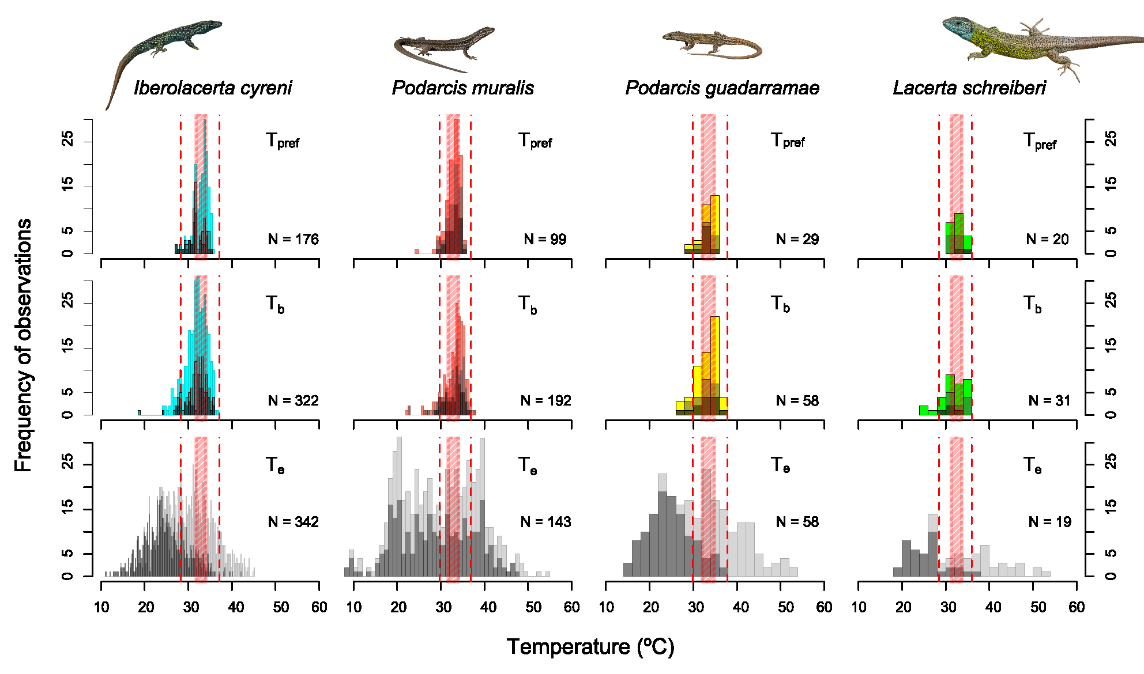
Figure 3. Distributions of body temperatures T_{b} measured in the field and operative temperatures T_{e} in Lacertidae lizard populations of the Sierra de Guadarrama aboe 1800 m, during the May-August 2013 and 2014, illustrating the accuracy and effectiveness of thermoregulation. In the first row, bright colours represent body temperatures measured in males, while the darker parts are females, being the gravid ones even darker. In the second row, the operative temperatures of plastic models simultaneous to active lizards observations are represented in two grey intensities: light grey for models exposed to full sun and dark grey for models in half shade conditions. Red cross-hatched rectangles indicate the set point range T_{set}, measured in the laboratory for every species, while the red dashed vertical lines are the thermal limits we assumed to define activity: the upper one, mean voluntary maximum T_{Vmax} measured in laboratory; the lower one, the10 percentile of body temperatures observed in active individuals in the field, which we used as a proxy of emergence temperature T_{emerge}.

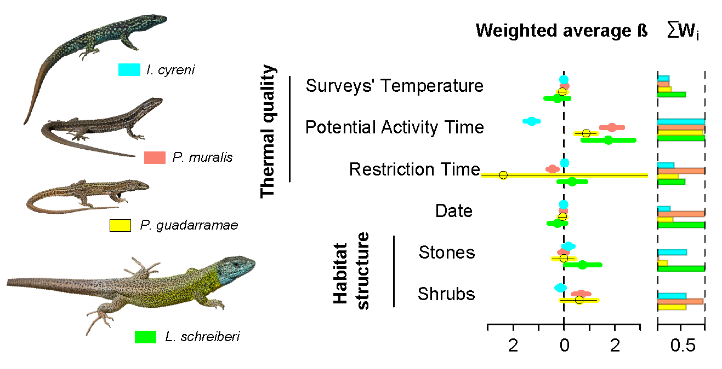
Figure 4. Graphic representation of the model averages from the sets of plausible ZIGLMM models (those with AICc two units lower than respective null models) explaining occurrences of the four lizard species present in the Sierra de Guadarrama above 1800 m: Iberolacerta cyreni (blue; averaged from 50 models), Podarcis muralis (salmon; averaged from 30 models), Podarcis guadarramae (yellow; averaged from 20 models) and Lacerta schreiberi (green; averaged from 3 models). In the left vertical axis, estimates of the weighted averages of standardized regression coefficients (dots), their unconditional standard errors (wider lines) and confidence intervals (thinner lines). In the right vertical axis, importance of variables contributing to explain variance of each species in lizard counts, defined as the sum of the AICc-based weights of plausible models in which a particular variable appears.

