Decoupled morphological and biomechanical evolution and diversification of the wing in bats
Camilo López-Aguirre^{1*}, Laura A. B. Wilson¹, Daisuke Koyabu^{2,3}, Vuong Tan Tu^{4,5} and Suzanne J. Hand¹
¹ PANGEA Research Centre, School of Biological, Earth & Environmental Sciences, University of New South Wales, Sydney, NSW 2052, Australia.
² Jockey Club College of Veterinary Medicine and Life Sciences, City University of Hong Kong, Tat Chee Avenue, Kowloon, Hong Kong.
³ Department of Molecular Craniofacial Embryology, Tokyo Medical and Dental University, 1-5-45 Yushima, Bunkyo-ku, Tokyo 113-8549 Japan.
⁴ Institute of Ecology and Biological Resources, Vietnam Academy of Science and Technology, No. 18, Hoang Quoc Viet road, Cau Giay district, Hanoi, Vietnam.
⁵ Graduate University of Science and Technology, Vietnam Academy of Science and Technology, No. 18, Hoang Quoc Viet road, Cau Giay district, Hanoi, Vietnam.
* Correspondence author: c.lopez-aguirre@unsw.edu.au

Abstract
Bats use their forelimbs in different ways, flight being the most notable example of morphological adaptation. However, different behavioural specializations beyond flight have also been described in several bat lineages. Understanding the postcranial evolution during the locomotory and behavioural diversification of bats is fundamental to understanding bat evolution. We investigate whether different functional demands influenced the evolutionary trajectories of humeral cross-sectional shape and biomechanics. We found a strong ecological signal and no phylogenetic structuring in the morphological and biomechanical variation in humerus phenotypes. Decoupled modes of shape and biomechanical variation were consistently found, with size and diet explaining variation in shape and biomechanics respectively. We tested both hypothesis- and data-driven multivariate evolutionary models, revealing decoupled pathways of evolution across different sections of the humerus diaphysis. We found evidence for a complex evolutionary landscape where flight might have acted as an evolutionary constraint, while size- and diet-based ecological opportunities facilitated diversification. We also found shifts in adaptive regimes independent from the evolution of flight (i.e. terrestrial locomotion and upstand roosting). Our results suggest that complex and multiple evolutionary pathways interplay in the postcranium, leading to the independent evolution of different features and regions of skeletal elements optimised for different functional demands.

Introduction
Animal locomotion is a key component of the ecological interactions that shape ecosystem functioning (Denzinger and Schnitzler 2013; da Silva et al. 2014). From foraging to reproduction, locomotory strategy has an important role in the evolvability and adaptability of taxa (Witton 2015; Dececchi et al. 2016) by shaping biological traits both at a micro- and macroscale (Patel et al. 2013; Martin-Serra et al. 2014; Verde Arregoitia et al. 2017; Medina et al. 2018; Luo et al. 2019). Locomotion has also been a major evolutionary driver in animals, enabling occupation of novel ecological niches in some cases (Simmons et al. 2008; Sallan and Friedman 2012) and an evolutionary constraint limiting adaptability in other cases (McInroe et al. 2016; Gutarra et al. 2019). Phenotypic specialisations have evolved (e.g. increased bone density and higher metabolic rates), fulfilling the functional demands associated with locomotory strategies (Hand et al. 2009; Voigt et al. 2012; Carter and Adams 2016; Dececchi et al. 2016). Moreover, phenotypic adaptations for locomotion also have a phylogenetic component, reflecting evolutionary relationships among taxa (Fabre et al. 2015). Nevertheless, the link between phylogeny, ecology and morphology in studies of bat locomotion has proven to be variable and sometimes inconsistent with predictions based on various ecomorphological hypotheses (Diogo 2017).
Vertebrate self-powered flight evolved independently in three speciose groups: pterosaurs (ca. 200 species), birds (ca. 10000 species) and bats (ca. 1400 species). Flight was a key innovation that provided a major ecological opportunity for these groups, enabling them to diversify into a vast range of previously empty niches (Stroud and Losos 2016). The convergent evolution of vertebrate flight was asynchronous, with pterosaurs evolving flight first (≈240 Mya), followed by birds (≈140 Mya), and bats (≈60 Mya) (Organ and Shedlock 2009). Throughout their evolution, flying vertebrates have been extremely successful at colonising and partitioning a variety of previously unexploited niches while avoiding competitive exclusion (McGowan and Dyke 2007). All flying vertebrates show some extreme postcranial morphological adaptations for flight, including highly modified forelimbs as wings (Rayner 1988; Norberg 1990; McGowan and Dyke 2007). Reduction of cortical bone thickness (Cubo and Casinos 1998), increased bone density of other bones (Dumont 2010), morphological changes in the pectoral girdle (Currey and Alexander 1985), and elongation of forelimb bones are some of the adaptations that these groups share (Lee and Simons 2015).
The relatively abundant fossil record of pterosaurs and birds has facilitated the study of the evolution of flight in these groups (Sato et al. 2009; Henderson 2010; Witton and Habib 2010; Dececchi et al. 2016). Bat flight evolution, on the other hand, has been relatively more difficult to study due to the incompleteness of the fossil record (Eiting and Gunnell 2009; Brown et al. 2019). Onychonycteris finneyi, known from one of the oldest bat skeletons, displays all the morphological characteristics needed to generate self-powered flight, indicating that flight evolved early in the history of this group (Simmons et al. 2008). Moreover, no transitional skeletal form between true flying bats and their non-flying ancestor have been found, leaving a significant gap in the known evolutionary history of bat flight. Nonetheless, a transition from an ancestral shrew-like arboreal insectivore to an Onychonycteris-like bat ancestor has been proposed as the most plausible scenario (Simmons et al. 2008; Gunnell et al. 2014; Hand et al. 2015b; Hand and Sigé 2018).
Recent studies have provided insights into flight evolution in bats based on analyses of both fossil and modern taxa (Amador et al. 2018; Amador et al. 2019a; Amador et al. 2019b). Aerofoil reconstruction of O. finneyi derived from aerodynamic modelling indicates that it had a primitive locomotor apparatus, and that the rapid evolution of the handwing was a key innovation during flight evolution (Amador et al. 2019b). The presence and diversity of sesamoid elements in the postcranium has also been associated with evolutionary pathways that led to modern ecological and locomotory variability in bats (Amador et al. 2018). A phylogenetic interpretation of traditional aerodynamic variables suggests an Oligo-Miocene aerial diversification in bats was associated with dietary specialisations, loss of echolocation in one lineage and optimal adaptation to environmental change (Amador et al. 2019a). Anatomical descriptions and phylogenetic analyses of the ankle in bats have provided evidence for the functional and evolutionary role that the calcar could have had during the evolution of flight manoeuvrability (Stanchak and Santana 2018; Stanchak et al. 2019). Evolutionary interpretations of developmental trajectories in bats have shown a shift from the general mammalian developmental plan in the development of flight-related bones, showing similarities with avian development (López-Aguirre et al. 2019a). Bat postcranial development has also been found to be highly variable across taxa, evidencing a phylogenetic structuring in its variability that corresponds to cladogenesis of the two main lineages (i.e. Yangochiroptera and Yinpterochiroptera) López-Aguirre et al. (2019b).
Bats evolved different flight strategies varying mainly in manoeuvrability (i.e. understory to open-air foragers) and speed (i.e. hovering to fast-flying) (Canals et al. 2011; Marinello and Bernard 2014). Hovering and slow, highly-manoeuvrable flight enabled the evolution of nectarivory and frugivory in New World bats, whereas fast flight is associated with the evolution of hawking and trawling (Canals et al. 2011). The interaction between aspect ratio and wing loading has been widely used to describe the range of wing morphology in bats and its interaction with flying behaviours (Riskin et al. 2010; Iriarte-Diaz et al. 2012; Marinello and Bernard 2014; Hedenstrom and Johansson 2015). These variables integrate the length, width and weight of the wing to characterise the overall structure of the wing and describe ecomorphological aerial guilds (Norberg and Rayner 1987; Norberg 1990; Marinello and Bernard 2014; Hedenstrom and Johansson 2015).
Although the forelimb skeleton of bats is adapted primarily to facilitate flight, bats display a wide range of locomotor and ecological behaviours aside from flying and these represent novel forelimb motion strategies (Dickinson 2008). Terrestrial locomotion and upstand roosting are rare behaviours that represent a different use of the bat forelimb (Riskin et al. 2005; Riskin et al. 2006; Hand et al. 2009; Fenton 2010; Schliemann and Goodman 2011). The polyphyly of bat nectarivory is widely accepted, suggesting that hovering flight might have also evolved more than once in bats (Datzmann et al. 2010), although this hypothesis has not yet been explicitly tested.
Terrestrial locomotion evolved independently in vampire bats (Desmodontinae), some molossid species (e.g. Cheiromeles) and species of the family Mystacinidae (Riskin et al. 2005). Terrestrial locomotion in vampire bats has been suggested to provide an evolutionary advantage, enabling them to chase prey that flees during a feeding event at the lowest energetic cost possible (Riskin et al. 2005; Riskin et al. 2006; Hand et al. 2009). Terrestrial locomotion in Mystacinidae was initially considered a result of insular flightlessness (Riskin et al. 2005; Riskin et al. 2006). However, analysis of fossil mystacinid species from Australia revealed that mystacinid terrestrial locomotion evolved before geographic isolation in New Zealand, positing a new hypothesis driven by selective advantage or energetic benefit (Hand et al. 2009; Hand et al. 2013; Hand et al. 2015a; Hand et al. 2018).
Upstand roosting also evolved twice in the bat families Thyropteridae, from South and Central America, and Myzopodidae, from Africa and Madagascar (Fenton 2010). Each family developed a unique set of adhering structures on their wrists that enable upstand roosting (Riskin et al. 2005; Schliemann and Goodman 2011; Davalos et al. 2014). This novelty allowed these species to exploit new roosts, such as the inside of furled leaves (Riskin et al. 2005; Schliemann and Goodman 2011; Davalos et al. 2014).
Despite study of the evolutionary drivers of modern ecomorphological diversity in bats (Rossoni et al. 2017; Thiagavel et al. 2018; Arbour et al. 2019; Hedrick et al. 2019; Rossoni et al. 2019), the relationship between the evolution of ecological traits (e.g. diet and echolocation) and locomotory-related adaptations remains unclear. The advent of three-dimensional imaging techniques has allowed for the development of new methods to study the morpho-biomechanical properties of bones, providing new insights into the evolution and ecology of functional performance (Simons et al. 2011; Patel et al. 2013; Pratt et al. 2018; Voeten et al. 2018). Here we use 3D morphometric analysis to investigate the connection between postcranial morpho-biomechanical variability and ecological diversity in modern bats, from a macroevolutionary perspective. We focus on the cross-sectional geometry and biomechanical properties of the humerus, a bone specialised in bats to withstand high mechanical loading (Swartz et al. 1992; Watts et al. 2001). In order to detect differences in functional specialisations across the bone (e.g. loading resistance in the shaft), cross-sections were extracted from the diaphysis and the proximal and distal metaphyses (Kilbourne and Hutchinson 2019). We recreate the macroevolutionary patterns of humeral morpho-biomechanical diversification by testing competing evolutionary models. Given the close interaction between feeding and locomotion in bats, we hypothesise that diet represents an adaptive opportunity that promoted phenotypic diversification in the humeri of bats.

Materials and methods

Sample description and digitisation
55 adult specimens were analysed in this study, covering a wide phylogenetic (37 species, 20 families and both bat suborders), dietary (five of seven broad dietary categories recognised in bats) and body size range (10-fold range in body mass) (Fig. 1). Alcohol-preserved specimens were sourced from the Western Australian Museum and research collections at the University of New South Wales and City University of Hong Kong (Appendix Table 1). The specimens were scanned at Musashino Art University using a microCT system (inspeXio SMX-90CT Plus, Shimadzu) with 90kv source voltage and 100mA source current at a resolution of 15μm, and a U-CT (Milabs, Utrecht) at UNSW Sydney with 55kV and 0.17 mA, ultrafocused setting at a resolution of 35-50 μm. Additional species were sampled from whole-body scans sourced from Digimorph (Appendix Table 1). Segmentation of humeri was performed using the thresholding tool in MIMICS v. 20 software (Materialise NV, Leuven, Belgium). To control the unwanted effect of bilateral asymmetry, only left humeri were sampled.
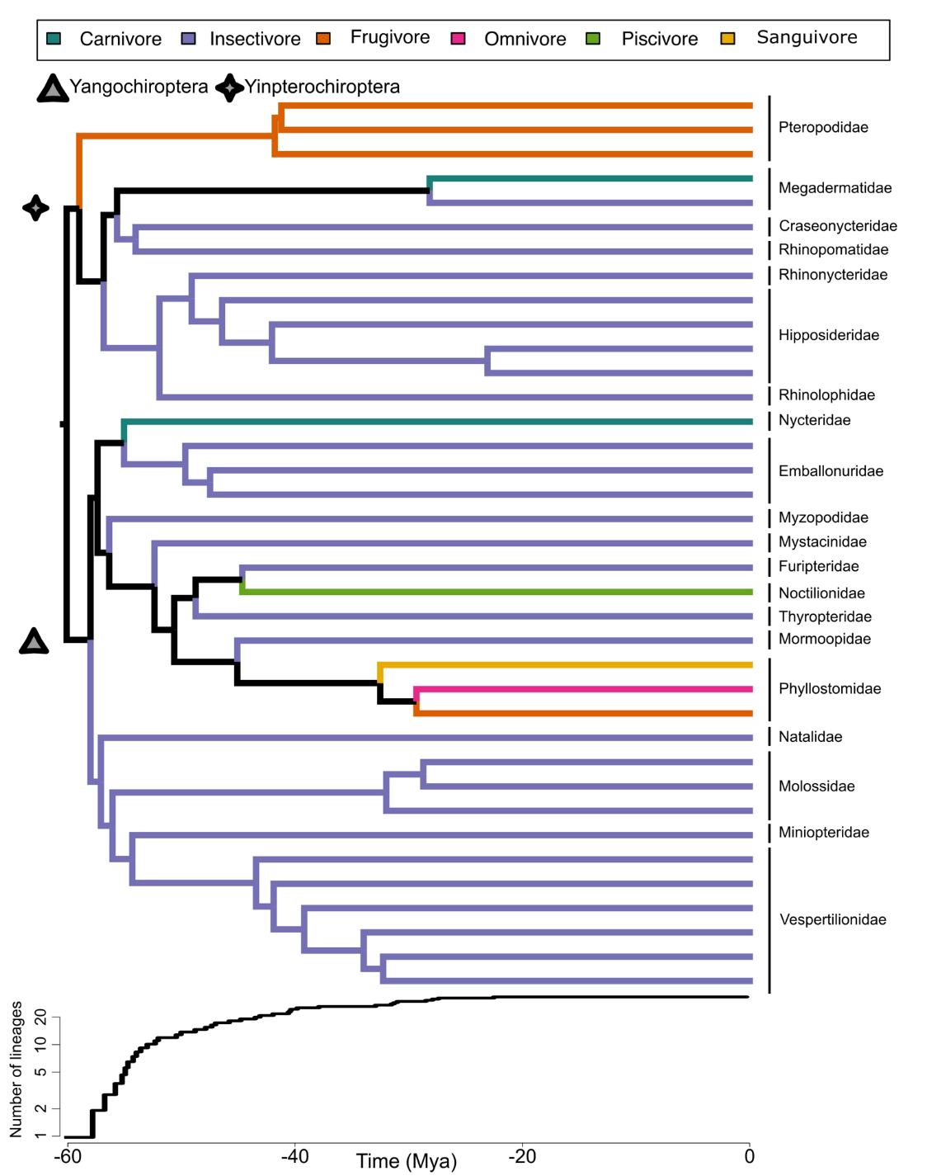
Figure 1. Phylogenetic reconstruction of the evolutionary relationships between the sampled species (top), based on Shi and Rabosky (2015). Colours of branches represent different dietary categories. Subordinal clades are marked in the phylogeny. Lineage through time plot (bottom) showing temporal accumulation of lineages in our sample.

Extraction of landmark and biomechanical data
3D humeri models were imported into Rhinoceros 5.0 (Robert McNeel & Associates, Seattle, WA). To remove non-shape effects of translation, rotation and size, all bone models were aligned to a standard position in 3D space, following a protocol for long-bone cross-sectional geometry, equivalent to a Procrustes superimposition (Wilson and Humphrey 2015). To quantify differences in morpho-biomechanical properties along the bone, cross-sections of the humeri were extracted at 25%, 50% and 75% of the length of the bone in Rhinoceros 5.0. These locations are widely used as the most informative when analysing differences on biomechanical properties along long bones (Cubo and Casinos 1998; Simons et al. 2011; Patel et al. 2013). A total of 165 cross sections were then aligned based on the position of the centroid of the cross-sections in the world coordinate system. A set of 16, equiangular landmarks were semi-automatically placed along the periosteal surface of the model to describe the cross-sectional shape of the humerus (Fig. 2), following the method described in Wilson and Humphrey (2015).
For our biomechanical dataset we extracted four cross-sectional properties of the humerus usually used to describe aerial guilds in flying vertebrates (Wolf et al. 2010; Simons et al. 2011; Voeten et al. 2018): polar moment of inertia of an area (J), ratio of maximum to minimum second moments of area (I_{max}/I_{min}), ratio of second moments of area about the x and y axes (I_{x}/I_{y}), and circularity (CircMaxR). J is a measure of resistance against torsional forces (Voeten et al. 2018). I_{max}/I_{min} measures relative maximum bending strength of the bone at that cross-section, whereas I_{x}/I_{y} measures the bending strength in the anterior-posterior plane relative to the medial-lateral plane (Ruff 1987). CircMaxR is a ratio between the maximum to actual circumference of a cross section, measuring the overall robusticity of a long bone, based on how circular the cross section is (Wilson and Humphrey 2015). All biomechanical properties were quantified using outputs from the AreaMoments command in Rhinoceros 5.0 (Wilson and Humphrey 2015).
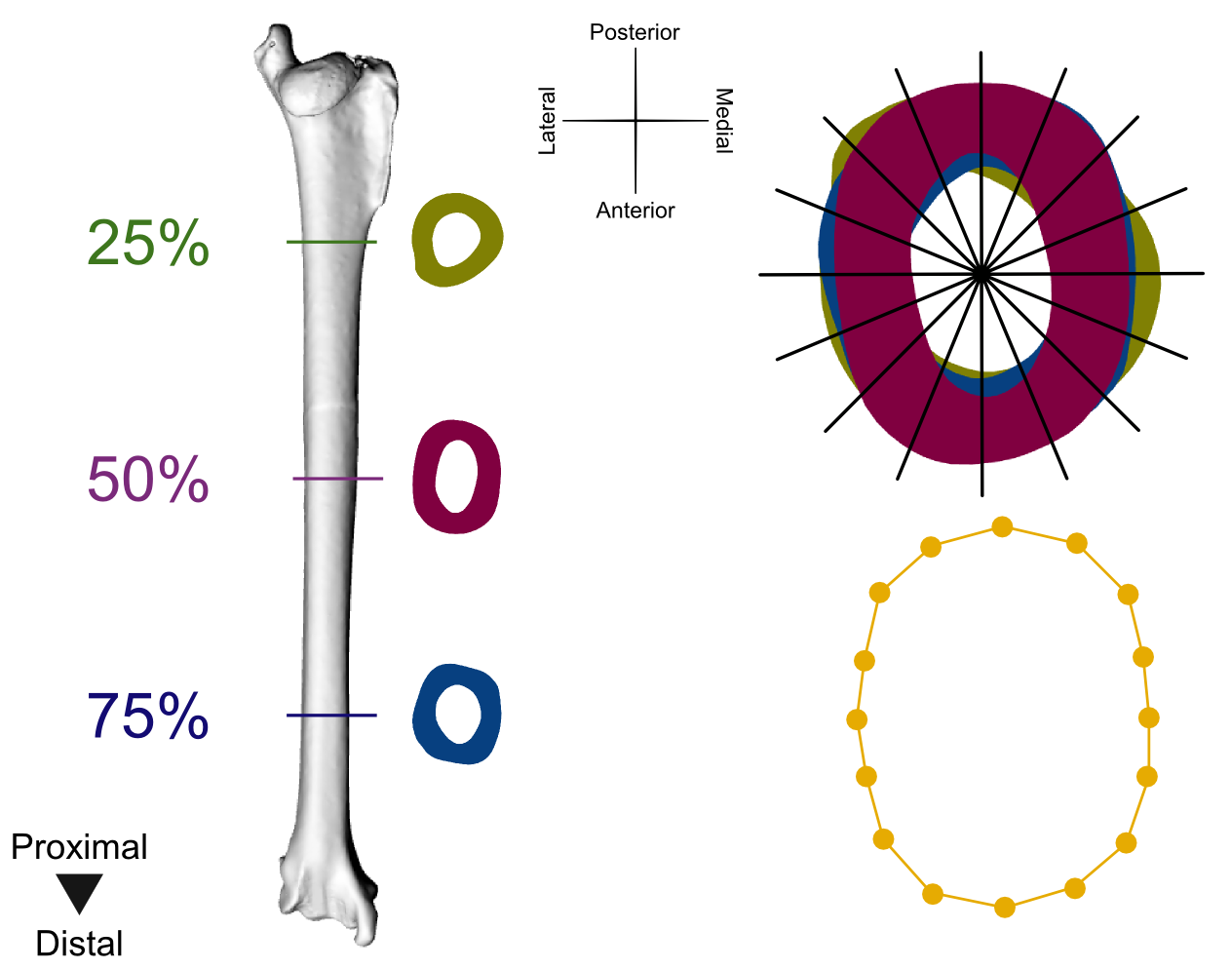
Figure 2. Three-dimensional virtual reconstruction of the humerus of Austronomus australis, showing a schematic representation of the cross-sectioning and landmarking protocol used in this study. Landmarks were collected at the intersection of equiangular radii and the periosteal contour of the cross section.

Ecological and phylogenetic characterisation of species
We compiled taxonomic arrangement, body size, diet and sex data for all species. These parameters were assessed in relation to morpho-biomechanical properties of the humerus. Taxonomic arrangement was registered at subordinal level (i.e. Yangochiroptera or Yinpterochiroptera). Centroid size (CS) of species based on the 16 cross-sectional landmarks was categorised as either small, medium or large, using an equal-width interval discretisation, implemented in the “discretize” function in the arules R package (Hahsler et al. 2011). Based on the correlation between body size and humeral cross-sectional diameter, we used the CS of the midshaft cross-section as a proxy for body size (Gunnell et al. 2009). Dietary categories comprised frugivory, insectivory, carnivory, piscivory and omnivory, and followed broad dietary classifications used in previous studies (Santana et al. 2012; Arbour et al. 2019).

Statistical analyses
In order to assess whether the macroevolutionary patterns of shape and biomechanics were divergent, each dataset was analysed independently. Generalised Procrustes analysis was used to retrieve the CS of all cross-sections using the “gpagen” function in the Geomorph R package (Adams et al. 2013; Adams et al. 2017). Log-transformed CS was then used to test the effect of size on cross-sectional shape and biomechanics, evaluating the presence of evolutionary allometry, using a Procrustes regression with the “procD.lm” function in Geomorph (Adams et al. 2013; Adams et al. 2017). Given the strong statistical significance of evolutionary allometry in shape and J, the residuals of each regression were used as size-corrected shape and biomechanical data (raw values of I_{max}/I_{min}, I_{x}/I_{y} CircMaxR were kept for further analyses) in all subsequent analyses. Species with multiple individuals were analysed based on the mean shape of the specimens using the “mshape” function in Geomorph for R.
We found no statistical significance for the effect of sex in morpho-biomechanics in our datasets. Phylogenetic ANOVAs (PGLS) were used to test differences in morpho-biomechanical properties of the humerus, while accounting for the inter-dependence in phenotypic variability due to evolutionary relatedness (Adams and Collyer 2018). Shi and Rabosky (2015)’s species-level bat super-tree was used as the phylogenetic hypothesis of evolutionary kinship in our sample; PGLS was implemented using the “procD.pgls” function in Geomorph (Adams et al. 2013; Adams et al. 2017). Morpho-biomechanical differences were tested across species, families, suborders, diet and size categories. Using a Principal Component Analysis (PCA) to visualise and summarise the dimensionality in our data, we reconstructed the spaces of morphometric and biomechanical variation (hereafter, morphospace and mechanospace, respectively), using the “plotTangentSpace” function in Geomorph. This was repeated for each section of the bone independently. Given the lack of a phylogenetic signal and a concentration of most of the variation (> 80%) in our datasets in the first PC two axes, we did not implement a phylogenetic correction for the PCA (Uyeda et al. 2015).
To estimate the level of association between the morpho- and mechanospaces along the bone, we first constructed pairwise Euclidian distance matrices between species based on the PC scores of the first two PC axes of each space (>80% of variance explained). Next, we implemented two different regimes of pairwise Mantel tests of the distance matrices: one testing the correlation between morphospace and mechanospace at each cross-section of the bone, and another testing the integration of each space across the different sections of the bone (Sherratt et al. 2017; Vidal-García and Scott Keogh 2017). This approach was implemented using the “dist” and “mantel” functions of the stats and vegan R packages (Dixon 2003). We used the Kmult (K−) statistic of the “physignal” function in Geomorph (Adams 2014) to test whether morpho-biomechanical differences between taxa had a phylogenetic structure reflecting evolutionary relatedness. We estimated differences in the amount of morphological and biomechanical disparity between dietary, size and subordinal categories, using the “morphol.disparity” function in Geomorph for R (Adams et al. 2017). Lastly, in order to test whether the evolutionary dynamics of morpho-biomechanical change differ based on ecological traits, we compared the net rates of evolution assuming a BM model of phenotypic evolution, using the “compare.evol.rates” in Geomorph (Adams et al. 2017).

Evolutionary trajectories of trait diversification
Disparity through time (DTT) analyses were used to assess the temporal dynamics of variability in morpho- and mechanospaces, as implemented in the “dtt” function in the R package geiger (Pennell et al. 2014). Using PC1-3 (which accounted for > 80% of phenotypic variation) scores from each dataset as input, we compared observed trait disparity to that expected under brownian motion (BM; constant-rate, random walk process) by simulating morphometric and biomechanical evolution 10,000 times across the tree, using the morphological disparity index (MDI) (Slater et al. 2010). This approach quantifies the relative subclade disparity at each internal node of the tree. It is anticipated that in adaptive radiations disparity would be highly partitioned among early-divergent clades, with more recent clades explaining smaller portions of total disparity (significant negative MDI values are expected) (Slater et al. 2010).
To recreate the evolutionary processes of morpho-biomechanical diversification we fitted five models of evolution (using PC1-3 scores from each dataset), based on different evolutionary scenarios: single-rate BM, single-peak early burst (EB), single-peak Ornstein-Uhlenbek (OU1), a three-peak OU model where each CS category had a separate optimum (OU-SIZE), and a five-peak OU model where each dietary category had a separate optimum (OU-DIET). BM models assume trait variance increasing linearly across time, proportional to lineage accumulation (Felsenstein 1973). Early burst (EB) assumes a decreasing temporal trend of trait variance after an early rapid diversification driven by ecological opportunity, consistent with an adaptive radiation (Harmon et al. 2010). Ornstein-Uhlenbeck (OU) processes incorporate stabilising selection, constraining trait variance through time towards adaptive optima (Hansen 1997). All multivariate models were fitted using the mvMORPH R package (Clavel et al. 2015), and model comparison was based on the sample-size corrected Akaike Information Criterion (AICc). Lastly, we identified evolutionary shifts in adaptive peaks across the phylogeny for each dataset (PC1-3 scores) using a data-driven approach developed in the PhylogeneticEM R package (Bastide et al. 2018). Contrary to the evolutionary models described above that rely on a priori hypotheses, this method can test evolutionary hypotheses of trait diversification informed by specific features of a given taxa. We identified shifts (set at a maximum of 10) in morpho- and mechanospace separately, using the scalar OU model in PhylogeneticEM that builds the full evolutionary rate matrix while accounting for multivariate correlations (Bastide et al. 2018).

Results

Evolutionary allometry
Procrustes regression analyses showed a significant effect of allometry on shape and biomechanics across all sections of the humerus (Table 1). In order to test allometry-corrected patterns of trait variability, all posterior analyses on shape were performed on the residuals of the shape~CS regression model. In-depth tests of allometry on biomechanics revealed that only J is highly size-dependent, driving the overall allometry found in biomechanics. Therefore, residuals of J ~CS regression model were used as J values in further analyses. Procrustes ANOVAs did not reject the null hypothesis of equal patterns of trait variation between sexes, refuting the presence of sexual dimorphism in our datasets (Appendix Table 2). A total of 30 PGLS were implemented to test differences in morpho-biomechanical variance based on taxonomic arrangement (at species, family and subordinal levels), diet and CS categories at each cross-section of the bone (25%, 50% and 75%). We found consistent patterns between our morphometric and biomechanical datasets, with size and diet being the most statistically significant variables across all cross-sections (Appendix Table 3). Size-dependent differences were significant for both datasets and diet-dependent differences were significant for our shape data only. On average, 27.36% of the variation in our datasets was explained by diet (34.59% and 20.14% in shape and biomechanics, respectively). Size explained 31.25%, with a marked difference in the explained variance of shape and biomechanics (52.45% and 10.05%, respectively).
Table 1. Individual multivariate linear regressions for the test of evolutionary allometry, based on an isometric null hypothesis.
 | Df | SS | MS | Rsq | F | Z | P
Shape
25% | 1 | 64.295 | 64.295 | 0.40548 | 36.148 | 3.3548 | <0.001
50% | 1 | 66.537 | 66.537 | 0.61392 | 85.866 | 3.3358 | <0.001
75% | 1 | 47.723 | 47.723 | 0.35183 | 29.311 | 2.8373 | <0.001
Biomechanics
25% | 1 | 873.27 | 873.27 | 0.53067 | 59.927 | 2.4167 | <0.001
50% | 1 | 355.51 | 355.51 | 0.46212 | 46.394 | 2.3625 | <0.001
75% | 1 | 655.41 | 655.41 | 0.35005 | 29.084 | 2.2697 | <0.001

Ecological differences in morpho- and mechanospaces
Based on the PCAs performed for each dataset at each cross-section, the first two principal components of the morpho- and mechanospaces explained an average of 96.81% of the variance in our data (93.66% and 99.95% for morpho- and mechanospace, respectively). For both datasets and across cross-sections, PC1 primarily divides species of different CS categories, with some overlap between small and medium-sized species (Fig. 3). Dispersion of small and medium-sized species across the PC1 of morphospace showed a greater separation between all size categories (Fig. 3a, c and e), with smaller species concentrating in the negative axis of PC1, and medium-sized to large species distributed along the positive axis. Mechanospaces showed secondary clustering between species of similar diets, with animalivorous diets showing complete overlap in their subspaces (Fig. 3b, d, and f). PC1 of mechanospace (explaining >90% of variation) was mostly influenced by changes in J.
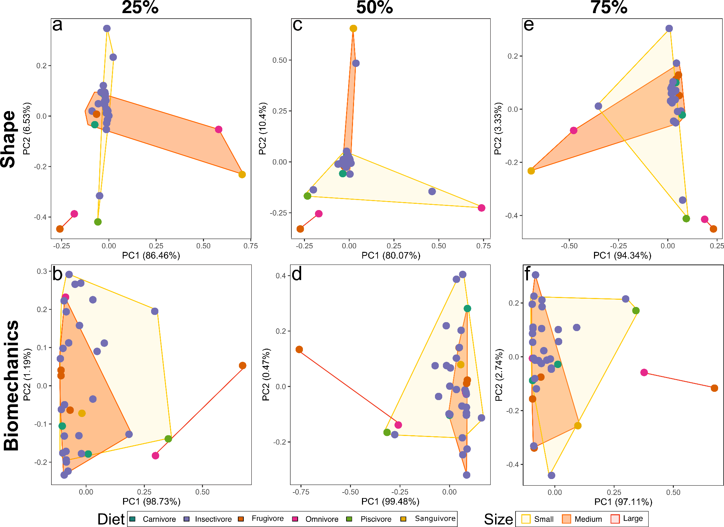
Figure 3. Morphospace (top) and mechanospace (bottom) of humerus cross-sectional shape and biomechanical data from the first two PCs. Morpho- and mechanospaces were constructed separately for cross-sections of the humerus extracted at 25%, 50% and 75% of bone length. Data points are colour-coded by dietary category, whereas convex hulls represent centroid size (CS) categories.
Tests for differences in morphological disparity revealed significant size-dependent differences in mechanospace, whereas morphospace showed significant diet-dependent differences (Fig. 4). Shape disparity was consistently higher in sanguivore and omnivore species, the former being significantly different from the rest. An inter-cross-sectional pattern of biomechanical disparity was evident, disparity increasing with size, and being significantly different in large species, compared to the rest. Based on non-significant K- statistics, we rejected the presence of a phylogenetic signal in our datasets for any of the cross-sections studied (Appendix Table 4).
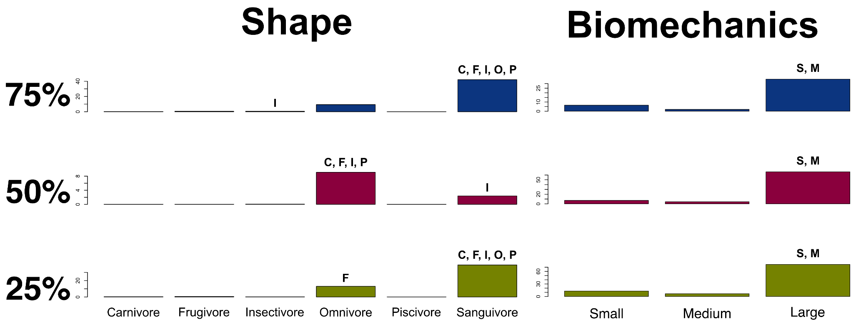
Figure 4. Phenotypic disparity based on trait variance for shape (left) and biomechanics (right), across the 25% (bottom), 50% (middle) and 75% (top) cross-sections. Shape disparity was deconstructed based on centroid size (CS) categories, and biomechanical disparity based on dietary categories. Letters on top of bars represent statistically significant differences from small (S), medium-sized (M), large (L), frugivore (F) and omnivore (O) species.

Morpho-biomechanical integration
Mantel tests of inter-cross-sectional covariation in the dispersion of taxa in morpho- and mechanospace showed that variance in each dataset was significantly correlated across cross-sections (more in shape than in biomechanics), indicating high integration along the bone (Table 2). Moreover, Mantel tests of correlation in the dispersion of taxa between morpho- and mechanospace showed similar patterns of variation between datasets in all of the cross-sections (25%).

Table 2. Mantel-based comparisons of covariation in the dispersion of taxa across morpho- and mechanospace based on pairwise Euclidian distance matrices. Comparisons between cross-sections were used to test the level of integration in shape (above the diagonal) and biomechanics (below the diagonal). Comparisons within cross-sections were used to test the level of association between both datasets (diagonal).
 |  | 25% | 50% | 75%
Mantel R statistic | 25% | 0.4502 | 0.6633 | 0.845
 | 50% | 0.6707 | 0.4497 | 0.6465
 | 75% | 0.7074 | 0.7282 | 0.5246
P values | 25% | 0.002 | 0.001 | 0.001
 | 50% | 0.001 | 0.001 | 0.001
 | 75% | 0.001 | 0.001 | 0.001
Values in bold represent statistical significance at P < 0.05.

Evolutionary model testing
Comparison of net evolutionary rates showed significant differences for both datasets based on diet and size (Appendix Table 5). DTT analyses indicated that each dataset had consistent temporal trajectories of disparity between cross-sections (Fig. 5). MDI values could not reject the null hypothesis of evolution under BM (most values were consistently positive and all were non-significant), rejecting an early morpho-biomechanical diversification under an EB model of evolution in disparity (Appendix Table 6). Evolution model comparisons revealed that each dataset reflects a distinctive evolutionary trajectory that was common across cross-sections (Table 3). Diet-informed (OU-DIET) OU evolutionary models were best supported for shape, whereas biomechanical evolution was better explained by size-informed (OE-SIZE) OU evolutionary models.
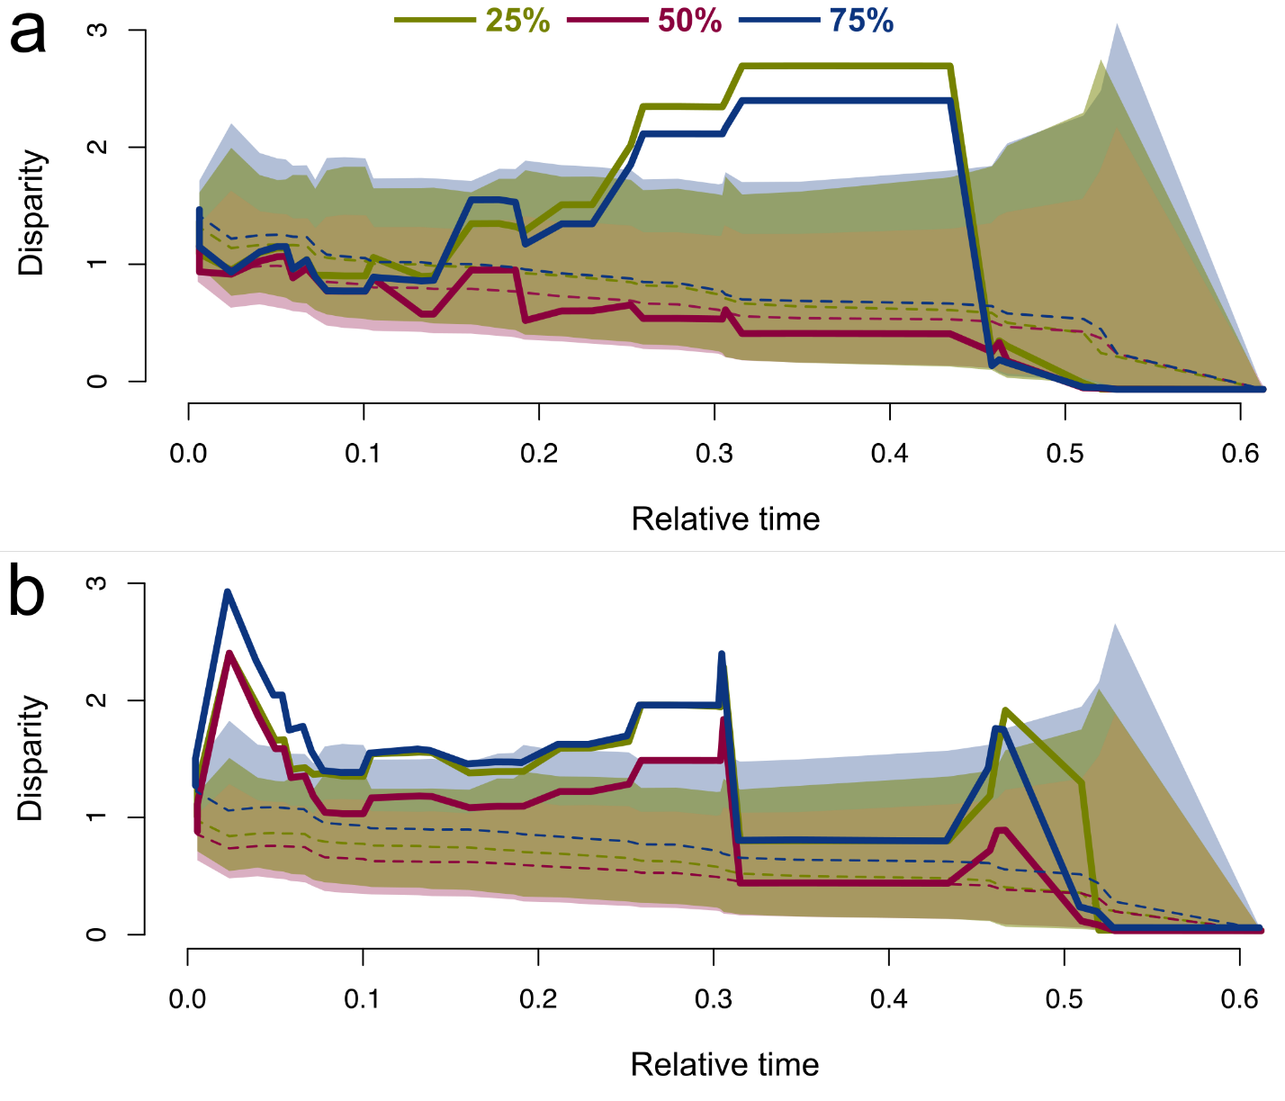
Figure 5. Disparity through time analysis of temporal patterns of phenotypic disparity in shape (a) and biomechanics (b) for each cross-section. Solid lines show the relative average disparity of subclades compared with the complete clade. Dashed lines represent the median expectation under a Brownian motion (BM) model of evolution based on 10000 simulations. Shaded areas represented 95% confidence intervals from each simulation.
Evolutionary shifts in adaptive peaks were found for both datasets and for all cross-sections, shape data showing a maximum of 11 shifts and biomechanics a maximum of eight shifts (Fig. 6). Shifts in shape evolution were found in taxa with highly modified metaphyses (Fig. 6A), whereas shifts in biomechanical evolution were generally found in taxa with extremely high J (Fig. 6B). Phylogenetic placement of these shifts showed that 78.94% occurred in Yangochiroptera (81% and 75% for shape and biomechanics, respectively), and that 47.36% occurred at family level (37.5% and 54.54% for biomechanics and shape, respectively). Shifts in adaptive peaks were found in families Craseonycteridae, Molossidae, Mormoopidae, Mystacinidae, Noctilionidae, Nycteridae, Phyllostomidae, Pteropodidae, Rhinonycteridae and Thyropteridae. Across datasets, the 25% cross-section showed the highest number of shifts. Shifts in shape exclusive to a single cross-section were found only for 25%, whereas exclusive shifts in biomechanics were found for every cross-section.

Table 3. Evolutionary model testing for cross-sectional shape and biomechanical data in three different sections of the humerus (at 25%, 50% and 75% bone length).
 | Cross-section | Model | LogLik | AICc | dAICc
Shape
 | 25% | BM | -86.9838 | 184.8768 | 116.4147
 |  | OU1 | -81.1673 | 185.9412 | 117.4791
 |  | EB | -86.9838 | 187.26 | 118.7979
 |  | OU-DIET | -5.9957 | 68.4621 | 0
 |  | OU-SIZE | -66.8736 | 169.1155 | 100.6534
 | 50% | BM | -76.5014 | 163.8851 | 47.609
 |  | OU1 | -71.4035 | 166.299 | 50.0229
 |  | EB | -76.5013 | 166.2564 | 49.9803
 |  | OU-DIET | -28.5302 | 116.2761 | 0
 |  | OU-SIZE | -55.7582 | 146.6351 | 25.2285
 | 75% | BM | -76.8312 | 164.5448 | 29.389
 |  | OU1 | -71.5611 | 163.1221 | 27.9663
 |  | EB | -76.8312 | 166.9161 | 31.7603
 |  | OU-DIET | -39.6534 | 135.1558 | 0
 |  | OU-SIZE | -56.1968 | 147.5122 | 12.3564
Biomechanics
 | 25% | BM | -120.096 | 251.1016 | 14.9109
 |  | OU1 | -116.121 | 255.8494 | 19.6587
 |  | EB | -120.096 | 253.4848 | 17.2941
 |  | OU-DIET | -103.744 | 263.9593 | 27.7686
 |  | OU-SIZE | -100.411 | 236.1907 | 0
 | 50% | BM | -94.2151 | 199.3125 | 26.3343
 |  | OU1 | -90.8788 | 205.2496 | 32.2714
 |  | EB | -94.2151 | 201.6838 | 28.7056
 |  | OU-DIET | -82.0203 | 219.8896 | 46.9114
 |  | OU-SIZE | -68.9298 | 172.9782 | 0
 | 75% | BM | -106.79 | 224.4627 | 27.8105
 |  | OU1 | -102.621 | 228.7333 | 32.0811
 |  | EB | -106.79 | 226.8341 | 30.1819
 |  | OU-DIET | -91.5648 | 238.9787 | 42.3265
 |  | OU-SIZE | -80.7668 | 196.6522 | 0
Log-likelihood (LogLik), sample-size corrected Akaike information criterion (AICc), and relative fit (dAICc) are shown. See Methods section for details on the Ornstein-Uhlenbek (OU) models.
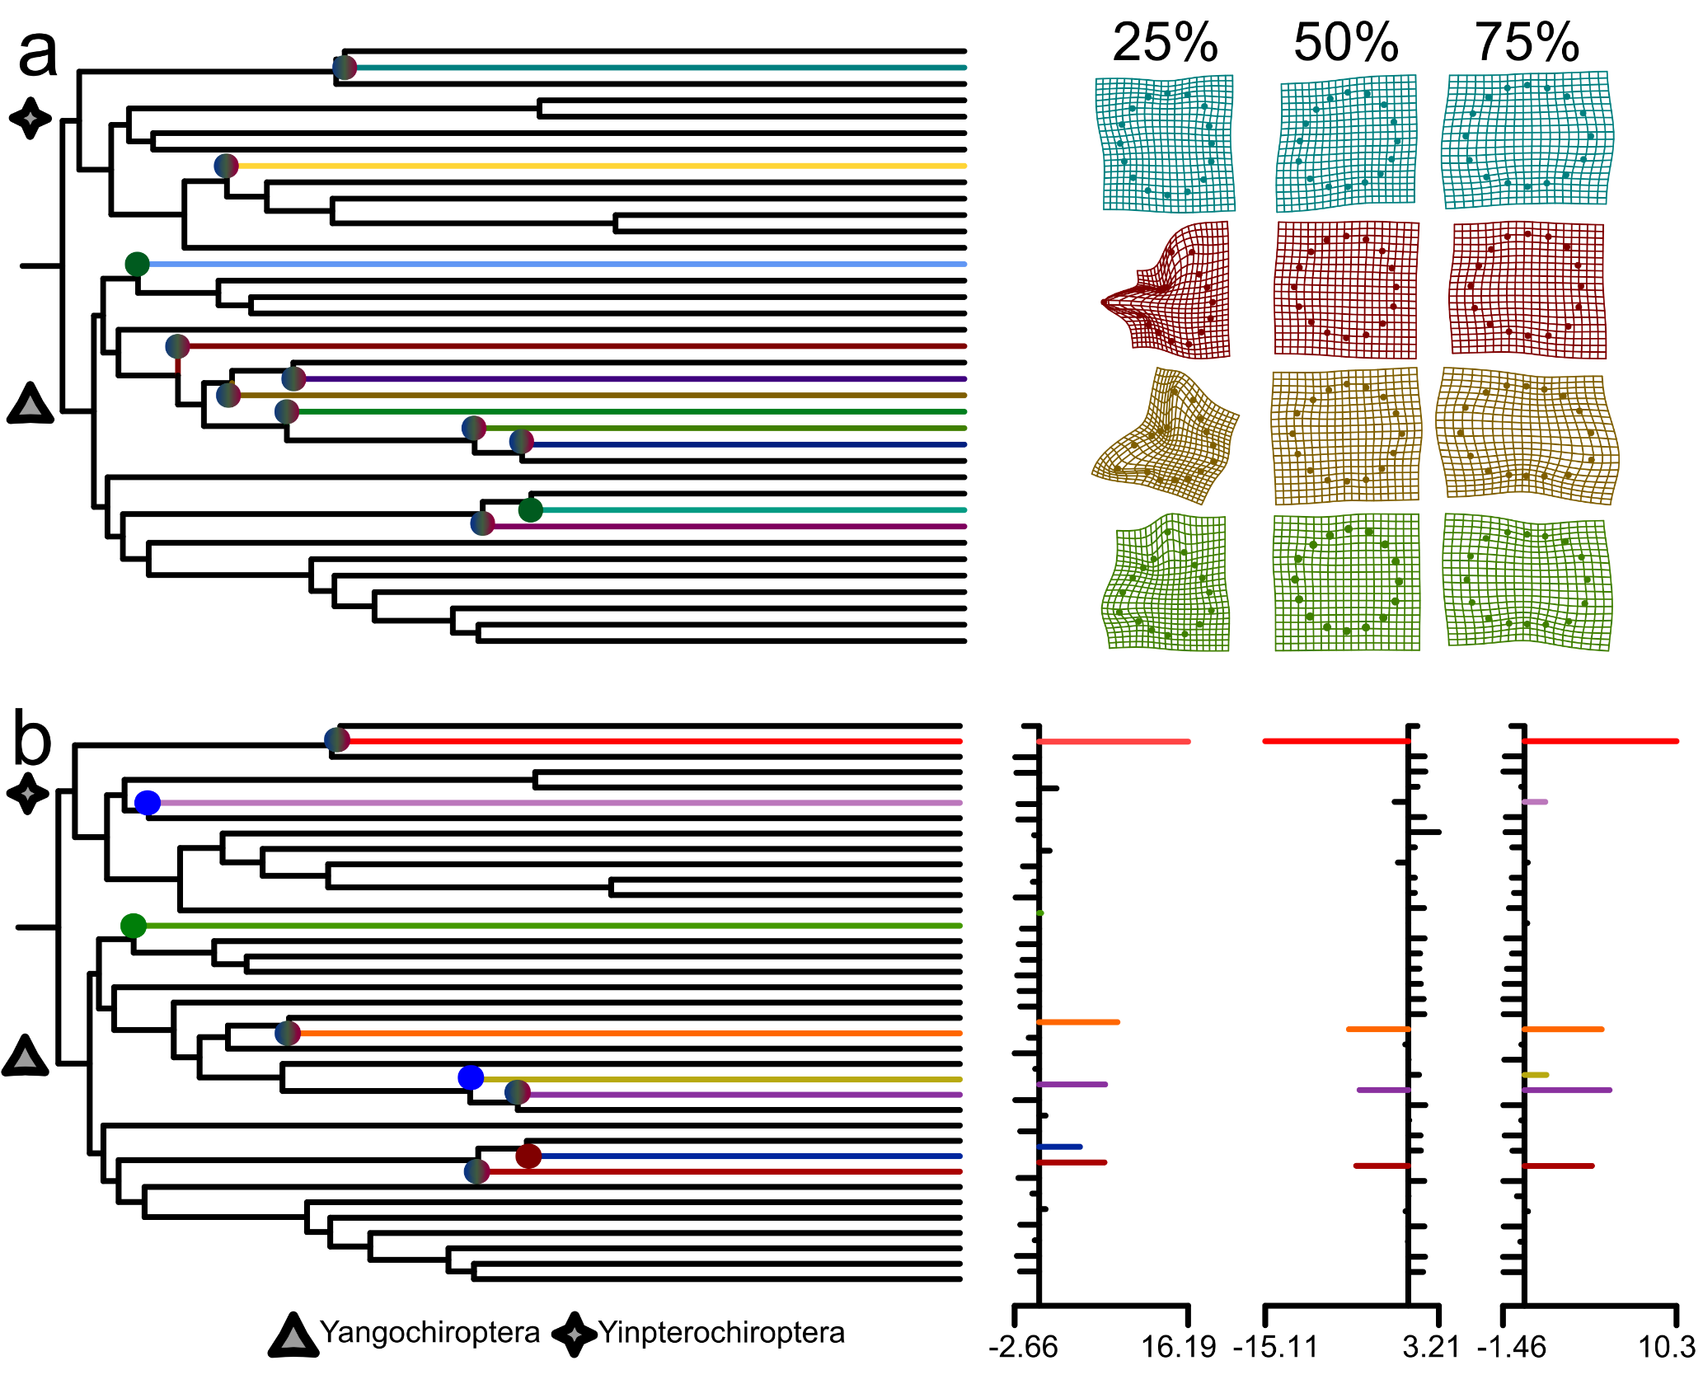
Figure 6. Evolutionary tests of shifts in adaptive peaks across the phylogeny represented in our sample for shape (a) and biomechanical data (b). Shifts are depicted as branches of different colours. Colours within each circle represent the cross-section at which each shift was found: 25% (green), 50% (red) and 75% (blue). Deformation grids show the greatest shape differences between taxa in which a shift was found and the average shape for all species. Barplots show PC scores in PC1 of mechanospace for 25% (left), 50% (middle) and 75% (right) cross-sections.

Discussion
Combining three-dimensional comparative morphology and phylogenetic comparative methods, this study represents a novel approach to understand the correspondence between the evolutionary pathways shaping the humeral variation, by decomposing its biomechanical and morphological components. Our results showed a strong link between phenotypic variation and ecological differences between taxa at a macroevolutionary scale, corresponding with previous studies both in bats (Arbour et al. 2019) and a wide variety of vertebrates (Esquerré et al. 2017; Maestri et al. 2017; Stange et al. 2018; Arbour et al. 2019; Pimiento et al. 2019; Stanchak et al. 2019). However, we also found a marked decoupling between the processes affecting the evolution of humeral morphological and biomechanical disparity, where diet and size were highly associated with differences in shape and biomechanics, respectively. A strong correlation between biomechanical properties, size and ecological traits has been suggested to have influenced the morphological evolution of many vertebrate taxa (McElroy et al. 2008; Houssaye et al. 2016; Muñoz et al. 2018). Nevertheless, the scale of the biomechanics-form-ecology interaction on macroevolutionary trajectories requires further study.
Our results reflect the evolutionary role that size had on vertebrate morphological diversification as a most-parsimonious evolutionary pathway (Marroig and Cheverud 2005; Friedman et al. 2019). Diet was also shown to explain a significant portion of trait variability, following similar trends found for the morphological evolution of the chiropteran skull (Arbour et al. 2019; Rossoni et al. 2019). Contrasting patterns of diet- and size-dependent differences between shape and biomechanical disparity suggest a greater importance of size for the evolution of biomechanics, and of diet for the evolution of shape. Femoral morphological diversity in bats has been described as size-dependent, linking biomechanical aspects of long bones (i.e. increase in robusticity) with increases in body mass (Louzada et al. 2019). Our results strongly support this finding, as size was highly associated with biomechanical properties (J being the most descriptive), whereas shape was more closely associated with dietary adaptations. Body size evolution in bats is thought to have been constrained mainly by echolocation and flight (Jones 1999; Norberg and Norberg 2012; Moyers Arévalo et al. 2018). Echolocation appears to have imposed the strongest constraint, greatly limiting size increases in insectivorous bats, whereas non-echolocating bats (e.g. frugivorous pteropodids) evolved larger body sizes (Moyers Arévalo et al. 2018). Flight acted as a posteriori secondary constraint, limiting maximum body size in larger-than-average non-echolocating bats (e.g. pteropodids). This pattern can be found in our sample, where larger species were either frugivorous or omnivorous, and animalivorous species were smaller. Nevertheless, ecological opportunity fostered adaptive radiation and morphological diversification in bats, leading to the colonisation of highly specialised niches, including the convergent evolution of larger size in carnivorous bats (Santana and Cheung 2016).
Diet-related morphological differences have been found both in closely-related mammal taxa as well as in sympatric taxa, indicating that these differences can have ecological and evolutionary drivers (Adams and Rohlf 2000; Marcé-Nogué et al. 2017). Dietary diversification is thought to have been a major driver of cladogenesis and morphological specialisation in bats, resulting in multiple cases of convergent evolution of cranial phenotypes (Datzmann et al. 2010; Santana et al. 2010; Santana et al. 2012). Correspondence between previous results of cranial morphological disparity and ours of humeral shape disparity suggests that diet may have shaped evolution of the cranium and postcranium along similar adaptive pathways.
Morphospace across different cross-sections showed common general patterns of species grouping based on size, whereas only mechanospace showed a separation of subspaces between animalivorous and plant-visiting species. The similarity of morpho- and mechanospace in our results indicates interaction between different ecological (i.e. diet) and biological (i.e. size) traits that reflects humeral phenotypic variability. New approaches to comparative analyses of multidimensional phenotypic data have found support for more complex evolutionary hypotheses in mammals than traditional models based on a priori assumptions (Maestri et al. 2017; Thiagavel et al. 2018; Arbour et al. 2019; Rossoni et al. 2019). Moreover, in our study morpho-spaces showed a differentiation of species with rare behavioural ecologies, such as terrestrial locomotion in vampire bats and mystacinids and upstand roosting in thyropterids, providing evidence for humeral adaptations not associated with flight. Similar to our PGLS results, phenotypic disparity showed dissimilarity between morpho- and mechanospaces. Differences in shape disparity based on diet underscore the importance of foraging strategies in the morphological diversity of bat humeri.
Mineralisation of the wing bones in bats shows a decreasing trend along the proximo-distal axis, with the humerus showing the highest levels of mineralisation (Watts et al. 2001). That pattern corresponds to the characterization of the armwing as the aerodynamic powerhouse of the wing, whereas the handwing conferred higher manoeuvrability during bat flight evolution (Swartz et al. 1992; Amador et al. 2019a). Considering that flight can potentially limit body size evolvability in bats, increased biomechanical disparity with size in the humerus suggests that higher kinematic demands in larger-bodied species could promote biomechanical diversification, optimising functional performance (Marroig and Cheverud 2005). Significant correlation in the dispersion of species in mechanospace across different cross-sections suggests that biomechanical variation is homogeneous along the bone, indicating highly similar patterns of cross-sectional variation in J across species (Cubo and Casinos 1998).
In contrast, diet-based differences in shape disparity suggest that non-animalivorous diets might facilitate variability and that animalivorous diets constrain it. Less manoeuvrable flight (long, thin wings and restricted movement around elbow and shoulder) is generally correlated with fast flying aerial insectivory (Norberg and Rayner 1987), whereas more manoeuvrable flight (short, wide wings, greater movement in elbow and shoulder joints) is associated with gleaning insectivory and non-insectivory (e.g. frugivory, carnivory, sanguivory) (Norberg and Rayner 1987). As such, we hypothesise that aerial insectivory may constrain shape disparity in optimising foraging performance, whereas other foraging modes including frugivory and carnivory involve less functional constraint, facilitating variability. Furthermore, size- and diet-based differences in evolutionary rates both in morpho- and mechanospace supports our interpretation of decoupling variation in the morphological and biomechanical dimensions of humeral morphology, with shape responding to diet-related constraints and J responding to mechanical-related pressures. Our results provide evidence for the decoupled evolution of different phenotypic features of a single element and emphasises the need to test not only multivariate and ecologically-informed evolutionary models, but also to test them for different attributes (e.g. morphology and biomechanics) (Kilbourne and Hutchinson 2019).
Temporal patterns of phenotypic evolution found in our study showed that most of the shape and biomechanical disparity remained relatively stable through time, rejecting the hypothesis of a single adaptive radiation - under an EB model - in humeral morphology during bat evolution. Evidence for early bursts of phenotypic diversification in mammals is scarce, which has been associated with limitations in experimental design (Slater and Friscia 2019). An exception is bat morphological evolution which went through early bursts of phenotypic diversification in both cranial and postcranial structures of functional importance for different ecological traits (Arbour et al. 2019; Stanchak et al. 2019). A lack of support in our results for an early burst of radiation in both of our datasets, compared with previous studies, indicates a complex evolutionary scenario where multiple evolutionary pathways (e.g. diet, flight and body size) could have interacted, producing the temporal trajectories of phenotypic diversification across different traits (Kilbourne and Hutchinson 2019). Three major peaks in phenotypic disparity found across cross-sections and datasets suggest a common temporal trajectory of humeral diversification. The timing of the peaks suggests three bursts in phenotypic disparity during the early, mid and late evolutionary history of Chiroptera. Temporal patterns in disparity peaks coincide with previous evidence for an early adaptive radiation in bat evolution, possibly associated with the acquisition of flight, followed by relative stasis (Simmons et al. 2008; Amador et al. 2019a). A second peak could be associated with a diversification of aerodynamic morphotypes coinciding with the cladogenesis of modern families (Simmons et al. 2008; Hand et al. 2009; Amador et al. 2019a). The last peak could represent rapid phenotypic diversification due to adaptive radiation associated with novel ecological opportunities to fill a range of aerial and dietary niches in the Miocene, especially in noctilionoids (i.e. frugivory, nectarivory and carnivory) (Simmons et al. 2008; Amador et al. 2019a).
Support for different evolutionary models between shape and biomechanics suggests that, within a single structure, individual features can evolve under divergent adaptive trajectories (Kilbourne and Hutchinson 2019). The axial skeleton in flying vertebrates represents the centre of mass during wingbeat, concentrating a greater proportion of mechanical stress in the armwing (Swartz et al. 1992; Iriarte-Diaz et al. 2011). As a result, the proximal diaphysis (25% cross-section) of the humerus in bats withstands higher mechanical load during flight (Watts et al. 2001; Iriarte-Diaz et al. 2011). Support for the OU-DIET evolutionary model in humeral morphology suggests the influence of diet on the evolution of flight-dependent mechanical adaptive regimes, reflecting the diet-locomotion macroevolutionary interplay (Moyers Arévalo et al. 2018). Differences in mobility of the shoulder joint could also have an effect on proximal diaphysis evolvability, as wing flexion during upstroke significantly reduces the inertial cost of flight (Riskin et al. 2012; Panyutina et al. 2015). However, macroevolutionary reconstructions of the diversification of flying behaviours are still lacking. An ecology-informed OU-DIET model of evolution for the distal epiphysis (75% cross-section) reflects the importance of manoeuvrability for wing phenotypic diversification. Palaeoenviromental changes during the Eocene-Oligocene transition has been linked to opening of foraging-based ecological opportunities that triggered shifts in aerodynamic optima in bats (Simmons et al. 2008; Amador et al. 2019a). Unique anatomical features in bat elbows have been associated with reduced energetics during wingbeat, as well as manoeuvrability during landing (Bergou et al. 2015; Konow et al. 2015). Combined, our results show multiple evolutionary trajectories shaping morphological and biomechanical components of phenotypic variability differently in the humerus. OU-SIZE as the best-supported evolution model for our biomechanical dataset corroborates our results showing that humeral resistance to torsion has comparably low variability. It also shows the role of evolutionary allometry on the biomechanical evolution of the humerus, possibly relating to specific evolutionary pressures that skewed disparity towards different adaptive optima. Amador et al. (2019b) suggest that flight manoeuvrability was a major evolutionary novelty during the aerodynamic diversification of bats, whereas mechanical performance was relatively static once self-powered flight was achieved in early bats. In contrast, our results show that biomechanical performance remained a significant driver of evolvability during the subsequent diversification of modern bats.
Novel modelling techniques (independent of a priori assumptions) to estimate otherwise unexplored evolutionary shifts further inform the mode and tempo of phenotypic evolution of the humerus in bats. Evolutionary shifts in shape and biomechanics could have relaxed ecological pressures constraining diversification, leading to the evolution of novel dietary-foraging strategies and large body size (Law 2019), between geographically isolated taxa (López-Aguirre et al. 2018). The distribution of evolutionary shifts found in the proximal diaphysis shows adaptive shifts towards higher J (i.e. resistance to torsional deformation) values in families Craseonycteridae, Pteropodidae, Nycteridae, Phyllostomidae and Molossidae, possibly in a scenario where larger body sizes and novel dietary strategies are interacting. Large-bodied omnivores, piscivores, and frugivores evolved as evolutionary novelties in their humeral shape and biomechanics, mirroring evolutionary patterns in cranial evolution (Arbour et al. 2019; Rossoni et al. 2019). Larger body size in piscivore species could have increased the mechanical loading on the bone, exerting a selective pressure for higher resistance to torsional bending (Swartz et al. 1992). A remarkable finding in our results were the shifts in the evolution of shape and biomechanics in mystacinids, vampire bats (Desmodontinae) and thyropterids, taxa that show behaviours with unique forelimb performance (i.e. terrestrial lomocotion and upstand roosting). More detailed analyses of the ecomorphological and biomechanical requirements of these behaviours could help better elucidate their role in the morphological evolution of the wing beyond flight. Shifts in cross-sectional shape and biomechanical evolution of the metaphyses exclusive to Molossidae and Nycteridae were found only in large-bodied species, each representing a different dietary adaptation (insectivory and carnivory, respectively). Within a general evolutionary scenario of diet- and size-dependent evolution (i.e. support for the OU-DIET and OU-SIZE models above), larger body size could represent unique selective regimes, leading to the shifts in adaptive peaks observed. The occurrence of most of the shifts at the generic level indicates low phylogenetic structuring, and high adaptability based on novel ecological opportunities during bat evolution.

Conclusions
This study analyses the tempo and mode of evolution in cross-sectional geometry of the humerus in bats, providing novel information about the evolution of locomotion in Chiroptera. We provide evidence for the decoupled evolution of humeral cross-sectional shape and resistance to torsion in bats, as well as divergent evolutionary pathways of the mid-diaphysis and the proximal and distal diaphyses. This pattern does not reflect phylogenetic structuring, but rather an ecological signature associated mainly with the evolution of novel foraging behaviours and larger body size. Our results suggest a correspondence between the evolutionary trajectories in cranial phenotypic diversification shown in previous studies (Arbour et al. 2019; Rossoni et al. 2019), and the evolutionary trajectories found in humeral phenotypic diversification in our study. We found shifts in adaptive regimes associated with functional demands that locomotory and roosting behaviours may have imposed on the wing of bats, shaping the evolution of bat humeri beyond the evolution of flight.

Acknowledgments
The authors thank: The facilities and technical assistance of the National Imaging Facility, a National Collaborative Research Infrastructure Strategy (NCRIS) capability, at the Mark Wainwright Analytical Centre, UNSW Sydney; Kenny Travouillon and Rebecca Bray from the Western Australia Museum for access to specimens for scanning; and Nancy Simmons of the American Museum of Natural History, DigiMorph.org, Jessica Maisano, and NSF grant DEB-9873663 for granting access to whole-body CT scans of additional species from the online repository.

References

Adams, D. C. 2014. A generalized K statistic for estimating phylogenetic signal from shape and other high-dimensional multivariate data. Syst Biol 63:685-697.
Adams, D. C. and M. L. Collyer. 2018. Phylogenetic ANOVA: Group-clade aggregation, biological challenges, and a refined permutation procedure. Evolution 72:1204-1215.
Adams, D. C., M. L. Collyer, A. Kaliontzopoulou, and E. Sherratt. 2017. Geomorph: software for geometric morphometric analyses. R package. https://cran.r-project.org/package=geomorph.
Adams, D. C., E. Otárola-Castillo, and E. Paradis. 2013. Geomorph: an R package for the collection and analysis of geometric morphometric shape data. Methods in Ecology and Evolution 4:393-399.
Adams, D. C. and F. J. Rohlf. 2000. Ecological character displacement in <em>Plethodon</em>: Biomechanical differences found from a geometric morphometric study. Proceedings of the National Academy of Sciences 97:4106-4111.
Amador, L. I., F. C. Almeida, and N. P. Giannini. 2019a. Evolution of Traditional Aerodynamic Variables in Bats (Mammalia: Chiroptera) within a Comprehensive Phylogenetic Framework. Journal of Mammalian Evolution.
Amador, L. I., N. P. Giannini, N. B. Simmons, and V. Abdala. 2018. Morphology and Evolution of Sesamoid Elements in Bats (Mammalia: Chiroptera). American Museum Novitates 2018:1-40, 40.
Amador, L. I., N. B. Simmons, and N. P. Giannini. 2019b. Aerodynamic reconstruction of the primitive fossil bat <i>Onychonycteris finneyi</i> (Mammalia: Chiroptera). Biol Letters 15:20180857.
Arbour, J. H., A. A. Curtis, and S. E. Santana. 2019. Signatures of echolocation and dietary ecology in the adaptive evolution of skull shape in bats. Nat Commun 10:2036.
Bastide, P., C. Ane, S. Robin, and M. Mariadassou. 2018. Inference of Adaptive Shifts for Multivariate Correlated Traits. Syst Biol 67:662-680.
Bergou, A. J., S. M. Swartz, H. Vejdani, D. K. Riskin, L. Reimnitz, G. Taubin, and K. S. Breuer. 2015. Falling with Style: Bats Perform Complex Aerial Rotations by Adjusting Wing Inertia. PLOS Biology 13.
Brown, E. E., D. D. Cashmore, N. B. Simmons, and R. J. Butler. 2019. Quantifying the completeness of the bat fossil record. Palaeontology 0.
Canals, M., J. Iriarte-Diaz, and B. Grossi. 2011. Biomechanical, Respiratory and Cardiovascular Adaptations of Bats and the Case of the Small Community of Bats in Chile. Pp. 299-322 in V. Klika, ed. Biomechanics in Applications. InTech.
Carter, R. T. and R. A. Adams. 2016. Integrating Ontogeny of Echolocation and Locomotion Gives Unique Insights into the Origin of Bats. Journal of Mammalian Evolution.
Clavel, J., G. Escarguel, and G. Merceron. 2015. mvmorph: an r package for fitting multivariate evolutionary models to morphometric data. Methods in Ecology and Evolution 6:1311-1319.
Cubo, J. and A. Casinos. 1998. The variation of the cross-sectional shape in the long bones of birds and mammals. Annales des Sciences Naturelles - Zoologie et Biologie Animale 19:51-62.
Currey, J. D. and M. R. Alexander. 1985. The thickness of the walls of tubular bones. Journal of Zoology 206:453-468.
da Silva, J. M., A. Herrel, G. J. Measey, B. Vanhooydonck, and K. A. Tolley. 2014. Linking microhabitat structure, morphology and locomotor performance traits in a recent radiation of dwarf chameleons. Functional Ecology 28:702-713.
Datzmann, T., O. von Helversen, and F. Mayer. 2010. Evolution of nectarivory in phyllostomid bats (Phyllostomidae Gray, 1825, Chiroptera: Mammalia). BMC Evol Biol 10.
Davalos, L. M., P. M. Velazco, O. M. Warsi, P. D. Smits, and N. B. Simmons. 2014. Integrating incomplete fossils by isolating conflicting signal in saturated and non-independent morphological characters. Syst Biol 63:582-600.
Dececchi, T. A., H. C. Larsson, and M. B. Habib. 2016. The wings before the bird: an evaluation of flapping-based locomotory hypotheses in bird antecedents. PeerJ 4:e2159.
Denzinger, A. and H. U. Schnitzler. 2013. Bat guilds, a concept to classify the highly diverse foraging and echolocation behaviors of microchiropteran bats. Front Physiol 4:164.
Dickinson, M. 2008. Animal locomotion: a new spin on bat flight. Curr Biol 18:R468-470.
Diogo, R. 2017. Etho-Eco-Morphological Mismatches, an Overlooked Phenomenon in Ecology, Evolution and Evo-Devo That Supports ONCE (Organic Nonoptimal Constrained Evolution) and the Key Evolutionary Role of Organismal Behavior. Frontiers in Ecology and Evolution 5.
Dixon, P. 2003. VEGAN, a package of R functions for community ecology. Journal of Vegetation Science 14:927-930.
Dumont, E. R. 2010. Bone density and the lightweight skeletons of birds. Proceedings of the Royal Society B: Biological Sciences 277:2193-2198.
Eiting, T. P. and G. F. Gunnell. 2009. Global Completeness of the Bat Fossil Record. Journal of Mammalian Evolution 16:151-173.
Esquerré, D., E. Sherratt, and J. S. Keogh. 2017. Evolution of extreme ontogenetic allometric diversity and heterochrony in pythons, a clade of giant and dwarf snakes. Evolution 71:2829-2844.
Fabre, A.-C., R. Cornette, A. Goswami, and S. Peigné. 2015. Do constraints associated with the locomotor habitat drive the evolution of forelimb shape? A case study in musteloid carnivorans. Journal of Anatomy 226:596-610.
Felsenstein, J. 1973. Maximum-likelihood estimation of evolutionary trees from continuous characters. Am J Hum Genet 25:471-492.
Fenton, M. B. 2010. Convergences in the diversification of bats. Current Zoology (formerly Acta Zoologica Sinica).
Friedman, S. T., C. M. Martinez, S. A. Price, and P. C. Wainwright. 2019. The influence of size on body shape diversification across Indo‐Pacific shore fishes. Evolution.
Gunnell, G. F., N. B. Simmons, and E. R. Seiffert. 2014. New Myzopodidae (Chiroptera) from the late Paleogene of Egypt: emended family diagnosis and biogeographic origins of Noctilionoidea. PLoS One 9:e86712.
Gunnell, G. F., S. R. Worsham, E. R. Seiffert, and E. L. Simons. 2009. Vampyravus orientalis Schlosser (Chiroptera) from the Early Oligocene (Rupelian), Fayum, Egypt - body mass, humeral morphology and affinitiesd. Acta Chiropterologica 11:271-278.
Gutarra, S., B. C. Moon, I. A. Rahman, C. Palmer, S. Lautenschlager, A. J. Brimacombe, and M. J. Benton. 2019. Effects of body plan evolution on the hydrodynamic drag and energy requirements of swimming in ichthyosaurs. Proceedings of the Royal Society B: Biological Sciences 286:20182786.
Hahsler, M., S. Chelluboina, K. Hornik, and C. Buchta. 2011. The arules R-Package Ecosystem: Analyzing Interesting Patterns from Large Transaction Data Sets. J. Mach. Learn. Res. 12:2021-2025.
Hand, S. J., R. M. D. Beck, M. Archer, N. B. Simmons, G. F. Gunnell, R. P. Scofield, A. J. D. Tennyson, V. L. De Pietri, S. W. Salisbury, and T. H. Worthy. 2018. A new, large-bodied omnivorous bat (Noctilionoidea: Mystacinidae) reveals lost morphological and ecological diversity since the Miocene in New Zealand. Sci Rep 8:235.
Hand, S. J., D. E. Lee, T. H. Worthy, M. Archer, J. P. Worthy, A. J. Tennyson, S. W. Salisbury, R. P. Scofield, D. C. Mildenhall, E. M. Kennedy, and J. K. Lindqvist. 2015a. Miocene Fossils Reveal Ancient Roots for New Zealand's Endemic Mystacina (Chiroptera) and Its Rainforest Habitat. PLoS One 10:e0128871.
Hand, S. J. and B. Sigé. 2018. A new archaic bat (Chiroptera: Archaeonycteridae) from an Early Eocene forest in the Paris Basin. Historical Biology 30:227-236.
Hand, S. J., B. Sigé, M. Archer, G. F. Gunnell, and N. B. Simmons. 2015b. A New Early Eocene (Ypresian) Bat from Pourcy, Paris Basin, France, with Comments on Patterns of Diversity in the Earliest Chiropterans. Journal of Mammalian Evolution 22:343-354.
Hand, S. J., V. Weisbecker, R. M. Beck, M. Archer, H. Godthelp, A. J. Tennyson, and T. H. Worthy. 2009. Bats that walk: a new evolutionary hypothesis for the terrestrial behaviour of New Zealand's endemic mystacinids. BMC Evol Biol 9:169.
Hand, S. J., T. H. Worthy, M. Archer, J. P. Worthy, A. J. Tennyson, and R. P. Scofield. 2013. MIOCENE MYSTACINIDS (CHIROPTERA, NOCTILIONOIDEA) INDICATE A LONG HISTORY FOR ENDEMIC BATS IN NEW ZEALAND. Journal of Vertebrate Paleontology 33:1442-1448.
Hansen, T. F. 1997. STABILIZING SELECTION AND THE COMPARATIVE ANALYSIS OF ADAPTATION. Evolution 51:1341-1351.
Harmon, L. J., J. B. Losos, T. Jonathan Davies, R. G. Gillespie, J. L. Gittleman, W. Bryan Jennings, K. H. Kozak, M. A. McPeek, F. Moreno-Roark, T. J. Near, A. Purvis, R. E. Ricklefs, D. Schluter, J. A. Schulte II, O. Seehausen, B. L. Sidlauskas, O. Torres-Carvajal, J. T. Weir, and A. Ø. Mooers. 2010. EARLY BURSTS OF BODY SIZE AND SHAPE EVOLUTION ARE RARE IN COMPARATIVE DATA. Evolution 64:2385-2396.
Hedenstrom, A. and L. C. Johansson. 2015. Bat flight: aerodynamics, kinematics and flight morphology. Journal of Experimental Biology 218:653-663.
Hedrick, B. P., G. L. Mutumi, V. D. Munteanu, A. Sadier, K. T. J. Davies, S. J. Rossiter, K. E. Sears, L. M. Dávalos, and E. Dumont. 2019. Morphological Diversification under High Integration in a Hyper Diverse Mammal Clade. Journal of Mammalian Evolution.
Henderson, D. M. 2010. Pterosaur body mass estimates from three-dimensional mathematical slicing. Journal of Vertebrate Paleontology 30:768-785.
Houssaye, A., K. Waskow, S. Hayashi, R. Cornette, A. H. Lee, and J. R. Hutchinson. 2016. Biomechanical evolution of solid bones in large animals: a microanatomical investigation. Biological Journal of the Linnean Society 117:350-371.
Iriarte-Diaz, J., D. K. Riskin, K. S. Breuer, and S. M. Swartz. 2012. Kinematic plasticity during flight in fruit bats: individual variability in response to loading. PLoS One 7:e36665.
Iriarte-Diaz, J., D. K. Riskin, D. J. Willis, K. S. Breuer, and S. M. Swartz. 2011. Whole-body kinematics of a fruit bat reveal the influence of wing inertia on body accelerations. J Exp Biol 214:1546-1553.
Jones, G. 1999. Scaling of echolocation call parameters in bats. Journal of Experimental Biology 202:3359-3367.
Kilbourne, B. M. and J. R. Hutchinson. 2019. Morphological diversification of biomechanical traits: mustelid locomotor specializations and the macroevolution of long bone cross-sectional morphology. BMC Evolutionary Biology 19:37.
Konow, N., A. Cheney Jorn, J. Roberts Thomas, J. R. S. Waldman, and M. Swartz Sharon. 2015. Spring or string: does tendon elastic action influence wing muscle mechanics in bat flight? Proceedings of the Royal Society B: Biological Sciences 282:20151832.
Law, C. J. 2019. Evolutionary shifts in extant mustelid (Mustelidae: Carnivora) cranial shape, body size and body shape coincide with the Mid-Miocene Climate Transition. Biol Letters 15:20190155.
Lee, A. H. and E. Simons. 2015. Wing bone laminarity is not an adaptation for torsional resistance in bats. PeerJ 3.
López-Aguirre, C., S. J. Hand, D. Koyabu, N. T. Son, and L. A. B. Wilson. 2019a. Postcranial heterochrony, modularity, integration and disparity in the prenatal ossification in bats (Chiroptera). BMC Evolutionary Biology 19:75.
López-Aguirre, C., S. J. Hand, D. Koyabu, N. T. Son, and L. A. B. Wilson. 2019b. Prenatal allometric trajectories and the developmental basis of postcranial phenotypic diversity in bats (Chiroptera). Journal of Experimental Zoology Part B: Molecular and Developmental Evolution 332:36-49.
López-Aguirre, C., S. J. Hand, S. W. Laffan, and M. Archer. 2018. Phylogenetic diversity, types of endemism and the evolutionary history of New World bats. Ecography 41:1955-1966.
Louzada, N. S. V., M. R. Nogueira, and L. M. Pessôa. 2019. Comparative morphology and scaling of the femur in yangochiropteran bats. Journal of Anatomy 235:124-150.
Luo, B., S. E. Santana, Y. Pang, M. Wang, Y. Xiao, and J. Feng. 2019. Wing morphology predicts geographic range size in vespertilionid bats. Sci Rep 9:4526.
Maestri, R., L. R. Monteiro, R. Fornel, N. S. Upham, B. D. Patterson, and T. R. O. de Freitas. 2017. The ecology of a continental evolutionary radiation: Is the radiation of sigmodontine rodents adaptive? Evolution 71:610-632.
Marcé-Nogué, J., T. A. Püschel, and T. M. Kaiser. 2017. A biomechanical approach to understand the ecomorphological relationship between primate mandibles and diet. Scientific Reports 7:8364.
Marinello, M. M. and E. Bernard. 2014. Wing morphology of Neotropical bats: a quantitative and qualitative analysis with implications for habitat use. Canadian Journal of Zoology 92:141-147.
Marroig, G. and J. M. Cheverud. 2005. Size as a line of least evolutionary resistance: Diet and adaptive morphological radiation in new world monkeys. Evolution 59:1128-1142.
Martin-Serra, A., B. Figueirido, and P. Palmqvist. 2014. A three-dimensional analysis of morphological evolution and locomotor performance of the carnivoran forelimb. PLoS One 9:e85574.
McElroy, E. J., K. L. Hickey, and S. M. Reilly. 2008. The correlated evolution of biomechanics, gait and foraging mode in lizards. Journal of Experimental Biology 211:1029-1040.
McGowan, A. J. and G. J. Dyke. 2007. A morphospace-based test for competitive exclusion among flying vertebrates: did birds, bats and pterosaurs get in each other's space? J Evol Biol 20:1230-1236.
McInroe, B., H. C. Astley, C. Gong, S. M. Kawano, P. E. Schiebel, J. M. Rieser, H. Choset, R. W. Blob, and D. I. Goldman. 2016. Tail use improves performance on soft substrates in models of early vertebrate land locomotors. Science 353:154-158.
Medina, I., G. M. Cooke, and T. J. Ord. 2018. Walk, swim or fly? Locomotor mode predicts genetic differentiation in vertebrates. Ecology Letters 21:638-645.
Moyers Arévalo, R. L., L. I. Amador, F. C. Almeida, and N. P. Giannini. 2018. Evolution of Body Mass in Bats: Insights from a Large Supermatrix Phylogeny. Journal of Mammalian Evolution.
Muñoz, M. M., Y. Hu, P. S. L. Anderson, and S. N. Patek. 2018. Strong biomechanical relationships bias the tempo and mode of morphological evolution. eLife 7:e37621.
Norberg, R. A. and J. M. V. Rayner. 1987. Ecological Morphology and Flight in Bats (Mammalia; Chiroptera): Wing Adaptations, Flight Performance, Foraging Strategy and Echolocation. Philos Trans R Soc Lond B Biol Sci 316:335-427.
Norberg, U. M. 1990. Vertebrate Flight, Mechanics, Physiology, Morphology, Ecology and Evolution. Springer-Verlag.
Norberg, U. M. and R. A. Norberg. 2012. Scaling of wingbeat frequency with body mass in bats and limits to maximum bat size. J Exp Biol 215:711-722.
Organ, C. L. and A. M. Shedlock. 2009. Palaeogenomics of pterosaurs and the evolution of small genome size in flying vertebrates. Biol Lett 5:47-50.
Panyutina, A., L. P. Korzun, and A. N. Kuznetsov. 2015. Flight of Mammals: From Terrestrial Limbs to Wings. Springer, New York.
Patel, B. A., C. B. Ruff, E. L. Simons, and J. M. Organ. 2013. Humeral cross-sectional shape in suspensory primates and sloths. Anat Rec (Hoboken) 296:545-556.
Pennell, M. W., J. M. Eastman, G. J. Slater, J. W. Brown, J. C. Uyeda, R. G. FitzJohn, M. E. Alfaro, and L. J. Harmon. 2014. geiger v2.0: an expanded suite of methods for fitting macroevolutionary models to phylogenetic trees. Bioinformatics 30:2216-2218.
Pimiento, C., J. L. Cantalapiedra, K. Shimada, D. J. Field, and J. B. Smaers. 2019. Evolutionary pathways toward gigantism in sharks and rays. Evolution 73:588-599.
Pratt, I. V., J. D. Johnston, E. Walker, and D. M. L. Cooper. 2018. Interpreting the three-dimensional orientation of vascular canals and cross-sectional geometry of cortical bone in birds and bats. Journal of Anatomy.
Rayner, J. M. 1988. The evolution of vertebrate flight. Biological Journal of the Linnean Society 34:269-287.
Riskin, D. K., A. Bergou, K. S. Breuer, and S. M. Swartz. 2012. Upstroke wing flexion and the inertial cost of bat flight. Proc Biol Sci 279:2945-2950.
Riskin, D. K., J. E. A. Bertram, and J. W. Hermanson. 2005. Testing the hindlimb-strength hypothesis: non-aerial locomotion by Chiroptera is not constrained by the dimensions of the femur or tibia. Journal of Experimental Biology 208:1309-1319.
Riskin, D. K., J. Iriarte-Diaz, K. M. Middleton, K. S. Breuer, and S. M. Swartz. 2010. The effect of body size on the wing movements of pteropodid bats, with insights into thrust and lift production. J Exp Biol 213:4110-4122.
Riskin, D. K., S. Parsons, W. A. Schutt, Jr., G. G. Carter, and J. W. Hermanson. 2006. Terrestrial locomotion of the New Zealand short-tailed bat Mystacina tuberculata and the common vampire bat Desmodus rotundus. J Exp Biol 209:1725-1736.
Rossoni, D. M., A. P. A. Assis, N. P. Giannini, and G. Marroig. 2017. Intense natural selection preceded the invasion of new adaptive zones during the radiation of New World leaf-nosed bats. Scientific Reports 7.
Rossoni, D. M., B. M. A. Costa, N. P. Giannini, and G. Marroig. 2019. A multiple peak adaptive landscape based on feeding strategies and roosting ecology shaped the evolution of cranial covariance structure and morphological differentiation in phyllostomid bats. Evolution 73:961-981.
Ruff, C. 1987. Sexual dimorphism in human lower limb bone structure: relationship to subsistence strategy and sexual division of labor. Journal of Human Evolution 16:391-416.
Sallan, L. C. and M. Friedman. 2012. Heads or tails: staged diversification in vertebrate evolutionary radiations. Proceedings of the Royal Society B: Biological Sciences 279:2025-2032.
Santana, S. E. and E. Cheung. 2016. Go big or go fish: morphological specializations in carnivorous bats. Proceedings of the Royal Society B: Biological Sciences 283:20160615.
Santana, S. E., E. R. Dumont, and J. L. Davis. 2010. Mechanics of bite force production and its relationship to diet in bats. Functional Ecology 24:776-784.
Santana, S. E., I. R. Grosse, and E. R. Dumont. 2012. Dietary hardness, loading behavior, and the evolution of skull form in bats. Evolution 66:2587-2598.
Sato, K., K. Q. Sakamoto, Y. Watanuki, A. Takahashi, N. Katsumata, C. A. Bost, and H. Weimerskirch. 2009. Scaling of soaring seabirds and implications for flight abilities of giant pterosaurs. PLoS One 4:e5400.
Schliemann, H. and S. M. Goodman. 2011. A new study on the structure and function of the adhesive organs of the Old World sucker-footed bat (Myzopoda: Myzopodidae) of Madagascar. Verh. Naturwiss. Ver. Hamburg.
Sherratt, E., M. Vidal-García, M. Anstis, and J. S. Keogh. 2017. Adult frogs and tadpoles have different macroevolutionary patterns across the Australian continent. Nature Ecology & Evolution 1:1385-1391.
Shi, J. J. and D. L. Rabosky. 2015. Speciation dynamics during the global radiation of extant bats. Evolution 69:1528-1545.
Simmons, N. B., K. L. Seymour, J. Habersetzer, and G. F. Gunnell. 2008. Primitive Early Eocene bat from Wyoming and the evolution of flight and echolocation. Nature 451:818-821.
Simons, E. L., T. L. Hieronymus, and P. M. O'Connor. 2011. Cross sectional geometry of the forelimb skeleton and flight mode in pelecaniform birds. J Morphol 272:958-971.
Slater, G. J. and A. R. Friscia. 2019. Hierarchy in adaptive radiation: A case study using the Carnivora (Mammalia). Evolution 73:524-539.
Slater, G. J., S. A. Price, F. Santini, and M. E. Alfaro. 2010. Diversity versus disparity and the radiation of modern cetaceans. Proceedings of the Royal Society B: Biological Sciences 277:3097-3104.
Stanchak, K. E., J. H. Arbour, and S. E. Santana. 2019. Anatomical diversification of a skeletal novelty in bat feet. Evolution.
Stanchak, K. E. and S. E. Santana. 2018. Assessment of the Hindlimb Membrane Musculature of Bats: Implications for Active Control of the Calcar. The Anatomical Record 301:441-448.
Stange, M., G. Aguirre-Fernandez, W. Salzburger, and M. R. Sanchez-Villagra. 2018. Study of morphological variation of northern Neotropical Ariidae reveals conservatism despite macrohabitat transitions. BMC Evol Biol 18:38.
Stroud, J. T. and J. B. Losos. 2016. Ecological Opportunity and Adaptive Radiation. Annual Review of Ecology, Evolution, and Systematics 47:507-532.
Swartz, S. M., M. B. Bennett, and D. R. Carrier. 1992. Wing bone stresses in free flying bats and the evolution of skeletal design for flight. Nature.
Thiagavel, J., C. Cechetto, S. E. Santana, L. Jakobsen, E. J. Warrant, and J. M. Ratcliffe. 2018. Auditory opportunity and visual constraint enabled the evolution of echolocation in bats. Nat Commun 9:98.
Uyeda, J. C., D. S. Caetano, and M. W. Pennell. 2015. Comparative Analysis of Principal Components Can be Misleading. Systematic Biology 64:677-689.
Verde Arregoitia, L. D., D. O. Fisher, and M. Schweizer. 2017. Morphology captures diet and locomotor types in rodents. R Soc Open Sci 4:160957.
Vidal-García, M. and J. Scott Keogh. 2017. Phylogenetic conservatism in skulls and evolutionary lability in limbs – morphological evolution across an ancient frog radiation is shaped by diet, locomotion and burrowing. BMC Evolutionary Biology 17:165.
Voeten, D., J. Cubo, E. de Margerie, M. Roper, V. Beyrand, S. Bures, P. Tafforeau, and S. Sanchez. 2018. Wing bone geometry reveals active flight in Archaeopteryx. Nat Commun 9:923.
Voigt, C. C., I. M. Borrisov, and S. L. Voigt-Heucke. 2012. Terrestrial locomotion imposes high metabolic requirements on bats. J Exp Biol 215:4340-4344.
Watts, P., E. Mitchell, and S. Swartz. 2001. A COMPUTATIONAL MODEL FOR ESTIMATING THE MECHANICS OF HORIZONTAL FLAPPING FLIGHT IN BATS: MODEL DESCRIPTION AND VALIDATION. Journal of Experimental Biology 204:2873-2898.
Wilson, L. and L. T. Humphrey. 2015. A Virtual geometric morphometric approach to the quantification of long bone bilateral asymmetry and cross‐sectional shape. American Journal of Physical Anthropology.
Witton, M. P. 2015. Were early pterosaurs inept terrestrial locomotors? PeerJ 3:e1018.
Witton, M. P. and M. B. Habib. 2010. On the size and flight diversity of giant pterosaurs, the use of birds as pterosaur analogues and comments on pterosaur flightlessness. PLoS One 5:e13982.
Wolf, M., L. C. Johansson, R. von Busse, Y. Winter, and A. Hedenstrom. 2010. Kinematics of flight and the relationship to the vortex wake of a Pallas' long tongued bat (Glossophaga soricina). J Exp Biol 213:2142-2153.

