Forest thinning in ponderosa pines increases carbon use efficiency and energy flow from primary producers to primary consumers

Authors: Christopher E. Doughty*¹, Tomos Prys-Jones¹, Andrew J. Abraham¹, Thomas E. Kolb²

Affiliations:
¹School of Informatics, Computing, and Cyber Systems, Northern Arizona University, Flagstaff, AZ. 86011, USA
²School of Forestry, Northern Arizona University, Flagstaff, AZ. 86011, USA

Keywords: Forest thinning, Ponderosa Pine, CUE, carbon allocation, herbivory, Flagstaff Watershed Protection Project

Key points:
- Forest thinning in high elevation dry forests increased energy flow from primary producers to primary consumers.
- Carbon was produced more efficiently in the thinned stands (CUE = 0.51 and 0.50) versus the un-thinned stand (CUE 0.34).
- GPP was similar in the two thinned stands ~3.5 Mg C ha⁻¹ year⁻¹, but was about 30% greater in the un-thinned stand (5.0 Mg C ha⁻¹ year⁻¹).

Abstract - A better understanding of carbon use efficiency and carbon allocation during disturbance is critical to improve simulations of the global carbon cycle and understanding future climate impacts. Forest thinning of high stem density, high elevation dry western US forests is becoming more common to reduce severe fire danger but there are uncertainties about how forest thinning may impact forest carbon use efficiency, carbon allocation and energy flow through the food chain. In three, quarter ha stands with similar soils, elevation and climate along a forest thinning chronosequence near Flagstaff (AZ), we measured total net primary production (NPP of wood, fine root, and leaves), total autotrophic respiration (R_{a} of wood, rhizosphere, and canopy respiration), gross primary production (GPP = NPP+R_{a}) and large mammal herbivory (with camera traps and dung counts) over a ~2-year period. We found strong seasonality in all carbon cycling variables and herbivory, peaking during the warm, wet monsoon period. Carbon was produced more efficiently in the thinned stands, with carbon use efficiency (CUE = NPP/GPP) of ~0.50, versus the un-thinned stand with CUE of 0.34. GPP was similar in the two thinned stands ~3.5 Mg C ha⁻¹year⁻¹ but was about 30% greater in the un-thinned stands (5.0 Mg C ha⁻¹ year⁻¹). Finally, the thinned stand had higher understory NPP, large herbivore consumption and had triple the total energy going into primary consumers despite reduced total GPP. Overall, the thinning, and the return to a more natural pre-fire suppression forest structure, increased the carbon use efficiency and energy flow from primary producers to primary consumers.

Introduction
Ponderosa pine (Pinus ponderosa) forests account for 22% of western U.S. forests and are an important part of the US carbon stock (Powell et al. 1993). Understanding carbon cycling in these forests will give a better understanding of the North American carbon cycle and the USA’s net contribution to climate change. Empirical understanding of carbon cycling in ponderosa forests beyond just photosynthesis and woody biomass is critical to inform land surface models because these models disagree widely (Friedlingstein et al 2014). By 2100, there is a 1000 Pg C discrepancy in land flux among current models, which makes future global climate predictions difficult (Friedlingstein et al., 2014). Much uncertainty of these models is due to uncertainty in carbon use efficiency (CUE: total Net Primary Production (NPP)/Gross Primary Production (GPP)) and how carbon is allocated to long term pools such as wood (De Lucia et al., 2007; Malhi et al., 2011) . For instance, a ±20% uncertainty in current estimates of carbon use efficiency in land surface models (between 0.4 to 0.6) could misrepresent an amount of carbon equal to total annual anthropogenic emissions of CO₂ when scaled globally (De Lucia et al., 2007). “Bottom up” measurements of carbon use efficiency and allocation are rare because they require separate monthly measurements of leaf, wood, and fine root growth (total net primary production) and leaf, wood and rhizosphere respiration (total autotrophic respiration) at the same site. It is also important to make these measurements during periods of perturbation such as mega-drought (Williams et al., 2020) and disturbances such as forest thinning (Amiro et al., 2010) to provide empirical data to parameterize and test the models against.
Restoration of high-elevation dry western US forests to their historic lower stand density present before widespread fire suppression efforts is an increasingly important management goal (Covington et al., 1997). Between 1637 and 1883 the historic fire return interval was 3.7 yr for all fires and 6.5 yr for widespread fires in the southwestern ponderosa pine landscape (Fulé et al., 1997). The fires were previously started by lightning and likely Native Americans (Allen et al., 2002; Kaye & Swetnam, 1999). Prior to fire suppression efforts, forests typically had 5-100 trees per hectare in small groups and more abundant grasses, forbs, and shrubs (Abella & Denton, 2009; Cooper, 1960; Covington et al., 1997; White, 1985) (Figure 1). A wide range of studies support these findings including verbal descriptions by early explorers (Cooper, 1960), stand data by early scientists (Woolsey 1911), and dendrochronological and restoration studies (Fulé et al., 1997). Fires have been broadly suppressed in the western US since the late 19th century leading to increased stand densities, decreased age and size class diversity, changes in successional dynamics, altered insect and disease dynamics, decreased understory productivity and diversity, and a more even-aged forest structure (Covington & Moore, 1994; Covington et al., 1997).
A review of eddy covariance studies found N. American forests generally lost carbon following a stand‐replacing disturbance, but returned to a carbon sink after at least 10 years for most forests (Amiro et al., 2010). There have been many studies on individual components of the carbon cycle in northern Arizona ponderosa pine forests, especially aboveground biomass changes. For instance, Dore et al (2012) found that forest carbon stocks recover quickly after thinning because of an increase in growth of residual trees and greater herbaceous production (Dore et al., 2012). Eddy covariance measurements have shown that thinning ameliorates the negative impacts of drought on forest carbon assimilation (Dore et al., 2012). Modelling studies suggest that thinning and associated prescribed burning treatments in ponderosa pine forests reduce carbon storage in the short term, but protect and stabilize long-term storage in live large trees (Krofcheck et al., 2019; Sorensen et al., 2011). There have been fewer studies of respiration and belowground components. One study showed inconclusive results of the impact of thinning of fine root growth (Dore et al., 2010). Another study showed a reduction in total soil respiration one and two years after thinning, but soil respiration was not partitioned into autotrophic and heterotrophic components (Sullivan et al., 2008).
High stem density ponderosa pine stands have high amounts of fuel accumulation which can lead to increased crown fire potential size and intensity. For instance, a survey in 2012 near Flagstaff, AZ, indicated an extreme fire hazard potential in 71 percent of the area (Stewart, 2014). Following large intense wildfires there is often an increased risk of flood damage. For example, a recent flood following a fire near Flagstaff, AZ, in 2010 caused tens of millions of dollars of damage to infrastructure and private property (Stewart, 2014). In response, many regions of the southwestern US have begun to thin forests to reduce the possibility of large dangerous fires and subsequent flooding. In Arizona, a recent project called the Flagstaff Watershed Protection Project (FWPP) is thinning forests to reduce the risk of high severity wildfire and subsequent flooding in two key watersheds (Stewart, 2014). Restoration treatments that include tree thinning to reduce fuel load, followed by prescribed burning, have the potential to improve the ecological health of the forest.
Such restoration efforts may be even more important in the future as climate change is expected to further increase the likelihood of severe wildfires (Westerling et al., 2006) and drought-related forest die-offs (Van Mantgem et al., 2009). Some climate models predict that the average forest drought stress by the 2050s will exceed that of the most severe droughts in the past 1000 years (Williams et al., 2013). Climate change in the North American Southwest is predicted to decrease winter precipitation (Seager & Vecchi, 2010) which is the most important water source for mature trees (Kerhoulas et al., 2013). Unusually high tree mortality has been reported in the North American Southwest during recent droughts, even in unburned forests (Ganey & Vojta, 2011). Productivity of the herbaceous understory in the region’s forests is limited by drought, but can be increased by forest restoration treatments like thinning (Moore et al., 2006).
A potential impact of forest thinning is that it will increase light and water availability in the forest understory, which increases understory plant growth (Dore et al., 2012; Moore et al., 2006) and herbivore populations. The most abundant large herbivores in the FWPP region are mule deer (Odocoileus hemionus), pronghorn (Antilocapra americana), and elk (Cervus canadensis). Arizona Game and Fish Department provides annual population trends for these game species and these have been used to predict that forest thinning will increase foraging habitat quality and quantity for elk, have little impact on mule deer populations, and unknown impacts on pronghorn (Stewart, 2014). Here we propose to address the impact of perturbations like forest thinning on energy flow through the trophic food chain. For instance, thinning may decrease GPP and increase herbivory, but it is unclear how herbivory/GPP will change.
As far as we are aware no studies have measured total NPP, total autotrophic respiration (Ra), and herbivory at the same time and place in N. American forests. Therefore, to better understand the impacts of forest thinning on carbon cycling and herbivore abundance, we investigated three stands in the FWPP (one not thinned, one thinned in 2015, and one thinned in 2017) that have similar soils and climate using a protocol where we measured Net Primary Production (NPP) (leaf, wood and fine root NPP) and autotropic respiration (leaf, wood and rhizosphere respiration) (Doughty et al., 2015) (detailed methods in Tables 1 and 2). Two previous studies have explored aspects of carbon use efficiency (CUE) and carbon allocation in ponderosa pine forests (Dore et al., 2012; Law et al., 1999) but each used different methodologies, did not include herbivory, and only one was along a thinning gradient in high-elevation, dry ponderosa forests. These terms are often poorly parameterized in global models (Malhi et al., 2011) making future climate impact predictions difficult in this region. Such thinning efforts are widespread across regions of the world (Sohn et al., 2016), making it vital to understand how these changes might affect the global carbon cycle. In addition, by estimating herbivory on the same stands we can better quantify impacts of the FWPP on herbivores and see how such changes impact total energy flows and food webs.
The hypotheses tested in this paper are threefold:
1) Forest thinning will increase CUE.
2) Forest thinning will increase carbon allocated to wood.
3) Forest thinning will increase energy flow from primary producers to primary consumers.

Methods
Site description - Our three, quarter ha stands are within ~2 km of each other and have similar soils, climate, and elevation (characteristics compared in Table 3). Soils are shallow, very stony and classified as Mollic eutroborralfs and Lithic eutroborralfs. The climate class is low sun cold and the soil temperature class is frigid (classifications based on Keys to Soil Taxonomy, Eighth Edition, 1998). They are on flat homogenous basalt substrate caused by a lava flow ~300,000 years ago (Duffield, 1997) near Flagstaff AZ at ~2260m elevation. The stands are on top of a flat plateau with 0 slope and aspect (<2m change per 100m). The thinning was part of the Flagstaff Watershed Protection Project (Figure 1) (Stewart, 2014). The vegetation community near our stands is dominated by ponderosa pines (Pinus ponderosa) which occur at elevations ranging from 2,130 to 2,800 m. Understory grasses in the area are typically Arizona fescue (Festuca arizonica), pine dropseed (Blepharoneuron tricholepis), mountain muhly (Muhlenbergia montana), and Kentucky bluegrass (Poa pratensis). Average (between 1913 to 1993) precipitation in the region is 577 mm yr⁻¹ falling ~half as snow and ~half as summer monsoonal rains, with a mean annual temperature of ~8 ºC (Savage et al., 1996; Schubert, 1974).
Thinning treatment – Stand T-17 (-111.679024, 35.218921, elevation 2260m) was thinned in 2017 and we started measurements a few months after thinning was completed. Stand T-15 (-111.689168, 35.207406, elevation 2264m) was thinned in 2015 and we started measurements two years after thinning was completed. Stand NT (-111.681604, 35.208055 elevation 2259m) was not thinned. Stand NT is 636m from Stand T-15 and 1170 m from Stand T-17. The area had been previous logged (sawtimber harvest) in 1919, 1925, and 1972. The forest thinning in our stands was done by crews on foot with chainsaws to remove the excess density of intermediate trees in the most abundant size class so as to develop uneven-aged structure and a mosaic of openings and tree groups of varying sizes. Openings occupy ~25% of the treatment area (Stewart, 2014). Further details of the thinning are available in an online supplement (SI). In our stands, there were 124 stems ha⁻¹ in Stand T-17 (thinned in 2017), 116 stems ha⁻¹ in Stand T-15 (thinned in 2015), and 400 stems ha⁻¹ in Stand NT (not thinned) including all trees. All trees were ponderosa pines. Mean DBH (>10cm) was 37 cm (5 trees <10cm dbh) in Stand T-17, 36 cm (6 trees <10cm dbh) in Stand T-15, and 30 cm (0 trees <10cm dbh) in Stand NT. Thinned stands (T-15 and T-17) have more trees at the extremes of height and DBH compared to stand NT (Figure 3).

Carbon fluxes - We estimate ecosystem C flux components (detailed methods in Tables 1 and 2) within the quarter ha stand (divided into 6, 20m by 20m subplots) using protocols similar to those developed by the Global Ecosystem Monitoring network (Doughty et al., 2015). A detailed description is available online for download (http://gem.tropicalforests.ox.ac.uk). Summaries of the different components quantified, and the field methods and data processing techniques used, are presented in Tables 1 and 2, respectively. Error propagation was carried out for all combination quantities using standard rules of quadrature, assuming that uncertainties were independent and normally distributed. We calculated net primary production (NPP) using the following equation:

NPP = NPP _{Above Ground Wood} _{(ACW)} + NPP_{litter fall} + NPP_{fine roots} + NPP_{coarse root} + NPP_{understory} + Herb_{dung} Equation 1

This neglects several small NPP terms, such as NPP lost as volatile organic emissions and litter decomposed in the canopy, but these terms are likely to be small (<5%) (Malhi et al., 2009). Total autotrophic respiration - R_{a} (detailed methods in Tables 1 and 2) was estimated as

R_{a} = R_{canopy} + R_{stems} + R_{rhizosphere} Equation 2

Here we count root exudates and transfer to mycorrhizae as a portion of R_{rhizosphere} rather than as NPP. In quasi-steady-state conditions (and on annual timescales or longer where there is no net change in plant non-structural carbohydrate storage), GPP should be approximately equal to the sum of NPP and R_{a.} Hence, we estimated GPP (detailed methods in Tables 1 and 2) as

GPP = NPP + R_{a} Equation 3
We estimated the CUE (detailed methods in Tables 1 and 2) as the proportion of total GPP invested in total NPP:

CUE = NPP / GPP Equation 4

Herbivory measurements - We estimated large herbivore (mule deer, elk and pronghorn) herbivory in similar units to our carbon cycle measurements (Mg C ha⁻¹ yr⁻¹) in two ways, with dung counts and camera traps (Bushnell Trophy Cam HD Essential E2 12MP Trail Camera – 2 per stand over 18 months). We also estimated carnivore (coyote and bobcat) occurrence with camera traps. We estimated herbivory with camera traps by counting numbers of mule deer, elk and pronghorn in photos which were triggered every 10 seconds (detailed methods in Tables 1 and 2). We calculated the metabolic needs of the animals observed in each of the photos (10 second snapshot) over an area of 672 m^² (~1/15 ha) (Bushnell user guide) using the following equation from Wolf et al (2013):
Metabolic rate = 0.021*M^^{0.716} kg DM/#/day Equation 5
We summed all individual elk, deer, and pronghorn photographed each month. M is mean weight which we estimated at M= 81 kg for mule deer (males 65 to 135 kg, females 45 to 80 kg) and M= 47 kg pronghorn (males 40 to 65 kg, females 34–48 kg), M=160 kg for elk (males 171 kg, females 150 kg) and coyote/bobcat M=14kg (males 8 to 20 kg , females 7 to 18 kg) (we did not observe any larger carnivores like mountain lions or bears). Each photo of an animal represented 10 seconds of metabolic cost. We therefore converted the 10 seconds to a day by dividing by 6*60*24. We multiplied by 15 to convert the area to ha and by 30 to convert to months. We estimated DM=50% carbon and animal assimilation efficiency of food is 50% (Chapin et al., 2012). This converted our camera trap abundance numbers to Mg C ha⁻¹ mo⁻¹ and we call this Herb_{camera}. We cross checked these values by comparing them to the dried weight of dung (50% carbon) fallen in our ground-based litter traps each year in six, 1 m² areas per stand. We dried and weighed the dung in a manner similar to the litterfall and we call this Herb_{dung}. We found roughly similar values for both methods (Table 4).
Climate – In each stand, we used the TMS-4 soil measurement system to measure soil moisture at a depth of 10cm and temperature at three depths, -6 (soil), +2 and +12 cm (air) (Wild et al., 2019). We used a conversion tool at http://tomst.com/web/en/systems/tms/software/ to convert data of humidity collected from TMS stations into real values of volumetric soil moisture content and assumed soil type to be sand based on our measurements described below (~95% rocks/sand and ~5% silt/clay).
Soils – We collected soil from three locations per stand (two corners and the center in a line) from the top 5cm after scraping away the top organic layer. We dried the soils for three days at 70°C. We then measured soil texture with a series of filters (2mm, 1mm, 0.25mm, 0.063mm) shaking for ~1 minute. We defined texture as >2mm as rock, between 0.063mm and 2mm as sand and below 0.063mm as silt/clay. We measured chemical composition on each dried, homogenized (<0.25mm) sample three times with a Bruker Tracer 5 XRF with a soil calibration which measures all elements with an atomic mass heavier than sodium.
Results
Climate– Averaged soil temperature in the unthinned stand NT during 2019/2020 was cooler by several degrees than the thinned stand T-17 for several afternoon hours but similar for the rest of the day (Figure 2a). Unfortunately, the sensor in stand T-15 was damaged by herbivores. Air temperature showed a similar, but reduced pattern (Figure 2b). Volumetric water content was higher in Stand T-17 than NT possibly because of the greater evapotranspiration in Stand NT from more trees (Figure 2c). There was strong seasonal variability in both air temperature and soil moisture at all stands (Figure 2d and e)
Soils - Soils across the three stands were similar and very sandy (~95% rocks/sand and ~5% silt/clay) due to the recent substrate (300,000-year-old lava flow) (Table 3). Soil chemical composition was broadly similar with some minor variations between stands, such as slightly less phosphorus in Stand T-15 and slightly more cations (Ca, Mg, and K) in Stand NT. Slope and aspect were similar across stands.
Forest Structure – The forest thinning greatly impacted forest structure with the thinned stands having higher structural diversity. Stands T-15 and T-17 have more trees at the taller and shorter and bigger and smaller DBH range than stand NT (Figure 3). Total stand level above-ground biomass in 2017 was 17.9 Mg C ha⁻¹ (Stand T-17- thinned in 2017), 14.3 Mg C ha⁻¹ (Stand T-15- thinned in 2015) and 42.0 Mg C ha⁻¹ (Stand NT - un-thinned). Total number of stems in stand NT was about four-fold greater (400 ha⁻¹ vs ~120 stems ha⁻¹) than the other stands, but total above ground biomass (AGB) was only about 2.5 times greater as most large trees remained after the thinning.
Net primary Production
Above-ground woody NPP - Based on measurements of DBH of all stems every three months from Nov 2017 to Sept 2019, NPP_{ACW} at stand T-17 was 0.06 Mg C ha⁻¹ year⁻¹, at stand T-15 was 0.14 Mg C ha⁻¹ year⁻¹, and at stand NT was 0.23 Mg C ha⁻¹ year⁻¹. However, individual trees in stand T-15 grew fastest (by an average of 0.44 cm circumference growth over the measurement period) followed by similar growth in stand NT (0.22 cm) and stand T-17 (0.20 cm). There was a strong seasonality in tree growth rate with most growth occurring during the summer monsoon seasons, whereas drought related shrinkage occurred during dry periods (Figure 4a). Dividing the above-ground wood biomass by the above-ground wood biomass productivity, we estimated stem biomass residence times of 204 years for T-17, 76 years for T-15, and 132 years for NT. In all three stands, we only noted two instances of tree mortality (but these were 20% of trees <5cm DBH) with signs of bark removal by herbivores. There were only eight trees <5cm DBH in all stands and both were in stands T-15 and T-17.
Litterfall NPP – Total canopy NPP was calculated from six, 1 m² ground litter traps per stand and was greatest in stand NT, followed by stand T-17 and stand T-15. All stands peaked in total litterfall in October with 0.19 Mg C ha⁻¹ month⁻¹ in stand T-17, 0.06 Mg C ha⁻¹ month⁻¹ in stand T-15 and 0.28 Mg C ha⁻¹ month⁻¹ in stand NT (Figure 4b).
Fine root NPP - In the initial excavation of the three ingrowth cores per stand, fine root stocks were 6.1 ± 2.3 Mg C ha⁻¹ for stand T-17 and 5.4 ± 2.8 Mg C ha⁻¹ for stand NT. Stand T-17 had almost double the total fine root NPP as stand NT (Figure 4c). Dividing the above-ground wood biomass by the above-ground wood biomass productivity, we estimated fine root biomass residence times of 3.3 and 5.8 years for the two stands. We did not measure root growth and biomass in stand T-15 and assume it is similar to stand T-17 for our total NPP calculations. There is a strong seasonality to all NPP components generally peaking during the warm wet monsoon period or mid-June to the end of September (Figure 4).

Respiration
Soil heterotrophic and rhizosphere respiration - Total annually averaged soil respiration peaked in stand T-15 followed by stand NT and stand T-17 (Figure 5a). However, we apply a temperature correction because the average soil temperature (taken at the time and point of each measurement by the PP Systems soil temperature and moisture probe) when our measurements were taken was ~20ºC but the average soil temperature at our site was ~8ºC. We plotted all our soil respiration data against soil temperature measured at the same time and found a positive linear relationship explained by the relationship R_{soiltotal} = 0.0144*soil temp - 0.0695 (R² = 0.28 – note this equation is for units grams (CO₂) m² hour⁻¹). Based on this relationship, total soil respiration taken at the mean annual temperature (8º C) would be 1.3 Mg C ha⁻¹ year⁻¹ at stand T-17, 1.7 Mg C ha⁻¹ year⁻¹ at stand T-15 and 1.6 Mg C ha⁻¹ year⁻¹ at stand NT. There is a strong seasonality to soil respiration peaking during the warm wet monsoon period (Figure 5a).
We calculated the average percentage of respiration attributable to the rhizosphere by subtracting monthly soil respiration values of tubes excluding rhizosphere respiration from those including rhizosphere and heterotrophic respiration. Averaged monthly values of rhizosphere respiration at stand T-17 were 40% of soil respiration and 43% of soil respiration at stand NT. We applied the percent rhizosphere respiration value from stand T-17 to stand T-15 (Figure 5b). Both total annually averaged rhizosphere respiration and heterotrophic respiration was greatest at Stand T-15 followed by Stand NT and Stand T-17. Total soil respiration varied seasonally with a strong peak during the warm wet monsoon period in ~July-Sept with these values >5 fold higher than the rest of the year (Figure 5a).
Wood respiration – We estimated total woody surface area of trees at stand T-17 as 1847 m² ha⁻¹, stand T-15 as 1426 m² ha⁻¹ and stand NT as 5426 m² ha⁻¹. We acknowledge this may overestimate surface area as it does not account for tree taper with height increase. Average tree respiration was greatest at stand T-15 followed by stand NT and stand T-17. There was a seasonal cycle in wood respiration with respiration peaking in the wet warm monsoon months (Figure 5c). To scale these measurements to the stand level we multiplied total stand woody surface area by our scaled woody respiration fluxes. However, we apply a temperature correction because the average soil temperature of our measurements was 23ºC but the average temperature at our site was ~8ºC. We plotted all our wood respiration data against soil temperature measured at the same time and found a positive linear relationship explained by the relationship R_{wood} = 0.0025*soil temp + 0.084 (R² = 0.04). Based on this relationship, our measurements taken at the mean annual temperature (8º vs 23ºC), total annual woody respiration would be 0.61 Mg C ha⁻¹ year⁻¹ at stand T-15, 0.52 Mg C ha⁻¹ year⁻¹ at stand T-15 and 1.9 Mg C ha⁻¹ year⁻¹ at stand NT. There is a moderate seasonality to wood respiration with a peak during the warm wet monsoon period (Figure 5c and d).
Leaf respiration - Leaf Area Index (LAI) measured with six hemispherical photos per stand per month averaged 0.68 ± 0.49 m² m⁻² at stand T-17, 0.37 ± 0.43 at stand T-15 and 1.01 ± 0.38 m² m⁻² at stand NT. There was not a seasonal cycle in LAI in the stands. We did not directly measure leaf dark respiration but used the value from Law et al. 2001 (normalized to 10°C which is close to the average air temperature measured at our site of 8°C) of 0.20 μmol m^{–2} s^{–1}. To account for light inhibition of dark respiration we multiplied our result by 0.67 (as in Malhi et al., 2009). Based on these results, we estimate total annual canopy respiration averaged was greatest at stand NT followed by stand T-17 and stand T-15 (Table 4).

Total productivity, autotrophic respiration and CUE - We added annually averaged fine root NPP, above-ground woody NPP, understory NPP, canopy NPP, herbivory NPP, and estimated coarse root NPP (25% of above-ground woody NPP) to estimate a stand level NPP of 2.27 Mg C ha⁻¹ year⁻¹ for stand T-17, 2.25 Mg C ha⁻¹ year⁻¹ for stand T-15, and 1.90 Mg C ha⁻¹ year⁻¹ for stand NT (Figure 6a and Table 4). We added annually averaged rhizosphere respiration, woody respiration, and leaf respiration to estimate total autotrophic respiration at 1.50 Mg C ha⁻¹ year⁻¹ for stand T-17, 1.42 Mg C ha⁻¹ year⁻¹ for stand T-15, and 3.16 Mg C ha⁻¹ year⁻¹ for stand NT. We added total autotrophic respiration to total NPP to estimate total GPP at 3.63 Mg C ha⁻¹ year⁻¹ for stand T-15, 3.32 Mg C ha⁻¹ year⁻¹ for stand T-17, and 4.96 Mg C ha⁻¹ year⁻¹ for stand NT (Figure 6b). We divided total NPP from total GPP to estimate carbon use efficiency (CUE) at 0.51, 0.50 and 0.34. There is a strong seasonality to GPP (or more accurately plant carbon expenditure -PCE) peaking during the warm wet monsoon period (Figure 6c). Seasonality is less pronounced in total autotrophic respiration and carbon use efficiency increases almost linearly until October when it drops.

Herbivory – We estimated herbivory due to larger species (deer, elk, and pronghorn) in two ways: with camera traps and with dung counts. Using 1-2 camera traps per stand and equation 5, we calculated the energy expended by the animals when in frame and averaged this per month (Figure 7) and per year. We find that herbivory was greatest at stand T-15 followed by stand T-17 and stand NT (figure 7a; Table 4). Dung count estimates had a similar pattern between the stands. We note generally good agreement between the two methods with both methods estimating stand T-15 having the highest herbivory. This amount is 48% of understory NPP with the camera trap method and 28% using the dung count method. We estimate carnivore biomass as a percent of herbivore biomass to average 0.04% for all three stands and slightly higher in stand NT at 0.06% (Table 5). There is a strong seasonality to herbivory that matches seasonality of other carbon fluxes (Figures 6 and 7). Thinning tripled energy flow into primary consumers (herb/GPP) with herbivores consuming 0.28% of GPP in the unthinned stand (NT) and 0.71% in the thinned stands (average of T-15 and T-17).

Discussion
Forest thinning affected the ponderosa forest in some expected ways, such as increasing understory NPP and herbivore abundance. It also increased the carbon use efficiency of the forest in the thinned stands (0.51 and 0.50) versus the unthinned stand (0.34) (Table 4 and Figure 8). There were also some unexpected changes, such as higher NPP allocation to root growth in the thinned stands than the unthinned stand. Overall, GPP was similar in the two thinned stands ~3.5 Mg C ha⁻¹ year⁻¹ but was about 30% greater in the unthinned stands (5.0 Mg C ha⁻¹ year⁻¹). There was not a clear trend in growth rates of individual trees in our stands (T-15 grew fastest, followed by stand NT and stand T-17). Past studies have documented greater growth rates of "big trees" like those in T-15 and T-17 in even-aged and uneven-aged stands (Blanche et al., 1985; O’Hara, 1988; Waring et al., 1980). The increase in understory growth (~0.06 Mg C ha⁻¹ year⁻¹) did not offset the loss of tree photosynthetic area following thinning in terms of total carbon fixed.
Our estimates of GPP are lower than from other ponderosa pine stands in the US. Near our stands in Flagstaff AZ, thinning of a ponderosa pine forest from 472 stems/ha to 143 stems/ha (versus 400 and ~120 at our stands) reduced GPP (measured by eddy covariance) from 9.1 to 8.3 Mg C ha⁻¹ year⁻¹ (versus 5.0 and 3.5 at our stands), and reduced NPP from 2.45 to 2.41 Mg C ha⁻¹ year⁻¹ (versus 2.2 and 1.9 at our stands) (Dore et al., 2010). LAI in the Dore et al. (2010) study was reduced from 1.5 to 0.9 m²/m² (versus ~1.0 and ~0.55 m²/m² at our stands). Therefore, in our stands, both GPP and LAI are ~55% of the Dore et al. (2010) study, but NPP is similar for both studies which suggests between site variability in CUE. In contrast, the differences in GPP could be partially methodological (eddy covariance versus bottom up scaling), although previous work has found similar GPP estimates between these methods (Doughty et al., 2015). In another study, a young ponderosa pine forest in central Oregon had a GPP of 8.0 Mg C ha⁻¹ year⁻¹ and a NPP of 3.6 Mg C ha⁻¹ year⁻¹ and a relatively undisturbed old-growth forest Oregon had a GPP of 10.4 Mg C ha⁻¹ year⁻¹ and a NPP of 4.7 Mg C ha⁻¹ year⁻¹ (Law et al., 2001). These values are more than double our estimates of GPP (~3.5 Mg C ha⁻¹ year⁻¹ in the thinned and 5.0 Mg C ha⁻¹ year⁻¹ in the unthinned). Carbon use efficiency was similar between the Oregon stands (~0.45) and the average for our stands (0.45 average). The Law et al. (2001) study reported similar carbon allocation of NPP (60% roots, 20% wood, and 20% leaves) to our study (57% roots, 7% wood, and 30% leaves) with most fixed carbon going towards roots. Therefore, average CUE and carbon allocation were similar between our Arizona site and the Law et al. (2001) Oregon site even though our GPP was ~half of GPP in Oregon. Carbon fluxes at our site were greater during the two-month warm, wet monsoon period (Figures 4-6); low activity in other seasons due to cold and aridity likely limits total annual GPP. Nutrient limitation due to young soils (~300K years) (Duffield, 1997) at our stands also could also limit GPP.
Our thinned stands produced carbon more efficiently (CUE ~0.5) than the unthinned stand (CUE ~0.35). The thinned stands are as efficient as the unthinnned stands during the dormant season, but more efficient during the growing season (Figure 6c). The thinned stands have similar total NPP to the unthinned stand during the dormant season and slightly more total NPP during the growing season (mainly due to increased root growth) than the unthinned stand (Figure 4) while R_{a} is uniformly lower in the thinned than unthinned stands. The thinned stands have lower R_{a} than the unthinned stand mainly due to higher R_{stems} in the unthinned stand. Per tree respiration is similar between the stands, but the threefold increase in stem density increases R_{stems} threefold in the unthinned stand. Therefore, it is the lower respiratory cost (R_{a} per total NPP) of maintaining biomass during the dormant season that appears to make the thinned stands more efficient. Thinning at another nearby site also showed similar (but smaller) trends in CUE to our stands (Dore et al., 2010). Carbon use efficiency can vary widely in forests and previous studies in temperate, boreal (Goulden et al., 2011) and Amazonian forests (Doughty et al., 2018) have found less carbon allocation to growth in older forests. However, it is important to note that forests can also change their CUE by becoming more efficient (increase CUE) during times of stress. For instance, a tropical site reduced autotrophic respiration rates during a major drought period (Doughty et al., 2015). Therefore, we intend to continue to monitor CUE to see if the change was temporary or more permanent.
The forest thinning surprisingly led to more growth allocated towards fine roots. This result differs from most previous studies (e.g., Dore et al., 2010). Forest thinning may increase soil compaction and decrease soil macroporosity due to the use of heavy machinery (Han et al., 2009), although this is unlikely in our study as most thinning was done with hand crews and chain saws. One possibility is the increased animal dung in the thinned stands triggered an increase in root growth to access nutrients in dung. Other studies found an increase in woody NPP compared with leaf NPP following logging but no change in root allocation (Anderson-Teixeira et al., 2016; Riutta et al., 2018). The Law et al. (2001) study found similar fine root NPP at both a young and old site. Why was more carbon allocated belowground both absolutely and as a percentage in the thinned stands (Table 5)? One possibility is that reduced tree water stress and higher leaf-level photosynthesis in the thinned stands provided more carbon for growth of the organ responsible for capturing the most limiting resource, which is root growth in a semi-arid forest where water is the most limiting resource. However, this result must be considered tentative because of our low ingrowth core sample size (N=6) and thus requires future evaluation.
We measured a 2-3 fold increase in understory NPP that was available for consumption by herbivores in the thinned stands versus the un-thinned stand (Table 4) similar to previous studies in the region (Kaye et al., 2005). There was also a 2-3 fold (using dung count) increase in herbivore abundance in the thinned stands. Increased herbaceous vegetation typically increases mammal abundance (Jenness, 2000). The high percentage (between 30-60%) of understory (non-tree) NPP that was consumed by large herbivores has been found by other studies as well. For instance, high densities of bison consumed ~1 Mg C ha⁻¹ yr⁻¹ in a tall-grass Kansas prairie (Towne et al., 2005) or >50% of NPP of a typical tall grass prairie (~1.8 Mg C ha⁻¹ yr⁻¹) (Olson et al., 2013). More broadly, a review found that large herbivores reduced aboveground NPP by an average of 0.7 Mg C ha⁻¹ yr⁻¹for temperate grasslands to 4.8 Mg C ha⁻¹ yr⁻¹ for temperate forests (Tanentzap & Coomes, 2012). However, much of this change is through herbivore impacts on plant community dynamics. The high consumption of understory NPP suggests the system is a bottom up (food limited) versus top down (predator) controlled system where an increase in food consumption will increase herbivore abundance since there are few predators in the system (there are mountain lions (Puma concolor) that eat deer and juvenile elk). We measured carnivore abundance with our camera traps and found a body weighted abundance percentage of 0.04%. This indicates very low number of carnivores in the system and carnivores too small to exert top down control on this system. Therefore, thinning appeared to increase energy flow from primary producers to primary consumers.
We documented only two trees dying in all three stands over the 2-year observation period. Both were small trees (<5cm DBH) in Stand T-15 that had signs of bark removal by herbivores. In all stands, there were few small trees (N=8 trees <5cm DBH in stands T-17 and T-15, none in stand NT). 20% died in a 2-year period, most likely killed by herbivores in stand T-15 (based on visual evidence of bark removal), which had the highest rate of herbivory. Therefore, this is limited evidence that the thinning is a self-reinforcing process with thinned stands having higher understory NPP, which attracts and supports more large herbivores, which then increases the mortality rate of small ponderosa trees and maintains the lower stem density forest. However, we acknowledge the stands are too small and the duration of the study is too short to get decent estimates of mortality and therefore this result needs further research for confirmation.
It is interesting to put herbivory in ponderosa pine forests into a broader historical context. Recent changes include abnormally high elk populations due to: A) introduction of Rocky Mountain elk about a century ago, B) creation of artificial water sources specifically to maintain high populations, C) near extirpation of wolves from the region. Over evolutionary timescales (>12,000 years before present) there were many large herbivores and carnivores. For instance, the goal of the FWPP is to restore forests to how they were pre-fire suppression ~200 years ago. However, for most of their evolutionary history, this region had large megaherbivores (>1000 kg) and megacarnivores (>100 kg) (Malhi et al., 2016). In fact, the Americas once had the largest concentration of large carnivores (Van Valkenburgh et al., 2016) and one of our study species (pronghorn) co-evolved with these now extinct predators. The pronghorn’s exceptionally large eyes and great speeds, second only to extant African cheetahs (Acinonyx jubatus), are thought to be evolutionary adaptations to counter the extinct North American species of cheetahs (Miracinonyx sp.) (Geist, 2001).
There is now good evidence that the presence of large herbivores can greatly impact forest structure (Bakker et al., 2016; Doughty et al., 2016) and thin the forest in a manner similar to the FWPP. The historic large carnivores most likely did not exert much top down control on the megaherbivores since their large size makes them much less vulnerable to predation (Van Valkenburgh et al., 2016). Mega-herbivores like elephants (or likely mammoths or mastodons) have a much larger overall impact on tree disturbance than mid-sized herbivores like elk (Asner & Levick, 2012). We hypothesize that past thinning by megaherbivores could have similarly increased forest efficiency and energy flow through the trophic food chain.
Overall, CUE varied between our study and other ponderosa studies but carbon allocation was similar to these previous studies (Dore et al., 2010; Law et al., 2001). Carbon was produced more efficiently in the thinned stands (0.51 and 0.50) versus the un-thinned stand (CUE 0.35). The thinning more than doubled understory grass and forb NPP which led to more than a doubling of large mammal herbivory. The thinning, and the return to a more natural pre-fire suppression stand structure, increased the efficiency of the forest both in terms of carbon storage and energy flow through the trophic food chain. Due to the amount of work necessary to make all the measurements, we only measured three stands, which make statistical certainty of the effect of thinning elusive. However, uncertainties in measurements often cancel each other when multiple simultaneous measurements of different NPP and Ra components are taken, and therefore our propagated errors were small enough to show interesting overall differences between treatments (Table 4). Overall, our study shows sensitivity of forest carbon balance to widespread management treatments and supports the incorporation of food chains into assessments of forest carbon cycling to obtain a more holistic understanding of ecosystem impacts.

Acknowledgements - We acknowledge Neil Chapman for providing information on the thinning process in Observatory Mesa and Matthew Millar and Anne LaBruzzo for helping to obtain permits for the work. This work was funded by the Technology and Research Initiative Fund (TRIF) funding from the state of Arizona. We have begun to archive all our data and code in a github repository https://github.com/cdoughty999/Doughty_JGR_2020.
Tables
Table 1. Methods for intensive studying of carbon dynamics on the three ponderosa pine stands near Flagstaff AZ.
 | Component | Description | Sampling period | Sampling interval
Above-ground net primary productivity (NPP_{AG}) | Above-ground coarse wood net primary productivity (NPP_{ACW}) | Forest inventory: All trees censused to determine growth rate of existing surviving trees and rate of recruitment of new trees. Stem biomass calculated using the Law et al 2001 allometric equation for ponderosa pines. We measured tree height for every tree using a laser rangefinder and trigonometry. | Nov 2017-Sept 2019 | Every 3 months
Above-ground net primary productivity (NPP_{AG}) | Litterfall net primary productivity (NPP_{litterfall}) | Litterfall production of dead organic material was estimated by collecting litterfall in 1 m² (1m x 1m) litter traps placed on the ground at the center of each of the 6 subplots in each stand. | July 2018-Sept 2019 | Every month
Above-ground net primary productivity (NPP_{AG}) | Leaf area index (LAI) | Canopy images were recorded with a digital camera and hemispherical lens near the litter trap of each of the 6 subplots in each stand, at a standard height of 1 m, and during overcast conditions or in a tree shadow. | Nov 2017-Sept 2018 | Every month
Above-ground net primary productivity (NPP_{AG}) | Herbivory (Herb_{camera} and Herb_{dung}) | We used 1-2 camera traps per stand and measured dung fallen in the area of the litter traps to estimate large herbivore herbivory. Herb_{dung} is estimated with dung from the ground litterfall traps. | April 2018-Sept 2019 | Every month
 | Understory Net primary production NPP_{under} | We removed all vegetation in 1 m² (1m x 1m) areas immediately adjacent to each of the 6 littertraps in each stand. We did not account for decay prior to collection as the dry climate makes for slow decomposition rates in pine needles. | Collected Oct. 2018 | Every year
Below-ground net primary productivity (NPP_{BG}) | Coarse root net primary productivity  (NPP_{coarse roots}) | This component of productivity was not measured directly and was estimated by assuming that coarse root productivity was 0.25 of above-ground woody productivity, based on published values from Law et al 2001. | n/a | Not directly measured
Below-ground net primary productivity (NPP_{BG}) | Fine root net primary productivity  (NPP_{fine roots}) | Three ingrowth cores (mesh cages 14 cm diameter, installed to ~30 cm depth) were installed in stand 1 and 3. Cores were extracted and roots were manually removed from the soil samples in three 5 min time steps and the pattern of cumulative extraction over time was used to predict root extraction to 45 minutes. Root-free soil was then re-inserted into the ingrowth core. This process was repeated for each measurement thereafter. | July 2018-Sept 2019 | Every 3 months
Autotrophic and heterotrophic respiration | Total soil CO₂ efflux (R_{soil}) | Total soil CO₂ efflux was measured using a closed dynamic chamber method, near the litterfall trap of each of the 6 subplots in each stand with an infra-red gas analyzer (IRGA; EGM-5) and soil respiration chamber (SRC-1) in the soil. | Nov 2017-Sept 2019 | Every month
Autotrophic and heterotrophic respiration | Soil CO₂ efflux partitioned into autotrophic (R_{rhizosphere}) and heterotrophic (R_{soilhet}) components | At three points, at each corner of the stand, we placed long collars (40 cm depth) to exclude both roots and mycorrhizae. We did not use the first three months of data to account for the effects of root severing and soil structure disturbance that occurs during installation. | July 2018-Sept 2019 | Every month
Autotrophic and heterotrophic respiration | Canopy respiration (R_{leaves}) | We did not directly measure leaf dark respiration but used the value for ponderosa pines from Law et al 1999 (normalized to 10°C) of 0.20 μmol m^{–2} s^{–1}. |  | Not directly measured
Autotrophic and heterotrophic respiration | Above-ground live wood respiration (R_{stems}) | Bole respiration was measured using a closed dynamic chamber method, from 6 trees one per subplot at ~1.3 m height with an IRGA (EGM-5) and soil respiration chamber (SRC-1) connected to a smoothed part of the tree bole surface. | April 2018-Sept 2019 | Every month

Table 2. Data analysis techniques.
 | Component | Data processing details
Above-ground net primary productivity (NPP_{AG}) | Above-ground coarse wood net primary productivity (NPP_{ACW}) | Stem biomass calculated using the (Law et al., 2001) allometric equation for ponderosa pines > 5cm dbh: AGB = 4141.644+14.509*((D^{^2})*H) where AGB is aboveground biomass (g), D is dbh (cm), and H is height (m). To convert biomass values into carbon, we assumed that dry stem biomass is 50% carbon.
Above-ground net primary productivity (NPP_{AG}) | Litterfall net primary productivity (NPP_{litterfall}) | NPP_{litterfall} is calculated as follows: NPP_{litterfall} = NPP_{canopy} over annual timescales. Litterfall is oven dried at 70°C to constant mass and weighed. Litter is estimated to be 50% carbon.
Above-ground net primary productivity (NPP_{AG}) | Leaf area index (LAI) | LAI estimated using 6 hemispherical photos taken in each subplot monthly following code developed in Hemiphot.R: Free R scripts to analyze hemispherical photographs for canopy openness, leaf area index and photosynthetic active radiation under forest canopies (ter Steege, 2018).
Above-ground net primary productivity (NPP_{AG}) | Herbivory (Herb_{camera} and Herb_{dung}) | The herbivory (Herb_{camera}) rate was an estimate of the number of elk, deer, and pronghorn present multiplied by estimated metabolic cost over a time period (10 seconds) and area. See methods for details. Herb_{dung} is estimated with dung from the ground litterfall traps.
 | Understory Net primary production (NPP_{under}) | We removed all vegetation in 1 m² (1m x 1m) areas immediately adjacent to each of the 6 littertraps in each stand. Vegetation is oven dried at 70°C to constant mass and weighed. Vegetation is estimated to be 50% carbon.
Below-ground net primary productivity (NPP_{BG}) | Coarse root net primary productivity (NPP_{coarse roots}) | Coarse root production (25% of wood production) following Law et al 2001.
Below-ground net primary productivity (NPP_{BG}) | Fine root net primary productivity (NPP_{fine roots}) | Roots were oven dried at 70°C to constant mass and weighed. Roots were manually removed from the soil samples in three 5 min time steps, according to a method that corrects for underestimation of biomass of hard-to-extract roots and used to predict root extraction beyond 15 min (45 minutes)(Metcalfe et al., 2007); we estimate that there was an additional 26% correction factor for fine roots not collected within 15 minutes. Due to very rocky soils we did not correct for fine root productivity below 30 cm depth.
Autotrophic and heterotrophic respiration | Soil CO₂ efflux partitioned into Heterotrophic (R_{soilhet}) components | The partitioning experiment allows estimation of the relative contributions of soil organic matter by estimating soil respiration with the long tube to exclude all R_{rhizosphere.}
Autotrophic and heterotrophic respiration | Soil CO₂ efflux partitioned into autotrophic (R_{rhizosphere}) components | The partitioning experiment allows estimation of the relative contributions of roots and mycorrhizae by subtracting R_{soilhet} from R_{soil}.
Autotrophic and heterotrophic respiration | Canopy respiration (R_{leaves}) | To scale to whole-canopy respiration, we multiplied mean dark foliage respiration normalized to 10°C which was 0.20 μmol m^{–2} s^{–1} from Law et al 1999 (Law et al., 1999), by our monthly estimates of LAI. 10°C is close to the measured average air temperature of our stands (~8°C). To account for light inhibition of dark respiration we multiplied our result by 0.67(Malhi et al., 2009).
Autotrophic and heterotrophic respiration | Above-ground live wood respiration (R_{stems}) | To estimate stand-level stem respiration tree respiration per unit bole area was multiplied by bole surface area (SA) for each tree, estimated with the equation for a cylinder: SA  = 2π (DBHb/2)*H+2πr² , where H is tree height, and DBHb is bole diameter at 1.3 m height.

Table 3 – Stand characteristics. Errors are sd.
 | Stand T-17 | Stand T-15 | Stand - NT
Elevation | 2260m | 2264m | 2259m
Stem density (stems ha⁻¹) | 124 | 116 | 400
Mean DBH (>10cm) | 37 | 36 | 30
Total Basal Area (m²) | 12.4 | 10.3 | 30.4
Tree height (m) (>10cm) | 14.6 | 13.0 | 14.0
Slope/aspect | 0/0 | 0/0 | 0/0
Rocks/Sand/Silt-clay (%) | 22/70/8 | 11/64/5 | 23/74/3
P parts per thousand (ppt) | 0.031±0.008 | 0.021±0.003 | 0.026±0.004
Ca (ppt) | 1.25±0.24 | 1.03±0.20 | 1.20±0.09
Mg (ppt) | 0.94±0.19 | 0.96±0.26 | 1.01±0.13
K (ppt) | 1.66±0.12 | 1.69±0.09 | 1.75±0.11

Table 4 - Total yearly averaged aboveground coarse wood (ACW), litterfall NPP, fine root NPP, NPP, coarse root NPP, understory NPP, total NPP, large herbivore herbivory from camera traps and dung counts, wood respiration, canopy respiration, rhizosphere respiration, total autotrophic respiration, total heterotrophic soil respiration, Gross Primary Production (GPP) and Carbon Use Efficiency (CUE) for 1-2 years of data for stands T-17, T-15, NT. Units are all Mg C ha⁻¹ year⁻¹. Errors are standard error and error is propagated with quadrature.
 | Stand T-17 | Error | Stand T-15 | error | Stand -NT | error
NPP_{ACW} | 0.06 | 0.01 | 0.14 | 0.01 | 0.23 | 0.02
NPP_{litter fall} | 0.64 | 0.39 | 0.34 | 0.19 | 0.85 | 0.31
NPP_{fine roots} | 1.42 | 0.55 | 1.42 | 0.55 | 0.72 | 0.26
NPP_{coarse root} | 0.01 | 0.00 | 0.03 | 0.00 | 0.06 | 0.01
NPP_{under} | 0.09 | 0.01 | 0.12 | 0.01 | 0.04 | 0.00
Total NPP | 2.27 | 0.67 | 2.15 | 0.58 | 1.90 | 0.40
Herb_{camera} | 0.037 | 0.004 | 0.103 | 0.008 | 0.006 | 0.001
Herb_{dung} | 0.021 | 0.002 | 0.028 | 0.003 | 0.014 | 0.001
R_{stems} | 0.61 | 0.27 | 0.52 | 0.18 | 1.93 | 0.77
R_{canopy} | 0.35 | 0.24 | 0.23 | 0.15 | 0.52 | 0.35
R_{rhizosphere} | 0.54 | 0.25 | 0.67 | 0.32 | 0.70 | 0.34
R_{a} | 1.50 | 0.51 | 1.42 | 0.51 | 3.16 | 0.51
Rsoilhet | 0.79 | 0.36 | 0.99 | 0.47 | 0.92 | 0.45
GPP | 3.63 | 0.84 | 3.32 | 0.72 | 4.96 | 1.07
CUE | 0.51 | 0.20 | 0.50 | 0.19 | 0.34 | 0.10

Table 5 - Net primary productivity (NPP) allocation to wood, fine roots and canopy. Note – these do not quite equal 100% because we do not include some minor terms like NPP_{under}. Partitioning of autotrophic respiration into stem, canopy and rhizosphere respiration. Large herbivore consumption of understory NPP, total carnivore mass divided by total herbivore mass and herbivore consumption of GPP for 1-2 years of data for stands T-17, T-15 and NT and the mean for all stands near Flagstaff AZ, USA. Units are all percentages.
 | Stand T-17 | Stand T-15 | Stand -NT | mean
NPP_{ACW} | 3 | 7 | 12 | 7
NPP_{litter fall} | 29 | 16 | 45 | 30
NPP_{fine roots} | 64 | 69 | 38 | 57
R_{stems} | 41 | 37 | 61 | 46
R_{canopy} | 23 | 16 | 16 | 19
R_{rhizosphere} | 36 | 47 | 22 | 35
Herb_{dung} | 23 | 24 | 38 | 28
Herb_{camera} | 42 | 86 | 15 | 48
Carn/Herb | 0.04 | 0.03 | 0.06 | 0.04
Herb_{dung}/GPP | 0.58 | 0.84 | 0.28 | 0.57

Figures
Figure 1 – (top) Historical photo from a nearby region from 1895 before widespread fire suppression efforts (from Northern Arizona University archives). (bottom) Google maps image from 2016 with red outlines for stands T-15 (left) and NT (right) showing the forest thinning. Stand T-15 was thinned in 2015. We do not show stand T-17 in the image because the google maps image was from prior to 2017 and does not show the thinning in T-17.

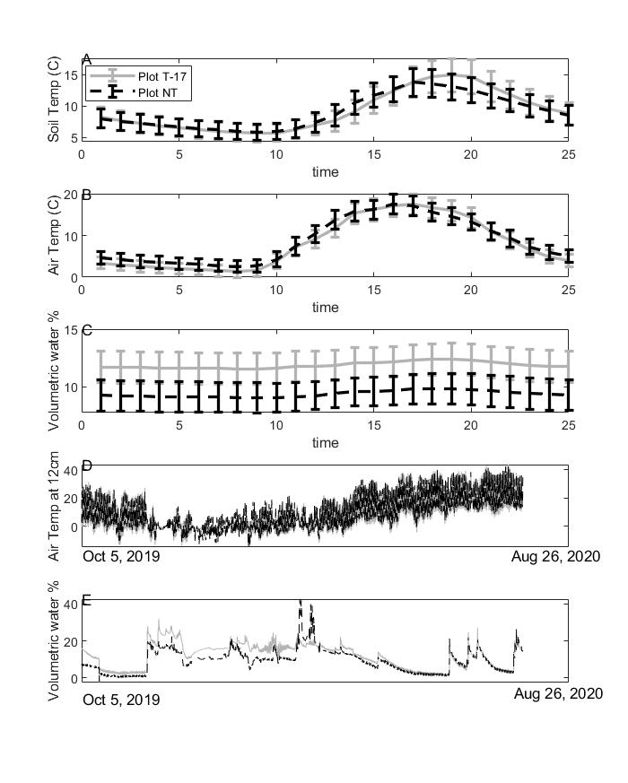
Figure 2 – (a) Diurnal soil temperature at 6 cm belowground (errorbars are standard errors), (b) diurnal air temperature at 12cm aboveground, (c) diurnal volumetric water content (%) (d) annual air temperature at 12cm and (e) annual volumetric water content (%) for stands T-17 (grey) and NT (black) over a 24-hour period for ~1 year of data (Oct 2, 2019 to Aug. 26, 2020). Error bars are sd. Stands T-17 is thinned while NT is unthinned.

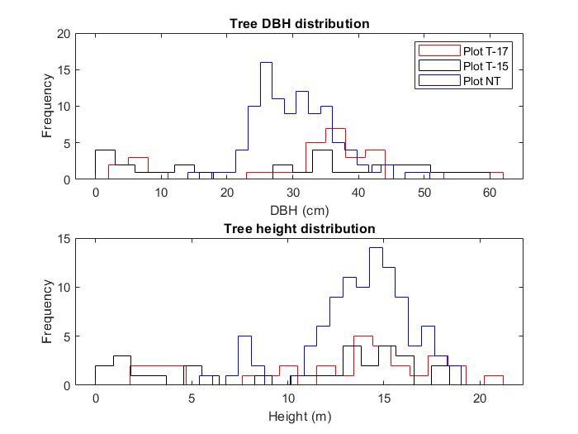
Figure 3 – Histograms for diameter at breast height (DBH) (top) and tree height (bottom) between the stands.

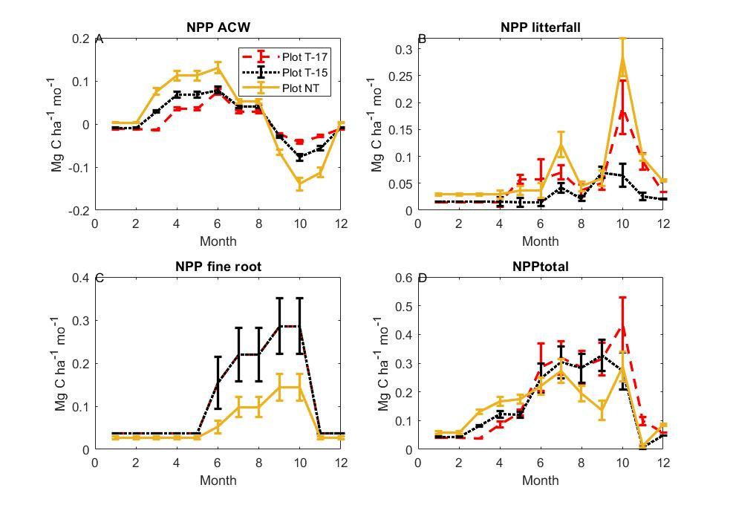
Figure 4 – (a) Woody NPP from measuring every tree per stand with a DBH tape every 3 months over a 2-year period for stand T-17 (red dashed), stand T-15 (black dotted) and stand NT (orange). (b) Fine root NPP from 3 ingrowth cores in Stands T-17 and NT collected every three-six months over a 15-month period. (c) Sum of the monthly collections from 6 litter traps per stand of total litter in a 1 m² area over a 1-year period. (d) Total NPP is the sum of the fine root, wood and litter NPP and here does not include NPP components such as understory, herbivory, or coarse roots because we have no seasonal data on these components. All units are Mg C ha⁻¹ mo⁻¹ and errorbars are standard errors. Stands T-15 and T-17 are thinned while NT is unthinned.
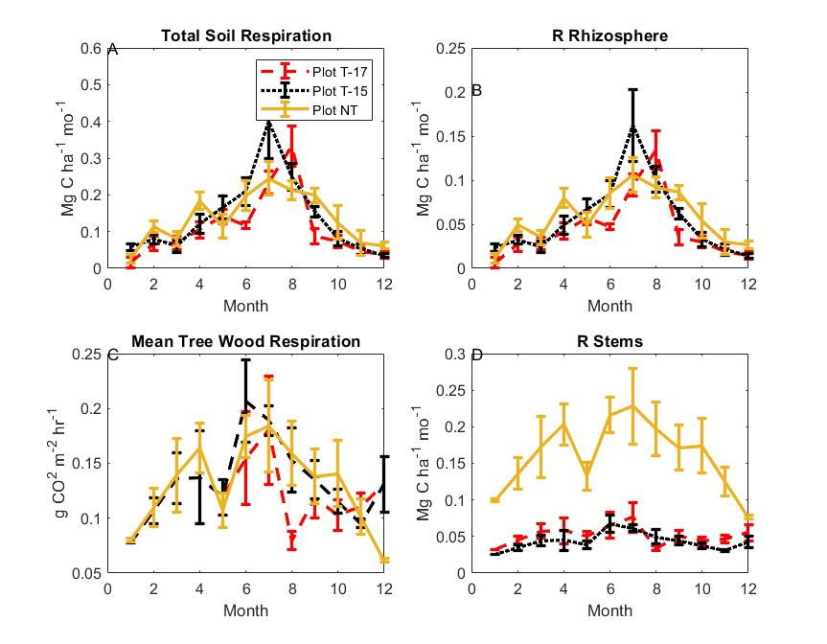
Figure 5 – (A) Total soil respiration and (B) autotrophic soil respiration measured at 6 locations per stand monthly over a ~2-year period for stand T-17 (red dashed), stand T-15 (black dotted) and stand NT (orange) near Flagstaff Az, USA. Autotrophic respiration was determined by an exclusion experiment (N = 3 per stand), where respiration was measured from tubes after roots and mycorrhizae had been removed. (C) Average tree above-ground wood respiration from 6 trees per stand measured every month and (D) multiplied by the total woody surface area of the stand over a 16-month period. (C) are in units of grams (CO₂) m² hr⁻¹ and (D) is in units of Mg C ha⁻¹ mo⁻¹ and errorbars are standard errors. Stands T-15 and T-17 are thinned, while NT is unthinned.

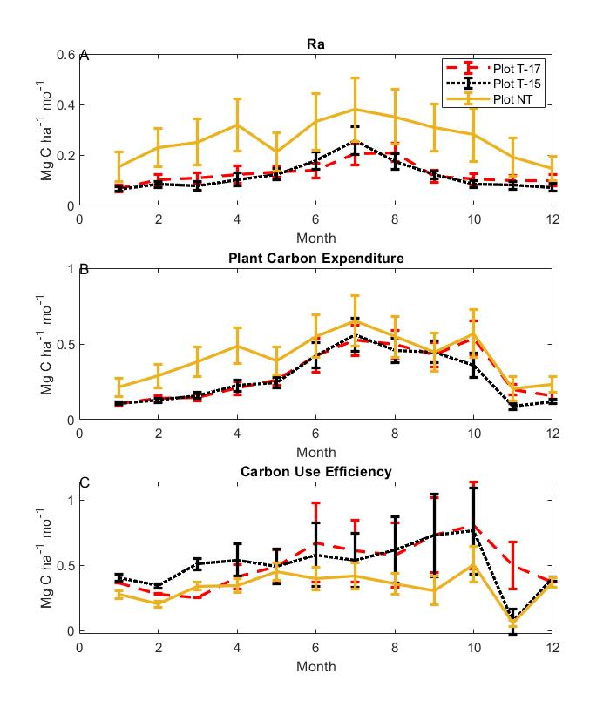
Figure 6 – Total autotrophic respiration (A), total plant carbon expenditure (PCE = NPP + Ra) (B) and carbon use efficiency (C) at a monthly timescale for Stand T-17 (red dashed), Stand T-15 (black dotted) and Stand NT (orange). PCE is a proxy for GPP. All values are in units of Mg C ha⁻¹ mo⁻¹, with the exception of carbon use efficiency (CUE) which is calculated as total NPP/GPP and errorbars are standard errors. Stands T-15 and T-17 are thinned, while NT is unthinned.

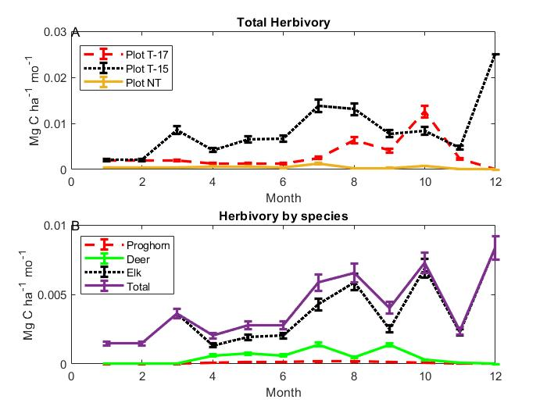
Figure 7 – Camera trap estimated herbivory as measured in each stand (A) for Stand T-17 (red dashed), Stand T-15 (black dotted) and Stand NT (orange) and by species (B) over a yearly cycle. All values are in units of Mg C ha⁻¹ mo⁻¹ and errorbars are standard errors. The high Elk value in December is likely anomalous as there was a stationary herd near the camera one day. Stands T-15 and T-17 are thinned, while NT is unthinned.

Figure 8 - Diagram showing the magnitude and pattern of key carbon fluxes for Stand T-17 the thinned stand (left) and Stand NT the un-thinned stand (b) near Flagstaff, AZ, USA. Components with prefixes R, NPP denote respiration, and net primary production terms respectively. Herb is the average large mammal herbivory estimate of the dung and camera trap methods. Detailed descriptions of C flux components measured are presented in Tables 1-4. All values are in units of Mg C ha⁻¹ year⁻¹, with the exception of carbon use efficiency (CUE) which is calculated as total NPP/GPP. Stands T-15 and T-17 are thinned, while NT is unthinned.

References
Abella, S. R., & Denton, C. W. (2009). Spatial variation in reference conditions: historical tree density and pattern on a Pinus ponderosa landscape. Canadian Journal of Forest Research, 39(12), 2391–2403. https://doi.org/10.1139/X09-146
Allen, C. D., Savage, M., Falk, D. A., Suckling, K. F., Swetnam, T. W., Schulke, T., et al. (2002). ECOLOGICAL RESTORATION OF SOUTHWESTERN PONDEROSA PINE ECOSYSTEMS: A BROAD PERSPECTIVE. Ecological Applications, 12(5), 1418–1433. https://doi.org/10.1890/1051-0761(2002)012[1418:EROSPP]2.0.CO;2
Amiro, B. D., Barr, A. G., Barr, J. G., Black, T. A., Bracho, R., Brown, M., et al. (2010). Ecosystem carbon dioxide fluxes after disturbance in forests of North America. Journal of Geophysical Research: Biogeosciences. https://doi.org/10.1029/2010JG001390
Anderson-Teixeira, K. J., Wang, M. M. H., McGarvey, J. C., & LeBauer, D. S. (2016). Carbon dynamics of mature and regrowth tropical forests derived from a pantropical database (TropForC-db). Global Change Biology, 22(5), 1690–1709. https://doi.org/10.1111/gcb.13226
Asner, G. P., & Levick, S. R. (2012). Landscape-scale effects of herbivores on treefall in African savannas. Ecology Letters. https://doi.org/10.1111/j.1461-0248.2012.01842.x
Bakker, E. S., Gill, J. L., Johnson, C. N., Vera, F. W. M., Sandom, C. J., Asner, G. P., & Svenning, J. C. (2016). Combining paleo-data and modern exclosure experiments to assess the impact of megafauna extinctions on woody vegetation. Proceedings of the National Academy of Sciences of the United States of America. https://doi.org/10.1073/pnas.1502545112
Blanche, C. A., Hodges, J. D., & Nebeker, T. E. (1985). A leaf area-sapwood area ratio developed to rate loblolly pine tree vigor. Canadian Journal of Forest Research. https://doi.org/10.1139/x85-192
Cooper, C. F. (1960). Changes in Vegetation, Structure, and Growth of Southwestern Pine Forests since White Settlement. Ecological Monographs, 30(2), 129–164. https://doi.org/10.2307/1948549
Covington, W., & Moore, M. (1994). Southwestern ponderosa pine forest structure: Changes since Euro-American settlement. Journal of Forestry, 92, 39–47.
Covington, W. W., Fulé, P. Z., Moore, M. M., Hart, S. C., Kolb, T. E., Mast, J. N., et al. (1997). Restoring ecosystem health in ponderosa pine forests of the southwest. Journal of Forestry. https://doi.org/10.1093/jof/95.4.23
Dore, S., Kolb, T. E., Montes-Helu, M., Eckert, S. E., Sullivan, B. W., Hungate, B. A., et al. (2010). Carbon and water fluxes from ponderosa pine forests disturbed by wildfire and thinning. Ecological Applications. https://doi.org/10.1890/09-0934.1
Dore, Sabina, Montes-Helu, M., Hart, S. C., Hungate, B. A., Koch, G. W., Moon, J. B., et al. (2012). Recovery of ponderosa pine ecosystem carbon and water fluxes from thinning and stand-replacing fire. Global Change Biology. https://doi.org/10.1111/j.1365-2486.2012.02775.x
Doughty, C. E., Metcalfe, D. B., Girardin, C. A. J., Amézquita, F. F., Cabrera, D. G., Huasco, W. H., et al. (2015). Drought impact on forest carbon dynamics and fluxes in Amazonia. Nature. https://doi.org/10.1038/nature14213
Doughty, C. E., Faurby, S., & Svenning, J. C. (2016). The impact of the megafauna extinctions on savanna woody cover in South America. Ecography. https://doi.org/10.1111/ecog.01593
Doughty, C. E., Goldsmith, G. R., Raab, N., Girardin, C. A. J., Farfan-Amezquita, F., Huaraca-Huasco, W., et al. (2018). What controls variation in carbon use efficiency among Amazonian tropical forests? Biotropica. https://doi.org/10.1111/btp.12504
Duffield, W. A. (1997). Volcanos of Northern Arizona. Grand Canyon Association.
Friedlingstein, P., Meinshausen, M., Arora, V. K., Jones, C. D., Anav, A., Liddicoat, S. K., & Knutti, R. (2014). Uncertainties in CMIP5 climate projections due to carbon cycle feedbacks. Journal of Climate. https://doi.org/10.1175/JCLI-D-12-00579.1
Fulé, P. Z., Covington, W. W., & Moore, M. M. (1997). DETERMINING REFERENCE CONDITIONS FOR ECOSYSTEM MANAGEMENT OF SOUTHWESTERN PONDEROSA PINE FORESTS. Ecological Applications, 7(3), 895–908. https://doi.org/10.1890/1051-0761(1997)007[0895:DRCFEM]2.0.CO;2
Ganey, J. L., & Vojta, S. C. (2011). Tree mortality in drought-stressed mixed-conifer and ponderosa pine forests, Arizona, USA. Forest Ecology and Management. https://doi.org/10.1016/j.foreco.2010.09.048
Geist, V. (2001). Antelope Country: Pronghorns: The Last Americans. Krause Publications.
Goulden, M. L., Mcmillan, A. M. S., Winston, G. C., Rocha, A. V., Manies, K. L., Harden, J. W., & Bond-Lamberty, B. P. (2011). Patterns of NPP, GPP, respiration, and NEP during boreal forest succession. Global Change Biology. https://doi.org/10.1111/j.1365-2486.2010.02274.x
Han, S. K., Han, H. S., Page-Dumroese, D. S., & Johnson, L. R. (2009). Soil compaction associated with cut-to-length and whole-tree harvesting of a coniferous forest. Canadian Journal of Forest Research. https://doi.org/10.1139/X09-027
Jenness, J. S. (2000). The Effects of Fire on Mexican Spotted Owls in Arizona and New Mexico. NAU.
Kaye, J. P., Hart, S. C., Fulé, P. Z., Covington, W. W., Moore, M. M., & Kaye, M. W. (2005). Initial carbon, nitrogen, and phosphorus fluxes following ponderosa pine restoration treatments. Ecological Applications. https://doi.org/10.1890/04-0868
Kaye, M. W., & Swetnam, T. W. (1999). AN ASSESSMENT OF FIRE, CLIMATE, AND APACHE HISTORY IN THE SACRAMENTO MOUNTAINS, NEW MEXICO. Physical Geography, 20(4), 305–330. https://doi.org/10.1080/02723646.1999.10642681
Kerhoulas, L. P., Kolb, T. E., & Koch, G. W. (2013). Tree size, stand density, and the source of water used across seasons by ponderosa pine in northern Arizona. Forest Ecology and Management. https://doi.org/10.1016/j.foreco.2012.10.036
Krofcheck, D. J., Remy, C. C., Keyser, A. R., & Hurteau, M. D. (2019). Optimizing Forest Management Stabilizes Carbon Under Projected Climate and Wildfires. Journal of Geophysical Research: Biogeosciences. https://doi.org/10.1029/2019JG005206
Lacey, S. T., & Ryan, P. J. (2000). Cumulative management impacts on soil physical properties and early growth of Pinus radiata. Forest Ecology and Management. https://doi.org/10.1016/S0378-1127(00)00422-9
Law, B E, Thornton, P. E., Irvine, J., Anthoni, P. M., & Van Tuyl, S. (2001). Carbon storage and fluxes in ponderosa pine forests at different developmental stages. Global Change Biology, 7(7), 755–777. https://doi.org/10.1046/j.1354-1013.2001.00439.x
Law, Beverly E, Ryan, M. G., & Anthoni, P. M. (1999). Seasonal and annual respiration of a ponderosa pine ecosystem. Global Change Biology, 5(2), 169–182. https://doi.org/10.1046/j.1365-2486.1999.00214.x
De Lucia, E. H., Drake, J. E., Thomas, R. B., & Gonzalez-Meler, M. (2007). Forest carbon use efficiency: Is respiration a constant fraction of gross primary production? Global Change Biology. https://doi.org/10.1111/j.1365-2486.2007.01365.x
Malhi, Y., Aragão, L. E. O. C., Metcalfe, D. B., Paiva, R., Quesada, C. A., Almeida, S., et al. (2009). Comprehensive assessment of carbon productivity, allocation and storage in three Amazonian forests. Global Change Biology. https://doi.org/10.1111/j.1365-2486.2008.01780.x
Malhi, Y., Doughty, C., & Galbraith, D. (2011). The allocation of ecosystem net primary productivity in tropical forests. Philosophical Transactions of the Royal Society B: Biological Sciences. https://doi.org/10.1098/rstb.2011.0062
Malhi, Y., Doughty, C. E., Galetti, M., Smith, F. A., Svenning, J. C., & Terborgh, J. W. (2016). Megafauna and ecosystem function from the Pleistocene to the Anthropocene. Proceedings of the National Academy of Sciences of the United States of America. https://doi.org/10.1073/pnas.1502540113
Metcalfe, D. B., Meir, P., Aragão, L. E. O. C., Malhi, Y., da Costa, A. C. L., Braga, A., et al. (2007). Factors controlling spatio-temporal variation in carbon dioxide efflux from surface litter, roots, and soil organic matter at four rain forest sites in the eastern Amazon. Journal of Geophysical Research: Biogeosciences. https://doi.org/10.1029/2007JG000443
Moore, M. M., Casey, C. A., Bakker, J. D., Springer, J. D., Fulé, P. Z., Covington, W. W., & Laughlin, D. C. (2006). Herbaceous vegetation responses (1992-2004) to restoration treatments in a ponderosa pine forest. Rangeland Ecology and Management. https://doi.org/10.2111/05-051R2.1
O’Hara, K. L. (1988). Stand structure and growing space efficiency following thinning in an even-aged Douglas-fir stand. Canadian Journal of Forest Research. https://doi.org/10.1139/x88-132
Olson, R.J., J.M.O. Scurlock, S.D. Prince, D.L. Zheng, and K. R. J. (2013). NPP Multi-Biome: Global Primary Production Data Initiative Products, R2. Data set. Data Set. Available on-Line [Http://Daac.Ornl.Gov] from the Oak Ridge National Laboratory Distributed Active Archive Center, Oak Ridge, Tennessee, USA. Doi:10.3334/ORNLDAAC/617.
Park Williams, A., Allen, C. D., Macalady, A. K., Griffin, D., Woodhouse, C. A., Meko, D. M., et al. (2013). Temperature as a potent driver of regional forest drought stress and tree mortality. Nature Climate Change, 3(3), 292–297. https://doi.org/10.1038/nclimate1693
Powell DS, Faulkner JL, Darr DR, Zhu Z, M. D. (1993). (1993). Forest resources of the United States, 1992. GTR.
Riutta, T., Malhi, Y., Kho, L. K., Marthews, T. R., Huaraca Huasco, W., Khoo, M., et al. (2018). Logging disturbance shifts net primary productivity and its allocation in Bornean tropical forests. Global Change Biology, 24(7), 2913–2928. https://doi.org/10.1111/gcb.14068
Savage, M., Brown, P. M., & Feddema, J. (1996). The role of climate in a pine forest regeneration pulse in the southwestern United States. Ecoscience. https://doi.org/10.1080/11956860.1996.11682348
Schubert, G. H. (2015). Silviculture of southwestern ponderosa pine : the status of our knowledge /. Silviculture of southwestern ponderosa pine : the status of our knowledge /. https://doi.org/10.5962/bhl.title.98816
Seager, R., & Vecchi, G. A. (2010). Greenhouse warming and the 21st century hydroclimate of southwestern North America. Proceedings of the National Academy of Sciences of the United States of America. https://doi.org/10.1073/pnas.0910856107
Sohn, J. A., Saha, S., & Bauhus, J. (2016). Potential of forest thinning to mitigate drought stress: A meta-analysis. Forest Ecology and Management. https://doi.org/10.1016/j.foreco.2016.07.046
Sorensen, C. D., Finkral, A. J., Kolb, T. E., & Huang, C. H. (2011). Short- and long-term effects of thinning and prescribed fire on carbon stocks in ponderosa pine stands in northern Arizona. Forest Ecology and Management. https://doi.org/10.1016/j.foreco.2010.10.031
ter Steege, H. (2018). Hemiphot.R: Free R scripts to analyse hemispherical photographs for canopy openness, leaf area index and photosynthetic active radiation under forest canopies.
Stewart, M. E. (2014). Draft Environmental Impact Statement for the Flagstaff Watershed Protection Project Coconino National Forest Coconino County, Arizona.
Stuart Chapin, F., Matson, P. A., & Vitousek, P. M. (2012). Principles of terrestrial ecosystem ecology. Principles of Terrestrial Ecosystem Ecology. https://doi.org/10.1007/978-1-4419-9504-9
Sullivan, B. W., Kolb, T. E., Hart, S. C., Kaye, J. P., Dore, S., & Montes-Helu, M. (2008). Thinning reduces soil carbon dioxide but not methane flux from southwestern USA ponderosa pine forests. Forest Ecology and Management. https://doi.org/10.1016/j.foreco.2008.03.051
Tanentzap, A. J., & Coomes, D. A. (2012). Carbon storage in terrestrial ecosystems: Do browsing and grazing herbivores matter? Biological Reviews. https://doi.org/10.1111/j.1469-185X.2011.00185.x
Towne, E. G., Hartnett, D. C., & Cochran, R. C. (2005). Vegetation trends in tallgrass prairie from bison and cattle grazing. Ecological Applications. https://doi.org/10.1890/04-1958
Van Valkenburgh, B., Hayward, M. W., Ripple, W. J., Meloro, C., & Roth, V. L. (2016). The impact of large terrestrial carnivores on Pleistocene ecosystems. Proceedings of the National Academy of Sciences of the United States of America. https://doi.org/10.1073/pnas.1502554112
Waring, R. H., Thies, W. G., & Muscato, D. (1980). Stem growth per unit of leaf area: a measure of tree vigor. Forest Science.
Westerling, A. L., Hidalgo, H. G., Cayan, D. R., & Swetnam, T. W. (2006). Warming and earlier spring increase Western U.S. forest wildfire activity. Science. https://doi.org/10.1126/science.1128834
White, A. S. (1985). Presettlement Regeneration Patterns in a Southwestern Ponderosa Pine Stand. Ecology, 66(2), 589–594. https://doi.org/10.2307/1940407
Wild, J., Kopecký, M., Macek, M., Šanda, M., Jankovec, J., & Haase, T. (2019). Climate at ecologically relevant scales: A new temperature and soil moisture logger for long-term microclimate measurement. Agricultural and Forest Meteorology. https://doi.org/10.1016/j.agrformet.2018.12.018
Williams, A. P., Cook, E. R., Smerdon, J. E., Cook, B. I., Abatzoglou, J. T., Bolles, K., et al. (2020). Large contribution from anthropogenic warming to an emerging North American megadrought. Science, 368(6488), 314 LP – 318. https://doi.org/10.1126/science.aaz9600
Woolsey T.S. Jr. (1911). Western yellow pine in Arizona and New Mexico. USDA Forest Service, Bulletin 101. Washington, DC.

