Title: Trophic cascades in coastal marine ecosystems: a meta-analysis of experimental and observational research

Running page head: Trophic cascades in coastal marine ecosystems
Authors: Aaron M. Eger*¹,², Julia K. Baum¹
Aaron M. Eger: Orcid ID: 0000-0003-0687-7340
Julia K. Baum: Orcid ID: 0000-0002-9827-1612
1: University of Victoria, Department of Biology, 3800 Finnerty Rd., Victoria, BC, Canada
2: Present Address: University of New South Wales, School of Biological, Earth, and Environmental Sciences, 2033, Sydney, NSW, Australia
*Corresponding Author: aaron.eger@unsw.edu.au

Keyword: trophic cascade, marine ecology, meta analysis, marine reserve, trophic control

Abstract: Predators, which are essential to the ecological and economic functioning of marine ecosystems, often exert top-down control on lower trophic levels, such that their removal can trigger trophic cascades. Here, we use a meta-analytic approach, building from earlier syntheses to better understand trophic cascades in marine benthic ecosystems. Our meta-analysis includes 46 experimental and observational studies that recorded herbivore and producer populations in the presence and absence of a secondary consumer, i.e. first level predator. From these data (77 independent data points and 147 measurements), we show that, although not as strong as previously estimated, there is consistent evidence for trophic cascades involving predators, herbivores, and producers in coastal marine ecosystems. We found that biotic factors related to an organisms’ size were most influential in determining the effect of predator presence on herbivore populations, while abiotic factors related to nutrients best determined the response of the producer populations. Although we detected no relationship between the changes in herbivore and producer populations, we did find that producers responded more intensely to changes in herbivores populations in high nutrient and low temperature environments. We also showed that trophic cascades can consistently be induced by marine reserves, and older reserves have a greater impact, a finding that highlights reserves as an effective tool in remediating the ecosystem consequences of predator loss. This work improves understanding of the drivers of benthic marine cascades, highlights the use of reserves to induce cascades, and establishes a new baseline of trophic cascades in benthic marine systems.

- INTRODUCTION
Marine predator populations often play important roles in maintaining the ecological functioning and economic services of coastal ecosystems. By exerting top-down control on herbivores, first level predators such lobsters (Ling et al. 2009), fishes (Caselle et al. 2018), and sea otters (Estes & Duggins 1995) indirectly support keystone foundation species, such as kelp, seagrasses, and other macroalgae, which would otherwise be controlled by the herbivores (Shurin et al. 2010). As a result of this indirect trophic interaction, known as a trophic cascade (Svenning et al. 2016), predator populations can help support and modify entire ecosystems and their associated ecosystem services (Larkum et al. 2006, Clark & Johnston 2017, Wernberg et al. 2018). Additionally, marine predators directly provide ecosystems services through human consumption or material use (Smith & Addison 2003, Myers & Worm 2005). Because of their high ecological and socioeconomic value, predators have not only been depleted in many systems (Heithaus et al. 2008), but in some cases reintroduced or conserved via socially complex management strategies, e.g. marine reserves (Davis et al. 2019). As humans become increasingly involved in either removing, introducing, or enhancing marine predator populations, it is crucial that we understand the ecosystem wide implications of these manipulations, intentional or otherwise. Theory and practice suggest that predators can structure consumer and producer populations in the ocean, but there is considerable variability within these observations (Borer et al. 2005, Shears et al. 2008, Baum & Worm 2009). It is therefore important to not only consider that generality of trophic cascades but also the biotic and abiotic conditions that might govern their strength in marine ecosystems (Borer et al. 2005). For example, under what conditions might removing or introducing a predator from marine ecosystem more likely impact lower trophic levels.

Despite coastal marine ecosystems containing some of the best-known trophic cascades (e.g. Estes & Duggins 1995, Shears & Babcock 2002, Moksnes et al. 2008) their determinants are not well synthesized - though see work on quantifying their magnitude in Atwood & Hammill (2018), and ecosystem and region specific work in He & Silliman (2016) and Östman et al. (2016). Previous syntheses on the determinants of indirect trophic interactions, i.e. trophic cascades (Shurin et al. 2002, Borer et al. 2005) contained very few data points from coastal marine systems (8 / 102 data points in the seminal Shurin et al. (2002) work and 18 / 210 in Borer et al.’s (2005) updated analysis), and demonstrated a high degree of variability in the strength of those cascades. More progress has been made in analyzing the factors that influence the direct trophic interactions of herbivory (Poore et al. 2012) and predation (Griffin et al. 2013, Katano et al. 2015). While the past studies on direct trophic controls allow us to make inferences about trophic cascades, we are currently limited in our ability to predict the ecosystem consequences of continued removal of marine predators, reintroductions, or how well marine reserves, which often restore predator populations, work to impact the entire ecosystems (Hessen & Kaartvedt 2014, He & Silliman 2016).

Marine reserves are well recognized as a useful tool to restore fish populations (Molloy et al. 2009), but there is less evidence to support their impact on non-extracted species such as herbivores and algae (Gilby & Stevens 2014, Woodcock et al. 2017). Although such species may not directly benefit from marine reserves, they could be indirectly impacted through trophic interactions, specifically by resurgant predator populations or indirect impacts of the marine reserve (Shears & Babcock 2002, McClanahan & Muthiga 2016). Such positive impacts could increase the resilience of foundation species (e.g. kelp) to climate, competition, and consumption based disturbances (Olds et al. 2014). Within an ecological theory context, marine reserves allow for ecological principles to be tested at the landscape level, a common detractor levelled against small scale experimental studies (Meentemeyer & Box 1987). To test for the ability of marine reserves to induce a trophic cascade, herbivore and producer populations within the reserve (with predators) are compared to herbivore and producer populations outside the reserve (without predators). Because they are not directly manipulated, we expect that cascades will not be as strong in the protected area studies as they are in controlled, experimental research (Hillebrand 2009), but could never-the-less prove to be a viable management option for reversing the trophic effects of marine predator declines. Within reserves, it is also expected that cascade strength will amplify with reserve age as predators have longer to recover from overexploitation (Molloy et al. 2009), but not size, as has been previously found with predator return (Lester et al. 2009).

Beyond the spatial scale, the occurrence and strength of trophic cascades still appears to be context dependent and to hinge on various biotic and-or abiotic factors, as well as the methodological pretexts present in that ecosystem or study (Borer et al. 2005, Cebrian et al. 2009, Shurin et al. 2010). Research into the abiotic drivers of trophic cascades has been fairly limited and we focus investigation on two potentially key factors 1) temperature, which regulates metabolism and determines how quickly predator or consumers populations can grow and reproduce, and 2) nutrient levels (NH4⁺ and PO3⁻), which determine if a producer can grow with a reduced consumer pressure. While past investigation on biotic factors has focused on species diversity and degrees of omnivory (excluded from our study, see methods), our work investigates the role of body size, which influences consumption pressure (Vucic-Pestic et al. 2010), predator-prey mass ratio, which influences the probability of predation (DeLong et al. 2015), and trophic connectivity which examines the progression of trophic effects through different levels of the food web (Duffy 2002).

In this study, we conducted a global meta-analysis of the peer-reviewed literature on coastal marine trophic cascades to synthesize current understanding of i) their direction and strengths; ii) their biotic and abiotic drivers; iii) how the implementation of marine reserves influences these food web interactions. Specifically, we hypothesized that trophic cascades would be stronger in high temperature environments which necessitate higher energy demands and consumption pressures (Bruno et al. 2015); in high nutrient environments, where systems are less nutrient limited and more likely to be top-down controlled (Oksanen et al. 1981, Jeppesen et al. 2003, Östman et al. 2016); when larger bodied species, with higher consumption rates, are involved (DeLong et al. 2015); when predator-prey mass ratios are intermediate, i.e. not too larger or too small, and species are likely to interact (Vucic-Pestic et al. 2010); and when trophic connectivity is high, such that changes in herbivore populations reflect changes in producer populations (Duffy 2002). We also compared our results to the two most closely related previous meta-analyses (Shurin et al. 2002, Borer et al. 2005) to assess how additional data from studies conducted over the past decade have influenced our understanding of trophic cascades in coastal marine ecosystems. As marine predators continue to decline (Christensen et al. 2014) and the oceans become increasingly managed (Edgar et al. 2014), such knowledge is vital not only to ecological theory, but also for marine management.

- METHODS
2.1. Literature search and study selection
We used SCOPUS Web of Science (WOS) to conduct two distinct searches of the primary literature related to marine trophic cascades. The first search sought studies that had examined trophic cascades using experimental methods and combined the terms: ("top down" or trop* or cascad* or contr* or indirect*) AND (exclus* or enclos* or remov* or cage* or fenc* or mesocosm) AND (marine or sea or ocean) AND (pred* or prey) AND (primary or producer or *grass or *phyte or alga* or seaweed). The second search targeted trophic cascade studies based upon natural experiments and observations surrounding marine reserves, and used the search terms: ("top down" or trop* or cascad* or contr* or indirect*) AND (reserve* or MPA or park or protect*) AND (marine or sea or ocean) AND (pred* or prey) AND (primary or producer or *grass or *phyte or alga* or seaweed). The first searches were conducted between February 23, 2016 and March 10th, 2016, and we conducted renewed searches to update the results between September 22nd and 26th, 2018. The WOS searches cumulatively and respectively yielded 821 and 1931 studies and contained studies published between the years 1990 and 2018. Additional papers were added from the references of the past meta-analyses on the subject.

We evaluated the titles and abstracts of our search results to determine if the papers were relevant to our research questions. We first read the title and abstract of each search result and marked studies for potential inclusion if it appeared that they recorded a three level trophic cascade in a coastal benthic marine environment; following this process we were left with 223 publications. We then read the full publication in greater detail to determine if the study measured the mean and variance of herbivore and producer populations with and without a primary predator population. In addition to these criteria, we excluded studies based on the following criteria to ensured that we only included relevant comparable data points in our analysis. We excluded a study if it explicitly examined an omnivorous predator that fed on both the herbivores and producers and would therefore confound the effects of the predator “treatment” (Heck Jr et al. 2000). Additionally, we excluded studies that: only reported values for grazing rate or tissue damage because they are not direct measures of producer populations (Shurin et al. 2002, Borer et al. 2005), recorded the predator effect when mixed with another treatment (e.g. nutrient addition), used cages that excluded both herbivorous and predatory species, or only provided modeled results, each of which would either confounded the effect being tested or not provide empirical evidence. We attempted to ensure temporal synchronicity in the measurements, and therefore excluded studies if they recorded predator, herbivore, or producer populations greater than one month apart from each other. Specific to marine reserves, we excluded studies that used fisheries landings as a proxy for biomass because they are not representative of the entire community or if the study reported herbivores that were part of an active fishery, as they too would directly benefit from the protection of the reserve.

From each paper that met our final selection criteria (N = 46), we extracted data on the mean herbivore and producer populations with and without predator populations, while also making additional considerations on how to record the data. The primary producer populations were recorded with biomass, density, percent cover, or chlorophyll-a concentrations as the units, while the herbivore populations were recorded using density, biomass, or abundance. If a study recorded both biomass and abundance, biomass was used as the metric of measurement as it is more comparable across species. If a study had multiple time points, we used the point at the end of the study because it was furthest from any manipulation and most likely to represent natural conditions. If a study manipulated a predator and recorded more than one herbivore or primary producer, each species response was considered individually while acknowledging that they were not independent events (see effect size calculation). Finally, to accommodate the use of the log response ratio, if zero values were present in either the herbivore or the producer metric, the lowest reasonable value that could have been recorded was substituted (e.g. 1 if abundance was measured or 1% if percent cover was measured, (Poore et al. 2012). To extract these data, we used the software graphClick 3.0.3 (Arizona Software Inc., USA) to extract all the data from the qualifying studies (full data in Supplement Table S1).

2.2. Predictor variables
In addition to the population data, we collected a variety of potential quantitative and qualitative predictor variables (Supplement Table S2). First, we recorded the following categorical factors related to the species involved, e.g. predator type (invertebrate, vertebrate), herbivore type (invertebrate, vertebrate), and primary producer type (macro algae, epiphytic algae, seagrass) from the study. Next, we used the World Ocean Atlas dataset, atlas resolution 1˚ x 1˚ (Levitus et al. 2013) and the site’s geographic coordinates to extract: sea surface temperature (SST), nitrate concentrations, and phosphate concentrations for each data point. We excluded mesocosm studies from this analysis because the field variables, SST, nitrate concentration, and phosphate concentration, would not necessarily be representative of the conditions in the mesocosm. We recorded the body size of predators and herbivores as the maximum length in any dimension (cm) and collected the information either from the study or extracted it from the online sources (Supplement Table S1). If multiple species were present, we used the mean body size. We calculated the marine reserve age as the year the work was conducted minus the year the reserve was founded and the reserve size data was sourced from the publication or extracted from the web (Supplement Table S1).

2.3. Calculation and analysis of the effect sizes
We used a meta-analytic approach to examine the direction and magnitude of the herbivore and primary producer effect sizes with and without predators. We opted to use the log-response ratio as the measure of effect size (Borenstein et al. 2009) to facilitate comparison with past studies on this subject (Shurin et al. 2002, Borer et al. 2005, Poore et al. 2012, Griffin et al. 2013, Katano et al. 2015). However, we diverged from the two major prior studies (Shurin et al. 2002, Borer et al. 2005), and included measures of variance while calculating the effect size. It was previously thought that too much data would be lost by requiring variance measures but this is no longer the case, as only 24 data points had to be removed due to a lack of variance data. We used the R programming environment 3.3.3 (R Core Team 2017), the package metafor (Viechtbauer 2010) to calculate the effect sizes, and the package ggplot2 (Wickham & Chang 2008) to plot the results.

A positive herbivore or producer effect size indicates an increase in the population in the presence of the predator and a negative effect size indicates a decrease. A significant herbivore effect size had a 95% CI less than 0 and a significant producer effect size had a 95% CI greater than 0.

We analyzed the statistical significance of the predictor variables (Appendix Table A1) using linear mixed effects models that were developed using the rma.mv function, also found in the metafor package (Viechtbauer 2010). We used linear mixed effects models to account for the number of repeated measures used in the analysis (e.g. same study, different species considered). If a factor had a P value < 0.05, it was tested for significant within-group differences using a Tukey Honest Significance test with a Bonferroni correction by using the R package multcomp (Hothorn et al. 2008). We found no statistical difference between the observational and experimental study effect sizes so we analyzed all studies together. Lastly, we used the funnel function in metafor to test for publication bias.

2.4. Strength of trophic connection and cascades
We determined the strength of the trophic connection to be the relative change in the producer population given a change in the herbivore population. We calculated this metric by taking the residuals of a 1:1 regression line with the producer effect sizes greater than zero on the y-axis and the herbivore effect sizes less than zero on the x-axis. A value of 0 indicates that for every unit change in the herbivore metric, there was a proportional change in the producer metric. A negative residual signifies a smaller increase in the producer metric than in the herbivore and a positive value indicates the opposite. We tested these values for significance using the same methods as above except using the nlme package (Pinheiro et al. 2012) in R.
Similarly, we used the nlme package in R to test whether the effect sizes from this study are significantly different than those found in Shurin et al. (2002) and Borer et al.’s (2005) work across alternate terrestrial and aquatic systems.

- RESULTS
Our meta-analysis yielded herbivore and producer effect sizes from 46 studies comprising 77 independent data points from 13 different countries (Appendix Fig. A1). The presence of predators had significant negative impacts on herbivore populations and significant positive impacts on primary producer populations: herbivores decreased an average of 3.16 times (95% CI, 2.10 – 4.76, Fig. 1) in the presence of predators, while producers increased an average of 2.13 times (95% CI, 1.62 – 2.83, Fig. 1, Table 1). We found no significant difference (P > 0.05, Appendix Table A1) between the effect sizes of the experimental and observational studies.

3.1. Effect size differences within groups
The majority of the within group category effect sizes (e.g. vertebrate or invertebrate herbivore) had the expected effect sizes, herbivore decline and producer increases in the presence of predators. There were 3 exceptions, the first was in the methodology category, specifically in studies that used an enclosure cage to test trophic cascades: these studies had non-significant herbivore (95% CI > 0) and producer effect sizes (95% CI < 0) (Table 1). Studies that examined vertebrate herbivores also had non-significant herbivore effect sizes (Table 1). Thereafter, the only within group categories to have a non-significant producer effect size were studies in which the primary producers were either epiphytes or seagrass (Table 1).

3.2. Predictors of the herbivore effect size
Four factors were significant predictors of the herbivore effect size. First, herbivore populations were more reduced by predators in higher temperature ecosystems (P = 0.04, N = 108, Fig. 2, Appendix Table A1). Second, herbivore reduction was greatest when predators were more similar in size to the herbivores, as indicated by a lower predator to herbivore size ratio (P < 0.01, N = 147, Fig. 2, Appendix Table A1). Third, the herbivore effect size was largest when larger bodied herbivores were involved in the interaction (P < 0.01, N = 147, Fig. 2, Appendix Table A1). Finally, the study method used, whether a mesocosm, cage enclosure, enclosure, marine reserve, or observation was a significant categorical predictor (P = 0.02, N = 147, Appendix Table A1), but there were no significant within group differences (P > 0.05, Appendix Table S4).

3.3. Predictors of the producer effect size
The key significant predictors of the producer effect size were abiotic. Producer populations had greater increases when predators were present in ecosystems that had higher phosphate and nitrate levels (P = 0.02 and P < 0.01, respectively, N = 108, Fig. 2, Table 1). We found no significant relationship between the herbivore effect size and the producer effect size (P > 0.05, Fig. 2)

3.4. Strength of trophic connection
The strength of the trophic connection, defined as the change in producer effect size given a change in the herbivore effect size, was affected by biotic and abiotic predictor variables. Specifically, trophic connectivity was strongest in low temperature environments (P = 0.04, N = 82, Fig. 3, Supplement Table S3), when predators were larger than herbivores (P = 0.02, N = 82, Fig. 3, Supplement Table S3) and in high phosphate and nitrate systems (P = 0.03 and P = 0.04, respectively, N = 82, Fig. 3, Supplement Table S3).

3.5. Influence of marine reserve design
There was an average 3.00 times decrease in herbivore populations and an average 1.84 times increase in primary producer populations within marine reserves compared to areas outside the reserve. The size of a marine reserve had no influence on the herbivore or producer effect size, whereas older marine reserves had greater reductions in herbivores compared to non-reserve areas (P = 0.04, N = 59, Fig. 4, Table 1), but no effect on the change in the producer population.

3.6 Comparison to past studies and systems
We found no significant difference between either the herbivore or producer effect sizes in our study and those estimated for coastal marine ecosystems in previous trophic cascade meta-analyses (P > 0.05, Fig. 5, Supplement Table S5; Shurin et al. 2002; Borer et al. 2005). However, comparing the effect sizes from our marine benthic meta-analysis to the effect sizes from other ecosystems (including marine, freshwater, and terrestrial ecosystems; Shurin et al. 2002; Borer et al. 2005), we found that the estimated herbivore effect was only significantly stronger in marine benthic than in lentic benthic ecosystems (P < 0.01, N = 12, Fig. 5, Supplement Table S5). We do not detect significant differences between ecosystems (P > 0.05) for the producer effect size.

- DISCUSSION
Our meta-analysis, which assesses over a decade of new research relative to the two most closely related previous studies, provides evidence that trophic cascades (involving non-omnivorous predators) have occurred in nearly all the marine systems and contexts examined, and have a variety of drivers, with differing implications for marine food web alterations. We found that whereas top-down control of herbivores appeared to be most influenced by biotic variables, that of producer populations was most influenced by abiotic factors, such as nutrients. Counter to our expectations, however, we found that changes in herbivore populations did not translate into proportional changes in producer populations. Evaluating studies involving marine reserves, a common conservation tool to increase predator populations, we found that reserve effects on predators often cascaded down to both herbivore and producer populations. Lastly, by comparing the effect sizes of our study to past work, we found that trophic controls in benthic marine systems were not as strong as previously thought, likely due to updated samples, however, even with our increased dataset, there are still major geographic and taxonomic gaps that require addressing in trophic cascade research.

4.1. Determinants of the herbivore effect size
The majority of the significant predictors of herbivore effect size were biotic variables related to the size of the species involved. Our finding that larger herbivores decreased more in the presence of a predator than smaller ones could have arisen because larger organisms have longer generation times (Fenchel 1974), and thus may be slower to recover from predation events, such that there are larger resultant effect sizes. A second, more methodological explanation, is that when larger individuals are removed, more biomass is taken from the system and when comparing between treatment and control data points, this stark contrast between predated and non-predated data, could also have led to larger effective sizes. This explanation, however, only holds true if biomass is considered and only 35 of our data points recorded herbivore populations as biomass. Future trophic interaction research should standardize predation events by body size to help account for this potentially confounding factor. Following from herbivore body size, we found that the predator-prey mass ratio also influenced the effect size, as herbivore reductions were greatest when the herbivore and predator were more similar in size. However, predator size, a component of the ratio, had no significant influence on the herbivore effect size, suggesting that herbivore body size may be the key determinant in this interaction. Consequently, we would expect that larger herbivores, that are more similar in size to their predators will be most affected by any future predator introductions. Past studies (Griffin et al. 2013, Gamfeldt et al. 2015) also found that biotic factors, including predator species richness (which we were unable to include due to limited sample size), were better predictors of the predator-herbivore connection than abiotic factors. Nevertheless, we found one significant abiotic variable; predators had a greater impact on herbivores in high temperature environments, likely due to increased metabolic demands consumption rates. Consequently, herbivores are more likely to increase following a predator removal in warmer waters which will be more common as sea temperature continues to rise (Aral & Guan 2016).

4.2. Determinants of the producer effect size
Contrary to herbivores, we found that abiotic factors were the best predictors of the effect size for producers. As predicted (Oksanen et al. 1981, Jeppesen et al. 2003, Östman et al. 2016), predator presence had the most positive impact on producer populations in high nutrient environments, where nutrients are not limiting, and producer populations are more likely top down controlled. Moreover, these conditions tend to be found in ecosystems with lower species diversity (Edgar et al. 2017), where the manipulation of a single species would be expected to have a greater impact (Rodríguez‐Castañeda 2013). Poore et al. (2012) found the same result for the herbivore-producer trophic link and hypothesized that it was due to greater primary productivity and higher standing stock producer biomass. As a result, the rate of production outpaces the rate of consumption and there is a greater contrast between the grazed and un-grazed plots. These explanations are not mutually exclusive but as with the herbivore effect size, future research should seek to standardize measures of producer populations by growth or production rates. Therefore, we would expect predator introductions or marine reserves to have the most positive impacts in high nutrient ecosystems where the producer can best take advantage of the reduced grazing pressure.

4.3. Trophic connectivity
Contrary to expectation, the strength of herbivore suppression had no influence on the strength of the producer response to predator presence. As a result, we saw that even minor modifications to food webs and ecosystems can have large reverberations. Conversely, large shifts in herbivore populations do not always proportionately influence producer populations. What determines the former as opposed to the latter will depend on the trophic connection between the herbivore and producer (Duffy et al. 2007, van Veen & Sanders 2013, Heath et al. 2014). Using the trophic connectivity metric, we showed strong trophic connectivity in high nutrient systems and weak connectivity in high temperature ecosystems, consistent with prior ecological theory that dictates that high nutrient environments are generally top down controlled, not bottom up (Oksanen et al. 1981, Jeppesen et al. 2003, Östman et al. 2016). Because marine ecosystems in warmer environments are more diverse (Tittensor et al. 2010), there are potentially more trophic connections and less reliance on a single interaction which should result in lower connectivity (Griffin et al. 2013). These results are inferential but provide a new approach to analyzing trophic cascade data and assessing ecological controls.

4.4. Marine reserves and trophic cascades
While numerous studies have reported positive effects of marine reserves on restoration of predatory fish populations (e.g. Lester et al. 2009, Edgar et al. 2014), few studies (Gilby & Stevens 2014) have examined the impact of marine reserves on herbivores and primary producer populations. Our work counters the results of Gilby & Stevens (2014), which had limited sample sizes for temperate kelp ecosystems (N = 5 for producers) and found no effect of reserves on either herbivore or algae populations. Instead, we found herbivores decreased on average 3.00 times and producers increased 1.84 times within reserves compared to outside, numbers that are comparable to studies that used enclosure cages, exclusion cages, or mesocosms to directly manipulated predator populations. Moreover, if potential confounding variables, such as spill over benefits to herbivore populations (e.g. higher habitat quality or lower pollution levels inside reserves, (Jamieson & Levings 2001) and illegal poaching from the reserve (Byers & Noonburg 2007) are considered, it even more notable that reserves have such a significant effect on producer populations. Despite the importance of producer or habitat species in marine ecosystems, the planning process for marine reserves does not typically consider producer populations and instead focuses on fishes and macroinvertebrates (Woodcock et al. 2017). Whilst important, there is clearly room to incorporate a more complex ecosystem perspective and begin to plan and evaluate reserves based upon their ability to protect keystone primary producer populations.

The mechanisms that make marine reserves more or less effective at restoring populations is the subject of much ongoing research (Lester et al. 2009, Molloy et al. 2009, Di Franco et al. 2016), and our work provides some insight into the reserve characteristics that influence trophic interactions. We found that reserve size had no influence on effect size, while reserve age was significantly and positively correlated with the herbivore effect size. Consequently, and as has been found with predator populations (Lester et al. 2009), when seeking to restore predator-herbivore dynamics, bigger is not necessarily better. And while we found strong evidence for the impact of marine reserves on herbivore and producer populations, managers should not expect immediate effects, because we also found that impacts increased over time. Because we found no connection between the size of the herbivore effect size and the size of producer effect size, it is not necessarily surprising that we there was no relationship between reserve age and the producer effect size. It is also possible, that because of their extremely quick growth rates, algae may quickly respond to reduced herbivory rates and thus there is no relationship with time.

4.5. Trophic Cascades in Marine Systems
Our findings were qualitatively consistent with previous marine meta-analyses of trophic controls and cascades (Shurin et al. 2002, Borer et al. 2005, Griffin et al. 2013, Katano et al. 2015, Östman et al. 2016), and we found consistent evidence for trophic controls and cascades in coastal marine ecosystems. In comparison, however, we estimate an average 3.16 times decrease in herbivores, larger than Katano et al.’s (2015) estimation (2.50 time decrease), and a 2.14 times increase in producers, which is smaller than the 3.1 times increase in producers populations when herbivores were directly removed in Poore et al’s (2012) examination of coastal marine systems. Katano et al.’s (2015) study had a much higher sample size (N = 293), which could account for the lower overall effect size, as we found when comparing our work to previous studies (see below). Poore et al. (2012) focused on the direct trophic link between herbivores and producers, and we suggest our results are lower because of the “trophic trickle” (Halaj & Wise 2001), which suggests that trophic effects are attenuated with the addition of trophic levels and the indirect predator-producer link in our study should be smaller than the direct link between herbivores and producers. Contrary to earlier cross-ecosystem studies (Shurin et al. 2002, Borer et al. 2005), we found very little differentiation amongst the within group factors such as invertebrates compared to vertebrates. Only a few within group factors had non-significant effect sizes (producer effect size 95% CI < 0 or herbivore effect size 95% CI > 0) and categorical factors were not predictors of cascade strength. Consequently, we can infer that cascades can be an important ecological mechanism in most coastal marine systems. And we found little evidence to suggest that cascade strength varies significantly based on the characteristics of the system or the taxonomy of the species involved.

Our updated analysis contained over 18 times as many coastal marine data points as the study conducted by Shurin et al. (2002), and 8 times as many as Borer et al. (2005), along with a greater diversity of contexts. For example, our results pertain to trophic cascades from a variety of habitats (coral reef, kelp, mudflat, rocky intertidal saltmarsh, seagrass, and shallow benthic), a wider range of geographic locations (Appendix Fig. A1), and a mix of observational and experimental research (N = 79 and N = 68, respectively). By revisiting Shurin et al.’s (2002) and Borer et al.’s (2005) cross-ecosystem comparison using an updated sample size, we found no statistical difference between the effect sizes in benthic marine systems and nearly all other ecosystems considered (lake benthic, lake plankton, marine plankton, streams, and terrestrial). The only difference that existed was found when comparing the new results to herbivore effect sizes previously found in lentic benthic (P < 0.01) ecosystems (Shurin et al. 2002). While Katano et al. (2015) found no significant differences in effect size for predator-herbivore interactions in terrestrial and marine systems, our work is to the best of our knowledge the first to provide evidence that trophic cascades in coastal marine systems are not inherently stronger than those in other ecosystems. It appears that the increased sample size included several studies with null or negative results and resulted in a lower overall effect size (Fig. 5). As a result, we can conclude that there is obvious potential for strong trophic cascades in coastal marine systems, but that they are not guaranteed and can indeed have counter-intuitive results (e.g. a decrease in producers when predators are present).

  - Influence of the study method
Interestingly, we found no significant difference between the effect sizes of experimental and observational studies. While previous studies have suggested that observational studies are too complex or contain too many confounding variables to allow for robust testing of theoretical principles (Sagarin & Pauchard 2012) our results demonstrate that natural experiments and observations can provide similar conclusions compared to those from traditional experimental research. Our findings should increase the confidence with which ecologists are able to test ecological theory at large scales and with little or no manipulation.

4.7. Data gaps
Despite synthesizing the results from 147 data points, there remain significant gaps in multiple data categories that prevent the synthesis of a truly balanced dataset. Whereas experimental study locations were all located in Europe and the United States of America (USA), the majority of observational studies occurred in other regions of the world (namely the Caribbean, SE Australasia, and E Africa). No studies at all were conducted in South America, Asia, or Antarctica, (Appendix Fig. A1). Future studies should seek to address these geographical biases. Naturally, these biases also extend to the abiotic variables associated with those regions. More work should be conducted in regions with high nutrient concentrations and sea surface temperatures (Fig. 2). Two notable biotic gaps exist as well. First, as was the case with Borer et al.’s (2005) analysis, very few vertebrate herbivores were examined in this study (11 / 147), and the majority of the studies looked at macroalgae as the producer (127 / 147), with seagrass particularly under-examined (3 / 147) (see Appendix Table A1; for all sample sizes). Because of these gaps, we present our results as an update of our understanding of cascades in coastal marine systems and challenge future research to work to address our limitations.

  - Conclusion
We found consistent evidence for trophic cascades in coastal marine systems regardless of the study method, species involved, or abiotic environment. The determinants of the strength of predator control on herbivores were primarily biotic and related to herbivore size, while those of predator induced herbivore release of producers were primarily abiotic and related to the nutrient levels of the system. Though there was no relationship between the strength of the herbivore reduction and the strength of the producer response, we used the residuals of a 1:1 regression of the two variables to glean further insight. This approach showed that top-down control and trophic connectivity are stronger in high nutrient, low temperature environments, and with larger predator-herbivore size ratios. As such, attention should be paid to predator loss in said types of marine ecosystems. Finally, examining studies of marine reserves, we found that reserves aimed at restoring predators led to decreases in herbivore populations and aided the restoration of producer populations. The older a reserve was, the greater the reduction in herbivores; however, this did not translate to the producer population. Our study updates understanding of trophic cascades in coastal marine systems, provides evidence contradicting earlier studies that suggested trophic cascades are strongest in coastal marine environments, and highlights the importance of revisiting ecological paradigms regularly as new data become available.

ACKNOWLEDGEMENTS
We would like to express our gratitude to J. Iacarella for statistical advice, R. Eger, M. Messager, L. Kehoe, and R. El-Sabaawi for providing suggestions and insights during the writing and editing process. We would also like to thank J. Shurin and E. Borer for providing the results from the prior study for comparison. We also acknowledge the National Science and Engineering Research Council of Canada and the World Wildlife Fund of Canada for providing funding in the form of a graduate scholarship to AME.

LITERATURE CITED
Aral M, Guan J (2016) Global sea surface temperature and sea level rise estimation with optimal historical time lag data. Water 8:519.
Atwood TB, Hammill E (2018) The Importance of Marine Predators in the Provisioning of Ecosystem Services by Coastal Plant Communities. Front Plant Sci 9:1289.
Baum JK, Worm B (2009) Cascading top‐down effects of changing oceanic predator abundances. J Anim Ecol 78:699–714.
Borenstein M, Hedges L V, Higgins JPT, Rothstein HR (2009) Effect sizes based on means. Introd to meta-analysis:21–32.
Borer ET, Seabloom EW, Shurin JB, Anderson KE, Blanchette CA, Broitman B, Cooper SD, Halpern BS (2005) What determines the strength of a trophic cascade? Ecology 86:528–537.
Bruno JF, Carr LA, O’Connor MI (2015) Exploring the role of temperature in the ocean through metabolic scaling. Ecology 96:3126–3140.
Byers JE, Noonburg EG (2007) Poaching, enforcement, and the efficacy of marine reserves. Ecol Appl 17:1851–1856.
Caselle JE, Davis K, Marks LM (2018) Marine management affects the invasion success of a non‐native species in a temperate reef system in California, USA. Ecol Lett 21:43–53.
Cebrian J, Shurin JB, Borer ET, Cardinale BJ, Ngai JT, Smith MD, Fagan WF (2009) Producer nutritional quality controls ecosystem trophic structure. PLoS One 4:e4929.
Christensen V, Coll M, Piroddi C, Steenbeek J, Buszowski J, Pauly D (2014) A century of fish biomass decline in the ocean. Mar Ecol Prog Ser 512:155–166.
Clark GF, Johnston EL (2017) Australia state of the environment 2016: coasts.
Davis RW, Bodkin JL, Coletti HA, Monson DH, Larson SE, Carswell LP, Nichol LM (2019) Future Directions in Sea Otter Research and Management. Front Mar Sci 5:510.
DeLong JP, Gilbert B, Shurin JB, Savage VM, Barton BT, Clements CF, Dell AI, Greig HS, Harley CDG, Kratina P (2015) The body size dependence of trophic cascades. Am Nat 185:354–366.
Duffy JE (2002) Biodiversity and ecosystem function: the consumer connection. Oikos 99:201–219.
Duffy JE, Cardinale BJ, France KE, McIntyre PB, Thébault E, Loreau M (2007) The functional role of biodiversity in ecosystems: incorporating trophic complexity. Ecol Lett 10:522–538.
Edgar GJ, Alexander TJ, Lefcheck JS, Bates AE, Kininmonth SJ, Thomson RJ, Duffy JE, Costello MJ, Stuart-Smith RD (2017) Abundance and local-scale processes contribute to multi-phyla gradients in global marine diversity. Sci Adv 3:e1700419.
Edgar GJ, Stuart-Smith RD, Willis TJ, Kininmonth S, Baker SC, Banks S, Barrett NS, Becerro MA, Bernard ATF, Berkhout J, Buxton CD, Campbell SJ, Cooper AT, Davey M, Edgar SC, Försterra G, Galván DE, Irigoyen AJ, Kushner DJ, Moura R, Parnell PE, Shears NT, Soler G, Strain EMA, Thomson RJ (2014) Global conservation outcomes depend on marine protected areas with five key features. Nature 506:216–220.
Estes JA, Duggins DO (1995) Sea otters and kelp forests in Alaska: generality and variation in a community ecological paradigm. Ecol Monogr 65:75–100.
Fenchel T (1974) Intrinsic rate of natural increase: the relationship with body size. Oecologia 14:317–326.
Di Franco A, Thiriet P, Di Carlo G, Dimitriadis C, Francour P, Gutiérrez NL, De Grissac AJ, Koutsoubas D, Milazzo M, del Mar Otero M (2016) Five key attributes can increase marine protected areas performance for small-scale fisheries management. Sci Rep 6:38135.
Gamfeldt L, Lefcheck JS, Byrnes JEK, Cardinale BJ, Duffy JE, Griffin JN (2015) Marine biodiversity and ecosystem functioning: what’s known and what’s next? Oikos 124:252–265.
Gilby BL, Stevens T (2014) Meta-analysis indicates habitat-specific alterations to primary producer and herbivore communities in marine protected areas. Glob Ecol Conserv 2:289–299.
Griffin JN, Byrnes JEK, Cardinale BJ (2013) Effects of predator richness on prey suppression: a meta‐analysis. Ecology 94:2180–2187.
Halaj J, Wise DH (2001) Terrestrial trophic cascades: how much do they trickle? Am Nat 157:262–281.
He Q, Silliman BR (2016) Consumer control as a common driver of coastal vegetation worldwide. Ecol Monogr 86:278–294.
Heath MR, Speirs DC, Steele JH (2014) Understanding patterns and processes in models of trophic cascades. Ecol Lett 17:101–114.
Heck Jr KL, Pennock JR, Valentine JF, Coen LD, Sklenar SA (2000) Effects of nutrient enrichment and small predator density on seagrass ecosystems: an experimental assessment. Limnol Oceanogr 45:1041–1057.
Heithaus MR, Frid A, Wirsing AJ, Worm B (2008) Predicting ecological consequences of marine top predator declines. Trends Ecol Evol 23:202–210.
Hessen DO, Kaartvedt S (2014) Top–down cascades in lakes and oceans: different perspectives but same story? J Plankton Res 36:914–924.
Hillebrand H (2009) Meta‐Analysis Of Grazer Control Of Periphyton Biomass Across Aquatic Ecosystems. J Phycol 45:798–806.
Hothorn T, Bretz F, Westfall P (2008) Simultaneous inference in general parametric models. Biometrical J J Math Methods Biosci 50:346–363.
Jamieson GS, Levings CO (2001) Marine protected areas in Canada implications for both conservation and fisheries management. Can J Fish Aquat Sci 58:138–156.
Jeppesen E, Jensen JP, Jensen C, Faafeng B, Hessen DO, Søndergaard M, Lauridsen T, Brettum P, Christoffersen K (2003) The impact of nutrient state and lake depth on top-down control in the pelagic zone of lakes: a study of 466 lakes from the temperate zone to the arctic. Ecosystems:313–325.
Katano I, Doi H, Eriksson BK, Hillebrand H (2015) A cross‐system meta‐analysis reveals coupled predation effects on prey biomass and diversity. Oikos 124:1427–1435.
Larkum AWD, Orth RJ, Duarte CM (2006) Seagrasses. Springer.
Lester SE, Halpern BS, Grorud-Colvert K, Lubchenco J, Ruttenberg BI, Gaines SD, Airamé S, Warner RR (2009) Biological effects within no-take marine reserves: a global synthesis. Mar Ecol Prog Ser 384:33–46.
Levitus S, Antonov J, Baranova O, Boyer T, Coleman C, Garcia H, Grodsky A, Locarnini R, Mishonov A, Reagan J (2013) The world ocean database. Data Sci J 12:WDS229–WDS234.
Ling SD, Johnson CR, Frusher SD, Ridgway KR (2009) Overfishing reduces resilience of kelp beds to climate-driven catastrophic phase shift. Proc Natl Acad Sci U S A 106:22341–5.
McClanahan TR, Muthiga NA (2016) Geographic extent and variation of a coral reef trophic cascade. Ecology 97:1862–1872.
Meentemeyer V, Box EO (1987) Scale effects in landscape studies. In: Landscape heterogeneity and disturbance. Springer, p 15–34
Moksnes P, Gullström M, Tryman K, Baden S (2008) Trophic cascades in a temperate seagrass community. Oikos 117:763–777.
Molloy PP, McLean IB, Côté IM (2009) Effects of marine reserve age on fish populations: a global meta‐analysis. J Appl Ecol 46:743–751.
Myers RA, Worm B (2005) Extinction, survival or recovery of large predatory fishes. Philos Trans R Soc B Biol Sci 360:13–20.
Oksanen L, Fretwell SD, Arruda J, Niemela P (1981) Exploitation ecosystems in gradients of primary productivity. Am Nat 118:240–261.
Olds AD, Pitt KA, Maxwell PS, Babcock RC (2014) Marine reserves help coastal ecosystems cope with extreme weather. Glob Chang Biol:3050–3058.
Östman Ö, Eklöf J, Eriksson BK, Olsson J, Moksnes P, Bergström U (2016) Top‐down control as important as nutrient enrichment for eutrophication effects in North Atlantic coastal ecosystems. J Appl Ecol 53:1138–1147.
Pinheiro J, Bates D, DebRoy S, Sarkar D, Team RC (2012) Nlme: Linear and nonlinear mixed effects models. R Packag version 3.
Poore AGB, Campbell AH, Coleman RA, Edgar GJ, Jormalainen V, Reynolds PL, Sotka EE, Stachowicz JJ, Taylor RB, Vanderklift MA (2012) Global patterns in the impact of marine herbivores on benthic primary producers. Ecol Lett 15:912–922.
Rodríguez‐Castañeda G (2013) The world and its shades of green: a meta‐analysis on trophic cascades across temperature and precipitation gradients. Glob Ecol Biogeogr 22:118–130.
Sagarin R, Pauchard A (2012) Is Observation-Based Ecology Scientific? In: Observation and Ecology. Springer, p 109–130
Shears NT, Babcock RC (2002) Marine reserves demonstrate top-down control of community structure on temperate reefs. Oecologia 132:131–142.
Shears NT, Babcock RC, Salomon AK (2008) Context-Dependent Effects Of Fishing: Variation In Trophic Cascades Across Environmental Gradients. Ecol Appl 18:1860–1873.
Shurin JB, Borer ET, Seabloom EW, Anderson K, Blanchette CA, Broitman B, Cooper SD, Halpern BS (2002) A cross-ecosystem comparison of the strength of trophic cascades. Ecol Lett 5:785–791.
Shurin JB, Markel RW, Mathews B (2010) Comparing trophic cascades across ecosystems. Trophic Cascades Predators, Prey, Chang Dyn Nat:319–336.
Smith MT, Addison JT (2003) Methods for stock assessment of crustacean fisheries. Fish Res 65:231–256.
Svenning J-C, Pedersen PBM, Donlan CJ, Ejrnæs R, Faurby S, Galetti M, Hansen DM, Sandel B, Sandom CJ, Terborgh JW, Vera FWM (2016) Science for a wilder Anthropocene: Synthesis and future directions for trophic rewilding research. Proc Natl Acad Sci U S A 113:898–906.
Tittensor DP, Mora C, Jetz W, Lotze HK, Ricard D, Berghe E Vanden, Worm B (2010) Global patterns and predictors of marine biodiversity across taxa. Nature 466:1098.
van Veen FJF, Sanders D (2013) Herbivore identity mediates the strength of trophic cascades on individual plants. Ecosphere 4:1–12.
Viechtbauer W (2010) Conducting meta-analyses in R with the metafor package. J Stat Softw 36.
Vucic-Pestic O, Rall BC, Kalinkat G, Brose U (2010) Allometric functional response model: body masses constrain interaction strengths. J Anim Ecol 79:249–256.
Wernberg T, Krumhansl K, Filbee-Dexter K, Pedersen MF (2018) Status and Trends for the World’s Kelp Forests. In: World Seas: an Environmental Evaluation.
Wickham H, Chang W (2008) Ggplot2: An implementation of the Grammar of Graphics. R Packag version 07, URL http//CRAN R-project org/package= ggplot2 3.
Woodcock P, O’Leary BC, Kaiser MJ, Pullin AS (2017) Your evidence or mine? Systematic evaluation of reviews of marine protected area effectiveness. Fish Fish 18:668–681.
Figure 1: Schematic showing three trophic levels with examples of marine predators, herbivores and primary producers, with positive (blue) and negative (dashed red) relationships amongst them. Numbers are the 95% confidence intervals of the mean herbivore decrease and mean producer increase in the presence of predators as found in the meta-analysis.
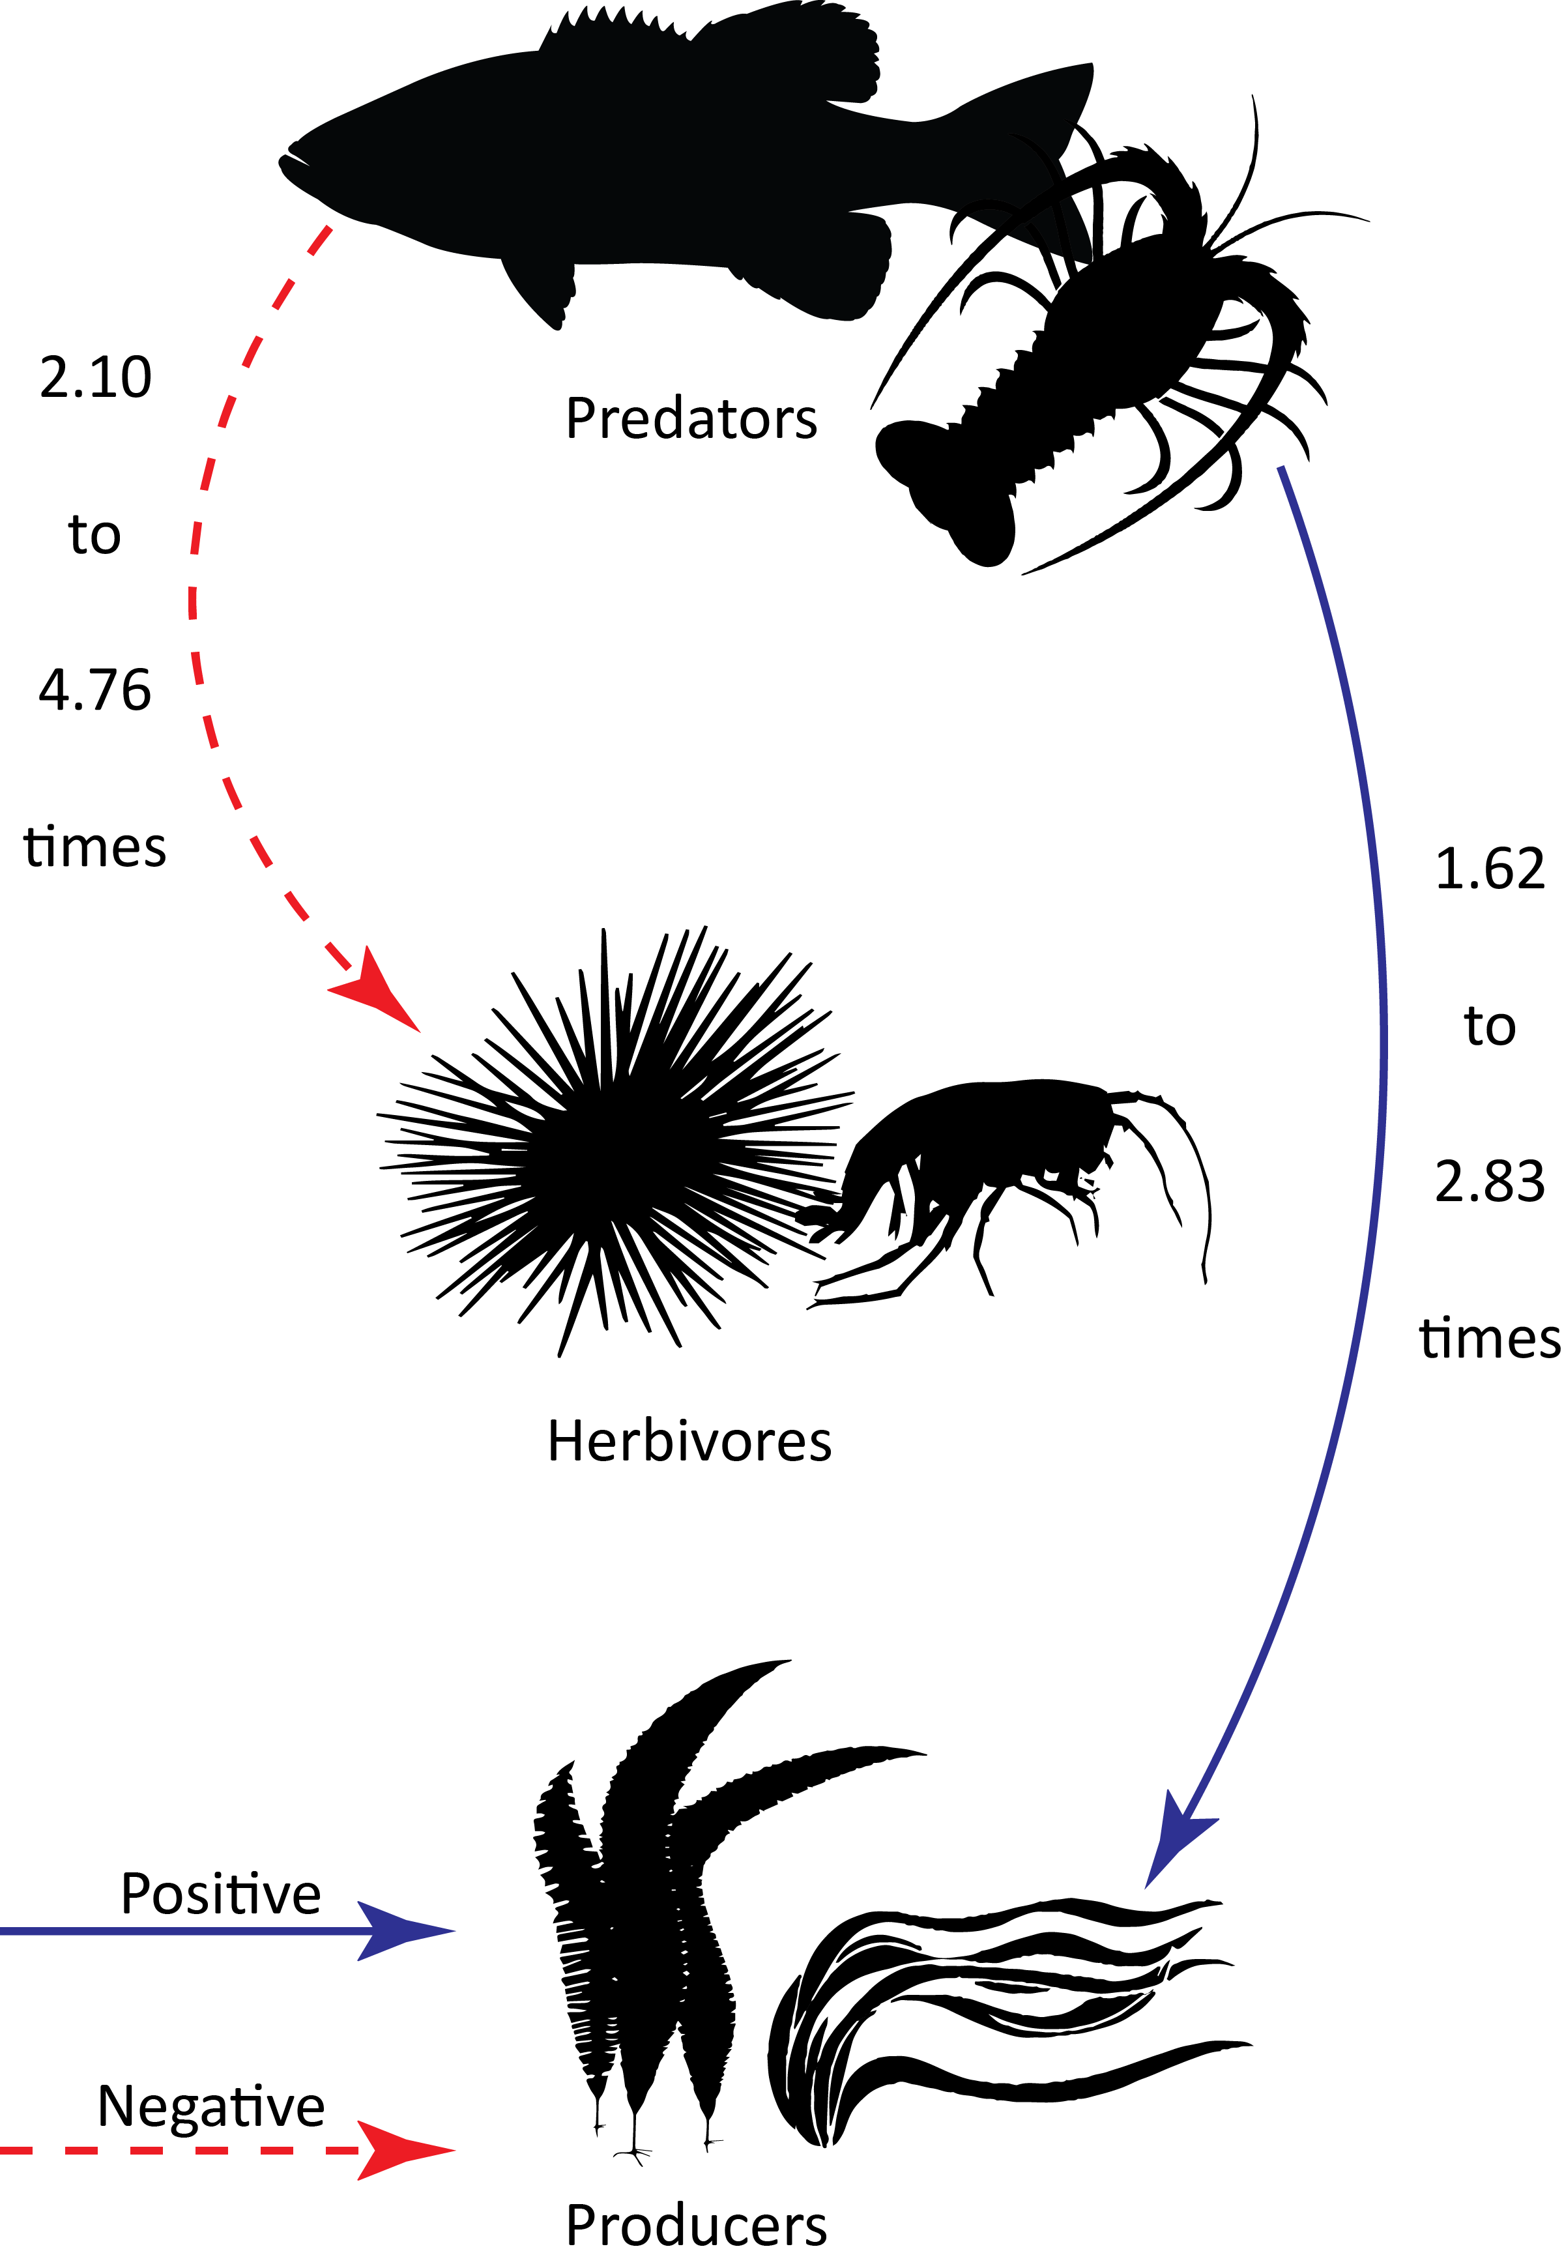
Figure 2: Herbivore (left) and producer (right) effect sizes versus explanatory variables, significant (P < 0.05) relationships are indicated with the black lines. In each panel, the solid line is the predicted value and the dashed lines are twice the standard error for significant relationships. *Indicates a variable that was log transformed for analysis.
Figure 3: The strength of the trophic connectivity versus significant explanatory variables. See methods for how the y-axis values were calculated. In each panel, the solid line is the predicted value and the dashed lines are twice the standard error for significant relationships (P < 0.05). *Indicates a variable that was log transformed for analysis.

Figure 4: Herbivore (top) and producer (bottom) effect sizes versus marine reserve age and size. The solid line is the predicted value and the dashed lines are twice the standard error for significant relationships (P < 0.05). *Indicates a variable that was log transformed for analysis.
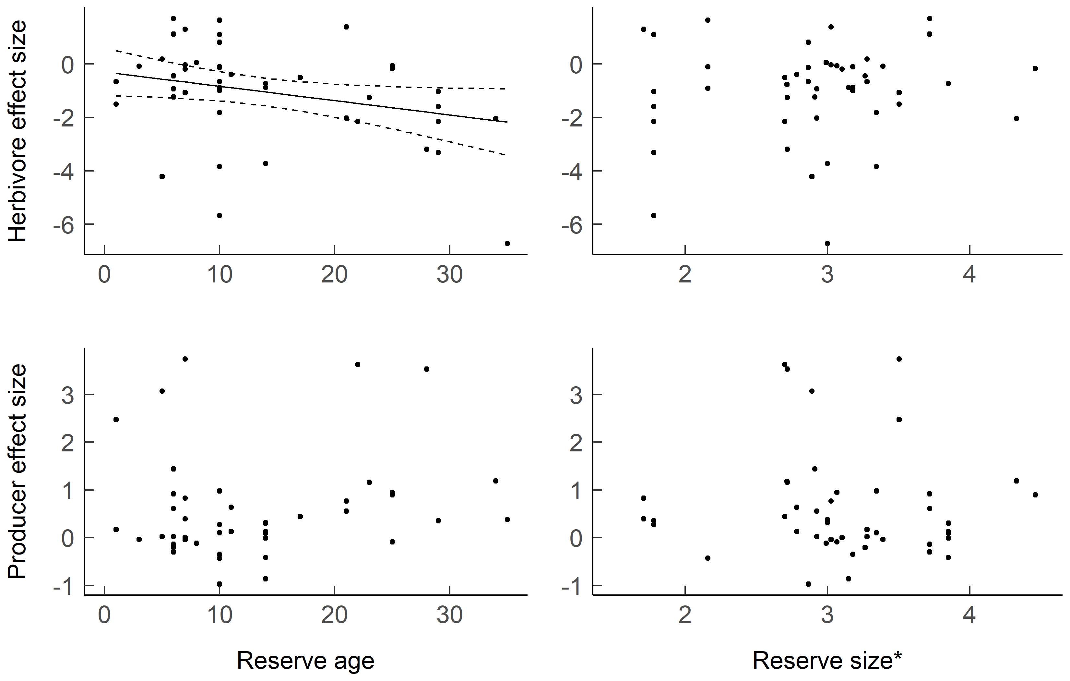

Figure 5: Histograms of the effect sizes from the current study and the effect sizes of the benthic marine studies used in Shurin et al.’s (2002) and Borer et al.’s (2005) work. Dashed grey lines indicate the non-significant effect size, while the solid black line is the mean effect size from the present study and the dashed black line is the mean effect size from previous related meta-analyses (top: Shurin et al. (2002); bottom: Borer et al. (2005)).
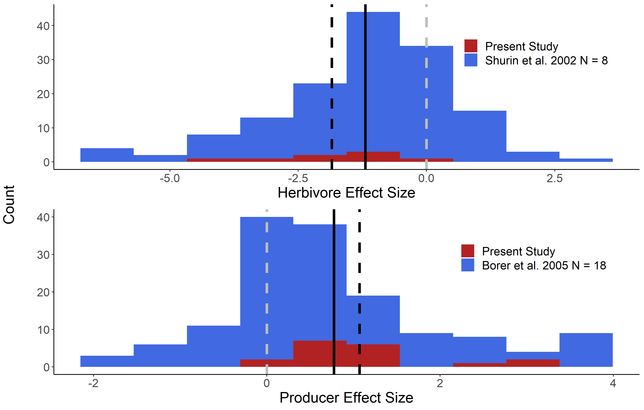

Table 1: Mean effect sizes (herbivore and producer) with the upper (Ub) and lower (Lb) boundaries of 95% confidence intervals as broken down by category. An italicized value indicates a non-significant effect size.
 | Producer effect size |  |  | Herbivore effect size
Factor | Mean | Ub | Lb | Mean | Ub | Lb
Biotic Factors
Predator: invertebrate | 0.80 | 1.30 | 0.3 | -1.25 | -0.52 | -1.98
Predator: vertebrate | 0.74 | 1.08 | 0.4 | -1.10 | -0.60 | -1.60
Herbivore: invertebrate | 0.76 | 1.04 | 0.48 | -1.18 | -0.77 | -1.60
Herbivore: vertebrate | 0.76 | 1.07 | 0.46 | -0.62 | 0.68 | -1.93
Producer: epiphyte | 0.43 | 1.12 | -0.25 | -1.15 | -0.63 | -1.67
Producer: macro | 0.81 | 1.10 | 0.52 | -1.14 | -0.73 | -1.55
Producer: seagrass | 0.53 | 1.71 | -0.64 | -1.26 | -0.67 | -1.85
Study Method
Enclosure | 0.47 | 1.14 | -0.19 | 0.07 | 1.14 | -1.01
Exclusion | 0.83 | 1.50 | 0.16 | -1.69 | -0.58 | -2.79
Marine reserve | 0.61 | 0.98 | 0.24 | -1.10 | -0.52 | -1.68
Mesocosm | 1.29 | 1.99 | 0.59 | -1.63 | -0.56 | -2.70
Observation | 0.98 | 1.88 | 0.08 | -1.47 | -0.05 | -2.89
Study Type
Experimental | 0.93 | 1.40 | 0.46 | -1.14 | -0.46 | -1.82
Observational | 0.67 | 1.01 | 0.32 | -1.15 | -0.63 | -1.67
Overall | 0.76 | 1.04 | 0.48 | -1.15 | -0.74 | -1.56

APPENDIX
Appendix Figure A1: Location of the studies included in this analysis. The dark to light color scale shows the number of studies per country while the red or blue dots indicate an observational (Obs) or experimental (Exp) study.
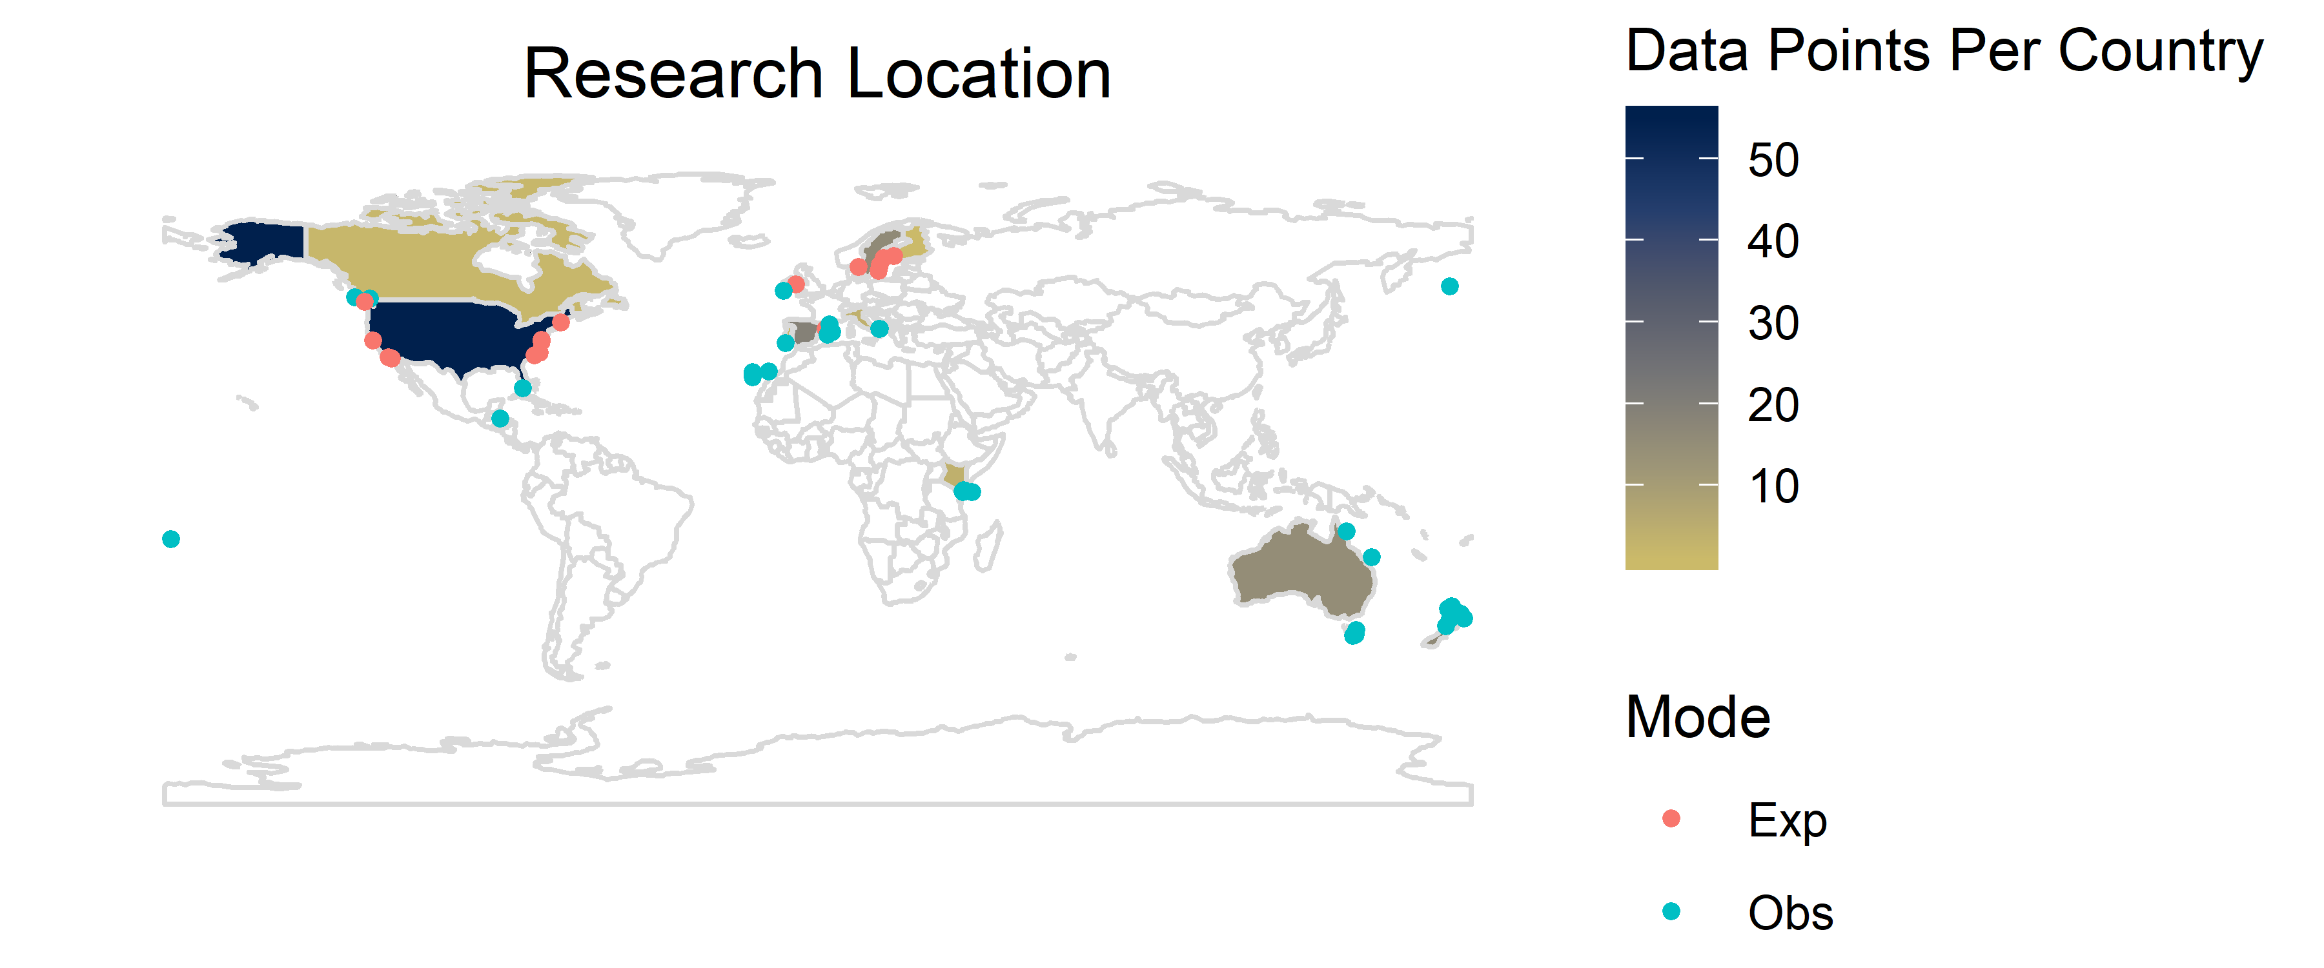
Appendix Table A1: Results of the linear mixed effects models between the various predictor variables and the herbivore and producer effect sizes. Bolded entries are statistically significant (P < 0.05), SE = standard error, “Int.” indicates the model intercept.
 |  | Producer effect size |  |  | Herbivore effect size
Factor | N | Estimate | SE | P value | Estimate | SE | P value
Biotic and Abiotic
Herbivore: invertebrate (Int.) | 136 | 0.82 | 0.16 | 0.90 | -1.28 | 0.23 | 0.63
Herbivore: vertebrate | 11 | 0.01 | 0.07 | 0.90 | 0.39 | 0.82 | 0.63
Herbivore size | 147 | 0.01 | 0.04 | 0.91 | -0.69 | 0.12 | < 0.01
Nitrate | 108 | 0.20 | 0.08 | < 0.01 | < 0.001 | 0.12 | 1.00
Phosphate | 108 | 1.63 | 0.71 | 0.02 | -0.502 | 0.99 | 0.61
Predator-herbivore size ratio | 147 | 0.00 | 0.02 | 0.98 | 0.01 | 0.00 | < 0.01
Predator: invertebrate (Int.) | 43 | 0.80 | 0.25 | 0.85 | -1.50 | 0.43 | 0.51
Predator: vertebrate | 86 | -0.06 | 0.31 | 0.85 | 0.34 | 0.51 | 0.51
Predator size | 147 | 0.13 | 0.23 | 0.58 | 0.10 | 0.48 | 0.84
Producer: epiphyte (Int.) | 17 | 0.40 | 0.38 | 0.53 | -1.27 | 0.28 | 0.97
Producer: macro | 127 | 0.48 | 0.38 | 0.53 | 0.01 | 0.18 | 0.97
Producer: seagrass | 3 | 0.18 | 0.72 | 0.53 | -0.10 | 0.30 | 0.97
Study duration | 75 | 0.07 | 0.59 | 0.91 | 0.53 | 0.74 | 0.47
Temperature | 108 | -0.04 | 0.03 | 0.15 | -0.09 | 0.04 | 0.04
Study Method
Enclosure (Int.) | 24 | 0.48 | 0.34 | 0.28 | -0.07 | 0.55 | 0.02
Exclusion | 16 | 0.35 | 0.25 | 0.28 | -1.76 | 0.55 | 0.02
Marine reserve | 60 | 0.14 | 0.39 | 0.28 | -1.17 | 0.62 | 0.02
Mesocosm | 39 | 0.82 | 0.50 | 0.28 | -1.70 | 0.77 | 0.02
Observation | 8 | 0.51 | 0.57 | 0.28 | -1.54 | 0.91 | 0.02
Study Type
Experimental | 79 | 0.93 | 0.24 | 0.37 | -1.14 | 0.35 | 0.98
Observational | 68 | -0.27 | 0.30 | 0.37 | -0.01 | 0.44 | 0.98
Reserve Characteristics
Reserve age | 59 | 0.43 | 0.322 | 0.42 | -0.05 | 0.03 | 0.04
Reserve size | 59 | 0.11 | 0.45 | 0.74 | 0.44 | 0.45 | 0.32

