Strengthening the evidence base for temperature-mediated
phenological asynchrony and its impacts
Jelmer M. Samplonius¹, Angus Atkinson², Christopher Hassall³, Katharine Keogan^{1,4},
Stephen J. Thackeray⁵, Jakob J. Assmann⁶, Malcolm D. Burgess^{7,8}, Jacob Johansson⁹,
Kirsty H. Macphie¹, James W. Pearce-Higgins^{10,11}, Emily G. Simmonds¹², Øystein Varpe ^{13,14}, Jamie C. Weir¹, Dylan Z. Childs¹⁵, Eleanor F. Cole¹⁶, Francis Daunt¹⁷, Tom Hart¹⁶,
Owen T. Lewis¹⁶, Nathalie Pettorelli¹⁸, Ben C. Sheldon¹⁶, Albert B. Phillimore¹
¹ Institute for Evolutionary Biology, The University of Edinburgh, Edinburgh, UK
² Plymouth Marine Laboratory, Prospect Place, The Hoe, Plymouth, PL13DH, UK
³ School of Biology, Faculty of Biological Sciences, University of Leeds, LS2 9JT
⁴ Marine Scotland Science, Marine Laboratory, 375 Victoria Road, Aberdeen, AB11 9DB
⁵ Lake Ecosystems Group, UK Centre for Ecology & Hydrology, Library Avenue, Bailrigg, Lancaster, LA1 4AP, UK.
⁶ Department of Biology, Aarhus University, Aarhus, Denmark
⁷ RSPB Centre for Conservation Science, The Lodge, Sandy, Beds SG19 2DL
⁸ Centre for Research in Animal Behaviour, University of Exeter, EX4 4QG
⁹ Department of Biology, Department of Biology, Lund University, SE-22362 Lund, Sweden
¹⁰ British Trust for Ornithology, Thetford, Norfolk, IP24 2PU, UK
¹¹ Conservation Science Group, Department of Zoology, University of Cambridge, David Attenborough Building, Pembroke Street, Cambridge, CB2 3QZ, UK
¹² Department of Mathematical Sciences and Centre for Biodiversity Dynamics, Norwegian University of Science and Technology (NTNU), Trondheim, Norway
¹³ University of Bergen, Department of Biological Sciences, 5020 Bergen, Norway
¹⁴ Norwegian Institute for Nature Research, 5006 Bergen, Norway
¹⁵ Department of Animal and Plant Sciences, University of Sheffield, S10 2TN Sheffield, United Kingdom
¹⁶ Department of Zoology, University of Oxford, UK
¹⁷ UK Centre for Ecology & Hydrology, Bush Estate, Penicuik EH26 0QB, UK
¹⁸ Institute of Zoology, Zoological Society of London, Regent's Park, London, United Kingdom
Climate warming has caused the seasonal timing of many components of ecological food chains to advance (Thackeray et al. 2010, 2016). In the context of trophic interactions the match-mismatch hypothesis (MMH) postulates that differential shifts can lead to phenological asynchrony with negative impacts for consumers (Cushing 1990). However, it is still largely unresolved whether unequal trophic shifts are adaptive or constrained by differential phenological sensitivity to temperature (Both et al. 2009; Visser et al. 2012; Thackeray et al. 2016; Kharouba et al. 2018; Radchuk et al. 2019; Visser and Gienapp 2019). At present there has been no consistent analysis of the links between temperature change, phenological asynchrony, and individual-to-population level impacts across taxa, trophic levels and biomes at a global scale. Instead, many of our insights into the MMH stem from a handful of independent single-system studies, varying in their conceptual basis and methodological approach. Here, we propose five criteria that all need to be met to demonstrate that temperature-mediated trophic asynchrony poses a growing risk to consumers. These criteria are: 1) an ephemeral resource contributes a large proportion of the consumer’s diet; 2) asynchrony between phenology of consumer and resource is increasing over time; 3) interannual variation in asynchrony is driven by interannual variation in temperature; 4) asynchrony reduces consumer fitness, and 5) asynchrony impacts negatively on consumer population size or growth. We conduct a literature review of 109 papers studying 132 taxa, and find that for most taxa only two of the five criteria are met. Moreover, all five criteria are only assessed for two taxa. The most commonly-tested criteria are 1 and 2, and few studies further examined evidence for criteria 3 to 5. Furthermore, effects of trophic asynchrony on fitness are heavily skewed towards juvenile stages rather than adults. Crucially, nearly every study was conducted in Europe or North America, and most studies were on terrestrial secondary consumers. We thus lack a robust evidence base from which to draw general conclusions about the risk that climate-mediated trophic asynchrony may pose to populations worldwide.

Introduction
The shifting seasonal timing of key life history events, such as the budburst of trees, emergence of insects or the migration and breeding times of vertebrates, is one of the three universal ecological responses to climate warming (Walther et al. 2002; Parmesan and Yohe 2003) alongside range shifts and reductions in organismal body size (Daufresne et al. 2009; Walther 2010). Such shifts in phenology have provided some of the earliest and strongest evidence that rising temperatures have left a discernible imprint on the planet’s ecosystems (Visser et al. 1998; Parmesan 2006; Thackeray et al. 2016; Cohen et al. 2018). For many consumer species, phenological events are timed to coincide with peak abundance of a predictable food resource. However, the strength and direction of the phenological response to temperature frequently differs among species occupying different trophic levels, leading to asynchrony between resource and consumer (box 1). The consequences of such asynchrony were first studied in the early 1900s in the context of trophic interactions between fish larvae and their zooplankton resource. This generated the classic match-mismatch hypothesis (MMH, reviewed by Cushing 1990). Fish larvae were found to spawn at a relatively fixed date, but zooplankton phenology was more variable across years, causing annual variation in asynchrony between consumer and resource. The degree of asynchrony (referred to as mismatch by Cushing) was proposed to account for annual fluctuations in fish recruitment to the population (Cushing 1990). In recent years, the hypothesis that changing temperatures might increase the frequency of costly trophic asynchrony between consumers and their resources has been increasingly discussed (Visser and Both 2005; Durant et al. 2007; Renner and Zohner 2018; Visser and Gienapp 2019). The impact of asynchronous phenological interactions on the fates of consumer species was identified as a key uncertainty in the fifth assessment report of the IPCC (IPCC 2014).
Box 1: Glossary of terms widely used in the study of trophic asynchrony
Phenology: the study of cyclically recurring biological events, such as the seasonal timing of tree leafing, insect hatching, or animal migration and reproduction. In this work, we also use it to refer to the events themselves, as has become the norm in the literature.
Trophic level: the position that an organism occupies in the food chain. Primary consumers are herbivores (e.g. winter moth, caribou), and secondary consumers are omnivores or carnivores (e.g. great tit, herring)
Phenological sensitivity/response: the extent to which phenology responds to biotic or abiotic variables, for example an advance in spawning date in response to temperature.
Phenological/trophic asynchrony: when the peak consumer demand for a resource does not coincide with the peak availability of that resource.
The match-mismatch hypothesis (MMH): poses that trophic asynchrony has negative consequences for consumer fitness or population size (Cushing 1990). This is also sometimes referred to as trophic mistiming (see Visser and Gienapp 2019 for an alternative definition).
Phenological asynchrony and mismatch are often used interchangeably in the ecological literature, but the meaning of the term “mismatch” is more ambiguous, as it is in some cases used to imply only dissimilar responses of adjacent trophic levels (Visser and Gienapp 2019), and in other cases implying negative impacts on the consumer (Johansson et al. 2015). In this paper we refer to “trophic asynchrony” when the consumer demand does not coincide with the phenology of the resource, and to the match-mismatch hypothesis (MMH) when asynchrony has negative impacts on fitness or populations (box 1). We note that the MMH is normally conceptualised from a unidirectional, bottom-up perspective (i.e. asynchrony leading to detrimental effects on consumers), rather than potential top-down effects upon prey and resources (but see Deacy et al. 2017).
Asynchrony has been detected in many study systems (Thackeray et al. 2010, 2016; Kharouba et al. 2018), but to demonstrate negative consequences of asynchrony on the consumer (i.e. the MMH), several conditions need to be met. For trophic asynchrony to be identified as detrimental, the consumer must depend on a short, seasonally-pulsed or ephemeral resource (Willson and Womble 2006; Varpe and Fiksen 2010; Dunn et al. 2011; Reneerkens et al. 2016; Samplonius et al. 2016; Mallord et al. 2017; Youngflesh et al. 2017), and it should be established whether asynchrony might be adaptive or the baseline state (Singer and Parmesan 2010; Visser et al. 2012; Kharouba and Wolkovich 2020). Moreover, there should be negative effects of asynchrony on consumer fitness (Vatka et al. 2011; Reed et al. 2013b, 2013a; van Asch et al. 2013; Gienapp et al. 2014; Ramakers et al. 2019a). Ultimately, asynchrony becomes of conservation concern when it affects mean demographic parameters and leads to population declines (Winder and Schindler 2004; Both et al. 2006; Miller-Rushing et al. 2010; Plard et al. 2014; Visser and Gienapp 2019). Although components of the MMH and consequences for population trends can be identified, these are based on very few and specific study systems. We therefore lack a general overview of how often trophic asynchrony leads to population declines.

Five criteria for demonstrating risks of temperature-mediated asynchrony
Here, based on ideas that have been widely discussed in the literature and which we outline above, we propose five criteria that must all be met for temperature-mediated phenological asynchrony to be both present, and causing population declines (Table 1). The five criteria can be seen as a best-practice framework, but we realize that each study system poses unique challenges for studying these criteria. We also do intend for their application to oversimplify the complex study of phenology, nor do we claim that they cover everything that phenological studies need to focus on: (1) the consumer is highly reliant on a seasonally ephemeral resource; (2) the degree of trophic asynchrony between consumer and resource phenology is increasing over the years (evidenced by time series); (3) increasing trophic asynchrony is due to differing temperature responses of consumer and resource; (4) trophic asynchrony impacts negatively on consumer fitness, and (5) asynchrony impacts negatively on population growth (Miller-Rushing et al. 2010). In Table 1 we identify some of the methods that can be used to test each of these criteria. In the next section we summarise the existing biological evidence for these criteria, with a particular focus on general insights that have emerged from multi-species studies and formal meta-analyses on questions that are pertinent to the study of the MMH.

Evidence for phenological asynchrony
Large-scale comparative analyses of phenological responses and formal meta-analyses provide ample evidence that on average spring timings are advancing at mid-high latitudes, and that species vary in their response to temperature (Edwards and Richardson 2004; Thackeray et al. 2010; Cohen et al. 2018). In two large multi-species analyses based on phenological data from the UK, the phenology of secondary consumers advanced less than primary producers and consumers over the years (Thackeray et al. 2010, criterion 2) and secondary consumers have a lower phenological sensitivity to temperature (Thackeray et al. 2016, criterion 3). For marine taxa, the magnitude of phenological advance varied among trophic groups, with phytoplankton, zooplankton and bony fish all more responsive than seabirds (Poloczanska et al. 2013; Keogan et al. 2018). However, while large-scale multi-species and multi-population studies provide valuable insights into general trends and patterns of inter- and intra-specific variation in phenological responses, they do not estimate in situ responses for specific trophic interactions. Of those studies that focus on trophic interactions known to be important to the consumer for a short period (criterion 1) most focus on a single interaction. Such studies have reported increasing asynchrony over the years (criterion 2), e.g. in great tits, Parus major, and winter moth, Operophtera brumata (Visser et al. 1998; Visser and Holleman 2001). However, a recent analysis of the phenological time series underpinning 27 species interactions (including but not limited to trophic interactions) found that whilst the degree of asynchrony has changed over the years, the number of cases where asynchrony had increased was roughly balanced by the number of cases where asynchrony had decreased (Kharouba et al. 2018). The same study also found that whilst phenology was responding to temperature in the ecological systems considered, it was not possible to attribute temporal trends in asynchrony to long-term increases in temperature (criterion 3).

Potential consequences of trophic asynchrony
The most prominent evidence for the MMH comes from intensively-studied wild systems, such as that of the reliance of great tits on winter moth caterpillars to feed their young. For these birds, asynchrony between the timing of peak nestling demand and peak caterpillar biomass has negative consequences for individual fitness and annual mean fitness (Reed et al. 2013a, 2013b). Meta-analyses of selection estimates in the wild report consistent selection pressures for earlier phenology (Kingsolver et al. 2012; Radchuk et al. 2019), but directional selection has not become stronger over time (Radchuk et al. 2019). However, meta-analyses addressing selection on phenology have considered only absolute timing, rather than the timing of a consumer relative to its resource (Visser and Both 2005), so it is unclear from these studies whether selection on consumers is being driven by asynchrony with resources.
Trophic asynchrony becomes a matter of conservation concern if it impacts negatively on population size (criterion 5) (Miller-Rushing et al. 2010). Two long-term studies of great tits found no evidence of an effect of asynchrony on population size (Reed et al. 2013a; Vedder et al. 2013), whereas a study of several populations of pied flycatchers Ficedula hypoleuca in the Netherlands reported stronger population declines where caterpillar phenology was earlier (Both et al. 2006). The only multi-species studies on this theme that we are aware of are for birds, one from across Europe (Both et al. 2010) and one in the UK (Franks et al. 2018). Both et al. (2010) found that long distance migrant passerine birds in European forest habitats had declined more than species that migrated less far or species inhabiting marsh habitats, which the authors attributed to the migrants becoming mismatched in the forest habitats with their more seasonally pulsed resource peak. Franks et al. (2018) found that, across 21 UK bird species, population declines were more pronounced for species that had advanced their breeding phenology least and in species whose annual productivity was most reduced by asynchrony with general insect and plant phenology. However, the evidence for the MMH was weak and not supported by declines in breeding success of those species, suggesting that population declines were not mechanistically driven by trophic asynchrony.

Table 1. Criteria of evidence that climate change induced trophic asynchrony is increasing and deleterious for the consumer (the MMH), with a consideration of the data and methods that can be used.
Criterion | Evidence required | Data and Methods
1. An ephemeral resource contributes a large proportion of the consumer’s diet | A large proportion of the diet is typically composed of a species or food type that shows a pulsed seasonal distribution | A variety of methods for quantifying diet composition exist, including direct observation of feeding, gut content dissection, faecal/regurgitate dissection, metabarcoding and stable isotope analysis. Requires that relevant aspects (e.g., biomass, abundance) of the favoured resource are measured over time within at least one season and analysis reveals a pulsed intra-year relationship.
2. Asynchrony between consumer and resource phenology is increasing over time | Analysis of time-series of consumer and resource phenology, with a test of whether trends in timing differ and whether this leads to an increase or decrease in asynchrony | Requires a time series that covers a period of temperature change. A large number of phenological time series exist, as recorded by researchers, citizens, herbaria, etc. Statistical analysis of increasing asynchrony is easily achieved by including an interaction between year and species. Inference of whether asynchrony is increasing or decreasing requires inspection of predictions based on estimated elevations and slopes of the modelled relationships for each species (Kharouba et al. 2018).
3. Variation in asynchrony is driven by interannual variation in temperature | Identification of the time period(s) over which consumer and resource is sensitive to temperature. Evidence that temperature is the driver | A variety of methods exist for identifying the time period over which phenology of each species is sensitive to temperature (Bailey and De Pol 2016; Teller et al. 2016; van de Pol et al. 2016; Simmonds et al. 2019a). Confidence in attribution can be increased by experiments (Kharouba and Wolkovich 2020) or by including year as a term in the model (Keogan et al. 2018), thereby de-trending the phenology data (Iler et al. 2017). Estimating temporal trends in temperature variables is also worthwhile, as differing trends may generate asynchrony (Visser et al. 2003; Both et al. 2004).
4. Asynchrony impacts negatively on consumer fitness | A suitable measure of consumer fitness decreases with increasing asynchrony | Can be assessed within years (relative fitness) or among years (mean fitness) or both (Reed et al. 2013a, 2013b). Depending on how asynchrony varies across individuals or years, the relationship between fitness and asynchrony may be a linear decline or a humped relationship. If the former, care may need to be taken to establish causation (Verhulst and Nilsson 2008). Ideally, models should take into account both asynchrony with peak resource and phenological distribution of the resource (Durant et al. 2005; Ramakers et al. 2019b). Studies of impacts on relative fitness are informative regarding selection and opportunities for adaptation, whereas studies on mean fitness may be informative regarding demographic rates (Visser and Gienapp 2019)
5. Asynchrony impacts negatively on consumer (meta) population size, density, or growth | Negative effects of asynchrony on fitness (4) that have a negative effect on population size/growth, as assessed over multiple years | Requires long-term data on asynchrony and population size or density. The impact of asynchrony on demographic rates can be incorporated into a population model (Simmonds et al. 2019b) or the causal pathways between asynchrony and population growth can be assessed in a structural equation model (Mclean et al. 2016). It is important to rule out a causal effect of other variables (e.g., land-use, resource availability, sea ice, range shifts) that could cause populations to change over time (Youngflesh et al. 2017). Such confounding effects can partially be accounted for by including year as a term to detrend the analysis (Iler et al. 2017; Keogan et al. 2018). An alternative approach involves modelling a population’s ability to persist on the basis of demographic and quantitative genetic parameters (Gienapp et al. 2013; Vedder et al. 2013).

Literature survey
We conducted a broad survey (n=109) of published work on the match-mismatch hypothesis (MMH) across terrestrial, marine and freshwater systems with the aim of: (i) examining the evidence that temperature-mediated trophic asynchrony is increasing and impacting negatively on consumer species and (ii) identifying gaps in the evidence base, thereby allowing us to (iii) make recommendations for priority areas for future work. To this end, we extracted data from published, peer-reviewed original research in which a trophic interaction was studied in relation to any of the five criteria we proposed as vital to the MMH (Table 1). Only original studies, where the specific interaction between consumer and resource could clearly be identified were included (see appendix A for methodological details).
Taxonomic and geographical bias in the data
The search identified 772 papers, of which the full text could be found for 760. Of these, 571 were not relevant (e.g. no trophic interactions were reported, or none of the five criteria were extractable), and 80 had no extractable data, resulting in a total of 109 papers that had relevant data on 132 consumer taxa (Fig. S2).
The characteristics of each study can be found in supplementary information (Table S1). All but six of the 109 trophic interaction studies were in Europe or North America (Fig. 1). The majority of trophic interactions were terrestrial (81.5% of the data), with marine (14%) and freshwater interactions (4.5%) being much more scarce. For most interactions the consumer was a secondary consumer (58%), with studies of primary (36.5%) or higher than secondary (5.5%) consumers less common. Birds made up the majority of the consumer taxa studied (53%), while 29.5% of taxa were insects, 8% were fish, 5% were mammals and 4% were crustaceans.

Testing the five criteria
The most tested criterion was criterion 1 (97% of interactions, n=128/132) - relating to dependence on a seasonally pulsed resource (Fig. 2, top panels). However, rather than conducting direct tests on the seasonal distribution of resources, 72% (n=92/128) of these included only a statement based on a priori knowledge of the natural history of the system that the resource was both ephemeral and important to the consumer.
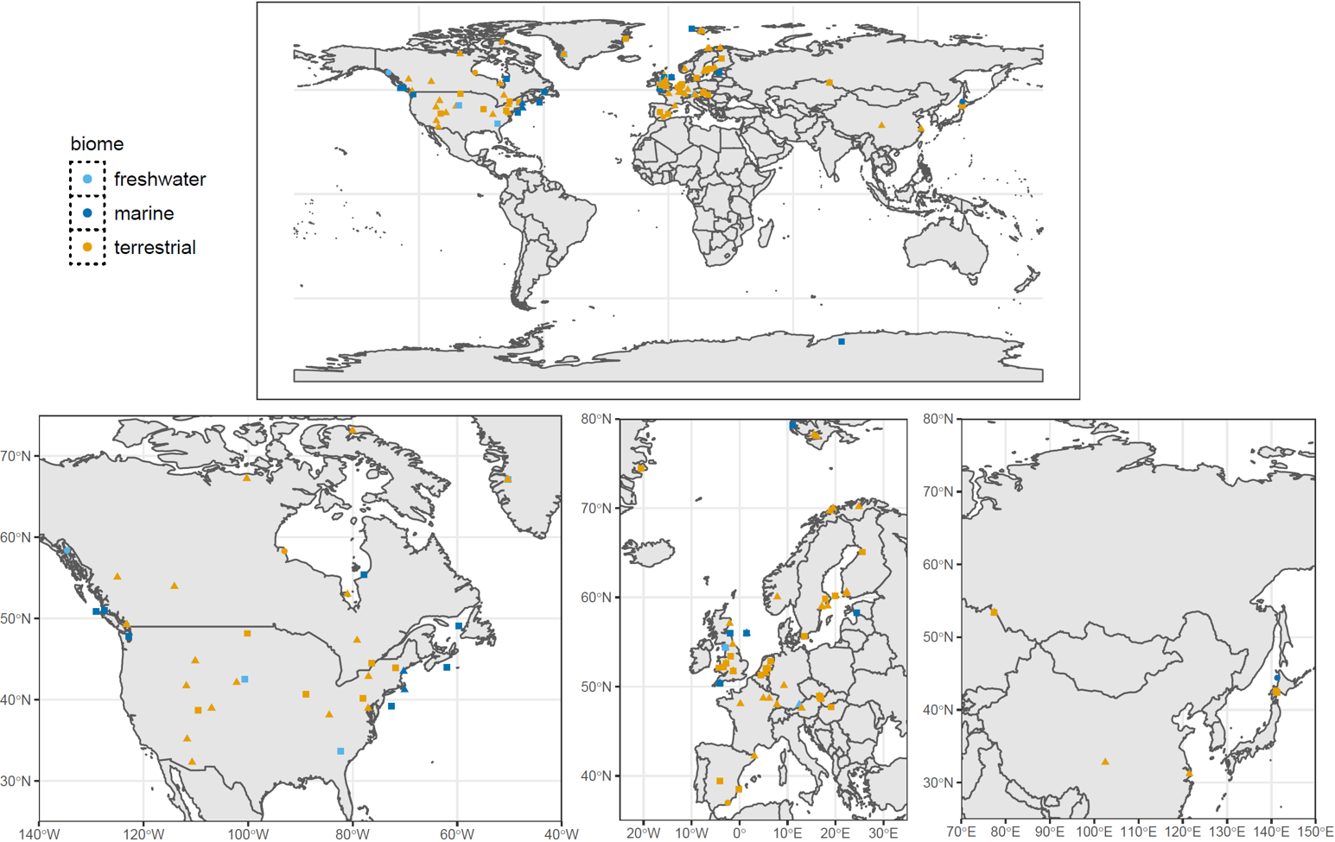
Figure 1. Locations of studies on phenological asynchrony identified by our analysis, subdivided by biome (colour) and consumer trophic level (triangles = primary, squares = secondary, circles = >secondary).

Figure 2. Individual criteria tested across taxa (a,b), and the evidence base per taxon (c,d). The most tested criteria (a,b) were 1 “ephemeral resource” and 2 “phenological change over the years”. The total number of criteria tested (c,d) was two out of five for most taxa, and all five criteria were tested for only two taxa (c,d). The left panels (a, c) are divided by trophic level, and the right panels by biome (b, d).

Of the study systems that were tested for dependence on a seasonally pulsed resource (i.e. where the resource was ephemeral and the consumer was a specialist), 42% (n=15/36) showed such dependence. Excluding the cases where criterion 1 was not explicitly tested, criterion 2 was the most frequently tested (72% of interactions, n=95/132), relating to whether phenological asynchrony was increasing over time (Fig. 2, top panels). The remaining criteria were all tested substantially less frequently, with criterion 5 (population consequences) being tested least often (7.6% of interactions, n=10/132). Surprisingly few studies report data for criterion 3 (Fig. 2, top panels), which relates temperature to asynchrony, and this was almost never reported for marine and freshwater taxa. The distributions of criteria tested were broadly similar across consumer levels and biomes, with the exception of primary consumers for which criteria 3 and 4 appear slightly more common.
Our analysis could identify only two out of 132 consumer taxa for which all five of our criteria have been tested at least once: both of these are forest-breeding passerine birds studied in Europe - the great tit and the pied flycatcher. In a further 13 taxa, four out of five criteria were assessed. In the remaining 117 taxa, three or fewer criteria were studied, with the majority (58%, n=77/132) of consumer taxa having only two of the five criteria known (Fig. 2, bottom panels). Breaking this same analysis down to the per study level, no single study explicitly tests all five criteria (Fig. S3). This is generally due to a tendency for studies to focus on either phenology slopes (criteria 2 & 3), or the consequences of asynchrony (criteria 4 & 5). Only a handful of studies detail temporal slopes, temperature slopes, and consequences of asynchrony in one study (Visser et al. 2006; Atkinson et al. 2015; Ross et al. 2017).

Figure 3. Consumer versus resource slopes in relation to year and temperature. Symbol shapes represent consumer trophic level (triangles = primary, squares = secondary, circles = >secondary), and larger symbols are from longer time series. The diagonal line represents an equal rate of change by consumer and resource. Where the resource slope < 0, points above the line represent systems where resource phenology is advancing by more than that of the consumer, whereas points below the line represent systems where consumer phenology is advancing more rapidly than resource phenology. Where resource slope > 0, points below the line represent systems where resource phenology is delaying by more than that of the consumer, whereas points above the line represent systems where consumer phenology is delaying more rapidly than resource phenology.
Phenology slopes over time and temperature
Consumer and resource responses appear to be positively correlated across studies, with consumers showing a slight tendency to advance their phenology by less than their resource (Fig. 3). In 61% (n=58/95) of the cases, the phenology slope over time was greater for the resource than for the consumer (Fig 3a,b). For the phenological response to temperature, the consumer slope was greater than the resource slope in 59% (n=13/22) of cases (Fig 3c,d). The degree to which these patterns differ across biomes and trophic levels could not be tested with this dataset, since the number of slope estimates is too low for non-terrestrial and non-secondary consumers. Based on visual inspection, it appears that especially terrestrial secondary consumers tend to be slower-advancing than their resource. However, more data on underrepresented groups would be required to reach robust conclusions about these patterns.

Fitness and demographic consequences
Fitness consequences in relation to trophic asynchrony (criterion 4) are studied in 36% (48/132) of the consumers (Fig. 2, top panels). Consequences of asynchrony for offspring are studied about three times as often as consequences for adults (Fig. 4), though it is possible that this reflects a research bias to study fitness components that are more sensitive to asynchrony. In about a third of the taxa, no negative effect of asynchrony on fitness was reported (Fig. 4). By far the least studied consequence of trophic asynchrony is its effects on population growth (criterion 5, Fig. 2, 4). In half of these interactions (n =5/10), there was no effect of asynchrony on population growth.

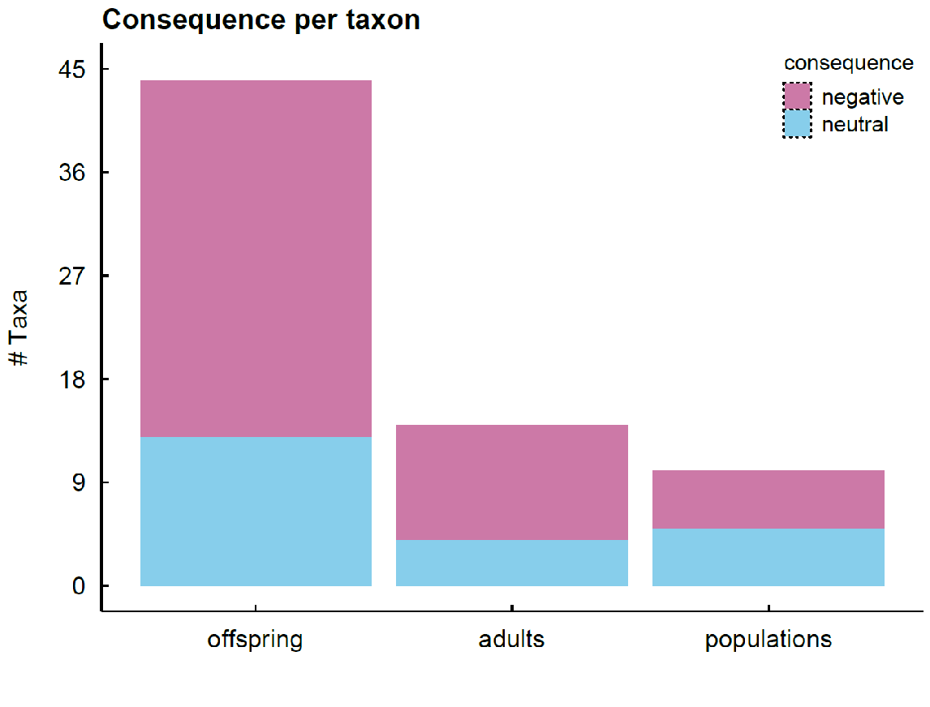
Figure 4. Number of taxa in which consequences of trophic asynchrony were studied, divided into those where the effect reported was negative or neutral (no positive effect of trophic asynchrony was ever reported). Studies tend to focus on the effects on offspring rather than adult and population consequences.

Discussion
Our literature survey reveals a lack of robust evidence from which to draw general inferences about the risks that temperature-mediated asynchrony poses to populations. Specifically, the full causal chain from temperature change, to temperature-driven shifts in seasonal timing, consumer-resource synchrony, and individual-to-population level impact has rarely been studied. Only two out of 132 taxa were studied for all criteria, and for the majority of study systems, only one or two out of five criteria were met. The available studies were strongly biased toward terrestrial secondary consumers (especially birds) in the Northern Hemisphere (largely Europe and North America). Notably, the effects of climate warming on trophic asynchrony in aquatic systems and in the Southern Hemisphere are understudied (Chambers et al. 2013). Low latitude studies are also under-represented, but this may reflect in part the reduced importance of temperature as a phenological cue in tropical ecosystems (Cohen et al. 2018). Crucially, demographic consequences of trophic asynchrony are the least studied of the five criteria, despite this knowledge being the most important to conservation.

Bias in the Match-Mismatch Hypothesis evidence base across biomes
Terrestrial systems were by far the most represented of the three environments that we considered, presumably by virtue of the comparative ease of collecting data on both phenology and fitness in these systems. This ease of data collection is evident in the great contribution that citizens have made to the study of terrestrial phenology (Hurlbert and Liang 2012; Newson et al. 2016; Phillimore et al. 2016; Tansey et al. 2017; Franks et al. 2018), which is rare for aquatic systems. Monitoring phenology of many aquatic organisms is hampered by their wide ranges and underwater habitats (Richardson and Poloczanska 2008), and compounded by the logistic and financial challenges encountered during offshore research. As a result, relatively few multi-decadal phenological time series have been collected at sufficient resolution to capture seasonal changes (Mackas et al. 2012; O’Brien et al. 2017). Moreover, separate sampling programmes are often needed for consumer and resource (e.g. piscivorous birds and their prey, Burthe et al. 2012), and even if resources can be quantified, many aquatic organisms are generalist feeders, further adding to the difficulties in quantifying the MMH. Citizen scientists can, however, collect valuable data on the terrestrial stages of aquatic organisms (e.g., dragonflies), or aquatic seasonal events that can be observed from shore (e.g., amphibian spawning, floating algal blooms). Furthermore, with ongoing technological innovation in data collection methodologies, it may become possible to widen the aquatic evidence base for some taxa. For example, radar can be used to quantify aquatic-terrestrial subsidies based on insect emergence, providing detailed measures of the timing and size of resource pulses (Stepanian et al. 2020), and satellite-based observation tools are providing a wide-scale perspective on phytoplankton phenology changes (Schmidt et al. 2020). It would therefore be valuable to consider how diverse data sources, and lines of evidence, can be fruitfully combined to advance our knowledge of the importance of the MMH in aquatic systems.
Despite their overrepresentation in MMH research, even in terrestrial systems there are biases and gaps in the evidence-base that extend beyond the aforementioned geographic biases (Fig 1). Of the terrestrial studies, temperate forest taxa and birds in particular predominate, which is likely due to the fact that this habitat experiences a seasonal temperature-mediated pulse in resources, whereas resources may be less pulsed in many other terrestrial environments (Both et al. 2010). Terrestrial systems are also over-represented in the study of individual fitness in the wild (e.g., cavity nesting birds). In aquatic systems, individual marking of philopatric seabirds and pinnipeds permits some components of fitness to be monitored (Sauve et al. 2019), but this is much harder for underwater organisms (Bradshaw et al. 2007). Likewise, for many widely-distributed groups such as fish, invertebrates, and plankton, individuals cannot be sampled repeatedly, and populations can rarely be sampled to the extent that demographic implications of asynchrony can be assessed. On the other hand, invertebrates are more amenable to experimental study (van Asch et al. 2013), and numerous national surveys of population sizes exist (Bell et al. 2015; Macgregor et al. 2019) that could be used to infer demographic consequences of trophic asynchrony. Another key research gap in aquatic systems involves the specific role of cross system consumer-resource interactions in mediating trophic asynchrony. For example, some freshwater consumers feed upon terrestrial resources, which represents a substantial source of nutrients (Tanentzap et al. 2017). The delivery of at least some of this material is strongly seasonal. Leaf fall, for example, is triggered by photoperiod in conjunction with drought and temperature (Estiarte and Peñuelas 2015). Aquatic phenology research would greatly benefit from increased consideration of the synchrony between freshwater consumers and terrestrial resources.

Further challenges in studying the MMH
We recognise that studying these five criteria and improving the evidence base regarding the risks posed by the MMH will not be straightforward and we have already discussed how aquatic environments present particular challenges, but other complexities remain. While criteria 2 and 3 are perhaps the easiest to satisfy, even here challenges exist in attributing a change in phenology/asynchrony to temperature, as sensitivity estimates can be obscured by non-climate drivers or compensatory mechanisms (Atkinson et al. 2015; Beaugrand and Kirby 2018). For example, changing nutrient availability and light conditions can influence the seasonal timing of phytoplankton blooms (Thackeray et al. 2008; Ji et al. 2013), but would not be expected to affect consumer organisms in the same way. In this article we have simplified the interaction between resource and consumer to a single metric, the asynchrony between the peak demand of consumer and availability of the resource. However, as the MMH predicts that consumer fitness relates to resource availability during a particular window (Cushing 1990), consumers might in addition to asynchrony be sensitive to the height and width of the resource (Durant et al. 2007; Miller-Rushing et al. 2010), either of which could be sensitive to temperature and exacerbate or ameliorate effects on fitness. Although the potential for resource abundance to influence fitness is widely acknowledged, it is unusual for studies on the MMH in relation to fitness (criterion 4) or population size (criterion 5) to include its effect (Durant et al. 2005; Ramakers et al. 2019b). We realize that especially criterion 4 may be hard to satisfy for study systems where individuals cannot be studies, which should not discourage people from working on such systems. Whilst fulfilling all the other criteria would allow one to infer whether the mismatch is causing population declines, there are clear advantages of studying individuals. Apart from the fact that individual data helps demonstrate causative effects of asynchrony on fitness, it can tell us whether the population will be under directional selection to reduce mismatch.
Where the resource is in fact a guild (caterpillars, phytoplankton) rather than a species, temperature-mediated shifts in the aggregate phenology may arise from a variety of processes, from similar plastic responses of different species, to changes in the relative abundance of early- and late-blooming constituent species, even when these species independently might show no or weak phenological shifts (Walters et al. 2013). While the effect of asynchrony on the consumer may not be sensitive to these two scenarios, if we want to project phenological changes into the future we need to understand the processes that underpin community phenological responses. An obvious solution to this problem is to improve the species level resolution of sampling (Shutt et al. 2019), but this can be costly and impractical in the short term, and might require new sampling approaches such as eDNA (Pochardt et al. 2020).

Is trophic asynchrony of conservation concern?
This review reveals a lack of robust evidence for the MMH, and even the two best studied taxa in terrestrial systems present a mixed message. In great tits, matching with the caterpillar peak has fitness impacts at both the individual and population level (Reed et al. 2013a, 2013b), but trophic asynchrony currently poses no threat to their population persistence (Reed et al. 2013a; Vedder et al. 2013). Pied flycatchers also perform worse when poorly matched with the caterpillar peak (Burger et al. 2012; Samplonius et al. 2016), but, in contrast to great tits, declines in those populations that were asynchronous with caterpillars have been recorded in the Netherlands (Both et al. 2006). Nevertheless, those pied flycatcher populations have been increasing again since 2002 (Pearce-Higgins and Green 2014). Interestingly, pied flycatchers breed about two weeks later than tits (Samplonius et al. 2018), the average nest is rarely matched with the caterpillar peak (Burgess et al. 2018), and a long-term study in the Netherlands found no correlation between annual mean asynchrony with the caterpillar peak and the strength of the seasonal decline in the number of recruits (Visser et al. 2015). Moreover, pied flycatchers are more generalist than tits in the nestling diet (Cholewa and Wesołowski 2011), so it remains uncertain to what extent these flycatcher populations will be negatively affected by trophic asynchrony on a larger geographical scale and into the future.
It would nevertheless be premature to conclude from this that a relative shortage of evidence for demographic consequences of trophic asynchrony constitutes evidence of absence of an effect. Even in species for which negative population consequences are not yet apparent, such as great tits, it is possible that continued increases in temperature will be problematic. Application of an integral projection model to a UK population of great tits suggested that under a high emission scenario, more rapid responses of the prey species (the winter moth caterpillar) coupled with limits to plasticity in great tit hatch date being reached, lead to an acceleration in directional selection. An increase in evolution of hatch date timing was to an insufficient degree to prevent negative consequences of trophic asynchrony, and the population in that scenario is projected to have an increased risk of extinction (Simmonds et al. 2020). Such demographic approaches should be greatly expanded upon, and provide a unique way to understand which life stages will likely matter from the perspective of pathways leading to shifts in population growth rate and density (Simmonds et al. 2019b).

Research Priorities
Based on our five criteria and our review of the literature we identify six priorities for future work to properly test the match-mismatch hypothesis and its impacts.
- From cause to effect - focusing on population consequences: There is an urgent need for studies that consider the full causal chain, from climate driver to seasonal timing, synchrony, and individual-to-population level impact i.e. studies that test multiple criteria. In particular we need many more tests of the impact of asynchrony on population size (criterion 5), across taxa and habitat types. This most important criterion from the perspective of conservation and policy (Miller-Rushing et al. 2010; Visser and Gienapp 2019) and yet has received the least attention. Furthermore, given that the population impacts of trophic asynchrony at one location may be buffered by matching at another location (Burgess et al. 2018), we strongly advocate expanding the spatial scale of current research to include multi-population studies. This will allow the consequences of phenological shifts to be interpreted in the context of other universal climate warming responses such as range shifts.
- Balancing the evidence - data collection and synthesis for aquatic systems: Despite the marine origin of the MMH, current monitoring and research has so far led to a limited understanding of the MMH in marine and freshwater systems, compared to terrestrial habitats. It is imperative for funders to continue to support time series, since with each passing year the statistical power of these to reveal patterns improves. We further recommend for underused historic records, including museum collections and naturalist observations, to be coupled with new work on these systems to create well documented long time series within a matter of years. However, we must also ask how additional monitoring approaches (e.g. eDNA, earth observation, passive acoustics) might be usefully combined with “traditional” monitoring approaches, to expand the species representation, monitoring of individual states and fitness consequences, and spatial coverage of aquatic ecosystem studies, and support a broader understanding of changes in phenological asynchrony (criterion 2) and the role of temperature as a driver (criterion 3) in these systems.
- Environmental drivers of phenology - beyond temperature: Here, we have addressed phenological asynchrony in relation to temperature (criterion 3), the best-studied driver. However, the environmental drivers of phenology vary geographically, for instance at lower latitudes seasonally pulsed precipitation is a more important driver of phenology (Cohen et al. 2018). In order to gain a global perspective on the risk that climate-mediated phenological asynchrony poses there is an urgent need to apply our criterion 3 to alternative environmental drivers of phenology.
- Assessing the risks - global predictions and species traits: We need more studies on trophic asynchrony and its drivers at different latitudes and many more to be conducted outside of Europe and North America (see Fig. 1). As data on the MMH accumulate, a fruitful approach would be to conduct comparative analyses to identify the taxonomic groups, trophic levels, environments and regions where a negative fitness impact of phenological asynchrony (criterion 4) is most likely, or where it leads to the most severe population declines (criterion 5). Based on first principles we may expect temperature-mediated asynchrony to be more frequent and deleterious when the consumers are endotherms rather than ectotherms (Cohen et al. 2018), income rather than capital breeders (Miller-Rushing et al. 2010; Youngflesh et al. 2017), at higher latitude regions experiencing the most rapid climate change (Cohen et al. 2018). However, empirical validation of these predictions is lacking.
- Observing interactions - enhancing the role of citizen science: Mass participation citizen science has collected many millions of phenological records that underpin many of the studies quantifying phenological shifts (Thackeray et al. 2010, 2016; Hurlbert and Liang 2012; Ovaskainen et al. 2020) and can even be used to project weather records into the past (Brohan et al. 2009). A strength of these schemes is their spatial as well as temporal coverage. In some instances it is possible to identify the phenology of consumer species and their resources from existing datasets (Phillimore et al. 2012), but this requires the assumption that co-occurring species are actually interacting. While using data amassed over larger spatial scales (e.g., via citizen science or remote sensing) is attractive as a means to examining geographic variation in temporal trends in asynchrony (criterion 2) and temperature sensitivity (criterion 3) or fitness consequences (criteria 4&5), care is required in matching data at a resolution that is pertinent to the trophic interaction. Moreover, we are not aware of any study combining citizen science-derived datasets to study the impacts of asynchrony of specific trophic interactions on population size (criterion 5). Therefore an opportunity exists for development or extensions of citizen science schemes to collect data on the phenology of trophically interacting species and on the fitness and/or population sizes of the consumer.
- Clarifying the concept - “asynchrony” or “mismatch”: There exists a degree of terminological inconsistency in relation to the MMH, which may confuse attempts at achieving a common understanding of the potential importance of this phenomenon. Many studies that claim to address “mismatch” identify the conditions that could lead to greater asynchrony, but stop short of explicitly testing whether asynchrony leads to any negative consequences for the consumer. Where no evidence for negative repercussions is presented we encourage authors to use the neutral term “asynchrony”, rather than “mismatch”, which implies a negative consequence.

Concluding remarks
Temperature-mediated trophic asynchrony and its consequences are widely discussed in global change research and have been intensively studied over the past two decades. In this study we have presented five criteria that together provide a causal chain to explicitly demonstrate the risk that temperature-mediated asynchrony poses to populations, which we hope will strengthen future work. In an extensive review of the literature we found that no single study and only two study systems have tested all five criteria, with a clear deficit of studies considering the impact of asynchrony on population size, which is the most important criterion from a conservation perspective (Miller-Rushing et al. 2010). This means that at present we cannot state from the literature that temperature-mediated trophic asynchrony will have a widespread negative impact on consumer population size or growth. We identify six research priorities, which need to be tackled as a matter of urgency to get a comprehensive understanding of the frequency and magnitude of trophic asynchrony and its impacts on consumers. A more consistent approach to the study of the match-mismatch hypothesis and its population consequences at the global scale will allow us to better target conservation efforts and provide much needed evidence describing the possible consequences of one of the most intriguing impacts of climate change on global biota: phenological change.
References
Atkinson, A., R. A. Harmer, C. E. Widdicombe, A. J. McEvoy, T. J. Smyth, D. G. Cummings, P. J. Somerfield, et al. 2015. Questioning the role of phenology shifts and trophic mismatching in a planktonic food web. Progress in Oceanography 137:498–512.
Bailey, L. D., and M. Van De Pol. 2016. Climwin: An R Toolbox for Climate Window Analysis. PLoS ONE 11:1–27.
Beaugrand, G., and R. R. Kirby. 2018. How Do Marine Pelagic Species Respond to Climate Change? Theories and Observations. Annual Review of Marine Science 10:169–197.
Bell, J. R., L. Alderson, D. Izera, T. Kruger, S. Parker, J. Pickup, C. R. Shortall, et al. 2015. Long-term phenological trends, species accumulation rates, aphid traits and climate: Five decades of change in migrating aphids. Journal of Animal Ecology 84:21–34.
Both, C., A. V Artemyev, B. Blaauw, R. J. Cowie, A. J. Dekhuijzen, T. Eeva, A. Enemar, et al. 2004. Large-scale geographical variation confirms that climate change causes birds to lay earlier. Proceedings of the Royal Society of London B: Biological Sciences 271:1657–1662.
Both, C., S. Bouwhuis, C. Lessells, and M. E. Visser. 2006. Climate change and population declines in a long-distance migratory bird. Nature 441:81–83.
Both, C., M. van Asch, R. G. Bijlsma, A. B. van den Burg, and M. E. Visser. 2009. Climate change and unequal phenological changes across four trophic levels: constraints or adaptations? Journal of Animal Ecology 78:73–83.
Both, C., C. A. M. Van Turnhout, R. G. Bijlsma, H. Siepel, A. J. Van Strien, and R. P. B. Foppen. 2010. Avian population consequences of climate change are most severe for long-distance migrants in seasonal habitats. Proceedings of the Royal Society B: Biological Sciences 277:1259–1266.
Bradshaw, C. J. A., H. F. Mollet, and M. G. Meekan. 2007. Inferring population trends for the world’s largest fish from mark-recapture estimates of survival. Journal of Animal Ecology 76:480–489.
Brohan, P., R. Allan, J. E. Freeman, A. M. Waple, D. Wheeler, C. Wilkinson, and S. Woodruff. 2009. Marine observations of old weather. Bulletin of the American Meteorological Society 90:219–230.
Burger, C., E. Belskii, T. Eeva, T. Laaksonen, M. Mägi, R. Mänd, A. Qvarnström, et al. 2012. Climate change, breeding date and nestling diet: how temperature differentially affects seasonal changes in pied flycatcher diet depending on habitat variation. Journal of Animal Ecology 81:926–936.
Burgess, M. D., K. W. Smith, K. L. Evans, D. Leech, J. W. Pearce-Higgins, C. J. Branston, K. Briggs, et al. 2018. Tritrophic phenological match-mismatch in space and time. Nature Ecology and Evolution 2:970–975.
Burthe, S., F. Daunt, A. Butler, D. A. Elston, M. Frederiksen, D. Johns, M. Newell, et al. 2012. Phenological trends and trophic mismatch across multiple levels of a North Sea pelagic food web. Marine Ecology Progress Series 454:119–133.
Chambers, L. E., R. Altwegg, C. Barbraud, P. Barnard, L. J. Beaumont, R. J. M. Crawford, J. M. Durant, et al. 2013. Phenological Changes in the Southern Hemisphere. PLoS ONE 8:e77514.
Cholewa, M., and T. Wesołowski. 2011. Nestling food of european hole-nesting passerines: do we know enough to test the adaptive hypotheses on breeding seasons? Acta Ornithologica 46:105–116.
Cohen, J. M., M. J. Lajeunesse, and J. R. Rohr. 2018. A global synthesis of animal phenological responses to climate change. Nature Climate Change 8:224–228.
Cushing, D. D. H. D. 1990. Plankton production and year-class strength in fish populations: an update of the match/mismatch hypothesis. Advances in Marine Biology, Advances in Marine Biology 26:249–293.
Daufresne, M., K. Lengfellner, and U. Sommer. 2009. Global warming benefits the small in aquatic ecosystems. Proceedings of the National Academy of Sciences of the United States of America 106:12788–93.
Deacy, W. W., J. B. Armstrong, W. B. Leacock, C. T. Robbins, D. D. Gustine, E. J. Ward, J. A. Erlenbach, et al. 2017. Phenological synchronization disrupts trophic interactions between Kodiak brown bears and salmon. Proceedings of the National Academy of Sciences 201705248.
Dunn, P. O., D. W. Winkler, L. A. Whittingham, S. J. Hannon, and R. J. Robertson. 2011. A test of the mismatch hypothesis: How is timing of reproduction related to food abundance in an aerial insectivore? Ecology 92:450–61.
Durant, J., D. Hjermann, G. Ottersen, and N. C. Stenseth. 2007. Climate and the match or mismatch between predator requirements and resource availability. Climate Research 33:271–283.
Durant, J. M., D. Hjermann, T. Anker-Nilssen, G. Beaugrand, A. Mysterud, N. Pettorelli, and N. C. Stenseth. 2005. Timing and abundance as key mechanisms affecting trophic interactions in variable environments. Ecology Letters 8:952–958.
Edwards, M., and A. J. Richardson. 2004. Impact of climate change on marine pelagic phenology and trophic mismatch. Nature 430:881–884.
Estiarte, M., and J. Peñuelas. 2015. Alteration of the phenology of leaf senescence and fall in winter deciduous species by climate change: Efects on nutrient proficiency. Global Change Biology 21:1005–1017.
Franks, S. E., J. W. Pearce-Higgins, S. Atkinson, J. R. Bell, M. S. Botham, T. M. Brereton, R. Harrington, et al. 2018. The sensitivity of breeding songbirds to changes in seasonal timing is linked to population change but cannot be directly attributed to the effects of trophic asynchrony on productivity. Global Change Biology 24:957–971.
Gienapp, P., M. Lof, T. E. Reed, J. McNamara, S. Verhulst, and M. E. Visser. 2013. Predicting demographically sustainable rates of adaptation: Can great tit breeding time keep pace with climate change? Philosophical Transactions of the Royal Society B: Biological Sciences 368:20120289.
Gienapp, P., T. E. Reed, and M. E. Visser. 2014. Why climate change will invariably alter selection pressures on phenology. Proceedings of the Royal Society B: Biological Sciences 281:20141611–20141611.
Hurlbert, A. H., and Z. Liang. 2012. Spatiotemporal variation in avian migration phenology: citizen science reveals effects of climate change. PloS ONE 7:e31662.
Iler, A. M., D. W. Inouye, N. M. Schmidt, and T. T. Høye. 2017. Detrending phenological time series improves climate-phenology analyses and reveals evidence of plasticity. Ecology 98:647–655.
IPCC. 2014. Climate Change 2014 Part A: Global and Sectoral Aspects. Climate Change 2014: Impacts, Adaptation, and Vulnerability. Part A: Global and Sectoral Aspects. Contribution of Working Group II to the Fifth Assessment Report of the Intergovernmental Panel on Climate Change.
Ji, R., M. Jin, and Ø. Varpe. 2013. Sea ice phenology and timing of primary production pulses in the Arctic Ocean. Global Change Biology 19:734–741.
Johansson, J., N. P. Kristensen, J. Å. Nilsson, and N. Jonzén. 2015. The eco-evolutionary consequences of interspecific phenological asynchrony - a theoretical perspective. Oikos 124:102–112.
Keogan, K., F. Daunt, S. Wanless, R. A. Phillips, C. A. Walling, P. Agnew, D. G. Ainley, et al. 2018. Global phenological insensitivity to shifting ocean temperatures among seabirds. Nature Climate Change 8:313–317.
Kharouba, H. M., J. Ehrlén, A. Gelman, K. Bolmgren, J. M. Allen, S. E. Travers, and E. M. Wolkovich. 2018. Global shifts in the phenological synchrony of species interactions over recent decades. Proceedings of the National Academy of Sciences 115:5211–5216.
Kharouba, H. M., and E. M. Wolkovich. 2020. Disconnects between ecological theory and data in phenological mismatch research. Nature Climate Change.
Kingsolver, J. G., S. E. Diamond, A. M. Siepielski, and S. M. Carlson. 2012. Synthetic analyses of phenotypic selection in natural populations: Lessons, limitations and future directions. Evolutionary Ecology 26:1101–1118.
Macgregor, C. J., J. H. Williams, J. R. Bell, and C. D. Thomas. 2019. Moth biomass increases and decreases over 50 years in Britain. Nature Ecology and Evolution 3:1645–1649.
Mackas, D. L., P. Pepin, and H. Verheye. 2012. Interannual variability of marine zooplankton and their environments: Within- and between-region comparisons. Progress in Oceanography 97–100:1–14.
Mallord, J. W., C. J. Orsman, A. Cristinacce, T. J. Stowe, E. C. Charman, and R. D. Gregory. 2017. Diet flexibility in a declining long-distance migrant may allow it to escape the consequences of phenological mismatch with its caterpillar food supply. Ibis 159:76–90.
Mclean, N., C. R. Lawson, D. I. Leech, and M. van de Pol. 2016. Predicting when climate-driven phenotypic change affects population dynamics. Ecology Letters 19:595–608.
Miller-Rushing, A. J., T. T. Høye, D. W. Inouye, and E. Post. 2010. The effects of phenological mismatches on demography. Philosophical Transactions of the Royal Society B: Biological Sciences 365:3177–3186.
Newson, S. E., N. J. Moran, A. J. Musgrove, J. W. Pearce-Higgins, S. Gillings, P. W. Atkinson, R. Miler, et al. 2016. Long-term change in spring and autumn migration phenology of common migrant breeding birds in Britain: results from large-scale citizen science bird recording schemes. Ibis 158:481–495.
O’Brien, T. D., L. Lorenzoni, K. Isensee, and L. Valdés. 2017. What are Marine Ecological Time Series telling us about the ocean? A status report. IOC-UNESCO, IOC 297.
Ovaskainen, O., E. Meyke, C. Lo, G. Tikhonov, M. del M. Delgado, T. Roslin, E. Gurarie, et al. 2020. Chronicles of nature calendar, a long-term and large-scale multitaxon database on phenology. Scientific Data 7:1–11.
Parmesan, C. 2006. Ecological and evolutionary responses to recent climate change. Annu. Rev. Ecol. Evol. Syst. 37:637–669.
Parmesan, C., and G. Yohe. 2003. A globally coherent fingerprint of climate change impacts across natural systems. Nature 421:37–42.
Pearce-Higgins, J. W., and R. E. Green. 2014. Birds and climate change: Impacts and conservation responses. Birds and Climate Change: Impacts and Conservation Responses. Cambridge University Press.
Phillimore, A. B., D. I. Leech, J. W. Pearce-Higgins, and J. D. Hadfield. 2016. Passerines may be sufficiently plastic to track temperature-mediated shifts in optimum lay date. Global Change Biology 22:3259–3272.
Phillimore, A. B., S. Stålhandske, R. J. Smithers, and R. Bernard. 2012. Dissecting the Contributions of Plasticity and Local Adaptation to the Phenology of a Butterfly and Its Host Plants. The American Naturalist 180:655–670.
Plard, F., J. M. Gaillard, T. Coulson, A. J. M. Hewison, D. Delorme, C. Warnant, and C. Bonenfant. 2014. Mismatch Between Birth Date and Vegetation Phenology Slows the Demography of Roe Deer. PLoS Biology 12:1–8.
Pochardt, M., J. M. Allen, T. Hart, S. D. L. Miller, D. W. Yu, and T. Levi. 2020. Environmental DNA facilitates accurate, inexpensive, and multiyear population estimates of millions of anadromous fish. Molecular Ecology Resources 20:457–467.
Poloczanska, E. S., C. J. Brown, W. J. Sydeman, W. Kiessling, D. S. Schoeman, P. J. Moore, K. Brander, et al. 2013. Global imprint of climate change on marine life. Nature Climate Change 3:919–925.
R Development Core Team. 2019. R: a language and environment for statistical computing.
Radchuk, V., T. Reed, C. Teplitsky, M. van de Pol, A. Charmantier, C. Hassall, P. Adamík, et al. 2019. Adaptive responses of animals to climate change are most likely insufficient. Nature Communications 10:1–14.
Ramakers, J. J. C., P. Gienapp, and M. E. Visser. 2019a. Phenological mismatch drives selection on elevation, but not on slope, of breeding time plasticity in a wild songbird. Evolution 73:175–187.
———. 2019b. Comparing two measures of phenological synchrony in a predator–prey interaction: Simpler works better. Journal of Animal Ecology 1–12.
Reed, T. E., V. Grøtan, S. Jenouvrier, B.-E. Sæther, and M. E. Visser. 2013a. Population growth in a wild bird is buffered against phenological mismatch. Science 340:488–491.
Reed, T. E., S. Jenouvrier, and M. E. Visser. 2013b. Phenological mismatch strongly affects individual fitness but not population demography in a woodland passerine. Journal of Animal Ecology 82:131–144.
Reneerkens, J., N. M. Schmidt, O. Gilg, J. Hansen, L. H. Hansen, J. Moreau, and T. Piersma. 2016. Effects of food abundance and early clutch predation on reproductive timing in a high Arctic shorebird exposed to advancements in arthropod abundance. Ecology and Evolution 6:7375–7386.
Renner, S. S., and C. M. Zohner. 2018. Climate Change and Phenological Mismatch in Trophic Interactions Among Plants, Insects, and Vertebrates. Annual Review of Ecology, Evolution, and Systematics 49:165–182.
Richardson, A. J., and E. S. Poloczanska. 2008. Under-resourced, under threat. Science 320:1294–1295.
Ross, M. V., R. T. Alisauskas, D. C. Douglas, and D. K. Kellett. 2017. Decadal declines in avian herbivore reproduction: density-dependent nutrition and phenological mismatch in the Arctic. Ecology 98:1869–1883.
Samplonius, J. M., L. Bartošová, M. D. Burgess, A. V Bushuev, T. Eeva, E. V Ivankina, A. B. Kerimov, et al. 2018. Phenological sensitivity to climate change is higher in resident than in migrant bird populations among European cavity breeders. Global Change Biology 24:3780–3790.
Samplonius, J. M., E. F. Kappers, S. Brands, and C. Both. 2016. Phenological mismatch and ontogenetic diet shifts interactively affect offspring condition in a passerine. Journal of Animal Ecology 85:1255–1264.
Sauve, D., G. Divoky, and V. L. Friesen. 2019. Phenotypic plasticity or evolutionary change? An examination of the phenological response of an arctic seabird to climate change. Functional Ecology 33:2180–2190.
Schmidt, K., A. J. Birchill, A. Atkinson, R. J. W. Brewin, J. R. Clark, A. E. Hickman, D. G. Johns, et al. 2020. Increasing picocyanobacteria success in shelf waters contributes to long-term food web degradation. Global Change Biology 1–14.
Shutt, J. D., M. D. Burgess, and A. B. Phillimore. 2019. A spatial perspective on the phenological distribution of the spring woodland caterpillar peak. American Naturalist 194:E109–E121.
Simmonds, E. G., E. F. Cole, and B. C. Sheldon. 2019a. Cue identification in phenology: A case study of the predictive performance of current statistical tools. Journal of Animal Ecology 88:1428–1440.
Simmonds, E. G., E. F. Cole, B. C. Sheldon, and T. Coulson. 2019b. Testing the effect of quantitative genetic inheritance in structured models on projections of population dynamics. Oikos 1–13.
Simmonds, E. G., E. F. Cole, B. C. Sheldon, and T. Coulson. 2020. Phenological asynchrony, a ticking time-bomb for seemingly stable populations. Ecology Letters (in review).
Singer, M. C., and C. Parmesan. 2010. Phenological asynchrony between herbivorous insects and their hosts: Signal of climate change or pre-existing adaptive strategy? Philosophical Transactions of the Royal Society B: Biological Sciences 365:3161–3176.
Stepanian, P. M., S. A. Entrekin, C. E. Wainwright, D. Mirkovic, J. L. Tank, and J. F. Kelly. 2020. Declines in an abundant aquatic insect, the burrowing mayfly, across major North American waterways. Proceedings of the National Academy of Sciences of the United States of America 117:2987–2992.
Tanentzap, A. J., B. W. Kielstra, G. M. Wilkinson, M. Berggren, N. Craig, P. A. Del Giorgio, J. Grey, et al. 2017. Terrestrial support of lake food webs: Synthesis reveals controls over cross-ecosystem resource use. Science Advances 3:1–11.
Tansey, C. J., J. D. Hadfield, and A. B. Phillimore. 2017. Estimating the ability of plants to plastically track temperature-mediated shifts in the spring phenological optimum. Global Change Biology 23:3321–3334.
Teller, B. J., P. B. Adler, C. B. Edwards, G. Hooker, and S. P. Ellner. 2016. Linking demography with drivers: Climate and competition. Methods in Ecology and Evolution 7:171–183.
Thackeray, S. J., P. A. Henrys, D. Hemming, J. R. Bell, M. S. Botham, S. Burthe, P. Helaouet, et al. 2016. Phenological sensitivity to climate across taxa and trophic levels. Nature 535:241–245.
Thackeray, S. J., I. D. Jones, and S. C. Maberly. 2008. Long-term change in the phenology of spring phytoplankton: Species-specific responses to nutrient enrichment and climatic change. Journal of Ecology 96:523–535.
Thackeray, S. J., T. H. Sparks, M. Frederiksen, S. Burthe, P. J. Bacon, J. R. Bell, M. S. Botham, et al. 2010. Trophic level asynchrony in rates of phenological change for marine, freshwater and terrestrial environments. Global Change Biology 16:3304–3313.
van Asch, M., L. Salis, L. J. M. Holleman, B. van Lith, and M. E. Visser. 2013. Evolutionary response of the egg hatching date of a herbivorous insect under climate change. Nature Climate Change 3:244–248.
van de Pol, M., L. D. Bailey, N. McLean, L. Rijsdijk, C. R. Lawson, L. Brouwer, and O. Gimenez. 2016. Identifying the best climatic predictors in ecology and evolution. Methods in Ecology and Evolution 7:1246–1257.
Varpe, Ø., and Ø. Fiksen. 2010. Seasonal plankton-fish interactions: Light regime, prey phenology, and herring foraging. Ecology 91:311–318.
Vatka, E., M. Orell, and S. Rytkönen. 2011. Warming climate advances breeding and improves synchrony of food demand and food availability in a boreal passerine. Global Change Biology 17:3002–3009.
Vedder, O., S. Bouwhuis, and B. C. Sheldon. 2013. Quantitative assessment of the importance of phenotypic plasticity in adaptation to climate change in wild bird populations. PLoS Biology 11:e1001605.
Verhulst, S., and J.-A. J. A. Nilsson. 2008. The timing of birds’ breeding seasons: a review of experiments that manipulated timing of breeding. Phil. Trans. R. Soc. B 363:399–410.
Visser, M. E., F. Adriaensen, J. H. Van Balen, J. Blondel, A. A. Dhondt, S. Van Dongen, C. Du Feu, et al. 2003. Variable responses to large-scale climate change in European Parus populations. Proceedings of the Royal Society of London B: Biological Sciences 270:367–372.
Visser, M. E., and C. Both. 2005. Shifts in phenology due to global climate change: the need for a yardstick. Proceedings of the Royal Society of London B: Biological Sciences 272:2561–2569.
Visser, M. E., and P. Gienapp. 2019. Evolutionary and demographic consequences of phenological mismatches. Nature Ecology and Evolution 3:879–885.
Visser, M. E., P. Gienapp, A. Husby, M. Morrisey, I. de la Hera, F. Pulido, and C. Both. 2015. Effects of spring temperatures on the strength of selection on timing of reproduction in a long-distance migratory bird. PLoS Biology 13:e1002120.
Visser, M. E., and L. J. Holleman. 2001. Warmer springs disrupt the synchrony of oak and winter moth phenology. Proceedings of the Royal Society of London B: Biological Sciences 268:289–294.
Visser, M. E., L. J. M. Holleman, and P. Gienapp. 2006. Shifts in caterpillar biomass phenology due to climate change and its impact on the breeding biology of an insectivorous bird. Oecologia 147:164–172.
Visser, M. E., L. te Marvelde, and M. E. Lof. 2012. Adaptive phenological mismatches of birds and their food in a warming world. Journal of Ornithology 153:75–84.
Visser, M. E., A. J. van Noordwijk, J. M. Tinbergen, and C. M. Lessells. 1998. Warmer springs lead to mistimed reproduction in great tits (Parus major). Proceedings of the Royal Society of London B: Biological Sciences 265:1867–1870.
Walters, A. W., M. De Los Ángeles González Sagrario, and D. E. Schindler. 2013. Species- and community-level responses combine to drive phenology of lake phytoplankton. Ecology 94:2188–2194.
Walther, G.-R. 2010. Community and ecosystem responses to recent climate change. Philosophical transactions of the Royal Society of London. Series B, Biological sciences 365:2019–2024.
Walther, G., E. Post, P. Convey, and A. Menzel. 2002. Ecological responses to recent climate change. Nature 389–395.
Wickham, H. 2009. ggplot2: Elegant Graphics for Data Analysis. Springer Science & Business Media.
Willson, M. F., and J. N. Womble. 2006. Vertebrate exploitation of pulsed marine prey: A review and the example of spawning herring. Reviews in Fish Biology and Fisheries 16:183–200.
Winder, M., and D. E. Schindler. 2004. Climate change uncouples trophic interactions in an aquatic ecosystem. Ecology 85:2100–2106.
Youngflesh, C., S. Jenouvrier, Y. Li, R. Ji, D. G. Ainley, G. Ballard, C. Barbraud, et al. 2017. Circumpolar analysis of the Adélie Penguin reveals the importance of environmental variability in phenological mismatch. Ecology 98:940–951.

Acknowledgements
We thank Arild Husby, Thomas Reed, and Marcel Visser for constructive criticism on an earlier version of this MS.

Author contributions
JMS, ABP, AA, CH, KK, SJT, JJA, MDB, JJ, KHM, JWPH, EGS, ØV, JCW, DZC, EFC, FD, TH, OWL, NP, and BCS contributed to conceiving ideas. All authors contributed to editing the manuscript. JMS, ABP, AA, CH, KK, SJT, JJA, MDB, JJ, KHM, JWPH, EGS, ØV, and JCW extracted data for the analyses. JMS, ABP, AA, CH, KK, and SJT contributed to writing the manuscript. JMS and ABP expanded on the initial ideas to determine the structure and content of the manuscript and wrote most of it. JMS conducted the analyses.

Appendix A: literature review criteria
We searched the Web of Science Core Collection Database for relevant literature on trophic mismatch using the following search terms in the Basic Search option: “*trophic* *match*” OR “*trophic* *synchr*” OR “*phenolog* *match*” OR “*phenolog* *synchr*” OR “match mismatch hypothesis” OR *phenolog* AND mistim* OR *trophic* AND mistim* OR *phenolog* AND *synchr* AND adapt* AND climat* OR *phenolog* AND *synchr* AND plastic* AND climat* OR *trophic* AND *synchr* AND adapt* AND climat* OR *trophic* AND *synchr* AND plastic* AND climat* OR *trophic* AND *match* AND adapt* AND climat* OR *trophic* AND *match* AND plastic* AND climat*. We then applied the following refining fields: “Ecology”, “Marine freshwater biology”, “Environmental Sciences”, “Entomology” “Oceanography”, “Biodiversity Conservation”, “Evolutionary Biology”, “Multidisciplinary Sciences”, “Zoology”, “Fisheries”, “Forestry”, “Plant Sciences”, “Biology”, “Ornithology”, “Limnology”. We included all years in our search, and the last search before paper allocation to co-authors was done in November 2018. The search returned 772 papers (Fig. S1, Table S1). To check how comprehensive this search was, we first checked whether any papers we expected to be in the list were missing. Moreover, all co-authors were asked to add to the list if they found any papers were missing. No additional papers were identified through this process, so we concluded the list was comprehensive. This was the main reason why no additional search engine was used.

Study selection and data extraction
Papers were allocated randomly and approximately equally among participating coauthors. For details of the numbers of papers that were included or excluded from our study at different steps see Fig. S2. We searched for each paper online, and determined whether one or more specific trophic interactions were studied in the paper, and whether inferences pertaining to any of the five criteria (table 1) could be extracted from it. If no trophic interaction was studied or if none of the five criteria could be extracted, the paper was excluded from the review (n = 663). For the 109 papers that yielded usable data we extracted meta-data, including latitude, longitude, year published, timespan, consumer species, resource species, biome, trophic level of the consumer, and data/results relating to the five criteria (Table 1). We collected data on (1) whether the consumer was a trophic specialist, (2) phenology slopes (days/year, consumer/resource timing, mismatch/year), (3) phenological sensitivity to temperature (days/°C, °C/year, mismatch/°C), (4) fitness consequences studied at the offspring or adult level, and (5) population trends in relation to mismatch. Because fitness consequences of mismatch are studied in widely different ways among fields, we chose to only extract whether the effect of mismatch was significantly positive, undetectable, or significantly negative for the consumer (1/0/-1). We adopted this approach as the main goal of the review was to draw comparisons among a wide range of studies, requiring that we had metrics that were universal. We also excluded meta-analyses, as we were specifically interested to assess the five criteria for unique study systems.

Quality control
General quality checks on the data generated by co-authors were conducted by the first author and involved careful checking for outlying values and different ways of reporting. Moreover, since most species respond to temperature with an advance in phenology, most slopes were expected to be negative. With that in mind, the first author revisited papers that reported positive slopes in the spreadsheet to check that it was a true positive or the result of the omission of a minus sign. This led to the correction of a small number of mistakes. A random subset of papers was revisited and not a single instant of a wrong negative slope was found, making it unlikely that minus signs were accidentally added to positive slopes. Resource and consumer phenology slopes over time and temperature generally had a single measure per trophic level. However, in some cases there was a single resource phenology slope, but multiple consumer phenology slopes for the same species across a small spatial scale. To avoid pseudoreplication, in those cases we decided to summarize the consumer phenology slopes into one average slope.

Data processing and analysis
We first summarized how often our five criteria were investigated, independent of their effect, to find out which of the five criteria were studied the most and how many criteria have been studied per taxon. To this end, we created a study-by-criterion matrix, in which any cell that had a value for any of the criteria was assigned a 1. The data were then aggregated by biome, trophic level, and taxon, and any number larger than zero was again assigned a 1 (i.e. if the same criterion had been studied multiple times for a certain species), since we were interested in whether a criterion had ever been studied for a taxon, not how often each taxon was studied. Not every taxon was a species, as some studies did not research individual species, but groupings at a higher taxonomic or functional level, for example “zooplankton” or “parasitic wasps”. This approach returned a value of 1 or 0 for each taxon for each criterion, after which we summarised the data by biome and trophic level. Results were summarised per trophic level and biome in R version 3.6.2 (R Development Core Team 2019) with the package ggplot2 (Wickham 2009). Second, to find out how the reaction norms differ among trophic levels and biomes, we plotted all “days / year” and “days / °C” slopes for which both trophic levels were assessed. Third, to investigate how often mismatch is deleterious, we aggregated all data in which fitness (criterion 4) or population consequences (criterion 5) of mismatch had been studied. Since no study documented a positive effect of mismatch, we divided the studies into two categories, “neutral” and “negative”. Finally, the data were grouped depending on the unit for which the effect of mismatch was studied: “offspring”, “adults” or “populations”.

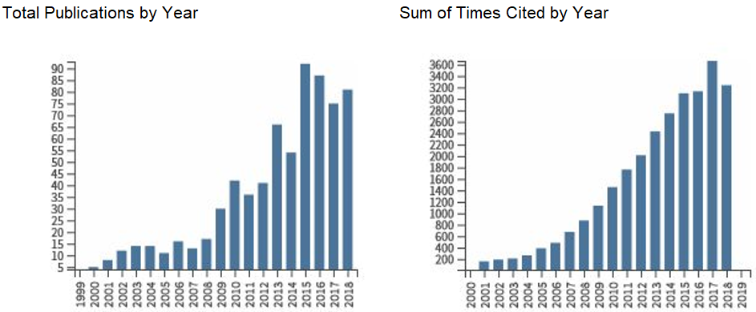
Figure S1. Total publications by year and sum of times cited for the studies captured by our search terms.

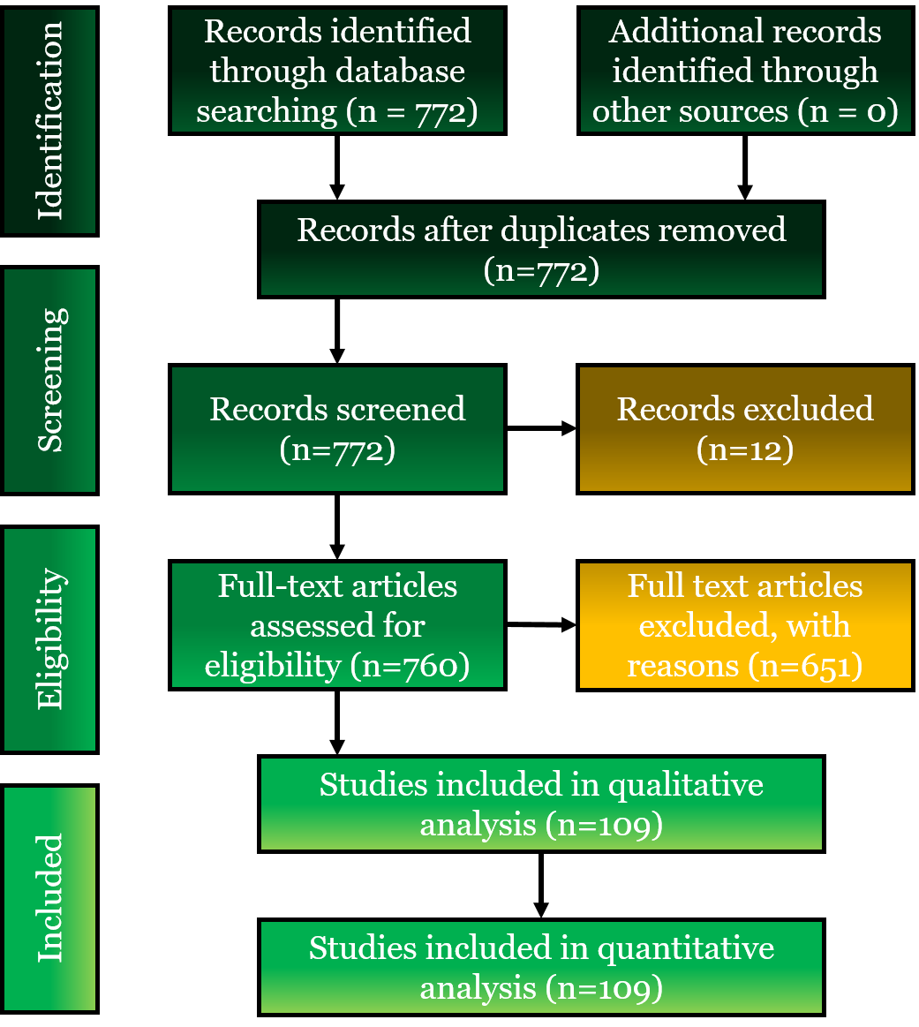
Figure S2. Flow chart of the number of papers screened, and those included and excluded using three filters. This process resulted in 109 relevant papers, which provided information on 132 taxa.
Figure S3. Overview of all the study-by-taxon combinations identified (200 in 109 papers), showing which (and how many) criteria were studied in individual papers.

