Article type: Original Article

Seawater temperature, but not pH, affects startle response behaviour in a wide-ranging marine bivalve

Abbreviated title: Bivalve startle response under high temperature and low pH

Jeff C. Clements^{1*}, Kirti Ramesh², Jacob Nysveen^{2,3}, Sam Dupont², Fredrik Jutfelt¹

¹ Department of Biology, Norwegian University of Science and Technology, Høgskoleringen 5, 7491 Trondheim, Norway

² Department of Biological and Environmental Sciences, University of Gothenburg, Kristineberg Marine Research Centre, Kristineberg 566, 45178 Fiskebäckskil, Sweden

³ Havets Hus, Strandvägen 9, 45330 Lysekil, Sweden

* Correspondence: Jeff C. Clements, Ph.D.
jeffery.clements@dfo-mpo.gc.ca; jefferycclements@gmail.com
+1 (506) 851-2724

Current address: 42 Senese St., Moncton, NB E1E 0B8, Canada

Lay summary
When seawater temperatures are hot, adult hybrid blue mussels spend more time hiding from predators. We show that high temperatures result in longer valve closure times following a tactile predator cue, while low seawater pH has no effect. Longer closure times result in reduced feeding and help explain temperature effects on mortality and energetic physiology in this species, which may affect mussel ecosystem services. Adult mussels are likely vulnerable to ocean warming but not acidification.
Abstract
Under the risk of predation, the first response of bivalves is to close their shells. The strength and duration of valve closure can influence the probability of predator-related mortality. The behavioral ecology of valve closure responses, however, is understudied and the effects of global change stressors on these responses are unknown. We exposed two size classes of blue mussels (Mytilus edulis × trossulus) to different combinations of temperature 15 and 19 °C) and pH (8.2 and 7.5 pH_{T}) for three months and subsequently measured individual time to open (i.e., startle response) following a tactile cue over a series of four consecutive trials. Time to open was highly repeatable on the short-term (adjusted R = 0.56) and decreased across the four trials from an average of 390.0 ± 493.6 secs in Trial 1 (mean ± SD) to 252.6 ± 421.4 secs in Trial 4. On average, individuals from the larger size class had a shorter time to open (154.1 ± 236.0 secs) than their smaller-sized counterparts (453.4 ± 449.9 secs). High temperature significantly increased time to open by 230%, on average, compared to low temperature, while pH had no effect. These results suggest that bivalve time to open is repeatable, related to relative vulnerability to predation, and affected by temperature. Given that increased closure times impact feeding and respiration, the effect of temperature on closure duration may play a role in the sensitivity to ocean warming in this species and contribute to ecosystem-level effects.

Keywords: anti-predator response; carbon dioxide; environmental stress; global change biology; ocean acidification; ocean warming
Introduction
Predator-prey interactions have long been considered a fundamental component of animal ecology, as the ways in which predators and their prey interact is a major driving force shaping the ecology and evolution of biological systems (Connell 1961; Paine 1966; Dawkins and Krebs 1979; Klompmaker et al. 2019). For predators, the successful capture and consumption of prey is important for growth and survival. For prey, defence and avoidance against a predator’s attack is critical for survival.
To combat predation, prey can employ a tremendous variety of defenses, including chemical, morphological, and behavioral defenses (Harvell 1990; Lima and Dill 1990; Kats and Dill 1998). One of the more common ways of avoiding an immediate predator attack is to simply move away from a predator. For semi-sessile animals such as many bivalves, however, this defense is not an option for immediate attacks (although these animals can move and aggregate given sufficient time to do so; Reimer and Tedengren 1996; Côté and Jelnikar 1999; Casey and Chattopadhyay 2008). Instead, bivalves rely heavily on a suite of inducible morphological defenses, often related to shell morphology and substrate attachment strength (Smith and Jennings 2000; Trussell and Smith 2000; Christensen et al. 2012; Lord and Whitlatch 2012; Scherer et al. 2018). Additionally, behavioral responses such as burrowing, aggregating, and valve closures play an important role in predator avoidance in these animals (Reimer and Tedengren 1996; Côté and Jelnikar 1999; Smee and Weissburg 2006; Nicastro et al. 2007; Casey and Chattopadhyay 2008; Flynn and Smee 2010; Robson et al. 2010), particularly given that inducible defenses can take long periods of time to accrue whereas many behavioral defenses are instantaneous.
Although the repertoire of anti-predator behaviors for semi-sessile bivalves is more limited than vagile species, often the most immediate response to the threat of predation is to close their valves and ‘hide’ (Robson et al. 2007; Robson et al. 2010; Carroll and Clements 2019). This avoidance strategy is thought to reduce the probability of being detected by predators (as hiding would reduce the emittance of chemical cues that predators could detect) and can reduce the probability of predators successfully accessing and consuming the tissue (Barbeau and Sceibling 1994; Carroll and Clements 2019). As such, the effectiveness of this strategy will depend on the strength of valve closure (weaker closure would allow predators to detect cues and open shells more easily) and the (Wilson et al. 2012)duration of closure (opening too soon would increase the probabilities of detection and the predator preventing further closure and successfully consuming the bivalve). While the strength of valve closure is predominantly dictated morphologically by adductor muscle strength, the duration of valve closure is determined by an individual’s behavioral decision. Under the threat of predation, the duration of valve closure thus represents a startle response in semi-sessile bivalves (as measured and defined in previous studies; e.g. (Rudin and Briffa 2012; Wilson et al. 2012).
While it is known that semi-sessile bivalves close their shells and exhibit a startle response under the threat of predation, aspects of the behavioral ecology of this response are understudied. Living in clusters as opposed to being solitary can reduce time to open in freshwater mussels (Wilson et al. 2012), likely resulting from reduced vulnerability to predation for group-living bivalves (and hence representing a measure of boldness in these animals; (Côté and Jelnikar 1999; Casey and Chattopadhyay 2008; Kobak and Ryńska 2014). Wilson et al. (2012) also suggested that startle responses were repeatable in freshwater bivalves, but did not directly quantify the repeatability of this measure. Recent evidence also suggests that cue type can affect valve closure responses to predators (Dzierżyńska-Białończyk et al. 2019). Startle responses could be affected by other factors as well, such as size (larger mussels are less vulnerable to predation than smaller mussels; Sommer et al. 1999) and time (time to open may change over short- and long-time scales due to fatigue or habituation). Such aspects of the behavioral ecology of valve closure responses to predator attacks, however, remain unexplored.
It is widely documented that predator-prey dynamics can be affected by global change stressors (Bretagnolle and Terraube 2010; Romero et al. 2018). In the marine realm, studies report that both ocean warming and acidification can affect predator-prey interactions in fish (Allan et al. 2017) and invertebrates (Sanford et al. 2014; Wright et al. 2018; Lord et al. 2019; but see Landes and Zimmer (2012) and Sundin et al. (2017) for contrasting results). With respect to invertebrates, however, much of this work has focused on alterations in predator-prey dynamics resulting from morphological effects. As such, only a handful of studies regarding prey defenses, including startle responses, are available (Clements and Comeau 2019a). For example, in hermit crabs, exposure to increased temperature reduced the mean time to open and increased inter-individual variation, which was suggested to be a function of temperature effects on metabolism (Briffa et al. 2013). A few studies have also tested for effects of seawater pH on prey defenses, reporting varied effects (but not all relating to startle responses; Bibby et al. 2007; Manríquez et al. 2013; Watson et al. 2014; Turra et al. 2019). However, the combined effects of temperature and pH on invertebrate startle responses are virtually absent from the literature. Such studies are important since alterations to animal behavior under global change are likely to drive ecosystem-level impacts (Kroeker et al. 2014; Nagelkerken and Munday 2016).
The overarching goal of this study was thus two-fold: 1) to assess aspects related to the behavioral ecology of bivalve startle responses including short-term repeatability, changes over time, and body size; and 2) to test the combined effects of pH and temperature on bivalve startle responses. To address these research goals, we conducted laboratory experiments using an ecologically and economically important bivalve (Mytilus edulis × trossolus). We predicted that: 1) startle responses would be repeatable; 2) individual time to open would decrease over time (trials) due to either fatigue or habituation; 3) larger animals would have a shorter startle response because they are less vulnerable to predation (Sommer et al. 1999); 4) higher temperature would reduce time to open because of higher metabolism and an increased need for oxygen and nutrient uptake (Briffa et al. 2013); and 5) low pH would affect the startle response as CO₂-induced pH declines are reported to have wide-ranging behavioral effects (Clements and Hunt 2015).
Materials and Methods
Animal collection and husbandry
Adult mussels (Figure S1a) were hand-collected from the side of a nearshore pier at a depth of 0–1 m in the Gullmar Fjord, adjacent to the Kristineberg Marine Research and Innovation Centre (KMRIC; 58.250 °N, 11.447 °E). The mussels were transported to a temperature-controlled wet lab at the KMRIC where they were cleaned of epibionts. The animals were then placed in flow-through aquaria with ambient surface seawater (filtered to remove rocks, sediment, and larger animals while allowing plankton to pass) from the fjord for 12–14 days prior to experimentation to allow acclimation to laboratory conditions. During the acclimation period, mussels fed on a natural diet of plankton from the fjord and were subjected to a 12:12 light:dark cycle (08:30–20:30 light). Mortality was checked every two days and any dead mussels were removed from the acclimation chambers; mortality was minimal (<3%) and mussels fed as evidenced by the consistent production of both faeces and pseudofaeces. Following acclimation, the mussels were weighed (wet weight), measured (shell length), individually labelled (with nail polish), and separated into two distinct size classes based on pre-exposure shell length: small (<58 mm; mean ± SD = 49.6 ± 4.4 mm shell length; 16.3 ± 4.4 g wet weight) and large (>59 mm; 67.1 ± 5.5 mm shell length; 40.0 ± 9.8 g wet weight) (Figure 1a). The animals were then placed into their experimental replicate tanks (Figure S1b,c) upon which exposure to temperature and pH treatments (see below) commenced.
Experimental design and setup
A 2×2×2 design was employed with two size classes (small and large; as above), two pH levels (ambient and –0.7 units), and two temperatures (16 °C and 20 °C [+4 °C]) crossed in a fully-factorial manner. Size classes were chosen based on vulnerability to sea star predation in a comparable biological community (Baltic Sea), whereby the small size class was at the upper end of sizes consumed by sea stars, while the large size class was well above a size refuge threshold and are considered safe from sea star predation (Sommer et al. 1999). We used a small size class that was at the upper end of the size refuge threshold reported for the Baltic Sea because invertebrates in the Baltic Sea are generally smaller than on the west coast of Sweden due to low salinity conditions in the Baltic (Westerbom et al. 2002). Although these specific thresholds may not directly translate to the Gullmar Fjord system, we assumed that the relative vulnerability to predation (not only from sea stars, but from other predators such as crabs and fish) would be greater for the smaller size class. Furthermore, while increasing valve closure times may not be an efficient strategy for avoiding sea star predation (based on sea stars’ mode of feeding), it would be for other predators in the Gullmar Fjord system such as crabs and fish. Temperature and pH treatments were designed to simulate deviations from ambient conditions in the fjord according to near future projections. We used a temperature offset of +4°C following ambient temperatures until they reached 16 °C after which temperature conditions were kept constant at 16 °C (low) and 20 °C (high) (Figure S2). We capped temperature manipulations at 16 °C and 20 °C to avoid temperature-related mortality that can occur during long exposures to temperatures above 20°C (Clements et al. 2018) and to avoid spawning. A pH offset of –0.7 units was employed, which represented an ocean acidification scenario corresponding to the extreme of the natural variability expected by 2100. This scenario was based on a –0.3 unit differential from the minimum pH currently observed in the fjord (0.4 units; low pH ≈7.6 from a mean of ≈8.1 according to Dorey et al. 2013)
(Figure S2).
A flow-through seawater system was constructed to expose animals to experimental temperature and pH conditions (Figure S1b). Ambient seawater was continuously pumped directly from the Gullmar Fjord into each of 12 header tanks (n = 3 header tanks per temperature×pH treatment). The water entered the lab through one of two lines, each of which were equipped with in-line temperature controllers to maintain the desired conditions for each temperature treatment. Seawater pH was manipulated in six of the header tanks via pure CO₂ injection which was maintained with a pH-stat control system (Aqua Medic, Bissendorf, Germany); pH was left at ambient conditions in the other six header tanks. Salinity was left uncontrolled in all treatments and varied naturally with ambient conditions in the fjord (Figure S2). The water in all 12 header tanks was continuously aerated to ensure proper mixing, oxygenation, and gas equilibration.
Seawater from each header tank was gravity fed into two exposure tanks (4 L) where the animals were held, one exposure tank for each size class (Figure S1b,c; n = 5 mussels replicate tank⁻¹; N = 120 mussels). Flow rate to the exposure chambers was adjusted to ≈3 ml s⁻¹ (≈22.2 min for one volume turnover). Mussels fed on the natural diet of plankton available in the seawater and were exposed to a 12:12 light:dark cycle as above. Filtration and ingestion of food was confirmed by the continual presence of faeces and pseudofaeces throughout the experiment, which was siphoned off to clean the exposure tanks as needed. Mortality, which was negligible (n = 4/120, 3%), was checked daily and dead mussels were immediately removed from the exposure tanks. The animals were exposed to experimental conditions for 88–93 days depending on the day in which individuals were subjected to behavioral assays (behavioral assays took six days to complete and different mussels were tested on each day).
Temperature and pH conditions in the exposure and header tanks were measured every 1–6 days to ensure that offsets were consistent (Figure S2). Temperature was measured with a high precision digital thermometer (± 0.1 °C accuracy; testo-112, Testo, Lenzkirch, Germany). Seawater pH was measured on the total scale (pH_{T}) with a benchtop pH meter (Metrohm 827 pH lab, Metrohm, Herisau, Switzerland) calibrated with TRIS (Tris/HCl) and AMP (2-aminopyridine/HCl) buffers. The pH stat systems were adjusted accordingly whenever seawater parameters were measured for temporal pH offset consistency. Salinity was also recorded at the time of temperature and pH measurement from the KMRIC website (https://www.weather.loven.gu.se/kristineberg/en/data.shtml) with the exception of measurements on and after 27 July, which were measured directly with a handheld salinity meter (WTW, Weilheim, Germany) due to a lack of data availability on the KMRIC website. Total alkalinity (A_{T}) was measured weekly by titration of 25 mL filtered (2μm) samples using a SI Analytics Titroline potentiometric titrator. Carbonate system parameters (TCO₂, pCO₂, Ω_{calcite}, and Ω_{aragonite}) were estimated in CO2SYS v2.1 (Pierrot et al. 2009) for each measurement of temperature, salinity, and pH_{T} above, using the A_{T} value from the closest day and the first and second dissociation constants of Mehrbach et al. (1973) refit by Dickson and Millero (1987). The methods above provided highly consistent temperature and carbonate system offset conditions (Figure S2); mean values are provided in Table 1.
Table 1. Abiotic parameters of the experimental treatments. Data are means ± standard deviation. Raw data can be found in in Supplementary file 3 (‘Carbonate chemistry’ sheet) and full CO2SYS results are in Supplementary file 4; temporal trends are presented in Figure S2.

 | Measured |  |  |  |  | Estimated
Treatment | Salinity | Temp (ºC) | pH_{T} | A_{T} (µmol kg⁻¹) |  | TCO₂ (µmol kg⁻¹) | pCO₂ (µatm) | Ω_{calcite} | Ω_{aragonite}
Amb pH + Low temp | 24.4 ± 2.3 | 15.1 ± 1.3 | 8.17 ± 0.10 | 2101.6 ± 124.8 |  | 1908.8 ± 113.3 | 298.8 ± 76.9 | 3.9 ± 1.0 | 2.4 ± 0.6
Low pH + Low temp | 24.4 ± 2.4 | 15.0 ± 1.3 | 7.49 ± 0.09 | 2139.7 ± 74.7 |  | 2162.2 ± 85.1 | 1694.0 ± 383.1 | 0.9 ± 0.2 | 0.6 ± 0.1
Amb pH + High temp | 24.4 ± 2.5 | 19.3 ± 1.2 | 8.14 ± 0.10 | 2110.6 ± 82.1 |  | 1900.4 ± 83.9 | 332.1 ± 85.2 | 4.1 ± 0.9 | 2.6 ± 0.6
Low pH + High temp | 24.4 ± 2.6 | 19.3 ± 1.2 | 7.47 ± 0.10 | 2127.8 ± 85.0 |  | 2138.0 ± 84.7 | 1793.3 ± 403.6 | 1.1 ± 0.3 | 0.7 ± 0.2

Behavioral assays
Behavioral assays were conducted in separate, flow-through experimental tanks (same style as the exposure tanks) under the same abiotic seawater conditions experienced in the exposure period (i.e., low temperature mussels were tested under low temperature conditions, high temperature mussels under high temperature, and so on). A total of 10 experimental tanks were used in a given assay and we were able to conduct two assays per day; all assays took place between 9:00 and 15:00 each day with treatment order randomized. Prior to each assay, mussels were removed from their exposure tank and each one placed into an individual experimental tank where they were left for one hour prior to experimentation. The mantle tissue of the mussels was then gently touched with the round end of a wooden skewer until they closed and the time to visually re-open was recorded (in seconds) with a stopwatch for each individual. This process was repeated for each individual over four consecutive trials every 30 mins from the previous re-opening, allowing us to determine the short-term repeatability in time to open and to compute individual valve closure coefficients of variation. If an animal did not open within 30 mins, the observations for that individual ceased, the individual was assigned a value of 1800 secs, and the animal was given an additional 30 mins to re-open before starting the next trial. Data were discarded from the analysis if an animal was not open at the start of a trial, which only occurred for individuals that did not open at all in any trials (n = 44 observations from 11 individuals; see Supplementary File 3). In addition, four animals died during the exposure period. Thus, the total number of individuals for behavioral assays was reduced by 15, from 120 to 105 (leaving 50 small and 55 large individuals). We ensured that all behavioral observations were fully blinded by having one person place the mussels in the experimental tanks prior to behavioral observations by a different person; the observer was also blinded to the goals and hypotheses until after the data were collected. We also dichotomously scored each individual trial according to whether or not the mussel opened within 30 mins after being startled.
Once behavioral assays were concluded, the mussels were once again weighed and measured, and individual changes in shell length and wet weight were calculated as a percentage of the starting length and weight.
Statistical analyses
All statistical analyses were conducted in R version 3.6.3 (R Core Team 2020). Normality was visually assessed with Q-Q plots and histograms, and homoscedasticity was visually assessed using fitted-residual plots; all plots for assumptions, and the decisions made based on them, can be found in Supplementary File 2. Main and interactive effects were considered significant at α = 0.05. Pairwise comparisons for significant interactive effects or significant independent effects of factors with more than two levels were determine using Tukey HSD post hoc tests with the glht() function from the multcomp package (Hothorn et al. 2008). Supplementary figures and tables are contained in Supplementary File 1. Annotated R script and all raw data are in Supplementary Files 2 and 3, respectively. Original R datafiles used in the analyses are also provided as Supplementary files 4–8. All data in text are reported as mean ± one standard deviation.
Linear models were used to determine if shell length and wet weights differed between size classes both prior to and after the exposure period using the lm() function followed by the anova() function to determine significance. Wet weights and post-exposure shell lengths were natural log transformed prior to analysis to assume normality (see Supplementary File 2). Generalized linear models (GLMs) were used to test for the fixed effects of initial size (continuous), pH_{T} (categorical, 2 levels), temperature (categorical, 2 levels), and their interactions on % changes in shell length and wet weight; GLMMs were selected because data transformations were unsuccessful at fixing initial violations of normality and homoscedasticity). We initially built generalized linear mixed models with tank as a random variable, but singularity errors suggested that these models were overfitting the data and we therefore chose to drop the random effect. GLMs were constructed using the glm() function in the lmerTest package (Kuznetsova et al. 2017) using a Gamma distribution (for continuous, right skewed data);. Significant effects were determined using the Anova() function in the car package.
Repeatability (R) of time to open was estimated using generalized linear mixed models (GLMMs) after (Dingemanse and Dochtermann 2013) and interpreted in a Bayesian fashion according to (Bell et al. 2009) (i.e., behavior can be considered ‘significantly’ repeatable at R ≥ 0.37). Two GLMMs were constructed: one to estimate agreements repeatability (R_{agree}; repeatability without accounting for any fixed effects) and another to estimate adjusted repeatability (R_{adj}; repeatability accounting for fixed effects of size class, pH_{T}, and temperature). The GLMMs were build using the MCMCglmm() function in the MCMCglmm R package (Hadfield 2010). Estimates and 90% confidence intervals for R_{agree} and R_{adj} were obtained using the posteriormode() and HPDinterval() functions, respectively, with code adapted from (Roche et al. 2016).
Behavioral assays were limited to 30 mins and if an animal did not open its valves in that time it was assigned a value of 1800 secs; some observations were thus censored. To account for this, the effects of size class, pH_{T}, temperature, trial, and their interactions time to open were tested using time-to-event analysis (or survival analysis). A mixed effect Cox proportional hazard model based on Kaplan Meier estimations was built using the Surv() function in the survival package (Therneau and Grambsch 2000) and the coxme() function in the coxme package (Therneau 2020) and the Anova() function was subsequently used to test for significant effects (Fox and Weisberg 2019).
To test for the fixed effects of size class, pH_{T}, temperature, trial, and their interactions on individual coefficients of variation (CoV; of time to open), we built linear mixed effects models using the lmer() function in the lmerTest package. Significant effects were determined using the anova() function. Data were natural log transformed prior to analysis to achieve normality and homoscedasticity (see Supplementary File 2). Independent and interactive effects of the same factors on the number of behavioral trials in which individual animals did not open were tested for with logistic regression using the glm() function with a binomial distribution family and the Anova() function to determine significant effects.
Results
Shell length and wet weight
Following exposure, shell lengths and wet weights were significantly different between the two size classes, with mean shell lengths of 67.5 ± 5.1 mm, 50.9 ± 4.1 mm, and mean wet weights of 40.8 ± 8.9 g and 17.6 ± 4.2 g, in the large and small size classes, respectively (Figure 1a-c; Table S1). For growth rates (i.e., changes in shell length and wet weight), initial size had a significant independent effect on growth rate, with smaller animals growing showing larger increases in both shell length and wet weight than larger individuals (Figure 1d,e). There were no significant effects of temperature, pH_{T}, or any interactions on growth rates (Table S2).
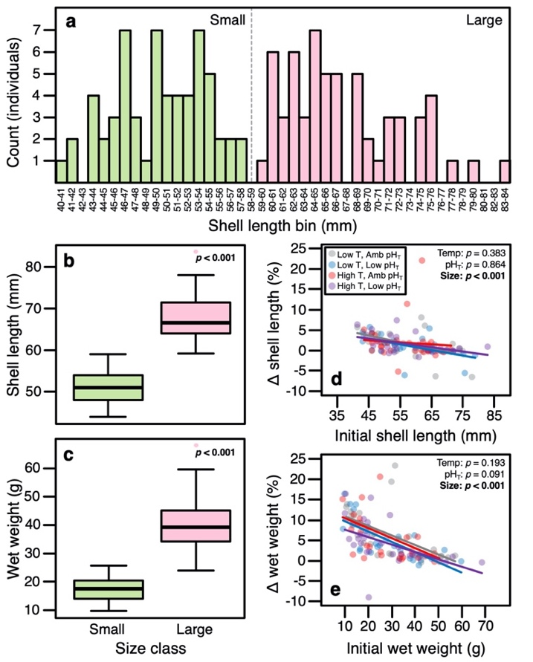
Figure 1. (a) Frequency distribution of shell lengths used to define mussel size classes at the beginning of the experiment. Green bars are the small size class and pink bars are the large size class (n = 60 for each size class). (b-c) Boxplots of post-experiment shell length (a) and wet weight (b) for each of the two size classes (n = 58 for each size class). (d-e) Scatterplots of changes in (Δ) shell length (d) and wet weight (e) as a function of initial size for each of the four treatments: ambient pH_{T} + low temperature (gray circles), low pH_{T} + low temperature (blue circles), ambient pH_{T} + high temperature (red circles), low pH_{T} + high temperature (purple circles). P-values represent results of linear models (see Table S1 in Supplementary file 2).

Short-term repeatability in time to open
Time to open was highly repeatable. Agreement repeatability (R_{agree}; repeatability without accounting for any fixed effects) was estimated to be 0.64 [0.56–0.77, 95% CI]. Similarly, adjusted repeatability (R_{adj}; repeatability accounting for fixed effects of size, pH_{T}, and temperature) was 0.56 [0.43–0.63, 95% CI].
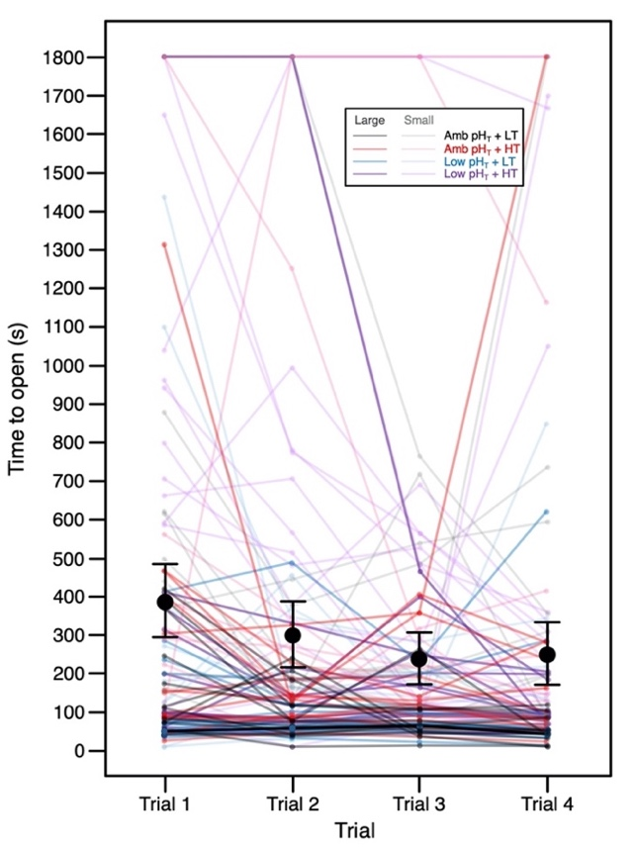
Figure 2. Individual (n = 105) time to open across the four trials. Black points and error bars represent the pooled mean ± 95% CI for time to open time in each trial.

Effects of size, pH_{T}, temperature, and trial on time to open
Time to open was independently affected by size class, temperature, and trial (Table S4). The small mussels had a time to open that was, on average, ≈3× longer than their larger counterparts (453.4 ± 449.9 secs for small mussels versus 154.1 ± 236.0 secs for large; Figure 3a,c, S3). Likewise, mussels from the high temperature treatment remained closed ≈2× longer than those in the low temperature treatment (422.1± 535.8 secs for high temperature versus 182.6 ± 270.9 secs for low temperature; Figure 3b,c, S3). With respect to trial, time to open decreased linearly across the four trials with the fourth trial being significantly lower than the first trial (Figure 3d, S3; Table S6). Seawater pH_{T} had no effect on time to open (Amb. pH: 290.2 ± 426.4 secs, Low pH: 302.0 ± 442.6 secs) and there were no interactive effects (Figure S3; Table S4).
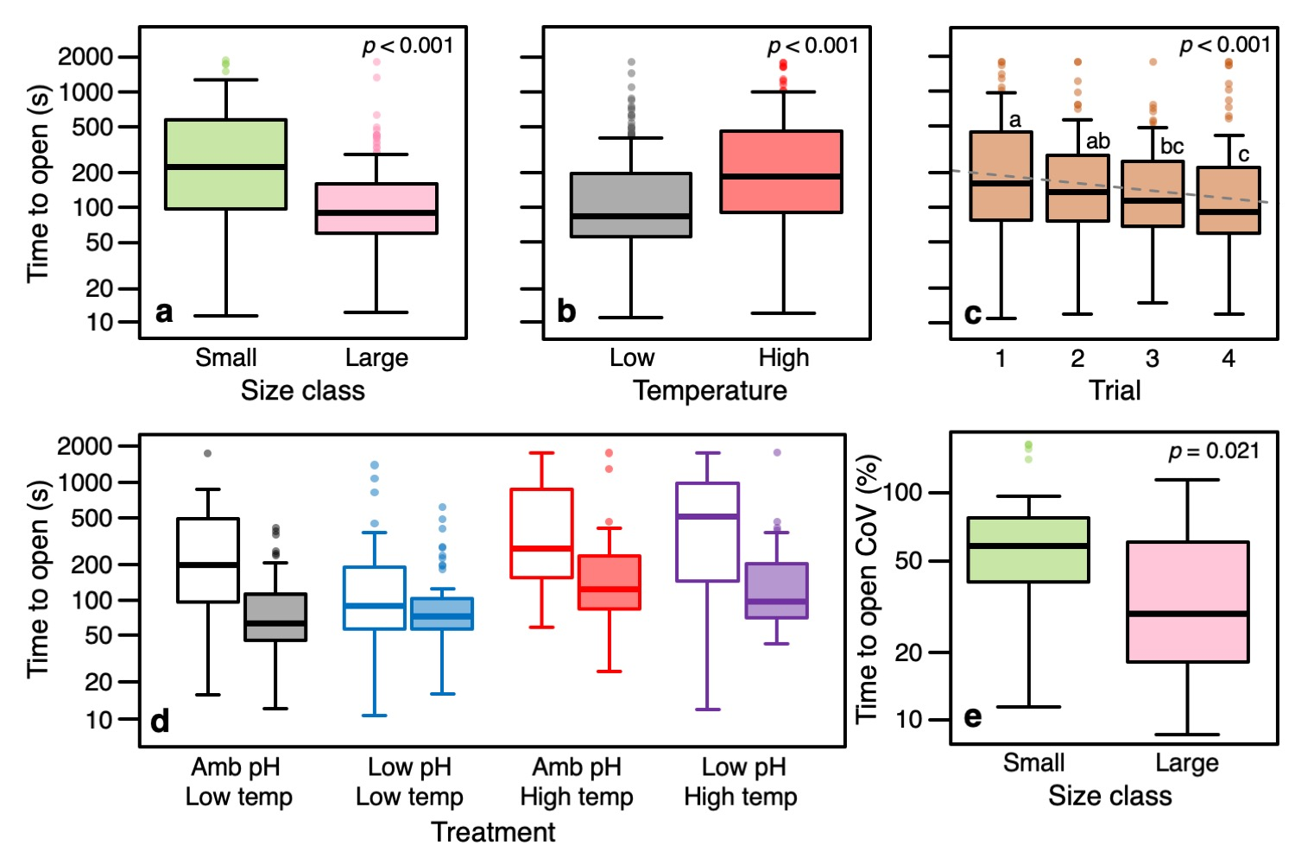
Figure 3. (a) Boxplot of time to open for each size class (n_{large} = 55, n_{small} = 50). (b) Boxplot of time to open for each experimental temperature (°C; n_{control} = 55, n_{high} = 50). (c) Boxplot of startle response times for each of the four trials (n = 105 individuals per trial). Note that the y-axis is log scaled. Dashed line is the linear best fit trendline. P-value represents the main effect of trial from the linear mixed effects model and letters above plots denote Tukey HSD pairwise differences (see Table S3). (d) Boxplot of time to open as a function of size class and experimental treatment. (n_{amb pH+low temp, large} = 14; n_{amb pH+low temp, small} = 15; n_{low pH+low temp, large} = 13; n_{low pH+low temp small} = 13; n _{amb pH+high temp, large} = 12; n _{amb pH+high temp, small} = 14; n_{low pH+high temp, large} = 9; n_{low pH+high temp, small} = 15). Small and large size classes are represented by open and filled boxes, respectively. (e) Boxplot of time to open coefficient of variation (CoV) for each size class (n_{large} = 55, n_{small} = 50). Note that all y-axes are log scaled. Sample sizes are number of individuals. P-values represent main effect results from the mixed effect Cox proportional hazards model for time to open (a-c), and linear mixed effects model for CoV (see Tables S2 and S5).

Alongside staying closed longer, smaller mussels also had a higher individual coefficient of variation (CoV) in time to open than larger mussels (59.9 ± 37.0 % in small versus 41.2 ± 28.6 % in large; Figure 3e). Time to open CoV was not significantly affected by any other factor (or interaction) aside from size class (Table S5).
The propensity of individuals to remain closed for the duration of a given trial was independently affect by size class and temperature but not by pH_{T} or trial (Figure S4; Table S7). The proportion of trials in which individuals did not open was higher in the small size class and under high temperatures (Figure S4). Overall, however, the percentage of trials in which individuals did not open was low (13.1%).
Discussion
This study provides novel insights into the behavioral ecology of a bivalve startle response (time to open) and how this behavior might be impacted under global changes. Results suggest that startle responses in bivalves are repeatable in short-term contexts. In addition, these responses appear to be a function of relative vulnerability to predation and are negatively affected by elevated temperatures but not by reduced pH_{T}.
Contrary to our prediction that increased temperatures would reduce time to open, exposure to elevated temperature resulted in increased time to open and drove a significantly higher proportion of observations where animals did not open during a given trial. Our initial prediction was generated from a physiological perspective with the reasoning that higher temperatures raise metabolic rates, which increase the need for oxygen and nutrient uptake. Similar results are reported for Mediterranean mussels, Mytilus galloprovincialis, which increased time to open under higher temperature (Anestis et al. 2007). In addition, continually opening and closing would incur energetic costs for individual mussels. Remaining closed for a longer period of time under the risk of predation at higher temperatures (where metabolic activity, and thus basal energetic expenditure, is higher) could potentially be a strategy to reduce energetic costs if the mussels would have to close again after re-opening. Rather than increasing oxygen and nutrient uptake, it seems that bivalves generally increase the time spent closed, possibly to depress metabolism and offset the energy demand associated with higher temperature (de Zwaan et al. 1980; Ortmann and Grieshaber 2003; Anestis et al. 2007). Such a strategy could help explain reports of reduced growth and condition under higher temperatures (Mackenzie et al. 2014; Clements, Hicks, et al. 2018), observations which have been verified in the field by mussel farmers in eastern Canada (Clements, Hicks, et al. 2018). This strategy appears ineffective for blue mussels, however, as prolonged exposure to higher temperatures is also associated with higher mortality (Clements, Hicks, et al. 2018). Given that the amount of time spent at temperatures at or above 20. °C will increase as global temperatures increase, ocean warming may pose a significant threat to these mussels unless they can adapt to increasing temperatures
When closed, bivalve feeding activity ceases. As such, longer periods spent closed under higher temperatures have the potential to reduce energy intake if feeding rates (when open) at higher temperatures are insufficient to compensate for the lost time feeding. Kittner and Riisgård (2005) reported that individual blue mussels increase their filtration rates from 5.1 L h⁻¹ at 15.6 °C to 5.5 L h⁻¹ at 20.3 °C (on average), with no effect of time up to 22 mins (estimated from Figure 3a at 22 mins using ImageJ). Based on 30 min observation periods in our experiment, mussels at 16 °C remained closed, on average, for 182.6 secs (≈3mins, or 6 mins hour⁻¹). In contrast, mussels at 20 °C remained closed for an average of 422.1 secs (≈7 mins, or 14 mins hour⁻¹). Based on our data, some back-of-the-envelope calculations reveal that mussels at 16 °C can filter a total of 4.6 L hour⁻¹, while those at 20 °C only filter 4.2 L hour⁻¹ (≈10 % less). Furthermore, differences in baseline opening times at similar temperature reveal a similar trend (Anestis et al. 2007). While studies testing this association more specifically for the mussel population used in this study, and a more precise metric of feeding (e.g. ingestion rate instead of filtration rate), would provide a more definitive answer, these numbers suggest that net food intake in mussels can be reduced under high temperatures. This finding aligns well with reports of reduced glycogen content, increased mortality, and weakened byssal strength under higher temperature in previous studies (Clements, Hicks, et al. 2018).
Reduced filtration under higher temperatures not only have implications for individual bivalves and their growth but could potentially impact the ecosystem benefits provided by bivalves (Clements and Comeau 2019b; van der Schatte Olivier et al. 2020). Given that mussels remained closed for durations more than two-times longer than their control temperature counterparts, areas of high predation pressure are likely to see less effective filtering capacity, potentially affecting the effectiveness at which bivalves can clean water and cycle nutrients. Similarly, our results, coupled with others (Anestis et al. 2007), suggest that the filtering capacity of bivalves may decrease in a warmer ocean, which may be amplified in areas where predators exist in high abundance. Given the ubiquitous distribution of marine bivalves and their importance to marine ecosystems globally, it is possible that ocean warming could influence benthic systems worldwide. Furthermore, our results provide a basis for informing spatial planning of shellfish restoration and aquaculture activities globally. More studies of predator encounter rates in the field in conjunction with associated ecosystem service estimates are needed to quantify the effects of temperature and warming on bivalve ecosystem services. Such studies should be accompanied by others quantifying the capacity of various species and populations of bivalves to cope with and/or adapt to shifting temperatures in the context of predator avoidance and feeding.
Some of the most striking effects of ocean acidification have been reported on animal behavior (Clements and Hunt 2015) which are anticipated to drive ecosystem-level impacts under global change (Nagelkerken and Munday 2016). Therein, behaviors involving sensory function are thought to be highly sensitive to ocean acidification (Ashur et al. 2017; Draper and Weissburg 2019), and anti-predator behaviors in both fish and invertebrates are reported to be impacted by acidification (Clements and Comeau 2019a; Draper and Weissburg 2019). As such, we predicted that exposure to low pH conditions would affect the mussels’ time to open in this experiment. In contrast to this prediction, however, we observed no effect of low pH, despite employing an extreme acidification scenario (–0.7 pH_{T}). While clumping behavior in Mytilus edulis was affected by acidification (Kong et al. 2019) and median valve openings in Mytilus galloprovincialis were reduced under 1200 μatm (from a 500 μatm control) (Lassoued et al. 2019), multiple studies suggest a lack of acidification effect on baseline valve gaping activity in marine bivalves (Jakubowska and Normant 2015; Bamber and Westerlund 2016; Clements, Comeau, et al. 2018). Furthermore, a recent study also found no effect of near-future ocean acidification (pH 7.70 from a control of 8.25) on startle responses in hermit crabs, Pagurus criniticornis (Turra et al. 2019). While it could be argued that the lack of pH effect is due to the cue type used (i.e., tactile versus olfactory), a similar study on Mytilus galloprovincialis found no effect of low pH on valve closure responses to chemical alarm cues (Clements et al. under review). Collectively, these results suggest that ocean acidification may have a relatively weak effect on marine bivalve behaviors and perhaps a far weaker effect on animal behavior, broadly, than currently thought (Clark et al. 2020).
We observed a high degree of behavioral repeatability in time to open following tactile predator cues in the lab, supporting our hypothesis that bivalve startle responses are repeatable. To our knowledge, only one other study has reported on the repeatability of time to open, reporting that similar responses in freshwater mussels, Margaritifera margaritifera, were repeatable across three trials with different cue types (although a quantitative estimate of repeatability was not reported) (Wilson et al. 2012). Behavioral aspects of escape performance in scallops are also repeatable on both short- and long-term timescales (Brokordt et al. 2012; Laming et al. 2013) and startle responses in other invertebrates such as sea anemones, hermit crabs, and squid are thought to be repeatable (Sinn et al. 2008; Briffa and Greenaway 2011; Rudin and Briffa 2012; Briffa et al. 2013). Our results, together with these other studies, suggest that bivalve startle responses across different species and contexts are repeatable. The high repeatability of time to open, coupled with the ease at which they can be measured, provides for a useful behavioral model, particularly with respect to theoretical questions associated with animal personality (Gosling 2001; Roche et al. 2016), behavioral syndromes (Sih et al. 2004), temperament (Réale et al. 2007), and coping styles (Koolhaas et al. 1999). It is important to note, however, that the strength of repeatability decreased over time in our experiment, as the relationships between Trial 1 and the other trials were weaker when trials were further apart. While this appeared to reflect habituation, future studies of repeatability in time to open in theoretical contexts would benefit from using varying stimuli unless habituation is of interest.
Our hypothesis that smaller mussels would remain closed longer than larger mussels was supported as smaller mussels remained closed three times longer than the larger mussels. The hypothesis was based on the fact that individuals in the smaller size class are considered more vulnerable to predation than the large size class. This idea is also supported by the observation that freshwater mussels living in clusters had shorter time to open than their solitary counterparts (Wilson et al. 2012), since living in clusters is thought to reduce vulnerability to predation in group-living bivalves (Wilson et al. 2012). Valve closures and the cessation of feeding are also reported to be cue specific (Castorani and Hovel 2016; Dzierżyńska-Białończyk et al. 2019). It is thus likely that time to open is at least partly dictated by relative vulnerability to predation and represents a measure of ‘boldness’ in bivalves. It is important to note, however, that feeding, and oxygen uptake, stop when a bivalve is closed. As such, while conferring a lower probability of being consumed by a predator, remaining closed for a longer period of time also means reduced filtering time, which can affect the net growth of individuals (Nakaoka 2000). Extended periods without oxygen uptake slows the metabolism which can also have numerous negative impacts (Ortmann and Grieshaber 2003), including reduced growth and fecundity. Indeed, previous studies have found that blue mussels and other bivalves will incur costs to growth in the interest of protection from predation (Nakaoka 2000; Eschweiler and Christensen 2011).
Interestingly, we observed that individual coefficients of variation were significantly higher in the smaller size class, meaning that time to open in the smaller size group were more variable that those in the large size class. This may be due to the relative importance of predator avoidance and feeding in the two size classes. For instance, while both size classes would benefit from maximizing food intake, animals from the large size class were considered less vulnerable to predation and therefore could afford to be consistently bolder (i.e., open faster) and take less risks. In contrast, the smaller size class was considered vulnerable to predation and would therefore stay closed longer. The smaller size class still needs to maximize food intake, however, and they may thus be more likely to take more risks (i.e., sometimes open quickly) than the larger size class, which may explain the higher degree of variability observed in the smaller size class. This explanation thus remains speculative and more research into the mechanism and function of more variable behavior in smaller bivalves is needed.
Across the four consecutive trials, time to open linearly decreased as trials progressed. Such an observation may indicate habituation or fatigue. If this observation represents short-term habituation, such a response would likely be adaptive. For example, given the aforementioned trade-offs between feeding and avoiding predation, as contextual adjustments would allow the animals to minimize the risk of being consumed by a predator while maximizing energy acquisition. It is important to note here, however, that we only used a single tactile predator cue in our experiments in the absence of olfactory cues, which comes with limitations as recent evidence suggests that different cues can alter bivalve gaping behavior in different ways (Dzierżyńska-Białończyk et al. 2019). Nonetheless, our approach does not allow us to determine if this response was habituation or simply fatigue. Since adductor muscle contractions required for shell closure would incur energetic costs, the shorter time to open in later trials may simply reflect reduced energy to sustain shell closures. This is particularly apparent given the relatively short rest period between trials. Further research is thus warranted to determine whether or not the trial effect observed here is related to habituation or fatigue.
Conclusions
The results of this study lend novel insights regarding bivalve startle response behavior, suggesting that this behavior is highly repeatable in short-term contexts, and are likely a function of relative vulnerability to predation. Low pH conditions simulating ocean acidification had no effect on bivalve startle responses in this study, adding to the growing body of literature suggesting that the behavioral effects of low pH on marine fauna may be less severe than previously thought. In contrast, however, our results show that these responses can be negatively affected by elevated temperature. Coupled with previous studies reporting similar results, ocean warming could have drastic implications for the important ecosystem services that bivalves provide globally. Future studies directly quantifying the effects of warming on these ecosystem services and bivalve populations worldwide are warranted and highly encouraged.

Acknowledgements
We thank the support staff at the KMRIC for outstanding support throughout the experiment. We also thank Alice D’Hurlaborde and Maria Asplund for assistance in collecting and cleaning mussels. Thanks Dr. Joacim Näslund for statistical advice regarding Cox proportional hazards models. JCC and kr also want to thank our many friends at the KMRIC for taking care of logistical aspects on short notice throughout the experiment: Roland Pfeiffer, Prema Mani, Elena Tamarit Castro, Julian Gallego, Elisabet Ekstrand, Marianna Rampul, Theresa Haller, Samuel Mwaniki Gaita, Sandra Schelzig, Nadine DeSilva, Catherina Maaßen, Ronja Weskott, Nicholas Plum, Ann-Christin Branscheid.

Supplementary material
Supplementary file 1. Supplementary figures and tables.
Supplementary file 2. Annotated R script.
Supplementary file 3. Raw data.
Supplementary file 4. R data file: mussel.size.txt
Supplementary file 5. R data file: valvo.txt
Supplementary file 6. R data file: valvo.repeat.txt
Supplementary file 7. R data file: valvo.cov.txt
Supplementary file 8. R data file: valvo.logistic.txt
Funding
This work was supported by a Marie Skłodowska-Curie Individual Fellowship funded through the European Union Horizon 2020 program (project number 752813 to J.C.C.); a KVA Fund through the University of Gothenburg (to J.C.C.); an Assemble Plus Grant from the European Marine Biological Resource Centre (EMBRC) (to J.C.C); the Research Council of Norway (262942 to F.J.); and by a Carl Tryggers Fellowship (to K.R.).

Ethics
Ethical approval was not required for the species used in this experiment. Nonetheless, the study was strictly conducted under the premise of the three Rs of animal ethics.

Data Accessibility Statement
All statistical results, raw data, R code, and original datafiles uploaded to R are available as supplementary material.

Author Contributions
JCC conceptualized the idea. JCC, FJ and KR designed the experiment. JCC and KR tended to the animals and collected abiotic seawater parameters. JCC and JN carried out the behavioural experiments. JCC analyzed data and wrote the manuscript. SD and FJ provided in-kind support and technical guidance. All authors revised and approved the manuscript.

Competing interests
We declare we have no competing interests.
References
Allan BJM, Domenici P, Watson S-A, Munday PL, McCormick MI. 2017. Warming has a greater effect than elevated CO₂ on predator–prey interactions in coral reef fish. Proc R Soc B. 284:20170784. doi:10.1098/rspb.2017.0784.
Anestis A, Lazou A, Pörtner H-O, Michaelidis B. 2007. Behavioral, metabolic, and molecular stress responses of marine bivalve Mytilus galloprovincialis during long-term acclimation at increasing ambient temperature. Am J Physiol - Reg Integr Comp Physiol. 293:R911–R921. doi:10.1152/ajpregu.00124.2007.
Ashur MM, Johnston NK, Dixson DL. 2017. Impacts of ocean acidification on sensory function in marine organisms. Integr Comp Biol. 57:63–80. doi:10.1093/icb/icx010.
Bamber SD, Westerlund S. 2016. Behavioral responses of Arctica islandica (Bivalvia: Arcticidae) to simulated leakages of carbon dioxide from sub-sea geological storage. Aquat Toxicol. 180:295–305. doi:10.1016/j.aquatox.2016.10.009.
Barbeau MA, Sceibling RE. 1994. Behavioral mechanisms of prey size selection by sea stars (Asterias vulgaris Verrill) and crabs (Cancer irroratus Say) preying on juvenile sea scallops (Placopecten magellanicus (Gmelin)). J Exp Mar Biol Ecol. 180:103–136. doi:10.1016/0022-0981(94)90082-5.
Bell AM, Hankison SJ, Laskowski KL. 2009. The repeatability of behaviour: A meta-analysis. Anim Behav. 77:771–783. doi:10.1016/j.anbehav.2008.12.022.
Bibby R, Cleall-Harding P, Rundle S, Widdicombe S, Spicer J. 2007. Ocean acidification disrupts induced defences in the intertidal gastropod Littorina littorea. Biol Lett. 3:699–701. doi:10.1098/rsbl.2007.0457.
Bretagnolle V, Terraube J. 2010. Predator–prey interactions and climate change. In: Effects of Climate Change on Birds. Oxford University Press. p. 199–220.
Briffa M, Bridger D, Biro PA. 2013. How does temperature affect behaviour? Multilevel analysis of plasticity, personality and predictability in hermit crabs. Anim Behav. 86:47–54. doi:10.1016/j.anbehav.2013.04.009.
Briffa M, Greenaway J. 2011. High in situ repeatability of behaviour indicates animal personality in the beadlet anemone Actinia equina (Cnidaria). PLoS ONE. 6:e21963. doi:10.1371/journal.pone.0021963.
Brokordt K, Farías W, Lhorente J-P, Winkler F. 2012. Heritability and genetic correlations of escape behaviours in juvenile scallop Argopecten purpuratus. Anim Behav. 84:479–484. doi:10.1016/j.anbehav.2012.05.025.
Carroll JM, Clements JC. 2019. Scaredy-oysters: In situ documentation of an oyster behavioral response to predators. Southeast Nat. 18:N21–N26. doi:10.1656/058.018.0303.
Casey MM, Chattopadhyay D. 2008. Clumping behavior as a strategy against drilling predation: Implications for the fossil record. J Exp Mar Biol Ecol. 367:174–179. doi:10.1016/j.jembe.2008.09.020.
Castorani MCN, Hovel KA. 2016. Native predator chemical cues induce anti-predation behaviors in an invasive marine bivalve. Biol Invasions. 18:169–181. doi:10.1007/s10530-015-1000-6.
Christensen HT, Dolmer P, Petersen JK, Tørring D. 2012. Comparative study of predatory responses in blue mussels (Mytilus edulis L.) produced in suspended long line cultures or collected from natural bottom mussel beds. Helgol Mar Res. 66:1–9. doi:10.1007/s10152-010-0241-0.
Clark TD, Raby GD, Roche DG, Binning SA, Speers-Roesch B, Jutfelt F, Sundin J. 2020. Ocean acidification does not impair the behaviour of coral reef fishes. Nature. 577:370–375. doi:10.1038/s41586-019-1903-y.
Clements JC, Comeau LA. 2019a. Behavioral defenses of shellfish prey under ocean acidification. J Shellfish Res. 38:1–18. doi:10.2983/035.038.0300.
Clements JC, Comeau LA. 2019b. Nitrogen removal potential of shellfish aquaculture harvests in eastern Canada: A comparison of culture methods. Aquacult Rep. 13:100183. doi:10.1016/j.aqrep.2019.100183.
Clements JC, Comeau LA, Carver CE, Mayrand E, Plante S, Mallet AL. 2018. Short-term exposure to elevated pCO₂ does not affect the valve gaping response of adult eastern oysters, Crassostrea virginica, to acute heat shock under an ad libitum feeding regime. J Exp Mar Biol Ecol. 506:9–17. doi:10.1016/j.jembe.2018.05.005.
Clements JC, Hicks C, Tremblay R, Comeau LA. 2018. Elevated seawater temperature, not pCO₂, negatively affects post-spawning adult mussels (Mytilus edulis) under food limitation. Cons Physiol. 6:cox078. doi:10.1093/conphys/cox078.
Clements JC, Hunt HL. 2015. Marine animal behaviour in a high CO₂ ocean. Mar Ecol Prog Ser. 536:259–279. doi:10.3354/meps11426.
Connell JH. 1961. The influence of interspecific competition and other factors on the distribution of the barnacle Chthamalus stellatus. Ecology. 42:710–723. doi:10.2307/1933500.
Côté IM, Jelnikar E. 1999. Predator-induced clumping behaviour in mussels (Mytilus edulis Linnaeus). J Exp Mar Biol Ecol. 235:201–211. doi:10.1016/S0022-0981(98)00155-5.
Dawkins R, Krebs JR. 1979. Arms races between and within species. Proc R Soc B. 205:489–511. doi:10.1098/rspb.1979.0081.
de Zwaan A, Thompson RJ, Livingstone DR. 1980. Physiological and biochemical aspects of the valve snap and valve closure responses in the giant scallop Placopecten magellanicus. J Comp Physiol B. 137:105–114.
Dickson AG, Millero FJ. 1987. A comparison of the equilibrium constants for the dissociation of carbonic acid in seawater media. Deep Sea Res I: Oceanogr Res Pap. 34:1733–1743. doi:10.1016/0198-0149(87)90021-5.
Dingemanse NJ, Dochtermann NA. 2013. Quantifying individual variation in behaviour: Mixed-effect modelling approaches. J Anim Ecol. 82:39–54. doi:10.1111/1365-2656.12013.
Dorey N, Lançon P, Thorndyke M, Dupont S. 2013. Assessing physiological tipping point of sea urchin larvae exposed to a broad range of pH. Glob Change Biol. 19:3355–3367. doi:10.1111/gcb.12276.
Draper AM, Weissburg MJ. 2019. Impacts of global warming and elevated CO₂ on sensory behavior in predator-prey interactions: A review and synthesis. Front Ecol Evol. 7:72. doi:10.3389/fevo.2019.00072.
Dzierżyńska-Białończyk A, Jermacz Ł, Zielska J, Kobak J. 2019. What scares a mussel? Changes in valve movement pattern as an immediate response of a byssate bivalve to biotic factors. Hydrobiologia. 841:65–77. doi:10.1007/s10750-019-04007-0.
Eschweiler N, Christensen HT. 2011. Trade-off between increased survival and reduced growth for blue mussels living on Pacific oyster reefs. Journal of Experimental Marine Biology and Ecology. 403:90–95. doi:10.1016/j.jembe.2011.04.010.
Flynn AM, Smee DL. 2010. Behavioral plasticity of the soft-shell clam, Mya arenaria (L.), in the presence of predators increases survival in the field. Journal of Experimental Marine Biology and Ecology. 383:32–38. doi:10.1016/j.jembe.2009.10.017.
Fox J, Weisberg S. 2019. An {R} Companion to Applied Regression. Third Edition. Thousand Oaks CA: Sage.
Gosling SD. 2001. From mice to men: What can we learn about personality from animal research? Psychol Bull. 127:45–86. doi:10.1037/0033-2909.127.1.45.
Hadfield JD. 2010. MCMC methods for multi-response generalized linear mixed models: The MCMCglmm R package. J Stat Soft. 33:1–22. doi:10.18637/jss.v033.i02.
Harvell CD. 1990. The ecology and evolution of inducible defenses. Q Rev Biol. 65:323–340. doi:10.1086/416841.
Hothorn T, Bretz F, Westfall P. 2008. Simultaneous inference in general parametric models. Biom J. 50:346–363. doi:10.1002/bimj.200810425.
Jakubowska M, Normant M. 2015. Metabolic rate and activity of blue mussel Mytilus edulis trossulus under short-term exposure to carbon dioxide-induced water acidification and oxygen deficiency. Mar Freshw Behav Physiol. 48:25–39. doi:10.1080/10236244.2014.986865.
Kats LB, Dill LM. 1998. The scent of death: Chemosensory assessment of predation risk by prey animals. Écoscience. 5:361–394. doi:10.1080/11956860.1998.11682468.
Kittner Christina, Riisgård HU. 2005. Effect of temperature on filtration rate in the mussel Mytilus edulis: no evidence for temperature compensation. Mar Ecol Prog Ser. 305:147–152. doi:10.3354/meps305147.
Klompmaker AA, Kelley PH, Chattopadhyay D, Clements JC, Huntley JW, Kowalewski M. 2019. Predation in the marine fossil record: Studies, data, recognition, environmental factors, and behavior. Earth Sci Rev. 194:472–520. doi:10.1016/j.earscirev.2019.02.020.
Kobak J, Ryńska A. 2014. Environmental factors affecting behavioural responses of an invasive bivalve to conspecific alarm cues. Anim Behav. 96:177–186. doi:10.1016/j.anbehav.2014.08.014.
Kong H, Clements JC, Dupont S, Wang T, Huang X, Shang Y, Huang W, Chen J, Hu M, Wang Y. 2019. Seawater acidification and temperature modulate anti-predator defenses in two co-existing Mytilus species. Mar Poll Bull. 145:118–125. doi:10.1016/j.marpolbul.2019.05.040.
Koolhaas JM, Korte SM, De Boer SF, Van Der Vegt BJ, Van Reenen CG, Hopster H, De Jong IC, Ruis MAW, Blokhuis HJ. 1999. Coping styles in animals: Current status in behavior and stress-physiology. Neurosci Biobehav Rev. 23:925–935. doi:10.1016/S0149-7634(99)00026-3.
Kroeker KJ, Sanford E, Jellison BM, Gaylord B. 2014. Predicting the effects of ocean acidification on predator-prey interactions: A conceptual framework based on coastal molluscs. Biol Bull. 226:211–222. doi:10.1086/BBLv226n3p211.
Kuznetsova A, Brockhoff PB, Christensen RHB. 2017. lmerTest package: Tests in linear mixed effects models. J Stat Soft. 82:1–26. doi:10.18637/jss.v082.i13.
Laming SR, Jenkins SR, McCarthy ID. 2013. Repeatability of escape response performance in the queen scallop, Aequipecten opercularis. J Exp Biol. 216:3264–3272. doi:10.1242/jeb.080416.
Landes A, Zimmer M. 2012. Acidification and warming affect both a calcifying predator and prey, but not their interaction. Mar Ecol Prog Ser. 450:1–10. doi:10.3354/meps09666.
Lassoued J, Babarro JMF, Padín XA, Comeau LA, Bejaoui N, Pérez FF. 2019. Behavioural and eco-physiological responses of the mussel Mytilus galloprovincialis to acidification and distinct feeding regimes. Mar Ecol Prog Ser. 626:97–108. doi:10.3354/meps13075.
Lima DL, Dill LM. 1990. Behavioral decisions made under the risk of predation: A review and prospectus. Can J Zool. 68:619–640. doi:10.1139/z90-092.
Lord JP, Harper EP, Barry JP. 2019. Ocean acidification may alter predator-prey relationships and weaken nonlethal interactions between gastropods and crabs. Mar Ecol Prog Ser. 616:83–94. doi:10.3354/meps12921.
Lord JP, Whitlatch RB. 2012. Inducible defenses in the eastern oyster Crassostrea virginica Gmelin in response to the presence of the predatory oyster drill Urosalpinx cinerea Say in Long Island Sound. Mar Biol. 159:1177–1182. doi:10.1007/s00227-012-1896-7.
Mackenzie CL, Ormondroyd GA, Curling SF, Ball RJ, Whiteley NM, Malham SK. 2014. Ocean warming, more than acidification, reduces shell strength in a commercial shellfish species during food limitation. PLoS ONE. 9:e86764. doi:10.1371/journal.pone.0086764.
Manríquez PH, Jara ME, Mardones ML, Navarro JM, Torres R, Lardies MA, Vargas CA, Duarte C, Widdicombe S, Salisbury J, et al. 2013. Ocean acidification disrupts prey responses to predator cues but not net prey shell growth in Concholepas concholepas (loco). PLoS ONE. 8:e68643. doi:10.1371/journal.pone.0068643.
Mehrbach C, Culberson CH, Hawley JE, Pytkowicx RM. 1973. Measurement of the apparent dissociation constants of carbonic acid in seawater at atmospheric pressure. Limnol Oceanogr. 18:897–907. doi:10.4319/lo.1973.18.6.0897.
Nagelkerken I, Munday PL. 2016. Animal behaviour shapes the ecological effects of ocean acidification and warming: Moving from individual to community-level responses. Glob Change Biol. 22:974–989. doi:10.1111/gcb.13167.
Nakaoka M. 2000. Nonlethal effects of predators on prey populations: Predator-mediated change in bivalve growth. Ecology. 81:1031–1045. doi:10.1890/0012-9658(2000)081[1031:NEOPOP]2.0.CO;2.
Nicastro KR, Zardi GI, McQuaid CD. 2007. Behavioural response of invasive Mytilus galloprovincialis and indigenous Perna perna mussels exposed to riisk of predation. Mar Ecol Prog Ser. 336:169–175.
Ortmann C, Grieshaber MK. 2003. Energy metabolism and valve closure behaviour in the Asian clam Corbicula fluminea. Journal of Experimental Biology. 206:4167–4178. doi:10.1242/jeb.00656.
Paine RT. 1966. Food web complexity and species diversity. Am Nat. 100:65–75. doi:10.1086/282400.
Pierrot D, Lewis E, Wallace DWR. 2009. CO2SYS: MS Excel Program Developed for CO2 System Calculations. ORNL/CDIAC-105a. Oak Ridge, Tennessee: Carbon Dioxide Information Analysis Center, Oak Ridge National Laboratory, U.S. Department of Energy. (doi: 10.3334/CDIAC/otg.CO2SYS_XLS_CDIAC105a).
R Core Team. 2020. R: A language and environment for statistical computing. Vienna, Austria: R Foundation for Statistical Computing. https://www.R-project.org/.
Réale D, Reader SM, Sol D, McDougall PT, Dingemanse NJ. 2007. Integrating animal temperament within ecology and evolution. Biol Rev. 82:291–318. doi:10.1111/j.1469-185X.2007.00010.x.
Reimer O, Tedengren M. 1996. Phenotypical Improvement of Morphological Defences in the Mussel Mytilus edulis Induced by Exposure to the Predator Asterias rubens. Oikos. 75(3):383. doi:10.2307/3545878.
Robson A, Wilson R, Garcia de Leaniz C. 2007. Mussels flexing their muscles: A new method for quantifying bivalve behaviour. Mar Biol. 151:1195–1204. doi:10.1007/s00227-006-0566-z.
Robson AA, Garcia De Leaniz C, Wilson RP, Halsey LG. 2010. Behavioural adaptations of mussels to varying levels of food availability and predation risk. J Mollusc Stud. 76:348–353. doi:10.1093/mollus/eyq025.
Roche DG, Careau V, Binning SA. 2016. Demystifying animal ‘personality’ (or not): why individual variation matters to experimental biologists. J Exp Biol. 219:3832–3843. doi:10.1242/jeb.146712.
Romero GQ, Gonçalves-Souza T, Kratina P, Marino NAC, Petry WK, Sobral-Souza T, Roslin T. 2018. Global predation pressure redistribution under future climate change. Nature Clim Change. 8:1087–1091. doi:10.1038/s41558-018-0347-y.
Rudin FS, Briffa M. 2012. Is boldness a resource-holding potential trait? Fighting prowess and changes in startle response in the sea anemone, Actinia equina. Proc R Soc B. 279:1904–1910. doi:10.1098/rspb.2011.2418.
Sanford E, Gaylord B, Hettinger A, Lenz EA, Meyer K, Hill TM. 2014. Ocean acidification increases the vulnerability of native oysters to predation by invasive snails. Proc R Soc B. 281:20132681. doi:10.1098/rspb.2013.2681.
van der Schatte Olivier A, Jones L, Vay LL, Christie M, Wilson J, Malham SK. 2020. A global review of the ecosystem services provided by bivalve aquaculture. Rev Aquacult. 12:3–25. doi:10.1111/raq.12301.
Scherer AE, Bird CE, McCutcheon MR, Hu X, Smee DL. 2018. Two-tiered defense strategy may compensate for predator avoidance costs of an ecosystem engineer. Mar Biol. 165:131. doi:10.1007/s00227-018-3391-2.
Sih A, Bell A, Johnson JC. 2004. Behavioral syndromes: An ecological and evolutionary overview. Trends Ecol Evol. 19:372–378. doi:10.1016/j.tree.2004.04.009.
Sinn DL, Gosling SD, Moltschaniwskyj NA. 2008. Development of shy/bold behaviour in squid: Context-specific phenotypes associated with developmental plasticity. Anim Behav. 75:433–442. doi:10.1016/j.anbehav.2007.05.008.
Smee DL, Weissburg MJ. 2006. Clamming up: Environmental forces diminish the perceptive ability of bivalve prey. Ecology. 87:1587–1598. doi:10.1890/0012-9658(2006)87[1587:CUEFDT]2.0.CO;2.
Smith LD, Jennings JA. 2000. Induced defensive responses by the bivalve Mytilus edulis to predators with different attack modes. Mar Biol. 136:461–469. doi:10.1007/s002270050705.
Sommer U, Meusel B, Stielau C. 1999. An experimental analysis of the importance of body-size in the seastar-mussel predator-prey relationship. Acta Oecol. 20:81–86. doi:10.1016/S1146-609X(99)80019-8.
Sundin J, Amcoff M, Mateos-González F, Raby GD, Jutfelt F, Clark TD. 2017. Long-term exposure to elevated carbon dioxide does not alter activity levels of a coral reef fish in response to predator chemical cues. Behav Ecol Sociobiol. 71:108. doi:10.1007/s00265-017-2337-x.
Therneau TM. 2020. coxme: Mixed effects Cox models. [accessed 2020 Jun 5]. https://cran.csiro.au/web/packages/coxme/coxme.pdf.
Therneau TM, Grambsch PM. 2000. Modeling survival data: Extending the Cox model. New York: Springer-Verlag.
Trussell GC, Smith LD. 2000. Induced defenses in response to an invading crab predator: An explanation of historical and geographic phenotypic change. Proc Natl Acad Sci USA. 97:2123–2127. doi:10.1073/pnas.040423397.
Turra A, Ragagnin MN, McCarthy ID, Fernandez WS. 2019. The effect of ocean acidification on the intertidal hermit crab Pagurus criniticornis is not modulated by cheliped amputation and sex. Mar Environ Res. 153:104794. doi:10.1016/j.marenvres.2019.104794.
Watson S-A, Lefevre S, McCormick MI, Domenici P, Nilsson GE, Munday PL. 2014. Marine mollusc predator-escape behaviour altered by near-future carbon dioxide levels. Proc R Soc B. 281:20132377. doi:10.1098/rspb.2013.2377.
Westerbom M, Kilpi M, Mustonen O. 2002. Blue mussels, Mytilus edulis , at the edge of the range: population structure, growth and biomass along a salinity gradient in the north-eastern Baltic Sea. Mar Biol. 140:991–999. doi:10.1007/s00227-001-0765-6.
Wilson CD, Arnott G, Elwood RW. 2012. Freshwater pearl mussels show plasticity of responses to different predation risks but also show consistent individual differences in responsiveness. Behav Process. 89:299–303. doi:10.1016/j.beproc.2011.12.006.
Wright JM, Parker LM, O’Connor WA, Scanes E, Ross PM. 2018. Ocean acidification affects both the predator and prey to alter interactions between the oyster Crassostrea gigas (Thunberg, 1793) and the whelk Tenguella marginalba (Blainville, 1832). Mar Biol. 165:46. doi:10.1007/s00227-018-3302-6.
Supplementary figures and tables

Effects of temperature and pH on startle response behaviour in a wide-ranging marine mollusc

Jeff C. Clements¹, Kirti Ramesh², Jacob Nysveen^{2,3}, Sam Dupont², Fredrik Jutfelt¹

¹ Department of Biology, Norwegian University of Science and Technology, Høgskoleringen 5, 7491 Trondheim, Norway

² Department of Biological and Environmental Sciences, University of Gothenburg, Kristineberg Marine Research Centre, Kristineberg 566, 45178 Fiskebäckskil, Sweden

³ Havets Hus, Strandvägen 9, 45330 Lysekil, Sweden

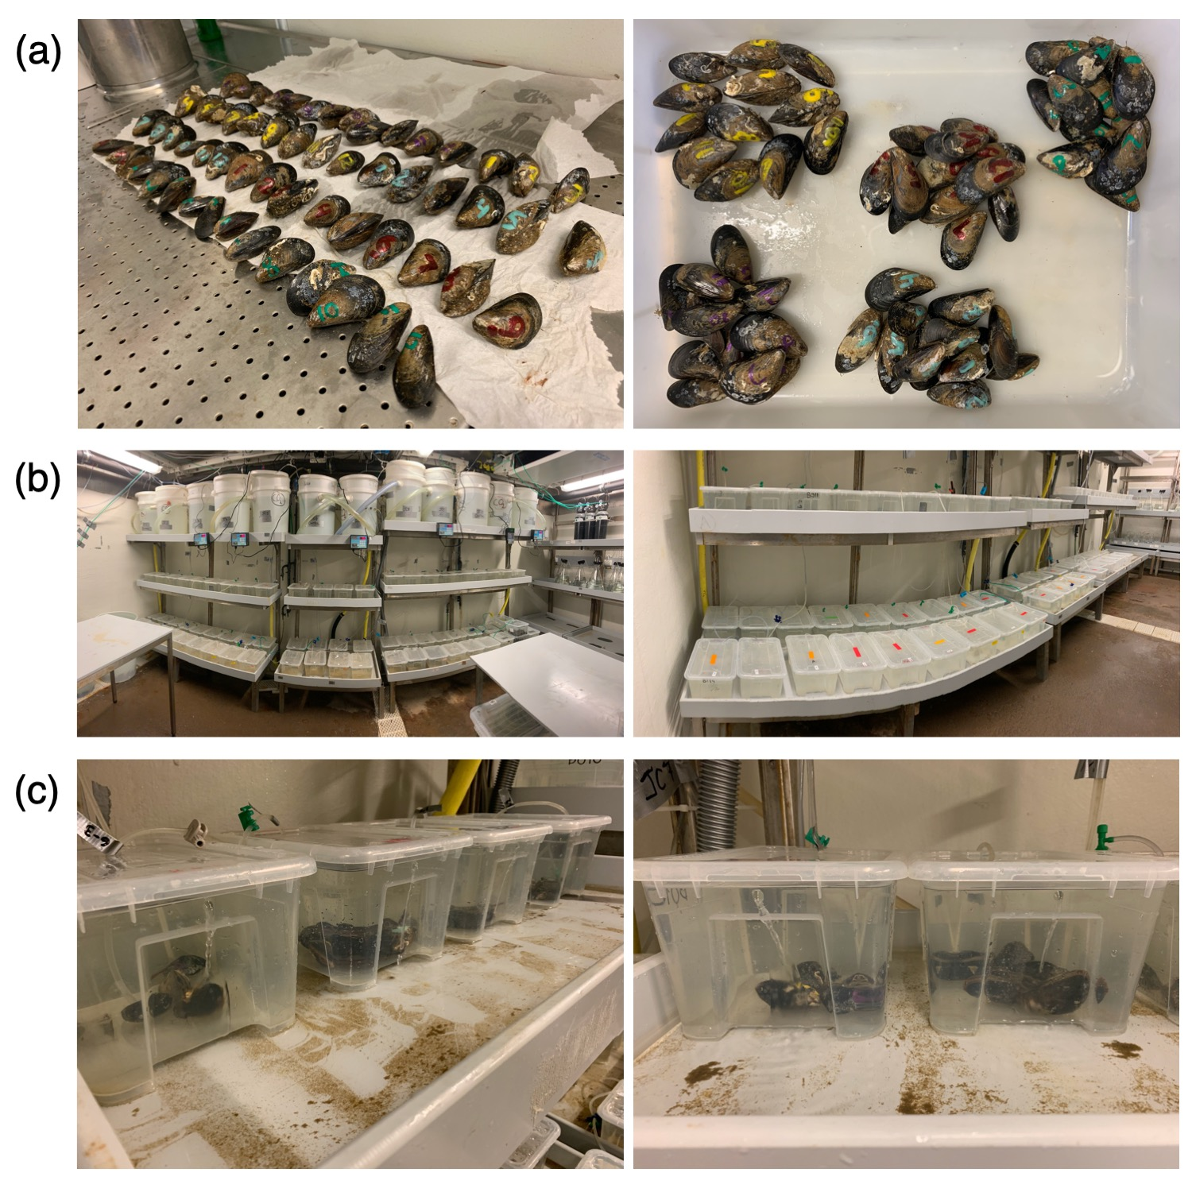

Figure S1. Images of the experimental animals and system. (a) Individual mussels for the large size class. (b) Experimental set-up as viewed before the experiment was initiated. Large buckets on top are the header tanks (N = 3 per pH_{T}×temperature treatment); smaller containers on shelves below the headers (i.e., right panel) are the exposure tanks (n = 2 per header, one for the large and one for the small size class; n = 3 per size class× pH_{T}×temperature treatment). Extra exposure tanks in photo (there are a total of 60 replicate tanks in the photo) were used for a separate experiment (c) Mussels in their exposure tanks (n = 5 mussels per exposure tank; n = 15 individuals per size class×pH_{T}×temperature treatment).

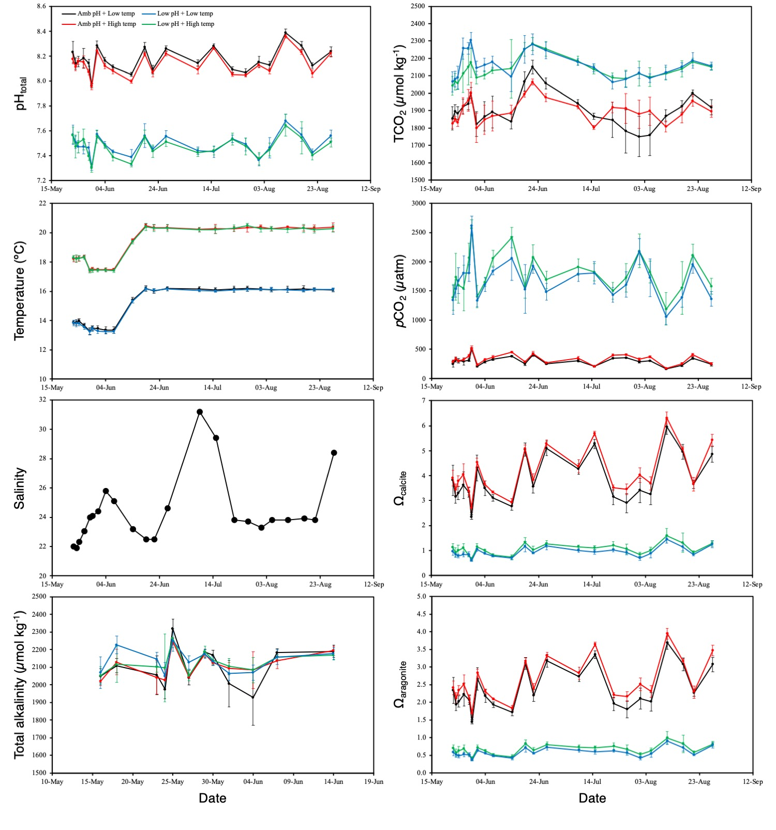
Figure S2. Abiotic seawater parameters in the replicate tanks (i.e., tanks with animals) for each treatment over the course of the experiment. TCO₂, pCO₂, and saturation states were estimated in CO2SYS. Raw data can be found in in Supplementary file 1 (‘Carbonate chemistry’ sheet) and full CO2SYS results are in Supplementary file 2.
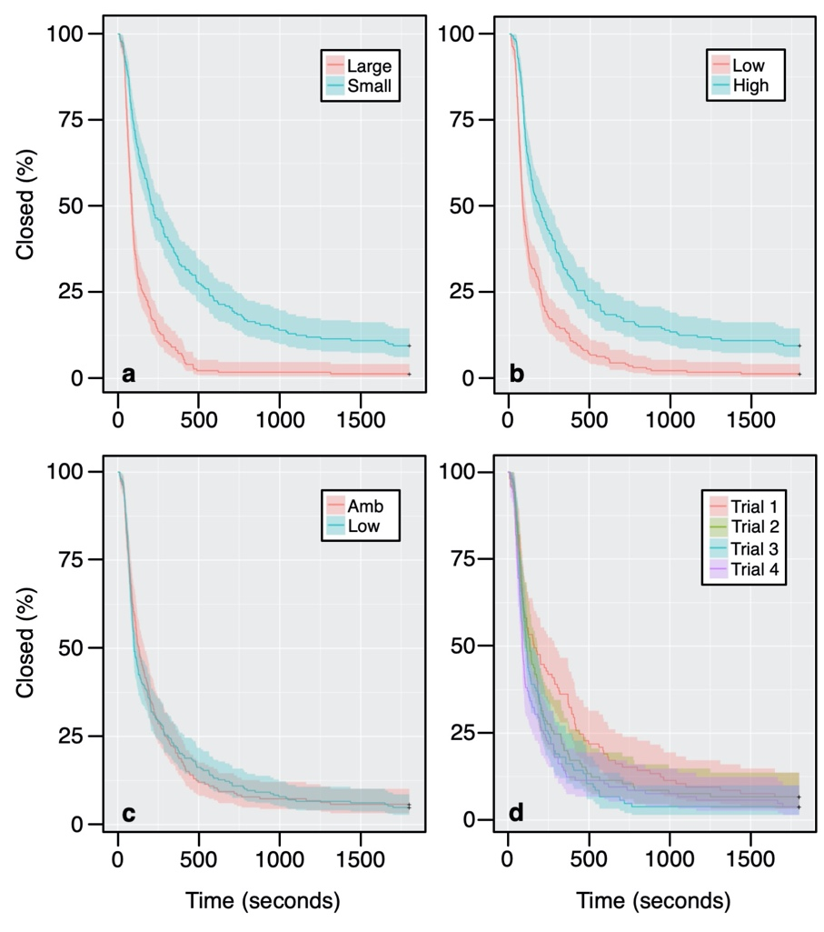
Figure S3. Time-to-event (i.e., time to open) curves for each of the four main factors including size class (a), temperature (b), pH_{T} (c), and trial (d). Curves show the percentage of individuals remaining closed over time based on the Kaplan Meier method; + denote censored observations (i.e., mussels that never opened).

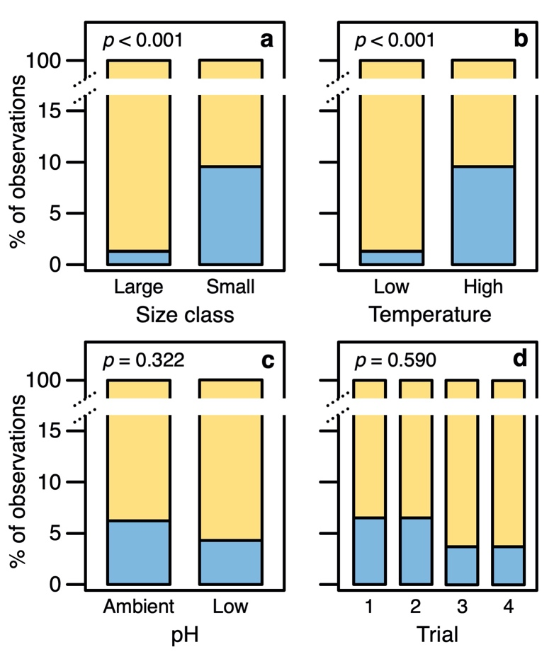
Figure S4. Bar plots for the percentage of observations (trials) in which individuals opened (yellow) or did not open (blue) during a given 30 minute trial for (a) size class (n_{large} = 220; n_{small} = 200); (b) temperature treatment (n_{control} = 220; n_{high} = 200); (c) pH treatment (n_{control} = 192; n_{high} = 228); and (d) trial (n = 105 per trial). Sample sizes are number of individuals. P-values represent results of logistic regression analysis (see Table S6).

Table S1. Results of linear model analyses for differences in shell length (mm) and wet weight (g) between the small and large size classes prior to and at the end of the exposure period. Wet weights and post-exposure shell lengths were log transformed prior to analysis (see Supplementary File 2). Bolded text denotes significant effects. df = degrees of freedom, SS = sum of squares, MS = mean of squares, F = Fisher’s F statistic, P = p-value.

Source of error | df | SS | MS | F-value | P
Pre-exposure
Shell length
Size class | 1 | 8619.8 | 8619.8 | 364.6 | <0.0001
Residuals | 114 | 2694.9 | 23.6
Wet weight
Size class | 1 | 22.9 | 22.9 | 352.07 | <0.0001
Residuals | 114 | 7.4 | 0.1
Post exposure
Shell length
Size class | 1 | 2.3 | 2.3 | 383.0 | <0.0001
Residuals | 114 | 0.7 | 0.0
Wet weight
Size class | 1 | 20.9 | 20.9 | 3388.4 | <0.0001
Residuals | 114 | 6.1 | 0.1

Table S2. Results of generalized linear model analyses for effects of initial size (length or weight), pH_{T}, and temperature on changes in shell length (mm) and wet weight (g) between the beginning and the end of the exposure period. Bolded text denotes significant effects. χ² = chi-squared test statistic, df = degrees of freedom, P = p-value.

Source of error | χ² | df | P
Shell length
Initial length | 20.12 | 1 | <0.0001
pH_{T} | 0.03 | 1 | 0.8637
Temp | 0.76 | 1 | 0.3829
Initial length×pH_{T} | 0.06 | 1 | 0.8004
Initial length×Temp | 2.59 | 1 | 0.1073
pH_{T}×Temp | 0.16 | 1 | 0.6912
Initial length×pH_{T}×Temp | 0.57 | 1 | 0.4518
Wet weight
Initial weight | 35.90 | 1 | <0.0001
pH_{T} | 2.85 | 1 | 0.0913
Temp | 1.69 | 1 | 0.1933
Initial weight×pH_{T} | 0.03 | 1 | 0.8716
Initial weight×Temp | 0.15 | 1 | 0.6997
pH_{T}×Temp | 0.23 | 1 | 0.8716
Initial weight×pH_{T}×Temp | 0.34 | 1 | 0.5589

Table S3. Results of Cox mixed effects regression analysis for the effects of size class, pH_{T}, temperature, and trial on startle response time. Bolded text denotes significant effects. df = degrees of freedom, D df = denominator degrees of freedom, χ² = Chi-squared statistic, P = p-value.

Source of error | df | χ² | P
Size class | 1 | 34.56 | <0.0001
pH_{T} | 1 | 1.30 | 0.2540
Temp | 1 | 20.52 | <0.0001
Trial | 3 | 35.37 | <0.0001
Size class×pH_{T} | 1 | 1.55 | 0.2130
Size class×Temp | 1 | 1.11 | 0.2917
pH_{T}×Temp | 1 | 1.32 | 0.2512
Size class×Trial | 3 | 3.25 | 0.3546
pH_{T}×Trial | 3 | 3.82 | 0.2820
Temp×Trial | 3 | 1.42 | 0.7016
Size class×pH_{T}×Temp | 1 | 3.71 | 0.0540
Size class×pH_{T}×Trial | 3 | 4.07 | 0.2545
Size class×Temp×Trial | 3 | 4.81 | 0.1865
pH_{T}×Temp×Trial | 3 | 2.02 | 0.5687
Size class×pH_{T}×Temp×Trial | 3 | 3,43 | 0.3302

Table S4. Tukey HSD results for pairwise comparisons of trials for the main effect of trial in Table S2. Estimate = effect size estimate, SE = standard error, z-value = z statistic, P = p-value.

Trial pairing | Estimate | SE | z-value | P
1–2 | 0.9794 | 0.4508 | 2.173 | 0.1305
1–3 | 1.4173 | 0.4218 | 3.360 | 0.0045
1–4 | 2.2380 | 0.4489 | 4.986 | <0.0001
2–3 | 0.4378 | 0.4651 | 0.941 | 0.7820
2–4 | 1.2585 | 0.4721 | 2.666 | 0.0381
3–4 | 0.8207 | 0.4239 | 1.936 | 0.2122

Table S5. Results of linear mixed effects model analysis for the effects of size class, pH_{T}, temperature, and trial on startle response time coefficient of variation. Response variable data were log transformed prior to analysis. Bolded text denotes significant effects. SS = sum of squares, MS = mean of squares, N df = numerator degrees of freedom, D df = denominator degrees of freedom, F = Fisher’s F statistic, P = p-value.

Source of error | SS | MS | N df | D df | F | P
Size class | 2.30 | 2.30 | 1 | 15.84 | 6.54 | 0.0212
pH_{T} | 0.28 | 0.28 | 1 | 15.84 | 0.80 | 0.3859
Temp | 0.05 | 0.05 | 1 | 15.84 | 0.14 | 0.7155
Size class×pH_{T} | 0.45 | 0.45 | 1 | 15.84 | 1.29 | 0.2733
Size class×Temp | 0.19 | 0.19 | 1 | 15.84 | 0.55 | 0.4692
pH_{T}×Temp | 0.63 | 0.63 | 1 | 15.84 | 1.80 | 0.1991
Size class×pH_{T}×Temp | 0.10 | 0.10 | 1 | 15.84 | 0.28 | 0.6026

Table S6. Results of logistic regression analysis for the effects of size class, pH_{T}, temperature, and trial on individuals that either opened or closed during a given trial. Bolded text denotes significant effects. χ² = chi-squared test statistic, df = degrees of freedom, P = p-value.

Source of error | χ² | df | P
Size class | 15.928 | 1 | <0.0001
pH_{T} | 0.981 | 1 | 0.3220
Temp | 16.578 | 1 | <0.0001
Trial | 1.916 | 3 | 0.5901
Size class×pH_{T} | 0.720 | 1 | 0.3962
Size class×Temp | 0.907 | 1 | 0.3409
pH_{T}×Temp | 3.299 | 1 | 0.0693
Size class×Trial | 2.120 | 3 | 0.5479
pH_{T}×Trial | 1.433 | 3 | 0.6978
Temp×Trial | 1.900 | 3 | 0.5934
Size class×pH_{T}×Temp | <0.001 | 1 | >0.9999
Size class×pH_{T}×Trial | 2.658 | 3 | 0.4474
Size class×Temp×Trial | <0.001 | 3 | >0.9999
pH_{T}×Temp×Trial | <0.001 | 3 | >0.9999
Size class×pH_{T}×Temp×Trial | <0.001 | 3 | >0.9999

