Do the ages of parents or helpers affect offspring fitness in a cooperatively breeding bird?

Eve B. Cooper*, Timothée Bonnet, Andrew Cockburn, Loeske E.B. Kruuk
Research School of Biology, Australian National University, Canberra 2601
*corresponding author email: eve.cooper@anu.edu.au

Abstract
Age-related changes in either the phenotypes or genotypes of care-givers can impact juvenile performance. However, rarely in wild populations have germline and non-germline transgenerational effects of ageing been separately quantified. In cooperatively breeding animals, in addition to parental ages, the age of ‘helpers’ attending the nest may also impact juvenile performance. Using a wild population of superb fairy-wrens (Malurus cyaneus), we investigated the effects of maternal, paternal, and helper ages on three measures of offspring performance: weight as a nestling, juvenile survival, and recruitment to the breeding population, using up to 4538 offspring over 30 cohorts. A mother’s age at conception negatively affected her offspring’s performance, but mothers with a longer total lifespan had offspring with higher juvenile survival. We distinguished the effects of paternal germline versus paternal environment (for offspring sired extra-pair) as well as the combined effect of paternal germline and environment (for offspring sired within-pair). Neither the ages of the genetic or the cuckolded social father impacted extra-pair offspring performance, however, for offspring sired within-pair, there was a positive effect of paternal age on the juvenile survival. Offspring performance increased most strongly and consistently with the average age of helpers. Our analyses thus revealed multiple associations between offspring fitness components and the ages of the adults around them. These associations appear to be primarily driven by age-related environmental effects, rather than age-related changes in germline.

Introduction
Identifying how parents influence the fitness of their offspring is central to understanding evolution by natural selection. In iteroparous animals, the age of parents can exert effects on offspring either because of changes with age in the parental germline, or the environment parents provide [1–3]. Negative effects of the age of human parents on offspring fitness have been recognized for over 100 years [4], and these deleterious effects are increasingly observed across the animal kingdom [1,5–8]. These negative parental age effects are typically attributed to age-related germline changes, such as de novo mutations and epigenetic changes that occur over time [9–11]. However, the environment that offspring experience can also vary with parental age, with changes in parental care or in the environment shared by parents and offspring potentially having substantial effects on offspring performance. For example, physiological senescence of parents could result in poorer provisioning with increasing age [3,12]. Alternatively, improvement of parental caring ability through experience, or accumulation of resources, could result in increases in provision of care with parental age [13–15]. Inferring the direction of causation of changes with parental age is also notoriously difficult, as for example when favorable environmental conditions result in both longer-lived parents and higher offspring performance without there being any underlying causal association between parental age and offspring performance. Finally, the different germline and environmental components of parental age effects may also not be mutually exclusive: for example there could be germline-level deterioration with age co-occurring with age-related improvements in the effectiveness of parental care.
In wild populations, the relative importance of these multiple different components of parental age effects are especially poorly understood. Most previous research has either isolated germline effects, or quantified combined germline and environmental effects [3]. To our knowledge, only one study to date has differentiated between germline and environmental parental age effects within the same population. Using cross-fostering experiments in a wild population of house sparrows (Passer domesticus), an important study by Schroeder et al. [2] found negative effects of the age of the genetic parents on chick fitness, but no effects of the age of the rearing parents. However, a cross-fostering manipulation necessarily removes potentially interesting aspects of natural variation in mating success and rearing ability. In particular, it removes any potential role of sexual selection in the natural breeding dynamics, as females are not raising extra-pair chicks from sires they themselves chose [16,17]. Germline changes may result in some males producing offspring of lower quality as they age. However, such senescence is likely to vary between males [18,19]. If female choice discriminates against senescent males so only older males that do not exhibit senescence are able to mate, negative effects of male germline senescence may not be apparent in natural conditions [20]. This may explain the paradox that females often demonstrate a preference for older sires, despite the evidence for negative effects of paternal germline [21,22]. It is therefore also useful to investigate germline and environmental paternal age effects observationally, without impeding any potential role of sexual selection. This can be done by using observational data on a population with biparental care of offspring, but where females are often unfaithful to their social mate – such that some but not all offspring will be cared for by an unrelated male. In such systems, extra-pair mating allows the germline and environmental effects of paternal ages to be separated.
In cooperative breeders, it is not only the ages of the parents which may influence offspring fitness. Ages of the group members that act as helpers in the rearing of offspring may also potentially be of importance. The presence [23,24], number [25,26], sex [27,28], behavior [29,30], and relatedness [31] of helpers can all impact the fitness of the young. There is also evidence from several species that helpers become more effective in provisioning young with increased experience. For example, in brown jays (Psilorhinus morio) , purple gallinules (Porphyrula martinica) and El Oro parakeets (Pyrrhura orcesi), older or more experienced helpers feed chicks more frequently [32–34], and in white-winged choughs (Corcorax melanorhamphos) and apostlebirds (Struthidea cinerea), older helpers spend more time incubating chicks [35,36]. However, despite the evidence that the presence of helpers can have important influences on offspring fitness, and the above evidence that helper behavior towards juveniles may change with their age, we are not aware of any study to date that has explicitly tested the impact of helper age on fitness-related traits of offspring.
The gaps in our understanding of both parental and helper age effects in wild populations are likely a consequence of the difficulties associated with investigating the effects of care-giver age on fitness. Longitudinal tracking of individuals is typically required so that both parents and helpers can be accurately aged. Additionally, models of age-related effects are at risk of being biased by ‘selective disappearance’ if the lifespan of individuals is correlated with other aspects of individual quality [37,38], in particular due to variation in environmental conditions. For example, lower-quality territories may result in lower survival of adults (whose average age of reproduction is then lower), generating an association between parental age and offspring performance. This selective disappearance can be modelled by including parental longevity as a covariate in models of offspring performance [38], but doing so obviously requires knowledge of the entire parental life-history. Lastly, offspring must also be tracked so that metrics of their fitness can be measured, and genetic testing of both offspring and adult males in the population is necessary to assign extra-group parentage.
The superb fairy-wren (Malurus cyaneus) offers an excellent system with which to investigate both germline and environmental effects of parental age, as well as effects of helper age. The superb fairy-wren (hereafter ‘fairy-wren’) is a cooperatively breeding passerine endemic to south-eastern Australia. Fairy-wrens occupy year-round territories, living in groups composed of a breeding female, a dominant male, and between zero and five sexually-mature male helpers [39]. The breeding female and the dominant male are aided in provisioning young by helpers residing on their territory. Once they reach independence, juvenile females disperse from their natal territory to obtain a breeding territory whereas juvenile males will often remain on their natal territory, acting as helpers in subsequent breeding seasons [39,40]. Helpers typically queue by age to reach the dominant male position [40], so the average age of helpers in a group is younger than that of the dominant male (figure 1). Despite the socially monogamous relationship between the dominant female and male on a territory, superb fairy-wrens have high rates of infidelity: 61% of chicks are sired by an extra-pair male that almost always (95%) resides on a different territory [41].
In this study, we aimed to quantify the effects of maternal, paternal and helper ages on three components of chick fitness in a wild population of fairy-wrens: (i) weight as a nestling (known to be under positive selection) [42], (ii) survival to foraging independence, and (iii) recruitment of male offspring into the breeding population in the year after hatching. We included the lifespan of each parent in our models as a test for selective disappearance of parents of differing performance. Using the naturally occurring instances of extra-pair matings, we were able to separate and quantify age-related effects of both paternal germline and paternal environment without impeding any influence sexual selection may have on these paternal age effects in a natural setting.
Methods
Study Population
Our study population of superb fairy-wrens is located in and around the Australian National Botanic Gardens, Canberra, Australia (35°16 S, 149°06 E) and has been intensively monitored since 1988 [39,43]. The study site, approximately 60 hectares in area, contains 40-90 territories encompassing between 120-230 year-round resident adults. In this study, we used data from the years 1988-2018 (30 cohorts spanning 31 years). Shortly after hatching, individuals are colour-banded, and a blood sample taken to assign parentage using SNP genotyping [44]. The reproduction and survival of adults is reliably tracked until death because adults rarely disperse further than one territory away from their home territory [39,40].
Males are fertile and can sire offspring from age one, as either the dominant male on the territory (‘within-pair sire’), or as an extra-pair sire (figure 1). Helpers queue for the dominant male breeding position based on age: when the dominant male dies, the eldest of any helpers on the territory will assume the dominant position [40]. Helpers can either be the sons of the dominant female on the territory, or be unrelated to the dominant female if their mother has died or dispersed and been replaced by another female [39,40]. The number of related vs unrelated helpers on a territory indicates slightly different information about that territory. The presence of unrelated helpers is indicative of a high quality territory, since it indicates that their survival as both chicks and adult males is relatively high. The presence of related helpers would similarly indicate high chick and adult survival, but it could also be indicative of a high quality mother who is capable of rearing offspring that survive beyond maturity. Recent evidence also suggests that female mating patterns are affected in different ways by the presence of related vs unrelated helpers (unpublished). Because of this slightly different information conveyed by the numbers of related and unrelated helpers, we fitted each as its own variable (rather than the more usual approach of considering the total number of helpers of any type, e.g. [41]). Since having more than two related or unrelated helpers on a territory is rare (in this dataset only 2% and 1% of chicks had more than two related and unrelated helpers, respectively), we included the number of helpers as a three-level factor of ‘none’, ‘one’ or ‘two or more’ for unrelated and related helpers separately.
Dataset
We used data from breeding events spanning the 1988 – 2018 Breeding seasons. Our data set comprised chicks with the following information: hatch date; the identities, ages and lifespans of the mother, the genetic father, and, if different, the cuckolded social father, and presence and ages of any helpers. Due to age-related queueing for dominance, the dominant female was occasionally socially paired with her son as the dominant male on a territory. In these situations, inbreeding is avoided and all offspring in the brood are extra-pair [41]. Since this results in a social father who is not the genetic father of the offspring but is still genetically related to them (as half or full siblings), separating genetic from environmental effects was more difficult and so we excluded any chicks in such broods (141 chicks, 3% of initial sample). We also excluded chicks whose genetic father was a helper on their natal territory since again these individuals share both genes and environment with the chicks, even though the chicks are extra-pair (165 chicks, 3% of initial sample). The final sample therefore comprised 4538 chicks from 1691 clutches over 30 cohorts, with 537 mothers, 562 genetic fathers and 482 cuckolded social fathers. The identities of the social father and the genetic father are the same for chicks sired within-pair (55% of the sample). Chicks were sexed using PCR-methods [45] on DNA in blood sampled from nestlings. There were approximately equal numbers of males (2369) and females (2153), and 25 chicks were of unknown sex.
Statistical Analysis
We measured effects of adult ages on offspring performance using three mixed effects models which tested the effects of maternal age, within-pair father age (for within-pair chicks), cuckolded social father age (for extra-pair chicks), extra-pair genetic father age (for extra-pair chicks), and mean helper age (for chicks with helpers) on each fitness-related trait in the chicks (nestling weight, survival to independence, and recruitment). Recruitment (i.e. survival to adult breeding age, at one) could only be accurately assessed for male offspring due to the juvenile dispersal of females (see recruitment below). In order to compare the separate effects of age of paternal germline and paternal environment (using the genetic father and the social father of extra-pair chicks) as well as the combined age effects of paternal germline and environment (fathers of within-pair chicks), we included all three ‘types’ of father ages in each model. To do this, we created a dummy variable (0 = within-pair chick, 1 = extra-pair chick) and fitted an interaction between this dummy variable and cuckolded social father age and extra-pair genetic father age, so only extra-pair chicks contributed to the estimates of these terms. Similarly, we fitted the term within-pair father age in an interaction with the reverse dummy variable (0 = extra-pair chick, 1 = within-pair chick), so that only within-pair chicks contributed to the estimate of this term. The model structure that results from this dummy variable method is described further in Box 1.
For 60% of chicks, the dominants were assisted by at least one helper, while the remaining 40% had no helpers. In order to include both these groups of chicks within each model, we used an analogous method to that used for the paternal age terms, fitting an interaction between the term mean helper age and a dummy variable (0 = no helpers, 1 = helper(s) present; box 1). Mean helper age was calculated as the average age of all the helper(s) residing on a chick’s natal territory at the time of their hatching. In order to separate any effects simply due to the presence of helpers and not their age, we also controlled for the number of unrelated helper(s) (indicative of a higher quality territory) and the number of related helper(s) (indicative of a higher quality territory and/or a higher quality mother) [46], each as a three level categorical effect (0, 1, 2+).
Box 1
Each fitness trait was modelled using a mixed effects regression model, described below:
$$f_{i}=β_{0}+EP+EP.\left(β | | germ.{age}_{Fgen}+β_{env}.{age}_{Fsoc}\right){+℘.β}_{germ∧env}.{age}_{Fgen}{+H+H.β}_{help}.{age}_{help}+\left(othereffects\right)$$
where is the fitness metric of an individual chick (i). EP is a dummy term of 1 for a chick sired extra-pair and 0 for a chick sired within-pair. The age of the genetic father is given by age_{Fgen} (for both within- and extra-pair sired chicks) and the age of the cuckolded social father by age_{Fsoc} (for extra-pair sired chicks only).The dummy term WP is the inverse of EP, where a value of 1 denotes a chick sired within-pair, and a value of 0 denotes a chick sired extra-pair. As a result, the coefficients for extra-pair genetic father age ) and cuckolded social father age (are only estimated for extra-pair chicks, and the coefficient for within-pair father age is only estimated for within-pair chicks. An analogous dummy variable is used to estimate the mean helper age coefficient only using chicks for which helper(s) were present at the nest. The estimates produced for the lower-level (non-interacting) dummy variables EP and are not interpretable given the higher order interactions containing these terms. All additional fixed effects and random effects included in each model are described under Statistical Analysis.

We included the lifespans of the mother and each type of father in order to control for and quantify potential ‘selective disappearance’ [38]: a positive association between, for example, maternal lifespan and chick survival would indicate that mothers with relatively longer lifespans also produced chicks with average higher survival (and that mothers with lower chick survival were selectively disappearing from the sample). As each parent has a single measure for lifespan, but may have produced offspring at multiple ages across their lifespan, fitting lifespan and parental ages therefore effectively models between- versus within-individual differences [38]. Julian incubation date (the number of days counted from 1 January of the calendar year of the cohort) was included in order to control for any potential changes in chick performance across the breeding season [47,48]. Julian incubation date was z-transformed (to zero mean and unit standard deviation) in all models. Random effects of each adult ID (mother, social father, and genetic father) were included to control for the non-independence of repeated measures from the same adults across chicks. Cohort was also included as a 30-level random effect to control for any potential heterogeneity between years.
The three offspring fitness-related traits analyzed were nestling weight, juvenile survival to independence, and male survival to recruitment, defined as follows:
- Nestling weight: Nestling weight was measured in grams when nestlings were briefly removed from their nest to be banded and bled for SNP genotyping. The majority of weights were measured 7 days after hatching, but sometimes one or two day(s) earlier or later. To control for this, the age of the chick (in days) at weighing was included in this model as a covariate. We also fitted a two-level factor ‘pre-1992’, indicating whether the cohort was before 1992 or not. This term controlled for a change in protocol in the time of day chicks were weighed from this year forward [47]. We included clutch size as a covariate to control for any potential reduction in chick weight resultant from a larger number of chicks being present in the nest. We excluded 226 chicks from this analysis for which weight was not measured during the nestling phase or measurements were deemed unreliable. This resulted in a sample size of 4310 chicks. Weight followed a Normal distribution and so a linear model with Gaussian error structure was used.
- Juvenile Survival to independence: Early-life survival was measured from the late nestling stage (approximately 7 days old, when chicks are banded and blood sampled to assign parentage), until 4 weeks after fledging (which occurs at 13 days, so in total, a period of 41 days from hatching); this is the earliest age at which chicks reach foraging independence from their parents, as indicated by rare dispersal to another territory. Individual survival was denoted by a binary trait, and survival probability was modeled using a Bernoulli distribution (fitted with a logit-link function). The total sample size was 4538 chicks.
- Male Survival to Recruitment: Survival from the late nestling stage to recruitment (measured as being alive at the start of the next year’s breeding season) was only estimated in males. Recruitment into the breeding population could only be assessed in males, since for females death after the nestling stage cannot be distinguished from emigration from the study area during their first year of life. In contrast, males are highly philopatric and easily tracked during all life stages, as 72% of males remain on their natal territory their entire life, and males that do disperse move to an immediately neighboring territory 95% of the time [40]. After excluding males for which emigration or death was uncertain due to living close to the study area border, 2252 males were used in this analysis. Recruitment probability was again modeled using a Bernoulli distribution (fitted with a logit-link function). For this model, social father was not included as a random effect as doing so led to non-convergence of the random effect estimates given the relatively smaller sample size.
Parental age effects sometimes vary with offspring sex [1,2,5,7,49], with mothers or fathers influencing the fitness of one sex more than that of the other. In order to test for this, we reran the weight and juvenile survival models including an additional interaction between each parental age term and chick sex (excluding the 25 chicks of unknown sex). The differences between the sexes were minimal and did not change interpretation of any results (supplementary material S1), and so from herein results refer to the base models without fitting offspring sex or its interaction with parental ages.
All statistical analyses were fitted in R version 3.5.0 [50] using the lme4 package for mixed models [51].
Results
There were some significant effects related to the ages of some care-givers for both chick survival to independence and male recruitment, but there was no evidence of care-giver age effects on chick weight (supplementary S2). There were strong effects of variables that controlled for differences in chicks that were not directly related to the ages of parents or helpers. Incubation date was positively associated with all three metrics of chick performance, as environmental conditions improve through the first half of the breeding season (table 1, S2.1). The age at weighing and pre-1992 (see Methods) had strong effects on chick weight while there was no evidence of clutch size being associated with chick weight (table S2.1). The extra-pair dummy variable was significant in the model of chick weight, however this does not indicate that extra-pair chicks necessarily weigh more than within-pair chicks, since the dummy variable is included in a higher-level interaction. In comparison to having no related helpers, there was a marginally positive effect of having two or more related helpers on chick weight (table S2.1). There was no support for any other effects of helper presence. Below we describe the rest of our results, as they apply to maternal, paternal and helper effects on chick survival to independence and male recruitment into the breeding population.
Maternal Effects
There was a significant positive association between maternal lifespan and chick survival to independence (table 1; Figure 2; log-odds CI 0.010 - 0.163; p = 0.03). Conversely, there was evidence of a (non-significant) negative association between maternal age and chick survival to independence. Although the maternal age effect was marginally non-significant, the effect size was of a similar magnitude (in the opposing direction) to the maternal lifespan effect (table 1; log-odds CI -0.157 – 0.003; p = 0.06). This indicates that chicks from mothers with longer lifespans had a higher probability of surviving to independence, but chicks hatched in their mother’s late-life had lower survival than those hatched by the same mother at an earlier stage of her life. For example, for a mother at age one the model predicts only a 37% chance of chick survival when the mother’s lifespan was one year, but a 54% chance of survival when the mother’s lifespan was nine years. However, once the mother with a lifespan of nine years reaches the age of nine her predicted probability of chick survival has declined to 38%. For male recruitment, the maternal age and lifespan effects were in the same direction and of similar magnitude to these effects on juvenile survival, but were non-significant (table 1). This is likely owing to the smaller sample size and thus decreased certainty in the effect estimates for male recruitment.
Since only those mothers with longer lifespans are necessarily alive to produce chicks at later ages, the counteracting effects of maternal age and maternal lifespan results in little apparent change in chick survival with increasing maternal lifespans in the raw data. For this reason, in order to illustrate the effect of maternal lifespan (figure 2), we separated the raw data into two maternal age categories, mothers of one to three years of age (with three years being the average lifespan of adult female fairy-wrens), and mothers of four years of age and above (up to the maximum recorded lifespan of ten years). When plotted separately for each of the two maternal age groups, the mean chick survival probability for each maternal lifespan illustrates that the positive effect of maternal lifespan is primarily driven by differences between the mothers occurring at relatively young ages (age 1-3), and that, for long-lived mothers, chick survival is lower in late life (ages 4 and above; figure 2).
Paternal Effects
For chicks sired within-pair, higher paternal age was weakly associated with increased juvenile survival probability (table 1; figure 3; log-odds CI 0.002 - 0.188; p = 0.04), but not with either weight or recruitment probability (table 1, S2.1). The ‘paternal age’ effects on these chicks represents the combined age-related effects of paternal germline and paternal environment. Surprisingly, despite this positive association between survival and within-pair age of the father, for extra-pair chicks there was no clear effect of either their genetic father’s age (representing paternal germline) or their social father’s age (representing paternal environment).
Helper Effects
Chicks with older helpers were more likely to survive to independence, and, for males, were also more likely to be recruited into the breeding population (table 1; figure 4). It is worth noting that the raw-data mean values for the associations between mean helper age and chick performance (filled circles, figure 4) suggest non-linear relationships with chick juvenile survival and recruitment into the breeding population. These measures of chick performance are relatively high when mean helper age is one, followed by a drop to low but increasing values beyond the mean age of one (figure 4). There is a bias towards younger helpers being primarily related, rather than unrelated to the chicks, since younger helpers are more likely to have their mother still alive on their territory. We explored the raw data to see if this bias towards a higher proportion of related helpers at younger mean helper ages could be contributing to the surprisingly high average effect of one-year-old helpers. However, both related and unrelated helpers showed similar age-specific averages in their associations with chick performance, indicating that this was not the case (supplementary material S3).

Table 1. Effects on (A) chick survival to independence (four weeks post-fledging), and, (B) male recruitment probability (survival to the breeding season after their hatching), each from a generalized linear mixed-effects model (Bernoulli distribution, logit-link function). Sample size across 30 years for survival to independence (A) is 4538 individual chicks across 1771 nests, and for male recruitment (B) is 2252 individual males across 1394 nests. Both chicks sired extra-pair and within-pair are included in each model. Interactions with dummy variables (0 or 1) are employed so that only extra-pair chicks contribute to estimates related to the extra-pair genetic fathers and cuckolded social fathers, while only within-pair chicks contribute to estimates related to within-pair fathers. This dummy variable method is also employed so that only chicks with helpers on the territory contribute to the estimate of mean helper age.
 | (A) Survival to Independence |  |  | (B) Male Recruitment
Predictors | Log-Odds (95% CI) |  | p-value | Log-Odds (95% CI) | p-value
Intercept | -1.948 (-2.442, -1.454) |  | <0.001 | -5.462 (-6.399, -4.525) | <0.001
Incubation Date (Days Past Jan. 1) | 3.292 (2.819, 3.764) |  | <0.001 | 14.534 (12.891, 16.177) | <0.001
Extra-Pair Dummy [yes] | 0.335 (-0.165, 0.835) |  | 0.189 | 0.295 (-0.643, 1.233) | 0.537
- Maternal age effects
Mother Age | -0.077 (-0.157, 0.003) |  | 0.059 | -0.067 (-0.196, 0.063) | 0.314
Mother Lifespan | 0.086 (0.010, 0.163) |  | 0.028 | 0.103 (-0.009, 0.215) | 0.071
- Paternal age effects
Within-pair Father Age | 0.095 (0.002, 0.188) |  | 0.044 | 0.121 (-0.039, 0.281) | 0.138
Within-pair Father Lifespan | -0.039 (-0.123, 0.045) |  | 0.361 | -0.085 (-0.224, 0.053) | 0.227
Cuckolded Social Father Age | -0.022 (-0.103, 0.059) |  | 0.597 | -0.086 (-0.229, 0.057) | 0.239
Cuckolded Social Father Lifespan | -0.035 (-0.111, 0.040) |  | 0.361 | -0.029 (-0.142, 0.084) | 0.619
Extra-pair Genetic Father Age | -0.053 (-0.132, 0.026) |  | 0.185 | -0.119 (-0.264, 0.026) | 0.108
Extra-pair Genetic Father Lifespan | 0.026 (-0.044, 0.097) |  | 0.466 | 0.081 (-0.053, 0.215) | 0.238
- Helper age effects
Related Helper Presence [1] | -0.123 (-0.421, 0.175) |  | 0.418 | -0.145 (-0.680, 0.389) | 0.594
Related Helper Presence [2+] | -0.208 (-0.581, 0.165) |  | 0.275 | 0.017 (-0.648, 0.683) | 0.959
Unrelated Helper Presence [1] | -0.371 (-0.745, 0.003) |  | 0.052 | -0.436 (-1.069, 0.196) | 0.177
Unrelated Helper Presence [2+] | -0.362 (-0.866, 0.142) |  | 0.159 | -0.430 (-1.266, 0.405) | 0.313
Mean Helper Age | 0.214 (0.065, 0.363) |  | 0.005 | 0.443 (0.179, 0.706) | 0.001
Note: The models each include random effects of mother ID (chick survival: n = 537, variance = 0.855; male recruitment: n = 492, variance = 1.298), genetic father ID (chick survival: n = 570, variance = 0.145; male recruitment: n = 497, variance = 1.158), (cuckolded) social father ID (chick survival: n = 490, variance = 0.772), and cohort (chick survival: n= 30, variance = 0.095; male recruitment: n= 30, variance = 0.092). Cuckolded social father ID was not included as a random effect for male recruitment as there was inadequate statistical power to estimate this term.

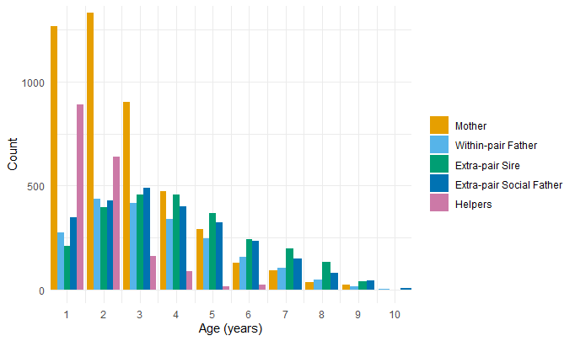
Figure 1 The age distribution of maternal, paternal and mean helper ages for all 4538 chicks used in analyses. There are a larger number of maternal ages overall than there are for within-pair fathers, extra-pair sires, extra-pair (cuckolded) social fathers or helpers because there is a maternal age associated with each chick (each data point) but there are only within-pair paternal ages associated with chicks sired within-pair (55% of sample), only extra-pair sire and social father ages associated with chicks sired extra-pair (45% of sample), and only mean helper ages associated with chicks with at least one helper on their territory (40% of sample). Mean helper ages are rounded to the nearest integer for illustrative purposes.

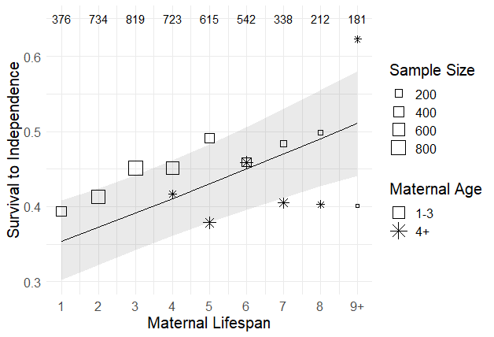
Figure 2 The effect of maternal lifespan (in years) on the probability of chick survival to independence, with the shaded area representing the 95% confidence interval. Raw-data mean values are seperated into two categories by maternal age at the time of chick hatching in order to illustrate that the positive effect of maternal lifespan is primarily driven by chicks raised by long-lived mothers during their early life. The size of the squares and stars is log proportional to the number of data points for that maternal lifespan within that age group, and the total sample sizes for each maternal lifespan (number of chicks) are included across the top of the graph.

Figure 3 The effect of extra-pair genetic (circles, light solid line), extra-pair social (triangles, light dashed line), and within-pair father (squares, dark dashed line) ages on the probability of chick survival to independence. Lines represent model predictions and the shaded areas are the 95% confidence intervals. Points represent raw mean values. The sample sizes (number of chicks) for all three father types together are included across the top of the graph.

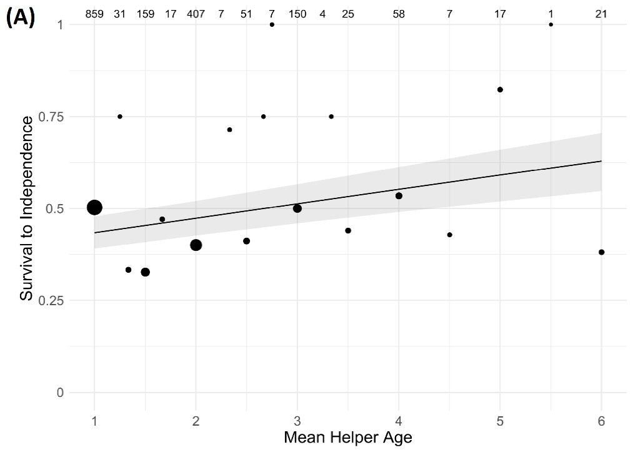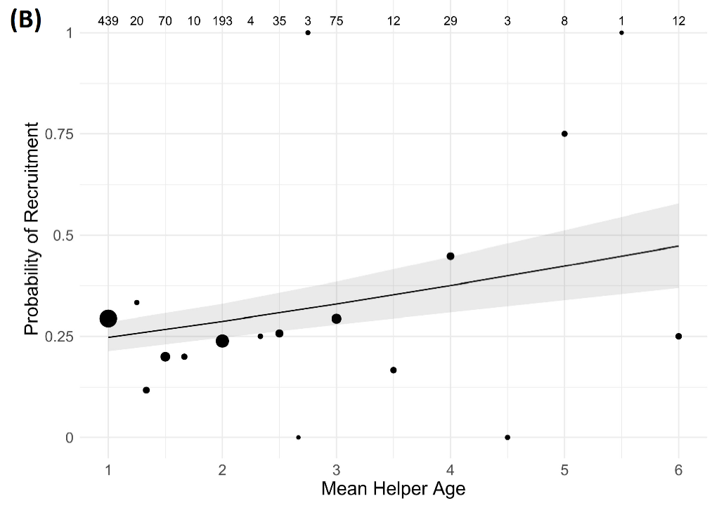
Figure 4 The effect of the mean age of helper(s) in a group on the probability of (a) chick survival to independence and (b) male recruitment. Lines represent model predictions and shaded areas are the 95% confidence intervals. Circles represent the raw-data mean values. The size of each circle is log proportional to the number of data points for that mean helper age. Sample sizes (number of chicks) are included across the top of the graph. (Note that mean helper age was not necessarily an integer value because groups could contain 1-5 helpers.)

Discussion
In this study, we investigated the intergenerational effects of age in the cooperatively breeding superb fairy-wren by testing how maternal, paternal, and helper ages influenced three different components of chick performance. Chicks of mothers that had a longer total lifespan had increased survival to independence, but there was evidence that maternal ageing was concurrently associated with reduced chick survival to independence. Survival to independence and male recruitment probability improved with the mean age of helpers on the natal territory; to our knowledge, this study is the first to demonstrate that the ages of cooperatively breeding helpers are associated with components of offspring fitness. There was evidence of improvement in juvenile survival probability with father age, but surprisingly only for within-pair fathers. This unexpected effect of the age of within-pair fathers could indicate that the complexity of natural and sexual selection pressures impact how intergenerational effects of age are realized in the wild. We discuss each of these results and their potential evolutionary and ecological implications below.
- Maternal Age Effects
There was evidence of maternal age effects on chick survival to independence, but not on nestling weight or male survival to recruitment. Mothers with longer lifespans had chicks with higher survival, irrespective of the age of the mother at the time the chicks were hatched. Conversely, there was a negative association between the maternal age at the time of hatching and chick survival. While the maternal age effect was marginally non-significant (table 1, p = 0.06), the magnitude of the effect was similar to that of maternal lifespan (table 1, mother age log-odds = -0.08, mother lifespan log-odds = 0.09). It is worth noting that the counteracting directionality of these two effects would obscure the association between maternal lifespan and chick survival if data were not longitudinal but were instead from a cross-section of the population. It is only when maternal age is controlled for that we are able to see that, at early ages, mothers who will live longer produce chicks with higher survival (figure 2). The associations between lifespan and chick performance constitute between-individual differences in mothers, which would be recognized as ‘maternal effects’ in a variance-partitioning analysis [52]. Conversely, the effects of mother’s age constitute within-individual change in the effect of a mother on her offspring, in a manner that would not be picked up in an analysis testing simply for differences between mothers. The results thus illustrate both the importance of maternal effects on offspring, but also that they may not be consistent over an individual mother’s lifetime – and hence why it is important to control for both within- and between-individual effects when investigating questions related to ageing.
It is likely that the positive effect of maternal lifespan is due to an association between either individual quality and lifespan, or between territory quality and lifespan. However, if it were an association between territory quality and lifespan, we might expect that extra-pair social father and within-pair father lifespans would also be positively associated with chick survival, which they were not. Thus, it is most likely that mothers that live longer are inherently better ‘quality’ than those living shorter lives, and this allows them to produce chicks with higher survival irrespective of their current age.
The suggestion of a negative effect of maternal age on chick survival to independence indicates that improvements in fairy-wren female fecundity with age are not a result of an increase in the ‘quality’ of chicks produced. Previous work on this population demonstrated that the total number of independent young produced each year by fairy-wren mothers increases considerably for the first three years of life, followed by little change in fecundity in later life [53]. The finding that a smaller proportion of hatched chicks survive to independence at higher maternal ages indicates females must be producing a higher quantity of chicks as they age to compensate for a reduced proportion of chicks surviving. It is likely the earlier breeding start and increased average clutch size associated with female age in this population [53] that drives this increase in the absolute number of independent chicks produced. It is difficult to ascertain the proximate causes of a maternal age effect on chick fitness. Any decline in chick survival with increasing maternal age could be a consequence of deterioration of the maternal germline [54], or non-germline-related aspects of senescence such as deterioration in maternal care [3].

- Paternal Age Effects
Increasing age of the father was associated with higher probability of juvenile survival for chicks sired within-pair, though this was not true for weight or probability of recruitment. There was no effect of the ages of the genetic or the social father on the performance of chicks sired extra-pair. Thus, the mechanism driving the positive effect of father age for within-pair chick survival is not entirely clear. The positive within-pair father age effect is unlikely to be a consequence of germline-level changes with age, for two reasons. First, we saw no effect of the genetic father’s age on extra-pair offspring performance here (figure 3). Second, it has now been shown in at least some other species that sperm DNA damage increases with paternal age [21,55], and that, if there are any effects of sperm age on offspring fitness, these are typically negative [3,56] (see below). We believe it is therefore more likely that the effect of paternal age for within-pair chicks is related to non-germline changes that in some way differ from the effects of social father age for extra-pair chicks.
It is possible that differences between dominant males associated with the extent to which they are cuckolded generate this difference in paternal age effects between within-pair and extra-pair sired chicks. In particular, it is plausible that the degree of cuckoldry a male experiences is negatively correlated with some aspect of his overall ‘quality’, and also with the quality of his offspring. During their fertile period, female fairy-wrens copulate with their social partner soon after they have mated with their preferred extra-group male [39]. The outcome of the resultant sperm competition must influence within-pair siring success [57]. If variation in male quality increases in older age groups, as is predicted by evolutionary theories of senescence [18,19], sperm competition may play a greater role in determining siring success for these older males. Thus, rather than any effect of ageing per se, the apparent improvement in chick performance with within-pair sire age could simply be a consequence of sperm competition biasing the sample of successful older dominant males. In other words, within-pair success at old age would be indicative of a high quality dominant male, who might then produce higher quality offspring. Note that the ‘inheritance’ of quality need not be genetic, but could also reflect correlations driven by shared environments. The raw-data means indicate that the positive effect of within-pair paternal age is driven by males above age five (figure 3), which few males survive to [53], and so the sample size is relatively low in comparison to data on younger fathers (figure 1). Thus, more work on this system will be required to investigate this paternal age effect further. Since our study is the first to attempt to disentangle age effects of both genetic and naturally-occurring ‘foster’ fathers on offspring performance, additional work on other species will also be valuable for assessing the robustness of this result across other systems.
As there was no support for effects of the age of the genetic father of extra-pair chicks in our analyses, there was no evidence of germline deterioration with age in this population. Although sperm has been shown to deteriorate in quality with male age [3,21], the effects of senescent sperm carrying over to influence offspring fitness are contentious. Some studies have found evidence of negative effects of male age on some measures of offspring fitness [2,49,58,59], but many others have not found any such associations [5,7,60,61]. In natural conditions, if senescence rates vary amongst individuals, females may avoid senescent males or their sperm may lose in competition with less senescent males [62]. Similar to how this may contribute to the positive effect of within-pair sire age as discussed above, this could also result in the sample of older males that are successful extra-pair sires being biased towards only high quality males [63,64], which may result in an overall null effect of extra-pair genetic father age. It is interesting to note that, to our knowledge, the studies to date which have found negative effects of paternal age on offspring fitness have all been in situations where both female choice and sperm competition are likely to be limited: either in controlled laboratory experiments or in a cross-fostering experiment where female choice and sperm competition are constrained [1,2,58], in species with high genetic monogamy where female choice and sperm competition play little to no role [49], and in modern-day humans [59] where adaptive female choice and sperm competition are likely to be rendered irrelevant by societal and cultural factors. Female superb fairy-wrens are highly promiscuous [41,65], and female choice and sperm competition may result in a reduction in senescent males being successful sires. Regardless of the mechanism underlying the results presented here, the lack of any negative effects of father age suggests that any female preference for older males is neither adaptive nor maladaptive in the context of offspring early life fitness.

- Effects of Helpers’ Age
We found evidence for positive associations between mean helper age and both survival to independence and male recruitment. There are two non-mutually exclusive mechanisms that could be driving these results. First, it is possible that the effect is driven by helper age per se, whereby helpers become better at providing care to chicks as they gain experience with age. This is plausible as it has been shown in several cooperatively-breeding bird species that the age of helpers is associated with their level of contribution towards chick provisioning and predator defense [32–36]. It has even been argued that learning the skills necessary for effective parental care is a selective force favouring helping behaviour [66–68] and there is evidence in some species that birds with helping experience are superior parents when they gain a breeding position [67].
A non-mutually exclusive but more plausible cause of the effect of helper age is that there is a correlation between helper survival and territory quality, which drives a correlation with offspring performance. Helpers may enjoy increased survival until later ages as a consequence of their natal territory having lower predation risk or greater food availability, which may be associated with the fitness of chicks hatched on this same territory. Since we found no evidence that helper age affects nestling weight, a trait which might be expected to respond strongly to helper provisioning, this suggests predator avoidance is the more likely source of the older helper advantage. Distinguishing cause and effect in associations between helper number and survival has proved notoriously difficult [46,69], and the hitherto uninvestigated association between helper age and offspring survival adds further complexity to that puzzle. However, the weight of evidence in this case does suggest that benefits to chicks associated with older helpers attending the nest may be a consequence of conditions favoring survival rather than the case of the helpers themselves increasing productivity with age.
In contrast to helper age, there were not strong or consistent effects of helper presence on chick performance. When compared with the absence of helpers, there was a marginally significant positive effect of the presence of two or more related helpers on chick weight, but no apparent effects of the presence of only one related helper, or any unrelated helpers (table S1.1). Previous work on the effects of helper presence found consistently positive effects of helpers on chick weight [41,47]. However, these studies did not separate unrelated and related helpers, and did not control for helper age effects, which may explain the difference in results. We found no associations between helper presence and chick survival to independence or male recruitment. Our results suggest that any benefits of the presence of helpers are not passed on to the chicks themselves, despite the fact that helper presence is associated with an increase in territory productivity [46,69].
Conclusions
Our study found evidence that the age of the different adults in an offspring’s early life can influence its fitness-related traits. There were counteracting within-individual (ageing) and between-individual (lifespan) effects associated with mothers, which illustrate the importance of longitudinal measurements in investigating questions related to ageing. The ages of fathers had a positive effect on chick performance, but only for chicks sired within-pair. The lack of effect of social father and genetic father ages for extra-pair sired chicks suggests that the dynamics of sexual selection may play an important role in the evolutionary ecology of intergenerational age effects. Our study is also the first, to our knowledge, to demonstrate that the age of helpers in cooperatively breeding groups is associated with increased chick performance, with increasing helper age improving chick survival to independence and recruitment probabilities. These results suggest the effects of parent and helper ages on the early-life fitness of the next generation appear to be primarily related to environmental changes in superb fairy-wrens. They thus indicate that negative germline effects of parental age may not be ubiquitous.

Acknowledgements
We are grateful to the Australian National Botanic Garden for permission to work at the study site and for logistical support. We also thank the many field assistants who contributed to data collection over the years. Our research was licensed by the Australian National University Animal Experimentation Ethics Committee. We thank Michael Morrissey for helpful advice on modelling. We thank the Australian Research Council for long-term funding of the superb fairy-wren project, of which the most recent grant for the data in this study was DP150100298.

References
1. Priest NK, Mackowiak B, Promislow DELL, Priest NK, Mackowiak B, Promislow DELL. 2002 The role of parental age effects on the evolution of aging. Evolution. 56, 927–935. (doi:10.1111/j.0014-3820.2002.tb01405.x)
2. Schroedera J et al. 2015 Reduced fitness in progeny from old parents in a natural population. Proc. Natl. Acad. Sci. U. S. A. 112, 4021–4025. (doi:10.1073/pnas.1422715112)
3. Lemaître J-F, Gaillard J-M. 2017 Reproductive senescence: new perspectives in the wild. Biol. Rev. 33. (doi:10.1111/brv.12328)
4. Bell AG. 1918 The Duration of Life and Conditions Associated with Longevity: A Study of the Hyde Genealogy. Genealogical Record Office.
5. Fox CW, Dublin L, Pollitt SJ. 2003 Gender differences in lifespan and mortality rates in two seed beetle species. Funct. Ecol. 17, 619–626. (doi:10.1046/j.1365-2435.2003.00781.x)
6. Bouwhuis S, Charmantier A, Verhulst S, Sheldon BC. 2010 Trans-generational effects on ageing in a wild bird population. J. Evol. Biol. 23, 636–642. (doi:10.1111/j.1420-9101.2009.01929.x)
7. Carnes BA, Riesch R, Schlupp I. 2012 The delayed impact of parental age on offspring mortality in Mice. Journals Gerontol. - Ser. A Biol. Sci. Med. Sci. 67 A, 351–357. (doi:10.1093/gerona/glr116)
8. Api M, Biondi P, Olivotto I, Terzibasi E, Cellerino A, Carnevali O. 2018 Effects of Parental Aging During Embryo Development and Adult Life: The Case of Nothobranchius furzeri. Zebrafish 15, 112–123. (doi:10.1089/zeb.2017.1494)
9. Soubry A, Hoyo C, Jirtle RL, Murphy SK. 2014 A paternal environmental legacy: Evidence for epigenetic inheritance through the male germ line. BioEssays 36, 359–371. (doi:10.1002/bies.201300113)
10. Sharma R, Agarwal A, Rohra VK, Assidi M, Abu-Elmagd M, Turki RF. 2015 Effects of increased paternal age on sperm quality, reproductive outcome and associated epigenetic risks to offspring. Reprod. Biol. Endocrinol. 13, 1–20. (doi:10.1186/s12958-015-0028-x)
11. Markunas CA et al. 2016 Maternal age at delivery is associated with an epigenetic signature in both newborns and adults. PLoS One 11, 1–11. (doi:10.1371/journal.pone.0156361)
12. Moorad JA, Nussey DH. 2016 Evolution of maternal effect senescence. Proc. Natl. Acad. Sci. 113, 362–367. (doi:10.1073/pnas.1520494113)
13. Forslund P, Pärt T. 1995 Age and reproduction in birds - hypotheses and tests. Trends Ecol. Evol. 10, 374–378. (doi:10.1016/S0169-5347(00)89141-7)
14. Daunt AF et al. 2007 Older and Wiser : Improvements in Breeding Success are Linked to Better Foraging Performance in European Shags. Funct. Ecol. 21, 561–567.
15. Froy H, Lewis S, Nussey DH, Wood AG, Phillips RA. 2017 Contrasting drivers of reproductive ageing in albatrosses. J. Anim. Ecol. 86, 1022–1032. (doi:10.1111/1365-2656.12712)
16. Burley N. 1988 The Differential-Allocation Hypothesis : An Experimental Test. Am. Nat. 132, 611–628.
17. Sheldon BC. 2000 Differential allocation: Tests, mechanisms and implications. Trends Ecol. Evol. 15, 397–402. (doi:10.1016/S0169-5347(00)01953-4)
18. Charlesworth B. 1990 Optimization Models , Quantitative Genetics , and Mutation. Evolution (N. Y). 44, 520–538.
19. Moorad JA, Promislow DEL. 2009 What can genetic variation tell us about the evolution of senescence? Proc. R. Soc. B Biol. Sci. 276, 2271–2278. (doi:10.1098/rspb.2009.0183)
20. Bowers EK, Forsman AM, Masters BS, Johnson BGP, Johnson LS, Sakaluk SK, Thompson CF. 2015 Increased extra-pair paternity in broods of aging males and enhanced recruitment of extra-pair young in a migratory bird. Evolution (N. Y). 69, 2533–2541. (doi:10.1111/evo.12746)
21. Johnson SL, Dunleavy J, Gemmell NJ, Nakagawa S. 2015 Consistent age-dependent declines in human semen quality: A systematic review and meta-analysis. Ageing Res. Rev. 19, 22–33. (doi:10.1016/j.arr.2014.10.007)
22. Gaillard J-M, Lemaître J-F. 2017 The Williams’ legacy: A critical reappraisal of his nine predictions about the evolution of senescence. Evolution (N. Y). , 1–61. (doi:10.1111/evo.13379)
23. Covas R, Deville AS, Doutrelant C, Spottiswoode CN, Grégoire A. 2011 The effect of helpers on the postfledging period in a cooperatively breeding bird, the sociable weaver. Anim. Behav. 81, 121–126. (doi:10.1016/j.anbehav.2010.09.022)
24. Hammers M, Kingma SA, Spurgin LG, Bebbington K, Dugdale HL, Burke T, Komdeur J, Richardson DS. 2019 Breeders that receive help age more slowly in a cooperatively breeding bird. Nat. Commun. 10, 1–10. (doi:10.1038/s41467-019-09229-3)
25. Sparkman AM, Adams J, Beyer A, Steury TD, Waits L, Murray DL. 2011 Helper effects on pup lifetime fitness in the cooperatively breeding red wolf (Canis rufus). Proc. R. Soc. B-Biological Sci. 278, 1381–1389. (doi:10.1098/rspb.2010.1921)
26. Brouwer L, Richardson DS, Komdeur J. 2012 Helpers at the nest improve late-life offspring performance: Evidence from a long-term study and a cross-foster experiment. PLoS One 7, 16–20. (doi:10.1371/journal.pone.0033167)
27. Stacey PB, Koenig WD. 1984 Cooperative Breeding in the Acorn Woodpecker. Sci. Am. 251, 114–121. (doi:10.1038/scientificamerican0884-114)
28. Hailman JP, McGowan KJ, Woolfenden GE. 1994 Role of Helpers in the Sentinel Behaviour of the Florida Scrub Jay (Aphelocoma c. coerulescens). Ethology 97, 119–140. (doi:10.1111/j.1439-0310.1994.tb01034.x)
29. Hammers M, Kingma SA, Boheemen LA Van, Sparks AM, Dugdale HL, Richardson DS, Komdeur J. 2019 Helpers compensate for age-related declines in parental care and offspring survival. EcoEvoRxiv (non-peer reviewed pre-print) 1–17. (doi:10.32942/osf.io/vgzc7)
30. Russell AF, Langmore NE, Cockburn A, Astheimer LB, Kilner RM. 2007 Reduced egg investment can conceal helper effects in cooperatively breeding birds. Science 168, 321–325.
31. Green JP, Freckleton RP, Hatchwell BJ. 2016 Variation in helper effort among cooperatively breeding bird species is consistent with Hamilton’s Rule. Nat. Commun. 7, 1–7. (doi:10.1038/ncomms12663)
32. Lawton MF, Guindon CF. 1981 Flock Composition, Breeding Success, and Learning in the Brown Jay. Condor 83, 27. (doi:10.2307/1367595)
33. Hunter LA. 1987 Cooperative breeding in purple gallinules: the role of helpers in feeding chicks. Behav. Ecol. Sociobiol. 20, 171–177. (doi:10.1007/BF00299730)
34. Klauke N, Jansen J, Kramer J, Schaefer HM. 2014 Food allocation rules vary with age and experience in a cooperatively breeding parrot. Behav. Ecol. Sociobiol. 68, 1037–1047. (doi:10.1007/s00265-014-1716-9)
35. Heinsohn R, Cockburn A. 1994 Helping is costly to young birds in cooperatively breeding white-winged choughs. Proc. R. Soc. B Biol. Sci. 256, 293–298. (doi:10.1098/rspb.1994.0083)
36. Woxvold IA, Mulder RA, Magrath MJL. 2006 Contributions to care vary with age, sex, breeding status and group size in the cooperatively breeding apostlebird. Anim. Behav. 72, 63–73. (doi:10.1016/j.anbehav.2005.08.016)
37. van Noordwijk AJ, De Jong G. 1986 Acquisition and Allocation of Resources : Their Influence on Variation in Life History Tactics. Am. Nat. 128, 137–142.
38. van de Pol M, Verhulst S. 2006 Age ‐ Dependent Traits : A New Statistical Model to Separate Within ‐ and Between ‐ Individual Effects. Am. Nat. 167, 766–773. (doi:10.1016/j.eswa.2009.06.024)
39. Cockburn A, Brouwer L, Margraf N, Osmond HL, Van de Pol M. 2016 Superb fairy-wrens: making the worst of a good job. In Cooperative breeding in vertebrates: studies of ecology, evolution and behavior (eds WD Koenig, JL Dickinson), pp. 133–149. Cambridge University Press.
40. Cockburn A, Osmond HL, Mulder RA, Double MC, Green DJ. 2008 Demography of male reproductive queues in cooperatively breeding superb fairy-wrens Malurus cyaneus. J. Anim. Ecol. 77, 297–304. (doi:10.1111/j.1365-2656.2007.01335.x)
41. Hajduk GK, Cockburn A, Margraf N, Osmond HL, Walling CA, Kruuk LEB. 2018 Inbreeding, inbreeding depression, and infidelity in a cooperatively breeding bird. Evolution (N. Y). 72, 1500–1514. (doi:10.1111/evo.13496)
42. Hajduk GK, Walling CA, Cockburn A, Kruuk LEB. 2020 The ‘algebra of evolution’: the Robertson–Price identity and viability selection for body mass in a wild bird population. Philos. Trans. R. Soc. B Biol. Sci. 375, 20190359. (doi:10.1098/rstb.2019.0359)
43. Cockburn A, Osmond HL, Mulder RA, Green DJ, Double MC. 2003 Divorce, dispersal and incest avoidance in the cooperatively breeding superb fairy-wren Malurus cyaneus. J. Anim. Ecol. 72, 189–202.
44. Cockburn A, Penalba JV, Jaccoud D, Kilian A, Brouwer L, Double MC, Margraf N, Osmond H., Kruuk LEB. In press. HIPHOP: a simple exclusion method for paternity analysis among close relatives using biallelic markers. Mol. Ecol. Resour (In Revisions).
45. Kahn NW, St. John J, Quinn TW. 1998 Chromosome-Specific Intron Size Differences in the Avian CHD Gene Provide an Efficient Method for Sex Identification in Birds. Auk 115, 1074–1078. (doi:10.2307/4089527)
46. Cockburn A, Sims RA, Osmond HL, Green DJ, Double MC, Mulder RA. 2008 Can we measure the benefits of help in cooperatively breeding birds: The case of superb fairy-wrens Malurus cyaneus? J. Anim. Ecol. 77, 430–438. (doi:10.1111/j.1365-2656.2007.01351.x)
47. Kruuk LEB, Osmond HL, Cockburn A. 2015 Contrasting effects of climate on juvenile body size in a Southern Hemisphere passerine bird. Glob. Chang. Biol. 21, 2929–2941. (doi:10.1111/gcb.12926)
48. Lv L, Liu Y, Osmond HL, Cockburn A, Kruuk LEB. 2019 When to start and when to stop: Effects of climate on breeding in a multi‐brooded songbird. Glob. Chang. Biol. , 1–15. (doi:10.1111/gcb.14831)
49. Bouwhuis S, Vedder O, Becker PH. 2015 Sex-specific pathways of parental age effects on offspring lifetime reproductive success in a long-lived seabird. Evolution (N. Y). 69, 1–21. (doi:10.1111/evo.)
50. R Core Team. 2018 R: A language and environment for statistical computing.
51. Bates D, Maechler M, Bolker B, Walker S. 2015 Fitting Linear Mixed-Effects Models Using lme4. J. Stat. Softw. 67, 1–48.
52. Räsänen K, Kruuk LEB. 2007 Maternal effects and evolution at ecological time-scales. Funct. Ecol. 21, 408–421. (doi:10.1111/j.1365-2435.2007.01246.x)
53. Cooper EB, Bonnet T, Osmond HL, Cockburn A, Kruuk LEB. 2020 Ageing and senescence across reproductive traits and survival in superb fairy-wrens (Malurus cyaneus). Am. Nat. (In Revisions). (doi:10.32942/osf.io/uepxj)
54. Wong WSW et al. 2016 New observations on maternal age effect on germline de novo mutations. Nat. Commun. 7, 1–10. (doi:10.1038/ncomms10486)
55. Velando A, Noguera JC, Drummond H, Torres R. 2011 Senescent males carry premutagenic lesions in sperm. J. Evol. Biol. 24, 693–697. (doi:10.1111/j.1420-9101.2010.02201.x)
56. Johnson SL, Gemmell NJ. 2012 Are old males still good males and can females tell the difference?: Do hidden advantages of mating with old males off-set costs related to fertility, or are we missing something else. BioEssays 34, 609–619. (doi:10.1002/bies.201100157)
57. Calhim S, Double MC, Margraf N, Birkhead TR, Cockburn A. 2011 Maintenance of sperm variation in a highly promiscuous wild bird. PLoS One 6. (doi:10.1371/journal.pone.0028809)
58. Ducatez S, Baguette M, Stevens VM, Legrand D, Fr H, Fréville H. 2012 Complex Interactions Between Paternal and Maternal Effects : Parental Experience and Age At Reproduction Affect Fecundity and. Evolution (N. Y). 66, 3558–3569. (doi:10.1111/j.1558-5646.2012.01704.x)
59. Nybo Andersen AM, Urhoj SK. 2017 Is advanced paternal age a health risk for the offspring? Fertil. Steril. 107, 312–318. (doi:10.1016/j.fertnstert.2016.12.019)
60. Fricke C, Maklakov AA. 2007 Male age does not affect female fitness in a polyandrous beetle, Callosobruchus maculatus. Anim. Behav. 74, 541–548. (doi:10.1016/j.anbehav.2006.12.016)
61. Avent TD, Price TAR, Wedell N. 2008 Age-based female preference in the fruit fly Drosophila pseudoobscura. Anim. Behav. 75, 1413–1421. (doi:10.1016/j.anbehav.2007.09.015)
62. Vuarin P, Bouchard A, Lesobre L, Levêque G, Chalah T, Jalme M Saint, Lacroix F, Hingrat Y, Sorci G. 2019 Post-copulatory sexual selection allows females to alleviate the fitness costs incurred when mating with senescing males. Proc. R. Soc. B Biol. Sci. 286. (doi:10.1098/rspb.2019.1675)
63. Pizzari T, Dean R, Pacey A, Moore H, Bonsall MB. 2008 The evolutionary ecology of pre- and post-meiotic sperm senescence. Trends Ecol. Evol. 23, 131–140. (doi:10.1016/j.tree.2007.12.003)
64. Fitzpatrick JL, Lüpold S. 2014 Sexual selection and the evolution of sperm quality. Mol. Hum. Reprod. 20, 1180–1189. (doi:10.1093/molehr/gau067)
65. Cockburn A, Osmond HL, Double MC. 2008 Swingin’ in the rain: condition dependence and sexual selection in a capricious world. Proc. R. Soc. B Biol. Sci. 275, 605–612. (doi:10.1098/rspb.2007.0916)
66. Dixon KL. 1966 Speciation in Wrens of the Genus Campylorhynchus. Bird-Banding 37, 72–73.
67. Komdeur J. 1996 Influence of helping and breeding experience on reproductive performance in the Seychelles warbler: a translocation experiment. Behav. Ecol. 7, 326–333. (doi:10.1093/beheco/7.3.326)
68. Cockburn A. 1998 Evolution of Helping Behavior in Cooperatively Breeding Birds. Annu. Rev. Ecol. Syst. 29, 141–177. (doi:10.1146/annurev.ecolsys.29.1.141)
69. Brouwer L, Cockburn A, van de Pol M. 2020 Integrating fitness components reveals that survival costs outweigh other benefits and costs of group living in two closely related species. Am. Nat. 195, 201–215. (doi:10.1086/706475)

