Delineating fragmented grassland patches in the tropical region using multi-seasonal SAR and Optical Satellite Images
A. Samrat¹,M. S. Devy¹, T. Ganesh¹
^{1.} Ecoinformatics Lab and Conservation Science Center, Ashoka Trust for Research in Ecology and the Environment (ATREE), Royal Enclave, Srirampura, Jakkur Post, Bangalore-560064, Karnataka, India.
Abstract
Globally grasslands are declining and are in highly degraded conditions. In south Asia grasslands are neglected and treated as wastelands. They remain unprotected, highly fragmented, and poorly understood which has led to a loss of unique biodiversity and livelihoods. Mapping grasslands accurately is a challenge and current maps based on optical remote sensing often over- or underestimate grasslands in south Asia due to a prevalant complex landscape matrix, small patch sizes, and obscuring monsoonal clouds. Synthetic Aperture Radar (SAR) fused with moderate spatial resolution has been used to delineate grasslands but, high-resolution, freely available ESA’s sentinel-1(SAR) and -2(optical) provides an opportunity to map small and fragmented patches that were not possible earlier with the publically available moderate or medium spatial resolution remote sensing dataset. Further, high resolution imageries require high computing power which is often limited with stand alone machines. Here we demonstrate that using cloud computing and optimal use of multi-seasonal imagery one can obtain a highly accurate land cover/use classification for a complex habitat matrix. We used freely accessible cloud computing platforms like Google Earth Engine (GEE) and land cover/use classification of sentinel-1 and -2. We compared the accuracy of grassland delineation between 1) seasonal (pre, during, and post-monsoon) sentinel-1, 2) post-monsoon sentinel-2, and 3) combined sentinel-1 and -2. We tested this method at two sites in a highly fragmented habitat matrix in semi-arid areas of Western and Southern India. The classification result has shown the overall accuracy of for the combined image was higher than only sentinel-2 and sentinel-1 alone for both sites. Grasslands habitat accuracy was also consistent with combined image classification across the sites. Our results identified newer grassland areas that coarse landuse management maps used by the government did not.
The computation was done on a basic laptop and processing completed very quick. We, therefore, suggest that this novel approach of using cloud computing and optimal use of resource-hungry (computation and storage) high-resolution ESA’s sentinel-1 and -2 data, can be used to identify major land classes and small patchy grassland in the semi-arid regions of Asia and has the potential to map at continent level.

Keywords: Grassland, Sentinel, SAR, cloud computing, Google Earth Engine (GEE), Semi-arid
- Introduction
Grasslands are the most threatened terrestrial ecosystem in the world. Extensive areas of grasslands across the world and specifically in tropical Asia have been converted into arable land (Rashford, Walker, and Bastian 2011; Stephens et al. 2008; J. Liu et al. 2005), uban expansion, forestry plantation (Abi Tamim Vanak et al. 2016), leaving small patches as refugias for grassland fauna and flora, of which many species have declined (Ganesh and Prashanth 2018), are threatened, endangered and on the brink of extinction (Abi Tamim Vanak et al. 2016). These grasslands also support pastoralists and, in India alone, over 520 million herds of livestock are dependent on grasslands. Grasslands have not received much attention from conservationists or policymakers (Rodgers, Panwar, and Mathur 2002; Singh et al. 2006). The government in India has categorised grasslands as wastelands, resulting in severe developmental pressure (Abi Tamim Vanak et al. 2016) and lack of protection for both the livelihood dependent pastoralists as well as endangered and endemic wildlife (A T Vanak and Gompper 2010; A T Vanak, Irfan-Ullah, and Peterson 2008; Abi Tamim Vanak et al. 2017).
The classification of remotely sensed data has become the conventional approach to deliver land cover maps. Mapping of land cover is an operational activity and land cover maps are being produced at global i.e MODIS land cover (M. Friedl 2015), ESACCI land cover (Buchhorn et al. 2019), and continental level i.e. Pan-European CORINE land cover (Bossard, Feranec, and Otahel 2000), US NLCD land cover (Homer, Fry, and Barnes 2012) and national level UK land cover (Morton et al. 2011), India NRSC land cover (NRSC 2012; Roy et al. 2015), China land cover (Zhang et al. 2019) with optical imagery as the input data of choice. Still, in the past the classification performance for grasslands remained relatively low compared to the other main cover types (Herold et al. 2008), which is problematic when these maps are used for monitoring. Various approaches have recently been developed to improve grassland mapping (Ali et al. 2016), many of which rely on time-series of optical imagery to exploit differences in phenology between grassland types and between grasslands and other cover types, (Rapinel et al. 2019; Stenzel et al. 2017; Schmidt et al. 2014). Multi-temporal data is particularly critical in tropical regions to spectrally separate grassland from crops during the growing (rainy) season and from fallow land and urban during the dry season (Ali et al. 2016). Grasslands have contracted and been fragmented across the tropics and what remains are small patches that can not be discerned by the coarse resolution (1km to 250m) observations (e.g. MODIS, MERIS, Sentinel3-OLCI) that provide the most frequent overpasses (daily or twice daily) (Wang et al. 2009). However, in tropical areas recurring cloud cover reduces the availability of suitable optical imagery. Thus land cover mapping, including grassland mapping, is generally based on cloud-free single-date or multi-temporal cloud-free composites images (Franke, Keuck, and Siegert 2012) sourced from Landsat -TM (30m) or Sentinel 2-MSI (10 – 60m) and is unable to benefit from multi-temporal optical information (Crowson et al. 2018; Erinjery, Singh, and Kent 2018).
Grassland covers, where phenology is a distinct characteristic, such as “natural pristine grasslands”, secondary savanna grasslands following deforestation and grasslands degraded due to intensive human utilisation, extensive grazing and burning (Abi Tamim Vanak et al. 2016), as a result classifying grassland becomes very difficult.

As an alternative, radar imagery has been used to map land cover of the regions prone to extensive cloud cover (Asner 2001; Hoekman, Vissers, and Wielaard 2010; Kasischke, Melack, and Craig Dobson 1997; Qi et al. 2012). Radar polarimetric information (dual or full polarization) is useful for land use and land cover discrimination (C. Liu et al. 2013; Freeman et al. 1994).
With the advent of the freely available and high-resolution European Space Agency (ESA)’s Sentinel-1 and -2 which captures optical and radar sensor data that are fundamentally different but also complementary (Dusseux et al. 2014; Kasischke, Melack, and Craig Dobson 1997). Recently several studies have used radar and optical image fusion techniques to enhance land cover classification (Clerici, Valbuena Calderón, and Posada 2017; Inglada et al. 2016; Joshi et al. 2016; Van Tricht et al. 2018) and used to differentiate grassland (Hong et al. 2014; Dusseux et al. 2014). Image fusion technique utilized the single time image of optical and radar.Single date image can not cover the sesonal phenological difference in land cover. In some cases even image fusion is unable to give complete cloud free image (Lopes et al. 2020). To overcome the above shortcoming, combination of multi-temporal optical and radar data (Lopes et al. 2020; Steinhausen et al. 2018) which has been used to assess agricultural and forested landscape for a single season has been used. These studies however account for multi-temporal data for a single season of the year and does not cover the annual seasonal phenology changes in land cover. Annual changes in landcover in semi-arid regions can be dramatic and response of spectral refelctances can be very different. For instance during post monsoon when agriculture use is almost over across the tropical semi-arid regions, agriculture spectral reflectance matches with grassland while in pre-monsoon season it matches with agriculture fallow.

While processing of a combination of temporal sentinel-1 and -2 classification has given high accuracy in prediction (Steinhausen et al. 2018; Lopes et al. 2020) of land classes, these still rely on high computing power, time and storage. The Google Earth Engine (GEE) provides a simple platform to do all the above analysis in a much more efficient and faster way using cloud computing resources. It also has a petabyte curated publically available widely used geospatial datasets of Earth-observing remote sensing imagery, including the entire Landsat archive as well as complete archives of data from sentinel-1 and sentinel-2 (Gorelick et al. 2017) that can be efficiently used for landcover mapping.

Our aim, therefore, was to use GEE, rely on sesonal combination of median pixels of sentinel-2 imagery from the cloud-free post-monsoon season and mean pixels of sentinel-1, sub categorising temporal data into three seasons, which cover the annual seasonal phenological variations across land use and land cover to delineate small and fragmented patches of grasslands of Indian subcontinent covering across different bioclimatic conditions.

- Materials and Method
  - Study area
We selected two sites (Figure 1) for our study that represent the extreme limits of grasslands under the semi-arid category in India. The first site located in Western India covers the Bhavnagar district (hereafter Site-1) in Gujarat state that has an area of approximately 8,432.54km2 and includes the Blackbuck National Park, a protected grassland area. The second site is located in southern India, Tirunelveli and Thoothukudi district (hereafter Site-2) of Tamil Nadu state and has an area of 11,432.45km2 approximate.
Both sites fall in different bioclimatic zones (Koppen classification) varying in their rainfall and temperature pattern. Site-1 has arid and semi-arid climate while Site-2 has semi-arid and tropical wet bio-climate. Both sites harbour different types of savannas grassland. Site-1 is affected by the southwest monsoon (June to Aug) and natural grasslands are dominated by Sehima-Dicanthium grass genera specific to western India (Mehta 2015) while Site-2 is affected by the northeast monsoon (Oct-Dec) and dominated by Heterepogon and Aristida sp and native reed grass (Ophiuros exaltatus) (Pers.comm A.Saravanan). Both have a mosaic of cropland and grasslands but grasslands in site-2 are found in small patches surrounded by agriculture fields. Agriculture in site-1 is rainfed and cultivated only between June to October while the winter wheat crop in some places extends up to January. Site-2 because of irrigation from reservoirs cropping of paddy and banana normally occurs almost throughout the year except in May and September.
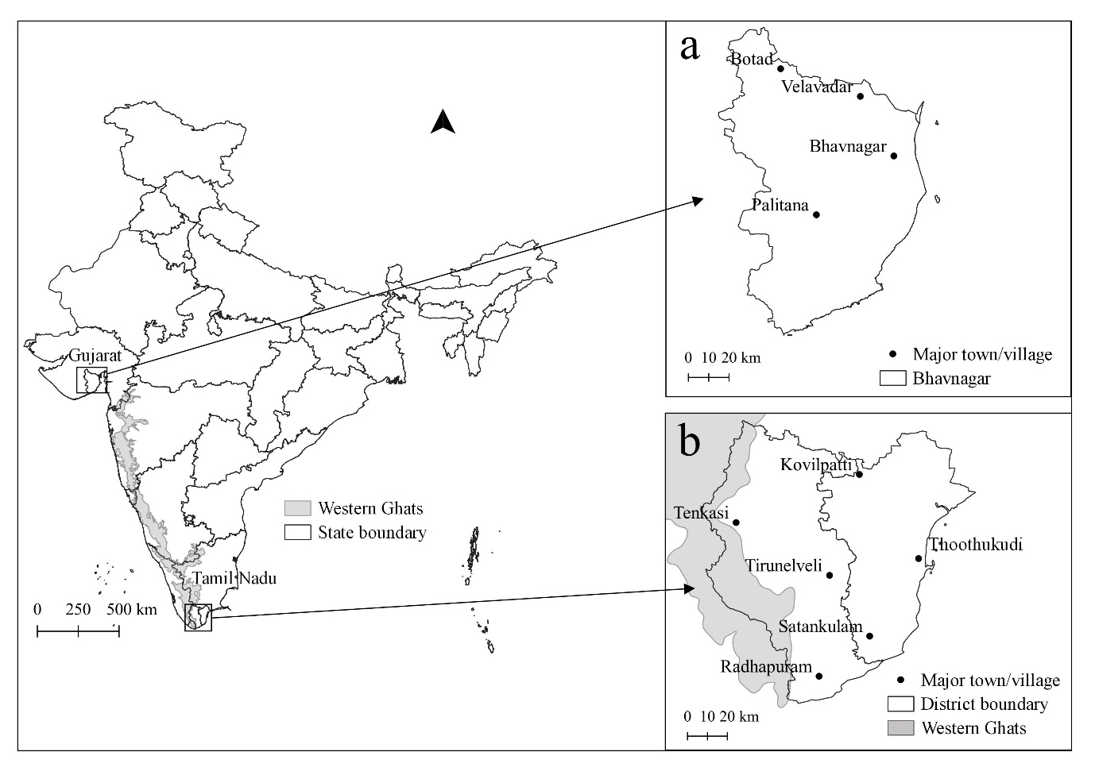
Figure 1: Study area map of the proposed methodology, a) site-1 is located in the Gujarat district of western India cover Bhavnagar district and b) site-2 in Tamil Nadu district of southern India cover Tirunelveli and Thoothukudi districts.

  - Data
We used the ESA’s Sentinel-1 and Sentinel-2 imagery acquired between 2016 and 2018. Sentinel-1 mission provides data from the dual-polarization C-band Synthetic Aperture Radar (SAR) instrument. It operates in four different modes with spatial resolution down to 5m and temporal resolution 12 days at equator. Each Sentinel-1 scene image was pre-processed for 1. Thermal noise removal, 2. Radiometric calibration 3. Terrain correction using SRTM 30 or ASTER DEM for areas above 60 degrees latitude, where SRTM is not available. The final terrain-corrected values are converted to decibels via log scaling (10*log10(x)) with Sentinel-1 Toolbox (https://sentinel.esa.int/web/sentinel/toolboxes/sentinel-1). We used Ground Range Detected (GRD) VV and VH bands pre-processed and hosted in GEE.
Sentinel-2 mission provides multi-spectral (12 bands), high spatial resolution 10-60m, and temporal resolution at the equator at 5 days in cloud-free condition imagery. We used Sentinel-2 TOA reflectance Level-1C 10m spatial resolution bands (B2, B3, B4, and B8).
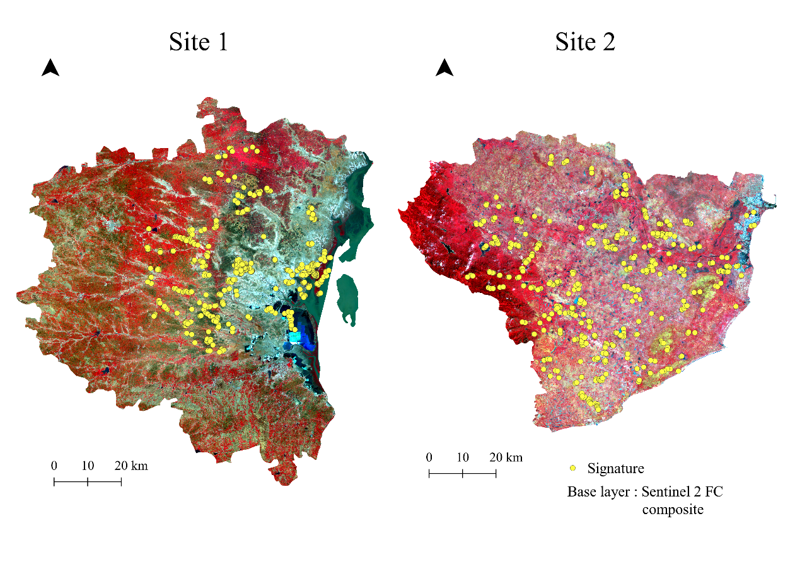
Figure 2: Signature locations for the site-1 located at Gujrat district western India and site-2 at Tamil Nadu district southern India.

Ground data were collected from 2016-2017 for both test sites. Fieldwork was conducted during crop availability (September to December) and when the crop was harvested (February-April) to identify crop, fallow, and grasslands. Ground data was collected from the areas accessible via road (Figure 2). We used a handheld Garmin GPS and Open Data Kit (ODK) and some signature were collected with reference to Google Earth. ODK (https://opendatakit.org/) is an open-source android based tool for field data collection. Ground data were pre-processed for all landcover classes. We created approximately 530 polygons for site-1 and 485 polygons for site-2. Each polygon cover approximately 4-16 pixels of the image. The signature was randomly split into 70% and 30% subset,70% was used to train the algorithm and 30% was used to validate the classification result for both sites. Splitting was performed in R using package ‘caTools’ version 1.18.0 (Tuszynski 2008).
  - Method
We used Google Earth Engine (GEE), a freely available cloud computing platform for scientific analysis and visualization of geospatial datasets for academic users to enable planetary-scale environmental data analysis (https://developers.google.com/earth-engine), and open-source QGIS 3.6 (http://qgis.osgeo.org) for analysis and map preparation. GEE host petabyte of free publically available remote sensing archived datasets. We selected time series Sentinel-1 and Sentinel-2 imagery acquired between 2016 and 2018 from Earth Engine data catalog to GEE Code Editor. We aggregate selected images (Table 1) into three season pre-monsoon (March to June), during-monsoon (July to November) and post-monsoon (December to February) for Sentinel-1 and Sentinel-2 (Figure 3). During pre- and during-monsoon, the study area was mostly cloudy due to which the seasonal’s data for Sentinel-2 (Optical) imagery was discarded for those seasons. The post-monsoon Sentinel-2 image was further filtered for cloud cover < 10% and the per band median value of the imagery was calculated. Median values further reduce cloud cover and keep the best pixels in the final Sentinel-2 image. Sentinel-1 imagery was aggregated into pre-monsoon, during-monsoon, and post-monsoon image sets (Figure 3). We applied the ‘mean reducer’ function on each season to reduce the speckle effect in Sentinel-1 imagery.

Figure 3: Flow chart for the selecting and stacking Sentinel-1 GRD (SAR) and Sentinel-2 MSI (optical) image

Table 1: Numbers of Sentinel-1 and Sentinel-2 imagery acquired for the study area across seasons
 | Sentinel-1 |  | Sentinel-2
 | Site-1 | Site-2 | Site-1 | Site-2
Pre-monsoon (March-June) | 60 | 95 | -
During-monsoon (July-November) | 87 | 138 | -
Post-monsoon (December-February) | 57 | 63 | 490 | 103
Total | 204 | 296 | -

Finally, we stacked the pre-monsoon, during-monsoon and post-monsoon Sentinel-1 and post-monsoon Sentinel-2 imagery to make a single image. We ran the classification on i) stacked mean bands VV and VH of Sentinel-1 pre-monsoon, during-monsoon and post-monsoon ii) post-monsoon stacked median bands B2, B3, B4, B5, and B8 of Sentinel-2, and iii) combined pre-monsoon and post-monsoon of Sentinel-1 and post-monsoon of Sentinel-2 bands (Figure 3).
  - Classification
Based on field visits, we decided to classify major land cover classes (Table 2) of the test sites. While there is a similarity between the two sites there are also some differences that are spelt out in the classification. Mudflats were specific to site-1 while reed grassland class is specific to the site-2.

Table 2: Land Cover Land Use classes and their description
LCLU class
Site-1 | Site-2 | Description
Grassland | Grassland | Area dominated by grass or grass like features. Site-1 natural grasslands are dominated by Sehima-Dicanthium grass genera while Site-2 natural grassland dominated by Heterepogon and Aristida sp
Agriculture land | Agriculture land | Land area which are arable or under crops cultivation. Our definition include either standing crops or the land left empty after harving the crops.
Waterbody | Waterbody | Waterbody area includes streams, lake, rivers, reservoir etc.
Scrub |  | Area dominated by scrub like plant communities
Mudflat |  | Wet area near sea cover by high tide
Other | Other | Site-1 other class include outcrop, rocky area, dried streams, and dried lake, etc and Site-2 other class includes forests, scrub, rocky outcrops, dried streams, and dried lake
 | Reed grassland | Grassland covers native reed grass (Ophiuros exaltatus) found in black soil

Support Vector Machine (SVM) (Burges 1998) machine learning algorithm used for image classification. We choose Radial Basis Kernal (RBF) for the SVM algorithm. SVM parameter (gamma and cost) was tunned (Hsu, Chang, and Lin 2003) in R using package ‘e1071’ version 1.17-3 (Meyer et al. 2019) and the best performance parameter (Table 3) gamma (γ) and cost (c) were used for image classification.

Table 3: Support Vector Machine parameter (γ, and c) of both sites Sentinel-1 had VV and VH bands for the pre, during and post-monsoon, Sentinel-2 had B2, B3, B4, and B8 bands for post-monsoon, while Sentinel-1 and -2 had the VV, VH, for pre and during and B2, B3, B4, B8 post-monsoon.
 | Data | Gamma (γ) | Cost(c) | best performance
Site-1 | Sentinel-1 | 1 | 10 | 0.7814267
Site-1 | Sentinel-2 | 1 | 10 | 0.1516654
Site-1 | Sentinel -1 and Sentinel-2 | 0.1 | 10 | 0.134271
Site-2 | Sentinel-1 | 1 | 1 | 0.1172909
Site-2 | Sentinel-2 | 1 | 10 | 0.6194885
Site-2 | Sentinel -1 and Sentinel-2 | 0.1 | 10 | 0.1321734

The Overall classification accuracy, kappa coefficient, producer accuracy, user accuracy, and confusion matrix (Stehman 1997) were used to assess the classification result. Overall accuracy indicates combied performance of all classes. Producer and user accuracy give information about individual classes. The confusion matrix provides information about cross-class confusion of classification accuracy. Kappa is agreement of two dataset corrected by chance. Kappa coefficient is widely used to assess classification results despite the dispute over their efficacy (Foody 2011; Pontius and Millones 2011).
- Result
  - Overall accuracy
We ran the analysis with three different data combinations of imagery on a seasonal basis for both the sites (Table 4). Combined Sentinel-1 and -2 had the highest overall accuracy approximately 96% for both sites and kappa approximately 95%. Overall accuracy was lowest for seasonal Sentinel-1 for site-1 and post-monsoon Sentinel-2 for site-2 while kappa was lowest for Sentinel-1 classification for site-1 and Sentinel-2 classification for site-2.

Table 4: Accuracy for the sites-1 and site-2 classification with data combination for the season (pre-monsoon, during-monsoon, and post-monsoon)
Site-1 |  | User's accuracy |  |  |  | Producer's accuracy
Site-1 | LCLU class | Combined | Sentinel-2 | Sentinel-1 |  | Combined | Sentinel-2 | Sentinel-1
Site-1 | Grassland | 97.06 | 100.00 | 100.00 |  | 99.00 | 100.00 | 62.00
Site-1 | Scrub | 99.18 | 89.17 | 80.18 |  | 97.58 | 86.29 | 71.77
Site-1 | Agriculture field | 99.10 | 91.40 | 54.43 |  | 99.70 | 96.08 | 90.66
Site-1 | Waterbody | 100.00 | 100.00 | 69.23 |  | 86.15 | 87.69 | 13.85
Site-1 | Mudflat | 95.65 | 92.59 | 82.76 |  | 89.80 | 76.53 | 24.49
Site-1 | Others | 85.40 | 86.03 | 64.00 |  | 94.35 | 94.35 | 38.71
Site-1 | Overall accuracy | 96.32 | 91.93 | 63.23
Site-1 | Kappa statisctic | 95.20 | 89.41 | 47.11
Site-2 |  | User's accuracy |  |  |  | Producer's accuracy
Site-2 | LCLU class | Combined | Sentinel-2 | Sentinel-1 |  | Combined | Sentinel-2 | Sentinel-1
Site-2 | Grassland | 96.88 | 92.49 | 91.08 |  | 100.00 | 90.06 | 98.09
Site-2 | Reed grassland | 91.95 | 86.22 | 75.43 |  | 98.77 | 83.02 | 40.74
Site-2 | Agriculture field | 97.83 | 79.28 | 89.28 |  | 93.35 | 72.89 | 96.26
Site-2 | Waterbody | 99.86 | 88.41 | 100.00 |  | 97.38 | 75.62 | 96.01
Site-2 | Others | 94.48 | 63.57 | 96.10 |  | 95.78 | 79.00 | 91.14
Site-2 | Overall accuracy | 96.69 | 80.17 | 92.22
Site-2 | Kappa statisctic | 95.64 | 73.92 | 89.65

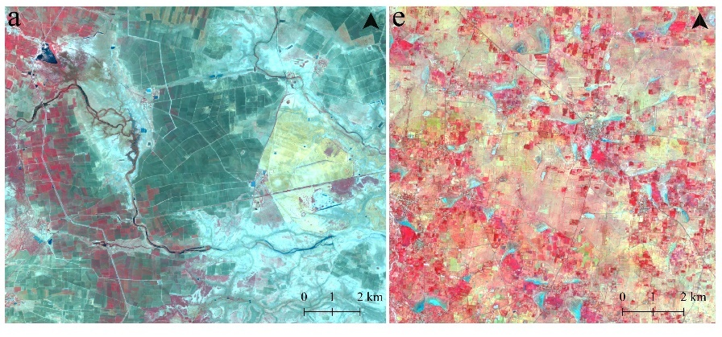
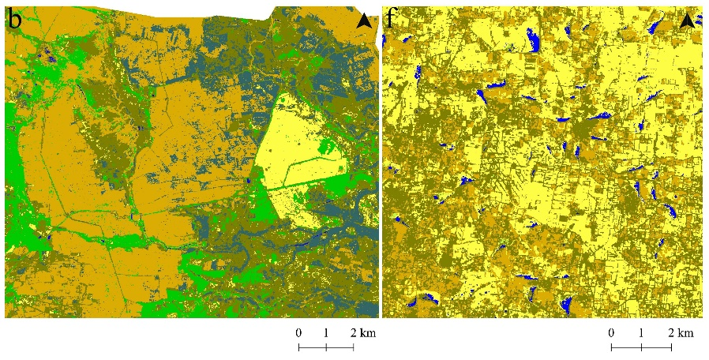
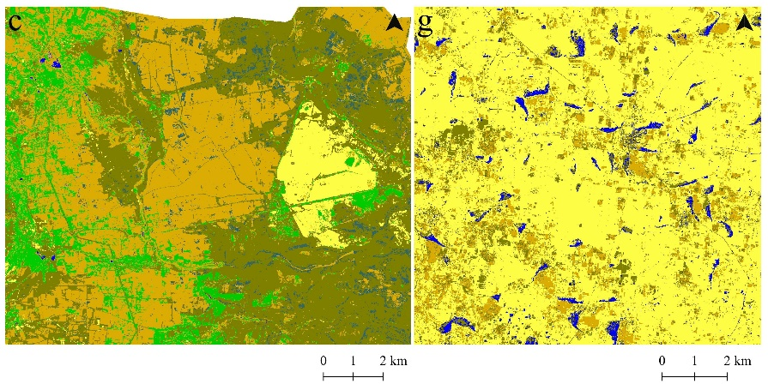
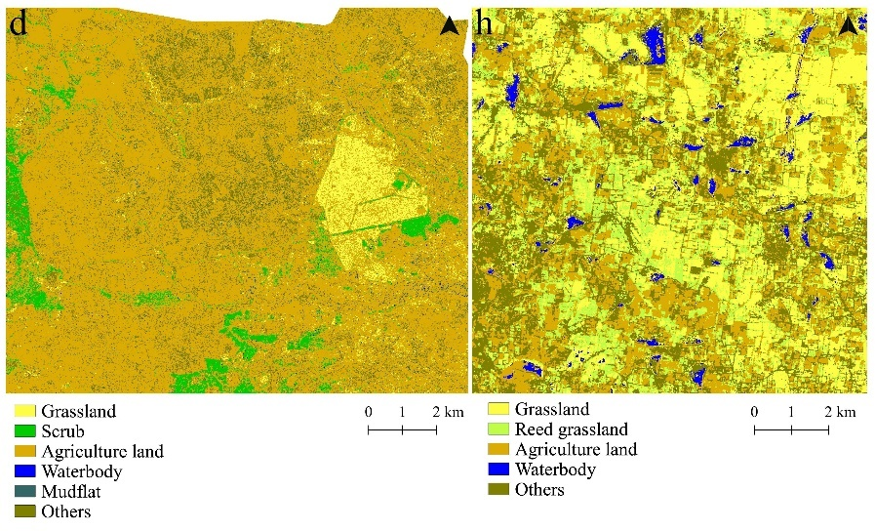
Figure 4: a) and e) are the False Color Combination(FCC) for the site-1 and site-2 respectevely. Site-1 LCLU classification b) combined Sentinel-1 and Sentinel-2, grassland is separated well from all others classes, a bit scrub class mixed with agriculture class c) Sentinel-2, scrub class was overestimated but grassland was well delineated and d) Sentinel-1, classification was not good enough. Site-2 classification f) combined Sentinel-1 and Sentinel-2, , grassland is separated well from rest of the classes, g) Sentinel-2, small agriculture/ fallow land was not detected and grassland was overestimated, and h) Sentinel-1, grassland and reed grassland confused but agriculture/fallow was delineated well
  - Grassland accuracy
Grassland accuracy for site-1 using Sentinel-2 had 100% user’s and 100% producer’s accuracy while Sentinel-1 had 100% producer’s accuracy but only 62% users accuracy.When combined Sentinel-1 and -2 was used user and producers accuracy was 97% and 99% respectively (Table 3). Similarly for site 2, Sentinel-2 had 92% and 90% users and producers’ accuracy respectively but Sentinel-1 had 91% and 98% accuracy respectively. When Sentinel-1 and -2 were combined, accuracy was 96% and 100% for user’s and producer’s repectively.
  - Habitat accuracy
Classification accuracy of individual classes (habitats) other than grassland varied among combinations. For site 1, Sentinel-2 classification user’s and producer’s accuracy was 89 and 86% for scrub, 91% and 96% for agriculture and waterbody was 100% and 87% mudflat was 92% and 76% but Sentinel-1 had much lower accuracy (Table 4). However, combined Sentinel-1 and 2 gave consistently highest user’s and producer’s accuracy >95% and >86% across all classes (Table 4). This was the case with Site 2 as well where reed grassland, a habitat unique to site 2 was well separated from grassland and agriculture with 98% producer’s accuracy, 91% user’s accuracy using only combined images and showed considerable overlap with agriculture fields in case Sentinel-1 and Sentinel-2 image classification.

Table 5: Land cover classes of combined Sentinel-1 and Sentinel-2 classification and crossponding aggregated land cover/use classes of NRSC for site-1 (Bhavnagar) and site-2 (Tirunelveli and Thoothukudi)
 | Land cover | NRSC land cover classes
Bhavnagar | Grassland | Grass / Grazing
Bhavnagar | Scrub | Scrub Land, and Scrub Forest
Bhavnagar | Agriculture land | Crop land, Fallow
Bhavnagar | Waterbody | Inland Wetland, Coastal Wetland,  River/Stream/Canals
Bhavnagar | Mudflat | Salf Affected Land
Bhavnagar | Others | Plantation, Barren Rockey, Sandy Area, Mining,  Rural, Urban, Deciduous, Forest plantation, Swamp/Mangroves
Tirunelveli and  Thoothukudi | Grassland | Grass / Grazing
Tirunelveli and  Thoothukudi | Reed Grassland
Tirunelveli and  Thoothukudi | Agriculture land | Crop land, Fallow
Tirunelveli and  Thoothukudi | Waterbody | Inland Wetland, Coastal Wetland, River/Stream/Canals
Tirunelveli and  Thoothukudi | Others | Plantation, Barren Rocky, Gullied/Ravinous Land, Salt Afftected Land,  Sandy Area, Scrub Land, Mining, Rural, Urban, Deciduous,  Evergreen/Semi evergreen, Forest Plantation,Scrub Forest, Swamp/Mangroves

  - Comparing grassland with national land cover classification
We compare combined image land cover/use classification result with government produced land cover/use of 2011-2012. National Remote Sensing Center (NRSC), India which used Rssoursat-2 Linear Imaging Self Scanning Sensor (LISS)‐III imagery has 23m spatial resolution to produce classification mapping on scale 1:50000 (NRSC 2012). They did land use/land cover at three level, Level‐I: 8 classes, Level‐II: 31 classes and Level‐III: 54 classes (NRSC 2012). For comparison we merged second level land cover/use classes to match our land cover/use classes for this study (Table 5).

Result shows that NRSC land cover/use did not detect small patches of grassland for both sites. Our result shown 0.9% of total area of site-1 (Bhavanagar) was covered by grassland but NRSC result have 0.005% of area cover with grassland. In case of site-2 (Tirunelveli and Thoothukudi district combined) NRSC classification did not have any grassland cover but our result shown 13% of the total area covered with grassland (Table 6).

Table 6: Land cover and their % area cover in the site-1 Bhavnagar district of Gujarat and site-2 Tirunelveli & Thoothukudi district of Tamil Nadu. Comparision of % of area cover by combined image classification and by NRSC classification cover
 | Land cover class | % cover(combined, Present study) | % cover (NRSC)
Bhavnagar | Grassland | 0.909 | 0.005
Bhavnagar | Scrub | 10.424 | 14.464
Bhavnagar | Agriculture land | 65.106 | 69.530
Bhavnagar | Waterbody | 1.528 | 7.765
Bhavnagar | Mudflat | 4.886 | 4.288
Bhavnagar | Others | 17.147 | 3.948
Tirunelveli & Thoothukudi | Grassland | 13.928 | 0.000
Tirunelveli & Thoothukudi | Reed Grassland | 4.811 | 0.000
Tirunelveli & Thoothukudi | Agriculture land | 27.754 | 63.114
Tirunelveli & Thoothukudi | Waterbody | 3.084 | 8.261
Tirunelveli & Thoothukudi | Others | 50.423 | 28.625

- Discussion
4.1 Overall accuracy
We have shown here that the accuracy of land use classifications improves when using multi-seasonal combinations of Sentinel-1 and -2 instead of using either just seasonal Sentinel-1 or seasonal Sentinel-2. Our accuracy results agree with earlier studies that used combined multi-temporal sar and optical (Steinhausen et al. 2018; Lopes et al. 2020) and SAR-optical fusion of high spatial resolution Sentinel data (Clerici, Valbuena Calderón, and Posada 2017; Van Tricht et al. 2018). However in our case, we achieved a higher accuracy(>96%) in grassland mapping compared to earlier studies (Dusseux et al. 2014; Hong et al. 2014). There could be several reasons for this. Lopes et al. (2020), who mapped rainforests in Indonesia with optical data, showed that fusion techniques to reduce cloud cover is not entirely reliable. Here we used seasonal Sentinel-2 median which minimised the probability of cloud presence in the images, and so further enhanced the quality. Also, to minimise the likelihood of dealing with an anomalous year, we used multi-seasonal layers that represent an average of several growing seasons instead of using multi-temporal layers representing a single growing season (Schmidt et al. 2014). Finally, the high resolution imagery, SVM classification algorithm with tuned parameters and fewer LCLU classes may all have contributed to an improved accuracy.

4.2 Habitat accuracy

The combined radar-optical approach also produced a high user’s and producer’s accuracy for individuals classes. However when using either Sentinel-1 or Sentinel-2 alone the among the land cover classes user’s and produce’s accuracy had large variance. Some of the classes well separate (Sentinel-2 of site-1 Grassland and Agriculture classs and Sentinel-1 of site-2 grassland class) and sesonal Sentinel-1 classification for site-1 results were unsatisfactory. Combined seasonal Sentinel-1 and Sentinel-2 user’s and produce’s accuracy across sites were consistent across sites but individually seasonal Setninel-2 and Sentinel-1 per class user and producer accuracy varies and this cannot be genralised and applied across different climatic zone. For site-2, which are located near the equator prone to frequent cloud cover have less per class accuracy for Sentinel-2 compared to seasonal Sentinel-1 alone or seasonal combination of Sentinel-1 and Sentinel-2. This suggests that for complex habitats and sites with long periods of cloud cover (site2) the additional temporal information provided by the radar-based layers are essential to obtain good classification results across all habitat classes. Hence even in areas with limited optical imagery as in site 2 inclusion of radar imagerly available improves classification accuracy.

4.3 Cloud processing

Processing Sentinel-1 and -2 demands high computing and storage resources. The Google Earth Engine cloud computing platform that we used offered access to and processing of petabytes of freely and publically available pre-processed satellite data. This service significantly reduces processing time and enables teams, who are limited in their hardware/software capacity, to carry out extensive classification tasks. For instance, to carry out this study it took, apart from field data collection, signature pre-processing, and SVM’s parameter tunning approximately 30min for data selection, 1h to create the multi-seasonal data layers and only 15 min for classification result per season per sensor. In total we could accomplish the analysis in under 2-3h depending on the load on GEE platform. Resources, memory, and processor allocation are decided by Google GEE team. The availability of a cloud-based platform such as Google Earth Engine enables remote sensing researchers to focus on the development of approaches for information retrieval rather than investing resources on hardware and time on the downloading and pre-processing of raw data.
Our study has shown how the availability of good temporal resolution optical and radar data at high spatial resolutions is essential to resolve cloud coverage issues but by incorporating multi-seasonal and fine spatial resolution information for mapping certain cover types accuracy is enhanced. High mapping accuracies can be achieved for grassland and other cover types in areas that are very cloudy, have high levels of landscape heterogeneity and where the patches are small and fragmented. This data combined with access to cloud computing creates an unprecented opportunity to accurately map grasslands and other land use and cover classes in the semi-arid and arid areas of tropical Asia irrespective of the monsoon clouds, and limited computing resources available. This will help produce high quality maps for the region, which are presently lacking, and help with the monitoring of grasslands across the region.

- Conclusion
Our results demonstrate that the seasonal combination of multi-temporal SAR and optical data produce accurate land cover classification than when seasonal optical or SAR was used alone. In addition, our multi-seasonal approach outlined was able to delineate grasslands with high accuracy within a tropical landscape dominated by agriculture across the different climate climatic zone. SAR alone did not adequately delineate all cover types but delineate grasslands well across sites. SAR’s classification varies with numbers of available imagery in the study area, more number of images better the classification.
Good temporal resolution optical and radar data at high spatial resolutions is essential to map cover types, including grasslands, across the semi-arid and arid areas of Asia irrespective of the climate. GEE facilitates to do land cover classification at country level or continent level in a short time frame. This can further monitoring of grasslands or other habitats at large spatial scale at regular intervals. Accurate maps of grassland will help management in conservation and sustainable use of the dry grassland cover across the South Asia region, the monitoring of which has so far been restricted to areas where charismatic large grassland mammals are found, while smaller but equally important areas have been ignored. This will also facilitate management of pastures for pastoralists and others dependent on grasslands for their livilihoods , value grasslands in terms of carbon storage and ground water recharge to prevent further degradation of dry grasslands in the subcontinent.

- Acknowledments
We acknowledge Royal Norwegian Embassy grant to MSD and Department of Science and Technology, New Delhi to TG for partly funding this study. We thank Tamizhazaghan, Saravanan, Mathivanan, Prashanth MB, for help during fieldwork and Vikram for providing comments on the manuscript.

- Reference
Ali, Iftikhar, Fiona Cawkwell, Edward Dwyer, Brian Barrett, and Stuart Green. 2016. “Satellite remote sensing of grasslands: from observation to management.” Journal of Plant Ecology 9 (6): 649–671. doi:10.1093/jpe/rtw005.
Asner, G P. 2001. “Cloud cover in Landsat observations of the Brazilian Amazon.” International journal of remote sensing 22 (18): 3855–3862. doi:10.1080/01431160010006926.
Bossard, M, Jan Feranec, and J Otahel. 2000. “CORINE land cover technical guide: Addendum 2000.”
Buchhorn, Marcel, Bruno Smets, Luc Bertels, Myroslava Lesiv, Nandin-Erdene Tsendbazar, Martin Herold, and Steffen Fritz. 2019. “Copernicus Global Land Service: Land Cover 100m: epoch 2015: Globe.” Zenodo. doi:10.5281/zenodo.3243509.
Burges, Christopher JC. 1998. “A tutorial on support vector machines for pattern recognition.” Data mining and knowledge discovery 2 (2): 121–167.
Clerici, Nicola, Cesar Augusto Valbuena Calderón, and Juan Manuel Posada. 2017. “Fusion of Sentinel-1A and Sentinel-2A data for land cover mapping: a case study in the lower Magdalena region, Colombia.” Journal of maps 13 (2): 718–726. doi:10.1080/17445647.2017.1372316.
Crowson, Merry, Eleanor Warren‐Thomas, Jane K. Hill, Bambang Hariyadi, Fahmuddin Agus, Asmadi Saad, Keith C. Hamer, et al. 2018. “A comparison of satellite remote sensing data fusion methods to map peat swamp forest loss in Sumatra, Indonesia.” Remote Sensing in Ecology and Conservation, December. doi:10.1002/rse2.102.
Dusseux, Pauline, Thomas Corpetti, Laurence Hubert-Moy, and Samuel Corgne. 2014. “Combined Use of Multi-Temporal Optical and Radar Satellite Images for Grassland Monitoring.” Remote sensing 6 (7): 6163–6182. doi:10.3390/rs6076163.
Erinjery, Joseph J., Mewa Singh, and Rafi Kent. 2018. “Mapping and assessment of vegetation types in the tropical rainforests of the Western Ghats using multispectral Sentinel-2 and SAR Sentinel-1 satellite imagery.” Remote Sensing of Environment 216 (October): 345–354. doi:10.1016/j.rse.2018.07.006.
Foody, Giles M. 2011. “Latent class modeling for site-and non-site-specific classification accuracy assessment without ground data.” IEEE Transactions on Geoscience and Remote Sensing 50 (7): 2827–2838.
Franke, Jonas, Vanessa Keuck, and Florian Siegert. 2012. “Assessment of grassland use intensity by remote sensing to support conservation schemes.” Journal for Nature Conservation 20 (3): 125–134. doi:10.1016/j.jnc.2012.02.001.
Freeman, A, J Villasenor, J D Klein, P Hoogeboom, and J Groot. 1994. “On the use of multi-frequency and polarimetric radar backscatter features for classification of agricultural crops.” International journal of remote sensing 15 (9): 1799–1812. doi:10.1080/01431169408954210.
Ganesh, T, and M B Prashanth. 2018. “A First Compilation of Harrier Roost Counts from India Suggests Population Declines of Wintering Birds over 30 Years.” Ardea 106 (1): 19–29. doi:10.5253/arde.v106i1.a6.
Gorelick, Noel, Matt Hancher, Mike Dixon, Simon Ilyushchenko, David Thau, and Rebecca Moore. 2017. “Google Earth Engine: Planetary-scale geospatial analysis for everyone.” Remote Sensing of Environment, July. doi:10.1016/j.rse.2017.06.031.
Herold, M, P Mayaux, C E Woodcock, A Baccini, and C Schmullius. 2008. “Some challenges in global land cover mapping: An assessment of agreement and accuracy in existing 1 km datasets.” Remote Sensing of Environment 112 (5): 2538–2556. doi:10.1016/j.rse.2007.11.013.
Hoekman, Dirk H., Martin A. M. Vissers, and Niels Wielaard. 2010. “PALSAR Wide-Area Mapping of Borneo: Methodology and Map Validation.” IEEE Journal of Selected Topics in Applied Earth Observations and Remote Sensing 3 (4): 605–617. doi:10.1109/JSTARS.2010.2070059.
Homer, Collin H, Joyce A Fry, and Christopher A Barnes. 2012. “The national land cover database.” US Geological Survey Fact Sheet 3020 (4): 1–4.
Hong, Gang, Aining Zhang, Fuqun Zhou, and Brian Brisco. 2014. “Integration of optical and synthetic aperture radar (SAR) images to differentiate grassland and alfalfa in Prairie area.” International Journal of Applied Earth Observation and Geoinformation 28 (May): 12–19. doi:10.1016/j.jag.2013.10.003.
Hsu, Chih-Wei, Chih-Chung Chang, and Chih-Jen Lin. 2003. “A practical guide to support vector classification.”
Inglada, Jordi, Arthur Vincent, Marcela Arias, and Claire Marais-Sicre. 2016. “Improved early crop type identification by joint use of high temporal resolution SAR and optical image time series.” Remote sensing 8 (5): 362. doi:10.3390/rs8050362.
Joshi, Neha, Matthias Baumann, Andrea Ehammer, Rasmus Fensholt, Kenneth Grogan, Patrick Hostert, Martin Jepsen, et al. 2016. “A review of the application of optical and radar remote sensing data fusion to land use mapping and monitoring.” Remote sensing 8 (1): 70. doi:10.3390/rs8010070.
Kasischke, Eric S, John M Melack, and M Craig Dobson. 1997. “The use of imaging radars for ecological applications—A review.” Remote Sensing of Environment 59 (2): 141–156. doi:10.1016/S0034-4257(96)00148-4.
Liu, Chen, Jiali Shang, Paris W. Vachon, and Heather McNairn. 2013. “Multiyear Crop Monitoring Using Polarimetric RADARSAT-2 Data.” IEEE Transactions on Geoscience and Remote Sensing 51 (4): 2227–2240. doi:10.1109/TGRS.2012.2208649.
Liu, Jiyuan, Mingliang Liu, Hanqin Tian, Dafang Zhuang, Zengxiang Zhang, Wen Zhang, Xianming Tang, and Xiangzheng Deng. 2005. “Spatial and temporal patterns of China’s cropland during 1990–2000: an analysis based on Landsat TM data.” Remote sensing of Environment 98 (4): 442–456.
Lopes, Mailys, Pierre‐Louis Frison, Merry Crowson, Eleanor Warren‐Thomas, Bambang Hariyadi, Winda D. Kartika, Fahmuddin Agus, et al. 2020. “Improving the accuracy of land cover classification in cloud persistent areas using optical and radar satellite image time series.” Methods in ecology and evolution / British Ecological Society 11 (4): 532–541. doi:10.1111/2041-210X.13359.
M. Friedl, D. Sulla-Menashe. 2015. “MCD12Q1 MODIS/Terra+Aqua Land Cover Type Yearly L3 Global 500m SIN Grid V006.” NASA EOSDIS Land Processes DAAC. doi:10.5067/modis/mcd12q1.006.
Mehta, Dhawal. 2015. “The Vidis of Saurashtra.” Ecology and Management of Grassland Habitats in India. ENVIS Bulletin: Wildlife and Protected Areas, Wildlife Institute of India, Dehradun, India, 54–63.
Meyer, David, Evgenia Dimitriadou, Kurt Hornik, Andreas Weingessel, Friedrich Leisch, Chih-Chung Chang, Chih-Chen Lin, and Maintainer David Meyer. 2019. “Package ‘e1071.” R J.
Morton, D, C Rowland, C Wood, L Meek, C Marston, G Smith, R Wadsworth, and I Simpson. 2011. “Final Report for LCM2007-the new UK land cover map. Countryside Survey Technical Report No 11/07.”
NRSC, ISRO. 2012. “Manual Of National Land Use/Land Cover Mapping (Second Cycle) Using Multi Temporal Satellite Data.” Department of Space, Hyderabad.
Pontius, Robert Gilmore, and Marco Millones. 2011. “Death to Kappa: birth of quantity disagreement and allocation disagreement for accuracy assessment.” International journal of remote sensing 32 (15): 4407–4429. doi:10.1080/01431161.2011.552923.
Qi, Zhixin, Anthony Gar-On Yeh, Xia Li, and Zheng Lin. 2012. “A novel algorithm for land use and land cover classification using RADARSAT-2 polarimetric SAR data.” Remote Sensing of Environment 118 (March): 21–39. doi:10.1016/j.rse.2011.11.001.
Rapinel, Sébastien, Cendrine Mony, Lucie Lecoq, Bernard Clément, Alban Thomas, and Laurence Hubert-Moy. 2019. “Evaluation of Sentinel-2 time-series for mapping floodplain grassland plant communities.” Remote Sensing of Environment 223 (March): 115–129. doi:10.1016/j.rse.2019.01.018.
Rashford, Benjamin S, Johann A Walker, and Christopher T Bastian. 2011. “Economics of grassland conversion to cropland in the prairie pothole region.” Conservation Biology 25 (2): 276–284. doi:10.1111/j.1523-1739.2010.01618.x.
Rodgers, W. Alan, Hemendra S. Panwar, and Vinod B. Mathur. 2002. Wildlife protected area network in India : a review. 1st ed. Dehradun : Wildlife Institute of India.
Roy, Parth, Arijit Roy, Pawan Joshi, Manish Kale, Vijay Srivastava, Sushil Srivastava, Ravi Dwevidi, et al. 2015. “Development of decadal (1985–1995–2005) land use and land cover database for india.” Remote sensing 7 (3): 2401–2430. doi:10.3390/rs70302401.
Schmidt, Tobias, Christian Schuster, Birgit Kleinschmit, and Michael Forster. 2014. “Evaluating an Intra-Annual Time Series for Grassland Classification—How Many Acquisitions and What Seasonal Origin Are Optimal?” IEEE Journal of Selected Topics in Applied Earth Observations and Remote Sensing 7 (8): 3428–3439. doi:10.1109/JSTARS.2014.2347203.
Singh, P, A R Rahmani, K D Singh, P Narain, K A Singh, S Kumar, G S Rawat, and R S Chundawat. 2006. Report of the Task Force on Grasslands and Deserts. Planning Commission, Government of India.
Stehman, Stephen V. 1997. “Selecting and interpreting measures of thematic classification accuracy.” Remote Sensing of Environment 62 (1): 77–89. doi:10.1016/S0034-4257(97)00083-7.
Steinhausen, Max J., Paul D. Wagner, Balaji Narasimhan, and Björn Waske. 2018. “Combining Sentinel-1 and Sentinel-2 data for improved land use and land cover mapping of monsoon regions.” International Journal of Applied Earth Observation and Geoinformation 73 (December): 595–604. doi:10.1016/j.jag.2018.08.011.
Stenzel, Stefanie, Fabian Ewald Fassnacht, Benjamin Mack, and Sebastian Schmidtlein. 2017. “Identification of high nature value grassland with remote sensing and minimal field data.” Ecological Indicators 74 (March): 28–38. doi:10.1016/j.ecolind.2016.11.005.
Stephens, Scott E, Johann A Walker, Darin R Blunck, Aneetha Jayaraman, David E Naugle, James K Ringelman, and Aaron J Smith. 2008. “Predicting risk of habitat conversion in native temperate grasslands.” Conservation Biology 22 (5): 1320–1330. doi:10.1111/j.1523-1739.2008.01022.x.
Tuszynski, Jarek. 2008. “caTools: Tools: moving window statistics, GIF, Base64, ROC AUC, etc.” R package version 1.
Van Tricht, Kristof, Anne Gobin, Sven Gilliams, and Isabelle Piccard. 2018. “Synergistic Use of Radar Sentinel-1 and Optical Sentinel-2 Imagery for Crop Mapping: A Case Study for Belgium.” Remote sensing 10 (10): 1642. doi:10.3390/rs10101642.
Vanak, A T, and M E Gompper. 2010. “Multi-scale resource selection and spatial ecology of the Indian fox in a human-dominated dry grassland ecosystem.” Journal of zoology 281 (2): 140–148. doi:10.1111/j.1469-7998.2010.00690.x.
Vanak, A T, M Irfan-Ullah, and T Peterson. 2008. “Gap analysis of Indian fox conservation using ecological niche modelling.” Journal of the Bombay Natural History Society 105 (1): 49–54.
Vanak, Abi Tamim, J Ankila Hiremath, Siddhartha Krishnan, T Ganesh, and Nitin D Rai. 2017. “Filling in the (forest) blanks: the past, present and future of India’s savanna grasslands.”
Vanak, Abi Tamim, Abhijeet Kulkarni, Ameya Gode, and Jagdish Krishnaswamy. 2016. “Extent and status of semiarid savanna grasslands in Peninsular India.” ENVIS Bulletin on Ecology and Management of Grassland Habitats in India 17: 192–201.
Wang, Zongming, Kaishan Song, Bai Zhang, Dianwei Liu, Chunying Ren, Ling Luo, Ting Yang, et al. 2009. “Shrinkage and fragmentation of grasslands in the West Songnen Plain, China.” Agriculture, Ecosystems & Environment 129 (1-3): 315–324. doi:10.1016/j.agee.2008.10.009.
Zhang, Xiao, Liangyun Liu, Xidong Chen, Shuai Xie, and Yuan Gao. 2019. “Fine Land-Cover Mapping in China Using Landsat Datacube and an Operational SPECLib-Based Approach.” Remote sensing 11 (9): 1056. doi:10.3390/rs11091056.

