Misunderstood Mismatch

Michael C Singer and Camille Parmesan

CNRS Station d'Écologie Théorique et Expérimentale, Université Paul Sabatier, 09220 Moulis, France

It is not controversial that we need to understand and predict impacts of climate change on phenological synchrony between consumers and resources, since we are already seeing novel "mismatches" detrimental to consumers (Renner & Zohner 2018,Visser & Gienapp 2019). To this end, Kharouba and Wolkovich (hereafter K&W) advocate developing approaches that combine theory and experiment to both forecast climate-change impacts and hindcast pre-climate-change "baseline" conditions. K&W provide a valuable review and cogent advocacy for future work. However, they misunderstand and misinterpret examples from plant-insect interactions. Their detailed case study involves phenological synchrony/asynchrony between spring hatching of Winter Moth eggs and budburst of their oak hosts. The novel approaches that K&W recommend for this system have mostly been done, and a long-term baseline study of the role of variable asynchrony in Winter Moth population dynamics is ignored. Published studies of this and other insect/plant systems are misinterpreted by applying a definition of phenological synchrony as "the situation in which the most energetically demanding period of the consumer's life cycle overlaps with the period of resource availability." This definition works well for ornithologists, since parent birds require high caterpillar abundance when their chicks are most demanding. But for Winter Moth the crucial phenological event occurs when larvae are just hatched and least demanding of energy, not most demanding (see below). The important role of phenological synchrony in most insect-plant systems is to fit the life cycle into the available time, not to synchronize peak resource demand with peak availability.
The Winter Moth/oak interaction is conspicuous, since early egg-hatch can cause >90% mortality of neonate Winter Moth larvae (Varley & Gradwell 1973), while synchronous hatch can result in total defoliation of oaks (Feeny 1970). This system has fascinated ecologists for decades, its complexity gradually emerging from a series of studies in different countries (Varley et al 1968, Holliday 1977, Tikkanen & Julkunen-Tiitto 2003, van Asch & Visser 2007, van Asch et al 2013, Sålis et al 2016).
To test a key assumption of the "Cushing hypothesis" (Cushing 1990) that phenological relationship with a resource controls consumer fitness, K&W use data from Tikkanen & Julkunen-Tiitto (2003) to show that larval mortality of Winter Moth increased with deviation in both directions from synchrony, since larvae hatching before budburst risked starvation while late-hatching larvae encountered increasing host defenses. However, data on mortality alone are not the most appropriate to test the Cushing hypothesis. Ever since Feeny's (1970) experiments in which he fed Winter Moth larvae oak leaves of differing age, it has been clear that the principal penalty for late egg hatch is reduced fecundity, not the increased mortality that K&W use in their argument. The eggs cannot tell when buds are bursting and so encounter a tradeoff between risk of mortality if they hatch early and reduced fecundity if they hatch late. The same paper by Tikkanen & Julkunen-Tiitto from which K&W extract their data on mortality also describes experiments that use the combined effects of phenology on mortality and fecundity to estimate fitness consequences of phenological synchrony/asynchrony. This dataset, rather than the one that K&W use, is the appropriate information in this study from which to deduce the effect on insect fitness of phenological synchrony with the host. The dataset predicts evolution of slight asynchrony, with mean hatch time later than mean budburst (Figure 1).
K&W suggest that novel understanding would come from combining the experiments on Winter Moth done by Tikkanen & Julkunen-Tiitto in Scotland with the field observations of van Asch & Visser (2007) in the Netherlands. Van Asch & Visser (2007) showed that, from 1996-2005, the mean timing of egg hatch was asynchronous, always preceding oak budburst. It did so to different extents in each year, indicating that moth and trees were using different cues to time their spring development. K&W imply that this work was observational, hence not very useful without being combined with the Scottish experiments. However, van Asch et al (2007) included experimental assessments of the effects of asynchrony on fitness, correctly combined the effects of phenology on fecundity and mortality, demonstrated heritability of egg hatch timing and predicted its evolution that was subsequently observed (van Asch et al 2013). Further, the Dutch group generated detailed analyses of climate effects on moth phenology (Sålis et al 2016). To a much greater extent than K&W imply, the combination of observation and experiment that they recommend for the Winter Moth has already been done.
K&W sugggest that, in the absence of baseline information, hindcasting with "process-based models" could be used deduce the baseline of the oak/Winter Moth system. Given current evolution of the moth's phenology (van Asch et al 2013), hindcasting with ecological models is questionable. Further, baseline information does exist about the role of phenological asynchrony in the moth's population dynamics. From 1950-1966 Varley and Gradwell (1968) measured the moth's population density each year, plus separate mortalities at different stages of the life cycle. They found that "winter disappearance," which they attributed almost exclusively to egg hatch before budburst, routinely caused more than 90% mortality of neonate larvae (Varley & Gradwell 1968). Variation among years of this mortality factor was the main driver of year-to-year population changes (Figure 2). Varley& Gradwell wrote: "Biologically, the amount of synchronization between egg hatch and bud burst determines the (population dynamic) changes. Apart from the assertion of a 4-5 day mean asynchrony between egg hatch and budburst (Wint 1983), this old study lacks detailed data on synchrony, concentrating instead on its effects on mortality. Nonetheless, it deserves to be disinterred and reinstated into discussions of pre-climate-change baselines and the importance of consumer-resource phenological synchrony for population dynamics.
By applying their definition of synchrony to entomological studies, K&W misinterpret them. They define "asynchrony baseline" as "a hypothesis put forward by Singer & Parmesan (2010) that before climate change the most energetically demanding period of the consumer was not timed to the peak resource availability and thus consumer fitness was not at its maximum." This statement, which refers to work on a metapopulation of the Bay Checkerspot butterfly, is wrong in three respects. First, as in Winter Moth, mortality from asynchrony occurred in the least energy-demanding phase of the life cycle. Although eggs were laid on non-senescent annual hosts, most of those hosts died in the 2-3 weeks before the eggs hatched, causing immediate mortality of neonate larvae that needed little food but found none at all; they were simply unable to fit their life cycles into the available time window. Second, this asynchrony baseline was not hypothesized, it was documented, resulting in mortality of an estimated 70-80% of neonate larvae in 1968, 1969 and 1970 and recorded again by other authors in 1983, 1984 and 1985 (refs in Singer & Parmesan 2010). Third, as we detail below, a fecundity-mortality tradeoff rendered this baseline asynchrony adaptive, not maladaptive as K&W state.
Adaptive asynchrony has multiple causes (Singer & Parmesan 2010, Johanssen & Jonzen 2012, Visser et al 2012). In the Bay Checkerspot it stems from choices made by female larvae to continue to feed after they have grown large enough to pupate, thereby increasing both their own fecundities and the asynchronies of their offspring with hosts. Field-gathered data on larval growth rate and temporal pattern of host senescence under baseline conditions generated the prediction that delaying adult eclosion by one week within the flight season would increase maternal fecundity by around 25% while adding only 10% to offspring mortality from host senescence (Singer & Parmesan 2010). Thus, prior to climate change, natural selection favored asynchrony. K&Ws assertion that baseline asynchrony showed that "consumer fitness was not at its maximum" is wrong. In fact, baseline data from the checkerspot fit K&W's definition of "adaptive mismatch." Unlike the Winter Moth, in which precise synchrony of egg hatch with budburst maximizes fitness for an individual trading its own fecundity against its chances of survival, the adaptive strategy for a Bay Checkerspot female is to force her offspring into asynchrony.
From the beginning of the series of Bay Checkerspot studies, the density-independence and climate-dependence of mortality caused by asynchrony predicted instability of population density (Singer & Parmesan 2010). Eventually, increasing climatic fluctuations associated with climate warming were ascribed as the cause of permanent extinction of the metapopulation in 1998 (McLaughlin et al 2002).
We hope that this account clarifies an important difficulty with the current definition of phenological synchrony and brings back into circulation old studies that are informative, despite failure to meet criteria for inclusion into modern meta-analyses.
Figure 1: Combined effects of mortality and fecundity on Winter Moth fitness (y-axis) with differing deviations from sychrony between time of Winter Moth egg hatch and oak budburst (x-axis). X-axis scale is degree-days (dd) above 5°C. From Tikkanen & Julkunen-Tiitto 2003.

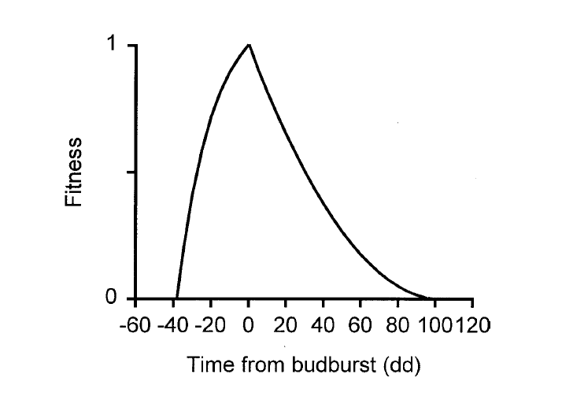
Figure 2. Baseline (pre-climate change) data from separate years (1950-1966) showing negative effects on moth population abundance of asynchrony with budburst. Plot of density of feeding Winter Moth larvae in spring against prior "winter mortality," ascribed by Varley & Gradwell to phenological mismatch (adapted from Varley & Gradwell 1973).
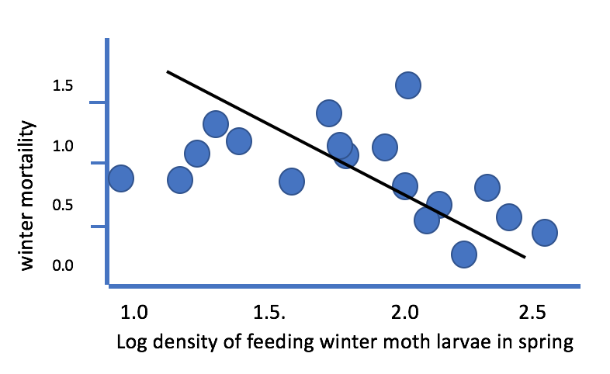

REFERENCES

Feeny P. 1970. Seasonal changes on oak leaf tannins and nuitrients as a cause of spring feeding by winter moth caterpillars. Ecology 51, 565-581.

Cushing DH 1990 Plankton production and year-class strength in fish populations: an update of the match/mismatch hypothesis. Adv. Mar. Biol. 26, 249-293 (1990) .

Holliday N 1977 Population ecology of winter moth (Opheoptera brumata) on apple in relation to larval dispersal and time of bud burst. J. Appl. Ecol. 14: 803-813.

Johanson J, Jonzen N. 2012. game theory sheds new light on ecological responses to current climate change when phenology is historically mismatched. Ecol Lett 15: 881-888.

Kharouba HM, Wolkovich EM. 2020. Disconnects between ecological theory and data in phenological mismatch research. Nat Clim Chang 10: 406-415

McLaughlin JF, Hellmann JJ, Boggs CL, Ehrlich PR. 2002. Climate change hastens population extinctions. Proc Nat Acad Sci USA 99: 6070-6074
Renner, SS, Zohner CM. 2018. Climate Change and phenological mismatch in trophic interactionbs among plants, insectrs anf vertebrates. Annu. Rev. Ecol. Evol. S. 49, 165-182.

Salis L, Lof M, van Asch M, Visser ME. 2016. Modeling Winter Moth Operophtera brumata egg phemology: nonlinear effects of temperature and developmental stage on developmental rate. Oikos 125: 1772-1781.

Singer MC 1972. Complex components of habitat suitability within a butterfly colony. Science 176, 75-77.

Singer MC, Parmesan C. 2010. Phenological asynchrony between herbivorous insects and their hosts: signal of climate change or pre-existing adaptive strategy? Phil Trans R Soc B 365, 3161-3176.

Tikkanen, O-P, Julkunen-Tiitto R. 2003. Phenological variation as protectionagainstd defoliating insects: the case of Quercus robur and Operophtera brumata. Oecologia 136: 244-251

van Asch M, van Tienderen PH, Holleman LJM, Visser ME 2007. Predicting adaptation of phenology in response to climate change, an insect herbivore example. Global Change Biology.

van Asch M, Salis L, Holleman LJM, van Lith B, Visser ME. 2013. Evolutionary response of the egg hatching date of a herbivorous insect under climate change. Nature Climate Change 3: 244-248

Van asch M, Visser ME 2007. Phenology of forest caterpillars and their host trees: the importance of synchrony. Annu Rev Entomol 52:37-55

Varley, GC, Gradwell, GR 1968. Population models for the winter moth. In: Insect Abundance, Symp Roy Ent Soc Lond No 4, ed. Southwood TRE, pages 132-142.

Visser, ME, Gienapp P. 2019. Evolutionary and demographic consequences of phenological mismatches. Nature Ecology and Evolution 3:879-885

Visser ME, te Marvelde L, Lof ME. 2012. Adaptive phenological mismatches of birds and their food in a warming world. J Ornithol 153 (suppl): S75-S84

Wint W 1983. The role of alternative host plant species in the life of a polyphagous moth, Operophtera brumata. J Aniom Ecol 52: 439-450

