What doesn’t kill you makes you stronger – or it might kill you during the next drought

Steel, Z.L.^{1,2*}, M.J. Goodwin³, M.D. Meyer⁴, G.A. Fricker⁵, H.S.J. Zald⁶, M.D. Hurteau³, and M.P. North^{1,7}

¹John Muir Institute, University of California, Davis, CA 95616
² Department of Environmental Science, Policy and Management, University of California, Berkeley, CA 94720
³ Department of Biology, University of New Mexico, Albuquerque, NM 87131
⁴ USDA Forest Service, Pacific Southwest Region, Southern Sierra Province, Bishop, CA 93514
⁵ Social Sciences Department, California Polytechnic University, San Luis Obispo, CA 93407
⁶ Department of Forestry and Wildland Resources, Humboldt State University, Arcata, CA 95521
⁷ USDA Forest Service, Pacific Southwest Research Station, Mammoth Lakes, CA 93546
* E-mail: zlsteel@berkeley.edu

Abstract
Climate change is amplifying the frequency and intensity of drought and fire stress in many forests. In the western U.S., fuels reduction treatments, both mechanical and prescribed fire, are widely used to increase resilience to wildfire but their effect on resistance to drought and beetle mortality is not as well understood. We followed more than 10,000 mapped and tagged trees in a mixed-conifer forest following mechanical thinning and/or prescribed burning treatments in 2001 through the extreme 2012-2016 drought in California. Mortality varied by species from 3% of incense cedar to 38% of red fir with proportionally higher mortality rates in the larger size classes for sugar pine, red fir and white fir. Treatment reductions in stem density were associated with increased diameter growth and rapidly growing trees had lower rates of mortality. However, the ultimate effects of treatment on drought-related mortality varied greatly by treatment type. All species had neutral to reduced mortality rates following mechanical thinning alone, but treatments that included prescribed burning increased beetle infestation rates and increased mortality of red fir and especially sugar pine. Fuels reduction treatments appear to benefit some species such as Jeffrey pine but can reduce resistance to extreme drought and beetle outbreaks in other species when treatments include prescribed burning. Overall, even heavy density reduction had only moderate effects on reducing tree mortality possibly because beetle populations from the surrounding fire-suppressed landscape largely overwhelm stand-level treatments attempting to increase tree resistance. In a non-analog future, increasing disturbance frequency and severity in forests destabilized by past management practices, make ecosystem resilience unlikely without significant changes in the pace and scale of forest management practices.
Keywords: bark beetle, climate change, drought, fire suppression, forest restoration, resilience

Introduction

The frequency and severity of forest disturbances are intensifying globally due to a combination of climate change and altered disturbance regimes, often interacting with past forest management (Millar et al. 2007, Flannigan et al. 2009, Allen et al. 2010, Abatzoglou and Williams 2016, Steel et al. 2018). Where such shifts result in forest mortality beyond historic norms, these changes will have important implications for ecosystem persistence, provisioning of ecosystem services, and biodiversity (Millar et al. 2007). Intensification of drought and accompanying beetle infestations are increasing in severity and extent in many western U.S. forests, and can change affected forests from carbon sinks to sources (Kurz et al. 2008, Hicke et al. 2012). In dry forests, climatic drought is often exacerbated by past fire-exclusion which has significantly increased tree density and competition for seasonally scarce soil moisture (Safford and Stevens 2017, Young et al. 2017). The recent 2012-2016 California drought, by some measures the most severe in the last 1000 years (Griffin and Anchukaitis 2015), may provide a harbinger of the stress and mortality that many dry forests are likely to experience in coming decades. Over 150 million trees are estimated to have died during this drought, most of them in the drier conditions of the southern Sierra Nevada (Asner et al. 2016, Stephens et al. 2018).

At broad scales, forest density and climatic water deficit (Young et al. 2017) have been suggested as important influences on mortality. Forest density may have two potential pathways for affecting mortality: higher density can lead to greater water competition and drought stress (Fettig et al. 2019), and higher density of conspecific trees can lead to greater beetle infestation (Smith et al. 2005). In many western U.S. forests, density reduction often occurs through mechanical thinning and/or prescribed burning treatments designed to reduce potential wildfire severity by removing ladder and surface vegetation (fuels). These treatments may improve survival of some conifer species at least during the early years of prolonged droughts (van Mantgem et al. 2016, Restaino et al. 2019). However, we still lack a mechanistic understanding of how specific treatments indirectly influence conifer mortality as mediated by competition, pre-drought vigor, and beetle infestation. Fully understanding the influence of these factors on tree resilience or susceptibility to drought requires manipulative experiments accompanied by detailed physiographic information and longer-term sampling.

Drought mortality may result from a complex interaction of tree species, size, beetle infestation, and growth over time. To evaluate the effects of these factors and their interaction, we used data from an ongoing study that manipulated forest density of an old-growth, mixed-conifer forest through replicated prescribed burning and thinning treatments 12 years prior to the 2012-2016 drought. This provided a rare opportunity to monitor stand conditions and drought effects on more than 10,000 individual trees, to experimentally evaluate the ecological drivers of forest density and disturbance history on drought mortality, as well as the indirect effects of forest treatments. In particular we tested the following proximate relationships: 1) How do fuels treatments influence forest density? 2) Does forest density and tree size effect tree growth (a surrogate for vigor)? 3) What are the drivers of beetle infestation? 4) What are the drivers of tree mortality during drought? Gaining a mechanistic understanding of the direct and indirect drivers of conifer mortality during droughts may aid efforts to maintain resilient forests in an age of increasingly severe disturbances.

Methods

Study area

The Teakettle Experimental Forest (36°58’N, 119°2’W) is located in the High Sierra Ranger District of Sierra National Forest, in California’s Sierra Nevada. Elevation of the forest ranges from 1,880 to 2,485 m. Soils are predominantly poorly developed and granite-based Inceptisols and Entisols with a coarse sandy loam texture and very low clay content. The climate is typical of the southern Sierra Nevada with hot, dry summers and cool, moist winters. Precipitation averages 1,250 mm per year and falls mostly as snow between the months of Nov. and Apr. Air temperatures range from a summer mean of 17.1°C to a winter mean of 1.2°C (North et al. 2002). The forest is composed of old-growth mixed conifer dominated by white fir (Abies concolor), red fir (A. magnifica), incense-cedar (Calocedrus decurrens), Jeffrey pine (Pinus jeffreyi), and sugar pine (Pinus lambertiana). Hardwood species are primarily found in the understory and account for less than 1% of the total basal area of the forest. Prior to experimental treatments, white and red fir combined totaled about 85% of the total basal area (North et al. 2002). Historically, fires occurred approximately every 17 years within the study area, but wildfire has been largely excluded since 1865 (North et al. 2005). There is no history of significant logging prior to the initiation of experimental thinning treatments, with the exception of limited hazard tree removal and some sugar pine removal as part of early white pine blister rust control efforts (North et al. 2002, Smith et al. 2005).

Treatments and field measurements

Eighteen experimental plots were established in 1998 representing six burning and thinning treatments, each with three replicates. Thinning treatments were a no thin, a thin of all trees between 25 and 75 cm diameter at breast height (DBH) treatment (hereafter referred to as an understory thin), and a heavier thinning treatment, cutting all trees >25 cm DBH but leaving 20 large (>75 cm) evenly spaced trees per hectare (hereafter “overstory thin”). Thinning treatments were crossed with an unburned and prescribed burn for a full factorial design. Plots are 200 x 200 m squares and included similar species compositions, densities and patch types (e.g. closed canopy vs. open canopy) prior to treatment. Burn treatments were thinned in 2000 and burned in 2001, and unburned treatments were thinned in 2001. Full treatment details can be found in North et al. (2002).

Comprehensive plot surveys were conducted before and after thinning and burning treatments. Plots were subsequently revisited in 2011 and 2012, prior to the recent drought and again following the drought in 2017 and 2018. As part of the initial survey, each tree and snag larger than 5 cm DBH was identified to species, mapped using a surveyor’s total station (accuracy + 35 cm) and tagged. In subsequent surveys, as new individuals grew to at least 5 cm DBH they were likewise mapped and tagged. Among other metrics, the status (live or dead), and DBH were assessed during each survey. Beetle sign was assessed (presence of pitch tubes, boring dust, and frass on tree bole) for each plot at the end of the drought. While all field technicians were trained and checked in their beetle detection abilities, these tallies were made with visual estimates of bole damage irrespective of the level of beetle damage. This sampling limitation likely resulted in some false-absences where beetle infestation was missed especially where infestation levels were low. For a small subset of dead trees with bark beetle sign, a section of bark ∼2500 cm² was removed with a hatchet at ∼2 m in height to examine the shape, orientation, and size of bark beetle galleries for confirming the accuracy of species identification based on bole surface characteristics. Mean annual solar radiation and topographic water index were calculated within a 10 m-radius circle surrounding each tree using a lidar-derived digital surface model with a resolution of 1 m (Fricker et al. 2019).

Pre-drought density of live trees within 10 m of every live tree was calculated from the 2011-2012 survey data, both in terms of the number of neighboring trees, and neighborhood tree basal area. The number of neighboring trees was split into small (< 25 cm DBH) and moderate-large (≥ 25 cm DBH) size classes. Bark beetles are host specific, with fir engraver (Scolytus ventralis) attacking red and white fir, Jeffrey pine beetle (D. jeffreyi) attacking Jeffrey pines, mountain pine beetle (D. ponderosae) attacking sugar pine, and red turpentine beetle (Dendroctonus valens) attacking Jeffrey and sugar pine. Thus, for each tree the neighboring basal area of each beetle’s host species and non-host species were calculated. The 10 m radius was selected based on analyses of local density effects on tree growth conducted in Sierra Nevada mixed conifer (Das et al. 2008, 2011). The mean annual growth rate of an individual tree was calculated as the difference in diameter from the post-treatment measurement (2003 or 2004) and the pre-drought measurement (2011 or 2012) divided by the number of years between measurements. Growth was standardized by species and tree size and should be interpreted as growth anomaly where negative values represent below average and above average growth respectively. Whether a tree died during the drought was determined by a change in live to dead status between the pre- and post-drought (2016 or 2017) survey. We only evaluated trees recorded as alive in 2011.

Statistical analysis

To evaluate the direct and indirect drivers of tree mortality during drought we built a Bayesian multi-level and multivariate model. The multi-part structure of the model follows our four primary questions with 1) density, 2) growth, 3) beetle infestation, and 4) mortality submodels (Figure 1).

[1]
$$\begin{matrix}density_{i,k}= & α_{treatment[i]}+α_{plot[i]}\end{matrix}$$

We modeled neighborhood density around tree i as a function of the six-level burning and thinning treatments. density_{i,k} is a multivariate response with k variables: number of small trees (< 25 cm DBH), medium-large trees ($≥$ 25 cm DBH), as well as basal area (BA) of fir engraver hosts, red turpentine beetle hosts, mountain pine beetle hosts, Jeffrey pine beetle hosts, and BA of non-host species for each beetle. A varying intercept for plot ID was included here and in subsequent sub-models to account for spatial non-independence of trees within plots. The log of all density metrics was used along with a gaussian error structure. We hypothesized treatments negatively affect stand density (Figure 1).

[2]
$$\begin{matrix}growth_{i}= & (α_{0}+β_{1}*density.sm_{i}+β_{2}*density.sm_{i}*dbh_{i} \\ & β_{3}*density.lg_{i}+β_{4}*density.lg_{i}*dbh_{i})*βspecies[i]+βplot[i]\end{matrix}$$

We modeled growth of tree i as a function of neighborhood density of small ($density.sm)$ and medium-large ($density.lg)$ trees, and the interaction of each trees’ diameter ($dbh_{i}$) and neighborhood density. The model intercept $α_{0}$ and slope parameters β were allowed to vary by species as random effects. We tested different metrics of local density and found that the number of neighboring trees outperformed models using basal area when evaluating growth. Growth was modeled using a Gaussian error structure. We hypothesized greater neighborhood density decreases tree growth but that this affect is dependent on species and tree size (Figure 1).

[3]
$$\begin{matrix}logit(beetle_{i,j})= & α_{0}+(β_{1}*Density.Host_{i,j}+β_{2}*Density.Other_{i,j}+ \\ & β_{3}*dbh_{i}+β_{4}*growth_{i}+β_{5}*burn_{i})*βspecies[i,j]+βplot[i]\end{matrix}$$

The likelihood of infestation by beetle j at tree i was modeled as a function of the log basal area of a beetle’s host species ($Density.Host_{i,j})$, log basal area of non-host species ($Density.Other_{i,j})$, diameter of the focal tree ($dbh_{i}$), the pre-drought growth ($growth_{i})$of the focal tree, and whether the tree experienced prescribed burning ($burn_{i})$. Where a beetle species has multiple conifer hosts (i.e. fir engraver infests both white and red fir, and red turpentine beetle infests both sugar and Jeffrey pines), the slope parameters were allowed to vary by species as random effects. The likelihood of infestation was modeled using a binomial error structure with a logit link. We hypothesized greater host density to increase the probability of infestation, non-host density to have no effect, and larger trees to be infested at greater rates. We also hypothesized trees previously exposed to prescribed fire to be infested more often because fire-damage may facilitate beetle attack (Schwilk et al. 2006, Youngblood et al. 2009; Figure 1).

[4]
$$\begin{matrix}logit(mortality_{i})= & (α_{0}+β_{1}*growth_{i}+β_{2}*burn_{i} \\ & β_{3}*density.sm_{i}+β_{4}*density.sm_{i}*dbh_{i} \\ & β_{5}*density.lg_{i}+β_{6}*density.lg_{i}*dbh_{i} \\ & β_{7}*solar_{i}+β_{8}*TWI_{i})*βspecies[i]+ \\ & βbeetle[j]*βspecies[i,j]+βplot[i]\end{matrix}$$

The likelihood of mortality of tree i was modeled as a function of a tree’s pre-drought growth rate ($growth_{i})$, density of small ($density.sm)$ and medium-large competitors ($density.lg)$, the interaction with density and focal tree diameter ($dbh_{i}$), whether the tree experienced prescribed burning ($burn_{i})$, mean annual solar radiation ($solar_{i})$, topographic wetness index ($TWI_{i})$, and whether beetle infestation was noted during 2017-2018 surveys. $βbeetle[j]*βspecies[i,j]$ represented an additive vector of beetle-conifer pairs where the effect of a beetle species is evaluated only for host conifer species. For example, the likelihood of Jeffrey pine mortality included effects of red turpentine and Jeffrey pine beetles but not fir engraver or mountain pine beetles. We included $burn_{i}$ as a predictor of drought mortality to account for any non-beetle related effects not accounted for elsewhere in our model, particularly for incense cedar which exhibited little evidence of important drought-related beetles such as cedar bark beetles (Phloeosinus spp.). The intercept $α_{0}$ and slope effects β were allowed to vary by species as random effects. The likelihood of mortality was modeled using a binomial error structure with a logit link. We hypothesized faster growing, un-infested and unburned trees with fewer neighbors are less likely to die during a drought. Further, we expected trees located in areas with lower solar radiation and higher values of TWI to die less often (Figure 1).
In addition to evaluating each hypothesized cause and effect relationship (Figure 1), we use the full model to simulate the indirect effects of thinning and prescribed burning on drought-related mortality. This was analyzed by fitting the model 1000 times for each combination of stand treatment, conifer species, and two tree sizes (25 and 75 cm DBH). Uncertainty associated with each model parameter and sub-model was propagated through the hypothesized chain of causation to avoid under-estimating the total uncertainty between treatment and mortality. The result of these simulations are posterior prediction distributions of the probability of mortality for each scenario. For each species and size, the effect of treatment is expressed as the difference in these distributions from the control scenario.

We report mortality rates of all monitored trees (14,764) below but for modeling we omitted trees along plot edges (i.e. within 10m) where neighborhood density could not be calculated fully. This reduced our samples size to a total of 10,510 trees (Table 1). Probabilistic statements in the results are calculated using model posterior distributions. For example, contrasts between categories (e.g. density within untreated vs. overstory thinned plots) were calculated as the difference between category posteriors. Probability an effect was positive (or negative) was calculated as the proportion of the parameter posterior distribution above (or below) zero. The model was fit using the brms and rstan packages (Bürkner 2017, Stan Development Team 2018) in the R statistical environment (R Core Team 2019). The full joint model was run with 3 chains, each for 3000 samples with a warmup of 1500 samples and 4500 total post-warmup samples. Traceplots and R-hat values were assessed for proper mixing and model convergence. Full model code and data can be found in the supplementary material.

Results

Mortality and infestation rates

Overall, the percent of trees that died during the drought was low for incense-cedar (3%), and Jeffrey pine (8%), and relatively high for sugar pine (24%), white fir (34%), and red fir (38%). Mortality rates were often lowest for both firs and incense-cedar with moderate diameters at breast height (25-50 and 50-75cm DBH). Sugar pines experienced high rates of mortality among larger diameter trees (>50 cm DBH), and Jeffrey pines showed little variation in mortality across size classes (Figure 2; Table A1).

Jeffrey pine mortality was 7% when no beetle infestation was observed, 10% when only Jeffrey pine beetle was observed, 15% when only red turpentine beetle was observed, and 14% among individuals infested by both beetle species. Un-infested sugar pine mortality was 20%, 25% when only mountain pine beetle was observed, 37% when only red turpentine beetle was observed, and 100% when trees were infested by both beetle species. Observed mortality rates of white fir increased from 25% among un-infested trees to 55% among infested trees, while red fir saw a similar but greater increase from 24% to 65% between the un-infested and infested groups, respectively. No important drought-associated insect infestations were observed among incense-cedars.

Treatment effects on density

Neighborhood density within a 10 m radius roughly declined in order of treatment intensity as measured approximately one decade following initial treatments. The number of small neighboring trees (<25 cm DBH) was highest within the unburned / understory thin with a median (M) of 8 and 50th inter-quantile range (Q50) of 4-14 neighbors and was statistically equivalent to the control densities. We observed median small tree densities of 3 (Q50: 1-7) in the burn / understory thin and 4 (Q50: 2-8) in the unburned / overstory thin plots, both of which were consistently lower than the controls with 98% (burn/understory thin) and 94% (unburned/overstory thin) probabilities (Pr.). Burning and overstory thinning created the lowest small tree density (M: 1, Q50: 0-3) and was statistically lower than the unburned/ overstory thin treatment (Pr. 99%; Figure 3a; Table S2). Trees within the control plots had the most medium-large (≥25 cm DBH) neighbors (M: 6, Q50: 4-9), while trees within burn / overstory thin plots had the fewest medium-large neighbors (M: 2, Q50: 1-3). Relative to the control, the model estimated the density of medium to large neighbors decreased for all thinning treatments with a greater than 99% probability, but there was no meaningful difference when a stand is burned but not thinned (Figure 3b; Table A2).

Treatments reduced neighborhood basal area of fir engraver host species (white and red firs) but had little effect on pine beetle host species (i.e. Jeffrey and sugar pines). Observed neighborhood basal area of fir engraver hosts was highest in the controls with a median of 1.3 m² within 10 m radius (Q50: 0.6-2.2) and lowest in burned – overstory thin treatments (M: 0.1, Q50: 0-0.5; Table S2). Relative to the control, there was no statistical effect on fir engraver host basal area of the burn / no thin treatment, a likely negative effect of the unburned / understory thin treatment (Pr. 92%), and clearly negative effects of the three more intense treatments (Pr. > 99%; Figure 3c). For red turpentine beetle, basal area was reduced in the burned / understory thin and burned / overstory thin treatments only (Pr. >97%; Figure 3d). Observed neighborhood basal area of Jeffrey pine beetle hosts was low to non-existent (median = 0; Table S2), with no clear effect of any treatment (Pr. < 90%; Figure 3e). Neighborhood basal area of mountain pine beetle hosts (i.e. sugar pines) was reduced by the burned / understory thin and burned / overstory thin treatments (Pr. >98%; Figure 3f). Effects of treatment on non-host basal area of all three pine beetles mirrored those on host species of fir engraver (Figure 3c-e).

Density effects on growth

The effect of neighborhood density on conifer growth during the drought was dependent on the size of the focal tree as well as the size of nearby competitors. The growth of small sugar pine, incense-cedar, white fir and red fir was lower when surrounded by both small and medium-large neighbors (Pr. > 95%; Figure 4a-b). For these four species, effect sizes of small competitors were most negative when the focal tree was small (Figure 4a) and declined as focal tree diameter increased (i.e. the density:dbh interaction was positive). For incense-cedar, sugar pine and red fir the effect on growth became negligible, while the estimated effect on white fir switches sign completely (Figure 4c). Medium-large competitors were estimated to negatively affect growth of large focal trees of all species (Pr. >95%) with the potential exception of large red firs (Figure 4b & d). Neighborhood density of either size class had no discernible effect on small Jeffrey pines but clear negative effects on large Jeffrey pines (Pr. > 95%; Figure 4).

Effects on beetle infestation

Large sugar pines were infested at greater rates than small trees by both red turpentine and mountain pine beetles (Pr. ≥ 99%), although the absolute infestation rate of mountain pine beetle was lower. Large Jeffrey pines were similarly infested at higher rates than small individuals by red turpentine beetles (Pr. 99%) and likely by Jeffrey pine beetles (Pr. 94%). Fir trees showed the opposite trend with smaller individuals being infested by fir engraver at higher rates than large individuals (Pr. $≥$ 97%; Figure 5a). Tree growth clearly affected infestation probability in two cases with vigorous white fir showing lower rates of infestation of fir engraver, and vigorous sugar pines exhibiting higher rates of mountain pine beetle infestation (Pr. > 99%; Figure 5b). Neighborhood host density increased the likelihood of fir engraver infestation for both fir species, and of red turpentine beetle for Jeffrey pine (Pr. ≥ 98%). Sugar pines were also likely infested by mountain pine beetles at higher rates with increased host density but with greater model uncertainty (Pr. 91%). Being in a burned plot increased the infestation rate of both sugar pines beetle species and of fir engraver in the case of red fir (Pr. ≥ 98%). White fir was expected to see greater infestation rates of fir engraver in burned plots as well but with greater model uncertainty (Pr. 93%; Figure 5d). Neighborhood density of non-host conifers showed no clear effect on infestation probability (supplemental material).

Effects on conifer mortality

Pre-drought growth anomaly and whether a tree showed signs of beetle infestation were often strong predictors of tree mortality. The infestation effect of both red turpentine beetle, mountain pine beetle and their interaction on sugar pine mortality were strongly (Pr. > 99%) positive. When other predictors are held at their mean values, our model predicted sugar pines with no sign of infestation to have a median (M) mortality rate of 19% (90% prediction interval: 14-25%). Being infested by only red turpentine beetle increased the probability of mortality to 39% (PI: 22-57%), and only mountain pine beetle increase predicted mortality rate to 27% (PI: 12-40%). When both beetles are observed, mortality is expected for a strong majority of sugar pines (M: 98%; PI: 93-100%). Similarly, being infested by fir engraver increased expected fir mortality rates from a median of 25% (PI: 20-32%) for un-infested white firs to 58% (PI: 50-56%) in infested trees, and from 27% (PI: 19-37%) in un-infested red fir to 74% (PI: 64-82%) for infested trees. There was no apparent effect of infestation on Jeffrey pine mortality, and no important drought-related pests were observed among incense-cedars (Figure 6a).

All five conifer species assessed showed strongly decreasing rates of mortality with increased pre-drought growth rates (Pr. >99%), although the benefit of pre-drought vigor was markedly lower for sugar pine as compared to other species (Figure 6b). After accounting for density-influenced growth, neighborhood density of medium-large (≥ 25 cm DBH) trees was positively related to mortality for white fir (Pr. > 99%), and Jeffrey Pine (Pr. 98%) with the magnitude of the effect varying little with the size of focal tree (Figure 6c). Conversely, white fir mortality was lower when density of small (< 25 cm DBH) neighbors was high, agreeing with earlier Teakettle research which found white fir basal area positively associated with thicker soils (Meyer et al. 2007) which hold more water. No other species showed clear direct effects of small tree density on mortality (supplementary material). The topographic variables of solar radiation and topographic water index (TWI) rarely influenced conifer mortality. Incense-cedar were more likely to die at low levels of TWI (Pr. 97%), and white fir were more likely to die in areas with high solar radiation (Pr. 95%). Being in a burned plot may directly increase mortality for incense-cedar (Pr. 94%) and sugar pine (Pr. 92%; supplementary material).

Indirect effects of treatment on mortality

Model predictions showed the indirect effect of treatments on drought-related mortality varied among species and occasionally by tree size (Figure 7). Our relatively smaller sample sizes for Jeffrey pine and red fir limited the power of some of our analyses when the data was parsed by tree size and treatment type (Table S1). Relative to the controls, mortality of small (25 cm DBH) incense-cedars was reduced when stands had been thinned and increased when burned, although absolute effect sizes are low given low rates of incense-cedar mortality generally. Small incense-cedars were predicted to die 0.4% (90% PI: 0.0, 1.0%) less often on average (μ) with understory thinning and 0.6% (PI: 0.2, 1.3%) when heavily thinned, but are predicted to die 1.4% (PI: 0.0, 3.1%) more often when burned only. Mortality differed little from controls when thinning and burning were combined. Large (75cm DBH) incense-cedars did not receive any clear benefit from thinning and may have had higher rates of mortality when a stand was burned, but with greater uncertainty (Figure 7a). Drought mortality of Jeffrey pines of all sizes was predicted to decrease for all treatments with the effect size and model certainty increasing with increasing intensity of treatment. Burned/overstory thin treatments were predicted to produce the greatest decrease in mortality rates for both large (μ: 4.7%; PI: 0.4, 9.9%) and small (μ: 4.5%; PI: 0.2, 10.1%) Jeffrey pines (Figure 7b). Sugar pine saw little effect of thinning on drought mortality when unaccompanied by prescribed burning. However, the species showed large increases in mortality within prescribed burn plots, especially among large trees. Relative to controls, mortality of large sugar pines was predicted to increase by 11.7% (PI: 2.2, 22.5%) within burned/no thin plots, and somewhat lower and less certain increases for burned/understory thin (μ: 8.4%; PI: -1.3, 18.9%) and burned/overstory thinned plots (μ: 7.0%; PI: -2.2, 18.2%). Predicted increases in mortality due to burning were marginally lower for small sugar pines (Figure 7c). Thinning treatments appear to have reduced drought-related mortality for white fir with the greatest reduction in mortality rate in understory thin treatments for large trees (μ: 7.0%; PI: 2.4, 11.8%), and overstory treatments for small trees (μ: 9.4%; PI: 6.6, 12.7%) when burning did not occur. These reductions were largely offset for large trees when a stand had been burned with no discernible difference in mortality rates relative to controls (Figure 7d). Thinning may have reduced and burning may have increased drought mortality of red fir, although model uncertainty was high. Relative to controls, mortality of large red firs was predicted to decrease the most in unburned/overstory thinned stands by 4.2% on average (PI: -3.2, 11.9%). Burned/no thin treatments were predicted to increase mortality of large red firs by 10.7% on average but with a wide prediction interval (PI: -7.6, 30.7%; Figure 7e).

Discussion

Trees can die during drought through water stress alone or through a combination of water stress and infestation of drought-associated beetle pests (Stephenson et al. 2019). The long-term study at Teakettle Experimental Forest and California’s historic 2012-2016 drought provided an opportunity to test these two inter-related pathways by manipulating stand densities and compositions through mechanical thinning and prescribed burning. Generally, we found that trees with a less dense competitive environment (i.e. fewer neighbors) were more vigorous prior to the drought, which translated to lower probability of mortality. Trees with greater neighborhood basal area of conifers that host the same beetle species were often infested at greater rates than relatively isolated individuals and were more likely to die during the drought. Surprisingly for some species, having previously experienced a prescribed burn increased the likelihood of beetle infestation and ultimately the probability of mortality. This effect was especially large for large sugar pines. Jeffrey pines appear to benefit most consistently from both thinning and prescribed burning treatments designed to reduce stand density and increase forest resilience to disturbance.

Large density reductions treatments a decade before the drought provided some reduction in drought mortality but the decreases were relatively small. There could be several reasons for this modest response but two in particular may be influential. The magnitude and duration of the unprecedented 2012-2016 drought (Griffin and Anchukaitis 2015) may have overridden treatment benefits. One element of California’s drought that may have made its impact so severe was the timing of warm temperatures and water scarcity during winter and early spring when substantial growth occurs in Mediterranean forests (Earles et al. 2018). The other likely influence on modest mortality reductions was the relatively small size of Teakettle’s plots (4 ha) imbedded in a larger, fire-suppressed landscape with high beetle populations. In an area near Teakettle, the Forest Service had accelerated forest treatments as part of the Dinkey Collaborative Forest Landscape Restoration Program (CFLRP), yet much of their treated 10,000 ha had substantial beetle mortality. These treatments might have reduced wildfire severity, as recent research suggests nested scales of bottom-up controls including forest treatments can influence fire effects under moderate weather conditions (Povak et al. 2020). We’re not aware of any similar analysis of the scale of forest treatments needed to dampen bark beetle mortality. Beetle outbreak severity in the Sierra Nevada varied with latitude and elevation, and these large-scale differences can overwhelm local factors such as reduced neighborhood competition and low conspecific density that otherwise increase tree resistance to beetle mortality. The high mortality in the Dinkey CFLRP, Teakettle, and across much of the southern Sierra Nevada, suggest that to mitigate beetle epidemics of the severity observed during the 2012-16 drought, the scale of current fuel treatments (10’s-100’s of ha) is not sufficient.

Pathways to persistence or mortality

A reduction in stand density often results in increased vigor among surviving trees. Trees in Teakettle with lower neighborhood density grew faster prior to the drought than those experiencing a higher competitive environment. This density reduction also likely affected beetle infestation in two ways. First, the direct effect of prescribed burning was positively associated with beetle infestation in sugar pines, red firs and likely white firs (Figure 8), consistent with previous Teakettle research which found bark beetle attack was higher in burned than unburned plots three years after treatment (Maloney et al. 2008). Research in other mixed-conifer and ponderosa pine forests have also found higher rates of bark beetle attack following damage from prescribed fire (McHugh et al. 2003, Breece et al. 2008, Fettig et al. 2010). Subsequently, fire induced damage may facilitate future beetle attack among trees whose defenses were weakened by past prescribed fire (Parker et al. 2006). Second, neighborhood density of beetle host trees was positively associated with beetle infestation rates in the case of fir engraver for both white and red firs (Smith et al. 2005), and red turpentine beetle in the case of Jeffrey pine (Egan et al. 2016). Non-host density did not affect beetle infestation. Fir engraver was observed more often in small firs, while red turpentine beetle infested large pines, and mountain pine beetle infested large sugar pines at higher rates. Thus, forestry treatments that reduce stand density can indirectly reduce the likelihood of beetle infestation in some cases but how the treatments affect stand composition and demography is also important. For example, removal of pines would not alter fir engraver infestation rates but decreased density of white or red firs would.

Both pre-drought tree growth and observed beetle infestation during the drought were strong predictors of tree mortality. For all species, slowly growing trees were more likely to die during the drought while rapidly growing trees frequently survived (Figure 8). Beyond these generalized responses, there were substantial differences by species. Jeffrey pine did not show increased mortality rates even when infested by either or both red turpentine and Jeffrey pine beetle (Figure 8b). This resistance to beetle infestation could be related to Jeffrey pine being less drought stressed because their roots can access deep (>4 m) water in fissures within the granitic bedrock (Hubbert et al. 2001, Hurteau et al. 2007). Although incense-cedar can potentially be colonized and killed by cedar bark beetles (Phloeosinus spp.), these species are generally not considered an important causal agent of tree mortality during prior droughts in the Sierra Nevada (Fettig and Mortenson 2018). Cedar mortality was mostly driven by dry sites and fire (Figure 8a).

Variation in the micro-climate has also been proposed as an important driver of drought-mortality (Restaino et al. 2019). While we were not able to test the influence of edaphic factors such as soil depth or texture, we tested the effects of topographic water index and solar radiation on tree mortality and found no consistent effects. The largely weak effects of tested micro-climate variables suggests that variation in climate may be more important at broad-scales (Young et al. 2017), while stand density and burn history are the primary indirect drivers of drought mortality at fine-scales.

Management implications

Treatments that reduce stand density indirectly decrease the likelihood of drought-mortality. However, in some cases there is a trade-off when treatments include prescribed burning. This is most striking in the case of large sugar pines which died at much higher rates in prescribed burn plots during the drought. The negative effect of burning on tree survival is surprising given that the fire regime under which these forests developed is characterized by frequent (i.e., 11-17 years) low- to moderate-severity fire (North et al. 2005, Safford and Stevens 2017), and that the prescribed burn occurred approximately a decade prior to the drought. Further, van Mantgem et al. (2016) observed decreased tree mortality elsewhere in the Sierra Nevada following the initial two years of California’s drought. These results could be unique to the Teakettle Experimental Forest, but we suspect they are more likely attributable to the historic severity of the 2012-2016 drought. When beetle populations are less than epidemic during previous moderate droughts or early in severe droughts (van Mantgem et al. 2016), previous fire and its associated reduced density may be neutral or ameliorating for conifer mortality. However, our sugar pine results may indicate a tipping point beyond which the combination of extreme water stress from drought, bark beetle outbreaks, and fire result in increasingly high rates of tree mortality (Nesmith et al. 2015), and subsequent forest structural changes outside the natural range of variation (Young et al. 2020). If this pattern holds in other studies, it suggests that cautious low-intensity and small (i.e., stand) scale prescribed burning, as it is often applied by managers, may only benefit forests under short duration drought stress while contributing to higher mortality in red fir and sugar pine during prolonged and exceptional droughts. However, in a comparison of paired burn and unburned red plots in red fir forest, Meyer et al. (2019) did not find any mortality differences during the middle and late periods of the drought. The forests they sampled, however, were at a higher elevation than Teakettle where soil moisture is substantially higher and temperatures lower. High mortality rates of large sugar pines may be related to prescribed fires consumption of deep litter and duff layers that have accumulated around the base of pine species under fire suppression. Nesmith et al. (2010) found that overall, raking did not significantly reduce sugar pine mortality but when examined by crown scorch and forest floor fuel depth, they did find raking increased survival and reduced bark beetle activity under moderate fire intensity (< 80% crown scorch) and when fuel depth was > 30 cm. Following decades of fire suppression, many large sugar pines have substantial forest floor fuels surrounding their boles. In the Sierra Nevada, forests eventually burn and not all of these trees can be raked. In the long run, retaining sugar pine in these pyrogenic landscapes may hinge on fostering sunny, bare mineral soil conditions favorable for sugar pine regeneration and in the future reducing surface fuels on a regular basis.

Treatment effects on large diameter trees are often the focus of management restoration efforts since these structures have been reduced from past logging, take a long time to develop, and are associated with important ecosystem services (i.e., sensitive species habitat, carbon storage, etc.). Treatments using only thinning consistently reduced mortality of large (> 75 cm DBH) trees across species, albeit with different effect sizes. For incense cedar and especially white fir there was a greater reduction in mortality for small versus large trees, which are often the target of fuels reduction treatments. Prescribed fire has mixed effects, reducing mortality of large Jeffrey pine and slightly reducing small white fir mortality when combined with thinning, but increasing mortality of large red fir, incense cedar, and significantly increasing large sugar pine mortality. While prescribed burning is an important tool for increasing resistance to wildfire (Stephens and Moghaddas 2005, Prichard et al. 2010), our results suggest such fuel treatments do not necessarily also instill drought resistance. There is general benefit to all species in reducing density, but the means (i.e., mechanical vs. prescribed fire) of treatment matters, suggesting caution in widespread use of fire in drought-prone areas where managers want to retain large sugar pines and red fir.

Acknowledgments
We thank the many field technicians that helped collect data for this project over the last 20 years. Support for this project came from the Joint Fire Science Project, grant #15-1-07-6 and from the California Department of Forestry and Fire Protection as part of the California Climate Investments Program, grant #8GG14803.

Literature Cited

Abatzoglou, J. T., and A. P. Williams. 2016. Impact of anthropogenic climate change on wildfire across western US forests. Proceedings of the National Academy of Sciences 113:11770–11775.
Allen, C. D., A. K. Macalady, H. Chenchouni, D. Bachelet, N. McDowell, M. Vennetier, T. Kitzberger, A. Rigling, D. D. Breshears, E. H. Hogg, P. Gonzalez, R. Fensham, Z. Zhang, J. Castro, N. Demidova, J.-H. Lim, G. Allard, S. W. Running, A. Semerci, and N. Cobb. 2010. A global overview of drought and heat-induced tree mortality reveals emerging climate change risks for forests. Forest Ecology and Management 259:660–684.
Asner, G. P., P. G. Brodrick, C. B. Anderson, N. Vaughn, D. E. Knapp, and R. E. Martin. 2016. Progressive forest canopy water loss during the 2012–2015 California drought. Proceedings of the National Academy of Sciences 113:E249–E255.
Breece, C. R., T. E. Kolb, B. G. Dickson, J. D. McMillin, and K. M. Clancy. 2008. Prescribed fire effects on bark beetle activity and tree mortality in southwestern ponderosa pine forests. Forest Ecology and Management 255:119–128.
Bürkner, P.-C. 2017. brms: An R Package for Bayesian multilevel models using Stan. Journal of Statistical Software 80:1–28.
Das, A., J. Battles, P. J. van Mantgem, and N. L. Stephenson. 2008. Spatial Elements of Mortality Risk in Old-Growth Forests. Ecology 89:1744–1756.
Das, A., J. Battles, N. L. Stephenson, and P. J. van Mantgem. 2011. The contribution of competition to tree mortality in old-growth coniferous forests. Forest Ecology and Management 261:1203–1213.
Earles, J. M., J. T. Stevens, O. Sperling, J. Orozco, M. P. North, and M. A. Zwieniecki. 2018. Extreme mid-winter drought weakens tree hydraulic–carbohydrate systems and slows growth. New Phytologist 219:89–97.
Egan, J. M., J. M. Sloughter, T. Cardoso, P. Trainor, K. Wu, H. Safford, and D. Fournier. 2016. Multi-temporal ecological analysis of Jeffrey pine beetle outbreak dynamics within the Lake Tahoe Basin. Population Ecology 58:441–462.
Fettig, C., R. Borys, and C. Dabney. 2010. Effects of Fire and Fire Surrogate Treatments on Bark Beetle-Caused Tree Mortality in the Southern Cascades, California. Forest Science 56:60–73.
Fettig, C. J., and L. A. Mortenson. 2018. Tree mortality due to record drought and outbreaks of native bark beetles in the central and southern Sierra Nevada, California, U. S.
Fettig, C. J., L. A. Mortenson, B. M. Bulaon, and P. B. Foulk. 2019. Tree mortality following drought in the central and southern Sierra Nevada, California, U.S. Forest Ecology and Management 432:164–178.
Flannigan, M. D., M. A. Krawchuk, W. J. de Groot, B. M. Wotton, and L. M. Gowman. 2009. Implications of changing climate for global wildland fire. International Journal of Wildland Fire 18:483–507.
Fricker, G. A., N. W. Synes, J. M. Serra-Diaz, M. P. North, F. W. Davis, and J. Franklin. 2019. More than climate? Predictors of tree canopy height vary with scale in complex terrain, Sierra Nevada, CA (USA). Forest Ecology and Management 434:142–153.
Griffin, D., and K. J. Anchukaitis. 2015. How unusual is the 2012–2014 California drought? Geophysical Research Letters:9017–9023.
Hicke, J. A., C. D. Allen, A. R. Desai, M. C. Dietze, R. J. Hall, E. H. (Ted) Hogg, D. M. Kashian, D. Moore, K. F. Raffa, R. N. Sturrock, and J. Vogelmann. 2012. Effects of biotic disturbances on forest carbon cycling in the United States and Canada. Global Change Biology 18:7–34.
Hubbert, K. R., J. L. Beyers, and R. C. Graham. 2001. Roles of weathered bedrock and soil in seasonal water relations of Pinus Jeffreyi and Arctostaphylos patula. Canadian Journal of Forest Research 31:1947–1957.
Hurteau, M., H. Zald, and M. North. 2007. Species-specific response to climate reconstruction in upper-elevation mixed-conifer forests of the western Sierra Nevada, California. Canadian Journal of Forest Research 37:1681–1691.
Kurz, W. A., C. C. Dymond, G. Stinson, G. J. Rampley, E. T. Neilson, A. L. Carroll, T. Ebata, and L. Safranyik. 2008. Mountain pine beetle and forest carbon feedback to climate change. Nature 452:987–990.
Maloney, P. E., T. F. Smith, C. E. Jensen, J. Innes, D. M. Rizzo, and M. P. North. 2008. Initial tree mortality and insect and pathogen response to fire and thinning restoration treatments in an old-growth mixed-conifer forest of the Sierra Nevada, California. Canadian Journal of Forest Research 38:3011–3020.
van Mantgem, P. J., A. C. Caprio, N. L. Stevenson, and A. J. Das. 2016. Does Prescribed Fire Promote Resistance to Drought in Low Elevation Forests of the Sierra Nevada, California, USA? Fire Ecology 12:13–25.
McHugh, C. W., T. E. Kolb, and J. L. Wilson. 2003. Bark Beetle Attacks on Ponderosa Pine Following Fire in Northern Arizona. Environmental Entomology 32:510–522.
Meyer, M. D., B. L. Estes, A. Wuenschel, B. Bulaon, A. Stucy, D. F. Smith, and A. C. Caprio. 2019. Structure, diversity and health of Sierra Nevada red fir forests with reestablished fire regimes. International Journal of Wildland Fire 28:386–396.
Meyer, M. D., M. P. North, A. N. Gray, and H. S. J. Zald. 2007. Influence of soil thickness on stand characteristics in a Sierra Nevada mixed-conifer forest. Plant and Soil 294:113–123.
Millar, C. I., N. L. Stephenson, and S. L. Stephens. 2007. Climate Change and Forests of the Future: Managing in the Face of Uncertainty. Ecological Applications 17:2145–2151.
Nesmith, J. C. B., A. J. Das, K. L. O’Hara, and P. J. van Mantgem. 2015. The influence of prefire tree growth and crown condition on postfire mortality of sugar pine following prescribed fire in Sequoia National Park. Canadian Journal of Forest Research 45:910–919.
Nesmith, J. C. B., K. L. O’Hara, P. J. van Mantgem, and P. de Valpine. 2010. The Effects of Raking on Sugar Pine Mortality following Prescribed Fire in Sequoia and Kings Canyon National Parks, California, USA. Fire Ecology 6:97–116.
North, M., M. Hurteau, R. Fiegener, and M. Barbour. 2005. Influence of Fire and El Niño on Tree Recruitment Varies by Species in Sierran Mixed Conifer. Forest Science 51:187–197.
North, M., B. Oakley, J. Chen, H. Erickson, A. Gray, A. Izzo, D. Johnson, S. Ma, J. Marra, M. Meyer, K. Purcell, T. Rambo, D. Rizzo, B. Roath, and T. Schowalter. 2002. Vegetation and Ecological Characteristics of Mixed-Conifer and Red Fir Forests at the Teakettle Experimental Forest. Tech. Rep. PSW-GTR-186. Albany, CA: Pacific Southwest Research Station, Forest Service, U.S. Department of Agriculture; 52 p. 186.
Parker, T. J., K. M. Clancy, and R. L. Mathiasen. 2006. Interactions among fire, insects and pathogens in coniferous forests of the interior western United States and Canada. Agricultural and Forest Entomology 8:167–189.
Povak, N. A., V. R. Kane, B. M. Collins, J. M. Lydersen, and J. T. Kane. 2020. Multi-scaled drivers of severity patterns vary across land ownerships for the 2013 Rim Fire, California. Landscape Ecology 35:293–318.
Prichard, S. J., D. L. Peterson, and K. Jacobson. 2010. Fuel treatments reduce the severity of wildfire effects in dry mixed conifer forest, Washington, USA. Canadian Journal of Forest Research 40:1615–1626.
R Core Team. 2019. R: A language and environment for statistical computing. R Foundation for Statistical Computing, Vienna, Austria.
Restaino, C., D. J. N. Young, B. Estes, S. Gross, A. Wuenschel, M. Meyer, and H. Safford. 2019. Forest structure and climate mediate drought-induced tree mortality in forests of the Sierra Nevada, USA. Ecological Applications 29:e01902.
Safford, H. D., and J. T. Stevens. 2017. Natural range of variation for yellow pine and mixed-conifer forests in the Sierra Nevada, southern Cascades, and Modoc and Inyo National Forests, California, USA. General Technical Report, U.S. Department of Agriculture, Forest Service, Pacific Southwest Research Station, Albany, CA.
Schwilk, D. W., E. E. Knapp, S. M. Ferrenberg, J. E. Keeley, and A. C. Caprio. 2006. Tree mortality from fire and bark beetles following early and late season prescribed fires in a Sierra Nevada mixed-conifer forest. Forest Ecology and Management 232:36–45.
Smith, T. F., D. M. Rizzo, and M. North. 2005. Patterns of Mortality in an Old-Growth Mixed-Conifer Forest of the Southern Sierra Nevada, California. Forest Science 51:266–275.
Stan Development Team. 2018. RStan: the R interface to Stan.
Steel, Z. L., M. J. Koontz, and H. D. Safford. 2018. The changing landscape of wildfire: burn pattern trends and implications for California’s yellow pine and mixed conifer forests. Landscape Ecology 33:1159–1176.
Stephens, S. L., B. M. Collins, C. J. Fettig, M. A. Finney, C. M. Hoffman, E. E. Knapp, M. P. North, H. Safford, and R. B. Wayman. 2018. Drought, tree mortality, and wildfire in forests adapted to frequent fire. BioScience 68:77–88.
Stephens, S. L., and J. J. Moghaddas. 2005. Experimental fuel treatment impacts on forest structure, potential fire behavior, and predicted tree mortality in a California mixed conifer forest. Forest Ecology and Management 215:21–36.
Stephenson, N. L., A. J. Das, N. J. Ampersee, B. M. Bulaon, and J. L. Yee. 2019. Which trees die during drought? The key role of insect host-tree selection. Journal of Ecology 107:2383–2401.
Young, D. J. N., M. Meyer, B. Estes, S. Gross, A. Wuenschel, C. Restaino, and H. D. Safford. 2020. Forest recovery following extreme drought in California, USA: natural patterns and effects of pre-drought management. Ecological Applications 30:e02002.
Young, D. J. N., J. T. Stevens, J. M. Earles, J. Moore, A. Ellis, A. L. Jirka, and A. M. Latimer. 2017. Long-term climate and competition explain forest mortality patterns under extreme drought. Ecology Letters 20:78–86.
Youngblood, A., J. B. Grace, and J. D. McIver. 2009. Delayed conifer mortality after fuel reduction treatments: interactive effects of fuel, fire intensity, and bark beetles. Ecological Applications 19:321–337.

Tables

Table 1. Summary statistics of trees used in statistical modeling. The median (50% inter-quantile range) of diameter at breast height, pre-drought growth rate, neighborhood basal area within a 10 m radius, percent of trees infested, topographic wetness index, solar radiation, and number of trees analyzed are reported for the five common conifer species assessed.
 | Incense-cedar | Jeffrey pine | sugar pine | white fir | red fir
Diameter at Breast Height (cm) | 24 (15, 41) | 50 (20, 94) | 31 (18, 92) | 23 (13, 39) | 21 (12, 47)
Growth (cm²/yr) | 14 (4, 34) | 18 (6, 43) | 25 (8, 76) | 14 (5, 32) | 12 (4, 35)
# neighboring trees | 10 (6, 16) | 6 (2, 10) | 9 (5, 15) | 12 (7, 19) | 12 (8, 17)
Neighborhood basal area (m²) | 1.3 (0.5, 2.3) | 0.7 (0.2, 1.5) | 1.2 (0.4, 2.3) | 1.6 (0.8, 2.7) | 1.9 (1.0, 2.9)
Topographic water index | 3.6 (3.3, 3.9) | 3.4 (3.1, 3.7) | 3.5 (3.3, 3.8) | 3.5 (3.3, 3.8) | 3.7 (3.4, 4.0)
Annual Solar Radiation (MWH/m²) | 1.67 (1.63, 1.70) | 1.68 (1.61, 1.72) | 1.66 (1.60, 1.69) | 1.66 (1.59, 1.69) | 1.62 (1.54, 1.69)
Observed beetle infestation (%) | 11.7 | 15.6 | 11.4 | 25.3 | 35.0
# Trees | 1736 | 467 | 901 | 6892 | 514

Figures

Figure 1. Hypothesized causal model of drought mortality. Direct positive (+) and negative (-) effects are hypothesized for all five dominant conifer species at the Teakettle Experimental Forest. Topographic wetness index is abbreviated as TWI.

Figure 2. Mortality of five conifer species during the 2012-2016 drought, summarized by diameter at breast height size class. Total number of monitored trees for each species is printed to the right of the bars. Tabulated mortality rates by species, size class, and treatment can be found in Table S1.

Figure 3: Estimated neighborhood density within 10 m under different forestry treatments. Density is measured as the number of A) small (< 25 cm diameter at breast height [DBH]) and B) medium-large (≥ 25 cm DBH) trees, and C-F) basal area (m²) of beetle host species.

Figure 4. Effects of neighborhood density on individual tree growth. The number of competing neighbors of two size classes (columns) interacts with the diameter at breast height (DBH) of the focal tree. DBH of the focal tree is modeled as a continuous variable but are fixed at 25 cm DBH and 75 cm DBH to illustrate this interaction. Thick lines show mean effects estimates with solid lines representing relationships where the 90% credible interval of the effect estimate does not include zero. To illustrate the spread of credible effects, 30 model posterior draws are also shown as faint lines. Neighborhood density was calculated as the number of small (<25 cm DBH) and medium-large (≥25 cm DBH) trees within a 10 m radius of a focal tree.
Figure 5. Marginal effects of beetle infestation. A) Tree diameter at breast height (DBH), B) pre-drought tree growth relative to an individual’s size and species average, C) host species basal area within a 10 m radius, and D) whether a tree experienced a prescribed burn treatment. Beetle and tree species abbreviations: jpb = Jeffrey pine beetle, rtb = red turpentine beetle, mpb = mountain pine beetle, eng = fir engraver, pije = Pinus jeffreyii (Jeffrey pine), pila = Pinus lambertiana (sugar pine), abco = Abies concolor (white fir), abma = Abies magnifica (red fir). For A)-C), thick lines show mean effects estimates with labeled solid lines represent relationships where the 90% credible interval does not include zero. To illustrate the spread of credible effects, 30 model posterior draws are also drawn as faint lines. Note the y-axis scale differs for D).

Figure 6. Direct drivers of mortality. Marginal effects of A) beetle infestation, B) pre-drought tree growth relative to an individual’s size and species average, and C) density of medium-large neighbors on an average sized focal tree. Beetle species abbreviations: jpb = Jeffrey pine beetle, rtb = red turpentine beetle, mpb = mountain pine beetle, eng = fir engraver. For B) and C), thick lines show mean effects estimates with solid lines representing relationships where the 90% credible interval does not include zero. To illustrate the spread of credible effects, 30 model posterior draws are also drawn as faint lines.

Figure 7. Indirect effect of forest treatment on drought-mortality. A) incense-cedar, B) Jeffrey pine, C) sugar pine, D) white fir, and E) red fir. Value distributions represent change in probability of mortality relative to controls for two tree sizes. The scale of the x-axis varies among species.

Figure 8. Causal pathways of drought-mortality for A) incense-cedar, B) Jeffrey pine, C) sugar pine, D) white fir, and E) red fir. Only links and effect directions are shown when certainty is high (≥ 95% probability of an effect).
Figure 1.
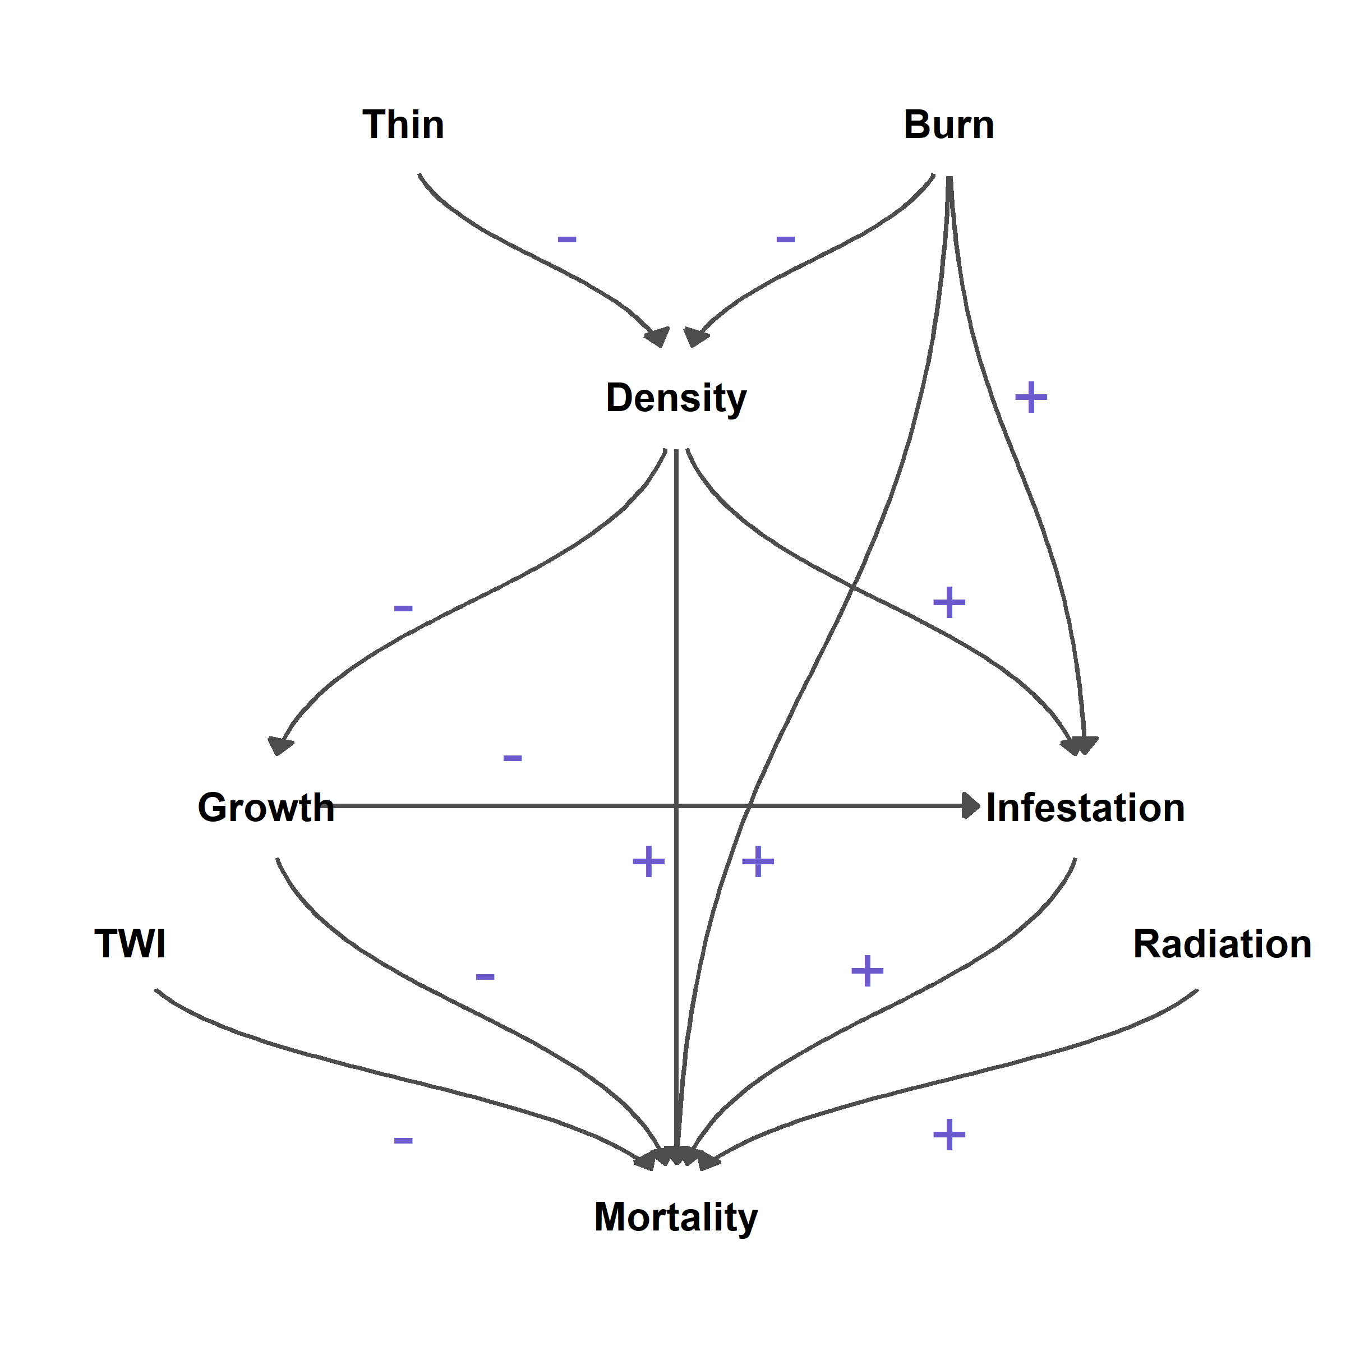

Figure 2.

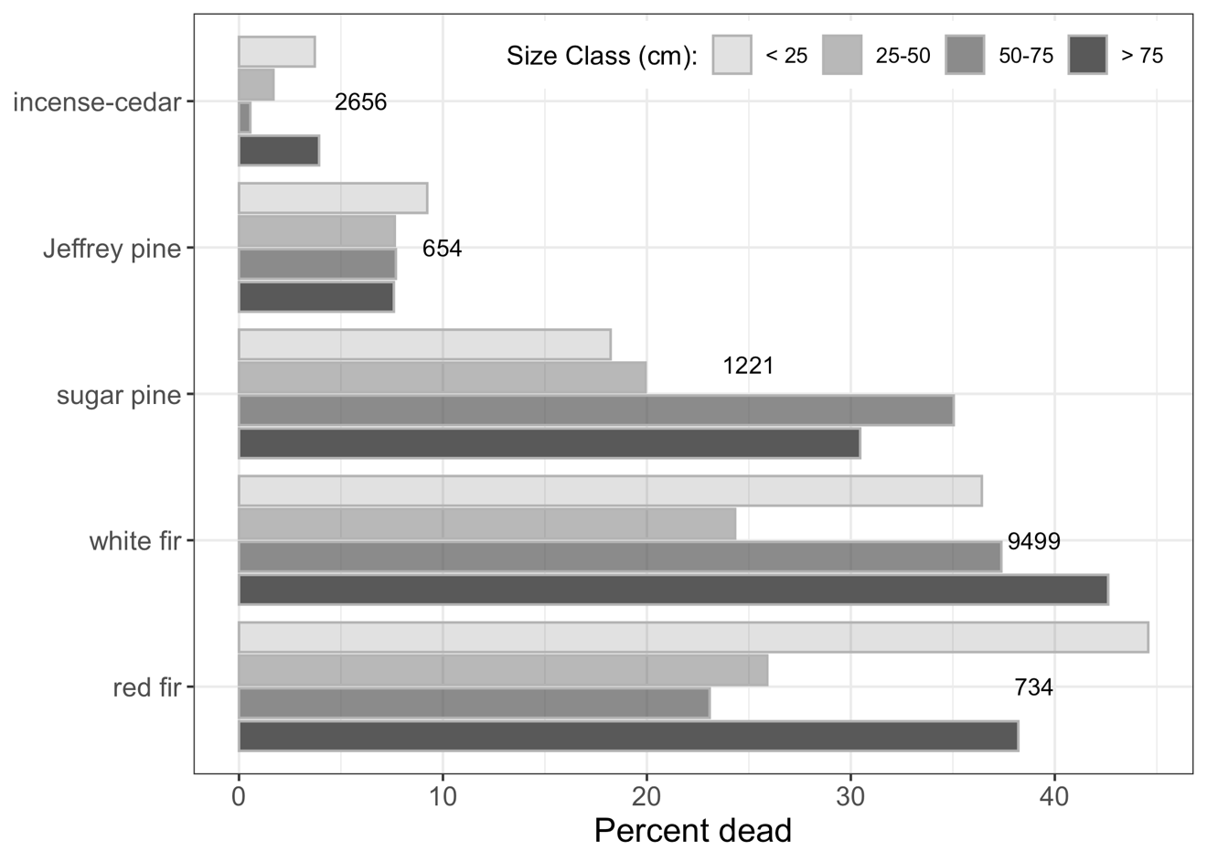

Figure 3.
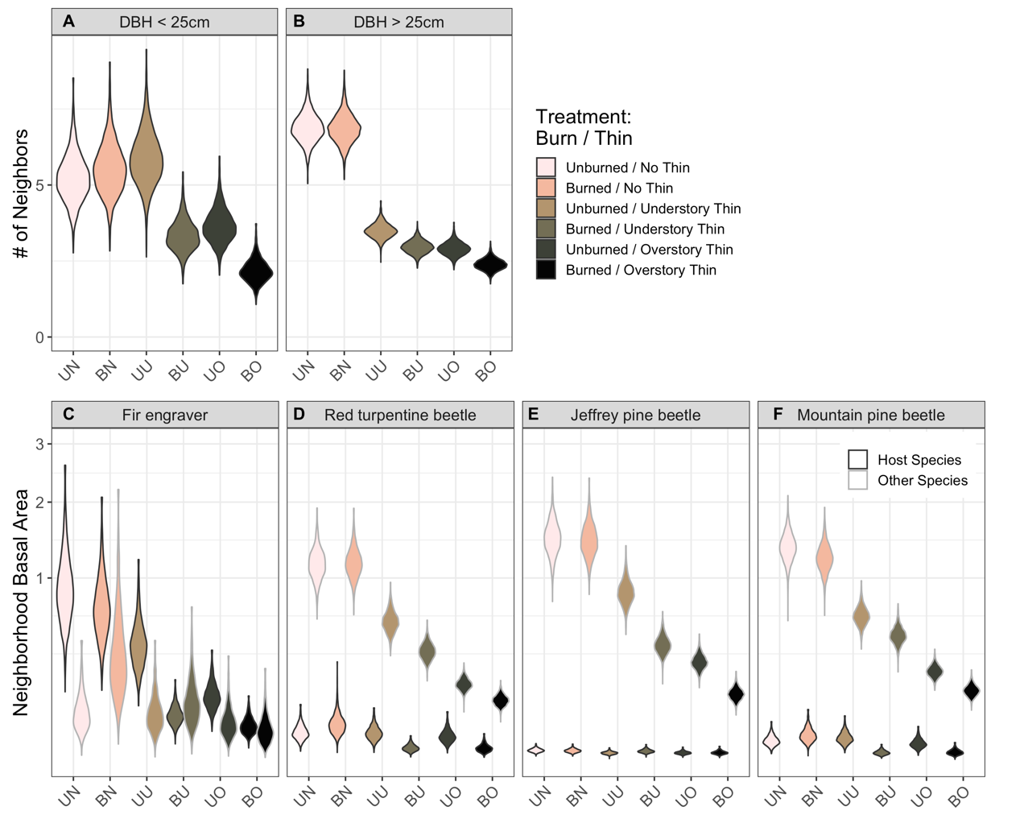

Figure 4.
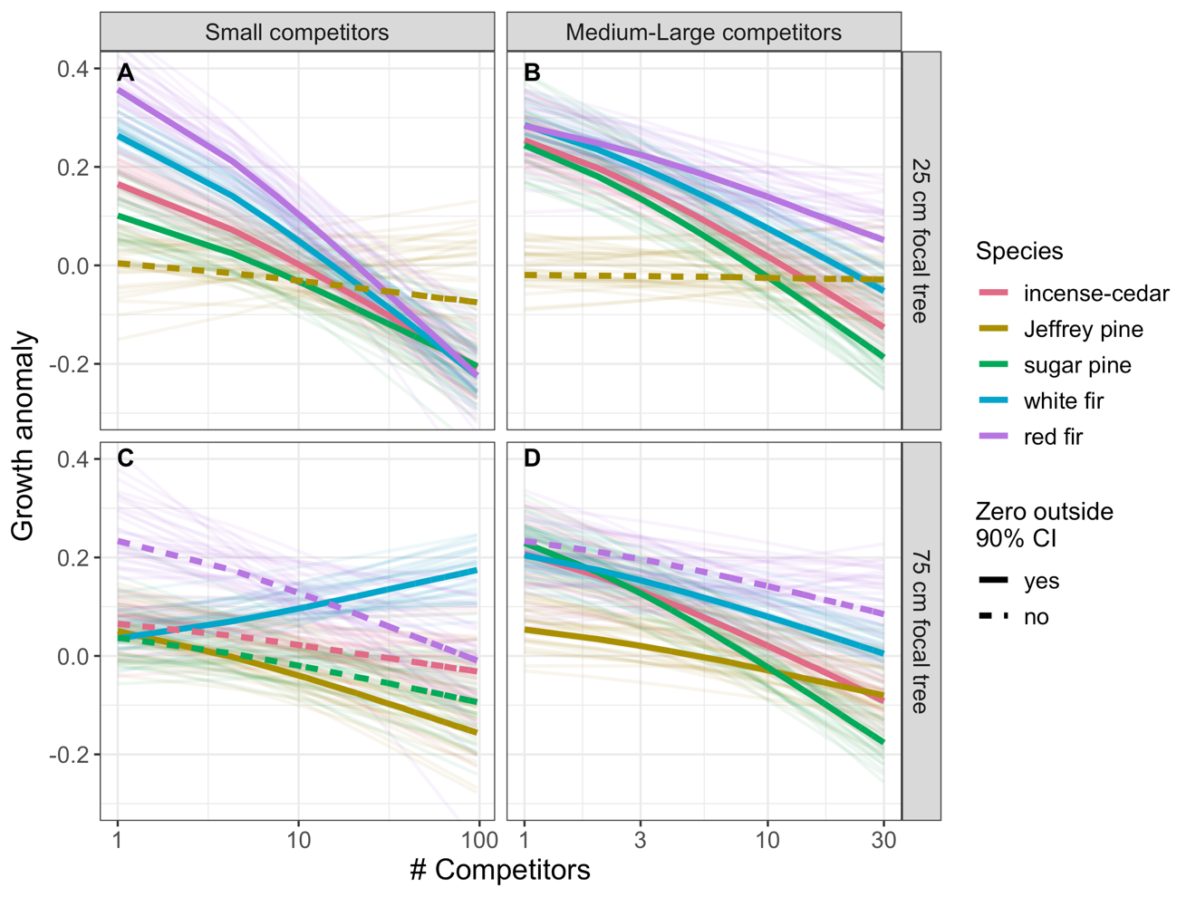

Figure 5.
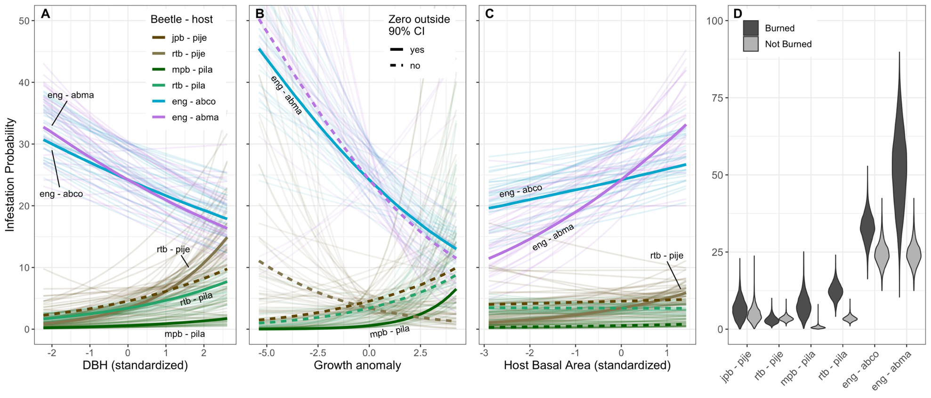

Figure 6.
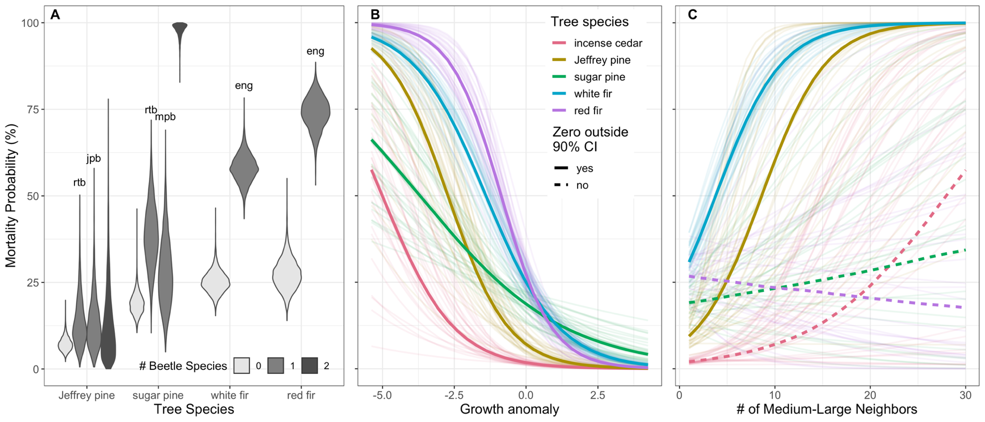

Figure 7.
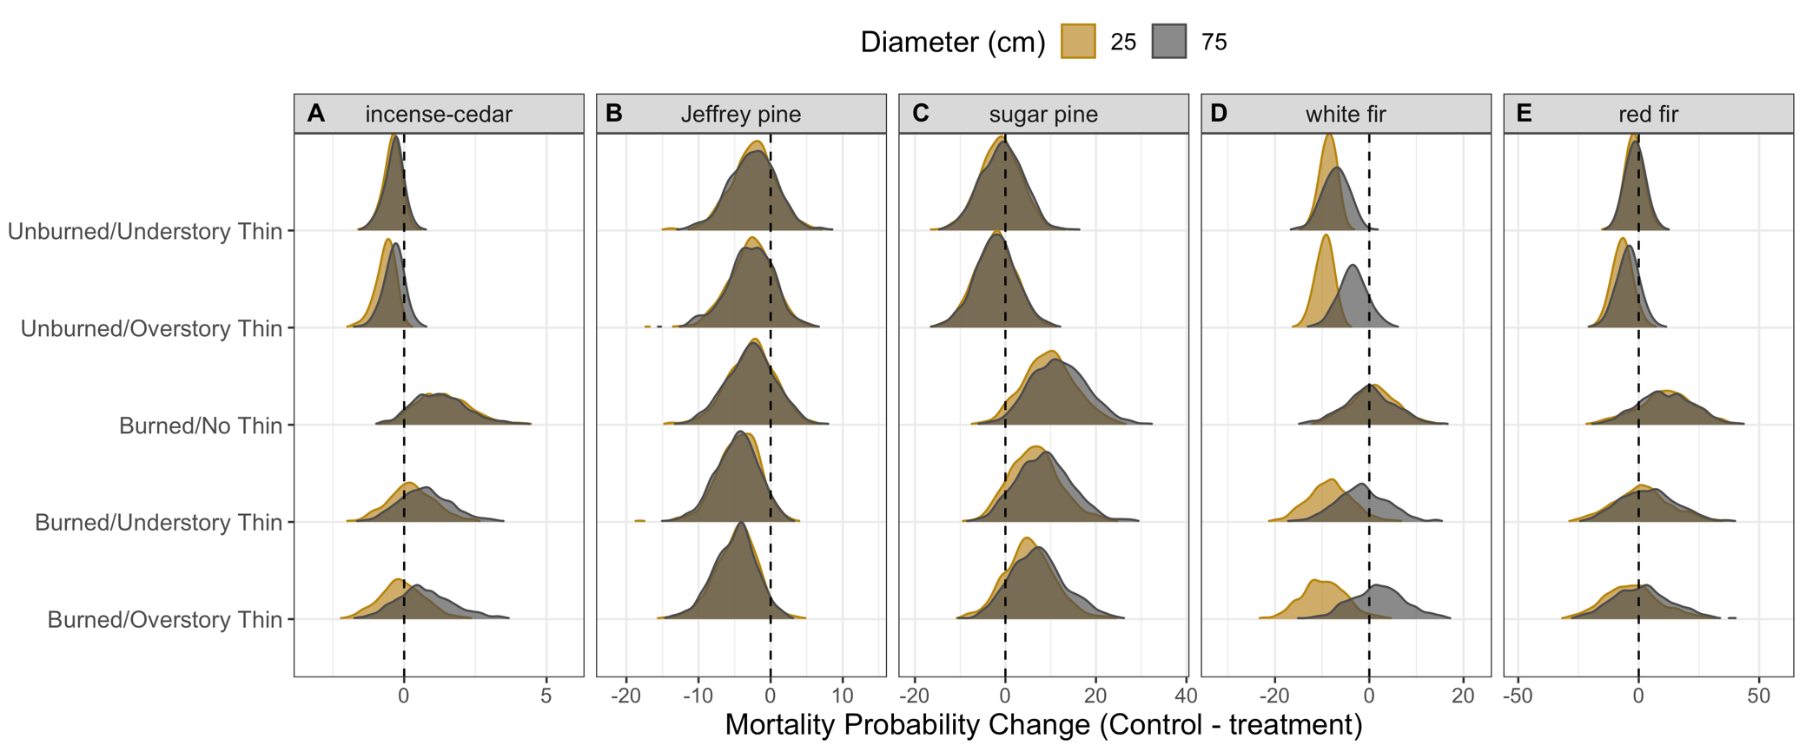

Figure 8.
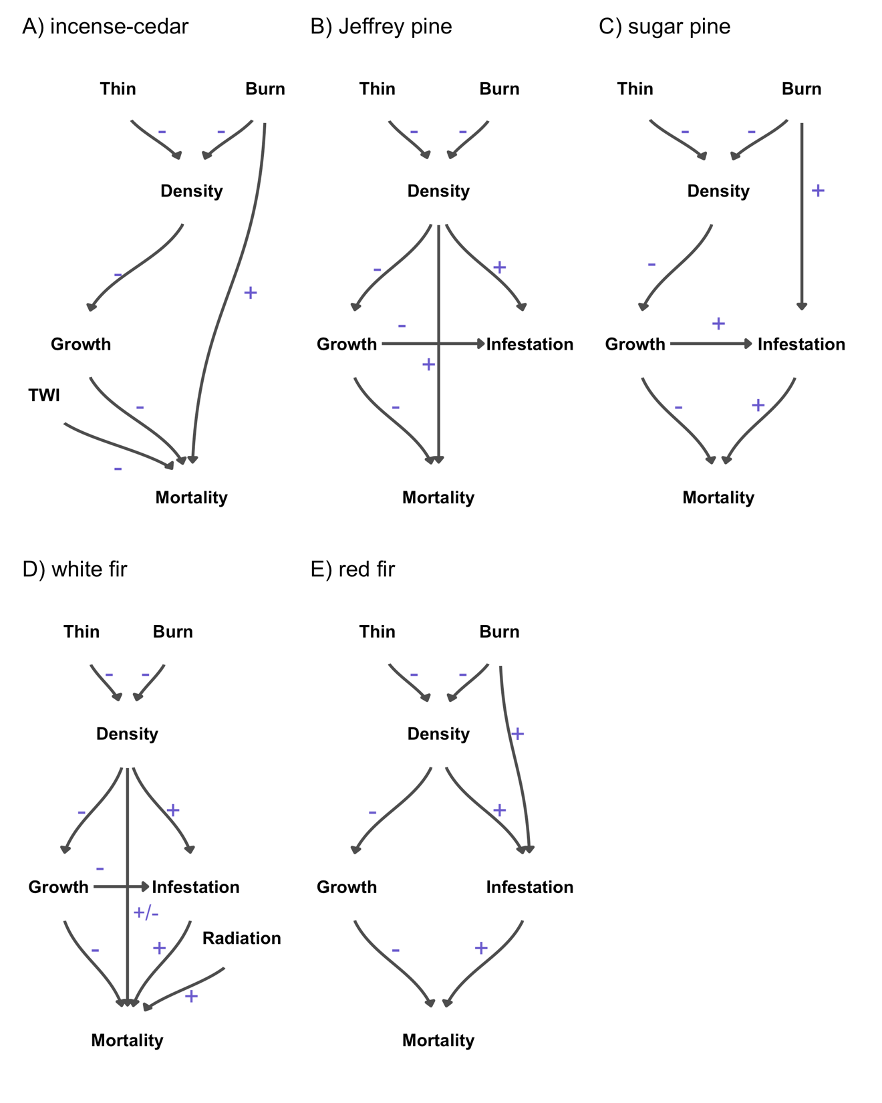
Appendices

Table A1. Percent mortality by species, size class and treatment of all monitored trees. NA indicates no trees are represented in a given combination of variables.
Species | Size Class | Control | Burned /  No Thin | Unburned / Understory Thin | Burned / Understory Thin | Unburned / Overstory Thin | Burned / Overstory Thin
Abies concolor | < 25 | 48 | 30 | 31 | 40 | 35 | 30
Abies concolor | 25 - 49 | 31 | 25 | 15 | 31 | 20 | 24
Abies concolor | 50 - 75 | 37 | 36 | 38 | 38 | 46 | 46
Abies concolor | > 75 | 35 | 44 | 46 | 47 | 41 | 45
Abies magnifica | < 25 | 56 | NA | 38 | 25 | 50 | 0
Abies magnifica | 25 - 49 | 31 | NA | 13 | 20 | 54 | NA
Abies magnifica | 50 - 75 | 18 | 100 | 0 | 50 | 0 | NA
Abies magnifica | > 75 | 38 | NA | 40 | 67 | 0 | NA
Calocedrus decurrens | < 25 | 3 | 5 | 2 | 3 | 3 | 5
Calocedrus decurrens | 25 - 49 | 2 | 1 | 0 | 3 | 0 | 2
Calocedrus decurrens | 50 - 75 | 0 | 0 | 0 | 0 | 0 | 3
Calocedrus decurrens | > 75 | 5 | 2 | 2 | 7 | 0 | 0
Pinus jeffreyi | < 25 | 22 | 2 | 12 | 0 | 6 | 0
Pinus jeffreyi | 25 - 49 | 18 | 8 | 4 | 0 | 0 | 0
Pinus jeffreyi | 50 - 75 | 13 | 10 | 0 | 0 | 0 | 0
Pinus jeffreyi | > 75 | 18 | 10 | 8 | 5 | 2 | 7
Pinus lambertiana | < 25 | 30 | 20 | 11 | 0 | 12 | 38
Pinus lambertiana | 25 - 49 | 33 | 30 | 3 | 18 | 14 | 7
Pinus lambertiana | > 75 | 18 | 44 | 35 | 37 | 13 | 39
Pinus lambertiana | 50 - 75 | 33 | 40 | 100 | NA | 19 | 75

Table A2. Median and 50th quantile range of neighborhood density. Observed values for number of small (< 25cm diameter at breast height) and medium-large (> 25cm DBH), as well as basal area of host and non-host trees for major beetle pest species are tabulated.
Density | Control | Burned / No Thin | Unburned /  Understory Thin | Burned /  Understory Thin | Unburned /  Overstory Thin | Burned /  Overstory Thin
# Small | 7 (4, 12) | 7 (4, 13) | 8 (4, 14) | 3 (1, 7) | 4 (2, 8) | 1 (0, 3)
# Med-Large | 6 (4, 9) | 7 (4, 9) | 3 (2, 4) | 2 (1, 4) | 2 (1, 4) | 2 (1, 3)
Beetle Host
Fir Engraver - Host | 1.3 (0.6, 2.2) | 1.1 (0.5, 1.8) | 0.6 (0.2, 1.2) | 0.1 (0, 0.8) | 0.2 (0.1, 0.6) | 0.1 (0, 0.5)
Fir Engraver - Other | 0.2 (0, 0.9) | 0.5 (0.1, 1.2) | 0.1 (0, 1.4) | 0.2 (0, 1.3) | 0.1 (0, 0.5) | 0.1 (0, 0.3)
Jeffrey Pine - Host | 0 (0, 0) | 0 (0, 0) | 0 (0, 0) | 0 (0, 0) | 0 (0, 0) | 0 (0, 0)
Jeffrey Pine - Other | 1.8 (1, 3) | 1.8 (1, 2.8) | 1.2 (0.4, 2.3) | 0.8 (0.2, 1.7) | 0.5 (0.2, 0.9) | 0.3 (0.1, 0.7)
Mountain Pine - Host | 0 (0, 0.2) | 0 (0, 0.4) | 0 (0, 0.1) | 0 (0, 0) | 0 (0, 0.2) | 0 (0, 0)
Mountain Pine - Other | 1.6 (0.9, 2.5) | 1.6 (0.9, 2.4) | 1 (0.3, 1.8) | 0.9 (0.2, 1.8) | 0.4 (0.1, 0.7) | 0.3 (0.1, 0.7)
Red Turpentine - Host | 0 (0, 0.6) | 0.1 (0, 0.6) | 0 (0, 0.8) | 0 (0, 0) | 0 (0, 0.3) | 0 (0, 0)
Red Turpentine - Other | 1.5 (0.8, 2.4) | 1.5 (0.8, 2.3) | 0.9 (0.3, 1.7) | 0.8 (0.2, 1.6) | 0.3 (0.1, 0.6) | 0.2 (0.1, 0.6)

Supplementary Material

TableS1_modeldata.csv
Model data. Continuous data are standardized with a mean of zero and standard deviation of one.

TableS2_parests.csv
Model coefficient estimates. Mean estimates, standard errors, and 90% confidence intervals are tabulated for each submodel.

Model.R
Model specification in R. Additional supporting code can be found in two publicly available GitHub repositories: https://github.com/africker/Topographic-Wetness-Index and https://github.com/zacksteel/Teakettle_mortality.

