Removing the bad apples: a simple bioinformatic method to improve loci-recovery in de novo RADseq data for non-model organisms
José Cerca^~$*>, Marius F. Maurstad~$‡, Nicolas Rochette%ø, Angel Rivera-Colón%, Niraj Rayamajhi%, Julian Catchen§%, Torsten H. Struck§$
Author details:
^ Corresponding authors: jose.cerca@gmail.com
~ co-first authors
§ co-last authors
$ Frontiers in Evolutionary Zoology, Natural History Museum, University of Oslo
* Department of Environmental Science, Policy, and Management, University of California, Berkeley, CA, USA
> Department of Natural History, NTNU University Museum, Norwegian University of Science and Technology, Trondheim, Norway
‡ Centre for Ecological and Evolutionary Synthesis, University of Oslo
% Department of Evolution, Ecology, and Behavior, University of Illinois at Urbana-Champaign
ø Department of Ecology and Evolutionary Biology, University of California, Los Angeles, CA, USA
Abstract
The restriction site-associated DNA (RADseq) family of protocols involves digesting DNA and sequencing the region flanking the cut site, thus providing a cost and time efficient way for obtaining thousands of genomic markers. However, when working with non-model taxa with few genomic resources, optimization of RADseq wet-lab and bioinformatic tools may be challenging, often resulting in allele dropout – that is when a given RADseq locus is not sequenced in one or more individuals resulting in missing data. Additionally, as datasets include divergent taxa, rates of dropout will increase since restriction sites may be lost due to mutation. Mitigating the impacts of allele dropout is crucial, as missing data may lead to incorrect inferences in population genetics and phylogenetics. Here, we demonstrate a simple pipeline for the optimization of RADseq datasets which involves reducing and analysing datasets at a population or species level. By running the software Stacks at this level, we were able to reliably identify and remove individuals with high levels of missing data (bad apples) likely stemming from artefacts in library preparation, DNA quality or sequencing artefacts. Removal of the bad apples generally led to an increase of loci and decrease of missing data in the final datasets, thus improving the biological interpretability of the data.
Keywords
Library preparation; Genetics; Genomics; Methods; Pipeline; Genome;

Introduction
The establishment of high-throughput sequencing, together with bioinformatic processing tools – the genomics revolution – has impacted biology during the last decade by resolving long standing questions in phylogenetics (Abalde et al., 2019; Rochette et al., 2014; Struck et al., 2011), speciation and adaptation (Birkeland et al., 2020; Ravinet et al., 2018, 2017; Weber et al., 2019), and opening new venues of research such as genome-wide structural variants (Catchen et al., 2020; Faria et al., 2019). While genome-level data has become widely accessible, population-level inference (i.e. population genomics) remains challenging due to the limited number of high-quality genomes and the costs associated with sequencing and analysing large datasets.
These challenges have encouraged the development and establishment of reduced-representation sequencing (RRS), where genomic complexity is reduced by sequencing only a portion of the genome. Chief among RRS is the ‘Restriction site-Associated DNA Sequencing’ (RADseq) (Baird et al., 2008; Davey et al., 2011), a family of techniques which involve digesting DNA using type-II restriction enzymes and sequencing the flanking regions of the cut site. Benefiting from the distribution of restriction sites over the genome, RADseq-based approaches are cost and time-efficient, typically providing thousands of independent loci for population-level inference. For instance, Rochette et al. (2019) estimated that for the price of a single whole genome re-sequenced three-spined stickleback (Gasterosteus aculeatus), >100 individuals may be sequenced at similar depth using RADseq – owing to the pooling of individuals during library preparation and sequencing of only ~3% of the genome.
Since RADseq-based approaches rely on the existence of cut sites along the genome, the conservation of the cut site is of critical importance for recovering shared data among different individuals (Eaton et al., 2017; Huang and Lacey Knowles, 2016; O’Leary et al., 2018). Allele dropout occurs when a given locus or allele is not sequenced in one or more individuals, and it may result from biological divergence – when a mutation modifies the cut site. Rates of allele dropout are thereby expected to be correlated with the time of lineage divergence (Crotti et al., 2019; Eaton et al., 2017; O’Leary et al., 2018). However, allele dropout may also result from artefacts in the experimental design, such as sampling bias and low sequence coverage; or from problems associated with library preparation, such as issues with enzyme digestion or size selection, and human error; or from artefacts from bioinformatic analyses, such as problems associated with clustering of sequencing reads (Crotti et al., 2019; O’Leary et al., 2018). In fact, allelic dropout originating from these technical artifacts can sometimes exceed dropout of biological origin under certain experimental conditions (Rivera-Colón et al., 2020). In some organisms, extracting DNA may still be non-trivial due to their reduced size, age of preservation, or presence of chemical compounds which may interfere with the extraction. Whatever the case may be, high allele dropout translates to high rates of missing data in the dataset, which may dramatically influence allele frequency in the dataset (Arnold et al., 2013; Gautier et al., 2013; Hodel et al., 2017), or phylogenetic estimations (Crotti et al., 2019; Eaton et al., 2017).
Attempts to minimize the challenges posed by allele dropout include suggestions for parameter optimization and control (Paris et al., 2017; Rochette and Catchen, 2017), data-filtering and data exploration (O’Leary et al., 2018), data-cleaning thresholds (Crotti et al., 2019), and prospective and retrospective data simulation based on the reference genome available (Rivera-Colón et al., 2020). Despite these, retrieving an optimal dataset from a RADseq experiment can pose challenges. On one hand, technical expertise involving enzyme selection, library size selection, and selection of the number of PCR rounds (broadly library preparation) may be scarce for biologists working with non-model systems. On the other hand, post-sequencing approaches to filter data may lead to pruning of informative loci (Huang and Lacey Knowles, 2016; Lee et al., 2018), or to the retention of loci with particular characteristics in datasets with varying levels of species divergence (Dincă et al., 2019; Hodel et al., 2017).
Here, we suggest a simple method to mitigate allelic dropout issues in datasets where biological allelic dropout is mixed with that associated with biases in library preparation, experimental design and bioinformatic processing of the data. Simply put, by processing RADseq data at the population or species level (Figure 1), users will be able to reduce evolutionary distance in the dataset, and isolate different sources of dropout. While most RAD studies are comprised of a metapopulation, composed from several subpopulations, most analyses focus on optimizing parameters across the metapopulation as a whole. Instead, here we suggest optimizing parameters directly in each subpopulation or subspecies. Using this approach in 4 datasets, we identified individuals with a high degree of missing data (hereafter bad apples), and removed them from the final analysis comprising all populations (Figure 1).
Materials and Methods

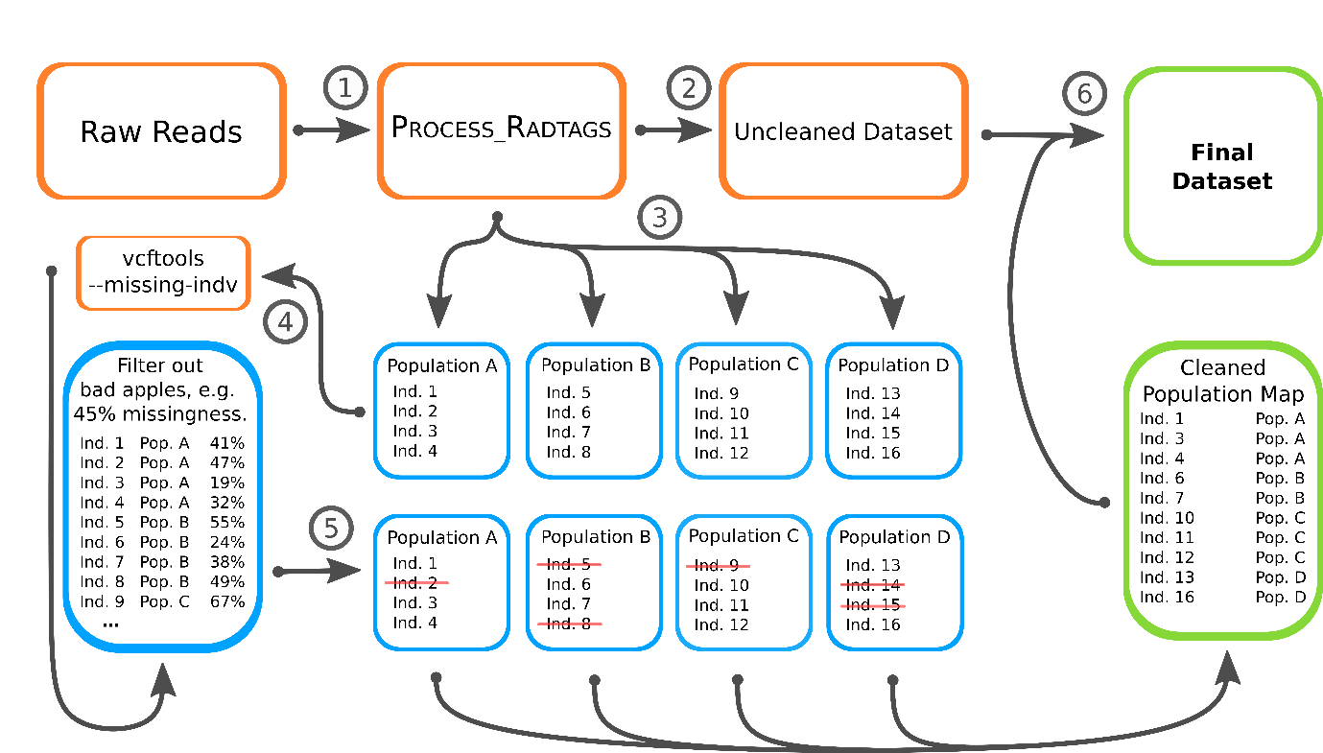
Figure 1 – Overview of the Stacks-based bad apples pipeline. 1 – raw reads are first processed with process_radtags, which removes reads without barcode and cut-site, and de-multiplexes the raw-reads; 2 – a Stacks run (u/c/s/gstacks) consisting of the whole dataset; 3 – Identification of bad apples by running Stacks separately for each population or species (depending on the scale of the dataset); 4 – determination of bad apples based on individual-level missing data, as estimated with vcftools (--missing-indv); 5 – identification and removal of bad apples from the population-map (the file that Stacks uses to assign individuals to populations or species); 6 – Using the initial Stacks run (unclean dataset) together with a cleaned population map, users retrieve the final dataset using the populations module which will filter the bad apples from the original dataset (hybrid-clean approach).

Data
To test the suggested pipeline, we used four datasets including: 1) a ddRADseq dataset comprising populations of the meiofaunal Annelid Stygocapitella zecae (Cerca et al unpublished data; 21 samples, six populations); 2) a single-digest RADseq dataset comprising several species of Euhadra molluscs (Richards et al., 2017); 16 samples, four species); 3) a ddRADseq dataset comprising populations of the Antarctic sponge Dendrilla antarctica (Leiva et al., 2019; 62 samples, seven populations); and 4) a hyRADseq dataset of Anthochaera phrygia combining museum and modern samples (Crates et al., 2019; 230 samples, eight populations).
Bioinformatic processing
A graphical overview of the bioinformatic processing is provided in Figure 1. We processed the four datasets using the de novo pipeline implemented in Stacks v2.41 (Rochette et al., 2019). We began by optimizing the clustering parameters -M (number of mismatches allowed between stacks within individuals) and -n (number of mismatches allowed between stacks between individuals) following Paris et al (2017)’s method to optimize RADseq data in Stacks. We selected -M 2 -n 2 for the final analysis of every dataset, with the exception of the A. phrygia where we selected -M 3 -n 3. Using these parameters, we ran Stacks using the de novo wrapper thereby generating a dataset with the complete number of individuals available (hereafter unclean datasets; Figure 1, steps 1-2).
After obtaining the unclean datasets, we ran Stacks for each population individually for the Stygocapitella, Dendrilla and Anthocaera datasets (Figure 1, step 3), and for each species separately in the Euhadra datasets (Supplementary tables 1-4) and generated a variant call format (VCF) file for each. We obtained information on missing data for each individual using vcftools (Danecek et al., 2011) (--missing-indv option; Supplementary tables 1-4; Figure 1, step 4). With the whole dataset in mind, we labelled individuals as to keep or remove (bad apples), following a general strategy which included: (i) retaining a minimum of two individuals per population or species; (ii) designating a threshold for missing data, based on the average missing data for each whole dataset (≥40% missing data for Stygocapitella, ≥30% for Euhadra, ≥65% for Dendrilla, ≥40% for Anthocaera). Notice that we kept some individuals with high missing data in the Anthochaera dataset since they are valuable ancient specimens, therefore only removing ancient specimens with 100% missing data (Figure 1, step 5). Additionally, since there was a very high range of missing data for Dendrilla, we also ran populations with -r 0.2 (minimum percentage of individuals in a population required to process a locus for that population) for this dataset.
After the identification of the bad apples, we generated three new datasets: clean, hybrid-clean and random. The clean dataset comprised only kept samples (that is every specimen not labelled as a bad apple), and involved re-running the whole Stacks pipeline (starting in ustacks). The hybrid-clean dataset also included the same specimens as the clean one (all kept specimens), but involved re-using the unclean Stacks output as represented in Figure 1, step 6. Essentially, Stacks assembles loci across all samples first using u/c/s/gstacks, and then the data are filtered with the populations module. Therefore, in its essence, the stacks-run behind the hybrid-clean dataset includes all individuals, but bad apples are only excluded at the filtering step. Finally, to understand the overall impact of removing specimens, we established 10 random runs, where we removed the same number of specimens as the number of bad apples detected, however, specimens were removed randomly. The aim of the random dataset is to assess the effect of just removing a certain number of specimens on the final dataset.
Assessment of the results
To determine differences between the unclean, clean, hybrid-clean and random datasets, at different filtering options we generated (i) the overall number of loci provided by populations at different filtering thresholds, (ii) the % of missing data also at different filtering thresholds (Supplementary Table 5) and (iii) explored whether there are differences between kept/removed loci. Specifically, to obtain the (i) number of loci, we ran populations with a fixed -p (minimum number of populations a locus must be present in to process a locus; -p 4 for Stygocapitella zecae, -p 4 for Euhadra spp., -p 2 for Dendrilla antarctica, and -p 2 for Anthochaera phrygia) and with -R of 0%, 10%, 20%, 30%, 40%, 50%, 60%, 70%, 80%, 90%, and 100% (minimum percentage of individuals across populations required to process a locus). We opted for a fixed -p since the number of populations was similar across datasets, but varied -R since it focuses on the number of individuals, that is the variable between the unclean and the remaining data. To obtain (ii) estimates of missing data, we obtained estimates of missing data using vcftools, as reported above for the identification of bad apples. For both, we determined the relative difference of the evaluated datasets (clean, hybrid-clean and random) to the value of the unclean dataset. Therefore, the difference of the number of loci and missing data, respectively, of the evaluated datasets to the unclean dataset was obtained and then divided by the value obtained for unclean dataset. The relative differences are given as percentages by multiplying by 100. We restricted these analyses to filtering thresholds, which generated at least 100 loci in the unclean dataset, since small denominators generate high relative values even when facing small changes. For example, in Stygocapitella the filtering of -p 4 -R 1 generates only one loci in the unclean dataset and two in the hybrid-clean and clean ones. In relative terms, this is a 100% increase in loci, but, in practical terms, this is not really practical. Moreover, studies using RADseq to not typically rely on small numbers of loci, but usually consider hundreds or thousands of loci. Therefore, only filtering stages up to -R 0.6 were considered for Stygocapitella, -R 1.0 for Euhadra, and -R 0.5 for both Dendrilla and Anthochaera (Supplementary Table 5). Finally, (iii) we explored whether removing individuals affected particular classes of loci by comparing the hybrid-clean and unclean datasets, which share the same set of set of assembled loci (catalogue in Stacks) since they diverge only at the filtering stage. To do so, we converted the data to a present/absence data format and plotted the number of a) loci kept in the whole dataset, b) all loci in the bad apples, c) all loci in kept specimens, d) loci kept in the bad apples, and e) removed loci in bad apples.
Results
Data cleaning
There was a wide variation in terms of variant sites (SNPs) and missing data when running different populations separately in all four datasets (Supplementary Tables 1-4). Nonetheless, the values for the number of variants and missing data do not correlate. For instance, in the Stygocapitella dataset, at one extreme the Ardtoe population had a total of 37,028 SNPs, while at the other end the Lødingen population had 2,821 SNPs (Table 1). Despite these differences, both populations had an average missing value of 53% and 55%, respective. These two, together with Henningsvær (53% missing data), are at the higher distribution of missing data (Table 1). The lowest value for missing data is 22% and found in Cutty Sark. According to the established protocol to label and remove bad apples, we removed one individual from Ardtoe 97% missing data, one individual from Lødingen with 71%, and two from Henningsvær with 60% and 94%. No individual was removed from the Cutty Sark population (Supplementary Table 1). The remaining populations, Kristineberg and Musselburough, have a number of variants within the aforementioned ranges, and we removed one individual from each with 60% and 68% missing data, respectively (Supplementary Table 1). In total, we removed six individuals from a total of 21 (i.e. 29% of the dataset was removed; Supplementary Table 1). This improved the average missing data for each population except for Cutty Sark, where no individuals were excluded (Table 1). The strongest change could be observed for the Henningsvær population, which decreased from 53% to 28% missingness.
Table 1. Results of the population or species level analyses for the respective level and case system. Total number of variant sites per population/species and average missingness per population/species for all individuals, all individuals below the threshold and all included individuals is given. Since there was a very high range of missing data for Dendrilla antarctica, we also ran populations’ filtering with -r = 0.2 (minimum percentage of individuals in a population required to process a locus for that population) for this species.

Population/species | Variant sites | Average missingness
 | # | all individuals | all <threshold | all included
Stygocapitella zecae
Ardtoe | 37,028 | 53 | 42 | 42
Cutty Sark | 11,059 | 22 | 22 | 22
Henningsvær | 13,893 | 53 | 28 | 28
Kristineberg | 20,158 | 45 | 41 | 41
Lødingen | 2,821 | 55 | 48 | 48
Musselburough | 6,172 | 48 | 38 | 38
Euhadra spp.
Euhadra aomoriensis | 33,866 | 28 | 22 | 22
Euhadra quaesita | 40,493 | 23 | 21 | 21
Euhadra senckenbergiana | 19,126 | 10 | 10 | 9
Dendrilla antarctica
Den_CIE (without -r) | 5,155 | 74 | - | -
Den_CIE (with -r 0.2) | 4,389 | 70 | 41 | 41
Den_DEC (without -r) | 4,829 | 68 | - | -
Den_DEC (with -r 0.2) | 4,083 | 65 | 44 | 44
Den_FIL (without -r) | 3,613 | 77 | - | -
Den_FIL (with -r 0.2) | 1,581 | 62 | 52 | 52
Den_HM (without -r) | 2,162 | 67 | - | -
Den_HM (with -r 0.2) | 1,944 | 64 | 55 | 55
Den_OH¹ | 2,086 | 44 | 44 | 37
Den_PAR¹ | 636 | 39 | 39 | 30
Den_ROT (without -r) | 6,317 | 71 | - | -
Den_ROT (with -r 0.2) | 3,299 | 57 | 47 | 44
Anthochaera phrygia
ACT | 937 | 38 | 20 | 24
ADL | 428 | 34 | 29 | 31
NA | 2,656 | 50 | 28 | 41
NNSW | 361 | 33 | 25 | 27
NVIC | 396 | 33 | 23 | 29
QLD | 76 | 36 | 28 | 32
SVIC | 467 | 40 | 23 | 31
BMTN | 305 | 38 | 22 | 28
¹ this population was assessed without filters due to the lack of data using filters and the average values for all individuals below the threshold and all included individuals were taken without the filters

Of all four datasets, the Euhadra dataset has the highest number of SNPs and the lowest missing data (Table 1). When running species separately, Euhadra aomoriensis has the highest average missingness, with 28% over 33,866 SNPs, while E. quaesita yielded the most SNPs (40,493) and an average of 23% missing data. Euhadra senckenbergiana had the lowest numbers in terms of variants and average missing data, with 19,126 SNPs and 10%, respectively. In E. aomoriensis, we identified and removed two individuals with 44% and 34% missing data. In E. quaesita, we removed one individual with 30% missing data (threshold of 29%; Supplementary Table 2). We also removed the individual of E. senckenbergiana with the highest degree of missingness (12%, Supplementary Table 2), since we wanted to explore the effect of removing several individuals. In total, we removed four individuals from a total of 15 (27% of the dataset removed; Supplementary Table 2). The average missingness for each population was decreased with the steepest decrease in E. aomoriensis (Table 1).
The Dendrilla dataset has the highest degrees of missingness of all four datasets. When running different populations separately, average missingness values range from 39% in the population Den_PAR to 77% in Den_FIL when no filtering is applied (‘-r’ flag, Table 1). The filter ‘-r 0.2’ decreased missingness (Table 1), but the populations Den_OH and Den_PAR yielded no SNPs left. These are also the two populations with lowest number of SNPs (i.e., 2,086 and 636) when no filtering was applied. The Den_ROT population yielded the most SNPs, with 6,317 without filtering (decreasing to 3,299 SNPs after filtering). The difference between the obtained number of loci before and after filtering was less substantial in the Den_CIE population; in specific, there were 5,155 and 4,389 before and after filtering (Table 1). Using a threshold of 64% missing data, we removed at least 1 individual from each population (Supplementary Table 3). The filtering was, in some cases, quite rigorous since it excluded a substantial number of individuals. For instance, in Den_CIE we excluded as many as six out of nine individuals. We removed 31 individuals from a total of 62 (50% of the dataset; Supplementary Table 3). Due to this rigorous removal of individuals, the average missingness decreased substantially in some populations (Table 1). For example, in Den_CIE missing data decreased from 70% to 41%.
Finally, the Anthochaera dataset had the lowest number of SNPs across populations ranging from 76 in the QLD population to 2,656 in the NA population (Table 1). The extent of missing data is comparable to that observed in the Stygocapitella dataset, with the NA population when ran separately, having the most missing data (50%), and NNSW and NVIC having only 33% (Table 1). We removed at least one individual in each population, following a threshold of 39% (Supplementary Table 4). Importantly, we kept some individuals above this threshold since the dataset included valuable individuals, such as ancient specimens. We removed 41 individuals from a total of 230 (18% of the dataset was removed; Supplementary table 4), which led to a decrease of the missing data (Table 1). However, due to some of the retained individuals, which have substantially high values of missing data, the decrease is not substantial. For example, the decrease in the SVIC population is only from 40% to 31% instead of 23% (Table 1).
Improvement of the datasets after the removal of bad apples
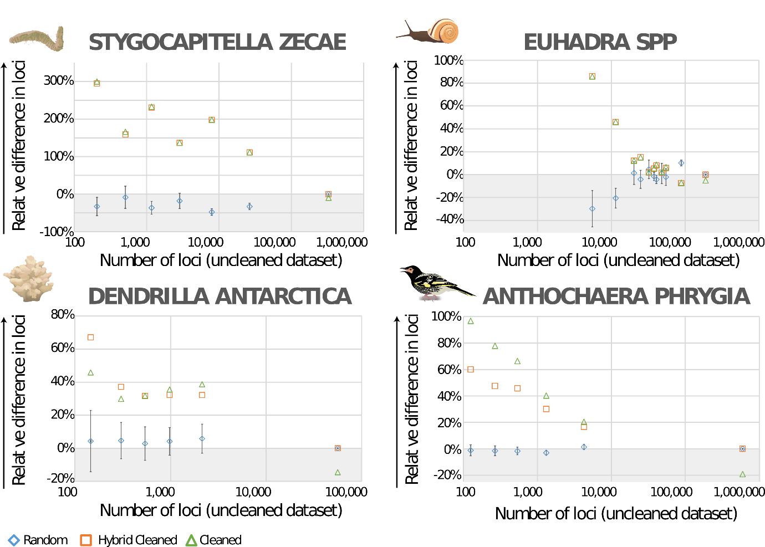
Figure 2 – The relative difference in the number of loci for the random, hybrid-clean and clean datasets to the unclean dataset for Stygocapitella, Euhadra, Dendrilla and Anthochaera datasets in relation to the number of loci in the unclean dataset (the higher the number of loci the lower the parameter R from the Populations module). For the random datasets, the median and the standard deviations are given. The arrows indicate the directions of improvement and the grey zones the areas, where the unclean dataset is performing better.

In general, the clean and hybrid-clean datasets yielded substantially more loci, in some cases as much as 300% more than the unclean dataset (Figure 2). Notably, the relative difference increases with decreasing numbers of loci in the unclean dataset. This effect cannot merely be attributed to having a smaller dominator, as discussed above, since the random datasets yields the same number of specimens than cleaned and hybrid cleaned. Therefore, this confirms that bad apples have an overall negative effect on the number of loci. While these effects are noticeable in every dataset, they are least pronounced in the Euhadra dataset. This is because Euhadra was, relatively, the best of all datasets, since it had lower missing data and a higher number of loci. In contrast to the remaining three datasets, in Euhadra, all -R filtering had >100 loci (Supplementary Table 5). However, even in an excellent dataset, such as the Euhadra dataset, the increase of loci in the clean and hybrid-clean datasets at lower numbers of loci, when compared to the random dataset (Figure 2), is indicative that even in this dataset there is an improvement of removing bad apples, when stricter settings are applied. Another interesting observation is that only at the least restrictive settings (- R 0, -R 0.1), which result in the greatest number of loci, there is not a negative effect of removing the bad apples on the number of loci across all datasets (Figure 2). Considering this, and the difference observed between the Euhadra dataset and the other three, it seems that in these cases (i.e., very low restrictive settings or very good dataset) the unclean dataset reaches a high number of loci. However, in all other cases, removing bad apples has a clear, sometimes substantial effect.
Except for the Anthochaera dataset, there is no obvious difference between the clean and hybrid-clean approach in terms of the number of loci (Figure 2). In the Stygocapitella and Euhadra datasets, both these datasets retrieve nearly similar values. In the Dendrilla dataset, clean and hybrid-clean perform better in different -R values. The clean performs slightly better at less restrictive settings than the hybrid-clean. In the Anthochaera dataset, the clean approach performs much better than the hybrid-clean.
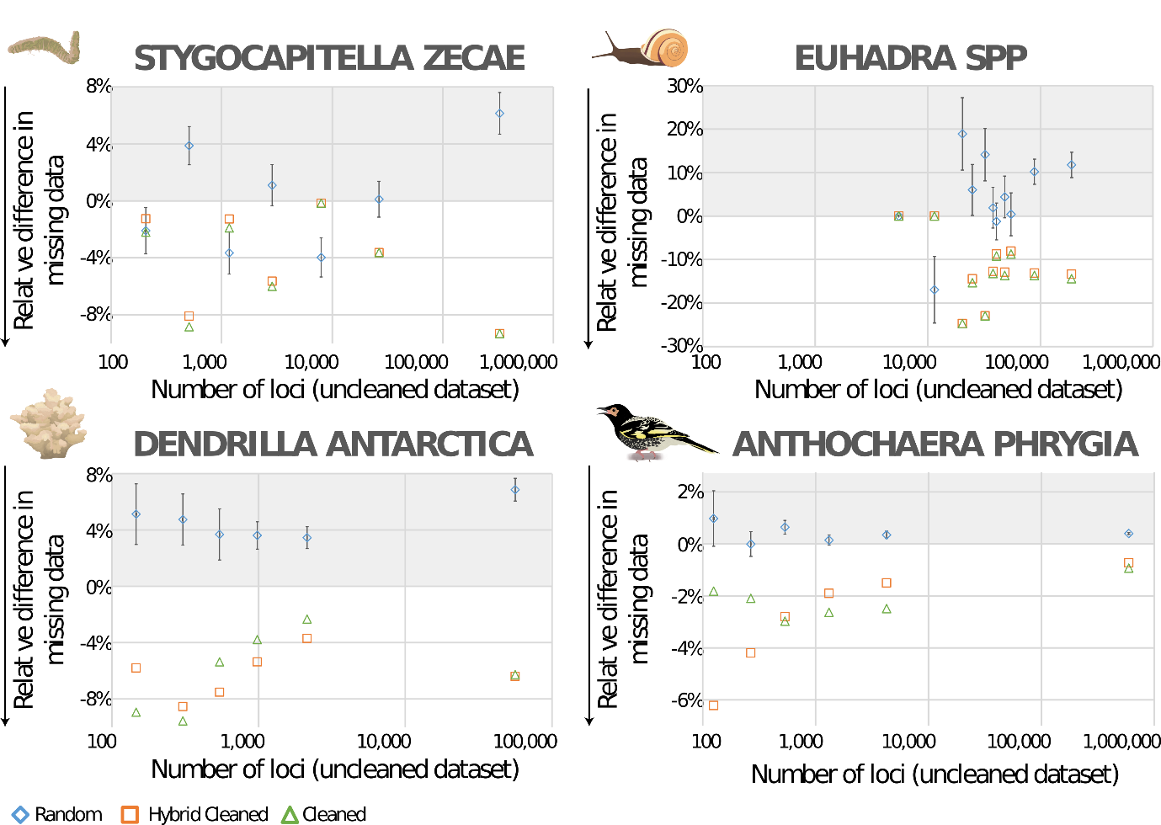
Figure 3 – The relative difference in the average missingness for the random, hybrid-clean and clean datasets to the unclean dataset for Stygocapitella, Euhadra, Dendrilla and Anthochaera datasets in relation to the number of loci in the unclean dataset (the higher the number of loci the lower the parameter R from the Populations module). For the random datasets, the median and the standard deviations are given. The arrows indicate the directions of improvement and the grey zones the areas, where the unclean dataset is performing better.

With respect to missing data, removing bad apples also improved the datasets. The only exceptions were two -R levels of the Euhadra dataset where there was no difference (0%) between the clean and unclean dataset (Figure 3). In the Dendrilla and Anthochaera datasets, the random datasets are clearly worse than the clean and hybrid-clean datasets. In the Stygocapitella dataset, there were different results following different filtering settings. In four cases, the two cleaning approaches are clearly better than the random exclusion, while in three cases the random exclusion was as good or even better than cleaned and hybrid cleaned. In the Euhadra dataset, except for the two most restrictive settings, the cleaned and hybrid-cleaned are clearly better than the random exclusion. This may be explained by this being the best of all datasets, as presented above (Table 1, Supplementary Table 5), and therefore there may be little room for improvement with respect to missingness at the most restrictive settings.
Considering the two cleaning approaches, clean and hybrid-clean, there is no difference in performance in the Stygocapitella and Euhadra datasets (Figure 3). In the Dendrilla dataset, the clean approach appears to perform slightly better at more restrictive settings (i.e. higher -R, lower number of loci) and the hybrid-clean at less restrictive settings. In the Anthochaera dataset, the clean outperforms hybrid-clean only in less restrictive settings.
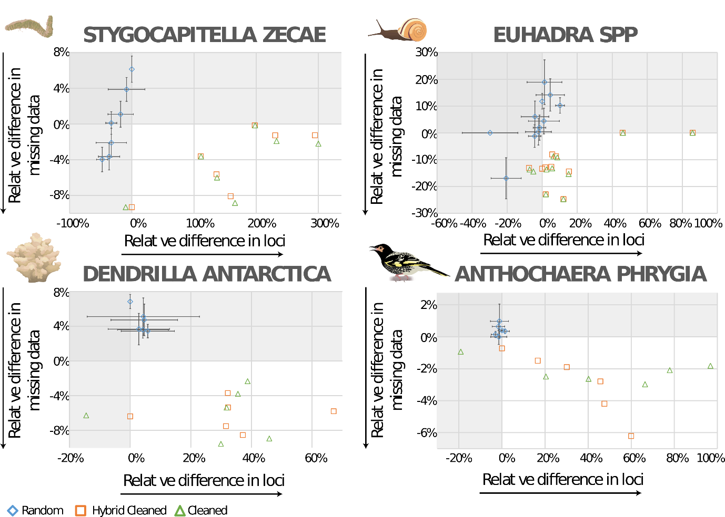
Figure 4 – The relative difference in the number of loci in relation to the average missingness. For the random datasets, the median and the standard deviations are given. The arrow indicate the directions of improvement and the grey zones the areas, where the unclean dataset is performing better in one or both of the parameters.

Finally, considering both the number of loci and the missingness, removing bad apples always improves the dataset, the random datasets are clearly performing worse than the clean and hybrid-clean approaches (Figure 4). Only in the Euhadra dataset, this difference is not as pronounced as in the other three datasets. In the Stygocapitella and Euhadra datasets, the number of loci is increased and the missingness is reduced in the majority of the settings. However, the relationship between these two measurements is slightly negative. Hence, when there is little or no improvement in missingness, the number of loci increases and vice versa. The two cleaning approaches perform generally very similar in both datasets. In the remaining two datasets, the correlation is slightly different. In the Dendrilla dataset, both the number of loci and the missing data generally improve, but there seems to be no correlation between them. In contrast, in the Anthochaera dataset, using the hybrid-clean approach there is a general positive correlation between both, while in the clean approach the improvement in missingness seems constant while the number of loci increases. Also, in the Dendrilla dataset, the clean and hybrid-clean approaches perform slightly different, but no clear pattern can be observed.
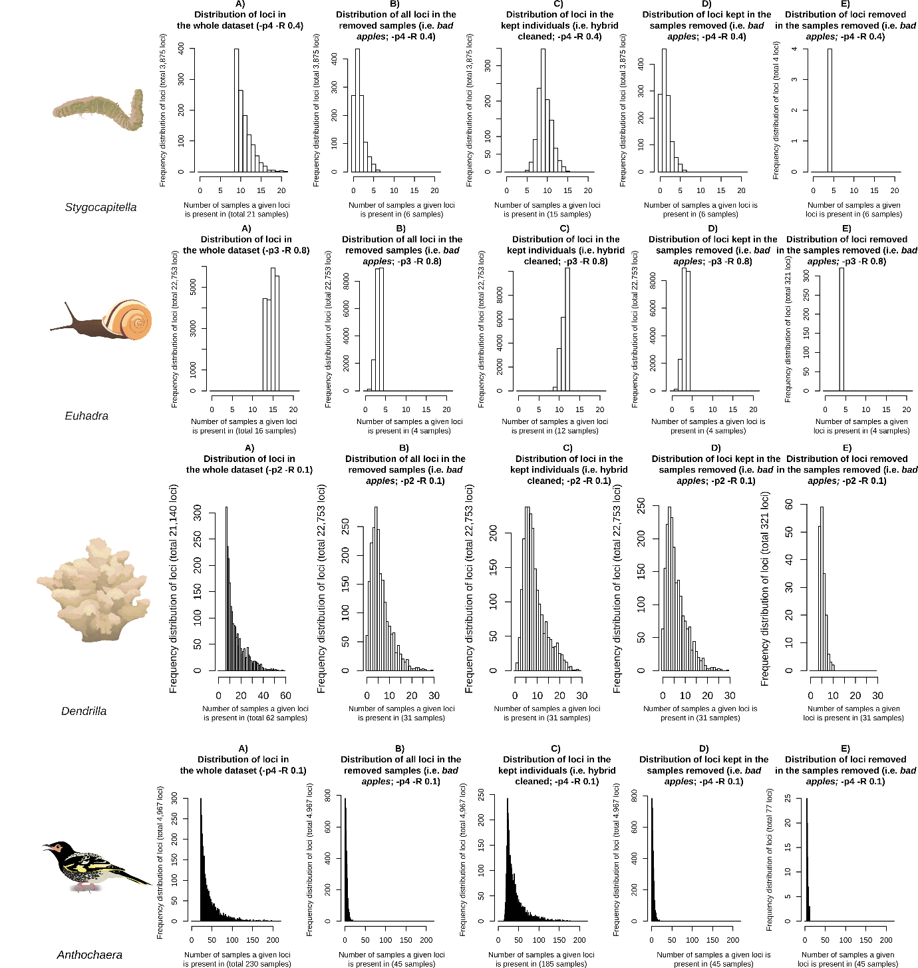
Figure 5 – Distribution of loci in the whole dataset (A, F, K, P), in the removed samples or bad apples (B, G, L, Q), and in the kept individuals (C, H, M, R). Distribution of only kept loci in the samples removed or bad apples (D, I, N, S), and the loci removed in the samples removed or bad apples (E, J, O, T). The four datasets Stygocapitella (A-E), Euhadra (F-J), Dendrilla (K-O), and Anthochaera (P-T) are presented. Notice different datasets had different cutting-thresholds.

Removal of bad apples does not appear to bias the dataset against a particular class of loci (Figure 5). Indeed, loci that were removed from the dataset as a result of the exclusion bad apples still had high missingness rates in bad apples. For Stygocapitella and Euhadra, this was evident from the very small number of removed loci (i.e. the rarity of loci for which the missingness criterion is met in the initial dataset due to a low missingness in bad apples). This suggests that the disappearance of some loci after the exclusion of bad apples is driven by the inherent stochasticity of locus presence/absence in both good individuals and bad apples, rather than by systemic differences in the set of loci present in bad apples.
Discussion
When considering the number of loci and missing data together, removing bad apples (i.e. samples with high missing data) has a positive effect on the datasets, by increasing loci and/or decreasing missing-data. This effect is not attributable to the removal of specimens, as the random dataset performed worse, retrieving less loci and generally retained more missing-data. Furthermore, the hybrid-clean and clean approaches generally yield similar performances, both in terms of missing data and number of loci (Figure 2-4). While some differences could be observed, they do not seem to be predictable, consistent and depended on the dataset and parameter investigated. This suggests that it will be easier for users to identify bad apples and by conducting a single Stacks run where bad apples may be only removed at the populations component of the pipeline (Figure 1).
Optimization of RADseq data
The identification and removal of the bad apples on a dataset yielded up to a 3-fold increase in the number of loci (Figure 2), at the cost of the removal of 18-50% of the specimens. The retrieval of more loci allowed filtering the data more thoroughly, thus obtaining a ‘high-quality’ collection of variants (Paris et al., 2017). For instance, -R 0.6 in the hybrid-clean approach in Stygocapitella, a threshold considered for datasets consisting of highly diverged individuals (Paris et al., 2017), yielded more loci than -R 0.5 in the unclean dataset.
Despite these clear benefits, the identification and removal of bad apples should be conducted carefully. First, the principle behind bad apples requires that population and/or species are carefully determined as part of the experimental design. For most studies, the determination of populations and species is done a priori and is required by ‘population maps’, included as part of Stacks. In any case, the lack of precision, such as the inclusion of individuals from different populations together, may lead to the pruning of individuals from a minor/deviant genetic background. This may be particularly difficult for, for instance, marine populations where determining populations remains challenging (Cerca et al., 2018; Hellberg, 2009), or in cases where individuals from morphologically similar species (cryptic species) are overlooked (Struck et al., 2018; Struck and Cerca, 2019) and potentially considered as bad apples. However, these cases may be a minority in the landscape of RADseq studies. Second, some individuals may be of particular interest. For instance, hybridization or incomplete lineage sorting may contribute to shifts in allelic variation (Sætre and Ravinet, 2019). If very divergent alleles lead to high missing data, and are restricted to only some samples, admixed individuals may then be wrongly pruned out (Cerca et al, submitted). Third, ancient specimens are precious, as in the case of A. phrygia, yielding a high rate of allelic dropout. While these concerns may be applicable to particular datasets, we recommend researchers should always carefully analyse their data, with best practices suggesting simulation-based assessments if possible (Rivera-Colón et al., 2020), to understand both the limitations of RADseq and their data.
Mitigating allele dropout
Current strategies to mitigate dropout focus on improving laboratory practices and bioinformatics, however they may not work for every case. For instance, high quantities of high quality DNA are desirable, but this is difficult to achieve for many non-model taxa. In the Stygocapitella dataset, a whole genome amplification was done to increase DNA concentration. This can be a powerful approach for microscopic eukaryotes, but that may, nonetheless, introduce biases in RADseq datasets (de Medeiros and Farrell, 2018). In the A. phrygia dataset, >100 year old museum samples were included, thus yielding highly fragmented and low-concentration DNA. In these cases, optimization of libraries may be limited and, therefore, bioinformatic optimization may be needed. Attempts to mitigate dropout and its downstream issues include the removal of alleles below a certain coverage and identifying loci with high variance in read depth among individuals (O’Leary et al., 2018). Yet again, these thresholds may not be applicable to the Stygocapitella and Anthochaera datasets. In the first case, whole genome amplification may lead to differences in DNA coverage, as some strands of DNA may be over-represented after whole genome duplication, thus translating to differences among individuals. In the second case, coverage of ancient samples may be biased due to their inherent properties. Thus, suggested methods based on depth filters may not work (O’Leary et al., 2018).
The proposed method allows to distinguish two sources of allele dropout, with clear benefits for RADseq population genetics inference. Allele dropout may stem from biological divergence (mutation in a restriction site) (Ravinet et al., 2016) or from artefacts in library preparation or sequencing (O’Leary et al., 2018). By running Stacks at a population-level, we partly separate both forms of allelic dropout and by removing bad apples, we obtained an improved dataset with respect to allelic dropout due to artefacts. Lowering the rates of allele-dropout in RADseq inference is of significant importance since high rates of dropout can lead to bias in the estimation of various statistics. For instance, high allele dropout causing high levels of missing data may lead to inflated estimates of F_{ST} and heterozygosity, and deflated rates of F_{IS} (Arnold et al., 2013; Gautier et al., 2013; Hodel et al., 2017). Simulation data compared with ‘true’ estimates shows that these statistics may vary dramatically when rates of dropout and missing data are high (Arnold et al., 2013; Gautier et al., 2013; Hodel et al., 2017). Inflation of these metrics occurs because, with lower sample sizes, the extent of intra-population diversity is not represented and, for example, when comparing between populations, estimates of F_{ST} tend to be higher. Therefore, mitigation of allele dropout should be a priority when designing RADseq-based projects.
Phylogenetic inference will also benefit from decreased rates of allele dropout. Best practices for the optimization of RADseq datasets for phylogenetic inference suggest that when pruning datasets for missing data users cannot be too stringent or too permissive (Crotti et al., 2019) as, in either case, loci kept may have particular characteristics (Lee et al., 2018). On one hand, being conservative may exclude fast-evolving loci, thus jeopardizing the resolution of terminal branches (Eaton et al., 2017; Huang and Lacey Knowles, 2016; Lee et al., 2018). On the other hand, being too permissive may jeopardize phylogenetic inference as the signal to noise ratio will be blurred by missing data (Crotti et al., 2019). An important note on our approach is that excluded loci do not seem to differ from kept loci in any obvious way, suggesting it does not bias the dataset. In this way, recovery of more loci and reduction of missing data in the matrix may allow researchers to obtain improved phylogenetic inferences.
Conclusions & recommendations
The biggest advantage of genomics, that is the retrieval of a large amount of genetic data, is intimately coupled with its biggest hindrance, that is biases associated with big data. RADseq-based methods allow obtaining genomic-level data for phylogenetic and population-genetic inference at affordable costs for organisms where reference genomes lack. However, optimizing de novo RADseq datasets still remains challenging, particularly when specimens are not closely related and when problems associated with library preparation and sequencing occur. Here, we suggest a simple procedure to mitigate some issues associated with allele dropout, which consists in the identification and removal of individuals with high degrees of missing data on a population-level scale (bad apples). Comparisons of datasets with and without bad apples clearly suggest that removal of bad apples leads to an increase in the number of loci and/or lowering of missing data (Figure 4). The more robust datasets obtained by removing bad apples are likely to improve phylogenetic and population genetic inferences. We recommend that users:
- Generate an unclean dataset and explore the level of missing data, as we did above, using vcftools (--missing-indv) and by exploring genetic variance-based clustering (Principal Component Analysis, Multidimensional Scaling).
- Determine bad apples by running Stacks at a reduced level of divergence in the dataset (e.g. population-by-population or species-by-species, depending on the scale of the dataset). After running Stacks at a reduced level, users should obtain missing data using vcftools (--missing-indv) and determine bad apples as specimens by setting a cut-off. For example, cutting specimens in which missing data is bigger than the mean of missing data of the population.
- We advice against re-running the whole pipeline of Stacks to generate a clean-dataset, but only re-run the populations module, with bad apples removed, therefore re-running a hybrid-clean dataset. In this way, computational resources, including space and running time, may be saved.

Author contribution
JCe, THS, NR designed the study. JCe, MFM, NR analysed the data with support, advice and infrastructure of AR-C, NR and JCa. JCe drafted the manuscript, all the authors read and approved the draft.
Acknowledgements
The authors thank Ana Riesgo, Carlos Leiva Martinez, Sergio Taboada, George Olah, Angus Davidson, Ross Crates for sharing their data with us. We are grateful to Emma Falkeid Eriksen for the illustrations provided. JCe dedicates this paper to the vision, dedication and hard work of those who run Forbio – the Research School in Biosystematics. Without its workshops, courses and financial support, this paper would not have been possible. JCe is also grateful to all those who fight for climate justice. JCe was partially supported by an Godfrey Hewitt mobility award from the European Society for Evolutionary Biology (ESEB), and UiO:Life Sciences Internationalization fund – two initiates which permitted JCe to visit JCa, NC, AR-C and NR in Urbana Champaign. Visiting UIUC greatly benefiting JCe’s bioinformatic and genomic skills. This is NHM Genomics contribution X.
References
Abalde, S., Tenorio, M.J., Uribe, J.E., Zardoya, R., 2019. Conidae phylogenomics and evolution. Zool. Scr. 48, 194–214. https://doi.org/10.1111/zsc.12329
Arnold, B., Corbett-Detig, R.B., Hartl, D., Bomblies, K., 2013. RADseq underestimates diversity and introduces genealogical biases due to nonrandom haplotype sampling. Mol. Ecol. 22, 3179–3190. https://doi.org/10.1111/mec.12276
Baird, N.A., Etter, P.D., Atwood, T.S., Currey, M.C., Shiver, A.L., Lewis, Z.A., Selker, E.U., Cresko, W.A., Johnson, E.A., 2008. Rapid SNP discovery and genetic mapping using sequenced RAD markers. PLoS One 3, e3376. https://doi.org/10.1371/journal.pone.0003376
Birkeland, S., S Gustafsson, A.L., Brysting, A.K., Brochmann, C., Nowak, M.D., 2020. Multiple genetic trajectories to extreme abiotic stress adaptation in Arctic Brassicaceae. Mol. Biol. Evol. 1–30. https://doi.org/10.1093/molbev/msaa068
Catchen, J., Amores, A., Bassham, S., 2020. Chromonomer: a tool set for repairing and enhancing assembled genomes through integration of genetic maps and conserved synteny. bioRxiv 2020.02.04.934711. https://doi.org/10.1101/2020.02.04.934711
Cerca, J., Purschke, G., Struck, T.H., 2018. Marine connectivity dynamics: clarifying cosmopolitan distributions of marine interstitial invertebrates and the meiofauna paradox. Mar. Biol. 165, 123. https://doi.org/10.1007/s00227-018-3383-2
Crates, R., Olah, G., Adamski, M., Aitken, N., Banks, S., Ingwersen, D., Ranjard, L., Rayner, L., Stojanovic, D., Suchan, T., Von Takach Dukai, B., Heinsohn, R., 2019. Genomic impact of severe population decline in a nomadic songbird. PLoS One 14, 1–19. https://doi.org/10.1371/journal.pone.0223953
Crotti, M., Barratt, C.D., Loader, S.P., Gower, D.J., Streicher, J.W., 2019. Causes and analytical impacts of missing data in RADseq phylogenetics: Insights from an African frog (Afrixalus). Zool. Scr. 48, 157–167. https://doi.org/10.1111/zsc.12335
Danecek, P., Auton, A., Abecasis, G., Albers, C.A., Banks, E., DePristo, M.A., Handsaker, R.E., Lunter, G., Marth, G.T., Sherry, S.T., McVean, G., Durbin, R., 2011. The variant call format and VCFtools. Bioinformatics 27, 2156–2158. https://doi.org/10.1093/bioinformatics/btr330
Davey, J.W., Hohenlohe, P.A., Etter, P.D., Boone, J.Q., Catchen, J.M., Blaxter, M.L., 2011. Genome-wide genetic marker discovery and genotyping using next-generation sequencing. Nat. Rev. Genet. 12, 499–510. https://doi.org/10.1038/nrg3012
de Medeiros, B.A.S., Farrell, B.D., 2018. Whole genome amplification in double-digest RAD-seq results in adequate libraries but fewer sequenced loci. PeerJ. https://doi.org/10.7717/peerj.5089
Dincă, V., Lee, K.M., Vila, R., Mutanen, M., 2019. The conundrum of species delimitation: a genomic perspective on a mitogenetically super-variable butterfly. Proc. Biol. Sci. 286.
Eaton, D.A.R., Spriggs, E.L., Park, B., Donoghue, M.J., 2017. Misconceptions on missing data in RAD-seq phylogenetics with a deep-scale example from flowering plants. Syst. Biol. 66, 399–412. https://doi.org/10.1093/sysbio/syw092
Faria, R., Johannesson, K., Butlin, R.K., Westram, A.M., 2019. Evolving Inversions. Trends Ecol. Evol. 34, 239–248. https://doi.org/10.1016/j.tree.2018.12.005
Gautier, M., Gharbi, K., Cezard, T., Foucaud, J., Kerdelhué, C., Pudlo, P., Cornuet, J.M., Estoup, A., 2013. The effect of RAD allele dropout on the estimation of genetic variation within and between populations. Mol. Ecol. 22, 3165–3178. https://doi.org/10.1111/mec.12089
Hellberg, M.E., 2009. Gene flow and isolation among populations of marine animals. Annu. Rev. Ecol. Evol. Syst. 40, 291–310. https://doi.org/10.1146/annurev.ecolsys.110308.120223
Hodel, R.G.J., Chen, S., Payton, A.C., McDaniel, S.F., Soltis, P., Soltis, D.E., 2017. Adding loci improves phylogeographic resolution in red mangroves despite increased missing data: Comparing microsatellites and RAD-Seq and investigating loci filtering. Sci. Rep. 7, 1–14. https://doi.org/10.1038/s41598-017-16810-7
Huang, H., Lacey Knowles, L., 2016. Unforeseen consequences of excluding missing data from next-generation sequences: Simulation study of rad sequences. Syst. Biol. 65, 357–365. https://doi.org/10.1093/sysbio/syu046
Lee, K.M., Kivela, S.M., Ivanov, V., Hausmann, A., Kaila, L., Walberg, N., Mutanen, M., 2018. Information Dropout Patterns in Restriction Site Associated DNA Phylogenomics and a Comparison with Multilocus Sanger Data in a Species-Rich Moth Genus. Syst. Biol. 1–15. https://doi.org/10.1093/sysbio/syy029
Leiva, C., Taboada, S., Kenny, N.J., Combosch, D., Giribet, G., Jombart, T., Riesgo, A., 2019. Population substructure and signals of divergent adaptive selection despite admixture in the sponge Dendrilla antarctica from shallow waters surrounding the Antarctic Peninsula. Mol. Ecol. 28, 3151–3170. https://doi.org/10.1111/mec.15135
O’Leary, S.J., Puritz, J.B., Willis, S.C., Hollenbeck, C.M., Portnoy, D.S., 2018. These aren’t the loci you’e looking for: Principles of effective SNP filtering for molecular ecologists. Mol. Ecol. 27, 3193–3206. https://doi.org/10.1111/mec.14792
Paris, J.R., Stevens, J.R., Catchen, J.M., 2017. Lost in parameter space: a road map for stacks. Methods Ecol. Evol. 8, 1360–1373. https://doi.org/10.1111/2041-210X.12775
Ravinet, M., Elgvin, T.O., Trier, C., Aliabadian, M., Gavrilov, A., Sætre, G.P., 2018. Signatures of human-commensalism in the house sparrow genome. Proc. R. Soc. B Biol. Sci. 285. https://doi.org/10.1098/rspb.2018.1246
Ravinet, M., Faria, R., Butlin, R.K., Galindo, J., Bierne, N., Rafajlović, M., Noor, M.A.F., Mehlig, B., Westram, A.M., 2017. Interpreting the genomic landscape of speciation: a road map for finding barriers to gene flow. J. Evol. Biol. 30, 1450–1477. https://doi.org/10.1111/jeb.13047
Ravinet, M., Westram, A., Johannesson, K., Butlin, R., André, C., Panova, M., 2016. Shared and nonshared genomic divergence in parallel ecotypes of Littorina saxatilis at a local scale. Mol. Ecol. 25, 287–305. https://doi.org/10.1111/mec.13332
Richards, P.M., Morii, Y., Kimura, K., Hirano, T., Chiba, S., Davison, A., 2017. Single-gene speciation: Mating and gene flow between mirror-image snails. Evol. Lett. 1, 282–291. https://doi.org/10.1002/evl3.31
Rivera-Colón, A.G., Rochette, N.C., Catchen, J.M., 2020. Simulation with RADinitio improves RADseq experimental design and sheds light on sources of missing data. Mol. Ecol. Resour. 00, 1–16.
Rochette, N., Rivera-Colón, A., Catchen, J.M., 2019. Stacks2: Analytical methods for paired-end sequencing improve RADseq-based population genomics. Mol. Ecol. https://doi.org/10.1111/mec.15253
Rochette, N.C., Brochier-Armanet, C., Gouy, M., 2014. Phylogenomic test of the hypotheses for the evolutionary origin of eukaryotes. Mol. Biol. Evol. 31, 832–845. https://doi.org/10.1093/molbev/mst272
Rochette, N.C., Catchen, J.M., 2017. Deriving genotypes from RAD-seq short-read data using Stacks. Nat. Protoc. 12, 2640–2659. https://doi.org/10.1038/nprot.2017.123
Sætre, G.-P., Ravinet, M., 2019. Evolutionary Genetics: Concepts, Analysis, and Practice, 1st ed. Oxford University Press.
Struck, T.H., Cerca, J., 2019. Cryptic species and their Evolutionary significance. eLS 1–9. https://doi.org/10.1002/9780470015902.a0028292
Struck, T.H., Feder, J.L., Bendiksby, M., Birkeland, S., Cerca, J., Gusarov, V.I., Kistenich, S., Larsson, K.-H., Liow, L.H., Nowak, M.D., Stedje, B., Bachmann, L., Dimitrov, D., 2018. Finding evolutionary processes hidden in cryptic species. Trends Ecol. Evol. 1–11. https://doi.org/10.1016/j.tree.2017.11.007
Struck, T.H., Paul, C., Hill, N., Hartmann, S., Hösel, C., Kube, M., Lieb, B., Meyer, A., Tiedemann, R., Purschke, G., Bleidorn, C., 2011. Phylogenomic analyses unravel annelid evolution. Nature 471, 95–98. https://doi.org/10.1038/nature09864
Weber, A.A.-T., Stöhr, S., Chenuil, A., 2019. Species delimitation in the presence of strong incomplete lineage sorting and hybridization. Mol. Phylogenet. Evol. 131, 240218. https://doi.org/10.1101/240218

