Title: Oil palm expansion reshapes indigenous hunting: Kadazandusun-Murut bearded pig hunting practices in Sabah, Malaysia

Authors: David J. Kurz^{1,9}, Fiffy Hanisdah Saikim², Vanielie Terrence Justine³, Jordan Bloem¹, Matthew Libassi¹, Matthew Scott Luskin⁴, Lauren S. Withey¹, Benoit Goossens^{5,6,7,8}, Justin S. Brashares¹, and Matthew D. Potts¹

Affiliations
- Department of Environmental Science, Policy, and Management, University of California, Berkeley, 130 Mulford Hall #3114, Berkeley, CA 94720, USA.
- Institute for Tropical Biology and Conservation, Universiti Malaysia Sabah, Jalan UMS, 88400 Kota Kinabalu, Sabah, Malaysia.
- Research and Education Division, Sabah Parks, Lot 45 & 46, 1st-5th Floor, Block H, Signature Office, KK Times Square, Coastal Highway, 88100 Kota Kinabalu, Sabah, Malaysia.
- School of Biological Sciences, University of Queensland, 534 Goddard Hall, St. Lucia, QLD, Australia.
- Organisms and Environment Division, School of Biosciences, Cardiff University, Museum Avenue, Sir Martin Evans Building, Cardiff CF10 3AX, UK.
- Danau Girang Field Centre, c/o Sabah Wildlife Department, Wisma Muis, 88100 Kota Kinabalu, Sabah, Malaysia.
- Sabah Wildlife Department, Wisma Muis, 88100 Kota Kinabalu, Sabah, Malaysia.
- Sustainable Places Research Institute, Cardiff University, 33 Park Place, Cardiff CF10 3BA, UK.
- Corresponding author. Email: david.kurz@berkeley.edu

Abstract
1. The widespread expansion of oil palm cultivation alters land-use, economic relationships, land ownership and access, and social practices across tropical forest landscapes globally. These shifts, primarily driven by broader structural forces of globalized commodity chains and transnational land grabs, profoundly reshape local socio-ecological relationships.

2. In particular, we focus on the socio-ecological dynamics between Kadazandusun-Murut (KDM) hunters of Sabah, Malaysian Borneo, and native bearded pigs (Sus babatus; Malay: “babi hutan”), the favored game animal for non-Muslim communities throughout much of Borneo. We conducted 38 semi-structured interviews on hunting practices and meat consumption.

3. We found that meat provision was the main motivation for hunting bearded pig and that most rural hunters—and almost half of urban hunters—consume bearded pig meat at least weekly. However, roughly half of respondents also said that their motivations included pest control (kawalan perosak), recreation (hobi), and gifting (hadiah) the meat to community members, including for KDM cultural events and celebrations. Only one quarter of respondents said that selling the meat was a motivation to hunt bearded pig and others reported a taboo on commercial hunting. Pig hunting using guns on foot and by car were the two most popular techniques. Numerous respondents reported that oil palm expansion removed pig habitat and reduced the frequency of hunting by increasing travel times to forested areas and reducing time to hunt due to work commitments.

4. Therefore, our results suggest that while bearded pig hunting is still a central part of KDM culture and diets, oil palm expansion has played a major role in reshaping KDM - bearded pig hunting relationships. In addition, other factors such as wildlife law enforcement and commercialization of bearded pig meat played roles in influencing hunting practices. In this paper, we argue that the social, environmental, and economic effects of oil palm expansion profoundly reshape the hunting practices of the KDM community in Sandakan District, Sabah. We also recommend policies that allow flexible, location-specific management approaches to ensure fair access to the dietary and social benefits of bearded pig hunting, while also promoting the critical conservation needs of bearded pig populations and habitat.

Keywords: Borneo, coupled human and natural systems, indigenous hunting, land use change, socio-ecological systems, telecoupling, Southeast Asia, wildlife management

Introduction
Hunting has been called “the master behaviour pattern of the human species…which puts motion and direction into the diagram of [hu]man’s morphology, technology, social organization, and ecological relations...” (Laughlin 1968). In addition to the provision of meat, a typical hunting event includes, among other behaviors, searching for prey, pursuing animals, killing and butchering one or more animals, transporting carcasses, distributing meat among households or markets, and communicating ecological information throughout and following the hunt (Laughlin 1968, Puri 2005). As such, a great number of physical, cultural, social, and ecological links are involved in hunting processes and lifestyles: hunting is, in short, one of the most fundamental and enduring of human-wildlife relationships.

Land use change and hunting are intimately linked. For example, land conversion increases access to wildlife habitats and often leads to dramatic and unsustainable levels of hunting (e.g., Parry et al. 2007, Abernethy et al. 2013, Harrison et al. 2016). Furthermore, land conversion has been shown to influence hunting practices and techniques in a variety of socio-cultural contexts (Wightman et al. 2002, Luskin et al. 2014). The many and varied modes in which land use changes interact with hunting practices call for greater understanding of the links between socio-ecological systems, social practices, food security, and the sustainability of wildlife populations (Bassett 2005, Brashares et al. 2014). As a case study of these integrated dynamics, we investigate the ways that oil palm expansion and its ancillary socio-economic effects have helped maintain or alter indigenous pig hunting practices in Sabah, Malaysia.

Historical and contemporary bearded pig hunting practices in Borneo and Sabah
The bearded pig (Sus barbatus, Bahasa Melayu - “babi hutan” : “forest pig”) is a large, nomadic Suid species native to Sundaland and deeply woven into the socio-ecological fabric of Borneo (Puri 2005, Luskin & Ke 2018). Bearded pig hunting is a deeply embedded social practice in many indigenous communities in Borneo, where indigenous peoples have hunted bearded pigs for over 40,000 years (Harrisson et al. 1961, Medway 1964). For example, for the Penan Benalui in East Kalimantan, hunting is the most regularly occurring economic activity and a central organizing activity in Penan society (Puri 2005). Bearded pig meat has also been shown to account for 54-97% of wild meat by weight in indigenous Bornean societies (Bennett & Sompud 2000, Chin 2001, Puri 2005), for whom wild meat can contribute to as much as 36% of meals (Bennett & Sompud 2000). Thus, bearded pig is the most heavily-consumed terrestrial game animal for indigenous, non-Muslim communities throughout Borneo, and is also widely considered the clear favorite type of wild meat among many of these communities (Bennett & Sompud 2000, Chin 2001, Puri 2005, Janowski 2014).

Bearded pig hunting also carries significant implications for spirituality, recreation, gift-giving, and social practices in many indigenous Bornean communities (Harrisson 1965, Wadley & Colfer 2004, Janowski 2014). More broadly within Malaysia, pigs and pig hunting are situated at intersections of religion, ethnic identity, and geography. In Malaysia, a multicultural society dominated by Islam, one of the many socio-religious delineations between Malay Muslim elites and other ethno-religious groups is the consumption of pig meat: many Malay Muslims find pigs and pork highly objectionable—to the point that “babi” (“pig”) is an insult (Yusof 2012). In contrast, other groups, including ethnic Chinese minorities, consume pork in large quantities (Neo 2011). The prominence of religious food practices has a dramatic influence on patterns of pork consumption in Malaysia (Chua 2012), to the extent that a “pig line” has even been described in Sarawak, delineating Islamic coastal fishing communities from non-Islamic inland communities who are nutritionally dependent on wild pig meat (Bolton et al. 1972). Similarly, ethno-religious dynamics shape hunting practices and determine target species in Indonesian Borneo (Wadley et al. 1997).

Bearded pig hunting today takes place within a general context of habitat loss and heterogeneous management policies across its range. Luskin & Ke (2019) estimated significant (20% or more) habitat loss and range reduction from 1990-2010 in each of the three largest historical regions of bearded pig habitat: Peninsular Malaysia, Sumatra, and Borneo. This decline in habitat was driven by agriculture-related habitat fragmentation (primarily due to oil palm and rubber plantations), leading to the recent listing of the bearded pig as a Vulnerable species in the International Union for Conservation of Nature and Natural Resources Red List (Luskin et al. 2018). While habitat loss is readily quantifiable via tools such as remote sensing and geographic information systems, hunting patterns and effects on bearded pig populations are more challenging to track and map. Furthermore, a patchwork of multiple legal frameworks regulates hunting across the bearded pig range. Hunting of the species is permitted in some form across bearded pig range countries (Indonesia, Malaysia, and Brunei), with restrictions varying by jurisdiction and including measures such as hunting permits, no-hunting protected areas, and native hunting clauses (Brunei Wildlife Protect Act 1984, Indonesia Act No. 5 of 1990, Sabah Wildlife Enactment of 1997, Sarawak Wildlife Protection Ordinance 1998). Law enforcement capacity also varies by region (Bennett & Sompud 2000, Luskin et al. 2014, Lintangah et al. 2015).

In Sabah, it is legal to hunt bearded pigs and sell the meat with appropriate licenses from the Sabah Wildlife Department (Sabah Wildlife Enactment of 1997). Hunting of bearded pigs in Sabah is widespread in rural areas, and bearded pig meat remains an important food resource for many communities (Bennett & Sompud 2000, Mojiol et al. 2013), including those adjacent to oil palm plantations (Wong et al. 2012). Furthermore, oil palm plantations have shaped bearded pig ecology by reducing the area available for behaviors such as nesting and wallowing, altering demographics, and shifting activity patterns (Love et al. 2018, Davison et al. 2019). Research has also shown how bearded pigs benefit from crop-raiding in oil palm plantations (Love et al. 2018, Davison et al. 2019), and has suggested that this behavior could potentially increase their populations near oil palm plantations (Luskin et al. 2017, Love et al. 2018, Davison et al. 2019).

These findings raise questions about how bearded pig responses to forest-oil palm mosaics might affect hunting practices. Despite the historical and contemporary prominence of these hunting and dietary relationships—in Sabah, most notably within KDM communities that depend most heavily on bearded pigs—there has been little published research on these practices and how they have been reshaped by the socio-economic and environmental changes brought about by oil palm expansion. Furthermore, case studies and syntheses, both regional and global, are needed to elucidate how relationships between human societies and natural resources change in response to factors such as land-use change and political-economic forces (Lambin & Meyfroidt 2010).

Economic, environmental, and social processes of oil palm expansion in Sabah
Sabah has been on the frontlines of the oil palm boom since the late 20th century. This transformative process is noteworthy for its deep roots in globalized commodity chains, and for its speed and breadth of influence on Sabahan society. By the 1960s, Borneo generally had been identified as a vital resource frontier, providing more tropical timber than anywhere else in the world by the late 1970s (Brookfield et al. 1995). With timber extraction helping pave the way for oil palm expansion, Malaysia emerged as the global leader in palm oil production in the 1970s (FAOSTAT 2020). By the early 1980s, oil palm had become Sabah’s most important cash crop due to high profitability and the diversity of commercial applications for palm oil (Bernard & Bissonnette 2011). Robustness to the Asian financial crisis of 1997-1998 and global demand for agrofuels continued to fuel the expansion of oil palm in the state (Bernard & Bissonnette 2011). Oil palm plantation area in Sabah reached over 1.7 million hectares (6,867 sq. miles) by 2015; 68% of this total area was converted to oil palm within five years of forest clearance (Gaveau et al. 2016). As of 2015, roughly 24% of Sabah’s total land area was covered by oil palm or pulpwood plantations (Gaveau et al. 2016).

These large-scale economic and land-use changes resulted in profound shifts in socio-ecological relationships in Sabah. In significant part, Sabah became a particular manifestation of the ‘global land grab’ phenomenon in which large tracts of public land were allocated to a small number of business, bureaucratic, and political elites (Cramb & Curry 2012). Indeed, some have argued that this socio-environmental shift represents an extension of colonial legacies of territorialisation, with capitalist plantation corporations taking a role analogous to their imperialist land-control forbearers (Bernard & Bissonnette 2011, Cooke 2012). This colonial-capitalist structure powerfully shaped labor relations and livelihood options across much of the state. While oil palm smallholdings became popular and often profitable options for some Sabahans with access to land (Cooke 2012), most labor and management in the vast stretches of industrial oil palm plantations began coming from outside of Sabah. For example, by the late 1990s, 95% of workers on Federal Land Development Authority (FELDA) plantations in Sabah were migrants from the Philippines or Indonesia (Bernard & Bissonnette 2011). As a result, this migrant labor force, consisting of both legal and illegal workers, has become a mainstay of Sabah’s plantation economy (Kelly 2011). For their part, Sabahans often take administrative posts within oil palm companies, or move to urban areas for relatively well-paying jobs in manufacturing and retail. For those Sabahans remaining in rural parts of the state, disputes over land allocation and ownership have reduced access to both croplands and forests in some areas, reducing food security and restricting accessibility to non-timber forest resources (Bernard & Bissonnette 2011). Due in large part to the vast areas already gazetted for timber production and oil palm plantations, new land for oil palm “either has to encroach on claimed but untitled lands on which customary rights have been established or excised from existing government forest reserves” (Cooke 2012).

Oil palm expansion and bearded pig hunting among Kadazandusun-Murut hunters in Sabah
In this paper, we argue that the socio-ecological process of oil palm expansion in Sabah has profoundly shaped—and continues to shape—hunting practices within the influential Kadazandusun-Murut racial-ethnic group (or “KDM”, the common shorthand for this community in Sabah). The KDM make up almost half of the total number of Bumiputera population (literally translated to “sons of the land,” used in Malaysia to refer to Malays and other indigenous ethnic groups) within the state of Sabah, and roughly 61% of the Sabah population (Malaysia Department of Statistics 2011). In this study, we investigate the particular ways that KDM bearded pig hunting practices have been preserved or changed in the face of the environmental, economic, and social changes that have come with oil palm expansion. Specifically, we interviewed KDM hunters in Sandakan District, Sabah, to assess their hunting motivations, hunting techniques, meat and fish consumption patterns, and perceptions of bearded pig behavior. We discuss ways our findings shed light on the relationship between land use change and hunting, and connect our results to potential biocultural conservation opportunities that encompass both KDM social practices as well as bearded pig conservation.

Methods

Study Area
We conducted our study in Sandakan District (5.840415, 118.116757), located along the eastern coast of Sabah, Malaysian Borneo (Figure 1). Sandakan is the third most populous district in Sabah, with a population of 396,290 in the 2010 census (Malaysia Department of Statistics 2015). Between 2000 and 2010, the population of the district grew by 13.6% (Malaysia Department of Statistics 2015). Most land area in Sandakan district is covered by industrial plantation agriculture (Gaveau et al. 2014). The Sandakan economy is also supported by numerous factories and industrial uses, including oil terminals, oil refineries, glue factories, a shipyard, and wood-based factories (Sabah State Government 2014). Of the Malaysian citizen population of Sandakan (constituting 63% of the total population), 71% identify as Bumiputera (Malay, Kadazandusun, Bajau, Murut, and other Bumiputera), 25% are Chinese, 0.4% are Indian, and 3.5% are from additional racial-ethnic groups (Malaysia Department of Statistics 2015).

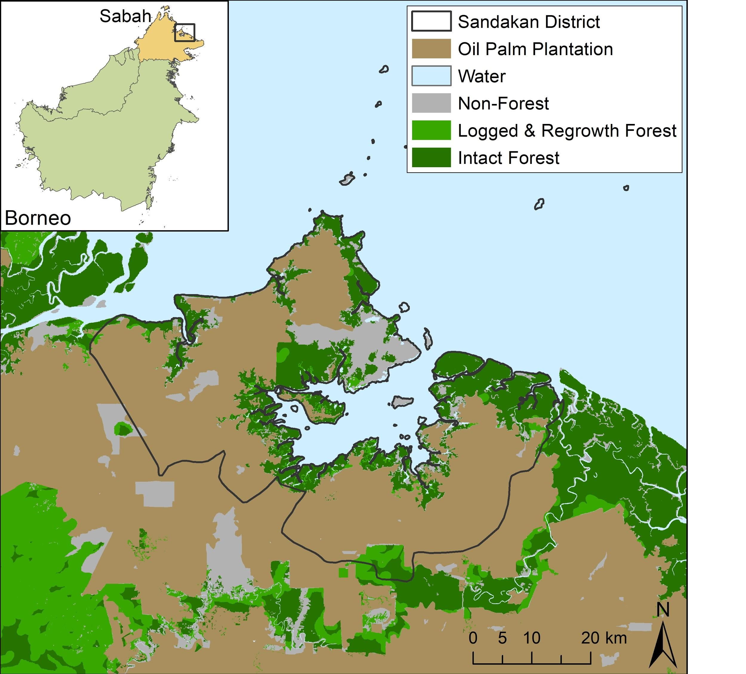
Primary interview area
Kinabatangan River
Figure 1. Map of the study area: Sandakan District, Sabah, Malaysian Borneo.

Data collection
We conducted 38 in-depth, semi-structured interviews with Kadazandusun-Murut (KDM) bearded pig hunters in 2019 in Sandakan District (Figure 1). Our interview protocol was approved by the Committee for Protection of Human Subjects at the University of California, Berkeley (Protocol number: 2019-04-12096). All hunters interviewed were male; we did not encounter any female hunters over the course of our study. Hunting is typically a male role in indigenous Bornean societies (Alexander & Alexander 1994, Thambiah 2016). We defined a “hunter” as someone who had hunted bearded pigs twice per year or more, on average, for a span of at least five years of their lifetime. A hunter did not need to be hunting regularly at the time of the interview to be included in our study. We identified hunters through our existing social and professional networks, and we relied on referral (“snowball”) sampling, by which respondents connected us with other hunters. While this strategy did not provide us with a representative pool of the KDM hunting community in Sandakan District, it can promote trust and help identify a set of highly knowledgeable respondents (e.g. Luskin et al. 2014). When potential respondents were in a village (kampung) setting, we sought and received permission from the village chief before proceeding with interviews. Before conducting an interview, we asked each participant for his verbal consent to participate in the research. To respect the privacy of respondents, we did not record their names or any audio.

Two (JB, VTJ) or three (DK, JB, VTJ) authors conducted each interview, primarily in Bahasa Melayu (supplemented only occasionally with English if respondents were comfortable and chose to speak in English). Both primary interviewers (JB, VTJ) spoke fluent Bahasa Melayu, and one of the primary interviewers (VTJ) was a local Sabahan. Each interview lasted from 0.5 - 2.5 hours, and took place in a location chosen by the respondent. Respondents were normally interviewed individually, but occasionally social norms and relationships led to respondents being more comfortable with an interview in a small group (i.e. 2-3 individuals). Our survey consisted of basic demographic information (e.g. age group, home village/city, education level, work information) and questions about their hunting practices (See Supplementary Material for interview guide in English and Bahasa Melayu). Specifically, we asked respondents about their hunting motivations, hunting techniques, animal protein consumption patterns, hunting narratives, hunting frequency, hunting practices, and hunting success). Most of the questions asked were open-ended, but we also asked closed questions about specific topics in order to gather information about certain categories of interest. To avoid asking for sensitive information and making our respondents uncomfortable, we did not ask whether they had obtained the appropriate licenses for hunting or sale of bearded pig meat. We did not compensate respondents for participating in the study.

To quantify bearded pig hunting motivations, we asked hunters to rank common motivations from several categories: subsistence food provision (makan), sale for money (jual), recreation (hobi), pest control (kawalan perosak), gift (hadiah), or other (lain-lain). To quantify the frequency with which different hunters used different techniques, we asked respondents to indicate yes (ya) or no (tidak) to whether they had ever used the following common hunting strategies: dog and spear (anjing dan tombak), spear only (tombak sahaja), dogs and gun (anjing dan senapang), gun on foot (senapang sahaja [kaki]), drive hunt with gun (senapang sahaja [kereta]), snare (jerat), trap (perangkap), homemade bomb (bom babi), and other (lain). To quantify meat and fish consumption patterns, we asked respondents how many times in the previous week they had eaten: bearded pig meat, deer meat, any other kind of wild meat, wild fish from rivers, wild fish from the sea, and domestic chicken, domestic pig, or other domestic meat. We asked respondents to share their consumption patterns for both village (kampung) and city (bandar) settings, as many respondents had spent significant time living in each setting. To quantify hunting success, we asked respondents how many hunting trips for bearded pig, on average, were successful out of four attempts.

Respondent characteristics
Hunter ages ranged from 26 - 72 years, with a mean age of 47 years. Most hunters had attended school until Form 1-5 (corresponding to 13-17 years of age), a few had received their Sijil Pelajaran Malaysia (Malaysia Certificate of Education, equivalent to a US high school degree), and a small minority of respondents had attended university or institute programs. Respondents worked in a variety of fields, including the oil palm industry (smallholder and industrial), police and government service, the clergy, semi-professional hunting, forestry, farming, rideshare driving, and various forms of self-employment. Twenty-seven out of 36 respondents who answered said they had worked in oil palm agriculture at some point, whether as small holders or in industrial oil palm plantation roles.

Data analysis
To investigate whether hunting practices have changed due to the expansion of oil palm plantations in Sandakan District, we compared hunting techniques used by hunters who started hunting earlier and later in the process of oil palm expansion in Sabah. We calculated the approximate year each hunter began hunting, based on their current age and the age they began hunting. We chose 1985, as extensive oil palm expansion in the Sandakan district occurred throughout the 1970s, resulting in an oil palm-dominated landscape by the late 1970s and 1980s (Norwana et al. 2011, Gaveau et al. 2016). We separated hunters into two categories: those who began hunting before 1985, and those who began in 1985 or later. To test for differences between the two categories, we then conducted a Fisher’s exact test in R version 3.6.0 (R Core Team 2019).

Qualitative data were analyzed via inductive content analysis (Elo & Kyngäs 2008), in which we started with specific observations of individual hunters and moved to a more general framework of contemporary KDM hunting practices among our respondent pool. We present our findings as a sequence of themes that emerged from the interviews (Dhee et al. 2019). The themes we chose to analyze were related to our guiding questions of (a) how structural political and economic forces shape interactions between KDM hunters and bearded pigs; and (b) how local sociocultural forces shape the KDM - bearded pig socio-ecological system. Except where noted, excerpts of interviews have been translated into English, with the original Bahasa Melayu quote sometimes included to present respondent insights in their own language and expression.

Results of surveys on contemporary KDM hunting practices
Hunting motivations
Food provision was the most commonly cited hunting motivation (97% of respondents) and was the primary motivation for 85% of respondents (n = 37) (Figure 2). Other major hunting motivations cited were pest control (59%), gift giving (54%), and hobby (51%). The vast majority of respondents (85%) also ranked food provision as their primary motivation to hunt (Figure 3). By contrast, several respondents ranked another reason as their primary hunting motivation, including sale (6%), pest control (6%), and hobby (3%).

Some hunters were very clear about the importance of bearded pig meat as a central food source. For example, one hunter said: “Dia menjadi sumber makanan orang kampung” (“It is the main source of food for people who live in the villages”). For some hunters, it was important that hunting bearded pig was a way of life. One hunter commented: “This is our life. We live in the forest; this is our food.” Another hunter responded: “We cannot stop eating the pig.” (“Kami tidak boleh tinggalkan babi.”) For many respondents, hunting bearded pigs was also regarded as an important form of pest control to limit bearded pig disturbance of oil palm plantations (both industrial and smallholder) and garden crops, such as cassava and durian. Multiple hunters also referenced the importance of sharing bearded pig meat communally at parties, weddings, and other celebrations. One hunter shared that during certain months “ada banyak permintaan” (“there are many requests” [to supply bearded pig meat]), due to seasonal parties and celebrations. For some respondents, community expectations therefore played an important role in motivating bearded pig hunting. Several respondents also mentioned satisfaction in their hunting ability; for example, one hunter said, “Only the kampung punyai people men know what the babi need bah” (“Only the village people have what it takes to know what the pig needs”).

Selling bearded pig meat for money was cited as a motivation for hunting among a minority of respondents (27%), followed by respondents citing other motivations (16%). Respondents expressed mixed perceptions of hunting bearded pig for sale. Some hunters said they never hunted for sale, and felt that selling bearded pig meat was irresponsible because it contributed to pig population declines. Others felt that selling bearded pig meat was unnecessary due to the robust culture of gifting the meat. For example, one respondent captured the sentiment of many KDM hunters towards selling bearded pig meat: “Don’t sell it, if people ask just share it.” (“Bukan jual lah, kalau orang minta bagi-bagi lah.”) However, for other hunters who sold bearded pig meat regularly or occasionally, the sale was an important source of income. Monthly income from pig hunting was reported to be as high as 5000 MYR (~1,194 US$) in a good month, substantially higher than wages earned in oil palm plantations. Hunters generally reported current bearded pig meat prices to be roughly 10-15 MYR / kilogram, and by contrast reported prices around 3-5 MYR / kilogram around 10 years ago (much lower than current prices, even when adjusted for inflation). One respondent commented, “The price of the babi sudah naik raise bah” (“The price of the pig has gone up”).

Hunting techniques in forest areas and oil palm plantations
We found no significant difference in hunting techniques between respondents who began hunting before 1985 and those who began in 1985 or later (p > 0.99). Overall, the most popular hunting techniques that respondents had used were: (a) on foot with a gun (83% of respondents); and (b) drive hunts with a gun (75% of respondents), although numerous other techniques were also widely used (Figure 4). Hunting with dogs and a spear as well as with snares were also common among our respondents, as has been reported in northern Sabah as well (Wong et al. 2012).

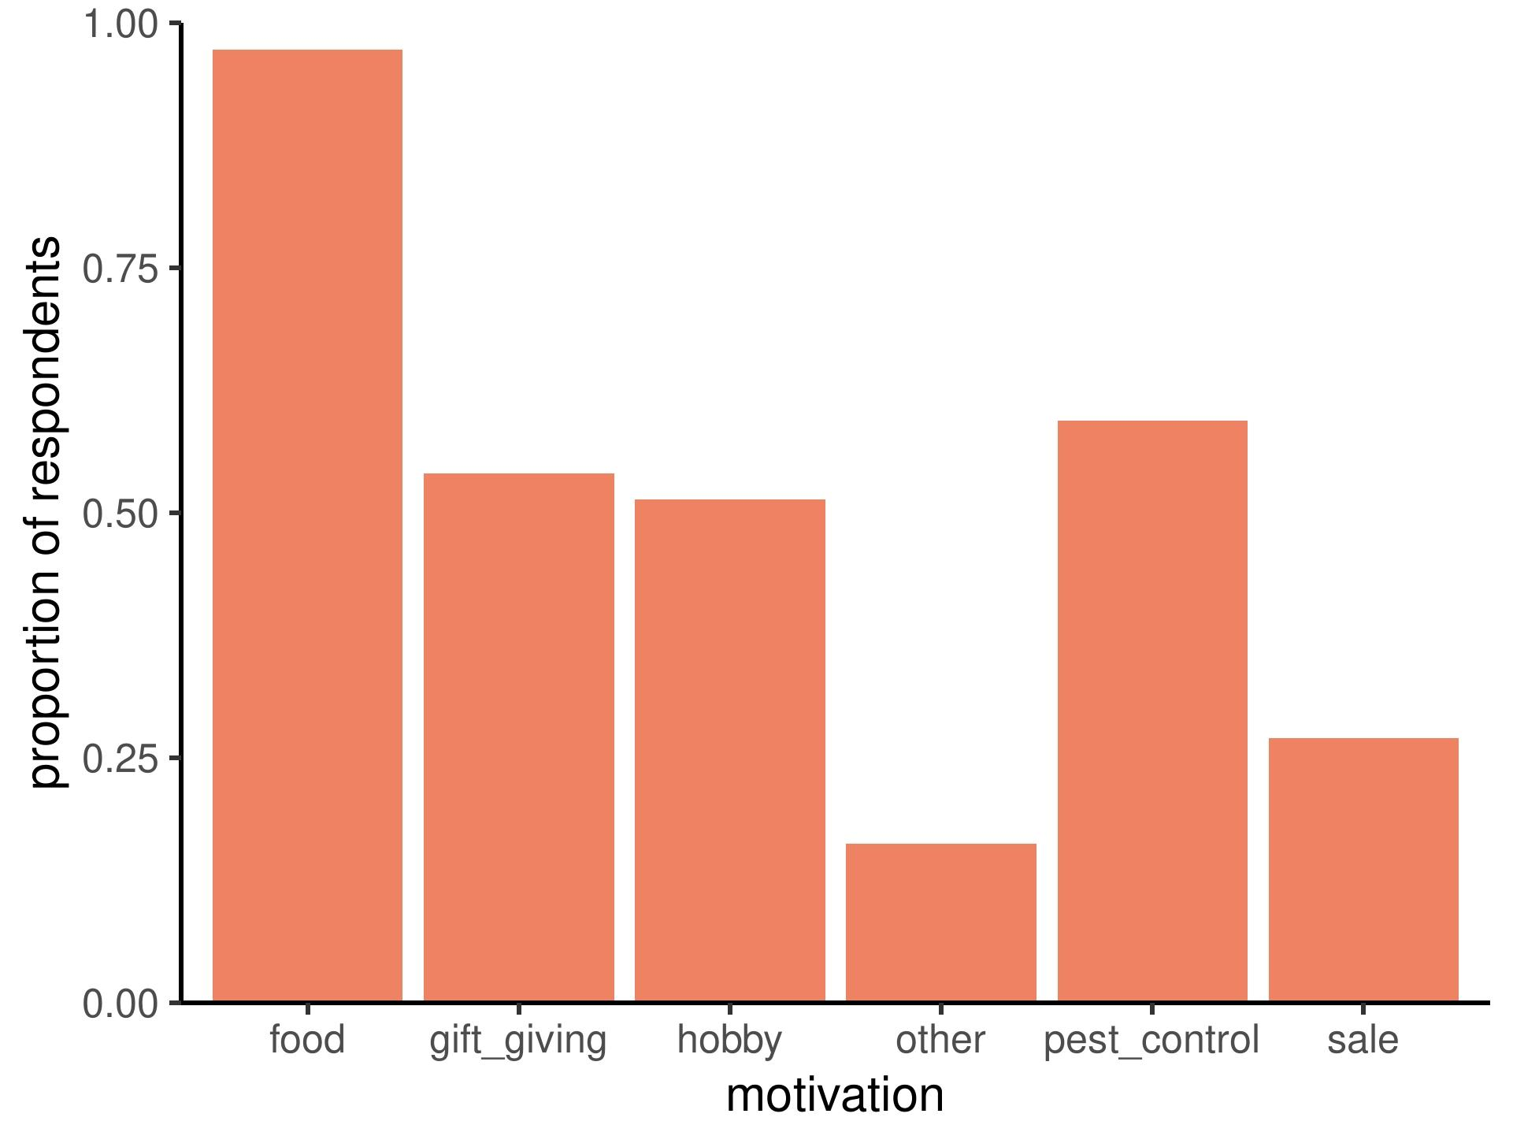
Figure 2. Common motivations of respondents (n = 37) for hunting bearded pig. All motivations listed by each hunter (i.e. regardless of rank order) are included.

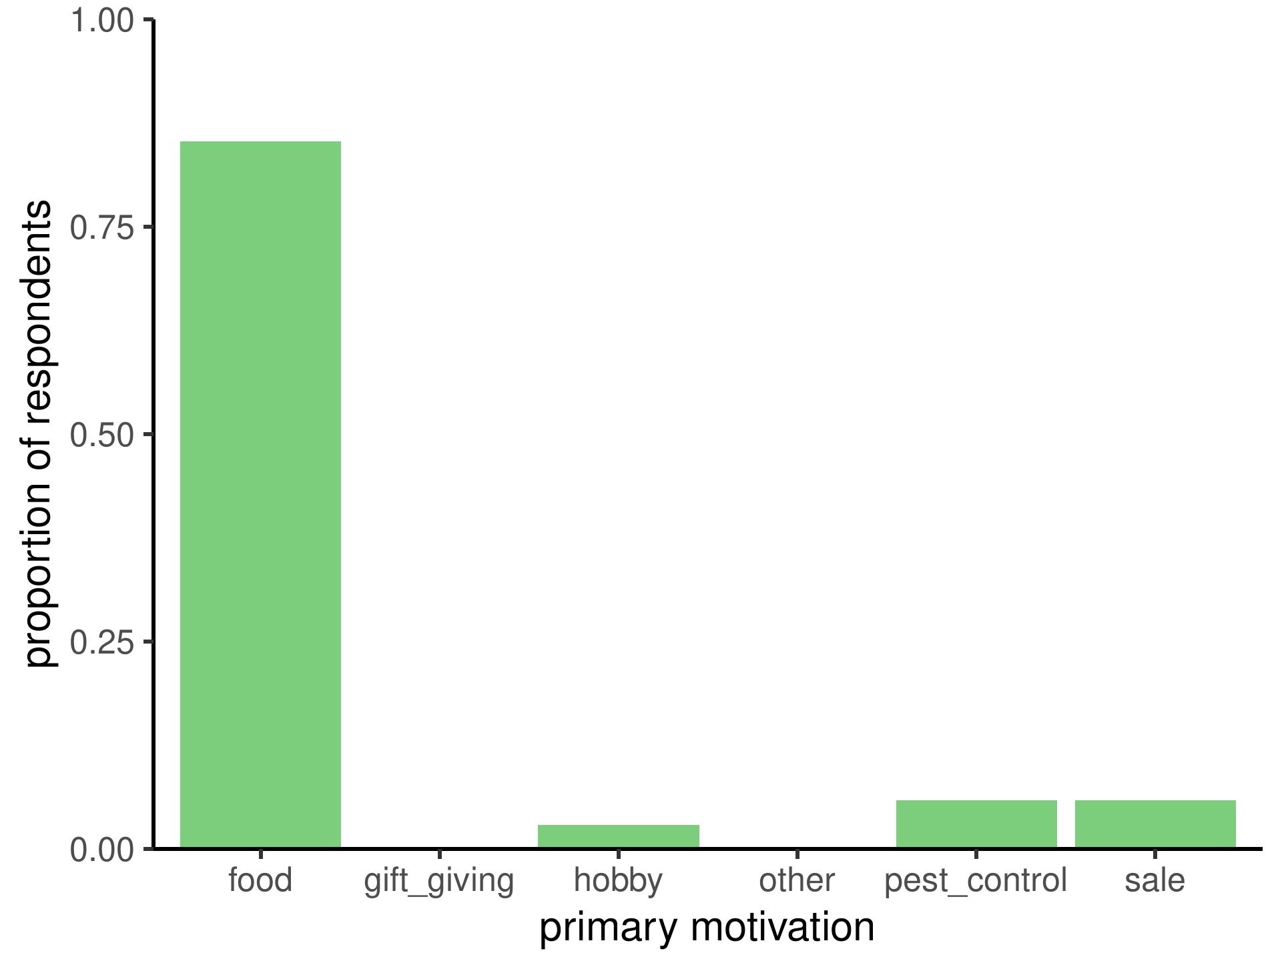
Figure 3. Primary motivations to hunt bearded pig among our respondent pool (n = 37).

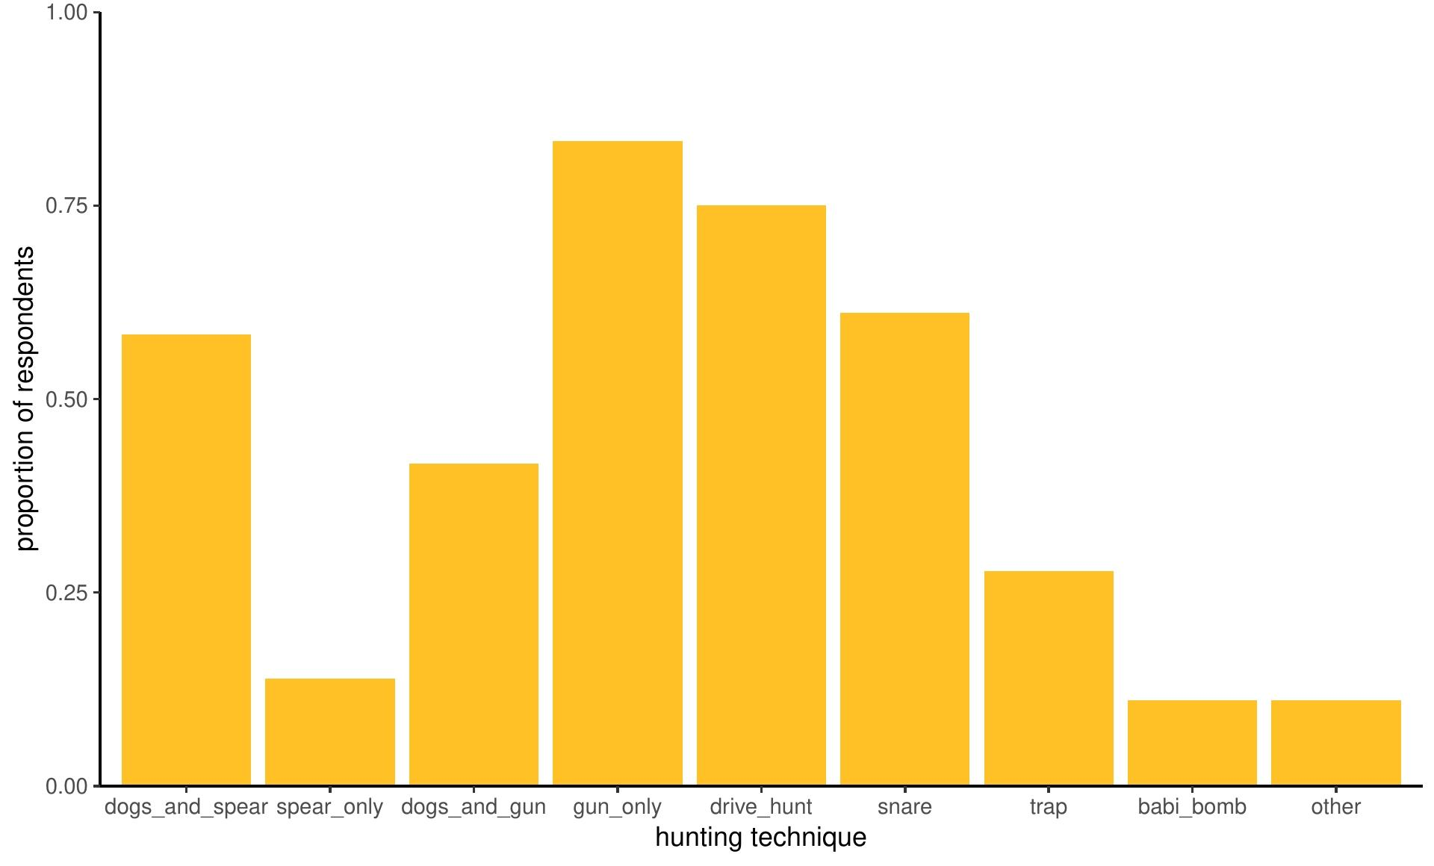
Figure 4. Proportion of KDM hunters within our respondent pool (n = 34) who had used a variety of traditional and modern techniques for hunting bearded pig.
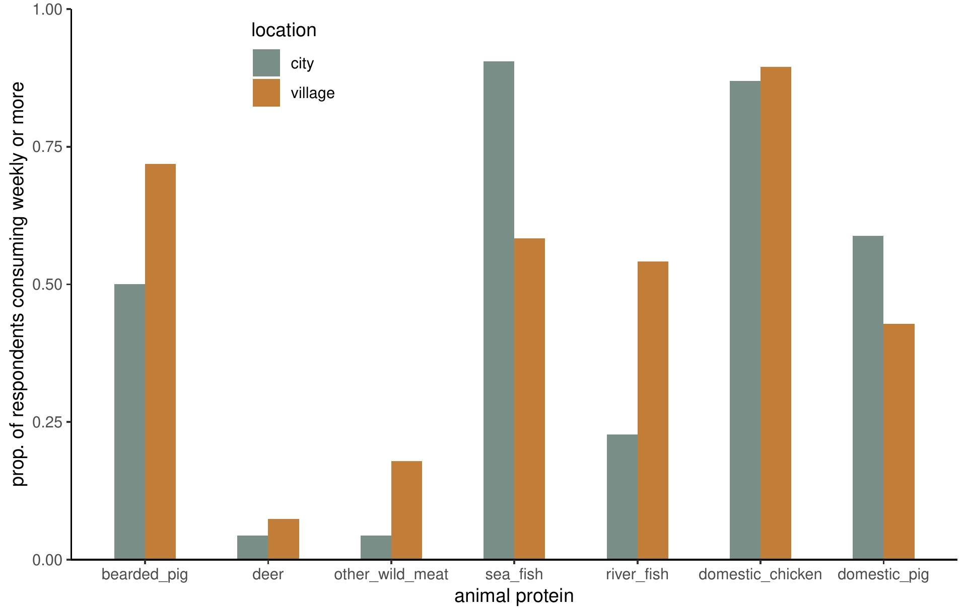
Figure 5. Comparison of animal protein consumption by respondents in village and urban contexts.

Respondents cited a variety of reasons why they preferred different hunting techniques. For many, hunting location was a major factor in the technique used. For example, some hunters mentioned that drive hunts were easier in oil palm plantations, but not conducive to hunting in forests or mangroves. Conversely, hunting on foot with a gun was possible in all habitat types. Other factors dictating the use of different techniques included success rate, effort and cost required, personal preference, and availability of tools such as guns and ammunition. For example, one hunter commented: “Mana ada mahu jerat sudah! Ada senapang.” (“Who in the world would use a snare when you have a gun!”) Multiple respondents also mentioned that hunting in the forest was more challenging due to a need to walk farther to access hunting sites, whereas hunting in an oil palm plantation was more straightforward, due to ease of access and knowledge of the exact foraging locations preferred by pigs. Hunting techniques taking advantage specifically of long-distance beaded pig movements (e.g. spearing nomadic or migratory pigs crossing rivers, Mohd-Azlan et al. 2016) were not reported among our respondents.

Hunters broadly reported a decline in hunting frequency, both in their own hunting patterns as well as among their community. Respondents tied this trend to several factors, including declining pig populations, deforestation, increased plantation area, age, and less free time due to work commitments. For example, some oil palm workers responded that they lacked the energy to hunt due to their work, and that some hunting trips were now more difficult due to the long distances required for travel through plantations. In particular, replacement of forest by oil palm plantations was considered by several hunters to cause pig population declines and less time spent by humans accessing forest resources; both of these perceived patterns were cited as drivers of declining hunting frequency. Many respondents noted that fewer people were learning to hunt than in the past.

Hunting success was highly variable, with hunters citing success rates per hunt ranging from roughly 25% to 100%. On average, hunters reported success obtaining a bearded pig on 25% - 50% of hunts. Hunt lengths varied between several hours to a full day or night.

Hunter consumption patterns in village and urban settings
In village settings, 72% of respondents (n = 32) reported consuming bearded pig weekly or more frequently, 31% of respondents reported consuming bearded pig 2-3 times per week, and 22% reported consuming bearded pig 4 or more times per week. Additionally, more respondents in village contexts consumed bearded pig meat on a weekly basis than any other meat besides domestic chicken (Figure 5). In addition to bearded pig meat, a minority of respondents in village settings reported at least weekly consumption of deer (7.4%) and other wild meat (18%). Other wild meat consumed in village settings varied widely, including Malay civet (Viverra tangalunga), common water monitor (Varanus salvator), large flying fox (Pteropus vampyrus), Bornean crested fireback (Lophura ignita), reticulated python (Malayopython reticulatus), and long-tailed macaque (Macaca fascicularis).

In city contexts, 50% of respondents (n = 26) reported consuming bearded pig weekly or more and 38% of respondents reported consuming bearded pig 2-3 times per week, but no respondents reported eating bearded pig meat 4 or more times per week. However, in city settings, more respondents consumed marine fish, domestic chicken, and domestic pork than bearded pig. In city contexts, only 4.3% of respondents reported consuming other wild meat on a weekly or more frequent basis.

Commercialization of pig meat as a driver of culture – resource relationships
For a minority of our respondents, the influence of commodification of wild meat—including the steep price point increase for bearded pig meat in the last 10 years reported by hunters—was apparent from the role of commercial sale as an important secondary motivation for some hunters. Perhaps due to the relatively high prices reported for bearded pig meat (~10-15 MYR / kg), multiple respondents also claimed that commercial hunting was on the rise. However, despite these trends, the majority of our respondents did not cite sale for money as a motivation to hunt bearded pigs, and several respondents reacted with disgust or condemnation of this practice, as it goes against the KDM tradition of gifting bearded pig meat.

Overview of links between historical and contemporary KDM pig hunting practices
The hunting motivations we recorded among KDM hunters in Sandakan district are in step with the outcomes Bennett & Sompud (2000) recorded in Sabah and Sarawak, with meat provision as the primary motivation for bearded pig hunting. Presumably meat provision was also the primary motivation for indigenous bearded pig hunting across Borneo for millennia, based on archaeological dig sites showing bearded pig bones in sites used for food consumption (Medway 1964). Additionally, Bennett & Sompud (2000) found that wild meat presence in rural villager diets was directly related to the abundance of bearded pigs in the forest, and unrelated to alternative sources of food and income. Thus, bearded pigs were hunted if they were locally available, whether or not local communities were directly reliant upon them. Similarly, we encountered some hunters who regarded bearded pig meat as essential to their livelihoods and food security (through consumption or sale), and others who did not. For example, in describing his motivation to hunt, one respondent said simply: “It’s a matter of survival.” (“Pasal – untuk survive lah.”) However, for many others, bearded pig was a favored delicacy but not an indispensable source of food given the widespread availability of wild fish and domestic chicken and pork. We observed important differences in animal protein consumption between respondents in village and city settings, with more frequent consumption of wild meat in village contexts, including bearded pig as the second most-frequently consumed wild meat. Therefore, as urbanization increases in Sabah (Cai 2018), our study suggests that reduction of bearded pig consumption levels in urban contexts is one way in which historical indigenous reliance on bearded pig has lessened in modern times.

Perhaps most striking was the degree to which bearded pig meat remains central to many cultural celebrations. Weddings, church events, family gatherings, festivals, birthdays, and other celebratory occasions were considered by many hunters to be incomplete without wild meat, typically bearded pig. As one respondent noted: “The bearded pig is our tradition. For celebrations you only use the bearded pig.” (Note: Other wild game meat is still used by some; for example, feral buffalo was also mentioned in connection with celebrations. However, bearded pig meat is indeed standard fare at many KDM cultural events.) Barbecued, sautéed, or roasted bearded pig was widely considered a favorite delicacy among our respondent pool, and for many the sharing and consuming of this delicacy constituted a centerpiece of communal celebrations. The significance of bearded pig meat for cultural events is also evident in the high proportion of respondents (54%) who ranked “gift-giving” as a secondary motivation to hunt. The sharing of bearded pig meat, in everyday life and in special life events, has been part and parcel of many indigenous cultures in Borneo (Wadley et al. 1997, Chin 2001); our results indicate that this species continues to be a cultural touchstone today.

Hereafter, we explore two major drivers of changes to KDM pig hunting patterns that stood out from our results: the environmental and socio-economic impact of oil palm plantations and the socio-institutional dynamics of wildlife law enforcement.

Oil palm expansion as a driver of changes in contemporary KDM bearded pig hunting practices
Respondents noted multiple ways that oil palm-driven land use change has shaped pig hunting practices in novel ways. First, numerous respondents considered deforestation and oil palm development to drive pig population declines by removing pig habitat, and thereby also reducing hunting frequency. For example, one respondent noted: “Bearded pig has decreased in population as compared to the past. This is because of less forest.” This qualitative evidence of reduced bearded pig numbers in oil palm plantations is consistent with ecological evidence finding reduced bearded pig sign (Love et al. 2018) and occupancy (Yue et al. 2015) in oil palm as compared to neighboring forest patches. Perceived reductions in bearded pig numbers was also given as a reason for the increase in price for bearded pig meat. Second, several hunters also claimed that oil palm plantations influenced them to spend less time in the forest and access fewer forest resources, resulting in declining frequency of pig hunting. They cited a variety of factors for this dynamic, including the increased time to travel to forest patches to hunt and less overall cultural reliance on the forest. Third, hunters working in the oil palm industry often cited a lack of time and energy to hunt due to work commitments. The palm oil industry is a major employer in Sabah, exerting significant influence in and around Sandakan District (Norwana et al. 2011). Hunters commented that their work opportunities and hunting frequency were often inversely related. This finding is in line with Bennett & Sompud (2000), who recorded similar patterns among oil palm workers, and recorded wild meat in meals of these workers at a rate 10 times less than respondents in rural, forested areas of Sabah and Sarawak.

Many hunters reported seeing bearded pig eruptions of scores or hundreds of individuals. Several hunters in our study described pig eruptions with awe, fear, excitement, and shock. For example, one hunter said: “I was sitting in a tree when a huge herd of pigs came by. I was so shocked that I didn’t even shoot any. I just sat there counting them.” A third hunter commented, “There are so many pigs that all you can do is just stand and stare until they run away.” However, other hunters acknowledged that large herding behavior occurred, but had not seen them and did not know many details about them. Younger hunters typically had never seen or heard of the migrations. This pattern is consistent with anticipated declines of bearded pig nomadism in the literature due to habitat fragmentation—splintering movement pathways themselves (Luskin & Ke 2018). Moreover, oil palm fruit subsidies to bearded pigs in many areas—as shown with wild boar (Sus scrofa) (Luskin et al. 2017)—could reduce or eliminate the ecological basis for bearded pigs to make nomadic movements at all. Historically, this nomadic movement phenomenon has been associated with mast fruiting events (Caldecott et al. 1993, Curran et al. 2000), but forest fragmentation is likely to be limiting mast fruiting and bearded pig eruptions (Luskin et al. 2018). In light of this ecological and social context, our findings suggest that we are observing a loss of traditional ecological knowledge, and a reshaping of some elements of indigenous Kadazandusun-Murut hunting practices with an ecological process that formerly comprised a major dimension of Borneo’s socio-ecological integrity (Bennett & Sompud 2000, Puri 2005, Janowski 2014).

When asked if they had noticed a change in bearded pig behavior over the last several decades, multiple hunters noted that pigs today are “wilder” or “smarter” —seemingly more skittish—as compared to the past. One hunter, for instance, claimed “Dulu tidak liar, sekarang liar diburu” (“In the past they weren’t as wild as today”, where wild means harder to catch). Another hunter similarly commented “Ada liar sikit” (“They are a bit wilder”), and a third concluded “Bermakna dia ada IQ” (“He [the pig] has IQ”). A number of hunters also noted that they do not hunt in the same area twice in a short span of time, because they know the pigs to be sensitive to gunshots, gunpowder smell, and headlamp lights. Many years of hunting may have selected for pigs with high behavioral plasticity, which has also been suggested with adaptive responses of red deer in Norway (Lone et al. 2015). Hunters were also highly in tune with movement ecology in forest-oil palm mosaics. For example, many respondents noted the pattern of pigs resting, mating, and nesting in the forest, and raiding oil palm plantations at night. Many of these patterns are supported by recent ecological evidence from this area (Love et al. 2018, Davison et al. 2019), and mirror behavior of wild boar in Peninsular Malaysia (Luskin et al. 2017). The ecological and social evidence of bearded pig behavior in these modified forest-oil palm mosaics suggests a population state similar to one laid out in Caldecott et al. (1993): “Small to medium populations exploiting concentrated, predictable and continuous ‘target’ food sources. High breeding and growth rates possible. Local movements only.” Based on the available lines of evidence to date, it would seem that bearded pigs in and around the Sandakan district are not exhibiting the full range of population states recorded in the literature (Caldecott et al. 1993), likely due to year-round availability of oil palm fruit that has allowed populations to escape their traditional cyclical boom and bust cycles in response to “bottom-up” regulation (Luskin & Ke 2018).
Finally, the influence of oil palm plantations on hunting patterns was apparent due to pest control as a motivation for bearded pig hunting among more than half of our respondents. Three quarters of our respondents worked in oil palm at some point in their lives, many of them as smallholders and some in industrial oil palm plantations; bearded pigs are often regarded as pests in both settings. Bearded pigs are regarded as pests within oil palm plantations (Meijaard et al. 2018); this is due to their rooting behavior, similar to that of the wild boar, which also damages young oil palm trees in plantations (Jambari et al. 2012, Luskin et al. 2014). Jambari et al. (2012) recorded pest control of wild boar as an important motivation for oil palm workers hunting for consumption and sale in plantations in Peninsular Malaysia. While our results indicate a similar pattern for bearded pig hunting among our study population of KDM hunters in Sabah, the primary motivation for hunting bearded pig remained subsistence hunting for meat provision. Thus, hunting for pest control does not seem to present a fundamentally distinct departure from the socio-ecological link most widely-referenced by our respondents regarding bearded pigs: meat provision. However, in other areas in Southeast Asia, the motivations to hunt wild pigs can change substantially according to group or ethnic identity (Luskin et al. 2014); therefore, it is reasonable to assume that these patterns may vary among other cultural groups hunting bearded pig or related species.

Socio-institutional drivers of KDM hunting practices and implications for biocultural conservation
Hunters were generally very aware that regulations existed about hunting bearded pigs, and that permits were required to legally hunt wildlife and sell wild meat. Most of our respondents were aware of hunting regulations, as has been shown for hunters in Paitan, Sabah as well (Wong et al. 2012). Many hunters shared stories about enforcement of these laws, or referenced permit requirements when explaining their own reasoning about hunting decisions. Sometimes respondents shared specific costs associated with hunting permits, which were considered by some hunters to be expensive. Several respondents were also aware of permit requirements for other species. However, despite their general awareness of the regulatory environment around hunting bearded pig and other species, there was inconsistency and confusion in understanding permit requirements and hunting regulations. There was also a shared perception that Wildlife Department and Forestry Department officials, among others, were frequently monitoring forest areas for illegal hunting. For example, one hunter said, “Many of my friends have been fined by the Wildlife Department.”

State-wide regulations and enforcement seemed to play a considerable role in reducing the frequency of KDM hunting of bearded pigs. As one respondent shared, “Sekarang, beli babi jak – sibuk – taku undang-undang” (“Now, you just buy pig because either you’re busy or you’re afraid of the law”). While bearded pig hunting remains an important part of KDM culture as it has been in the past (Bennett & Sompud 2000), many of our respondents noted a decline in bearded pig hunting frequency, both personally and generally, over the last several decades. While work in oil palm and other sectors was frequently implicated in this trend, this time frame also corresponds with the passage of important conservation legislation requiring licenses for hunting bearded pig (Sabah Wildlife Enactment of 1997), and increasing enforcement in many areas of the state (e.g. Latip et al. 2015). This finding could suggest that the permitting system and/or enforcement of hunting laws could be influencing the frequency of hunting behavior in Sabah. However, the influence of state-wide regulation on indigenous hunting practices in Sabah illustrates the intersecting tensions of biodiversity conservation, local sovereignty, poverty, and cultural traditions. As Duffy et al. (2016) note, hunting studies in many parts of the world have often failed to conduct qualitative work with hunters themselves to better understand hunter motivations and the complex cultural, economic, political, and social contexts within which wildlife hunting occurs. In our system, hunters referenced motivations for pig hunting extending beyond subsistence, referencing many cultural dynamics as well, such as gift-giving, sport, and community expectations. Therefore, our study demonstrates qualitative evidence for the influence of law enforcement on wild meat hunting frequency, as well as the important socio-cultural factors that should be taken into consideration in wildlife management.

Conclusion
While several historical pig hunting motivations and techniques were maintained amongst our respondents, our findings indicate that oil palm has weakened socio-ecological relationships for some KDM bearded pig hunters in multiple ways: by replacing forest habitat, increasing the distance to the forest for many hunters, and reducing time available for hunting due to work commitments. We appear to be observing the effects of: (a) weakened historical relationships between bearded pigs and mast fruiting cycles; (b) weakened relationships between people and historical bearded pig eruptions; and (c) reshaped relationships between people and bearded pigs in the context of modified oil palm – forest mosaic systems. Thus, our study supports broader trends suggesting similar factors causing altered social-ecological relationships due to habitat loss (e.g. Carter et al. 2014), reduced proximity to natural landscapes (e.g. Eder 1988), and land-use for agriculture (e.g. Izquierdo et al. 2018). Our findings also suggest the influence of wildlife policies and enforcement on the frequency of pig hunting within the KDM community. These socio-institutional dynamics offer both an opportunity and a challenge for management in Sabah that conserves bearded pig populations and ecological functions while also incorporating the need for sustainable pig harvest within KDM communities.

Moving forward, our study points to the continued relevance of biocultural conservation for conservation theory and practice (Bridgewater & Rotherham 2019). Our findings support several previously identified principles for designing conservation plans that conserve biology and support human cultural values, including: (a) the value of an inclusive approach to identify culturally important species and practices; (b) importance of including flagship species [in this case, the bearded pig as a cultural keystone species (Puri 2005)]; and (c) adaptive management that achieves biocultural conservation aims in the midst of shifting (Rozzi et al. 2013). Given the pace of change of the drivers that have already shaped KDM pig hunting, our study also points to the dynamic interrelation of culture, natural resource use, and conservation (Gavin et al. 2015). For biocultural conservation of the KDM - bearded pig socio-ecological system, we recommend that local and state government officials and conservation managers consider flexible and location-specific management approaches. These approaches should include local indigenous peoples to ensure fair access to the provision of meat, cultural benefits, and pest control from sustainable bearded pig hunting, while also ensuring conservation of bearded pig populations, habitat, and long-distance movements.

Acknowledgements
Thank you to Kate Montana and Wendy Ooi for help with reading, organizing, and discussing themes from the background literature. Thank you to Professor Claire Kremen and Professor Jimmy McGuire for helpful comments that improved the manuscript. Thank you to Evelyne St-Louis for creating Figure 1, and for advice on structure and framing. Thank you to the UC Berkeley Undergraduate Research Apprenticeship Program, the Sponsored Projects for Undergraduate Research program, and the College of Natural Resources Travel Grant for summer funding for JB. DJK is grateful to the SJ Hall Fellowship, the Hannah M. and Frank Schwabacher Memorial Scholarship Fund, the Howard William Siggins Fellowship, the Philomathia Graduate Student Fellowship in the Environmental Sciences, the Harvey Fellowship, and the Institute of East Asian Studies for funding that supported this work. We are grateful to the Brashares Lab and Potts Lab for feedback on this project at various stages of analysis and writing. Thank you to the Sabah Biodiversity Centre for permission to conduct fieldwork in Sabah (Licence Ref.No. JKM/MBS.1000-2/2 JLD.9 (59)). Thank you to Mr. Johny Ronggitom and the Sandakan Municipal Council for permission to conduct interviews in Sandakan. We are also grateful to Mr. Peter Jr Naintin for his help with connecting us to KDM communities in Sandakan District. Most of all, thank you to the hunters who welcomed us into their communities, spent time with us, and shared their rich experiences and knowledge with us – we are very grateful to you all.

Statement of data archive intent
We intend to archive the de-identified data used in this study at https://www.biorxiv.org/.

References
Abernethy, K.A., et al. 2013. Extent and ecological consequences of hunting in Central African
rainforests in the twenty-first century. Philosophical Transactions of the Royal Society B,
368(1625), 20120303.
Act of the Republic of Indonesia No. 5 of 1990 concerning Conservation of Living Resourcesand their Ecosystems. Ministry of Forestry of the Republic of Indonesia.
Alexander, J. & Alexander, P., 1994. Gender differences in tobacco use and thecommodification of tobacco in Central Borneo. Social Science and Medicine, 38(4), pp.603–608.
Bassett, T.J., 2005. Card-carrying hunters, rural poverty, and wildlife decline in northern Côte d’Ivoire. The Geographical Journal, 171(1), pp.24–35.
Bennett, E.L. & Sompud, J., 2000. Saving Borneo's bacon: the sustainability of hunting in Sarawak and Sabah. In J. G. Robinson & E. L. Bennett, eds. Hunting for Sustainability in Tropical Forests. New York: Columbia University Press.
Bernard, S., & Bissonnette, J.-F., 2011. Oil palm plantations in Sabah: agricultural expansion for whom? In R. De Koninck, S. Bernard, & J.-F. Bissonnette, eds. Borneo Transformed: agricultural expansion on the Southeast Asian Frontier. Singapore: NUS Press.
Bolton, J.M., et al., 1972. Food taboos among the Orang Asli in West Malaysia: a potential nutritional hazard. The American Journal of Clinical Nutrition, 25, 789-799.
Brashares, J.S. et al., 2014. Wildlife decline and social conflict. Science, 345(6195), pp.376–378.
Bridgewater, P. & Rotherham, I.D., 2019. A critical perspective on the concept of biocultural diversity and its emerging role in nature and heritage conservation R. Rozzi, ed. People and Nature, 1(3), pp.291–304.
Brookfield, H.C., Byron, Y., & Potter, L.M., 1995. In In place of the forest: environmental and socio-economic transformation in Borneo and the Eastern Malay Peninsula. Tokyo: United Nations University Press.

Brunei Wildlife Protect Act 1984. Cap. 102. B.L.R.O. 1/1984

Cai, Y. 2018. Between tradition and modernity: the ritual politics of indigenous cultural heritage in urbanizing Sabah, East Malaysia. Routledge Handbook of Urbanisation in Southeast Asia, 179-190.

Caldecott, J.O., Blouch, R.A. & Macdonald, A.A., 1993. The bearded pig (Sus barbatus). In W. Oliver, ed. Pigs, peccaries and hippos: status survey and conservation action plan. Gland, Switzerland: Pigs, pp. 136–145.
Carter, N.H. et al., 2014. Coupled human and natural systems approach to wildlife research and conservation. Ecology and Society, 19(3), pp. 43–18.
Chin, C., 2001. Pig in the pot: Comments on Sus barbatus in the hunting lifestyle of the Penan in Sarawak (Borneo). (1), pp.10–12.
Chua, L. 2012. The Christianity of Culture: Conversion, Ethnic Citizenship, and the Matter of Religion in Malaysian Borneo. New York: Palgrave Macmillan.
Cooke, F.M., 2012. In the name of poverty alleviation: experiments with oil palm smallholders and customary land in Sabah, Malaysia. Asia Pacific Viewpoint, 53(3), 240-253.

Cramb, R. & Curry, G.N., 2012. Oil palm and rural livelihoods in the Asia-Pacific region: an overview. Asia Pacific Viewpoint, 53(3), 223-239.

Curran, L.M. & Leighton, M., 2000. Vertebrate Responses to Spatiotemporal Variation in Seed Production of Mast-Fruiting Dipterocarpaceae. Ecological Monographs, pp.101–128.
Davison, C.W. et al., 2019. Shifts in the demographics and behavior of bearded pigs ( Sus barbatus) across a land‐use gradient. Biotropica, 105(2), pp.305–11.
Dhee et al., 2019. The leopard that learnt from the cat and other narratives of carnivore–human coexistence in northern India J. Young, ed. People and Nature, 1(3), pp.376–386.
Duffy, R., et al. 2016. Toward a new understanding of the links between poverty and illegal wildlife hunting. Conservation Biology, 30(1), 14-22.
Eder, J.F., 1988. Batak Foraging Camps Today: A Window to the History of a Hunting-Gathering Economy. Human Ecology, 16(1), pp.1–21.
Elo, S. & Kyngäs, H., 2008. The qualitative content analysis process. Journal of Advanced Nursing, 62(1), pp.107–115.
Food and Agriculture Organization of the United Nations. FAOSTAT Statistical Database. [Rome]: FAO, 2020.
Gaveau, D.L.A. et al., 2014. Four Decades of Forest Persistence, Clearance and Logging on Borneo K. Bawa, ed. PLoS ONE, 9(7), pp.e101654–11.
Gaveau, D.L.A., Sheil, D., Husnayaen, Salim, M.A., Arjasakusuma, S., Ancrenaz, M., Pacheco, P. & Meijaard, E., 2016. Rapid conversions and avoided deforestation: examining four decades of industrial plantation expansion in Borneo. Scientific Reports, 6, 32017.

Gavin, M.C. et al., 2015. Defining biocultural approaches to conservation. Trends in Ecology & Evolution, pp.1–6.
Harrison, R.D., et al., 2016. Impacts of hunting on tropical forests in Southeast Asia. Conservation Biology, 30(5), 972-981.
Harrisson, T., 1965. Three “secret” communication systems among Borneo nomads (and their dogs). Journal of the Malaysian Branch of the Royal Asiatic Society, 38(2), pp.67–86.
Harrisson, T., Hooijer, D.A. & Medway, L., 1961. An extinct giant pangolin and associated mammals from Niah Cave, Sarawak. Nature, 189(166).
Izquierdo, A.E. et al., 2018. Highlands in Transition: Urbanization, Pastoralism, Mining, Tourism, and Wildlife in the Argentinian Puna. Mountain Research and Development, 38(4), pp.390–12.
Jambari, A. et al., 2012. Avian Biodiversity and Conservation in Malaysian Oil Palm Production Areas. Journal of Oil Palm Research, 24, pp.1277–1286.
Janowski, M., 2014. Pigs and people in the Kelabit Highlands, Sarawak. Indonesia and the Malay World, 42(122), pp.88–112.
Kelly, P.F., 2011. Migration, agrarian transition, and rural change in Southeast Asia. Critical Asian Studies, 43, 479-506.

Lambin, E.F. & Meyfroidt, P., 2010. Land use transitions: Socio-ecological feedback versus socio-economic change. Land Use Policy, 27(2), pp.108–118.
Latip, N.A., et al., 2015. The involvement of indigenous peoples in promoting conservation and sustainable tourism at Lower Kinabatangan Sabah: common issues and challenges. Australian Journal of Basic and Applied Sciences, 9(7), 323-325.
Laughlin, W.S. 1968. Hunting: an integrating biobehavior system and its evolutionary importance. In R.B. Lee and I. DeVore (Eds.), Man the Hunter. Chicago: Aldine Publishing Company, pp. 304-320.
Laws of Sarawak, Wild Life Protection Ordinance, 1998. Chapter 26.
Lintangah, W. et al., 2015. Forest law enforcement and mitigation of forest offences in Sabah: lessons learnt. In Malaysian Forestry Conference. pp.166–175.
Lone, K., et al., 2015. An adaptive behavioural response to hunting: surviving male red deer shift habitat at the onset of the hunting season. Animal Behaviour, 102, 127-138.

Love, K. et al., 2018. Bearded pig (Sus barbatus) utilisation of a fragmented forest–oil palm landscape in Sabah, Malaysian Borneo. Wildlife Research, 44(8), pp.603–10.
Luskin, M.S. et al., 2014. Modern Hunting Practices and Wild Meat Trade in the Oil Palm Plantation-Dominated Landscapes of Sumatra, Indonesia. Human Ecology, 42(1), pp.35–45.
Luskin, M.S., et al., 2017. Cross-boundary subsidy cascades from oil palm degrade distant tropical forests. Nature Communications, 8, 2231.
Luskin MS, Ke A, Linkie M, Meijaard E (2018). Sus barbatus. The IUCN Red List of Threatened Species: e.T41772A10559190.
Luskin, M.S. & Ke, A., 2018. Bearded Pig Sus barbatus (Müller, 1838). In M. Melletti & E. Meijaard, eds. Ecology, Conservation and Management of Wild Pigs and Peccaries. Pp.175–183.
Luskin, M.S. & Ke, A., 2019. Integrating disparate occurrence reports to map data-poor species ranges and occupancy: a case study of the Vulnerable bearded pig Sus barbatus. Oryx, 53, 377-387.
Malaysia Department of Statistics, 2011. Taburan penduduk dan ciri-ciri asas demografi.
Malaysia Department of Statistics, 2015. Department of Statistics, Official Portal.
Medway, L., 1964. Post-Pleistocene changes in the mammalian fauna of Borneo: archaeological evidence from the Niah caves. Studies in Speleology, 1, pp.33–37.
Meijaard, E., et al., 2018. Oil palm and biodiversity: a situation analysis by the IUCN Oil Palm Task Force. IUCN Oil Palm Task Force Gland, Switzerland: IUCN. xiii + 116pp.
Mohd-Azlan, J. et al., 2016. River crossing and migration of the bearded pig (Sus barbatus) in Central Sarawak, Borneo. Suiform Soundings, 15(1), pp.11–15.
Mojiol, A.R., et al. 2013. Study of birds composition at the burned and unburned forests in Klias Forest Reserve, Sabah, Malaysia.
Neo, H., 2011. “They hate pigs, Chinese farmers...everything!” Beastly racialization in multiethnic Malaysia. Antipode, 44(3), 950-970.
Norwana, A.A.B.D. et al., 2011. The local impacts of oil palm expansion in Malaysia: An assessment based on a case study in Sabah State, Bogor: Center for International Forestry Research (CIFOR), Bogor, Indonesia.
Parry, L., et al., 2007. Large-vertebrate assemblages of primary and secondary forests in the Brazilian Amazon. Journal of Tropical Ecology, 23(6), 653-662.
Puri, R., 2005. Deadly Dances in the Bornean Rainforest. Leiden: KITLV Press.
R Core Team. 2019. R: A language and environment for statistical computing. R Foundation for Statistical Computing, Vienna, Austria. URL https://www.R-project.org/.
Rozzi, et al. 2006. Ten principles for biocultural conservation at the Southern Tip of the Americas: the approach of the Omora Ethnobotanical Park. Ecology and Society, 11(1): 43.
Sabah State Government, 2014. Industrial Zones in Sandakan. Available at: http://ww2.sabah.gov.my/mps/sdk/sdk15.html [Accessed January 8, 2020].
Thambiah, S., 2016. Household Formation and Egalitarian Gender Relations among the Bhuket of Central Borneo. Asian Journal of Women's Studies, 3(3), pp.101–126.
Wadley, R.L., & Colfer, C.J.P., 2004. Sacred Forest, Hunting, and Conservation in West Kalimantan, Indonesia. Human Ecology, 32(3), pp.1–26.
Wadley, R.L., Colfer, C.J.P., & Hood, I.G., 1997. Hunting primates and managing forests: the case of Iban forest farmers in Indonesian Borneo. Human Ecology, 25(2), 243-271.
Wightman, A., et al., 2002. The cultural politics of hunting: sporting estates and recreational land use in the highlands and islands of Scotland. Sport in Society, 5(1), 53-70.
Wildlife Conservation Enactment 1997. No. 6 of 1997. State of Sabah.
Wong, A., Huaimei, Y., Wong, C., and Shukor, J.A., 2012. A study on hunting activity of Sambar deer and bearded pig in Paitan Forest Reserve, Pitas, Sabah, Malaysia. Journal of Tropical Biology and Conservation, 9(1), 35-47.
Yue, S. et al., 2015. Oil palm plantations fail to support mammal diversity. Ecological Applications, 25(8), pp.2285–2292.
Yusof, N.M., 2012. Study of social interaction among students of Vision Schools in Malaysia. Asian Ethnicity, 13(1), 47-73.

Women in some communities in Sarawak, however, play significant roles by consuming pig meat, participating in discussions of pig hunts, and feeding domesticated pigs (Janowski 2014). Women in our study area in Sabah participate in preparation and consumption of bearded pig meat at meals and community feasts.

