Insights from regional and short-term biodiversity monitoring datasets are valuable. A Reply to Daskalova et al. 2020 EcoEvoRxiv doi:10.32942/osf.io/cg3zs
Sebastian Seibold^{1,2,3*}, Torsten Hothorn⁴, Martin M. Gossner^{5,6}, Nadja K. Simons⁷, Nico Blüthgen⁷, Jörg Müller^{8,9}, Didem Ambarlı^{1,10}, Christian Ammer¹¹, Jürgen Bauhus¹², Markus Fischer¹³, Jan C. Habel¹⁴, Caterina Penone¹³, Peter Schall¹¹, Ernst-Detlef Schulze¹⁵, Wolfgang W. Weisser¹

Summary
Reports of major losses in biodiversity have stimulated an increasing interest in temporal population changes, particularly in insects, which had received little attention in the past. Existing long-term datasets are often limited to a small number of study sites, few points in time, a narrow range of land-use intensities and only some taxonomic groups, or they lack standardized sampling. While new multi-site monitoring programs have been initiated, most of them still cover rather short time periods. Daskalova et al. 2020¹ argue that temporal trends of insect populations derived from short time series are biased towards extreme trends, while their own analysis of an assembly of shorter- and longer-term time series does not support an overall insect decline. With respect to the results of Seibold et al.² based on a 10-year multi-site time series, they claim that the analysis suffers from not accounting for temporal pseudoreplication. In this note, we explain why the criticism of missing statistical rigour in the analysis of Seibold et al.² is not warranted. Models that include ‘year’ as random effect, as suggested by Daskalova et al. 2020, fail to detect non-linear trends and assume that consecutive years are independent samples which is questionable for insect time-series data. We agree with Daskalova et al. 2020 that the assembly and analysis of larger datasets is urgently needed, but it will take time until such datasets are available. Thus, short-term datasets like ours are highly valuable, should be extended and analysed continually to provide a more detailed understanding of how insect populations are changing under the influence of global change, and to trigger immediate conservation actions.

Appropriate statistical analysis
We would like to thank Daskalova et al. 2020 for critically reanalysing our published data set. The credibility and public acceptance of science depends on a culture of rigorous peer review, both before and after publication of a study. In essence, the critique of Daskalova et al. 2020 hinges on the point whether the variable ‘year’, which Seibold et al.² included as a continuous variable to test for linear changes over time and for analysing effects of land-use measures on temporal trends, should also be included as a random effect. In principle, adding a random term for time (i.e. year) would account for the fact that several measurements taken in the same year are simultaneously affected by year-to-year variation in environmental conditions. Daskalova et al. 2020 re-analyzed the data of Seibold et al.² using a modelling approach presented in VanLeeuwen et al.³, which includes a normal random intercept with a common variance to each year. However, the units of random terms in this model are assumed to be independent from each other³. This assumption is questionable for insect time-series data. Yearly changes in insect population size have been shown to depend on density-independent factors such as winter and spring temperature^{4,5}, but there is also substantial evidence for density-dependent effects⁶. Thus, consecutive years do not represent a random set of samples⁷. In addition, the model presented in VanLeeuwen et al.³ was developed to deal with multiple observations from the same site in the same year, in contrast to the analysis of Seibold et al.² with only one observation per site and year. Therefore, applying such a model to the data of Seibold et al.² is inappropriate. Rather than using a random effect for each year, the models presented by Seibold et al.² adjust for year-to-year variation in environmental conditions directly, by including annual and site-specific temperature and precipitation, two major drivers of insect populations. Compared with the model in Daskalova et al. 2020 (their Extended Data Fig. 1) the models in Seibold et al.² (their Fig. 1) show a better model fit, indicating that weather conditions and land-use parameters indeed explain considerably more variation than simply including year as random factor.
If a model includes ‘year’ both as continuous fixed effect and as random effect, as suggested by Daskalova et al. 2020, potential nonlinear developments over time are subsumed by the random effect. It is not surprising that such models fail to detect temporal trends, if nonlinear developments over time occurred. To investigate the occurrence of nonlinear effects, we fitted a model using fixed treatment contrasts, comparing each year to the reference 2008 instead of the random intercepts and including land-use and weather variables as in the original models of Seibold et al.² (Supplementary information). We used 95% sequential confidence intervals for each of the six models, which compare the mean change between two subsequent years, either directly or on the log scale for Poisson models. In line with the descriptive analysis (Fig. 1 in Seibold et al.²), a decrease from 2008 to 2009 and further from 2009 to 2010 can be observed for the grassland models (Fig. 1). This shows that nonlinear developments over time occurred and that high arthropod numbers in 2008 contributed to the overall decline in grasslands, but are not solely responsible for it. No indication could be found that high arthropod numbers in 2008 were caused by some kind of artefact (Supplementary Information S3 in Seibold et al.²). Our reanalysis shows that biomass and species numbers in forests also decreased over time, although in later years (Fig. 1). We would also like to point out that the analysis of gamma diversity in Seibold et al.², which showed a decline in overall species number across all study sites for forests and grasslands, is not affected by these considerations, as the bootstrapping approach allows comparisons between individual years and inference based on comparison of confidence intervals⁸. Thus, both the more complex reanalyses presented here and the analysis of gamma diversity in Seibold et al.² confirm that arthropods declined in both grasslands and forests, in all but one metric, i.e. arthropod abundance in forests. Finally, we want to stress that even the reanalyses of Daskalova et al. 2020, with limited power to detect temporal trends, found significant declines in arthropods in at least one metric in both grasslands and forests, supporting the overall finding of arthropod decline in both habitats.
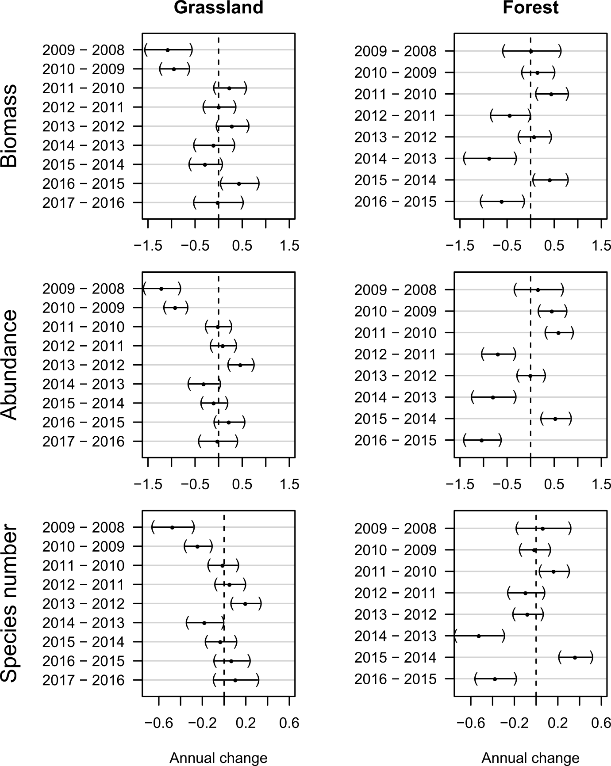

Figure 1: Temporal patterns of arthropods in 150 grasslands and 30 forests in Germany based on data from Seibold et al.².
Mean change between two subsequent years, either directly for biomass or on the log scale for abundance and species number, based on models using fixed-treatment contrasts comparing each year to the reference 2008 and presenting simultaneous 95% sequential confidence intervals. Models contained temperature, precipitation, local land-use intensity, cover of arable field and cover of grasslands within 1000 m radius as covariates and site nested in region as random effects to account for the nested structure of study sites within three regions. Poisson models contained an observation-specific random effect to account for overdispersion.

Regional and global patterns
Daskalova et al. 2020 2020 proceed by analysing a heterogeneous global dataset of aquatic and terrestrial time series from the BioTIME database⁹ and by reanalysing the data compilation from the meta-analysis by van Klink et al.¹⁰. From these analyses, they report declines in abundance of terrestrial insects in the data of van Klink et al.¹⁰, and in biomass of aquatic invertebrates in the BioTIME data. Although Daskalova et al. 2020 acknowledge that declines “could potentially be occurring in certain parts of the world and/or for specific taxa”, their main conclusion is that there was no evidence for an overall decline of invertebrates. It is not surprising that there are places where invertebrate biomass, abundance or species numbers have not declined, as reported also by Van Klink et al.¹⁰. But it is also important to analyse such datasets in more detail with regard to differences between regions, habitat types and taxa instead of focussing only on overall trends. Seibold et al.² were careful in drawing conclusions from their dataset and neither extrapolated results beyond a Central European perspective nor beyond the studied time period (2008-2017). Regional observations should be taken seriously and conservation measures should be implemented in regions where insects are declining¹¹, even if this might not reflect a global trend. For taxa such as birds and mammals, for which long-term, standardized and global datasets exist, major losses in biodiversity are undisputed^{12,13}, but such datasets do not exist for invertebrates. Nevertheless, there is an increasing number of studies that reported declines in the long^{14,15}, medium^{16,17} and short² term and investigated their drivers. Short-term studies may be more likely to find extreme trends, as pointed out by Daskalova et al. 2020, but long-term studies often suffer from less standardized sampling or opportunistic site selection limiting their ability to detect trends and underlying drivers^{14,18}. The strength of the data of Seibold et al.² is the well-selected underlying gradient of land-use intensity at local and landscape scale, replicated in three regions, which allowed inferences about the drivers of the observed declines. The fact that an increasing number of studies is now published, which differ in study system, results and insights, suggests that the scientific process is intact. Seibold et al.² have been very careful in phrasing their findings, as did e.g. Hallmann et al.¹⁶ and many others. Thus, we disagree with Daskalova et al. 2020 that studies reporting a decline have been alarmist. However, as put succinctly by Lindenmayer et al.¹⁹, the purpose of monitoring cannot be the passive observation of species decline until extinction. Instead, monitoring should inform actions, and in a first step this includes publishing and discussion of results.
Conclusions
In conclusion, we disagree with Daskalova et al. 2020 that the results of Seibold et al.² are based on flawed statistics and suggest that their model structure with ‘year’ as both fixed and random factor should be interpreted with caution. We agree, however, that observational data have to be interpreted with great care, especially when time series are short. Nevertheless, short time series also contribute important knowledge about arthropod population trends, particularly if monitoring is highly standardized, well-replicated and conducted along environmental gradients relevant for decision makers as in the case of Seibold et al.². Hence, we believe that it is important to publish findings irrespective of whether observed trends are negative, positive or neutral, as long as sampling and statistical analysis are sound.

References
1. Daskalova, G. N., Phillimore, A. B. & Myers-Smith, I. H. Accounting for year effects and sampling error in temporal analyses of population and biodiversity change. Response to Seibold et al. 2019 “Arthropod decline in grasslands and forests is associated with landscape-level drivers”. Nature, 574(7780), 671-674. EcoEvoRxiv (2020). doi:10.32942/osf.io/cg3zs
2. Seibold, S. et al. Arthropod decline in grasslands and forests is associated with landscape-level drivers. Nature 574, 671–674 (2019).
3. VanLeeuwen, D. M., Murray, L. W. & Urquhart, N. S. A Mixed Model with Both Fixed and Random Trend Components across Time. J. Agric. Biol. Environ. Stat. 1, 435–453 (1996).
4. Andrewartha, H. G. & Birch, L. C. The distribution and abundance of animals. (University of Chicago Press, 1954).
5. Pöyry, J. et al. Climate-induced increase of moth multivoltinism in boreal regions. Glob. Ecol. Biogeogr. 20, 289–298 (2011).
6. Turchin, P. Population regulation: old arguments and a new synthesis. in Population dynamics: new approaches and synthesis (eds. Cappucino, N. & Price, P. W.) 19–40 (1995).
7. Zuur, A. F., Ieno, E. N. & Saveliev, A. A. Beginner’s Guide to Spatial, Temporal and Spatial-Temporal Ecological Data Analysis with R-INLA. (Highland Statistics Ltd., 2017).
8. Schenker, N. & Gentleman, J. F. On judging the significance of differences by examining the overlap between confidence intervals. Am. Stat. 55, 182–186 (2001).
9. Dornelas, M. et al. BioTIME: A database of biodiversity time series for the Anthropocene. Glob. Ecol. Biogeogr. 27, 760–786 (2018).
10. van Klink, R. et al. Meta-analysis reveals declines in terrestrial but increases in freshwater insect abundances. Science (80-. ). 368, 417–420 (2020).
11. Harvey, J. A. et al. International scientists formulate a roadmap for insect conservation and recovery. Nat. Ecol. Evol. 4, 30–32 (2020).
12. Ceballos, G. et al. Accelerated modern human – induced species losses: Entering the sixth mass extinction. Sci. Adv. 1, 1–6 (2015).
13. Diaz, S., Settele, J. & Brondizio, E. Summary for policymakers of the global assessment report on biodiversity and ecosystem services of the Intergovermental Science-Policy Platform on Biodiversity and Ecosystem Services. (IPBES, 2019).
14. Habel, J. C. et al. Butterfly community shifts over two centuries. Conserv. Biol. 30, 754–762 (2016).
15. Soroye, P., Newbold, T. & Kerr, J. T. Climate change contributes to widespread declines among bumble bees across continents. Science (80-. ). 87, 685–688 (2020).
16. Hallmann, C. A. et al. More than 75 percent decline over 27 years in total flying insect biomass in protected areas. PLoS One 12, e0185809 (2017).
17. Welti, E. A. R., Roeder, K. A., De Beurs, K. M., Joern, A. & Kaspari, M. Nutrient dilution and climate cycles underlie declines in a dominant insect herbivore. Proc. Natl. Acad. Sci. U. S. A. 117, 7271–7275 (2020).
18. Kunin, W. E. Robust evidence of declines in insect abundance and biodiversity. Nature 574, 641–642 (2019).
19. Lindenmayer, D. B., Piggott, M. P. & Wintle, B. A. Counting the books while the library burns: Why conservation monitoring programs need a plan for action. Front. Ecol. Environ. 11, 549–555 (2013).

Author affiliations
¹Terrestrial Ecology Research Group, Department of Ecology and Ecosystem Management, Technical University of Munich, Hans-Carl-von-Carlowitz-Platz 2, 85354 Freising, Germany
²Ecosystem Dynamics and Forest Management Group, Department of Ecology and Ecosystem Management, Technical University of Munich, Hans-Carl-von-Carlowitz-Platz 2, 85354 Freising, Germany
³Berchtesgaden National Park, Doktorberg 6, 83471 Berchtesgaden, Germany
⁴Departement of Biostatistics, Epidemiology, Biostatistics and Prevention Institute, University of Zurich, Hirschengraben 84, 8001 Zurich, Switzerland
⁵Forest Entomology, Swiss Federal Research Institute WSL, Zürcherstrasse 111, 8903 Birmensdorf, Switzerland
⁶ETH Zurich, Department of Environmental Systems Science, Institute of Terrestrial Ecosystems, 8092 Zurich, Switzerland
⁷Ecological Networks, Department of Biology, Technical University of Darmstadt, Schnittspahnstraße 3, 64287 Darmstadt, Germany
⁸Field Station Fabrikschleichach, Department of Animal Ecology and Tropical Biology, Julius-Maximilians-University Würzburg, Glashüttenstraße 5, 96181 Rauhenebrach, Germany
⁹Bavarian Forest National Park, Freyunger Str. 2, 94481 Grafenau, Germany
¹⁰Department of Agricultural Biotechnology, Faculty of Agriculture, Düzce University, 81620 Düzce, Turkey
¹¹Silviculture and Forest Ecology of the Temperate Zones, University of Göttingen, Büsgenweg 1, 37077 Göttingen, Germany
¹²Chair of Silviculture, Institute of Forest Sciences, Faculty of Environment and Natural Resources, University of Freiburg, Tennenbacherstr. 4, 79106 Freiburg, Germany
¹³Institute of Plant Sciences, University of Bern, Altenbergrain 21, 3013 Bern, Switzerland
¹⁴Evolutionary Zoology, Biosciences, Salzburg University, Hellbrunner Str. 34, 5020 Salzburg, Austria
¹⁵Max Planck Institute for Biogeochemistry, Box 100164, 07701 Jena, Germany
*Corresponding author: sebastian.seibold@tum.de

