Environmental conditions promote local segregation, but functional distinctiveness allow aggregation of catfishes in the Amazonian estuary

Bruno E. Soares¹, Naraiana L. Benone², Ronaldo B. Barthem³, Alexandre P. Marceniuk³, Luciano F. A. Montag⁴

¹ Laboratório de Limnologia, Instituto de Biologia, Universidade Federal do Rio de Janeiro – UFRJ, Rio de Janeiro – RJ, Brazil
² Universidade do Estado de Minas Gerais – UEMG, Unidade Passos, Passos – MG, Brazil
³ Museu Paraense Emílio Goeldi, Belém – PA, Brazil
⁴ Laboratório de Ecologia e Conservação, Instituto de Ciências Biológicas, Universidade Federal do Pará – UFPA, Belém – PA, Brazil

Abstract
Cooccurrence patterns of species can appear through niche-related processes such as (i) environmental filtering matching specific sets of traits to a given environment, and (ii) limiting similarity selecting divergent functional traits to reduce niche overlap. Locally, both processes should act together to shape the distribution of species. We evaluated the importance of environmental variables and functional distinctiveness to the co-occurrence patterns of nine marine catfishes in the inner estuary of the Amazon River mouth. Sampling was carried out in the dry seasons of 1996 and 1997, and the rainy season of 1996 by nearly 120 standardized bottom trawls per expedition. We observed 13 significant pairs of segregated species and two pairs of aggregated species, which sum 41.7% of all combinations. Amphiarius phrygiatus and Sciades couma segregated from all the remaining marine catfishes by occupying shallower areas with lower salinity levels. Aggregated pairs were strongly associated with higher functional distinctiveness. We concluded that environmental filtering is the main force structuring the co-occurrence patterns by promoting spatial segregation, but functional distinctiveness allowed some species to aggregate.

Keywords: environmental filtering; limiting similarity; ecomorphology; Ariidae, co-occurrence patterns.
Highlights
- Environmental filtering and limiting similarity shape the co-occurrence of species
- We studied the co-occurrence of marine catfishes in the Amazon River estuary
- Marine catfishes exhibited a high rate of non-random co-occurrence structure
- Non-random pairs were mostly segregated due to differences in salinity and depth
- Aggregated pairs exhibited high functional distinctiveness

Introduction
Community structure is shaped by many processes from which environmental filtering and limiting similarity are usually highlighted. Environmental filtering favors the survival of species exhibiting suitable traits given regional or local abiotic variables (Kraft et al. 2015). Limiting similarity inhibits species' coexistence with an overlapping niche in scenarios of limited resources and unequal competitive ability (Meszéna et al. 2006, Violle et al. 2011). These processes have contrasting effects on the structure of ecological communities (Mouillot et al. 2007) but are not mutually exclusive (Boet et al. 2020, Várbíró et al. 2020).
In general, environmental filtering is the first process that acts upon the regional pool of species by selecting those that may survive locally (Kraft et al. 2015). Limiting similarity may have a strong role in the local community structure by eliminating poor competitors (Huston 1999). The relative importance of environmental filtering and limiting similarity depends on multiple factors, such as environmental context (Echevarria & Rodriguez 2017, Álvarez-Grzybowska et al. 2020) and spatial scale (Araújo & Rozenfeld 2014, Boet et al. 2020). For example, environmental conditions may filter most of the functional traits of fish communities, while limiting similarity may be stronger on traits related to trophic partitioning if the competition for trophic resources is important (Ford & Roberts 2020). The debate on the relative importance of environmental filtering and limiting similarity is often addressed by analyzing diversity measures, but species within communities may be affected differently by assembly rules (e.g., dominant and rare species; Benone et al. 2020). Pairwise co-occurrence patterns offer fine-scale information on how and why species occupy a given site (Echevarria & Rodriguez 2017).
Pairwise co-occurrence tests return pairs of spatially segregated (species that often do not co-occur) and aggregated (species that often co-occur) species. Regionally, segregated pairs are more common than aggregated pairs in plant and animal communities (Gotelli & McCabe 2002). Species segregations were initially associated with competitive exclusion (Diamond 1975), but other processes promote species' segregations, such as environmental specialization to microhabitats (Guterres et al. 2020) or historical contingencies (Germain et al. 2016). Conversely, species aggregation arises if species have similar niche requirements or positive species interactions (Peoples & Frimpong 2016, Cordero & Jackson 2019). Co-occurrence patterns are not direct measures of species' interactions, but they may strongly shape it in some circumstances (Blanchet et al. 2020). Nonetheless, the signal of these assembly processes in the pairwise associations may be intricate: environmental tracking, for example, may lead to both segregated and aggregated pairs in the same environment (D'Amen et al. 2018).
The Amazon River estuary provides suitable conditions to test co-occurrence because it encompasses some marked environmental variation and highly diversified fauna. The area is dominated by the Amazon River's influence, which carries one-fifth of the global freshwater discharge and 40% of the Atlantic Ocean's sediment flux (Armijos et al. 2020). This discharge interacts with the tides and creates a marked gradient in salinity, organic matter, and sediment deposition that strongly affects species distribution and population dynamics (Martins et al. 2015, Lobato et al. 2018, Neumann-Leitão et al. 2018). Such spatial heterogeneity and high biological productivity support high endemism and fisheries activities (MPA 2012, Aguilera & Marceniuk 2018, Marceniuk et al. 2020). Marine catfishes (Siluriformes: Ariidae) are important components of the regional fauna as they exhibit high biomass (Barletta et al. 2005) and taxonomic diversity (13 species divided into five genera; Marceniuk & Menezes 2007). Marine catfishes have an overall conserved body plan and similar ecological strategies but display differences in body size (Soares et al. 2016), diet composition (Mishima & Tanji 1982, Mendes & Barthem 2010), habitat use, and freshwater affinity (Barletta et al. 2008, Dantas et al. 2010).
Here, we evaluated the relative role of environmental filtering and limiting similarity on the local distribution of marine catfishes in the shallow and muddy bottom of the inner Amazonian estuary. We disentangled the co-occurrence patterns of marine catfishes by identifying segregated and aggregated species pairs. Then we analyzed how non-random patterns were related to environmental variation and functional distinctiveness. Given the marked variation in salinity, we expected that environmental filtering would promote species' segregation or aggregation by their freshwater affinity. As we characterized species by functional traits related to habitat use and feeding, we considered two competing hypotheses: (i) environmental filtering could select similar functional traits, then aggregated species would be ecologically redundant; or (ii) functional distinctiveness would allow the use of different resources within sites and, consequently, would promote aggregation.

Material and methods
Study area and fieldwork
This study was conducted in the inner estuary of the Amazon River mouth between the latitude 2º 30'N to 0º 05'N and by the longitude 47º 50'W to 50º 30'W (Figure 1), and the isobaths 5 - 50 m classified into three strata: 5-10 m, 10-20 m, and 20-50 m. The climate is tropical, characterized by high temperature and precipitation throughout the year, with relative humidity above 80% and an average atmospheric temperature of 25 ºC. The area is characterized by a shallow muddy substrate and the dynamism of the mixture of the Amazon River's freshwater discharge and the marine water (Eisma & Van der Marel 1971, Curtin & Legeckis 1986). The annual cycle of the Amazon River discharge is the most important force acting in the salinity structure because it determines the displacement of the salty wedge along the shelf of the Amazon River mouth (Geyer et al. 1996). The dry period is marked by the brackish waters to the coast from May to November, and the rainy period by the predominance of fresh waters from December to April (Barthem & Schwassmann 1994).
Specimens were sampled during three trawling expeditions,
two of which were conducted during the dry season (August
and September) of 1996 and 1997, and the third in the rainy
season of 1996 (March and April). Each trawling expedition
included 120 hauls, except the dry season of 1996, when only
111 hauls were conducted. Fishes were sampled by trawlers
equipped with bottom-trawl nets of 58.2 meters length and
14 cm between opposite knots. Each trawl was operated for
30 min at a speed of 2–3 knots.
Data were obtained during the sea-borne survey of the project executed in the Amazon River Mouth by Japan International Cooperation Agency (JICA), Museu Paraense Emílio Goeldi (MPEG), and Instituto Brasileiro do Meio Ambiente e dos Recursos Naturais Renováveis (IBAMA) between 1996-1997. The sampling area was divided into 1,330 blocks of 3' latitude by 3' longitude each and nearly nine nautical miles of area. Samplings were carried out during three trawling expeditions during the dry period of 1996 (August to September of 1996), the rainy period of 1997 (March to April of 1997), and the dry period of 1997 (August to September of 1997). Each seasonal survey comprised 120 trawling stations distributed randomly and proportionally to the area of each isobath stratum. In each station, fishes were sampled by bottom trawling conducted by a pair of vessels operating for 30 minutes along the current direction at a constant 2-3 knots speed. Standardized trawls were carried out at daytime by trawlers equipped with bottom-trawl nets of 58.2 meters length and 14 cm between opposite knots (JICA 1998).

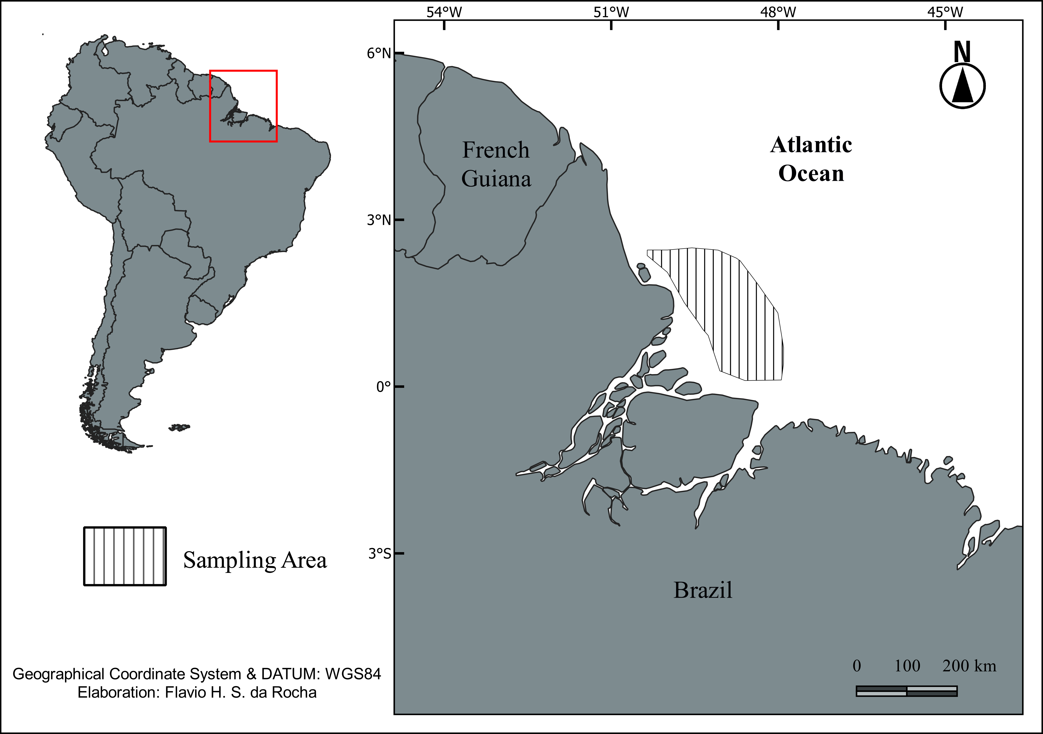
Figure 1 – Area in the inner estuary of the Amazon River mouth where marine catfishes were sampled in the dry season of 1996 and 1997, and during the rainy season of 1996.

Environmental variables
We recorded measured salinity and temperature at the bottom of the water column for each site to describe the environmental conditions in which species occurred by using a multiparameter. We characterized the environmental conditions in which species occurred based on the average of the salinity and temperature taken at the 5 m near the bottom, which correspond to the trawl net mouth height, using a salinity/temperature/depth instrument (temperature measuring capability 5–40ºC, precision 0.02ºC, salinity measuring capability 0–40 ‰, depth range 0–200 m, measurement distance 0.2 m). Environmental variation was spatially constrained by the linear distance among sampled stations (Mantel test; r = 0.66; p = 0.001). We summarized the environmental variation by applying a Principal Component Analysis (PCA). We selected only the first axis of the PCA, which explained ~53% of the total variation and was strongly related to depth and salinity (Supporting Information). We used values in the first axis of the PCA to represent the environmental variation in further analysis.

Functional distinctiveness
We used nine ecomorphological indices describing the species based on body size, the shape of the caudal peduncle, the size of the eyes, barbels, and mouth width (Supporting Information). These indices are related to food acquisition and mobility of fishes and are often used as functional traits in fish ecology (Villéger et al. 2017). For example, the shape of the teeth is related to the type of consumed items. Long, recurved teeth indicate ariid catfishes with stronger piscivorous habits, while small, conical teeth are more associated with polychaete-eaters (Blaber et al. 1994). Regarding body size, larger fish are expected to be faster swimmers and better at avoiding predation than small fish (Villéger et al. 2017).
We built a dissimilarity matrix based on the functional traits using the Gower distance. Then, we calculated the average functional distinctiveness (D_{i}; Violle et al. 2017) for the species captured in each trawl. D_{i} is the average distance of each species to the remaining species in the site; therefore, average D_{i} represents the site's average functional originality. We built the dissimilarity matrix and calculated D_{i} by using the cluster (Maechler et al. 2019) and funrar (Grenié et al. 2017) packages in R environment (R Core Team 2018).

Co-occurrence patterns
We identified species co-occurrence patterns by quantifying the strength and significance of pairwise associations between species against null probabilities (Gotelli & Ulrich 2010). We quantified the strength of the association between species pairs by calculating the C-score index (Stone & Roberts 1990) rescaled from 0 (maximum aggregation) to 1 (maximum segregation). We established the significance of aggregation or segregation patterns by comparing observed values to 10,000 null communities' values. Null communities were generated by a 'fixed-equiprobable' algorithm that preserves species' frequency in the samples but randomizes equiprobably the richness per sample (Gotelli 2000). Then, we reduced the rate of type I error by applying the empirical Bayes approach. In this approach, pairwise C-scores were grouped in 22, evenly spaced bins. Significant C-scores are those whose values per bin are higher than the average number of values per bin drawn from a null distribution. Non-random C-scores were standardized to Z-scores by the null mean and standard deviation to compare different pairs of species and classify between aggregation (positive values) or segregation (negative values).
Finally, we compared differences in the environmental variables (first axis of the environmental PCA) and in the functional distinctiveness (D_{i}) between sets of sites to infer the processes shaping the observed patterns of co-occurrence, following the framework from Blois et al. (2014). Sites were categorized in four occupancy classes depending on the presence/absence of the species from an associated pair: (1,0) and (0,1) if the site contains only species a or b, respectively; (1,1) and (0,0) if the site includes both or neither species, respectively. Tests referring to segregated pairs compare the average differences in the dependent variables between classes (1,0) and (0,1), while tests referring to aggregated pairs compare the average differences in the dependent variables between classes (1,1) and (0,0). We applied a Multivariate Analysis of Variance (MANOVA) in the distance tests and Analyses of Variance (ANOVA) for the environmental and functional tests. Additionally, we applied Chi-squared tests to evaluate if the relative number of segregations [(1,0) and (0,1)] and aggregations (1,1) were different between rainy and dry seasons. All co-occurrence analyses were based on the classic framework available in D'Amen et al. (2018). Our dataset and R coding are available at Zenodo (https://doi.org/10.5281/zenodo.4118631).

Results
Catfishes differed in the ecomorphological space and local occupancy. Ecomorphologically, species varied primarily by body size, the shape of the caudal peduncle, the size of the eyes, and length of the mentonian barbel (Supporting Information). In regional occupancy, Sciades couma was the rarest species, while Bagre bagre, Notarius grandicassis, and Cathorops arenatus were the most frequent ones (Figure 2). We observed 15 non-random pairs of species (41.7% of all possible combinations). Among them, 13 showed segregated patterns, and 2 showed aggregated patterns (Table 1). Patterns were related to environmental variation and functional distinctiveness and did not shift between seasons (Supplementary Table 1).
Amphiarius phrygiatus and S. couma were generally segregated from all the remaining ariids due to differences in environmental conditions. A. phrygiatus and S. couma occupied shallower areas with lower salinity levels and D_{i} than other species (Figure 3; ANOVA; p < 0.001). Aggregation was primarily related to functional distinctiveness. Assemblages encompassing aggregated species exhibited higher D_{i} than those that neither occurred (Figure 4; ANOVA; p < 0.001). Aggregated pairs exhibit marked differences in the body size and relative size of the mouth (A. quadriscutis and S. parkeri) or the relative size of eyes and depth of the caudal peduncle (A. rugispinis and C. arenatus). Nonetheless, other pairs displaying opposite ecomorphological patterns did not exhibit strong association (e.g., C. arenatus and N. grandicassis). Environmental conditions poorly explained the co-occurrence of aggregated pairs (low R²).

Figure 2 – Occupancy patterns of marine catfishes (Ariidae) in the studied area of the inner estuary of the Amazon River mouth.
Table 1 – Association of environment and functional distinctiveness with the co-occurrence patterns of marine catfishes in the inner estuary of the Amazon River mouth. The coefficients of explanation (R²) of the linear models indicate the strength of the association.
Associated pairs | Environmental test (R²) | Environmental test (p-value) | Functional test (R²) | Functional test (p-value)
Segregated pairs
Amphiarius phrygiatus - Aspistor quadriscutis | 0.372 | < 0.001 | 0.510 | < 0.001
Amphiarius phrygiatus - Amphiarius rugispinis | 0.586 | < 0.001 | 0.744 | < 0.001
Amphiarius phrygiatus - Bagre bagre | 0.406 | < 0.001 | 0.468 | < 0.001
Amphiarius phrygiatus - Cathorops arenatus | 0.409 | < 0.001 | 0.502 | < 0.001
Amphiarius phrygiatus - Notarius grandicassis | 0.391 | < 0.001 | 0.439 | < 0.001
Amphiarius phrygiatus - Sciades parkeri | 0.583 | < 0.001 | 0.746 | < 0.001
Amphiarius phrygiatus - Sciades proops | 0.648 | < 0.001 | 0.612 | < 0.001
Amphiarius rugispinis - Sciades couma | 0.509 | < 0.001 | 0.688 | < 0.001
Bagre bagre - Sciades couma | 0.303 | < 0.001 | 0.272 | < 0.001
Cathorops arenatus - Sciades couma | 0.302 | < 0.001 | 0.289 | < 0.001
Notarius grandicassis - Sciades couma | 0.302 | < 0.001 | 0.259 | < 0.001
Sciades couma - Sciades parkeri | 0.472 | < 0.001 | 0.672 | < 0.001
Sciades couma - Sciades proops | 0.656 | < 0.001 | 0.622 | < 0.001
Aggregated pairs
Aspistor quadriscutis - Sciades parkeri | 0.022 | 0.021 | 0.869 | < 0.001
Amphiarius rugispinis - Cathorops arenatus | 0.086 | < 0.001 | 0.864 | < 0.001

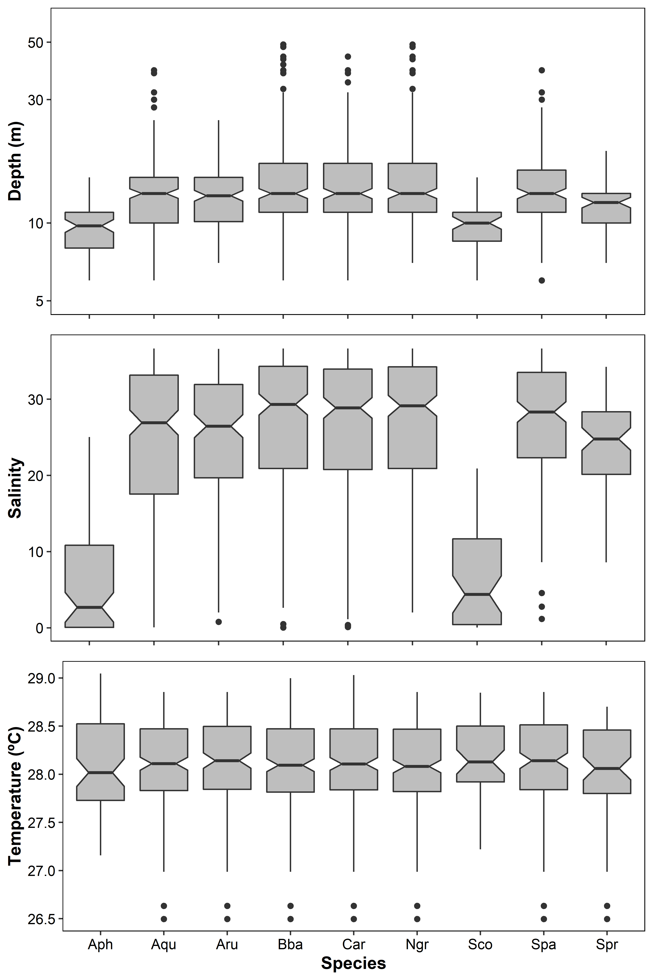
Figure 3 – Depth (m), salinity (‰), and temperature (ºC) in the sites where each species occurred. Codes: Aph – Amphiarius phrygiatus; Aqu – Aspistor quadriscutis; Aru – Amphiarius rugispinis; Bba – Bagre bagre; Car – Cathorops arenatus; Ngr – Notarius grandicassis; Spa – Sciades parkeri; Spr – Sciades proops; Sco – Sciades couma.

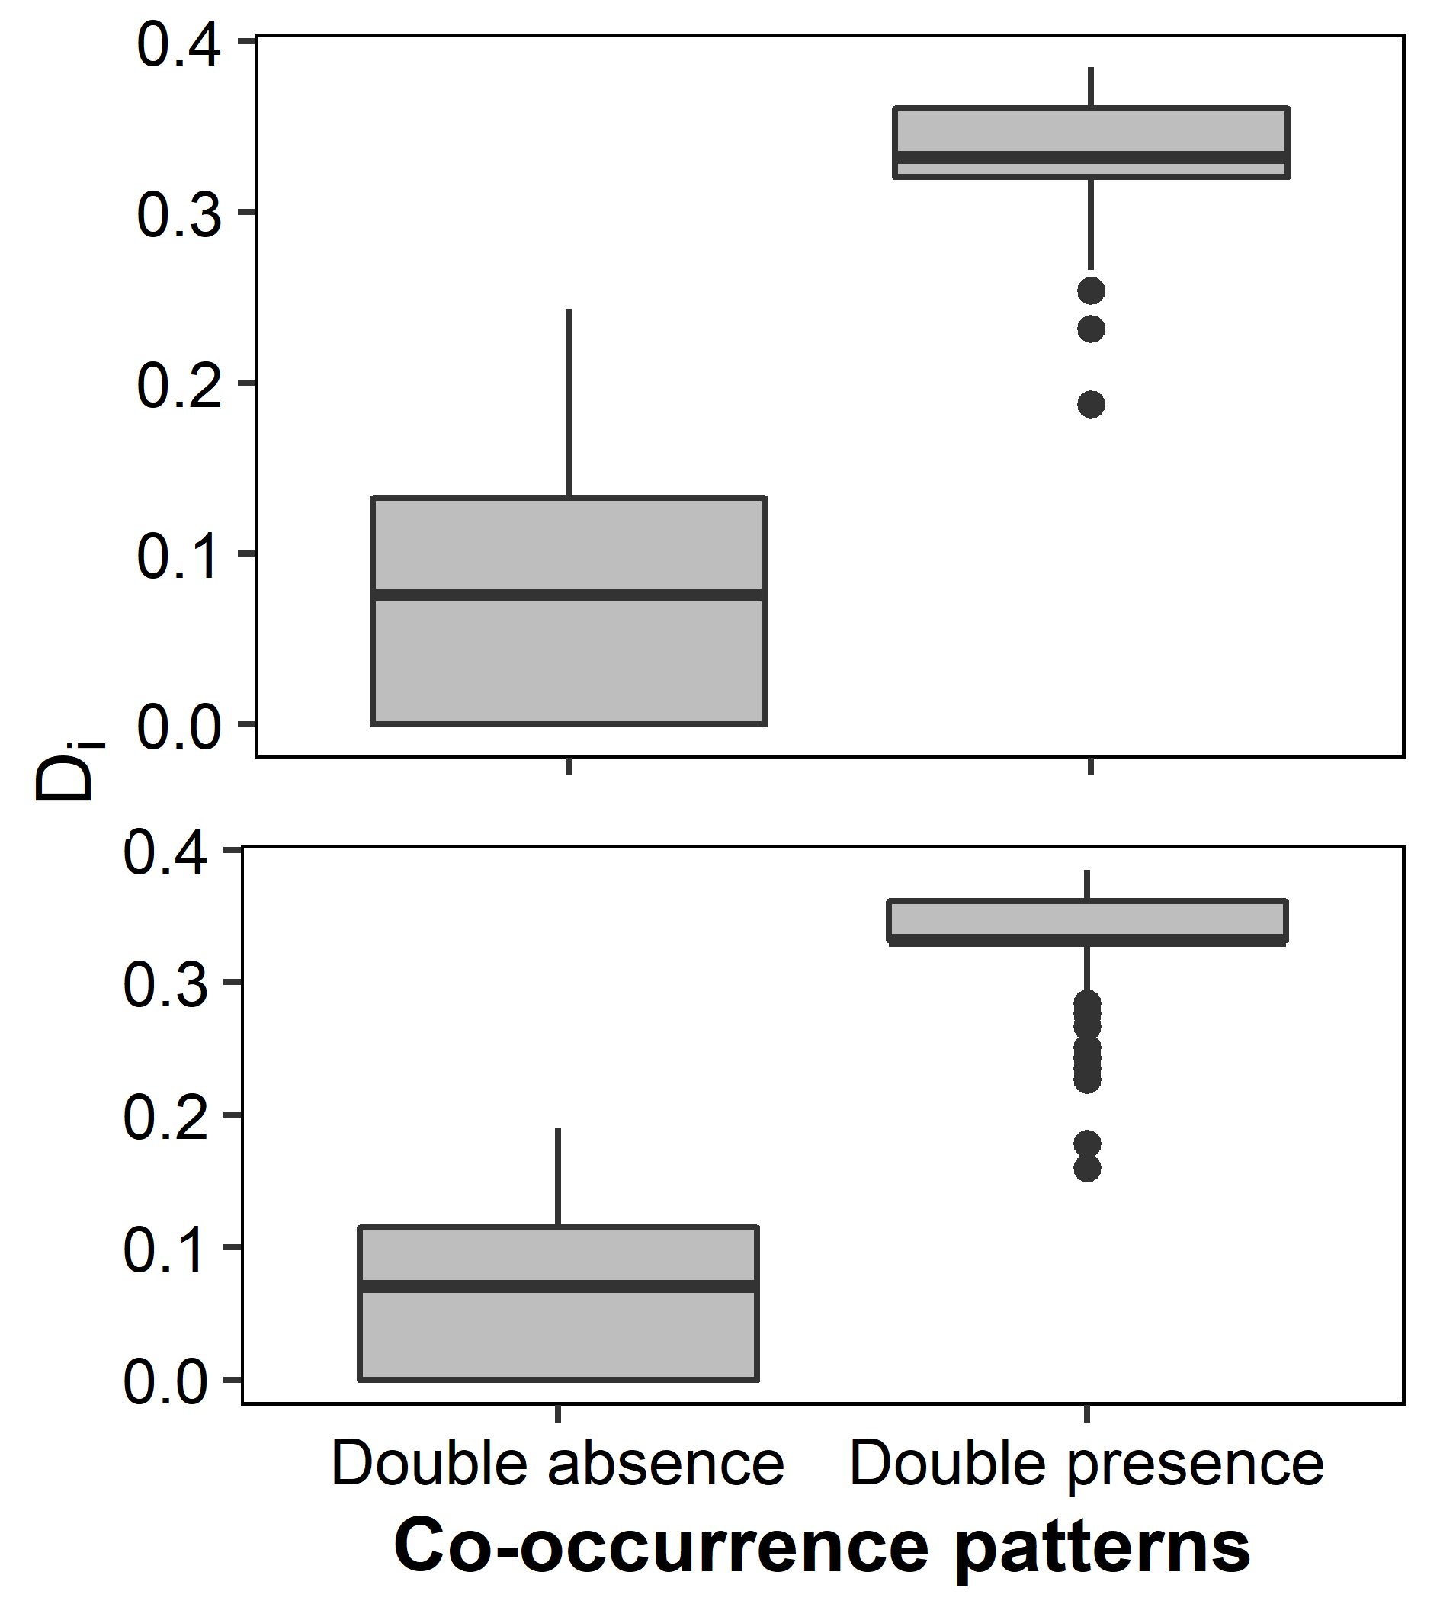
Figure 4 – Functional distinctiveness (D_{i}) of the assemblages in which aggregated pairs were both absent or both present: Aspistor quadriscutis and Sciades parkeri (above); Amphiarius rugispinis and Cathorops arenatus (below).

Discussion
Environmental conditions favor the occurrence of some species but hinder the occurrence of others, thus promoting aggregation and segregation patterns. If environmental filtering constrains functional traits, aggregated species should promote low functional distinctiveness. In contrast, these features may allow habitat partitioning and favor species aggregation; then, aggregated species would display higher functional distinctiveness. We showed that depth and salinity heterogeneity promote spatial segregation but not the aggregation of marine catfishes in the inner estuary of the Amazon River mouth. Aggregation only occurred in two species pairs and were strongly linked to high functional distinctiveness. Therefore, both environmental filtering and habitat partitioning are shaping the occupancy patterns of species in estuaries.
Estuarine fishes are known to track optimal conditions in the face of salinity variation (Barletta et al. 2005, 2008) or to use areas where environmental conditions are stable (Vendel et al. 2010). The Ariidae family comprises euryhaline fishes that inhabit both freshwater and marine systems (Schmidt et al. 2008, Pusey et al. 2020). Juvenile and adult fish usually exhibit marked segregation in habitat use juveniles and spawning adults usually occupy shallower and less saline areas (Mishima & Tanji 1981, Dantas et al. 2010). Because of the wide range of salinity and depth that ariid catfishes occur, depth and salinity should be less critical to shape adult distribution in the inner estuary. Therefore, despite the overall capacity to use freshwater and marine environments during their life cycle, these catfishes exhibited differences in environmental affinities and tracked favorable conditions in the inner estuary as A. phrygiatus and S. couma segregated from the remaining species by occupying less saline and shallower areas.
The marine catfishes were divided into two groups in the inner Amazonian estuary: (i) two species occupying shallower, less saline areas, and (ii) seven species inhabiting deeper, more saline areas. Most of the species with similar environmental affinities co-occurred randomly, and two pairs of species in the deepest area were aggregated. Therefore, negative interactions do not seem to be a major determinant in structuring the co-occurrence patterns of these catfishes. Aggregated species greatly varied in niche axes that promote shared use of space and food: (i) S. parkeri is a large species with caniniform teeth, while A. quadriscutis is a small species with molariform teeth; and (ii) A. rugispinis and C. arenatus are small-sized species that differ in traits related to habitat use, such as eye size and depth of the caudal peduncle. In fishes, ecomorphological differences between phylogenetically close species facilitate coexistence either by trophic (Portella et al. 2016, Silva et al. 2016) or microhabitat partitioning (Manna et al. 2017, 2020). Trophic partitioning may be an important factor underpinning the observed co-occurrence patterns because marine catfishes display high interspecific trophic variation (Mishima & Tanji 1982, Dantas et al. 2013), and syntopic species may exhibit trophic specialization (Maitra et al. 2020). If food resources are limiting and homogeneously distributed, trophic partitioning would inhibit competition and spatial segregation. Indeed, marine catfishes in the Amazonian estuary exhibit marked differences in the main prey type: S. parkeri and S. couma feed primarily on benthonic fishes, C. arenatus feed primarily on copepods, and the remaining species feed primarily on other crustaceans (Mendes & Barthem 2010, Soares et al. 2020).
Nonetheless, trophic and ecomorphological dissimilarity do not promptly determine species aggregation separately, as some pairs that exhibit marked functional and trophic differences do not aggregate. For example, C. arenatus is markedly different from A. phrygiatus and N. grandicassis in the ecomorphospace, but they do not aggregate. Different affinities to salinity and depth segregate the first pair (C. arenatus and A. phrygiatus), but the second pair (C. arenatus and N. grandicassis) inhabited sites with similar environmental conditions and co-occurred randomly. Several reasons may hinder the identification of non-random co-occurrence structure. First, temporal variation in the movement and distribution of the species may be a confounding factor. Marine catfishes usually move to less saline habitats for spawning (Dantas et al. 2010, 2012) and exhibit markedly seasonal distribution in the Amazonian estuary (Barletta et al. 2005). These seasonal movements should decrease local occupancy and abundance in the sampling area and do not change the pairwise co-occurrence patterns. Second, the adequate sampling size to identify co-occurrence patterns with a 95% confidence interval is over 500 samples (Blanchet et al. 2020), often unachievable in ecological studies. Third, the higher the number of non-random patterns within a community, the weaker and more undetectable the remaining ones are (Cazelles et al. 2016, Blanchet et al. 2020).
We recovered nearly half of the total number of species pairs as non-random associations, a high proportion compared to studies applying similar methods (Blois et al. 2014, Lyons et al. 2016). The explanation is threefold. First, we used a less conservative method to build the pairwise null models (fixed-equiprobable algorithm) than the one applied in other studies (fixed-fixed algorithm). This may only slightly affect overall results as they return similar results (Gotelli 2000). Second, this method is sensitive to species rarity and may not detect a significant pairwise structure when analyzing two rare species (D'Amen et al. 2018). We included species with at least 50 occurrences, thus diminishing issues related to low detectability of non-random associations in rare/rare species pairs. Third, we analyzed the co-occurrence patterns of species within a single taxonomic family, thus encompassing less phylogenetic diversity than assemblages investigated in other studies (e.g., Cordero & Jackson 2019, Guterres et al. 2020). Phylogenetic proximity constrains ecological diversification and species interactions (Peralta 2016, Laigle et al. 2018), which drive some co-occurrence patterns (Freilich et al. 2018) and may have contributed to the high proportion of non-random patterns observed herein.
We can draw meaningful conclusions from these data. The environmental heterogeneity in the inner estuary of the Amazon River mouth sets boundaries to the local distribution and co-occurrence patterns despite the temporal dynamics in the species' movements. This suggests that regional variation in the environmental conditions promote spatial segregation even in closely related species inhabiting an environment with a homogenous shallow muddy substrate and that could be similarly important in other marine systems. We also showed that functional differences related to habitat use allow species aggregation. Therefore, both environmental filtering and limiting similarity play a role in shaping species' distribution and co-occurrence. Future research may better disentangle the relative roles of environmental filtering and competition by evaluating species affinities in a phylogenetic and historical context or determining the behavioral and physiological traits underpinning species' co-occurrence.

Acknowledgments
We are grateful to CNPq for the postdoctoral grant provided to BES (process nº 151743/2019-3) and for the research productivity grant to LFAM (302406/2019-0); to MCTIC/CNPq by the funding provided to APM through the Programa de Capacitação Institucional (process nº 444338/2018-7 and 300675/2019-4).

Author statement
Soares BE: Writing – Original Draft; Soares BE, Benone NL: Conceptualization, Methodology, Formal analysis. Barthem RB, Marceniuk AP: Data curation, Project administration, Funding acquisition. Benone NL, Barthem RB, Marceniuk AP, Montag LFA: Writing – Review & Editing.

References
Aguilera, O., & Marceniuk, A. P. 2018. Neogene tropical sea catfish (Siluriformes; Ariidae), with insights into paleo and modern diversity within northeastern South America. Journal of South American Earth Sciences, 82, 108–121. DOI: 10.1016/j.jsames.2017.12.017
Álvarez-Grzybowska, E., Urbina-Cardona, N., Córdova-Tapia, F., & García, A. 2020. Amphibian communities in two contrasting ecosystems: functional diversity and environmental filters. Biodiversity and Conservation, 29(8), 2457–2485. DOI: 10.1007/s10531-020-01984-w
Araújo, M. B., & Rozenfeld, A. 2014. The geographic scaling of biotic interactions. Ecography, 37(5), 406–415. DOI: 10.1111/j.1600-0587.2013.00643.x
Armijos, E., Crave, A., Espinoza, J. C., Filizola, N., Espinoza-Villar, R., Ayes, Fonseca, P., Fraizy, P., Gutierrez, O., Vauchel, P., Camenen, B., Martiınez, J. M., Dos Santos, A., Santini, W., Cochonneau, G., & Guyot, J. L. 2020. Rainfall control on Amazon sediment flux: synthesis from 20 years of monitoring. Environmental Research Communications, 2(5), 051008. DOI: 10.1088/2515-7620/ab9003
Barletta, M., Amaral, C. S., Corrêa, M. F. M., Guebert, F., Dantas, D. V., Lorenzi, L., & Saint-Paul, U. 2008. Factors affecting seasonal variations in demersal fish assemblages at an ecocline in a tropical-subtropical estuary. Journal of Fish Biology, 73(6), 1314–1336. DOI: 10.1111/j.1095-8649.2008.02005.x
Barletta, M., Barletta-Bergan, A., Saint-Paul, U., & Hubold, G. 2005. The role of salinity in structuring the fish assemblages in a tropical estuary. Journal of Fish Biology, 66, 45–72. DOI: 10.1111/j.1095-8649.2004.00582.x
Barthem, R. B., & Schwassmann, H. O. 1994. Amazon River influence on the seasonal displacement of the salt wedge in the Tocantins River estuary, Brazil, 1983-1985. Boletim Do Museu Paraense Emílio Goeldi. Série Zoologia., 10(1), 119–130.
Benone, N. L., Soares, B. E., Lobato, C. M. C., Seabra, L. B., Bauman, D., & de Assis Montag, L. F. 2020. How modified landscapes filter rare species and modulate the regional pool of ecological traits? Hydrobiologia, 9. DOI: 10.1007/s10750-020-04405-9
Blaber, S. J. M., Brewer, D. T., & Salini, J. P. 1994. Diet and dentition in tropical ariid catfishes from Australia. Environmental Biology of Fishes, 40(2), 159–174. DOI: 10.1007/BF00002543
Blanchet, F. G., Cazelles, K., & Gravel, D. 2020. Co-occurrence is not evidence of ecological interactions. Ecology Letters, 23(7), 1050–1063. DOI: 10.1111/ele.13525
Blois, J. L., Gotelli, N. J., Behrensmeyer, A. K., Faith, J. T., Lyons, S. K., Williams, J. W., Amatangelo, K. L., Bercovici, A., Du, A., Eronen, J. T., Graves, G. R., Jud, N., Labandeira, C., Looy, C. V., Mcgill, B., Patterson, D., Potts, R., Riddle, B., Terry, R., Tóth, A., Villaseñor, A., & Wing, S. 2014. A framework for evaluating the influence of climate, dispersal limitation, and biotic interactions using fossil pollen associations across the late Quaternary. Ecography, 37(11), 1095–1108. DOI: 10.1111/ecog.00779
Boet, O., Arnan, X., & Retana, J. 2020. The role of environmental vs. Biotic filtering in the structure of European ant communities: A matter of trait type and spatial scale. PLoS ONE, 15(2), 1–18. DOI: 10.1371/journal.pone.0228625
Cazelles, K., Araújo, M. B., Mouquet, N., & Gravel, D. 2016. A theory for species co-occurrence in interaction networks. Theoretical Ecology, 9(1), 39–48. DOI: 10.1007/s12080-015-0281-9
Cordero, R. D., & Jackson, D. A. 2019. Species‐pair associations, null models, and tests of mechanisms structuring ecological communities. Ecosphere, 10(7). DOI: 10.1002/ecs2.2797
Curtin, T. B., & Legeckis, R. V. 1986. Physical observations in the plume region of the Amazon River during peak discharge-III. Currents. Continental Shelf Research, 6(1–2), 73–86. DOI: 10.1016/0278-4343(86)90054-3
D'Amen, M., Mod, H. K., Gotelli, N. J., & Guisan, A. 2018. Disentangling biotic interactions, environmental filters, and dispersal limitation as drivers of species co-occurrence. Ecography, 41(8), 1233–1244. DOI: 10.1111/ecog.03148
Dantas, D. V., Barletta, M., Costa, M. F., Barbosa-Cintra, S. C. T., Possatto, F. E., Ramos, J. A. A., Lima, A. R. A., & Saint-Paul, U. 2010. Movement patterns of catfishes (Ariidae) in a tropical semi-arid estuary. Journal of Fish Biology, 76(10), 2540–2557. DOI: 10.1111/j.1095-8649.2010.02646.x
Dantas, D. V., Barletta, M., Lima, A. R. A., de Assis Almeida Ramos, J., da Costa, M. F., & Saint-Paul, U. 2012. Nursery Habitat Shifts in an Estuarine Ecosystem: Patterns of Use by Sympatric Catfish Species. Estuaries and Coasts, 35(2), 587–602. DOI: 10.1007/s12237-011-9452-0
Dantas, D. V., Barletta, M., Ramos, J. A. A., Lima, A. R. A., & Costa, M. F. 2013. Seasonal Diet Shifts and Overlap Between Two Sympatric Catfishes in an Estuarine Nursery. Estuaries and Coasts, 36(2), 237–256. DOI: 10.1007/s12237-012-9563-2
Diamond, J. M. 1975. Assembly of species communities. In: M. L. Cody & J. M. Diamond (Eds.), Ecology and evolution of communities. pp. 342–444. Belknap Press.
Echevarria, G., & Rodriguez, J. P. 2017. Co-occurrence patterns of fish species in two aquatic habitats of the Arauca River floodplain, Venezuela. Community Ecology, 18(2), 137–148. DOI: 10.1556/168.2017.18.2.3
Eisma, D., & Van der Marel, H. W. 1971. Marine muds along the Guyana coast and their origin from the Amazon basin. Contributions to Mineralogy and Petrology, 31(4), 321–334. DOI: 10.1007/BF00371152
Ford, B. M., & Roberts, J. D. 2020. Functional traits reveal the presence and nature of multiple processes in the assembly of marine fish communities. Oecologia, 192(1), 143–154. DOI: 10.1007/s00442-019-04555-1
Freilich, M. A., Wieters, E., Broitman, B. R., Marquet, P. A., & Navarrete, S. A. 2018. Species co-occurrence networks: Can they reveal trophic and non-trophic interactions in ecological communities? Ecology, 99(3), 690–699. DOI: 10.1002/ecy.2142
Germain, R. M., Weir, J. T., & Gilbert, B. 2016. Species coexistence: Macroevolutionary relationships and the contingency of historical interactions. Proceedings of the Royal Society B: Biological Sciences, 283(1827). DOI: 10.1098/rspb.2016.0047
Geyer, W. R., Beardsley, R. C., Lentz, S. J., Candela, J., Limeburner, R., Johns, W. E., Castro, B. M., & Soares, I. D. 1996. Physical oceanography of the Amazon shelf. Continental Shelf Research, 16(5–6), 575–616. DOI: 10.1016/0278-4343(95)00051-8
Gotelli, N. J. 2000. Null model analysis of species co-occurrence patterns. Ecology, 81(9), 2606–2621. DOI: 10.1890/0012-9658(2000)081[2606:NMAOSC]2.0.CO;2
Gotelli, N. J., & McCabe, D. J. 2002. Species Co-Occurrence: A Meta-Analysis of J. M. Diamond's Assembly Rules Model. Ecology, 83(8), 2091. DOI: 10.2307/3072040
Gotelli, N. J., & Ulrich, W. 2010. The empirical Bayes approach as a tool to identify non-random species associations. Oecologia, 162(2), 463–477. DOI: 10.1007/s00442-009-1474-y
Grenié, M., Denelle, P., Tucker, C. M., Munoz, F., & Violle, C. 2017. funrar: An R package to characterize functional rarity. Diversity and Distributions, 23(12), 1365–1371. DOI: 10.1111/ddi.12629
Guterres, A. P. M., Cunha, E. J., Godoy, B. S., Silva, R. R., & Juen, L. 2020. Co-occurrence patterns and morphological similarity of semiaquatic insects (Hemiptera: Gerromorpha) in streams of Eastern Amazonia. Ecological Entomology, 45(1), 155–166. DOI: 10.1111/een.12785
Huston, M. A. 1999. Local Processes and Regional Patterns: Appropriate Scales for Understanding Variation in the Diversity of Plants and Animals. Oikos, 86(3), 393. DOI: 10.2307/3546645
JICA. 1998. Fishery resources study of the Amazon and Tocantins River mouth areas in the Federative Republic of Brazil.
Kraft, N. J. B., Adler, P. B., Godoy, O., James, E. C., Fuller, S., & Levine, J. M. 2015. Community assembly, coexistence and the environmental filtering metaphor. Functional Ecology, 29(5), 592–599. DOI: 10.1111/1365-2435.12345
Laigle, I., Aubin, I., Digel, C., Brose, U., Boulangeat, I., & Gravel, D. 2018. Species traits as drivers of food web structure. Oikos, 127(2), 316–326. DOI: 10.1111/oik.04712
Lobato, C. M. C., Soares, B. E., & Montag, L. F. A. 2018. Temporal and spatial variation in the trophic ecology of the banded puffer fish Colomesus psittacus (Tetraodontiformes: Tetraodontidae) in the Amazon coastal zone. Marine and Freshwater Research. DOI: 10.1071/MF17328
Lyons, S. K., Amatangelo, K. L., Behrensmeyer, A. K., Bercovici, A., Blois, J. L., Davis, M., DiMichele, W. A., Du, A., Eronen, J. T., Tyler Faith, J., Graves, G. R., Jud, N., Labandeira, C., Looy, C. V, McGill, B., Miller, J. H., Patterson, D., Pineda-Munoz, S., Potts, R., Riddle, B., Terry, R., Tóth, A., Ulrich, W., Villaseñor, A., Wing, S., Anderson, H., Anderson, J., Waller, D., & Gotelli, N. J. 2016. Holocene shifts in the assembly of plant and animal communities implicate human impacts. Nature, 529(7584), 80–83. DOI: 10.1038/nature16447
Maechler, M., Rousseeuw, P., Struyf, A., Hubert, M., Hornik, K., Studer, M., Roudier, P., Gonzalez, J., Kozlowski, K., Schubert, E., & Murphy, K. 2019. Package "cluster." Version 2.1.0. R Package Version 2.1.0.
Maitra, S., Harikrishnan, M., & Nidhin, B. 2020. Feeding strategy, dietary overlap and resource partitioning among four mesopredatory catfishes of a tropical estuary. Journal of Fish Biology, 96(1), 130–139. DOI: 10.1111/jfb.14194
Manna, L. R., Miranda, J. C., Rezende, C. F., Mazzoni, R., Janeiro, R. De, & Fluminense, U. F. 2020. Feeding strategy and morphology as indicators of habitat use and coexistence of two loricariid fishes from a Brazilian coastal stream., 20(1), 1–12.
Manna, L. R., Rezende, C. F., & Mazzoni, R. 2017. Effect of body size on microhabitat preferences in stream-dwelling fishes. Journal of Applied Ichthyology, 33(2), 193–202. DOI: 10.1111/jai.13320
Marceniuk, A. P., Barthem, R. B., Wosiacki, W. B., Klautau, A. G. C. de M., Vaske-Junior, T., Cordeiro, A. P. B., Romão-Júnior, J. G., Santos, W. C. R., Reis, T. da S., Muniz, M. R., Cardoso, G. S., & Viana, S. T. F. L. 2020. Sharks and batoids (Subclass Elasmobranchii) caught in the industrial fisheries off the Brazilian North coast. Revista Nordestina de Biologia, 27(1), 120–142. DOI: 10.22478/ufpb.2236-1480.2019v27n1.47112
Marceniuk, A. P., & Menezes, N. A. 2007. Systematics of the family Ariidae (Ostariophysi, Siluriformes), with a redefinition of the genera. Zootaxa.p. 1–126. DOI: 10.11646/zootaxa.1416.1.1
Martins, D. E. G., Camargo-Zorro, M., Souza Filho, P. W. M., Cintra, I. H. A., & Silva, K. C. A. 2015. Spatial distribution of southern brown shrimp (Farfantepenaeus subtilis) on the Amazon continental shelf: a fishery, marine geology and GIS integrated approach. Brazilian Journal of Oceanography, 63(4), 397–406. DOI: 10.1590/S1679-87592015090106304
Mendes, F. L., & Barthem, R. B. 2010. Hábitos alimentares de bagres marinhos (siluriformes: ariidae) do estuário amazônico. Amazonia: Ci & Desenv., 5(jan/fev), 153–166.
Meszéna, G., Gyllenberg, M., Pásztor, L., & Metz, J. A. J. 2006. Competitive exclusion and limiting similarity: A unified theory. Theoretical Population Biology, 69(1), 68–87. DOI: 10.1016/j.tpb.2005.07.001
Mishima, M., & Tanji, S. 1981. Distribuição geográfica de bagres marinhos (Osteichthyes, Ariidae) no complexo estuarino lagunar de Cananéia (25 ºS, 48 ºW). Boletim Do Instituto De Pesca, 8(1), 157–172.
Mishima, M., & Tanji, S. 1982. Nicho alimentar de bagres marinhos (Teleostei, Ariidae) no complexo estuarino lagunar de Cananéia (25ºS, 48ºW). Boletim Do Instituto De Pesca, 9(1), 131–140.
Mouillot, D., Dumay, O., & Tomasini, J. A. 2007. Limiting similarity, niche filtering and functional diversity in coastal lagoon fish communities. Estuarine, Coastal and Shelf Science, 71(3–4), 443–456. DOI: 10.1016/j.ecss.2006.08.022
MPA, M. de P. e A. 2012. Boletim Estatístico Da Pesca E Aquicultura. p. 128. Brasília.
Neumann-Leitão, S., Melo, P. A. M. C., Schwamborn, R., Diaz, X. F. G., Figueiredo, L. G. P., Silva, A. P., Campelo, R. P. S., Júnior, M. de M., Melo, N. F. A. C., Costa, A. E. S. F., Araújo, M., Veleda, D. R. A., Moura, R. L., & Thompson, F. 2018. Zooplankton from a reef system under the influence of the Amazon River plume. Frontiers in Microbiology, 9(MAR), 1–15. DOI: 10.3389/fmicb.2018.00355
Peoples, B. K., & Frimpong, E. A. 2016. Biotic interactions and habitat drive positive co-occurrence between facilitating and beneficiary stream fishes. Journal of Biogeography, 43(5), 923–931. DOI: 10.1111/jbi.12699
Peralta, G. 2016. Merging evolutionary history into species interaction networks. Functional Ecology, 30(12), 1917–1925. DOI: 10.1111/1365-2435.12669
Portella, T., Lobón-Cerviá, J., Manna, L. R., Bergallo, H. G., & Mazzoni, R. 2016. Ecomorphological attributes and feeding habits in coexisting characins. Journal of Fish Biology, 1–18. DOI: 10.1111/jfb.13162
Pusey, B. J., Pusey, B. J., Pusey, B. J., Jardine, T. D., Bunn, S. E., & Douglas, M. M. 2020. Sea catfishes (Ariidae) feeding on freshwater floodplains of northern Australia. Marine and Freshwater Research. DOI: 10.1071/MF20012
R Core Team, F. 2018. R: A language and environment for statistical computing. R Foundation for Statistical Computing Vienna, Austria: R Foundation for Statistical Computing. DOI: 10.1007/978-3-540-74686-7
Schmidt, T. C. D. S., Martins, I. A., Reigada, A. L. D., & Dias, J. F. 2008. Taxocenose de bagres marinhos (Siluriformes, Ariidae) da região estuarina de São Vicente, SP, Brasil. Biota Neotropica, 8(4), 73–81. DOI: 10.1590/S1676-06032008000400006
Silva, N. C. dos S., Costa, A. J. L. da, Louivise, J., Soares, B. E., Reis, V. C. e S., Albrecht, M. P., & Caramaschi, É. P. 2016. Resource partitioning and ecomorphological variation in two syntopic species of Lebiasinidae (Characiformes) in an Amazonian stream. Acta Amazonica, 46(1), 25–36. DOI: 10.1590/1809-4392201501024
Soares, B. E., Lobato, C. M. C., Marceniuk, A. P., Rosa, D. C. O., & Montag, L. F. de A. 2020. Feeding of the estuarine catfish Cathorops arenatus (Valenciennes, 1840) in Maiandeua Island, pará, Brazil. Biota Amazônia, 10(1), 59–61.
Soares, B. E., Santos, A. C. C., Mendes, F. L. S., Barthem, R. B., & Montag, L. F. A. 2016. Length–weight relationship of seven marine catfishes (Siluriformes: Ariidae) in the Amazon Coastal Zone (Brazil). Journal of Applied Ichthyology, 32(1), 163–164. DOI: 10.1111/jai.12927
Stone, L., & Roberts, A. 1990. The checkerboard score and species distributions. Oecologia, 85, 74–79.
Várbíró, G., Borics, G., Novais, M. H., Morais, M. M., Rimet, F., Bouchez, A., Tapolczai, K., Bácsi, I., Usseglio-Polatera, P., & B-Béres, V. 2020. Environmental filtering and limiting similarity as main forces driving diatom community structure in Mediterranean and continental temporary and perennial streams. Science of the Total Environment, 741, 140459. DOI: 10.1016/j.scitotenv.2020.140459
Vendel, A. L., Bouchereau, J. L., & Chaves, P. de T. 2010. Environmental and subtidal fish assemblage relationships in two different Brazilian coastal estuaries. Brazilian Archives of Biology and Technology, 53(6), 1393–1406. DOI: 10.1590/S1516-89132010000600016
Villéger, S., Brosse, S., Mouchet, M., Mouillot, D., & Vanni, M. J. 2017. Functional ecology of fish : current approaches and future challenges. Aquatic Sciences, 0(0), 0. DOI: 10.1007/s00027-017-0546-z
Violle, C., Nemergut, D. R., Pu, Z., & Jiang, L. 2011. Phylogenetic limiting similarity and competitive exclusion. Ecology Letters, 14(8), 782–787. DOI: 10.1111/j.1461-0248.2011.01644.x
Violle, C., Thuiller, W., Mouquet, N., Munoz, F., Kraft, N. J. B., Cadotte, M. W., Livingstone, S. W., & Mouillot, D. 2017. Functional Rarity: The Ecology of Outliers. Trends in Ecology and Evolution, 32(5), 356–367. DOI: 10.1016/j.tree.2017.02.002

