A new high throughput assay for measuring zebrafish anxiety: tall tanks that better characterize between-individual differences
Hamza Anwer^{1,2,} Dominic Mason^{1,2}, Susanne Zajitschek^{1, 2, 3}, Daniel Noble^{1, 4}, Daniel Hesselson^{2,5,} Margaret J. Morris⁶, Malgorzata Lagisz^{1, 2}, Shinichi Nakagawa^{1, 2}
¹ Evolution & Ecology Research Centre and School of Biological, Earth and Environmental Sciences, University of New South Wales, Sydney, NSW, Australia
² Diabetes and Metabolism Division, Garvan Institute of Medical Research, Darlinghurst, Sydney, NSW, Australia
³ Liverpool John Moores University, School of Biological and Environmental Sciences, Liverpool L3 3 AF, United Kingdom
⁴ Division of Ecology and Evolution, Research School of Biology, The Australian National University, Canberra, Australia
⁵ Centenary Institute and Faculty of Medicine and Health, University of Sydney, Sydney, Australia
⁶ Department of Pharmacology, School of Medical Sciences, University of New South Wales, Sydney, NSW, Australia

Corresponding Author:
Hamza Anwer¹
Email address: hamza.anwer@student.unsw.edu.au

Acknowledgements
We are grateful for the staff at the Biological Testing Facility, Garvan Institute of Medical Research (in particular to Miki Jahn) for their support and husbandry of zebrafish.
Funding
This research was funded through an Australian Research Council Discovery grant (DP180100818) awarded to S. Nakagawa
Author Contributions
Hamza Anwer: conceptualization, methodology, data curation, formal analysis, investigation,writing – original draft preparation, writing – review and editing, visualization, Dominic Mason: investigation, writing – review and editing. Susanna Zajikschek: writing – review and editing, supervision. Daniel Noble: conceptualization, writing – review and editing. Daniel Hesselson: resources, writing – review and editing. Margaret Morris: writing – review and editing, supervision. Malgorzata Lagisz: data curation, writing – review and editing, supervision, Shinichi Nakagawa: conceptualization, methodology, software, resources, writing – review and editing, supervision, funding acquisition
Data accessibility. All data and code can be accessed at the Github https://github.com/Apex619/F1_Methods_Chapter_Anxiety_Hamza

Abstract
Background: Zebrafish (Danio rerio) are increasingly being used to model anxiety. A common behavioral assay employed for assessing anxiety-like behaviors in zebrafish is the “novel tank test”. We hypothesized that using ‘deeper’ tanks (truly ‘novel’) would result in greater between-individual variation in behavioral responses, and result in a more ‘repeatable’ assay.
New methods: After mapping the literature and identifying common behavioral parameters used in analysis, we performed novel tank anxiety tests in both custom-designed ‘tall’ tanks with increased depth and conventional ‘short’ trapezoidal holding tanks. We compared the repeatability of the behavioral parameters between tall and short tanks and also investigated sex differences.
Results: Overall, regardless of tank depth, almost all behavioral parameters associated with anxiety in zebrafish were significantly repeatable (R = 0.23 to 0.60). Importantly, our tall tanks better captured between-individual differences in these anxiety assays, resulting in higher repeatability estimates (tall tanks: R = 0.30 to 0.60; short tanks: R = 0.10 to 0.53) and clearer sex differences.
Conclusions: Our assay has advantages versus novel tank tests for zebrafish based on tanks of similar dimension and volume to traditional holding tanks (not completely novel) which underestimate repeatabilty. We argue that use of deeper tanks will improve the reliability of behavioral data across studies. Our results also call for increased attention in designing the most appropriate assay in biomedical and behavioral sciences as current methods may lack the sensitivity to detect subtle, yet important, information, such as between-individual variation, an important component in assessing the reliability of behavioral data.
Keywords: Zebrafish, Anxiety, Repeatability, Sex, Novel, Depth, Tank dimension
- Introduction
It is important to infer an animal’s internal state to gain insight into why they make certain decisions (Kennedy et al., 2014). Inference into their internal state also provides information regarding the animal's welfare, care requirements, preferences, and dislikes (Mason & Mench, 1997). However, given our inability to directly communicate with animals, inferring internal states is challenging (Corrales-Carvajal et al., 2016), and studying behaviour remains the best option. Therefore, a range of behavioral assays have been developed and are widely used as important indicators of internal states, such as anxiety (Brown & Bolivar, 2018). Anxiety is defined as “a psychological, physiological, and behavioral state induced in animals and humans by a threat to well-being or survival, either actual or potential” (Steimer, 2002). In humans, anxiety is characterized by excessive worry, hyperarousal, and debilitating fear, and is prevalent worldwide in many population subgroups (Remes et al., 2016). Anxiety is also associated with a range of other health issues (Culpepper, 2009) and places heavy economic burden on affected individuals (Konnopka & König, 2020). Consequently, the importance of anxiety research using animal models has significantly increased over the last several decades (Harro, 2018).

Animal models are powerful for answering anxiety related questions, and are often grouped into two subclasses (Clement & Chapouthier, 1998). The first subclass involves paradigms which assess an animal’s conditioned response to aversive stimuli (Freudenberg et al., 2018). The second subclass includes ethological paradigms, which involve the animal’s natural reactions to a novel environment (unconditioned response) (Bourin, 2015). The latter attempts to emulate natural conditions under which anxious states are elicited (Bourin, 2015). Classic ethological tests include the open field test (Kraeuter et al., 2019) and elevated plus maze (Pellow et al., 1985). While rodents (rats and mice) are the most commonly used animals in these tests, other animal models have become popular in recent times (Steimer, 2011).

Zebrafish (Danio rerio) are increasingly being used as an animal model for addressing anxiety related questions (Blaser & Rosemberg, 2012). They are inexpensive to maintain and they reproduce readily, allowing for high-throughput screening and easy experimental manipulation (Nguyen et al., 2013). In addition, they display homologies to humans in key genetic, physiological and behavioral features of stress regulation (Griffiths et al., 2012; Howe et al., 2013; Stewart et al., 2014). Most relevantly, they possess a complex behavioral repertoire (Kalueff et al., 2013) and can be phenotyped to measure their state of anxiety (Stewart et al., 2012). A standard method used to measure zebrafish anxiety is the “novel tank diving test” (ethological paradigm). This method exploits the zebrafish’s natural tendency to dive, freeze and reduce exploration in unfamiliar environments (Egan et al., 2009). Typically, the novel environment used in zebrafish experiments are identical or very similar to holding tanks (either of a trapezoidal or rectangular prism shape, with a limited depth).

However, there seems little to no research on using tanks that differ in depth, although zebrafish are known to prefer greater surface depth (Blaser & Goldsteinholm, 2012). We hypothesize that tanks with increased depth will result in more variation in behavioral responses among individuals, and thus provide a more ‘repeatable’ assay. Repeatability (R), also known as intra-class correlation (ICC), is the proportion of phenotypic variation attributed to between-subject (or between-individual) variation (Nakagawa & Schielzeth, 2010). Repeatability is an important index used to quantify the measurement accuracy and constancy of phenotypes. Research has shown that a wide range of behavioral traits are more consistent than previously thought (Bell et al., 2009). This warrants the inclusion of repeatability as an essential index in assessing the accuracy of behavioral studies (Rudeck et al., 2020). Zebrafish display between-individual variation in anxiety; that is, anxiety is a repeatable trait (Thomson et al., 2020). However, an anxiety assay with low sensitivity could fail to adequately quantify between-individual variation. We hypothesized that increasing tank depth in novel tank tests would increase between-individual variation, allowing us to develop a more effective assay.

Here, we describe development of a new and high-throughput anxiety assay for zebrafish. Our main aims for this study are threefold. First, we mapped the literature regarding novel tank anxiety tests in zebrafish. By doing so, we obtained an overview of the main behavioral parameters used to assess anxiety, as well as other information, such as types of tanks used. Second, we performed novel tank anxiety tests in both custom-designed ‘tall’ tanks with increased depth and typically used ‘short’ trapezoidal holding tanks. Thus, we examined differences in behavioral parameter measurements (as identified in our survey) between these two types of tanks. Third, we compared the repeatability of the behavioral parameters between tall and short tanks. In addition, we investigated sex differences, as they are ubiquitous and there has been repeated calls for inclusion of sex as an important biological variable in experiments (Jenkins, 2011; Nakagawa et al., 2007).

- Materials and methods
2.1 Anxiety survey
We performed a systematic review/survey of the academic literature using the online database Scopus in May 2020. We used the following search string:

TITLE-ABS-KEY ( "zebrafish" OR "danio rerio" OR “zebra fish” OR “D*rerio” ) AND ( "anxiety-like behaviour*" OR "anxiety-related behaviour*" OR "anxiety test" OR "anxiety assay" OR "tank test" OR "novel tank test" OR "diving test" OR "novel tank" OR "novel tank diving test" OR "video tracking" OR "novel environment" OR "novel tank dive test" ) AND NOT ( bovine OR sheep OR pig* OR drosophila OR cattle OR bull OR vitro OR cow ) AND NOT TITLE ( women OR men OR patient* OR human* OR child* ) AND ( LIMIT-TO ( DOCTYPE , "ar" ) )

Our search in Scopus yielded 336 results. We screened titles and abstracts of downloaded bibliometric records using Rayyan QCRI (Ouzzani et al., 2016). We randomly selected the first 50 experimental studies (see Supplementary Materials for full list of studies) that met our inclusion criteria. To be included, studies had to be empirical work using laboratory zebrafish in a novel tank test to measure anxiety-like behavior. We then coded experiment-level information from the included studies, such as study focus (e.g. behavioral, medical), treatment (e.g. drugs), and tank type (e.g. rectangular, trapezoidal). We extracted numbers pertaining to tank capacity, tank dimensions, duration of assay and sample sizes, and coded zebrafish behavioral parameters used to assess an anxiety state (see Supplementary Materials, SM, for full list). Following extraction, we tallied behavioral parameters and selected seven behaviour measurements (for details, see Results).

2.2 Zebrafish husbandry
Mixed Wildtype (WT) zebrafish stock were raised and maintained in a Tecniplast Zebtec System at 28°C under a 12-h light:12-h dark cycle at the Garvan Institute of Medical Research, Sydney, Australia. Adult zebrafish were housed in 3.5L tanks (max 24 fish per tank), and larval zebrafish until 1 month of age were housed in 1.1L tanks (max 40 fish per tank). At 60 days post-fertilization (dpf), zebrafish were anesthetized in tricaine solution (4.2 ml of 0.4% in 100 ml of system water) and marked with Visible Implant Elastomer tags (VIE, Northwest Marine Technologies, Inc.; Shaw Island, Washington, United States) for individual identification. We used 9 colored tags: red, brown, purple, black, white, yellow, orange, pink, green; and ‘blank’ (no marking). We injected fish once on either side of the dorsal fin (Hohn & Petrie-Hanson, 2013), unless they were designated blanks. We used a total of 160 WT zebrafish (n = 79 males, n = 81 females). All tanks received recirculating water (pH 7 – 8, conductivity 1000 μs). Zebrafish were fed a standard facility diet of Paramecium twice daily, up until 10 – 12 dpf, at which point they were weaned onto live Artemia (twice a day) and dried fish food (once a day). All the procedures involved in this experiment were approved by the Garvan Animal Ethics Committee (approval: ARA 18_18).

2.3 Testing apparatus
We employed two different tank types (see Figure 1): 1 non-novel holding tank typically used in zebrafish anxiety assays (trapezoidal; width 11 cm, height 17.5 cm, length at top 28 cm, Figure 1B) and 1 novel tall tank with custom dimensions to increase depth (width 7 cm, height 152 cm, length 10.5 cm, Figure 1A). Each tank had a standardized mark displaying the water level at 3.4 L capacity.

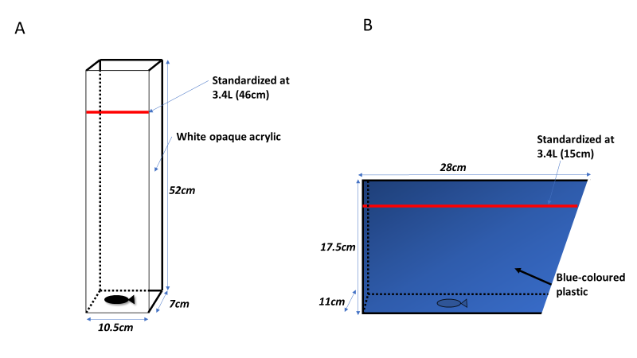
Figure 1 Characteristics of tanks used in anxiety assays. A) Our custom-designed tall tank was composed of white acrylicThe water depth equated to 46 cm after standardizing at 3.4 L; B) Trapezoidal short tanks were composed of blue-coloured plastic.These short tanks were also used to house zebrafish outside of behavioral assays. Water depth equated to 15 cm when standardized at 3.4 L (hence tanks did not differ in volume of water held).

2.4 Experimental setup
When using tall tanks, we set up 6 tanks to run 6 fish per trial. All 6 tanks were set side-by-side and facing the camera (Figure 2A). White Corflute® sheets were used to block all sides of the arenas except the front portion where the camera was placed; this ensured that fish were not disturbed during trials. When utilizing trapezoidal tanks, we set up 8 tanks to run 8 fish per trial. The setup for the trapezoidal tanks required the use of 2 cameras (4 tanks per camera). To fit 4 tanks in the frame of one camera, we placed a platform (raised approximately 25cm) behind two tanks to place an additional two tanks on top (Figure 2B). A white Corflute® sheet was also placed between the tanks (to prevent fish seeing each other) and behind (to improve contrast). We used the same setup on the other half of the main platform (a Corflute® sheet was placed between both setups). We labelled tanks appropriately with individual fish mark and tank ID.
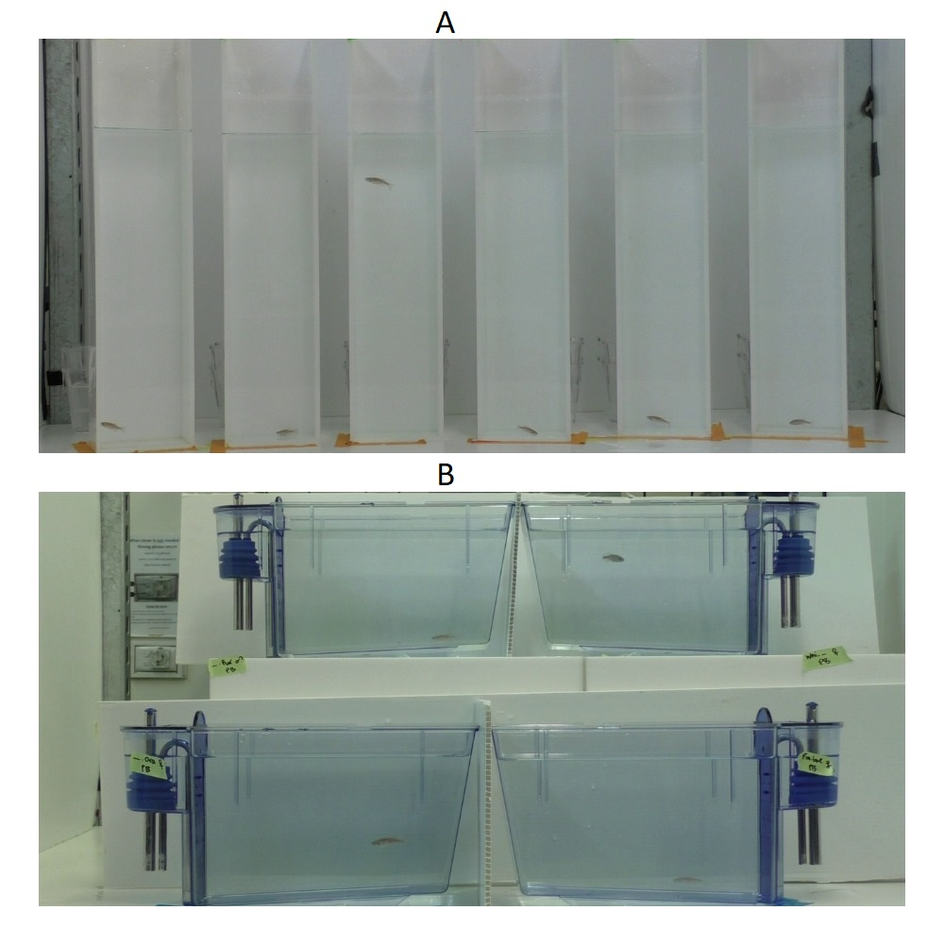
Figure 2 Setup of tall tanks and short tanks for anxiety assays. A) Tall tanks (maximum 6) were positioned side-by-side on the main platform. Temporary holding containers were located directly behind each tank for ease of transfer of zebrafish as only one camera was used. No Corflute® was required owing to the opaque acrylic design of the side and back tank walls; B) Short tanks (maximum 4 per camera) were positioned in 2 by 2 setup (rows = 2, columns = 2). Those on the top row were placed on a raised custom-made platform. Those on the bottom row were placed directly in front of this platform. This allowed all 4 tanks to be captured in the camera frame. White Corflute® was placed between tanks to prevent fish from seeing each other, as well as behind tanks to improve contrast for video tracking. This same setup was also used on the other half of the main platform. Both halves of the platform were separated by Corflute®. We used 2 cameras to simultaneously capture 8 tanks at once; we labelled all tanks appropriately with individual fish mark and tank ID.

2.5 Experimental design and procedure
Each individual experienced the anxiety assay in each type of tank twice (i.e. a fish was assayed 4 times in total). For each of the four assay sessions (the sessions were separated by 2 – 3 days), we ran all fish in a single day. We pseudorandomized the order of fish being run to account for the day of experiments, as well as the time of day. In total, one assay consisted of 20 trials for short tanks (8 fish per trial) and 28 trials for tall tanks (6 fish per trial) (see Supplementary Material for more details). Before each trial, fish to be tested were removed from their holding tanks and isolated in separate containers (14 cm × 9 cm × 9 cm; 1.13L) for temporary holding (~5 mins). At the beginning of each assay, fish were transferred from their temporary holding container into their assigned testing tank (tanks 1 – 6 for tall tanks; tanks 1 – 8 for short tanks) and recorded for eight minutes, then removed. This continued until all fish had been assayed for the day. Trials began at 10 am and ended at 4 pm. Water changes occurred every hour to minimize drops in temperature (water was maintained at ~28°C) and the effects of stress hormones from fish already trialed (for more details, see the step-by-step protocol in Supplementary Materials).

2.6 Behavioral and statistical analyses
We analyzed all video recordings with the video tracking software Ethovision XT 14.0 (Noldus, Spink and Tegelenbosch, 2001). In Ethovision, we created three digital zones (low, mid and high) in the tanks for analysis (see Ethovision protocol in Supplementary Materials). Acquisition of data began 40 seconds after the fish had been placed in the testing tank. This was deemed necessary as it took into account the time taken to place all fish in the testing tanks and ensured the lighting and contrast had stablised (changes occured once researchers removed themselves from the frame). We assessed anxiety by analyzing behavioral parameters as decided from our anxiety survey (see Results).

All statistical analyses were conducted in the R environment (Version 3.4.3) (R Development Team, 2013) with R Studio (Version 1.1.453) (R Studio Team, 2015). To examine mean and variance differences in anxiety-associated behaviour between tall and short tanks, we modelled seven behavioral parameters: 1) time spent in the low zone, 2) time in the mid zone, 3) time in the high zone; 4) latency to enter the high zone, 5) number of entries into the high zone, 6) total distance travelled, and 7) time spent freezing (see Results on how we chose these measurements). We used linear mixed models implemented in the function lme in the nlme package (version 3.1-148) (Pinheiro et al., 2020), which allowed us to model different residual variances. The residual normality of the behavioral measurements was visually checked for all behavioral parameters. We applied transformations to three behavioral measurements to meet the normality assumptions: square-root transformation on time spent in the high zone and entries into the high zone, and ln-transformation on time spent freezing (after adding 1, because of 0 values); these transformed values were used throughout. In all mixed models (seven models; one per behavioral measurement) we used tank type (i.e. our experimental condition) as a fixed factor, and fish ID as a random (clustering) factor. In addition, we also added sex as an extra fixed factor, as behavioral responses often vary depending on sex (Michelangeli et al., 2016; Schuett et al., 2010) and it is an important biological factor which improves reliability (Tannenbaum et al., 2019). To model different residual variance between tall and short tanks, we specified an lme function to do so, but also, we ran the same models assuming a constant variance between the two types of tanks. These two models were compared by likelihood ratio tests using the anova function from the R ‘stats’ package (Version 3.6.2) (R Core Team, 2013) to examine statistical significance for modeling different variances.

Repeatability (R) is formally defined as the proportion of between-group (between-individual) variance out of total variance (Sokal & Rohlf, 2012):

$$R=\frac{σ_{α}^{2}}{σ_{α}^{2}+σ_{ε}^{2}}$$

where $σ_{α}^{2}$ is the between-group (between-individual) variance and $σ_{ε}^{2}$ is the within-group (within-individual) variance. To calculate repeatability estimates between tall and short tanks, and then between males and females in tall and short tanks, we used rptR (Version 0.9.21) (Stoffel et al., 2017), a package based on a mixed-effects model framework using the R package lme4 (version 20) (Bates et al., 2014). Our repeatability analysis consisted of three steps. First, the overall dataset was divided into tank subsets (i.e. short and tall) to obtain repeatability estimates of each of the seven behavioral measurements with the rpt function. We also extracted between-individual and within-individual variance estimates from rptr models after performing a z transformation on response variables. Second, the dataset was further divided by sex to obtain repeatability estimates of males and females in both tall and short tanks. All estimates were ‘unadjusted’ repeatabilites (Nakagawa & Schielzeth, 2010), and only included individual fish IDs as a random effect. We obtained standard error and 95% confidence intervals (CI’s) using rptr, which employs parametric bootstrapping (Faraway, 2016) with all models set to have 10,000 bootstrap samples. Repeatability estimates with confidence intervals not overlapping 0 were considered statistically significant. Third, we calculated contrasts between repeatability estimates. We achieved this by calculating the differences between estimated bootstrap distributions and obtaining quantiles at 2.5% and 97.5% from the difference. Contrasts (subtracting a distribution with a higher mean from that with a lower mean) were deemed significant if the difference distribution did not fall below the 2.5% threshold. All R code and datasets are available at https://github.com/Apex619/F1_Methods_Chapter_Anxiety_Hamza.

- Results
3. 1 Systematic survey
From 336 studies identified from our literature search, we included 50 for analysis, following our inclusion criteria. These studies were published between the years 2008-2020, comprised mainly of behavioral studies (44) with a few medical studies (5) and one toxicology study. Tank types employed were either rectangular in shape (27) or trapezoidal (21), except for two studies (which did not specify the shape). Mean dimensions for rectangular tanks were: height 20.1 cm ± 3.2 SD, width 12.6 cm ± 7.4 SD and length 23.6 cm ± 4.4 SD; and trapezoidal tanks were: height 15.6 cm ± 1.8 SD, width 7.4 cm ± 0.9 SD, length at bottom 22.8 cm ± 0.6 SD and length at top 27.8 cm ± 0.8 SD. Average sample sizes in studies equated to 14 ± 8.9 SD. We identified a total of 16 behavioral parameters from included studies (see Figure 3) and tallied when they were used in included studies. For analysis we used the 6 following highly ranked parameters along with one parameter which was lowly ranked, but we felt was important to include (total of 7 parameters shown in bold; see Figure 3).

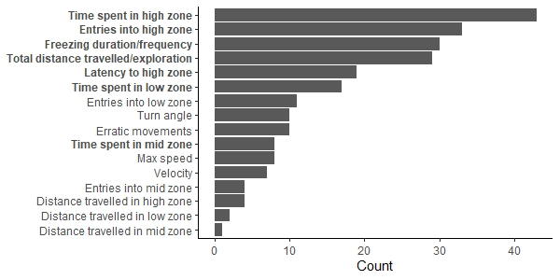
Figure 3 Results from our systematic survey tallying behavioral parameters used in novel tank test assays from the literature. From our sample of 50 studies, we identified a total of 16 behavioral parameters used to assess an anxious state in novel tank tests. Of these 16 parameters, we chose 7 (highlighted in bold). The first 6 ranked highest, i.e. were the most frequently used. “Time spent in mid zone” was not amongst the most used parameters, however, we included it based on our design of splitting the tank into 3 zones (as opposed to 2).

3.2 Behavioral parameter measurements
First, statistically significant differences were observed across all behavioral parameters across tank types (see Figure 4, Table S1). In short tanks, zebrafish travelled more (LMM, est = 2270.88, df = 469, t = 32.24, p < 0.001); had longer bouts of freezing (LMM est = 1.82, df = 469, t = 11.58, p < 0.001) and spent more time in the low zone (LMM, est = 342.55, df = 469, t = 43.24, p < 0.001). In tall tanks, zebrafish spent more time in the mid zone (LMM, est = 71.33, df = 469, t = 19.39, p < 0.001) and high zone (LMM, est = 8.05, df = 469, t = 20.80, p < 0.001), displayed a quicker latency to enter the high zone (LMM, est = 107.09, df = 469, t = 10.93, p < 0.001) and recorded more entries into the high zone (LMM, est = 4.07, df = 469, t = 19.87, p < 0.001). Mean responses between sexes did not significantly differ except for the latency to enter the high zone parameter (see Table S1). Second, tall tanks generated more overall variation than short tanks for time spent in the low zone (6.78%, p < 0.001) and high zone (6.34%, p < 0.0001) as well as entries into the high zone (5.74%, p < 0.0001). Time spent freezing however, was more variable in short tanks (4.00%, p < 0.025). No statistically significant differences in variance were observed between tall and short tanks for total distance travelled, time spent in the mid zone, and latency to the high zone (Figure 4).

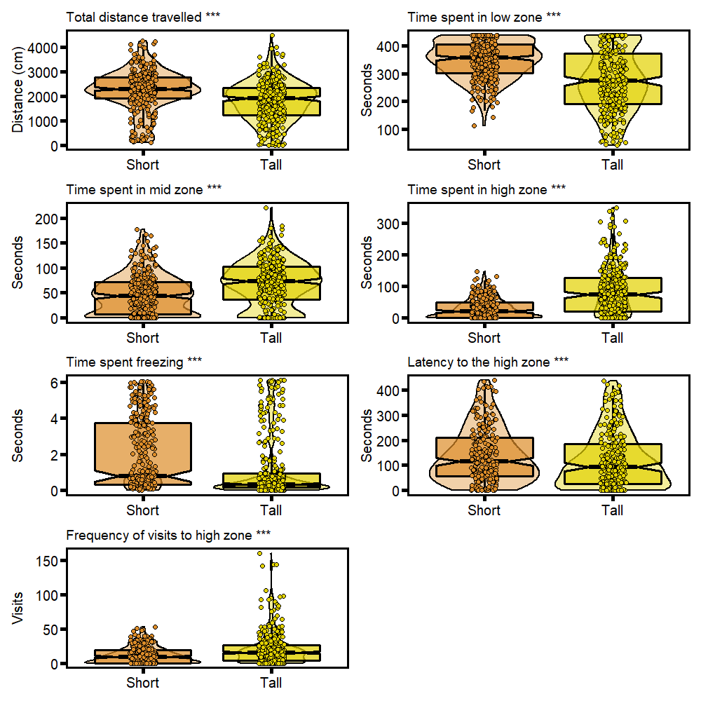
Figure 4 Distribution of zebrafish behavioral measurements in short and tall tanks. Each plot displays a combination of: individual data points for males (n = 79) and females (n = 81) from two observations in different tanks (total of 320 observations per plot). Box plots show the median, 95% confidence interval of the median, quantiles and outliers. Violin plots display distribution density. Time spent freezing is transformed using log(x+1) function. Note: ***p<0.01

3.3 Repeatability analysis
Overall, repeatability estimates were in the expected direction, with tall tanks having higher repeatability than short tanks for 5 out of 7 analysed behavioral parameters (see Figure 5; Table S2): total distance travelled (R = 0.42, 95% CI [0.285 – 0.54]), time spent in the low zone (R = 0.54, 95% CI [0.42 – 0.64]), time spent in the high zone (R = 0.60, 95% CI [0.48 – 0.69]), latency to the high zone (R = 0.49, 95% CI [0.34 – 0.61]) and time spent freezing (R = 0.30, 95% CI [0.15 – 0.44]). However, for only 2 out of these 5 parameters was the difference between tall and short tanks statistically significant: time spent in the low zone (95% CI [0.0004 – 0.36]) and latency to the high zone (95% CI [0.14 – 0.57]). Males had higher repeatability estimates than females for all measured behavioural parameters, displaying a clear sex difference (see Figure 6; Table S4). Except for the total distance travelled and time spent freezing, all repeatability estimates in tall tanks were significantly different between males and females.

Short tanks had higher and statistically significant repeatability estimates only for time spent in the mid zone (R = 0.51, 95% CI [0.38 – 0.62]) and entries into the high zone (R = 0.48, 95% CI [0.35 – 0.59]). Results for sex differences were mixed in short tanks (see Figure 7; Table S3). Males had higher repeatability than females for total distance travelled, time spent in the mid zone, and time spent freezing. However, females had higher repeatability than males for time spent in the low zone, time spent in the high zone and entries into the high zone. Repeatability estimates for latency to the high zone in short tanks were statistically non-significant. Unlike in the tall tanks, we only found statistically significant differences between males and females in short tanks for total distance travelled (95% CI [0.35 – 0.68]) and time spent freezing (95% CI [0.03 – 0.56]).

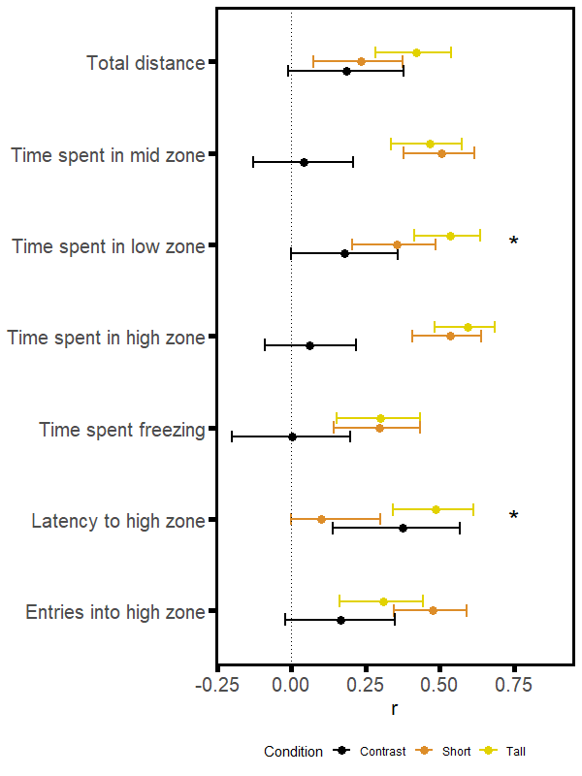
Figure 5 Forest plot of repeatability estimates for each measured behavioral parameter in tall (yellow) and short tanks (orange), as well as their contrast (in black). Repeatability estimates are deemed significant if the associated 95% confidence interval does not cross 0. The contrasts are deemed significant (denoted by *) if the associated confidence interval does not cross 0.

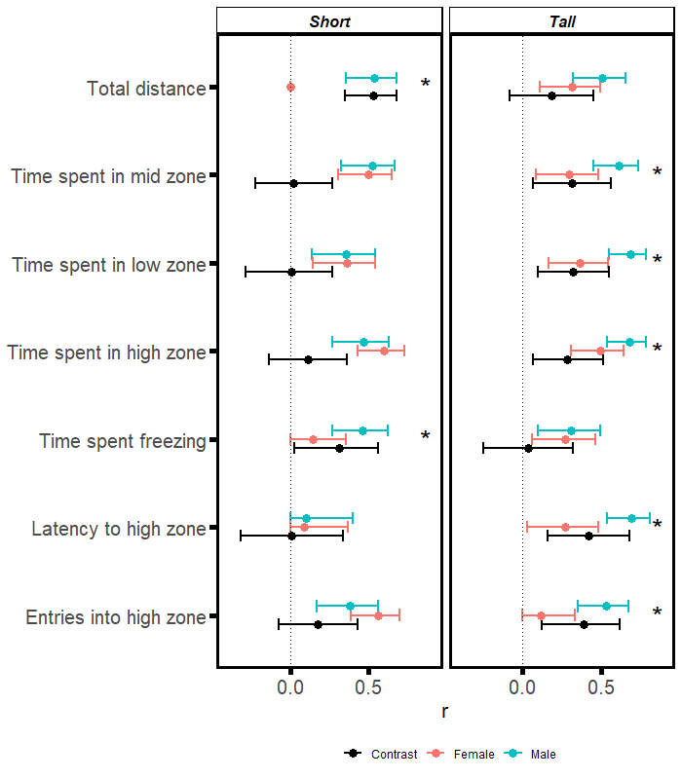

Figure 6 Forest plot of repeatability estimates for males (blue) and females (red) , as well as the contrast between the sexes (in black), per behavioral parameter in tall and short tanks. Repeatability estimates are deemed significant if the associated 95% confidence interval does not cross 0. The contrasts are deemed significant (denoted by *) if the associated confidence interval does not cross 0.

- Discussion
The main goal of this study was to compare the repeatability of behavior in anxiety tank tests between custom-designed tall tanks and traditional short trapezoidal tanks. We addressed three specific aims in this study. First, we mapped a sample of the relevant literature, which confirmed our assumption that little to no studies use tanks that are dissimiliar to regular maintenance tanks in height in novel tank test assays. Second, we compared anxiety-related behavioral parameters in zebrafish between the two types of tanks, which showed clear behavioral differences. Third, we hypothesized that using the tall tanks would lead to higher repeatability estimates than short tanks. On average, our tall tanks generated more behavioural variation, had higher repeatability estimates and displayed clearer effects between sexes when comparing repeatability estimates. We discuss each of these three points in more detail below.

4.1 Anxiety literature survey
Our survey showed that tanks with depths similar to our tall tanks are not used in novel tank test assays. Although we expected this survey result, it is still somewhat surprising for two reasons. First, when evaluating anxiety, depth is a significant factor in influencing zebrafish behavioral responses (Blaser & Rosemberg, 2012; Córdova et al., 2016; Kysil et al., 2017). Second, anxious zebrafish show a tendency to dive in novel environments (Levin et al., 2007). This diving response indicates a preference to escape the water surface, rather than simply approach the bottom of a tank that has similar dimensions to the home tank (hence a ‘non-novel’ tank) (Kysil et al., 2017), emphasizing depth preference. The average heights of tanks used in studies surveyed ranged from 16 to 20 cm, which are typical of traditional holding tanks and may be inadequate in capturing between-individual variation. Furthermore, when conducting novel tank tests to measure anxiety, Bencan et al. (2009) proposed that tanks with dimensions dissimilar to those of holding tanks should be used. However, most studies appear to use holding tanks or a ‘novel tank’ with similar dimensions to holding tanks. In comparison, our custom-designed tall tanks are 52 cm in height, with a water depth of 46 cm.

4.2 Behavioral response differences
Our analysis revealed that zebrafish in the short tank travelled more and displayed longer bouts of freezing, although both types of tanks had the same volume of water. Total distance travelled may be directly associated with the dimensions of the trapezoidal (short) tank. That is, while shorter in height, the trapezoidal tanks are also much longer in length in comparison to our tall tanks, allowing fish to swim horizontally in the trapezoidal tanks compared to the tall tanks, which limit the fishes’ horizontal movements. As such, zebrafish might have adjusted their locomotion to suit this environment (i.e. the tall tank) (Stewart et al., 2012). Furthermore, longer bouts of freezing in short tanks may be the result of a sudden change in social dynamics, as our short testing tanks were also used to house zebrafish in groups (i.e. the novelty may mainly come from social environment disruption rather than the tank itself). Therefore, tanks similar to holding tanks are likely to affect behavioral responses (Bencan et al., 2009).

Overall, we attribute zebrafish behavioral responses to dimensional differences between tall and short tanks. For example, the vertical nature of the tall tank, which had a limited width for horizontal movement, may have driven zebrafish to explore the mid zone and high zone in the tall tank more than in the short tank. As expected, tall tanks also generated more overall behavioral variation than short tanks. This increased variation likely led to enhanced between-individual variation and, consequently, repeatability (see below).

4.3 Repeatability
Overall, we have demonstrated that, regardless of tank depths, almost all behavioral parameters associated with anxiety in zebrafish were significantly repeatable in novel tank tests (R = 0.23 to 0.60; Figure 5). This result follows suit with a recent study showing significant repeatability in behavioral responses from novel tank tests in zebrafish (R = 0.35 to 0.47 for the parameters total distance travelled, time spent in bottom zone, time spent freezing and exploration; Thomson et al., 2020). Indeed, our tall tanks are also better at characterizing between-individual differences by increasing between-individual variation or decreasing within-individual variance (see Figures S1, S2, S3; and Table S2), which results in higher repeatability estimates (tall tanks: R = 0.30 to 0.60; short tanks: R = 0.10 to 0.53; Figure 5).

Differences in repeatability resulting from the use of tall tanks may have important implications in (bio-)medical science, as accuratly capturing between-individual variation should translate into more accurately capturing between-group/treatment variation. In other words, our new assay, which has higher repeatability, could be more effective in distinguishing effects between control and treatment groups than assays that have lower repeatability compared to conventional short tanks (e.g., Mizuno et al., 2020). Furthermore, our result highlight the importance of employing methods that ensure behavioral responses are specific to the assumptions of the paradigm being measured, i.e. construct validity (Giuliano et al., 2008; Liu et al., 1982; Maximino et al., 2010). Assays that are usually believed to be appropriate and effective may lack the components needed to detect subtle, yet important, information – including between-individual variation (like what we have shown between conventional short tanks and our custom-designed tall tank).

Our finding also has implications for animal personality studies. Consistent individual differences in behavior (and therefore repeatability) are an essential component of ‘animal personality’ (Dall et al., 2004). Consistent individual differences may represent adaptive behavioral differences within a group (Dall et al., 2004), which, in turn, can influence individual fitness (Dingemanse & Réale, 2005; MacPherson et al., 2017). For example, an animal’s inclination to take risks is associated with the bold-shy behavioral continuum (Sloan Wilson et al., 1994), that is closely related to anxiety (Koolhaas et al., 1999). In novel tank test assays, bold individuals (less anxious) are likely to travel more and traverse to the upper regions of the tank. In our assay, tall tanks captured between-individual variation in behavioral parameters related to total distance travelled and time spent in the low zone better than short tanks (See Figure 5). As previously highlighted, the methodology becomes crucial when attempting to capture between-individual variation.

There seems little emphasis on employing diverse methods to quantify and compare repeatabilities. As such, we call for investing time into comparing and contrasting different assays (e.g., O’Neill et al., 2018) to find the one that is most relevant to the question at hand (note that the most relevant method may not always have the highest repeatability). For example, one way of improving methodology is to assess the ecological relevance of the trait being measured for the species being measured (Roche et al., 2016) (i.e. depth preference in zebrafish, which is better captured by the use of a deeper tank).

We also found significant sex differences in tall tanks, with males displaying more consistent responses than females for all behavioral parameters (tall tanks males: R = 0.31 to 0.69; tall tanks females: R = 0.12 to 0.49), mimicking results found by Thomson et al. (2020) (males: R = 0.45 to 0.58; females: R = 0.15 to 0.24). In contrast, results for sexes were mixed in short tanks. Behavioural repeatability was low in females for 3 out of 7 parameters, and there was no clear pattern observed (i.e. one sex being more consistent than the other). However, of the 2 statistically significant results obtained (total distance travelled and time spent freezing), males still displayed higher repeatability than females, a trend also observed in other behavioral studies with different animal models (e.g., Strickland & Frère, 2018; Wexler et al., 2016). Thus, we confirmed the inclusion of sex as an important biological factor to disentangle sources of variation.

4.4 Limitations and future directions
Our study tested individuals in each tank twice (a total of four assays) over one week (with 2 – 3 days between each assay). However, recent research has highlighted that more tests carried out over an extended period would increase the accuracy of measurements (Thomson et al., 2020). This approach will also address issues associated with observations taken closely together in time, an action which can overestimate repeatability (Mitchell et al., 2020). Further, while our research addressed differing depths, we did not investigate the impact of varying tank volume. This was due to logistical constraints, as increasing tank volume would have resulted in fewer fish being assayed. A major strength of our study, however, was our large sample size (79 males and 81 females) in comparison to most studies, enabling us to draw more robust conclusions.

Our study implemented a custom-designed tall tank to measure zebrafish anxiety in novel tank tests. In doing so, we developed a high-throughput assay that captured more between-individual variation, and consequently, repeatability, an important index that improves the reliability of experimental data (Branch, 2019). Also, our tall-tank assay is advantageous in the sense that many studies conducting zebrafish novel tank tests use tanks which are similar or identical in dimension to traditional holding tanks (thereby not completely novel). Our tall tanks with increased depth are dissimilar and truly ‘novel’. Further, our tall-tank assay was able to effectively detect sex differences in comparison to the traditional-tank assay. We highly recommend employing this newly developed assay in anxiety diving tests to improve reliability of behavioral data amongst future studies in (bio-)medical and behavioral sciences.

References

Bates, D., Maechler, M., Bolker, B., & Walker, S. (2014). lme4: Linear mixed-effects models using Eigen and S4. R Package Version, 1(7), 1–23.
Bell, A. M., Hankison, S. J., & Laskowski, K. L. (2009). The repeatability of behaviour: a meta-analysis. In Animal Behaviour (Vol. 77, Issue 4, pp. 771–783). Academic Press. https://doi.org/10.1016/j.anbehav.2008.12.022
Bencan, Z., Sledge, D., & Levin, E. D. (2009). Buspirone, chlordiazepoxide and diazepam effects in a zebrafish model of anxiety. Pharmacology Biochemistry and Behavior, 94(1), 75–80. https://doi.org/https://doi.org/10.1016/j.pbb.2009.07.009
Blaser, R. E., & Goldsteinholm, K. (2012). Depth preference in zebrafish, Danio rerio: control by surface and substrate cues. Animal Behaviour, 83(4), 953–959.
Blaser, R. E., & Rosemberg, D. B. (2012). Measures of anxiety in zebrafish (Danio rerio): Dissociation of black/white preference and novel tank test. PLoS ONE, 7(5). https://doi.org/10.1371/journal.pone.0036931
Bourin, M. (2015). Animal models for screening anxiolytic-like drugs: A perspective. Dialogues in Clinical Neuroscience, 17(3), 295–303. www.dialogues-cns.org
Branch, M. N. (2019). The “Reproducibility Crisis:” Might the Methods Used Frequently in Behavior-Analysis Research Help? Perspectives on Behavior Science, 42(1), 77–89. https://doi.org/10.1007/s40614-018-0158-5
Brown, R. E., & Bolivar, S. (2018). The importance of behavioural bioassays in neuroscience. Journal of Neuroscience Methods, 300, 68–76. https://doi.org/10.1016/j.jneumeth.2017.05.022
Clement, Y., & Chapouthier, G. (1998). Biological bases of anxiety. Neuroscience & Biobehavioral Reviews, 22(5), 623–633. https://doi.org/https://doi.org/10.1016/S0149-7634(97)00058-4
Córdova, S. D., dos Santos, T. G., & de Oliveira, D. L. (2016). Water column depth and light intensity modulate the zebrafish preference response in the black/white test. Neuroscience Letters, 619, 131–136. https://doi.org/10.1016/j.neulet.2016.03.008
Corrales-Carvajal, V. M., Faisal, A. A., & Ribeiro, C. (2016). Internal states drive nutrient homeostasis by modulating exploration-exploitation trade-off. ELife, 5(OCTOBER2016). https://doi.org/10.7554/eLife.19920.001
Culpepper, L. (2009). Generalized anxiety disorder and medical illness. The Journal of Clinical Psychiatry.
Dall, S. R. X., Houston, A. I., & McNamara, J. M. (2004). The behavioural ecology of personality: consistent individual differences from an adaptive perspective. Ecology Letters, 7(8), 734–739.
Dingemanse, N. J., & Réale, D. (2005). Natural Selection and Animal Personality. Behaviour, 142(9/10), 1159–1184. http://www.jstor.org/stable/4536295
Egan, R. J., Bergner, C. L., Hart, P. C., Cachat, J. M., Canavello, P. R., Elegante, M. F., Elkhayat, S. I., Bartels, B. K., Tien, A. K., Tien, D. H., Mohnot, S., Beeson, E., Glasgow, E., Amri, H., Zukowska, Z., & Kalueff, A. V. (2009). Understanding behavioral and physiological phenotypes of stress and anxiety in zebrafish. Behavioural Brain Research, 205(1), 38–44. https://doi.org/https://doi.org/10.1016/j.bbr.2009.06.022
Faraway, J. J. (2016). Extending the linear model with R: generalized linear, mixed effects and nonparametric regression models. CRC press.
Freudenberg, F., O’Leary, A., Aguiar, D. C., & Slattery, D. A. (2018). Challenges with modelling anxiety disorders: a possible hindrance for drug discovery. In Expert Opinion on Drug Discovery (Vol. 13, Issue 4, pp. 279–281). Taylor and Francis Ltd. https://doi.org/10.1080/17460441.2018.1418321
Giuliano, S., Director, A., Gambarotta, M., Trasorras, V., & Miragaya, M. (2008). Collection method, season and individual variation on seminal characteristics in the llama (Lama glama). Animal Reproduction Science, 104(2), 359–369. https://doi.org/https://doi.org/10.1016/j.anireprosci.2007.02.016
Griffiths, B., Schoonheim, P. J., Ziv, L., Voelker, L., Baier, H., & Gahtan, E. (2012). A zebrafish model of glucocorticoid resistance shows serotonergic modulation of the stress response. Frontiers in Behavioral Neuroscience, 6(SEPTEMBER). https://doi.org/10.3389/fnbeh.2012.00068
Harro, J. (2018). Animals, anxiety, and anxiety disorders: How to measure anxiety in rodents and why. In Behavioural Brain Research (Vol. 352, pp. 81–93). Elsevier B.V. https://doi.org/10.1016/j.bbr.2017.10.016
Hohn, C., & Petrie-Hanson, L. (2013). Evaluation of visible implant elastomer tags in zebrafish (Danio rerio). Biology Open, 2(12), 1397–1401.
Howe, K., Clark, M. D., Torroja, C. F., Torrance, J., Berthelot, C., Muffato, M., Collins, J. E., Humphray, S., McLaren, K., Matthews, L., McLaren, S., Sealy, I., Caccamo, M., Churcher, C., Scott, C., Barrett, J. C., Koch, R., Rauch, G.-J., White, S., … Stemple, D. L. (2013). The zebrafish reference genome sequence and its relationship to the human genome. Nature, 496(7446), 498–503. https://doi.org/10.1038/nature12111
Jenkins, S. H. (2011). Sex differences in repeatability of food-hoarding behaviour of kangaroo rats. Animal Behaviour, 81(6), 1155–1162. https://doi.org/10.1016/j.anbehav.2011.02.021
Kalueff, A. V, Gebhardt, M., Stewart, A. M., Cachat, J. M., Brimmer, M., Chawla, J. S., Craddock, C., Kyzar, E. J., Roth, A., Landsman, S., Gaikwad, S., Robinson, K., Baatrup, E., Tierney, K., Shamchuk, A., Norton, W., Miller, N., Nicolson, T., Braubach, O., … Consortium, Z. N. R. (2013). Towards a comprehensive catalog of zebrafish behavior 1.0 and beyond. Zebrafish, 10(1), 70–86. https://doi.org/10.1089/zeb.2012.0861
Kennedy, A., Asahina, K., Hoopfer, E., Inagaki, H., Jung, Y., Lee, H., Remedios, R., & Anderson, D. J. (2014). Internal states and behavioral decision-making: Toward an integration of emotion and cognition. Cold Spring Harbor Symposia on Quantitative Biology, 79, 199–210. https://doi.org/10.1101/sqb.2014.79.024984
Konnopka, A., & König, H. (2020). Economic Burden of Anxiety Disorders: A Systematic Review and Meta-Analysis. In PharmacoEconomics (Vol. 38, Issue 1, pp. 25–37). Adis. https://doi.org/10.1007/s40273-019-00849-7
Koolhaas, J. M., Korte, S. M., De Boer, S. F., Van Der Vegt, B. J., Van Reenen, C. G., Hopster, H., De Jong, I. C., Ruis, M. A. W., & Blokhuis, H. J. (1999). Coping styles in animals: Current status in behavior and stress- physiology. Neuroscience and Biobehavioral Reviews, 23(7), 925–935. https://doi.org/10.1016/S0149-7634(99)00026-3
Kraeuter, A. K., Guest, P. C., & Sarnyai, Z. (2019). The Open Field Test for Measuring Locomotor Activity and Anxiety-Like Behavior. In Methods in Molecular Biology (Vol. 1916, pp. 99–103). Humana Press Inc. https://doi.org/10.1007/978-1-4939-8994-2_9
Kysil, E. V, Meshalkina, D. A., Frick, E. E., Echevarria, D. J., Rosemberg, D. B., Maximino, C., Lima, M. G., Abreu, M. S., Giacomini, A. C., & Barcellos, L. J. G. (2017). Comparative analyses of zebrafish anxiety-like behavior using conflict-based novelty tests. Zebrafish, 14(3), 197–208.
Levin, E. D., Bencan, Z., & Cerutti, D. T. (2007). Anxiolytic effects of nicotine in zebrafish. Physiology and Behavior, 90(1), 54–58. https://doi.org/10.1016/j.physbeh.2006.08.026
Liu, K., Stamler, J., Stamler, R., Cooper, R., Shekelle, R. B., Schoenberger, J. A., Berkson, D. M., Lindberg, H. A., Marquardt, J., Stevens, E., & Tokich, T. (1982). Methodological problems in characterizing an individual’s plasma glucose level. Journal of Chronic Diseases, 35(6), 475–485. https://doi.org/https://doi.org/10.1016/0021-9681(82)90062-5
MacPherson, B., Mashayekhi, M., Gras, R., & Scott, R. (2017). Exploring the connection between emergent animal personality and fitness using a novel individual-based model and decision tree approach. Ecological Informatics, 40, 81–92. https://doi.org/https://doi.org/10.1016/j.ecoinf.2017.06.004
Mason, G. J., & Mench, J. (1997). Using behaviour to assess animal welfare. Animal Welfare.
Maximino, C., de Brito, T. M., da Silva Batista, A. W., Herculano, A. M., Morato, S., & Gouveia, A. (2010). Measuring anxiety in zebrafish: A critical review. In Behavioural Brain Research (Vol. 214, Issue 2, pp. 157–171). Behav Brain Res. https://doi.org/10.1016/j.bbr.2010.05.031
Michelangeli, M., Chapple, D. G., & Wong, B. B. M. (2016). Are behavioural syndromes sex specific? Personality in a widespread lizard species. Behavioral Ecology and Sociobiology, 70(11), 1911–1919. https://doi.org/10.1007/s00265-016-2197-9
Mitchell, D. J., Dujon, A. M., Beckmann, C., & Biro, P. A. (2020). Temporal autocorrelation: a neglected factor in the study of behavioral repeatability and plasticity. Behavioral Ecology, 31(1), 222–231.
Mizuno, Y., McCutcheon, R. A., Brugger, S. P., & Howes, O. D. (2020). Heterogeneity and efficacy of antipsychotic treatment for schizophrenia with or without treatment resistance: a meta-analysis. Neuropsychopharmacology, 45(4), 622–631. https://doi.org/10.1038/s41386-019-0577-3
Nakagawa, S, Gillespie, D. O. S., Hatchwell, B. J., & Burke, T. (2007). Predictable males and unpredictable females: sex difference in repeatability of parental care in a wild bird population. Journal of Evolutionary Biology, 20(5), 1674–1681.
Nakagawa, Shinichi, & Schielzeth, H. (2010). Repeatability for Gaussian and non-Gaussian data: a practical guide for biologists. Biological Reviews, 85(4), no-no. https://doi.org/10.1111/j.1469-185X.2010.00141.x
Nguyen, M., Yang, E., Neelkantan, N., Mikhaylova, A., Arnold, R., Poudel, M. K., Stewart, A. M., & Kalueff, A. V. (2013). Developing ‘integrative’ zebrafish models of behavioral and metabolic disorders. Behavioural Brain Research, 256, 172–187. https://doi.org/https://doi.org/10.1016/j.bbr.2013.08.012
O’Neill, S. J., Williamson, J. E., Tosetto, L., & Brown, C. (2018). Effects of acclimatisation on behavioural repeatability in two behaviour assays of the guppy Poecilia reticulata. Behavioral Ecology and Sociobiology, 72(10), 1–11. https://doi.org/10.1007/s00265-018-2582-7
Ouzzani, M., Hammady, H., Fedorowicz, Z., & Elmagarmid, A. (2016). Rayyan---a web and mobile app for systematic reviews. Systematic Reviews, 5(1), 210. https://doi.org/10.1186/s13643-016-0384-4
Pellow, S., Chopin, P., File, S. E., & Briley, M. (1985). Validation of open: closed arm entries in an elevated plus-maze as a measure of anxiety in the rat. Journal of Neuroscience Methods, 14(3), 149–167.
Pinheiro, J., Bates, D., DebRoy, S., Sarkar, D., & R Core Team. (2020). nlme: Linear and Nonlinear Mixed Effects Models (3.1-148). https://cran.r-project.org/package=nlme
Remes, O., Brayne, C., van der Linde, R., & Lafortune, L. (2016). A systematic review of reviews on the prevalence of anxiety disorders in adult populations. Brain and Behavior, 6(7), e00497. https://doi.org/10.1002/brb3.497
Roche, D. G., Careau, V., & Binning, S. A. (2016). Demystifying animal “personality” (or not): Why individual variation matters to experimental biologists. In Journal of Experimental Biology (Vol. 219, Issue 24, pp. 3832–3843). Company of Biologists Ltd. https://doi.org/10.1242/jeb.146712
Rudeck, J., Vogl, S., Banneke, S., Schönfelder, G., & Lewejohann, L. (2020). Repeatability analysis improves the reliability of behavioral data. PLOS ONE, 15(4), e0230900. https://doi.org/10.1371/journal.pone.0230900
Schuett, W., Tregenza, T., & Dall, S. R. X. (2010). Sexual selection and animal personality. Biological Reviews, 85(2), 217–246. https://doi.org/10.1111/j.1469-185X.2009.00101.x
Sloan Wilson, D., Clark, A. B., Coleman, K., & Dearstyne, T. (1994). Shyness and boldness in humans and other animals. Trends in Ecology and Evolution, 9(11), 442–446. https://doi.org/10.1016/0169-5347(94)90134-1
Sokal, R., & Rohlf, F. (2012). Biometry: the principles and practice of statistics in biological research. 2nd ed. In Journal of the Royal Statistical Society. Series A (General) (Vol. 133). https://doi.org/10.2307/2343822
Steimer, T. (2002). The biology of fear-and anxiety-related behaviors. Dialogues in Clinical Neuroscience, 4(3), 231.
Steimer, T. (2011). Animal models of anxiety disorders in rats and mice: some conceptual issues. Dialogues in Clinical Neuroscience, 13(4), 495–506. www.dialogues-cns.org
Stewart, A., Gaikwad, S., Kyzar, E., Green, J., Roth, A., & Kalueff, A. V. (2012). Modeling anxiety using adult zebrafish: A conceptual review. Neuropharmacology, 62(1), 135–143. https://doi.org/10.1016/j.neuropharm.2011.07.037
Stewart, A. M., Braubach, O., Spitsbergen, J., Gerlai, R., & Kalueff, A. V. (2014). Zebrafish models for translational neuroscience research: from tank to bedside. Trends in Neurosciences, 37(5), 264–278. https://doi.org/10.1016/j.tins.2014.02.011
Stewart, A. M., Gaikwad, S., Kyzar, E., & Kalueff, A. V. (2012). Understanding spatio-temporal strategies of adult zebrafish exploration in the open field test. Brain Research, 1451, 44–52. https://doi.org/10.1016/j.brainres.2012.02.064
Stoffel, M. A., Nakagawa, S., & Schielzeth, H. (2017). rptR: Repeatability estimation and variance decomposition by generalized linear mixed‐effects models. Methods in Ecology and Evolution, 8(11), 1639–1644.
Strickland, K., & Frère, C. H. (2018). Predictable males and unpredictable females: Repeatability of sociability in eastern water dragons. Behavioral Ecology, 29(1), 236–243. https://doi.org/10.1093/beheco/arx148
Tannenbaum, C., Ellis, R. P., Eyssel, F., Zou, J., & Schiebinger, L. (2019). Sex and gender analysis improves science and engineering. Nature, 575(7781), 137–146. https://doi.org/10.1038/s41586-019-1657-6
Team, R. C. (2013). R: A language and environment for statistical computing. Vienna, Austria.
Team, Rs. (2015). RStudio: integrated development for R. RStudio, Inc., Boston, MA URL Http://Www. Rstudio. Com, 42, 14.
Thomson, H. R., Lamb, S. D., Besson, A. A., & Johnson, S. L. (2020). Long-term repeatability of behaviours in zebrafish (Danio rerio). Ethology, 126(8), 803–811. https://doi.org/10.1111/eth.13038
Wexler, Y., Subach, A., Pruitt, J. N., & Scharf, I. (2016). Behavioral repeatability of flour beetles before and after metamorphosis and throughout aging. Behavioral Ecology and Sociobiology, 70(5), 745–753.

SUPPLEMENTARY MATERIALS
A new high throughput assay for measuring zebrafish anxiety: tall tanks that better characterize between-individual differences

Hamza Anwer^{1,2,} Dominic Mason^{1,2}, Susanne Zajitschek³, Daniel Noble⁴, Daniel Hesselson^{2,5,} Margaret Morris⁶, Malgorzata Lagisz¹, Shinichi Nakagawa¹

¹ Evolution & Ecology Research Centre and School of Biological, Earth and Environmental Sciences, University of New South Wales, Sydney, NSW, Australia
² Diabetes and Metabolism Division, Garvan Institute of Medical Research, Darlinghurst, Sydney, NSW, Australia
³ Liverpool John Moores University, School of Biological and Environmental Sciences, Liverpool L3 3 AF, United Kingdom
⁴ Division of Ecology and Evolution, Research School of Biology, The Australian National University, Canberra, Australia
⁵ Centenary Institute and Faculty of Medicine and Health, University of Sydney, Sydney, Australia
⁶ Department of Pharmacology, School of Medical Sciences, University of New South Wales, Sydney, NSW, Australia

Corresponding Author:
Hamza Anwer¹
Email address: hamza.anwer@student.unsw.edu.au

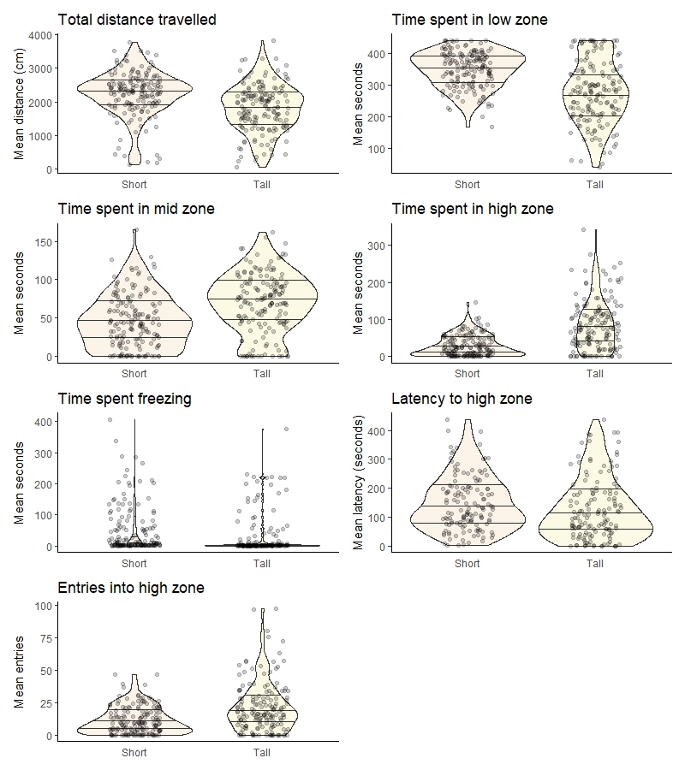

Figure S1) Mean individual results for 7 measured behavioral parameters. In plot indicated as “short” and “tall” tanks, respectively. Each plot displays a combination of mean individual data points (n = 160 per tank; means were calculated from 2 observations per individual); and violin plots displaying the distribution density. Quantiles are displayed as straight black lines at 25%, 50% and 75%.

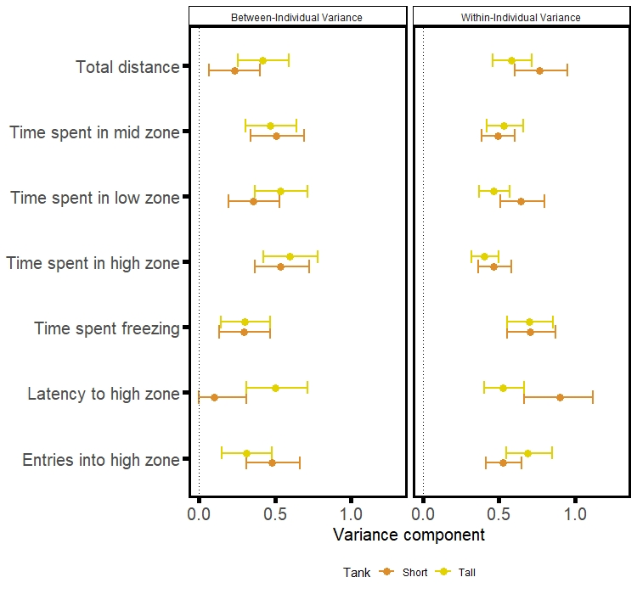
Figure S2) Between-individual and within-individual variance components for each of the 7 measured behavioral parameters. Extracted from repeatability models with a Z transformation and displayed with 95% confidence intervals

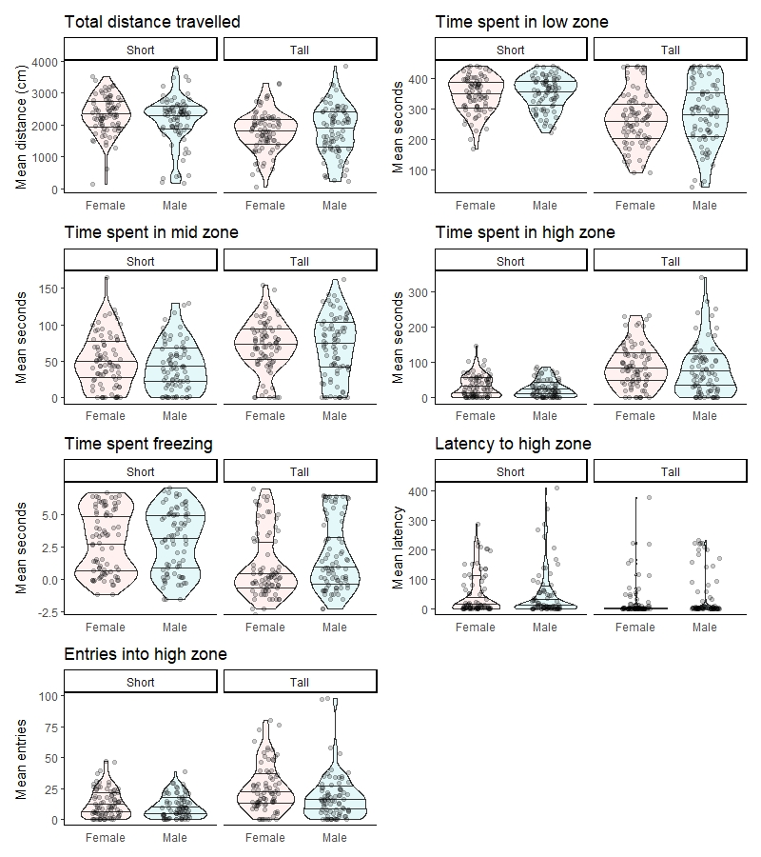
Figure S3) Mean individual results per tank and sex. Each plot displays a combination of: mean individual data points for males (n = 79) and females (n = 81) (means were calculated from 2 observations per individual) per tank; and violin plots displaying the distribution density. Quantiles are displayed as straight black lines at 25%, 50% and 75%.

Table S1) Mixed model results for 7 measured behavioral parameters. We used intercept-only models. Contrasts are provided for sex differences. Point estimates (means) are provided, standard errors are displayed in brackets, as well as t-values.
 | Behavioral parameters
 | Total distance travelled | Time spent in low zone | Time spent in mid zone | Time spent in high zone | Time spent freezing | Latency to high zone | Entries to high zone
Short Tank | 2,270.883*** | 342.546*** | 48.916*** | 4.631*** | 1.822*** | 132.996*** | 3.001***
 | (70.426) | (7.923) | (3.697) | (0.389) | (0.157) | (10.154) | (0.206)
 | t = 32.245 | t = 43.235 | t = 13.232 | t = 11.917 | t = 11.583 | t = 13.097 | t = 14.594
Tall Tank | 1,831.621*** | 270.822*** | 71.326*** | 8.052*** | 0.994*** | 107.094*** | 4.066***
 | (70.008) | (7.879) | (3.678) | (0.387) | (0.156) | (9.799) | (0.205)
 | t = 26.163 | t = 34.372 | t = 19.394 | t = 20.799 | t = 6.351 | t = 10.929 | t = 19.872
Male | -49.325 | 12.502 | -4.405 | -0.755 | 0.321 | 28.766** | -0.536*
 | (91.487) | (10.377) | (4.870) | (0.525) | (0.205) | (12.861) | (0.272)
 | t = -0.539 | t = 1.205 | t = -0.905 | t = -1.437 | t = 1.561 | t = 2.237 | t = -1.971
Observations | 630 | 630 | 630 | 630 | 630 | 487 | 630
Note: | *p<0.1; **p<0.05; ***p<0.01

Table S2) Repeatability results and between-individual and within-individual variance components for 7 measured behavioral parameters for short and tall tanks. Repeatability R is provided with confidence intervals. Contrasts are between repeatability estimates. Results in bold deem repeatability differences between short and tall tanks to be statistically significant (confidence interval does not cross 0). Between- and within-individual variance components are given with 95% confidence intervals.
 | Behavioral parameters
 | Total distance travelled | Time spent in low zone | Time spent in mid zone | Time spent in high zone | Time spent freezing | Latency to high zone | Entries to high zone
Short tank R | 0.23 (0.07-0.38) | 0.36 (0.20-0.49) | 0.51(0.38-0.62) | 0.53(0.41-0.64) | 0.296(0.14-0.43) | 0.10(0-0.30) | 0.48(0.35-0.59)
Tall tank R | 0.42 (0.29-0.54) | 0.53(0.42-0.64) | 0.47(0.34-0.58) | 0.59(0.48-0.69) | 0.299(0.15-0.43) | 0.49(0.34-0.61) | 0.31(0.16-0.45)
Contrast | 0.19 (-0.01-0.38) | 0.18(0.00004-0.36) | 0.04(-0.13-0.21) | 0.06(-0.09-0.22) | 0.003(-0.2-0.2) | 0.37(0.14-0.57) | 0.17(-0.02-0.35)
Between-individual variance (Short tank) | 0.23(0.07-0.40) | 0.36(0.20-0.53) | 0.51(0.34-0.69) | 0.54(0.37-0.72) | 0.30(0.14-0.47) | 0.10(0-0.31) | 0.48(0.31-0.67)
Between-individual variance (Tall tank) | 0.42(0.26-0.59) | 0.54(0.37-0.72) | 0.47(0.31-0.64) | 0.60(0.42-0.78) | 0.30(0.14-0.47) | 0.50(0.31-0.72) | 0.31(0.48)
Within-individual variance (Short tank) | 0.77(0.60-0.95) | 0.65(0.51-0.80) | 0.49(0.39-0.61) | 0.47(0.37-0.58) | 0.71(0.56-0.87) | 0.90(0.66-1.12) | 0.52(0.41-0.65)
Within-individual variance (Tall tank) | 0.58(0.46-0.72) | 0.47(0.37-0.57) | 0.53(0.42-0.66) | 0.41(0.32-0.50) | 0.70(0.56-0.86) | 0.53(0.40-0.67) | 0.69(0.55-0.85)

Table S3) Repeatability results for 7 measured behavioral parameters for males and females in the short tanks. Repeatability R is provided with confidence intervals. Contrasts are between repeatability estimates of males and females. Results in bold deem repeatability differences between short and tall tanks to be statistically significant (confidence interval does not cross 0).
 | Behavioral parameters
 | Total distance travelled | Time spent in low zone | Time spent in mid zone | Time spent in high zone | Time spent freezing | Latency to high zone | Entries to high zone
Males R | 0.54(0.35-0.68) | 0.35(0.14-0.53) | 0.52(0.33-0.67) | 0.46(0.27-0.63) | 0.46(0.27-0.62) | 0.10(0-0.40) | 0.38(0.17-0.56)
Females R | 0 | 0.36(0.15-0.54) | 0.50(0.31-0.65) | 0.59(0.43-0.72) | 0.14(0-0.36) | 0.09(0-0.37) | 0.56(0.39-0.69)
Contrast | 0.53(0.35-0.68) | 0.009(-0.28-0.27) | 0.02(-0.22-0.27) | 0.12(-0.13-0.36) | 0.31(0.03-0.56) | 0.01(-0.31-0.34) | 0.18(-0.07-0.43)

Table S4) Repeatability results for 7 measured behavioral parameters for males and females in the tall tanks. Repeatability R is provided with confidence intervals. Contrasts are between repeatability estimates of males and females. Results in bold deem repeatability differences between short and tall tanks to be statistically significant (confidence interval does not cross 0).
 | Behavioral parameters
 | Total distance travelled | Time spent in low zone | Time spent in mid zone | Time spent in high zone | Time spent freezing | Latency to high zone | Entries to high zone
Males R | 0.50(0.32-0.65) | 0.69(0.55-0.79) | 0.61(0.45-0.73) | 0.68(0.54-0.78) | 0.31(0.10-0.50) | 0.69(0.54-0.81) | 0.53(0.35-0.67)
Females R | 0.32(0.11-0.50) | 0.36(0.17-0.54) | 0.30(0.09-0.48) | 0.49(0.31-0.64) | 0.27(0.06-0.46) | 0.27(0.03-0.48) | 0.12(0-0.33)
Contrast | 0.18(-0.08-0.45) | 0.32(0.1-0.55) | 0.31(0.07-0.56) | 0.28(0.07-0.51) | 0.04(-0.25-0.32) | 0.42(0.16-0.68) | 0.39(0.12-0.62)

