Title: When bigger isn’t better – implications of large high-severity wildfire patches on avian diversity and community composition
Running Title: Birds and high-severity wildfire
Abstract
Aim:
Wildfires increasingly create large high-severity patches with interior areas far from less disturbed habitats. We evaluated how these trends impact bird communities by investigating the effect of internal distance from lower severity areas, high-severity patch size, and years since fire on avian alpha and beta diversity.

Location:
Sierra Nevada, California, USA

Methods:
Bird occurrence data were collected during 2009-2017 within high-severity patches of 27 wildfires representing 1-30 years since disturbance. A two-step multispecies occupancy method was used to account for imperfect detection of 94 species and estimate effects of patch characteristics on community richness and dissimilarity.

Results:
Community richness decreased with distance from patch edge and with patch size. Richness increased with years since fire, but this pattern was dependent on distance from edge with higher peak richness (23 species) near edges than interiors (18 species). Community dissimilarity was not associated with distance, indicating that large high-severity patch interiors contain subsets of, rather than complements to, edge communities. Dissimilarity peaked later with increasing patch size. Guild richness of tree and primary cavity nesters was negatively associated with distance and patch size. Richness of ground and shrub nesters was insensitive to distance, while shrub nester richness increased somewhat with patch size. Due to declines among other species, ground and shrub nesters made up a greater percentage of the avian community within the interiors of large high-severity patches.

Main conclusions:
As fire activity increases due to accumulating forest fuels and accelerating climate change, high-severity patches and their resulting early-seral habitats are becoming more extensive with less edge and more interior area. Such changes are likely to decrease avian diversity locally and shift community composition away from forest-associated species. Management actions that promote the full range of fire effects but limit high-severity patch size may best conserve bird diversity within fire-adapted ecosystems.

Keywords
Avian diversity, fire ecology, fire suppression, heterogeneity, landscape ecology, multispecies occupancy model, patch size, pyrodiversity, wildfire

Introduction

Wildfire is a fundamental ecological process that influences the distribution of ecosystems (Whittaker 1975, Bond and Keeley 2005, McLauchlan et al. 2020), landscape pattern (Turner 2010), and vegetation structure (Agee 1996). Wildfire patterns are shifting globally (Flannigan et al. 2009, Bowman et al. 2011) and especially in fire-prone forests of California where wildfires are creating ever larger patches of high-severity effects in which forests are converted to early-seral habitats (Miller et al. 2012, Westerling 2016, Abatzoglou and Williams 2016). Further, increasingly large extents of these high-severity patches are located far from lower severity areas where fire-caused vegetation mortality and habitat structure is more variable and forests remain largely intact (Steel et al. 2018). Such shifts influence landscape heterogeneity and habitat availability, potentially driving patterns of species diversity and community composition. A greater understanding of how changes in the spatial pattern of high-severity fire are impacting bird communities is necessary to effectively manage fire-adapted ecosystems and conserve biodiversity.

Bird species vary widely in their response to wildfire and in their associations with post-fire habitats (Fontaine and Kennedy 2012). High-severity fire that removes the majority of pre-fire vegetation (i.e., >75 % canopy cover mortality), leaves fire-killed trees (snags) in the short-term, with early-successional habitats such as grasslands and shrublands developing in the years immediately following the fire (White et al. 2016). If reestablishment of conifer or hardwood trees are successful and in the absence of repeated severe disturbance, the habitat will transition back to a forested state in the medium- to long-term (Agee 1996, van Wagtendonk et al. 2018). In contrast, low- to moderate-severity effects reduce tree and understory density but maintain mature canopy cover (Miller et al. 2009) and habitat structure more similar to unburned areas (Roberts et al. 2021). Many bird species in the Sierra Nevada are adapted to particular combinations of burn severity and time since fire, including early-successional habitats created by high-severity fire (Fontaine et al. 2009, White et al. 2016, Taillie et al. 2018). Indeed peak abundance of at least a quarter of the bird community occurs in recently burned forests (≤ 15 years) across the severity gradient with an equivalent number most abundant in unburned forests (Taillie et al. 2018). While bird communities in contrasting severities have been relatively well studied, our understanding of how spatial patterns of high-severity patches influence bird diversity is limited.

The spatial pattern of high-severity fire may influence bird diversity at both the patch and local scale. Patch size influences the amount and connectivity of early-seral habitat created by a given fire, as well as the amount of habitat isolated from lower severity areas. Within a given high-severity patch, distance from its edge can drive the level of landscape heterogeneity a bird perceives. High-severity areas near surviving forests (i.e., low- to moderate-severity areas) potentially provide complementary resources not available to birds occupying the high-severity patch interior (Stillman et al. 2019, 2021). In these fire-adapted landscapes bird diversity may maximize in areas characterized by heterogeneous fire histories (aka pyrodiversity) where variation in burn severity and other fire regime characteristics is high (Martin and Sapsis 1992, Tingley et al. 2016, Beale et al. 2018, Steel et al. Accepted), suggesting that high-severity patch edges may contain greater bird diversity than interiors. Wildfire spatial pattern is also an important determinant of vegetation succession (Turner 2010) with likely consequences for avian composition shifts in the decades following disturbance. In forests composed of tree species that are unable to resprout or regenerate through serotiny, the distance to surviving trees determines the rate of post-fire forest recovery (Greene and Johnson 1995, Welch et al. 2016, Shive et al. 2018) and bird habitat quality. While individual bird species respond to fire patterns idiosyncratically, generalized responses may emerge among functional groups with species reliant on residual trees (e.g., tree nesters) showing opposing effects as those reliant on early-seral resources (e.g., shrub nesters).

To assess how the spatial pattern of high-severity patches influences avian community diversity and composition we used a two-step multispecies occupancy model analysis along with 2044 bird community surveys conducted within high-severity patches of 27 wildfires. Specifically, we addressed the following questions: 1) How does location within a high-severity patch (i.e., distance from lower severity areas) and patch size influence occupancy of individual species, as well as avian alpha and beta diversity? 2) How does diversity change 1-30 years after fire and are these changes dependent on distance to lower severity areas or high-severity patch size? 3) Do these factors influence species richness of functional groups (i.e., nesting guilds), and their relative prevalence in the bird community?

Methods

Study system
Through a combination of lightning ignitions and indigenous management, semi-arid conifer forests of California historically experienced frequent fire dominated by low- to moderate-severity effects (Safford and Stevens 2017). However, legacies of 19th and 20th century fire and forest management as well as accelerating climate change are causing shifts in fire patterns across the region (Mallek et al. 2013, Safford and Water 2014). Following Euro-American colonization and genocide of native peoples in the 1800s, traditional fire management ceased and naturally-ignited wildfires were suppressed (Stephens et al. 2007, Anderson and Keeley 2018, van Wagtendonk et al. 2018). Forest structure was further altered in many areas by 19th and 20th century timber harvest and silvicultural practices (McKelvey and Johnston 1992, Safford and Stevens 2017). These changes led to a large increase in tree density, surface fuels, and an elevated risk of high-severity fire effects (Stephens et al. 2015, Steel et al. 2015, Lydersen and Collins 2018). Apart from vegetation pattern and structure, climate change is lengthening fire seasons and increasing instances of extreme fire weather (Westerling 2016, Williams et al. 2019). Contemporary wildfires that escape suppression efforts are consequently burning with a greater proportion of high-severity effects, larger high-severity patches, and more high-severity area far from patch edges (Miller et al. 2012, Steel et al. 2018, Parks and Abatzoglou 2020).

We surveyed birds within previously burned conifer forests of the Sierra Nevada and Southern Cascade ranges in California (Figure 1). Sample locations span an elevation gradient of 1050 – 2200 m, and a latitudinal gradient of 35.8 – 41.4 degrees, which encompasses the lower and upper montane zones of the range. Along this gradient, dominant tree species transition from Pinus ponderosa, P. lambertiana, Abies concolor, Pseudotsuga menziesii, Calocedrus decurrens and Quercus spp in the lower montane to A. magnifica, Pinus jeffreyi, and Pinus monticola in the upper montane. Shrubs, including Arctostaphylos spp., Ceanothus spp., Prunus spp., Q. vaccinifolia, Chrysolepis sempervirens and Ribes spp., are also found in conifer stands or as the dominant vegetation in areas characterized by xeric conditions, poor soils, or past disturbance (van Wagtendonk et al. 2018). Historically, the lower montane yellow pine and mixed conifer forests were characterized by a 10-20 year mean fire return interval with 5-8% of burned area experiencing high-severity effects on average. At higher elevations red fir forests burned slightly less frequently (40 year mean fire return interval) and with greater percentage of high-severity (10-20%; Mallek et al. 2013, Safford and Water 2014). The historic spatial patterns of fire severity is less certain, but high-severity patches were likely relatively small (mostly < 10 ha) in the yellow pine and mixed conifer forests (Safford and Stevens 2017), and contemporary reference sites show 86% of high-severity patches in red fir and subalpine forests are less than 15 ha in size (Meyer and North 2019).

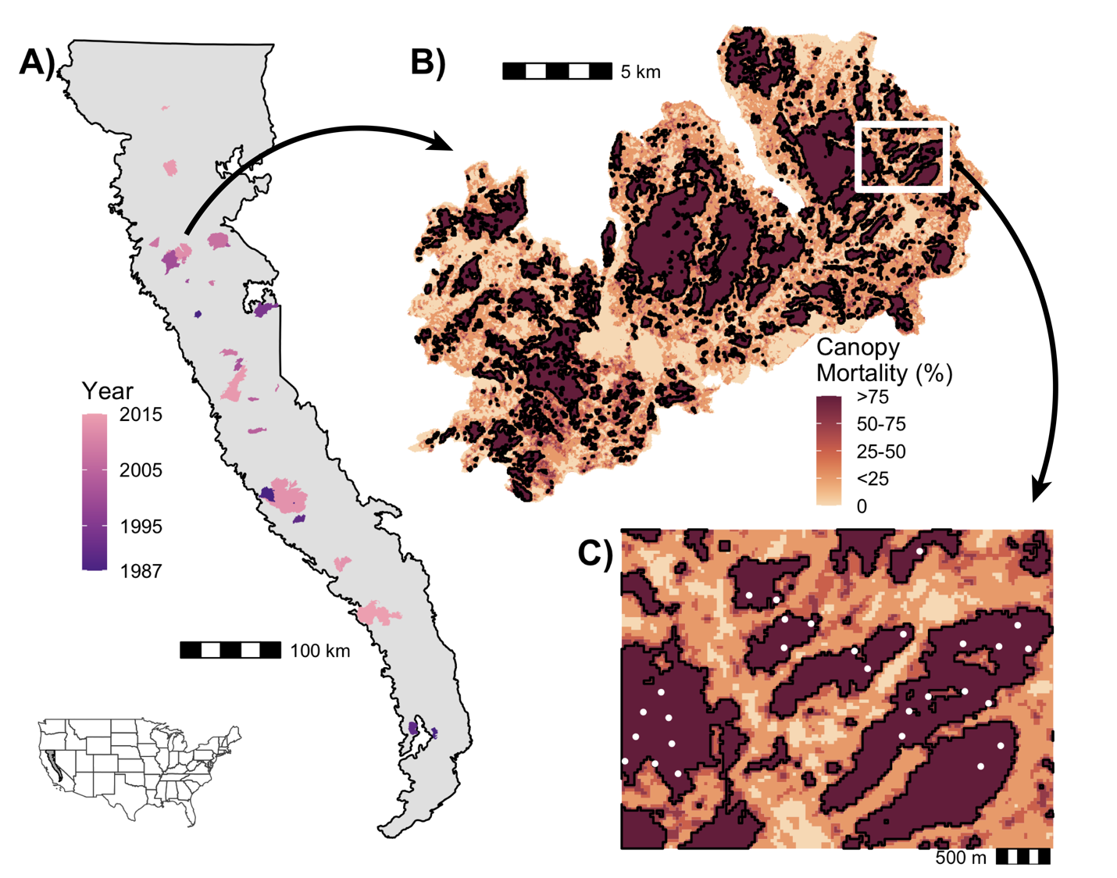
Figure 1. Study region map and illustration of sampling design. A) Footprints of 27 sampled fires that burned across a range of years within California’s Southern Cascades and Sierra Nevada bioregions. B) An example severity map (the 2012 Chips Fire) with high-severity patches of various sizes outlined in black. C) An example burned area containing bird survey locations (white dots) at various distances from patch edge.
Environmental and bird data
Fire severity data were obtained from a Forest Service-maintained database, which includes fires that occurred at least partially on Forest Service or National Park Service land in California since 1984 (available at http://www.fs.usda.gov/detail/r5/landmanagement/gis/). The database was derived from LANDSAT-TM satellite multispectral imagery. The Relativized differenced Normalized Burn Ratio was calculated as a measure of vegetation change resulting from each fire, and was subsequently used to quantify canopy cover mortality (Miller and Thode 2007, Miller et al. 2009). Extensive calibration and validation of this database has shown high classification accuracy of high-severity areas with greater classification uncertainty within the matrix of moderate-severity (25-75 % mortality; Miller et al. 2009, Miller and Quayle 2015, Lydersen et al. 2016). We focus on high-severity areas where a minimum of 75% of the pre-fire canopy cover was killed and define high-severity patches as contiguous areas connected by at least one 900 m² pixel (not including diagonals). This mortality threshold is often employed to designate high-severity fire effects, and has been used effectively to describe differences in vegetation structure, avian diversity, and occurrence of sensitive species (e.g., Tingley et al. 2016, Welch et al. 2016, Jones et al. 2020, Steel et al. In Review). However, other thresholds have also been used in the literature to test various ecological questions (e.g., Lydersen et al. 2016, Collins et al. 2017). Patch size and the distance to survey locations within a high-severity patch from areas with < 75% pre-fire mortality (i.e., patch edge) was calculated using R (R Core Team 2020).

We combined avian point count survey data from multiple monitoring programs in the Sierra Nevada and Southern Cascade Mountains (Figure 1). The majority of surveys (62%) were conducted as part of a post-fire monitoring program in eight fires of the central and northern part of the study region. To extend the temporal and geographic scope of our analysis, we also drew from a region-wide monitoring program where survey locations were coincident with areas that previously experienced high-severity fire. The post-fire monitoring program included sampling stratified across the burn severity gradient, while the region-wide program used a generalized random tessellation stratified sampling design with a habitat type strata (Roberts et al. 2011, Burnett and Roberts 2015, Taillie et al. 2018). Only points surveyed following high-severity fire were considered here (Figure 1). Survey sites were spaced a minimum of 250 m apart and were located on US Forest Service lands. A standard 5-min point count survey protocol was used where each individual bird was recorded along with its initial distance from point center (Ralph et al. 1993). All observers were experienced avian field technicians that completed an intensive two week training and passed a double observer test with experts in bird identification and point count methods prior to conducting surveys. Surveys were conducted during the peak breeding season (May - June), with repeat visits conducted by different observers to reduce the likelihood that variability in observer skill affected occupancy estimates. Sites used in analysis were limited to locations that had not experienced a previous high-severity event since at least 1984 and were classified as conifer forests prior to the most recent fire, and where no major management actions (e.g., salvage logging, herbicide, or reforestation treatments) had occurred since the fire either at the location of the survey or between survey points and the nearest high-severity patch edge. The Forest Service Activity Tracking System database (available at https://www.fs.usda.gov/main/r5/landmanagement/gis) was used to identify post-fire management and was verified with historical Google Earth aerial imagery. In total, 746 point count sites were surveyed in multiple years during the 2009-2017 seasons. Sites were located within one of 130 high-severity patches and 27 fires. Sampled wildfires burned between 1987 and 2015, with surveys conducted 1-30 years post-fire (median = 3 years; mean = 6 years). Sample distributions of distance from edge and patch size were log-normal with distance from lower severity areas ranging between 1 m and 1090 m (median = 81 m; mean = 125 m) and high-severity patch size ranging between 0.1 and 21,000 ha (median = 42 ha; mean = 680 ha). Stand structure data were also collected at point count locations during some years using a modified relevè protocol (Ralph et al. 1993), and used for modeling variation in bird detectability. For years where birds were surveyed but not vegetation, the most proximate (before or after) vegetation data were used.

Statistical Analysis
Of the 122 species observed during at least one survey occasion, we restricted our analysis to 94 species that are effectively surveyed using the point count protocol and are known to breed within the study area (see Appendix S1 in Supporting Information). Species were classified into nesting guilds according to known life-histories as breeding bird territories and occurrence are tightly linked to nesting sites (Steel et al. 2012, Beedy and Pandolfino 2013). Specifically, each species was classified as predominantly a tree, primary cavity, secondary cavity, shrub, or ground nester (Appendix S1). We consider each survey season and site combination as a primary survey occasion (i), and within season visits as temporal replicates (j). The community is assumed to be closed during each season, allowing for formal estimation of rates of detection and occupancy. On average, each site was surveyed for 2.7 years, for a total of 2044 primary survey occasions; most (90%) composed of two visits per year. Observation data are binary with $y_{s,i,j}=1$ when species $s$ is detected during survey $i$ and visit $j$ within 100 m of the observer, or $y_{s,i,j}=0$, when a species was not detected. Because detection is imperfect, we used an occupancy modeling framework $y_{s,i,j}=Bernoulli\left(p_{s,i,j}∗z_{s,i}\right)$ where $p_{s,i,j}$ is the probability of detection given a site is occupied (i.e., $z_{s,i}$ = 1). A species’ true occurrence is modeled as $z_{s,i}=Bernoulli\left(ψ_{s,i}\right)$ where $ψ_{s,i}$ is the probability of occurrence, and $z_{s,i}$ is a binary latent variable of a species’ true occurrence state.
We assumed detection and occurrence probabilities vary by species and survey and are functions of habitat and survey characteristics. The detection process is modeled using the following logit-linear function:
[1]
$$\begin{matrix}logit\left(p_{s,i,j}\right) & α0_{s} \\ & +α_{snag,s}∗X3_{i}+α_{shrub,s}∗X4_{i}\end{matrix}$$

where the Julian day ($α_{day}$ and $α_{day^{2}}$) of each visit, snag basal area ($α_{snag}$), and percentage shrub cover ($α_{shrub}$) are predictors of detection probability. The occurrence process is modeled using the following logit-linear function:
[2]
$$\begin{matrix}logit\left(ψ_{s,i}\right) & β0_{s}+β{site\left[i\right]}_{s}+β{patch\left[i\right]}_{s}+β{fire\left[i\right]}_{s} \\ & +β_{dist,s}∗X7_{i}+β_{dist∗YSF,s}∗X7_{i}∗X5_{i} \\ & +β_{lat,s}∗X9_{i}+β_{elev,s}∗X{10}_{i}+β_{elev^{2},s}∗X{11}_{i}\end{matrix}$$

Where$βsite$, $βpatch$, and $βfire$ are random intercepts for site, patch, and fire ID for species s. For each species, occupancy probability is a function of number of years since fire ($β_{YSF}$ and $β_{YSF^{2}}$), distance (log m; $β_{dist}$) from high-severity patch edge, the interaction of distance and years since fire ($β_{dist∗YSF}$), patch area (log ha; $β_{area}$), the interaction of patch area and years since fire ($β_{area∗YSF,s}$), latitude (degrees; $β_{lat}$), and elevation (m; $β_{elev}$ and $β_{elev^{2}}$). Quadratic terms for distance and patch area were also considered, but early models showed little justification for their inclusion. Variable correlations were low (< | 0.6 |) among the detection or occupancy model.
The primary predictor variables of interest are distance from patch edge, years since fire, and high-severity patch size. The additional predictors in equations 1 and 2 were chosen based on previous work assessing species occurrence in the Sierra Nevada Mountains (e.g., Siegel et al. 2011, Burnett and Roberts 2015, White et al. 2016, Tingley et al. 2016). We utilize a multispecies occupancy model where each species-specific parameter $α_{s}$ or $β_{s}$ is modeled as a random sample from a community-level hyperparameter. This allows for more precise estimates for rare species, which can be challenging to model using single-species approaches, and improves estimates of community metrics with appropriate propagation of model uncertainty (Zipkin et al. 2010). We allow intercepts of $ψ_{s}$ to vary by fire and patch ID to help account for spatial clustering of points and for cluster-specific environmental variation not explicitly included in the model (e.g., fire size). Similarly, site ID is modeled as a varying intercept to account for variation in unmodeled habitat characteristics and other local influences unique to each point. This approach may be considered a correlated multispecies model as it makes explicit the assumption that occupancy at a site is not fully independent among years. This model differs from a dynamic multispecies model (Dorazio et al. 2010) in that correlations are bi-directional (e.g., information in survey year two informs estimates of year one and vice versa) and does not estimate rates of local extinction and colonization, which are not of interest here. All continuous predictors were standardized with a mean of zero and standard deviation of one, and random intercepts are estimated with a group population mean of zero. The multispecies occupancy model was estimated using Hamiltonian Monti Carlo sampling in Stan via the rstan package (Stan Development Team 2020). We specified weakly regularizing priors to prevent model over-fitting (McElreath 2016).
To estimate alpha and beta diversity at the community level we used a two-step (aka Bayesian meta-analysis) modeling process (Tingley and Beissinger 2013, Kery and Royle 2015) where the detection-corrected estimates of occupancy ($z_{s,i}$) from the multispecies occupancy model were used to calculate diversity metrics for each primary survey occasion. Richness (alpha diversity) is calculated as the sum of $z_{s,i}$ for the full community or for a subset of species when conducting nesting guild analysis. Beta diversity is calculated as the compositional dissimilarity from the group centroid (multidimensional median), where groups are defined as each of the 27 sampled fire areas. We limit our assessment of alpha diversity to species richness because metrics such as evenness and Shannon diversity require estimates of species abundance which cannot be produced by occupancy models and the presence/absence data used. We use the Raup-Crick Index (Raup and Crick 1979) as our measure of beta diversity because it adjusts for differences in species richness by evaluating dissimilarity between each survey and randomly generated communities based on the group’s species pool (Chase et al. 2011). Alpha and beta diversity calculations were conducted for each draw of the model posterior distribution creating derived distributions for each metric and each primary survey occasion. By using the full multispecies model posterior distribution, model uncertainty is properly propagated to the community models (Tingley and Beissinger 2013, Kery and Royle 2015). Community models were fit using the BRMS and rstan packages (Bürkner 2017, Stan Development Team 2020) with the same set of predictors as equation 2 as well as a gaussian error structure and log-link. All models were run with 4 chains, each for 1000 samples with a warmup of 500, resulting in 2000 post-warmup samples. Proper mixing of sampling chains was checked using traceplots, and all parameters received R-hat values of less than 1.1. Model code can be found in Appendix S2 with additional supporting code found at https://github.com/[BLINDED]/High_Severity_Birds.
To quantify the interaction of distance to patch edge and years since fire we calculated marginal effects of years since fire at three distance levels (10, 50, and 250 m). We limit projected effects to 250 m because surveys conducted at greater distances from patch edge were limited to the first two decades since fire. The marginal effect of patch size and its interaction with years since fire was similarly quantified using projected effects for 1, 50, and 2500 ha patches. The use of a linear and quadratic effect of years since fire assumes a parabolic form with an average peak or nadir at some vertex year following disturbance. We solved for the location of the vertex of each richness model by calculating the expected year since fire when the derivative of the parabola is equal to zero (i.e., when the rate of change is zero; ${{−β}_{YSF}}/{{2∗β}_{YSF^{2}}}$). To evaluate the degree to which distance or patch size influences changes in species richness over time we calculated the expected difference between year one and the vertex year with respect to the three distance and patch size levels. Probabilistic statements as well as derived model estimates and credible intervals were calculated using model posterior distributions. For example, the probability an effect was positive (or negative) was calculated as the proportion of the parameter posterior distribution above (or below) zero.

Results

Species-level effects
Individual bird species differed greatly in how occupancy was affected by the environmental variables tested (Figure 2 & Appendix S3). Among the primary variables of interest, years since fire showed the widest range of standardized effects, with 26% of species showing clear positive (probability [Pr.] > 95%) and 21% showing clear negative associations with occupancy. 15% of species showed a concave (positive quadratic effect) and 27% showed a convex (negative quadratic effect) functional relationship between occupancy and years since fire. Occupancy of 13% of species showed clear positive associations with internal distance to patch edge, while 27% showed a clear negative relationship. The species with the strongest positive effect of distance from edge included European Starling (Sturnus vulgaris), Bullock’s Oriole (Icterus bullockii), Sooty Grouse (Dendragapus fuliginosus), and Lewis’ Woodpecker (Melanerpes lewis), while those with the strongest negative effect included Red-breasted Nuthatch (Sitta canadensis), Hermit Warbler (Setophaga occidentalis), Mountain Chickadee (Poecile gambeli), and Brown Creeper (Certhia americana). Occupancy of 7% of species showed either a positive or negative interaction between years since fire and distance while 3% of species showed a clear interaction between year since fire and patch size, indicating that the rate of change following fire varies by distance from edge more often than patch size. Occupancy of only 1% of species (i.e., Lazuli Bunting; Passerina amoena) showed a positive association with high-severity patch size, while 9% of species occurred more often in smaller patches (Figure 2). Those species with the strongest negative effect of patch size included Red-breasted Nuthatch, Western Wood-pewee (Contopus sordidulus), Hutton’s Vireo (Vireo huttoni), and Mountain Chickadee. Estimates of all multispecies model parameters can be found in Appendix S3.

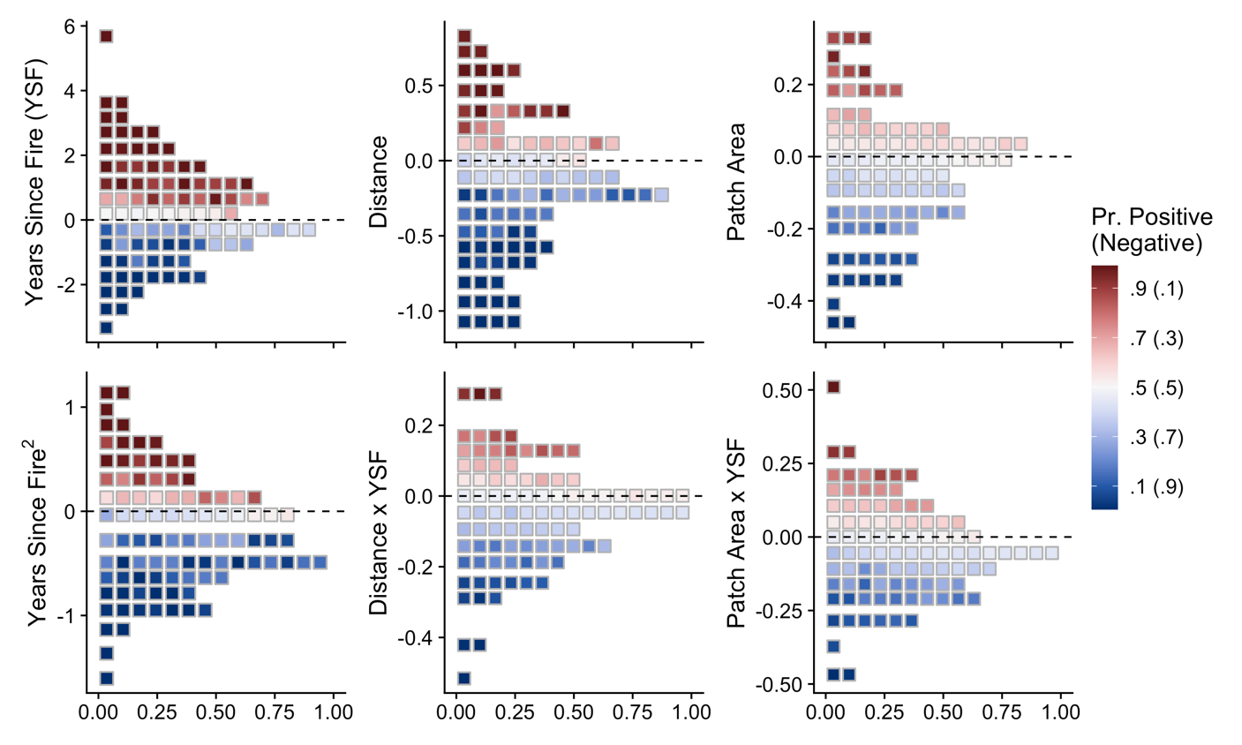
Figure 2. Coefficient estimates for avian multispecies occupancy model parameters of interest. Each square represents a single species with its location on the y-axis indicating the mean parameter estimate and color indicating probability of a positive or conversely negative (1 – Pr. Positive) effect. The x-axis indicates the proportion of species in a given effect size bin relative to the bin with the maximum count. Estimates are for bird species of the Sierra Nevada, California.

Community richness and dissimilarity
The community richness model estimated very clear (Pr. ≥ 99%) effects of all parameters describing internal distance to patch edge, years since fire, and patch area (Figure 3a). Richness was positively associated with years since fire with a negative quadratic term indicating a convex (humped-shaped) relationship with time. Richness was negatively associated with internal distance to high-severity patch edge, and to a lesser degree patch size. The interaction of years since fire and distance to patch edge was negative indicating that the positive effect of years since fire diminished with distance, and conversely that the negative effect of distance grew stronger with time. The interaction of patch size and years since fire was similarly negative but with greater model uncertainty (Pr. 90%). Richness declined with latitude, and likely increased with elevation but with greater uncertainty (Pr. = 94%; Figure 3a). The combined effects of years since fire, distance from patch edge, and patch size resulted in the most speciose communities occurring in the later years of our sample period, near patch edges, and within relatively small patches (Figure 4). After accounting for differences in species richness, community dissimilarity was negatively associated with the linear elevation term and positively with the quadratic elevation term (Pr. > 99%), indicating a concave (U-shaped) relationship with points located at low and high elevations most different from the average community (Figure 3b). Community dissimilarity was also negatively associated with the quadratic term of years since fire and likely positively related to linear term of years since fire (Pr. = 93%; Figures 3b & 4). Dissimilarity was positively associated with the interaction of patch area and years since fire, resulting in a delayed peak in beta diversity within large patches (Figure 4). The direction of all other effects in the community dissimilarity model were less certain (Pr. < 90%; Figure 3b).

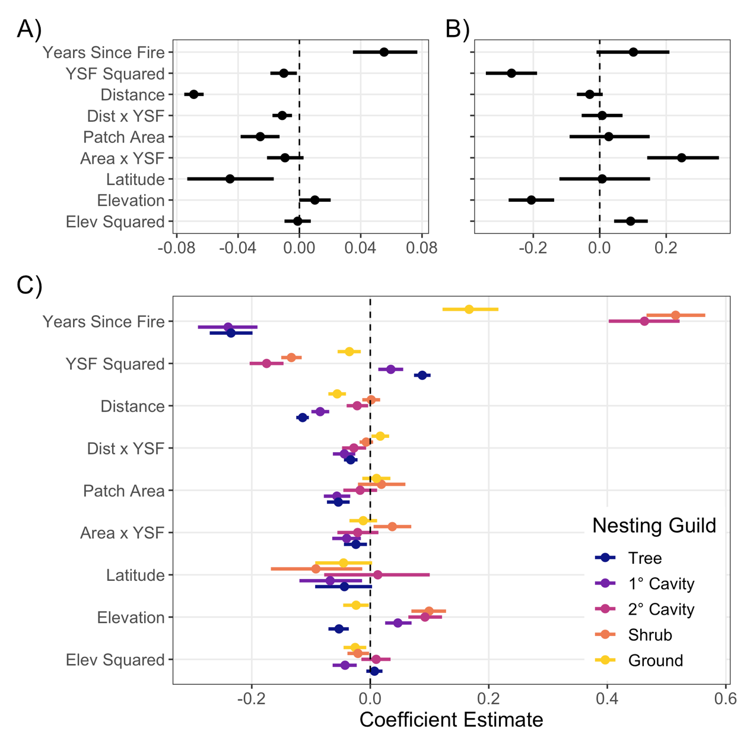
Figure 3. Coefficient dotplots for avian A) community richness, B) community dissimilarity, and C) guild richness in the Sierra Nevada, CA. Points represent median parameter estimates and bars represent 90% credible intervals. Tabulated parameter estimates can be found in Appendix S4.

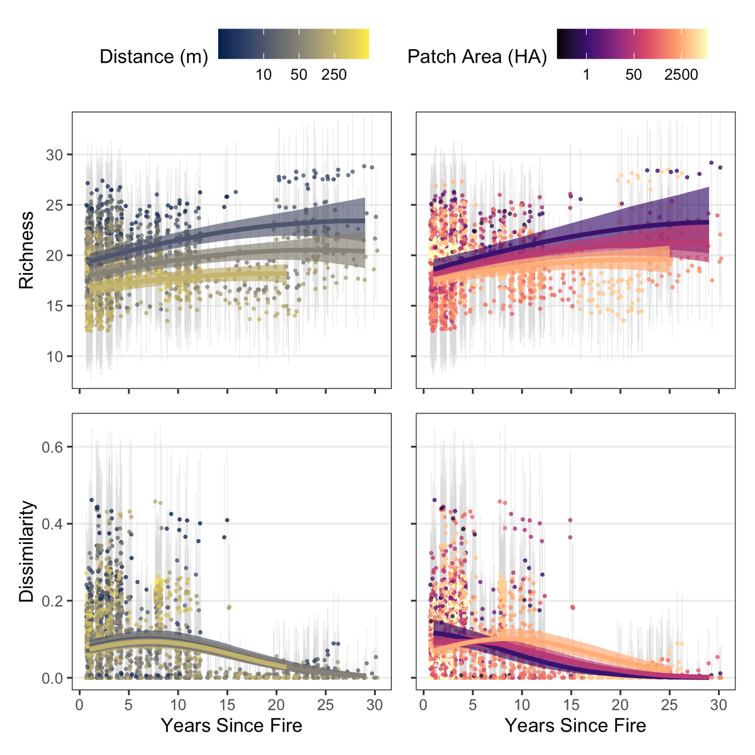

Figure 4. Marginal effects of years since fire, distance from high-severity patch edge, and patch size on bird community alpha and beta diversity in the Sierra Nevada, CA. Alpha diversity is quantified as species richness. Beta diversity is quantified using the Raup-Crick Index, where groups (species pools) are defined by each individual fire area. Model fits are shown as median lines and 90% credible interval bands for 10 (blue), 50 (grey), and 250 m (yellow) from patch edge or 1 (purple), 50 (pink), and 2500 ha (orange) patches with other predictor variables held at their mean values. After accounting for imperfect detection, estimated medians and 90% credible intervals of sampled communities are shown as jittered points and vertical bars.

Nesting Guilds
The direction and magnitude of model effects varied considerably among nesting guilds (Figure 3c). Tree and primary cavity nester richness was very clearly negatively associated with years since fire and positively associated with years since fire quadratic term resulting in concave (U-shaped) relationships over time. Conversely, secondary cavity, shrub, and ground nester richness was positively associated with years since fire and negatively associated with the years since fire quadratic term resulting in a convex (hump-shaped) relationship over time (Figures 3c, 5 & 6). Distance from patch edge had a negative effect on richness for all guilds with the exception of shrub nesters; the magnitude of the effect was strongest for tree nesters, followed by primary cavity nesters. The interaction of distance and years since fire had a negative effect on richness of for tree, primary cavity, and secondary cavity nesters, while positive for ground nesters (Figures 3c & 5). High-severity patch area was negatively associated with richness of tree and primary cavity nesters and the interaction between patch area and years since fire was positive for shrub nester richness (Figures 3c & 6). Latitude was negatively associated with richness of primary cavity and shrub nesters, and likely negatively with ground and tree nester richness (Pr. 94%). Elevation was positively associated with richness of primary cavity, secondary cavity, and shrub nesters, and negatively with tree and ground nesters. The quadratic term of elevation was negative for primary cavity, ground, and shrub nesters (Figure 3c). While guild-level patterns were often apparent, there were within-guild exceptions. For example, in contrast to the guild overall Hairy (Dryobates villosus), Lewis’, and Acorn (M. formicivorus) woodpeckers occurred more often with increasing distance from patch edge, while the Black-backed woodpecker (Picoides arcticus; an important species for post-fire management) showed a neutral response (Appendix S3).

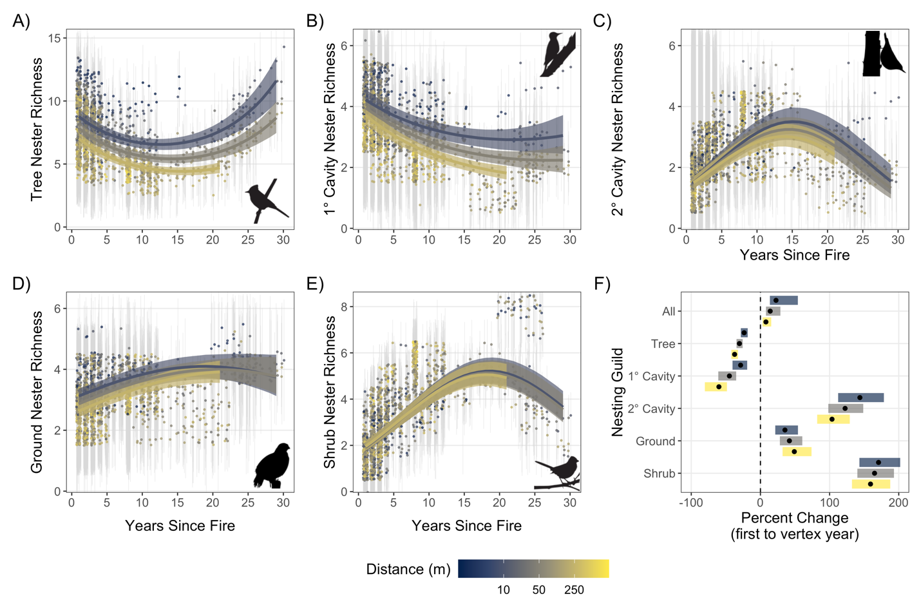
Figure 5. Marginal effects of years since fire and internal distance from high-severity patch edge on avian guild richness in the Sierra Nevada, CA. Panels represent A) tree, B) primary cavity, C) secondary cavity, D) ground, and E) shrub nester richness. F) Shows the predicted percent change in richness from one year since fire to the median vertex (peak or nadir) year for an average point characterized by a given distance from patch edge. For example, shrub nester richness at an average point 250 m from patch edge is expected to maximize at a mean of 5.1 species in year 18, a 159% increase from year one. Model fits are shown as median lines and 90% credible interval bands for 10 (blue), 50 (grey), and 250 m (yellow) from patch edge with other predictor variables held at their mean values. After accounting for imperfect detection, estimated medians and 90% credible intervals of sampled communities are shown as jittered points and vertical bars. Bird silhouettes from www.allaboutbirds.org, © Cornell Lab of Ornithology.

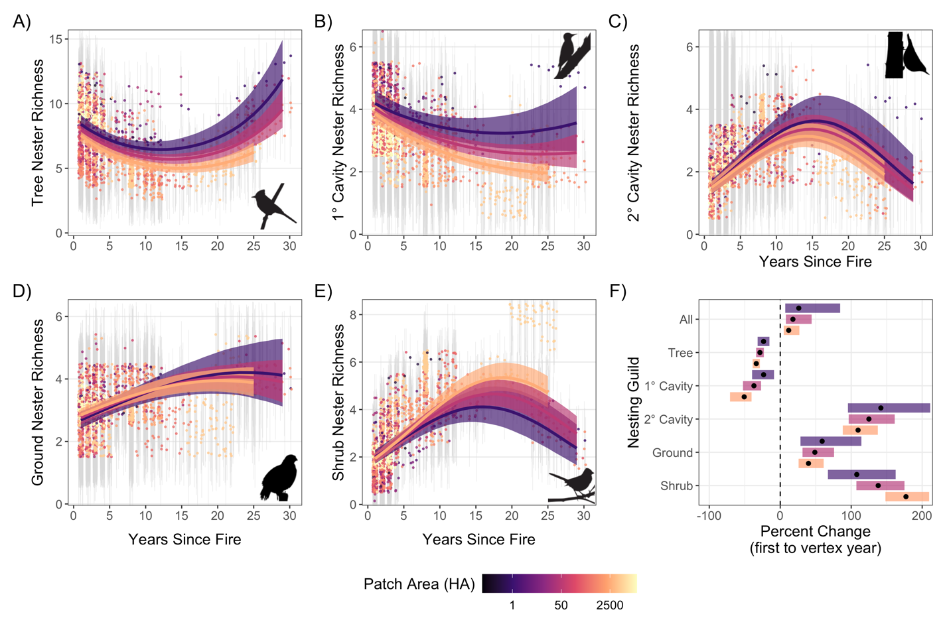
Figure 6. Marginal effects of years since fire and high-severity patch size on avian guild richness in the Sierra Nevada, CA. Panels represent A) tree, B) primary cavity, C) secondary cavity, D) ground, and E) shrub nester richness. F) Shows the predicted percent change in richness from one year since fire to the median vertex (peak or nadir) year for an average point within a given size patch. For example, shrub nester richness at an average point within a 2500 ha patch is expected to maximize at a mean of 5.3 species in year 19, a 177% increase from year one. Model fits are shown as median lines and 90% credible interval bands for 1 (purple), 50 (pink), and 2500 ha (orange) patches with other predictor variables held at their mean values. After accounting for imperfect detection, estimated medians and 90% credible intervals of sampled communities are shown as jittered points and vertical bars. Bird silhouettes from www.allaboutbirds.org, © Cornell Lab of Ornithology.

Distance- and patch size-dependent avian succession
Distance from patch edge, and to a lesser degree patch size, influenced the rate at which species richness changed following wildfire (Figure 3c). In addition to greater mean richness, patch edges also experienced greater growth in community richness with time since fire as compared to patch interiors (Figure 5f). Conversely, the declines in richness experienced by the tree and primary cavity nesting guilds were more pronounced in patch interiors than edges. Similar to the overall community, between year one and the year of peak richness, secondary cavity nester richness increased more along edges than interiors. Temporal changes in ground and shrub guild richness were largely unaffected by distance from edge (Figure 5f). Larger patches also resulted in more rapid declines in tree and primary cavity nester richness. However, where temporal changes in shrub nester richness was unaffected by distance from edge, the guild peaked at higher levels within large high-severity patches (Figure 6f).

The strength of the interactions of distance or patch size and years since fire ultimately influenced the relative composition of communities along edges and interiors. When guilds reached their richness peak or nadir approximately two decades following a fire, tree and primary cavity nesters represented greater percentages of the full community along edges than interiors, while the ground and shrub guilds saw the opposite pattern. Specifically, the relative number of tree nesters decreased from a median of 28% of the community at 10 m from edge to 24% at 250 m from edge. Similarly, the relative number of primary cavity nesters decreased from 12% to 9%. While absolute ground and shrub nester richness was insensitive to distance, the loss in forest-dependent species resulted in relative increases for these groups. The median percentage of the community composed of ground nesters increased from 18% at 10 m from edge to 22% at 250m from edge, while the relative number of shrub nesters increased from 22% to 28%. Secondary cavity nesters maintained approximately the same percentage of the community regardless of distance from edge.

Patch size had a similar effect on community composition with tree and primary cavity nesters making up a smaller component of the community on average in large patches as compared to small patches, and ground and shrub species making up a relatively greater component. Due to smaller effect sizes (Figure 3c) the realized compositional shifts were weaker for most guilds, except for the shrub nesters. At its peak richness, the shrub nester group made up approximately 18% of the community at an average point in small patches (1 ha) and 27% of the community in large patches (2500 ha). These ultimate effects of distance to patch edge and patch size on community composition were weaker in the years immediately following a fire, and likely continued or strengthened into the third decade since fire. However, our sampling of patch interiors (e.g., > 250 m) and very large patches (e.g., > 2500 ha) beyond 20 years since fire was limited, making projections into the third decade less certain (Figures 5 & 6).

Discussion
As fire activity increases across the western United States and large patches of high-severity effects become more common, it is important to understand how bird communities will respond in the decades following disturbance. Here we show that as compared to small high-severity patches or patch edges, interiors of large patches support fewer species and a lower rate of increase in species richness within the first three decades following wildfire. Further, this lower richness is not compensated by an increase in compositional dissimilarity, indicating that high-severity patch interiors contain a subset of those species found at patch edges, rather than species unique to patch interiors. These differences within and among high-severity patches are largely attributable to tree and primary cavity nesting species (e.g., Hermit Warbler and Red-breasted Nuthatch), which were more common in small patches and along patch edges. Neither ground nor shrub nesting guilds had higher species richness in patch interiors despite the greater cover of early-seral habitat in the local landscape. However, differential responses among functional groups to high-severity spatial pattern resulted in relative shifts in community composition where ground and especially shrub nesting species made up an increasing percentage of interior communities within large patches with greater time since fire, while tree and primary cavity nesters experienced declines. While distance from edge generally showed stronger effects on bird diversity than patch size, it is important to highlight that these features are functionally related to each other in that for a given patch geometry (e.g., a circle) larger patches have more area far from edges and residual forests. Taken together these results suggest that small high-severity patches or large patches with high edge-area ratios support higher levels of bird diversity than large high-severity patches containing extensive interior habitat.

These findings further our understanding of how montane bird communities respond to the spatial pattern of high-severity wildfire but also highlight areas of future research. Species occupancy is generally correlated with abundance (Kery and Royle 2015), but the latter along with fecundity and survival data can provide a more nuanced picture of how individual species respond to their environment (e.g., Stillman et al. 2021). Further, our data was limited to 30 years since fire with relatively few surveys in the oldest fires. While this remains an exceptionally wide range of time since fire relative to existing research, more extensive sampling of older fires would allow for a more complete understanding of the relationship between fire patterns, vegetation succession, and bird diversity. We also limit our assessment of patch dynamics to one local-level metric (distance from edge) and one patch-level metric (size). Assessments of other landscape metrics and the broader landscape context (e.g., how diversity is affected by distance from the burn perimeter) may complement this work and our understanding of post-fire habitats. Further investigation into the mechanisms of elevated avian richness at high-severity edges could also better inform conservation efforts. Due to the limitations of the remotely sensed fire severity data, it was not currently possible to confidently classify soft (gradual) vs. hard (abrupt) patch edges, which may influence the nature of patch dynamic effects on the avian community. More broadly, this work can provide greater context for a growing literature assessing the influence of disturbance on metacommunity dynamics, including how the relative importance of dispersal and competition in structuring metacommunities may vary with disturbance severity, successional stage, and patch size (Vanschoenwinkel et al. 2013, Holyoak et al. 2020). As burn severity data accumulate (availability starting in 1984) and recent large wildfires age, future studies can further elucidate the relationship between high-severity patch dynamics and long-term avian succession.

High-severity patches and pyrodiversity
Pyrodiversity, or the variation in a landscape’s history of fire severity, patch sizes, frequency, and seasonality likely plays an important role in maintaining biodiversity in fire-adapted ecosystems (Martin and Sapsis 1992, Tingley et al. 2016, Steel et al. Accepted). Local landscapes surrounding edges of high-severity patches contain greater variation in fire severity than patch interiors due to their proximity to lower-severity areas. Thus, our finding that edges of high-severity patches support greater species richness is consistent with past research showing many western bird species are tolerant or even benefit from creation of habitat edges (McGarigal and McComb 1995, Sisk and Battin 2002), and that variation in burn severity is positively associated with bird diversity (Tingley et al. 2016). Diversity of other taxa in the Sierra Nevada including bats (Steel et al. 2019) and plant-pollinator communities (Ponisio et al. 2016) also increase with variation in burn severity suggesting that pyrodiversity likely promotes biodiversity generally. Although a forested landscape composed of a variety of patch sizes of post-fire habitats consisting of multiple severity classes may promote biodiversity, many of the large patches assessed in this study far exceeded the estimated natural range of variation, where the majority of high-severity patches were likely less than 10 ha in size (Safford and Stevens 2017). Thus these large patches may not be optimal for promoting biodiversity and instead may perpetuate landscape homogeneity. Our results suggest that maintaining avian diversity in these burned landscapes can be achieved without the largest high-severity patches, but rather with smaller high-severity patches interspersed with a matrix of low- to moderate-severity fire. The availability of habitat features such as snags and montane chaparral necessary for early-seral birds may be sufficient in much smaller high-severity patches than the largest patches studied here. The relatively strong influence of distance from patch edge on community richness suggests that shape complexity (i.e., the amount of edge per unit area) may also be an important consideration as large patches may accommodate high bird diversity if most of its area is near less disturbed habitats. Additionally, edges of high-severity patches appear to accommodate individual bird species of conservation concern with otherwise contrasting habitat needs. While we found little effect of distance from patch edge on occupancy of breeding Black-backed Woodpeckers, other studies have found juveniles of the snag specialist preferred patch edges to interiors (Stillman et al. 2019, 2021) and nest site suitability was lower toward the center of large patches (Campos et al. 2020). On the other hand, the mature forest specialist Spotted Owl (Strix occidentalis) selects relatively small high-severity patches (i.e., < 115 ha) and uses patch edges but avoids large patches and interior areas beyond approximately 100 m (Kramer et al. 2020, Jones et al. 2020).

The temporal components of pyrodiversity have been less explicitly studied but our findings that individual species and guild richness peak at different years reinforces previous work showing a variety of fire ages within a landscape promote overall bird diversity (Smucker et al. 2005, Taillie et al. 2018). Both absolute richness and the post-fire rate of change were dependent on distance from patch edge and patch size, perhaps reflecting that proximity to residual live trees and greater natural regeneration of conifers near patch edges (Greene and Johnson 1995, Welch et al. 2016) might be important for the bird community in this region. We suspect that the relatively high richness of tree nesters soon after fire is indicative of high site fidelity for some species as well as delayed tree mortality providing temporary residual habitat (Hood et al. 2007). Primary cavity nesters also showed greater richness soon after fire and a decline with years since fire, likely reflecting woodpecker food resources associated with recently killed trees and subsequent losses of snag habitat as fire-killed trees decay and fall (Raphael et al. 1987, Smucker et al. 2005, Ritchie et al. 2013, White et al. 2016). This decline was less pronounced along edges where woodpeckers can switch to using residual live trees (Dudley and Saab 2007). This reduced richness, especially in primary cavity nesting species, may have cascading effects on biodiversity in high-severity patches (Tarbill et al. 2015). Richness peaked at later times since fire for the other three nesting guilds. Slightly more secondary cavity nesters were found near patch edges and mean guild richness along edges is expected to reach a higher peak as compared to patch interiors. This response to distance from edge is similar to primary cavity nesters, but secondary cavity nesters showed a later peak and subsequent decline in richness reflecting their dependence on woodpeckers to create nesting habitat and less of a dependence on snag-associated prey species (Saab et al. 2004). Distance from patch edge had little influence on the succession of either ground or shrub guilds, but shrub nesters reached greater and later peak richness within large patches. Overall, high-severity patches of a range of ages contributed to montane bird diversity with edges producing greater species richness across the gradient of years since fire.

Changing fire regimes and outlook for the future
Montane bird communities face opposing but interconnected changes to habitats shaped by fire or its absence. A century of fire exclusion in western forests has led to over-densification and in some areas a loss or degradation of early-seral habitats (Betts et al. 2010). Due to these changes and factors associated with climate change (Westerling 2016, Parks and Abatzoglou 2020), contemporary fires are becoming more severe with larger patches of high-severity effects. As fires continue to grow larger and more severe, we are likely to see directional shifts from conifer forests to montane chaparral or forests dominated by resprouting oaks (Coppoletta et al. 2016, Tepley et al. 2017, Safford and Vallejo 2019, Coop et al. 2020). Such shifts would have mixed consequences for the montane bird community. Increases in chaparral habitat will benefit shrub-associated bird species, but when conversions are primarily concentrated in large patches with proportionally less edge, overall diversity is likely to decline at least within the first 30 years after fire. On the other hand, yellow pine and mixed conifer forests of the Sierra Nevada have experienced a massive reduction in acres burned since the onset of modern fire suppression with a large deficit in low- to moderate-severity fire (Stephens et al. 2007, Mallek et al. 2013). While modern wildfires contain increasing proportions of high-severity effects (Steel et al. 2018), they often also include extensive areas of low- to moderate-severity which can promote forest resilience (Collins et al. 2018, Kane et al. 2019, Steel et al. In Review). Thus, increasing burn activity promises both positive and negative impacts with interiors of large high-severity patches representing degraded ecosystem resilience and biodiversity while areas of more moderate and heterogeneous fire effects supporting partially restored ecological communities.

Management implications
High-severity patches, which represent the greatest ecosystem change within a wildfire footprint, are also frequently the targets of post-fire management. To reforest a burned area quickly, practices include removing snags, controlling shrubs mechanically or chemically, and planting desired tree species (Lindenmayer et al. 2012, North et al. 2019). These management actions themselves impact the local bird community, particularly species that rely on snags, shrubs, and herbaceous vegetation as habitat (Saab et al. 2009, Lindenmayer et al. 2012). For example, salvage logging can negatively affect primary cavity nesters like the Black-backed woodpecker while shrub abatement can have similarly negative consequences for shrub-associated species (Easton and Martin 2002, Saab et al. 2009, Cahall and Hayes 2009). In the longer term, reforestation may eventually benefit late-seral species by accelerating forest succession, whereas high-severity wildfire without intensive post-fire management may benefit early seral species for decades. When attempting to balance multiple objectives with limited funds, reforestation on public lands may be conducted in some areas with natural succession left to proceed in others (North et al. 2019). These tradeoffs are accentuated in modern wildfires, which are progressively more likely to be large and severe with increasingly large and simply shaped (low edge:area) high-severity patches (Miller et al. 2012, Westerling 2016, Steel et al. 2018). If reforestation efforts occur, managers concerned with avian diversity can prioritize interiors of large high-severity patches where average bird diversity is lowest and where natural conifer reforestation is least likely to succeed (Welch et al. 2016, Shive et al. 2018). In contrast, avoiding intensive management along patch edges and within high-severity patches of sizes that fall within the natural range of variation can retain pyrodiversity and diversity of the broader avian community. Further, prescribed fire and managed wildfire that increase pyrodiversity in both previously burned and fire suppressed forests can help restore fire-adapted habitats and promote bird diversity as the avian community responds to accelerating global change.

References

Abatzoglou, J. T., and A. P. Williams. 2016. Impact of anthropogenic climate change on wildfire across western US forests. Proceedings of the National Academy of Sciences 113:11770–11775.
Agee, J. K. 1996. Fire Ecology of Pacific Northwest Forests. Island Press.
Anderson, M. K., and J. E. Keeley. 2018. Native Peoples’ Relationship to the California Chaparral. Pages 79–121 in E. C. Underwood, H. D. Safford, N. A. Molinari, and J. E. Keeley, editors. Valuing Chaparral: Ecological, Socio-Economic, and Management Perspectives. Springer International Publishing, Cham.
Beale, C. M., C. J. C. Mustaphi, T. A. Morrison, S. Archibald, T. M. Anderson, A. P. Dobson, J. E. Donaldson, G. P. Hempson, J. Probert, and C. L. Parr. 2018. Pyrodiversity interacts with rainfall to increase bird and mammal richness in African savannas. Ecology Letters 21:557–567.
Beedy, E. C., and E. R. Pandolfino. 2013. Birds of the Sierra Nevada: Their Natural History, Status, and Distribution. Univ of California Press.
Betts, M. G., J. C. Hagar, J. W. Rivers, J. D. Alexander, K. McGarigal, and B. C. McComb. 2010. Thresholds in forest bird occurrence as a function of the amount of early-seral broadleaf forest at landscape scales. Ecological Applications 20:2116–2130.
Bond, W., and J. Keeley. 2005. Fire as a global ‘herbivore’: the ecology and evolution of flammable ecosystems. Trends in Ecology & Evolution 20:387–394.
Bowman, D. M. J. S., J. Balch, P. Artaxo, W. J. Bond, M. A. Cochrane, C. M. D’Antonio, R. DeFries, F. H. Johnston, J. E. Keeley, M. A. Krawchuk, C. A. Kull, M. Mack, M. A. Moritz, S. Pyne, C. I. Roos, A. C. Scott, N. S. Sodhi, and T. W. Swetnam. 2011. The human dimension of fire regimes on Earth. Journal of Biogeography 38:2223–2236.
Bürkner, P.-C. 2017. brms: An R Package for Bayesian multilevel models using Stan. Journal of Statistical Software 80:1–28.
Burnett, R. D., and L. J. Roberts. 2015. A quantitative evaluation of the conservation umbrella of spotted owl management areas in the Sierra Nevada. PLOS ONE 10:e0123778.
Cahall, R. E., and J. P. Hayes. 2009. Influences of postfire salvage logging on forest birds in the Eastern Cascades, Oregon, USA. Forest Ecology and Management 257:1119–1128.
Campos, B. R., Q. S. Latif, R. D. Burnett, and V. A. Saab. 2020. Predictive habitat suitability models for nesting woodpeckers following wildfire in the Sierra Nevada and Southern Cascades of California. The Condor 122.
Chase, J. M., N. J. B. Kraft, K. G. Smith, M. Vellend, and B. D. Inouye. 2011. Using null models to disentangle variation in community dissimilarity from variation in α-diversity. Ecosphere 2:art24.
Collins, B. M., J. M. Lydersen, R. G. Everett, and S. L. Stephens. 2018. How does forest recovery following moderate-severity fire influence effects of subsequent wildfire in mixed-conifer forests? Fire Ecology 14:3.
Collins, B. M., J. T. Stevens, J. D. Miller, S. L. Stephens, P. M. Brown, and M. P. North. 2017. Alternative characterization of forest fire regimes: incorporating spatial patterns. Landscape Ecology 32:1543–1552.
Coop, J. D., S. A. Parks, C. S. Stevens-Rumann, S. D. Crausbay, P. E. Higuera, M. D. Hurteau, A. Tepley, E. Whitman, T. Assal, B. M. Collins, K. T. Davis, S. Dobrowski, D. A. Falk, P. J. Fornwalt, P. Z. Fulé, B. J. Harvey, V. R. Kane, C. E. Littlefield, E. Q. Margolis, M. North, M.-A. Parisien, S. Prichard, and K. C. Rodman. 2020. Wildfire-Driven Forest Conversion in Western North American Landscapes. BioScience.
Coppoletta, M., K. E. Merriam, and B. M. Collins. 2016. Post-fire vegetation and fuel development influences fire severity patterns in reburns. Ecological Applications 26:686–699.
Dorazio, R. M., M. Kéry, J. A. Royle, and M. Plattner. 2010. Models for inference in dynamic metacommunity systems. Ecology 91:2466–2475.
Dudley, J. G., and V. A. Saab. 2007. Home range size of Black-backed woodpeckers in burned forests of southwestern Idaho. Western North American Naturalist 67:593–600.
Easton, W. E., and K. Martin. 2002. Effects of Thinning and Herbicide Treatments on Nest-Site Selection by Songbirds in Young Managed Forests. The Auk 119:685–694.
Flannigan, M. D., M. A. Krawchuk, W. J. de Groot, B. M. Wotton, and L. M. Gowman. 2009. Implications of changing climate for global wildland fire. International Journal of Wildland Fire 18:483–507.
Fontaine, J. B., D. C. Donato, W. D. Robinson, B. E. Law, and J. B. Kauffman. 2009. Bird communities following high-severity fire: Response to single and repeat fires in a mixed-evergreen forest, Oregon, USA. Forest Ecology and Management 257:1496–1504.
Fontaine, J. B., and P. L. Kennedy. 2012. Meta-analysis of avian and small-mammal response to ﬁre severity and ﬁre surrogate treatments in U.S. ﬁre-prone forests. Ecological Applications 22:15.
Greene, D. F., and E. A. Johnson. 1995. Wind Dispersal of Seeds from a Forest Into a Clearing. Ecology 77:595–609.
Holyoak, M., T. Caspi, and L. W. Redosh. 2020. Integrating Disturbance, Seasonality, Multi-Year Temporal Dynamics, and Dormancy Into the Dynamics and Conservation of Metacommunities. Frontiers in Ecology and Evolution 8.
Hood, S. M., S. L. Smith, and D. R. Cluck. 2007. Delayed conifer tree mortality following fire in California. In: Powers, Robert F., tech. editor. Restoring fire-adapted ecosystems: proceedings of the 2005 national silviculture workshop. Gen. Tech. Rep. PSW-GTR-203, Albany, CA: Pacific Southwest Research Station, Forest Service, U.S. Department of Agriculture: p. 261-283 203.
Jones, G. M., H. A. Kramer, S. A. Whitmore, W. J. Berigan, D. J. Tempel, C. M. Wood, B. K. Hobart, T. Erker, F. A. Atuo, N. F. Pietrunti, R. Kelsey, R. J. Gutiérrez, and M. Z. Peery. 2020. Habitat selection by spotted owls after a megafire reflects their adaptation to historical frequent-fire regimes. Landscape Ecology 35:1199–1213.
Kane, V. R., B. N. Bartl-Geller, M. P. North, J. T. Kane, J. M. Lydersen, S. M. A. Jeronimo, B. M. Collins, and L. Monika Moskal. 2019. First-entry wildfires can create opening and tree clump patterns characteristic of resilient forests. Forest Ecology and Management 454:117659.
Kery, M., and J. A. Royle. 2015. Applied Hierarchical Modeling in Ecology: Analysis of distribution, abundance and species richness in R and BUGS: Volume 1:Prelude and Static Models. 1st Edition. Academic Press, Amsterdam ; Boston.
Kramer, H. A., G. M. Jones, S. A. Whitmore, J. J. Keane, F. A. Atuo, B. Dotters P., S. C. Sawyer, S. L. Stock, R. J. Gutiérrez, and M. Z. Peery. 2020. California spotted owl habitat selection in a fire-managed landscape suggests conservation benefit of restoring historical fire regimes. Forest Ecology and Management 479.
Lindenmayer, D. B., P. J. Burton, and J. F. Franklin. 2012. Salvage Logging and Its Ecological Consequences. Island Press.
Lydersen, J. M., and B. M. Collins. 2018. Change in vegetation patterns over a large forested landscape based on historical and contemporary aerial photography. Ecosystems 21:1348–1363.
Lydersen, J. M., B. M. Collins, J. D. Miller, D. L. Fry, and S. L. Stephens. 2016. Relating Fire-Caused Change in Forest Structure to Remotely Sensed Estimates of Fire Severity. Fire Ecology 12:99–116.
Mallek, C., H. Safford, J. Viers, and J. Miller. 2013. Modern departures in fire severity and area vary by forest type, Sierra Nevada and southern Cascades, California, USA. Ecosphere 4:art153.
Martin, R., and D. B. Sapsis. 1992. Fires as agents of biodiversity: pyrodiversity promotes biodiversity. Page Proceedings of the Conference on Biodiversity of Northwest California Ecosystems. Cooperative Extensions, University of California, Berkeley, CA.
McElreath, R. 2016. Statistical rethinking: a bayesian course with examples in R and Stan.
McGarigal, K., and W. C. McComb. 1995. Relationships Between Landscape Structure and Breeding Birds in the Oregon Coast Range. Ecological Monographs 65:235–260.
McKelvey, K. S., and J. D. Johnston. 1992. Historical perspectives on forests of the Sierra Nevada and the transverse ranges of southern California; forest conditions at the turn of the century. Chapter 11 in: Verner, Jared; McKelvey, Kevin S.; Noon, Barry R.; Gutierrez, R. J.; Gould, Gordon I. Jr.; Beck, Thomas W., Technical Coordinators. 1992. The California spotted owl: a technical assessment of its current status. Gen. Tech. Rep. PSW-GTR-133. Albany, CA: Pacific Southwest Research Station, Forest Service, U.S. Department of Agriculture; pp. 225-246.
McLauchlan, K. K., P. E. Higuera, J. Miesel, B. M. Rogers, J. Schweitzer, J. K. Shuman, A. J. Tepley, J. M. Varner, T. T. Veblen, S. A. Adalsteinsson, J. K. Balch, P. Baker, E. Batllori, E. Bigio, P. Brando, M. Cattau, M. L. Chipman, J. Coen, R. Crandall, L. Daniels, N. Enright, W. S. Gross, B. J. Harvey, J. A. Hatten, S. Hermann, R. E. Hewitt, L. N. Kobziar, J. B. Landesmann, M. M. Loranty, S. Y. Maezumi, L. Mearns, M. Moritz, J. A. Myers, J. G. Pausas, A. F. A. Pellegrini, W. J. Platt, J. Roozeboom, H. Safford, F. Santos, R. M. Scheller, R. L. Sherriff, K. G. Smith, M. D. Smith, and A. C. Watts. 2020. Fire as a fundamental ecological process: Research advances and frontiers. Journal of Ecology 108:2047–2069.
Meyer, M. D., and M. P. North. 2019. Natural range of variation of red fir and subalpine forests in the Sierra Nevada bioregion. Gen Tech. Rep., U.S. Department of Agriculture, Forest Service, Pacific Southwest Research Station, Albany, CA.
Miller, J. D., E. E. Knapp, C. H. Key, C. N. Skinner, C. J. Isbell, R. M. Creasy, and J. W. Sherlock. 2009. Calibration and validation of the relative differenced Normalized Burn Ratio (RdNBR) to three measures of fire severity in the Sierra Nevada and Klamath Mountains, California, USA. Remote Sensing of Environment 113:645–656.
Miller, J. D., and B. Quayle. 2015. Calibration and validation of immediate post-fire satellite-derived data to three severity metrics. Fire Ecology 11:12–30.
Miller, J. D., C. N. Skinner, H. D. Safford, E. E. Knapp, and C. M. Ramirez. 2012. Trends and causes of severity, size, and number of fires in northwestern California, USA. Ecological Applications 22:184–203.
Miller, J. D., and A. E. Thode. 2007. Quantifying burn severity in a heterogeneous landscape with a relative version of the delta Normalized Burn Ratio (dNBR). Remote Sensing of Environment 109:66–80.
North, M. P., J. T. Stevens, D. F. Greene, M. Coppoletta, E. E. Knapp, A. M. Latimer, C. M. Restaino, R. E. Tompkins, K. R. Welch, R. A. York, D. J. N. Young, J. N. Axelson, T. N. Buckley, B. L. Estes, R. N. Hager, J. W. Long, M. D. Meyer, S. M. Ostoja, H. D. Safford, K. L. Shive, C. L. Tubbesing, H. Vice, D. Walsh, C. M. Werner, and P. Wyrsch. 2019. Tamm Review: Reforestation for resilience in dry western U.S. forests. Forest Ecology and Management 432:209–224.
Parks, S. A., and J. T. Abatzoglou. 2020. Warmer and drier fire seasons contribute to increases in area burned at high severity in western US forests from 1985-2017. Geophysical Research Letters 47:e2020GL089858.
Ponisio, L. C., K. Wilkin, L. K. M’Gonigle, K. Kulhanek, L. Cook, R. Thorp, T. Griswold, and C. Kremen. 2016. Pyrodiversity begets plant-pollinator community diversity. Global Change Biology 22:1794–1808.
R Core Team. 2020. R: A language and environment for statistical computing. R Foundation for Statistical Computing, Vienna, Austria.
Ralph, C. J., G. R. Geupel, P. Pyle, T. E. Martin, and D. F. DeSante. 1993. Handbook of field methods for monitoring landbirds. Page PSW-GTR-144. U.S. Department of Agriculture, Forest Service, Pacific Southwest Research Station, Albany, CA.
Raphael, M. G., M. L. Morrison, and M. P. Yoder-Williams. 1987. Breeding Bird Populations during Twenty-Five Years of Postfire Succession in the Sierra Nevada. The Condor 89:614–626.
Raup, D. M., and R. E. Crick. 1979. Measurement of Faunal Similarity in Paleontology. Journal of Paleontology 53:1213–1227.
Ritchie, M. W., E. E. Knapp, and C. N. Skinner. 2013. Snag longevity and surface fuel accumulation following post-fire logging in a ponderosa pine dominated forest. Forest Ecology and Management 287:113–122.
Roberts, L. J., R. D. Burnett, A. M. Fogg, and G. R. Geupel. 2011. PRBO MIS final study plan and sampling protocols for Mountain Quail, Hairy Woodpecker, Fox Sparrow and Yellow Warbler. PRBO Contribution 1714.
Roberts, L. J., R. Burnett, and A. Fogg. 2021. Fire and Mechanical Forest Management Treatments Support Different Portions of the Bird Community in Fire-Suppressed Forests. Forests 12:150.
Saab, V. A., J. Dudley, and W. L. Thompson. 2004. Factors Influencing Occupancy of Nest Cavities in Recently Burned Forests. The Condor 106:20–36.
Saab, V. A., R. E. Russell, and J. G. Dudley. 2009. Nest-site selection by cavity-nesting birds in relation to postfire salvage logging. Forest Ecology and Management 257:151–159.
Safford, H. D., and J. T. Stevens. 2017. Natural range of variation for yellow pine and mixed-conifer forests in the Sierra Nevada, southern Cascades, and Modoc and Inyo National Forests, California, USA. General Technical Report, U.S. Department of Agriculture, Forest Service, Pacific Southwest Research Station, Albany, CA.
Safford, H. D., and V. R. Vallejo. 2019. Chapter 12 - Ecosystem management and ecological restoration in the Anthropocene: integrating global change, soils, and disturbance in boreal and Mediterranean forests. Pages 259–308 in M. Busse, C. P. Giardina, D. M. Morris, and D. S. Page-Dumroese, editors. Developments in Soil Science. Elsevier.
Safford, H. D., and K. M. V. de Water. 2014. Using fire return interval departure (FRID) analysis to map spatial and temporal changes in fire frequency on national forest lands in California. Res. Pap. PSW-RP-266. Albany, CA: U.S. Department of Agriculture, Forest Service, Pacific Southwest Research Station. 59 p 266.
Shive, K. L., H. K. Preisler, K. R. Welch, H. D. Safford, R. J. Butz, K. L. O’Hara, and S. L. Stephens. 2018. From the stand scale to the landscape scale: predicting the spatial patterns of forest regeneration after disturbance. Ecological Applications 28:1626–1639.
Siegel, R., R. Wilkerson L., J. F. Saracco, and Z. L. Steel. 2011. Elevation ranges of birds on the Sierra Nevada’s west slope. Western Birds 42:2–26.
Sisk, T. D., and J. Battin. 2002. Habitat edges and avian ecology: geographic patterns and insights for western landscapes. Studies in Avian Biology 25:30–48.
Smucker, K. M., R. L. Hutto, and B. M. Steele. 2005. Changes in Bird Abundance After Wildfire: Importance of Fire Severity and Time Since Fire. Ecological Applications 15:1535–1549.
Stan Development Team. 2020. RStan: the R interface to Stan.
Steel, Z. L., M. L. Bond, R. B. Siegel, and P. Pyle. 2012. Avifauna of Sierra Nevada Network Parks: Assessing distribution, abundance, stressors, and conservation opportunities for 145 bird species (appendix A – species accounts). NPS/SIEN/NRR—2012/506.A., National Park Service, Fort Collins, Colorado.
Steel, Z. L., B. Campos, W. F. Frick, R. Burnett, and H. D. Safford. 2019. The effects of wildfire severity and pyrodiversity on bat occupancy and diversity in fire-suppressed forests. Scientific Reports 9:1–11.
Steel, Z. L., B. M. Collins, D. B. Sapsis, and S. L. Stephens. Accepted. Quantifying pyrodiversity and its drivers. Proceedings of the Royal Society B: Biological Sciences.
Steel, Z. L., D. E. Foster, M. Coppoletta, J. M. Lydersen, B. Wing, S. L. Stephens, and B. Collins. In Review. Ecological resilience and vegetation transition in the face of multiple large wildfires. Journal of Ecology.
Steel, Z. L., M. J. Koontz, and H. D. Safford. 2018. The changing landscape of wildfire: burn pattern trends and implications for California’s yellow pine and mixed conifer forests. Landscape Ecology 33:1159–1176.
Steel, Z. L., H. D. Safford, and J. H. Viers. 2015. The fire frequency-severity relationship and the legacy of fire suppression in California forests. Ecosphere 6:art8.
Stephens, S. L., J. M. Lydersen, B. M. Collins, D. L. Fry, and M. D. Meyer. 2015. Historical and current landscape-scale ponderosa pine and mixed conifer forest structure in the Southern Sierra Nevada. Ecosphere 6:art79.
Stephens, S. L., R. E. Martin, and N. E. Clinton. 2007. Prehistoric fire area and emissions from California’s forests, woodlands, shrublands, and grasslands. Forest Ecology and Management 251:205–216.
Stillman, A. N., T. J. Lorenz, P. C. Fischer, R. B. Siegel, R. L. Wilkerson, M. Johnson, and M. W. Tingley. 2021. Juvenile survival of a burned forest specialist in response to variation in fire characteristics. Journal of Animal Ecology.
Stillman, A. N., R. B. Siegel, R. L. Wilkerson, M. Johnson, and M. W. Tingley. 2019. Age-dependent habitat relationships of a burned forest specialist emphasize the role of pyrodiversity in fire management. Journal of Applied Ecology 0.
Taillie, P. J., R. D. Burnett, L. J. Roberts, B. R. Campos, M. N. Peterson, and C. E. Moorman. 2018. Interacting and non-linear avian responses to mixed-severity wildfire and time since fire. Ecosphere 9:e02291.
Tarbill, G. L., P. N. Manley, and A. M. White. 2015. Drill, baby, drill: the influence of woodpeckers on post-fire vertebrate communities through cavity excavation: Influence of woodpeckers on post-fire vertebrate communities. Journal of Zoology 296:95–103.
Tepley, A. J., J. R. Thompson, H. E. Epstein, and K. J. Anderson‐Teixeira. 2017. Vulnerability to forest loss through altered postfire recovery dynamics in a warming climate in the Klamath Mountains. Global Change Biology 23:4117–4132.
Tingley, M. W., and S. R. Beissinger. 2013. Cryptic loss of montane avian richness and high community turnover over 100 years. Ecology 94:598–609.
Tingley, M. W., V. Ruiz-Gutiérrez, R. L. Wilkerson, C. A. Howell, and R. B. Siegel. 2016. Pyrodiversity promotes avian diversity over the decade following forest fire. Proceedings of the Royal Society B: Biological Sciences 283:20161703.
Turner, M. G. 2010. Disturbance and landscape dynamics in a changing world ¹. Ecology 91:2833–2849.
Vanschoenwinkel, B., F. Buschke, and L. Brendonck. 2013. Disturbance regime alters the impact of dispersal on alpha and beta diversity in a natural metacommunity. Ecology 94:2547–2557.
van Wagtendonk, J. W., N. G. Sugihara, S. L. Stephens, A. E. Thode, K. E. Shaffer, and J. A. Fites-Kaufman. 2018. Fire in California’s Ecosystems. Univ of California Press.
Welch, K. R., H. D. Safford, and T. P. Young. 2016. Predicting conifer establishment post wildfire in mixed conifer forests of the North American Mediterranean-climate zone. Ecosphere 7:e01609.
Westerling, A. L. 2016. Increasing western US forest wildfire activity: sensitivity to changes in the timing of spring. Philosophical Transactions of the Royal Society B: Biological Sciences 371:20150178.
White, A. M., P. N. Manley, G. L. Tarbill, T. W. Richardson, R. E. Russell, H. D. Safford, and S. Z. Dobrowski. 2016. Avian community responses to post-fire forest structure: implications for fire management in mixed conifer forests: Avian responses to post-fire forest structure. Animal Conservation 19:256–264.
Whittaker, R. H. 1975. Communities and Ecosystems. Macmillan USA, New York.
Williams, A. P., J. T. Abatzoglou, A. Gershunov, J. Guzman‐Morales, D. A. Bishop, J. K. Balch, and D. P. Lettenmaier. 2019. Observed Impacts of Anthropogenic Climate Change on Wildfire in California. Earth’s Future 7:892–910.
Zipkin, E. F., J. Andrew Royle, D. K. Dawson, and S. Bates. 2010. Multi-species occurrence models to evaluate the effects of conservation and management actions. Biological Conservation 143:479–484.

Data Accessibility Statement
Data used in analysis are publicly available at https://github.com/[BLINDED]/High_Severity_Birds.

