All together now: Limitations and recommendations for the simultaneous analysis of all eukaryotic soil sequences

Authors: Stephanie D. Jurburg*^{1,2}, Petr Keil^{1,3,4}, Brajesh K. Singh⁵, Jonathan M. Chase^{1,3}

¹ German Centre for Integrative Biodiversity Research (iDiv) Halle-Jena-Leipzig, Deutscher Platz 5e, 04103, Leipzig, Germany
² Leipzig University, Institute of Biology, Deutscher Platz 5e, 04103 Leipzig, Germany
³Department of Computer Science, Martin Luther University, Halle‐Wittenberg, Halle, Germany
⁴ Faculty of Environmental Sciences, Czech University of Life Sciences Prague, Kamýcká 129, Praha – Suchdol, 16000, Czech Republic
⁵Hawkesbury Institute for the Environment, and Global Centre for Land-Based Innovation, Western Sydney University, Penrith, NSW, Australia

*Correspondence: Stephanie D. Jurburg
s.d.jurburg@gmail.com
German Centre for Integrative Biodiversity Research (iDiv), Deutscher Pl. 5E, 04103 Leipzig, Germany

Keywords: soil, microbiome, community ecology, sequencing

ABSTRACT
The soil environment contains a large, but historically underexplored reservoir of biodiversity. While sequencing of prokaryotic marker genes has become commonplace for the discovery and characterization of soil bacteria and archaea, this approach has been increasingly applied to sequencing eukaryotic marker genes to characterize the diversity of soil eukaryotes. However, understanding the properties and limitations of eukaryotic marker sequences is essential for correctly analyzing, interpreting, and synthesizing the resulting data. Here, we explore how biases in sequencing data arise from variation in morphology, taxonomy and phylogeny, and sampling design, and how these affect measurements of diversity and community composition. We recommend analytical approaches to overcome these limitations, and outline the benchmarking and standardization of sequencing protocols may improve the comparability of the data in the future.

- INTRODUCTION
Next generation sequencing technologies have revolutionized microbial ecology, revealing the extensive diversity of bacteria and archaea in our planet [1, 2], and providing insights into their ecology [3, 4]. The popularity of amplicon sequencing, where a section of a universal marker gene is amplified and sequenced, has soared over the past decade. In soil, amplicon sequencing of the 16S rRNA gene has been especially useful, as soil prokaryotes remain largely uncultured but are extremely diverse and perform key ecosystem functions [5].
Soil eukaryotes, including protists, worms, arthropods, fungi, plant roots, and others, have received comparatively less attention. This is due to technological difficulties associated with sampling, including the complexity and heterogeneity of the soil matrix [6]. Consequently, data on the diversity and distributions of soil meso- and macrofauna are limited [7], largely because the identification of these organisms is body size-specific, labor-intensive, and requires a deep knowledge of organisms’ morphologies or specific biochemistry [6]. Nevertheless, soil eukaryotes are essential to soil functions, including the assembly of prokaryote communities (as both consumers and ecosystem engineers)[8].
Amplicon sequencing has become an increasingly attractive alternative for the identification of soil eukaryotes [9, 10]. Universal marker genes including the ITS region, as well as the 18S rRNA and the COI genes, have been used to assess the global diversity of fungi [11, 12], protists [13], nematodes and microarthropods [14], soil fauna [15] and rotifers [16]. These markers allow researchers to study several groups simultaneously, filling gaps in soil biodiversity data and serving as the basis for synthesis efforts [17]. Such efforts are underway both at regional and global scales (e.g.,[18–20]).
Less well appreciated, however, is that the interpretation of eukaryotic amplicon sequences differs radically from that of the prokaryotes for which the current protocols were originally developed. Understanding the properties and limitations of amplicon sequencing applied to eukaryotic markers is essential for analyzing and interpreting the results [21]. Here, we explore how the wide range of morphological and phylogenetic variation and sampling practices compromise the comparability of biodiversity and community composition among taxa, studies, and sampling designs from amplicon sequencing data. Our aim is to identify the challenges and limitations associated with this technique, as well as to provide recommendations on how to produce and analyze amplicon sequencing data so that the data are reusable and results interpretable.
- PROBLEMS
Morphological, taxonomic, phylogenetic, and sampling variation may all bias the quality of amplicon sequencing data of eukaryotes. In turn, this alters estimates of their diversity, abundance, and distribution.
2.1 Morphological variation
Soil eukaryotes range in body size from unicellular protists to multicellular organisms (i.e., earthworms and snails; Figure 1a), all of which may contribute DNA to a soil sample. The study of ecological communities with amplicon sequencing relies on the assumption that the genes belonging to each individual in the community are amplified proportional to their abundance in the community (ideally, one gene: one organism; Figure 1b). All life deviates from this assumption, but with their variable morphologies, soil eukaryotes deviate from one gene: one organism in several ways, and to a greater extent than prokaryotes.
First, multicellularity disrupts estimates of relative abundances, as these become confounded with the organisms’ sizes [22] (Figure 1c). Second, the variable number of copies of a marker gene is exacerbated in eukaryotes. While bacterial cells may contain up to 15 copies of the 16S RNA gene, protists may contain between 1 and 400,000 copies of the 18S rRNA gene, ([23], Figure 1d). In bacteria, this variable gene copy number can be corrected using bacterial sequence databases (although is discouraged for soil prokaryotes, which are poorly represented in sequence databases [24]); however, eukaryotic sequence databases are considerably sparser [25]. These two phenomena obfuscate the relationship between the number of gene copies detected from a sample and the abundance of organisms in the community, leading to potential overestimation of the abundance of larger individuals or those with the most copies of the marker gene (Figure 1g-h, [25]). Studies focusing on groups with known cell numbers have approached this limitation by modelling relative copy numbers per individuals (e.g., in nematodes [26] and protists [27]), but this does not work for the majority of soil fauna that are highly variable in body sizes.
Third, a single eukaryotic cell may have multiple, different copies of a gene (intragenomic polymorphisms, Figure 1e) (e.g., protists, nematodes, and fungi; [28–30])(Figure 1f). While multicellularity and multiple gene copies per cell lead to an overestimation of abundance, intragenomic polymorphisms can result in inflated estimates of biodiversity (Figure 1f). These polymorphisms can emerge quickly (i.e., over 400 generations in a nematode population [29]).
2.2 Taxonomic and phylogenetic variation
To work accurately, the marker gene or region of choice must be sufficiently conserved on either flank of the DNA segment so that primers can capture all versions of the segment; but it must also be adequately variable in the center of the segment to classify species according to variations in the DNA sequences. Such an ideal universal marker does not exist, as life exhibits a wide range of taxonomic and phylogenetic variation. While the 16S rRNA gene is widely used to classify prokaryotes into taxonomic units, no such consensus exists among eukaryotes, and extant markers must consider several hurdles that arise from this variation.
Primer mismatches, in which a primer does not match the DNA template and fails to amplify it, occur selectively [22, 31, 32], resulting in diversity underestimation (Figure 2b,e). Such primer mismatches result in the systematic exclusion of certain clades. Soil invertebrate communities exhibit different compositions depending on whether the 28S rRNA gene or the COI gene is sequenced [33], and richness estimates depend on whether the 18S rRNA or COI gene are sequenced [34]. Estimates may also depend on the target region selected within the marker gene (e.g., in the 18S rRNA gene [31]).
The ability of a marker gene to detect taxonomic diversity is further obscured by the relationship between trait- and gene-based taxonomy. On the one hand, varying rates of evolution between different clades result in different taxonomic resolutions. For example, morphological differentiation in recently radiated lineages may be more apparent than genetic differences [35]. These may result in the classification of all members of a clade as a single species (Figure 2c,e) [32, 34], and also result in the underestimation of diversity [31].
The operational taxonomic units (OTUs) defined by sequences often do not match established taxonomic frameworks for eukaryotes (Figure 2d), and provide a different paradigm for quantifying diversity and composition than morphology-based assessments [36]. A cutoff of 97% or 100% similarity in the 16SrRNA gene is generally used for prokaryotes (but see [37]), however no such consensus exists for eukaryotes. The taxonomic level at which the community is analyzed greatly affects estimates of diversity (i.e. in nematode communities [38]; Figure 2e). Due to the variable rates of evolution among eukaryotic taxa, there is likely no universally applicable species cutoff [37]. For the purpose of comparability, defining taxonomic units at the level of single nucleotide variations—the strictest possible definition for the sequenced amplicons—may present a viable, and increasingly popular alternative for defining taxonomic units [39, 40].
2.3 Sampling variation
One of the greatest incentives for using amplicon sequencing is the potential to facilitate synthesis and the comparison among distinct groups of eukaryotic taxa. Spatial dependency has long been recognized in ecological sampling designs in microbial ecology (e.g., spatially explicit designs [41]), and the study of the global distribution of microbes in space predates amplicon sequencing [3, 4, 42]. The spatial scale of sampling is critical for comparability across studies [43], but has received relatively less attention. The spatial scale of sampling [44] is characterized by volume or area of samples taken (their grain), the spatial extent of a study, and the distance between samples (Figure 3). In particular, the distance between samples in a study are seldom documented in microbial ecology, and the homogenization of multiple, randomly selected samples within a plot is common.
Two fundamental spatial relationships in ecological communities are (i) the distance decay of compositional similarity (DDS, Figure 3, [45]), and (ii) the taxa-area (or taxa-volume) relationships (TAR, Figure 3, [42, 46]). These illustrate why the sampling choices made affect the resulting estimates of diversity and community composition. For example, due DDS, samples that are taken more closely together will typically exhibit more similar composition, and thus have lower total diversity, than samples that are taken from further apart. It is therefore essential to take the grain, distance, and extent of the samples into consideration when comparing across samples which were collected in disparate ways. However this information is seldom considered [43].
The laboratory methodologies used prior to sequencing may also bias soil diversity assessments. Current protocols for eukaryotic sequencing are nearly identical to those for prokaryotic sequencing (e.g., the Earth Microbiome Project’s protocols [1]), despite the much wider range of body sizes in soil eukaryotes (Figure 1). Sieving (e.g., 2-4mm mesh) is often suggested to homogenize multiple soil cores, however eukaryotes are often larger than the sieve size, artificially reducing estimates of soil eukaryote diversity. The suggested mass of the soil sample (less than 1 g in most commercial DNA extraction kits) is also much smaller than that traditionally used in taxonomic assessments of soil fauna, and this may result in estimates of diversity that are lower and have higher between-replicate variability (e.g., in nematodes [47]). Additionally, estimates of diversity are also influenced by the use of commercial DNA extraction kits or established protocols for manual extraction [48].
- SOLUTIONS
Despite the long list of biases inherent to eukaryotic amplicon sequencing, certain precautions can be taken to mitigate the impacts of these biases in ecological studies. We propose a three-step approach to using eukaryotic amplicon sequencing data to study soil communities:
3.1 Stratify analyses per phylum
We advocate for the separation of eukaryotic amplicon sequencing data by phylum (heretofore stratification) as a way to deal with the vast diversity in soil fauna [49], as traits conventionally used to stratify analyses may be unknown for sequenced taxa. Physiological traits and the spatial scale at which different ecological processes affect the community (i.e., community assembly [50]) are often conserved at the phylum level [51, 52], although further studies are necessary to determine the optimal phylogenetic cutoff for stratification. The biases associated with using a universal primer are likely to be more consistent within phyla and affect some phyla more severely than others [31, 32]. Stratification ensures that detection biases within a phylum do not propagate to the rest of the community (i.e., [50]) and remain comparable within phyla. For example, intra-genomic polymorphisms of 18S in nematodes can inflate nematode diversity estimates [38]. Here, stratifying the data per phylum would ensure that the resulting bias does not affect other soil eukaryotes. However, whether stratification is necessary may depend on the research question, as analyzing organisms with diverse body sizes with amplicon sequencing may be akin to assessing the community through biomass estimates, rather than individual abundances [22, 53], once the difference in marker gene copies per cell is considered.
3.2 Rarefy separately
In addition to the standard issues associated with the ecological analysis of observational data, sequencing data is further distorted by the amplification and sequencing processes. Amplification artificially increases the number of reads in the original sample, and the sequencer used imposes its own limits on the number of reads. Amplicon sequencing data is therefore compositional, and must be standardized prior to statistical analyses [54]. However, no consensus on the best methodology for standardizing amplicon sequencing data exists, and the optimal method depends on the ecological questions of interest [55] and the data’s characteristics [56]. We advocate for rarefaction, which randomly resamples observations to the same depth as a sensible compromise. Rarefaction outperforms most bioinformatics methods in compositional analyses [55], and deals well with small sample sizes and variable read depths [56].
When cataloguing all eukaryotes simultaneously, biases arising from morphological and phylogenetic variation may interact to further distort diversity estimates. We suggest rarefying phylogenetic groups separately, as most biases (i.e., marker gene copies per cell, organism size, and taxonomic resolution of the marker gene of choice) are phylogenetically conserved [51, 52]. Consider, for example, a comparison between the diversity in two adjacent soil samples, one which captured a segment of earthworm tissue, and a second one which did not. In rarefying both samples to the same observation depth, a high proportion of the reads in the first sample will belong to the earthworm, which has more cells and likely more marker copies per cell than smaller eukaryotes. Consequently, smaller taxa will be underrepresented and diversity will be underestimated in the first sample relative to the second. Stratifying data at the phylum level may be a good starting point, as physiological traits are often conserved at the phylum level [51, 52], and sequencing biases are likely to be more consistent within phyla, affecting some groups more severely [31, 32], however further benchmarking is necessary to determine the . Performing rarefactions separately for each phylum allows the adjustment of the minimum amount observations of individuals for each group, and prevents the propagation of biases across different phylogenetic groups.
3.3 Use presence/absence instead of abundance
Once the data have been rarefied, working with binary presence/absence (incidence) data instead of abundances may address, at least partially, the mismatch between reads and abundances which arises from variable numbers of marker gene copies per cell and cells per organism (Figure 1). This approach has been recommended [22, 57] and occasionally adopted [20]. While this results in data loss, the abundance information provided by universal eukaryotic amplicon sequencing is riddled with biases, many of which are currently black boxes (i.e., biases exist but we do not know how they affect the resulting data). Furthermore, many fundamental ecological variables are derived from incidences, and are robust and practically useful (i.e., species richness, incidence-based beta diversity, and their scaling relationships).
3.4 Standardize sampling
One particularly underappreciated source of methodological variation is how soil samples are arranged in space, since biodiversity and community composition vary with area, volume, and distance (Figure 3). A community can be defined for any extent, and all extents may be ecologically meaningful [47, 58]. However, communities defined at different spatial scales (both at different grain and extent) cannot be directly compared (Figure 3). The Earth Microbiome Project [1] has pioneered the large-scale standardization of laboratory protocols and the recording of standard environmental metadata. We argue that additional metadata of the spatial component of sampling, which includes distance among samples, precise reporting of the spatial location, volume, extent, and grain should be reported for each sample.
3.5 Account for imperfect detection statistically
Many of the issues described above concern imperfect detection (i.e., Figure 1, Figure 2).
Several statistical methods have been developed to deal with the complexities of microbiome data (e.g., SparCC, isometric log ratio transforms, and machine learning algorithms, see [59]). One additional solution is occupancy modelling [60], a powerful toolset that accounts for the biases caused by imperfect detection (Figure 4). Occupancy models are hierarchical statistical models that explicitly separate the observed (biased) detections and the unobserved true presences/absences (i.e. occupancy) or abundances. This is possible by having separate submodels for the true occupancy and the observation process (Figure 4). For the model to work, the data must be informative about the detection process, such as via repeated sampling in time or spatial sub-samples. Importantly, there are also variants that can estimate abundance, work for multi-species, and can estimate multiple facets of biodiversity (for an overview, see [60]). Indeed, first promising steps have been made towards the application of multi-species occupancy models to various metabarcoding data (i.e., [57, 61]), and we see this as an exciting opportunity for amplicon sequencing in soil.
- Moving forward: benchmarking and standardizing
While sequencing technologies for eukaryotes can be adopted from prokaryote-based techniques, benchmarking and standardization remain to be done. Empirical studies have shown how sample size [47], extraction method [62], and the primers used [53] influence nematode diversity estimates, but less is known about how these procedures affect the diversity estimates of other groups of soil fauna (i.e., [63]). Benchmarking is a formidable challenge, but it is necessary for soil eukaryotic biodiversity assessments. The efficacy and accuracy of different universal gene markers needs to be benchmarked for each phylogenetic subgroup of soil biota, as the affinity of any universal primer pair is likely to have biases, and is highly specific. Metagenomic shotgun sequencing may serve to compare diversity assessments performed with different gene segments, and may help uncover novel biota [64]. Additionally, the sensitivity of the resulting sequence fragments for assigning species identities needs to be determined and reported within each phylogenetic group. Such benchmarking efforts are essential to characterizing and quantifying biases, within taxonomic groups as well as across all eukaryotes targeted [22, 65], and may aid in selecting the appropriate phylogenetic grouping for stratifying the data prior to analyses.
The standardization of methodologies is inextricably linked to benchmarking. The assessment of soil communities using amplicon sequencing involves countless choices (e.g., sample size, marker gene, primers). Each of these may affect the resulting output, and thus requires benchmarking to ensure comparability. Another, easier way to ensure comparability is with the development of a standard protocol, such as that proposed by the Earth Microbiome Project [1]. Ultimately, the standardization of methods across studies may never be perfect, and the continued development of several protocols may maximize the discovery rate. Here, the best solution is to ensure that potential biases and deviations from the standard protocol (for example varying sample size or primer sequence) are always reported in the metadata. If these are available, then data integration, meta-analyses, and comparison among studies are possible, as methodological biases can be modelled and accounted for a posteriori using statistical models and meta-analytical machinery [66] .
As the cost of next generation sequencing continues to plummet and its throughput continues to rise, amplicon sequencing will likely become an integral part of soil ecology, filling long-standing gaps in the field and improving our understanding of belowground biota [7]. Data created by amplicon sequencing may be integrated to inform ecological syntheses, and will serve as the record of soil biodiversity for future generations, aiding in the study of the effects of global change on the diversity and dynamics of soil biota. Ensuring that these data remain comparable in the long term is paramount for the both the present and the future of soil ecology.
Acknowledgements
This work was funded by the German Centre for Integrative Biodiversity Research (iDiv) Halle-Jena-Leipzig, funded by the German Research Foundation (DFG FZT 118). We would like to thank S. Tem for the valuable discussions. The authors declare no conflicts of interest.
References
1. Thompson LR, Sanders JG, McDonald D, Amir A, Ladau J, Locey KJ, et al. A communal catalogue reveals Earth’s multiscale microbial diversity. Nature 2017.
2. Bates ST, Berg-Lyons D, Caporaso JG, Walters WA, Knight R, Fierer N. Examining the global distribution of dominant archaeal populations in soil. ISME J 2011; 5: 908–917.
3. Fierer, Jackson RB. The diversity and biogeography of soil bacterial communities. Proc Natl Acad Sci U S A 2006; 103: 626–631.
4. Martiny JBH, Bohannan BJM, Brown JH, Colwell RK, Fuhrman JA, Green JL, et al. Microbial biogeography: putting microorganisms on the map. Nat Rev Microbiol 2006; 4: 102–12.
5. Steen AD, Crits-Christoph A, Carini P, DeAngelis KM, Fierer N, Lloyd KG, et al. High proportions of bacteria and archaea across most biomes remain uncultured. ISME J 2019.
6. Orgiazzi A, Bardgett RD, Barrios E. Global soil biodiversity atlas. 2016. European Commission.
7. Cameron EK, Martins IS, Lavelle P, Mathieu J, Gottschall F, Guerra CA, et al. Global gaps in soil biodiversity data. Nat Ecol Evol 2019; 2018: 1042–1043.
8. Thakur MP, Phillips HRP, Brose U, De Vries FT, Lavelle P, Loreau M, et al. Towards an integrative understanding of soil biodiversity. Biol Rev 2019; 31.
9. Deiner K, Bik HM, Mächler E, Seymour M, Lacoursière-Roussel A, Altermatt F, et al. Environmental DNA metabarcoding: Transforming how we survey animal and plant communities. Mol Ecol 2017; 26: 5872–5895.
10. White HJ, Leon-Sanchez L, Burton VJ, Cameron EK, Caruso T, Cunha L, et al. Methods and approaches to advance soil macroecology. Glob Ecol Biogeogr 2020.
11. Větrovský T, Kohout P, Kopecký M, Machac A, Man M, Bahnmann BD, et al. A meta-analysis of global fungal distribution reveals climate-driven patterns. Nat Commun 2019; 10: 1–9.
12. Tedersoo L, Bahram M, Põlme S, Kõljalg U, Yorou NS, Wijesundera R, et al. Global diversity and geography of soil fungi. Science (80- ) 2014; 346: 1256688.
13. Oliverio AM, Geisen S, Delgado-Baquerizo M, Maestre FT, Turner BL, Fierer N. The global-scale distributions of soil protists and their contributions to belowground systems. Sci Adv 2020; 6: 1–11.
14. Wu T, Ayres E, Bardgett RD, Wall DH, Garey JR. Molecular study of worldwide distribution and diversity of soil animals. Proc Natl Acad Sci U S A 2011; 108: 17720–17725.
15. Beng KC, Corlett RT, Tomlinson KW. Seasonal changes in the diversity and composition of the litter fauna in native forests and rubber plantations. Sci Rep 2018; 8: 1–13.
16. Robeson MS, King AJ, Freeman KR, Birky CW, Martin AP, Schmidt SK. Soil rotifer communities are extremely diverse globally but spatially autocorrelated locally. Proc Natl Acad Sci 2011; 108: 4406–4410.
17. Orgiazzi A, Bonnet M, Panagos P, Arjen G, Groot D, Lemanceau P. Soil biodiversity and DNA barcodes : opportunities and challenges. Soil Biol Biochem 2015; 80: 244–250.
18. Bastida F, Eldridge DJ, Abades S, Alfaro FD, Gallardo A, Carlos LG, et al. Climatic vulnerabilities and ecological preferences of soil invertebrates across biomes. 2019; 1–10.
19. Ramirez KS, Leff JW, Barberan A, Bates, Scott Thomas, Betley J, Crowther TW, et al. Biogeographic patterns in below-ground diversity in New York City ’ s Central Park are similar to those observed globally. 2014.
20. Delgado-Baquerizo M, Reich PB, Trivedi C, Eldridge DJ, Abades S, Alfaro FD, et al. Multiple elements of soil biodiversity drive ecosystem functions across biomes. Nat Ecol Evol 2020; 4.
21. Bent SJ, Forney LJ. The tragedy of the uncommon: understanding limitations in the analysis of microbial diversity. ISME J 2008; 2: 689–695.
22. Elbrecht V, Leese F. Can DNA-based ecosystem assessments quantify species abundance ? Testing primer bias and biomass - sequence relationships with an innovative metabarcoding protocol. PeerJ 2015.
23. Kirchman DL. Processes in microbial ecology. 2018. Oxford University Press.
24. Louca S, Doebeli M, Parfrey LW. Correcting for 16S rRNA gene copy numbers in microbiome surveys remains an unsolved problem. Microbiome 2018; 6: 41.
25. Geisen S, Briones MJI, Gan H, Behan-Pelletier VM, Friman VP, de Groot GA, et al. A methodological framework to embrace soil biodiversity. Soil Biol Biochem . 2019. Elsevier Ltd. , 136
26. Darby BJ, Todd TC, Herman MA. High‐throughput amplicon sequencing of r RNA genes requires a copy number correction to accurately reflect the effects of management practices on soil nematode community structure. Mol Ecol 2013; 22: 5456–5471.
27. Gong W, Marchetti A. Estimation of 18S Gene Copy Number in Marine Eukaryotic Plankton Using a Next-Generation Sequencing Approach. Front Mar Sci 2019; 6.
28. Thornhill DJ, Santos SR. Measuring rDNA diversity in eukaryotic microbial systems: how intragenomic variation, pseudogenes, and PCR artifacts confound biodiversity estimates. Mol Ecol 2007; 16: 5326–5340.
29. Bik HM, Fournier D, Sung W, Bergeron RD, Thomas WK. Intra-Genomic Variation in the Ribosomal Repeats of Nematodes. PLoS One 2013; 8: 1–8.
30. Wu Z-W, Wang Q-M, Liu X-Z, Bai F-Y. Intragenomic polymorphism and intergenomic recombination in the ribosomal RNA genes of strains belonging to a yeast species Pichia membranifaciens. Mycology 2016; 7: 102–111.
31. Leasi F, Sevigny JL, Laflamme EM, Artois T, Curini-Galletti M, de Jesus Navarrete A, et al. Biodiversity estimates and ecological interpretations of meiofaunal communities are biased by the taxonomic approach. Commun Biol 2018; 1: 112.
32. Tedersoo L, Bahram M, Cajthaml T, Põlme S, Hiiesalu I, Anslan S, et al. Tree diversity and species identity effects on soil fungi, protists and animals are context dependent. ISME J 2016; 10: 346–362.
33. Dopheide A, Tooman LK, Grosser S, Agabiti B, Rhode B, Xie D, et al. Estimating the biodiversity of terrestrial invertebrates on a forested island using DNA barcodes and metabarcoding data. Ecol Appl 2019; 29: e01877.
34. Tang CQ, Leasi F, Obertegger U, Kieneke A, Barraclough TG, Fontaneto D. The widely used small subunit 18S rDNA molecule greatly underestimates true diversity in biodiversity surveys of the meiofauna. Proc Natl Acad Sci U S A 2012; 109: 16208–16212.
35. Eberle J, Ahrens D, Mayer C, Niehuis O, Misof B. A Plea for Standardized Nuclear Markers in Metazoan DNA Taxonomy. Trends Ecol Evol 2020; 1–10.
36. Shade A, Dunn RR, Blowes SA, Keil P, Bohannan BJMM, Herrmann M, et al. Macroecology to Unite All Life, Large and Small. Trends Ecol Evol 2018; 33: 731–744.
37. Mysara M, Vandamme P, Props R, Kerckhof F-M, Leys N, Boon N, et al. Reconciliation between operational taxonomic units and species boundaries. FEMS Microbiol Ecol 2017; 93.
38. Dell’Anno A, Carugati L, Corinaldesi C, Riccioni G, Danovaro R. Unveiling the Biodiversity of Deep-Sea Nematodes through Metabarcoding: Are We Ready to Bypass the Classical Taxonomy? PLoS One 2015; 10: e0144928.
39. Edgar RC. Updating the 97% identity threshold for 16S ribosomal RNA OTUs. Bioinformatics 2018; 34: 2371–2375.
40. Callahan BJ, McMurdie PJ, Holmes SP. Exact sequence variants should replace operational taxonomic units in marker-gene data analysis. ISME J 2017; 11: 2639.
41. Yergeau E, Bokhorst S, Huiskes AHL, Boschker HTS, Aerts R, Kowalchuk GA. Size and structure of bacterial, fungal and nematode communities along an Antarctic environmental gradient. FEMS Microbiol Ecol 2007; 59: 436–451.
42. Green JL, Holmes AJ, Westoby M, Oliver I, Briscoe D, Dangerfield M, et al. Spatial scaling of microbial eukaryote diversity. Nature 2004; 432: 747–750.
43. Dickie IA, Boyer S, Buckley HL, Duncan RP, Gardner PP, Hogg ID, et al. Towards robust and repeatable sampling methods in eDNA-based studies. Mol Ecol Resour . 2018. Blackwell Publishing Ltd. , 18: 940–952
44. Dungan JL, Perry JN, Dale MRT, Legendre P, Citron-Pousty S, Fortin MJ, et al. A balanced view of scale in spatial statistical analysis. Ecography (Cop) 2002; 25: 626–640.
45. Nekola JC, White PS. The distance decay of similarity in biogeography and ecology. J Biogeogr 1999; 26: 867–878.
46. Woodcock S, Curtis TP, Head IM, Lunn M, Sloan WT. Taxa-area relationships for microbes: The unsampled and the unseen. Ecol Lett 2006; 9: 805–812.
47. Wiesel L, Daniell TJ, King D, Neilson R. Determination of the optimal soil sample size to accurately characterise nematode communities in soil. Soil Biol Biochem 2014; 9–11.
48. Santos SS, Nunes I, Nielsen TK, Jacquiod S, Hansen LH, Winding A. Soil DNA Extraction Procedure Influences Protist 18S rRNA Gene Community Profiling Outcome. Ann Anat 2017; 168: 283–293.
49. Graham CH, Storch D, Machac A. Phylogenetic scale in ecology and evolution. Glob Ecol Biogeogr 2018; 27: 175–187.
50. Zinger L, Taberlet P, Schimann H, Bonin A, Boyer F, De Barba M, et al. Body size determines soil community assembly in a tropical forest. Mol Ecol 2019; 28: 528–543.
51. Briones MJI. Soil fauna and soil functions: A jigsaw puzzle. Front Environ Sci . 2014. Frontiers Media S.A. , 2
52. Martiny JBH, Jones SE, Lennon JT, Martiny AC. Microbiomes in light of traits: A phylogenetic perspective. Science (80- ) 2015; 350.
53. Schenk J, Geisen S, Kleinboelting N, Traunspurger W. Metabarcoding data allow for reliable biomass estimates in the most abundant animals on earth. Metabarcoding and Metagenomics 2019; 3: 117–126.
54. Quinn TP, Erb I, Gloor G, Notredame C, Richardson MF, Crowley TM. A field guide for the compositional analysis of any-omics data. Gigascience 2019; 8: 1–14.
55. McKnight DT, Huerlimann R, Bower DS, Schwarzkopf L, Alford RA, Zenger KR. Methods for normalizing microbiome data: An ecological perspective. Methods Ecol Evol 2019; 10: 389–400.
56. Weiss S, Xu ZZ, Peddada S, Amir A, Bittinger K, Gonzalez A, et al. Normalization and microbial differential abundance strategies depend upon data characteristics. Microbiome 2017; 5: 27.
57. Ficetola GF, Pansu J, Bonin A, Coissac E, Giguet‐Covex C, De Barba M, et al. Replication levels, false presences and the estimation of the presence/absence from eDNA metabarcoding data. Mol Ecol Resour 2015; 15: 543–556.
58. Chase JM, McGill BJ, McGlinn DJ, May F, Blowes SA, Xiao X, et al. Embracing scale-dependence to achieve a deeper understanding of biodiversity and its change across communities. Ecol Lett 2018; 21: 1737–1751.
59. Knight R, Vrbanac A, Taylor BC, Aksenov A, Callewaert C, Debelius J, et al. Best practices for analysing microbiomes. Nat Rev Microbiol 2018; 16: 410–422.
60. Guillera‐Arroita G. Modelling of species distributions, range dynamics and communities under imperfect detection: advances, challenges and opportunities. Ecography (Cop) 2017; 40: 281–295.
61. Nguyen BAT, Chen QL, He JZ, Hu HW. Microbial regulation of natural antibiotic resistance: Understanding the protist-bacteria interactions for evolution of soil resistome. Sci Total Environ 2020; 705: 135882.
62. Griffiths BS, de Groot GA, Laros I, Stone D, Geisen S. The need for standardisation: Exemplified by a description of the diversity, community structure and ecological indices of soil nematodes. Ecol Indic 2018; 87: 43–46.
63. Marquina D, Esparza-Salas R, Roslin T, Ronquist F. Establishing arthropod community composition using metabarcoding: Surprising inconsistencies between soil samples and preservative ethanol and homogenate from Malaise trap catches. Mol Ecol Resour 2019; 19: 1516–1530.
64. Eloe-Fadrosh EA, Ivanova NN, Woyke T, Kyrpides NC. Metagenomics uncovers gaps in amplicon-based detection of microbial diversity. Nat Microbiol 2016; 1: 1–4.
65. Thomas AC, Deagle BE, Eveson JP, Harsch CH, Trites AW. Quantitative DNA metabarcoding : improved estimates of species proportional biomass using correction factors derived from control material. 2016; 714–726.
66. Gerstner K, Moreno-Mateos D, Gurevitch J, Beckmann M, Kambach S, Jones HP, et al. Will your paper be used in a meta-analysis? Make the reach of your research broader and longer lasting. Methods Ecol Evol . 2017. British Ecological Society. , 8: 777–784
67. Swift MJ, Heal OW, Anderson JM, Anderson JM. Decomposition in terrestrial ecosystems. 1979. Univ of California Press.
68. Kéry M. Introduction to WinBUGS for ecologists: Bayesian approach to regression, ANOVA, mixed models and related analyses. 2010. Academic Press.

FIGURES AND CAPTIONS
Glossary:
- Amplicon sequencing: the sequencing of a specific genetic sequence, which has been previously amplified through polymerase chain reaction.
- 16S rRNA and 18S rRNA genes: the gene coding for a portion of the small ribosomal subunit in prokaryotes and eukaryotes, respectively. These genes are commonly used as universal marker genes.
- COI: the mitochondrially-encoded cytochrome c oxidase gene, commonly used as a universal marker gene of arthropods.
- ITS: The internal transcribed spacer region between ribosomal genes, routinely used in the study of fungal communities
- OTU: operational definition used to classify taxa into groups according to the similarity in their genes. The commonly used bacterial OTU is defined as 97% similarity in the 16S rRNA gene.
- Intragenomic polymorphisms: the occurrence of multiple variants of a gene in a single organism.
- Compositional data: each vector in a compositional dataset contains positive real numbers and an uninformative sum. In the case of amplicon sequencing, the number of observed organisms is related to the sequencing machinery used rather than to ecological characteristics of the system studied.
- Rarefaction: standardization of observation depth, or effort across samples.
- Benchmarking: empirically comparing methods
- Occupancy models: a toolset that accounts for the biases caused by imperfect detection using hierarchical statistical models (see Figure 4).
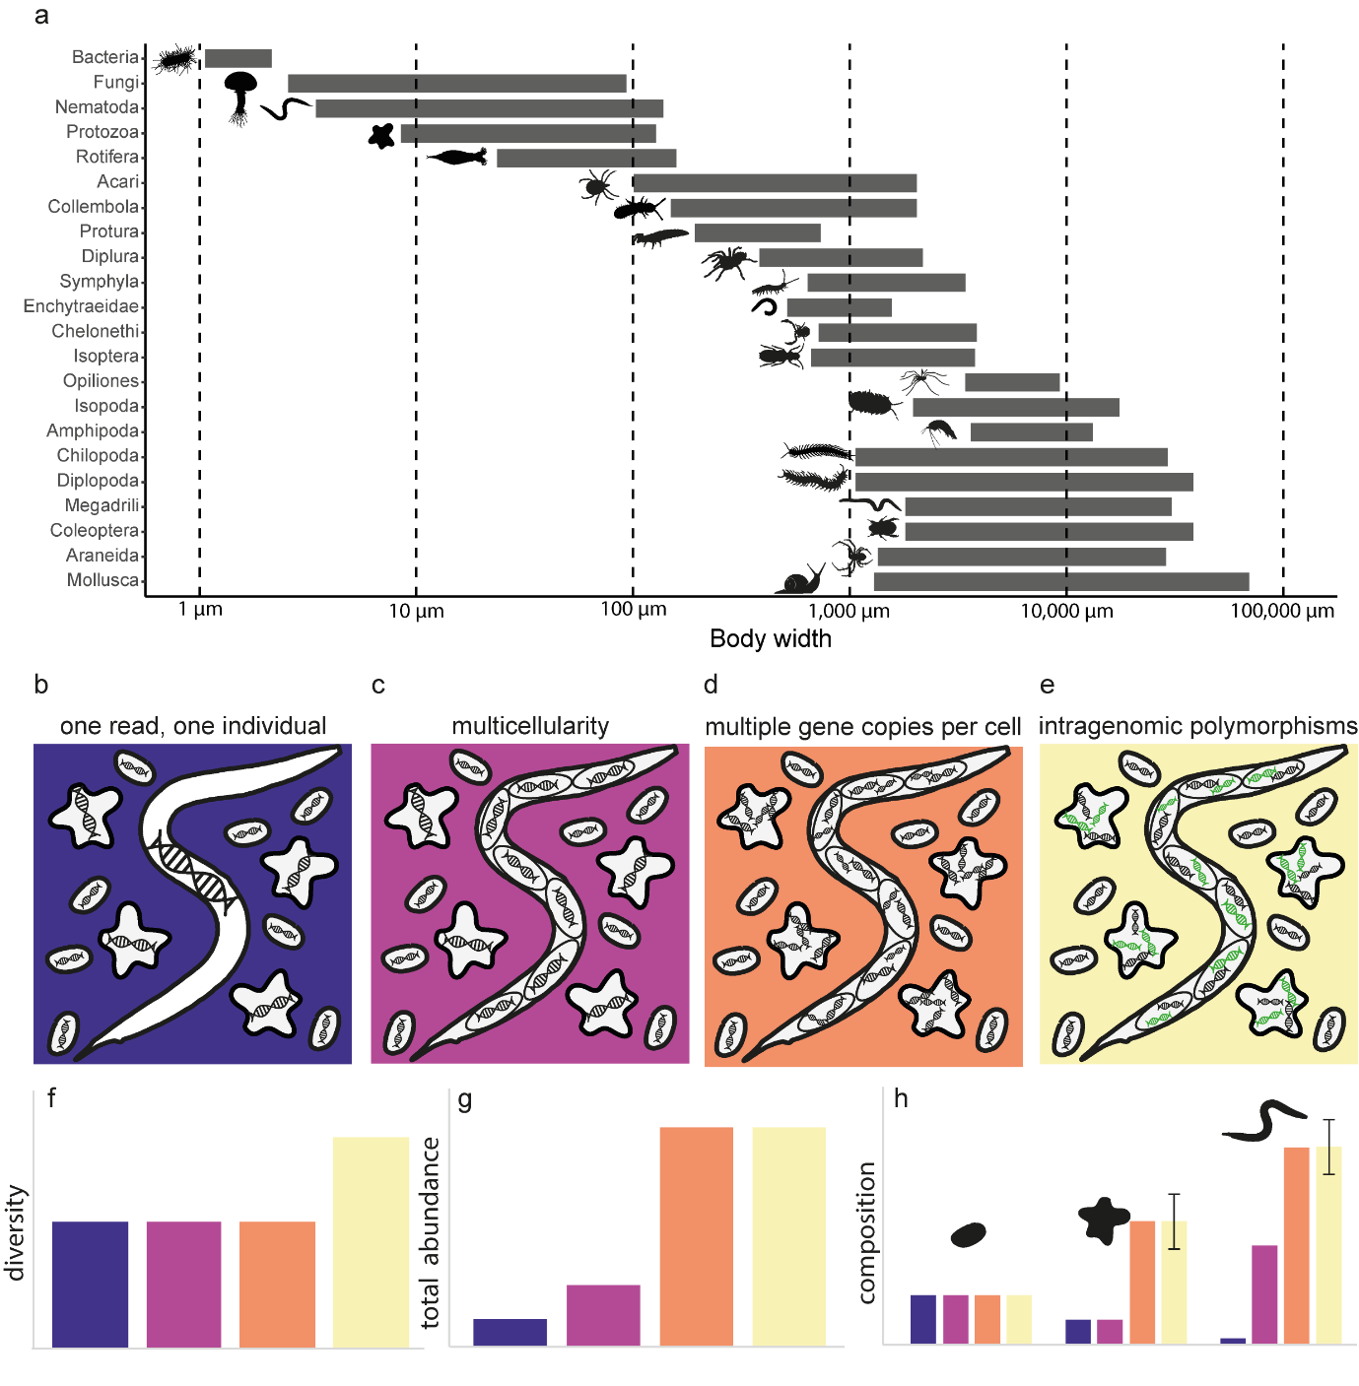
Figure 1. Issues arising from variation in morphology. (a) Soil biota comprise a broad range of sizes (adapted from [67]). (b) The ideal scenario for amplicon sequencing-based studies is that a sequenced read is equivalent to an organism, or proportional to its abundance. (c) The multicellularity of eukaryotes results in an overestimation of the abundance according to body size, while (d) the abundance of organisms with multiple copies of the marker gene per cell will also be overestimated. Finally, (e) organisms which contain multiple, different copies of the marker gene (intragenomic polymorphisms) may be estimated as several species. These biases affect estimates of (f) diversity, (g) the total abundance of organisms, and (h) estimates of the abundances of specific species. In the case of intragenomic polymorphisms, compositional data may be biased by the incorrect classification of different sequences from a single organism as multiple species, indicated by error bars.
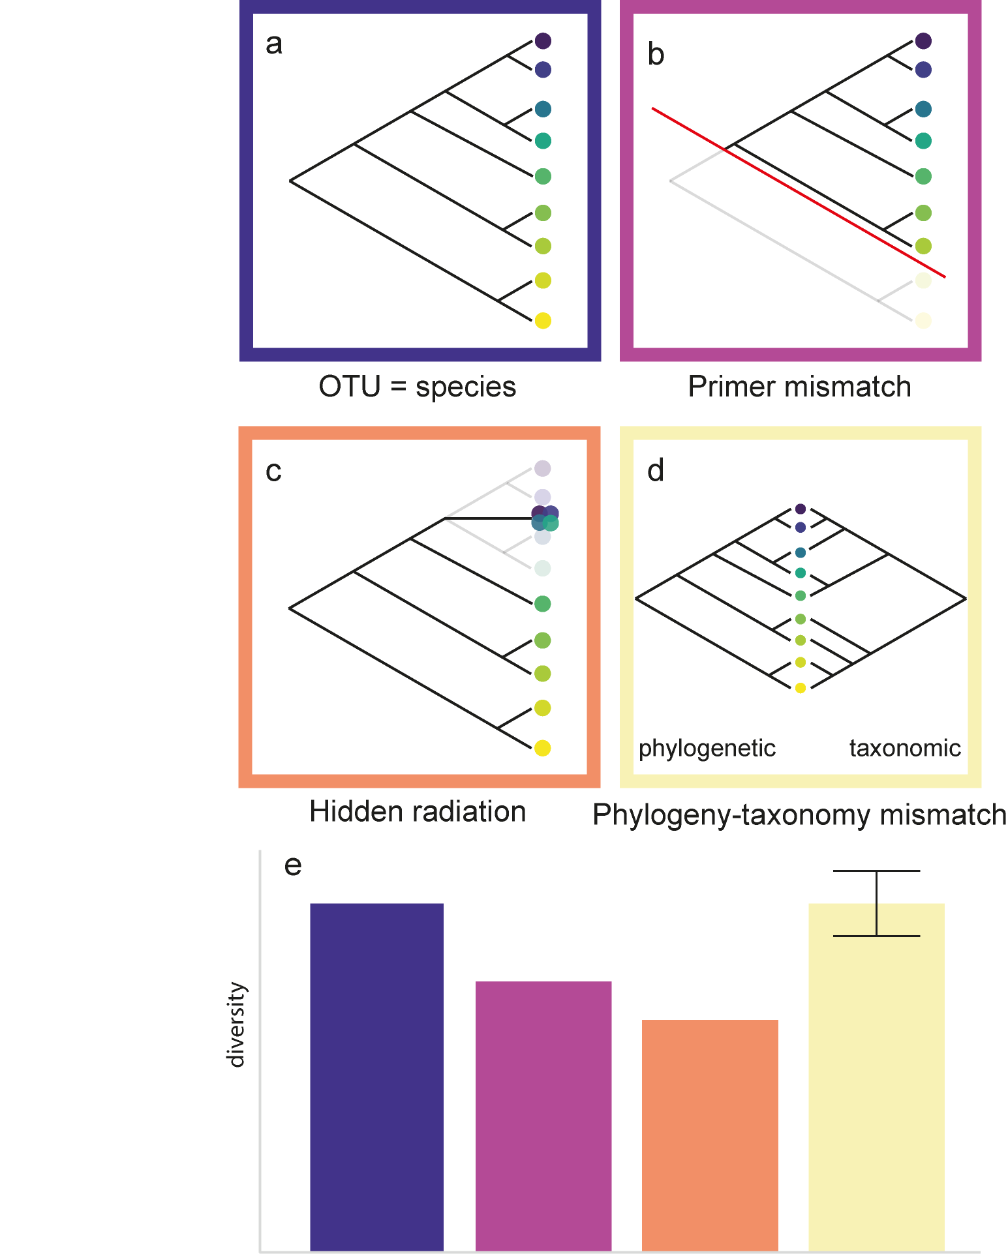
Figure 2. Issues arising from variations in phylogeny and taxonomy. (a) The ideal scenario for amplicon sequencing-based studies is that a taxonomic unit is equivalent to a species, and that all species are detected; however (b) primer mismatches result in the systematic exclusion of certain branches of the phylogenetic tree which are not captured by the selected primer set, resulting in the omission of present taxa. (c) Differing evolutionary rates among clades may result in the clustering of several species into one, and (d) the taxonomic classification of species may greatly differ from the sequence-based phylogeny. (e) all three phenomena may bias estimates of biodiversity, however the difference between taxonomic and sequence-based phylogenetic classifications may result in over- or underestimation of diversity, indicated by grey lines.
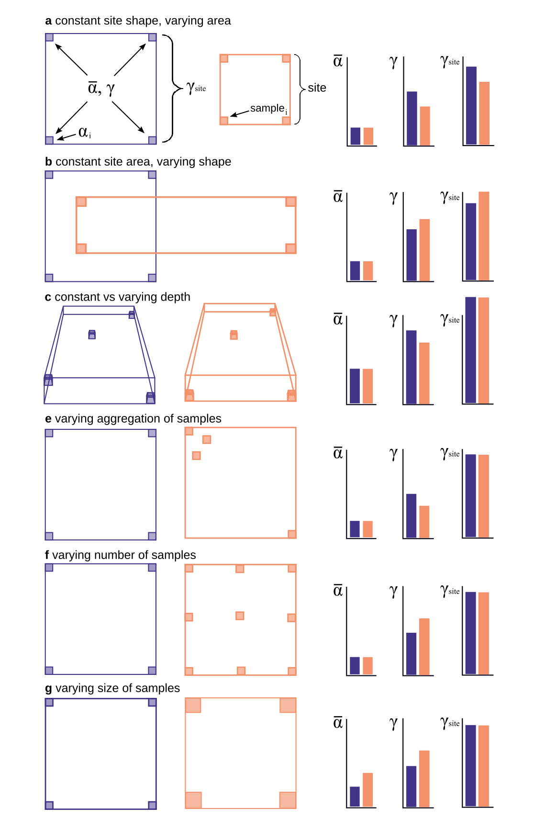
Figure 3. Spatial sampling issues that affect average species richness per sample ($\overline{α}$), total richness across all samples ($γ$), and total richness of an entire site, i.e. both within and outside of the samples ($γ_{site}$). All of the expected effects stem from two ubiquitous empirical patterns: the increase of number of taxa with increasing area or volume (taxa-area or taxa-volume relationship) and the Tobler’s law (a.k.a. distance decay of similarity) that states that closer locations are more similar in their taxonomic composition that distant ones
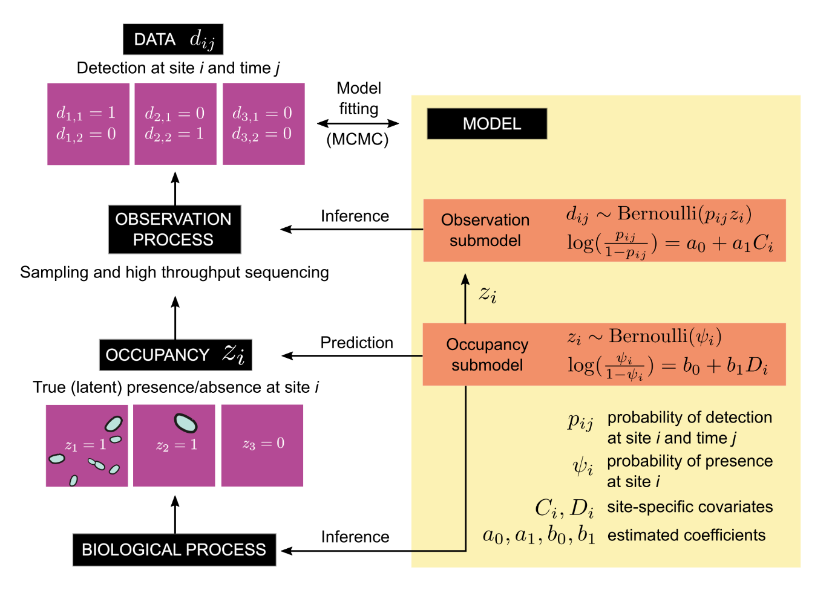Figure 4. Example of a simple occupancy model that accounts for imperfect detectability when estimating presence/absence of a single species at three sites (based on [68] and [60]). The model has two parts: (1) an occupancy sub-model, which is an ordinary logistic regression of presence/absence against a covariate, and (2) an observation submodel that estimates detectability of the species thanks to repeated sampling at each site. Both submodels are fitted at the same time, usually by Markov Chain Monte Carlo (MCMC) or maximum likelihood.

