Experimentally testing the response of feral cats and their prey to poison baiting

Tim S. Doherty¹, Michelle Hall^{2,3,4}, Ben Parkhurst², Vanessa Westcott²
¹ School of Life and Environmental Sciences, University of Sydney, Sydney, New South Wales, Australia. tim.doherty@sydney.edu.au
² Bush Heritage Australia, 1/395 Collins St, Melbourne, Victoria, Australia
³ School of Biological Sciences, The University of Western Australia, Perth, Western Australia, Australia
⁴ School of BioSciences, The University of Melbourne, Melbourne, Victoria, Australia

Abstract
Feral cats Felis catus have caused the decline and extinction of many species worldwide, particularly on islands and in Australia where native species are generally naïve to the threat of this introduced predator. Effectively reducing cat populations to protect wildlife is challenging because cats have a cryptic nature, high reproductive rate and strong reinvasion ability. We experimentally tested the response of feral cats and their native prey to an Eradicat® poison baiting program at a conservation reserve. Baits were distributed by hand along roads and tracks every 50 m (~10 baits km⁻²). We used camera traps to monitor the response of cats to baiting using a repeated before-after, control-impact design over six years. We also measured introduced rabbit Oryctolagus cuniculus activity using sand pads and small mammal and reptile captures using pitfall trapping. Dynamic occupancy modelling revealed only modest effects of baiting on cats in two out of six years, with occupancy in the baited area decreasing from 54% to 19% in 2014 (-35%) and 89% to 63% in 2017 (-26%). Baiting effectiveness was not related to antecedent rainfall or prey availability. Bait availability was reduced by non-target interference, with 73% of baits for which fate could be determined being removed by non-target species. We found no evidence for persistent changes in small mammal or reptile capture rates in the baited area relative to the unbaited area over the life of the project. We highlight key areas for future research that should benefit feral cat management not only in Australia, but also on the many islands worldwide where cats threaten native wildlife.

Keywords: cat baiting, dynamic occupancy model, impact evaluation, invasive predator, lethal control, pest control
Introduction
Invasive predators are a major driver of global biodiversity loss, having contributed to more than 50% of bird, mammal and reptile extinctions worldwide (Doherty et al. 2016). Their impacts have been greatest on islands, where prey species are typically naïve to the threat of introduced predators (Salo et al. 2007; Medina et al. 2011). Feral cats Felis catus are one of the most damaging species because humans have spread them across the world, they are highly adaptable to varying environmental conditions (Bengsen et al. 2016), and they prey on a range of birds, mammals, reptiles, amphibians and invertebrates (Bonnaud et al. 2011). We use the term ‘feral cats’ to refer to animals that live in the wild and have no direct dependence on humans. Reducing the impacts of cats on native wildlife is a key concern of conservation practitioners and scientists globally (Nogales et al. 2013; Shionosaki et al. 2015; Loss and Marra 2017; Doherty et al. 2017).

Management of feral cats has typically focussed on lethal control, including trapping, shooting, and poison baiting. Each of these methods rely on removing individual predators from a system to reduce or eliminate predation pressure on prey species. Cats have a high reproductive rate and ability to reinvade, so lethal control must be intensive and sustained in order to effectively reduce cat population densities (Leo et al. 2018; Lohr and Algar 2020). Demographic studies indicate that, on average, more than 57% of a cat population must be removed annually to reduce population densities (Hone et al. 2010). Achieving this in practice, though, has been challenging due to the cryptic nature of cats and their aversion to entering traps and consuming baits (Fisher et al. 2015). For instance, the huntability of cats (number of cats shot at as a percentage of those sighted) on Marion Island ranged from 25–44% over four years (Bloomer and Bester 1992). Low intensity trapping and removal of cats in Tasmania, Australia actually caused an increase in cat activity and relative abundance at removal sites, possibly due to immigration by neighbouring cats into vacated territories (Lazenby et al. 2014). On Rota Island, spotlight hunting of cats caused a modest knockdown within the first 18 months, but the population stabilised over the next 11 months (Leo et al. 2018).

In Australia, where cats have contributed to the extinction of more than 20 native mammal species and threaten many other birds, mammals and reptiles (Woinarski et al. 2015, 2019), there are two specially designed poison baits that can effectively reduce cat populations, dependent on environmental conditions. Eradicat® and Curiosity® are small sausage style baits comprised of kangaroo meat, chicken fat, and digest and flavour enhancers (Algar et al. 2007; Johnston et al. 2013, 2014; Lohr and Algar 2020). Eradicat® is registered for use in parts of Western Australia and contains 4.5 mg of 1080 poison (sodium fluoroacetate) injected into the bait (Algar et al. 2007). Curiosity® is designed for use in southern and eastern Australia and contains a hard capsule of para-aminopropiophenone (PAPP) poison (Johnston et al. 2013, 2014). Eradicat® is usually deployed aerially at a rate of 50 baits km⁻², which can reduce cat populations, although effectiveness varies between years (Algar et al. 2007, 2011, 2013; Richards and Algar 2010; Comer et al. 2018; Lohr and Algar 2020). The baits are also readily consumed by dingoes Canis dingo and introduced red foxes Vulpes vulpes and thus can also reduce their population densities (Richards and Algar 2010; Berry et al. 2014; Wysong et al. 2020b).

An alternative to aerial baiting is ground-based distribution of baits along tracks and roads, although this approach has received far less attention (but see Doherty and Algar 2015; Burrows et al. 2018; Lohr and Algar 2020). Because ground baiting relies on roads and tracks for bait distribution, effective baiting densities are reduced, which may limit effectiveness. Placing baits along tracks may increase encounter rates by animals that preferentially move along tracks (Wysong et al. 2020a; Geyle et al. 2020), but by the same token the baits will be biased away from animals that rarely use tracks. In this study, we experimentally tested the impacts of Eradicat® ground baiting on feral cat occupancy and activity over six years (2013–19, excluding 2015) at a conservation reserve in Western Australia. Results from the first two years of this project showed that baiting reduced cat activity in 2014, but not 2013 (Doherty and Algar 2015). We reanalyse that data here, along with the new data (2016–19), to address the following questions:
- Which species consume Eradicat® baits and how often?
- Does ground baiting with Eradicat® reduce cat occupancy and activity?
- Is baiting effectiveness related to rainfall or prey availability?
- Have capture rates of small mammals and reptiles in the baited area changed over time relative to the unbaited area?

Methods
Study site and design
This study was conducted at Charles Darwin Reserve, a property managed for conservation by Bush Heritage Australia (-29.65, 116.97; Fig. 1). The climate is semi-arid Mediterranean and mean annual rainfall is approximately 300 mm (Bureau of Meteorology 2020). Vegetation primarily consists of Acacia shrublands and Eucalyptus woodlands, with smaller areas of salt lakes, and granite outcrops and breakaways. Cats are common in the study area and dingoes
less so, whereas foxes are comparatively rare.
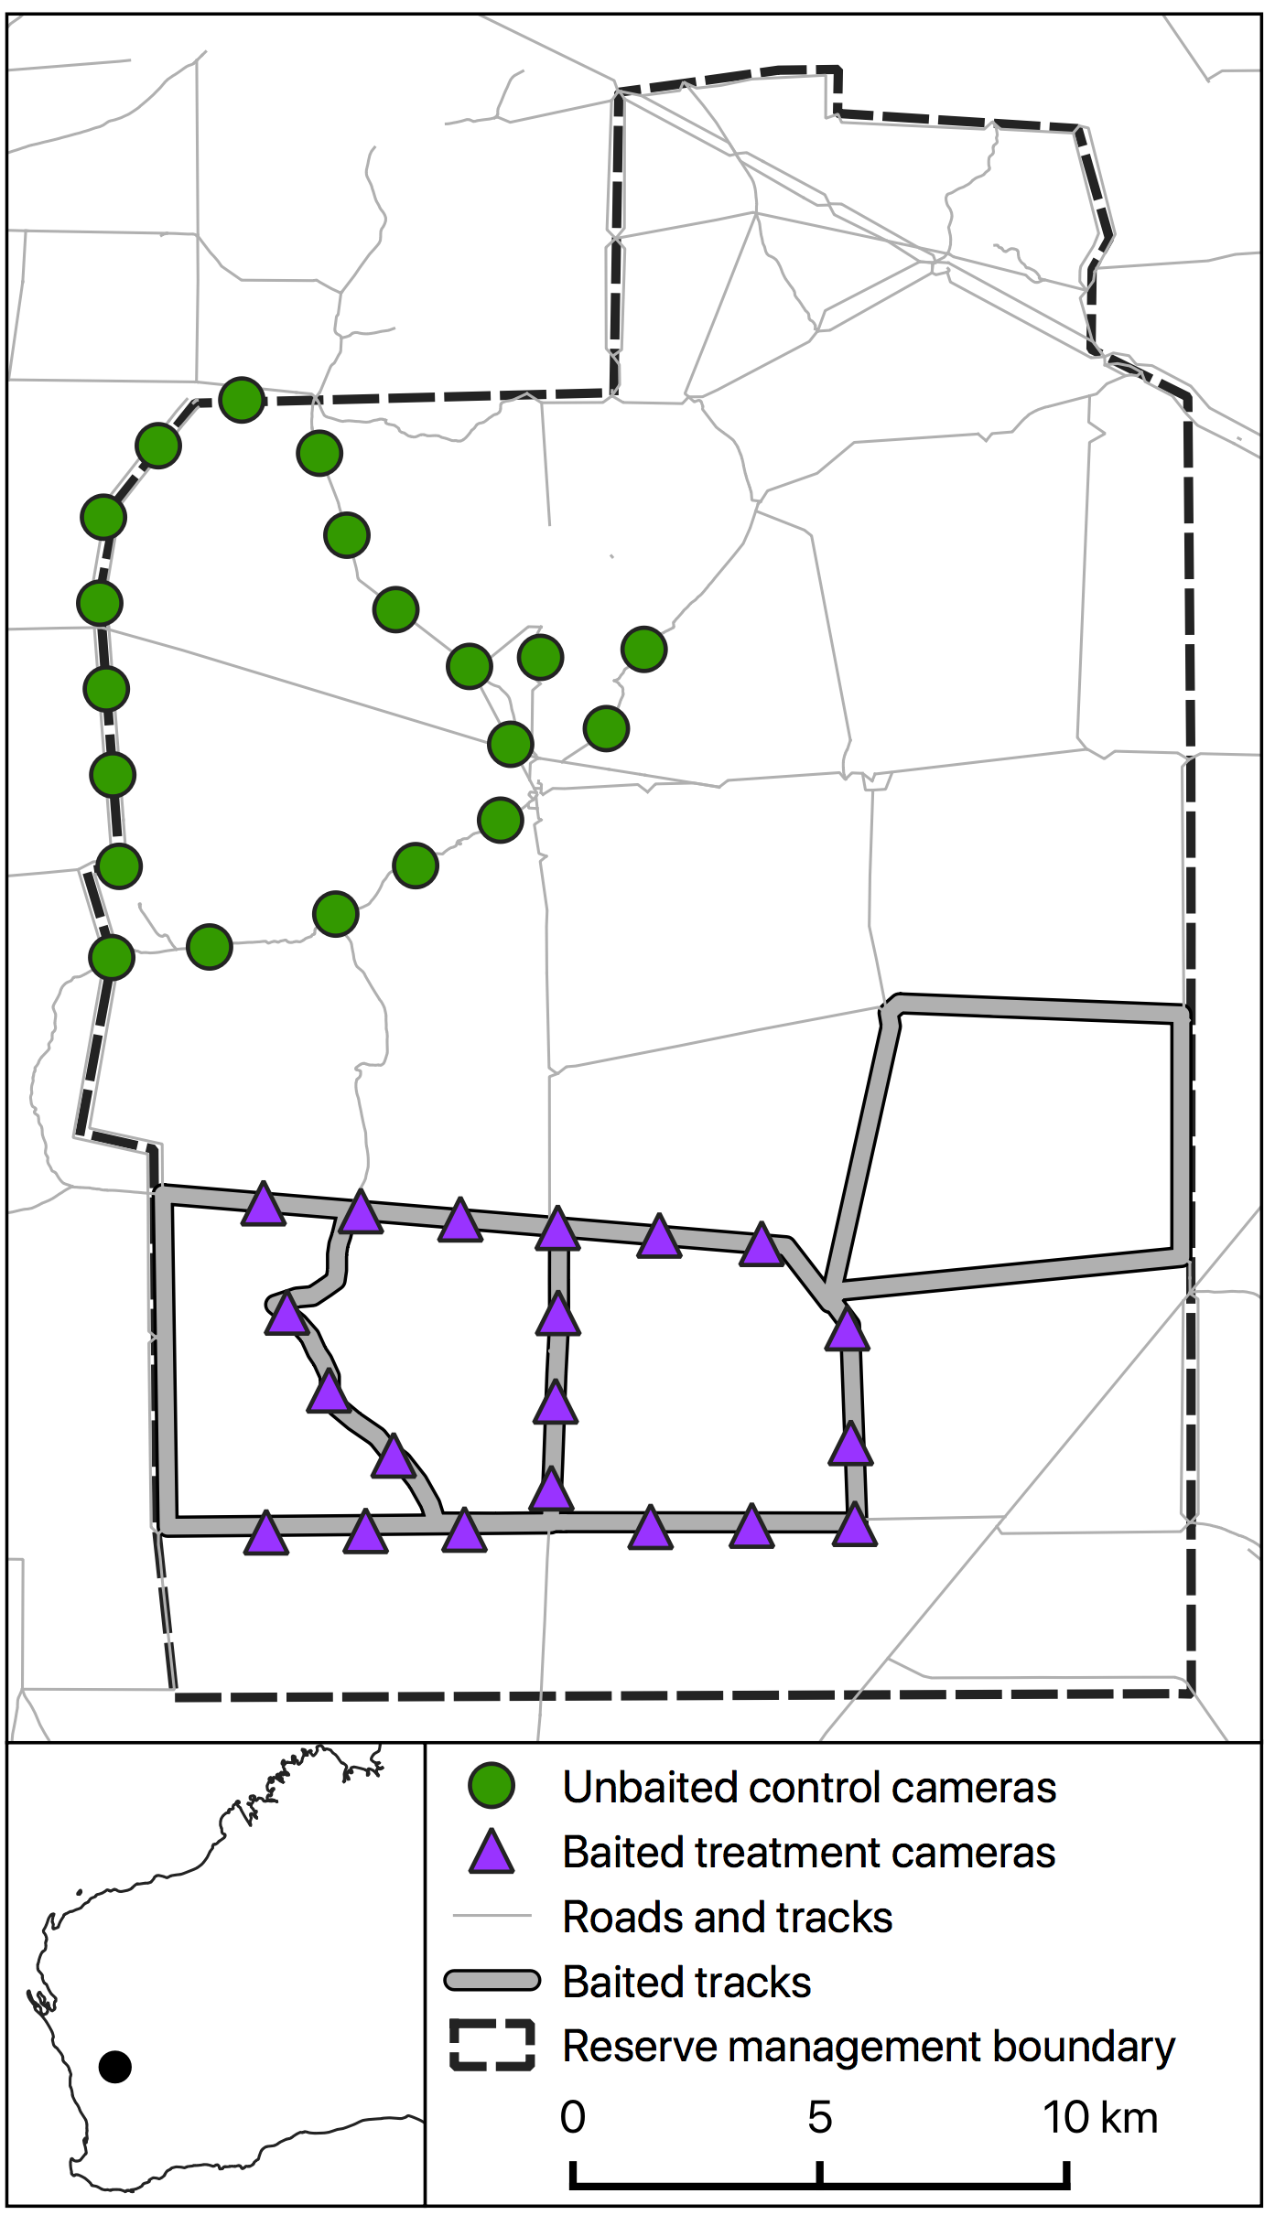
Figure 1. Map of the study site and camera trap locations, with the smaller map showing location within Western Australia.

The baited treatment area was located in the southern half of the reserve and the unbaited experimental control area was located in the northern half (Fig. 1). Toxic Eradicat® baits were distributed in the baited area once annually from 2013 to 2019. Baits were laid by hand along alternating sides of vehicle tracks at a rate of one bait every 50 m, with ~1,500 baits laid each year, resulting in a density of ~10 baits km⁻². Baiting was conducted once in each of September 2013, May 2014, June 2015, and May 2016–19. However, we do not present the 2015 data due to multiple issues with camera trap operation that year that compromised data collection.

Camera set-up and bait uptake trials
Cats were monitored before and after baiting each year using motion-sensing cameras. Twenty cameras each separated by ≥ 2 km were deployed in each of the baited and unbaited treatments. Most of the unbaited cameras (75%) were >9.5 km from the baited area, with the minimum distance being 5.5 km. We considered this distance large enough for the two treatments to be considered independent for cats, given that home range studies from similar Australian environments recorded mean home ranges of 2.48–22.1 km² (Jones and Coman 1982; Edwards et al. 2001; Molsher et al. 2005; Hilmer 2010; Bengsen et al. 2012), which corresponds to a home range diameter of 1.8–5.3 km (if assumed to be a circle). Although dingoes were recorded on our cameras, we do not present the data here because the treatments were too close together to be independent for dingoes, given their much larger home ranges (Harden 1985; Robley et al. 2010; Newsome et al. 2013; Allen et al. 2014). The proximity of the baited and unbaited areas meant that it was not possible to confidently distinguish treatment effects from seasonal changes for dingoes. We also experienced many issues related to poor model convergence and fit during preliminary analysis of the dingo data.

The cameras used in 2013–15 were a mixture of Moultrie i60 and Scoutguard 560PV units, whereas the cameras used in 2016–19 were Reconyx HC600 Hyperfire. Equal numbers of the two camera models were deployed in each treatment in 2013–15 and assignment to locations was randomised, in order to reduce any bias. Cameras were fixed to steel posts ~30 cm above the ground and next to vehicle tracks. Cameras in 2013–15 were programmed to take three photographs each time the sensor was triggered, with a minimum delay of one minute between triggers. Cameras in 2016–19 were set to take three photos per trigger with a 10-second rest period between trigger events. To measure bait uptake, each of the 20 cameras in the baited area had a bait placed in front of it during the baiting period in 2015–2019. Memory cards were collected from cameras after 1–3 weeks and photos were inspected to assess whether baits were taken, which species were responsible, and how long after placement removal took place.

Feral cat occupancy and activity
Each pre- and post-baiting monitoring session lasted for 4–6 weeks (Table S1), although some individual cameras stopped working prematurely due to battery failure or memory cards reaching capacity. Post-baiting monitoring began 1–4 weeks after baiting, except in 2016 when it began two months after baiting. In 2013–15, half of the cameras had a scent lure and the other half an audio lure, which were swapped between cameras halfway through each monitoring session. Scent lures were a fresh chicken wing encased in a PVC tube pegged to the ground, with a fresh chicken wing provided when lures were swapped. The audio lure was a small electronic device that emitted the sound of a bird tweeting (Lucky Duck, WI, USA). Only scent lures (chicken wings) were used at all cameras in 2016–19.

Photos were manually inspected, and the presence of animal species was recorded, along with the site number, date and time. We created dataframes relating to sampling effort and detection histories using the camtrapR package in R (Niedballa et al. 2016; R Core Team 2019). The sampling effort dataframes recorded when cameras stopped functioning prior to the end of survey periods. Two cameras were also stolen in 2013. Detection histories represented the presence or absence of a species at each camera during each successive three-day period throughout a survey. For instance, a 31-day survey would have 10 three-day sampling occasions, with the extra day excluded. We chose a three-day, rather than daily, sampling period in order to improve model convergence.

We used dynamic occupancy models in the unmarked package in R (Fiske and Chandler 2011) to assess changes in cat occupancy in response to baiting each year. Dynamic occupancy models use data from multiple primary periods (pre-baiting and post-baiting here) that are comprised of multiple secondary periods (three-day blocks in this case). This approach enables the estimation of detectability, initial site occupancy (first primary period), and colonisation and extinction probabilities, which represent changes in site occupancy between primary periods, i.e. from before to after baiting.

We employed a multi-step approach for analysis and analysed each year separately. First, we determined whether detection probabilities were influenced by vegetation composition at each site using model selection. We calculated the proportion of five vegetation types within a 500 m radius of each camera: young shrublands (<20 years since fire), old shrublands (≥20 years since fire), woodlands, salt lakes and granite outcrops. We excluded young shrublands from the modelling because it was negatively correlated with old shrublands (Pearson’s r = -0.58) and woodlands (-0.43). We fitted a global detection model containing main effects for each of the four vegetation variables, while holding occupancy, colonisation and extinction probabilities constant. For 2013 and 2014, we also included camera model (Moultrie or Scoutguard) as a potential predictor of detectability. We used the dredge function in the MuMIn package (Bartoń 2019) to fit all possible model combinations and ranked the models using Akaike’s Information Criterion corrected for small sample size (AICc). For the subsequent modelling of occupancy and extinction probabilities, we used the detection variables from the model with the highest weight, which in some cases was the null model (Table S2).

To determine whether baiting had an effect on cat occupancy, we fitted and ranked a series of models that included treatment (baited/unbaited) as a predictor of initial site occupancy, extinction probability, or both. These models also included the detection covariates as per Table S2. We compared these three models to a null model that only included the detection covariates (if applicable). Because the experiment used a before-after, control-impact (BACI) design, an effect of baiting would be supported if there was an effect of treatment on extinction probability. Specifically, we would expect extinction probability from pre- to post-baiting to be higher in the baited compared to unbaited area. We discuss the results from any models with a ΔAICc ≤ 2. We used parametric bootstrapping with 1,000 simulations to derive pre- and post-baiting occupancy estimates for each treatment, which we present as means with 95% confidence intervals.

We also used generalised linear mixed models with a Gaussian distribution to assess changes in cat activity in response to baiting. The activity index was calculated by dividing the number of independent detections of cats on each camera by the number of nights the camera was active and multiplying this by 100 (i.e. number of detections per 100 trap-nights). Independent detections were photographs on the same camera that were at least 60 minutes apart. The models included fixed effects of Time (pre-/post-baiting), Treatment (baited/unbaited), and Time×Treatment. A significant interaction would support an impact of baiting on cat activity. Models also included a random effect of Site to account for repeat sampling. We fitted a separate model for each year and present parameter estimates and 95% confidence intervals.

To provide further context to the occupancy and activity results, we also present plots of naïve occupancy, which represents the proportion of sites within each treatment where each species was detected, disregarding varying sampling effort. This simpler metric and the activity index are more accessible to practitioners, but the different metrics are rarely compared. We therefore we used Pearson’s correlation tests to determine how closely naïve occupancy, modelled occupancy (from the top model each year) and mean activity index are related to one another. Values were compared for each treatment pre- and post-baiting each year.

Drivers and outcomes of baiting effectiveness
We used data on rainfall, small mammal capture rates, and introduced rabbit Oryctolagus cuniculus activity to assess if baiting effectiveness is related to the availability of potential prey. We calculated total rainfall for the six months (‘Rain_6m’) and 12 months (‘Rain_12m’) prior to each baiting event using data from a rain gauge at the reserve. We used pitfall trapping data to estimate capture rates of small mammals (‘Mammal_CR’, number of individuals captured per trap-night) in the spring (September–November) prior to each baiting event (n = 8–16 sites). We used sand pad monitoring data to calculate an index of rabbit activity for both the spring (‘Rab_spr’) and winter (‘Rab_win’) prior to each baiting event (i.e. in the previous year). The index was calculated as the proportion of days rabbits were detected on each sand pad (n = 69), averaged across all sand pads for each season. Sand pad data were not available for winter 2013 and spring 2012 and 2013. Following previous work (Christensen et al. 2013), we also calculated a ratio of prey availability to predator activity (‘PP_ratio’) by dividing Mammal_CR by mean pre-baiting cat activity across all cameras for each year. Pitfall trapping and sand pad monitoring sites were spread across baited and unbaited areas (Fig. S1), although we pooled all data for analysis to assess broadscale inter-annual variation in prey availability, and because there were few differences between treatments across years (see Results). Full details of the field sampling are provided in the Supplementary Materials.

To create a measure of baiting effectiveness for each year, we subtracted the mean difference in activity or occupancy between baited and unbaited sites pre-baiting, from the mean difference after baiting, i.e. $\left({After}_{Unbaited}−{After}_{Baited}\right)−\left({Before}_{Unbaited}−{Before}_{Baited}\right)$ (Christie et al. 2019). For the occupancy metric, we used the estimates from the top ranked model for each year. Using this approach, values of 0 indicate that the difference between treatments is equal for before and after baiting. Positive values indicate a greater difference in favour of unbaited sites, i.e. occupancy decreased more in baited than unbaited sites and/or unbaited sites increased more than baited sites. Negative values indicate a greater difference in favour of baited sites, i.e. occupancy in unbaited sites decreased more than in baited sites and/or baited sites increased more than unbaited sites. As such, more positive values are indicative of a greater impact of baiting.

To test the relationship between baiting effectiveness and environmental variables, we fitted general linear models with either the occupancy or activity baiting effectiveness metric as the response variable and either Rain_6m, Rain_12m, Mammal_CR, PP_ratio, Rab_spr, or Rab_win as the predictor variable. We included only one predictor variable per model due to the small sample size (n = 4–6 years). We present model parameter estimates, 95% confidence intervals and plots of the data.

We also used generalised linear mixed models assuming a Gaussian distribution to assess if capture rates of small mammals and reptiles have changed over time in baited and unbaited areas. Data were derived from the pitfall trapping as described above and in the Supplementary Materials. The response variable was small mammal or reptile capture rate for each spring 2012–2018 (excluding 2014, when sampling was not undertaken). 2012 represents a baseline from before baiting began. We included fixed effects of Year, Treatment, and Year×Treatment, and a random effect of Site to account for repeat sampling.

Results
Bait uptake
Of the 100 baits laid in front of cameras in 2015–19, 30 could not be seen on camera due to poor placement or camera malfunction, and a further 29 baits disappeared without the event being recorded on camera. Of the remaining 41 baits, we recorded an animal interaction for 34 baits. Records of cats included one bait consumed nine hours after being laid, another bait inspected but not removed 7 days after being laid, and another bait that a cat walked past without seeming to inspect it. Twenty baits were either eaten or taken away by emus Dromaius novaehollandiae (49% of visible baits), seven by ravens Corvus coronoides (17%), and one each by a fox, hopping mouse Notomys mitchellii, and grey currawong Strepera versicolor. Emus removed baits within 0–9 days of baits being laid (mean = 4.1). In one case, the bait was removed five hours after being laid. Ravens removed baits within 1–22 days (mean = 6.4) and the fox, hopping mouse and currawong removed baits 3 days, 2 days and 5 minutes after being laid, respectively. Twenty-six minutes after the fox consumed a bait, a fox also inspected but did not remove a bait at a neighbouring camera. One dingo was also recorded walking past a bait without seeming to inspect it. Ten baits remained in place at the end of the trial period.

Occupancy and activity
Over the six-year study, feral cats were detected at 18–37 of the 40 camera locations each year (mean = 72%), dingoes at 7–36 (56%), and foxes at 0–12 (7%). There was uncertainty in the impacts of baiting on cat occupancy in most years, with multiple models having ΔAICc values ≤ 2 (Table S4, Fig. S2). There was only one year with a clear impact of baiting on cat occupancy: in 2017 occupancy decreased in the baited area post-baiting (from 0.89 to 0.63 in the top model), whereas it increased slightly in the unbaited area (0.89 to 1.00; Fig. 2). The changes in activity and naïve occupancy also support an impact of baiting in 2017, including a significant Time×Treatment interaction in the mixed model (Fig. 2 & S3, Table S5).

The best supported occupancy models for 2014 and 2019 also indicated greater declines in occupancy in the baited compared to unbaited area (Fig. 2), although the null models were also well supported (Table S4, Fig. S2). Changes in naïve occupancy and the activity index support an impact of baiting in 2014, but not 2019 (Fig. 2 & S3). The Time×Treatment interaction for activity in 2014 had confidence intervals slightly overlapping zero (-0.48–5.56; Table S5). Estimated occupancy from the top model for 2014 was 0.54 in both treatments pre-baiting and 0.48 in the unbaited area and 0.19 in the baited area post-baiting (Fig. 2). The activity confidence intervals for Time×Treatment in 2013 and 2018 also only slightly overlapped zero (Table S5), but when considered together with the occupancy data, there is little support for an impact of baiting.
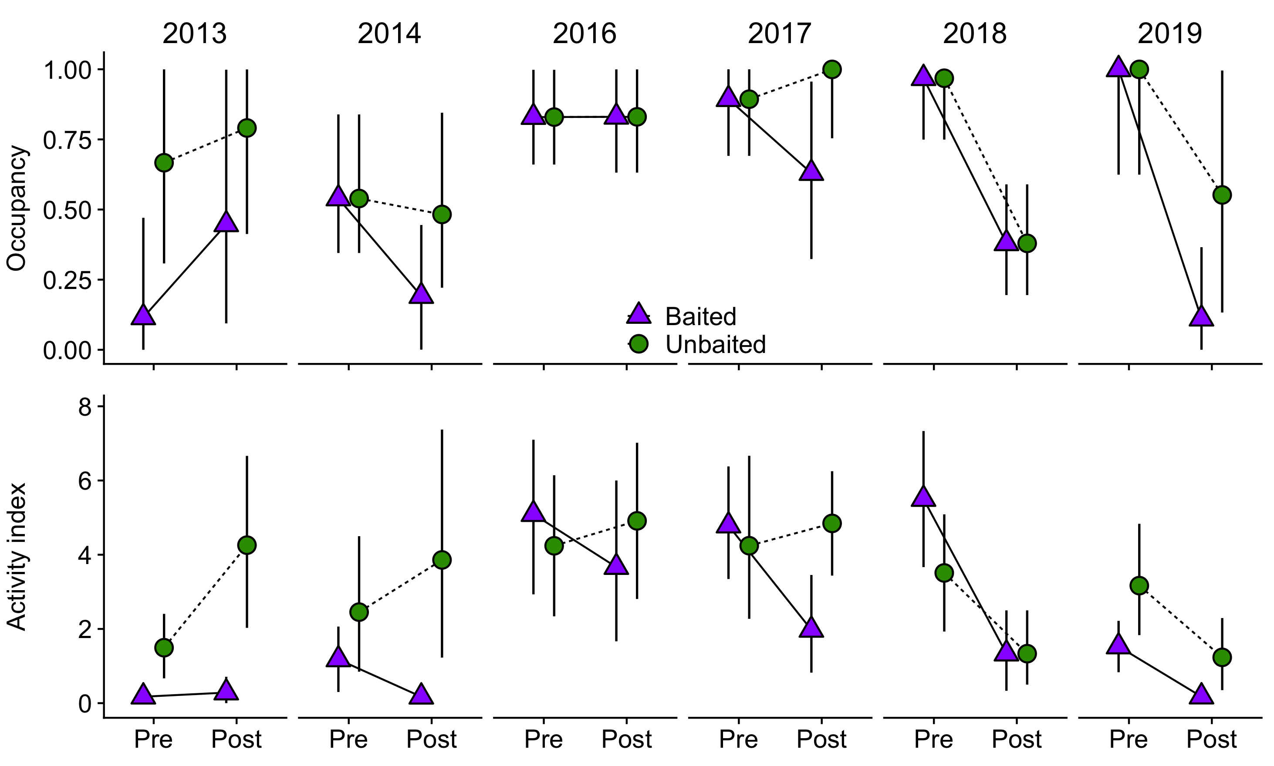

Figure 2. Feral cat occupancy (top row) and activity (bottom row) for the baited and unbaited areas each year. Symbols represent means and error bars represent 95% confidence intervals. The dotted boxes around 2014 and 2017 represent years where the data support an impact of baiting.

Modelled occupancy and the activity index were strongly correlated with each other (r = 0.78, t(22) = 5.85, P < 0.001) and both were very strongly correlated with naïve occupancy (modelled occupancy: r = 0.91, t(22) = 10.17, P < 0.001; activity index: r = 0.94, t(22) = 12.42, P < 0.001; Fig. 3).
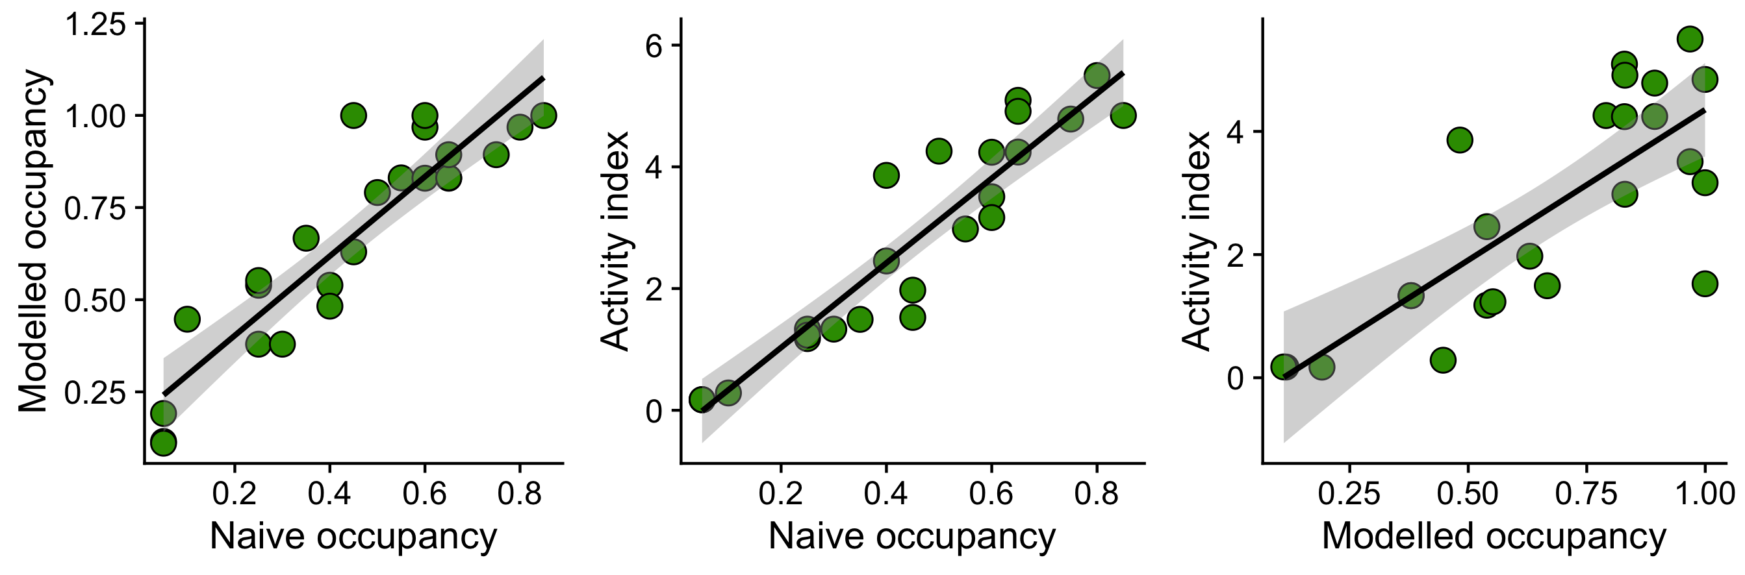
Figure 3. Relationships between modelled occupancy, the activity index and naïve occupancy, with each point representing pre- or post-baiting for either the baited or unbaited area in each year. Solid lines are the mean relationships and grey bands are the 95% confidence intervals.

Drivers and outcomes of baiting effectiveness
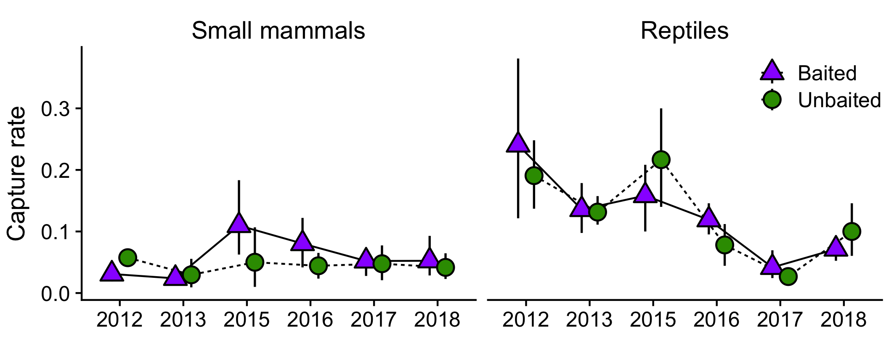
Pre-baiting occupancy, activity and naïve occupancy were similar between baited and unbaited treatments each year from 2014 to 2019 (Fig. 2 & S3), indicating that there was no cumulative effect of baiting on cat activity or occupancy over time. There was no relationship between baiting effectiveness (based on changes in cat activity/occupancy) and rainfall, small mammal capture rate, rabbit activity, or the predator-prey ration index (Table S6, Fig. S4). Small mammal capture rates were similar between treatments every year, except in 2015 and 2016 when average capture rates were 2.1- and 1.8-fold higher, respectively, at baited compared to unbaited sites (Fig. 4, Table S7). Mean capture rates of reptiles did not vary between treatments, but overall capture rates in 2013 and 2016–2018 were lower than the baseline year of 2012 (Fig. 4, Table S7).
Figure 4. Capture rates (number of individuals captured per trap per night) of small mammals and reptiles at baited and unbaited pitfall trapping sites. Symbols represent treatment means and vertical lines are 95% confidence intervals.

Discussion
We experimentally tested the impact of poison baiting on feral cats and their native prey at a conservation reserve over six years. Ground baiting using Eradicat® was mostly ineffective at reducing cat occupancy, with there being only weak treatment effects in two out of the six years tested (absolute decreases in occupancy of 35% and 26%). There are a number of factors that could have limited the efficacy of the baiting program, including baiting density, prey availability and non-target uptake of baits.

The baiting density achieved in this project was ~10 baits km⁻², which is much lower than the rate of 50 baits km⁻² used in aerial operations. The lower baiting density may be insufficient for the majority of cats to detect baits or to encounter a bait when they are likely to eat it. At Matuwa in central Western Australia, ground baiting at ~2.8 baits km⁻² was less effective than aerial baiting at 50 baits km⁻² (Lohr and Algar 2020). In the Gibson Desert, Burrows et al. (2003) found that a fresh meat bait designed for cats reduced activity by 75% and 100% at densities of 10 and 22 baits km⁻², respectively, during low rainfall periods, whereas baiting at 11 baits km⁻² during a high rainfall period reduced activity by 25%. Moseby & Hill (2011) tested aerial Eradicat® baiting at densities of 10 and 25 baits km⁻² and found that cat activity declined in response to baiting in just one of seven trials. When taken together, these studies suggest that a baiting density of 10 baits km⁻² is not in itself insufficient, but may be when combined with other factors, as discussed below.

The effective baiting density was likely reduced by non-target consumption of baits. Our uptake trials in 2013–14 (reported in Doherty and Algar 2015) showed that corvids Corvus spp. removed the most baits (12 of 30), followed by cats (6) and varanids Varanus spp. (2). In 2015–19, 73% of the baits where fate could be determined were removed by non-target species, primarily emus, which removed 49% of visible baits. We only recorded one bait being removed by a cat. Fate could not be determined for a large number of baits, but if we assume that none of those baits were taken by non-targets (which is unlikely), then a minimum of 30% of baits were removed by non-target species. Of the baits removed by non-targets, 47% were removed within three days of being laid and 90% within seven days. This means that the window of bait availability to cats is very narrow and when combined with the already low propensity of cats to consume baits, the chances of bait uptake are very low.

Many other studies have also recorded high non-target uptake of cat baits, including 22% of baits at Peron Peninsula (Algar et al. 2007), 14–57% at Arid Recovery (Moseby et al. 2011), 71% at Kangaroo Island (Hohnen et al. 2020), and 97% at Dryandra and Tutanning (Friend et al. 2020). Only one of those studies recorded emus removing baits (Algar et al. 2007), although it is not clear what proportion of baits were interfered with. Emus commonly travel long distances along tracks at our study site and elsewhere (TSD, personal observation), which would provide them with ample opportunity to encounter baits, which were placed at 50-m intervals. However, it is also worth noting that baits for the uptake trials were placed in the open to facilitate camera monitoring, which may have increased their detection and hence removal by non-targets species. Moseby et al. (2011) found that bait removal by corvids was higher for baits in the open compared to those under bushes. In practice, most of the 1,500 baits deployed each year were placed underneath or close to shrubs, thus actual rates of non-target removal may have been lower. We recommend that future work quantify rates of non-target bait removal for baits that are placed both in the open and under shrubs, both on and off tracks.

Prey availability is one of the strongest determinants of the efficacy of cat baiting programs, which itself is primarily driven by rainfall in arid and semi-arid Australia (Letnic and Dickman 2010). Using data from three sites in Western Australia, Christensen et al. (2013) showed that the efficacy of aerial cat baiting was predicted by a predator-prey ratio index. Reductions in cat activity were greatest when the amount of prey available per cat was lowest (as inferred from indices; Christensen et al. 2013). Short et al. (1997) also found that bait uptake by cats was inversely related to rabbit density. In contrast, we found no relationship between baiting effectiveness and a similar predator-prey index, nor with measures of rainfall, rabbit activity, or small mammal capture rate. However, this does not mean that prey availability is not important in our study area. It may just be that small sample sizes and low bait availability (and hence effectiveness) inhibited the detection of any trends. A larger sample size covering a greater range of baiting effectiveness would provide more detailed insights.

A strength of this study was the inclusion of an unbaited reference area for comparison, allowing treatment effects to be separated from seasonal effects that could otherwise bias conclusions. For instance, if we did not survey an unbaited control area, we could have concluded that baiting was effective in 2018 and 2019, even though decreases in activity and occupancy were similar between baited and unbaited areas. We recommend that future work, where feasible, include an unbaited reference area to maximise inferential strength (Christie et al. 2019). This is especially important where control programs are still being developed, or widespread and consistent effectiveness has not yet been demonstrated. However, where inclusion of an unbaited reference area is not feasible, GPS/VHF tracking of target animals to record survival post-baiting can provide complementary information about baiting efficacy. Further, our comparison of three different metrics of cat activity/occurrence showed that occupancy values derived from dynamic occupancy models were strongly correlated with the naïve occupancy and the activity index. This suggests that naïve occupancy and the activity index—which are generally more accessible than dynamic occupancy modelling to practitioners—can provide valuable information about changes in predator occurrence over time and in response to management actions. We recommend these relationships be explored further using both real and simulated data to understand how the metrics behave across a broader parameter space than that represented by our data.

Controlling predators is only a means to an end and the ultimate aim of any invasive predator control program should be to produce positive outcomes for the target asset, such as increased species richness, abundance, or threatened species survival. Small mammals and reptiles, along with rabbits, are the major components of cat diets in our study area (Doherty 2015). We found no consistent differences in capture rates of small mammals and reptiles between baited and unbaited areas over the life of this project. Small mammal captures were higher in baited compared to unbaited areas in 2015 and 2016, but since we were unable to measure the impact of baiting on cats in 2015, it is difficult to contextualise these results. However, the overall lack of differences is not surprising given that there were only modest effects of baiting on cats in two out of six years (2014 and 2017). For cat control to benefit prey populations, reductions in cat populations must be intense and sustained, although there is little precise information about the minimum level of suppression required (Norbury et al. 2015). The clearest examples are where cats (and foxes) have been eradicated from islands and fenced exclosures, resulting in dramatic improvements in the survival of reintroduced mammals (Legge et al. 2018) and increases in the abundance and richness of resident fauna (Moseby et al. 2009; Roshier et al. 2020). Although there are many studies demonstrating reductions in cat activity or density in response to baiting, there is very little evidence available regarding the outcomes for prey populations (but see Stewart et al. 2019; Comer et al. 2020). We recommend that control programs for cats and other pest species more generally, incorporate clear objectives and monitoring programs for the species they are trying to protect (see also Reddiex and Forsyth 2006). Such monitoring can enable assessment of return-on-investment and adaptive management to refine interventions over time, including detecting and addressing unexpected negative consequences (Ruscoe et al. 2011; Walsh et al. 2012).

Feral cat management is challenging, and the effectiveness of different approaches varies between locations and years. Further work is clearly needed to improve the effectiveness of ground baiting of feral cats. Key areas for future research are investigation of methods to reduce non-target removal of baits; investigation of methods that improve bait detection and consumption by cats; and assessment of different baiting densities and frequencies. Furthermore, since effective baiting may selectively target only a subset of the population (e.g. poor hunters or bait naïve cats; Lohr and Algar 2020), complementing baiting with other control methods such as trapping and shooting may be important to maximise the impacts of control efforts and to reduce the risk of selecting for bait resistance (Allsop et al. 2017; Lohr and Algar 2020). In addition, research on the effects of managing the environment by either reducing the resources supporting cat populations (e.g. rabbit populations; McGregor et al. 2020), or managing fire and grazing to conserve habitat structure that provides refuges for native species (Leahy et al. 2016; Legge et al. 2019), could help identify the most effective approaches for feral cat management. Such work would benefit feral cat management not only in Australia, but also on the many islands worldwide where cats threaten native wildlife.

Acknowledgements
We acknowledge the Badimia People as the Traditional Owners of the land on which this research was conducted. Financial support for this project was provided by Earthwatch Institute Australia, Bush Heritage Australia and Edith Cowan University. We thank Luke Bayley and Will Hansen for conducting the baiting, Nic Dunlop and the Conservation Council of Western Australia for providing the rainfall data, Brian Crute for conducting the sand pad monitoring, Dave Algar, Matt Appleby, Rob Davis and Jim Radford for advice on initial study design, and the many volunteers who assisted with fieldwork. TSD was supported by Edith Cowan University, Deakin University and the Australian Research Council (DE200100157) over the life of the project. Data collection in 2013–14 was approved by the Edith Cowan University Animal Ethics Committee (8501), and in 2015–19 by the Department of Parks and Wildlife (08-000407-1).

Authors’ contributions
TSD conceived and designed the research; all authors collected the data; TSD analysed the data and wrote the manuscript, with input from all co-authors.

Data availability
Data and code are available at FigShare https://doi.org/10.6084/m9.figshare.13240637.v1

References
Algar D, Angus GJ, Williams MR, Mellican AE (2007) Influence of bait type, weather and prey abundance on bait uptake by feral cats (Felis catus) on Peron Peninsula, Western Australia. Conserv Sci West Aust 6:109–149
Algar D, Hamilton N, Onus M, et al (2011) Field trial to compare baiting efficacy of Eradicat® and Curiosity® baits. Department of Environment and Conservation, Woodvale
Algar D, Onus M, Hamilton N (2013) Feral cat control as part of Rangelands Restoration at Lorna Glen (Matuwa), Western Australia: the first seven years. Conserv Sci West Aust 8:367–381
Allen BL, Engeman RM, Leung LKP (2014) The short-term effects of a routine poisoning campaign on the movements and detectability of a social top-predator. Environ Sci Pollut Res 21:2178–2190. https://doi.org/10.1007/s11356-013-2118-7
Allsop SE, Dundas SJ, Adams PJ, et al (2017) Reduced efficacy of baiting programs for invasive species: Some mechanisms and management implications. Pacific Conserv Biol 23:240–257. https://doi.org/10.1071/PC17006
Bartoń K (2019) MuMIn: Multi-Model Inference. R package version 1.43.15. https://CRAN.R-project.org/package=MuMIn
Bengsen AJ, Algar D, Ballard G, et al (2016) Feral cat home-range size varies predictably with landscape productivity and population density. J Zool 298:112–120. https://doi.org/10.1111/jzo.12290
Bengsen AJ, Butler JA, Masters P (2012) Applying home-range and landscape-use data to design effective feral-cat control programs. Wildl Res 39:258–265. https://doi.org/10.1071/WR11097
Berry O, Tatler J, Hamilton N, et al (2014) Slow recruitment in a red-fox population following poison baiting: a non-invasive mark–recapture analysis. Wildl Res 40:615–623. https://doi.org/10.1071/WR13073
Bloomer JP, Bester MN (1992) Control of feral cats on sub-Antarctic Marion Island, Indian Ocean. Biol Conserv 60:211–219. https://doi.org/10.1016/0006-3207(92)91253-O
Bonnaud E, Medina FM, Vidal E, et al (2011) The diet of feral cats on islands: a review and a call for more studies. Biol Invasions 13:581–603. https://doi.org/10.1007/s10530-010-9851-3
Bureau of Meteorology (2020) Climate data online. Australian Government Bureau of Meteorology. http://www.bom.gov.au/climate/data/
Burrows N, Liddelow G, Thoomes E, Ambrose D (2018) Aerial and ground baiting, Matuwa 2018. Department of Biodiversity, Conservation and Attractions, Woodvale
Burrows ND, Algar D, Robinson AD, et al (2003) Controlling introduced predators in the Gibson Desert of Western Australia. J Arid Environ 55:691–713. https://doi.org/10.1016/S0140-1963(02)00317-8
Christensen PES, Ward BG, Sims C (2013) Predicting bait uptake by feral cats, Felis catus, in semi‐arid environments. Ecol Manag Restor 14:47–53. https://doi.org/10.1111/emr.12025
Christie AP, Amano T, Martin PA, et al (2019) Simple study designs in ecology produce inaccurate estimates of biodiversity responses. J Appl Ecol 56:2742–2754. https://doi.org/10.1111/1365-2664.13499
Comer S, Clausen L, Cowen S, et al (2020) Integrating feral cat (Felis catus) control into landscape-scale introduced predator management to improve conservation prospects for threatened fauna: a case study from the south coast of Western Australia. Wildl Res 47:762–778. https://doi.org/10.1071/WR19217
Comer S, Speldewinde P, Tiller C, et al (2018) Evaluating the efficacy of a landscape scale feral cat control program using camera traps and occupancy models. Sci Rep 8:5335. https://doi.org/10.1038/s41598-018-23495-z
Doherty TS (2015) Dietary overlap between sympatric dingoes and feral cats at a semiarid rangeland site in Western Australia. Aust Mammal 37:219–224. https://doi.org/10.1071/AM14038
Doherty TS, Algar D (2015) Response of feral cats to a track-based baiting programme using Eradicat baits. Ecol Manag Restor 16:124–130. https://doi.org/10.1111/emr.12158
Doherty TS, Dickman CR, Johnson CN, et al (2017) Impacts and management of feral cats Felis catus in Australia. Mamm Rev 47:83–97. https://doi.org/10.1111/mam.12080
Doherty TS, Glen AS, Nimmo DG, et al (2016) Invasive predators and global biodiversity loss. Proc Natl Acad Sci 113:11261–11265. https://doi.org/10.1073/pnas.1602480113
Edwards GP, De Preu N, Shakeshaft BJ, et al (2001) Home range and movements of male feral cats (Felis catus) in a semiarid woodland environment in central Australia. Austral Ecol 26:93–101
Fisher P, Algar D, Murphy E, et al (2015) How does cat behaviour influence the development and implementation of monitoring techniques and lethal control methods for feral cats? Appl Anim Behav Sci 173:88–96. https://doi.org/10.1016/j.applanim.2014.09.010
Fiske I, Chandler R (2011) unmarked: An RPackage for Fitting Hierarchical Models of Wildlife Occurrence and Abundance. J Stat Softw 43:1–23. https://doi.org/10.18637/jss.v043.i10
Friend JA, Hill R, Macmahon B, et al (2020) Are red-tailed phascogales (Phascogale calura) at risk from Eradicat® cat baits? Wildl Res 47:747–761. https://doi.org/10.1071/WR19087
Geyle HM, Stevens M, Duffy R, et al (2020) Evaluation of camera placement for detection of free‐ranging carnivores; implications for assessing population changes. Ecol Solut Evid 1:e12018. https://doi.org/10.1002/2688-8319.12018
Harden RH (1985) The ecology of the dingo in north-eastern New South Wales I. Movements and home range. Wildl Res 12:25–37. https://doi.org/10.1071/wr9850025
Hilmer S (2010) Ecophysiology of feral cats (Felis catus) in Australia. PhD thesis, Goethe University, Frankfurt
Hohnen R, Murphy BP, Legge SM, et al (2020) Uptake of ‘Eradicat’ feral cat baits by non-target species on Kangaroo Island. Wildl Res 47:547–556. https://doi.org/10.1071/WR19056
Hone J, Duncan RP, Forsyth DM (2010) Estimates of maximum annual population growth rates (rm) of mammals and their application in wildlife management. J Appl Ecol 47:507–514. https://doi.org/10.1111/j.1365-2664.2010.01812.x
Johnston MJ, Bould L, O’Donoghue M, et al (2014) Field efficacy of the Curiosity® bait for management of a feral cat population at Roxby Downs, South Australia. Department of Environment and Primary Industries, Heidelberg
Johnston MJ, O’Donoghue M, Holdsworth M, et al (2013) Field assessment of the Curiosity® bait for managing feral cats in the Pilbara. Department of Sustainability and Environment, Heidelberg, Victoria
Jones E, Coman BJ (1982) Ecology of the feral cat, Felis catus (L.), in south-eastern Australia III.* Home ranges and population ecology in semiarid north-west Victoria. Aust Wildl Res 9:409–420
Lazenby BT, Mooney NJ, Dickman CR (2014) Effects of low-level culling of feral cats in open populations: a case study from the forests of southern Tasmania. Wildl Res 41:407–420. https://doi.org/10.1071/WR14030
Leahy L, Legge SM, Tuft K, et al (2016) Amplified predation after fire suppresses rodent populations in Australia’s tropical savannas. Wildl Res 42:705–716. https://doi.org/10.1071/WR15011
Legge S, Smith JG, James A, et al (2019) Interactions among threats affect conservation management outcomes: Livestock grazing removes the benefits of fire management for small mammals in Australian tropical savannas. Conserv Sci Pract 1:e52. https://doi.org/10.1111/csp2.52
Legge SM, Woinarski JCZ, Burbidge AA, et al (2018) Havens for threatened Australian mammals: the contributions of fenced areas and offshore islands to the protection of mammal species susceptible to introduced predators. Wildl Res 45:627–644. https://doi.org/10.1071/WR17172
Leo BT, Anderson JJ, Ha J, et al (2018) Modeling impacts of hunting on control of an insular feral cat population. Pacific Sci 72:57–67. https://doi.org/10.2984/72.1.4
Letnic M, Dickman CR (2010) Resource pulses and mammalian dynamics: conceptual models for hummock grasslands and other Australian desert habitats. Biol Rev 85:501–521. https://doi.org/10.1111/j.1469-185X.2009.00113.x
Lohr CA, Algar D (2020) Managing feral cats through an adaptive framework in an arid landscape. Sci Total Environ 720:137631. https://doi.org/10.1016/j.scitotenv.2020.137631
Loss SR, Marra PP (2017) Population impacts of free-ranging domestic cats on mainland vertebrates. Front Ecol Environ 15:502–509. https://doi.org/10.1002/fee.1633
McGregor H, Moseby K, Johnson CN, Legge S (2020) The short-term response of feral cats to rabbit population decline: Are alternative native prey more at risk? Biol Invasions 22:799–811. https://doi.org/10.1007/s10530-019-02131-5
Medina FM, Bonnaud E, Vidal E, et al (2011) A global review of the impacts of invasive cats on island endangered vertebrates. Glob Chang Biol 17:3503–3510. https://doi.org/10.1111/j.1365-2486.2011.02464.x
Molsher R, Dickman CR, Newsome A, Müller W (2005) Home ranges of feral cats (Felis catus) in central-western New South Wales, Australia. Wildl Res 32:587–595. https://doi.org/10.1071/WR04093
Moseby KE, Hill BM (2011) The use of poison baits to control feral cats and red foxes in arid South Australia I. Aerial baiting trials. Wildl Res 38:338–349. https://doi.org/10.1071/WR10235
Moseby KE, Hill BM, Read JL (2009) Arid Recovery - A comparison of reptile and small mammal populations inside and outside a large rabbit, cat and fox-proof exclosure in arid South Australia. Austral Ecol 34:156–169. https://doi.org/10.1111/j.1442-9993.2008.01916.x
Moseby KE, Read JL, Galbraith B, et al (2011) The use of poison baits to control feral cats and red foxes in arid South Australia II. Bait type, placement, lures and non-target uptake. Wildl Res 38:350–358. https://doi.org/10.1071/WR10236
Newsome TM, Ballard G-A, Dickman CR, et al (2013) Home range, activity and sociality of a top predator, the dingo: a test of the Resource Dispersion Hypothesis. Ecography (Cop) 36:914–925. https://doi.org/10.1111/j.1600-0587.2013.00056.x
Niedballa J, Sollmann R, Courtiol A, Wilting A (2016) camtrapR: an R package for efficient camera trap data management. Methods Ecol Evol 7:1457–1462. https://doi.org/10.1111/2041-210X.12600
Nogales M, Vidal E, Medina FM, et al (2013) Feral cats and biodiversity conservation: the urgent prioritization of island management. Bioscience 63:804–810
Norbury GL, Pech RP, Byrom AE, Innes J (2015) Density-impact functions for terrestrial vertebrate pests and indigenous biota: Guidelines for conservation managers. Biol Conserv 191:409–420. https://doi.org/10.1016/j.biocon.2015.07.031
R Core Team (2019) R: A language and environment for statistical computing. R Foundation for Statistical Computing, Vienna, Austria
Reddiex B, Forsyth DM (2006) Control of pest mammals for biodiversity protection in Australia. II. Reliability of knowledge. Wildl Res 33:711–717. https://doi.org/10.1071/WR05103
Richards J, Algar D (2010) Sustained introduced predator control in the southern rangelands of Western Australia. Unpublished report, Australian Wildlife Conservancy
Robley A, Gormley A, Forsyth DM, et al (2010) Movements and habitat selection by wild dogs in eastern Victoria. Aust Mammal 32:23–32. https://doi.org/10.1071/AM09030
Roshier DA, Hotellier FL, Carter A, et al (2020) Long-term benefits and short-term costs: small vertebrate responses to predator exclusion and native mammal reintroductions in south-western New South Wales, Australia. Wildl Res 47:570–579. https://doi.org/10.1071/WR19153
Ruscoe WA, Ramsey DSL, Pech RP, et al (2011) Unexpected consequences of control: competitive vs. predator release in a four-species assemblage of invasive mammals. Ecol Lett 14:1035–1042. https://doi.org/10.1111/j.1461-0248.2011.01673.x
Salo P, Korpimaki E, Banks PB, et al (2007) Alien predators are more dangerous than native predators to prey populations. Proc R Soc B Biol Sci 274:1237–1243. https://doi.org/10.1098/rspb.2004.2694
Shionosaki K, Yamada F, Ishikawa T, Shibata S (2015) Feral cat diet and predation on endangered endemic mammals on a biodiversity hot spot (Amami-Ohshima Island, Japan). Wildl Res 42:343–352. https://doi.org/10.1071/WR14161
Short J, Turner B, Risbey DA, Carnamah R (1997) Control of feral cats for nature conservation. II. Population reduction by poisoning. Wildl Res 24:703–714
Stewart A, Portelli D, Nano C (2019) Central Rock rat monitoring and feral cat control in the West MacDonnell Ranges, 2019. Northern Territory Department of Environment and Natural Resources Flora and Fauna Division, Alice Springs
Walsh JC, Wilson KA, Benshemesh J, Possingham HP (2012) Unexpected outcomes of invasive predator control: the importance of evaluating conservation management actions. Anim Conserv 15:319–328. https://doi.org/10.1111/j.1469-1795.2012.00537.x
Woinarski JCZ, Burbidge AA, Harrison PL (2015) Ongoing unraveling of a continental fauna: Decline and extinction of Australian mammals since European settlement. Proc Natl Acad Sci 112:4531–4540. https://doi.org/10.1073/pnas.1417301112
Woinarski JCZ, Legge SM, Dickman CR (2019) Cats in Australia: companion and killer. CSIRO Publishing, Clayton South
Wysong ML, Hradsky BA, Iacona GD, et al (2020a) Space use and habitat selection of an invasive mesopredator and sympatric, native apex predator. Mov Ecol 8:1–14. https://doi.org/10.1186/s40462-020-00203-z
Wysong ML, Iacona GD, Valentine LE, et al (2020b) On the right track: placement of camera traps on roads improves detection of predators and shows non-target impacts of feral cat baiting. Wildl Res 47:557–569. https://doi.org/10.1071/WR19175

Supplementary materials
Table S1. Dates of monitoring periods and baiting in each year of the project.
Year | Pre-baiting | Baiting | Post-baiting
2013 | 9 Aug – 7 Sep | 8 Sep | 1 Oct – 6 Nov
2014 | 2 Apr – 9 May | 11 May | 20 May – 18 Jun
2015* | 8 Apr – 8 May | 5 June | 19 Jun – 1 Aug
2016 | 30 Mar – 4 May | 12 May | 9 Jul – 7 Aug
2017 | 10 Apr – 12 May | 19 May | 26 May – 26 Jun
2018 | 3 Apr – 2 May | 8 May | 15 May – 13 Jun
2019 | 3 Apr – 2 May | 8 May | 15 May – 13 Jun
*As described in the methods, we do not present or analyse the 2015 data, but include the dates here for comprehensiveness.

Table S2. Detection covariates used in cat occupancy modelling.
Year | Covariates
2013 | Shrub_old
2014 | Shrub_old + Woodland
2016 | Shrub_old + Salt_lake
2017 | None
2018 | Shrub_old + Salt_lake
2019 | None

Additional details about pitfall trapping and sand pad monitoring
We used pitfall trapping data to estimate capture rates of small mammals and reptiles in the spring (September–November) prior to each baiting event. Small mammals were sampled at 6–16 pitfall trapping sites each year. Sites were split between young (8 to 20 years since last fire) and old (26 to >55 year since last fire) shrublands (Table S3, Fig. S1). Each site consisted of two parallel 25-cm high aluminum drift fences 60 m in length and separated by ~30 m. Six pitfall traps (4 x 20-L buckets and 2 x 15-cm diameter PVC pipes) were situated at 10-m intervals along the fences. Sites were sampled for 10 nights each in 2012 and 2013, and 4–5 nights in 2015–18 (mean = 4.3), so we truncated the earlier data to the first five nights of trapping. We calculated small mammal capture rates for each year as the number of individuals captured at each site divided by the number of trap-nights (number of nights × number of traps).

Table S3. Number of pitfall trapping sites in young (8 to 20 years since last fire) and old (26 to >55 year since last fire) shrublands sampled each year.
Year | Young shrublands | Old shrublands | Total sites
2012 | 8 | 8 | 16
2013 | 8 | 8 | 16
2015 | 4 | 4 | 8
2016 | 8 | 7 | 15
2017 | 7 | 6 | 13
2018 | 8 | 7 | 15

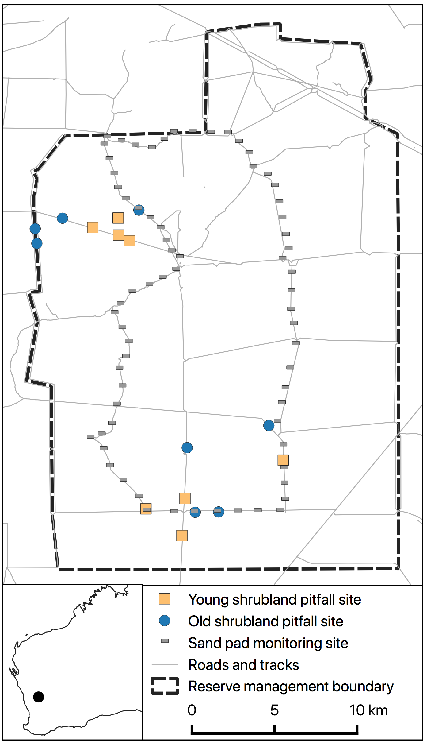
We used sand pad monitoring data to calculate an index of rabbit activity for both the spring and winter seasons prior to each baiting event (i.e. in the previous year). There was a circuit of 69 sand pads separated by 1–2 km each (Fig. S1), which were monitored for 3–6 days in each season and the presence/absence of rabbits and other animals was recorded each morning. The index was calculated as the proportion of days rabbits were detected on each sand pad, averaged across all sand pads. Sand pad data were not available for winter 2013 and spring 2012 and 2013.
Figure S1. Map of the study site, pitfall trapping sites and sand pads, with the smaller map showing location within Western Australia.
Table S4. Dynamic occupancy modelling results for feral cats. Only models with a ΔAICc ≤ 2 are shown. 𝜓, initial occupancy; 𝜀, extinction probability.
Year | Model | ΔAICc | Weight
2013 | 𝜓 ~ Treatment, 𝜀 ~ 1 | 0 | 0.44
 | 𝜓 ~ 1, 𝜀 ~ Treatment | 1.52 | 0.21
 | 𝜓 ~ 1, 𝜀 ~ 1 | 1.69 | 0.19
 | 𝜓 ~ Treatment, 𝜀 ~ Treatment | 2.00 | 0.16
2014 | 𝜓 ~ 1, 𝜀 ~ Treatment | 0 | 0.29
 | 𝜓 ~ 1, 𝜀 ~ 1 | 0.10 | 0.28
 | 𝜓 ~ Treatment, 𝜀 ~ 1 | 0.57 | 0.22
 | 𝜓 ~ Treatment, 𝜀 ~ Treatment | 0.72 | 0.20
2016 | 𝜓 ~ 1, 𝜀 ~ 1 | 0 | 0.48
 | 𝜓 ~ Treatment, 𝜀 ~ 1 | 1.55 | 0.22
 | 𝜓 ~ 1, 𝜀 ~ Treatment | 1.71 | 0.20
2017 | 𝜓 ~ 1, 𝜀 ~ Treatment | 0 | 1.56
 | 𝜓 ~ Treatment, 𝜀 ~ Treatment | 1.40 | 0.28
2018 | 𝜓 ~ 1, 𝜀 ~ 1 | 0 | 0.45
 | 𝜓 ~ 1, 𝜀 ~ Treatment | 1.16 | 0.25
 | 𝜓 ~ Treatment, 𝜀 ~ 1 | 1.86 | 0.18
2019 | 𝜓 ~ 1, 𝜀 ~ Treatment | 0 | 0.47
 | 𝜓 ~ 1, 𝜀 ~ 1 | 1.40 | 0.23
 | 𝜓 ~ Treatment, 𝜀 ~ Treatment | 2.00 | 0.17
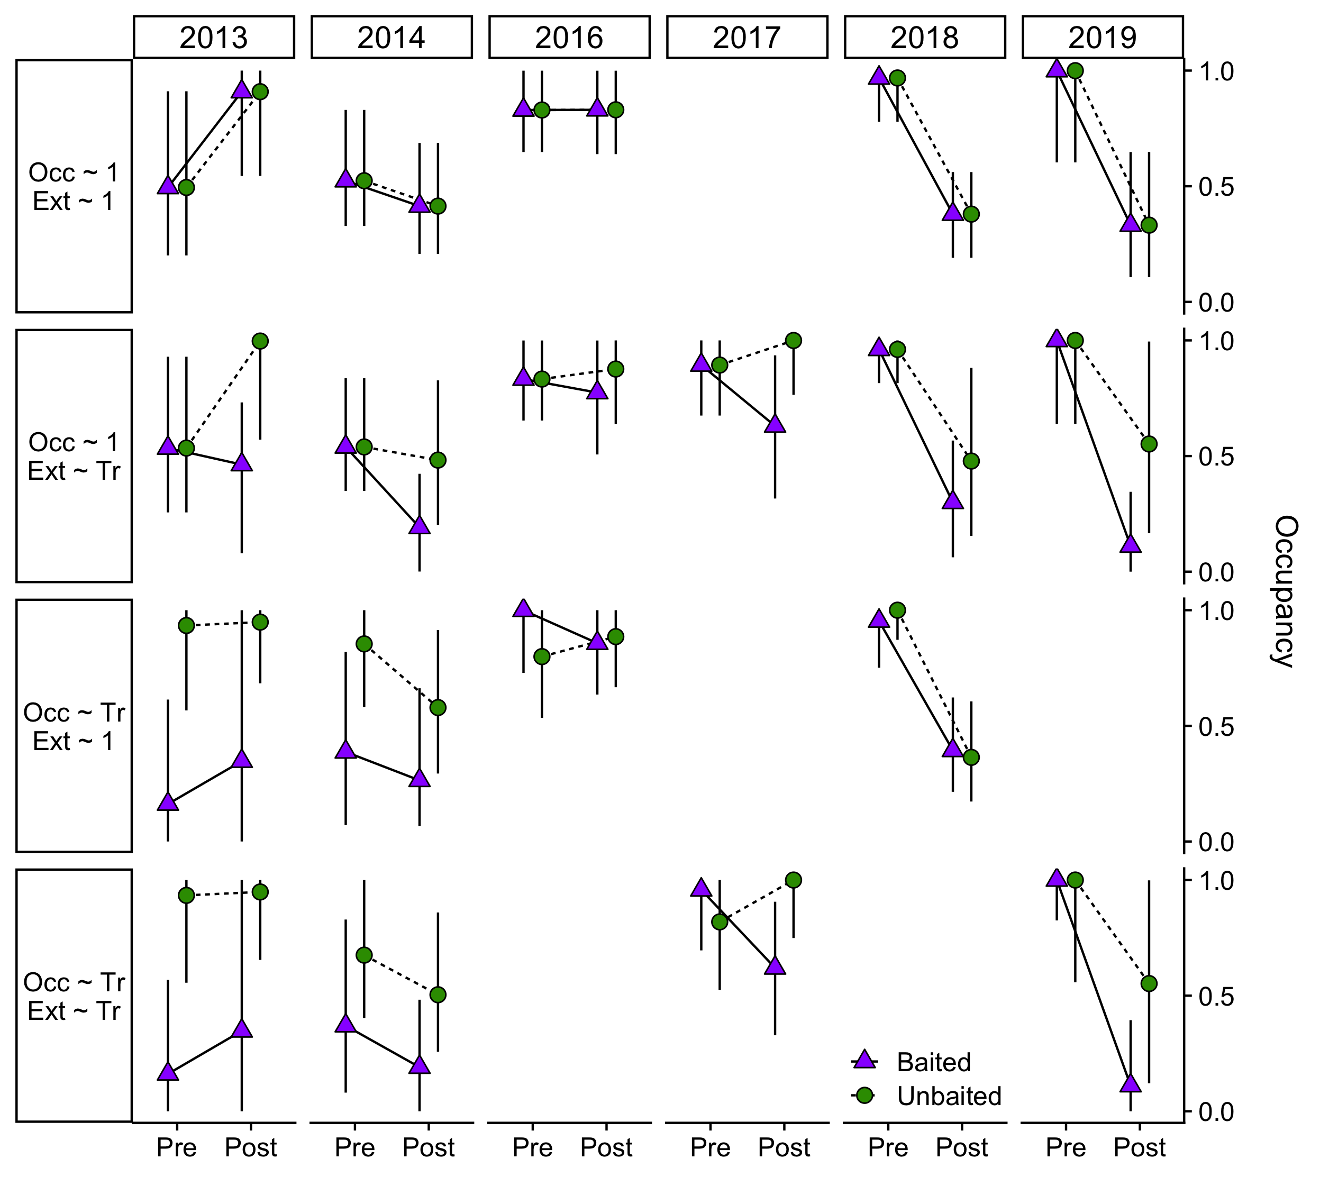
Figure S2. Estimated cat occupancy for all well supported models (ΔAICc ≤ 2) in each year. Occ, initial occupancy; Ext, extinction probability; Tr, treatment (baited/unbaited). Symbols represent means and bars represent 95% confidence intervals.
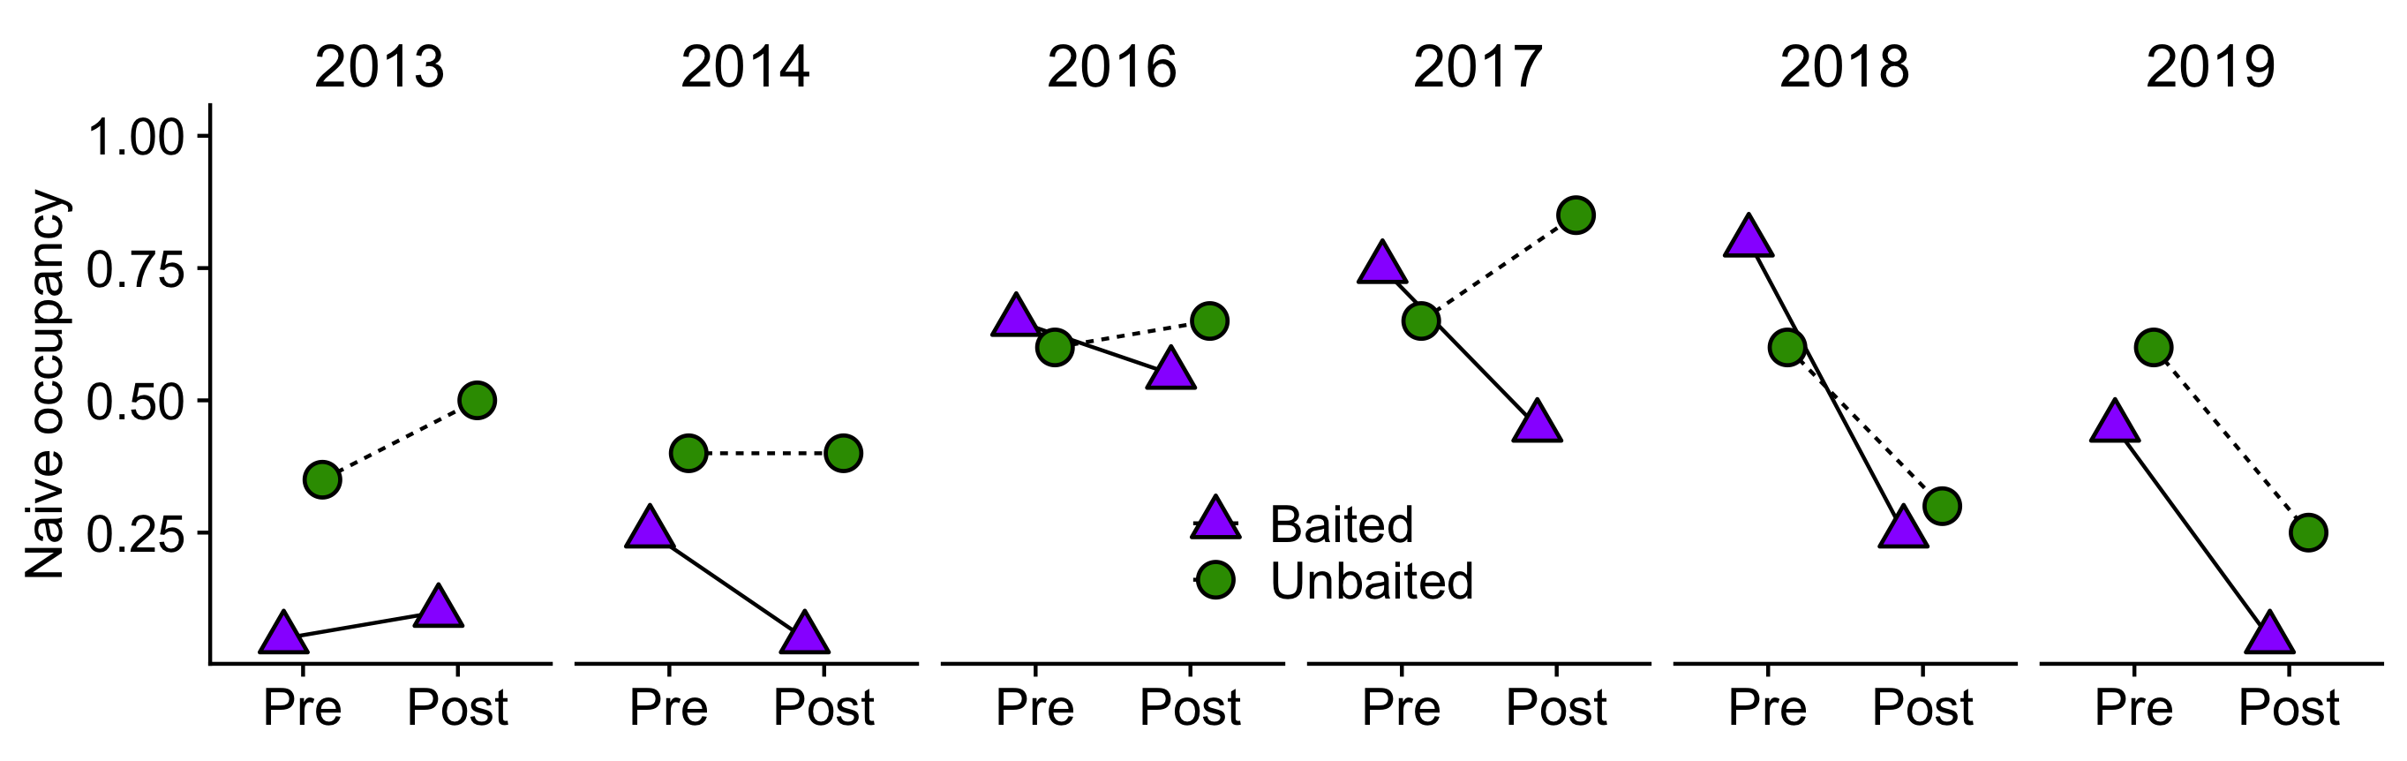
Figure S3. Naïve occupancy of cats (proportion of sites with cats present) pre- and post-baiting each year.
Table S5. Mixed modelling results for changes in cat activity in response to poison baiting. Values in cells are model parameter estimates and 95% confidence intervals are provided in parentheses. Time represents before or after baiting, Treatment represents baited or unbaited, and Interaction represents the interaction those two fixed effects. Bold text indicates variables where the 95% confidence intervals do not overlap zero.
Year | Intercept | Time | Treatment | Time×Treatment
2013 | 0.19 (-1.36 – 1.74) | 0.10 (-2.06 – 2.26) | 1.21 (-0.92 – 3.35) | 2.76 (-0.24 – 5.76)
2014 | 1.17 (-0.86 – 3.21) | -1.00 (-3.14 – 1.13) | 1.28 (-1.57 – 4.13) | 2.54 (-0.48 – 5.56)
2016 | 5.04 (2.97 – 7.11) | -2.10 (-4.34 – 0.14) | -0.80 (-3.70 – 2.09) | 2.77 (-0.61 – 6.16)
2017 | 4.79 (3.06 – 6.52) | -2.84 (-5.18 – -0.50) | -0.55 (-2.96 – 1.87) | 3.44 (0.18 – 6.70)
2018 | 5.50 (4.08 – 6.92) | -4.17 (-6.18 – -2.16) | -1.99 (-4.03 – 0.05) | 1.99 (-0.87 – 4.85)
2019 | 1.53 (0.49 – 2.57) | -1.37 (-2.70 – -0.03) | 1.64 (0.17 – 3.11) | -0.56 (-2.45 – 1.32)

Table S6. General linear modelling results for the effect of environmental variables on baiting effectiveness. Values in cells are model parameter estimates and 95% confidence intervals are provided in parentheses. Rain_6m, total rainfall for the six months prior to baiting; Rain_12, total rainfall for the 12 months prior to baiting; Mammal_CR, capture rate of small mammals for spring prior to baiting; PP_ratio, ratio of prey availability to predator activity (see Methods); Rab_win, rabbit activity index for winter prior to baiting; Rab_spr, rabbit activity index for spring prior to baiting.
Predictor | Occupancy | Activity
Rain_6m (n = 6) | -0.0002 (-0.004 – 0.004) | 0.01 (-0.01 – 0.03)
Rain_12m (n = 6) | 0.001 (-0.003 – 0.004) | 0.01 (-0.01 – 0.02)
Mammal_CR (n = 6) | -3.04 (-19.07 – 12.99) | 11.77 (-75.10 – 98.64)
PP_ratio (n = 6) | -9.08 (-20.98 – 2.81) | 10.93 (-68.19 – 90.05)
Rab_win (n = 5) | -1.80 (-6.84 – 3.23) | 3.06 (-26.77 – 32.89)
Rab_spr (n = 4) | 2.54 (-0.74 – 5.81) | 5.68 (-27.44 – 38.81)

Figure S4. Relationships between baiting effectiveness and environmental variables. The top row relates to occupancy and the bottom row relates to activity. Values of 0 for the baiting effectiveness index indicate that the difference between treatments is equal for before and after baiting. Positive values indicate a greater difference in favour of control sites, i.e. impact sites decreased more than control sites and/or control sites increased more than impact sites. Negative values indicate a greater difference in favour of impact sites, i.e. control sites decreased more than impact sites and/or impact sites increased more than control sites.
Table S7. Generalised linear mixed modelling results relating to differences in capture rates (CR) of small mammals and reptiles in response to Year, Treatment and the interaction. Values in cells are model parameter estimates and 95% confidence intervals are provided in parentheses. Bold text indicates predictor variables where the 95% confidence intervals do not overlap zero. The reference levels used for the intercept were 2012 and Baited.
Predictor | Level | Mammal_CR | Reptile_CR
Intercept | 2012, Baited | 0.03 (0.00 – 0.06) | 0.24 (0.19 – 0.29)
Year | 2013 | -0.01 (-0.05 – 0.04) | -0.10 (-0.17 – -0.04)
 | 2015 | 0.08 (0.02 – 0.13) | -0.07 (-0.16 – 0.02)
 | 2016 | 0.05 (0.008 – 0.09) | -0.19 (-0.19 – -0.05)
 | 2017 | 0.02 (-0.02 – 0.06) | -0.20 (-0.27 – -0.13)
 | 2018 | 0.02 (-0.02 – 0.06) | -0.17 (-0.24 – -0.10)
Treatment | Unbaited | 0.03 (-0.01 – 0.07) | -0.05 (-0.12 – 0.02)
Interaction | 2013×Unbaited | -0.02 (-0.08 – 0.04) | 0.05 (-0.05 – 0.14)
 | 2015×Unbaited | -0.09 (-0.16 – -0.02) | 0.10 (-0.02 – 0.22)
 | 2016×Unbaited | -0.06 (-0.12 – -0.01) | 0.01 (-0.08 – 0.10)
 | 2017×Unbaited | -0.03 (-0.09 – 0.03) | 0.04 (-0.06 – 0.13)
 | 2018×Unbaited | -0.04 (-0.10 – 0.02) | 0.08 (-0.01 – 0.17)

