Title: Management effectiveness positively influences forest conservation outcomes in protected areas in Mexico

Authors: Kathryn A. Powlen^{1a}, Michael Gavinª, Kelly W. Jonesª

ª Human Dimensions of Natural Resources, Colorado State University, Fort Collins, CO, USA
¹Corresponding author: kapowlen@colostate.edu

Highlights (3-5)
- Protected areas reduce forest loss across Mexico compared to control areas.
- Protected areas with higher management effectiveness scores prevent more forest loss.
- Management dimensions associated with human capacity and financial resources were found to have the strongest relationship with protected area outcomes.

Abstract
Understanding the factors that drive protected area outcomes is critical to increase the success of global conservation efforts. Until recently, our understanding of the influence of management effectiveness has been restricted by the limited availability of standardized management data and study design limitations of prior evaluations. Here we use a quasi-experimental matching approach to test the influence of management effectiveness on forest cover change inside 46 protected areas in Mexico. We test the influence of five management categories, including context and planning, administration and finance, use and benefits, governance and social participation, and management quality, as well as an overall effectiveness score, using a subgroup analysis and an interaction term in post-matching multiple linear regression. Our results show that protected areas with higher management effectiveness have a greater effect on reducing deforestation compared to those with low management effectiveness, but that both types of protected areas experience less forest loss compared to similar unprotected areas. We find this trend in all five of the management categories and the overall score, with administration and finance scores having the greatest effect on forest loss outcomes. Our findings suggest careful design and planning, effective participation from multiple stakeholders and equal sharing of benefits, and sufficient human and financial capital can improve the effectiveness of protected areas in preventing forest loss.

Keywords:
Protected areas, Management effectiveness, Forest conservation, Impact evaluation, Mexico

- Introduction
Protected areas are a widely promoted tool to conserve the world’s remaining forests, and have significantly expanded since the adoption of the Aichi Targets by the Convention of Biological Diversity (Butchart et al., 2015; CBD, 2010). While we are on track to reach global goals for protected area coverage, less progress has been made on other global goals, including minimal improvements in the loss and fragmentation of natural habitats and the restoration of ecosystems that provide essential services (Secretariat of the Convention on Biological Diversity, 2020). In light of this disconnect between protected area establishment and conservation metrics, it is critical that we gain a better understanding of what drives conservation outcomes for the effective pursuit of biodiversity goals.
In addition to increasing global terrestrial protected area coverage to 17%, the CBD calls for the effective and equitable management of protected areas (CBD, 2010). Management effectiveness is expected to lead to better conservation outcomes as more strategic protected area planning, better monitoring capacity, improved accountability and transparency, and sufficient human and financial resources should theoretically result in more effective enforcement and governance (Coad, Leverington, Burgess, Cuadros, Geldmann, et al., 2013; Coad et al., 2015; Dudley & Stolton, 2009; Geldmann et al., 2018; Nolte & Agrawal, 2013). However, until recently, these theoretical links remained largely untested due to limited data on de facto management (i.e., how management actions are carried out on the ground) and a lack of counterfactual evaluation. Our study overcomes both limitations by using a rigorous impact evaluation design to examine the influence of management effectiveness scores on protected area outcomes using the results of a recently developed national management effectiveness assessment in Mexico.
Standardized management effectiveness assessments, known as Protected Area Management Effectiveness (PAME) tools, have been designed to increase and standardize protected area management monitoring (Coad, Leverington, Burgess, Cuadros, Stoll-kleemann, et al., 2013; Coad et al., 2015; Geldmann et al., 2015, 2018; Hockings, Cook, & Leverington, 2015; Leverington, Costa, Pavese, Lisle, & Hockings, 2010). These assessments focus on the design and planning, capacity and resources, and decision-making processes of protected areas (Hockings et al., 2006; Stolton & Dudley, 2016). In addition to strengthening efforts to meet global conservation goals, many conservation organizations have adopted these assessments as a measurement of protected area success, and the results play an important role in conservation investments by large donors, such as the Global Environmental Facility (GEF) (Nolte & Agrawal, 2013).
Scores from management effectiveness assessments provide new opportunities to examine de facto management rather than de jure management (e.g., IUCN management categories) used in previous studies (Ferraro et al., 2013; Muñoz Brenes, Jones, Schlesinger, Robalino, & Vierling, 2018). To date, few impact evaluations have critically examined the relationship between de facto management and biodiversity outcomes (Coad et al., 2015). As of 2015, an estimated 17,700 PAME assessments had been conducted in over 9,000 protected areas (Coad, Leverington, Burgess, Cuadros, Stoll-kleemann, et al., 2013), but a review from the same year found only nine studies, from peer-review and gray literature, that could be summarized as evidence on the relationship between PAME scores and biodiversity outcomes (Coad et al., 2015). Of those nine studies, only three studies used counterfactual evaluation, and all three of these studies found no correlation between management effectiveness and biodiversity outcomes (Coad et al., 2015).
Evidence from other existing impact evaluations have drawn inconsistent conclusions about the influence of management effectiveness on conservation outcomes. For example, Geldmann et al (2018) found only management characteristics related to staff and budget had a significant relationship with vertebrate abundance in global protected areas, while other studies have found no relationship between management effectiveness scores and forest loss mitigation in Brazil (Nolte, Agrawal, & Barreto, 2013) or forest fire mitigation in the broader Amazon basin (Nolte & Agrawal, 2013). Additionally, while a few existing impact evaluations have attempted to link assessment scores to conservation outcomes on a global scale (e.g., Geldmann et al., 2018, 2019; Leverington et al., 2010), national-level evaluations have been largely concentrated in Brazil and the Amazon basin region (e.g., Carranza, Balmford, Kapos, Manica, & Busch, 2014; Nolte & Agrawal, 2013; Nolte, Agrawal, & Barreto, 2013).
The limited empirical research critically examining the relationship between management effectiveness and conservation outcomes, as well as the importance of measuring management effectiveness for global conservation goals and conservation funding, warrants further investigation. We contribute to this body of evidence by conducting an evaluation of the impacts of management effectiveness on forest cover loss in 46 terrestrial protected areas in Mexico, a biodiversity hotspot. We link the results of a standardized management effectiveness assessment developed by Mexico’s National Commission of Natural Protected Areas (CONANP) to forest loss data inside protected areas and use matching techniques to more accurately measure the influence of five different management dimensions, as well as an overall management score, on changes in forest cover.
Mexico provides a unique opportunity to examine the influence of management effectiveness on protected area performance due to recent advances in management effectiveness monitoring across its extensive protected area network, estimated at 14.5% of terrestrial area and 21.6% of marine area (UNEP-WCMC, 2020). Similar to other regions of the world, researchers have found variability in the performance of Mexico’s protected area network (Blackman, Pfaff, & Robalino, 2015; Figueroa, Fernanda, Sánchez-Cordero & Illoldi-Rangel, Patricia, Linaje, 2011; Figueroa & Sanchez-Cordero, 2008; Pfaff, Santiago-Ávila, & Joppa, 2017; Sánchez-Cordero, Figueroa, Illoldi-rangel, & Linaje, 2011; Sims & Alix-Garcia, 2017). For example, when controlling for placement biases, Blackman et al. (2015) found that some protected areas experienced more deforestation compared to matched non-protected areas while others experienced less, concluding that larger, newer, mixed-use protected areas and protected areas with sufficient funding were more successful at slowing deforestation. Conversely, Pfaff et al. (2017) found stricter protected areas to be more successful at slowing forest loss compared to mixed-use protected areas when examining a similar list of protected areas over a slightly different time span.
Efforts to monitor management effectiveness in Mexico’s protected area network have been ongoing since 2005 (Comisión Nacional de Áreas Naturales Protegidas, 2019). However, in 2016, CONANP developed a new national assessment (i-efectividad, or El Sistema Permanente de Evaluación de la Efectividad del Manejo de las Áreas Naturales Protegidas Federales de México) to collect standardized results using indicators from four existing PAME evaluations. While the role of management effectiveness in protected area success has been examined in three marine protected areas in the Yucatan (Herrejón, Morales-Vela, Ortega-Argueta, Pozo, & Olivera-Gómez, 2020), and financial resources have been examined as a driver of outcomes in 56 terrestrial protected areas across Mexico (Blackman et al., 2015), this is the first study to test the influence of a comprehensive suite of management dimensions on conservation outcomes in Mexico using the results of CONANP’s recently developed assessment. By identifying the specific management factors that have the greatest influence on conservation outcomes, our results serve to inform more efficient investments in protected areas to ensure better protection of global biodiversity.

- Methods
  - Data
Data extraction was completed using ArcMap 10.7 and data analysis was conducted using R statistical software. Similar to Nolte & Agrawal (2012), we created sampling grid cells of 1 km² and used the Global Forest Watch (GFW) forest cover data to randomly select 80,000 forested grid cells across Mexico for a computationally feasible final sample. The final sample consists of 60,000 cells outside of protected areas and 20,000 inside protected areas.
We use protected area data from the World Database on Protected Areas (IUCN & UNEP-WCMC, 2019) and the scores of CONANP’s management effectiveness evaluation to test the influence of management effectiveness on performance in all forested protected areas with scores available at the time of this study. This includes 46 of the 76 protected areas with completed management evaluations, accounting for 36% of all national protected areas with management plans in Mexico (Figure 1, full list included in Supplementary Material Table S1). The management effectiveness evaluation, like many of the PAME tools, is a self-administered survey and responses are provided by management personnel. It consists of 48 indicators organized into five management categories, including context and planning, administration and finance, use and benefits, governance and social participation, and management quality, each category with a score on a scale from 0-100 (Table 1). We use scores from a one-time response in 2017.
Table 1: Examples of indicators in the five management categories listed in CONANP's management effectiveness evaluation.
Category | Indicator Examples
Context and Planning | Existence of a management plan, work plan, monitoring and evaluation plan, documentation of natural and cultural resources
Administration and Finance | Sufficient financial resources, human capacity, appropriate equipment
Use and Benefits | Economic benefits, sustainable use or production within the boundary, appropriate infrastructure for use and visitation
Governance and Social Participation | Recognition and respect of rights of all stakeholders, participation from local communities and neighboring resource users, education and outreach programs
Management Quality | Area is managed to objectives, sufficient information and active management strategies are used for threats or endemic species

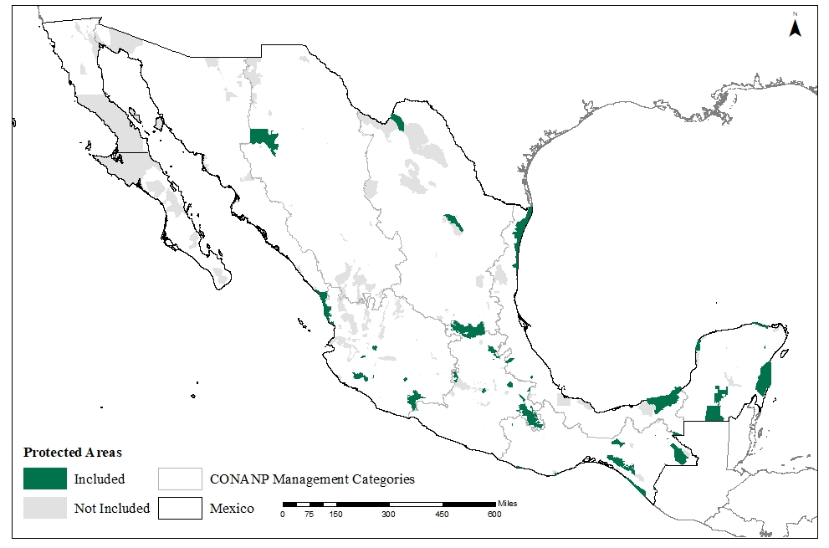
Figure 1: Map of the 46 protected areas included in the analysis. Management effectiveness subgroup were split at the median (i.e., high management effectiveness score ≥ 74 and low management score < 74).

For the outcome variable, we use data on annual forest cover loss from Global Forest Watch (GFW), the most comprehensive high-resolution data available on global forest cover (Hansen et al., 2013). We define protected area performance as forest loss between 2017-2019, assuming that management effectiveness did not change significantly in the two years after the CONANP assessment was conducted.
Similar to prior protected area evaluations (e.g., Blackman et al., 2015; Nolte & Agrawal, 2013; Pfaff et al., 2017), we include socio-economic, ecological and climatological variables in our analysis to control for confounding factors. These variables include elevation, slope, distance to roads, road density, distance to urban centers, population density, average temperature, rainfall, and ejido (communal) land tenure (list of data sources included in Supplementary Material Table S2).
Prior evaluations have found distance to roads and road density to have a negative influence on forest conservation outcomes due to roads increasing access and opportunities for extraction of forest resources (e.g., Joppa & Pfaff, 2009; Kere et al., 2017; Oliveira et al., 2007). Slope and elevation have been linked to agricultural and urban development suitability, similar to temperature and rainfall (e.g., Blackman, 2015; Lucas N. Joppa & Pfaff, 2009; Christoph Nolte & Agrawal, 2013). Flatter areas and more favorable weather conditions can increase forest clearing for agricultural production or other development. Proximity to urban areas and higher population density can increase deforestation due to space and resources needed to support the human population, as well as market integration opportunities (e.g., Leberger et al., 2019; Nolte & Agrawal, 2013; Waldron et al., 2017). Finally, land tenure has been found to influence conservation outcomes, with some community-owned forests producing better outcomes than protected areas (e.g., Durán-Medina, Mas, & Velázquez, 2005; Porter-Bolland et al., 2012). We controlled for tenure in our analysis due to the substantial overlap of ejidos and protected areas in Mexico.

  - Data Analysis
    - Matching
To accurately measure causal effect relative to a counterfactual, impact evaluation design is needed to account for hidden biases in intervention placement (Baylis et al., 2016). Matching is one approach used to control for such biases, and can help account for non-randomly assigned treatment groups by increasing similarities among predictive variables, or observable covariates, within treatment and non-treatment groups (Austin, 2011; Schleicher et al., 2019; Stuart, 2010). We implement matching following the best practices outlined by Schleicher et al. (2019).
Prior to matching, we examined correlation coefficients between all socioeconomic, ecological, and climatological covariates to minimize potential multicollinearity and maximize model fit (Supplementary Material Table S3). We selected six covariates that were not highly correlated and that were significant predictors of both forest loss and protected area status (Supplementary Material Table S4). The final six covariates used in matching included elevation, slope, urban distance, road distance, average yearly rainfall, and ejido tenure.
We found no evidence of spillover effects, or the displacement of deforestation from protected areas to adjacent unprotected areas, within a 5km and 10km buffer around each protected area (Supplementary Material Table S5). We used two matching algorithms to match protected and unprotected cells: Propensity Score Matching and Mahalanobis Distance Matching. We used a one-to-one matching without replacement for both algorithms and tested a caliper of 0.2 standard deviations and 0.1 standard deviations when necessary to improve match quality (Imbens & Rubin, 2015; Stuart, 2010). We evaluated the quality of each match by calculating the standardized bias (SB) and examined potential biases from omitted variables using Rosenbaum bounds sensitivity test (Γ), a measure of the amount of change in a confounding factor required to undermine the statistical significance of the treatment effect (Rosenbaum, 2002).
The influence of management effectiveness on protected area outcomes was measured by (1) calculating average treatment effect (ATE) across matched management subgroups and (2) using an interaction term in a general linear regression model. For the subgroup analysis, let D_{he}=1 if the grid cell has a high management effectiveness score and equal to 0 if unprotected and D_{le}=1 if the grid cell has a low management effectiveness score and 0 if unprotected. The median management effectiveness score was used as the cutoff between high and low management effectiveness protected areas. Y is the continuous percent forest loss between 2017-2019. After selecting the most balanced match for each subgroup, we calculated ATE as the difference in mean outcomes between treatment and control cells, or [Σ (Y|D_{he}=1)-Σ(Y|D_{he}=0)] and [Σ(Y|D_{le}=1)-Σ(Y|D_{le}=0)], using t-tests.
To account for possible remaining imbalances, we also examined the significance of the treatment effect for each matched group using a multivariate linear regression, which included the six covariates used in matching as independent variables. Specifically, we regressed the binary treatment dummy variables (D_{he} and D_{le}) and the six covariates outlined above (CoVar) on Y, as follows:
Equation 1: Y = β₀+ β ₁D_{he}+ β ₂CoVar1+ …+ β ₇CoVar6+U
for the high management subgroup and
Equation 2: Y = β₀+β ₁D_{le}+ β ₂CoVar1+ …+ β ₇CoVar6+U
for the low management subgroup.
We used robust standard errors, U, in both regressions after finding evidence of heteroscedasticity among the residuals using a Breusch-Pagan test.

    - Multivariate Regression with Interaction Effect
Second, we used an interaction term in a multivariate linear regression to test for a moderating effect of management effectiveness. While both subgroup analysis and interaction effects are used to test for moderating effects in impact evaluation, the use of an interaction term allows for more variation in the moderator compared to a subgroup approach (Sills & Jones, 2018). The moderating effect of management effectiveness in this analysis is estimated as follows:
Equation 3: Y = β₀ + β ₁(PA * D_{c}) + β ₂CoVar1 + … + β ₇CoVar6 + U,
where PA is a treatment dummy variable equal to 1 if the cell is within a protected area and 0 if else and D_{c} is a continuous management effectiveness score. We estimated the above regression separately for each of the five management categories, as well as for the overall management score. We used robust standard errors, U, after finding evidence of heteroscedasticity and the same six covariates listed above are included in each interaction model.
Additionally, to test the robustness of the interaction models, we created a binary dependent variable from the continuous percent forest loss, Y, where Y_{b}=1 for any loss and Y_{b}=0 for no forest loss. A logit regression and a constructed binary variable can be used to test the robustness of linear regression results when continuous data contains a large number of zeros, and is thus severely skewed to the right (Boulton & Williford, 2018). We therefore examined the moderating effect of each management score using Y_{b} as the dependent variable in a logit regression model similar to equation 3. We tested for spatial autocorrelation using Moran’s I using the residuals of each interaction model (Legendre, 1993; Negret et al., 2020).

- Results
The 20,000 protected area grid cells located within our 46 protected areas were all established before 2010 and ages ranged from 11 to 83 years. The areas represented five protected area types: Biosphere Reserves (IUCN Category Ia and VI; 72%), National Parks (IUCN Category II; 6%), National Monuments (IUCN Category III; <1%), Flora and Fauna Protection Areas (IUCN Category VI; 17%) and Natural Resource Protection Areas (IUCN Category VI; <1%).

  - Management Scores
Management scores in all categories varied across the 46 protected areas (Figure 2). Using the median to create high and low subgroups, 34 protected areas fell within the low overall effectiveness score category (< 74) and 12 protected areas were in the high overall effectiveness category (>74). No protected area had an overall management score of less than 40. Across the five management categories, protected areas scored highest on governance and social participation and lowest on administration and finance (Figure 2).
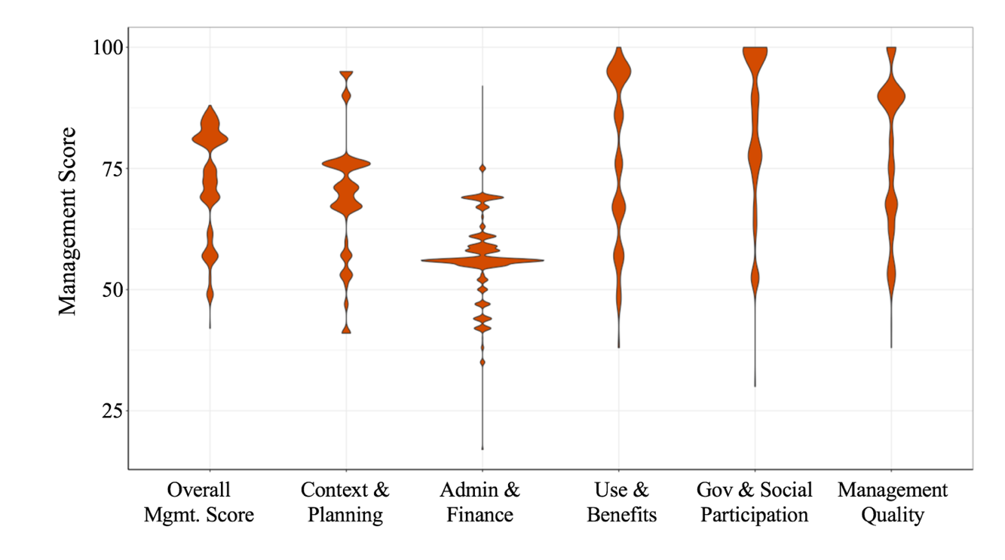
Figure 2: Distribution of scores for each management category and the overall score from the grid cells in the 46 protected areas.

  - Covariates and Matching
The socioeconomic, ecological and climatological covariates varied greatly across protected and unprotected cells, as well as high and low management protected area cells (Figure 3, Supplementary Material Table S6). A t-test found that cells within protected areas tend to be at lower elevations (p<.001), with steeper slopes (p<.0001), closer to urban areas (p<.0001) and roads (p<.0001), and with higher road density (p<.0001). They were also found to have higher temperatures and a greater amount of rainfall, as well as a higher percentage of ejido tenure (p<.0001 for all covariates).
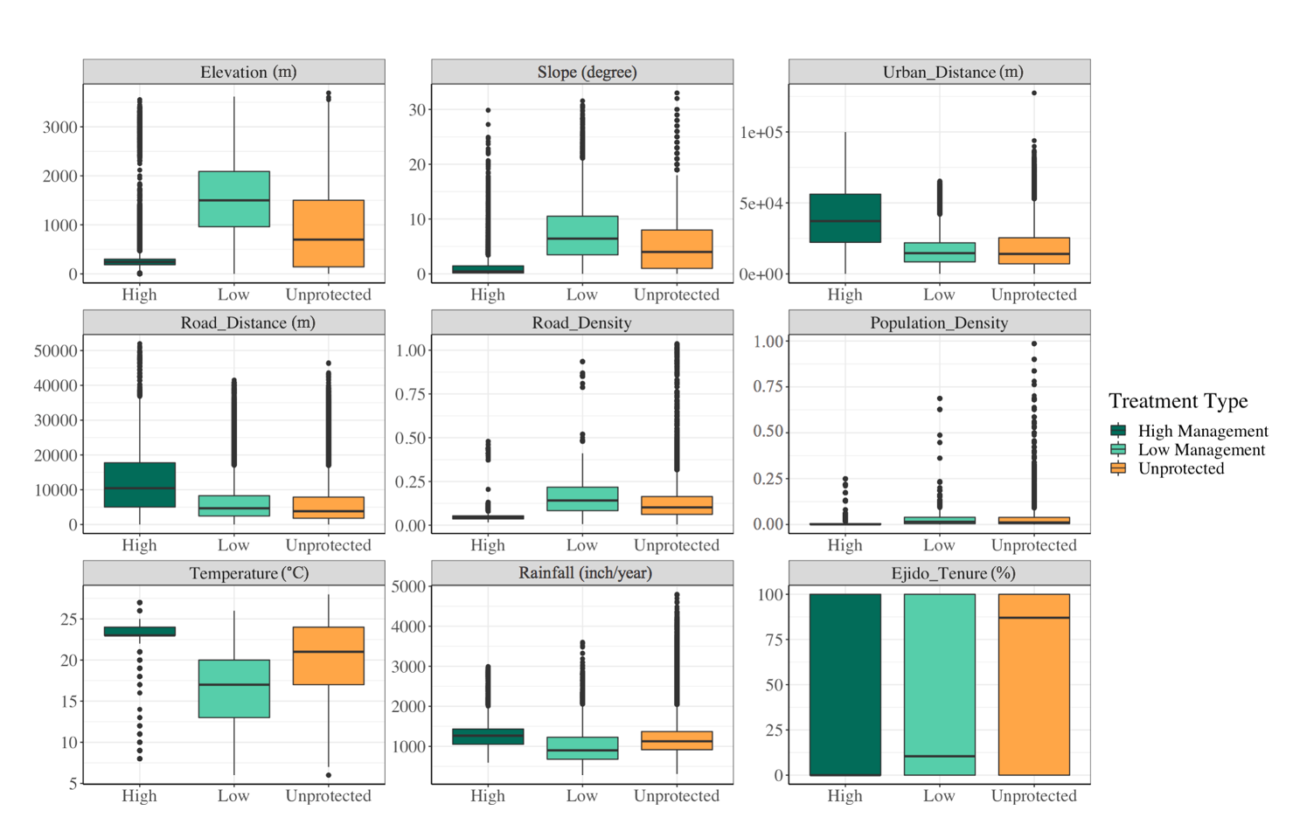
Figure 3: Boxplots displaying the variation in covariates across high and low management subgroups and unprotected cells.
Cells in low management protected areas were located at higher elevations with steeper slopes and closer to roads and urban areas compared to high management protected areas (Supplementary Material Table S6). They were also found to have a higher population density and road density, contained a higher percentage of ejido tenure, as well as less rainfall and lower temperatures on average (p<.0001 for all covariates).
The significant differences in covariates posed a challenge for well-balanced matches, with high management being more challenging to match with unprotected cells than low management. Thus, we used a caliper in all protected area matches to improve match balance. We present the results from the best matching algorithms below (see Supplementary Material Table S7 and Table S8 for summaries of all matching algorithms tested and the associated post-matching balance).

  - Average Treatment Effect Estimates
3.3.1 Subgroup analysis
Both high and low management effectiveness protected areas experienced significantly less deforestation than their matched controls using post-matching t-tests (Supplementary Material Table S9). The average percent loss between 2017-2019 in high overall management cells was 1.19 compared to 3.30 in the matched unprotected cells (p <.0001), and 0.46 in low overall management cells compared to 1.05 in the matched unprotected cells (p<.0001). Similarly, average forest loss in the high and low matches of each of the five management categories was significantly less than their matched control group.
Although low management cells experienced less deforestation than high management cells in all categories except for context and planning and administration and finance, a Wilcoxon Rank Sum test found the ATE to be significantly higher in the high subgroups of the overall management scores (p <.0001), context and planning (p <.0001), use and benefits (p <.0001), governance and social participation (p <.0001), and management quality (p <.0001) compared to the ATE of the low management subgroups (Figure 4). The ATE of the low administration subgroup was higher that of the high subgroup (low: -1.23, high: -0.73), however, no statistical significance was found.
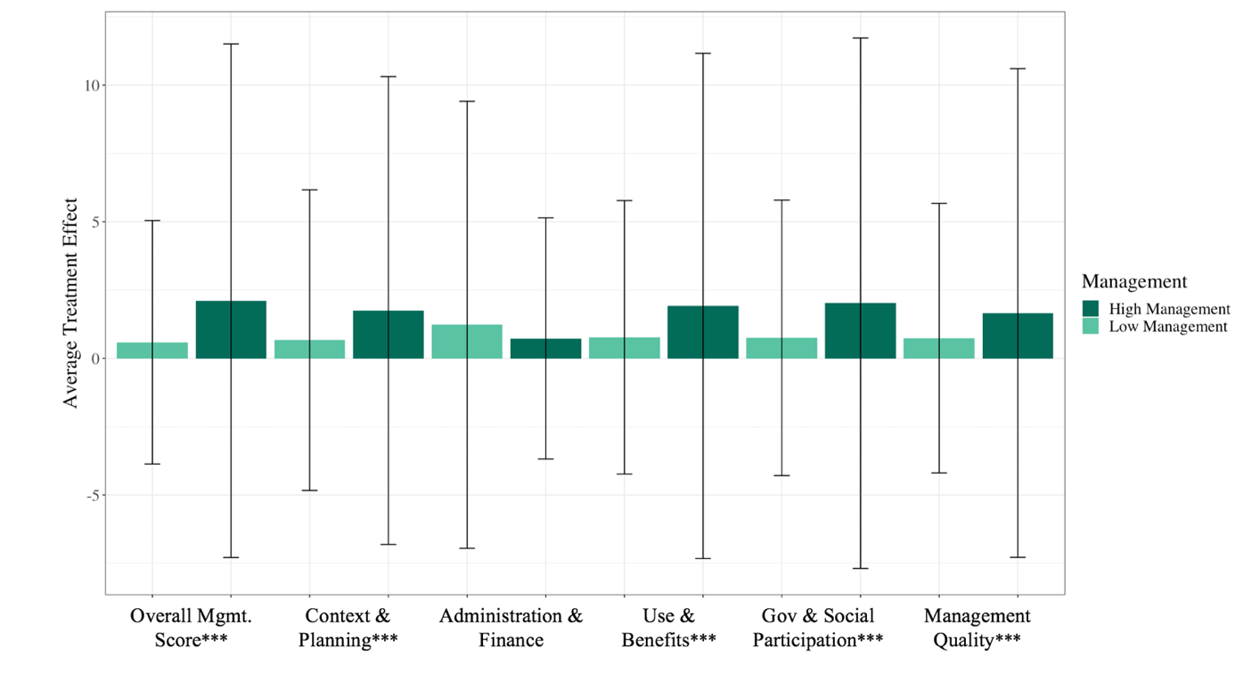
Figure 4: Bar chart and error terms of average treatment effects (ATE), calculated as the difference in average forest loss in the treatment group minus the control. Statistical significance was estimated using Wilcoxon Rank Sum analysis (p<.0001***, p<.001**, p<.01*).

The post-match linear regression model, used to control for remaining imbalances in covariates, found that both high and low management protected areas significantly reduce deforestation in all models (p <.0001) the models indicate that less forest loss occurred in both high and low management categories when compared to unprotected sites. , full model results in Supplementary Material Table S10 and Table S11). Across all management categories, the models indicate that less forest loss occurred in both high and low management categories when compared to unprotected sites.

Table 2: High and low management effects for individual management categories. Regression coefficients and robust standard errors shown for only the treatment variable of each model. Dependent variable is percent forest loss between 2017-2019 for all models.
 | Overall Mgmt. Effectiveness | Context & Planning | Admin & Finance | Use &  Benefits | Gov & Social Participation | Management Quality
High Management | -2.18***  (1.06e-01) | -1.77***  (1.17e-01) | -0.73***  (4.94e-02) | -2.01***  (1.10e-01) | -2.00***  (1.15e-01) | -1.81*** (1.04e-01)
Observations | 14,046 | 10,232 | 15,476 | 12,958 | 12,866 | 10,820
 | Overall Mgmt. Effectiveness | Context & Planning | Admin & Finance | Use &  Benefits | Gov & Social Participation | Management Quality
Low Management | -0.50***  (4.32e-02) | -0.63***  (4.87e-02) | -1.32***  (7.73e-02) | -0.73*** (4.76e-02) | -0.71***  (4.82e-02) | -0.71***  (4.74e-02)
Observations | 20,242 | 23,334 | 21,140 | 20,740 | 20,820 | 20,658
p <.0001*** p <.001** p <.01*

3.3.2 Interaction Effects
Our results found a significant moderating effect of management effectiveness (overall effectiveness and each sub-category) using an interaction term. Higher management effectiveness in each category was significantly correlated with a reduction in forest loss (coefficients range from -1.25e-02 to -1.84e-02, all p <.0001) (full results in Supplementary Material Table S12). The administration and finance score was found to have the largest ATE on average, followed by context and planning, use and benefits, management quality and governance and social participation. The overall management score was also statistically significant at the <.0001 level.
While holding all else constant, a 10% increase in the administration and finance score was associated with the largest decrease in percent forest loss, of about 0.19% (Figure 5). A 10% increase in the context and planning score and the overall score was found to decrease the average forest loss by about 0.16% and 0.15%, respectively. We found similar effects for a 10% increase in the use and benefits and management quality score, which were both found to decrease average forest loss by 0.14%. Finally, a change in governance and social participation had the smallest effect, with a 10% increase in score decreasing forest loss by 0.13%. Full marginal effects results are presented in Supplementary Material Table S13.
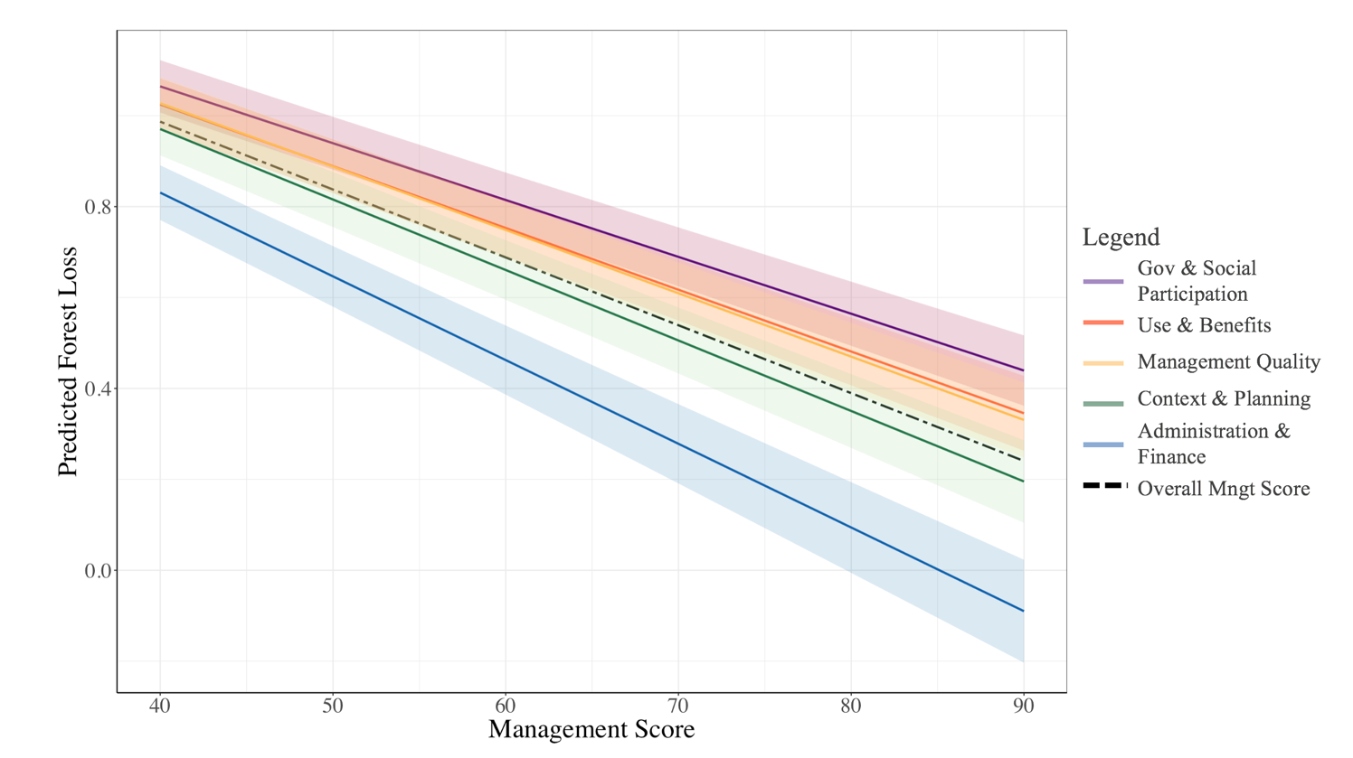Figure 5: Marginal effect of each management category on predicted forest loss. Shaded area represents 95% confidence intervals for each model.

3.3.3. Robustness checks
The Rosenbaum bounds sensitivity test found that our analysis was sensitive to small changes in unobservable bias (Supplementary Material Table S14). However, this test is not able to detect if there is unobservable bias present, only what would happen if there were omitted variables that affected both the treatment and outcome variables. When comparing subgroups (i.e., high management experiences less deforestation than low management), the unobservable heterogeneity would need to act differently across subgroups to bias our findings (Ferraro & Hanauer, 2011).
The results of the logit models also confirm the robustness of our interaction model results (Supplementary Material Table S15). In the logit models, all interaction effects were found to have a negative effect on predicted forest loss (p <.0001). Additionally, we find no evidence of spatial clustering in the residuals of the interaction model, with all Moran indices equal to ~0.00 (Supplementary Material Figure S1).

- Discussion
Our study contributes to a growing number of impact evaluations designed to measure the influence of protected areas on conservation outcomes. More specifically, it adds to the small number of those studies that have measured the moderating effect of multiple dimensions of protected area management on conservation outcomes (e.g., Coad et al., 2015; Geldmann et al., 2018; Muñoz Brenes et al., 2018).
We found that protected areas in general avoid more forest loss than their matched controls, meaning that protected areas are successfully reducing deforestation across Mexico. Moreover, we found that protected areas with higher overall management effectiveness scores, as well as those with higher scores in all five sub-categories, are associated with lower rates of forest loss (Figure 5). Our results emphasize the importance of improving effectiveness across multiple dimensions of management to ensure the greatest conservation outcomes. These findings also illustrate the predictive power of management assessments in monitoring terrestrial protected area effectiveness and support their use in conservation investment decisions.
Results of our covariate comparison suggest that, on average, protected areas with higher management effectiveness scores are located in areas with greater human pressure compared to those with low management scores (Figure 3). This includes areas with closer proximity to urban areas and roads located at lower elevations with lower slopes. As a result, we found large differences in forest loss outcomes between the subgroup analysis of high and low management effectiveness protected areas. For example, unprotected cells matched with high management protected areas experienced a much higher amount of forest loss compared to the unprotected cells matched with low management protected areas in almost all matches (Supplementary Material Table S9).
Protected areas with high management effectiveness also experience higher rates of forest loss than protected areas with low management effectiveness. However, when compared to a counterfactual in our subgroup analysis, protected areas with high management effectiveness are found to prevent a greater degree of forest loss compared to those with low management effectiveness, resulting in a higher treatment effect (Figure 4). This trend was found for the overall management score and across all management categories, except for administration and finance. When controlling for imbalances in the matched pairs using a post-match regression and the interaction regression models, we found higher scores in all five management categories to be associated with lower rates of forest loss. These findings illustrate the importance of quasi-experimental impact evaluation methods that utilize a counterfactual to compare observed differences. The influence of each management category is discussed in turn below.

  - Influence of management by category
The management category with the greatest influence over forest loss was the administration and finance category, which measures whether or not the protected area has sufficient human and financial resources (Figure 5). Our results support prior research pointing to the importance of financial and administrative resources in protected areas (Barnes, Craigie, & Hockings, 2016; Barnes, Craigie, Dudley, & Hockings, 2017; Blackman et al., 2015; Bruner, Gullison, Rice, & Fonseca, 2001; Coad et al., 2019; Gill et al., 2017) and in conservation more broadly (Waldron et al., 2017). Additionally, in a global management effectiveness impact evaluation, Geldmann et al. (2018) found “capacity and resources” to be the only management category significantly related to changes in vertebrate abundance. Financial resources are often interlinked with human capacity (e.g., number of staff and staff training) and can enable better management practices for planning and enforcement of protected area restrictions (Leverington et al., 2010). Thus, this analysis provides additional empirical support to the hypothesized relationship that financial and human capital are critical to achieving conservation outcomes.
The management category with the next strongest relationship with forest loss was context and planning. Planning has previously been highlighted as a critical component to increasing protected area ecological impact and has been linked to improved resource monitoring and adaptive capacity of management (Pressey, Visconti, & Ferraro, 2015). Muñoz Brenes et al. (2018) found planning to play a significant role in protected area outcomes in an impact evaluation examining management capacity in 12 protected areas across Central America. Given that effective planning requires sufficient resources, including time, human capacity, and appropriate equipment, management planning may be largely enabled by administrative and financial resources. The significance of our findings highlight the important role that effective planning can have in protected area success and encourages greater investment in this dimension of management.
The management quality category includes indicators on the protected area’s ability to monitor and respond to specific threats as well as to fulfill management objectives in pursuit of protected area goals. An increase in the management quality score was associated with less forest loss. Since the early 2000s, there has been a growing awareness of the importance of monitoring and evaluation in the conservation field and the influence that these processes have on conservation intervention success (Ferraro & Pattanayak, 2006; Stem, Margoluis, Salafsky, & Brown, 2005). Monitoring and evaluation can increase the ability of protected area management to adapt to specific threats by providing sufficient information for decision-making, thereby increasing the likelihood of achieving specific goals.
Higher management scores in the governance and social participation and use and benefits categories were also found to decrease the probability of forest cover loss. The governance and social participation category reflects the degree of procedural equity in protected area management, or the level of inclusion and effective participation of diverse stakeholders in management decisions (Franks & Schreckenberg, 2016; Zafra-Calvo et al., 2017). The use and benefits category can be linked to distributive equity, or the distribution of cost and benefits across relevant stakeholders (Zafra-Calvo et al., 2017). Thus, while these categories contribute to overall management effectiveness, they can also be strong indicators of the level of equity in protected area management, another key component of the Aichi Target 11.
A global literature review of protected area socio-economic and conservation outcomes found that protected areas with greater socio-economic benefits and greater empowerment of local communities were more successful ecologically (Oldekop, Holmes, Harris, & Evans, 2016). Greater participation from local communities in decision-making has also been linked to more effective resource allocation, by identifying appropriate needs such as specific local capacity building or outreach and education programs (Andrade & Rhodes, 2012). Additionally, a study examining management effectiveness in three marine protected areas in Mexico found protected areas to be more successful at conserving manatee populations when management incorporated activities that produced socio-economic benefits for the community, such as fishing and tourism (Herrejón et al., 2020). In addition to the strong evidence that exists on the links between equitable management and conservation outcomes, researchers have argued that equitable management is also important for moral reasons (Franks & Schreckenberg, 2016; Greiber, Janki, Orellana, Savaresi, & Shelton, 2009; Vucetich et al., 2018).
While we found all five management categories to have a significant influence on protected area outcomes, our interaction models were only able to explain a fraction of the observed forest loss (Supplementary Material Table S12). Therefore, while management effectiveness can influence protected area success, it may not be the main driver of success. Future research could try to incorporate additional data on potential institutional moderators of protected area effectiveness to increase the model’s predictive power (Sills and Jones, 2018). For example, level of tenure security has been found to influence protected area outcomes in Brazil (C. Nolte, Agrawal, Silvius, & Soares-Filho, 2013), and Sims and Alix-Garcia (2017) found Mexico’s payment for ecosystem services program helped reduce deforestation inside and outside of protected areas (Sims & Alix-Garcia, 2017). Additionally, we found a greater number of protected areas with higher overall effectiveness scores in Southern Mexico, specifically in the states of Chiapas and Yucatan. Future research could test additional ecological, cultural, or socio-economic moderators which may be driving these regional disparities.
We also acknowledge the limitation posed by potential biases in self-reported management assessments (Coad et al., 2015). Capturing the perceptions of stakeholders beyond protected area staff, similar to Herrejón et al. (2020), may more accurately measure different management categories, especially those addressing equity in power and benefit sharing. Ground truthing the scores of CONANP’s management assessment should be a focus of future research.
In addition to capturing the perspectives of multiple stakeholders, future research on management effectiveness should focus on temporal changes in management to better determine causality, as well as the interrelationships between different aspects of management effectiveness (i.e., if better planning and resources leads to better outcomes, or if better performing protected areas receive greater resources and thus are better able to plan), similar to the global analysis conducted by Geldmann et al., (2015). Our results are better interpreted as correlations between management effectiveness and forest loss, versus causality, due to the one-time survey response.

Conclusion
Our study responds to calls for more rigorous evidence identifying the moderators that lead to protected area success by examining the role of management effectiveness in protected area success (Geldmann et al., 2013; Macura, Secco, & Pullin, 2015). In our sample of 46 terrestrial protected areas in Mexico, we find statistically significant and positive relationships between better management effectiveness and mitigation of forest loss. While many studies have previously identified the importance of sufficient financial resources for protected areas success, our findings highlight the importance of additional management components including planning and design, relationships with diverse stakeholders, equitably shared benefits, and adaptive management. We recognize that these management components are not mutually exclusive, and that often an improvement in one can enable an improvement in another (i.e., greater financial resources can lead to more training and human capacity building, which can lead to improved resource monitoring programs). However, our findings highlight that each dimension can have a significant impact on conservation outcomes, thereby emphasizing the importance to conservation planners of investing time and resources in each category to ensure the greatest conservation outcomes. Finally, our findings support the theory that standardized management effectiveness tools can be useful predictors of conservation outcomes, and thus can be an appropriate measurement for global monitoring.

Acknowledgements
The authors acknowledge support from the Society of Woman Geographers Pruitt Dissertation Fellowship and are grateful to CONANP for sharing the unpublished results of the management effectiveness evaluation.

Competing Interests: None.
References:
Andrade, G. S. M., & Rhodes, J. R. (2012). Protected areas and local communities: An inevitable partnership toward successful conservation strategies? Ecology and Society, 17(4). https://doi.org/10.5751/ES-05216-170414
Austin, P. C. (2011). An Introduction to Propensity Score Methods for Reducing the Effects of Confounding in Observational Studies. Mutivariate Behavioral Research, 46, 399–424. https://doi.org/10.1080/00273171.2011.568786
Barnes, M., Craigie, I. D., & Hockings, M. (2016). Towards Understanding Drivers of Wildlife Population Trends in Terrestrial Protected Areas. In Luccas N. Joppa, J. E. M. Ballie, & J. G. Robinson (Eds.), Protected Areas: Are They Safeguarding Biodiveristy? (First). John Wiley & Sons, Ltd.
Barnes, M. D., Craigie, I. D., Dudley, N., & Hockings, M. (2017). Understanding local-scale drivers of biodiversity outcomes in terrestrial protected areas. Annals of the New York Academy of Sciences, 1399(1), 42–60. https://doi.org/10.1111/nyas.13154
Baylis, K., Honey-Roses, J., Borner, J., Corbera, E., Ezzine-de-Blas, D., Ferraro, P. J., … Wunder, S. (2016). Mainstreaming Impact Evaluation in Nature Conservation. Conservation Letters, 9(1), 58–64. https://doi.org/10.1111/conl.12180
Blackman, A. (2015). Strict versus mixed-use protected areas: Guatemala’s Maya Biosphere Reserve. Ecological Economics, 112, 14–24. https://doi.org/10.1016/j.ecolecon.2015.01.009
Blackman, A., Pfaff, A., & Robalino, J. (2015). Paper park performance: Mexico’s natural protected areas in the 1990s. Global Environmental Change, 31, 50–61. https://doi.org/10.1016/j.gloenvcha.2014.12.004
Boulton, A. J., & Williford, A. (2018). Analyzing Skewed Continuous Outcomes With Many Zeros: A Tutorial for Social Work and Youth Prevention Science Researchers. Journal of the Society for Social Work and Research, 9(4), 721–740. https://doi.org/10.1086/701235
Bruner, A. G., Gullison, R. E., Rice, R. E., & Fonseca, G. A. B. (2001). Effectiveness of Parks in Protecting Tropical Biodiversity. Science, 291(5501), 125–128.
Butchart, S. H. M., Clarke, M., Smith, R. J., Sykes, R. E., Scharlemann, J. P. W., Harfoot, M., … Burgess, N. D. (2015). Shortfalls and Solutions for Meeting National and Global Conservation Area Targets. Conservation Letters, 8(5), 329–337. https://doi.org/10.1111/conl.12158
Carranza, T., Balmford, A., Kapos, V., Manica, A., & Busch, J. (2014). Protected Area Effectiveness in Reducing Conversion in a Rapidly Vanishing Ecosystem: The Brazilian Cerrado. Conservation Letters, 7(3), 216–223. https://doi.org/10.1111/conl.12049
CBD. (2010). The Strategic Plan for Biodiversity 2011–2020 and the Aichi Biodiversity Targets.
Coad, L., Leverington, F., Burgess, N. D., Cuadros, I. C., Geldmann, J., Marthews, T. R., … Hockings, M. (2013). Progress towards the CBD protected area management effectiveness targets. Parks, 19(1), 13–24. https://doi.org/10.2305/IUCN.CH.2013.PARKS-19-1.LC.en
Coad, L., Leverington, F., Burgess, N. D., Cuadros, I. C., Stoll-kleemann, S., Vansteelant, N., & Zamora, C. (2013). Progress towards the CBD Protected Area Management Effectiveness targets. Parks, 19(1). https://doi.org/10.2305/IUCN.CH.2013.PARKS-19-1.LC.en
Coad, L., Leverington, F., Knights, K., Geldmann, J., Eassom, A., Kapos, V., … Hockings, M. (2015). Measuring impact of protected area management interventions: current and future use of the Global Database of Protected Area Aanagement Effectiveness. Philosophical Transactions of the Royal Society B: Biological Sciences, 370(20140281). https://doi.org/10.1098/rstb.2014.0281
Coad, L., Watson, J. E. M., Geldmann, J., Burgess, N. D., Leverington, F., Hockings, M., … Marco, M. Di. (2019). Widespread shortfalls in protected area resourcing undermine efforts to conserve biodiversity. Frontiers in Ecology and the Environment, 259, 259–264. https://doi.org/10.1002/fee.2042
Comisión Nacional de Áreas Naturales Protegidas. (2019). Documento técnico base del Sistema Permanente de Evaluación e la Efectividad del Manejo de las Áreas Naturales Protegidas Federales. México.
Dudley, N., & Stolton, S. (2009). The Protected Areas Benefits Assessment Tool. Assessment. Retrieved from http://wwf.panda.org/what_we_do/where_we_work/amazon/publications/?174401/PABAT
Durán-Medina, E., Mas, J. F., & Velázquez, A. (2005). Land use/cover change in community-based forest management regions and protected areas in Mexico. In D. Bray, L. Merino, & D. Barry (Eds.), The Community Forests of Mexico: Managing for Sustainable Landscapes. Mexico City, MX: INE-SEMARNAT.
Ferraro, P. J., & Hanauer, M. M. (2011). Protecting ecosystems and alleviating poverty with parks and reserves: “Win-win” or tradeoffs? Environmental and Resource Economics, 48(2), 269–286. https://doi.org/10.1007/s10640-010-9408-z
Ferraro, P. J., Hanauer, M. M., Miteva, D. A., Canavire-Bacarreza, G. J., Pattanayak, S. K., & Sims, K. R. E. (2013). More strictly protected areas are not necessarily more protective: Evidence from Bolivia, Costa Rica, Indonesia, and Thailand. Environmental Research Letters, 8(2). https://doi.org/10.1088/1748-9326/8/2/025011
Ferraro, P. J., & Pattanayak, S. K. (2006). Money for nothing? A call for empirical evaluation of biodiversity conservation investments. PLoS Biology, 4(4), 482–488. https://doi.org/10.1371/journal.pbio.0040105
Figueroa, Fernanda, Sánchez-Cordero, V., & Illoldi-Rangel, Patricia, Linaje, M. (2011). Evaluación de la efectividad de las áreas protegidas para contener procesos de cambio en el uso del suelo y la vegetación. ¿Un índice es suficiente? Revista Mexicana de Biodiversidad, (82), 951–963.
Figueroa, F., & Sanchez-Cordero, V. (2008). Effectiveness of natural protected areas to prevent land use and land cover change in Mexico. Biodiversity and Conservation, 17, 3223–3240. https://doi.org/10.1007/s10531-008-9423-3
Franks, P., & Schreckenberg, K. (2016). Advancing equity in protected area conservation. The International Institute for Environment and Development (IIED), (February), 5–9. https://doi.org/10.13140/RG.2.1.2817.0649
Geldmann, J., Barnes, M., Coad, L., Craigie, I. D., Hockings, M., & Burgess, N. D. (2013). Effectiveness of terrestrial protected areas in reducing habitat loss and population declines. Biological Conservation, 161, 230–238. https://doi.org/10.1016/j.biocon.2013.02.018
Geldmann, J., Coad, L., Barnes, M., Craigie, I. D., Hockings, M., Knights, K., … Burgess, N. D. (2015). Changes in protected area management effectiveness over time: A global analysis. Biological Conservation, 191, 692–699. https://doi.org/10.1016/j.biocon.2015.08.029
Geldmann, J., Coad, L., Barnes, M. D., Craigie, I. D., Woodley, S., Balmford, A., … Burgess, N. D. (2018). A global analysis of management capacity and ecological outcomes in terrestrial protected areas. Conservation Letters, 11(3), 1–10. https://doi.org/10.1111/conl.12434
Geldmann, J., Manica, A., Burgess, N. D., Coad, L., & Balmford, A. (2019). A global-level assessment of the effectiveness of protected areas at resisting anthropogenic pressures. PNAS, 116(46), 23209–23215. https://doi.org/10.1073/pnas.1908221116
Gill, D. A., Mascia, M. B., Ahmadia, G. N., Glew, L., Lester, S. E., Barnes, M., … Whitmee, S. (2017). Capacity shortfalls hinder the performance of marine protected areas globally. Nature Publishing Group, 543(7647), 665–669. https://doi.org/10.1038/nature21708
Greiber, T., Janki, M., Orellana, M., Savaresi, A., & Shelton, D. (2009). Conservation with Justice. Environmental Policy and Law. https://doi.org/10.2305/IUCN.CH.2009.EPLP.71.en
Hansen, M. C., Potapov, P. V., Moore, R., Hancher, M., Turubanova, S. A., Tyukavina, A., … Townshend, J. R. G. (2013). High-Resolution Global Maps of 21st-Century Forest Cover Change. Science, 342(6160), 850–853. https://doi.org/10.1126/science.1244693
Herrejón, J. C. R., Morales-Vela, B., Ortega-Argueta, A., Pozo, C., & Olivera-Gómez, L. D. (2020). Management effectiveness in marine protected areas for conservation of Antillean manatees on the eastern coast of the Yucatan Peninsula, Mexico. Aquatic Conservation: Marine Freshwater Ecosystems, 30, 1182–1193. https://doi.org/10.1002/aqc.3323
Hockings, M., Cook, C. N., & Leverington, F. (2015). Protected Area Management Effectiveness. In G. L. Worboys, M. Lockwood, A. Kothari, S. Feary, & I. Pulsford (Eds.), Protected Area Governance and Management (pp. 889–928). Canberra: ANU Press.
Hockings, M., Stolton, S., Leverington, F., Dudley, N., Courrau, J., & Valentine, P. (2006). Evaluating effectiveness: A framework for assessing management effectiveness of protected areas. IUCN. https://doi.org/10.2305/IUCN.CH.2006.PAG.14.en
Imbens, G. W., & Rubin, D. B. (2015). Causal Inference for Statistics, Social, and Biomedical Sciences. New York, NY: Cambridge University Press.
IUCN, & UNEP-WCMC. (2019). World Database on Protected Areas (WDPA). Cambridge (UK): UNEP World Conservation Monitoring Center. Available at: www.protectedplanet.net.
Joppa, Lucas N., & Pfaff, A. (2009). High and far: Biases in the location of protected areas. PLoS ONE, 4(12), 1–6. https://doi.org/10.1371/journal.pone.0008273
Kere, E. N., Choumert, J., Combes Motel, P., Combes, J. L., Santoni, O., & Schwartz, S. (2017). Addressing Contextual and Location Biases in the Assessment of Protected Areas Effectiveness on Deforestation in the Brazilian Amazônia. Ecological Economics, 136(2017), 148–158. https://doi.org/10.1016/j.ecolecon.2017.02.018
Leberger, R., Rosa, I. M. D., Guerra, C. A., Wolf, F., & Pereira, H. M. (2019). Global patterns of forest loss across IUCN categories of protected areas. Biological Conservation. https://doi.org/10.1016/j.biocon.2019.108299
Legendre, P. (1993). Spatial autocorrelation: Trouble or new paradigm? Ecology, 74(6), 1659–1673.
Leverington, F., Costa, K. L., Pavese, H., Lisle, A., & Hockings, M. (2010). A global analysis of protected area management effectiveness. Environmental Management, 46(5), 685–698. https://doi.org/10.1007/s00267-010-9564-5
Macura, B., Secco, L., & Pullin, A. S. (2015). What evidence exists on the impact of governance type on the conservation effectiveness of forest protected areas? Knowledge base and evidence gaps. Environmental Evidence, 4(24), 1–29. https://doi.org/10.1186/s13750-015-0051-6
Muñoz Brenes, C. L., Jones, K. W., Schlesinger, P., Robalino, J., & Vierling, L. (2018). The impact of protected area governance and management capacity on ecosystem function in Central America. PLoS One, 13(10).
Negret, P. J., Marco, M. Di, Sonter, L. J., Rhodes, J., Possingham, H. P., & Maron, M. (2020). Effects of spatial autocorrelation and sampling design on estimates of protected area effectiveness. Conservation Biology, 00(0), 1–11. https://doi.org/10.1111/cobi.13522
Nolte, C., Agrawal, A., Silvius, K. M., & Soares-Filho, B. S. (2013). Governance regime and location influence avoided deforestation success of protected areas in the Brazilian Amazon. Proceedings of the National Academy of Sciences, 110(13), 4956–4961. https://doi.org/10.1073/pnas.1214786110
Nolte, Christoph, & Agrawal, A. (2013). Linking Management Effectiveness Indicators to Observed Effects of Protected Areas on Fire Occurrence in the Amazon Rainforest. Conservation Biology, 27(1), 155–165. https://doi.org/10.1111/j.1523-1739.2012.01930.x
Nolte, Christoph, Agrawal, A., & Barreto, P. (2013). Setting priorities to avoid deforestation in Amazon protected areas: Are we choosing the right indicators? Environmental Research Letters, 8(1). https://doi.org/10.1088/1748-9326/8/1/015039
Oldekop, J. A., Holmes, G., Harris, W. E., & Evans, K. L. (2016). A global assessment of the social and conservation outcomes of protected areas. Conservation Biology, 30(1), 133–141. https://doi.org/10.1111/cobi.12568
Oliveira, P. J. C., Asner, G. P., Knapp, D. E., Almeyda, A., Galván-gildemeister, R., Keene, S., … Smith, R. C. (2007). Land-use Allocation Protected the Peruvian Amazon. Science, 317, 1233–1237.
Pfaff, A., Santiago-Ávila, F., & Joppa, L. (2017). Evolving protected-area impacts in Mexico: Political shifts as suggested by impact evaluations. Forests, 8(1), 1–14. https://doi.org/10.3390/f8010017
Porter-Bolland, L., Ellis, E. A., Guariguata, M. R., Ruiz-Mallén, I., Negrete-Yankelevich, S., & Reyes-García, V. (2012). Community managed forests and forest protected areas: An assessment of their conservation effectiveness across the tropics. Forest Ecology and Management, 268, 6–17. https://doi.org/10.1016/j.foreco.2011.05.034
Pressey, R. L., Visconti, P., & Ferraro, P. J. (2015). Making parks make a difference: poor alignment of policy, planning and management with protected-area impact, and ways forward. Philosophical Transactions Royal Society B, 370, 20140280.
Rosenbaum, P. R. (2002). Overt bias in observational studies. In Observational Studies (pp. 71–104). New York, NY: Springer.
Sánchez-Cordero, V., Figueroa, F., Illoldi-rangel, P., & Linaje, M. (2011). Efectividad del Sistema de Áreas Protegidas para conservar la vegetación natural. Planeación Para La Conservación de La Biodiversidad Terrestre En México: Retos En Un País Megadiverso, (January), 59–86.
Schleicher, J., Eklund, J., Barnes, M. D., Geldmann, J., Oldekop, J. A., & Jones, J. P. G. (2019). Statistical matching for conservation science. Conservation Biology, 34(3), 538–549. https://doi.org/10.1111/cobi.13448
Secretariat of the Convention on Biological Diversity. (2020). Global Biodiversity Outlook 5. Montreal.
Sills, E. O., & Jones, K. (2018). Chapter 9 - Causal inference in environmental conservation: The role of institutions. Handbook of Environmental Economics (Vol. 4). Elsevier B.V. https://doi.org/10.1016/bs.hesenv.2018.09.001
Sims, K. R. E., & Alix-Garcia, J. M. (2017). Parks versus PES: Evaluating direct and incentive-based land conservation in Mexico. Journal of Environmental Economics and Management, 86, 8–28. https://doi.org/10.1016/j.jeem.2016.11.010
Stem, C., Margoluis, R., Salafsky, N., & Brown, M. (2005). Monitoring and evaluation in conservation: a review of trends and appraoches. Conservation Biology, 19(2), 295–309. https://doi.org/10.1111/j.1523-1739.2005.00594.x
Stolton, S., & Dudley, N. (2016). METT Handbook: A guide to using the Management Effectiveness Tracking Tool (METT). WWF-UK.
Stuart, E. A. (2010). Matching methods for causal inference: A review and a look forward. Stat Science, 25(1), 1–21. https://doi.org/10.1214/09-STS313.Matching
UNEP-WCMC. (2020). Protected Area Profile for Mexico from the World Database of Protected Areas. Retrieved from www.protectedplanet.net
Vucetich, J. A., Burnham, D., Macdonald, E. A., Bruskotter, J. T., Marchini, S., Zimmermann, A., & Macdonald, D. W. (2018). Just conservation: What is it and should we pursue it? Biological Conservation, 221(February), 23–33. https://doi.org/10.1016/j.biocon.2018.02.022
Waldron, A., Miller, D. C., Redding, D., Mooers, A., Kuhn, T. S., Nibbelink, N., … Gittleman, J. L. (2017). Reductions in global biodiversity loss predicted from conservation spending. Nature, 551(7680), 364–367. https://doi.org/10.1038/nature24295
Zafra-Calvo, N., Pascual, U., Brockington, D., Coolsaet, B., Cortes-Vazquez, J. A., Gross-Camp, N., … Burgess, N. D. (2017). Towards an indicator system to assess equitable management in protected areas. Biological Conservation, 211(May), 134–141. https://doi.org/10.1016/j.biocon.2017.05.014

