Title: Space-for-time inferences about range-edge dynamics of tree species can be influenced by sampling biases
Running head: Sampling biases and species range dynamics
Ming Ni¹ (ming.ni@usherbrooke.ca), Mark Vellend¹ (mark.vellend@usherbrooke.ca)

¹ Département de Biologie, Université de Sherbrooke, Sherbrooke, QC, Canada

Acknowledgements
This work was funded by the China Scholarships Council program (No. 201806380175) and the Natural Sciences and Engineering Research Council of Canada. We thank François Rousseu for help with spatial simulations.

Abstract:
Differences between the distributions of tree saplings and adults in geographic or niche space have been used to infer climate change effects on tree range dynamics. Previous studies have reported narrower latitudinal or climatic niche ranges of juvenile trees compared to adults, concluding that tree ranges are contracting, contradicting climate-based predictions. However, more comprehensive sampling of adult trees than juvenile trees in most regional forest inventories could potentially bias ontogenetic comparisons. Here we first report spatial simulations showing that reduced sampling intensity can result in underestimates of range and niche limits, but that resampling the same number of individuals of different life stages can eliminate this bias. We then re-analyzed the U.S. Forest Inventory and Analysis data, comparing the range and niche limits between adult trees and saplings of 92 tree species, both using the original data and two re-sampling procedures. Resampling aimed to reduce sampling biases by controlling for either sampling area or the number of individuals sampled. Overall, these resampling procedures had a major influence on the estimation of range limits, most often by reducing, eliminating, or even reversing the tendency in the original analyses for saplings to have broader distributions than adult trees. These results indicate that previous conclusions that the distributions of juvenile trees were contracting in response to climate change were potentially artefacts of sampling in the underlying data. More generally, sampling effects involved in the estimation of geographical ranges and environmental niche widths need to be taken into account in studies comparing different life stages, and also likely in other types of distribution comparisons.
Keywords: Tree migration, climate change, ontogenetic shift, space-for-time, sapling, Forest inventory and analysis

Introduction:
As global climate continues to change rapidly, many species are expected to migrate to higher latitudes or elevations in response to temperature increases. According to Loarie et al. (2009), plant species need to migrate a global mean of 0.42 km/year to spatially track the temperature conditions of their current locations, but multiple studies indicate that plant species are failing to do so (reviewed by Chen et al., 2011; Corlett & Westcott, 2013). Since tree species provide important functions in supporting many terrestrial ecosystems, predicting whether or not tree species can track climate change has been an important goal in ecology.
One method to test for ongoing range expansion involves comparing the geographical range limits and/or climatic niche ranges between juvenile trees (seedlings/saplings) and adult trees: if tree species are migrating in response to recent climate warming, juvenile trees should be distributed farther north and/or in colder sites than adult trees, because recent climate warming would cause juvenile trees to occur at higher latitudes, before enough time had passed to produce adult trees (e.g., Bell et al., 2014; Dobrowski et al., 2015; Sittaro et al., 2017; Woodall et al., 2009, 2013, 2018; Zhu et al., 2012, 2014). For example, Zhu et al. (2012) compared the 5th and 95th percentile latitudes between juvenile and adult trees for 92 species native to the eastern United States based on Forest Inventory and Analysis (FIA) data. They found that juvenile tree distributions did not extend as far north (95th percentile latitude) or as far south (5th percentile latitude) as adult tree distributions for most species – a result commonly cited as evidence of tree range contractions (e.g., Corlett et al., 2013; Lenoir & Svenning et al., 2015; Bohner & Diez, 2020; Knott et al., 2020; Oldfather et al., 2020). Similarly, Dobrowski et al. (2015) found that seedlings of 62 western US tree species generally occupied only a subset of the climate conditions where conspecific adults were found, which was also interpreted as reduced seedling recruitment at species’ range limits, a signal of ongoing range contractions.
There are two potential problems with this method of inferring temporal range edge dynamics from spatial data. First, most regional or national forest inventories (e.g., FIA, Quebec Forest Inventory) have more comprehensive sampling of adult than juvenile trees. Given higher densities of juvenile than adult trees, smaller sampling areas for juveniles might result in comparable numbers of sampled individuals of different life stages. However, in the case of the FIA dataset, the sampling area for adult trees is ~12.6 times larger than the sampling area of juvenile trees (Figure 1a), and the number of individual adult trees is also several times greater than the number of saplings for most species (Figure 1b). Because geographical range limits or niche limits are often quantified by estimating extreme values (e.g., the 95th percentile of sample latitudes or annual mean temperature), estimates might be strongly influenced by sample sizes. For example, in samples from a normal distribution, the maximum value tends to increase with sample sizes and the minimum value tends to decrease (David & Nagaraja, 2003; Royston, 1982). The observation of smaller latitudinal or climatic niche ranges of juvenile trees compared to adult trees might thus be due to size-based sampling biases in the underlying data. Therefore, it is important to understand how spatial sampling intensity influences the estimation of population range limits or niche widths, and to correct for any sampling effects in ontogenetic comparisons. To our knowledge, this has not been done to date.
Second, inferences about tree migration via comparisons of adult and juvenile distributions assume an absence of ontogenetic niche shifts for tree species – that is, that environmental factors have the same effects on the presence or abundance of juvenile and adult trees. This may not be the case (Bertrand et al., 2011; Young et al., 2005). Ontogenetic niche shifts are widespread in nature: both the response of species performance to abiotic environments (fundamental niches) and observed species-environment relationships (realized niches) can change over species’ life histories (Cavender-Bares & Bazzaz, 2000; Parish & Bazzaz, 1985). Seedlings may occur in habitats where seeds have arrived and germinated but where conditions are not suitable for conspecific adults, such that realized niches are broader for seedlings or saplings than for adults (Young et al., 2005, Figure S1). Such niche contraction across plant life stages has been found in multiple studies, both experimental and observational, at both local and regional scales (Baldeck et al., 2013; Bertrand et al., 2011; Quero et al., 2008). Conversely, seedling regeneration can require specific conditions (e.g., fire), but once plants have established environments can change over time without killing adults (Grubb, 1977). In such cases, adult trees might occur in a wider range of habitats than seedlings, although this may only occur in relatively few species with the combination of long life spans and narrow regeneration niches. Importantly, intrinsic ontogenetic shifts in either climatic or soil niches could result in different latitudinal distributions between juvenile trees and adult trees, unrelated to climate warming or shifting range limits. Thus, detecting changes in realized niches across tree life stages can help assess the reliability of inferences about migration based on the spatial differences between juvenile and adult trees.
One way to assess whether intrinsic ontogenetic niche shifts influence latitudinal differences in the distributions of seedlings/saplings vs. adult trees would be to compare both the cold-edge limits and warm-edge limits of climatic niches between life stages. If the observed latitudinal differences are caused primarily by climate warming (i.e., not intrinsic ontogenetic niche differences), climatic niche limits should differ between life stages in a predictable direction, predominantly at the cold edge of a species range (seedlings/saplings occurring in colder sites). At warm range edges (i.e., lower latitudes), one expects either the opposite pattern (regeneration failure preceding adult mortality) or no systematic difference. In other words, the climate warming hypothesis does not predict that seedlings/saplings occur farther south than adult trees. Conversely, if ontogenetic niche differences are such that seedlings/saplings have systematically broader temperature niches than adult trees, then seedling/sapling distributions will extend beyond those of adults at both cold and warm edges (rather than just at the cold edge, see Figure S1), and vice versa. Finally, if niche differences between saplings and adult trees are highly variable and idiosyncratic across species, differences in range limits will be equally idiosyncratic.
In this study, we first conducted simulations with virtual landscapes (rectangles with the long axis oriented south-north) to assess the influence of sampling intensity (the size of the area sampled or the number of individuals sampled) on the estimation of range limits (i.e., 95th percentile latitudes of species occurrences) for populations with different pre-determined range limits or densities. We then used the FIA data to calculate and compare range/niche limits of adult trees and of saplings for 92 tree species in eastern North America, following the methods of previous studies (Zhu et al. 2012; Dobrowski et al. 2015). Finally, given the results of our simulations, we re-analyzed the FIA data using a re-sampling procedure to reduce the influence of sampling biases on ontogenetic comparisons. Specifically, we resampled the data such that adults and saplings had either the same sampling area or the same number of individuals sampled, and we compared the ontogenetic differences using the resampling procedures with those estimated using the original data. We hypothesized that, i) the estimated extent of population range limits increases with sampling intensity; ii) for most species, after controlling sampling biases, saplings would generally show wider latitudinal/niche limits than adults at both upper/lower range limits, or that differences would be idiosyncratic (i.e., not systematically in one direction only at norther limits), such that the latitudinal differences between saplings and adult trees are likely caused by ontogenetic niche shifts rather than ongoing tree migration.

Methods:

1) Simulation of sampling effects on estimating species range limits
To assess the influence of sampling and individual density on the estimation of range limits, we used spatial simulations in which individuals of three different life stages (or, more generically, three “populations”) were distributed within virtual landscapes - rectangular areas with arbitrary units 5 degrees wide (0°-5° longitude) and 40 degrees long (10°-50° latitude). Each 1° × 1° area was considered as one unit of space, for a total area of 200 spatial units (5° × 40°). The distribution of individuals of a given population always followed a two-dimensional normal distribution centered in the middle of the landscape (longitude 2.5°, latitude 30°). In the first set of simulations, the three populations had the same density of individuals (individual number/range area) but different spatial distributions, set by the standard deviation of the normal distribution and imposed truncations on the range limits (Figure S2a). In natural forests, seedlings/saplings usually have higher individual densities than adult trees, so we also tested the influence of population density on the relationship between sampling area and estimated range limits. In the second set of simulations, the three populations had different densities, but the same geographic distribution parameters (Figure S2b). We then overlaid sampling plots of different sizes to simulate empirical estimation of ranges limits for each population in each landscape.
In the first set of simulations (Sim1), the three latitudinal ranges were: 10°-50° with the 95th percentile latitude at 44° (named pop1_44), 15°-45° with the 95th percentile latitude at 40° (pop2_40), and 20°-40° with the 95th percentile latitude at 37° (pop3_37) (see Figure S2a). The three populations were all comprised of 2000 individuals per unit space, on average (200,000, 300,000 and 400,000 individuals in total for the three populations, respectively). The locations of individuals within a population were drawn randomly from two-dimensional normal distributions with SD = 8, 4, and 1 for latitudes and SD = 2 for longitudes, truncated at the pre-defined range limits. We do not expect such large latitudinal differences between life stages for real tree species, so the model was used as a qualitative test of possible sampling effects.
In each landscape, we created 20,000 virtual, circular sampling plots randomly distributed in space. We used a series of plot radii between 0.000108° and 0.0028° with an increment of 0.00008° (100 radii in total). Decisions about the number of plots in total, and the number required to calculate distribution limits, were based roughly on the FIA data (~20,000 plots per 5° longitude) and the analyses of Zhu et al. (2012). The range of plot sizes was selected based on the number of individual occurrences in simulations: the minimum plot radius (0.00108°) was set such that there was at least one individual sampled across the landscape, although only cases with ≥3 individuals were used in subsequent analyses. The maximum plot radius (0.009°) was set such that the number of individual occurrences was most often >100 (variable among simulations). This corresponds roughly to the range of occurrence numbers per latitudinal band (per life stage of per species) in the empirical comparisons of latitudinal limits (75th quantile = 113; see next section). For each population in the set of plots of each radius, we then calculated the 95th percentile upper and lower latitudes across occurrences (i.e., plots where at least one individual was present). We report mean 95th percentiles across 100 independent random samples of plots of each radius. In order to assess the dependence of estimated range limits on the number of individuals sampled (rather than plot size), we also calculated the mean number of individuals sampled in plots of each radius.
In the second set of simulations (Sim2), we assumed different densities of individuals of each life stage: juveniles (sapling/seedling) are generally more numerous than adults. In these simulations, the three populations had the same latitudinal range (10°-50° with the 95th percentile latitude at 41.5°), but different population sizes to generate density differences: 250 individuals per unit space and 50,000 individuals in total (pop1_250), 500 individuals per unit space and 100,000 individuals in total (pop2_500) and 2,000 individuals per unit space and 400,000 individuals in total (pop3_2000) (Figure S2b). The subsequent sampling process for estimation of range limits was the same as for Sim1. As for Sim1 we only analyzed simulations with more than 3 occurrences.

2) Empirical comparison of latitudinal/niche limits between saplings and adults using the original FIA data
In our empirical analyses, we first used the original FIA data and followed the approaches of Zhu et al. (2012) and Dobrowski et al. (2015) to estimate range/niche limits of adult trees and of saplings for 92 tree species of eastern North America. FIA uses a national sampling protocol with one plot per 2428 ha within forest lands (Oswalt et al., 2014). Each FIA inventory plot consists of four 7.2 m-fixed-radius subplots spaced 36.6 m apart in a triangular arrangement with one subplot in the center (Figure 1a). In each subplot, all adult trees with a diameter at breast height (dbh) of at least 12.7 cm were recorded. Sapling trees with a dbh between 2.5 and 12.7 cm and seedlings were only inventoried in a 2.07 m-radius microplot within each subplot (Figure 1a). The area of a microplot is about 8% of the area of a subplot. In this analysis, to ensure that our results are comparable to those of Zhu et al. (2012), we used the same sampling period and species. Specially, we only extracted the FIA data sampled from 1999-2008 in 31 eastern states for a total of 88,674 inventory plots (http://fia.fs.fed.us/). We used the 92 species chosen by Zhu et al. (2012), which have their entire geographic ranges within the eastern United States. We only compared saplings vs. adults, given similar results when comparing seedling and adults (Zhu et al., 2012). We first used the original data (i.e., without any correction for sampling bias) and the methods described below to compare the differences of latitudinal range limits and environmental niches between saplings and adult trees.
Latitudinal range limits: We adopted the method “longitudinal band analysis (LBA)” developed by Zhu et al. (2012) to calculate the latitudinal range limits of each species and each life stage. Specially, LBA involves stratifying the selected FIA plots into 1° wide longitudinal bands, ranging from 98°W to 68°W. For each longitudinal band with at least three occurrences, we calculated the 5th and 95th percentiles of latitudinal occurrence of each species and each life stage. To evaluate the difference between life stages, we calculated the difference for each longitudinal band between saplings and adults: the “latitudinal difference distributions (LDD)”. For the x^{th} (95th or 5th) latitudinal percentile,
$${LDD}_{j,x}=q_{j,x}^{sapling}−q_{j,x}^{adult}$$
In this equation q_{j,x} is the x^{th} percentile latitude in longitudinal band j. At the 95th percentile latitude (northern boundary), positive LDD_{j,x} indicates that saplings are distributed farther north than adults. At the 5th percentile latitude (southern boundary), negative LDD_{j,x} indicates that saplings are distributed farther south than adults. The mean of LDD at each range boundary (north and south) summarizes the average latitudinal difference between saplings and adults for a given species, and the standard error of LDD is calculated to determine whether the mean of LDD is significantly different from zero. We also compared latitudinal ranges, calculated as the difference between 95th and 5th percentile latitudes (LDD_{j,95th} - LDD_{j,5th}), and used the same method as for LDD to test for significant differences between saplings and adult trees.
Niche limits and widths: Following the methods of Dobrowski et al. (2015), we calculated the 95th and 5th percentiles of mean annual temperature (MAT), mean annual precipitation (MAP) and soil pH from occupied plots (minimum N = 3) as climatic or soil niche limits for each life stage of each species. These niche calculations applied to the whole study range, rather than individual latitudinal bands. Climate data were extracted from the ClimateNA dataset (AdaptWest Project, 2015) with 1km resolution. Because soil pH is correlated with latitude in eastern North America (although with considerable variation independent of latitude) and soil pH can influence plant distributions (Bertrand et al., 2012), we also included soil pH in the niche analyses. Soil data were extracted from the SoilGrid dataset with 1 km resolution (Hengl et al., 2014). We calculated the differences of niche limits (95th and 5th percentiles) between adults and saplings for each species (“niche limit difference”, NLD) in the same way that we calculated LDD:
$${NLD}_{s,x}=n_{s,x}^{sapling}−n_{s,x}^{adult}$$
In this equation, n_{s,x} is the x^{th} (95th or 5th) percentile niche value of species s. For species’ 95th percentile MAT values (southern boundary), positive NLD_{s,x} indicates that saplings are distributed in warmer sites than adult trees. For species 5th percentile MAT values (northern boundary), negative NLD_{s,x} indicates that saplings are distributed in colder sites than adult trees. We also compared niche widths, calculated as the difference between niche 95th and 5th percentiles. We tested whether such differences in niche limits or width were significantly different from zero across 92 species using one-sample Wilcoxon signed rank tests.

3) Resampling to account for sampling bias
Given that the simulation results showed strong effects of sampling on the estimation of latitudinal range limits in (see Results), we used two different resampling methods on the FIA data to control for such biases, before comparing the latitudinal/niche limits between saplings and adult trees:
- Resample1 randomly resampled 8% of adult individuals (across all species) in each plot, which equalizes the sampling area for the two life stages.
- Resample2 randomly resampled whichever of adult trees or saplings (across all species) had a greater number of individuals in a given plot (most often adults) to force them to have the same number of individuals in each plot.
Based on the datasets generated by these two resampling methods, we calculated ontogenetic differences in range/niche limits mentioned above. Each resampling process was repeated 100 times and summarized by calculating means across the 100 replicates. We then compared the ontogenetic differences estimated using the resampling procedures with those estimated using the original data.

Results:
Spatial simulation of sampling effects
In both sets of simulations, the estimated range limits (average 95th percentile latitudes across occurrences) increased with both sampling area (radius) and individual number up to an asymptote (‘actual range limits’) (Figure 2). In Sim1 (Figure 2a-b), in which populations had equal spatial densities but different range limits, keeping the sampling area or individual number constant generally revealed the correct rank of population range limits. In Sim2 (Figure 2c-d), in which populations had equal range limits but different individual densities, populations with larger densities appeared to have larger range limits than populations with smaller densities when sampling was done in relatively small plots. For the largest plots or when sampling the same number of individuals, the models correctly indicate the same range limits for different populations (Figure 2c-d).
Latitudinal limit comparison
There were 87 species kept in the final empirical analyses of ontogenetic latitudinal comparisons (Table S1). For species’ northern latitudinal limits (95th percentile latitude, Figure 3a), the original data showed that, for most species (63.2% species), adult trees were distributed significantly farther north than saplings (Figure 3a). However, equalizing the area sampled (resample1) or the individual number sampled (resample2) for different life stages showed that there were similar proportions of species for which adults were distributed farther north than saplings and the opposite (29.9% vs. 34.5% in resample1, 33.3% vs. 27.6% in resample2; Figure 3a).
For species southern latitudinal limits (5th percentile latitude, Figure 3b), the original data showed that there was a higher proportion of species for which adults were distributed farther south than saplings than the opposite (41.4% vs. 21.8% species). In contrast, both resample1 and resample2 revealed far fewer species for which adults were distributed farther south than saplings than the opposite (8% vs. 60.9% in resample1, 9.2% vs. 49.4% in resample2). For species latitudinal range extents (95th percentile latitude - 5th percentile latitude, Figure 3c), the original data suggested a much higher proportion of species for which adults had wider distributions than saplings than the opposite (62.5% vs 10.2% species), but both resample1 and resample2 showed the reverse (18.4% vs. 49.4% in resample1 and 20.7% vs. 42.5% in resample2).
For one illustrative species, Quercus michauxii, comparing different methods showed that for northern latitudinal limits, the original data indicated that adult trees had higher values of 95th percentile latitudes than saplings (above the 1:1 line in Figure 4) in most latitudinal bands. Both resample1 and resample2 indicated similar values for adult trees and saplings (centered on the 1:1 line in Figure 4).
Niche limit and width comparison
There were 92 species kept in the final analyses of ontogenetic niche comparisons. For species’ lower temperature niche limits (5th percentile MAT, Figure 5a), analyses of the original data indicated that adult trees tended to occur in colder sites than saplings (median value of niche difference across 92 species = 0.153, P < 0.001). But analyses using resample1 and resample2 showed no significant differences (both P > 0.05, Figure 5a). For species upper temperature niche limits (95th percentile MAT, Figure 5b), analyses of the original data and resample1 suggested that, across species, saplings tended to occur in warmer sites than adults, but the difference was significant only for resample1 (P < 0.001, Figure 5b). There was no difference for resample 2.
Resampling data also altered results concerning ontogenetic niche shifts for other two niche dimensions, mean annual precipitation (MAP) and soil pH (Figure S3 and Figure S4). For species’ lower precipitation niche limits (5th percentile MAP), analyses of the original data indicated that adults occur in drier sites than saplings (P < 0.001). In contrast, resample1 suggested that adults occur in wetter sites than saplings (P < 0.001), and resample2 showed no significant differences (P > 0.05, Figure S3a). For species’ upper precipitation niche limits (95th percentile MAP), the original data, resample1 and resample2 all indicated qualitatively that saplings tended to occur in wetter sites than adults, but the difference was significant only for resample1 (P < 0.05, Figure S3b). For species lower pH niche limits (5th percentile soil pH), the original data indicated no significant differences (P > 0.05), while resample1 and resample2 indicated that saplings occurred in sites with lower pH than adult trees (both P < 0.05). For species upper pH limits, the original data and resample2 indicated that adults occurred in sites with higher pH than saplings (both P < 0.05), while resample1 suggested the opposite (P < 0.001, Figure S4b).
For species’ temperature niche widths (mean annual temperature, Figure 6a), original data and resample2 indicated no significant difference between saplings and adults (P = 0.174, 0.107, respectively), while resample1 indicated that saplings had a wider temperature distribution than adults (P = 0.018). Differences across methods were similar for species precipitation niche widths (Figure 6b; original data, P = 0.031; resample1, P < 0.001; resample 2, P = 0.1448). For species’ pH niche widths (Figure 6c), original data suggested that saplings occurred in a narrower range of pH conditions than adults (P < 0.001), but otherwise differences across methods were the same as for temperature and precipitation (resample1, P <0.001; resample2, P = 0.645).

Discussion
Our combination of spatial simulations and empirical analyses of latitudinal distribution and niche differences between saplings and adult trees revealed two important findings. First, spatial sampling intensity and population density can significantly influence the estimation of range limits. For two populations or life stages with the same true range limits, estimated range limits can appear broader for the one with larger sampling areas or individual densities. Second, empirical comparisons showed estimated range limits and niche limits are strongly influenced by resampling methods aimed at correcting for differences in sampling effort between adults and saplings. For example, while the original FIA data suggest broader distributions for adults than saplings in most species (67%; Figure 3c), controlling for sampling biases reduces the proportion of species showing this pattern to <21%, with the opposite pattern indicated for 40-50% of species (Figure 3). These analyses call into question previous results suggesting that tree species ranges are contracting in response to climate change.
Most previous studies that compare latitudinal or niche differences between juvenile and adult trees have not accounted for possible sampling biases in their analyses (e.g., Bell et al., 2014; Dobrowski et al., 2015; Zhu et al., 2012, 2014). However, our simulations showed that sampling intensity can strongly influence the estimation of range limits, thus supporting our first hypothesis. Estimated northern range limits (95th percentile latitudes) significantly increased with sampling plot sizes before converging on the true value (Figure 2). As such, data comprised of small plots may result in underestimation of range limits, and comparing species or life stages sampled in plots of different sizes requires somehow correcting for sampling differences. Although we only tested “northern” range limits in our simulations, the simulated distributions were symmetric with latitude and so conclusions apply to both edges equally. For any environmental variable changing directionally over space, such as mean annual temperature, plot size would be expected to have a similar influence on the estimation of niche limits. Therefore, previous studies comparing latitudinal or niche limits between juvenile trees and adult tress using forest inventories with different plot sizes for different life stages, such as FIA, have likely underestimated the geographical ranges or niche widths of juvenile trees compared to adult trees, calling into question their conclusions.
In natural forests, the individual densities of juvenile trees typically exceed the densities of adult trees (Silvertown & Charlesworth, 2009), such that standardizing the plot sizes (sampling areas) could result in oversampling of juvenile trees in terms of the number of individuals. Our simulation results (Sim2) indicated that individual densities influence the relationship between sampling area and estimated population range limits: for populations with higher densities, estimated range limits converge more rapidly on the true range limits as sampling areas increased (Figure 2c). This density effect is likely related to sampling more individuals, given that standardizing the number of individuals sampled leads to estimates of range limits that are independent of population density (Figure 2d). Therefore, standardizing the number of individuals sampled, rather than plot sizes, should best maximize the comparability of ontogenetic comparisons when plot and sample sizes differ.
In our analyses of the empirical FIA data, we found that ontogenetic differences, including those for latitudinal range extents (LDD) and niche breadths (NLD), changed considerably after controlling for sampling biases. Overall, analyses based on the original FIA dataset suggested that adult trees were distributed both further north and south than saplings, with broader environmental ranges, consistent with the findings of Zhu et al. (2012) and Dobrowski et al. (2015). However, after controlling for sampling biases, neither resample1 nor resample2 supported this conclusion. Controlling for sampling area (resample1) or the number of individual sampled (resample2) both indicated that saplings, on average, had distributions extending as far north as adult trees at northern range limits and farther south than adult trees at southern range limits (Figure 3a-b). These results suggest that previous conclusions that the distributions of juvenile trees were contracting in response to climate change were potentially artefacts of sampling in the underlying data. These conclusions have also been questioned in some studies comparing tree distributions across time (e.g., Fei et al., 2017; Sittaro et al., 2017). For example, using repeated forest inventories in Québec, Canada, Sittaro et al. (2017) found that juvenile and adult trees appear to be shifting northward over time, despite smaller range extents in adult trees compared to juvenile trees at a given time (suggestive of range contraction). However, because the Québec data also have smaller sampling areas for juvenile trees compared to adult trees, these results concerning ontogenetic comparisons might also be influenced by sampling bias.
Partially supporting our second hypothesis, at species southern range limits, saplings were distributed farther south than adult trees for most species (49%-60%) after controlling for sampling biases (Figure 3b). This seems most likely to be caused by intrinsic ontogenetic differences among species (see the mechanism in Figure S1) rather than climate warming effects on sapling recruitment. This result also suggests that limitations to the transition from saplings to adult trees could be an important mechanism contributing to the determination of southern range limits of many tree species. For southern areas that appear suitable for saplings but not adults, transition to the adult stage might be limited by high temperatures, nutrient competition with other species, and/or pathogens (Comita et al., 2017). Controlled experiments are needed to identify the mechanisms underlying southern range dynamics of tree species, and therefore to predict possible responses to climate warming.
In contrast to patterns observed at southern range limits, saplings extended farther north than adult trees for only about one third of species, after controlling for sampling biases; a similar proportion of species exhibited the opposite pattern or no significant difference (Figure 3a). For those species with saplings distributed further north than adult trees, the difference could be caused by intrinsic ontogenetic differences, or possibly by the climate warming that has allowed tree recruitment beyond current distributions of adult trees. Experiments and long-term monitoring will be required to test these hypotheses.
Our resampling results also suggest that saplings have similar northern range limits as adult trees for about one third of species. One possible explanation for this result is that the fecundity of many tree species is relatively low at their northern range limits (Stephenson et al., 2005; Vanderwel et al., 2013; Zhu et al., 2014), such that the distribution of saplings is less likely to extend beyond that of adult trees in northern areas compared to southern areas. For species in which saplings did not extend as far north as adults, non-climatic factors (e.g., recovery from past human disturbance, insect pests) might be having large, species-specific effects on tree recruitment that may obscure any general climate-driven tendencies (Nowacki & Abrams et al., 2014). For example, Danneyrolles et al. (2019) found that human disturbances have been more important than climate change in causing temporal changes in forest composition in eastern Canada. Testing for impacts of climate change on species distributions in the face of major non-climatic effects, such as the increasing human disturbance, land use change and invasive pests, remains an important research challenge.
Drawing clear inferences about differences between saplings and adult trees in environmental niches is complicated by the fact that the two resampling methods yielded different results (Figures 5-6). For the three environmental niche axes, resample1 indicated that saplings generally occupied wider environmental ranges than adult trees, while resample2 indicated that there were no significant ontogenetic differences. That said, given that standardizing sampling areas tends to oversample populations with higher densities, and standardizing the number of individuals eliminates incorrectly estimated differences in distribution limits (see Sim2, Figure 2d), results based on our resample2 procedure seem likely to provide the most reliable (or at least most conservative) estimates of ‘true’ ontogenetic niche differences. For the 92 species we used in the analyses, the original FIA data indicate that saplings tended to have higher spatial densities than adult trees in most cases: the mean individual density ratio between adults and saplings was 0.438, and for 91.3% species (84 out of 92) saplings had a higher density of individuals than adult trees. For the FIA data, controlling sampling area (resample1) may lead to saplings being oversampled compared to adult trees. In resample1, the occurrence number of saplings was generally less than the occurrence number of adult trees (0.792:1 on average), but in resample2 the ratio was much closer to one (1: 0.978 on average).
In a related study, Baldeck et al. (2013) found that, after controlling for the number of individuals, observed ontogenetic differences were smaller compared to those measured using the raw data (which used the same sampling area for juveniles and adult trees). Overall, it seems very likely that previous findings concerning ontogenetic differences using data with equal sampling areas for juvenile and adult trees are also influenced by oversampling of juvenile trees. In short, the results from resample2 seem most appropriate for application in other ontogenetic comparison studies. That said, resample2 suggested significant ontogenetic differences in geographic distributions but not environmental niches. The magnitudes of ontogenetic latitudinal differences in resample2 were quite small (median LDD for 5th percentile latitude across 87 species = -0.0018°, Table S1), and given the relatively coarse resolution in climate and soil data (1km, about 0.008°), such small differences in latitudinal distributions could be difficult to detect in environmental niche comparisons.
In addition to studies inferring tree migration (e.g., Zhu et al. 2012; Dobroski et al. 2016), there are other studies involving ontogenetic comparisons whose results may be influenced by differences in sampling intensity. For example, Lankau et al. (2015) used the latitudinal differences between juvenile and adult trees in the eastern United States as a proxy of tree migration rates in response to current climate change. They found that tree species associated with ectomycorrhizal fungal symbionts were contracting slower at their trailing edge than tree species associated with arbuscular fungal symbionts. However, the latitudinal differences they used were taken from Zhu et al. (2012), and are likely strongly influenced by sampling biases. Importantly, it is not only ontogenetic comparisons within species that can be influenced by sampling intensity, but also interspecific comparisons. In our results, the LDD at a species’ trailing edge estimated from the original data was weakly correlated with the LDD estimated using resample2 (adjusted R² = 20.5%, Table S1), such that Lankau et al.’s (2015) findings could be quite different after correcting for differences in sampling intensity.
To conclude, our results suggests that previous findings that juvenile trees were contracting at both cold and warm edges in response to climate warming were possibly caused by sampling biases. After controlling for the number of individuals sampled, our findings suggest that species intrinsic ontogenetic differences could influence the differences in geographic range limits between saplings and adult trees, especially at southern range limits in the FIA dataset. Climate warming may have resulted in saplings being distributed further north than adult trees for some species, but this was found only for a minority of species. In future studies, sampling effects involved in estimating geographical ranges and environmental niche widths need to be taken into account when comparing different life stages, and also likely in other types of comparisons. For example, fossil pollen is often used to infer historical plant migration (Davis & Shaw, 2001; Ordonez & Williams, 2013). However, the sampling completeness of fossil occurrences could vary across time and species, with sparser sampling potentially underestimating species’ ranges, thus influencing the evaluation of migration rates (comparisons across time) and interspecific comparisons. Rapoport’s rule claims that species at lower latitudes have narrower latitudinal ranges compared to species at higher latitudes, and at least part of this difference may be caused by fewer occurrence records for species from lower latitudes (Pintor et al., 2015). The resampling techniques in this study are specific to inventory data with abundance information for multiple species, but the general approach could be extended to occurrence data, such as herbarium records. The details of implementation will be context specific, depending on the data and source of bias. Developing more generalized tools, akin to rarefaction curves used in biodiversity comparisons (Chao & Jost, 2012), is an important avenue for future research aimed at comparing species’ geographical and niche ranges.

Tables and figures:
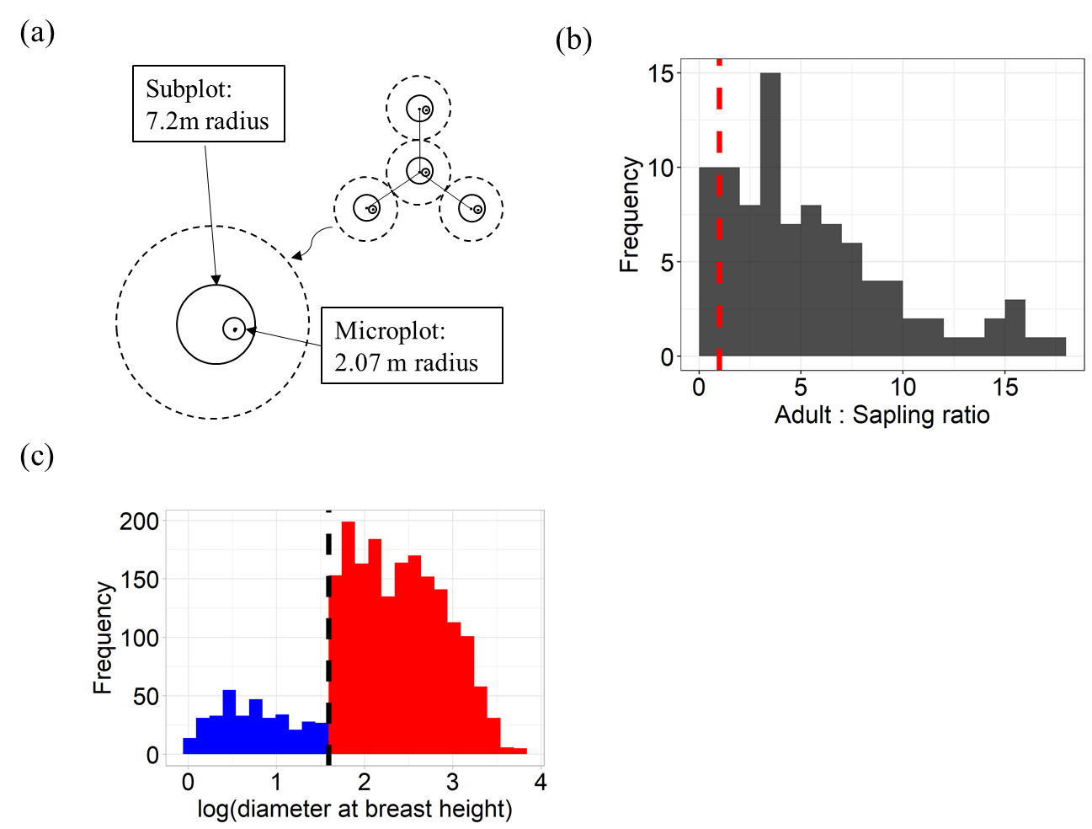

Figure 1. Sampling of trees of different sizes in the U.S. Forest Inventory and Analysis data. (a) The FIA sampling design (essential features re-drawn from https://www.fia.fs.fed.us/). The sampling area for adult trees (subplot) is roughly 12.6 times larger than the sampling area for seedlings and saplings (microplot). (b) The frequency distribution of the ratio between the number of individual adult vs. sapling trees across species in the FIA dataset. The red dashed line indicates 1:1. (c) The distribution of diameters at breast height (DBH) across all plots for one example species (Quercus michauxii) showing clear ontogenetic sampling bias. Blue bars show saplings (diameter at breast height < 12.7cm) and red bars show adult trees (dbh > 12.7cm).
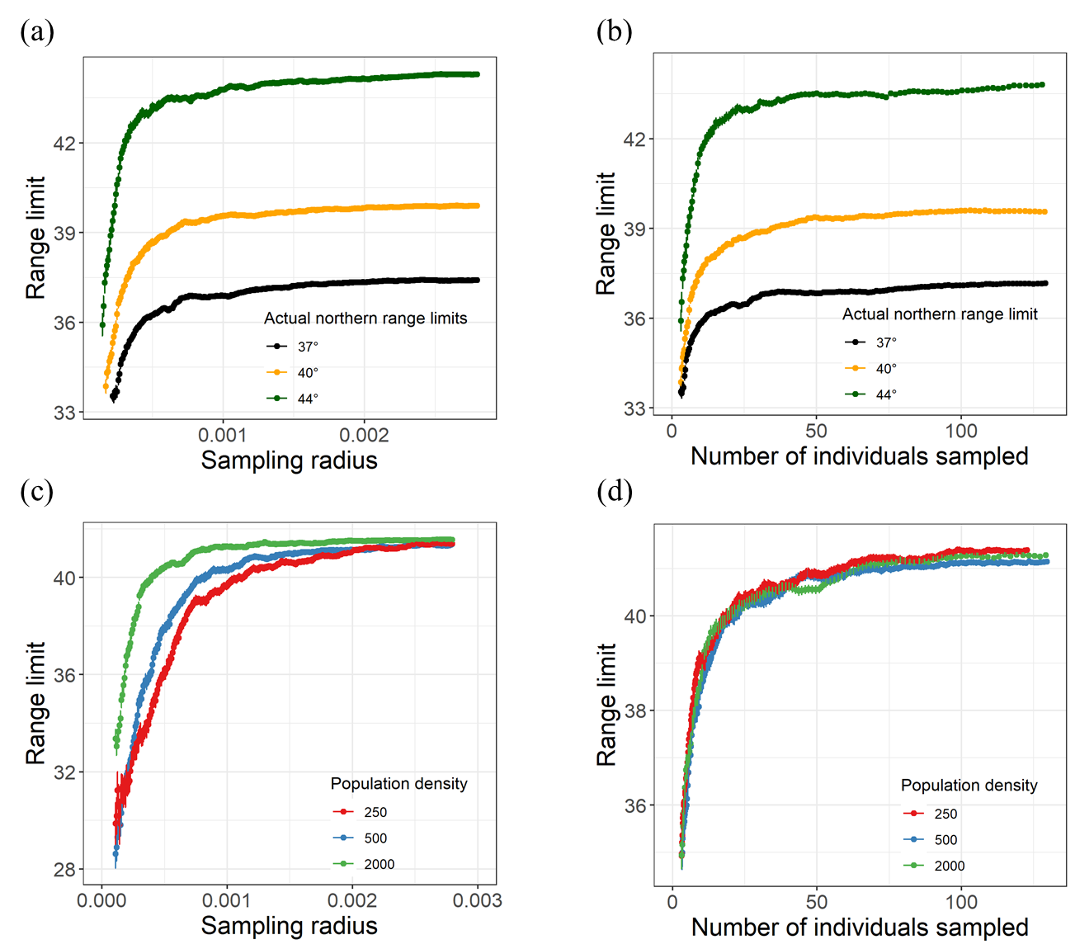

Figure 2. Results of two types of simulation model for assessing the effects of sampling (plot area and number of individuals) on the estimation of range limits. Here range limits refer to the 95th percentile latitude of sampled individuals. Error bars represents ±1 standard deviation across 100 replicates. (a) – (b) Results of Sim1, in which each population (life stage) has the same individual density but different actual range limits: 44°, 40° or 37°. (c) - (d) The results of Sim2, in which each population had the same range limit (41.5°) but different individual densities (# individuals per 1° × 1° area).

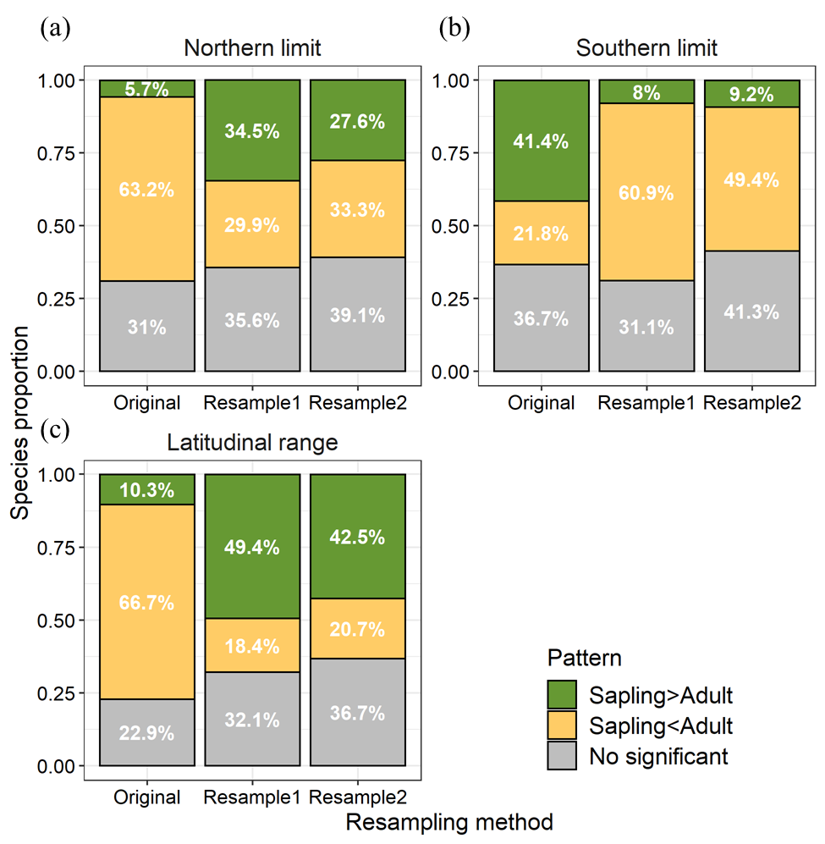

Figure 3. Latitudinal range comparisons between saplings and adult trees using different estimation methods. Results shown for (a) northern latitudinal limits (95th percentile latitude, (b) southern latitudinal limits (5th percentile latitude, and (c) the difference between the two (latitudinal range). For a given method each species showed either a significant result of Sapling > Adult (green) or Sapling < Adult (yellow) or no significant difference (grey). Analyses used either the original data or one of two resampling methods, controlling for plot size (Resample1) or the number of individuals (Resample2).

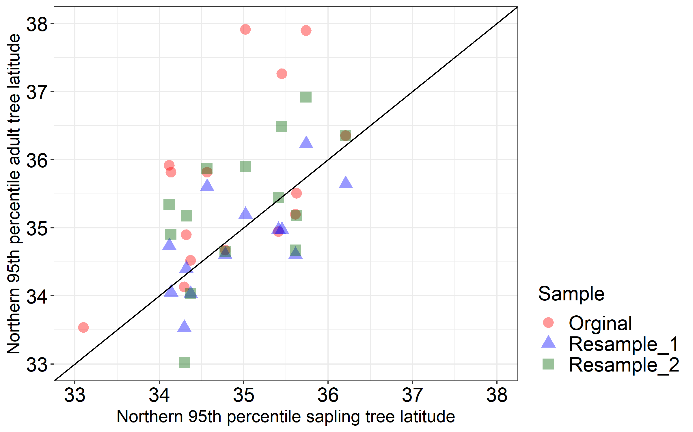

Figure 4. Results for one example species, Quercus michauxii. Estimated northern range limits of Quercus michauxii saplings (x-axis) and adult trees (y-axis), estimated in different latitudinal bands (each data point is one band) from the original dataset (red) and two resampling procedures (blue and green). Results are shown for analyses using the original data or one of two resampling procedures: resample1, standardizing area, and resample2, standardizing the number of individuals sampled.

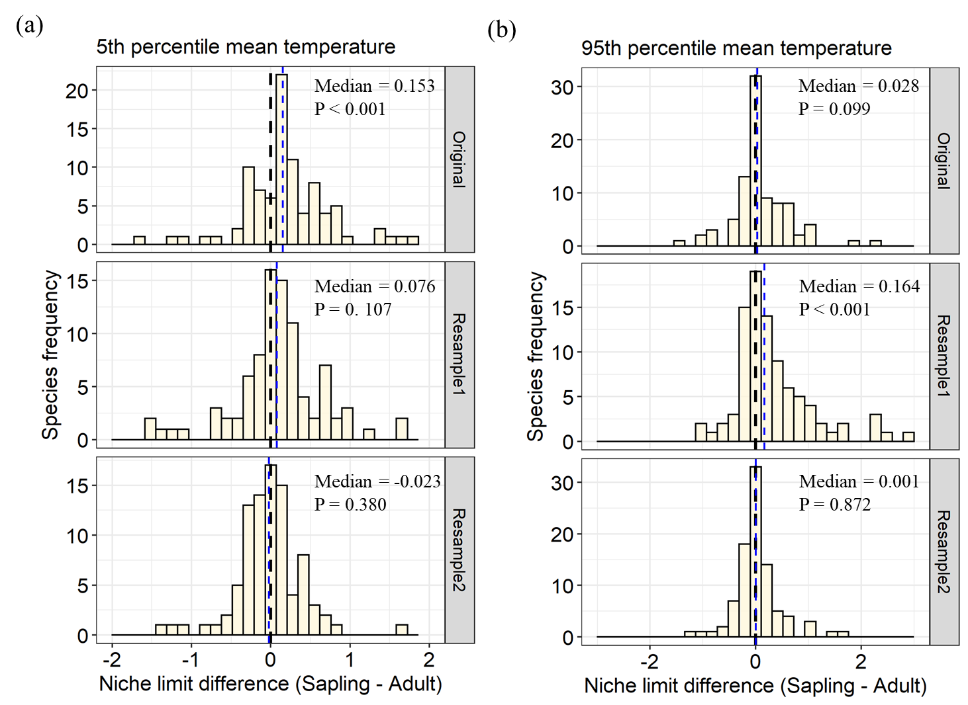

Figure 5. Niche limit comparisons for mean annual temperature between saplings and adult trees. The x-axis shows the “niche limit difference” (NLD) between saplings and adult trees at their cold (5th percentile) and warm (95th percentile) limits. Positive NLD suggests that saplings are distributed in warmer sites than adult trees; Negative NLD suggests that saplings are distributed in colder sites than adult trees. Blue dashed lines indicate the median value across 92 species, and black dashed lines indicate zero as a reference. Distributions are across species, and p values are from one-sample Wilcoxon signed rank tests. Results are shown for analyses using the original data or one of two resampling procedures: resample1, standardizing area, and resample2, standardizing the number of individuals sampled.
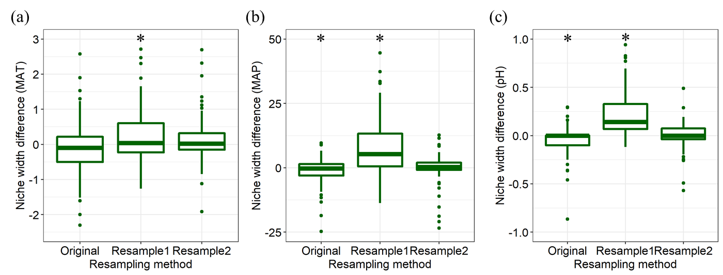

Figure 6. Niche width comparisons between saplings and adult trees for (a) mean annual temperature, (b) mean annual precipitation and (c) pH. The y-axis shows the niche width difference between saplings and adult trees (sapling – adult). Positive y-axis values indicate that saplings have wider niches than adult trees. Asterices (*) indicate significant differences from zero (P < 0.05). Results are shown for analyses using the original data or one of two resampling procedures: resample1, standardizing area, and resample2, standardizing the number of individuals sampled.

References:
AdaptWest Project. (2015). Gridded current and projected climate data for North America at 1km resolution, interpolated using the ClimateNA v5.10 software. Available at adaptwest.databasin.org.
Baldeck, C. A., Harms, K. E., Yavitt, J. B., John, R., Turner, B. L., Valencia, R., Navarrete, H., Bunyavejchewin, S., Kiratiprayoon, S., Yaacob, A., Supardi, M. N. N., Davies, S. J., Hubbell, S. P., Chuyong, G. B., Kenfack, D., Thomas, D. W., & Dalling, J. W. (2013). Habitat filtering across tree life stages in tropical forest communities. Proceedings Of the Royal Society B-Biological Sciences, 280(1766), 20130548-20130548.
Bell, D. M., Bradford, J. B., & Lauenroth, W. K. (2014). Early indicators of change: divergent climate envelopes between tree life stages imply range shifts in the western United States. Global Ecology and Biogeography, 23(2), 168-180.
Bertrand, R., Gégout, J., & Bontemps, J. (2011). Niches of temperate tree species converge towards nutrient‐richer conditions over ontogeny. Oikos, 120(10), 1479–1488.
Bertrand, R., Perez, V., & Gégout, J. (2012). Disregarding the edaphic dimension in species distribution models leads to the omission of crucial spatial information under climate change: the case of Quercus pubescens in France. Global Change Biology, 18(8), 2648–2660.
Bohner, T., Diez, J. (2019). Extensive mismatches between species distributions and performance and their relationship to functional traits. Ecology Letters, 23(1), 33-44.
Cavender-Bares, J., & Bazzaz, F. A. (2000). Changes in drought response strategies with ontogeny in Quercus rubra: implications for scaling from seedlings to mature trees. Oecologia, 124(1), 8–18.
Chao, A., & Jost, L. (2012). Coverage‐based rarefaction and extrapolation: standardizing samples by completeness rather than size. Ecology, 93(12), 2533-2547.
Chen, I.-C., Hill, J. K., Ohlemüller, R., Roy, D. B., & Thomas, C. D. (2011). Rapid range shifts of species associated with high levels of climate warming. Science, 333(6045), 1024-1026.
Comita, L. S. (2017). How latitude affects biotic interactions. Science, 356(6345), 1328-1329.
Corlett, R. T., & Westcott, D. A. (2013). Will plant movements keep up with climate change? Trends in Ecology and Evolution, 28(8), 482-488.
Danneyrolles, V., Dupuis, S., Fortin, G., Leroyer, M., de Römer, A., Terrail, R., ... & Arseneault, D. (2019). Stronger influence of anthropogenic disturbance than climate change on century-scale compositional changes in northern forests. Nature communications, 10(1), 1-7.
David, H. A., & Nagaraja, H. N. (2003). Order statistics. USA: John Wiley & Sons. Inc.
Davis, M. B., & Shaw, R. G. (2001). Range Shifts and Adaptive Responses to Quaternary Climate Change. Science, 292(5517), 673–679.
Dobrowski, S. Z., Swanson, A. K., Abatzoglou, J. T., Holden, Z. A., Safford, H. D., Schwartz, M. K., & Gavin, D. G. (2015). Forest structure and species traits mediate projected recruitment declines in western US tree species. Global Ecology and Biogeography, 24(8), 917-927.
Fei, S., Desprez, J., Potter, K., Jo, I., Knott, J., Oswalt, C. (2017). Divergence of species responses to climate change. Science Advances, 3(5), e1603055.
Grubb, P. J. (1977). The maintenance of species-richness in plant communities: the importance of the regeneration niche. Biological Reviews, 52(1), 107-145.
Knott, J., Jenkins, M., Oswalt, C., Fei, S. (2020). Community-level responses to climate change in forests of the eastern United States. Global Ecology and Biogeography, 29(8), 1299-1314.
Lankau, R. A., Zhu, K., & Ordonez, A. (2015). Mycorrhizal strategies of tree species correlate with trailing range edge responses to current and past climate change. Ecology, 96(6), 1451-1458.
Lenoir, J., Gégout, J., Pierrat, J., Bontemps, J., Dhôte, J. (2009). Differences between tree species seedling and adult altitudinal distribution in mountain forests during the recent warm period (1986–2006). Ecography, 32(5), 765-777.
Loarie, S. R., Duffy, P. B., Hamilton, H., Asner, G. P., Field, C. B., & Ackerly, D. D. (2009). The velocity of climate change. Nature, 462(7276), 1052-1055.
Nowacki, G. J., & Abrams, M. D. (2015). Is climate an important driver of post‐European vegetation change in the Eastern United States? Global Change Biology, 21(1), 314-334.
Oldfather, M., Kling, M., Sheth, S., Emery, N., Ackerly, D. (2020). Range edges in heterogeneous landscapes: Integrating geographic scale and climate complexity into range dynamics. Global Change Biology, 26(3), 1055-1067.
Ordonez, A., & Williams, J. W. (2013). Climatic and biotic velocities for woody taxa distributions over the last 16 000 years in eastern North America. Ecology Letters, 16(6), 773-781.
Oswalt, S. N., Smith, W. B., Miles, P. D., & Pugh, S. A. (2014). Forest Resources of the United States, 2012: a technical document supporting the Forest Service 2010 update of the RPA Assessment. Gen. Tech. Rep. WO-91. Washington, DC: US Department of Agriculture, Forest Service, Washington Office. 218 p., 91.
Parish, J. A. D., & Bazzaz, F. A. (1985). Ontogenetic niche shifts in old‐field annuals. Ecology, 66(4), 1296–1302.
Pintor, A. F. V., Schwarzkopf, L., & Krockenberger, A. K. (2015). Rapoport’s Rule: Do climatic variability gradients shape range extent? Ecological Monographs, 85(4), 643-659.
Quero, J. L., Gómez-Aparicio, L., Zamora, R., & Maestre, F. T. (2008). Shifts in the regeneration niche of an endangered tree (Acer opalus ssp. granatense) during ontogeny: Using an ecological concept for application. Basic and Applied Ecology, 9(6), 635–644.
Royston, J. P. (1982). Algorithm AS 177: Expected normal order statistics (exact and approximate). Journal of the royal statistical society. Series C (Applied statistics), 31(2), 161-165.
Silvertown, J., & Charlesworth, D. (2009). Introduction to plant population biology. John Wiley & Sons
Sittaro, F., Paquette, A., Messier, C., & Nock, C. A. (2017). Tree range expansion in eastern North America fails to keep pace with climate warming at northern range limits. Global Change Biology, 23(8), 3292–3301.
Stephenson, N. L., & van Mantgem, P. J. (2005). Forest turnover rates follow global and regional patterns of productivity. Ecology letters, 8(5), 524-531.
Vanderwel, M., Lyutsarev, V., Purves, D. (2013). Climate‐related variation in mortality and recruitment determine regional forest‐type distributions. Global Ecology and Biogeography, 22(11), 1192-1203.
Woodall, C. W., Oswalt, C. M., Westfall, J. A., Perry, C. H., Nelson, M. D., & Finley, A. O. (2009). An indicator of tree migration in forests of the eastern United States. Forest Ecology and Management, 257(5), 1434-1444.
Woodall, C. W., Zhu, K., Westfall, J. A., Oswalt, C. M., D’Amato, A. W., Walters, B. F., & Lintz, H. E. (2013). Assessing the stability of tree ranges and influence of disturbance in eastern US forests. Forest Ecology and Management, 291, 172-180.
Woodall, C., Westfall, J., D'Amato, A., Foster, J., Walters, B. (2018). Decadal changes in tree range stability across forests of the eastern U.S. Forest Ecology and Management, 429, 503-510.
Young, T. P., Petersen, D. A., & Clary, J. J. (2005). The ecology of restoration: historical links, emerging issues and unexplored realms. Ecology Letters, 8(6), 662-673.
Zhu, K., Woodall, C. W., & Clark, J. S. (2012). Failure to migrate: lack of tree range expansion in response to climate change. Global Change Biology, 18(3), 1042-1052.
Zhu, K., Woodall, C. W., Ghosh, S., Gelfand, A. E., & Clark, J. S. (2014). Dual impacts of climate change: forest migration and turnover through life history. Global Change Biology, 20(1), 251-264.

