Let's talk about sex: what influences researchers’ perceptions of sex differences in animal behaviour?

Pietro Pollo* & Michael M. Kasumovic

Evolution & Ecology Research Centre, School of Biological, Earth & Environmental Sciences, University of New South Wales, Kensington, Sydney 2052 NSW, Australia
* Corresponding author: pietro_pollo@hotmail.com

Abstract
The traditional theory of sexual selection posits the idea of sex roles: females should be choosy and caring, while males should be competitive and promiscuous. Despite criticism of these stereotypes from some evolutionary biologists, sex roles still appear as a norm in the literature. This may be because scientists anthropomorphize animal behaviours, which raises the question of whether human traits and experiences can influence one’s perception regarding sex differences in nature. Here we test whether age, gender, country, and research experiences are associated with different perceptions of sex roles in nature. We conducted a survey in which we asked participants about their perception of the frequency that certain behaviours associated with sex roles (promiscuity, mate choice, intrasexual competition, and parental care) occur in non-human animals for each sex. We found that participants’ country, research experience with certain taxonomic groups and research experience with sex-specific topics were associated with different perceptions of sex differences in non-human animals. Participants from more gender unequal countries showed greater agreement with the idea of sex roles. In contrast, participants who had experience with mechanisms not predicted by the idea of sex roles such as male mate choice, paternal care, and female-female competition, showed greater disagreement with the idea of sex roles than other participants. Our study reveals that personal experiences from inside and outside of academia are associated with different perspectives on sex roles. We suggest that increasing social and research diversity may benefit the study of behavioural patterns related to reproduction.

Keywords: gender roles, conventional sex roles, sex role reversal, evolutionary biology.

Significance statement
Females and males are often portrayed stereotypically in evolutionary biology in what can be called “sex roles”. Some researchers disagree with that stance and argue that this notion is built on different biases. Using a survey, we assessed whether people’s perception of sex differences in nature was associated with their traits and their experiences. We found that many factors were associated with participants’ perceptions on this matter, such as their country’s gender inequality and their research experience with certain animal groups. Our results suggest that our knowledge regarding sex differences in nature can be subjective and that we should be careful when drawing broad conclusions about behavioural differences we observe between males and females in non-human animals.

Introduction
The Darwin-Bateman paradigm predicts a set of distinct reproductive behaviours for each sex based on the fact that females produce few large eggs while males produce many tiny sperm (i.e. anisogamy; [1–3]). According to this paradigm, females should be reluctant to mate because a single male would be capable of fertilizing all a female’s eggs, which means that mating more than once should be unnecessary or even costly for females. Females should also be choosy because they would only be able to increase their reproductive success by selecting a mate that provides the most benefits. In contrast, males should compete for access to females and mate whenever possible because their reproductive success is theoretically only restrained by the number of females they can inseminate. These stereotypical expectations often appear under the label of “sex roles” in conjunction with the prefixes “traditional” or “conventional” (equivalent to “masculine and feminine syndromes” by Williams [4]) or with the suffix “reversal” to refer to cases in which males and females have supposedly exchanged their roles.
This stereotypical view was popularized by Trivers [5] when he stated that initial parental investment of each sex should predict their future behaviours. For instance, Trivers argued that the great amount of resources females invest in the offspring from the start (high gametic investment) makes the offspring extremely valuable to them. Females should then express parental care to avoid losing their investment. On the other hand, males invest little in the offspring at the gametic level, so the death of some offspring would be negligible, and males should prioritize new mates over parental care. Thus, Trivers updated the conventional sex roles from females being coy, choosy, and non-competitive and males being eager to mate, non-choosy, and competitive, to include parental roles which state that females should exert parental care while males should not. Since Trivers [5], this portrayal of sexual selection served as a guide for much of the research related to animal reproduction and essentially remains a dogma in the scientific literature [6].
Scientists are now starting to question the power of the Darwin-Bateman paradigm to explain the variety of mating patterns in the animal kingdom [3,6–10]. For example, Kokko et al. [11] stated that decisions should be made based on future payoffs, not on past investment as Trivers suggested (but see [12,13]). Most importantly, evidence that directly contradicts the conventional sex roles is accumulating: empirical data demonstrates that females are commonly polyandrous [14–16], males can be choosy [17,18], females may compete for access to males (as a limiting resource; [19]), and males may provide care [20]. Even when the sexes appear to express conventional sex roles, males and females do not express all the behavioural traits predicted by these stereotypes [21–24]. Moreover, traits that are normally used to define sex roles are not necessarily fixed. For example, mate choice can vary among individuals, over time, or can be dependent on social and environmental circumstances [18,25].
Given the diversity and lack of co-occurrence of sexually related behaviours, Ah-King & Ahnesjö [24] assert that scientists should refrain from using the term “sex roles”. However, this subject remains controversial and scientists continue to use this stereotypical term in their publications. This may be because humans, even scientists, tend to anthropomorphize animal behaviours and traits as it provides a starting point to understanding the unknown [26]. The study of sexual selection may be especially problematic because scientists —as other humans— have inherent gender stereotypes from their social context and may unconsciously apply these biases to infer patterns regarding behaviours of other organisms. It is likely that such social biases have influenced sexual selection theory from its inception. For example, Darwin [1] extensively used human behaviours (i.e. social practices) to support his ideas on sex roles, which were very similar to the gender roles accepted in the Victorian society in which he lived [27]. Social biases may be deeply connected to values from the society in which a researcher currently lives and also from early experiences in life. The influence of social bias on the study of sexual selection (and the idea of sex roles) has been speculated (e.g. [6]), but evidence that it represents a current issue is still lacking.
Our goal in this study is thus to investigate whether individual biases that arise from personal experiences can affect how humans perceive the behaviour of other organisms. We also examine the extent to which individuals perceive males and females as distinct behavioural units and whether their perception matches the stereotypes idealized by the traditional theory of sexual selection. To explore these ideas, we note that throughout this manuscript we use terms with the word “sex” (e.g. sex roles, sex differences) to refer exclusively to non-human organisms, and terms with the word “gender” (e.g. gender roles, gender differences) to refer to humans. We asked individuals to complete a survey regarding the frequency that they think certain behaviours associated with animal sex roles —promiscuity, mate choice, intrasexual competition, and parental care— occur in nature for each sex. We then asked participants to answer questions about their demography to understand how social factors can affect perceptions, as well as questions about their experience with certain taxonomic groups and sex-specific topics to understand how experiences in the research domain can influence perceptions on sex roles. Although our approach is exploratory, we use published data to outline several predictions of how personal experiences may influence individuals’ perception of the behavioural disparity between males and females in non-human animals.
First, we hypothesize that participants' demographics, such as gender and age, influence their perception of the behavioural disparity between males and females in non-human animals. Assuming that societies are becoming more equal for men and women in recent decades, older individuals may have different social biases than younger ones. This may be compounded by the fact that older people are often more conservative than their younger counterparts (e.g. [28–31]) and men may also be more conservative than women (e.g. [32–35]; but see [36]). Although conservatism is a broad term, it refers to measurements of resistance to change and acceptance of inequality (reviewed in [37]), and thus may be positively related to a more traditional view regarding gender roles in society. Following the rationale that agreement with gender roles in society is connected to less scepticism regarding sex roles in nature, we predict that men and old researchers will be more conformative to the idea of sex roles compared with other genders and younger peers.
Second, we hypothesize that gender inequality in a society can affect participants’ perception of sex roles. Men and women are more similar regarding several sex-related behaviours and attitudes in countries in which genders are more equal [38]. Countries in which men and women are more equal also present lower levels of ambivalent sexism [39,40]. As such, it is very likely that societal differences in gender inequality can have a similar effect on the perspectives of sex roles. We thus predict that the more gender-unequal the country in which a person has spent most of their life, the more likely they are to conform to the idea of sex roles in nature.
Third, we hypothesize that research experiences with certain taxonomic groups may influence scientists’ likelihood to accept or reject the idea of conventional sex roles. Although it is clear that much of our scientific knowledge on behavioural ecology and evolutionary biology is taxonomically biased [41–44], taxonomic bias may not influence all scientists in the same way. Because scientists often use species of a single taxonomic group (e.g. birds, spiders) in their research, they may have a more skewed perception of patterns occurring in the animal kingdom. However, taxonomic groups can contain different mating systems and behavioural patterns, making it particularly hard to predict how each taxonomic group can influence researchers’ perceptions. As a result, we explore the influence of research experience with specific animal taxa on researchers’ perception, but we refrain from making exact predictions.
Fourth, we hypothesize that immersing oneself into research on topics that compose the sex roles idea may influence scientists’ perception of how males and females differ on these same sex-specific topics. Accepting that working within a particular field could act as a form of priming, we predict that conformative research experience (i.e. with behaviours predicted by the idea of sex roles: female mate choice, male-male competition, maternal care) increases conformity with the idea of sex roles. Similarly, we predict that non-conformative research experience (i.e. with behaviours not predicted by the idea of sex roles: male mate choice, female-female competition, paternal care) decreases conformity with the idea of sex roles.

Material and methods
We conducted a survey with three separate sections: demographics, relevant research experience, and perception of behaviours related to sex roles (see details below). The survey was available online from 26 November 2019 to 11 May 2020 to any person that desired to participate with the only requirement being above 18 years of age. We recruited participants by sending a link to the survey to a target email list and by sharing the link to the survey on Twitter. We obtained this email list by extracting emails associated with 24,346 publications retrieved on a Web of Science search (using “sexual selection” OR “mating system$” in the topic field search, between 1999 and 2019), resulting in 15,337 unique emails. We received complete responses from a total of 1,081 participants. We note that this survey was also designed to capture the current demography of the behavioural ecology community, so it contains questions that were not directly connected to our hypotheses regarding sex roles perceptions. Although we do not discuss the answers to these additional questions, they are available with the rest of our data.

Demographics
We asked participants about their age, marital status (divorced, married, single, widowed), and current highest level of education (less than high school, high school, technical school, undergraduate or honour’s degree, master’s degree, doctoral degree). We also asked participants the country in which they have spent most of their life (open-ended) and the gender they identify as (female, male, other with option to specify). We note that our use of the terms “male” and “female” for gender may be erroneous as these are terms better associated with biological sex, while gender identity is usually associated with “man” and “woman” (with other non-binary possibilities including gender fluid or genderless). Thus, throughout the manuscript we use “man/men” to refer to participants that identified with the male gender and “woman/women” to refer to participants that identified with the female gender in our survey. This decision may be problematic as these terms are not necessarily interchangeable but are often used as synonymous by researchers and the general public in investigations on gender terms (e.g. [45,46]).

Relevant research experience
We asked participants the best term that described their current academic position (undergraduate or honours student, postgraduate student, postdoctoral researcher, professor or lecturer, other with the option to specify, no academic position at the moment) and whether one of their academic degrees or current studies is in Biological Sciences or its subareas (yes, no but with a degree in another field, no degree in any field). Then, participants answered whether they had ever conducted empirical research using non-human animals (yes, no). If they answered yes, they also answered which animal group they most used in their empirical research and which other animal groups they had experience within their empirical research (several options, see Appendix I). Next, we asked participants whether they ever had conducted research on topics involving reproduction, mating systems, or sexual selection (yes, no). If they answered yes, we also asked how many years they spent conducting research in these topics, which specific topics on sexual selection they conducted research on (several options, see Appendix I), and whether they had ever used non-statistical mathematical modelling or individual-based modelling (yes, do not know, no).

Perception of the frequency of behaviours related to sex roles
We asked participants to share their perception of the frequency (seven point scale from “never” to “always”) that certain behaviours —promiscuity, mate choice, intrasexual competition, and parental care— occur in non-human animals, each with a “female” and a “male” version (see details in Appendix I).

Data management and statistical analysis
To explore participants’ perceptions on conventional sex roles with respect to our behaviours of interest —promiscuity, mate choice, intrasexual competition, and parental care— we created a separate ordered logistic regression for each behaviour. We chose this type of regression because although our response variables were ordered, the distances between the seven points in our scale are subjective. Because participants were asked to rate the frequency of the behaviours we are exploring separately for both males and females, rather than create two separate models (i.e. one model for each sex), we created a binary dummy variable that coded participants’ responses relative to whether the sex under consideration was conformative in that behaviour (hereby known as conformity). The conformative sex for mate choice and parental care was female (females were coded as 1 and males as 0), while the conformative sex for intrasexual competition and promiscuity was male (males were coded as 1 and females as 0). Using this approach, the coefficients from our models are interpreted as how much participants conformed to the idea of sex roles. Positive values represent a perception that the conformative sex expresses a behaviour more often than the non-conformative sex (i.e. agree with the direction of sexual differences predicted by the idea of sex roles). In contrast, negative values represent a perception that the non-conformative sex expresses a behaviour more often than the conformative sex (i.e. disagree with the direction of sexual differences predicted by the idea of sex roles). As such, conformity was added as a fixed factor in each of our four regressions. We also added participants as a random factor since each participant answered each behavioural question twice, once for each sex. This formed the base model for our analyses, and we added to these models to answer our specifically outlined hypotheses.
To test our first hypothesis that individual differences influence the perception of the behavioural disparity between males and females, we used participants’ age (continuous) and gender (categorical with two levels: man were coded as 1, other genders as 0) as operational variables. According to our prediction that men and older researchers will be more conformative to the idea of sex roles, we predicted that the coefficients related to the interaction between age and conformity, and gender and conformity, are positive.
To test our second hypothesis that gender inequality can affect the perception of sex roles, we used the United Nations Development Programme’s 2018 Gender Inequality Index (GII; continuous; [47]) as an operational variable. GII is a country-related gender inequality measure that condenses several aspects related to women’s health, empowerment, and participation in the labour market into a single variable [47]. We calculated the GII for each participant by using the country in which they spent most of their life. We used this to test our prediction that the more gender unequal the country, the more likely individuals are to conform to the idea of sex roles in nature. As greater GII values represent greater gender inequality, we predicted that the coefficient of the interaction between GII and conformity is positive.
To test our third hypothesis that research experiences with certain taxonomic groups may influence scientists’ likelihood to accept or reject the idea of conventional sex roles, we used the taxonomic group that participants had the most empirical research experience with (categorical with five levels: birds, mammals, other vertebrates, invertebrates, none) as an operational variable for taxonomic bias. We had to combine several taxonomic groups into larger groups (e.g. amphibians, fish, and non-avian reptiles into “other vertebrates”) because of the low number of responses for these individual groups (see Figure S1). Participants that had no experience with empirical research with non-human animals were labelled as “none” for the taxonomic group with most experience with. They were used as reference to compare the influence of the other taxonomic groups into our response variables. Given that predictions regarding the role that a specific taxonomic group can play on individual perceptions on conformity are not straightforward, we had no a priori predictions of the coefficient of the interaction between each taxonomic group and conformity.
To test our final and fourth hypothesis that immersing oneself into research topics explicitly exploring the behaviours of interest, we added whether participants had any experience in that research field. For this analysis, we only used the experience related to the response variable in that model. For example, in the model exploring the perceived frequency of mate choice, we added two predictor variables: whether the participant had experience with female mate choice (as sex roles conformative research) and male mate choice (as sex roles non-conformative research). The only regression that did not include these predictor variables was the model in which participants’ perceived frequency of promiscuity in nature was the response variable, as polygyny and polyandry are not considered sex-specific topics in the literature of sexual selection as the other behaviours we evaluated. We predicted that that the coefficient related to the interaction between sex roles conformative research experience and conformity is positive, while the coefficient related to the interaction between sex roles non-conformative research experience and conformity is negative.
When exploring the output from each of our four models, we only focused on the coefficients of the interactions between our operational variables and conformity, ignoring the individual operational variables themselves (as additive terms of the model). This is because these terms only represent whether operational variables were associated with changes in behaviours’ perceived frequency in nature without considering the role of conformity (e.g. whether age influences how common parental care in nature is perceived, regardless of sex). We performed all our analysis using R 3.6.3 [48]. We used the function clmm2 from the package ordinal [49] to perform our ordinate logistic regressions. We standardized all continuous predictor variables to a mean of zero and then divided by two times its standard deviation (following [50]) before making the regressions. We base our inferences on the 95% confidence interval for the coefficients in our regressions. The assumption of proportional odds in our ordinal logistic regressions were not met, meaning that the effect of our explanatory variables may differ across levels. Nonetheless, we argue that our results are reliable as a linear regression (assumes that distances between our seven-point scale is fixed) leads to similar results (see Appendix III). Moreover, the proportional odds assumption is often violated when the number of explanatory variables is large [51], as it is our case.

Ethics statement
All research was approved by the ethics committee at UNSW Australia (reference number HC190901). Participants did not receive any financial benefits for answering the survey.

Results

Participant profile
We collected 1,081 responses from participants but removed the responses that were not possible (e.g. experience with sexual selection greater than age) or that were unclear in open-ended questions, decreasing our sample size to 1,057. Participants in our study ranged from 18 to 79 years old (x̄ = 43.3, SD = 11.61). Approximately 44.2% of the participants identified themselves as women, 55% of the participants identified themselves as men, and the remaining 0.8% participants did not identify themselves as one of these binary genders (e.g. agender/non-binary). Roughly 71.6% of the participants reported that they were or had been married (currently married, divorced, or widowed). We obtained 54 different responses regarding the country in which participants spent most of their life: the United States of America was the most common answer (27.4%), followed by Canada and Brazil (7.5% each, see Figure S2).
Most of the participants in our study reported that they had a Doctoral degree (86.6%), were a postdoctoral fellow or a professor/lecturer (74.7%), and had at least one academic degree in Biology or its subareas (95.4%). The majority of the participants had experience with empirical research with non-human animals (88.7%): 16.7% of them mainly worked with birds, 16.7% with mammals, 21.5% with other vertebrates, and 33.8% with invertebrates (Figure S1). Although most of the participants declared that they had experience with topics involving reproduction, mating systems, or sexual selection (92.1%), only 81.1% of participants had experience with at least one of the specific topics we were interested in (i.e. mate choice, intrasexual competition, or parental care, with males or females).

Perception of sex differences in non-human animals
Participants’ perception of the frequency that certain behaviours occur in nature changes with animals’ sex (Figure 1). On average, participants perceived that females express parental care and mate choice more often than males. On the other hand, participants perceived males as more competitive and promiscuous than females. This can also be seen in the coefficients related to conformity in our ordinate logistic regressions that were positive for all behaviours (Figure 2).

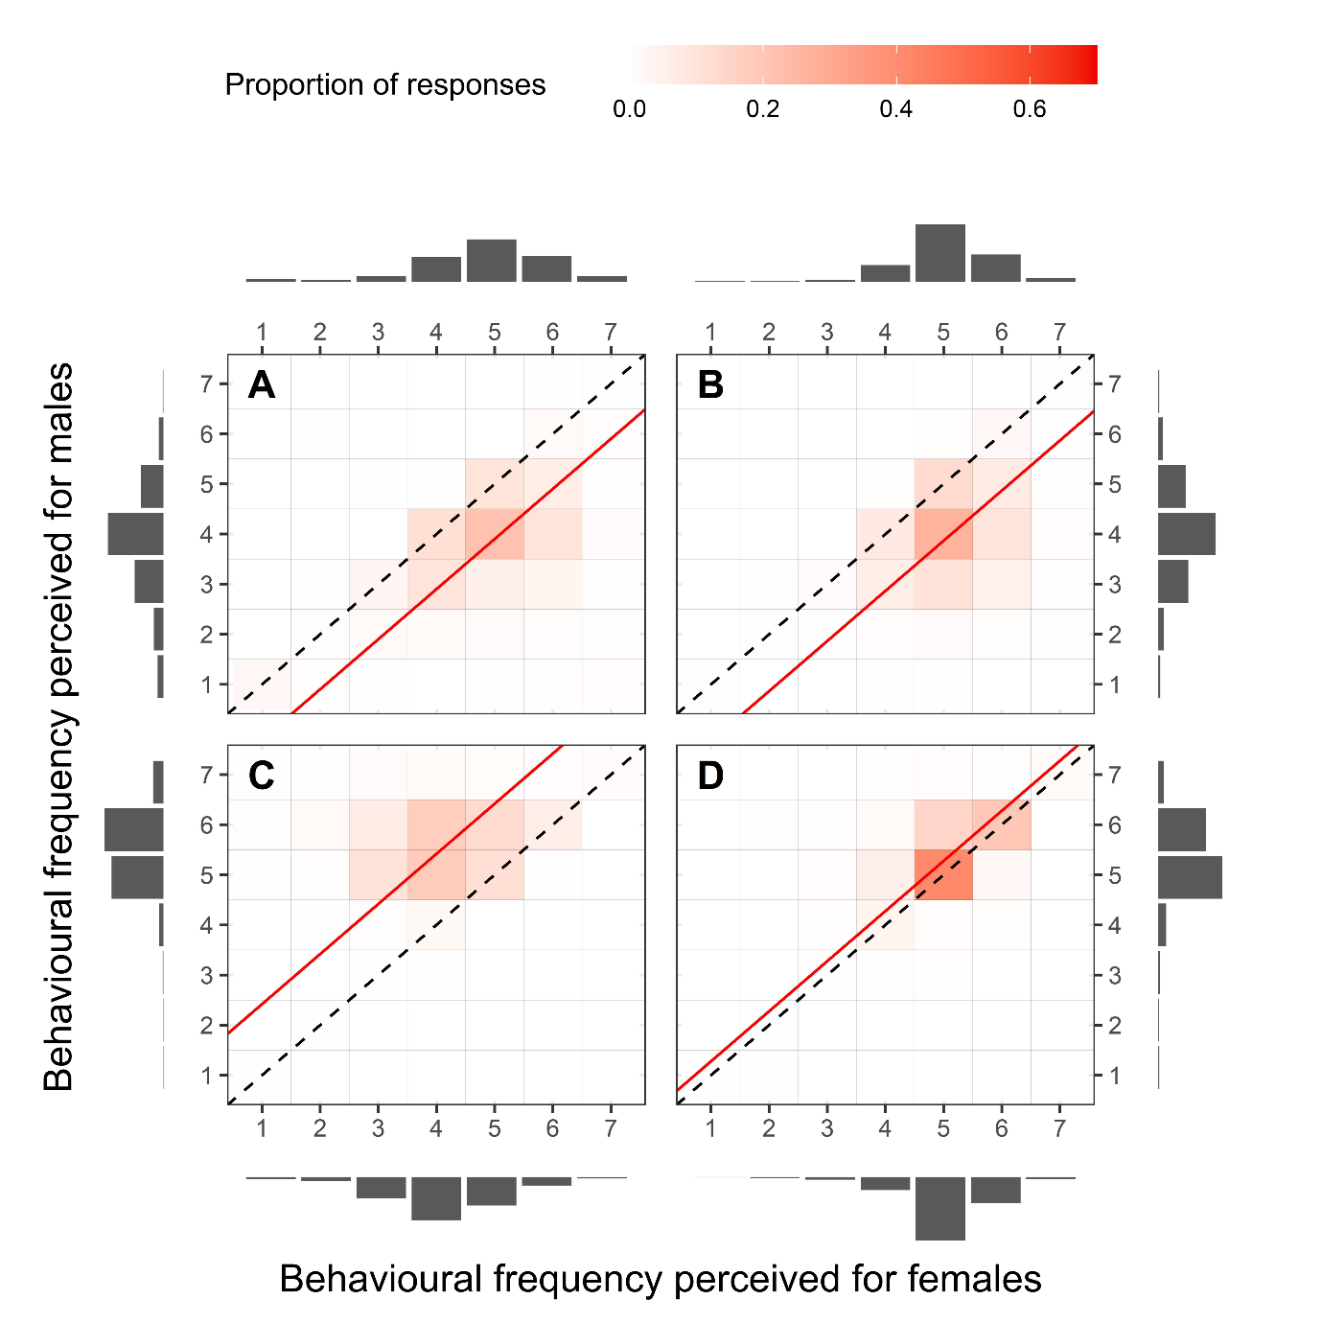
Figure 1. Participants’ perception of the frequency that certain behaviours ((A) parental care, (B) mate choice, (C) intrasexual competition, (D) promiscuity) are expressed by females (x-axis) and males (y-axis) in non-human animals. Dashed lines emphasize when participants’ responses were the same for both males and females. Red continuous lines represent the mean values from participants in our study: if above the dashed line, represents an average perception that males express a given behaviour more often than females; if below the dashed line, represents an average perception that females express a given behaviour more often than males.

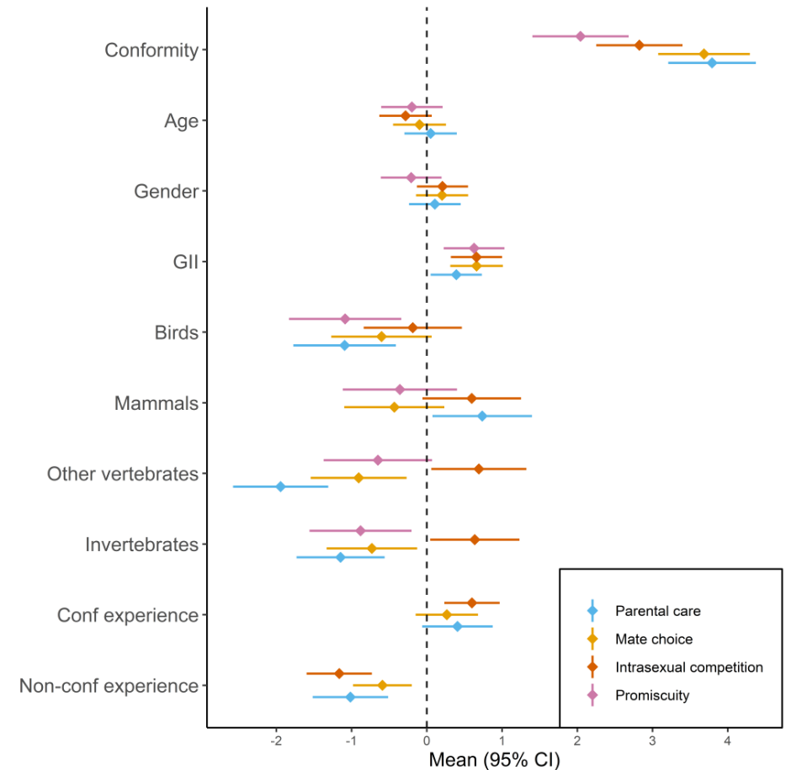
Figure 2. Explanatory variables’ coefficients from ordered logistic regressions regarding participants’ perception of the frequency that certain behaviours occur in nature. Positive values indicate that a variable is associated with an increased agreement with the direction predicted by idea of sex roles for that behaviour. Variables shown represent the interaction terms with conformity (see Material and methods). GII stands for Gender Inequality Index [47].
Regarding our first hypothesis that participants’ individual differences influence the perception of the behavioural disparity between males and females, we found that gender and age coefficients were not different from zero. This means that contrary to our prediction, these factors had little to no association with differences in perception of reproductive behaviours between the sexes.
For our second hypothesis that the gender inequality affects participants’ perception of sex roles, we found that the gender inequality index (GII) of the country in which a participant spent most of their life was positive for all the behaviours evaluated. Our results thus confirm our prediction that the greater the GII of the country in which a participant spent most of their life, the more conformative their perception related to the idea of sex roles.
Our results exploring our third hypothesis that certain taxonomic groups may influence scientists’ likelihood to accept or reject the idea of conventional sex roles varied dramatically according to each behaviour and with each taxonomic group. For instance, regarding intrasexual competition, coefficients related to primary experience with mammals and birds were not different from zero, but were positive with other vertebrates and invertebrates. For mate choice, coefficients related to primary experience with mammals and birds were not different from zero but were negative with other vertebrates and invertebrates. Regarding parental care, the coefficient related to primary experience with mammals was positive, but with other taxonomic groups (birds, other vertebrates, invertebrates) was negative. And finally, for promiscuity, coefficients related to primary experience with birds and invertebrates were negative, but were not different from zero with mammals and other vertebrates.
Our results exploring our fourth hypothesis that experience with a research topic can affect participants’ perception of sex roles partially supported our predictions; the coefficients related to experience with non-conformative research were all negative, while the coefficients related to experience with conformative research were not different from zero for mate choice and parental care, but was positive for intrasexual competition. We interpret our results to mean that scientists with non-conformative research experience believe that females and males behave less differently than people without research experience. In contrast, scientists with conformative research experience and people without research experience perceive sex differences in mate choice and parental care similarly. However, scientists that worked with male-male competition (conformative experience) perceive that males are more competitive than females relative to people without research experience with intrasexual competition.

Discussion
In this study, we aimed to understand whether individual differences, gender inequality and research experiences (taxonomic and sex-specific topics related) affect the perceptions that individuals have of sex roles in non-human animals. Overall, our survey results demonstrate that individuals generally had conformative ideas about how each sex behaved: females were perceived as providing more parental care and being choosier, and males were perceived as more competitive and promiscuous. We also found that these conformative perceptions were affected by experiences from both inside and outside of academia.
Although our results show that people have a conformative perception of sex roles in direction, the magnitude of their perception of sex differences is not as large as we expected (Figure 1). This is especially true for promiscuity as shown by the lower coefficient value for conformity (Figure 2) and as most participants (approximately 67.3%; Figure 1) answered that polyandry occurs with the same frequency as polygyny. This can be explained by the fact that polyandry has recently received a surge of interest, culminating in the recognition that females are not as coy as once thought [14–16]. Perhaps a similar pattern would occur if researchers were to shift their research efforts in a similar vein when exploring parental care, intrasexual competition, and mate choice as well. We emphasize that our results do not represent evidence regarding sex differences in nature, but rather people’s (most of them researchers) perception about it. If this investigation were conducted 30 years ago, we would possibly have a different response because the literature at that time was more restricted as was the culture regarding human sexual behaviours [52].
We found little support for our hypothesis that individual differences (age and gender) influence individuals’ perception of sex roles in nature. Although these traits are often associated with differences in conservatism (e.g. [28–35]), they may only be confounding factors if they are related to other variables that truly cause conservative patterns. For instance, Cornelis et al. [53] found that personality traits (such as openness to experience) can partially explain the relationship between age and conservatism; older people tend to be less open to new ideas than their younger counterparts. Similarly, Pratto et al. [54] found that social dominance orientation can partially explain the relationship between gender and conservatism. Thus, if participants in our study present more homogeneous openness to experience and social dominance orientation as most of them are researchers, then the relationship of age and gender with conservatism may not exist as strongly in academic environments. It is also possible that although conservatism may predict peoples’ attitudes towards gender roles in human societies, it may not translate to sex differences in non-human animals. Alternatively, the diverse cultural background of our sample of participants might have obfuscated the relationship between gender or age and their perception of sex differences in nature, just as gender differences in human sexual behaviours and attitudes are subjected to cultural changes [52,55].
In contrast, we found support for our hypothesis that gender inequality is associated with changes in perception regarding behavioural sex differences in non-human animals. The Gender Inequality Index (GII; [47]) was a predictor of perception regarding sex roles conformity: the more gender-unequal the country a participant spent most of their life, the greater their agreement with the idea of sex roles. This leads to the possibility that the research output from a country may be biased by the researchers that live there, depending on how diverse academia is in that country (e.g. proportion of researchers from abroad). For instance, a gender-unequal country in which most researchers are domestic may generate research focused on topics that conform to the idea of sex roles, as our results suggest that these researchers are more prone to agree with this concept. Although here we only speculate, this could be verified by comparing the amount of published studies involving sex-specific behaviours that are conformative to the idea of sex roles (e.g. female mate choice) with the amount of published studies involving sex-specific behaviours that are non-conformative to the idea of sex roles (e.g. male mate choice) for each country. Our results may show how social diversity in science can be important to scientific development if it promotes the influx of different perceptions and creates a wider debate about it.
A result that we found particularly interesting was that empirical research experience with certain taxonomic groups can generate distinct perspectives on behavioural differences between the sexes. Despite this, there was no clear pattern between empirical research experience with a taxonomic group and a more agreeable or disagreeable perception of the idea of sex roles for all behaviours evaluated (Figure 2). For instance, compared with people without empirical research experience, working with invertebrates decreases sex roles conformity related to parental care, mate choice, and promiscuity, but increases sex roles conformity related to intrasexual competition. On the other hand, empirical experience with certain taxonomic groups increased (e.g. mammals) or decreased (e.g. birds) sex roles conformity regarding some behaviours, but did not change sex roles conformity regarding other behaviours compared with people without empirical research experience. For example, a more conformative view of parental care was seen in researchers studying mammals (i.e. maternal care), while a more non-conformative view of parental care (i.e. paternal care is common) was seen by researchers studying birds. Despite this more intuitive association, it is difficult to understand our specific results regarding how research experience with each taxon generates different bias for each behaviour because relevant data is too widespread across the literature. For example, intrasexual competition is partitioned into subcategories (i.e. scramble competition, sperm competition, and physical contests; [56]) and it is mostly investigated in males (e.g. [57]), making it extremely difficult to trace patterns in sex differences for this behaviour in each taxon. Our study uses higher taxonomic groups (at the phylum or order level), suggesting that having detailed information on animal groups that people work with (at the genus or species level) may result in different effects on how personal taxonomic experiences can shape our perceptions on sex differences in nature. Our understanding of taxonomic bias comes mainly from literature surveys (e.g. [41–44]), but here we show that taxonomic bias can also arise from personal experiences.
We found mixed support for our hypothesis that research experience with sex-specific topics is associated with different perceptions of the idea of sex roles. While researchers that worked with paternal care believe that males and females express parental care more alike in frequency than inexperienced people, researchers that worked with maternal care show a similar perception to inexperienced people. We found the same pattern for mate choice: researchers that worked with male mate choice believe that males and females express mate choice more alike in frequency than inexperienced people, while researchers that worked with female mate choice show a similar perception to inexperienced people. On the other hand, compared with inexperienced people, researchers that worked with female-female competition believe that males and females express intrasexual competition more alike in frequency, while researchers that worked with male-male competition believe that males are even more competitive than females. It is unclear why non-conformative experience decreased participant conformity with sex roles while conformative experience did not increase participant conformity with sex roles (except for intrasexual competition). One possibility is that the idea of sex roles is still widely propagated in outlets that reach inexperienced people (such as evolution and behavioural ecology textbooks) which mostly show examples of competitive males and choosy females ([58]; e.g. [59,60]). As a consequence, researchers that then work with topics that confirm the idea of sex roles (i.e. conformative experience; e.g. maternal care, female mate choice, male-male competition) just continue to perceive sex differences as they would before because their belief is confirmed by their experience. In contrast, researchers that worked with sex-specific topics that are not predicted by the idea of sex roles (i.e. non-conformative experience, e.g. paternal care, male mate choice, female-female competition) are exposed to a “hidden” literature filled with counter-examples to the idea of sex roles. Following this rationale, we would possibly see a more neutral perception from the inexperienced public if non-conformative examples were given more coverage in outlets that target them. Most importantly, our results suggest that we should encourage researchers to explore the same topics in both sexes; e.g. when exploring mate choice in a given species, why not test whether both males and females can be choosy? Doing so might reduce the bias that researchers show when working with only one sex in their careers.
Some researchers claim that, despite the diversity found on the sexual behaviours expressed by both sexes, “there are clear non-random patterns in the distribution of sex roles and sexual dimorphism throughout the animal kingdom” ([61]; re-stated by [12], but see [62]). Our results show that people differ in their perception of sex roles depending on their experiences, suggesting that our knowledge on sex differences in non-human animals can be subjective. One may argue that quantitative analyses may provide a data-based solution, but this should not be a trivial quest. For instance, Janicke et al. [63] claimed to confirm the existence of sex roles in a meta-analysis but used the term sex roles to refer to patterns of sexual selection (e.g. sexual dimorphism), not behavioural processes (e.g. mate choice; [64]). In addition, most of the data used in Janicke et al.’s [63] were from vertebrates, revealing that broad patterns are being inferred with potential taxonomic bias. Quantitative analyses on the behavioural disparity between the sexes are especially difficult because behaviours are commonly investigated in one sex and assumed to be non-existent in the other one. In fact, if scientists focus their efforts investigating certain sex-specific mechanisms (e.g. female mate choice) while neglecting others (e.g. male mate choice) then these “non-random patterns” referred by Schärer et al. [61] may simply be a result of non-random patterns of research. For now, we cannot make extremely broad inferences about sex differences in behaviour given that our knowledge can be a product of multiple biases. To solve this problem, we suggest that existing data should first be well compiled to identify which sex-specific mechanisms and taxonomic groups have been overlooked. Furthermore, we suggest that empirical research should be conducted with the assumption that both sexes are able to express reproductive behaviours to minimize bias. At last, we advocate that researchers would benefit from diversifying their experiences (i.e. working with different sex-specific topics and taxonomic groups) as this would expand their view of behavioural differences between the sexes to beyond what is typically shown in most outlets.

References
1. Darwin C. 1871 The descent of man, and selection in relation to sex. London, UK: John Murray.
2. Bateman AJ. 1948 Intra-sexual selection in Drosophila. Heredity (Edinb). 2, 349–368. (doi:10.1038/hdy.1948.21)
3. Dewsbury DA. 2005 The Darwin-Bateman paradigm in historical context. Integr. Comp. Biol. 45, 831–837. (doi:10.1093/icb/45.5.831)
4. Williams GC. 1966 Natural selection, the costs of reproduction, and a refinement of Lack’s principle. Am. Nat. 100, 687–690. (doi:10.1086/282461)
5. Trivers RL. 1972 Parental investment and sexual selection. In Sexual selection and the descent of man: 1871-1971 (ed B Campbell), pp. 136–179. Chicago, IL: Aldine Publishing Company.
6. Tang-Martinez Z. 2016 Rethinking Bateman’s principles: challenging persistent myths of sexually reluctant females and promiscuous males. J. Sex Res. 53, 532–559. (doi:10.1080/00224499.2016.1150938)
7. Tang-Martinez Z, Ryder TB. 2005 The problem with paradigms: Bateman’s worldview as a case study. Integr. Comp. Biol. 45, 821–830. (doi:10.1093/icb/45.5.821)
8. Snyder BF, Gowaty PA. 2007 A reappraisal of Bateman’s classic study of intrasexual selection. Evolution (N. Y). 61, 2457–2468. (doi:10.1111/j.1558-5646.2007.00212.x)
9. Gowaty PA, Kim Y-K, Anderson WW. 2012 No evidence of sexual selection in a repetition of Bateman’s classic study of Drosophila melanogaster. Proc. Natl. Acad. Sci. U. S. A. 109, 11740–11745. (doi:10.1073/pnas.1207851109)
10. Hoquet T. 2020 Bateman (1948): rise and fall of a paradigm? Anim. Behav. 164, 223–231. (doi:10.1016/j.anbehav.2019.12.008)
11. Kokko H, Jennions MD. 2008 Parental investment, sexual selection and sex ratios. J. Evol. Biol. 21, 919–948. (doi:10.1111/j.1420-9101.2008.01540.x)
12. Kokko H, Booksmythe I, Jennions MD. 2013 Causality and sex roles: prejudice against patterns? A reply to Ah-King. Trends Ecol. Evol. 28, 2–4. (doi:10.1016/j.tree.2012.08.008)
13. Fromhage L, Jennions MD. 2016 Coevolution of parental investment and sexually selected traits drives sex-role divergence. Nat. Commun. 18, 12517. (doi:10.1038/ncomms12517)
14. Pizzari T, Wedell N. 2013 The polyandry revolution. Philos. Trans. R. Soc. B Biol. Sci. 368, 20120041. (doi:10.1098/rstb.2012.0041)
15. Parker GA, Birkhead TR. 2013 Polyandry: the history of a revolution. Philos. Trans. R. Soc. B Biol. Sci. 368, 20120335. (doi:10.1098/rstb.2012.0335)
16. Taylor ML, Price TAR, Wedell N. 2014 Polyandry in nature: a global analysis. Trends Ecol. Evol. 29, 376–383. (doi:10.1016/j.tree.2014.04.005)
17. Bonduriansky R. 2001 The evolution of male mate choice in insects: a synthesis of ideas and evidence. Biol. Rev. 76, 305–339. (doi:10.1017/s1464793101005693)
18. Edward DA, Chapman T. 2011 The evolution and significance of male mate choice. Trends Ecol. Evol. 26, 647–654. (doi:10.1016/j.tree.2011.07.012)
19. Berglund A, Magnhagen C, Bisazza A, König B, Huntingford F. 1993 The adaptive bases of female sexual behavior: reports from a workshop. Behav. Ecol. 4, 184–187. (doi:10.1093/beheco/4.2.184)
20. Ridley M. 1978 Paternal care. Anim. Behav. 26, 904–932. (doi:10.1016/0003-3472(78)90156-2)
21. Barlow GW. 2005 How do we decide that a species is sex-role reversed? Q. Rev. Biol. 80, 28–35. (doi:10.1086/431022)
22. Houde AE. 2002 Sex roles, ornaments, and evolutionary explanation. Proc. Natl. Acad. Sci. U. S. A. 98, 12857–12859. (doi:10.1073/pnas.241503598)
23. Bonduriansky R. 2009 Reappraising sexual coevolution and the sex roles. Plos Biol. 7, 2–4. (doi:10.1371/journal.pbio.1000255)
24. Ah-King M, Ahnesjö I. 2013 The ‘sex role’ concept: an overview and evaluation. Evol. Biol. 40, 461–470. (doi:10.1007/s11692-013-9226-7)
25. Jennions MD, Petrie M. 1997 Variation in mate choice and mating preferences: a review of causes and consequences. Biol. Rev. 72, 283–327. (doi:10.1111/j.1469-185X.1997.tb00015.x)
26. Kokko H. 2017 Give one species the task to come up with a theory that spans them all: what good can come out of that? Proc. R. Soc. B Biol. Sci. 284, 20171652. (doi:10.1098/rspb.2017.1652)
27. Ruse M. 2015 Sexual selection: why does it play such a large role in the descent of man? In Current perspectives on sexual selection (ed T Hoquet), pp. 3–17. Dordrecht: Springer.
28. Truett KR. 1993 Age differences in conservatism. Pers. Individ. Dif. 14, 405–411. (doi:10.1016/0191-8869(93)90309-Q)
29. Henningham JP. 1996 A 12-item scale of social conservatism. Pers. Individ. Dif. 20, 517–519. (doi:10.1016/0191-8869(95)00192-1)
30. Maltby J. 1997 The concurrent validity of a short measure of social conservatism among English students. Pers. Individ. Dif. 23, 901–903. (doi:10.1016/S0191-8869(97)00115-3)
31. Grant MJ, Ross AS, Button CM, Hannah TE, Hoskins R. 2001 Attitudes and stereotypes about attitudes across the lifespan. Soc. Behav. Pers. 29, 749–762. (doi:10.2224/sbp.2001.29.8.749)
32. Sidanius J, Ekehammar B. 1980 Sex‐related differences in socio‐political ideology. Scand. J. Psychol. 21, 17–26. (doi:10.1111/j.1467-9450.1980.tb00336.x)
33. Sidanius J, Ekehammar B. 1983 Sex, political party preference, and higher-order dimensions of sociopolitical ideology. J. Psychol. Interdiscip. Appl. 115, 233–239. (doi:10.1080/00223980.1983.9915440)
34. Marjoribanks K. 1981 Sex‐related differences in socio‐political attitudes: a replication. Educ. Stud. 7, 1–6. (doi:10.1080/0305569810070101)
35. Furnham A. 1985 Adolescents’ sociopolitical attitudes: a study of sex and national differences. Polit. Psychol. 6, 621. (doi:10.2307/3791020)
36. Eagly AH, Johannesen-Schmidt MC, Diekman AB, Koenig AM. 2004 Gender gaps in sociopolitical attitudes: a social psychological analysis. J. Pers. Soc. Psychol. 87, 796–816. (doi:10.1037/0022-3514.87.6.796)
37. Jost JT, Glaser J, Kruglanski AW, Sulloway FJ. 2003 Political conservatism as motivated social cognition. Psychol. Bull. 129, 339–375. (doi:10.1037/0033-2909.129.3.339)
38. Petersen JL, Hyde JS. 2010 A meta-analytic review of research on gender differences in sexuality, 1993–2007. Psychol. Bull. 136, 21–38. (doi:10.1037/a0017504)
39. Glick P, Diebold J, Bailey-Werner B, Zhu L. 1997 The two faces of Adam: ambivalent sexism and polarized attitudes toward women. Personal. Soc. Psychol. Bull. 23, 1323–1334. (doi:10.1177/01461672972312009)
40. Glick P et al. 2000 Beyond prejudice as simple antipathy: hostile and benevolent sexism across cultures. J. Pers. Soc. Psychol. 79, 763–775. (doi:10.1037/0022-3514.79.5.763)
41. Bonnet X, Shine R, Lourdais O. 2002 Taxonomic chauvinism. Trends Ecol. Evol. 17, 2000–2002. (doi:10.1016/S0169-5347(01)02381-3)
42. Stahlschmidt ZR. 2011 Taxonomic chauvinism revisited: insight from parental care research. PLoS One 6, 6–9. (doi:10.1371/journal.pone.0024192)
43. Zuk M, Garcia-Gonzalez F, Herberstein ME, Simmons LW. 2013 Model systems, taxonomic bias, and sexual selection: beyond Drosophila. Annu. Rev. Entomol. 59, 321–338. (doi:10.1146/annurev-ento-011613-162014)
44. Rosenthal MF, Gertler M, Hamilton AD, Prasad S, Andrade MCB. 2017 Taxonomic bias in animal behaviour publications. Anim. Behav. 127, 83–89. (doi:10.1016/j.anbehav.2017.02.017)
45. Bauer GR, Braimoh J, Scheim AI, Dharma C. 2017 Transgender-inclusive measures of sex/gender for population surveys: mixed-methods evaluation and recommendations. PLoS One 12, 1–28. (doi:10.1371/journal.pone.0178043)
46. Fraser G, Bulbulia J, Greaves LM, Wilson MS, Sibley CG. 2019 Coding responses to an open-ended gender measure in a New Zealand national sample. J. Sex Res. 00, 1–8. (doi:10.1080/00224499.2019.1687640)
47. UNDP. 2018 Human development indices and indicators 2018. New York, NY: United Nations. (doi:10.18356/656a3808-en)
48. R Core Team. 2020 R: a language and environment for statistical computing.
49. Christensen RHB. 2019 ordinal - regression models for ordinal data.
50. Gelman A. 2008 Scaling regression inputs by dividing by two standard deviations. Stat. Med. 27, 2865–2873. (doi:10.1002/sim.3107)
51. Brant R. 1990 Assessing proportionality in the proportional odds model for ordinal logistic regression. Biometrics 46, 1171. (doi:10.2307/2532457)
52. Twenge JM, Sherman RA, Wells BE. 2015 Changes in american adults’ sexual behavior and attitudes, 1972–2012. Arch. Sex. Behav. 44, 2273–2285. (doi:10.1007/s10508-015-0540-2)
53. Cornelis I, Van Hiel A, Roets A, Kossowska M. 2009 Age differences in conservatism: evidence on the mediating effects of personality and cognitive style. J. Pers. 77, 51–88. (doi:10.1111/j.1467-6494.2008.00538.x)
54. Pratto F, Stallworth LM, Sidanius J. 1997 The gender gap: differences in political attitudes and social dominance orientation. Br. J. Soc. Psychol. 36, 49–68. (doi:10.1111/j.2044-8309.1997.tb01118.x)
55. Wells BE, Twenge JM. 2005 Changes in young people’s sexual behavior and attitudes, 1943-1999: a cross-temporal meta-analysis. Rev. Gen. Psychol. 9, 249–261. (doi:10.1037/1089-2680.9.3.249)
56. Andersson M. 1994 Sexual selection. Princeton, New Jersey: Princeton University Press.
57. Emlen DJ. 2008 The evolution of animal weapons. Annu. Rev. Ecol. Evol. Syst. 39, 387–413. (doi:10.1146/annurev.ecolsys.39.110707.173502)
58. Ah-King M. 2013 Queering animal sexual behavior in biology textbooks. Confero Essays Educ. Philos. Polit. 1, 46–89. (doi:10.3384/confero.2001-4562.13v1i21d)
59. Futuyma DJ, Kirkpatrick M. 2017 Evolution. Sunderland, MA: Sinauer Associates, Inc.
60. Dugatkin LA. 2019 Principles of animal behavior. Chicago, IL: University of Chicago Press. (doi:10.7208/chicago/9780226448411.001.0001)
61. Schärer L, Rowe L, Arnqvist G. 2012 Anisogamy, chance and the evolution of sex roles. Trends Ecol. Evol. 27, 260–264. (doi:10.1016/j.tree.2011.12.006)
62. Ah-King M. 2013 On anisogamy and the evolution of ‘sex roles’. Trends Ecol. Evol. 28, 1–2. (doi:10.1016/j.tree.2012.04.004)
63. Janicke T, Häderer IK, Lajeunesse MJ, Anthes N. 2016 Darwinian sex roles confirmed across the animal kingdom. Sci. Adv. 2, e1500983. (doi:10.1126/sciadv.1500983)
64. Ahnesjö I, Bussière LF. 2016 RE: response on the Darwinian sex roles. Sci. Adv. See https://advances.sciencemag.org/sites/default/files/response_attachments/2016/03/ResponseDarwiniansexrole.pdf.

Appendix I: Survey

PART 1: Demographics
1. How old are you? __[fill]__

2. What gender do you identify as?
o Female
o Male
o Other (please specify) __[fill]__

3. What is your marital status?
o Divorced
o Married
o Single
o Widowed

4. In what country have you spent most of your life? __[fill]__

5. What is your current highest level of education? (obtained degree, DO NOT consider current studies)
o Less than high school
o High school
o Technical school
o Undergraduate/Honours degree
o Master’s degree
o Doctoral degree

PART 2: Relevant research experience
6. What is the best term that fits your current academic position?
o Undergraduate/Honours student
o Postgraduate student
o Postdoctoral researcher
o Professor (or any variation of professorship/lecturer)
o Other (please specify) __[fill]__
o I do not hold any academic position at this moment

7. Is one of your academic degrees or current studies in Biology/Biological Sciences (or its subareas; e.g., Ecology, Zoology, Botany, Genetics)?
o Yes, one of my academic degrees or current studies is in Biology/Biological Sciences or its subareas
o No, but I have or I am pursuing an academic degree in another field (please specify) __[fill]__
o No, I do not have nor I am pursuing an academic degree

8. Have you ever conducted empirical research using non-human animals? *Empirical research is based on observational or experimental data collection.
o Yes, I have
o No, I have not

9. [only for those who answered ‘yes’ on q8] Please select the animal group that you have used the most in your empirical research.
o Annelids
o Arthropods: arachnids
o Arthropods: crustaceans
o Arthropods: insects
o Arthropods: myriapods
o Chordates: amphibians
o Chordates: birds
o Chordates: mammals
o Chordates: non-avian reptiles
o Chordates: fish
o Echinoderms
o Molluscs
o Other (please specify) __[fill]__

10. [only for those who answered ‘yes’ on q8] Please select OTHER animal group(s) that you have used in your empirical research. Select all that apply.
□ None (I have only used one animal group in my empirical research)
□ Annelids
□ Arthropods: arachnids
□ Arthropods: crustaceans
□ Arthropods: insects
□ Arthropods: myriapods
□ Chordates: amphibians
□ Chordates: birds
□ Chordates: mammals
□ Chordates: non-avian reptiles
□ Chordates: fish
□ Echinoderms
□ Molluscs
□ Other(s) (please specify) __[fill]__

11. Have you ever conducted research (empirical or theoretical) on topics involving reproduction, mating systems or sexual selection?
o Yes, I have
o No, I have not

12. [only for those who answered ‘yes’ on q11] How many years have you spent on research on topics involving reproduction, mating systems or sexual selection, approximately? You may round up the number, so if you started your research less than a year ago, you can say “1”. __[fill]__

13. [only for those who answered ‘yes’ on q11] Which of the following topics have you conducted research on? Select all that apply.
□ Female mate choice
□ Male mate choice
□ Female-female competition
□ Male-male competition
□ Maternal care
□ Paternal care
□ Sexual conflict
□ Other(s) (please specify) __[fill]__

14. [only for those who answered ‘yes’ on q11] Have you used mathematical modelling or individual-based modelling to conduct research involving reproduction, sexual selection or mating systems topics? Do not consider statistical tests/models (e.g. ANOVAs, GLMs, PCAs) for this question.
o Yes, I have
o I do not know if I have
o No, I have not

PART 3: Perception of the frequency of behaviours related to sex roles
15. Considering only non-human animals, what is the frequency that you estimate that… *There are no wrong answers, we are interested in your personal perception.

… females copulate with more than one male in a single reproductive season? | Never | Almost never | Rarely | Occasionally | Often | Almost always | Always
… males copulate with more than one female in a single reproductive season? | Never | Almost never | Rarely | Occasionally | Often | Almost always | Always
… females carefully select which male they mate with? | Never | Almost never | Rarely | Occasionally | Often | Almost always | Always
… males carefully select which female they mate with? | Never | Almost never | Rarely | Occasionally | Often | Almost always | Always
… females compete (directly or indirectly) with other females to gain access to males to mate with? | Never | Almost never | Rarely | Occasionally | Often | Almost always | Always
… males compete (directly or indirectly) with other males to gain access to females to mate with? | Never | Almost never | Rarely | Occasionally | Often | Almost always | Always
… females provide care for their offspring? | Never | Almost never | Rarely | Occasionally | Often | Almost always | Always
… males provide care for their offspring? | Never | Almost never | Rarely | Occasionally | Often | Almost always | Always

Appendix II: Descriptive results
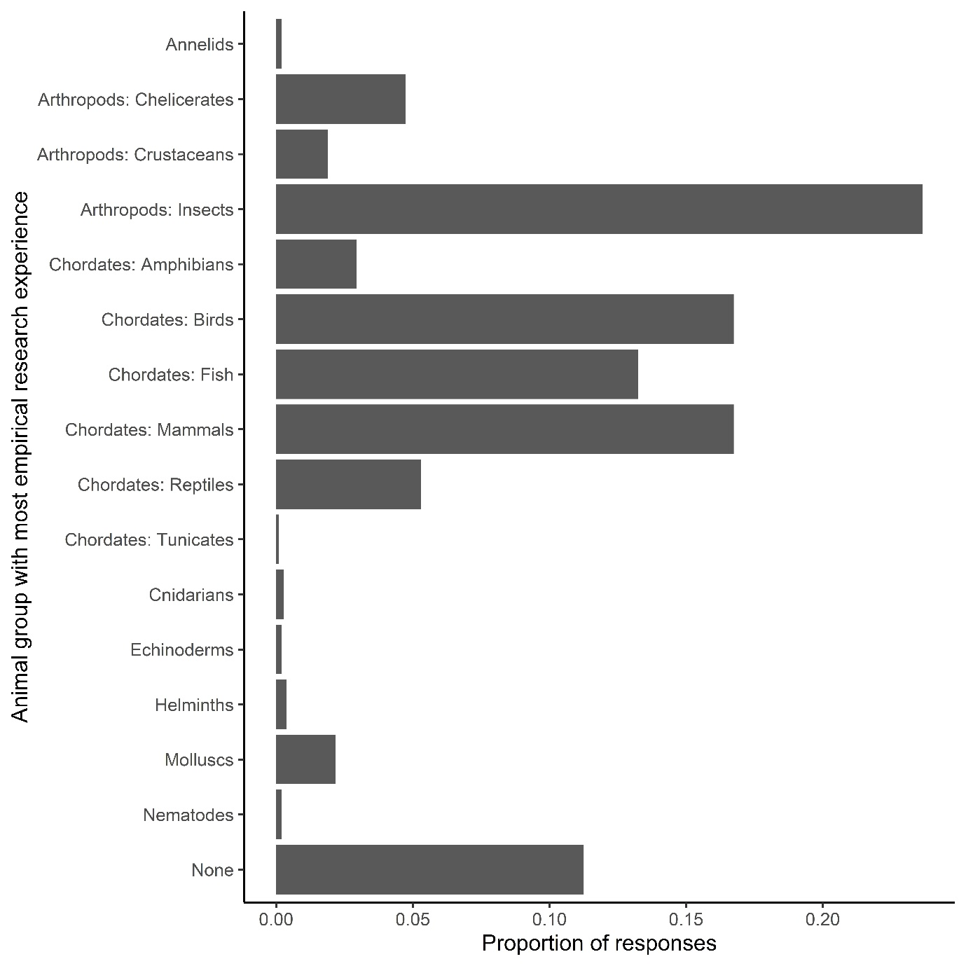
Figure S1. Proportion of participants’ responses to which animal group they had the most empirical research experience with. “None” represents no empirical research with non-human animals.

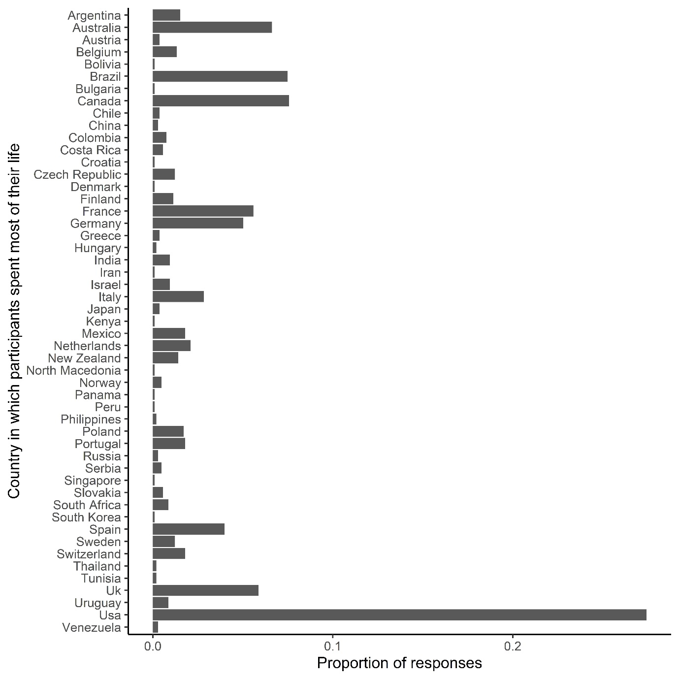
Figure S2. Proportion of participants’ responses to which country they spent most of their life in.

Appendix III: Alternative analysis
For this alternative analysis, we transformed participants’ perception of the frequency of each sex-specific behaviour in nature to a numerical scale of 1 (never) to 7 (always). For each participant in the survey, we subtracted the behavioural frequency perceived for females by the behavioural frequency perceived for males for mate choice and parental care, and the opposite (male minus female) for promiscuity and intrasexual competition. This resulted in four different response variables (one for each behaviour evaluated) that represented a conformity index regarding the sex roles predictions. This index could range from -6 to 6, in which a zero value refers to a perception that males and females express a behaviour with the same frequency; greater values represent greater agreement with the sex roles predictions, and lower values represent greater disagreement with the sex roles predictions. Conformity index in this alternative analysis is analogous to the conformity variable controlled for participant in the main analysis. Thus, while in the main analysis we evaluate interaction terms between conformity and variables of interest, here we only assess additive terms as the conformity variable and the random effect of participant are absent (the response variable already reflects sex roles conformity for each participant).
This analysis assumes that differences between any two categories in our seven-point scale is the same. Its results are presented in Figure S3.
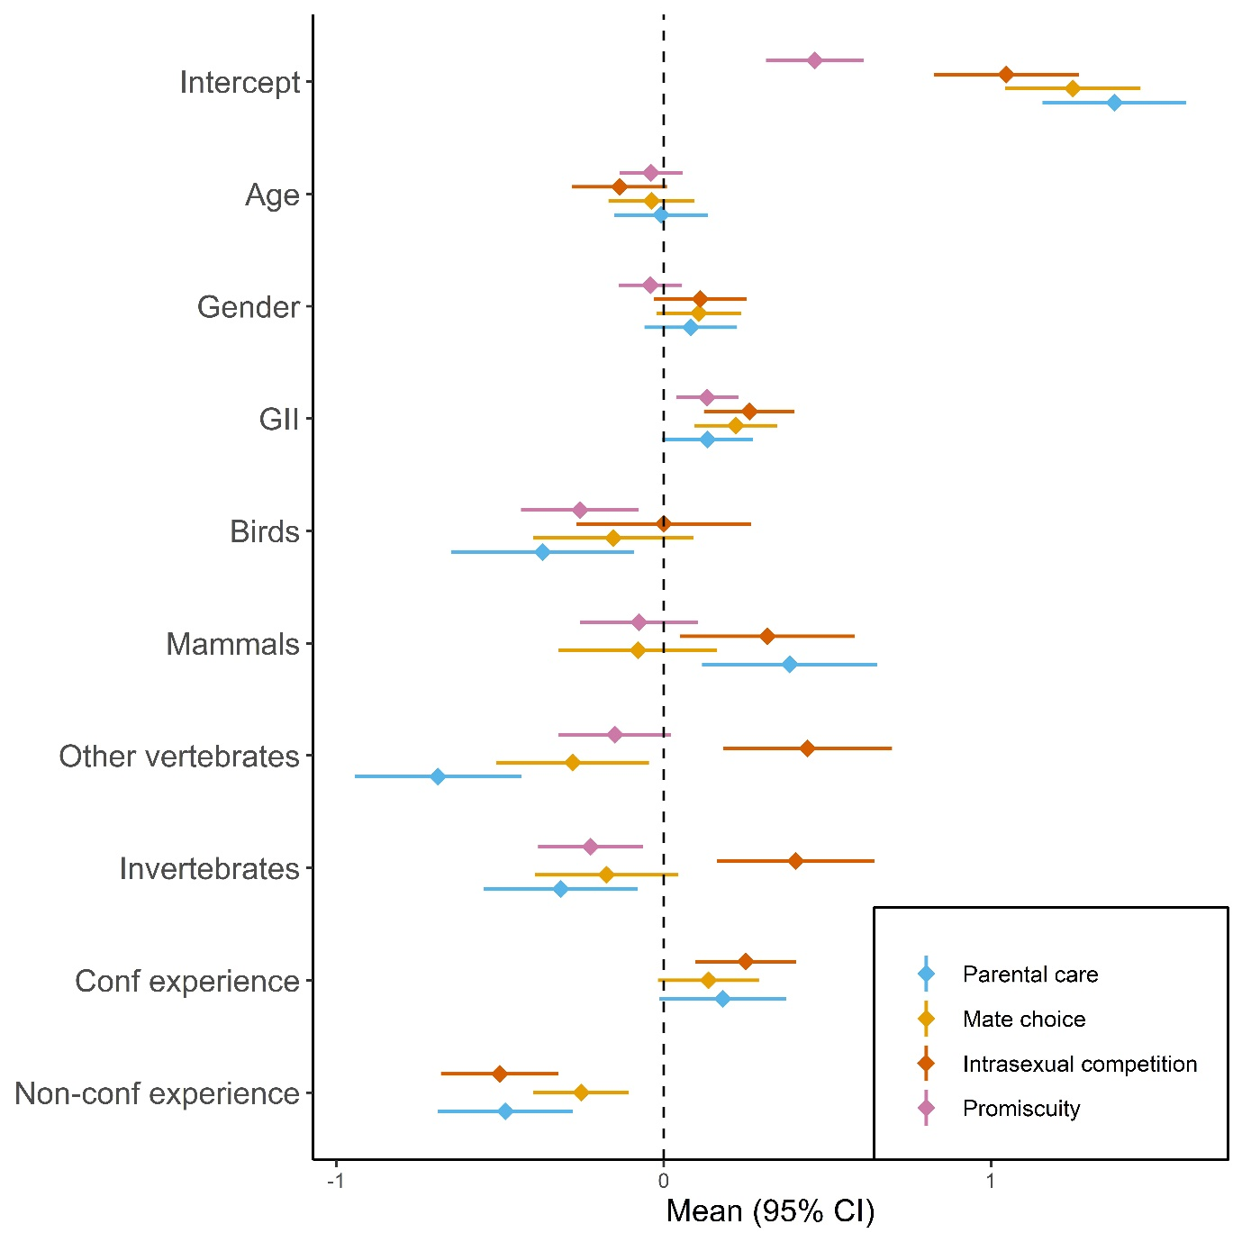
Figure S3. Explanatory variables’ coefficients from linear regressions regarding participants’ conformity index for different behaviours. Positive values indicate that a variable is associated with an increased agreement with the direction predicted by idea of sex roles for that behaviour. GII stands for Gender Inequality Index [46].

