COVID-19 restrictions and recreational fisheries in Ontario, Canada: preliminary insights from an online angler survey

In Prep for Fisheries Research

A. Howarth^{1,}*, A.L. Jeanson¹, A.E.I. Abrams¹, C. Beaudoin², I. Mistry², A. Berberi¹, N. Young², V.M. Nguyen^{1,3}, S.J. Landsman³, A.N. Kadykalo¹ A.J. Danylchuk⁴, and S.J. Cooke^{1,3}

¹Department of Biology, Carleton University, 1125 Colonel By Dr., Ottawa, ON, K1S 5B6, Canada

²School of Sociological and Anthropological Studies, University of Ottawa, 120 University Private, Ottawa, ON, K1N 6N5, Canada

³Institute of Environmental and Interdisciplinary Science, Carleton University, 1125 Colonel By Dr., Ottawa, ON, K1S 5B6, Canada

⁴ Department of Environmental Conservation, University of Massachusetts Amherst, 160 Holdsworth Way, Amherst, MA, 01003, USA

*Corresponding author: andrewhowarth@cmail.carleton.ca

Keywords: Recreational fisheries, COVID-19 pandemic, angling, fisheries management, lockdown, communications

Abstract

The COVID-19 pandemic and corresponding public health mitigation strategies have altered many facets of human life. And yet, little is known about how public health measures have impacted complex socio-ecological systems such as recreational fisheries. Using a web-based online snowball survey, we targeted resident anglers in Ontario, Canada, to obtain preliminary insight on how the pandemic has impacted recreational fishing and related activity. We also explored angler perspectives on pandemic-related restrictions and other aspects of fisheries management. Our results point to the value of recreational fisheries for the mental and physical well-being of participants, as well as the value and popularity of outdoor recreation during a pandemic. Although angling effort and fish consumption appeared to decline during the early phases of the pandemic, approximately 20% of the anglers who responded to our survey self-identified as new entrants who had begun or resumed fishing in that time. Self-reported motivations to fish during the pandemic suggest that free time, importance to mental and physical health, and desires for self-sufficiency caused some anglers to fish more, whereas a lack of free time, poor or uncertain accessibility, and perceived risks caused some anglers to fish less. Respondents also expressed their desires for more clear and consistent communication about COVID-19 fishing restrictions from governments, and viewed angling as a safe pandemic activity. Information on recreational angler behaviours, motivations, and perspectives during the pandemic may prove valuable to fisheries managers and policy makers looking to optimize their strategies for facing this and other similar crises.

1. Introduction

The COVID-19 pandemic has altered many facets of human life profoundly on both local and global scales. Restrictions aimed at limiting the spread of the virus have not only changed how humans interact with each other, but also with the natural world. Lockdown measures such as shelter at home orders, and the curtailing of transportation (i.e., global trade, business travel, tourism; Bakar & Rosbi, 2020; Chakraborty & Maity, 2020) during the early phase(s) of the pandemic have led to such dramatic changes in human-environment interactions that some are now referring to this period of reduced human mobility and activity as the “Anthropause” (Rutz et al., 2020). Efforts to characterize the Anthropause’s effect(s) on biodiversity (relative to the Anthropocene; Steffen et al., 2007) and the environment are underway (e.g., Bates et al., 2020; Buckley, 2020; Corlett et al., 2020; Diffenbaugh et al., 2020).
Recreational angling is a popular activity globally, and has significant cumulative effects on ecosystems and the environment (Arlinghaus & Cooke, 2009; FAO, 2012). Given that recreational angling can involve travel, group congregation, and organized events, participation has likely been affected, and impacts may be even more significant in densely populated areas (Rice et al., 2020). In particular, lockdowns are likely to have impacted fishing effort, as they involved strict prohibitions against non-essential travel, along with other typical components of recreational fishing and related activities. Also note-worthy, is the fact that regulators in some jurisdictions have sought to reduce the spread of COVID-19 by cancelling permits for competitive fishing events, as well as closing boat ramps, marinas, and other access points used for fishing (Paradis et al., In Press). However, restrictions have been modified and eased over time, and recreational fishing effort has fluctuated and increased accordingly. Despite this, little is known about the effects of the pandemic on the recreational fishing sector, and more specifically, angler and government agency responses.
Given that the pandemic will persist in some form for years, and that an increase in pandemic frequency is anticipated in the future (Billington et al., 2020), there is an urgent need to learn from current and ongoing experiences. For instance, it is important for researchers and regulators to know how the pandemic is affecting the behaviours and perceptions of individuals and groups as they navigate new life circumstances and social norms (Standl et al., 2020). More generally, the current moment provides an opportunity to understand what lessons can be drawn from the Anthropause for the management of recreational fisheries in the future. Currently, fisheries scientists are learning about the impacts of the Anthropause on fisheries using traditional stock assessment tools (e.g., creel surveys, netting surveys; Cooke et al., In Press). Similarly, much can be learned about the human dimensions of the pause by using social science research methods. Angler perspectives are important predictors of behaviour and compliance, and are a major determinant of policy success (Nguyen et al., 2016). Moreover, given that government restrictions on fishing have been met with opposition from some members of the angling community (Paradis et al., In Press), it is salient to conduct a retrospective analysis of angler perspectives on that response, including how it was implemented and communicated.
The purpose of our study was to assess the effect(s) of the pandemic on recreational angler practices and perspectives. We conducted an online snowball survey designed to provide preliminary information and exploratory analysis of angler perspectives, experiences, and behaviours related to the impact(s) of COVID-19 on recreational fishing in Ontario, Canada. Ontario is home to nearly 1 million resident anglers, and more than 1 million anglers—both resident and non-resident—fish in Ontario annually (Government of Ontario, 2020). Approximately $1.5 billion (CAD) are spent annually on recreational fishing by Ontario anglers (Fisheries and Oceans Canada, 2019). Angling also supports a vibrant tourism industry in Ontario, although travel restrictions have prevented international travel to Ontario during the relevant period. Our study provides a snapshot of the COVID-19 pandemic’s effect(s) on Ontario’s vast, multitudinous, and both socio-economically and culturally significant recreational fisheries.

1.2 The Case
On March 17th, 2020, the government of Ontario declared a state of emergency in response to COVID-19 outbreaks, curtailing all non-essential activities and gatherings related to work, education, social interaction, and entertainment (e.g., schools, restaurants, entertainment venues, parks). After more than one month in lockdown, select businesses, public facilities, and services were allowed to resume and begin gradually reopening in the month of May. Provincial park day use, for example, was reopened to the public on May 11th. On May 16th, restrictions on several other outdoor recreational businesses and activities (e.g., marinas, camping) were loosened, and many more businesses were allowed to reopen three days later, on May 19th (Nielsen, 2020). Select regions of Ontario began entering the next stage of the province’s recovery plan during the month of June, while more strict pandemic procedures were maintained in densely populated areas (e.g., Toronto). On June 24th, the Ontario government extended the state of emergency to July 15th. Some areas of Ontario began entering the third stage of the province’s recovery plan in late July.
Due to major differences in pandemic restrictions between the initial province-wide lockdown and the subsequent uneven ‘reopening’ phase, we chose to study the effect(s) of the pandemic on recreational fisheries during two distinct time periods: March 17th to May 16th, and May 16th to July 15th. This division of study periods allowed us to compare and distinguish the impacts of the pandemic on recreational fisheries during two important phases lasting ~60 days. To reduce confusion and verbosity, we refer to the first distinguished period from March 17th to May 16th, 2020, as Pandemic Phase 1, and the second distinguished period from May 16th to July 15th, 2020, as Pandemic Phase 2 for the remainder of this article (Figure 1).

2. Methods
We used an online survey with purposive snowball-style recruitment (i.e., using participant referrals to build the sample; Penrod et al., 2003) to target resident anglers in Ontario, Canada. Respondents were recruited in social media advertisements (i.e., via Facebook, targeting users from Ontario who included recreational fishing as a topic of interest and were between the ages of 18 and 65) and posts (e.g., on Twitter, Instagram, and various Ontario-centric fishing groups on Facebook) that were shared by members of the research team and survey respondents over the course of one month. In addition, several news and outdoor media outlets wrote articles and blogs about the survey and shared the link (e.g., https://oodmag.com/researchers-surveying-angler-behaviour/). Non-random recruitment was necessary because it was not possible to gain access to the provincial license database (it is used as part of a national survey [Brownscombe et al., 2013] and managers of the database expressed concerns about respondent fatigue), nor was a broader mail or telephone survey possible given the lack of quick-turnaround funding opportunities. The non-random sampling method means that results should be considered exploratory and indicative of potential trends in angler perspectives and behaviour, rather than representations of the entire population of Ontario anglers—a standard caveat with snowball-style surveys (Fricker & Schonlau, 2002; Beidernikl & Kerschbaumer, 2007).
Survey questions addressed changes in recreational fishing effort, years of experience with angling, fishing-related travel and spending, retention and consumption of caught fish, quality of fishing during the pandemic, and the roles and responses of both government and recreational anglers in recreational fisheries during the pandemic (Appendix A). The survey consisted of 41 questions (14 demographic), the majority of which were closed-ended and sought numeric estimates (e.g., number of days fished, percentage of fish harvested, amount of money spent on recreational angling, number of fish caught), as well as Likert-style questions involving the reasons and motivations behind behaviours and (or) behavioural changes (e.g., for increasing or decreasing fishing effort, for consuming fish during the pandemic). Respondents were provided with open-ended ‘other’ options when applicable. Additional open-ended questions about governments and anglers, and their respective roles in ensuring safe and responsible recreational fishery use during the pandemic, were also included. All questions were optional, and filtering questions allowed respondents to skip parts of the survey that did not apply to them.
Survey data provided insight on three distinct themes: (1) the general patterns in recreational fisheries during the pandemic (i.e., total days fished, number of fish caught, percentage of fish kept and [or] consumed, fishing-related spending), (2) participant motivations and (or) reasons for change (i.e., for increased or decreased effort, increased or decreased consumption of fish), and (3) the communications and response(s) of governments and recreational anglers to the pandemic. Methods and findings for each respective theme are organized under distinct subheadings in subsequent sections (Appendix A).
Survey questions were generated and refined over a period of approximately one month by a team of professors and graduate students from Carleton University and the University of Ottawa, as well as collaborating fisheries researchers from other institutions. The survey was tested by ten members of the Fish Ecology and Conservation Physiology Laboratory (FECPL), prior to its official launch on August 4th, 2020. A research ethics application was completed and submitted to the Carleton University Research Ethics Board B (CUREB-B), and the project was granted ethical clearance on July 22nd (Project #113204). The survey was administered using the Qualtrics online survey platform. Survey submissions were removed from analysis if they were <90% complete, and (or) if respondents did not identify as Ontario residents who had previously fished recreationally in Ontario.

2.1 General Patterns
We obtained paired samples for the main hypothesized impacts on recreational fisheries during the pandemic (i.e., changes in angler effort, fish consumption, fishing-related spending, quality of fishing) in questions that sought estimates (e.g., of total days fished, percentage of fish consumed) across four distinct periods: Pandemic Phase 1, Pandemic Phase 2, and the same time periods in 2019. We performed paired samples t-tests in SPSS Version 26 to compare sample means, as in Morgan & Soucy (2009) and Shrestha & Loomis (2003). Because a significant portion of survey respondents (n = 166) self-identified as new entrants (i.e., individuals who began fishing, or resumed fishing after a hiatus of at least one year, between March 17th and July 15th, 2020), some tests were repeated separately for regular anglers and new entrants.

2.2 Reasons and Motivations
Opinion statements regarding angler motivations (e.g., to fish more or less) during the pandemic were sought in closed-ended questions, wherein respondents were asked to indicate their level of agreement with various items using a five-point Likert scale (i.e., strongly disagree, somewhat disagree, neither agree nor disagree, somewhat agree, strongly agree). Likert data were analyzed using a factor analysis with varimax rotation as in Forina et al. (1989) in SPSS Version 25, in order to identify the important components of motivators.

2.3 Communications and Response
Likert data on the pandemic response and quality of communications between governments and anglers were imported and organized in NVivo 12. Angler suggestions and perspectives on the role(s) of government in managing recreational fisheries during the pandemic were analyzed in NVivo 12 using inductive thematic coding, as in Thomas (2006). Codes were reviewed by two study authors. Descriptive statistics were obtained in SPSS Version 26, and a Kendall Tau-b correlation coefficient was used to measure the association between respondent ratings of communication quality by Ontario’s Ministry of Natural Resources and Forestry (MNRF), various municipal governments in Ontario, and the recreational angling community. GraphPad Prism (version 8.4.2) was used to produce the corresponding bar chart.
To analyze angler responses to questions about subsequent pandemic waves and emergent impacts of COVID-19 on recreational fisheries, a codebook was created deductively based on a preliminary overview of the data, as in Roberts et al. (2019). We used the values 1, 0, and 88 as proxies for agreement, disagreement, and uncertain agreement or disagreement with the predetermined codes. Additional codes were created inductively as other themes emerged. Respondent comments were described qualitatively for the most frequently agreed-upon codes.

3. Results

Of the 1620 surveys that were commenced, 811 were only partially completed, of which 32 were only opened. From the remaining 809 surveys, 789 were retained after eliminating submissions from respondents who did not identify as Ontario residents, or exceed 90% completion. On average, respondents took 46 minutes to complete the survey, but this was probably a result of some respondents completing the survey intermittently over a much longer period of time, as the median completion time was ~16 minutes, and the most common completion time was ~10 minutes.

3.1 Socio-demographics
Most respondents to our survey identified as male (90.7%, n = 706), with the remaining respondents identifying as female (8.5%, n = 66) or other (0.8%, n = 6). The mean age of respondents was 51, with a range of 12 to 81. The only fisheries management zone (FMZ) that was not selected as a common fishing region by respondents was Zone 1 in the province’s far north, and other northern FMZs (e.g., 2, 3, 4, 5, 7, 9) were identified in <10 responses. FMZ 15 in southcentral Ontario (n = 134), 16 in southwestern Ontario (n = 136), and 18 in eastern Ontario (n = 143) were selected most commonly by respondents as primary fishing regions. Respondent levels of education ranged from “Some high school” (n = 36), to “High school diploma” (n = 135), to “College diploma” (n = 284), “Undergraduate degree” (n = 180), and “Post-graduate degree” (n = 141). Annual household income in Canadian dollars (CAD) among respondents varied, but was skewed toward the high end of our income categories (<20 K, n = 18; 20-40 K, n = 72; 40-60 K, n = 87; 60-80 K, n = 111; 80-100 K, n = 113; >100 K, n = 308). When asked about fishing-related income, approximately 95% of respondents reported earning their income from sources unrelated to fishing (n = 741 of 782), and the remaining 5% of respondents whose income was earned partially or fully from recreational fishing identified as members of angling media, guides, tourism professionals or outfitters, tackle and gear salespeople, and sponsored professional anglers. Approximately 90% of respondents were born in Canada (n = 692 of 768), and the remaining 10% identified the United States (US), China, and countries in the United Kingdom, for example, as their birthplaces. Approximately 98% of respondents identified as Canadian citizens (n = 763 of 779), with approximately 2% self-identifying as permanent residents, and only one respondent identifying as a temporary resident.

3.1.1 Centrality to lifestyle and fishing experience
When asked about their skill level, approximately 50% of all respondents reported having intermediate angling expertise (n = 387 of 778), with approximately 45% self-identifying as advanced or expert anglers (n = 349), and approximately 5% identifying as novice anglers (n = 42). When asked about their agreement with the statement “fishing is an important part of my life” approximately 92% of all respondents either agreed strongly (n = 458 of 780) or agreed (n = 256), with approximately 1% disagreeing with the statement, and approximately 7% responding neutrally (n = 57). Approximately 64% of respondents were not members of fishing clubs and (or) organizations (n = 491 of 767), whereas approximately 36% (n = 276) reported belonging to a variety of provincial organizations (e.g., Ontario Federation of Anglers and Hunters [OFAH], Ontario Women Anglers, Ontario Fishing Club), regional organizations (e.g., North Bay Fishing Club, Hamilton Area Fly Fishers and Tyers, Bluewater Fishing Club), and species-specific groups (e.g., Muskies Canada, Bass Anglers Sportsman Society, Ontario Steelheaders).

3.2 General Patterns

3.2.1 Angling Effort
When asked directly about their participation in recreational fishing during the pandemic, approximately 19% of respondents (n = 148 of 785) reported not fishing at all during Pandemic Phase 1 and Pandemic Phase 2 (i.e., March 17th and July 15th, 2020, Table 1). Approximately 81% of respondents reported fishing at some point during Pandemic Phase 1 and (or) Pandemic Phase 2, and four respondents provided no answer. Approximately 7% of respondents (n = 46 of 635) reported not fishing at all between March 17th and July 15th in both 2019 and 2020, while approximately 93% did fish during the aforementioned time period in both years. The remaining 154 survey respondents provided no answer. Approximately 50% of all respondents (n = 390 of 781) reported fishing less than normal during Phase 1 and Phase 2, while the other 50% stated that they did not fish less at any point during or as a result of the pandemic. Perhaps most notably, approximately 20% of all survey respondents (n = 166 of 789) reportedly began fishing, or resumed fishing after a hiatus of at least one year, at some point during Phase 1 or Phase 2 (Table 2).

Paired samples t-tests comparing the estimated total days fished by respondents during Pandemic Phase 1 (n = 743) and Pandemic Phase 2 to the previous year (n = 695) revealed a significant decrease during Phase 1 (x̄ = 3.90, SD = 8.03) compared to the same period in 2019 (x̄ = 5.32, SD = 7.77, t₇₄₂ = 5.22, p < 0.001), and a significant decrease during Phase 2 (x̄ = 9.12, SD = 10.92) compared to 2019 (x̄ = 10.65, SD = 9.88, t₆₉₄ = 3.97, p < 0.001). Additional tests comparing the estimated days fished by regular participants during Phase 1 (n = 591) and Phase 2 (n = 555) to the previous year revealed significant decreases during Phase 1 (x̄ = 4.48, SD = 8.72) compared to the same period in 2019 (x̄ = 5.79, SD = 8.19, t₅₉₀ = 4.08, p < 0.001), and during Phase 2 (x̄ = 9.19, SD = 10.77) compared to 2019 (x̄ = 10.97, SD = 10.13, t₅₅₄ = 4.39, p < 0.001).

3.2.2 Fishing-Related Travel
When asked directly about fishing-related travel during Pandemic Phase 1, approximately 40% of all survey respondents (n = 83 of 789) reported travelling far less compared to the previous year. However, when asked about fishing-related travel in Pandemic Phase 2, approximately 45% of all respondents reported either much more, or somewhat more fishing-related travel compared to the same period in 2019. Approximately 30% reported about the same amount of fishing-related travel during Phase 2 as in the previous year. When asked about fishing-related travel in both periods, approximately 42% of all survey respondents reported “About the same” amount of fishing related travel during both Phase 1 and Phase 2, compared to 2019, and an additional 26%, reported “Much less” fishing-related travel, compared to the previous year (Table 3).

3.2.3 Fish Consumption
When asked about their retention and (or) consumption of fish during the period from March 17th to July 15th, 2020, approximately 57% of all respondents (n = 361 of 638) reported keeping and (or) consuming fish at some point, while approximately 47% reported not keeping and (or) consuming any caught fish. The remaining survey respondents provided no answer. Paired samples t-tests comparing estimated percentages of caught fish that were kept and (or) consumed during Phase 1 (n = 734) and Phase 2 (n = 689) to the previous year revealed a statistically significant decrease during Phase 1 (x̄ = 6.24, SD = 20.1) compared to the same period in 2019 (x̄ = 9.28, SD = 25.88, t₇₃₃ = 3.41, p = 0.001), and a statistically significant decrease during Phase 2 (x̄ = 9.85, SD = 22.94) compared to the same period in 2019 (x̄ = 12.22, SD = 23.9, t₆₈₈ = 3.33, p = 0.001). Tests were repeated with new entrant responses excluded, but results consistently pointed to a significant decrease in the estimated percentage of caught fish that anglers kept and (or) consumed during the pandemic.

3.2.4 Fishing-Related Spending
Paired samples t-tests comparing estimates of fishing-related spending during Phase 1 (n = 735) and Phase 2 (n = 688) to the previous year revealed an increase during Phase 1 (x̄ = 447.27, SD = 2532.86) from the same period in 2019 (x̄ = 321.27, SD = 1556.26) that was not statistically significant (t₇₃₄ = -1.31, p = 0.191), and an increase during Phase 2 (x̄ = 820.38, SD = 5258.5) from the same period in 2019 (x̄ = 478.14, SD = 1795.6) that also was not statistically significant (t₆₈₇ = -1.65, p = 0.099). Repeating these tests separately with regular anglers and new entrants also revealed no statistically significant changes in mean estimated spending between Phase 1 and Phase 2, and the previous year, although mean estimated spending by new entrants increased by more than $900.00 CAD in Phase 2. Respondents were asked about the likelihood of them making typical fishing-related purchases during Phase 1 and Phase 2 using a three-point Likert scale. Descriptive statistics for responses to the likeliness-to-pay question are presented in Table 4. In Phase 1 and Phase 2, respondents were least likely to make online purchases at US-based big box stores. In Phase 2, respondents were reportedly more likely to buy fishing gear and tackle, particularly from local specialty stores.

3.2.5 Quality of Fishing
Paired samples t-tests comparing the estimated number of fish caught by respondents during Phase 1 (n = 713) and Phase 2 (n = 678) to the previous year revealed a decrease during Phase 1 (x̄ = 15.14, SD = 71.02) from the same period in 2019 (x̄ = 19.38, SD = 48.3) that was not statistically significant (t₇₁₂ = 1.760, p = 0.79), and no difference between Phase 2 (x̄ = 38.81, SD = 113.91) and the same period in 2019 (x̄ = 38.81, SD = 67.43).

3.3 Reasons and Motivations

3.3.1 Increases in Effort
Three components of angler motivations to begin, resume, or continue fishing during the pandemic (n = 208) were identified (Figure 2). Together, the three distinct constructs explain 58% of the variance, and Bartlett’s Test of Sphericity indicates p < 0.001. Component 1 was related to what respondents perceived as an opportunity or desire to engage in a hobby, whereas Component 2 items were general motivations to maintaining physical and mental wellbeing in a relatively safe manner. Component 3 items were related to a desire for self-sufficiency by means of fish harvest.

3.3.2 Reductions in Effort
Four motivators for anglers to fish less at any point during the pandemic (n = 157) were identified. Collectively, these constructs explain 66% of the variance, and Bartlett’s Test of Sphericity indicates p < 0.001. The following four components were identified: (1) lack of free time (e.g., due to work, familial obligations); (2) inability to access fishing spots and fear of being ticketed; (3) lack of support services; and (4) fear and (or) anticipated guilt of transmitting COVID-19, or being socially judged for not self-isolating. Motivations to fish less during the pandemic are visualized in Figure 3.

3.3.3 Consumption of Fish
Two motivators for anglers to keep and (or) consume fish at any point during Phase 1 and Phase 2 (n = 214) were identified. The two distinct constructs explain 66% of the variance, and Bartlett’s Test of Sphericity indicates p < 0.001. Component 1 was related to new opportunities as a result of reduced fishing pressure, and Component 2 items were general motivators for maintaining normalcy and safe self-sufficiency.

3.4 Communications and Response

3.4.1 Communications Between Anglers and Governments
When asked to rate the quality of communications between the MNRF (n = 781) and municipal governments and anglers (n = 778), the majority of respondents rated MNRF (~55%) and municipal government (~52%) communication with anglers as average or good, while a minority of respondents rated MNRF (~15%) and municipal government (~22%) communications as poor. Ratings of MNRF and municipal government communication were moderately associated (τ_{b} = 0.341, p = <0.0001; Figure 4). Respondents who expressed dissatisfaction were more likely to contribute suggestions when prompted.

3.4.2 Angler Perspectives
Many respondents suggested ways to improve communications between the MNRF and anglers (n = 171), and between municipal governments and anglers (n = 179). Many of these suggestions were related to the belief that access to public boat launches, parking, and shoreline fishing spots should not have been closed or restricted during the pandemic, although other respondents acknowledged the necessity of such measures despite their dissatisfaction. Angler views on enforcement varied notably; some survey respondents felt that rules and enforcement were unnecessarily prohibitive toward fishing, whereas other respondents viewed the same measures as justified. Fishing was viewed by some respondents as a relatively safe pandemic activity due to its conduciveness to social distancing (3% of all comments). Additional comments touched on food security (1%), and many respondents testified to the benefits of fishing and outdoor recreation for their mental health (3%). Some1 respondents felt that institutions were not adequately prepared to manage crises due to a lack of funding and capacity. The perceived need for more funding in fisheries conservation appeared partially attributable to more people discovering and rediscovering fishing during the pandemic. Approximately 4% of all respondents expressed a desire for governments to take a more active role in ensuring safe use of fisheries during the pandemic.

3.4.3 Suggestions for Communication
Respondent suggestions highlighted a common desire for greater clarity and communication by the MNRF and Ontario municipal governments in relation to (1) legal and (or) permissible pandemic-time activities, (2) facility accessibility, and (3) special closures. Regarding their confusion about restrictions and the rationale(s) for closures, respondents cited mixed messaging, a general lack of communication, and a lack of information in intermittent or rare communications as causes for uncertainty. Respondents who provided additional input suggested that government communication be clear across different regions, proactive in nature, and updated in a timely manner. In response to such uncertainty, some respondents reportedly obtained information from the OFAH, confirming the strengths of such organizations in mediating and communication roles. The OFAH maintained a website with details on fishing closures across the province (see https://www.ofah.org/covid19closures/) and also provided anglers with guidance for how to fish safely during the pandemic (https://www.ofah.org/safetytips/). Respondents also alluded to the possibility of municipalities and the MNRF using social media to provide updates and counteract misinformation, or devoting specific websites and (or) web pages to clarifying details related to access points and closures. Among other things, respondents noted that the use of lay language would be important to maximize and ensure accessibility. Additional respondents suggested that the MNRF send information by email to all license holders. Respondents found local signage that was posted by municipalities to be particularly useful, and expressed their desire to see more, noting that this varied significantly across jurisdictions (Figure 5).

3.4.4 Preparing for Future Waves
Participants were asked directly about their conceptions of the MNRF’s role in ensuring safety, sustainability, and accessibility in Ontario’s recreational fisheries during the COVID-19 pandemic, and response to potential long-term effects. Only 2% of all respondents believed that the pandemic would have no long-term impact(s) on Ontario’s fisheries. Approximately 4% believed that the MNRF should play a greater role in protecting public health, and approximately 6% felt that the MNRF should play a greater role in ensuring fishery accessibility. Approximately 39% of the respondents who offered suggestions believed that the MNRF should modify management practices in order to protect fisheries in response to any threats (e.g., increased exploitation) that emerged or were exacerbated by the pandemic. Respondents also offered suggestions that were loosely related to the pandemic, and more closely related to fisheries management in general: according to respondents, the MNRF should increase enforcement and monitoring efforts, stocking, bag limits and restrictions, and angler education (e.g., about responsible catch-and-release practices for new anglers). Approximately 11% of respondent anglers felt that the MNRF’s ongoing efforts were effective, and should not be modified.
Approximately 40% of all respondents believed that the pandemic presented opportunities for fishing and conservation in Ontario. However, 8% believed that the pandemic would ease pressure on fisheries, and 16% felt that the pandemic would cause increases in both the number of anglers and cumulative fishing pressure. Only 2% of respondents felt that the pandemic would create economic opportunities (e.g., due to increases in local tourism, fishing-related purchases, license sales). Approximately 9% believed that the pandemic presented opportunities to educate new and existing anglers on sustainable practices such as catch and release, and approximately 5% felt that the pandemic would create more support for the protection of natural resources. Some of the approximately 18% of respondents who believed that the pandemic did not present any opportunities for recreational fisheries argued that more restrictions were necessary, and that ongoing conservation efforts were disrupted by the pandemic.
Finally, respondents were asked how anglers and governments should respond to a second wave of COVID-19, to which approximately 57% responded that governments should either continue to allow fishing with procedures and restrictions similar to those used during the first wave, or return to ‘business as usual.’ Some of these respondents suggested the following actions during the anticipated second wave: (1) education on best fishing practices, etiquette, catch and release, and pandemic health and safety precautions (~2%); (2) enforcement of social distancing and fishing limits (~6%); and (3) better communication of restrictions (~10%). Only 12% of respondents believed that governments should shut down or further restrict fisheries by, for example, limiting access to local residents and (or) modifying bag limits. Approximately 48% of all respondents believed that anglers should continue fishing and follow public health guidelines during a second wave, and 3% felt that anglers should only fish locally (Table 5).

4. Synthesis

4.1 Survey Limitations
The statistically robust 2015 Canadian Recreational Fishing Survey administered by the federal government by mail provides some insight on the demographic consistency of our sample with the population of resident anglers in Ontario. According to Fisheries and Oceans Canada (DFO), 77% of Ontario anglers are male, and 23% are female. Women were comparatively underrepresented in our survey, at 8.5%. The average age of anglers in our survey was 51 years, which is two years older than the average male angler in Ontario, and five years older than the average female angler, according to DFO’s survey. Fisheries and Oceans Canada does not ask questions about the centrality of recreational fishing to respondent lifestyles, and our survey lacks a comparator in this regard. However, because >91% of respondents indicated that they strongly agreed or agreed with the statement “fishing is an important part of my life,” our study was likely subject to an avidity bias. This hypothesis is supported even further by the high levels of participation and membership in fishing clubs and organizations in our respondent group, and most respondents self-identifying as anglers with intermediate or advanced expertise. Participation in the online survey was also voluntary. Although we did ask questions about fishing effort, harvest, catch rates, and fishing-related expenditures, responses were limited to periods of interest (i.e., Pandemic Phase 1 and Pandemic Phase 2) rather than full seasons or years. Our findings may also be subject to both response and nonresponse bias, which could have caused certain angler and (or) response types to be under- or over-represented (Steinert et al., 1994; Fisher, 2005; Aubry & Guillemain, 2019). We relied heavily on social media for distribution (e.g., Facebook groups, targeted advertising) which requires individuals to sign up and join fishing groups, and (or) identify fishing as one of their hobbies.
Despite previously mentioned biases, a significant number of new entrants (i.e., anglers who fished for the first time, or began fishing after a hiatus of at least one year) responded to our survey, indicating that it did reach beyond the regular angling community (e.g., due to conventional media advertisement, or angler to non-angler sharing). Some questions required anglers to recall activities and expenditures from approximately one year prior, and it is possible that our results were affected by recall bias (Tarrant et al., 1993). However, recall bias tends toward overestimation of things like angling effort and catches (Connelly & Brown, 1995, 2011), which may explain the relatively small effect sizes that were observed in comparisons of fishing and related activities between Phase 1 and Phase 2, and the previous year. Limitations considered, we suggest that other researchers exercise—as we do here—appropriate caution when considering the implications of our results more broadly (e.g., in the greater angling community). The results of our study serve more appropriately as an exploratory snapshot of the COVID-19 pandemic’s effect(s) on recreational angling in Ontario, Canada.
We acknowledge the limitations of virtual snowball-style surveys (Johnson, 2005; Baltar & Brunet, 2012), but do not attempt to make inferences or extrapolations beyond our respondent group. We are aware of several government-led, state or province-wide surveys that are currently in development (e.g., in Louisiana) which use license databases and other strategies (e.g., using angler apps) to obtain more statistically robust and less biased samples, but these will require significantly more time to execute and analyze. The research reported here is timely and is intended to be exploratory, and attempts to identify a range of perspectives, experiences, and behaviours that likely exist within a broader population, instead of precisely measuring their prevalence or interactions. The analysis that we present is preliminary, and yet valuable to fisheries managers, the fishing industry, fishing organizations (e.g., clubs, advocacy groups), and resource management agencies concerned with threats and opportunities that have arisen due to COVID-19.

4.2 General Trends
Mean estimated fishing effort for regular anglers and new entrants decreased during Pandemic Phase 1 and Phase 2 compared to the same periods in 2019. Although results were statistically significant, mean decreases were qualitatively small (i.e., between one and two days less over the course of 60 days). In general, the effects of the pandemic and corresponding restrictions on fishing appeared negligible. Approximately 21% of survey respondents (n = 166 of 789) self-identified as new entrants who began or resumed fishing (after a hiatus of at least one year) during Phase 1 and (or) Phase 2. This result appears supportive of the notion that recreational fishing is relatively unaffected by pandemic conditions and restrictions compared to other leisure activities, and also speaks to the benefits of recreational fishing for participants’ physical and mental well-being.
Estimates of fishing-related travel decreased significantly during Pandemic Phase 1, compared to the same period in 2019. Conversely, during Phase 2, fishing-related travel increased significantly relative to the previous year. Across the entire study period (i.e., Phase 1 and Phase 2), fishing-related travel appeared relatively unaffected by pandemic conditions, with the exception of a significant minority of anglers who elected to abstain from non-local fishing, or travelled far less than in previous years. As with angling effort, notable percentages of respondents reported increasing or decreasing their fishing-related travel drastically during Phase 1 and (or) Phase 2. Participation disparities in recreational fishing and other recreational activities have been attributed to physical disabilities and inequality in previous research (Freudenberg & Arlinghaus, 2009; Sotiriadou & Wicker, 2014), and some polarities in recreational fishing and related activity during the pandemic may be explained by differences in perceived vulnerability and risk (e.g., due to age, pre-existing medical conditions) across different participants and groups. This notion is also supported by motivational components related to lacking support services that were identified in factor analyses.
Mean estimated percentages of caught fish that were kept and (or) consumed by respondents decreased significantly in Phase 1 and Phase 2, compared to the same periods in 2019. Prior to conducting the study, our team had considered that fears of food and nutritional insecurity could be reflected in more consumptive recreational angling behaviours, as has been observed in some subsistence fisheries (see Pinder et al., 2020). This result may be partially attributable to changes in angling effort and culture, such as the growing emphasis on catch and release, recreational angler and fishery heterogeneity (Nguyen et al., 2013), pursuit of different species, and (or) catching fewer legally-harvestable fish. Statistical interpretation and testing revealed increases in fishing-related spending during Phase 1 and Phase 2 compared to the previous year, but these were not statistically significant, due in part to high variance. It may be noted, however, that mean estimates of fishing-related spending by new entrants increased by more than $900.00 CAD in Pandemic Phase 2.

4.3 Reasons and Motivations
Some anglers elected to fish more than usual during Phase 1 and Phase 2, while others did the opposite, and our analysis of estimated days fished revealed unremarkable differences in recreational fishing effort between the study period and the same dates in 2019. Anglers who increased their effort cited opportunities to engage in a new or preferred hobby, benefits to mental and physical well-being, and desires for self-sufficiency as important motivations. These findings are consistent with prior research on the importance of recreational fishing for participants’ mental and physical health (McManus et al., 2011; Griffiths et al., 2016), as well as the important role that recreational fishing plays in the food and nutritional security of many families and individuals (Cooke et al., 2017).
Respondents who fished less during Phase 1 and Phase 2 did so due to lack of free time (e.g., due to work, familial obligations), a lack of access to fishing spots and (or) fear of being ticketed, insufficient support services, and fear or guilt associated with contracting or transmitting the virus or failing to comply with and uphold social distancing norms. These results suggest that the different individual angler responses resulted from differences in perceived risk (e.g., due to age, pre-existing conditions, proximity to high-risk individuals) and familial obligations. Individuals with a lower perceived risk and fewer constraints appeared more likely to fish for reasons related to mental and physical well-being. Disparities in recreational fishing and related activity during the pandemic appear attributable, in part, to the balance of costs (e.g., health risks, social stigma) and benefits (e.g., improved mental and physical health) perceived by each individual.

4.4 Communications and Response
The COVID-19 pandemic reinforces calls for improved environmental governance and resilience building in preparation for crises in socio-ecological systems such as recreational fisheries (Berkes, 2017). Although most Ontario anglers were satisfied with government communications, our survey highlights gaps and opportunities for improvement. It is worth noting that angling communities are heterogenous (Arlinghaus, 2007), and that Ontario anglers have diverse views on closures and other pandemic-related public health recommendations. In response to angler dissatisfaction, governments may improve their communication strategies by making information more consistently available and accessible (e.g., by using social media, the internet). Coordinating messages and communication across geographical and institutional boundaries, building and utilizing relationships with influential groups, centralizing information management, communicating with the public in a clear and transparent way, and creating mechanisms for the public to provide input and engage in dialogue with governments may aid in this endeavour (see Kim & Kreps, 2020). In addition to transparency, science and (or) evidence-based rationales may increase angler compliance and support for restrictive mitigation strategies.
The pandemic also highlights the importance of non-governmental organizations (NGOs) like OFAH in information sharing. Communication and management could be improved through multilevel collaborations that nurture dialogue and increase coordination between community organizations and municipalities, and across all levels of government (Armitage, 2008). This is particularly crucial in a pandemic context wherein relevant issues extend beyond jurisdictional and political boundaries, and demonstrate the value of coordinated multilevel governance in complex crisis management (Ryan, 2020).
Inconsistent closures and differences in pandemic response across municipalities can ‘funnel’ anglers into adjacent ‘open’ areas, creating what some researchers refer to as spillover effects (Andrés et al., 2012). This type of response has the potential to exacerbate crowding, which poses a risk to both public and fishery health. Consequences of this phenomenon may emerge and persist as long as mitigation strategies remain inconsistent (e.g., across municipalities), and may intensify if perceptions of crowding are met with further restrictions, creating a positive feedback loop. Improved coordination could help to minimize this type of spillover effect. Respondents also expressed their desires for the MNRF to take a more active role in pandemic mitigation, although many additional suggestions were related to pre-existing concerns (e.g., education, enforcement, stocking, monitoring, budget; Galea, 2019).

4.5 Conclusion
The COVID-19 pandemic sparked immediate changes in human behaviour, due largely to government-ordered ‘shelter-in-place’ restrictions, and other drivers such as health concerns, financial instability, psychological stress, and leisure time availability (Corlett et al., 2020). Restrictions that related specifically to outdoor recreation (Freeman & Eykelbosh, 2020; Rice et al., 2020) and recreational fishing (see Paradis et al., In Press) were also enacted, and played a role in this. Despite the inherent biases of snowball surveying, our research yielded valuable insight on the diverse perspectives of anglers in relation to pandemic restrictions, and their impact(s) on recreational fisheries. Our findings suggest that survey respondents from Ontario’s recreational fisheries did alter their fishing-related behaviour(s), albeit not as drastically as we had anticipated. Particularly noteworthy, and consistent with reports from legacy media sources (e.g., McEwan, 2020; Thomas, 2020), was the fact that a significant minority of respondents (~20%) reportedly resumed or began fishing during the pandemic.
Subsequent pandemic waves are now occurring across the globe and are forecast to continue in 2021, even during the period of mass vaccination. Given this, as well as the potential for future pandemics, our findings provide insight on effective communication, management, and mitigation strategies, as well as restrictions that regulators may find useful in future attempts to protect public health and well-being. Ensuring public safety is the ultimate responsibility of governments, and the diverse perspectives shared here may help to inform future decisions, as well as enhance communications between management authorities and the angling community. Among other things, this may help to improve compliance with imposed measures (Van Bavel et al., 2020). Early efforts to restrict outdoor recreation and reduce potential consequences did not benefit sufficiently from scientific information and stakeholder input, due largely to the need for swift action. However, expectations about consultation, the use of evidence (Kadykalo et al., In Press), and matters beyond public health (e.g., natural resource management, recreational fisheries) will change going forward. This snapshot may also encourage fisheries managers to consider how the pandemic has influenced anglers in various regions, while providing a basis for more comprehensive human dimensions surveys that explore central issues across different regions, and with more robust sampling and survey designs.

Acknowledgements
We thank the participants for their participation in the survey. Funding was provided by Carleton University and the Natural Sciences and Engineering Research Council of Canada.

References

Andrés, S.M., Mir, L.C., Bergh, J.C., Ring, I., Verburg, P.H., 2012. Ineffective biodiversity policy due to five rebound effects. Ecosyst. Serv. 1, 101-110. https://doi.org/10.1016/j.ecoser.2012.07.003.
Arlinghaus, R., 2007. Voluntary catch‐and‐release can generate conflict within the recreational angling community: a qualitative case study of specialised carp, Cyprinus carpio, angling in Germany. Fish. Manag. Eco. 14, 161-171. https://doi.org/10.1111/j.1365-2400.2007.00537.x.
Arlinghaus, R., Cooke, S.J., 2009. Recreational Fisheries: Socioeconomic Importance, Conservation Issues and Management Challenges. In: Dickson, B., Hutton, J., Adams, W.M. (Eds.), Recreational Hunting, Conservation and Rural Livelihoods: Science and Practice. Blackwell Publishing Ltd., pp. 39-58.
Armitage, D., 2008. Governance and the commons in a multi-level world. Int. J. Commons. 2, 7-32. http://doi.org/10.18352/ijc.28.
Aubry, P., Guillemain, M., 2019. Attenuating the nonresponse bias in hunting bag surveys: the multiphase sampling strategy. PloS One, 14. https://doi.org/10.1371/journal.pone.0213670.
Bakar, N.A., Rosbi, S., 2020. Effect of Coronavirus disease (COVID-19) to tourism industry. Int. Adv. Res. J. Sci. Eng. Technol. 7. https://doi.org/10.22161/ijaers.74.23.
Baltar, F., Brunet, I., 2012. Social research 2.0: virtual snowball sampling method using Facebook. Internet Res. 22, 57-74. https://doi.org/10.1108/10662241211199960.
Bates, A.E., Primack, R.B., Moraga, P., Duarte, C.M., 2020. COVID-19 pandemic and associated lockdown as a “Global Human Confinement Experiment” to investigate biodiversity conservation. Biol. Conserv. 108665. https://doi.org/10.1016/j.biocon.2020.108665.
Beidernikl, G., Kerschbaumer, A., 2007. Sampling in online surveys. In: Reynolds, R.A., Woods, R., Baker, J.D. (Eds.), Handbook of Research on Electronic Surveys and Measurements. Idea Group: Hershey, pp. 264-268.
Berkes, F., 2017. Environmental governance for the Anthropocene? Social-ecological systems, resilience, and collaborative learning. Sustainability. 9, 1232. https://doi.org/10.3390/su9071232.
Billington, J., Deschamps, I., Erck, S.C., Gerberding, J.L., Hanon, E., Ivol, S., Shiver, J.W., Spencer, J.A., Van Hoof, J., 2020. Developing vaccines for SARS-CoV-2 and future epidemics and pandemics: applying lessons from past outbreaks. Health Secur. 18, 241-249. https://doi.org/10.1089/hs.2020.0043.
Buckley, R., 2020. Conservation implications of COVID19: Effects via tourism and extractive industries. Biol. Conserv. 247. https://doi.org/10.1016/j.biocon. 2020.108640.
Canada, Fisheries and Oceans, 2019. Survey of Recreational Fishing in Canada 2015. Ottawa. https://www.dfo-mpo.gc.ca/stats/rec/can/2015/index-eng.html.
Chakraborty, I., Maity, P., 2020. COVID-19 outbreak: migration, effects on society, global environment and prevention. Sci. Total Environ. 728, 138882. https://doi.org/10.1016/j.scitotenv.2020.138882.
Connelly, N.A., Brown T.L, 1995. Use of angler diaries to examine biases associated with 12-month recall on mail questionnaires. Trans. Am. Fish. Soc. 124, 413–422. https://doi.org/10.1577/1548-8659(1995)124<0413:UOADTE>2.3.CO;2.
Connelly, N.A., Brown, T.L., 2011. Effect of recall period on annual freshwater fishing effort estimates in New York. Fish. Manag. Eco. 18, 83-87. https://doi.org/10.1111/j.1365-2400.2010.00777.x.
Cooke, S.J., Twardek, W.M., Lennox, R.J., Zolderdo, A.J., Bower, S.D., Gutowsky, L.F., Danylchuk, A.J., Arlinghaus, R., Beard, D., 2017. The nexus of fun and nutrition: recreational fishing is also about food. Fish Fish. 19, 201-224. https://doi.org/10.1111/faf.12246.
Cooke, S.J., Twardek, W.M., Lynch, A.J., Cowx, I.G., Olden, J.D., Funge-Smith, S., Lorenzen, K., Arlinghaus, R., Chen, Y., Weyl, O.L.F., Nyboer, E.A., Pompeu, P.S., Carlson, S.M., Koehn, J.D., Pinder, A.C., Raghavan, R., Phang, S., Koning, A.A., Taylor, W.W., Bartley, D., Britton, J.R., In Press. A global perspective on the influence of the COVID-19 pandemic on freshwater fish biodiversity. Biol. Conserv. 00, 000-000.
Corlett, R.T., Primack, R.B., Devictor, V., Maas, B., Goswami, V.R., Bates, A.E., Koh, L.P., Regan, T.J., Loyola, R., Pakeman, R.J., 2020. Impacts of the coronavirus pandemic on biodiversity conservation. Biol. Conserv. 246, 108571. https://doi.org/10.1016/j.biocon.2020.108571.
Diffenbaugh, N.S., Field, C.B., Appel, E.A., Azevedo, I.L., Baldocchi, D.D., Burke, M., Burney, J.A., Ciais, P., Davis, S.J., Fiore, A.M., Fletcher, S.M., Hertel, T.W., Horton, D.E., Hsiang, S.M., Jackson, R.B., Jin, X., Levi, M., Lobell, D.B., McKinley, G.A., Moore, F.C., Montgomery, A., Nadeau, K.C., Pataki, D. E., Randerson, J.T., Reichstein, M., Schnell, J.L., Seneviratne, S.I., Singh, D., Steiner, A.L., Wong-Parodi, 2020. The COVID-19 lockdowns: a window into the Earth System. Nat. Rev. Earth Environ. 1, 470–481. https://doi.org/10.1038/s43017-020-0079-1.
Fisher, M.R., 1996. Estimating the effect of nonresponse bias on angler surveys. Trans. Am. Fish. Soc. 125, 118-126. https://doi.org/10.1577/1548-8659(1996)1252.3.co;2.
Forina, M., Armanino, C., Lanteri, S., Leardi, R., 1989. Methods of varimax rotation in factor analysis with applications in clinical and food chemistry. J. Chemom. 3, 115–125. https://doi.org/10.1002/cem.1180030504.
Freeman, S., Eykelbosh, A., 2020. COVID-19 and outdoor safety: considerations for use of outdoor recreational spaces. https://ncceh.ca/documents/guide/covid-19-and-outdoor-safety-considerations-use-outdoor-recreational-spaces (accessed 6 May 2020).
Freudenberg, P., Arlinghaus, R., 2009. Benefits and constraints of outdoor recreation for people with physical disabilities: inferences from recreational fishing. Leis. Sci. 32, 55-71. https://doi.org/10.1080/01490400903430889.
Fricker, R.D. Jr., Schonlau, M., 2002. Advantages and disadvantages of internet research surveys: evidence from the literature. Field Methods. 14, 347–367.
Galea, S., 2019. Provincial budget cuts hit MNRF hard. https://oodmag.com/provincial-budget-cuts-hit-mnrf-hard/ (accessed 16 November 2020).
Government of Ontario, 2020. Fisheries in Ontario. https://www.ontario.ca/page/fisheries-ontario (accessed 16 November 2020).
Griffiths, S.P., Bryant, J., Raymond, H.F., Newcombe, P.A., 2016. Quantifying subjective human dimensions of recreational fishing: does good health come to those who bait? Fish Fish. 18, 171-184. https://doi.org/10.1111/faf.12149.
Johnson, T.P., 2005. Snowball sampling. Encycl. Biostat. 7. https://doi.org/10.1002/0470011815.b2a16070.
Kim, D.K.D., Kreps, G.L., 2020. An analysis of government communication in the United States during the COVID‐19 pandemic: recommendations for effective government health risk communication. World Med. Health Policy. https://doi.org/10.1002/wmh3.363.
McEwan, T., 2020. Pandemic fishing hooks new anglers in Alberta as permit sales increase. https://www.cbc.ca/news/canada/edmonton/fishing-alberta-pandemic-1.5726943 (accessed 3 November 2020).
McManus, A., Hunt, W., Storey, J., White, J., 2011. Identifying the health and well-being benefits of recreational fishing. FRDC Project Number: 2011/217. http://hdl.handle.net/20.500.11937/27359.
Morgan, M., Soucy, J., 2009. Use of recreation specialization to understand resource knowledge of trout anglers. Appl. Environ. Educ. Commun. 7, 155-163. https://doi.org/10.1080/15330150902744202.
Nguyen, V.M., Rudd, M.A., Hinch, S.G., Cooke, S.J., 2013. Recreational anglers' attitudes, beliefs, and behaviors related to catch-and-release practices of Pacific salmon in British Columbia. J. Environ. Manage. 128, 852-865. https://doi.org/10.1016/j.jenvman.2013.06.010.
Nguyen, V.M., Young, N., Cooke, S.J., Hinch, S., 2016. Getting past the blame game: convergence and divergence in perceived threats to salmon resources among anglers and Indigenous fishers in Canada’s lower Fraser River. Ambio. 45, 591–601. https://doi.org/10.1007/s13280-016-0769-6.
Nielsen, K., 2020. A timeline of the novel coronavirus in Ontario. https://globalnews.ca/news/6859636/ontario-coronavirus-timeline/ (accessed 1 October, 2020).
Paradis, Y., Bernatchez, S., Lapointe, D., Cooke, S.J., In Press. Can you fish in a pandemic? An overview of recreational fishing management policies in North America during the COVID-19 crisis. Fisheries. 00, 000-000.
Penrod, J., Preston, D.B., Cain, R.E., Starks, M.T., 2003. A discussion of chain referral as a method of sampling hard-to-reach populations. J. Transcult. Nurs. 14, 100–107.
Pinder, A.C., Raghavan, R., Britton, J.R., Cooke, S.J., 2020. COVID-19 and biodiversity: The paradox of cleaner rivers and elevated extinction risk to iconic fish species. Aquat. Conserv. 30(6), 1061-1062.
Razani, N., Radhakrishna, R., Chan, C., 2020. Public lands are essential to public health during a pandemic. Pediatr. 146, e20201271. https://doi.org/10.1542/peds.2020-1271.
Rice, W.L., Mateer, T.J., Reigner, N., Newman, P., Lawhon, B., Taff, B.D., 2020. Changes in recreational behaviors of outdoor enthusiasts during the COVID-19 pandemic: analysis across urban and rural communities. J. Urban Ecol. 6, juaa020. https://doi.org/10.1093/jue/juaa020.
Roberts, K., Dowell, A., Nie, J.B., 2019. Attempting rigour and replicability in thematic analysis of qualitative research data; a case study of codebook development. BMC Med. Res. Methodol. 19, 1-8. https://doi.org/10.1186/s12874-019-0707-y.
Rutz, C., Loretto, M.C., Bates, A.E., Davidson, S.C., Duarte, C.M., Jetz, W., Johnson, M., Kato, A., Kays, R., Mueller, T., Primack, R.B., Ropert-Coudert, Y., Tucker, M.A., Wikelski, M., Cagnacci, F., 2020. COVID-19 lockdown allows researchers to quantify the effects of human activity on wildlife. Nat. Ecol. Evol. 4, 1-4. https://doi.org/10.1038/s41559-020-1237-z.
Ryan, E., 2020. Lessons from the Coronavirus pandemic for environmental governance. https://seeingthewoods.org/2020/05/31/lessons-from-the-coronavirus-pandemic-for-environmental-governance/ (accessed 1 June 2020).
Samuelsson, K., Barthel, S., Colding, J., Macassa, G., Giusti, M., 2020. Urban nature as a source of resilience during social distancing amidst the coronavirus pandemic. OSF Preprints. https://doi.org/10.31219/osf.io/3wx5a.
Saraswat, R., Saraswat, D.A., 2020. Research opportunities in pandemic lockdown. Sci. 368, 594-595. https://doi.org/10.1126/science.abc3372.
Shrestha, R.K., Loomis, J.B., 2003. Meta-analytic benefit transfer of outdoor recreation economic values: testing out-of-sample convergent validity. Environ. Resour. Econ. 25, 79-100.
Slater, S.J., Christiana, R.W., Gustat, J., 2020. Recommendations for keeping parks and green space accessible for mental and physical health during COVID-19 and other pandemics. Prev. Chronic Dis. 17, E59. https://doi.org/10.5888/pcd17.200204.
Sotiriadou, P., Wicker, P., 2014. Examining the participation patterns of an ageing population with disabilities in Australia. Sport Manage. Rev. 17, 35-48. https://doi.org/10.1016/j.smr.2013.04.004.
Standl, F., Joeckel, K.H., Kowall, B., Schmidt, B., Stang, A., 2020. Subsequent waves of viral pandemics, a hint for the future course of the SARS-CoV-2 pandemic. medRxiv. https://doi.org/10.1016/S1473-3099(20)30648-4.
Steffen, W., Crutzen, P.J., McNeill, J.R., 2007. The Anthropocene: are humans now overwhelming the great forces of nature. Ambio. 36, 614-621. https://doi.org/10.1579/0044-7447(2007)36[614:TAAHNO]2.0.CO;2.
Steinert, S.F., Riffel, H.D., White, G.C., 1994. Comparisons of big game harvest estimates from check station and telephone surveys. J. Wildl. Manage. 58, 335-340. https://doi.org/10.2307/3809399.
Tarrant, M.A., Manfredo, M.J., Bayley, P.B., Hess, R., 1993. Effects of recall bias and nonresponse bias on self-report estimates of angling participation. N. Am. J. Fish. 13, 217–222. https://doi.org/10.1577/1548-8675(1993)013<0217:EORBAN>2.3.CO;2.
Thomas, D.R., 2006. A general inductive approach for analyzing qualitative evaluation data. Am. J. Eval. 27, 237-246. https://doi.org/10.1177/1098214005283748.
Thomas, M., 2020. Fishing license sales jump 20% with Covid-19 outdoor recreation boom. https://triblive.com/news/pennsylvania/fishing-license-sales-jump-20-with-covid-19-outdoor-recreation-boom/ (accessed 3 November 2020).
Van Bavel, J.J., Baicker, K., Boggio, P.S., Capraro, V., Cichocka, A., Cikara, M., Crockett, M.J., Crum, A.J., Douglas, K.M., Druckman, J.N., Drury, J., Dube, O., Ellemers, N., Finkel, E.J., Fowler, J.H., Gelfand, M., Han, S., Haslam, S.A., Jetten, J., Kitayama, S., Mobbs, D., Napper, L.E., Packer, D.J., Pennycook, G., Peters, E., Petty, R.E., Rand, D.G., Reicher, S.D., Schnall, S., Shariff, A., Skitka, L.J., Smith, S.S., Sunstein, C.R., Tabri, N., Tucker, J.A., van der Linden, S., van Lange, P., Weeden, K.A., Wohl, M.J.A., Zaki, J., Zion, S.R., Willer, R., 2020. Using social and behavioural science to support COVID-19 pandemic response. Nat. Hum. Behav. 4, 460-471. https://doi.org/10.1038/s41562-020-0884-z.

Figures and Tables

Table 1. Descriptive statistics for respondent estimates of days fished, percentage of fish consumed, fishing-related spending, and number of fish caught during Pandemic Phase 1 (i.e., March 17th to May 16th, 2020) and Pandemic Phase 2 (i.e., May 16th to July 15th, 2020), as well as the same periods in 2019.
 | Time period | n | x̄ | SD | Median
Estimated number of days fished (N) | March 17th - May 16th, 2019 | 754 | 5.4 | 8.0 | 3
Estimated number of days fished (N) | May 16th - July 15th, 2019 | 703 | 10.6 | 9.9 | 8
Estimated number of days fished (N) | Pandemic Phase 1 | 749 | 3.9 | 8.0 | 0
Estimated number of days fished (N) | Pandemic Phase 2 | 705 | 9.2 | 10.9 | 5
Estimated percentage of fish kept and (or) consumed | March 17th - May 16th, 2019 | 744 | 9.4 | 26.0 | 0
Estimated percentage of fish kept and (or) consumed | May 16th - July 15th, 2019 | 698 | 12.2 | 24.0 | 1
Estimated percentage of fish kept and (or) consumed | Pandemic Phase 1 | 739 | 6.2 | 20.0 | 0
Estimated percentage of fish kept and (or) consumed | Pandemic Phase 2 | 698 | 9.9 | 23.0 | 0
Estimated fishing-related spending (CAD) | March 17th - May 16th, 2019 | 746 | 318 | 1545 | 75
Estimated fishing-related spending (CAD) | May 16th - July 15th, 2019 | 694 | 478 | 1788 | 100
Estimated fishing-related spending (CAD) | Pandemic Phase 1 | 739 | 446 | 2526 | 50
Estimated fishing-related spending (CAD) | Pandemic Phase 2 | 698 | 812 | 5221 | 100
Estimated number of fish caught (N) | March 17th - May 16th, 2019 | 729 | 14.8 | 47.8 | 3
Estimated number of fish caught (N) | May 16th - July 15th, 2019 | 688 | 38.5 | 67.0 | 15
Estimated number of fish caught (N) | Pandemic Phase 1 | 728 | 14.9 | 70.3 | 0
Estimated number of fish caught (N) | Pandemic Phase 2 | 692 | 38.5 | 112.8 | 10

Table 2. Summary of reported changes in fishing effort by respondents during Pandemic Phase 1 (i.e., March 17th to May 16th, 2020) and Pandemic Phase 2 (i.e., May 16th to July 15th, 2020).
 | Pandemic Phase 1 |  | Pandemic Phase 2 |  | Both Phases
 | % | n (336) | % | n (571) | % | n (343)
I returned or began fishing again after a one-year hiatus (break from fishing) during this period | 4.5 | 15 | 21.7 | 124 | 7.9 | 27
I continued to fish as usual during this period | 10.1 | 34 | 33.6 | 192 | 46.4 | 159
I have increased my fishing effort during this period | 6.9 | 23 | 31.4 | 179 | 20.1 | 69
I have decreased my fishing effort during this period | 29.5 | 99 | 11.9 | 68 | 24.2 | 83
I did not fish during this period | 49.1 | 165 | 1.4 | 8 | 1.5 | 5

Table 3. Reported changes in fishing-related travel by survey respondents during Pandemic Phase 1 (i.e., March 17th to May 16th, 2020) and Pandemic Phase 2 (i.e., May 16th to July 15th, 2020), and the same periods in 2019.
 | Pandemic Phase 1 |  | Pandemic Phase 2 |  | Both Phases
 | % | n (207) | % | n (353) | % | n (263)
Much more than 2019 | 14.5 | 30 | 24.4 | 86 | 10.7 | 28
Somewhat more than 2019 | 11.1 | 23 | 21.0 | 74 | 8.8 | 23
About the same as 2019 | 16.9 | 35 | 29.8 | 105 | 42.2 | 111
Somewhat less than 2019 | 17.4 | 36 | 15.9 | 56 | 12.6 | 33
Much less than 2019 | 40.1 | 83 | 9.1 | 32 | 25.9 | 68

Table 4. Likeliness to pay responses (1 = Likely, 2 = Neither likely nor unlikely, 3 = unlikely).
 | Pandemic Phase 1 |  |  | Pandemic Phase 2
 | n | x̄ | SD | n | x̄ | SD
Fishing licenses/outdoor cards | 439 | 1.86 | 0.64 | 346 | 1.82 | 0.63
Fishing license/outdoor card renewals | 440 | 1.83 | 0.65 | 346 | 1.82 | 0.64
Fishing gear and tackle | 452 | 1.83 | 0.76 | 354 | 1.66 | 0.68
Fishing-related travel | 434 | 2.15 | 0.77 | 354 | 1.96 | 0.77
Boating-related expenses (e.g., launch fees, fuel) | 432 | 2.03 | 0.77 | 350 | 1.85 | 0.76
Online big box store purchases (Canada-based) | 432 | 1.97 | 0.76 | 349 | 1.91 | 0.76
Online big box store purchases (US-based) | 414 | 2.31 | 0.7 | 341 | 2.27 | 0.73
Local specialty store purchases (e.g., tackle/fly shops) | 436 | 1.89 | 0.76 | 347 | 1.73 | 0.73
Local online store purchases | 425 | 1.97 | 0.76 | 345 | 1.95 | 0.75

Table 5. Percentages of angler responses to the second wave of the COVID-19 pandemic. Percentages do not add to 100, as some respondents provided no answer, and some responses were coded in multiple categories.
Response category | Respondent suggestions (%)
Stay home and forego fishing | 7.0
Only fish locally | 3.3
Fish with precautions for COVID-19 | 48.0
Sustainable fishing practices | 5.1
Continue fishing as usual | 9.8
Fish more | 1.4

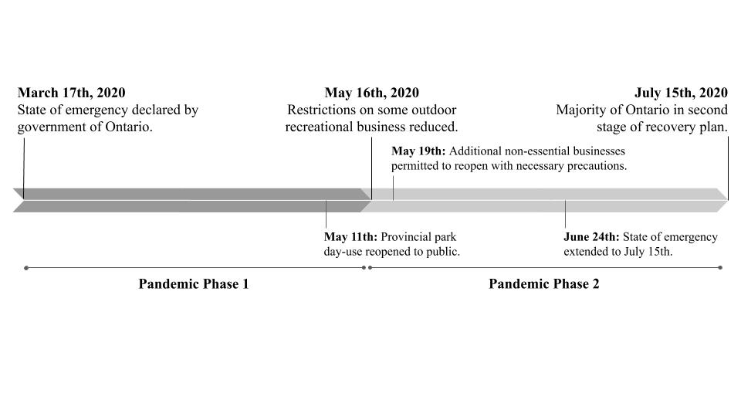Figure 1. Ontario pandemic lockdown and response timeline. The first ~60 day period is referred to as ‘Pandemic Phase 1’ or ‘Phase 1’ for the remainder of this article, and the second ~60 day period is referred to similarly, as ‘Pandemic Phase 2’ or ‘Phase 2.’

Figure 2. Motivations to fish during the pandemic as indicated by agreement with Likert-style response options.

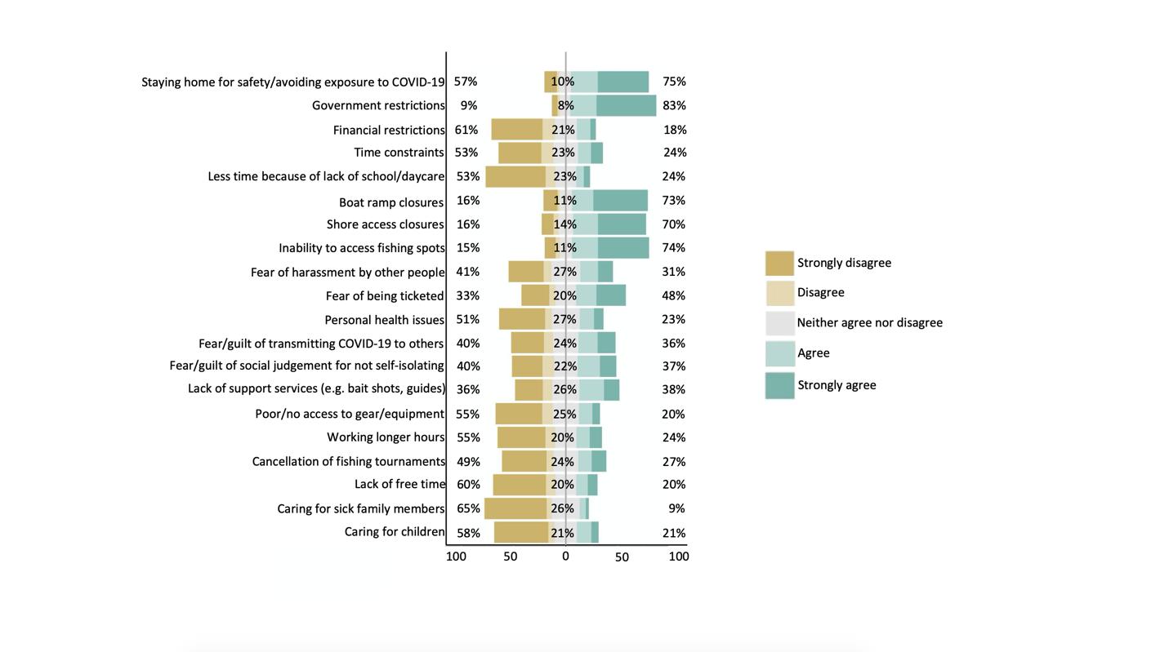
Figure 3. Motivations to fish during the pandemic as indicated by agreement with Likert-style response options.

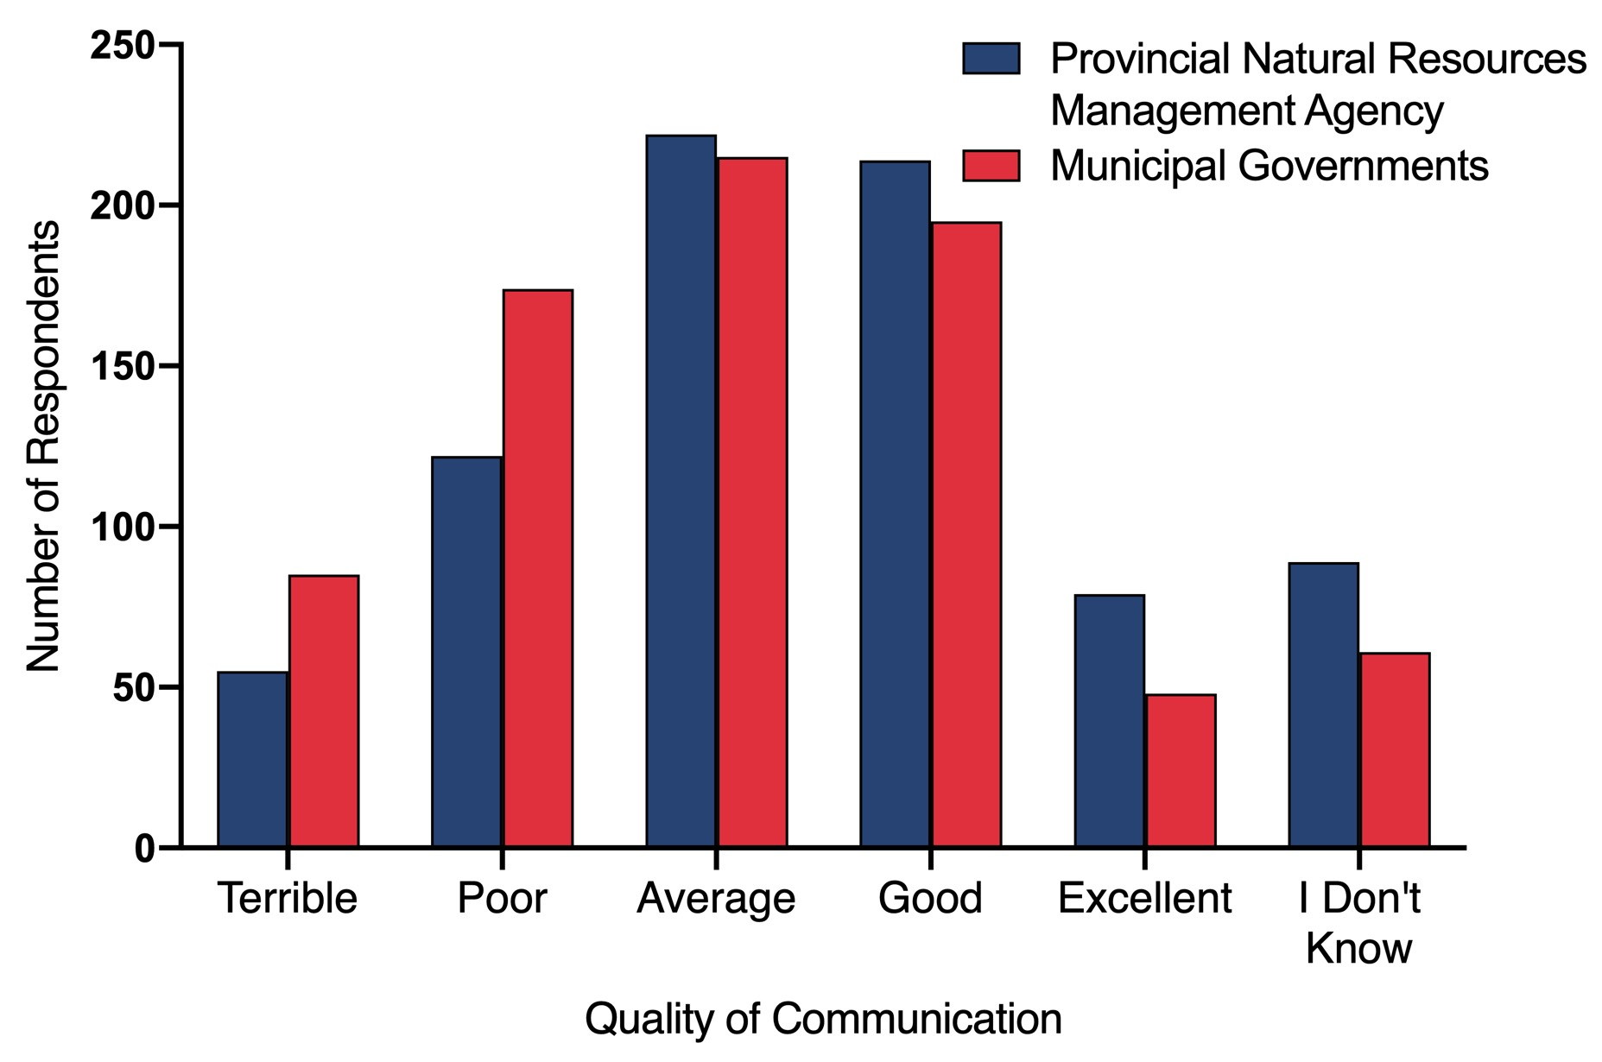
Figure 4. Respondent ratings of communications quality for the Ontario Ministry of Natural Resources and Forestry (i.e., the provincial natural resources management agency) and Ontario municipal governments in relation to recreational fisheries and angling during the pandemic.
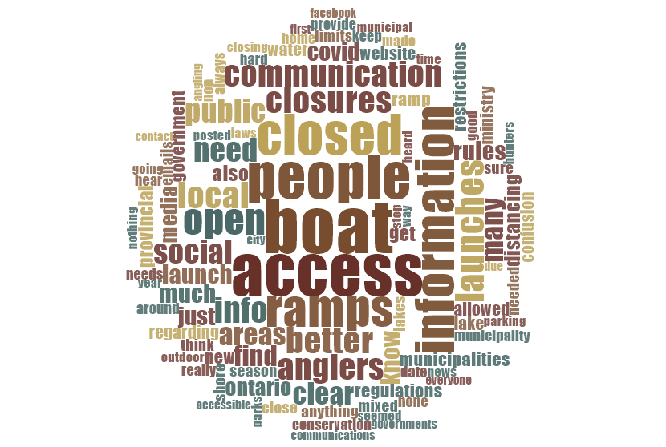
Figure 5. Word cloud generated from angler suggestions regarding the management of fishery use during the pandemic, and communication between governments and anglers. Respondents expressed concerns about limited access to fishing spots and facilities, and mentioned their desires for greater clarity and consistency across jurisdictions.

Appendix A. Survey Questions

The following Appendix includes a full list of survey questions for Resident angler perspectives on the impact of the COVID-19 pandemic on recreational fisheries in Ontario. Answers to survey questions are either illustrated through bullet-point format or tables.

(Open answer) indicates options where participants were able to write out an open answer to survey questions.

(*) indicates survey questions where participants chose one of the following Likert scale options: Strongly agree, somewhat agree, neither agree nor disagree, somewhat disagree, strongly disagree, NA.

---

Resident angler perspectives on the impacts of COVID-19 on recreational fisheries in Ontario

(1) Are you an Ontario resident who has fished in Ontario?
- Yes
- No
(2) What Ontario fisheries management zone (FMZ) do you fish in most frequently?
- 1-20
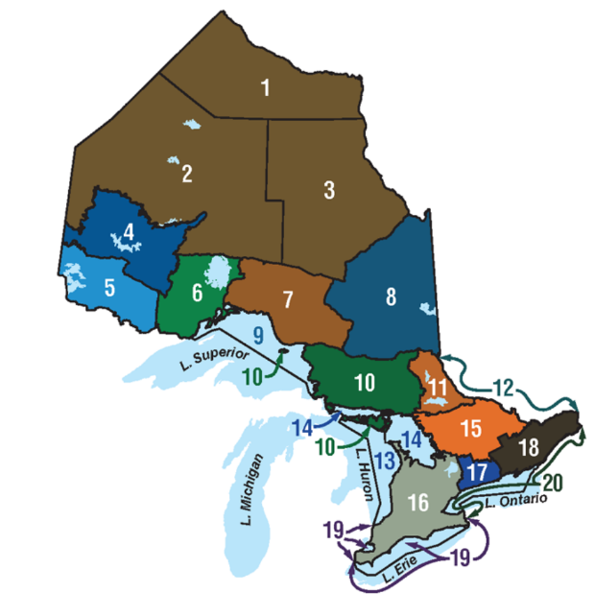
(3a) Approximately how many days did you fish in Ontario during each of the following periods? If you did not fish during time period(s) input 0.
 | March 17th to May 16th | May 16th to July 15th
2019 (no pandemic)
2020 (COVID-19 pandemic)

(3b) Approximately how many fish in Ontario did you catch during each of the following periods? If you did not catch any fish during time period(s) input 0.
 | March 17th to May 16th | May 16th to July 15th
2019 (no pandemic)
2020 (COVID-19 pandemic)

(3c) What percentage of fish in Ontario did you keep/consume during each time period below? If you did not keep/consume fish during time period(s) input 0.
 | March 17th to May 16th | May 16th to July 15th
2019 (no pandemic)
2020 (COVID-19 pandemic)

(3d) Approximately how much money did you spend on fishing gear, tackle, boats, angling/boating accessories, and other fishing-related expenses in Ontario during the following time periods? Estimate to the nearest $50. If you did not spend money during time period(s) input 0.
 | March 17th to May 16th | May 16th to July 15th
2019 (no pandemic)
2020 (COVID-19 pandemic)

(4) Did you fish during the 2020 pandemic/emergency from March 17th to July 15th, 2020?
- No
- Yes
(5) Please select all statement(s) that apply to you:
 | From March 17th to May 16th (height of 2020 COVID-19 pandemic/emergency) | From May 16th to July 15th (reintroduction/post-2020 COVID-19 pandemic/emergency)
I returned or began fishing again after a one-year hiatus (break from fishing) during this period
I continued to fish as usual during this period
I have increased my fishing effort during this period
I have decreased my fishing effort during this period
I did not fish during this period

(6) What motivated you to begin/resume/continue fishing during the COVID-19 pandemic?*
- More time due to working less and/or at home
- I wanted to try something new
- Greater flexibility in work schedule
- Finding a new hobby and/or way to spend time
- Doing something I used to do prior to the pandemic/maintaining normalcy
- Spending time with family/kids
- Less competition for space
- To get away from people and be safe
- Access to fish for food
- Desire to be self-sufficient
- Lack of school/daycare
- Improving mental/physical wellbeing
- Looking for local activities due to travel restrictions/avoiding travel
- Other (open answer)
- Other (open answer)
- Other (open answer)
(7) Did you keep/consume fish you caught at any point during the pandemic (from March 17th to July 15th 2020)?
- Yes
- No
(8) Why did you keep/consume fish at any point during the pandemic (from March 17th to July 15th 2020)?*
- I wanted to provide my own food, rather than risk exposure to COVID-19 at the grocery store
- I wanted to partake in something I used to do prior to the pandemic, to maintain normalcy
- I wanted to ensure that I had a supply of my favourite food, in case authorities cancelled or otherwise restricted the angling season
- I wanted to try something new
- I wanted to take advantage of the cancellation/delay of fishing tournaments due to COVID-19
- Reduced fishing pressure made keeping fish less harmful
- Other (open answer)
- Other (open answer)
- Other (open answer)
(9) Did you fish between March 17th to July 15th in 2019 AND in 2020?
- Yes
- No
(10a) During the following periods, did you travel more/less to go fishing, compared to the same time period in 2019? Please select all that apply.
 | Height of pandemic (March 17th to May 16th) | Reopening (May 16th to July 15th)
Much more than 2019
Somewhat more than 2019
About the same as 2019
Somewhat less than 2019
Much less than 2019

(10b) During the pandemic, were you more/less likely to pay for the following things, compared to the same period in 2019?
 | March 17th to May 16th 2020 (Options: Likely; Neither likely nor unlikely; Unlikely) | May 16th to July 15th 2020  (Options: Likely; Neither likely nor unlikely; Unlikely)
Fishing licenses/outdoor cards
Fishing license/outdoor card renewals
Fishing gear and tackle
Fishing-related travel
Boating-related expenses (e.g., launch feed, fuel)
Online big box store purchases (Canada-based)
Online big-box store purchases (US-based)
Local specialty store purchases (e.g., tackle/fly shops)
Local online store purchases

(10c) How were your catch rates during the following periods, compared to the same time periods in 2019? Please select all that apply.
 | Height of pandemic (March 17th to May 16th) | Reopening (May 16th to July 15th)
Much higher than 2019
Higher than 2019
About the same as 2019
Lower than 2019
Much lower than 2019

(10d) How big were the fish you caught during the following periods, compared to the same time periods in 2019? Please select all that apply.
 | Height of pandemic (March 17th to May 16th) | Reopening (May 16th to July 15th)
Much bigger than 2019
Bigger than 2019
About the same as 2019
Smaller than 2019
Much smaller than 2019

(11) Did you fish less than you normally would because of the COVID-19 pandemic, at any point from March 17th to July 15th, 2020?
- Yes
- No
(12) What motivated you to fish less at any point during the pandemic?*
- Staying home for safety, avoiding exposure to COVID-19
- Government restrictions
- Financial constraints
- Time constraints
- Less time because of lack of school/daycare
- Boat ramp closures
- Shore access closures
- Inability to access fishing spot(s)
- Fear of harassment by other people
- Fear of being ticketed
- Personal health issues
- Fear/guilt of social judgement for not self-isolating
- Lack of support services (e.g., bait shops, guides)
- Poor/no access to gear/equipment
- Working longer hours
- Cancellation of fishing tournament(s)
- Lack of free time
- Caring for sick family members
- Caring for children
- Other (open answer)
- Other (open answer)
- Other (open answer)
(13a) How would you describe the following?
 | Very positive | Somewhat positive | Neutral | Somewhat negative | Very negative
Short-term (<5 years) impacts of COVID-19 on quality of fishing in Ontario
Long-term (>5 years) impacts of COVID-19 on the quality of fishing in Ontario
Short-term (<5 years) impacts of COVID-19 on the recreational fishing industry
Short-term (<5 years) impacts of COVID-19 on angling communities/culture in Ontario

(13b) Please explain your answers for the above questions. (Open answer)

(14) How would you rate the quality of communication(s) between the following groups during the pandemic? (Options: Excellent; Good; Average; Poor; Terrible; I don’t know).
- MNRF (Ministry of Natural Resources and Forestry) and anglers (e.g., regarding safety, legality of fishing)
  - Suggestions/improvements (Open answer)
- Municipal governments and anglers (e.g., regarding boat ramp/park/shoreline access, parking)
  - Suggestions/improvements (Open answer)
(15a) Knowing that COVID-19 may have long-term impacts, what—if anything—does the MNRF (Ministry of Natural Resources and Forestry) need to do to ensure that we have healthy, sustainable, and accessible fisheries for Ontarians and visitors in the coming years? (Open answer).

(15b) Do you think the COVID-19 pandemic presents any opportunities for angling, conservation, or other fish-related activities in Ontario? (Open answer).

(15c) If there is a 2nd wave to the COVID-19 pandemic, how should government respond in regards to recreational fisheries? (Open answer).

(15d) If there is a 2nd wave to the COVID-19 pandemic, how should anglers respond? (Open answer).

(16a) I consider myself a …
- Novice angler
- Intermediate angler
- Advanced angler
(16b) To what extent do you agree with the following statement: “fishing is an important part of my life”
- Strongly agree
- Agree
- Neither agree nor disagree
- Disagree
- Strongly disagree
(17) Do you earn any of your income from fishing?
- Yes
- No
(18) Please indicate which of the following contribute to your income (select all that apply):
- Guiding
- Professional angling
- Angling media
- Angling tourism/outfitter
- Tackle/gear sales
- Other (open answer)
(19a) Are you a member of any fishing clubs and/or other related organizations?
- Yes
- No
(19b) Please write the name of all fishing clubs and/or other related organizations you are a part of. (Open answer).

(20a) Please input your age.
- 18-123
(20b) Please specify your gender.
- Male
- Female
- Other
- I choose not to answer
(20c) Please write your postal code. (Open answer)

(20d) What is your highest degree of education?
- Some highschool
- Highschool diploma
- College diploma
- Undergraduate degree
- Post-graduate degree
(20e) What is your country of birth?
- Canada
- Other (open answer)
(20f) What is your residency status?
- Canadian citizen
- Permanent resident
- Temporary resident
(20g) What is your annual household income (CAN dollars)?
- 0-20,000
- 20,000-40,000
- 40,000-60,000
- 60,000-80,000
- 80,000-100,000
- 100,000+

