Interactions between microbial diversity and substrate chemistry determine the fate of carbon in soil.

Nanette Raczka^{1†}, Juan Piñeiro^{2†}, Malak M Tfaily^{3,4}, Mary S Lipton³, Ljiljana Pasa-Tolic³, Ember Morrissey², Edward Brzostek¹*.

¹Department of Biology, West Virginia University, Morgantown, WV, USA
²Division of Plant and Soil Sciences, West Virginia University, Morgantown, WV, USA
³Environmental Molecular Sciences Laboratory, Richland, WA, USA
⁴Department of Soil, Water and Environmental Science, University of Arizona, Tucson, AZ, USA

†These authors contributed equally to the presented work.
* Corresponding author

Abstract
Microbial decomposition drives the transformation of plant-derived substrates into microbial products that form stable soil organic matter (SOM). Recent theories have posited that decomposition depends on an interaction between SOM chemistry with microbial diversity and resulting function. Here, we explicitly test these theories by coupling quantitative stable isotope probing and metabolomics to track the fate of ¹³C labeled substrates that vary in chemical composition as they are assimilated by microbes and transformed into new metabolic products in the lab. We found that mycorrhizal-driven differences in forest nutrient economies (e.g., nutrient cycling, microbial competition) led to arbuscular mycorrhizal (AM) soils harboring greater microbial diversity than ectomycorrhizal (ECM) soils. When incubated with ¹³C labeled substrates, the greater diversity in AM soils led to substrate type driving shifts in the identity of active decomposers and their metabolic products. The decomposition pathways were more static in the less diverse, ECM soil. Importantly, the majority of these shifts were driven by non-co-occurring taxa suggesting a strong link between microbial identity and specialized function. Collectively, these results highlight an important interaction between ecosystem-level processes and microbial diversity; whereby the identity and function of active decomposers impacts the composition of decomposition products that can form stable SOM.

1. Introduction
Microbial decomposition is the foundation for carbon (C) and nutrient cycling in terrestrial ecosystems and the primary step in the transformation of plant-derived substrates into stable soil organic matter^{1,2} (SOM). There is a long and rich history of research that has linked differences in the chemical composition of substrates with their subsequent decomposition rates and residence time in SOM^{3,4}. Recent theoretical and empirical studies, however, have posited that the rate at which substrates are transformed and the degree to which decomposition products form stable SOM are influenced by the composition and functional traits of soil microbial communities^{5,6}. While these studies have been successful in explaining empirical patterns in SOM decomposition and stabilization, the role of microbes in driving these patterns has been inferred from aggregate metrics describing composition (e.g. diversity, and/or richness). This focus on aggregate measures reflects methodological limitations in quantifying taxon-specific metabolic rates in natural communities and hinders our fundamental understanding of the contribution of individual taxa to community-level decomposition processes^{7,8}. Thus, unlocking the microbial “black box” and thereby, linking microbial identity with function continues to represent a grand challenge in microbial ecology⁹. Meeting this challenge also has the potential to reduce uncertainty in Earth System Models that explicitly model the impacts of microbial function and traits on soil C cycling.
As our conceptual understanding of decomposition has evolved from theories centered on substrate chemistry to those accounting for microbial community composition and function, important interactions between these two drivers have largely been ignored. For instance, substrate and nutrient availability influence microbial biodiversity via habitat filtering and also by promoting competitive interactions between microbial guilds^{7,10}. On the other hand, microbial biodiversity influences soil organic matter formation through the transformation of plant inputs into decomposition products¹²⁻¹⁶. We developed a new conceptual model that integrates interactions between substrate chemistry, microbial biodiversity, and the resulting decomposition products (Fig 1). Leaf substrate that is chemically complex (e.g. rich in lignocellulose) may foster a low diversity saprotrophic community since comparatively few species will have the metabolic capability to degrade the substrate^{14–16}. In contrast, substrates that are less chemically complex (e.g. sugars and amino acids) can be utilized by most microorganisms^{17–20} and consequently may foster more diverse saprotrophic communities. Microbial diversity can, in turn, influence the functional potential. More diverse communities likely harbor more metabolic pathways, exhibit greater metabolic flexibility, and produce a wider variety of decomposition products that are potentially sorbed onto mineral surfaces forming stable organic matter²¹ . Understanding the linkages between microbial biodiversity and the chemistry of decomposition products they produce is critical, since their characteristics may impact the rates of stable SOM formation through physio-chemical interactions with mineral surfaces²².
Here, we explicitly test our conceptual model (Fig 1) using a novel approach that couples quantitative Stable Isotope Probing²³ (qSIP) to quantify the amount of litter C that is assimilated by active bacterial and fungal taxa, with Fourier Transform ion cyclotron resonance mass spectrometry (FTICR MS) to track changes in metabolite composition during microbial degradation. We used known differences in plant traits and microbial communities between ecosystems influenced by ectomycorrhizal fungi (ECM) vs. those influenced by arbuscular mycorrhizal fungi (AM) as a model system to test our conceptual framework^{24,25}. ECM trees generally have leaf litter that has greater lignin content and less nitrogen and more reliance on rhizosphere processes to access nutrients from organic sources than AM trees²⁶. ECM microbial communities have higher fungal to bacterial ratios and stronger competitive interactions between mycorrhizal symbionts and free-living microbes than AM microbial communities^{27,28}. To test our conceptual model, we incubated isotopically labeled ¹³C AM (tulip poplar, Liriodendron tulipifera) and ECM (English oak, Quercus rubra) substrates in soils from AM and ECM dominated plots in a factorial mesocosm experiment.

2. Results & Discussion
Here we show the extent to which differing routes of decomposition and metabolic byproducts hinge on an interaction between microbial community identity with substrate chemistry. Our results support our conceptual model in that the diversity of microbes is greater in AM than ECM soils (Fig. 1) and that microbial diversity is tightly coupled to the breadth of functional capabilities and the resulting shift in SOM chemistry with microbial degradation (Fig. 2). This outcome links community ecology theory with ecosystem processes and produces a transformative framework to advance our ability to incorporate these fundamental pathways into ecosystem models.
Differences in habitat characteristics between these adjacent AM and ECM-dominated tree stands over nearly 120 years of ecosystem development appear to have led to divergent microbial communities, soil chemical properties, and SOM chemical composition (Table S1, Fig. S1, S2). Fungal and bacterial communities found in AM soils were more diverse than those in ECM soils (p-value < 0.01 and 0.01, respectively; Fig. 1). The greater microbial diversity in AM soils than ECM likely reflects both habitat filtering and competitive interactions. The long-term inputs of higher quality litter to AM soil likely reduced microbial stress and enhanced access to resources that fuel microbial growth and release competition^{7,10,22}. By contrast, in ECM soils, the lower quality litter may have reduced diversity by selecting a lower number of taxa with the metabolic ability to degrade more complex substrates^{14,16}, or by indirectly promoting greater competition for limiting resources between microbial guilds²⁹. The soils also differed in C:N stoichiometry with AM soils having a lower C:N ratio (-24%, p-value=0.04; Table S1) relative to ECM soils, a pattern commonly observed in forest ecosystems²⁹. Further, there were feedbacks between microbial community composition and SOM chemical composition, with AM soils possessing a different profile than ECM soils (PerMANOVA p-value< 0.01, Fig. S2, Table S1). ECM soils had lower percentages of lignin- and protein-like compounds (-43%, p-value=0.03; -92%, p-value= 0.01, respectively), but relatively more amino sugar- (+85%, p-value=0.01), unsaturated hydrocarbon- (+127%, p-value= 0.01) and lipid-like compounds (+92%, p-value=0.02) than AM soils. This lower lignin content in ECM soils may reflect a greater capacity of the saprotrophic communities in ECM soils to process lignin-rich substrates and the ability of plant-C subsidies to ECM fungi to stimulate lignin degradation³⁰. Overall, these results suggest a tight coupling between differences in the nutrient economies of ECM and AM ecosystems and microbial diversity that feeds back on decomposition pathways to alter the chemical composition of soils.
When we followed the fate of the ¹³C poplar and oak substrates into microbial taxa (i.e. APE), we found distinctive responses to substrate characteristics between AM and ECM microbial communities (Fig. 2, Table S2.). While bacterial ¹³C assimilation was altered by both substrates in both soils (substrate p-value < 0.05), fungal ¹³C assimilation was only altered by substrate characteristics in AM soils (soil X substrate interaction p-value < 0.01, Fig. 2 C and D). This can be visualized on the principal coordinate analysis of community ¹³C assimilation (Fig 2) which shows distinct clustering due to substrate type in the AM soil but not in the ECM soil for fungi. These results suggest that the greater fungal diversity in AM than ECM soils lead to communities that can rapidly shift the identity of active decomposers to metabolize plant-derived inputs of contrasting characteristics. In addition, abundance weighted ¹³C assimilation was greater in fungi than bacteria when analyzed across soils and substrate treatments (Fig. S3), supporting previous research showing that the decomposition of plant-derived substrates is driven to a greater extent by fungi than bacteria in aerobic forest soils^{26,31}.
By leveraging the taxonomic resolution of our qSIP analysis, we were able to identify the fungal and bacterial families that were the dominant active decomposers across soil and substrate types (Fig. 3, S4, S5). Within fungi, Glomerellaceae and an unclassified group of Helotiales were important assimilators of the substrate at both sites. Some bacterial families also appeared to be generalists assimilating both litter types in both sites (e.g. Bradyrhizobiaceae, Xanthomonadaceae, Comamonadaceae, and Soilbacteraceae). However, we found that the fungi and bacteria families that were active decomposers in only one soil type assimilated more C than those that were active decomposers in both soils (Fig. S4, S5), and often showed a preference based on substrate type. For example, Chthoniobacteraceae was only active in the AM soil where it assimilated the oak but not the poplar substrate (Fig. S4). For fungi, in AM soil, Boletaceae was a key assimilator of the poplar litter; whereas, in ECM soils, a family within Russulales accounted for rough 5% of C assimilation from both litter types (Fig. S5). These results highlight that decomposition of plant-derived substrates relies upon the identity of actively decomposing microbes, and that in many cases the dominant decomposing families in one system can be absent from another³¹.
We used the FTICR analysis to examine extent to which differences in the composition of active saprotrophic communities between AM and ECM soils affect SOM physicochemical characteristics. While we found no changes in SOM chemistry in response to substrate addition in either soil when all molecular formulae were analyzed, the molecules unique to one substrate type differed in AM, but not in ECM soils (Fig. 4). This pool of molecules likely played an important role in driving the observed differences in the chemical characteristics of SOM in AM soils. In particular, weighted mean indices in AM soils receiving the poplar substrate showed greater O:C ratio (P=0.036), NOSC (P<0.001), and aromaticity values (P=0.038), but had lower average H:C ratio (P=0.04) when compared to the oak substrate (Fig. 4). The ability of decomposition products to form stable SOM can be inferred through their molecular properties such as, bioavailability (i.e. higher H/C ratio), reactiveness (i.e. lower Ai) and the energetic rewards from oxidative degradation (i.e. higher NOSC)^{28,32–34}. Overall, these results indicate lower abundance of reduced and saturated C-containing molecules (i.e., the C atoms are linked by double and single bonds) ^{12,27,28} in AM soils receiving poplar substrate when compared to oak substrate. These differences in molecules’ C saturation and reduction are important because both metrics indicate greater stabilization potential since unsaturated and oxidized molecules tend to enter the microbial stabilization loop to a greater extent than their counterparts due to the lower activation energies. As such, the decomposition products of ECM substrates in AM soils likely have a greater potential to be stabilized by organo-mineral interactions^{12,21,35}(Fig. 4).
We used lipidomics analysis to further explore the potential of decomposition products to form stable SOM, as widespread evidence suggests a dominance of microbial-originated lipids in newly-formed SOM³⁶, as well as in C associated with soil minerals. Mirroring the results from the qSIP analysis, the lipidomic profiles varied with substrate type in AM soils and were unresponsive to substrate in the ECM soil (Fig. 5, Table S3). In AM soils, AM substrate led to greater relative intensity of lipids of the class Glycerophosphoethanolamines (+7%, P=0.041), but lower intensity of Diacylglycerols (+3%, P=0.036 Fig. S6). In addition, the trends observed on the chemical characteristics of lipids are in line with the SOM results; substrate chemistry led to greater differences in weighted mean indices in AM soil than ECM soil. In particular, AM soils receiving the poplar substrate showed greater O:C ratio, NOSC and aromaticity values (P<0.01 in all cases; Fig. 5) than under oak substrate. Thus, substrate chemistry drove divergent responses in the community of active decomposers as well as their decomposition products in AM soil, leading to a distinct chemical signature that can be indicative of the microbial communities involved in the decomposition process. These results are consequential because they suggest a novel mechanistic cascade whereby highly diverse microbial communities can drive shifts in the composition of decomposers in response to substrate chemistry and alter the resulting decomposition products that have the potential to form stable SOM.
Collectively, these results support our conceptual model by showing a novel dynamic interplay between substrate chemistry and microbial diversity that advances our mechanistic understanding of linkages between microbial community composition and function (Fig. 1). Differences between mycorrhizal associations in their nutrient economies over the course of ecosystem development led to AM soil harboring greater microbial diversity than ECM soil (Fig S1). This coupling of nutrient economies and microbial diversity also appears to have led to divergent functional capabilities of the resulting microbial communities. In the AM soil, greater diversity led to flexibility in the decomposition pathways with the identity of the active decomposers and the composition of their decomposition products shifting dynamically in response to variability in substrate quality (Figs. 2-3). By contrast, in the less diverse ECM soil, the decomposition pathway was comparatively static (Figs. 2-3). The more diverse AM community generated a greater proportion of highly-processed decomposition products supporting our conceptual model that higher diversity saprotrophic communities have the potential to generate more stable soil organic matter. Conceptually, these results transform our understanding of stable SOM formation by showing that diversity in microbial identity and function is coupled directly to the chemical diversity of decomposition products that are the foundation of SOM. Integrating this conceptual advance into models has the potential to improve our predictive understanding of how ongoing shifts in the global distribution of AM and ECM ecosystems owing to environmental change, invasion, and disease will impact future SOM stocks.

3. Material & Methods
3.1. Soil and litter sampling.
Mineral soil (0-15 cm) was collected at the Elizabeth Woods site, a 120-year-old deciduous forest in West Virginia, US (39°32'50.6"N, -80°00'00.4"W). Soils were collected from four 20x20 m plots dominated by either AM-associated trees (i.e. Liriodendron tulipifera and Acer saccharum), or ECM-associated trees (i.e. Quercus rubra, Quercus velutina and Carya ovata). These sites have been characterized previously as Culleoka-Westmoreland silt loam soils at the AM sites and Dormont and Guernsey silt loams at the ECM sites³⁷. Soils were also characterized as having 11.7 C:N content and 14.1 C:N content for the AM and ECM soils respectively, with a pH of 6.8 for both soils. Soils with the same mycorrhizal status were pooled and homogenized, air-dried at room temperature for ~24 h and sieved through two mm mesh before the initiation of the experiment. Uniformly ¹³C labeled litter (>97 atom % ¹³C) from Quercus robur (i.e., ECM substrate) and Liriodendron tulipifera (i.e. AM substrate) leaves (Isolife BV, Wageningen, NL) were incubated in soil mesocosms in a factorial design with five replicates for each treatment combination (2 soil types x 2 litter types), along with five replicate controls (no litter addition) for each soil type. The labeled litter was added to each jar with 20 g of soil at a concentration of 400 ug ¹³C g⁻¹ soil. These incubations were well mixed and kept at 60% water-holding capacity for the 21-day period at room-temperature¹⁷. Chemical characteristics of soils and litter substrate are provided in table S1.
3.2. DNA processing and qSIP
For quantitative stable isotope probing, DNA was extracted, quantified, ultracentrifuged, fractionated and sequenced as described in^{17,23}. DNA was extracted using a MoBio PowerSoil HTP Kit following the manufacturer’s instructions. For stable isotope probing, 5 ug of DNA was loaded into a 5-ml ultracentrifuge tube with ~3.5ml of a saturated cesium chloride (CsCl) solution and ~900ml gradient buffer (200mM Tris, 200mM KCl, 2mM EDTA). DNA was separated via ultracentrifugation at 127000 g for 72 h using a TLN-100 rotor in an Optima Max bench top ultracentrifuge (Beckman Coulter, Fullerton, CA, USA). Tubes were fractionated into ~25 fractions of 150 µl each, and the density of each fraction was measured with a Raichart AR200 digital refractometer. DNA was purified using an isopropanol precipitation method. The 16S rRNA gene was subsequently quantified and sequenced in samples containing DNA, within the density range 1.660–1.735 gml⁻¹ (~10 fractions per sample). To quantify the 16S rRNA gene, quantitative PCR was performed in triplicate using a QuantStudio 5 applied biosystems (Thermo Fisher Scientific) and primers 515F (5′-GTGCCAGCMGCCGCGGTAA-3′) and 806R (5′-GGACTACVSGGGTATCTAAT-3′)³⁸. The PCR program used was as follows: 95 °C for 2min followed by 45 cycles of 95 °C for 30 s, 64.5 °C for 30 s and 72 °C for 1 min. Libraries were sequenced on an Illumina MiSeq instrument (Illumina, Inc., San Diego, CA, USA) using a 300-cycle v2 reagent kit. Fungal 18S rRNA gene copies in each fraction were also quantified. These fractions were amplified for fungal ITS rRNA genes using primers ITS4F (5′-AGCCTCCGCTTATTGATAT GCTTAART-3′) and 5.8SF (5′-AACTTTYRRCAAYGGATCWCT-3′)³⁹ and 300-bp paired-end read chemistry on an IlluminaMiSeq (Illumina, Inc., San Diego, CA, USA). The PCR program used was as follows: 95 °C for 6 min followed by 35 cycles of 95 °C for 15s, 55 °C for 30s, and 72 °C for 1 min. These fractions were then sequenced using a 500 cycle v2 reagent kit.
Files came pre-split and joined multiple paired ends that we combined to pick operational taxonomic units (OTU). Open reference OTUs were picked at 97% identity using SILVA 128 release database for Bacteria and RDP database for Fungi. Taxa were analyzed at the ‘OTU’ level from the QIIME L7 table. Calculation of ¹³C atom percent excess (APE) was performed for each taxon as described previously^{17,18}. Briefly, after incubation, the presence of unlabeled and isotopically enriched substrates was calculated for each taxon’s DNA as a weighted average density. This shift based on density distribution across a CsCl density gradient can be used to quantify the amount of isotope incorporated into the DNA as verified experimentally^{17,18}. Preliminary data analysis revealed an effect of ultracentrifuge tube on estimation of phylotype weighted average density, probably a consequence of slight differences in CsCl density gradients between tubes. This technical error was corrected as previously described^{17,18}.

3.3. FTICR-MS and lipidomic analyses
Soil from litter-incubated and controls mesocosms were processed and analyzed with Fourier transform ion cyclotron resonance mass spectrometry (FTICR-MS), using a 12 T Bruker SolariX FTICR mass spectrometer at the Environmental Molecular Sciences Laboratory in Richland, WA, as described⁴⁰. Briefly, 100 mg of dried soil or litter was extracted using an adjusted Folch extraction⁴¹. Extraction was performed on each sample by sequentially adding 2 ml MeOH, followed by a 5 s vortex; 4 ml CHCl3, followed by a 5 s vortex; sonication at 25°C for 1 hr (CPX3800 Ultrasonic Bath, Fisherbrand); addition of 1.25 ml of H2O, followed by a slight mix to achieve bi‐layer separation; and incubated at 4°C overnight. The top, aqueous layer (metabolite—polar) was pipetted off into 1 ml glass vials and stored at −80°C until FTICR‐MS. The bottom, chloroform layer was dried down and stored in 50:50 methanol:chloroform until lipidomics analysis.
A standard Bruker electrospray ionization (ESI) source was used to generate negatively charged molecular ions in the metabolite fraction. Samples were then introduced directly to the ESI source. The instrument settings were optimized by tuning on a Suwannee River fulvic acid (SRFA) standard, purchased from International Humic Substances Society (IHCC). Blanks (HPLC grade methanol) were analyzed at the beginning and end of the day to monitor potential carry over from one sample to another. The instrument was flushed between samples using a mixture of water and methanol. One hundred and forty‐four individual scans were averaged for each sample and internally calibrated using an organic matter homologous series separated by 14 Da (CH2 groups). The mass measurement accuracy was less than 1 ppm for singly charged ions across a broad m/z range (m/z 300– 800). Data analysis software (Bruker Daltonik version 4.2) was used to convert raw spectra to a list of m/z values, applying the FTMS peak picker module with a signal-to noise ratio (S/N) threshold set to 7 and absolute intensity threshold set to the default value of 100. Chemical formulae were then assigned using in-house software following the compound identification algorithm that was described in⁴². Peaks below 200 and above 800 were dropped to select only for calibrated and assigned peaks. Chemical formulae were assigned based on the following criteria: S/N > 7 and mass measurement error < 0.5 ppm, taking into consideration the presence of C, H, O, N, S, and P and excluding other elements. Detected peaks and the associated molecular formula were uploaded to the in-house pipeline FTICR R Exploratory Data Analysis (FREDA) to obtain abundance of compound classes (carbohydrate-, lipid-, protein-, amino-sugar-, lignin-, tannin-, condensed hydrocarbon-, and unsaturated hydrocarbon-like) based on molar H : C and O : C ratios of the compounds²⁷. For further analysis, we only consider those masses that meet the above criteria and were detected in more than five samples. Mass-to-charge ratios with assigned molecular formulae meeting the criteria (1546 different m/z values) were normalized to the sum of intensities. Ions with m/z > 800 were not detected in our samples. The m/z values represent the molecular mass (in dalton) of the detected ions since all detected ions were singly charged ions. While our results do not represent a quantitative characterization of OM, the values presented are relative differences and should be representative of the samples.
Lipids in the chloroform fraction were analyzed by LC‐MS/MS in both positive and negative ESI modes o using a linear trap quadropole (LTQ) Orbitrap Velos mass spectrometer (Thermo Fisher Scientific), as described in detail previously⁴³. Lipid species were identified using the LIQUID tool⁴³ followed by manual data inspection. Confidently identified lipid species were quantified using MZmine 2 ⁴⁴ and the peak intensities were normalized by linear regression and central tendency (i.e., identifying a central or typical value for a probability distribution) using InfernoRDN.

3.4. Statistical analysis
All data analyses were performed using R 3.2.0⁴⁵. To examine the effects of soil type, substrate type and their interaction in the bacterial, fungal and chemical composition of DOM and the lipid pool; Bray-Curtis distance matrices were compared with permutational multivariate analysis of variance (PerMANOVA) and visualized with Principle Coordinate Analysis (PCoA) using vegan package⁴⁶. PerMANOVA analysis were run on the relative abundance and on the ¹³C APE of individual microbial taxa, separately for both bacterial and fungal communities. The analyses for FTICR-MS were performed separately for control and incubated soils using all assigned molecular formulae remaining after quality filtering²⁸. In all cases, we removed molecular formulae present in the added substrates and applied a Z-score standardization before calculating Bray-Curtis distance matrices⁴⁶.
We calculated aggregated indices that characterize both the composition and the physicochemical properties of the microbial (both bacteria and fungi) and the SOM and lipid pool^{34,32}. For bacterial and fungal communities, we quantified Shannon-Weaver diversity index for each sample H′= $−\sum_{i=1}^{S}{}piln⁡\left(pi\right)$ (where pi is the proportion of species I) using the relative abundance of individual microbial taxa⁴⁷. To find the percent of substrate assimilation by individual taxa, we calculated the proportion of C assimilated by each group as previously described^{17,48} as a percent. For SOM and lipid molecular formulae, we separately calculated weighted means of formula-based characteristics (i.e. m/z, Aromaticity Index -AI; H/C, O/C, and Nominal Oxidation State of Carbon -NOSC) as the sum of the product of the single-formula information (i.e. m/z_{i}, AI_{i}, H/C_{i} and NOSC_{i}) and the relative intensity (I_{i}) divided by the sum of all intensities (e.g., m/z _{sample1} = $\sum_{i=1}^{S}{}$ (m/z_{i} ·I_{i})/Σ(I_{i})). With these metrics we obtained sample-level information related to the molecular size (i.e. m/z), the molecular bioavailability (i.e. higher H/C ratio), the molecular reactiveness (i.e. lower AI) and the energetic rewards from molecular oxidative degradation (i.e. higher NOSC) of the SOM, which allows to infer the potential of decomposition products to form stable SOM ^{12,28,32}. Detailed information of the calculated indices can be found here^{28,32,33}.
We further tested the effects of soil type, substrate type and their interaction on each index using the “lm” function from the “stats” package. In these analyses, P-values were approximated by an F test using Type II ANOVA tests with Kenward-Roger Degrees of Freedom⁴⁹. When interactions between soil and litter type were found at P < 0.1, we examined differences for each level of a given factor by pairwise comparisons using the “lsmeans” package. All analyses were checked for the assumptions of residual normality and variance homogeneity.

References
1. Austin, A. T., Vivanco, L., González-Arzac, A. & Pérez, L. I. There’s no place like home? An exploration of the mechanisms behind plant litter–decomposer affinity in terrestrial ecosystems. New Phytol. 204, 307–314 (2014).
2. Cotrufo, M. F. et al. Formation of soil organic matter via biochemical and physical pathways of litter mass loss. Nat. Geosci. 8, 776–779 (2015).
3. Aerts, R. Climate, Leaf litter chemistry and leaf litter decomposition in terrestrial ecosystems: a triangular relationship. Oikos 79, 439–449 (1997).
4. Hobbie, S. E. Plant species effects on nutrient cycling: revisiting litter feedbacks. Trends Ecol. Evol. 30, 357–363 (2015).
5. Keiser, A. D. & Bradford, M. A. Climate masks decomposer influence in a cross-site litter decomposition study. Soil Biol. Biochem. 107, 180–187 (2017).
6. Strickland, M. S., Osburn, E., Lauber, C., Fierer, N. & Bradford, M. A. Litter quality is in the eye of the beholder: initial decomposition rates as a function of inoculum characteristics. Funct. Ecol. 23, 627–636 (2009).
7. Glassman, S. I., Wang, I. J. & Bruns, T. D. Environmental filtering by pH and soil nutrients drives community assembly in fungi at fine spatial scales. Mol. Ecol. 26, 6960–6973 (2017).
8. García-Palacios, P., Prieto, I., Ourcival, J.-M. & Hättenschwiler, S. Disentangling the litter quality and soil microbial contribution to leaf and fine root litter decomposition responses to reduced rainfall. Ecosystems 19, 490–503 (2016).
9. Isobe, K., Bouskill, N. J., Brodie, E. L., Sudderth, E. A. & Martiny, J. B. H. Phylogenetic conservation of soil bacterial responses to simulated global changes. Philos. Trans. R. Soc. B Biol. Sci. 375, 20190242 (2020).
10. Song, H.-K. et al. Environmental filtering of bacterial functional diversity along an aridity gradient. Sci. Rep. 9, 866 (2019).
11. Nunan, N., Leloup, J., Ruamps, L. S., Pouteau, V. & Chenu, C. Effects of habitat constraints on soil microbial community function. Sci. Rep. 7, 4280 (2017).
12. Amelung, W., Brodowski, S., Sandhage-Hofmann, A. & Bol, R. B. T.-A. in A. combining biomarker with stable isotope analyses for assessing the transformation and turnover of soil organic matter. in Advances in Agronomy (ed. Sparks, D.) 100, 155–250 (Academic Press, 2008).
13. Wang, T., Tian, Z., Bengtson, P., Tunlid, A. & Persson, P. Mineral surface-reactive metabolites secreted during fungal decomposition contribute to the formation of soil organic matter. Environ. Microbiol. 19, 5117–5129 (2017).
14. Goldfarb, K. et al. Differential growth responses of soil bacterial taxa to carbon substrates of varying chemical recalcitrance . Frontiers in Microbiology 2, 94 (2011).
15. Koeck, D. E., Pechtl, A., Zverlov, V. V & Schwarz, W. H. Genomics of cellulolytic bacteria. Curr. Opin. Biotechnol. 29, 171–183 (2014).
16. Andlar, M. et al. Lignocellulose degradation: An overview of fungi and fungal enzymes involved in lignocellulose degradation. Eng. Life Sci. 18, 768–778 (2018).
17. Morrissey, E. M. et al. Evolutionary history constrains microbial traits across environmental variation. Nat. Ecol. Evol. 3, 1064–1069 (2019).
18. Morrissey, E. M. et al. Bacterial carbon use plasticity, phylogenetic diversity and the priming of soil organic matter. ISME J. 11, 1890–1899 (2017).
19. Chapman, S. K. & Newman, G. S. Biodiversity at the plant–soil interface: microbial abundance and community structure respond to litter mixing. Oecologia 162, 763–769 (2010).
20. Maron, P.-A. et al. High microbial diversity promotes soil ecosystem functioning. Appl. Environ. Microbiol. 84, e02738-17 (2018).
21. Schmidt, M. W. I. et al. Persistence of soil organic matter as an ecosystem property. Nature 478, 49–56 (2011).
22. Mikutta, R. et al. Microbial and abiotic controls on mineral-associated organic matter in soil profiles along an ecosystem gradient. Sci. Rep. 9, 10294 (2019).
23. Hungate, B. A. et al. Quantitative microbial ecology through stable isotope probing. Appl. Environ. Microbiol. 81, 7570–81 (2015).
24. Midgley, M. G., Brzostek, E. & Phillips, R. P. Decay rates of leaf litters from arbuscular mycorrhizal trees are more sensitive to soil effects than litters from ectomycorrhizal trees. J. Ecol. 103, 1454–1463 (2015).
25. Cheeke, T. E. et al. Dominant mycorrhizal association of trees alters carbon and nutrient cycling by selecting for microbial groups with distinct enzyme function. New Phytol. 214, 432–442 (2017).
26. Malik, A. A. et al. Soil fungal:bacterial ratios are linked to altered carbon cycling . Frontiers in Microbiology 7, 1247 (2016).
27. Bailey, V. L., Smith, A. P., Tfaily, M., Fansler, S. J. & Bond-Lamberty, B. Differences in soluble organic carbon chemistry in pore waters sampled from different pore size domains. Soil Biol. Biochem. 107, 133–143 (2017).
28. Roth, V.-N. et al. Persistence of dissolved organic matter explained by molecular changes during its passage through soil. Nat. Geosci. 12, 755–761 (2019).
29. Averill, C., Turner, B. L. & Finzi, A. C. Mycorrhiza-mediated competition between plants and decomposers drives soil carbon storage. Nature 505, 543–545 (2014).
30. Talbot, J. M. & Treseder, K. K. Interactions among lignin, cellulose, and nitrogen drive litter chemistry–decay relationships. Ecology 93, 345–354 (2012).
31. Eichorst, S. A. & Kuske, C. R. Identification of cellulose-responsive bacterial and fungal communities in geographically and edaphically different soils by using stable isotope probing. Appl. Environ. Microbiol. 78, 2316–2327 (2012).
32. Roth, V.-N., Dittmar, T., Gaupp, R. & Gleixner, G. The molecular composition of dissolved organic matter in forest soils as a function of ph and temperature. PLoS One 10, e0119188 (2015).
33. Koch, B. P. & Dittmar, T. From mass to structure: an aromaticity index for high-resolution mass data of natural organic matter. Rapid Commun. Mass Spectrom. 20, 926–932 (2006).
34. Tanentzap, A. J. et al. Chemical and microbial diversity covary in fresh water to influence ecosystem functioning. Proc. Natl. Acad. Sci. 116, 24689 LP-24695 (2019).
35. Shao, S. et al. Linkage of microbial residue dynamics with soil organic carbon accumulation during subtropical forest succession. Soil Biol. Biochem. 114, 114–120 (2017).
36. Kallenbach, C. M., Frey, S. D. & Grandy, A. S. Direct evidence for microbial-derived soil organic matter formation and its ecophysiological controls. Nat. Commun. 7, 13630 (2016).
37. USDA-Natural Resources Conservation Service. Keys to Soil Taxonomy. (USDA-Natural Resources Conservation Service, 2014).
38. Liu, C. M. et al. BactQuant: An enhanced broad-coverage bacterial quantitative real-time PCR assay. BMC Microbiol. 12, 56 (2012).
39. Liu, C. M. et al. FungiQuant: A broad-coverage fungal quantitative real-time PCR assay. BMC Microbiol. 12, 255 (2012).
40. Fudyma, J. D. et al. Untargeted metabolomic profiling of Sphagnum fallax reveals novel antimicrobial metabolites. Plant Direct 3, e00179 (2019).
41. Folch, J., Lees, M. & Sloane Stanley, G. H. A simple method for the isolation and purification of total lipides from animal tissues. J. Biol. Chem. 226, 497–509 (1957).
42. Tolić, N. et al. Formularity: Software for automated formula assignment of natural and other organic matter from ultrahigh-resolution mass spectra. Anal. Chem. 89, 12659–12665 (2017).
43. Kyle, J. E. et al. LIQUID: an-open source software for identifying lipids in LC-MS/MS-based lipidomics data. Bioinformatics 33, 1744–1746 (2017).
44. Pluskal, T., Castillo, S., Villar-Briones, A. & Orešič, M. MZmine 2: Modular framework for processing, visualizing, and analyzing mass spectrometry-based molecular profile data. BMC Bioinformatics 11, 395 (2010).
45. R Core Team. R: A language and environment for statistical computing. (2019).
46. Oksanen, J., Blanchet, F., Friendly, M. Kindt, R. Legendre, P., McGlinn, D., Minchin, P., O’Hara, R. B., Simpson, G.L., Solymos, P., Stevens, M.H.H., Szoecs, E., and Wagner, H. vegan: Community Ecology Package Title. (2019).
47. Hill, M. O. Diversity and Evenness: A Unifying Notation and Its Consequences. Ecology 54, 427–432 (1973).
48. Hungate, B. A. et al. Quantitative microbial ecology through stable isotope probing. Appl. Environ. Microbiol. (2015). doi:10.1128/AEM.02280-15
49. Kenward, M. G. & Roger, J. H. Small sample inference for fixed effects from restricted maximum likelihood. Biometrics 53, 983 (1997).

Acknowledgements
This research was supported by grants from…. We also thank Chansotheary Dang for assistance in the laboratory.

Author contributions
N.C.R., E.M.M. and E.R.B. developed core ideas and experimental design for this manuscript. N.C.R. carried out the soil manipulation and participated in the sample analysis. N.C.R., J.P.N. and E.M.M. performed bioinformatics and data analysis. M.M.T. provided guidance on data analysis and interpretation. EMSEL performed FTICR analysis.

Competing interests
The authors declare no competing interests.

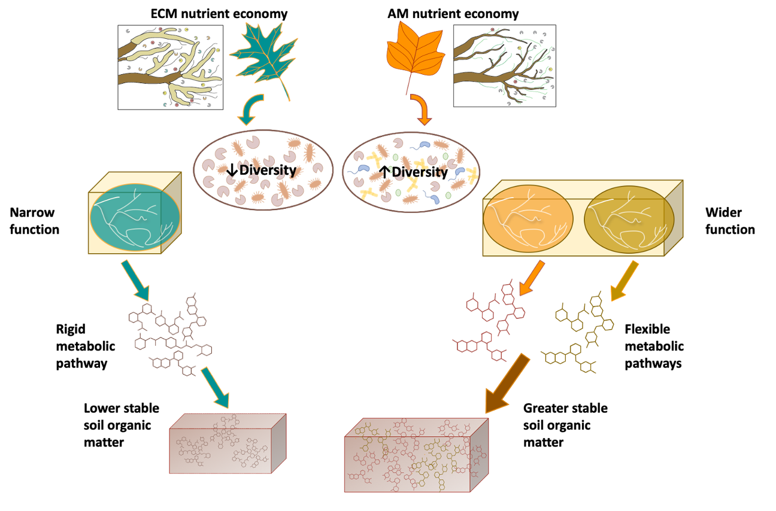
Figure 1.

Figure 1. Conceptual framework. We used known differences in ECM and AM nutrient economies for our conceptual model in which ECM nutrient economies are known to have leaf substrate that is chemically complex, which promote a low diversity microbial community that promotes a narrow function. This narrow function provides only a rigid metabolic pathway in which few varying products are produced to be sorbed onto SOM, which leads to lower stable soil organic matter. In contrast, AM nutrient economies with less chemically complex substrates can be utilized by most microbes which may lead to higher diversity and a wider function within the soil community. This, in turn, generates flexible metabolic pathways that produced a greater variety of metabolic products to form greater stable soil organic matter.

Figure 2. Variation in microbial diversity and composition between soils. Bar chart depicting fungal a) and bacterial b) Shannon diversity index in AM and ECM soils. Error bars indicate standard error (n=5). Asterisks denote p values < 0.05. Principal Coordinate Analysis showing variation in 13C substrate assimilation for fungal c) and bacterial communities d)

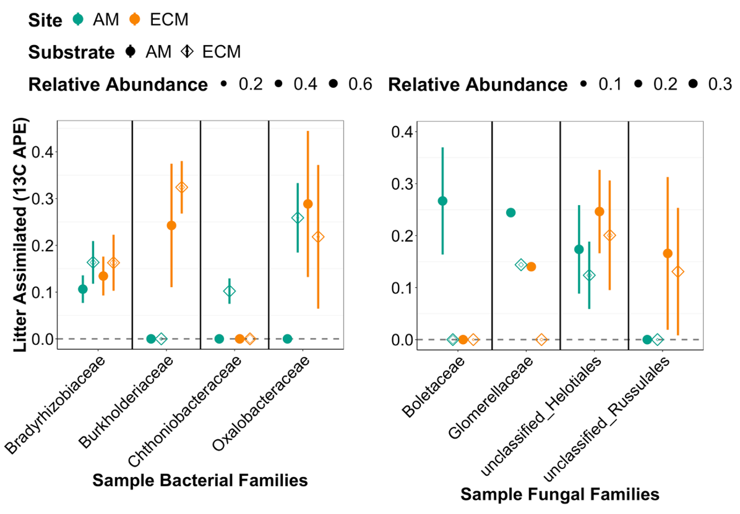
Figure 3.

Figure 3. Example taxa illustrative of variation in substrate assimilation by soil and substrate. Litter assimilated is shown with sample bacterial and fungal families. Open circles are averages with crossbars as standard error.

Figure 4.

Figure 4. Variation in SOM chemistry. Van Krevelen diagram showing molecular formulae unique for each substrate in each soil, (a and d). Bar plots depicting mean values aggregated indices showing physicochemical properties of the SOM pool (b, c, e and f). Error bars indicate standard error (n=5). Asterisks denote p values < 0.05.

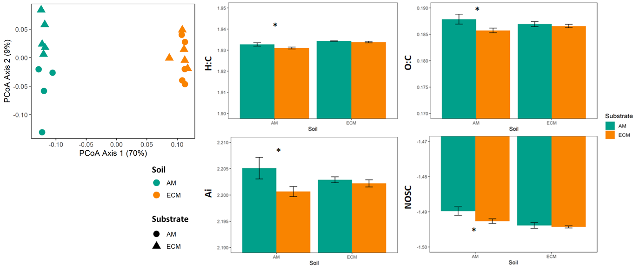
Figure 5.

Figure 5. Variation in lipid pools between soils and substrate. Principal coordinates analysis (PCoA) of the lipid pool composition in incubated soils (a). Bar plots depicting mean values aggregated indices showing physicochemical properties of the lipid pool (b, c, d and e). Error bars indicate standard error (n=5). Asterisks denote p values < 0.05.

Supplementary information

Table S1. Soil properties

Figure S1. Pie chart showing the relative abundance of bacterial and fungal communities in AM and ECM soils (n=5).

Figure S2. Pie chart showing the relative intensity of metabolite groups in control AM and ECM soils (n=5) and the added substrates.

AM Soil
ECM Soil

Table S2. Summary of PERMANOVA analysis on the effects of substrate type on fungi and bacteria composition and ¹³C assimilation (APE). Bold font indicates significance at P<0.05.

Figure S3. Box plots depicting minimum and maximum values of weighted average APE for microbial type in AM and ECM soils in response to substrate type. Cross bars indicate median (n=5). Analyzed by type with Welch two sample t-test, p<0.05.

Figure S4. A. Active decomposers at only one and at both sites within bacterial families at the AM Site and B. Bacterial families at the ECM site. Change in color denotes APE, symbol the litter substrate and the site of the point denotes relative abundance.

Figure S5. C. Active decomposers at only one and at both sites within fungal families at the AM Site and D. Fungal families at the ECM site. Change in color denotes APE, symbol the litter substrate and the site of the point denotes relative abundance.

Table S3. Summary of PERMANOVA analysis on the effects of substrate type metabolites. Bold font indicates significance at P<0.05.

Figure S6. Bar plots depicting mean values of relative intensity of different compound classes communities in AM and ECM soils in response to substrate type. Error bars indicate standard error (n=5). Asterisks denote p values < 0.05.

