A 25-years population dynamics of sika deer in Kyushu Island, Japan: Estimation using vector autoregressive spatiotemporal model and evaluation of a large-scale management

Kei K. Suzuki^{1,*}, Yasumitsu Kuwano², Yuki Kanamori³, Yohei Kawauchi⁴, Yoshihiko Uchimura⁵, Masatoshi Yasuda¹, Hiroshi Kondoh¹, Teruki Oka⁶
1 Kyushu Research Center, Forestry and Forest Products Research Institute, Kumamoto, Kumamoto 860-0862, Japan
2 Institute of Agricultural and Forest Resources, Fukuoka Agriculture and Forestry Research Center, Kurume, Fukuoka 839-0827, Japan
3 Fisheries Resources Institute, Japan Fisheries Research and Education Agency, 25-259, Shimomekurakubo, Samemachi, Hachinohe, Aomori 031-0841, Japan
4 Socio-Ecological Systems Division, Fisheries Resources Institute, Japan Fisheries Research and Education Agency, Yokohama, Kanagawa 236-8648, Japan
5 Environment and Forestry Affairs Department of Kagoshima Prefectural Office, Kagoshima, Kagoshima 890-8577, Japan
6 Department of Wildlife Biology, Forestry and Forest Products Research Institute, Tsukuba, Ibaraki 305-8687, Japan
Highlights
We evaluated effects of large-scale management on deer population dynamics.
Population dynamics and spatio-temporal distributions were estimated by VAST model.
More than 110000 deer harvesting per year didn’t contribute to a population decline.
This study indicates difficulties of large-scale management of large herbivores.
This study highlights points out the importance of accurate stock assessment.
Abstract
Regional management of large herbivore populations is known to be effective in reducing local economic damages and conserving local endemic plants. However, herbivores often move across management areas, and the effect of population management on a large spatial scale is poorly understood, even though it is necessary to use a large-scale approach across multiple management units to implement appropriate management. In this study, to better understand large-scale management and improve management efficiency, we evaluated effects of large-scale management of a sika deer (Cervus nippon) population on Kyushu Island (approximately 36,750 km²) in Japan. We estimated the population dynamics and spatial distributions of the deer and evaluated the effects of harvests, density dependence, and climatic conditions on the population dynamics both across Kyushu Island and in smaller prefectural management units. Fecal pellet count surveys conducted from 1995 to 2019 and results from a vector autoregressive spatio-temporal model showed relatively stable population dynamics and four high-density core areas. No increasing or decreasing trends were observed in the population dynamics, even though harvesting increased annually until it reached about 110,000 in 2014, indicating that harvesting was not related to the population dynamics. In addition, although no effects of density dependence were confirmed, maximum snow depth during winter decreased deer density at the management unit scale. Harvesting represents a major source of mortality in the Kyushu Island population because of the absence of predators. Although, approximately 110,000 sika deer were harvested annually after 2014, it is surprising that the effect of harvesting on population dynamics was not significant. A main cause of no reduction of the population was that the population used to determine the harvest number was underestimated. In addition, it was indicated that multi-management units need to manage the core areas because the high-density core areas were located across a few management units. This study highlights the difficulties involved with wide-area management of large herbivores and points out the importance of accurate stock assessment, reduction of the risk of management failure, and cooperation among management units. Our research is an important contribution to the study of the effects of large-scale harvesting in a large geographic area.

Keywords: Large herbivore, Population dynamics, Vector Autoregressive Spatiotemporal model, Wildlife management
- Introduction
Overbrowsing by abundant large herbivores is considered to be detrimental to both natural and artificial environments (Côté et al., 2004; Takatsuki, 2009a). For example, as plants are repeatedly browsed by herbivores year after year, progressively smaller individuals are generated from belowground resources, and fewer flowering plants are produced (Anderson, 1994). Long-lasting overbrowsing by deer has led to almost complete recruitment failure of tree species and inhibited the natural regeneration of trees (White, 2012), and covers of ground vegetation do not increase over a long period as a legacy effect of overbrowsing (Tanentzap et al., 2009; Harada et al., 2020). In addition, herbivores that browse field crops (Laforge et al., 2017), sown grasslands (Trdan and Vidrih, 2008; Hata et al., 2019), and planted tree seedlings (Trembley et al., 2007) have been shown to be destructive and cause economic damages (Conover, 1997; Reimoser, 2003). Thus, measures are needed to decrease browsing damage from both the ecological and economic sustainability points of view.
Population management is used to decrease browsing damage by herbivores in many parts of the world, including Europe (Hagen et al., 2018), North America (Simard et al., 2013), and Asia (Ueno et al., 2010). Herbivore population management has often focused on the single population within defined management units, for example, local government and national parks (Gordon et al., 2004). Such regional management is effective in reducing local economic damages and conserving local endemic plants. However, animals often move across management areas (Bhat and Huffaker, 2007), and this movement should be considered during management planning (Iijima et al., 2015; Bengsen et al., 2020). Although it is necessary to use a large-scale approach across multiple management units to implement appropriate management, the current understanding of the effects of harvesting on populations on a large spatial scale is inadequate (Hothorn and Müller, 2010).
A popular method to decrease herbivore population is to increase the harvest (Kilpatrick and Walter, 1999; deCalesta, 2017; Hagen et al., 2018), so understanding the effects of harvesting is an important issue in successful population management. However, the population dynamics of large herbivores are determined not only by anthropogenic factors, such as the harvesting, but also by biological and non-biological factors. For example, density dependence is well known as an important biological factor in the population dynamics of many herbivores (Bonenfant et al., 2009). Increased density causes a decrease in the survival rate and recruitment via lower food density (Fowler, 1987; Bonenfant et al., 2009). In addition, lower food density inhibits growth in juveniles and delays maturity (Kjellander et al., 2006). Climate conditions, a good example of non-biological factors, affect population abundance (Chavez et al., 2003; Both et al., 2006). In herbivores, the bottom-up effects of changes of climatic conditions can easily be observed in high-density populations (Vucetich and Peterson, 2004; Bowyer et al., 2014). In particular, low temperatures and high snow depths cause population and recruitment declines (Grøtan et al., 2005; Dou et al., 2013; Warbington et al. 2017). It is therefore necessary to simultaneously evaluate the effects of biological and non-biological factors to adequately understand the effects of harvesting on population dynamics.
On Kyushu Island, the third largest (approximately 36,750 km²) of Japan’s four main islands, ongoing attempts are being made to manage sika deer (Cervus nippon) populations on a large spatial scale. From the late 19th to the early 20th centuries, sika deer populations were threatened by overharvesting for venison and hides. The Japanese government restricted hunting of female sika deer for their protection, and deer populations began to recover by the 1970s (Tokita, 1998). However, the population rapidly increased, and deer have caused significant damage to plantations and agricultural lands over the past few decades. In recent years, the damage has covered a wide area of Kyushu Island (Suzuki et al., 2021). In addition, deer browsing has damaged the understory vegetation, especially dwarf bamboo (Sasa spp.), to the point it has caused soil degradation (Kawakami et al., 2020). Thus, the management objective for deer has changed from protection to population control.
To decrease the deer population, a policy to rapidly increase the harvests of sika deer was implemented. The harvest number has increased approximately six-fold from 2000 to 2015 and has exceeded 110,000 each year since 2014. Constant monitoring of density fluctuations and feedback-management system reflecting the monitoring are usually necessary to adequately manage resources (Tanaka, 1982; Constable et al., 2000; Kai and Shirakihara, 2005). However, despite the large effort to control the sika deer population, the effects of harvesting have not been verified because the population dynamics for Kyushu Island were not previously estimated. In addition, although management on Kyushu Island is implemented in prefectural units, the deer usually cross prefectural boundaries. Therefore, management in cooperation with multiple prefectures is required, especially in areas with high population density, but the locations of high-density areas are unclear.
On Kyushu Island, the sika deer densities per square kilometer have been estimated by the fecal pellet count method (FPCM; Iwamoto et al., 2000) in surveys conducted by each prefectural government. Although the FPCM can estimated sika deer density by considering seasonal changes in the decay rate of fecal pellets, the density for the entire island cannot be directly predicted from the sum of the number of fecal pellets calculated from the FPCM data for two reasons related to the spatial heterogeneity of the survey design. The first is that the survey areas varied among years because the surveys were not conducted annually, and the survey year differed among the prefectures. The second is that the surveyed locations are spatially heterogeneous because there are more data from easily accessed locations than from inaccessible locations. These problems introduce estimation bias into any calculation of sika deer density.
To gain a deeper understanding of the large-scale management of a herbivore population to improve management efficiency, we evaluated the effects of large-scale management of the sika deer population on Kyushu Island. We first estimated the dynamics of sika deer density and spatial distributions of high deer density areas on Kyushu Island by using a state-of-the-art spatio-temporal model that can incorporate the different survey designs. We then evaluated the effects of the harvests and density dependence, as the anthropogenic and biological factors, on the estimated density fluctuation on Kyushu Island. Finally, we estimated deer density fluctuations in each prefecture from the first spatio-temporal model, and we simultaneously evaluated the effects of the anthropogenic and biological factors as well as climatic conditions on density fluctuation. Because population management is conducted at the prefectural level, clarifying density fluctuations and effects of harvesting at the prefecture level will help improve management. In addition, non-biological factors, such as low temperatures and snow depth, are important factors, but the climatic conditions of Kyushu Island differ between the East China Sea side and the Seto Inland Sea-Pacific side. Therefore, we included non-biological factors in the analyses of the prefectural level.
- Methods
  - Study areas and fecal pellet count method
Natural forest vegetation on Kyushu Island splits into in two main zones with a boundary at an altitude of 800–1000 m: an evergreen broad-leaf forest zone at low altitudes and a deciduous broad-leaf forest zone at high altitudes. In addition, plantations comprising Japanese cedar (Cryptomeria japonica) and Japanese cypress (Chamaecyparis obtusa) cover 56% of forests on the island. In recent years, as harvests on these plantations have increased, Japanese cedar cuttings and/or Japanese cypress seedlings have been planted in the clear-cut areas.
The study area included five prefectures (Fukuoka, Oita, Kumamoto, Miyazaki, and Kagoshima) on the island (Fig. 1). Sika deer fecal pellets were collected in 1380 of 1587 survey plots (Table 1, Fig. 1, and Appendix A) in mountainous areas from 1995 to 2019 (the Japanese fiscal year, from April to the next March, was used). Total number of surveys was 3279 and the fecal pellets were observed in 2770 surveys. The sika deer densities per square kilometer in each plot were calculated based on the pellet numbers by using the FPCM (Iwamoto et al., 2000).

  - Estimation of deer density fluctuations and attribution of high-density core areas
To estimate changes in sika deer density over Kyushu Island considering the spatial heterogeneity of survey design, we used the vector autoregressive spatio-temporal (VAST) model (Thorson and Barnett, 2017; Thorson, 2019). This model can account for spatio-temporal changes in survey design and accurately estimate relative local density at high resolution, so it can partially overcome the challenges of estimating the sika deer density on Kyushu Island given the existing data. Previous studies have mainly applied the VAST model to marine organisms to clarify distributions (Brodie et al., 2020), shifts in fish spawning grounds associated with climate change (Kanamori et al., 2019), and the spatio-temporal dynamics of fisheries (Dolder et al., 2018; Xu et al., 2019). Ours is the first application of the VAST model to a terrestrial organism (i.e., sika deer). Expected deer densities $d\left(s_{i}, t_{i}\right)$ for each sample$i$ were estimated using a log-linked linear predictor and a lognormal distribution with the following formula:
$$log\left(d_{i}\right)= β_{t} + ω\left(s_{i}\right) + ε\left(s_{i}, t_{i}\right),$$
where $β$ is the intercept for year $t$, and $ω$ and $ε$ are spatial and spatio-temporal random effects for year t and location s (latitude and longitude). The probability density function of $ω\left(∙\right)$ is a multivariate normal distribution $MVN\left(0, R\right)$, where the variance-covariance matrix $R$ is a Matérn correlation function. The probability density function of $ε\left(s_{i}, t_{i}\right)$ is
$$ε\left(∙, t_{i}\right)\sim \left\{\begin{aligned}MNV\left(0,R\right), if t=1 \\ MNV\left(ρ_{ε}ε\left(∙, t-1_{i}\right),R\right), if t>1\end{aligned}\right.$$
We set $ρ_{ε}=0$ under the assumption that the year was independent. For computational reasons, we used a k-means algorithm minimizing the total distance between the locations (Thorson et al., 2015) in sampling data by using R-INLA software (Lindgren, 2012) to approximate $ε_{d}\left(s_{i}, t_{i}\right)$ as being piecewise constant at a fine spatial scale. Number of the locations termed “knots” controls the accuracy of the piecewise-constant approximation. We identified 200 knots based on both the accuracy and computational speed.
Parameters in the VAST model were estimated in the VAST package (https://github.com/James-Thorson-NOAA/VAST, accessed on 24 February 2020). The model was run in R 3.5.2 (R Development Core Team, 2018). The model diagnostic Q-Q plot is shown in Appendix B. From the model, we estimated the deer abundance $\hat{d}\left(t, s\right)$ in year $t$ at location $s$, deer density indexes (DDIs) $\hat{D}\left(t\right)$ in year $t$ on Kyushu Island, and prefectural DDIs $\hat{D}\left(t, p\right)$ in year $t$ at prefecture $p$ as follows:
$$\hat{d}\left(t, s\right)= exp\left[β_{d}\left(t\right)+ ω_{d}\left(s\right) + ε_{d}\left(s, t\right)\right]$$
$$\hat{D}\left(t\right)=\frac{μ\hat{d}\left(t\right)}{μ\hat{d}}$$
$$\hat{D}\left(t, p\right)=\frac{μ\hat{d}\left(t, p\right)}{μ\hat{d}\left(p\right)} ,$$
where $μ$ is average.

  - Factors affecting population
We evaluated the effects of harvesting pressure and density dependence on DDI fluctuations on Kyushu Island to clarify which factors affect density fluctuation. The harvesting data were downloaded from wildlife statistical data published by the Ministry of the Environment (https://www.env.go.jp/nature/choju/docs/docs2.html, accessed on 22 December 2020). These data included annual harvest in each prefecture from 1995 to 2016. In addition, we collected the annual harvest for 2017 to 2019 from each prefectural government. The effect of harvesting on DDI was evaluated by using the vector auto regressive (VAR) model. However, a unit root test (Phillips–Perron test; Phillips and Perron, 1987) showed the presence of a unit root of the harvesting $H\left(t\right)$ ($α=-5.05, p=0.81$). We avoided the non-stationarity problem by transforming harvesting to delta harvesting $∆H\left(t\right)$ and evaluated the effects of delta harvesting $∆H\left(t-1\right)$ and density dependence $\hat{D}\left(t-1\right)$ on $\hat{D}\left(t\right)$ in year $t$ as follows:
$$∆H\left(t\right)=H\left(t\right)-H\left(t-1\right)$$
$$\hat{D}\left(t\right)= α+\hat{D}\left(t-1\right)+ ∆H\left(t-1\right)+ γ\left(t\right),$$
where $α$ is the intercept, and $γ(t)$ is white noise in year $t$.
Next, we evaluated effects of harvesting, density dependence, and winter temperature as well as snow depth on prefectural DDIs. We downloaded mean winter (December–February) temperatures and maximum snow depth data recorded by observation stations in each prefecture from the Japan Meteorological Agency (https://www.data.jma.go.jp/obd/stats/etrn/index.php, accessed on 22 December 2020). Results of the unit root test of harvesting in each prefecture are shown in Table 2. Because the results of the test of harvesting indicated the presence of a unit root in all prefectures, we again transformed harvesting to delta harvesting $∆H\left(t,p\right).$ We conducted VAR modelling to evaluate the effects of delta harvesting $∆H\left(t-1, p\right)$, density dependence $\hat{D}\left(t-1, p\right)$, temperature $T\left(t-1, p\right)$, and snow depth $S\left(t-1, p\right)$ on DDI $\hat{D}\left(t,p\right)$ in year $t$ in prefecture $p$ as follows:
$$∆H\left(t, p\right)=H\left(t, p\right)-H\left(t-1, p\right)$$
$\hat{D}\left(t, p\right)= α+\hat{D}\left(t-1, p\right)+∆H\left(t-1, p\right)+T\left(t-1, p\right)+S\left(t-1, p\right)+γ(t,p)$ ,
where $α$ is the intercept, and $γ(t,p)$ is white noise in year $t$ in prefecture $p$.
Parameters in the VAR model were estimated by the vars package in R, and the VAR models were run in R 3.5.2 (R Development Core Team, 2018). We selected the model with the minimum Akaike information criterion (AIC) and smallest number of the variables in models less than 2 ∆AIC as the best model. The effect of density dependence was included in all models due to the structure of the VAR model.

- Results
  - Deer density fluctuations and location of high-density core areas
The DDI estimated from VAST over Kyushu Island fluctuated inter-annually, but there was no increasing or decreasing trend over time (Fig. 2).
Figure 3 presents DDI maps for each year based on the VAST model estimates. In 1995, the first survey year, four high-density (≥1.5) core areas were identified: core areas A and B in the northwestern and northeastern areas, respectively, around 33.5°N, area C in the middle eastern area around 33.0°N, and area D in southern area around 32.5°N (Fig. 3, 1995). Although the core area D was unclear in 1999 (a low-density year, Fig. 2), these core areas basically had a relatively high density throughout the study period. Three core areas were located across multiple prefectures: area A was in Fukuoka and Oita prefectures; area C was in Oita and Miyazaki prefectures; and area D was in Kumamoto, Miyazaki, and Kagoshima prefectures.

  - Effects of harvesting and density dependence over Kyushu Island
Harvests of sika deer increased continuously from 1995 to 2014 and stabilized after 2014 at about 110,000 (Fig. 2). In contrast, DDI did not decline, and the VAR model (Table 3, F_{(2, 21)} = 0.53, p = 0.59) showed no effects of the harvests on DDI dynamics. In addition, the densities in the previous year had little effect on the current year’s values. In summary, fluctuations in the sika deer population on Kyushu Island were not related to the harvest number, and the effect of density dependence was very small.

  - Effects of harvesting and climates in each prefecture
DDIs were relatively stable in each prefecture throughout the study period (Fig. 4). Results of the model selection and summaries of the VAR models for each prefecture are shown in Tables 4 and 5, respectively. Although harvests tended to increase in all prefectures (Fig. 5), delta harvesting was selected only in the best models of Kumamoto and Miyazaki prefectures. Each prefecture had a negative coefficient for delta harvesting, but the effect was not significant. Density dependency did not affect DDI in all prefectures. Climatic conditions such as snow depth and temperature were included in the best models of all prefectures except Miyazaki. Snow depth negatively affected DDI dynamics in Fukuoka Prefecture. Heavy snow decreased DDI in the following year (Figs. 4 and 6). In contrast, winter temperatures had little effect in all prefectures (Figs. 4 and 7).
- Discussion
  - Estimation of the sika deer population and factors affecting the population
In this study, we estimated the population dynamics of sika deer on a very large scale with the VAST model. Continuing large-scale estimations of the density of large herbivores are usually both costly and labor-intensive, and the data gap often occurs spatio-temporally as a result of differences in the budget and management enthusiasm of each unit. Use of the VAST model resolved these problems by accounting for spatio-temporal differences in the survey design. Although the confidence intervals were relatively large in some years (Fig. 2), this may have been a result of the small number of survey plots in those years (Appendix A).
The estimated deer population was relatively stable during the 25-year study period on Kyushu Island. In contrast, the number of deer harvested increased in the first 20 years of the period, and approximately 110,000 sika deer were harvested annually from 2014 to 2019. Thus, yearly recruitment successes in this latter 5-year period likely averaged 110,000 or even more. The number of sika deer inhabiting an area can be estimated from the rate of immaturity and recruitment successes. Immature deer make up approximately 40% of adult females (Kaji et al., 2005), and sika deer are mature at the age of 1 year (Koizumi et al., 2009). If half of the adult population are females, the rate of recruitment is therefore approximately 20% of the population. Thus, assuming that the number of inhabitants is approximately five times the number of recruits, we estimate that more than 550,000 sika deer inhabit the study area. However, natural death is not included in this estimate. If natural death is included, additional recruitment is needed to maintain the population, so more sika deer may actually inhabit the area.
Harvesting did not affect population dynamics at either the island or the prefectural scale. In 2013, the Ministry of the Environment and the Ministry of Agriculture, Forestry, and Fisheries proposed a policy to halve the deer population in the current decade by harvesting (https://www.env.go.jp/nature/choju/effort/effort9/kyouka.pdf, accessed on 18 January 2021), but our results showed no population decline by 2019 (Figs. 2 and 4). The cause of this type of management failure has often been attributed to an inability to remove a sufficient proportion of the population to cause a population decline (Giles and Findlay, 2004; Bengsen et al., 2020). The Ministry of the Environment estimated the sika deer population in the five prefectures to be less than 400,000 in 2012 (https://www.env.go.jp/press/files/jp/26912.pdf, accessed on 18 January 2021), and the harvests were determined in a scenario analysis based on this estimate. In contrast, our results show that, even in 2014, when the DDI was relatively small, the sika deer population exceeded 550,000 because DDI increased in the following year even though approximately 110,000 sika deer were harvested. It is therefore likely that the sika deer population in 2012 (when the DDI was greater than that of 2014) also exceeded 550,000. Thus, it is possible that the sika deer population has not declined because the original management decisions were based on an underestimation of the population.
In this study, there was no evidence of density dependence in the population at either the island or prefecture scales. In contrast, density dependence was detected in the sika deer population on Hokkaido Island, located in northern Japan (Ueno et al., 2010). Various inter- and intra-specific variations in density dependence are known, and body size has been identified as one of the important factors causing the variation. For example, density dependence is stronger in larger species because resource requirements are greater and competition is stronger in larger individuals (Coulson et al., 2000). The body sizes of sika deer gradually change with latitude (Takatsuki, 2009a). Whereas the mass of male deer in Hokkaido exceeds 100 kg, that of male deer in Kyushu is only 50 kg (Ohtaishi, 1986). In addition, geographical changes in food abundance cause variations in density dependence. Although northern deer are highly dependent on graminoids, southern deer depend not only on graminoids but also on fruits, seeds, and browsing (Takatsuki, 2009b). Thus, body size and diversity of the food resources may contribute to the small density dependence effects in the Kyushu population.
Snow depth affected the population in Fukuoka Prefecture. In sika deer, heavy snow has been observed to cause both a decrease in the survival rate (Ueno et al., 2018) and a population decline (Kaji et al., 1988). Decreased food resources resulting from heavy snow cover may directly cause death (Loison and Langvatn, 1998; DelGiudice, 2002) and/or decrease recruitment because of malnutrition of female sika deer (Garroway and Broders, 2007; Simard et al., 2010). In contrast, it is also possible that heavy snow cover spatially changes the deer habitat. The fecal pellet counts in this study were conducted in mountainous areas. Sika deer show seasonal migration behavior to avoid heavy snow (Igota et al., 2004; Takii et al., 2012), so sika deer in this study area may have also moved to low-altitude plains with relatively little snow cover. However, we have no direct evidence of this type of movement, and little is also known about the movement of sika deer on Kyushu Island (Yabe and Takatsuki, 2009). In addition, it is unclear whether movement related to changes in habitat continue into the following year. Radio tracking of sika deer after a heavy snow season would add to our understanding of deer behavior.
In contrast, in Kagoshima Prefecture, which also had a relatively large amount of snow, snow depth did not affect the population. These changes could be related to the basic geography of Kyushu Island. Mountains are located in the center of the island, and Fukuoka Prefecture, which is located on the northern part of the island, has more north-facing slopes than Kagoshima Prefecture. Therefore, it is possible that snow remains for a longer time in Fukuoka than in Kagoshima. Evaluating the impact of continuous snow cover remains as a future task.

  - Island-scale management of sika deer
We concluded that the management failure (i.e., not reducing the population) was caused by an original underestimation of the deer population (section 4.1). A similar sika deer management failure was observed on Hokkaido Island (Matsuda et al., 2002). Because stock assessment errors can lead to population management failures (Walters and Maguire, 1996), choosing a more pessimistic population scenario would be more robust against uncertainty and reduce the risk of management failure. For example, the Ministry of the Environment used the median of the estimate in their population management strategy. However, the upper end of the 50% CI in this estimation was approximately 600,000 (https://www.env.go.jp/press/files/jp/26912.pdf, access on 18 January 2021), which is relatively close our estimated value of 550,000.
Although we were unable to calculate the harvests that would be required to lead to a population decline because we observed no relation between harvest number and DDI, this indicates that more deer should be harvested to decrease the population. However, the harvest has remained stable since 2014, although the harvesting continuously increased before then. Iijima et al. (2013) pointed out the difficulties of increasing harvests because Japanese hunters and trappers are aging and decreasing in number. Thus, in the future, it may be also difficult to increase harvests in our study area. This means that the population need to be reduced in ways other than increasing harvesting. For example, the sex of the harvested sika deer is also important to decrease population. Harvesting more female sika deer, which determine recruitment, has been shown to be effective in reducing the population (Matsuda et al., 1999; Ueno et al., 2010). In addition, because there are dietary overlaps between male and female sika deer (Nakahama et al., in press), harvests of male sika deer in high-density areas would increase recruitment by improving the nutritional status of females (Clutton-Brock et al., 2002). In the future, female-biased harvesting may become important to manage deer populations, if it is difficult to increase the harvesting.

  - Management at the prefectural scale
In Fukuoka Prefecture, snow depth affected the population. Thus, aggressive harvesting of sika deer when the population declines because of heavy snow may lead to increased population declines by the interaction of these and be useful for population management.
In addition, we showed four core areas where DDIs were continuously high throughout the study period. High levels of browsing damages have been observed in core areas A, C, and D (Ohashi et al., 2014; Suzuki et al., 2021). Browsing damage increases with increased herbivore density (Ward et al., 2008), which indicates that our results relatively accurately show the spatial distributions of sika deer on Kyushu Island. These core areas were located on prefectures borders, and wildlife can often move across management areas (Bhat and Huffaker, 2007). Although this movement can be a limiting factor for appropriate management (Iijima et al., 2015; Bengsen et al., 2020), it is often not considered (Yamamura et al., 2008). Although no effects of harvesting on DDI were shown in this study, localized management is known to be effective in large herbivores (Kilpatrick and Walter, 1999; Hagen et al., 2018), including sika deer (Mizuki et al., 2020). Therefore, we believe that it is important to first identify the high-density core areas, and then it may be more efficient for the relevant prefectures to work together to manage the population in those areas. Creating this type of cooperative system among prefectural governments is a future task.

- Conclusion
In this study, we simultaneously evaluated the effects of anthropogenic, biological, and non-biological factors on deer population dynamics. In the Kyushu Island where predators are absent, even though harvesting represents a major source of mortality in top-down effects, it is surprising that the effects of harvesting were found to be very small. Previous studies have indicated that harvesting affects population dynamics in large herbivores (Langvatn and Loison, 1999; Riley et al., 2003), but few studies have evaluated it on a large spatial scale. Milner et al. (2006) conducted a large-scale study of the annual harvest of red deer (Cervus elaphus) in Europe, but the harvest was approximately 50,000 deer. In contrast, in our study area, approximately 110,000 sika deer have been harvested yearly since 2014. Few studies have evaluated the effects of such high harvesting pressures on deer populations. Thus, our research is an important study of the effects of large-scale harvesting on a large spatial scale. The study highlights not only the difficulties of wide-area management of large herbivores but also three important factors for successful management: accurate stock assessment, reducing the risk of management failure, and cooperation among management units for effective management.

Acknowledgements: We thank the Kumamoto, Miyazaki, Oita, Fukuoka, and Kagoshima prefectural governments for providing the pellet count survey data.

References
Anderson RC (1994) Height of white-flowered trillium (Trillium grandiflorum) as an index of deer browsing intensity. Ecol. Appl. 4:104−109
Bengsen AJ, Forsyth DM, Harris S, Latham ADM, McLeod SR, Pople A (2020) A systematic review of ground-based shooting to control overabundant mammal populations. Wildl. Res. 47:197–207
Bhat MG, Huffaker RG (2007) Management of a transboundary wildlife population: a self–enforcing cooperative agreement with renegotiation and variable transfer payments. J. Environ. Econ. Manag. 53:54–67
Bonenfant C, Gaillard JM, Coulson T, Festa-Bianchet M, Loison A, Garel M, Loe LE, Blanchard P, Pettorelli N, Owen-Smith N, Du Toit J, Duncan P (2009) Empirical evidence of density-dependence in populations of large herbivores. Adv. Ecol. Res. 41:313–357
Both C, Bouwhuis S, Lessells CM, Visser ME (2006) Climate change and population declines in a long-distance migratory bird. Nature 441:81−83
Bowyer RT, Bleich VC, Stewart KM, Whiting JT, Monteith KL (2014) Density dependence in ungulates: a review of causes, and concepts with some clarifications. Calif. Fish Game 100:550−572
Brodie SJ, Thorson JT, Carroll G, Hazen EL, Bograd S, Haltuch MA, Holsman KK, Kotwicki S, Samhouri JF, Willis‐Norton E, Selden RL (2020) Trade‐offs in covariate selection for species distribution models: a methodological comparison. Ecography 43:11−24
Chavez FP, Ryan J, Lluch-Cota SE, Ñiquen MC (2003) From anchovies to sardines and back: multidecadal change in the Pacific Ocean. Science 299:217−221
Clutton-Brock T, Coulson T, Milner-Gulland E, Thomson D, Armstrong HM (2002) Sex differences in emigration and mortality affect optimal management of deer populations. Nature 415: 633–637
Conover MR (1997) Monetary and intangible valuation of deer in the United States. Wildl. Soc. Bull. 25:298−305
Constable AJ, de la Mare WK., Agnew DJ, Everson I, Miller D (2000) Managing fisheries to conserve the Antarctic marine ecosystem: practical implementation of the Convention on the Conservation of Antarctic Marine Living Resources (CCAMLR). ICES J. Mar. Sci. 57:778−791
Côté SD, Rooney TP, Tremblay JP, Dussault C, Waller DM (2004) Ecological impacts of deer overabundance. Annu. Rev. Ecol. Evol. Syst. 35:113–147
Coulson T, Milner-Gulland EJ, Clutton-Brock T (2000) The relatice roles of density and climatic variation on population dynamics and fecundity rate in three contrasting ungulate species. Proc. Roy. Soc. B 267:1771–1779
deCalesta DS (2017) Achieving and maintaining sustainable white-tailed deer density with adaptive management. Hum.–Wildl. Interact. 11:99–111
DelGiudice GD, Riggs MR, Joly P, Pan W (2002) Winter severity, survival, and cause-specific mortality of female white-tailed deer in north-central Minnesota. J. Wildl. Manag. 66:698–717
Dolder PJ, Thorson JT, Minto C (2018) Spatial separation of catches in highly mixed fisheries. Sci. Rep. 8:13886
Dou H, Jiang G, Stott P, Piao R (2013) Climate change impacts population dynamics and distribution shift of moose (Alces alces) in Heilongjiang Province of China. Ecol. Res. 28:625−632
Fowler CW (1987) A review of density dependence in population of large mammals. Curr. Mammal. 1:401–441
Garroway CJ, Broders HG (2007) Adjustment of Reproductive Investment and Offspring Sex Ratio in White-Tailed Deer (Odocoileus virginianus) in Relation to Winter Severity. J. Mammal. 88:1305–1311
Giles BG, Findlay CS (2004) Effectiveness of a selective harvest system in regulating deer populations in Ontario. J. Wildl. Manag. 68:266–277
Gordon IJ, Hester AJ, Festa-Bianchet M (2004) Review: The management of wild large herbivores to meet economic, conservation and environmental objectives. J. Appl. Ecol. 41:1021–1031
Grøtan V, Saether BE, Engen S, Solberg EJ, Linnell JDC, Andersen R, Broseth H, Lund E (2005) Climate causes large-scale spatial synchrony in population fluctuations of a temperate herbivore. Ecology 86:1472–1482
Hagen R, Hayden A. Suchant R (2018) Estimating red deer (Cervus elaphus) population size in the Southern Black Forest: the role of hunting in population control. Eur. J. Wildl. Res. 64:42
Harada K, Ann JAM, Suzuki M (2020) Legacy effects of sika deer overpopulation on ground vegetation and soil physical properties. For. Ecol. Manag. 474:118346
Hata A, Tsukada H, Washida A, Mitsunaga T, Takada MB, Suyama T, Takeuchi M (2019) Temporal and spatial variation in the risk of grazing damage to sown grasslands by sika deer (Cervus nippon) in a mountainous area, central Japan. Crop Prot. 119:185–190.
Hothorn T, Müller J (2010) Large-scale reduction of ungulate browsing by managed sport hunting. For. Ecol. Manag. 260:1416–1423
Igota H, Sakuragi M, Uno H, Kaji K, Kaneko M, Akamatsu R, Maekawa K (2004) Seasonal migration patterns of female sika deer in eastern Hokkaido, Japan. Ecol. Res. 19:169–178.
Iijima H, Fujimaki A, Ohta U, Yamamura K, Yokomizo H, Uno H, Matsuda H (2015) Efficient management for the Hokkaido population of sika deer Cervus nippon in Japan: accounting for migration and management cost. Popul. Ecol. 57:397–408
Iijima H, Nagaike T, Honda T (2013) Estimation of deer population dynamics using a Bayesian state-space model with multiple abundance indices. J. Wildl. Manag. 77:1038–1047
Iwamoto T, Sakata T, Nakazono T, Utaoka H, Ikeda K, Nishishita Y, Tsuneda K, Doi T (2000) Improvement of the pellet count method for the estimation of Sika deer density. Mammal. Sci. 40:1−17 (in Japanese with English abstract)
Kai M, Shirakihara K. (2005) A feedback management procedure based on controlling the size of marine protected areas. Fish. Sci. 71:56−62
Kaji K, Koizumi T, Ohtaishi N (1988) Effects of resource limitation on the physical and reproductive condition of sika deer on Nakanoshima Island, Hokkaido. Acta Theriol. 33:187–208
Kaji K, Takahashi H, Tanaka J, Tanaka Y (2005) Variation in the herd composition counts of sika deer. Popul. Ecol. 47:53–59
Kanamori Y, Takasuka A, Nishijima S, Okamura H (2019) Climate change shifts the spawning ground northward and extends the spawning period of chub mackerel in the western North Pacific. Mar. Ecol. Prog. Ser. 624:155−166
Kawakami E, Katayama A, Hishi T (2020) Effects of declining understory vegetation on leaf litter decomposition in a Japanese cool-temperate forest. J. For. Res. 25:260−268
Kilpatrick HJ, Walter WD (1999) A controlled archery deer hunt in a residential community: Cost, effectiveness, and deer recovery rates. Wildl. Soc. Bull. 27:115–123
Kjellander P, Gaillard JM, Hewison AJM (2006) Density-dependent responses of fawn cohort body mass in two contrasting roe deer populations. Oecologia 146:521–530
Koizumi T, Hamasaki S-I, Kishimoto M, Yokoyama M, Kobayashi M, Yasutake A (2009) Reproduction of female sika deer in western Japan. In: McCullough DR, Takatsuki S, Kaji K (eds) Sika Deer: Biology and management of native introduced populations. Springer, Tokyo, pp 327–344
Laforge MP, Michel NL, Brook RK (2017) Spatio-temporal trends in crop damage inform recent climate-mediated expansion of a large boreal herbivore into an agro-ecosystem. Sci. Rep. 7:15203
Langvatn R, Loison A (1999) Consequences of harvesting on age structure, sex ratio and population dynamics of red deer Cervus elaphus in central Norway. Wildl. Biol. 5:213–223
Lindgren F (2012) Continuous domain spatial models in R-INLA. ISBA Bull. 19:14−20
Loison A, Langvatn R (1998) Short- and long-term effects of winter and spring weather on growth and survival of red deer in Norway. Oecologia 116:489–500
Matsuda H, Kaji K, Uno H, Hirakawa H, Saitoh T (1999) A management policy for sika deer based on sex-specific hunting. Popul. Ecol. 41:139–149
Matsuda H, Uno H, Tamada K, Kaji K, Saitoh T, Hirakawa H, Kurumada T, Fujimoto T (2002) Harvest-based estimation of population size for sika deer on Hokkaido Island, Japan. Wildl. Soc. Bull. 30:1160–1171
Milner JM, Bonenfant C, Mysterud A, Gaillard JM, Csányi S, Stenseth NC (2006) Temporal and spatial development of red deer harvesting in Europe: biological and cultural factors. J. Appl. Ecol. 43:721–734
Mizuki I, Itô H, Yamasaki M, Fukumoto S, Okamoto Y, Katsuki M, Fukushima K, Sakai M, Sakaguchi S, Fujiki D, Nakagawa H, Ishihara MI, Takayanagi A (2020) Seasonal and annual fluctuations of deer populations estimated by a Bayesian state–space model. PLoS One 15:e0225872
Nakahama N, Furuta T, Ando H, Setsuko S, Takayanagi A, Isagi Y (in press) DNA meta-barcoding revealed that sika deer foraging strategies vary with season in a forest with degraded understory vegetation. For. Ecol. Manag.
Ohashi H, Yoshikawa M, Oono K, Tanaka N, Hatase Y, Murakami Y (2014) The impact of sika deer on vegetation in Japan: Setting management priorities on a national scale. Environ. Manag. 54:631–640
Ohtaishi N (1986) Preliminary memorandum of classification, distribution and geographic variation on sika deer. Mammal. Sci. 53:13–17 (In Japanese)
Phillips PCB, Perron P (1988) Testing for a unit root in time series regression. Biometorika 75:335–346
R Development Core Team (2018) R: A language and environment for statistical computing. R Foundation for Statistical Computing, Vienna, Austria. URL https://www.R-project.org/
Reimoser F (2003) Steering the impacts of ungulates on temperate forests. J. Nat. Conserv. 10:243−252
Riley S, Decker DJ, Enck JW, Cruits PD, Lauber TB, Brown TL (2003) Deer populations up, hunter populations down: Implications of interdependence of deer and hunter population dynamics on management. Ecoscience 10:455–461
Simard MA, Coulson T, Gingras A, Côté SD (2010) Influence of density and climate on population dynamics of a large herbivore under harsh environmental conditions. J. Wildl. Manag. 74:1671–1685
Simard MA, Dussault C, Huot J, Côté SD (2013) Is hunting an effective tool to control overabundant deer? A test using an experimental approach. J. Wildl. Manag. 77:254–269
Suzuki KK, Watanabe Y, Kubota T, Kuwano Y, Kawauchi Y, Yamagawa H, Yasuda M, Kondoh H, Nomiya H, Oka T (2021) Large-scale spatial distribution of deer browsing damage to young tree plantations. iForest 14:34–40
Takatsuki S (2009a) Effects of sika deer on vegetation in Japan: A review. Biol. Conserv. 142:1988–1929
Takatsuki S (2009b) Geographical variations in food habitats of sika deer: The northern grazer vs. southern browser. In: McCullough DR, Takatsuki S, Kaji K (eds) Sika Deer: Biology and management of native introduced populations. Springer, Tokyo, pp 231–237
Takii A, Izumiyama S, Taguchi M (2012) Partial migration and effects of climate on migratory movements of sika deer in Kirigamine Highland, central Japan. Mamm. Study 37:331–340
Tanaka S. (1982) The management of a stock-fishery system by manipulating the catch quota based on the difference between present and target stock levels. Bull. Jpn. Soc. Sci. Fish. 46:1477−1482
Tanentzap AJ, Burrows LE, Lee WG, Nugent G, Maxwell JM, Coomes DA (2009) Landscape-level vegetation recovery from herbivory: progress after four decades of invasive red deer control. J. Appl. Ecol. 46:1064−1072
Thorson JT (2019) Guidance for decisions using the Vector Autoregressive Spatio-Temporal (VAST) package in stock, ecosystem, habitat and climate assessments. Fish. Res. 210:143−161
Thorson JT, Barnett LAK (2017) Comparing estimates of abundance trends and distribution shifts using single- and multispecies models of fishes and biogenic habitat. ICES J. Mar. Sci. 74:1311–1321
Thorson JT, Shelton AO, Ward EJ, Skaug HJ (2015) Geostatistical delta-generalized linear mixed models improve precision for estimated abundance indices for West Coast groundfishes. ICES J. Mar. Sci. 72:1297−1310
Tokita K (1998) Sika deer in Kyushu [Kyushu no Sika jijo]. Ringyo Gijutsu 680:27−30 (in Japanese)
Trdan S, Vidrih M (2008) Quantifying the damage of red deer (Cervus elaphus) grazing on grassland production in southeastern Slovenia. Eur. J. Wildl. Res. 54:138−141
Tremblay J-P, Hout J, Potvin F (2007) Density-related effects of deer browsing on the regeneration dynamics of boreal forests. J. Appl. Ecol. 44:552−562
Ueno M, Iijima H, Takeshita K, Takahashi H, Yoshida T, Uehara H, Igota H, Matsuura Y, Ikeda T, Azumaya M, Kaji K (2018) Robustness of adult female survival maintains a high-density sika deer (Cervus nippon) population following the initial irruption. Wildl. Res. 45:143–154
Ueno M, Kaji K, Saitoh T (2010) Culling versus density effects in management of a deer population. J. Wildl. Manag. 74:1472–1483
Vucetich JA, Peterson RO (2004) The influence of top–down, bottom–up and abiotic factors on the moose (Alces alces) population of Isle Royale. Proc. Roy. Soc. B 271:183−189
Walters C, Maguire J-J (1996) Lessons for stock assessment from the northern cod collapse. Rev. Fish Biol. Fish. 6:125–137
Warbington CH, Van Deelen TR, Norton AS, Stemglein JL, Storm DJ, Martin KJ (2017) Cause‐specific neonatal mortality of white‐tailed deer in Wisconsin, USA. J. Wildl. Manag. 81:824–833
Ward AI, White PCL, Walker NJ, Critchley CH (2008) Conifer leader browsing by roe deer in English upland forests: Effects of deer density and understorey vegetation. For. Ecol. Manag. 256:1333–1338
White MA (2012) Long-term effects of deer browsing: Composition, structure and productivity in a northeastern Minnesota old-growth forest. For. Ecol. Manag. 269:222–228
Xu H, Lennert-Cody CE, Maunder M, Minte-Vera CV (2019) Spatiotemporal dynamics of the dolphin-associated purse-seine fishery for yellowfin tuna (Thunnus albacares) in the eastern Pacific Ocean. Fish. Res. 213:121−131
Yabe T, Takatsuki S (2009) Migratory and sedentary behavior patterns of sika deer in Honshu and Kyushu Japan. In: McCullough DR, Takatsuki S, Kaji K (eds) Sika Deer: Biology and management of native introduced populations. Springer, Tokyo, pp 273–283
Yamamura K, Matsuda H, Yokomizo H, Kaji K, Uno H, Tamada K, Kurumada T, Saitoh T, Hirakawa H (2008) Harvest-based Bayesian estimation of sika deer populations using state-space models. Popul. Ecol. 50:131–144
Table 1. Number of sites and surveys of the fecal pellet count in each prefecture.
Prefecture | Number of sites | Number of surveys
Fukuoka | 105 | 878
Oita | 517 | 588
Kumamoto | 441 | 811
Miyazaki | 482 | 837
Kagoshima | 42 | 165

Table 2. Results of unit root test in each prefecture.
 | Fukuoka |  | Oita |  | Kumamoto |  | Miyazaki |  | Kagoshima
 | $$α$$ | $$p$$ | $$α$$ | $$p$$ | $$α$$ | $$p$$ | $$α$$ | $$p$$ | $$α$$ | $$p$$
$$H$$ | $$-3.4$$ | $$0.91$$ | $$-4.4$$ | $$0.85$$ | $$-10.9$$ | $$0.42$$ | $$-9.5$$ | $$0.51$$ | $$-3.7$$ | $$0.90$$
$$\hat{D}$$ | $$-24.0$$ | $$0.01$$ | $$-20.7$$ | $$0.02$$ | $$-28.4$$ | $$0.01$$ | $$-28.4$$ | $$0.01$$ | $$-22.4$$ | $$0.01$$
$$T$$ | $$-30.7$$ | $$0.01$$ | $$-30.7$$ | $$0.01$$ | $$-27.6$$ | $$0.01$$ | $$-24.5$$ | $$0.01$$ | $$-22.2$$ | $$0.01$$
$$S$$ | $$-20.2$$ | $$0.02$$ | $$-18.9$$ | $$0.04$$ | $$-20.2$$ | $$0.02$$ | $$-20.7$$ | $$0.02$$ | $$-21.6$$ | $$0.02$$

Table 3. Results of VAR model for evaluating the effect of harvesting on deer density on the island scale.
Variable | Coefficient | SE | t-value | p-value
$$∆H$$ | –0.001 | 0.002 | –0.84 | 0.41
$$\hat{D}$$ | 0.09 | 0.22 | 0.43 | 0.68
$$α$$ | 114.80 | 29.69 | 3.87 | <0.01
$∆H$ and $\hat{D}$ are delta harvesting and estimated deer density index in year $t-1$. $α$ is the intercept.

Table 4. Selection of the best models based on AIC in the VAR model for evaluating effects of harvest and climatic conditions in prefecture scale level. Estimated deer density indexes $(\hat{D})$ in year $t-1$ in prefecture $p$ and the intercept were included in all models.
Model | Fukuoka | Oita | Kumamoto | Miyazaki | Kagoshima
$$∆H+T+S$$ | 23.11 | 24.11 | 22.67 | 39.90 | 14.14
$$∆H+T$$ | 26.39 | 24.30 | 25.29 | 37.91 | 12.59
$$∆H+S$$ | 25.27 | 22.28 | 23.77 | 38.42 | 12.82
$$T+S$$ | 21.39 | 22.38 | 26.20 | 39.62 | 12.14
$$∆H$$ | 27.58 | 22.63 | 25.32 | 36.42 | 11.26
$$T$$ | 25.22 | 22.37 | 26.24 | 37.63 | 10.65
$$S$$ | 23.37 | 20.70 | 25.12 | 37.81 | 10.83
$∆H$, $T$, and $S$ are delta harvesting, mean winter temperature, and maximum snow depth in year $t-1$ in prefecture $p$. Bold-face indicates the best models (minimum AIC and smallest number of the variables in models less than 2 $∆AIC$). AIC: Akaike information criterion.
Table 5. Results of the VAR model for evaluating the effect of harvesting, density dependence, and climatic conditions on deer density in each prefecture.
Variable | Coefficient | SE | t-value | p-value
Fukuoka: $F_{(2,21)}=3.111$, $p=0.066$, $Adjusted R^{2}=0.155$
$$\hat{D}$$ | 0.270 | 0.202 | 1.339 | 0.195
$$S$$ | –0.049 | 0.023 | –2.131 | 0.045
$$α$$ | 1.186 | 0.303 | 3.914 | <0.001
Oita: $F_{(2,21)}=1.702$, $p=0.207$, $Adjusted R^{2}=0.058$
$$\hat{D}$$ | 0.268 | 0.212 | 1.269 | 0.218
$$S$$ | –0.032 | 0.023 | –1.386 | 0.180
$$α$$ | 0.912 | 0.259 | 3.521 | 0.002
Kumamoto: $F_{(3,20)}=1.729$, $p=0.193$, $Adjusted R^{2}=0.087$
$$∆H$$ | –0.0001 | 0.00006 | –1.731 | 0.099
$$\hat{D}$$ | 0.129 | 0.198 | 0.649 | 0.524
$$S$$ | –0.071 | 0.040 | –1.785 | 0.089
$$α$$ | 0.861 | 0.182 | 4.727 | <0.001
Miyazaki: $F_{(2,21)}=0.706$, $p=0.505$, $Adjusted R^{2}=-0.262$
$$∆H$$ | –0.00004 | 0.00003 | –1.123 | 0.274
$$\hat{D}$$ | 0.050 | 0.214 | 0.234 | 0.817
$$α$$ | 0.926 | 0.225 | 4.109 | <0.001
Kagoshima: $F_{(2,21)}=1.096$, $p=0.353$, $Adjusted R^{2}=0.008$
$$\hat{D}$$ | 0.264 | 0.212 | 1.243 | 0.228
$$T$$ | 0.051 | 0.068 | 0.747 | 0.463
$$α$$ | 0.218 | 0.404 | 0.540 | 0.595
$∆H$, $\hat{D}$, $T$, and $S$ are delta harvesting, estimated deer density index, mean winter temperature, and maximum snow depth in year $t-1$ in prefecture $p$. $α$ is the intercept.

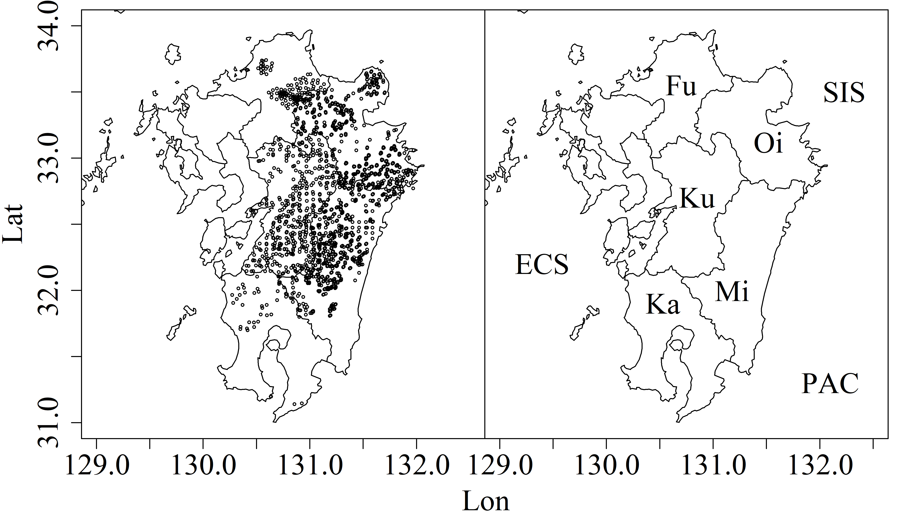Fig. 1. All survey plots from 1995 to 2019 (left) and location of surveyed prefectures (right). Fu, Oi, Ku, Mi, and Ka indicate Fukuoka, Oita, Kumamoto, Miyazaki, and Kagoshima prefectures, respectively. ECS and SIS indicate the East China and the Seto Inland Seas. PAC is Pacific.

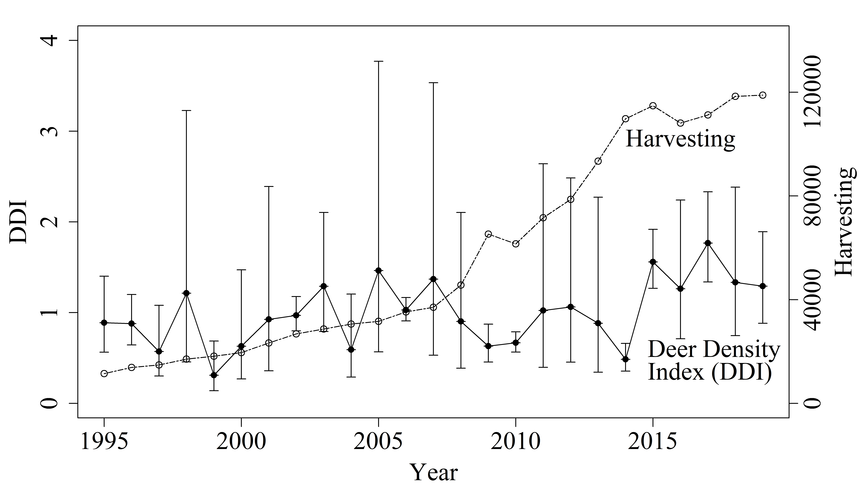
Fig. 2. Annual deer density index (DDI) and harvests in the entire study area during the study period. DDI and error bars (95% CI) values were estimated from the VAST model discussed in the text.

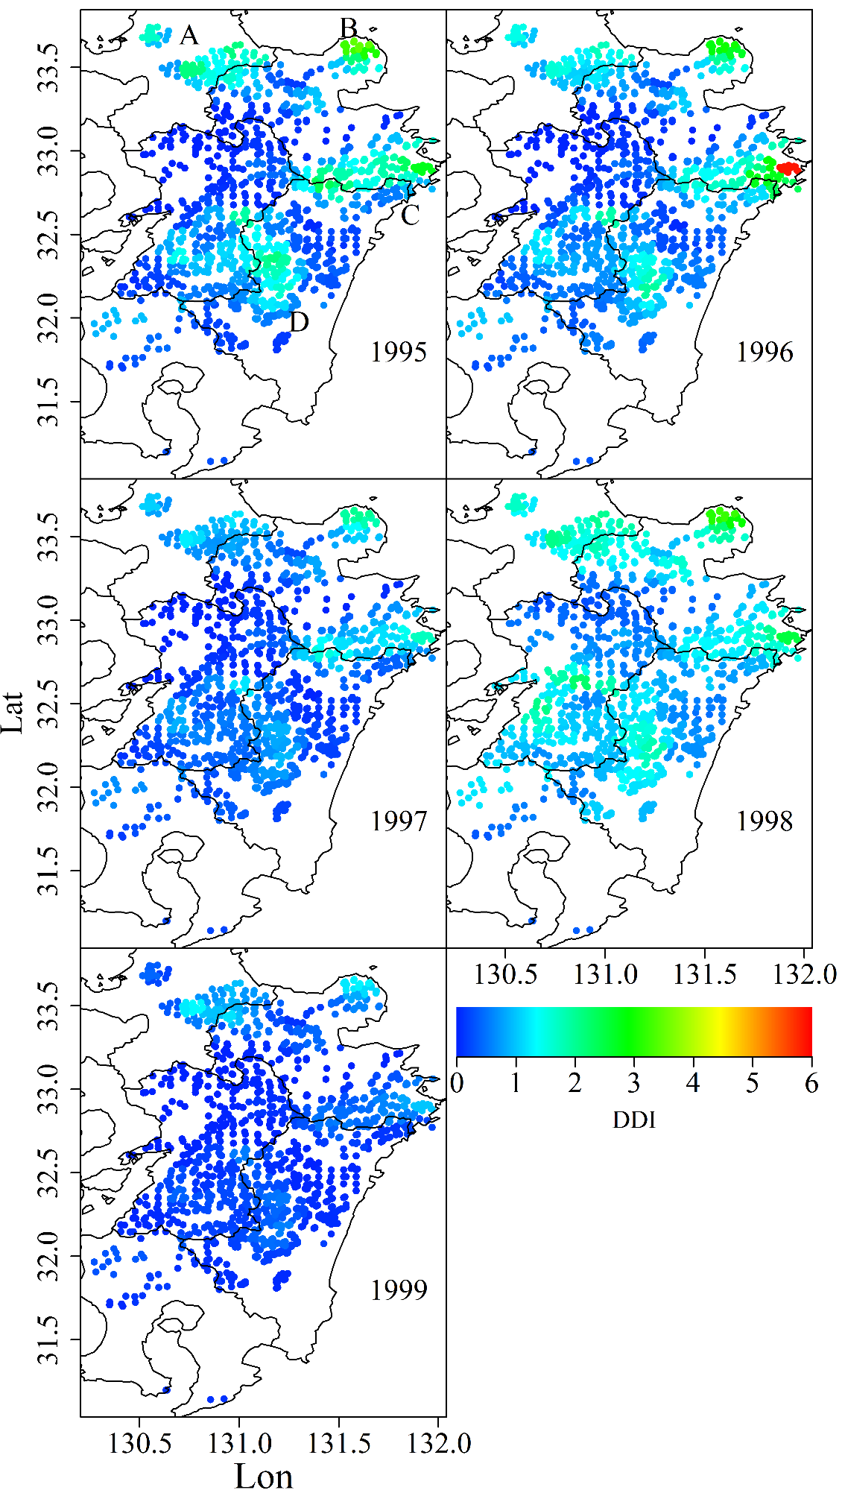
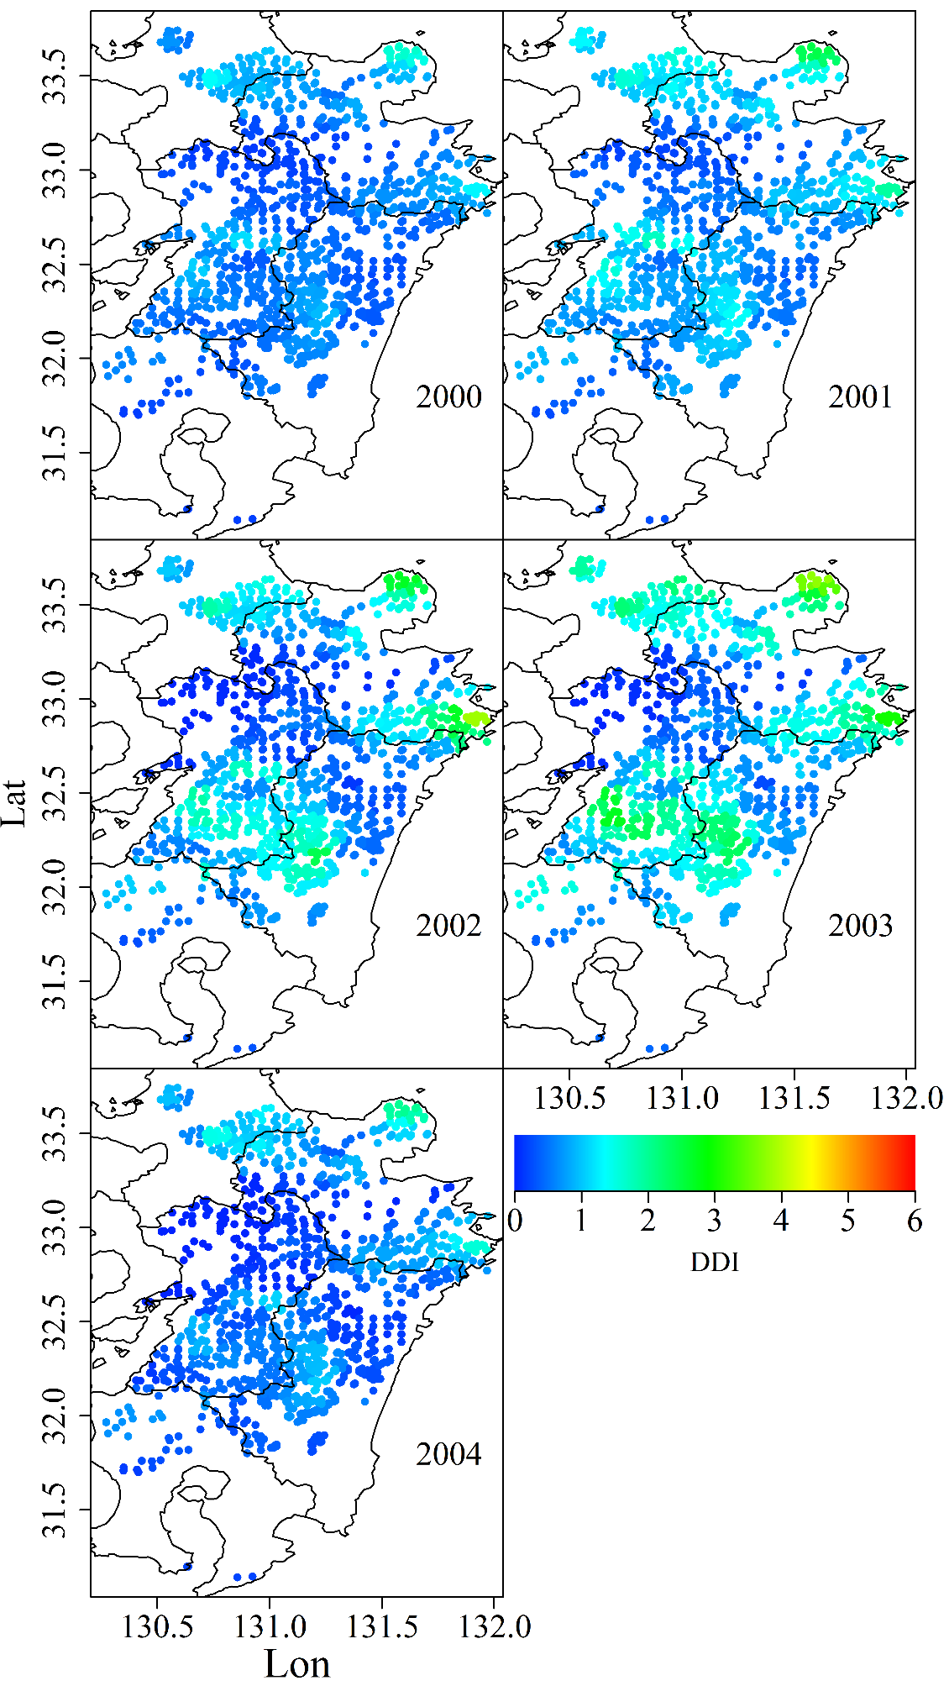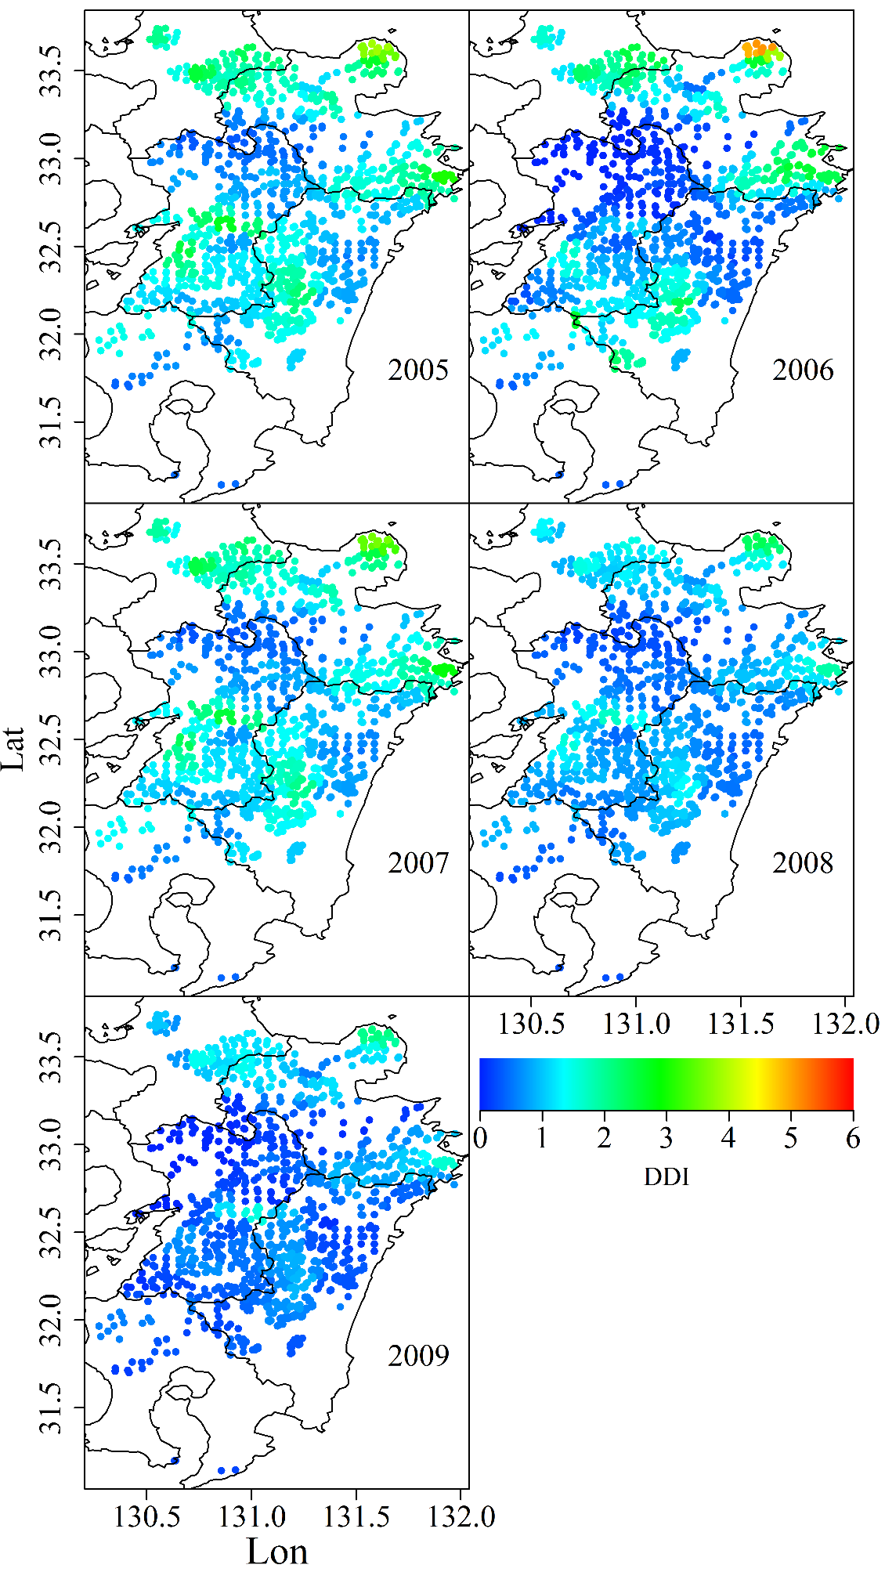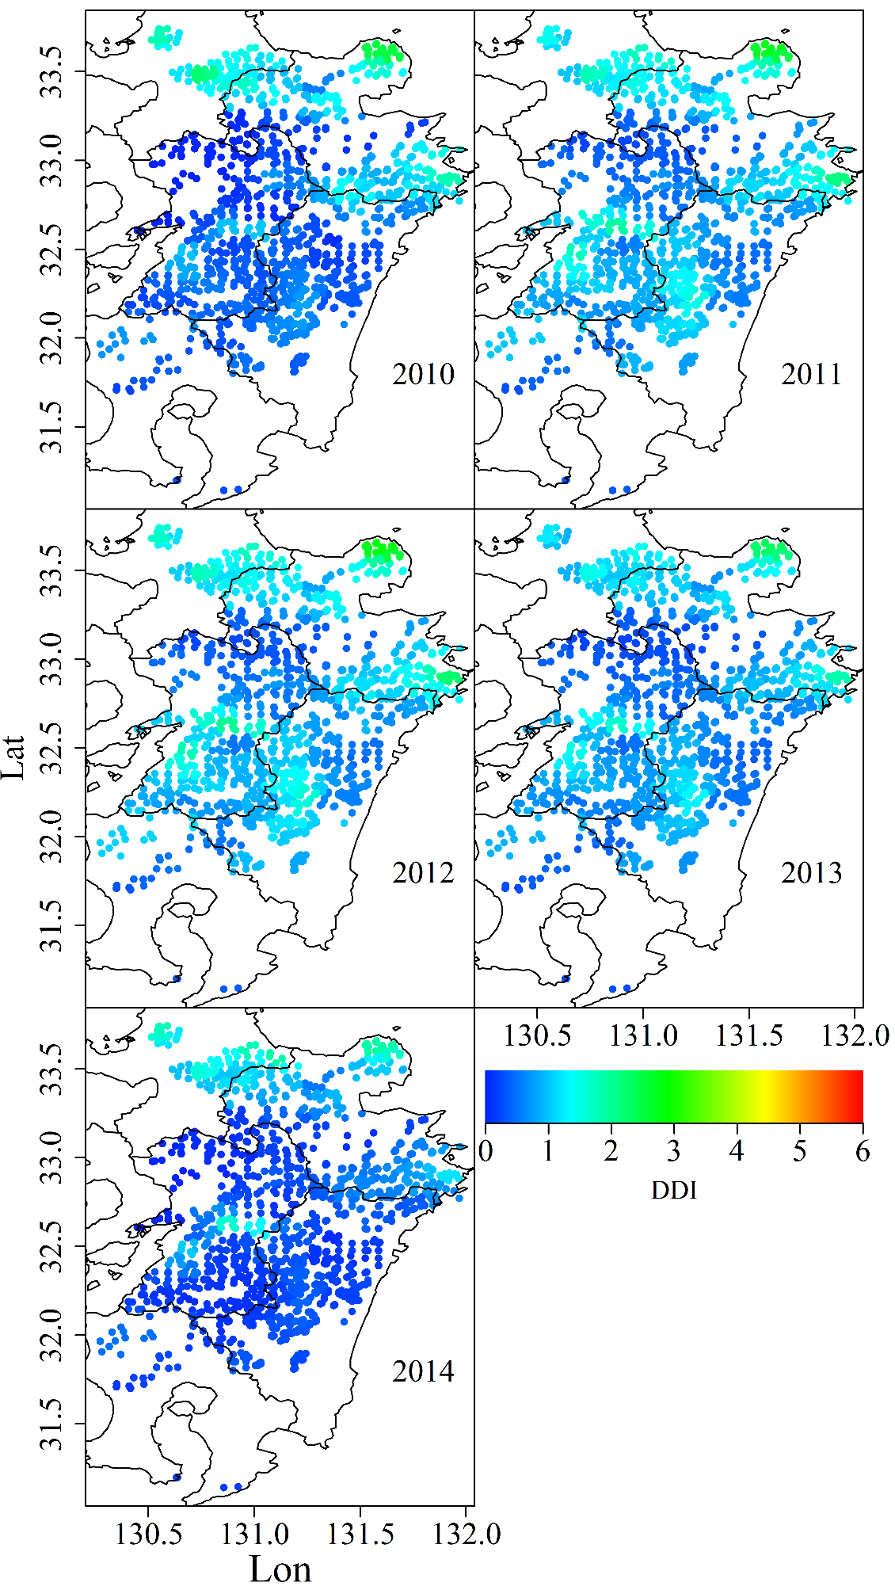
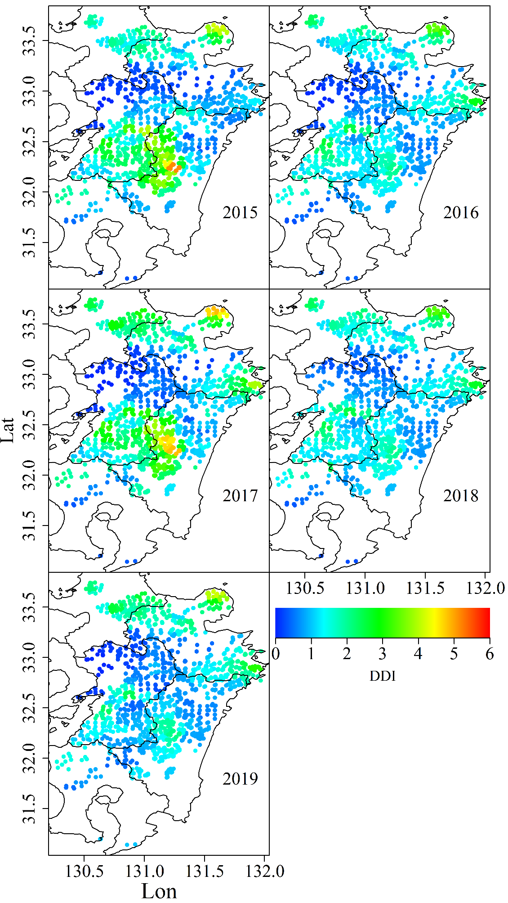
Fig. 3. Spatio-temporal changes of deer density index (DDI) at survey plots. A to D in the top left image indicate the locations of core areas with high deer density.

Fig. 4. Deer density index (DDI) fluctuation in each prefecture. DDIs and error bars (95% CI) were estimated from the VAST model described in the text.

Fig. 5. Annual deer harvest in each prefecture during the study period.

Fig. 6. Maximum snow depth in each prefecture during the study period.

Fig. 7. Mean winter temperature in each prefecture during the study period.

Appendix A. Plots of fecal pellet count surveys in each year.

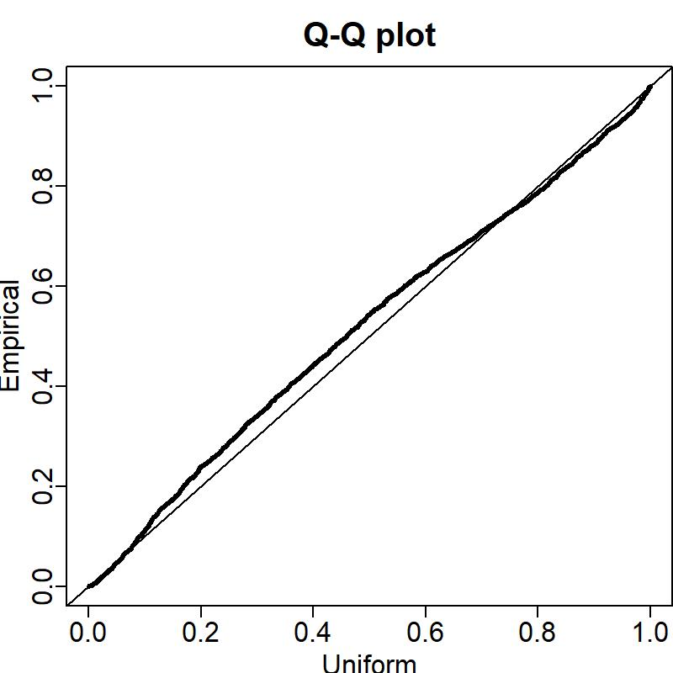
Appendix B. Quantile–quantile plot indicating residuals for deer density

