Collection and analysis of a global marine phytoplankton primary production dataset
F. Mattei^{a,b,c}, M. Scardi^{a,b}

ª Department of Biology, University of Rome “Tor Vergata”, Via della Ricerca Scientifica (no street number), 00133 Rome, Italy.
^{b} CoNISMa, Piazzale Flaminio, 9, 00196, Rome, Italy.
^{c} Ph.D. Program in Evolutionary Biology and Ecology, Department of Biology, University of Rome Tor Vergata.

Corresponding Author: Francesco Mattei francesco.mattei90@yahoo.it

Declarations of interest: none

Abstract
Phytoplankton primary production is a key oceanographic process. It has intimate relationships with the marine food webs dynamics, the global carbon cycle and the Earth’s climate. The study of phytoplankton production on a global scale relies on indirect approaches due to the difficulties associated with field campaigns. On the other hand, modelling approaches require in situ data for both calibration and validation. In fact, the need for more phytoplankton primary production data was highlighted several times during the last decades.
Most of the available primary production datasets are scattered in various repositories, reporting heterogeneous information and missing records. For these reasons we decided to retrieve field measurements of marine phytoplankton primary production from several sources and create a homogeneous and ready to use dataset. We handled missing data and added several variables related to primary production which were not present in the original datasets. Subsequently, we carried out a general analysis of the dataset in which we highlighted the relationships between the variables from a numerical and an ecological perspective.
Data paucity is one of the main issues hindering the comprehension of complex natural processes.
In this framework, we believe that an updated and improved global dataset, complemented by an analysis of its characteristics, can be of interest to anyone studying marine phytoplankton production and the processes related to it.

Keywords: Phytoplankton primary production, Marine ecology, Global marine primary productivity.

1 INTRODUCTION
Phytoplankton primary production is a pivotal process in biological oceanography. It accounts for roughly 98% of the marine system autotrophic production and 50% of the global one (Carvalho et al., 2017; Field et al., 1998). Accordingly, this process provides the main source of energy for structuring the marine food webs (Duarte and Cebrián, 1996; Kwak and Park, 2020a). Furthermore, it influences the absorption of carbon dioxide from the atmosphere and the flux of carbon to the deep ocean generating a process known as biological pump (Giering et al., 2014; Longhurst and Glen Harrison, 1989). The estimated global phytoplankton production is comprised between 30 and 70 Gt C y⁻¹ (Carr et al., 2006; Friedrichs et al., 2009; Saba et al., 2010; Siegel et al., 2013), i.e. most probably still larger than the global anthropogenic CO₂ emissions (roughly 37 Gt CO₂ y⁻¹) (Caldeira and Duffy, 2000; Falkowski and Wilson, 1992; Jackson et al., 2019; Peters et al., 2020; Sabine et al., 2004).
These features highlight the strong link between phytoplankton production and both ecosystem services and Earth’s climate (Barange et al., 2014; Behrenfeld et al., 2006; Blanchard et al., 2012a; Blythe et al., 2020). This link in turn reflects the central role of this biological process not only in the oceans’ dynamics, but also in those of the whole geo-biosphere.
The availability of remotely sensed information allowed the study of the phytoplankton production at a global scale providing a synoptic view of several ocean features, such as chlorophyll a surface concentration, Sea Surface Temperature (SST) and Photosynthetic Active Radiation (PAR) (Platt and Sathyendranath, 1988; Sammartino et al., 2018; Westberry and Behrenfeld, 2014). Several models which exploits satellite information to estimate primary production have been proposed (e.g. Behrenfeld and Falkowski, 1997; Friedrichs et al., 2009; Mattei and Scardi, 2020; Westberry and Behrenfeld, 2014). In fact, estimators of this process provide valuable tools to assess global phytoplankton production characteristics and patterns which in turn could provide insights into the dynamics of several phenomena, e.g. fishery yields and climate change effects (Fox et al., 2020; Richardson and Schoeman, 2004; Russo et al., 2019).
Nevertheless, the lack of field data negatively affects the power and the reliability of both satellite information and model estimates. In fact, these data are essential to calibrate satellite sensors and develop primary production estimators.
The most complete and freely accessible phytoplankton production dataset is available at http://sites.science.oregonstate.edu/ocean.productivity/field.data.c14.online.php. From now on we will refer to this data as the Ocean Productivity dataset. This dataset contains data from several oceanographic cruises accounting for roughly 3000 production profiles. Accordingly, this dataset has been widely used to develop several models (Behrenfeld and Falkowski, 1997; Scardi, 2001) since it contains depth-resolved ¹⁴C phytoplankton production estimates coupled with chlorophyll a profiles, SST and PAR measurements. Such data are crucial for both studying phytoplankton production and developing model for estimating this process. Despite being a precious source of information, these field data cover only some ocean basins, they are affected by missing values and they have not been updated since 1994 (orange dots in Fig. 1). As the amount and quality of field data are paramount characteristics to understand the dynamics of natural processes, we wanted to create a new global dataset expanding both the temporal and the spatial coverage of the previously cited one. Moreover, we decided to associate more production related information to each record, e.g. production to biomass ratio, bottom depth of the sampling station, distance from the coastline etc. The extra information could be extremely valuable for analysis and modelling purposes especially when machine learning techniques come into play (Peters et al., 2014; Recknagel, 2001).
In order to retrieve phytoplankton production data, we consulted several sources which provide freely accessible information such as PANGEA, the Biological & Chemical Oceanography Data Management Office and the National Oceanic and Atmospheric Administration (a complete list of the exploited datasets with the respective references can be found in the supplementary materials).
To select suitable data, we adopted only four compulsory criteria that the newly found information had to meet. The first two criteria were related to the spatial-temporal context of the observations. Accordingly, we kept only the data for which date (yyyy-mm-dd) and geographical coordinates (latitude and longitude) of the field measurements were recorded. The third fundamental requirement was the presence of depth-resolved ¹⁴C measurements, i.e. phytoplankton production profiles. Depth-resolved data are more informative with respect to the depth-integrated ones, since they provide not only information on the production magnitude but also on its vertical distribution. The final requirement was the measurement of chlorophyll a profiles associated to the production data. Even if several studies suggest that chlorophyll to carbon ratio could be extremely variable depending on physical forces and phytoplankton physiological adaptation (Huot et al., 2007; Westberry et al., 2008), chlorophyll a is one of the most commonly used proxy for phytoplankton biomass, which in turn is a key parameter for studying the phytoplankton production. This is especially true when the relationship between the pigment and the biomass is not explicitly formulated, i.e. in the machine learning field. Furthermore, chlorophyll a can be easily measured with probes during sampling cruises and its surface concentration is also estimated from remote sensing platforms since 1978 (CZCS). The former feature is important to exploit these measures to develop production models while the latter is crucial in a synoptic application of these estimators.
On the other hand, we did not discard records lacking other variables, such as SST or PAR. In fact, if these measurements were not available, we filled the gaps using interpolation techniques or retrieving the missing information from satellite platforms (see section 2.1).
Retrieving phytoplankton production data that were not present into the Ocean Productivity dataset and the gap filling operation allowed to expand both the spatial and the temporal coverage of this dataset. Spatial and temporal variability are important features in dealing with global assessments of natural processes such as phytoplankton primary production. The new dataset comprised 6089 production profile collected between 1958 and 2017, 2214 of which derived from the Ocean Productivity dataset. The need of larger amount of data related to phytoplankton production process was already highlighted by several studies which either developed or compared primary production models (Campbell et al., 2002; Carr et al., 2006; Friedrichs et al., 2009; Lee et al., 2015; Saba et al., 2010; Scardi, 1996). In fact, from the latter type of studies emerged a high level of uncertainty in determining the global phytoplankton production. The range of estimated global production resulted from comparison papers was extremely large, highlighting how challenging could be modelling this process on a large scale.
Additionally, we enriched the new dataset with several qualitative and quantitative variables. These variables were either derived from the existing one, retrieved from satellite platforms or extracted from freely accessible dataset (see section 2.2).
Once the new dataset was structured, we highlighted its characteristics using several descriptive techniques and analysed the results from an ecological perspective (section 3).

2 MATERIALS AND METHODS

2.1 Data merging and reconstruction
As stated in the previous section, the most complete dataset of phytoplankton primary production was freely downloadable from the Ocean Productivity website. It contained roughly 3000 production profiles (Fig. 1, orange dots) associated with ancillary information such as chlorophyll profiles, SST and PAR measurements. We used this dataset as starting point and searched for data that could improve its spatial and temporal coverage. We conducted our searches mainly on PANGEA and NOAA websites, which are freely accessible data repositories. Each dataset that we used in this work has been cited as specified by the repository or the owners. We limited our search to datasets which contained depth-resolved measurements of net phytoplankton production as ¹⁴C associated with the respective chlorophyll a concentration. The main reasons for this choice were the additional vertical distribution information provided by phytoplankton profiles with respect to depth-integrated estimates and the biomass proxy provided by the chlorophyll concentration. This feature allowed to analyse several characteristics of phytoplankton production, thus contributing to a deeper understanding of the whole process.
The retrieved data were incorporated into the new dataset only if the geographic coordinates and the sampling date had been recorded. These data allowed to incorporate both the spatial and temporal variability of the phytoplankton production into the analysis.
For each retrieved dataset that met our requirements, the first step was to merge it with the Ocean Productivity one. From the latter dataset we kept the following variables: Date of the sampling (yyyy-mm-dd), geographical coordinates of the sampling station (latitude and longitude, degrees), day length as hours of photoperiod (h), sampling depth (m), Pb_{opt} (mg C mg Chla⁻¹ h⁻¹), SST (° C), surface PAR (E m⁻² day⁻¹), sampling depth chlorophyll a concentration (mg m⁻³), sampling depth daily primary production (mg C m⁻³ day⁻¹) and integrated daily primary production (mg C m⁻² day⁻¹). To perform the merging procedure, we filled all the gaps in the newly retrieved data relative to the abovementioned variables. We computed the day length from the latitude and the day of the year of the sampling. SST missing values were filled using MODIS daily data for observations from 2003 till present (MODIS-Aqua/Mapped/Daily/4km (nasa.gov)), multiple sensors daily data for records from 1981 to 2003 and the 1981-1990 mean for the data prior to 1981 (Copernicus SST) (Merchant et al., 2019). We used the MODIS values also for filling the PAR gaps from 2003 till present. The profiles previous to this date that lacked of PAR measures were discarded, since daily PAR estimates are available only through MODIS platform (late 2002-present). Discarding these data, the Ocean Productivity dataset dropped from roughly 3000 profiles to 2214. We estimated the Pb_{opt} parameter using the procedure proposed by Behrenfeld and Falkowski (1997a). Finally, we estimated the missing values in chlorophyll a and primary production profiles with a depth-weighted average of adjacent values.

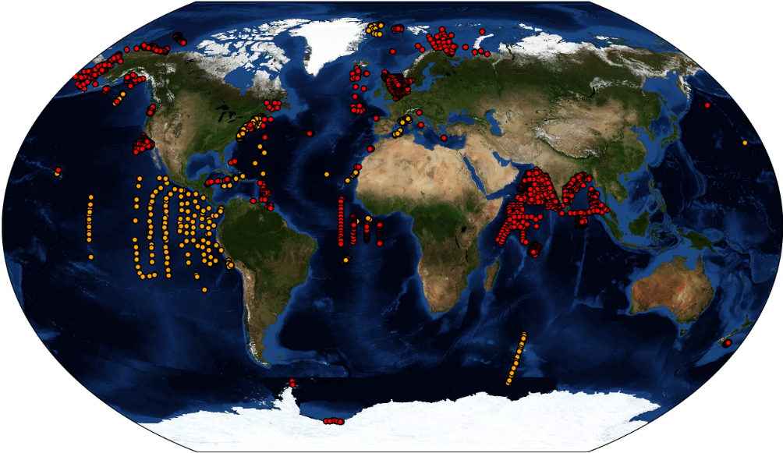

Figure 1. Maps of the 6089 phytoplankton production profiles comprised in the new dataset. In orange the profiles derived from the Ocean Productivity dataset (2214) and in red the newly retrieved ones (3875).

Once the merging procedure was finished, the new dataset contained 37822 records from 6089 profiles with respect to the 14300 and 2214 of the old one (Fig. 1).
Subsequently, we added to the dataset several variables related to phytoplankton primary production (table 1 and table 2). These variables can be divided in three groups: (i) data extracted from freely available datasets, (ii) numerical measures computed from the existing ones and (iii) categorical data derived from the previous two groups.

2.2 Ancillary data association
Among the variables that belong to the first group we list the bottom depth (m) and the stats related to it. We retrieved the bathymetry information from the GEBCO website (https://www.gebco.net/data_and_products/gridded_bathymetry_data/#global). We queried the GEBCO dataset using the geographic coordinates of the sampling stations to extract the bottom depth data. We also exploited up to 8 neighbour pixels to compute the bottom depth variance of the sampling point neighbourhood.
We retrieved information about the mixed layer depth (m) using the Levitus model datasets (Levitus et al., 1994; Levitus and Boyer, 1994) which are freely available on the Levitus webpage (https://psl.noaa.gov/data/gridded/data.nodc.woa94.html).
The last data that we gathered from an external dataset was the distance from the coastline (km). The 0.04 degrees distance dataset was downloaded from the NASA website (https://oceancolor.gsfc.nasa.gov/docs/distfromcoast/).
The second group of new variables was computed from information already present in the new production dataset at this stage. We computed the day of the year from the date, i.e. January the first and the last day of December were represented by 1 and 365 respectively.

Table 1. Production dataset numerical variables

N | Variable name | Units
1 | Date | yy/mm/dd
2 | Day year | /
3 | Latitude | degrees
4 | Longitude | degrees
5 | Day length | h
6 | Bottom depth | m
7 | Bottom depth sd | m
9 | Mixed layer depth | m
10 | Distance from coastline | km
11 | Euphotic zone depth | m
12 | Max sampling depth | m
13 | Max production depth | m
14 | SST | °C
15 | Surface PAR | E m⁻² day⁻¹
16 | Pb_{opt} | mg C mg Chla⁻¹ h⁻¹
17 | Surface Chl a | mg m⁻³
19 | Integrated Chl a | mg Chl a m⁻²
20 | Depth-resolved primary production | mg C m⁻³ day⁻¹
21 | Depth-integrated primary production | mg C m⁻² day⁻¹
22 | Production to biomass ratio | mg C day⁻¹ / mg Chl a

We also estimated the euphotic zone depth and the total chlorophyll a in the euphotic zone (mg chlorophyll a m⁻²) using a model developed by Morel and Berthon (1989).
Moreover, we extracted both the max sampling depth of non-null production value (m) and the depth at which maximum production occurred for each profile (m) thus creating two new variables.
We estimated depth-integrated chlorophyll a and depth-integrated primary production by trapezoidal integration of in situ measurements (mg chlorophyll a m⁻² and mg C m⁻² day⁻¹ respectively). Subsequently, we estimated the production to biomass ratio dividing the depth-integrated phytoplankton production by the depth-integrated chlorophyll a concentration (mg C day⁻¹ / mg chlorophyll a).
The last group of variables were generated by dividing the production profiles in classes on the basis of the previously computed variables. We created the hemisphere variable assigning each profile to northern hemisphere, southern hemisphere or equator on the basis of the sampling latitude. We also created a season variable on the basis of the date and northern hemisphere season. We divided the year in four groups of three months each starting from January and tagged them as winter, spring, summer and autumn respectively.
For numerical data, we applied the Jenks optimization algorithm (Jenks, 1967) to define the boundaries of six classes from very low to huge (very low, low, moderate, high, very high, huge). Then we used these boundaries to assign each pattern to one of the six classes. It is important to note this class segmentation is relative to our data rather than an absolute classification criterion.

Table 2. Production dataset categorical variables

N | Variable name | Range
23 | Hemisphere | /
24 | Season | /
25 | Bottom depth magnitude | Very low to huge
26 | Bottom depth sd magnitude | Very low to huge
28 | Mixed layer depth magnitude | Very low to huge
29 | Distance from coastline magnitude | Very low to huge
30 | Euphotic zone depth magnitude | Very low to huge
31 | Max sampling depth magnitude | Very low to huge
32 | Max production depth magnitude | Very low to huge
33 | SST magnitude | Very low to huge
34 | Surface PAR magnitude | Very low to huge
35 | Pb_{opt} magnitude | Very low to huge
36 | Surface Chl a magnitude | Very low to huge
37 | Total Chl a magnitude | Very low to huge
38 | Integrated Chl a magnitude | Very low to huge
39 | Surface primary production magnitude | Very low to huge
40 | Integrated primary production magnitude | Very low to huge
41 | Production to biomass ratio magnitude | Very low to huge

Finally, we investigated the relationship between the variables which are more intimately related with phytoplankton primary production, i.e. SST, PAR, chlorophyll a, max sampling depth, max production depth and production to biomass ratio. We produced heatmaps to provide an insight into the categorical variables and performed a Principal Component Analysis (PCA) for their numerical counterparts.

3 RESULTS AND DISCUSSION
With this work we aimed at building a global phytoplankton production dataset updating the Ocean Productivity one. Moreover, we wanted to expand the available information by associating several variables related to the primary production.
The comprehension of natural phenomena deeply relies on available data. These complex processes often involve non-linear and not well-known relationships among their components. Accordingly, we believe that one crucial way to enhance our understanding of natural systems is provided by gathering information and then analysing it.
In this framework, we extended both the spatial and the temporal coverage of the Ocean Productivity dataset. These two features are paramount to boost our knowledge about the spatio-temporal distribution of phytoplankton production. In fact, the former allows to take into account temporal trends in the processes which are linked with climate related issues and food webs dynamics. The Ocean Productivity dataset contained data from cruises carried out between 1958 and 1994, which is a large span of time, but it has not been updated since then. Our data retrieval added 23522 new patterns from 3875 production profiles which in most cases do not overlap with the Ocean Productivity temporal coverage. In fact, 2210 of the 3875 new phytoplankton profiles, i.e. roughly 57 % of the total, were collected between 1995 and 2017. Even if roughly 43 % of the new profiles shares the time coverage with the Ocean Productivity ones, the majority of these data does not overlap with the spatial coverage of the older dataset, thus enhancing the heterogeneity of the data.
Although the Ocean Productivity dataset was the most comprehensive source of information about phytoplankton primary production, the bulk of its data was restricted to three main regions. These areas were the North-Western Atlantic, the Eastern Equatorial Pacific and the North-East Pacific along the West coast of the United States. The other ocean basins were under-sampled or not sampled at all (Fig.1 orange markers). The new data improved the global coverage of the previous dataset. Several profiles were added in the Arctic Ocean specifically in the Chukchi sea, the Beaufort sea, the Greenland sea, the North sea, the Norwegian sea, the Barents sea and the Kara sea. In the Pacific Ocean the new represented areas were the Bering sea, the Gulf of Alaska, the areas off the Oregon and California coasts in addition to few production profiles gathered off the Eastern coast of New Zealand. In the Western Atlantic, new information was available for the Gulf of Saint Lawrence, the Florida coast and the Caribbean sea. In the Central Atlantic the new represented areas were located South-East off Ireland, South of Cape Verde island, off the Gulf of Guinea plus few records in the Bay of Biscay, off the coast of Morocco and in the Mediterranean sea. Few of the data in the Indian Ocean were present in the old dataset but we reconstructed missing information and added new profiles from a different datasets (PANGEA). The Southern Ocean remain strongly under-sampled, with the addition of few production profiles.
The temporal and spatial coverage of a dataset are crucial features. The first one allows to take into account the evolution of the studied process. This aspect is important in any type of assessment work, especially in a climate change context. In the phytoplankton production framework, the temporal span covered by the available in situ data could be used to study several aspects. For example, repeated observations through the years for the same area could highlight temporal patterns of the investigated region. Moreover, this feature could be used to investigate the relationships between phytoplankton production and large-scale phenomena, e.g. El Nino-Southern Oscillation (ENSO). From a spatial perspective, the larger the global oceans area represented in the dataset the larger the spatial variability of the phytoplankton production process taken into account. This feature is crucial since both depth-resolved and depth-integrated phytoplankton production estimates are deeply influenced by the geographic characteristics of the investigated area, e.g. latitude, distance from the coastline, bottom depth. Therefore, to deepen the understanding of this biological process we need to gather and analyse information from a heterogeneous pool of areas. Finally, if we want to exploit a dataset to perform any global assessment on the phytoplankton primary production or tackle production-climate related issues we need an information pool that take into account as much variability of the process as possible (Behrenfeld et al., 2016; Gibert et al., 2018; Hays et al., 2005),.
One of the fields which heavily rely upon the amount and quality of the data is modelling. Several studies stressed how most of the limits in modelling the phytoplankton production depend upon the data availability (Campbell et al., 2002; Carr et al., 2006; Mattei and Scardi, 2020; Scardi, 2001). For these reasons, we believe that the enhancement of both spatial and temporal coverage of a freely available production dataset is an important contribution to modern oceanography.
We did not limit our work to homogenize several data source into a single one, but we also enhanced the amount of phytoplankton-related available information. This type of information could be useful for boosting our understanding of primary production. Moreover, the ancillary data could be extremely valuable to model development, especially when machine learning techniques come into play. In fact, these approaches allow the use of variables as predictors even if the relationship with the target variable (primary production here) is not known (Catucci and Scardi, 2020; Franceschini et al., 2019; Olden et al., 2008; Peters et al., 2014; Recknagel, 2001).
The first two descriptors that we added to the new dataset were the hemisphere of the sampling station and sampling season, intended as northern hemisphere season. These two variables provided an insight into the global temporal and spatial distribution of the data (Fig. 2).

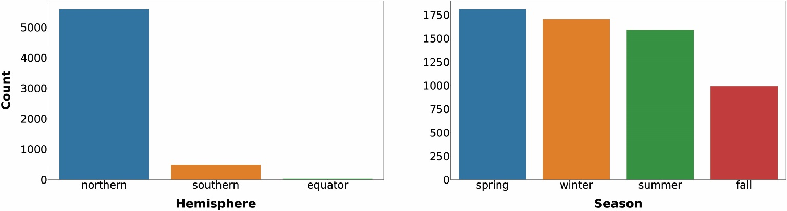
Figure 2. a) Number of profiles gathered in the two hemispheres or at the Equator. b) Number of profiles sampled in northern winter (January to April), Spring (March to June), Summer (July to September) and Fall (October to December).

As shown in figure 2a, the spatial distribution of the records was strongly unbalanced towards the northern hemisphere compared to the southern one (5583 vs 478), while the profiles recorded exactly at latitude zero were 28. This feature highlights the importance of gathering more data in the southern hemisphere, especially in the Southern Ocean. In fact, this Ocean is one of the least well-known areas of the global ocean and the uncertainty related to this lack of knowledge negatively affects our understanding of both the global phytoplankton production and carbon cycle (Arrigo et al., 2008; Caldeira and Duffy, 2000; Moigne et al., 2016; Reuer et al., 2007).
On the other hand, the temporal variability in the new dataset is more balanced with respect to the spatial one. Accordingly, the number of profiles sampled during the northern Winter, Spring, Summer and Fall are respectively 1701, 1806, 1590 and 992. This is an important feature especially for the areas characterized by seasonal patterns, e.g. Spring peak at temperate latitudes. This patterns not only influence the magnitude of primary production but also its distribution along the water column (Falkowski and Raven, 2007a). Therefore, when both the depth-integrated and the depth-resolved perspectives are taken into account, this temporal variability is doubly valuable.
We also added information related to the bathymetry of the sampling area. We queried the GEBCO dataset to extract the bottom depth of sampling stations. Afterwards, we applied the Jenks optimization algorithm to partition the data into six classes (Fig. 3).

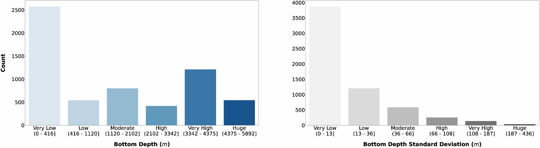
Figure 3. a) Bottom depth and b) its variance classes. The bar colour intensity reflects the magnitude of the class values.

As showed in figure 3a, the majority of the observations were collected in areas shallower than 416 m. This feature highlights that the continental shelf areas are the most frequently sampled ones (see fig. 1). The second class in terms of profiles abundance was the very high one (3342-4375 m), while the other classes had roughly the same numerosity. In figure 3b we can notice that almost all the sampling stations had a very low bottom depth variance in their neighbourhood., thus the area of the sampling was homogenously deep. From this perspective, the sampling station depth and its standard deviation could help understanding the geomorphological region of the ocean where the sampling station was situated, i.e. coastal, continental shelf or open ocean.
The depth information could help us analysing the profiles characteristics, since it could be interpreted as a proxy for several features such as nutrients availability and water column dynamics. In fact, even if the depth is not directly related to the phytoplankton production, it is an important physical descriptor of the ocean system in which this biological process occurs.
We retrieved mixed layer data from the Levitus dataset. These estimates provide a seasonal indication for the water column mixing status which is related to both the magnitude and the vertical distribution of the phytoplankton production. We also added the distance from coastline as ancillary information. This distance provides an insight into how much factors like terrestrial runoff, rivers and waste water discharges could affect the primary production. It is well known that coastal areas are characterized by higher level of primary production mainly due to nutrients inputs from natural and anthropogenic sources (Paerl et al., 1990; Teixeira et al., 2018; Wollast, 1998).

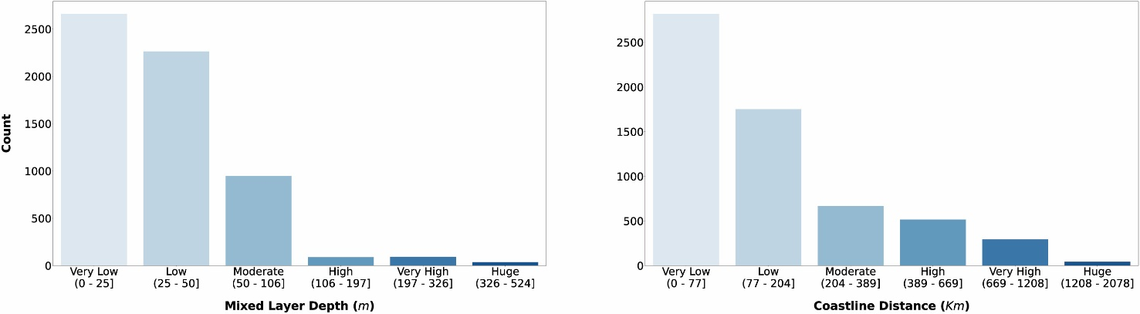
Figure 4. a) Mixed layer depth (m) and coastal distance (km) magnitude. The bar colour intensity reflects the magnitude of the class values.

Figure 4a shows that 96.4 % of the sampling stations presented a mixed layer depth from very low to moderate (0 – 106 m), while the 80 % of them is in the 0 – 50 m range. This reflects the numerosity of coastal areas in the dataset. This rationale can also be applied to the distance from the coastline (fig. 4b). The bulk of the patterns are comprised in the first two classes which encompass the sampling stations from 0 to 204 km off the coast. The main reason for adding these variables to our dataset is their indirect influence on the phytoplankton production process. This influence is exerted mainly through the relationship between these variables and the nutrient availability which generally became scarcer as the distance from the coastline and the bottom depth augment. Moreover, the available nutrients are distributed in different concentrations along the water column according to the mixed layer depth magnitude (Falkowski and Raven, 2007a; Huisman and Weissing, 1995; Jäger et al., 2008). The latter feature is one of the factors influencing the vertical distribution of the phytoplankton production.
Another group of variables was extracted directly from the sampling data. The first two variables of this group were maximum sampling depth and maximum production depth. We created them by examining the production profiles. The first one is the depth at which the deepest water sample was collected (fig. 5a). Usually, this depth corresponds to the 1% of the surface irradiance, but it was not specified in all the retrieved data. The second one is the depth at which occurred the maximum depth-resolved production value, i.e. the peak of the production profile (fig. 5b).

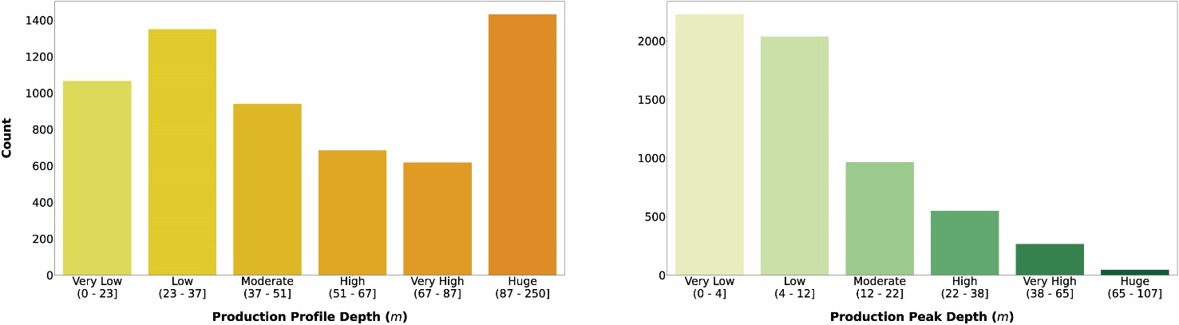
Figure 5. a) Maximum profile depth and b) maximum production depth classes. The bar colour intensity reflects the magnitude of the class values.

As showed in figure 5a the majority of the profiles (2781) was comprised in the low (23 - 37 m) and the huge (87 - 250 m) production profile depth classes. Although the huge class maximum value was 250, the bulk of profiles (90 %) was comprised between 87 and 150 m. The profiles included in the first three classes were 55 % of the total, while the ones in the last three summed up to 45 %. This feature reflected again the higher number of coastal profiles with respect to the open ocean ones. On the other hand, the profile peak depth (fig. 5b) showed a clear decreasing trend with respect to depth. In fact, the majority of the profiles (70 %) were characterized by a peak comprised in the first two classes (from 0 to 24 m). The decrease of primary production with depth is justified mainly by the light attenuation along the water column which is one of the main physical forcing for phytoplankton production. In fact, even if deeper waters are usually nutrient-rich while the shallower ones are nutrient-depleted, the photosynthetic process cannot prescind from light availability.
SST and surface PAR variables were already present in the Ocean Productivity dataset, but these measurements were missing in several profiles. As described in the section 2.1, we filled the gaps where possible in both the old and the new data. The results of the Jenks algorithm on SST and PAR variables are presented in figure 6.

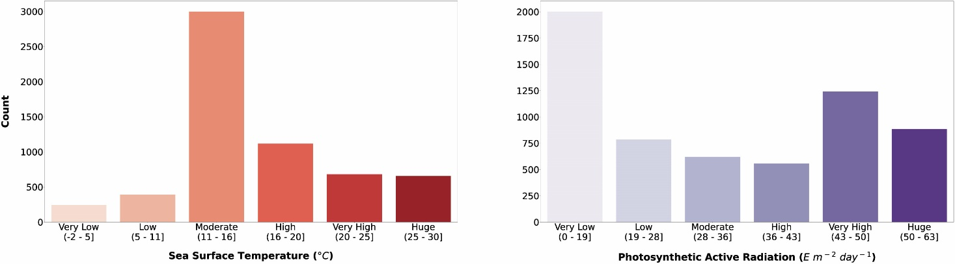
Figure 6. a) Sea surface temperature and b) photosynthetic active radiation classes. The bar colour intensity reflects the magnitude of the class values.

As showed in figure 6a the bulk of the records (49 %) fell in the moderate class (11 - 15 °C), while the lowest and highest values were the less abundant (from -2 to 10 °C and from 20 to 30 °C. The surface PAR classification showed a different pattern in which the very low values (0 – 18 E m⁻² day⁻¹) were the majority followed by the very high (43 - 49 E m⁻² day⁻¹) and the huge (50 – 62 E m⁻² day⁻¹) values.
These two parameters exert an important influence on phytoplankton primary production and they have been key factors in modelling this biological process. In fact, SST affects physiological characteristics of phytoplankton influencing its primary productivity and PAR represents the share of solar energy that is used for CO₂ fixation.
Unfortunately, most of the times these parameters are measured only at surface level while it could be extremely useful to have depth-resolved in situ measurements for studying phytoplankton production from a depth-resolved perspective.
One of the most important variables related to phytoplankton production is the depth-resolved chlorophyll a concentration (mg m⁻³). Accordingly, it was one of the compulsory requirements for inclusion in the gathered data set. Even if the relationship is not straightforward, it is often used as phytoplankton biomass proxy. Several works pointed out that other variables could be a more precise proxy (Huot et al., 2007; Westberry et al., 2008), but it is often difficult if not impossible to compute them for old data, thus limiting the effectiveness of the new candidates.
Starting from the chlorophyll a profiles, we also computed the depth-integrated values (mg m⁻²) using a trapezoidal integration. We exploited the depth-integrated value to compute a production to biomass ratio and as source of information for the dataset analysis. We also considered the surface chlorophyll a concentration since it is one of the most important parameters in phytoplankton production models.

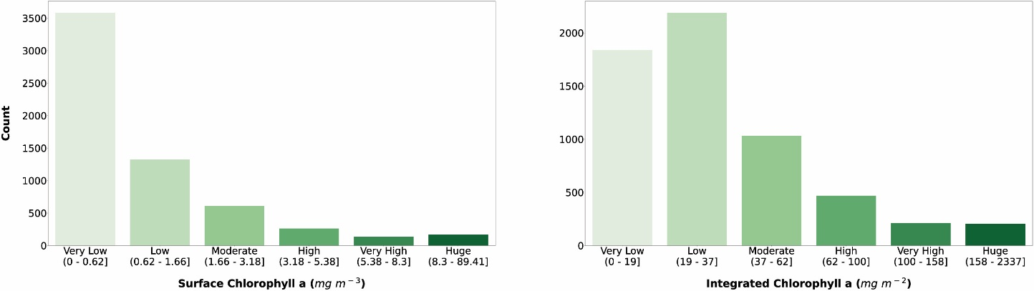
Figure 7. a) Surface chlorophyll a and b) depth-integrated chlorophyll a classes. The bar colour intensity reflects the magnitude of the class values.

The classification of surface chlorophyll a concentration (fig 7a) showed that 58.8 % of the phytoplankton profiles in the dataset fell in the very low class (0 – 0.62 mg m⁻³). 5517 profiles (90.6 %) were comprised between 0 and 3.18 mg m⁻³ which is the range of the first three classes, while only 572 (9.4 %) belonged to the second three ones. Surface chlorophyll a concentration is one of the main variables used to predict phytoplankton production since it is related to the biomass of these autotrophic organisms. Moreover, this variable is retrievable through remote sensing platforms thus allowing a quasi-synoptic application of production estimators.
On the other hand, the segmentation of the integrated chlorophyll a concentration (fig. 7b) showed a different pattern compared to the surface one. Although the first three classes were the most abundant, the bulk of the profiles were split between the first two (0 – 37 mg m⁻²). In fact, the very low and low classes comprised 1839 and 2188 profiles respectively (66 % in total), while the other classes accounted for 2026 profiles (34 %).
As already stated in the previous sections, we considered the availability of phytoplankton production profiles as compulsory information for the newly retrieved data. The reason for this requirement was twofold: firstly, we wanted to keep all the information already present in the Ocean Productivity dataset, which contained depth-resolved measurements of phytoplankton production. Secondly, we believed that the study of phytoplankton production could benefit from the coupled information of magnitude and its distribution along the water column with respect to taking into account only the former. Starting from the depth-resolved production data (mg C m⁻³ day⁻¹), we computed the depth-integrated production using a trapezoidal integration (mg C m⁻² day⁻¹). Subsequently, we computed a production to biomass ratio using depth-integrated phytoplankton production and depth-integrated chlorophyll a. The segmentation in classes of depth-integrated primary production and production to biomass ratio is shown in figure 8.

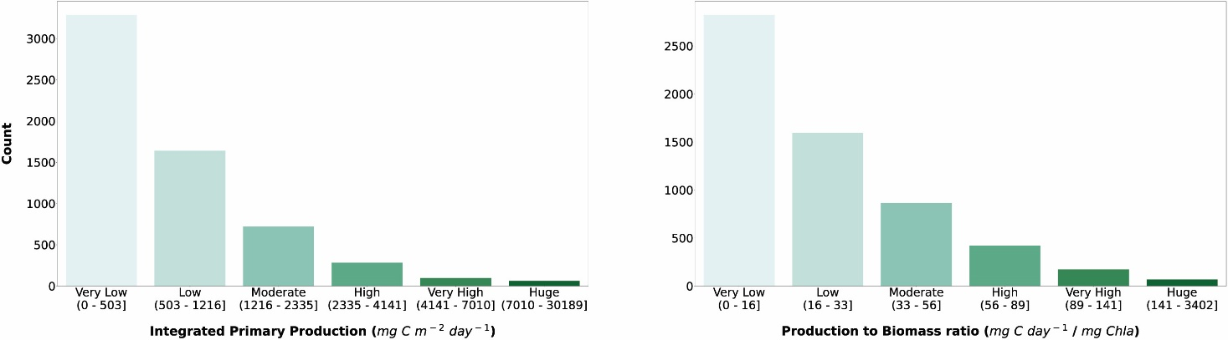
Figure 8. a) Depth-integrated phytoplankton primary production b) production to biomass ratio classes. The bar colour intensity reflects the magnitude of the class values.

Both integrated primary production and production to biomass ratio classifications showed the same pattern. Accordingly, the larger the class values the lesser the numerosity of the class. The first class comprised 3285 profiles (54 %) and 2822 profiles (46.3%) for depth-integrated primary production and production to biomass ratio respectively. Moreover, the sum of the very low and low numerosity was larger than 50% of total patterns in both cases.
Integrated primary production is an important measure in global assessments of phytoplankton production. It provides a bidimensional view (latitude vs longitude) of the oceanic production which in turn influences several biological and non-biological processes in the biosphere, e.g. energy flow in the marine food webs, fish landings and CO₂ absorption (Anderson et al., 2018; Barange et al., 2014; Blanchard et al., 2012b; Caldeira and Duffy, 2000; Carvalho et al., 2017; Kwak and Park, 2020b; Maureaud et al., 2017; Shurin Jonathan B et al., 2006). On the other hand, depth-resolved production provides more insights into the phytoplankton production process characteristics which in turn could lead to better estimates of depth-integrated primary production (Mattei et al., 2018).
Production to biomass ratio could convoy valuable information on the physiological state of the phytoplankton which in turn is influenced by biotic and abiotic forcing. This ratio can be also used to further analyse the profiles characteristic and to decide whether they are suitable or not for specific purposes, e.g. modelling phytoplankton primary production (Mattei and Scardi, 2020; Scardi, 2001).
Subsequently, we selected a subset of these variables and described their relationships with the depth-integrated phytoplankton production (see heatmaps fig. 9 to 15).
We analysed the relationship between the integrated primary production and the bottom depth magnitude (fig. 9).

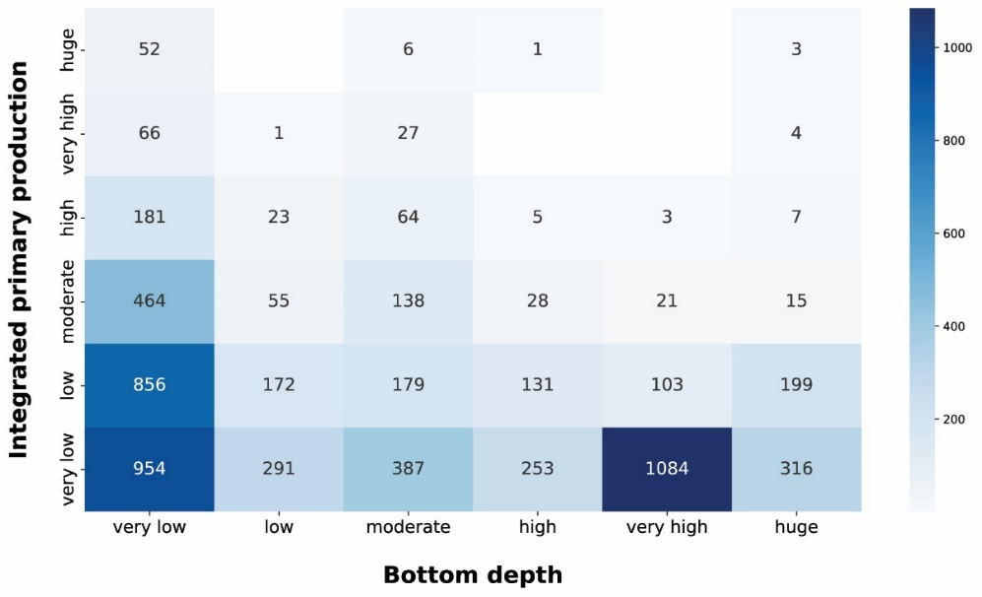
Figure 9. Integrated primary production vs Bottom depth. The blue heatmap highlight the difference in production potential between coastal and open ocean areas.

The very low production class was the most abundant in all the depth ranges. This feature was prominent in the very high bottom depth class, in which 1084 out of 1211 production profiles (89.5 %) fell in the very low production class. This is characteristic of open ocean areas which are usually nutrient depleted thus limiting phytoplankton production even if other environmental conditions are favourable. On the other hand, shallower sampled areas showed higher levels of depth-integrated production. This was manifest for the very low class, which showed a noticeable amount of profiles for each production class and the bulk of largest depth-integrated values i.e. 63.9 %, 67.3 %, 83.8 % of the high, very high and huge production profiles respectively. The latter feature was mainly due to land inputs to coastal areas which, when associated to favourable physical conditions, lead to high production levels. The blue heatmap showed the high potential of shallower areas in contrast with the low one of the open ocean zones.
We wanted to focus on the production-bathymetry relationship, hence we took into account the local variance of the bottom depth (fig. 10).

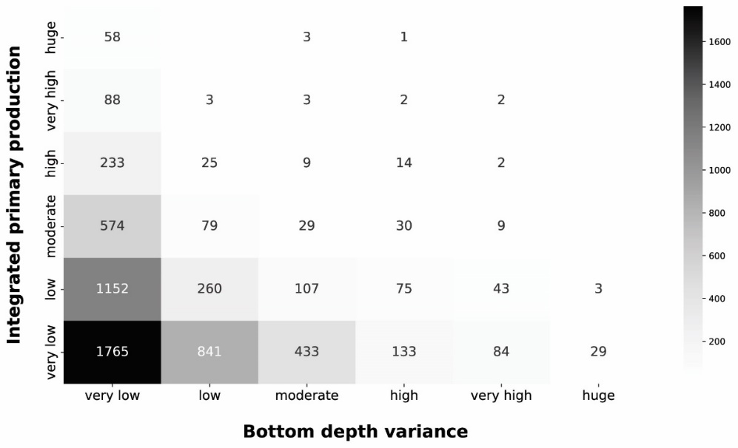
Figure 10 Integrated primary production vs Bottom depth variance. The grey heatmap shows the relationship between the variance of the bottom depth and the depth-integrated primary production

The grey heatmap complement the information of the blue one. In fact, the very low bottom depth variance comprises both very low and huge production profile. The low level of variance characterizes coastal areas, in which bottom depth is consistently low, and the open ocean zones, in which the bottom depth was consistently high. Progressively larger variance values showed the transition from shallower to deeper areas which corresponds to a decrease in depth-integrated production. This is consistent with our previous analysis and with phytoplankton ecology.
Subsequently, we analysed the relationship between integrated production and the profile depth (fig. 11).

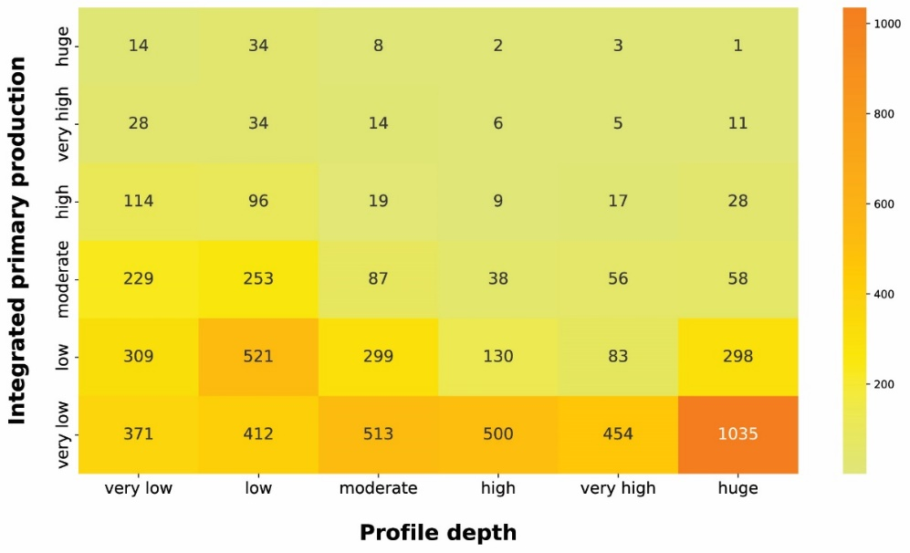
Figure 11 Integrated primary production vs Profile depth. The yellow to orange heatmap highlight the relationship between the depth-integrated phytoplankton production and the production profile depth.

The yellow to orange heatmap showed that the bulk of high production profiles was comprised in the first two profile depth classes. Shallow production profiles are usually the ones closer to the coastline or upwelling zones. These areas are nutrient-rich even in surface waters, where light availability is high, thus allowing high level of production. Moreover, high levels of production in shallow waters enhance the light attenuation phenomenon reducing the column water area suitable for primary production. Conversely, the deeper the phytoplankton profile the lower the depth-integrated production. Low-nutrients conditions lead to low phytoplankton biomasses values and thus to a deeper light penetration along the water column. The latter feature allows the structuring of deeper production profiles. Although these profiles occupy a large portion of the water column, the total profile production is limited by the scarce nutrients level.
Continuing our analysis of the relationship between depth-resolved features and magnitude of depth-integrated production, we took into account the production peak depth (fig. 12).

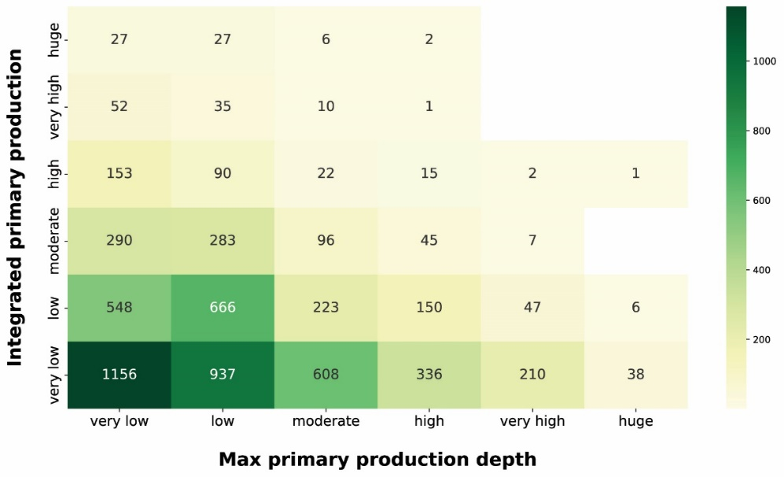
Figure 12 Integrated primary production vs maximum primary production depth. The yellow to green heatmap shows how the magnitude of depth-integrated primary production is related to the depth at which the maximum production occurs.

The production distribution along the water column is influenced by physiological and physical forcing. The optimum between light and nutrient availability determines the depth at which the maximum production occurs (Falkowski and Raven, 2007b). Since light availability exponentially decrease with depth, shallow peaks reflect either a condition of low irradiance or high irradiance and high nutrients. Both these situations lead to surface production peaks which are associated with a wide range of integrated production magnitudes. The yellow to green heatmap highlighted how the high depth-integrated magnitudes are associated only with shallow peak profiles. This feature reflected the relationship between phytoplankton physiological needs and the light extinction behaviour. Deep production peaks indicate a nutrient paucity condition in shallow waters which shifts the optimum condition near the nutricline depth. From the integrated production perspective, low values were associated with shallow peaks in conditions of low PAR or low nutrients even in deeper areas of the water column. Highest levels of production were coupled with surface or sub-surface peaks, while deeper peaks (very high and huge classes) represented the 5 % of total profiles and showed only very low to moderate depth-integrated production with the exception of 3 production profiles.
Among the physical forcing that influences the phytoplankton production we explored the characteristics of SST and PAR (fig. 13 and 14). It is worth stressing that the segmentation derived from the Jenks algorithm is relative to our data. For instance, the procedure was influenced by the under representation of circumpolar areas especially in the colder months.

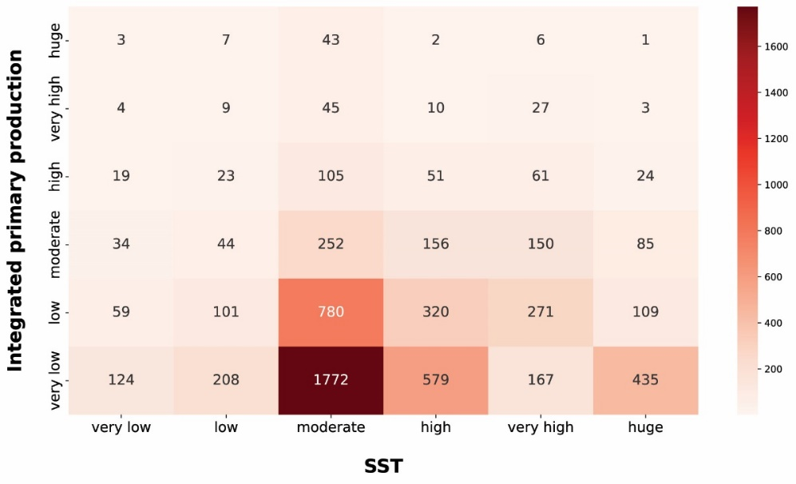
Figure 13 Integrated primary production vs SST. The red heatmap represents the relationship between depth-integrated production and SST.

The red heatmap showed that very low and low levels of SST were associated mainly with low primary production magnitude. The same pattern characterized very high and huge levels of SST. These features are related to primary production seasonality induced by physical forcing. The former situation referred to cold seasons in which the nutrient levels in the water column is high but not enough solar radiation is available for the photosynthetic organisms. The latter reflects a strong shallow stratification of the water column which is typical of warm seasons or areas constantly subjected to high levels of irradiance. This leads to low nutrient concentration in shallow waters which in turn severely limits the primary producers. Moderate levels of SST were associated with highest levels of phytoplankton production reflecting the transition between cold and warm seasons. In this period of the year the environmental conditions are optimal for primary production since the high nutrient concentration accumulated during the cold season became exploitable due to the increasing available solar radiation.

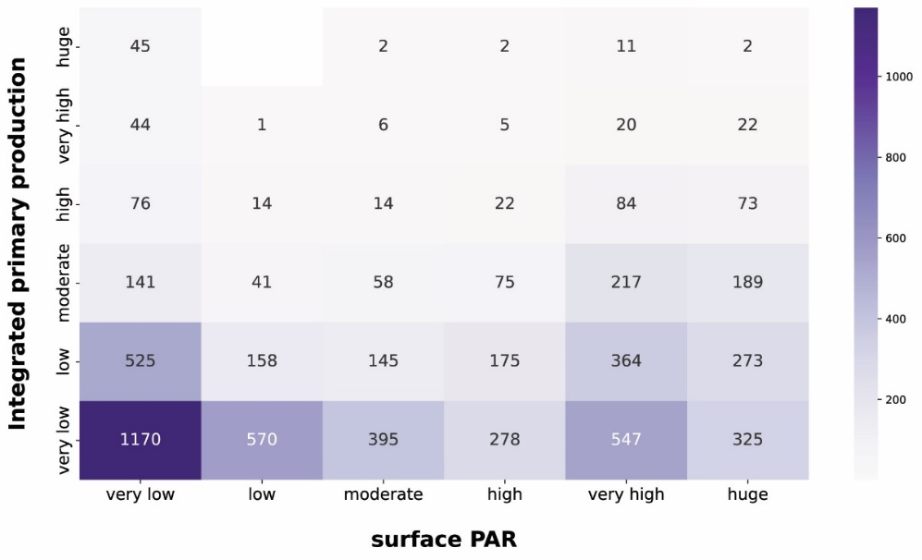
Figure 14 Integrated primary production vs PAR. The purple heatmap shows how integrated phytoplankton production and PAR are related to each other.

The purple heatmap summarizes the relationship between depth-integrated primary production and PAR (fig. 14). The first feature highlighted by figure 14 was the large share of very low integrated production profiles in each PAR class. This is mainly related to the nutrient availability, since low nutrients concentration leads to very low production levels independently from the physical forcing.
Not surprisingly, very high and huge levels of PAR were associated with larger magnitudes of integrated production since the photosynthesis is intimately related to the solar radiation.
Another striking aspect was the wide range of phytoplankton responses to very low PAR magnitudes. In fact, all the production levels are well represented in this PAR class showing that the geographical characteristics of the area deeply influences the primary producers. Accordingly, a constant nutrient input from terrestrial run-off can boost the primary production especially in shallower layers of the water column where usually it is nutrient limited.
The last relationship that we analysed was the one between depth-integrated primary production and depth-integrated chlorophyll a (fig 15).

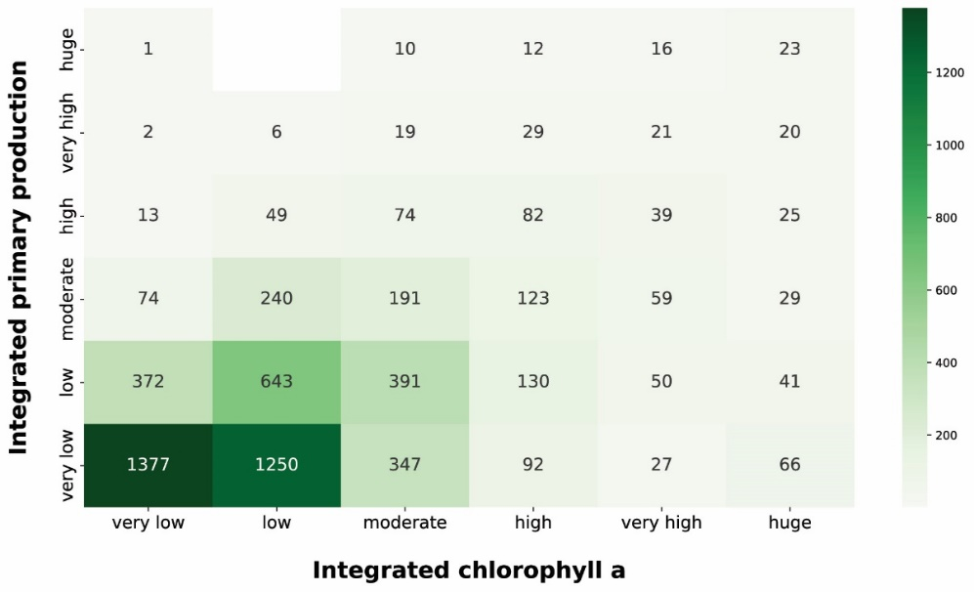
Figure 15 Integrated primary production vs chlorophyll a. The green heatmap relate the depth-integrated phytoplankton production to the chlorophyll a magnitude which is one of the most used proxy for phytoplankton biomass.

The pattern emerged from the green heatmap was a proportional one. Accordingly, the higher the integrated production the higher the integrated chlorophyll a. This feature justifies the common usage of this pigment concentration as a proxy for phytoplankton biomass. The bulk of the profiles was comprised in the very low and low integrated chlorophyll a classes (30.2 % and 35.9 % respectively). 2627 profiles (65.2 % of the two classes) from very low and low chlorophyll a concentration were coupled with very low production, while 1015 (25.2 % of the two classess) were associated to low production. Conversely, higher levels of integrated chlorophyll a were characterized by a larger share of high production profiles (from high to huge). This was not surprising since the chlorophyll a is the principal photosynthetic pigment and its raise is caused by physiological needs of phytoplankton or biomass augmentation.
The final analysis we carried out was a PCA, in order to spot and analyse general patterns in the dataset. We selected the following twelve variables to perform the PCA: day length, bottom depth, bottom depth variance, MLD, distance from coastline, SST, PAR, surface chlorophyll a, integrated chlorophyll a, surface phytoplankton production, integrated phytoplankton production and production to biomass ratio (fig 16).
We used the type one scaling since our main focus was on the position of the profiles. Using this type of scaling the distance between the objects in the plot approximate their Euclidean distances in full dimensional space. The variance explained by the first and the second axis was 0.22 and 0.14 respectively. The relatively low share of explained variance highlights the high complexity of the data which encompass large levels of spatial and temporal variability. Nevertheless, the ordination allowed to spot and show several features of the production dataset. From a general point of view (fig. 16a) we can see that high levels of surface and depth-integrated chlorophyll a are associated between them. The same remark is valid for the phytoplankton production. Moreover, is not surprising that chlorophyll a concentration and phytoplankton production measures point in the same direction along the first axis. Another feature that is consistent with the results previously presented was the inverse relationship between bottom depth and coastline distance with respect to primary production magnitude.

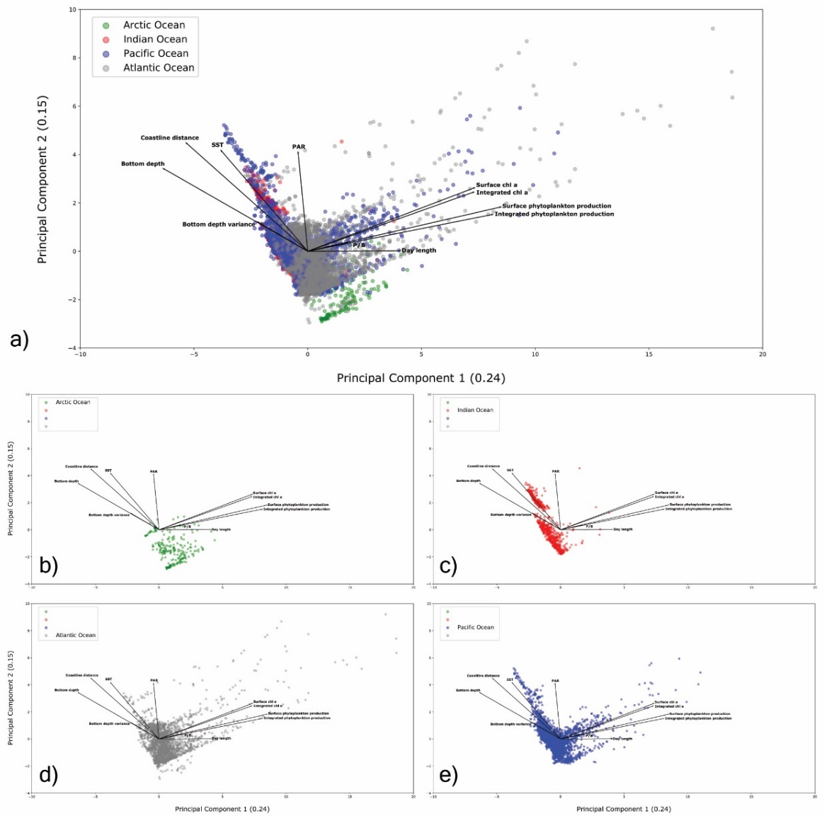
Figure 16 Principal component analysis 0.22 & 0.14 explained variance from the first two axes respectively (0.36). a) global PCA; b) Arctic Ocean profiles; c) Indian Ocean profiles; d) Atlantic Ocean profiles; e) Pacific Ocean profiles.

The Arctic Ocean (fig. 16b) presented the narrowest cloud of point among the basins. This could be the result of the low number of records collected in this region and the peculiar characteristic of the area. In fact, the Arctic Ocean is characterized by low level of SST and PAR throughout the year with the exception of short periods of time.
The Indian Ocean showed two groups of samples. This feature was the result of the monsoon system that characterize this basin. The wind blows from northeast during cooler months and from southwest during the warmest months of the year (Dickson et al., 2001). Moreover, the plot (fig. 16c) shows that this is not a highly productive area independently from the environmental conditions. In fact, the bulk of the points were placed in the opposite direction of both chlorophyll a concentration and phytoplankton production levels.
A large amount of information was associated with the Atlantic and Pacific Oceans (fig. 16d and 16e respectively) since they were the most sampled areas. Accordingly, they showed the largest range of sampled conditions with large and low levels for almost every environmental and biological variable. Moreover, almost every profile associated with a high level of phytoplankton production or chlorophyll a concentration was recorded in these basins.

4 CONCLUSIONS
The data paucity is one of the most important issues related to several disciplines and Ecology makes no exception. This is especially true if the task to tackle is the understanding of the dynamics of a complex biological process, such as phytoplankton primary production, on a global scale. Moreover, several researchers during the last decades highlighted how the lack of data is the main constraint for modelling phytoplankton production.
In this framework, we believe that building a new, homogenous and ready to use dataset, associated with a general analysis of its features, could play an important role in the study of phytoplankton production. For this reason, we retrieved phytoplankton production data from heterogeneous sources and created a new global dataset. We also applied several data analysis and visualization technique to spot and discuss both the dataset characteristics and the variables relationships.
Furthermore, enriching the dataset with ancillary data related to the phytoplankton production could be extremely useful in improving our understanding of this pivotal process, e.g. in a machine learning context.
Despite the new dataset is still unbalanced from a spatial and temporal perspective and the need for new data will never be fully satisfied, we believe that it represents a crucial improvement of the previous existing ones.

REFERENCES
Anderson, T.R., Martin, A.P., Lampitt, R.S., Trueman, C.N., Henson, S.A., Mayor, D.J., Handling editor: Jason Link, 2018. Quantifying carbon fluxes from primary production to mesopelagic fish using a simple food web model. ICES J. Mar. Sci. https://doi.org/10.1093/icesjms/fsx234
Arrigo, K.R., Dijken, G.L. van, Bushinsky, S., 2008. Primary production in the Southern Ocean, 1997–2006. J. Geophys. Res. Oceans 113. https://doi.org/10.1029/2007JC004551
Barange, M., Merino, G., Blanchard, J.L., Scholtens, J., Harle, J., Allison, E.H., Allen, J.I., Holt, J., Jennings, S., 2014. Impacts of climate change on marine ecosystem production in societies dependent on fisheries. Nat. Clim. Change 4, 211–216. https://doi.org/10.1038/nclimate2119
Behrenfeld, M.J., Falkowski, P.G., 1997. Photosynthetic rates derived from satellite-based chlorophyll concentration. Limnol. Oceanogr. 42, 1–20. https://doi.org/10.4319/lo.1997.42.1.0001
Behrenfeld, M.J., O’Malley, R.T., Boss, E.S., Westberry, T.K., Graff, J.R., Halsey, K.H., Milligan, A.J., Siegel, D.A., Brown, M.B., 2016. Revaluating ocean warming impacts on global phytoplankton. Nat. Clim. Change 6, 323–330. https://doi.org/10.1038/nclimate2838
Behrenfeld, M.J., O’Malley, R.T., Siegel, D.A., McClain, C.R., Sarmiento, J.L., Feldman, G.C., Milligan, A.J., Falkowski, P.G., Letelier, R.M., Boss, E.S., 2006. Climate-driven trends in contemporary ocean productivity. Nature 444, 752. https://doi.org/10.1038/nature05317
Blanchard, J.L., Jennings, S., Holmes, R., Harle, J., Merino, G., Allen, J.I., Holt, J., Dulvy, N.K., Barange, M., 2012a. Potential consequences of climate change for primary production and fish production in large marine ecosystems. Philos. Trans. R. Soc. B Biol. Sci. 367, 2979–2989. https://doi.org/10.1098/rstb.2012.0231
Blanchard, J.L., Jennings, S., Holmes, R., Harle, J., Merino, G., Allen, J.I., Holt, J., Dulvy, N.K., Barange, M., 2012b. Potential consequences of climate change for primary production and fish production in large marine ecosystems. Philos. Trans. R. Soc. B Biol. Sci. 367, 2979–2989. https://doi.org/10.1098/rstb.2012.0231
Blythe, J., Armitage, D., Alonso, G., Campbell, D., Esteves Dias, A.C., Epstein, G., Marschke, M., Nayak, P., 2020. Frontiers in coastal well-being and ecosystem services research: A systematic review. Ocean Coast. Manag. 185, 105028. https://doi.org/10.1016/j.ocecoaman.2019.105028
Caldeira, K., Duffy, P.B., 2000. The Role of the Southern Ocean in Uptake and Storage of Anthropogenic Carbon Dioxide. Science 287, 620–622. https://doi.org/10.1126/science.287.5453.620
Campbell, J., Antoine, D., Armstrong, R., Arrigo, K., Balch, W., Barber, R., Behrenfeld, M., Bidigare, R., Bishop, J., Carr, M.-E., Esaias, W., Falkowski, P., Hoepffner, N., Iverson, R., Kiefer, D., Lohrenz, S., Marra, J., Morel, A., Ryan, J., Vedernikov, V., Waters, K., Yentsch, C., Yoder, J., 2002. Comparison of algorithms for estimating ocean primary production from surface chlorophyll, temperature, and irradiance. Glob. Biogeochem. Cycles 16, 9-1-9–15. https://doi.org/10.1029/2001GB001444
Carr, M.-E., Friedrichs, M.A.M., Schmeltz, M., Noguchi Aita, M., Antoine, D., Arrigo, K.R., Asanuma, I., Aumont, O., Barber, R., Behrenfeld, M., Bidigare, R., Buitenhuis, E.T., Campbell, J., Ciotti, A., Dierssen, H., Dowell, M., Dunne, J., Esaias, W., Gentili, B., Gregg, W., Groom, S., Hoepffner, N., Ishizaka, J., Kameda, T., Le Quéré, C., Lohrenz, S., Marra, J., Mélin, F., Moore, K., Morel, A., Reddy, T.E., Ryan, J., Scardi, M., Smyth, T., Turpie, K., Tilstone, G., Waters, K., Yamanaka, Y., 2006. A comparison of global estimates of marine primary production from ocean color. Deep Sea Res. Part II Top. Stud. Oceanogr., The US JGOFS Synthesis and Modeling Project: Phase III 53, 741–770. https://doi.org/10.1016/j.dsr2.2006.01.028
Carvalho, M.C., Schulz, K.G., Eyre, B.D., 2017. Respiration of new and old carbon in the surface ocean: Implications for estimates of global oceanic gross primary productivity. Glob. Biogeochem. Cycles 31, 975–984. https://doi.org/10.1002/2016GB005583
Catucci, E., Scardi, M., 2020. A Machine Learning approach to the assessment of the vulnerability of Posidonia oceanica meadows. Ecol. Indic. 108, 105744. https://doi.org/10.1016/j.ecolind.2019.105744
Dickson, M.-L., Orchardo, J., Barber, R., Marra, J., Mccarthy, J., Sambrotto, R., 2001. Production and respiration rates in the Arabian Sea during the 1995 Northeast and Southwest Monsoons. Deep Sea Res. Part II Top. Stud. Oceanogr. 48, 1199–1230. https://doi.org/10.1016/S0967-0645(00)00136-3
Duarte, C.M., Cebrián, J., 1996. The fate of marine autotrophic production. Limnol. Oceanogr. 41, 1758–1766. https://doi.org/10.4319/lo.1996.41.8.1758
Falkowski, P.G., Raven, J.A., 2007a. Aquatic Photosynthesis: (Second Edition), STU-Student edition. ed. Princeton University Press.
Falkowski, P.G., Raven, J.A., 2007b. Aquatic Photosynthesis: (Second Edition), STU-Student edition. ed. Princeton University Press.
Falkowski, P.G., Wilson, C., 1992. Phytoplankton productivity in the North Pacific ocean since 1900 and implications for absorption of anthropogenic CO 2. Nature 358, 741–743. https://doi.org/10.1038/358741a0
Field, C.B., Behrenfeld, M.J., Randerson, J.T., Falkowski, P., 1998. Primary Production of the Biosphere: Integrating Terrestrial and Oceanic Components. Science 281, 237–240. https://doi.org/10.1126/science.281.5374.237
Fox, J., Behrenfeld, M.J., Haëntjens, N., Chase, A., Kramer, S.J., Boss, E., Karp-Boss, L., Fisher, N.L., Penta, W.B., Westberry, T.K., Halsey, K.H., 2020. Phytoplankton Growth and Productivity in the Western North Atlantic: Observations of Regional Variability From the NAAMES Field Campaigns. Front. Mar. Sci. 7. https://doi.org/10.3389/fmars.2020.00024
Franceschini, S., Mattei, F., D’Andrea, L., Di Nardi, A., Fiorentino, F., Garofalo, G., Scardi, M., Cataudella, S., Russo, T., 2019. Rummaging through the bin: Modelling marine litter distribution using Artificial Neural Networks. Mar. Pollut. Bull. 149, 110580. https://doi.org/10.1016/j.marpolbul.2019.110580
Friedrichs, M.A.M., Carr, M.-E., Barber, R.T., Scardi, M., Antoine, D., Armstrong, R.A., Asanuma, I., Behrenfeld, M.J., Buitenhuis, E.T., Chai, F., Christian, J.R., Ciotti, A.M., Doney, S.C., Dowell, M., Dunne, J., Gentili, B., Gregg, W., Hoepffner, N., Ishizaka, J., Kameda, T., Lima, I., Marra, J., Mélin, F., Moore, J.K., Morel, A., O’Malley, R.T., O’Reilly, J., Saba, V.S., Schmeltz, M., Smyth, T.J., Tjiputra, J., Waters, K., Westberry, T.K., Winguth, A., 2009. Assessing the uncertainties of model estimates of primary productivity in the tropical Pacific Ocean. J. Mar. Syst., Skill assessment for coupled biological/physical models of marine systems 76, 113–133. https://doi.org/10.1016/j.jmarsys.2008.05.010
Gibert, K., Izquierdo, J., Sànchez-Marrè, M., Hamilton, S.H., Rodríguez-Roda, I., Holmes, G., 2018. Which method to use? An assessment of data mining methods in Environmental Data Science. Environ. Model. Softw. 110, 3–27. https://doi.org/10.1016/j.envsoft.2018.09.021
Giering, S.L.C., Sanders, R., Lampitt, R.S., Anderson, T.R., Tamburini, C., Boutrif, M., Zubkov, M.V., Marsay, C.M., Henson, S.A., Saw, K., Cook, K., Mayor, D.J., 2014. Reconciliation of the carbon budget in the ocean’s twilight zone. Nature 507, 480–483. https://doi.org/10.1038/nature13123
Hays, G., Richardson, A., Robinson, C., 2005. Climate change and marine plankton. Trends Ecol. Evol. 20, 337–344. https://doi.org/10.1016/j.tree.2005.03.004
Huisman, J., Weissing, F.J., 1995. Competition for Nutrients and Light in a Mixed Water Column: A Theoretical Analysis. Am. Nat. 146, 536–564. https://doi.org/10.1086/285814
Huot, Y., Babin, M., Bruyant, F., Grob, C., Twardowski, M.S., Claustre, H., 2007. Does chlorophyll &lt;i&gt;a&lt;/i&gt; provide the best index of phytoplankton biomass for primary productivity studies? (preprint). https://doi.org/10.5194/bgd-4-707-2007
Jackson, R.B., Friedlingstein, P., Andrew, R.M., Canadell, J.G., Quéré, C.L., Peters, G.P., 2019. Persistent fossil fuel growth threatens the Paris Agreement and planetary health. Environ. Res. Lett. 14, 121001. https://doi.org/10.1088/1748-9326/ab57b3
Jäger, C.G., Diehl, S., Schmidt, G.M., 2008. Influence of water-column depth and mixing on phytoplankton biomass, community composition, and nutrients. Limnol. Oceanogr. 53, 2361–2373. https://doi.org/10.4319/lo.2008.53.6.2361
Jenks, G., 1967. The Data Model Concept in Statistical Mapping. Int. Yearb. Cartogr. 7, 186–190.
Kwak, I.-S., Park, Y.-S., 2020a. Food Chains and Food Webs in Aquatic Ecosystems. Appl. Sci. 10, 5012. https://doi.org/10.3390/app10145012
Kwak, I.-S., Park, Y.-S., 2020b. Food Chains and Food Webs in Aquatic Ecosystems. Appl. Sci. 10, 5012. https://doi.org/10.3390/app10145012
Lee, Y.J., Matrai, P.A., Friedrichs, M.A.M., Saba, V.S., Antoine, D., Ardyna, M., Asanuma, I., Babin, M., Bélanger, S., Benoît-Gagné, M., Devred, E., Fernández-Méndez, M., Gentili, B., Hirawake, T., Kang, S.-H., Kameda, T., Katlein, C., Lee, S.H., Lee, Z., Mélin, F., Scardi, M., Smyth, T.J., Tang, S., Turpie, K.R., Waters, K.J., Westberry, T.K., 2015. An assessment of phytoplankton primary productivity in the Arctic Ocean from satellite ocean color/in situ chlorophyll-a based models. J. Geophys. Res. Oceans 120, 6508–6541. https://doi.org/10.1002/2015JC011018
Levitus, S., Boyer, T.P., 1994. World Ocean Atlas 1994. Volume 4. Temperature (No. PB-95-270112/XAB; NESDIS-4). National Environmental Satellite, Data, and Information Service, Washington, DC (United States).
Levitus, S., Burgett, R., Boyer, T.P., 1994. World Ocean Atlas 1994. Volume 3. Salinity (No. PB-95-270104/XAB; NESDIS-3). National Environmental Satellite, Data, and Information Service, Washington, DC (United States).
Longhurst, A.R., Glen Harrison, W., 1989. The biological pump: Profiles of plankton production and consumption in the upper ocean. Prog. Oceanogr. 22, 47–123. https://doi.org/10.1016/0079-6611(89)90010-4
Mattei, F., Franceschini, S., Scardi, M., 2018. A depth-resolved artificial neural network model of marine phytoplankton primary production. Ecol. Model. 382, 51–62. https://doi.org/10.1016/j.ecolmodel.2018.05.003
Mattei, F., Scardi, M., 2020. Embedding ecological knowledge into artificial neural network training: A marine phytoplankton primary production model case study. Ecol. Model. 421, 108985. https://doi.org/10.1016/j.ecolmodel.2020.108985
Maureaud, A., Gascuel, D., Colléter, M., Palomares, M.L.D., Du Pontavice, H., Pauly, D., Cheung, W.W.L., 2017. Global change in the trophic functioning of marine food webs. PLOS ONE 12, e0182826. https://doi.org/10.1371/journal.pone.0182826
Merchant, C.J., Embury, O., Bulgin, C.E., Block, T., Corlett, G.K., Fiedler, E., Good, S.A., Mittaz, J., Rayner, N.A., Berry, D., Eastwood, S., Taylor, M., Tsushima, Y., Waterfall, A., Wilson, R., Donlon, C., 2019. Satellite-based time-series of sea-surface temperature since 1981 for climate applications. Sci. Data 6, 223. https://doi.org/10.1038/s41597-019-0236-x
Moigne, F.A.C.L., Henson, S.A., Cavan, E., Georges, C., Pabortsava, K., Achterberg, E.P., Ceballos‐Romero, E., Zubkov, M., Sanders, R.J., 2016. What causes the inverse relationship between primary production and export efficiency in the Southern Ocean? Geophys. Res. Lett. 43, 4457–4466. https://doi.org/10.1002/2016GL068480
Olden, J.D., Lawler, J.J., Poff, N.L., 2008. Machine Learning Methods Without Tears: A Primer for Ecologists. Q. Rev. Biol. 83, 171–193. https://doi.org/10.1086/587826
Paerl, H.W., Rudek, J., Mallin, M.A., 1990. Stimulation of phytoplankton production in coastal waters by natural rainfall inputs: Nutritional and trophic implications. Mar. Biol. 107, 247–254. https://doi.org/10.1007/BF01319823
Peters, D.P.C., Havstad, K.M., Cushing, J., Tweedie, C., Fuentes, O., Villanueva-Rosales, N., 2014. Harnessing the power of big data: infusing the scientific method with machine learning to transform ecology. Ecosphere 5, art67. https://doi.org/10.1890/ES13-00359.1
Peters, G.P., Andrew, R.M., Canadell, J.G., Friedlingstein, P., Jackson, R.B., Korsbakken, J.I., Le Quéré, C., Peregon, A., 2020. Carbon dioxide emissions continue to grow amidst slowly emerging climate policies. Nat. Clim. Change 10, 3–6. https://doi.org/10.1038/s41558-019-0659-6
Platt, T., Sathyendranath, S., 1988. Oceanic Primary Production: Estimation by Remote Sensing at Local and Regional Scales. Science 241, 1613–1620. https://doi.org/10.1126/science.241.4873.1613
Recknagel, F., 2001. Applications of machine learning to ecological modelling. Ecol. Model. 146, 303–310. https://doi.org/10.1016/S0304-3800(01)00316-7
Reuer, M.K., Barnett, B.A., Bender, M.L., Falkowski, P.G., Hendricks, M.B., 2007. New estimates of Southern Ocean biological production rates from O2/Ar ratios and the triple isotope composition of O2. Deep Sea Res. Part Oceanogr. Res. Pap. 54, 951–974. https://doi.org/10.1016/j.dsr.2007.02.007
Richardson, A.J., Schoeman, D.S., 2004. Climate Impact on Plankton Ecosystems in the Northeast Atlantic. Science 305, 1609–1612. https://doi.org/10.1126/science.1100958
Russo, T., Carpentieri, P., D’Andrea, L., De Angelis, P., Fiorentino, F., Franceschini, S., Garofalo, G., Labanchi, L., Parisi, A., Scardi, M., Cataudella, S., 2019. Trends in Effort and Yield of Trawl Fisheries: A Case Study From the Mediterranean Sea. Front. Mar. Sci. 6. https://doi.org/10.3389/fmars.2019.00153
Saba, V.S., Friedrichs, M.A.M., Carr, M.-E., Antoine, D., Armstrong, R.A., Asanuma, I., Aumont, O., Bates, N.R., Behrenfeld, M.J., Bennington, V., Bopp, L., Bruggeman, J., Buitenhuis, E.T., Church, M.J., Ciotti, A.M., Doney, S.C., Dowell, M., Dunne, J., Dutkiewicz, S., Gregg, W., Hoepffner, N., Hyde, K.J.W., Ishizaka, J., Kameda, T., Karl, D.M., Lima, I., Lomas, M.W., Marra, J., McKinley, G.A., Mélin, F., Moore, J.K., Morel, A., O’Reilly, J., Salihoglu, B., Scardi, M., Smyth, T.J., Tang, S., Tjiputra, J., Uitz, J., Vichi, M., Waters, K., Westberry, T.K., Yool, A., 2010. Challenges of modeling depth-integrated marine primary productivity over multiple decades: A case study at BATS and HOT. Glob. Biogeochem. Cycles 24. https://doi.org/10.1029/2009GB003655
Sabine, C.L., Feely, R.A., Gruber, N., Key, R.M., Lee, K., Bullister, J.L., Wanninkhof, R., Wong, C.S., Wallace, D.W.R., Tilbrook, B., Millero, F.J., Peng, T.-H., Kozyr, A., Ono, T., Rios, A.F., 2004. The Oceanic Sink for Anthropogenic CO2. Science 305, 367–371. https://doi.org/10.1126/science.1097403
Sammartino, M., Marullo, S., Santoleri, R., Scardi, M., 2018. Modelling the Vertical Distribution of Phytoplankton Biomass in the Mediterranean Sea from Satellite Data: A Neural Network Approach. Remote Sens. 10, 1666. https://doi.org/10.3390/rs10101666
Scardi, M., 2001. Advances in neural network modeling of phytoplankton primary production. Ecol. Model. 146, 33–45. https://doi.org/10.1016/S0304-3800(01)00294-0
Scardi, M., 1996. Artificial neural networks as empirical models for estimating phytoplankton production. Mar. Ecol. Prog. Ser. 139, 289–299. https://doi.org/10.3354/meps139289
Shurin Jonathan B, Gruner Daniel S, Hillebrand Helmut, 2006. All wet or dried up? Real differences between aquatic and terrestrial food webs. Proc. R. Soc. B Biol. Sci. 273, 1–9. https://doi.org/10.1098/rspb.2005.3377
Siegel, D.A., Behrenfeld, M.J., Maritorena, S., McClain, C.R., Antoine, D., Bailey, S.W., Bontempi, P.S., Boss, E.S., Dierssen, H.M., Doney, S.C., Eplee, R.E., Evans, R.H., Feldman, G.C., Fields, E., Franz, B.A., Kuring, N.A., Mengelt, C., Nelson, N.B., Patt, F.S., Robinson, W.D., Sarmiento, J.L., Swan, C.M., Werdell, P.J., Westberry, T.K., Wilding, J.G., Yoder, J.A., 2013. Regional to global assessments of phytoplankton dynamics from the SeaWiFS mission. Remote Sens. Environ. 135, 77–91. https://doi.org/10.1016/j.rse.2013.03.025
Teixeira, I.G., Arbones, B., Froján, M., Nieto-Cid, M., Álvarez-Salgado, X.A., Castro, C.G., Fernández, E., Sobrino, C., Teira, E., Figueiras, F.G., 2018. Response of phytoplankton to enhanced atmospheric and riverine nutrient inputs in a coastal upwelling embayment. Estuar. Coast. Shelf Sci. 210, 132–141. https://doi.org/10.1016/j.ecss.2018.06.005
Westberry, T., Behrenfeld, M.J., Siegel, D.A., Boss, E., 2008. Carbon-based primary productivity modeling with vertically resolved photoacclimation. Glob. Biogeochem. Cycles 22. https://doi.org/10.1029/2007GB003078
Westberry, T.K., Behrenfeld, M.J., 2014. Oceanic Net Primary Production, in: Hanes, J.M. (Ed.), Biophysical Applications of Satellite Remote Sensing, Springer Remote Sensing/Photogrammetry. Springer, Berlin, Heidelberg, pp. 205–230. https://doi.org/10.1007/978-3-642-25047-7_8
Wollast, R., 1998. Evaluation and comparison of the global carbon cycle in the coastal zone and in the open ocean. p. Sea Vol 10 213–252.

