Do macrophytes act as restaurants for fishes in tropical beaches? An approach using stomach content and prey availability analyses

Jonas de Andrade Santos^{a,*}, Rafael Lima Oliveira^{b}, Ana Paula Penha Guedes^{c}, Alexandre Clistenes de Alcântara Santos^{d}, Leonardo Evangelista Moraes^{e}

ªLaboratório de Ictiologia; Programa de Pós-Graduação em Ciências Biológicas (Zoologia) - Centro de Ciências Exatas e da Natureza, Departamento de Sistemática e Evolução, Universidade Federal da Paraíba, Campus I - Lot. Cidade Universitaria – CEP 58051-900, João Pessoa, Paraíba, Brazil. jonasandradebio@gmail.com
^{b}Laboratório de Ecologia de Peixes Marinhos; Programa de Pós-Graduação em Ciências Biológicas (Biologia Animal), Universidade Federal do Espírito Santo, Rodovia BR 101 Norte, Km. 60. Bairro Litorâneo, S/N – CEP 29.932-540, São Mateus, Espírito Santo, Brazil. oliveirarl.uesb@gmail.com
^{c}Laboratório de Ecologia de Peixes e Museu de Zoologia; Programa de Pós-Graduação em Ecologia Humana e Gestão Socioambiental, Universidade do Estado da Bahia, Campus VII. BR 407, Km 127, CEP 48970-000, Senhor do Bonfim, Bahia, Brazil. appguedes@uneb.br
^{d}Laboratório de Ictiologia; Programa de Pós-Graduação em Ecologia e Evolução, Universidade Estadual de Feira de Santana. Avenida Transnordestina s/n - Novo Horizonte, 44036-900, Feira de Santana, Bahia, Brazil. alexandreclistenes@uefs.br
^{e}Laboratório de Recursos Pesqueiros e Aquicultura; Centro de Formação em Ciências Ambientais, Universidade Federal do Sul da Bahia (Campus Sosígenes Costa). BR 367, Km 10. Rod. Porto Seguro-Eunápolis. CEP 45810-000. Porto Seguro, Bahia, Brazil. leomoraes.ufsb@gmail.com

*Correspondence to: Laboratório de Ictiologia - Centro de Ciências Exatas e da Natureza, Departamento de Sistemática e Evolução, Universidade Federal da Paraíba, Campus I - Lot. Cidade Universitaria – CEP 58051-900, João Pessoa, Paraíba, Brazil. E-mail address: jonasandradebio@gmail.com (J.A. Santos).

Abstract
Tropical sandy beaches have low primary productivity, thus depend on external food sources. Generally, allochthonous macrophytes, form the basis of these food webs, and also may influence factors such as fish’s abundance, richness, species composition, and biomass. However, the role of macrophytes to the feeding ecology of fishes in tropical sandy beaches is uncertain. We aim to explain if this microhabitat acts as restaurants for fishes by performing stomach content and prey availability analyses using Ophioscion punctatissimus as a model because it has an association with detached macrophytes mainly on sandy beaches along the northeastern Brazilian coast. The most consumed prey was crustaceans, mainly amphipods, which were eaten in a specialist way, especially by the smaller fishes. The prey availability along with electivity index suggested that this species choose amphipods. Seasonal variations may indicate that the fishes did not locate their preferential prey as an effect of the availability, this can be also explained by factors such as palatability, and optimal foraging theory. Here, we redefined the O. punctatissimus trophic guild as zooplanktivorous, highlighting macrophytes as restaurants for fishes in tropical sandy beaches as they are the main source of food, adding another function to this microhabitat in this environment.
Keywords: Allochthonous sources, feeding ecology, sandy beaches, sciaenidae, trophic guild

- Introduction
At first glance, sandy beaches could be classified as marine deserts, especially when compared to more productive systems such as estuaries, due to the general lack of conspicuous animals or plants. This is especially in tropical beaches, which depend on external inputs to their primary production because their autochthonous production is lower than in temperate beaches (marine or estuarine) (McLachlan & Brown 2006; Andrades et al. 2014; Garcia et al. 2019). Despite this, tropical sandy beaches are inhabited mainly by juvenile fish, which use that habitat for foraging. Although the wave action causes low transparency levels in this habitat, which decreases the chance to locate prey, the transparency can act as a proxy for prey availability (Pessanha & Araújo 2003; Gonzalez & Vaske-Junior 2017).
In tropical sandy beaches, these external inputs are dominated by macrophytes, which are generally in low amounts but can be higher in beaches close to reef banks or seagrass meadows. These macrophytes are brought into surf zones where they provide a source of food and shelter, which substantially contributing to the local food web (Ince et al. 2007; Hyndes et al. 2014). An essential factor in explaining the role of macrophytes in tropical sandy beaches is the condition of the major primary source. Beyond acting on the food web, this food input also, in some way, works to promote structural heterogeneity, resulting in an attractive place for large predators such as fishes (Knox 2000; Baring et al. 2019). On the tropical coast, this microhabitat is essential for the food web and presents a positive correlation with fish occurrence. It also has a positive effect on fish species richness, composition, and size. However, this pattern seems to follow a species-specific pattern and varies over regions with different oceanographic characteristics such as having windrows and some small-scale currents (Andrades et al. 2014; Gomes et al. 2018; Olds et al. 2018; Baring et al. 2019). Therefore, macrophytes have an important function as a microhabitat, as it is a food source for microcrustaceans (e.g., amphipods and isopods) which also use this microhabitat as a shelter from predators (Beermann et al. 2018).
To attest the main role of the macrophytes in sandy beaches, they have to be able to support several zooplankton groups but also maintain bigger fauna such as fishes, even those at the juvenile phase. As a location used by several fish species at different levels (i.e., residents, marine stragglers), there is a demanding requirement of food supply to avoid oversaturated resources and support the community through seasonal and ontogenetic variations (Lasiak 1986; Lenanton & Caputi 1989; Carr & Syms 2006; Elliot et al. 2007). These variations in sandy beaches (e.g., vertical, seasonal, or ontogenetic) are affected by prey availability and are also a result of changes in feeding behavior as well as morphological changes upon feeding apparatus or other structural aspects related to senses (e.g., sight, smell) that work to locate prey. In this way, this habitat feasibly recruits individuals in shallow waters (Lasiak 1986; Deary & Hilton 2016).
One of the typical and dominant species in sandy beaches, mostly along the northeastern coast of Brazil, is Ophioscion punctatissimus Meek & Hildebrand 1925 (Fig. 1). This species is associated with the accumulation of macrophytes in exposed beaches (unpublished data). It has a higher abundance between Colombian and northeastern Brazilian (NE) coastal waters, which decreases southward of Bahia state along the southeastern coast (SE). This decrease may be explained by the higher occurrence of siliciclastic bottoms and rocky shores on the SE coast in comparison with the mainly sandy shores and biogenic reefs along the NE coast (Félix et al. 2007; Lira & Teixeira 2008; Barroso et al. 2016; Plazas-Gómez et al. 2018). This could also be an effect of the cline variation from the center of origin of this species (i.e., close to the Isthmus of Panama) to southwards (Tuya et al. 2008; Lo et al. 2015; Silva et al. 2018). Biological data are scarce for this species as feeding biology or recruitment traits are mentioned in only a few studies (Zahorcsak et al. 2000; Lira & Teixeira 2008). Only the occurrence/abundance records along its distribution range can be found in several studies (Oliveira-Silva et al. 2008; Moraes et al. 2009; Santana et al. 2013; Plazas-Gómez et al. 2018; Silva-Júnior et al. 2019; Passarone et al. 2019).
In the northeast region of Brazil, it is common to find large amounts of macroalgae clustered on sandy beaches due to the proximity of these habitats to reef environments that are sources of this allochthone material. It is known that the food web in tropical sandy beaches has a dependency on macrophytes, as seen in areas close to the study area (Itaparica Island) by Santos et al. (2020) using an approach of stable isotopes. Therefore, we used stomach content analysis and determination of prey availability to evaluate if this microhabitat works as a restaurant for fishes in sandy beaches using O. punctatissimus as a model. We also sought to verify this information with the only data available for the SE coast.

- Materials and methods
  - Study area and sampling design
The sampling was conducted at Ponta da Ilha beach (13°06′38.6′′S 38°45′32.1′′W), located on the southwest coast of Itaparica Island (Todos os Santos Bay “TSB” – Bahia, Northeastern Brazil) (Fig. 2). It is an intermediate beach, with high exposure to waves as well as a large amount of macrophyte accumulation that occurs almost entirely throughout the year with slight variations in their volume (there are a few months where that amount was close to zero). At this site, both subsistence and recreational fishing are conducted (Barros et al. 2012; JAS pers. obs.). The source of these macrophytes seems to be Caramuanas reef bank, which is located approximately 2 km southwest of the sampling site (CWN Moura, March 2019 - pers. communication). Because the reef bank is located on the mouth of TSB, it is more exposed to waves at low tide than other shallow reef banks located northeasterly or within TSB, leading to macrophyte transportation from this reef bank to the Itaparica Island coast (Barros-Junior et al. 2009). Samplings were conducted in during daylight hours on a monthly basis from March/2013 to October/2015, and bimonthly from November/2015 to February/2019 using a manual beach seine net of 10 m length with a mesh 12 mm on the borders and 5 mm at the center. In each month, five trawls (close to the 150 m total) were set parallel to the coast using a manual beach seine net 9 m in length and 1.7 m in height, with 13 mm mesh on the lateral and 5 mm mesh in the center. The trawling was always done at low tide during syzygy. The hydrological periods were defined using historical data in the studied area, herein called wet season (March–July) and dry season (August–February) (Lessa et al. 2001; Cirano & Lessa 2007).
  - Stomach content and prey availability
The stomachs of each fish were removed after the sampling process and conserved in a 10% formalin solution, and preserved in a 70% alcohol solution until analysis. Using a binocular stereomicroscope, the food items were identified to the lowest possible taxonomic level and counted. When possible, the volume was also measured. We analyzed 220 stomachs from Ophioscion punctatissimus individuals, which ranged between 23 mm to 153 mm in standard length (SL). To evaluate ontogenetic shifts, the specimens were separated into two size classes: Class I – up to 80 mm SL and Class II – over 80 mm SL. In doing so, we had split the range of sizes in almost half, resulting in those classes not being able to account for classifications such as juveniles or adults. The codes for prey item analysis were: Amphipods (AMP), Brachyura (BRA), Bivalvia (BIV), Cephalopods (CEP), Copepods (COP), Crustacean unidentified (CRU), Foraminifera (FOR), Gastropods (GAS), Isopods (ISO), Macrophytes (MAC), Megalopa larvae of Brachyura (MEG), Shrimps (SHR), Microplastic (PLA), Polychaeta (POL), Sediment (SED), Spicule (SPI), Stomatopods (STO), and Unidentified animal matter (UNI).
To perform the prey availability analysis, we used two subsamples (one-third of a sample) of macrophytes (herein a sample refers to at least 20 L of macrophytes collected in the beach seine together with the fishes). Each sample corresponded to distinct situations (i.e., at a low rate of amphipods in the stomach vs. at a high rate of amphipods in the stomach; March and May 2014). The macrophyte samples were frozen and then filtered through water with a current using three sets of filters in a vertical sequence. First, the samples were washed on a 50 cm diameter (4 mm mesh) filter, and then through a rectangular filter measuring 70 cm diagonally (4 mm mesh), before the filtered material was collected in a conical filter of 500 µm mesh. A subsample of this filtered material measuring 25 cm³ was used. In each sample, this process was repeated three times. After this, two persons inspected the samples manually for at least 5 min. The items found were counted, and when possible, we measured their total volume. We also took individual measures of total length to verify the size of the amphipods, the most consumed prey (89 individuals in each food source: macrophytes and fish stomach contents).
  - Statistical analysis
For the diet analysis, the frequency of occurrence (%FO) and the volume (%VO) of food items were used to calculate the alimentary index (Iai) (Kawakami & Vazzoler 1980). Amundsen’s graphic method, which is a modification of Costello’s method (Costello 1990; Amundsen et al. 1996), was used to elucidate the feeding strategy, where to the %FO was incorporated the prey-specific abundance (Pi) calculation (which presents the numeric proportion of prey counting only those stomachs in which this prey was found). The electivity index (EI) was also calculated to determine the electivity of resources on prey availability analysis, following Ivlev (1961). All of the following analyses were carried out in the R software (R Core Team 2020). Correlation for the co-occurrence analysis was calculated using a transformation of the % FO matrix into one presence/absence matrix that was later used to calculate the correlation (Kendall’s tau) between items using the “corrplot” package (Wei & Simko 2017) using a significance level of 𝑎 = 0.05. Here, only significant values (P < 0.05) are shown (blank spaces correspond to P > 0.05). Classification for correlation values follow Cohen’s example (1988): small value (0.1–0.29); medium value (0.3–0.49); and large value (0.50–1.0). The correlation analysis procedure was performed to examine the relationship among prey and among groups formed by them. We applied the sample size (individuals or stomach analyzed) and coverage-based rarefaction/extrapolation curves (herein called, accumulation of prey) along with a bridging sample completeness curve, using an incidence frequencies dataset in the “iNEXT” package v. 2.0.20 (Hsieh et al. 2016) to verify the suitability of the size sample as well as to distinguish between dry/wet season. A density plot, in the “ggplot2” package (Wickham 2016), was also performed using the total length (in millimeters) of 178 amphipods from two sources: macrophytes and fish stomachs (n=89, in each).

- Results
The stomach contents of 200 individuals (20 empty) were analyzed, and 17 prey items were identified, mostly from animal origin, except for the macrophytes (MAC), sediment (SED), and microplastic (PLA). The MAC and SED showed a low VO% with a medium or low FO%, which agrees with the opinion of keeping them in the analysis. The two most consumed items, with the higher alimentary index (Iai), originated from crustaceans (summing 91% Iai) followed by unidentified animal matter (UNI) (Table 1).
In analyzing the Iai, we found that the main prey were the same in the two classes, showing a variation only in the position of MAC and UNI, as well as in the different uses of some prey. The AMP was consumed more by Class I; while UNI, Crustacean remains (CRU), Isopods (ISO), and Polychaeta (POL) were largely consumed by the individuals from Class II (Table 2).
The group formed by the main prey displayed the most significant correlations. We found some medium positive correlations, such as: MAC vs. AMP/ISO, AMP vs. ISO, UNI vs. POL, and Spicule (SPI) vs. Copepods (COP). However, we also found medium negative correlations such as: AMP vs. UNI/POL/SED as well as for ISO vs. UNI, MAC vs. SED, and SHR vs. POL. Some prey of the most consumed group (AMP, ISO, MAC) had a negative correlation with all prey items from another group formed by POL, SED, and UNI. This pattern was also seen in the small correlations when negative correlations were found between those groups and positive correlations were found within groups. Here, we designate the former group (or microhabitats) as “Macrophyte group” and the latter as “Sediment group.” The correlations within the components of the groups, as well as the negative correlations between them, show segregation between microhabitats. The correlations within indicate that the species consumed those prey items at the same time, while correlations between groups (negative) suggest a microhabitat change when food sources mainly from the “Macrophyte group” were lacking (Fig. 3).
With regard to seasonal variation, AMP was the most consumed in both seasons. However, in the dry season, consumption was more equally distributed among other prey items; while in the wet season, only the AMP reached 96% of all Iai (Table 3). The accumulation of prey showed almost sample completeness with a sample coverage (SC) of 0.9932 (dry season) and 0.9876 (wet season), while at the same time indicating a higher richness in the dry season, as pointed out before by the Iai (Table 3; Fig. 4). In addition, the highest SC for the wet season may support the results of the Iai because we analyzed a supposedly low size sample for the wet season (n=56).
Generally, Amundsen’s plot followed the previous data showing a specialist condition for the AMP, especially in the wet season, due to them having a high Pi value and the highest FO%. In Class I, the most dominant prey was AMP, while in Class II this group presented a lower dominance but still had a specialist/dominant condition, beyond a higher individual specialization in feeding strategy. This graphic does not suggest any other large variation. The same variation was seen for AMP between seasons as they had extreme importance in the wet season, which decreased to medium importance in the dry season (Fig. 5).
The prey availability analysis showed nine and six food resources for the first and second samples, taken in March 2014 and May 2014, respectively (Fig. 6). The first sample had a lower volume of food resources (1.31 g/mm³; 3.09%), while the second sample had a higher amount (14.25 g/mm³; 38.77%). In the first sample, gastropods (GAS) and Foraminifera (FOR) comprised most of the food resources, accounting for 81% of the total volume; while AMP and CRU (which are usually predominant in stomach contents) were present in a lower percentage, accounting for only 0.03%. Meanwhile in the second sample, AMP and GAS stood out in the first positions, both totaling 78% of the total volume (Fig. 6). The electivity index (EI) showed a preference for AMP in spite of the presence of ISO, which had a strongly negative electivity index (EI of -0.95); while AMP presented a median positive value (EI of 0.46). Only these two food resources were used in the EI analysis due to their occurrence in both sources (macrophytes and fish stomach contents). The EI cannot be calculated in the situation of the first sample where no AMP was found in the stomach contents, and only unidentified matter was found in that sample.
The measurements of amphipods from macrophyte sources showed a higher mean and lower variance (3.97 mm mean; 1.78 variance) than the fish stomach source, which had a slightly lower mean and higher variance (3.34 mm mean; 3.18 variance). In this microhabitat, the amphipods consumed were mainly slightly smaller than those available in the macrophytes (Fig. 7).

- Discussion
A diet composed of crustaceans is common for several Sciaenidae species, especially in the Stelliferinae subfamily (Vendel & Chaves 1998; Rodrigues & Vieira 2010; Frehse et al. 2015; Sabinson et al. 2015; Cardoso & Haimovici 2016). Herein, this pattern was not different for the Ophioscion punctatissimus, as what was seen in a previous study (Zahorczak et al. 2000).
In stomach content analysis, the inclusion of differential traits (e.g., dominance) and the maintenance of items such as sediment or algae, leads to a better understanding of specialization tendency (Bennemann et al. 2006). The correlation could be interpreted to suggest that segregation between groups formed by these prey items were preferred to keep it in our analysis; otherwise, we could have biased results if they were removed from the analysis. Despite this, we disregard the occurrence of MAC and SED because we had failed to appoint the origin of both, which could be from accidental ingestion during the feeding activity as well as during the course of sampling.
These supposed vertical variations (i.e., sediment/bottom to macrophytes/mid-water) were also reflected in ontogenetic shifts, indicating a change from upper-mid water to bottom water along the life cycle. This is probably a result of changes in feeding behavior as well as morphological changes in feeding apparatus or other structural aspects of senses that help to detect and pursue prey (Deary & Hilton 2016). However, due to the low vertical separation between the bottom and upper/mid-water levels in the surf zone, these assertions should be treated carefully. In addition, a slight increase in individual specialization, showing an opportunistic behavior, maybe due to the differential distribution of prey patches across the beach. However, it may also be caused by the morphological changes (e.g. mouth gape, eye size) which allow the consumption of other food items, thereby, expanding the niche breadth of this species. Nevertheless, across phylogeny, the morphological changes may also restrict the niche (Larouche et al. 2020). In this way, the species may consume more energetic prey as is seen here when AMP was more sought out by the smaller fishes, while in the larger ones, prey such as shrimps (SHR) had increased their importance in the feeding strategy. This highlighted an effect of ontogenetic shifts which may reflect the optimal foraging theory in the way that those animals tend to feed on larger and more energetic prey, thereby, decreasing the “importance” of prey that are smaller and cost more energetically, such as AMP, in the diet (MacArthur & Pianka 1966; Deary & Hilton 2016). This is shown by Amundsen et al. (1996) as a mixed feeding strategy along the life cycle, from the within-phenotype component (WPC) to the between-phenotype component (BPC) driven by availability, and probably morphological changes, along the development (Deary & Hilton 2016).
These variations, ontogenetic or not, may indicate that the species uses the environment in two general groups: macrophytes and sediment microhabitat. The positive correlation between UNI and POL, together with FO% values to MAC and SED suggests that a diet switch occurs over the course of the life cycle and probably in conditions when preferential prey are lacking. The positive correlation between UNI and POL, as well as the negative correlation between UNI and AMP, agrees with Pombo et al. (2013) who stated that the presence of digested material (referred to here as UNI) is related to a near-bottom feeding habit. In addition, this could confirm the diet switch once UNI (“Sediment group”) were not found together with MAC and AMP (“Macrophyte group”). In addition, Leggett & Deblois (1994) cited turbulence as an influence on the encounter rate of prey, principally at the early stages of fish, because suspended particles or macrophytes reduce visibility in the water. Our sample completeness analysis suggested an almost complete sampling and indicated that it seems to have a distinction in prey offered between seasons, which could act as a driving force for the diet switch. In the dry season, the species presented a broader diet than in the wet season. This was most likely due to the preferential prey (AMP) that had shown up as the main prey in the microhabitat and is evidenced by the fact that when AMP was not found in the stomach, they were also scarce in the environment (as seen in the prey availability analysis). We could also suggest that the differentiation between the seasons shows the diet switch due to the broader feeding habitat when AMP was almost equally consumed. At the same time, it could also be the result of prey selection when AMP was the only preferential prey in the environment during the wet season, as discussed before.
Probably the most important factor of prey selection should be their availability; here applies it to the prey model when the choice of prey depends on the density and encounter rate (Gerking 1994; Cardoso & Haimovici 2016). When both were abundant, AMP was more consumed despite ISO abundance in their macrophyte microhabitat may follow the optimal foraging theory. The differences in palatability between them (i.e., difference in calcification on the external body surface), fast-moving behavior in AMP as opposed to adaptive-color behavior in ISO, which depends on macrophyte background (i.e., leading to a higher ISO’s survivorship), and the predator’s mouth size are all factors that could lead to a higher consumption rate of the former (MacArthur & Pianka 1966; Scharf et al. 2000; Hultgren & Mittelstaedt 2015). The sharing of microhabitat by AMP and ISO reduces the encounter rate for both, looking from the predator perspective; thus, maximizing the cost benefits of Ophioscion punctatissimus by making it easier to find one prey or another in the microhabitat, thereby creating a tendency to present a more restricted diet (MacArthur & Pianka 1966). When the abundance of AMP and ISO was lowered, the only food resource in the stomach content was unidentified matter, which may corroborate our suggested diet switch as well as the relationship between UNI and a near-bottom feeding habitat, as previously observed by Pombo et al. (2013). However, the electivity index (EI) results should be treated carefully due to the weakness of the methods in small-sized samples, pending further analysis using other indices or sample designs (Lechowicz 1982).
Using a design similar to that used here, Gerking (1994) presented an inverse pattern of prey selection about size, which is probably due to the mouth size in O. punctatissimus (i.e., about 28% of head length). This restricts the maximum prey size, working as a filter, giving a slightly shorter curve with a lower mean. Given that consumption was below the mean of available size on macrophytes, the higher size would be available to another species inhabiting the same place and presenting feeding similar to Polydactylus virginicus as it has a larger mouth (i.e., about 40% of head length), moreover a pectoral fin with long filaments that have a gustatory and tactile function (Lopes & Oliveira-Silva 1998; Presti et al. 2020; unpublished data), allowing food partitioning in prey size. This is in addition to the fact that P. virginicus seems to be a nocturnal feeder (Motomura 2004). This shows that macrophytes can play a major role in the lives of the fish species of these sandy beaches by supporting and having an association with several zooplankton groups, mainly amphipods (Crawley et al. 2009; Baring et al. 2018b; Baring et al. 2019). This phenomenon can be seen in this study, and also in another study with sandy beaches on the same island on which we did our samplings, which pointed out that macrophytes are one of the major basal food sources for fish guilds, using isotopic approaches (Santos et al. 2020).
The definition of specialist species is more clearly defined when the food resource is always abundant. As stated by MacArthur & Pianka (1966), the specialized predator should not be susceptible to changes in food density; therefore the specialist strategy at the population level (to AMP), as showed here by Amundsen’s method, cannot be used in the full meaning of the word and should not be applied in the feeding history of species. Because a variation in the most abundant resource was found (via stomach content analysis), we do not follow the exact definition of specialist as these variations (i.e. ontogenetic shifts, seasonal) imply a switch from a generalist to an opportunistic condition when a particular food resource is scarce. Therefore, for that classification, we prefer to follow Pianka (2011) who stated that specialist species are relatively rare, whereas generalists are more abundant. Following Knox (2000), this species could be classified as an ambush hunter mainly by cryptic coloration, which could lead us to point out coloration as an adaptation of a specialist species to feeding inside macrophyte accumulations, instead of ignoring this coloration as a remarkable adaptation because it is a different than that seen in a truly specialist species (e.g., Chaetodon spp.). As stated by Gerking (1994), a specialist is characterized by remarkable adaptations. It was also noted that specialization levels should be more accurately affirmed by manipulative experiments (Baraf et al. 2019). However, the feeding strategy classification “specialist” should not be completely disregarded because they indicate the macrophytes as a preferential microhabitat in addition to correlations and FO% values which help to clarify the shifts (i.e. ontogenetic and seasonal), and the proper condition of preferential microhabitat to the macrophytes.
The cryptic coloration of the Ophioscion punctatissimus works with the action of ambushing prey/avoid predators in the macrophyte microhabitat. Therefore, the classification as zooplanktivorous it is more ecomorphological acceptable because the morphological aspects work as limiting factors for bottom-feeding behavior. In addition, the information brought by morphological variations in the alimentary apparatus (e.g., pores, mental barbels, and mouth position) points to guild definitions as zooplanktivorous, because bottom-feeders (such as P. virginicus) depend more on smell and touch to locate prey, while pelagic feeders need other senses such as sight for locating prey (Chao & Musick 1977; Blasina et al. 2016; Deary et al. 2016; Deary & Hilton 2017). These morphological traits serve to explain our zooplanktivorous classification for O. punctatissimus, in a different manner than the classification suggested by Zahorcsak et al. (2000), where this species was classified as zoobenthivorous, using a small sample size (n= 5) and without discussing morphological characteristics. Hargreaves et al. (2017) pointed out that, in order to classify a species into the zoobenthivorous guild, there must be additional information such as mouth size and degree of specialization. The zooplanktivore guild assigned to this macrophyte-living species by this study, highlights this place as essential to the maintenance of the food web in sandy beaches with that microhabitat standing out as a main and direct source of food items. This environment depends on external inputs that we suggested are brought from a reef bank close by (e.g., Caramuanas). Thus, oceanographic processes (e.g., tide movement and wind) lead to macrophyte accumulation on this site, and may have an essential function in this environment, which could be further explored in additional analyses, as these patterns seem to vary by region (Baring et al. 2014; Baring et al. 2018a).
These processes might have associated macrophytes in the acts of waste disposal in coastal zones, thus it is important to note the presence of microplastics, especially the microfibers, in the diet of O. punctatissimus, which could have been accidentally ingested as they are often found in association with macrophytes in the surf zone (Gago et al. 2018; Amorim et al. 2020; Seng et al. 2020).
In the tropical coast, macrophytes are considered the main basal food source for this environment. Considering this plus the fact that their suitability for being inhabited by several zooplanktons, such as amphipods, and the fact that they are the target for feeding in Ophioscion punctatissimus (mainly in juveniles), we reinforce the macrophytes’ roles as a restaurant and as a shelter, at the same time. Also, by change the erroneous previous designation of the guild to O. punctatissimus we pointed out the need to incorporate morphological features to avoid misapplied this definition in future studies on fish feeding ecology, as well as reinforce the importance of such microhabitat for sandy beaches food web.

CRediT authorship contribution statement
Jonas de Andrade Santos: Conceptualization, Methodology, Formal analysis, Investigation, Data curation, Writing – Original draft, Writing – Review & Editing, Visualization. Rafael Lima Oliveira: Formal analysis, Investigation, Writing – Review & Editing. Ana Paula Penha Guedes: Validation, Writing – Review & Editing, Visualization. Alexandre Clistenes de Alcântara Santos: Conceptualization, Methodology, Investigation, Resources, Writing – Review & Editing, Supervision, Project administration, Funding acquisition. Leonardo Evangelista Moraes: Conceptualization, Methodology, Investigation, Resources, Writing – Review & Editing, Supervision, Project administration, Funding acquisition.

Declaration of competing interest
The authors declare that they have no known competing financial interests or personal relationships that could have appeared to influence the work reported in this paper.

Acknowledgments
We would like to thank the fieldwork team of Projeto Isótopos/UEFS (2013 to 2015) for their help with field samplings and laboratorial processes. Special thanks to Marcelo Carvalho, Elizabete Sampaio, and Sílvio Marques for their help in prey availability procedures, including amphipod measurements. Furthermore, we would also like to thank Verônica F. Costa for her work in map production. We would like to thank Editage (www.editage.com) for English language editing.

Funding
This work was supported by the Fundação de Amparo à Pesquisa do Estado da Bahia (FAPESB) [grant numbers PET0030/2012, DCR004/2012, 0537/2013, 4413/2014 and 2946/2015]; Conselho Nacional de Desenvolvimento Científico e Tecnológico (CNPq) [grant number 114794/2016-2]; the Universidade Federal do Sul da Bahia (UFSB) [grant numbers PROPPG/UFSB Nº 08/2020; 23746.005146/2020-91); and the Coordenação de Aperfeiçoamento de Pessoal de Nível Superior (CAPES) [grant number 001].

References
Amundsen, P.A., H.M. Gabler & F.J. Staldvik, 1996. A new approach to graphical analysis of feeding strategy from stomach contents data–modification of the Costello (1990) method. Journal of Fish Biology 48: 607–614. doi: 10.1006/jfbi.1996.0060
Amorim, A.L.A., J.A.A. Ramos & M. Nogueira-Júnior, 2020. Ingestion of microplastic by ontogenetic phases of Stellifer brasiliensis (Perciformes, Sciaenidae) from the surf zone of tropical beaches. Marine Pollution Bulletin 158: 111214. doi: 10.1016/j.marpolbul.2020.111214
Andrades, R.C., M.P. Gomes, G.H. Pereira-filho, J.F. Souza-filho, C.Q. Albuquerque & A.S. Martins, 2014. The influence of allochthonous macroalgae on the fish communities of tropical sandy beaches. Estuarine, Coastal and Shelf Science 144: 75–81. doi: 10.1016/j.ecss.2014.04.014
Baraf, L.M., M.S. Pratchett & P.F. Cowman, 2019. Ancestral biogeography and ecology of marine angelfishes (F: Pomacanthidae). Molecular Phylogenetics and Evolution 140: 106596. doi: 10.1016/j.ympev.2019.106596
Baring, R.J., P.G. Fairweather & R.E. Lester, 2014. Storm versus calm: variation in fauna associated with drifting macrophytes in sandy beach surf-zones. Journal of Experimental Marine Biology and Ecology 461: 397–406. doi: 10.1016/j.jembe.2014.09.011
Baring, R.J., P.G. Fairweather & R.E. Lester, 2018a. Nearshore drift dynamics of natural versus artificial seagrass wrack. Estuarine, Coastal Shelf Science 202: 164–171. doi: 10.1016/j.ecss.2017.12.017
Baring, R.J., R.E. Lester & P.G. Fairweather, 2018b. Trophic relationships among animals associated with drifting wrack. Marine and Freshwater Research 69: 1248–1258. doi: 10.1071/MF17274
Baring, R.J., R.E. Lester & P.G. Fairweather, 2019. Short-term accumulation of fauna colonising natural versus artificial seagrass floating near to shore. Marine Biology 166: 57. doi: 10.1007/s00227-019-3505-5
Barros, F., P.C. Costa, I. Cruz, D.L.S. Mariano & R.J. Miranda, 2012. Habitats Bentônicos na Baía de Todos os Santos. Revista Virtual de Quimica 4 (5): 551–565. doi: 10.5935/1984-6835.20120043
Barroso, C.X., T.M.C. Lotufo & H. Matthews-Cascon, 2016. Biogeography of Brazilian prosobranch gastropods and their Atlantic relationships. Journal of Biogeography 43: 2477–2488. doi: 10.1111/jbi.12821
Barros-Junior, F.C.R., I.C.S. Cruz, R.K.P. Kikuchi & Z.M.A.N. Leão, 2009. Ambiente bentônico. In Hatje, V., & J.B. Andrade (Orgs.), 2009. Baía de todos os santos: aspectos oceanográficos. Salvador, 208–241, EDUFBA.
Beermann, J., K. Boos, L. Gutow, M. Boersma & A.C. Peralta, 2018. Combined effects of predator cues and competition define habitat choice and food consumption of amphipod mesograzers. Oecologia 186: 645–654. doi: 10.1007/s00442-017-4056-4
Bennemann, S.T., A.M. Gealh, M.L. Orsi & L.M. Souza, 2005. Ocorrência e ecologia trófica de quatro espécies de Astyanax (Characidae) em diferentes rios da bacia do rio Tibagi, Paraná, Brasil. Iheringia 95 (3): 247–254. doi: 10.1590/S0073-47212005000300004
Blasina, G., J. Molina, A.L. Cazorla & J.D. de Astarloa, 2016. Relationship between ecomorphology and trophic segregation in four closely related sympatric fish species (Teleostei, Sciaenidae). Comptes Rendus Biologies 339: 498–506. doi: 10.1016/j.crvi.2016.07.003
Cardoso, L.G. & M. Haimovici, 2016. Density-dependent changes in the feeding behavior of Macrodon atricauda of the southern Brazil. Journal of Fish Biology 89: 1002–1008. doi: 10.1111/jfb.12974
Carr, M.H. & C. Syms, 2006. Recruitment. In Allen, L.G., D.J. Pondella & M.H. Horn (eds) The ecology of marine fishes: California and adjacent waters. Berkeley, CA, 411−427. University of California Press. doi: 10.1525/california/9780520246539.003.0015
Chao, L.N. & J.A. Musick, 1977. Life history, feeding habits, and functional morphology of juvenile sciaenid fishes in the York river estuary. Fishery Bulletin 75: 657–702.
Cirano, M. & G.C. Lessa, 2007. Oceanographic characteristics of Baía de Todos os Santos, Brazil. Revista Brasileira de Geofísica 254: 363–387. doi: 10.1590/S0102-261X2007000400002
Cohen, J., 1988. Statistical Power Analysis for the Behavioral Sciences. New York: Routledge Academic
Costello, M.J., 1990. Predator feeding strategy and prey importance: a new graphical analysis. Journal of Fish Biology 36: 261–263. doi: 10.1111/j.1095-8649.1990.tb05601.x
Crawley, K.R., G.A. Hyndes, M.A. Vanderklift, A.T. Revill & P.D. Nichols, 2009. Allochthonous brown algae are the primary food source for consumers in a temperate, coastal environment. Marine Ecology Progress Series 376: 33–44. doi: 10.3354/meps07810
Deary, A.L. & E.J. Hilton, 2016. Comparative ontogeny of the feeding apparatus of sympatric drums (Perciformes: Sciaenidae) in the Chesapeake Bay. Journal of Morphology 277: 183–195. doi: 10.1002/jmor.20488
Deary, A.L., B. Metscher, R.W. Brill & E.J. Hilton, 2016. Shifts of sensory modalities in early life history stage estuarine fishes (Sciaenidae) from the Chesapeake Bay using X-ray micro computed tomography. Environmental Biology of Fishes 99: 361–375. doi: 10.1007/s10641-016-0479-8
Deary, A.L. & E.J. Hilton, 2017. Influence of cladogenesis on feeding structures in drums (Teleostei: Sciaenidae). Zoology 120: 53–61. doi: 10.1016/j.zool.2016.08.004
Elliott, M., A.K. Whitfield, I.C. Potter, S.J.M. Blaber, D.P. Cyrus, F.G. Nordlie & T.D. Harrison, 2007. The guild approach to categorizing estuarine fish assemblages: a global review. Fish and Fisheries 8: 241–268. doi: 10.1111/j.1467-2679.2007.00253.x
Félix, F.C., H.L. Spach, P.S. Moro, C.W. Hackradt, G.M.L.N. Queiroz & M. Hostim-Silva, 2007. Ichthyofauna composition across a wave-energy gradient on southern Brazil beaches. Brazilian Journal of Oceanography 55 (4): 281–292. doi: 10.1590/S1679-87592007000400005
Frehse, B.F.A., M.O. Valduga & M.F.M. Correa, 2015. Feeding ecology and resource sharing patterns between Stellifer rastrifer (Jordan, 1889) and S. brasiliensis (Schultz, 1945) (Perciformes: Sciaenidae) along the coasts of Paraná and Santa Catarina, Brazil. Journal of Applied Ichthyology 31: 479–486. doi: 10.1111/jai.12768
Gago, J., O. Carretero, A. Filgueiras & L. Viñas, 2018. Synthetic microfibers in the marine environment: A review on their occurrence in seawater and sediments. Marine Pollution Bulletin 127: 365–376. doi: 10.1016/j.marpolbul.2017.11.070
Garcia, A.M., M.C.L.M. Oliveira, C. Odebrecht, A.L. Colling, J.P. Vieira, F.L. Rodrigues & R.F. Bastos, 2019. Allochthonous versus autochthonous organic matter sustaining macroconsumers in a subtropical sandy beach revealed by stable isotopes. Marine Biology Research 15: 241–258. doi: 10.1080/17451000.2019.1627559
Gerking, S.D., 1994. Feeding Ecology of Fish. San Diego: Academic Press
Gomes, M.P., C.Q. de Albuquerque, R. Andrades, A.S. Martins, L.A. Robinson & M. Spencer, 2018. Influence of detached macroalgae on fish size and condition in nearshore habitats. Estuarine, Coastal and Shelf Science 211: 227–237. doi: 10.1016/j.ecss.2017.08.023
Gonzalez, J.G. & T. Vaske-Júnior, 2017. Feeding ecology of the beach silverside Atherinella blackburni (Atherinopsidae) in a tropical sandy beach, Southeastern Brazil. Brazilian Journal of Oceanography 65 (3): 346–355. doi: 10.1590/s1679-87592017131506503
Hargreaves, D., A. Buckland & M. Sheaves, 2017. Trophic guild concept: factors affecting within-guild consistency for tropical estuarine fish. Marine Ecology Progress Series 564: 175–186. doi: 10.3354/meps11955
Hsieh, T.C., K.H. Ma & A. Chao, 2016. iNEXT: an R package for rarefaction and extrapolation of species diversity (Hill numbers). Methods in Ecology and Evolution 7: 1451–1456. doi: 10.1111/2041-210X.12613
Hultgren, K.M. & H. Mittelstaedt, 2015. Color change in a marine isopod is adaptive in reducing predation. Current Zoology 61 (4): 739–748. doi: 10.1093/czoolo/61.4.739
Hyndes, G.A., I. Nagelkerken, R.J. McLeod, R.M. Connolly, P.S. Lavery & M.A. Vanderklift. 2014. Mechanisms and ecological role of carbon transfer within coastal seascapes. Biological Reviews of the Cambridge Philosophical Society 89: 232–254. doi: 10.1111/brv.12055
Ince, R., G.A. Hyndes, P.S. Lavery & M.A. Vanderklift, 2007. Marine macrophytes directly enhance abundances of sandy beach fauna through provision of food and habitat. Estuarine, Coastal and Shelf Science 74: 77–86. doi: 10.1016/j.ecss.2007.03.029
Ivlev, V.S., 1961. Experimental ecology of the feeding of fishes. New Haven, Connecticut: Yale University Press
Kawakami, E. & G. Vazzoler, 1980. Método gráfico e estimativa de Índice Alimentar aplicado no estudo de alimentação de peixes. Boletim do Instituto Oceanográfico 29 (2): 205–207. doi: 10.1590/S0373-55241980000200043
Knox, G.A., 2000. The Ecology of Sea Shores. New York: CRC Press.
Larouche, O., J.R. Hodge, L.R.V. Alencar, B. Camper, D.S. Adams, K. Zapfe, ST. Friedman, P.C. Wainwright & S.A. Price, 2020. Do key innovations unlock diversification? A case-study on the morphological and ecological impact of pharyngognathy in acanthomorph fishes. Current Zoology 66 (5): 575–588. doi: 10.1093/cz/zoaa048
Lasiak, T.A., 1986. Juveniles, food and the surf zone habitat: implications for teleost nursery areas. South African Journal of Zoology 21: 51–56. doi: 10.1080/02541858.1986.11447956
Lechowicz, M.J., 1982. The sampling characteristics of electivity indices. Oecologia 52: 22–30. doi: 10.1007/BF00349007
Leggett, W.C. & E. Deblois, 1994. Recruitment in marine fishes: is it regulated by starvation and predation in the egg and larval stages? Netherlands Journal of Sea Research 32: 119–134. doi: 10.1016/0077-7579(94)90036-1
Lenanton, R.C.J. & N. Caputi, 1989. The roles of food supply and shelter in the relationship between fishes, in particular Cnidoglanis macrocephalus (Valenciennes), and detached macrophytes in the surf zone of sandy beaches. Journal of Experimental Marine Biology and Ecology 128 (2): 165–176. doi: 10.1016/0022-0981(89)90144-5
Lessa, G.C., J.M.L. Dominguez, A.C.S.P. Bittencourt & A. Brichta, 2001. The tides and tidal circulation of Todos os Santos Bay, Northeast Brazil: A general characterization. Anais da Academia Brasileira de Ciências 73 (2): 245–261. doi: 10.1590/S0001-37652001000200009
Lira, A.K.F. & S.F. Teixeira, 2008. Ictiofauna da praia de Jaguaribe, Itamaracá, Pernambuco. Iheringia Série Zoologia 98 (4): 475–480.
Lo, P.C., S.H. Liu, N.L. Chao, F.K.E. Nunoo, H.K. Mok & W.J. Chen, 2015. A multi-gene dataset reveals a tropical New World origin and Early Miocene diversification of croakers, Perciformes: Sciaenidae. Molecular Phylogenetics and Evolution 88: 132–143. doi: 10.1016/j.ympev.2015.03.025
Lopes, P.R.D. & J.T. Oliveira-Silva, 1998. Nota sobre a alimentação de Conodon nobilis (Linnaeus) e Polydactylus virginicus (Linnaeus) (Actinopterygil: Haemulidae e Polynemidae) na praia de Jaguaribe (Ilha de Itamaracá), estado de Pernambuco. Bioikos 12 (2): 53–59.
MacArthur, R.H. & E.R. Pianka, 1966. On optimal use of a patchy environment. The American Naturalist 100 (916): 603–609. doi: 10.1086/282454
McLachlan, A. & A.C. Brown, 2006. The ecology of sandy shores. Burlington, Massachusetts, MA: Academic Press. doi: 10.1590/S0073-47212008000400010
Moraes, L.E., R.M. Romero, G.R.A. Rocha & R.L. Moura, 2009. Ictiofauna demersal da plataforma continental interna ao largo de Ilhéus, Bahia, Brasil. Biota Neotropica 9 (4): 163–168. doi: 10.1590/S1676-06032009000400016
Motomura, H., 2004. Threadfins of the world. An annotated and illustrated catalogue of polynemid species known to date. FAO Species Catalogue for Fishery Purposes, no 3. Rome.
Olds, A.D., E. Vargas-Fonseca, R.M. Connolly, B.L. Gilby, C.M. Huijbers, G.A. Hyndes, C.A. Layman, A.K. Whitfield & T.A. Schlacher, 2018. The ecology of fish in the surf zones of ocean beaches: a global review. Fish and Fisheries 19: 78–89. doi: 10.1111/FAF.12237
Oliveira-Silva, J.T., M.C. Peso-Aguiar & P.R.D. Lopes, 2008. Ictiofauna das praias de Cabuçu e Berlinque: Uma contribuição ao conhecimento das comunidades de peixes na Baía de Todos os Santos - Bahia - Brasil. Biotemas 21 (4): 105–115. doi: 10.5007/2175-7925.2008v21n4p105
Passarone, R., K.C. Aparecido, L.N. Eduardo, A.S. Lira, L.V.S.S. Silva, A.K.S. Justino, C. Craveiro, E.F. Silva & F. Lucena-Frédou, 2019. Ecological and conservation aspects of bycatch fishes: An evaluation of shrimp fisheries impacts in Northeastern Brazil. Brazilian Journal of Oceanography 67: e19291. doi: 10.1590/s1679-87592019029106713.
Pessanha, A.L.M. & F.G. Araújo, 2003. Spatial, temporal and diel variations of fish
assemblages at two sandy beaches in the Sepetiba Bay, Rio de Janeiro, Brazil.
Estuarine, Coastal and Shelf Science 57: 817–828. doi: 10.1016/S0272-7714(02)00411-0

Pianka, E.R., 2011. Evolutionary Ecology, 7th Edition. Pianka (ebook), Austin.
Plazas-Gómez, R.A., C. Posada-Peláez, D. Bustos-Montes & L.M. Grijalba-Bendeck, 2018. Bycatch of the Isla del Rosario (Gulf of Salamanca, Colombian Caribbean) artisanal shrimp fishery in an approximation to the biodiversity impact. Latin American Journal of Aquatic Research 46 (4): 690–698. doi: 10.3856/vol46-issue4-fulltext-6
Pombo, M., M.R. Denadai & A. Turra, 2013. Seasonality, dietary overlap and the role of taxonomic resolution in the study of the diet of three congeneric fishes from a tropical bay. PLoS ONE 8 (2): e56107. doi: 10.1371/journal.pone.0056107
Presti, P., G.D. Johnson & A. Datovo, 2020. Anatomy and evolution of the pectoral filaments of threadfins (Polynemidae). Scientific Reports 10: 17751. doi: 10.1038/s41598-020-74896-y
R Core Team., 2020. R: A language and environment for statistical computing. R Foundation for Statistical Computing. https://www.R-project.org/.
Rodrigues, F.L. & J.P. Vieira, 2010. Feeding strategy of Menticirrhus americanus and Menticirrhus littoralis (Perciformes: Sciaenidae) juveniles in a sandy beach surf zone of southern Brazil. Zoologia 27: 873–880. doi: 10.1590/S1984-46702010000600006
Sabinson, L., J. Rodrigues-Filho, A. Peret, J.O. Branco & J. Verani, 2015. Feeding habits of the congeneric species Stellifer rastrifer and Stellifer brasiliensis (Acanthopterygii: Sciaenidae) co-occurring in the coast of the state of Santa Catarina, Brazil. Brazilian Journal of Biology 75 (2): 423–430. doi: 10.1590/1519-6984.15813
Santana, F.M.S., W. Severi, C.V. Feitosa & M.E. Araújo, 2013. The influence of seasonality on fish life stages and residence in surf zones: a case of study in a tropical region. Biota Neotropica 13 (3): 181–192. doi: 10.1590/S1676-06032013000300021
Santos, E.P., M.V. Condini, A.C.A. Santos, H.M. Alvarez, L.E. de Moraes, A.F.S. Garcia & A.M. Garcia, 2020. Spatio-temporal changes in basal food source assimilation by fish assemblages in a large tropical bay in the SW Atlantic Ocean. Estuaries and Coasts 43: 894–908. doi: 10.1007/s12237-020-00716-1.
Scharf, F.S., F. Juanes & R.A. Rountree, 2000. Predator size-prey size relationships of marine fsh predators: interspecifc variation and efects of ontogeny and body size on trophic-niche breadth. Marine Ecology Progress Series 208: 229–248. doi: 10.3354/meps208229
Seng, N., S. Lai, J. Fong, M.F. Saleh, C. Cheng, Z.Y. Cheok & P.A. Todd, 2020. Early evidence of microplastics on seagrass and macroalgae. Marine and Freshwater Research 71: 922–928. doi: 10.1071/MF19177
Silva-Júnior, C.A.B., A.S. Lira, L.N. Eduardo, A.P. Viana, F. Lucena-Frédou & T. Frédou, 2019. Ichthyofauna bycatch of the artisanal fishery of penaeid shrimps in Pernambuco, northeastern Brazil. Boletim do Instituto de Pesca 45 (1): e435. doi: 10.20950/1678-2305.2019.45.1.435
Silva, T.F., H. Schneider, I. Sampaio, A. Angulo, M.F.G. Brito, A.C.A. Santos, J.A. Santos, A. Carvalho-Filho & S. Santos, 2018. Phylogeny of the subfamily Stelliferinae suggests speciation in Ophioscion Gill, 1863 (Sciaenidae: Perciformes) in the western South Atlantic. Molecular Phylogenetics and Evolution 125: 51–61. doi: 10.1016/j.ympev.2018.03.025
Tuya, F., T. Wernberg & M.S. Thomsen, 2008. Testing the ‘abundant centre’ hypothesis on endemic reef fishes in south-western Australia. Marine Ecology Progress Series 372: 225–230. doi: 10.3354/meps07718
Vendel, A.L. & P.T.C. Chaves, 1998. Alimentação de Bairdiella ronchus (Cuvier) (Perciformes, Sciaenidae) na Baía de Guaratuba, Paraná, Brasil. Revista Brasileira de Zoologia 15 (2): 297–305. doi: 10.1590/S0101-81751998000200003
Wei, T. & V. Simko, 2017. R package "corrplot": Visualization of a Correlation Matrix (Version 0.84). Available from https://github.com/taiyun/corrplot
Wickham, H., 2016. ggplot2: Elegant Graphics for Data Analysis. Springer-Verlag New York. ISBN 978-3-319-24277-4. Available from https://ggplot2.tidyverse.org.
Zahorcsak, P., R.A.M. Silvano & I. Sazima, 2000. Feeding biology of a guild of benthivorous fishes in a sandy shore on south-eastern Brazilian coast. Revista Brasileira de Biologia 60: 511–518. doi: 10.1590/S0034-71082000000300016

Figure legends
Fig. 1. Ophioscion punctatissimus collected at Ponta da Ilha beach, Itaparica Island, Brazil. Upper: recently collected specimen, 51 mm of Standard length (SL), using the macrophytes as background; Lower: live specimen, 66 mm of Standard length (SL), in an aquarium
Fig. 2. Map showing the study site, Ponta da Ilha beach, in the southern region of Itaparica Island inside the Todos os Santos Bay, Bahia, Northeastern Brazil. Caramuanas reef bank is highlighted on the map
Fig. 3. Correlogram showing the correlation between prey items. Only P < 0.05 correlations are shown, and correlation coefficient of these correlations placed on the right side
Fig. 4. Curves based on sample size with prey richness expected (extrapolation) for hydrological seasons: Dry and Wet season
Fig. 5. Amundsen’s plot with Frequency of occurrence (%FO) against Prey-specific abundance (%). Upper left - Class I: 20-80 mm SL; Upper right - Class II: 80-153 mm SL/ Lower left: Dry season; Lower right: Wet season. See 2.2. section for acronym statement
Fig. 6. Prey availability for the two analyzed samples, using the total volume in each sample. Prey ordered in decreasing volume (sum for both samples)
Fig. 7. Density plot with Amphipoda length in millimeters (mm) from Macrophyte and fish stomach sources (n=89, each sample)

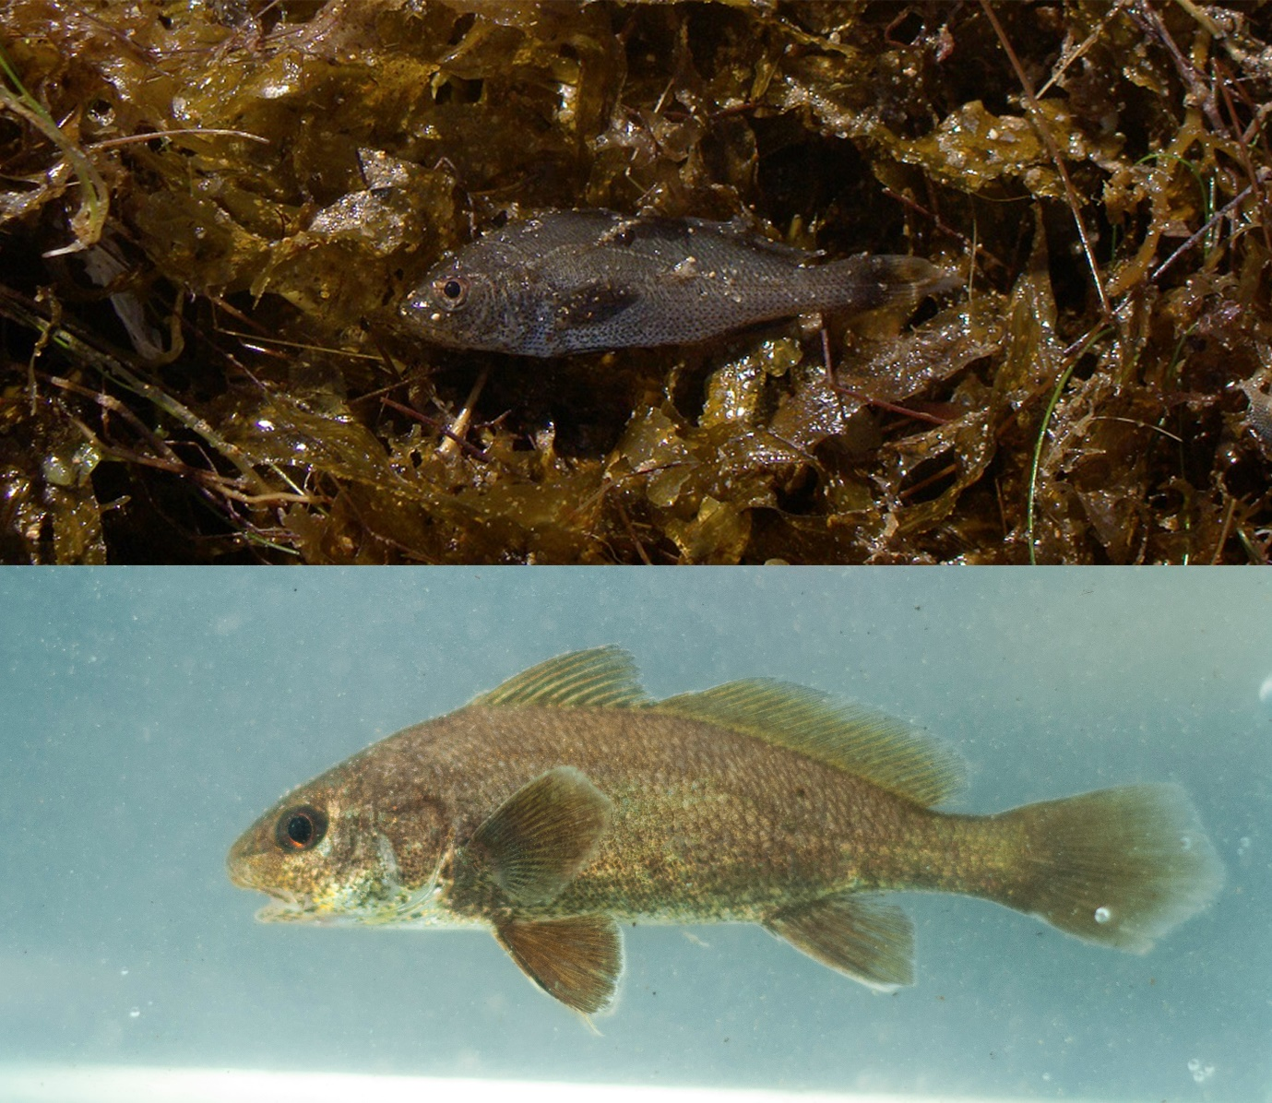
Fig. 1

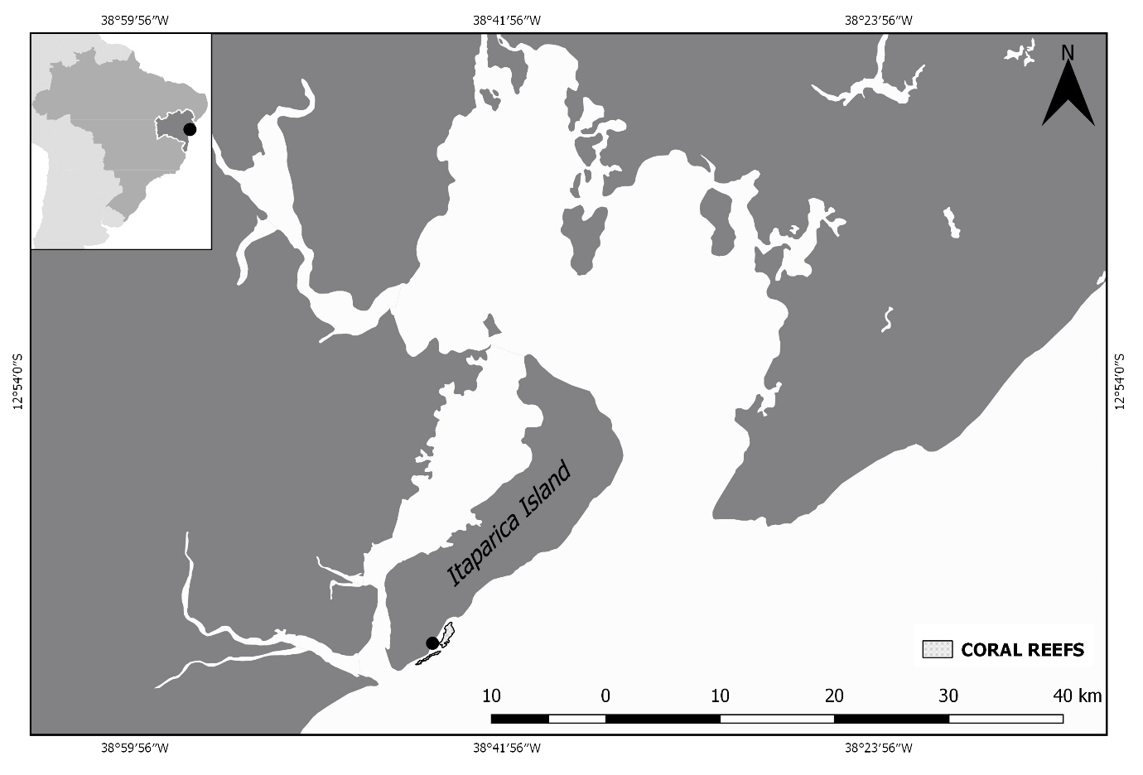
Fig. 2

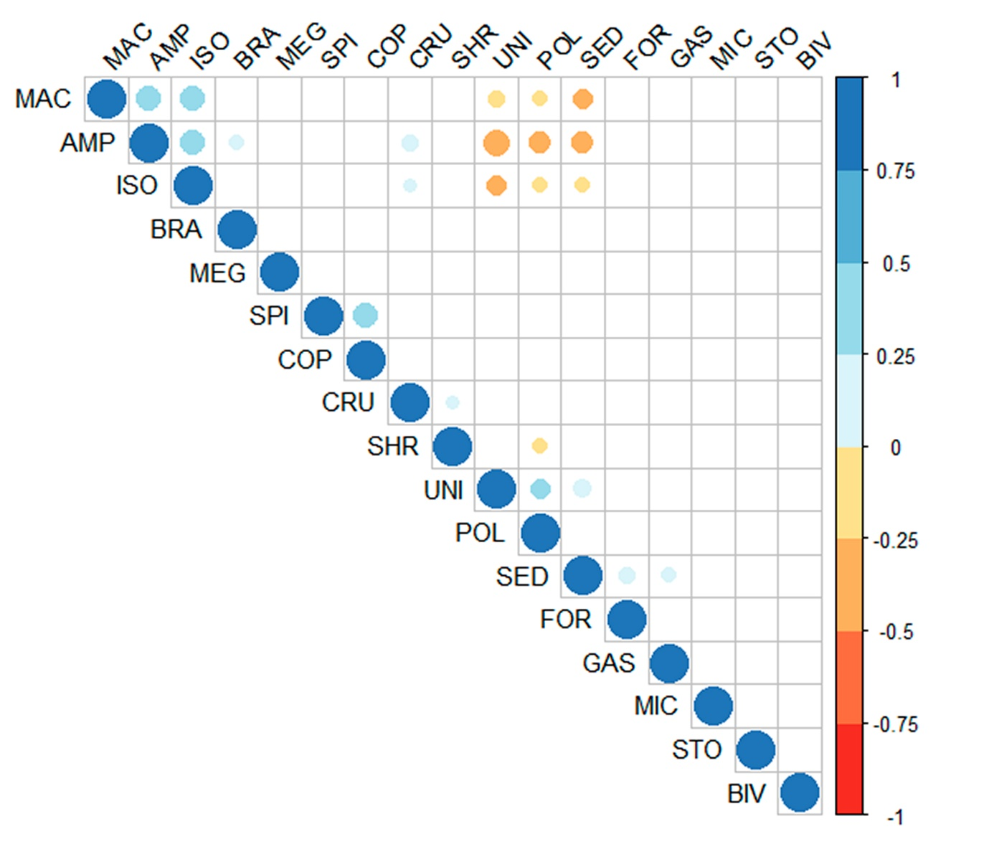
Fig. 3

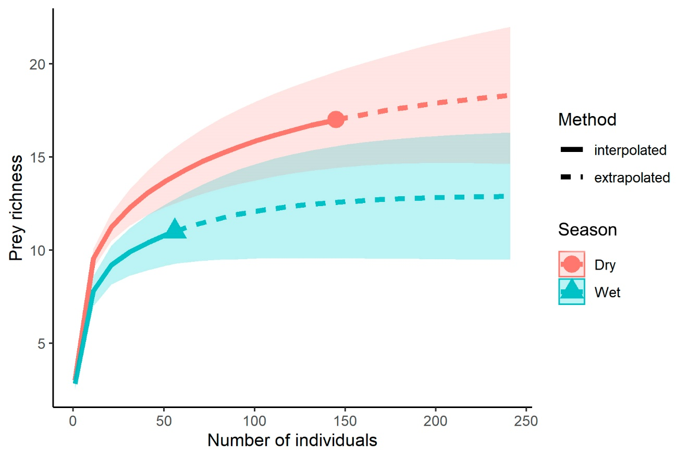
Fig. 4

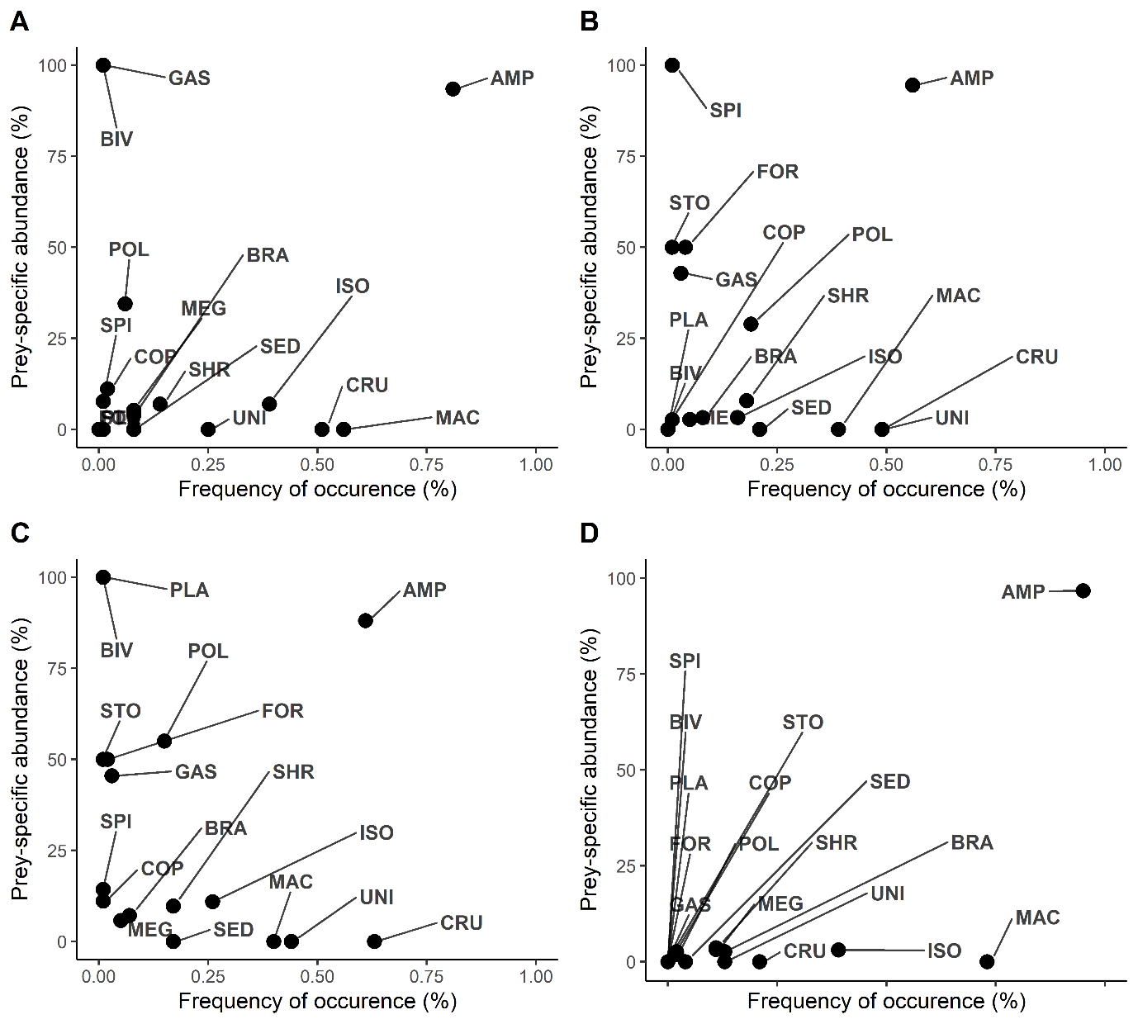
Fig. 5

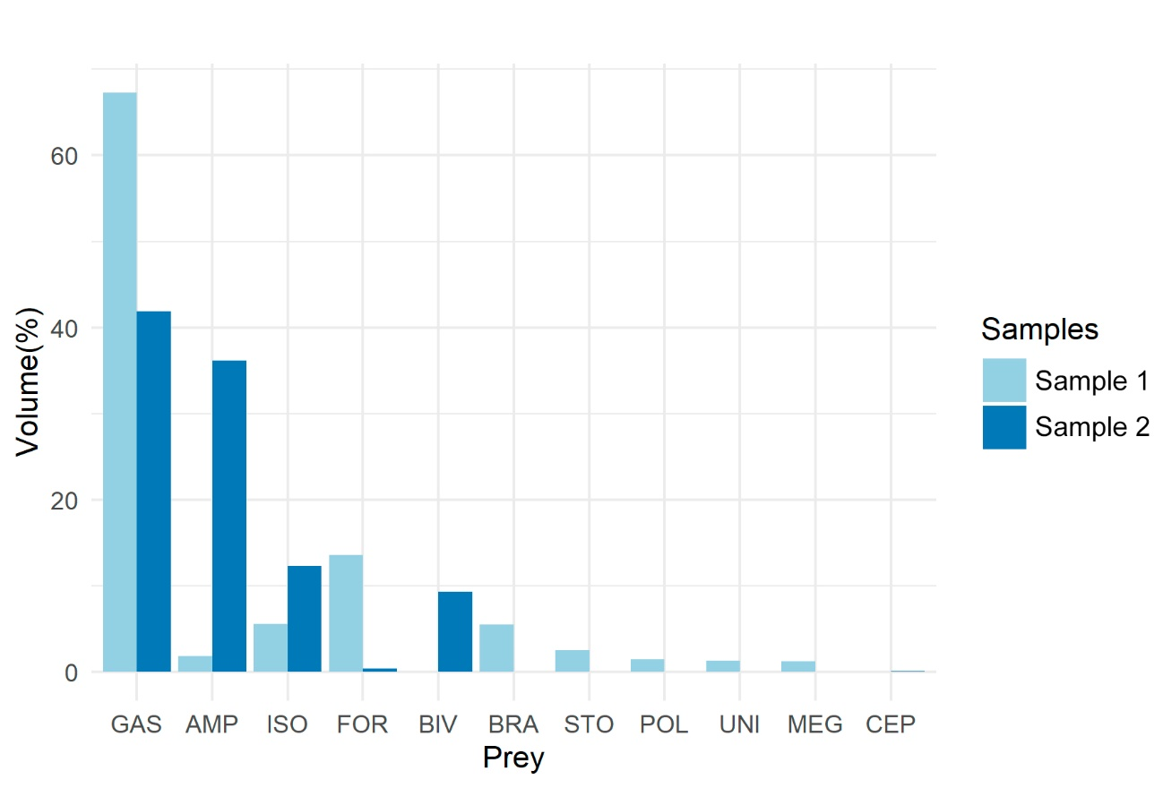
Fig. 6

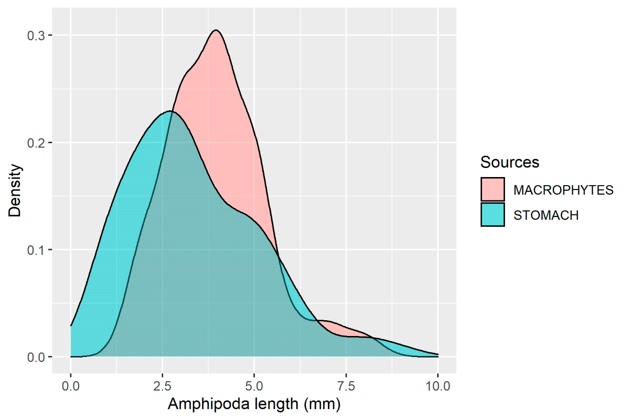
Fig. 7

Table 1. Prey items identified in the stomach contents of Ophioscion punctatissimus, with Frequency of occurrence (%FO), Volume (%VO), and Alimentary Index (Iai %)
Prey | %FO | %VO | Iai (%)
Amphipods (AMP) | 70.50 | 62.46 | 75.72
Crustacean unidentified (CRU) | 51.00 | 17.90 | 15.70
Macrophytes (MAC) | 49.00 | 3.70 | 3.12
Unidentified animal matter (UNI) | 35.50 | 4.01 | 2.45
Isopods (ISO) | 30.00 | 2.12 | 1.10
Shrimps (SHR) | 15.50 | 3.34 | 0.89
Polychaeta (POL) | 11.00 | 2.38 | 0.45
Brachyura (BRA) | 8.50 | 2.15 | 0.31
Sediment (SED) | 13.00 | 0.96 | 0.21
Megalopa larvae of Brachyura (MEG) | 6.50 | 0.36 | 0.04
Gastropods (GAS) | 2.00 | 0.20 | 0.01
Stomatopods (STO) | 0.50 | 0.28 | <0.01
Spicule (SPI) | 1.00 | 0.07 | <0.01
Copepods (COP) | 1.50 | 0.02 | <0.01
Foraminifera (FOR) | 1.50 | 0.02 | <0.01
Bivalvia (BIV) | 0.50 | 0.01 | <0.01
Microplastic (PLA) | 0.50 | 0.01 | <0.01

Table 2. Prey items identified in the stomach contents of Ophioscion punctatissimus, with Frequency of occurrence (%FO), Volume (%VO), and Alimentary Index (Iai %) according to size class. Class I: 23–80 mm SL; Class II: 80–153 mm SL
Prey | 23–80mm SL (n=119) |  |  | 80–153mm SL (n=77)
Prey | %FO | %VO | Iai (%) | %FO | %VO | Iai (%)
Amphipods (AMP) | 80.67 | 75.21 | 85.91 | 55.84 | 53.41 | 65.77
Crustacean unidentified (CRU) | 51.26 | 11.21 | 8.13 | 49.35 | 15.11 | 16.44
Macrophytes (MAC) | 56.30 | 3.64 | 2.90 | 38.96 | 4.55 | 3.91
Unidentified animal matter (UNI) | 25.21 | 2.83 | 1.01 | 49.35 | 6.06 | 6.60
Isopods (ISO) | 39.50 | 2.55 | 1.43 | 49.35 | 6.06 | 6.60
Shrimps (SHR) | 14.29 | 1.75 | 0.35 | 18.18 | 6.94 | 2.78
Polychaeta (POL) | 5.88 | 0.86 | 0.07 | 19.48 | 5.63 | 2.42
Brachyura (BRA) | 7.56 | 1.17 | 0.13 | 7.79 | 2.86 | 0.49
Sediment (SED) | 7.56 | 0.26 | 0.03 | 20.78 | 2.00 | 0.92
Megalopa larvae of Brachyura (MEG) | 7.56 | 0.43 | 0.05 | 5.19 | 0.32 | 0.04
Gastropods (GAS) | 0.84 | 0.02 | <0.01 | 2.60 | 0.30 | 0.02
Stomatopods (STO) |  |  |  | 1.30 | 0.84 | 0.02
Foraminifera (FOR) |  |  |  | 3.90 | 0.06 | 0.01
Spicule (SPI) | 0.84 | 0.02 | <0.01 | 1.30 | 0.17 | <0.01
Copepods (COP) | 1.68 | 0.02 | <0.01 | 1.30 | 0.02 | <0.01
Bivalvia (BIV) | 0.84 | 0.02 | <0.01
Microplastic (BIV) | 0.84 | 0.001 | <0.01

Table 3. Prey items identified in the stomach contents of Ophioscion punctatissimus, with Frequency of occurrence (%FO), Volume (%VO), and Alimentary Index (Iai %) according to season (dry and wet season)
Prey | Dry season (n=56) |  |  | Wet season (n=144)
Prey | %FO | %VO | Iai (%) | %FO | %VO | Iai (%)
Amphipods (AMP) | 61.11 | 40.76 | 48.56 | 94.64 | 91.58 | 96.71
Crustacean unidentified (CRU) | 62.50 | 30.41 | 37.04 | 21.43 | 1.12 | 0.27
Macrophytes (MAC) | 39.58 | 4.51 | 3.48 | 73.21 | 2.61 | 2.13
Unidentified animal matter (UNI) | 44.44 | 6.54 | 5.66 | 12.50 | 0.62 | 0.09
Isopods (ISO) | 26.39 | 2.87 | 1.47 | 39.29 | 1.13 | 0.49
Shrimps (SHR) | 17.36 | 5.08 | 1.72 | 10.71 | 1.00 | 0.12
Polychaeta (POL) | 14.58 | 3.80 | 1.08 | 1.79 | 0.47 | 0.01
Brachyura (BRA) | 6.94 | 2.93 | 0.40 | 12.50 | 1.10 | 0.15
Sediment (SED) | 16.67 | 1.55 | 0.50 | 3.57 | 0.17 | 0.01
Megalopa larvae of Brachyura (MEG) | 4.86 | 0.50 | 0.05 | 10.71 | 0.18 | 0.02
Gastropods (GAS) | 2.78 | 0.35 | 0.02
Stomatopods (STO) | 0.69 | 0.49 | 0.01
Foraminifera (FOR) | 2.08 | 0.49 | <0.01
Spicule (SPI) | 1.39 | 0.12 | <0.01
Copepods (COP) | 1.39 | 0.02 | <0.01 | 1.79 | 0.02 | <0.01
Bivalvia (BIV) | 0.69 | 0.02 | <0.01
Microplastic (PLA) | 0.69 | <0.01 | <0.01

