Temporal Change Detection Analysis of Monroe County, NY tree cover from 2009 to 2017

Authors: Sarah Bacchus, Amanda Walker, Kaitlin Stack Whitney

Abstract

Forests provide many ecosystem services which are enjoyed by nearby residing communities. This includes pollution and flood mitigation, carbon sequestration, oxygen production, food, fuel, education, recreation, and aesthetics. These ecosystem services also come from urban and suburban forests. Urban ecosystems, specifically urban green spaces services have been noted to improve human health significantly. Yet urban forests and ecosystem services have not and are not distributed. Understanding where and when forest cover and green spaces are changing can give insight into corresponding changes in services and access within and between communities. Thus, our objective was to complete a temporal analysis of the tree canopy-cover in the city of Rochester, NY was performed to examine change in tree cover and green spaces from 2009-2017. We did this using three-band orthorectified data; red, green, and blue bands and unsupervised and supervised classifications. A stacked-PCA image was created and applied to the change-detection PCA technique. In running the stack PCA analysis band 3 was found to be indicative of change, highlighting the expansion of agriculture as a major drive of change. The stacked PCA change detection technique determined that 8,448,898,967 tons/ha of vegetation was gained during these two time periods. The attempted NDVI change detection indicated that 1.890893535¹⁰ tons/ha of vegetation was gained. The NDVI change detection analysis revealed the most vegetation gains occurring in the rural and suburban regions of Monroe County, NY between 2090 and 2017. Given the many benefits of forests and green spaces for health and well-being, we make recommendations for future researchers attempting this kind of assessment for Monroe County and identify local programs that may be mitigating some of the green space disparities in the county.

Introduction

Human communities rely heavily on services from natural systems, known as ecosystem services.An ecosystem service is any positive benefit that wildlife or ecosystems provide to people (NWF, 2020). These services are essential for human life: assisting in the cultivation of agriculture for food to eat, regulation of water to drink and bathe in, and air quality to breathe. Major categories of ecosystem services are provisioning, regulating, culture, and supporting services. Provision services supply humans with products from ecosystems; this includes water, crops, and timber (FAO, 2020). Regulating services impact water quality in addition to climate, and waste. Cultural services refer to the recreational and spiritual experiences that are gained from being in nature; where human and nature values are woven together, forming an anthropological relationship with nature. Supporting services benefits are granted through processes such as carbon sequestration, photosynthesis, and nutrient cycling (MEA, 2005).

Forests provide many ecosystem services which are enjoyed by nearby residing communities. This includes pollution and flood mitigation, carbon sequestration, oxygen production, food, fuel, education, recreation, and aesthetics (Myers, 1997). Forests also provide land for grazing, wildlife habitats, water sources, and recreational areas; all of which are threatened by anthropological forces such as logging, illegal cutting, agricultural expansion and much more (Forkuo, E. 2012). New Zealand forests are notorious for the other products, services, and benefits they provide timber, fiber, and fuel to its communities. The New Zealand Forest Owners Association has noted that their forest benefits are worth far more in total than the wood, fibre and fuel alone (NVFOA, 2020).

Urban ecosystems, specifically urban green spaces services have been noted to improve human health significantly (Haase, D., et al. 2014). Some urban ecosystems take the form of green spaces and tree cover; lawns, parks, wetlands, trees, and fields. These urban green spaces provide ecosystem service benefits such as air filtration, climate regulation, sewage treatments (Bolund, P., & Hunhammar, S. 1999). According to Nutsford, D., Pearson, A. L., and Kingham, S. (2013), urban green spaces are shown to improve mental health for those that have access to and usability of them. Increased access to green spaces has been linked to numerous health benefits, such as decreased risk for diabetes and heart disease, as well as decreased blood pressure and cortisol levels (Twohig-Bennett, 2018). Disparities and disproportional access to urban green spaces represent unfair access to an important health-promoting resource and, as a result, unequal health outcomes (Liu, D., Kwan, M., Kan, Z. 2021). Areas that lack urban green spaces in turn have a dearth of ecosystem services that could support the mental and physical health of urban residents.

Urban forests and ecosystem services have not and are not distributed evenly through cities and urban areas. An assessment of the spatial variation in urban ecosystem services was conducted in Rotterdam, in the Netherlands using high resolution special and thematic images. It was determined that Rotterdam had a high spatial variation in urban green spaces. It was also concluded that the more urban green spaces there are, the more ecosystem services will be present (Derkzen, M.,et al. 2015). A green space accessibility analysis in Chicago, IL USA found the urban green spaces were distributed mostly throughout white-majority census tracts in the city of Chicago, indicating that they enjoy significantly better urban green spaces than minority groups (Liu, D., Kwan, M., Kan, Z. 2021). This study also recognized that urban green spaces deliver stress and depression reduction, and noise and heat reduction services to nearby residents.

Yet while urban areas can provide ecosystem services through green spaces and other processes, urbanization itself can threaten the health of urban ecosystems and therefore the benefits they provide (Bolund, P., & Hunhammar, S. 1999). However, issues like deforestation, intended especially for agricultural purposes and further development of urban-residential spaces, have become more prevalent in low-income urban areas (Richardson, J., et al. 2020). This issue can be heavily exacerbated depending on where an individual resides, with inner cities and urban-fringes generally having the least access to the services that forests and green spaces provide (McGranahan, et al., 2004). Communities with the most need for urban forests and ecosystem services thus may be at the highest risk of their green spaces disappearing.

Understanding where and when forest cover and green spaces are changing can give insight into corresponding changes in services and access within and between communities. Temporal change detection analysis research conducted on the Owabi forest reserve area in Ghana found that 4347.27 ha of high density forests in 1986 decreased to 2383.32 ha by 2002, which was then reduced to 1363.95 as of 2007 (Forkuo, E. 2012). The degradation of forests were observed from cultivation and land allocation practices of nearby communities. In another study from Ghana, in the Barekese catchment area, average biomass for forested land was being diminished drastically for their observed period of 1973-2000 (Boakye, E., et al. 2008). They found that grassland and open area/town had increased significantly which forested lands decreased over the observed years (Boakye, E., et al. 2008). This was done to make way for expansion of agriculture as a source of income to accommodate for the human population growth occurring in this part of Ghana during 1973-2008. Another study quoted a American Forestry Association survey which reported New York City’s change in tree cover experiencing a 25% loss in street trees from 1977-1987 (Bolund, P., & Hunhammar, S. 1999).

Our research objective was thus to assess whether overall forest cover and vegetation (green space) has increased in urban residential areas in Monroe County, NY. Additionally, we wanted to identify which areas of the county saw the most change over this time period. We hypothesized that suburban and rural residential areas would experience a significant increase in tree cover. We expected this because past studies have reported that cities are losing vegetation over time (Bolund, P., & Hunhammar, S. 1999). This work identifies distribution of tree canopy cover in Monroe County, NY. Our results can equip urban city planners and environmental scientists with knowledge of the locations that have experienced reductions in vegetation, potentially enabling offsets elsewhere.

Methodology

Overall approach
To examine vegetation and tree canopy change over time in Monroe County, NY, we used three-band orthorectified imagery of Monroe County (NAIP, 2020). The 2009-2017 examination period was selected because these were the only available datasets for this analysis. We performed several change detection analyses, including stack Principal Component Analysis (PCA), Normalized Difference Vegetation Index (NDVI) change detection, and both supervised and unsupervised change detection. This analysis is based on the methods outlined in Coppin’s 2004 review, Digital change detection methods in ecosystem monitoring: a review, such as bi-temporal change detection and univariate image differencing (NDVI) (Coppin, 2004).

Supervised Classification Attempt
Beginning supervised classification, we generated training sites for water, grass, trees, roads, and agriculture classes. Following the examination of the separability, we revamped the training sites to increase definition of each. Once satisfactory separability levels were met, we performed a Maximum Likelihood Classification. This was repeated to ensure that both time periods were classified. We attempted the construction of the thematic change workflow map with the supervised classification.

Unsupervised Classification Attempt
For the unsupervised classification, we ran the classification on both the 2009 and 2017 data with a minimum of 5 and maximum of 10 classes, which yielded 7 classes. We deemed these classes too inaccurate because of the resulting pixel confusion amongst classes. This led us to run another classification on each dataset with a minimum of 8 classes and maximum of 14, which yielded 11 classes. We condensed these classes into 5 classes and an unclassified class. We also attempted the construction of a thematic change workflow map for the unsupervised classification, but it was unsuccessful due to ENVI software crashing. The attempt remained unsuccessful.

Stacked PCA Analysis
We implemented the stacked PCA change detection technique by first creating a stacked image of the 2009 and 2017 images. We performed a PCA on the stacked image to determine if any of the PCs were indicative of change. We resized the stack PCA image to show the PC of change which was then applied in change detection. We used a threshold value of 23.00 in the rule classifier to adjust the image, making it so that only change pixels were highlighted. We used the histogram of the one-band PC image to gauge this threshold which then captured the most change pixels based on PC band 3. We examined the statistics for this change detection technique to obtain the count of pixels that were above the set threshold; pixels highlighted as change. We were then able to convert these pixels into area (tons/ha) of change.

NDVI Analysis
We also attempted the calculation of NDVI for both images using the green and red bands. This was due to the absence of the Near Infrared (NIR) band in these images. We created a total of 5 classes, (Change (+2), Change (+1), Change (0), Change (-1), Change (-2)) to define the change thresholds. We turned each class layer on to determine which of the 5 was the change class. Through examination of the statistics for the NDVI change detection image, we obtained the count of pixels for the change class and used it to convert change pixels into area (ha) and vegetation lost between the two time periods.

Results

Stacked-PCA Change Detection
The outputs from these various change detection techniques examine the change in vegetation from 2009-2017 in Monroe County, NY. We found that 8,448,898,967 tons/ha was gained from 2009-2017 in performing the stacked PCA change detection in comparison to 1.890893535¹⁰ tons/ha gained from the NDVI analysis. Most of the vegetation gained occurred in the central region of the city and in rural/suburban areas. The stacked PCA change detection technique indicated that most changes occurred in agriculture-intensive regions (Figure 1). This was interpreted as increased agriculture being one of the main trends driving land cover change in Monroe county, NY from 2009-2017. With the absence of the NIR band, change in vegetation could not be fully explored, however we used the green band as a replacement for the image subtraction implemented for the NDVI analysis (Figure 2).

NDVI Change Detection
Upon the completion of the NDVI change detection, we found a significantly greater amount of areas that changed compared to the stacked PCA technique. The boxed region in figure 2 demonstrates increased vegetation that was detected by NDVI tool, but not the stacked PCA tool. As mentioned previously, we found the stacked PCA technique mainly identified agricultural regions that experienced a change in vegetation. The NDVI analysis expresses much more change in vegetation, especially in the central region of Monroe county, whereas the stacked PCA change detection did not. This is most likely due to the absence of the NIR band for both techniques since they are both spectrally based. Since the green band looks at vegetative vigor, it was determined as the best replacement for the NIR band in the NDVI analysis. The additional areas of change in the NDVI change(-1) class were assumed to be vegetation present within residential communities; forms of open and greenspaces such as trees, roadside vegetation, parks, and fields.

Supervised Classification
There was a significant amount of pixel mixing in the supervised classifications (Figure 3 and Figure 4). This was most likely a result of there being too few classes. This also occurred for the unsupervised classification (Figure 5 and Figure 6). We visually observed that vegetation increased significantly in rural and suburban areas. Since we created 5 classes to classify the entire image, a majority of the pixels were clumped together in one of the 5 because of the similarity in spectral signatures. We identified 35 transition types during the attempt to run the supervised classification thematic workflow within the 5 classes from 2009-2017. This part of the analysis was not successful because the classes were not generated in the same order across the two time periods.

In running multiple change detection analyses on Monroe County, we discovered that there had been a significant increase in vegetation from 2009-2017. When we ran both classification techniques, much of the pixel mixing was a result of there being too few classes and the absence of the NIR band from the dataset. We found the main overlaps in classification had occurred between agriculture and grass as well as agriculture and roads. During the first attempts of classification the separability between agriculture and grass returned very low indicating a significant amount of pixel mixing. Among other classes, the “Water” class was misclassified as grass for a few locations in the 2017 image. This was most likely a result of increased algal blooms in Monroe county over the examined time periods. This confusion occurred mostly among the agriculture, road, grass, and water classes. To remedy this, we revisited and revamped the ROIs for the supervised classification to enhance class definition. Doing so only slightly increased separability between agriculture and grass. The degraded areas in the 2017 image are more defined than in the 2009 image. Revisiting the ROIs and revamping them for the 2009 image is recommended. Alternatively, creating more classes will assist in reducing pixel confusion and increased definition of the land cover. The thematic change workflow for the supervised classification of both time periods was unsuccessful due to the classes not being in the same order per image. Each classification required a significant amount of time (3+hrs) to run; due to a lack in time and the ENVI software crashing multiple times, repetition of classification with classes in the same order was not possible.

Unsupervised Classification
There was also a lot of pixel mixing in the unsupervised classification, likely due to not enough classes being generated (Figure 5 and Figure 6). In the 2009 classification, there was a lot of mixing between agriculture, water, and vegetation, meaning that many of the pixels had to be incorrectly classified when condensing the classes. Similarly, in the 2017 classification, there was a lot of mixing between agriculture and roads, resulting in a similar issue. This is the cause of most of Lake Ontario being incorrectly classified as trees or grass; the focus while condensing the classes was on correctly classifying the land section of Monroe County, as the focus was on vegetation in this region. However, both land cover classifications are overall somewhat inaccurate, most likely due to pixel mixing from too few classes being generated. Due to time constraints, and the ENVI software taking several hours to perform a classification, there was not enough time to perform a classification with more classes. A thematic change workflow for the unsupervised classification was also attempted several times but caused ENVI to crash upon every attempt, and was thus unsuccessful. Troubleshooting was attempted by changing workflow settings, but this was also unsuccessful and had to be abandoned due to time constraints.

Discussion
Overall we found that Monroe county experienced significant gains in vegetation; specifically in suburban and rural communities. The gain in vegetation is disproportionate in the city of Rochester in comparison to the outer parts of the county.

The change detection analyses demonstrate that the suburban and rural areas in Monroe County, NY experienced increases in vegetation from 2009-2017. Conversely, our stacked-PCA change detection analysis shows the city of Rochester having experienced significantly less gains in vegetation compared to the surrounding suburb and rural communities. Similar projects to this one have found similar results. An analysis of the distribution of tree canopy and ecosystem services in the Bronx, NY, found that they were disproportionately distributed.This study also concluded that disadvantaged socio-demographic and socio-economic block groups are receiving disproportionately lower ecosystem services from urban trees like the Bronx, NY (Nyelele, C., & Kroll, C. N. 2020). However, not all cities have seen this pattern. A different study found no significant change in forest cover in Hangzhou City, China between 2000 and 2003. This pattern was likely due to increased conservation efforts and/or possible misclassification of orchards and forest cover (Deng, 2008).

Some existing programs in the region may help mitigate the apparent disparity in where tree cover has been gained within the county. Given the many benefits of forests, municipalities have begun taking the initiative to increase the amount of urban forests and greenspaces for its citizens, especially in residential areas. For example, in Rochester, NY, the Rochester Green Team aims to increase the use of environmentally sustainable technology to improve human health of people now and in future generations. In 2010, the Green Team installed a roof garden system which consisted of garden and waterproofing systems, as an addition to the Rochester City Hall building (City of Rochester). The city of Rochester's roof garden was built directly over its waterproofing system. The filtration layer of the waterproofing system was reused for drainage, and sedum mats were placed over this layer in addition to a growing medium. By completing the roof garden project, the city has implemented environmentally sustainable technology that promotes forest services. In return, they receive the benefits of forest services that are provided by the roof garden; regulating temperature, air and water quality, and reducing the overall. A similar project was conducted for the City of Chicago's City Hall building. Both entail roof gardens with native grasses, herbaceous plants, and other foliage intended for pollinating species to forage. The installation of the Chicago roof garden project, concluded in 2001, includes over 150 plant species and has been observed to regulate building temperature; keeping the building at cooler temperatures during summer months (TCLF, 2020).

We recommend future researchers create additional classes to narrow class definition when performing supervised classification. This will most likely produce images with reduced pixel mixing. According to this analysis, Monroe County NY has experienced a high level of urbanization prior to and within 2009-2017; there are various ongoing human activities such as agriculture and increased urban development in this region that result in similar spectral reflectances. Creating more classes for classification would assist in classifying these activities uniquely; separability among the grass and agriculture classes remained low after visiting and revamping the ROIs, making adding more classes to the classification scheme the ideal improvement here. We also recommend being mindful to create the classes in the same order for both time periods. Although the stacked PCA found the expansion of agriculture as one of the main drivers of change between 2009-2017, using this technique would not be advised if one is trying to identify changes in all types of vegetation. NDVI was the best technique to implement for the purpose of this project, however with the absence in the NIR band from the datasets, the accuracy of this analysis is thus questionable. The NDVI change detection is based on the green and red bands from the images, assessing vegetation vigor instead of biomass content. When looking for data, we recommend inspecting the associated text files from the dataset to ensure all bands that are required for NDVI analyses are present. Ortho data with NIR bands for this region was unavailable in this case, in which the green band was used as a replacement; investigation about biomass content would thus be possible.

Ultimately, our change detection analysis found a great amount of vegetation gained in the suburban and rural regions of Monroe County, NY, from 2009-2017. Residents within those communities thus have access to greater ecosystem services compared to those in urban areas. This demonstrates that there was a significant increase in vegetation cover in the rural and suburban areas of Monroe County, Rochester NY. Simultaneously, provision of and access to forest ecosystem services for residents in those communities has increased significantly. Residents in the central city as well as the urban-fringe have not seen early similar levels of increased green-spaces and forests from 2009-2017. As seen from studies in other regions, increased green-spaces and forests has been shown to increase human health -- but those who lack access to forest ecosystems cannot experience the benefits of them. Additional green-spaces and forests in urban settings can take many forms; rooftop gardens discussed previously, communal gardens, parks, and more.

Author Contributions
SB and KSW developed the research question. SB completed the supervised classification, image subtraction, transformations, and attempted change detection with supervised classification. AW completed the literature review, the unsupervised classification, and attempted thematic change detection with unsupervised classification. SB, AW, and KSW contributed to writing.

Acknowledgements
This project was not externally funded. We would like to thank Dr. van Aardt for his guidance and recommendations for the completion of this project.

References

Bolund, P., Hunhammar, S. (1999). Ecosystem services in urban areas. Ecological Economics, 29(2), 293–301. https://doi.org/10.1016/s0921-8009(99)00013-0

Boakye, E., Odai, S. N., Adjei, K. A., Annor, F. (2008). Landsat images for assessment of the impact of land use and land cover changes on the Barekese catchment in Ghana. 21. 617-626.

City of Chicago City Hall - Green Roof. City of Chicago City Hall - Green Roof | The Cultural Landscape Foundation. (2020). https://tclf.org/landscapes/city-chicago-city-hall-green-roof.
City of Rochester. (2020). https://www.cityofrochester.gov/article.aspx?id=8589952778.
Coppin, P., Jonckheere, I., Nackaerts, K., Muys, B., and Lambin, E. (2004). Review ArticleDigital change detection methods in ecosystem monitoring: a review. International Journal of Remote Sensing, 25(9), 1565–1596. https://doi.org/10.1080/0143116031000101675

Deng, J. S., Wang, K., Deng, Y. H., and Qi, G. J. (2008). PCA‐based land‐use change detection and analysis using multitemporal and multisensor satellite data. International Journal of Remote Sensing, 29(16), 4823–4838. https://doi.org/10.1080/01431160801950162

Derkzen, M. L., van Teeffelen, A. J., and Verburg, P. H. (2015). REVIEW: Quantifying urban ecosystem services based on high-resolution data of urban green space: an assessment for Rotterdam, the Netherlands. Journal of Applied Ecology, 52(4), 1020–1032. https://doi.org/10.1111/1365-2664.12469

Forkuo, E. (2012). Analysis of Forest Cover Change Detection. Analysis of Forest Cover Change Detection, 2(4), 82-92.

Haase, D., Larondelle, N., Andersson, E., Artmann, M., Borgström, S., Breuste, J., … and Elmqvist, T. (2014). A Quantitative Review of Urban Ecosystem Service Assessments: Concepts, Models, and Implementation. AMBIO, 43(4), 413–433. https://doi.org/10.1007/s13280-014-0504-0

Liu, D., Kwan, M., and Kan, Z. (2021). Analysis of urban green space accessibility and distribution inequity in the City of Chicago . Urban Forestry & Urban Greening, 59, 127029. https://doi.org/10.1016/j.ufug.2021.127029

McGranahan G., Satterthwaite, D. and Tacoli, C. (2004). (rep.) Rural–urban change, boundary problems and environmental burdens (pp. 5-11). International Institute for Environment and Development. http://www.jstor.org/stable/resrep01814.4

Millennium Ecosystem Assessment, 2005. Ecosystems and Human Well-Being: Wetlands and Water Synthesis. World Resources Institute, Washington, DC.
National Agricultural Imagery Program (NAIP). (2020). United States Department of Agriculture Geospatial Data Gateway. https://nrcs.app.box.com/v/naip

Nyelele, C., and Kroll, C. N. (2020). The equity of urban forest ecosystem services and benefits in the Bronx, NY. Urban Forestry & Urban Greening, 53, 126723. https://doi.org/10.1016/j.ufug.2020.126723

Nutsford, D., Pearson, A. L., and Kingham, S. (2013). An ecological study investigating the association between access to urban green space and mental health. Public Health, 127(11), 1005–1011. https://doi.org/10.1016/j.puhe.2013.08.016

Myers, N. (1997). The World's Forests and Their Ecosystem Services. In Nature's services: Societal dependence on natural ecosystems (pp. 215-230). Washington, DC: Island Press.

Richardson, J., Mitchell, B. C., Meier, H. S. C., Lynch, E, and Edlebi, J. (2020). (rep). Redlining and Neighborhood Health (pp. 1-55). National Community Reinvestment Coalition. https://ncrc.org/holc-health/
The Cultural Landscape Foundation. City of Chicago City Hall - green roof. https://tclf.org/landscapes/city-chicago-city-hall-green-roof
Twohig-Bennett, C. (2018). The health benefits of the great outdoors: A systematic review and meta-analysis of greenspace exposure and health outcomes. Environmental Research, 166, 628-637. doi:https://doi.org/10.1016/j.envres.2018.06.030

Figures

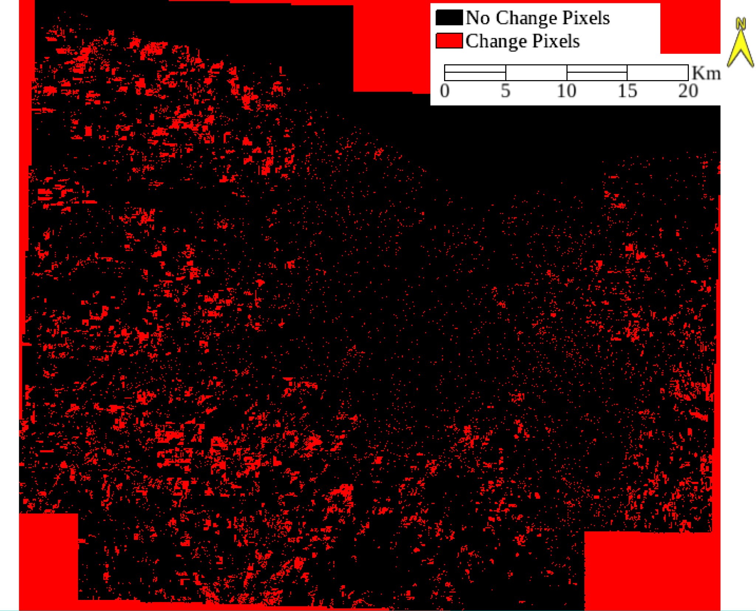

Figure 1. Stacked PCA change detection over Monroe County, NY.

The red pixels are reflective of significant change in tree canopy cover from 2009-2017. Black pixels indicate no change. PC band 3 was determined as the change band, as expressed.This change was interpreted as an increase in agricultural practices as well as intensified greening in those regions. Noticed the trend of increased change occurring significantly in the suburban and rural regions of Monroe County over the examined time period.
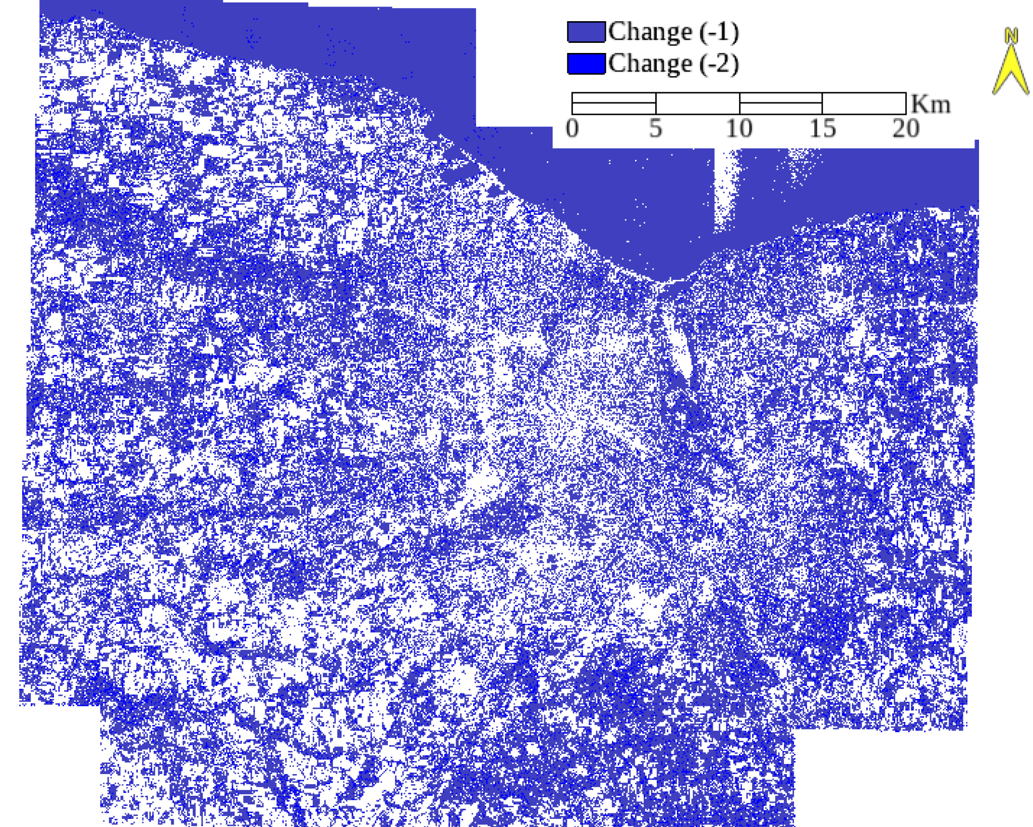

Figure 2. NDVI change detection, depicting the overall change (-1) class

The blue pixels indicate change in vegetation distributing from 2009-2017 in Monroe County, NY. This NDVI analysis was constructed using the Red and Green bands. Traditionally, the Red and NIR bands would be used for this analysis, however due to the lack of the NIR band in this orthorectified dataset, an investigation of the red and green bands was alternatively performed. From this visual representation of change in vegetation cover, one can see that suburban and rural regions experienced the most change in vegetation compared to the urban area of Rochester City.
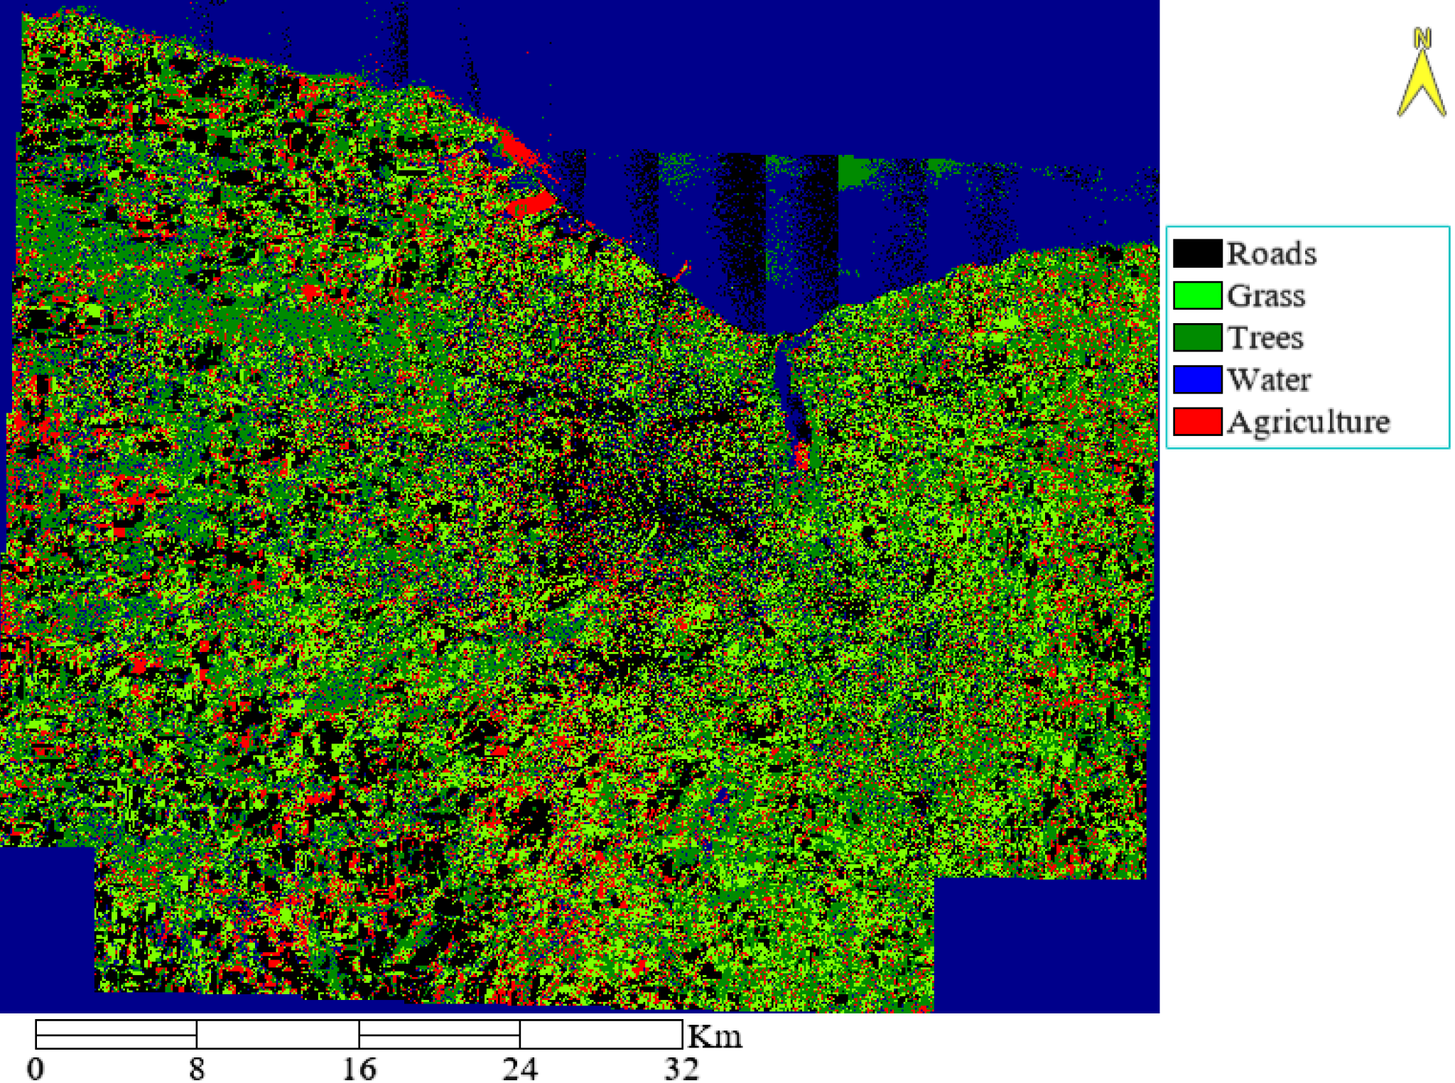

Figure 3. 2009 Supervised classification of Monroe County, NY

This figure shows the 2009 supervised classification of land in Monroe County, NY. Notice that it is difficult to distinguish between the Grass and Trees classes the most for this analysis. This was due the significant pixel mixing which most likely occurred due to the absence of the NIR band. The pair separation for these two classes were relatively low.
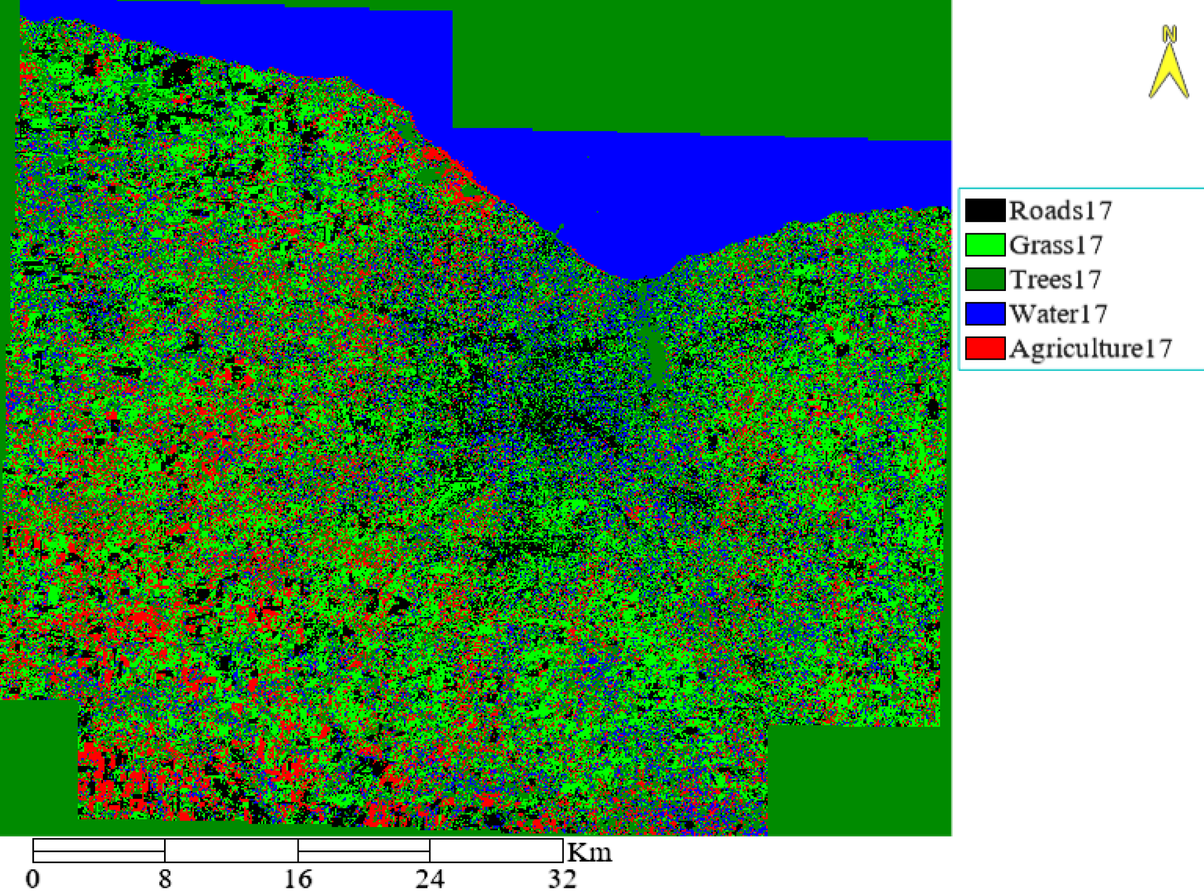
Figure 4: 2017 supervised classification of Monroe County, NY

This figure shows the 2017 supervised classification of land in Monroe County, NY. Generally, This analysis concludes that tree cover increased in the suburban and rural regions more so than in the city. An abundance of water pixels were detected in the urban region of Monroe county. This may have been confused with the tree and grass classes due to the absences of the NIR band in the dataset. Pixel mixing between the water, tree, and grass classes made quantitative and qualitative observances unreliable.
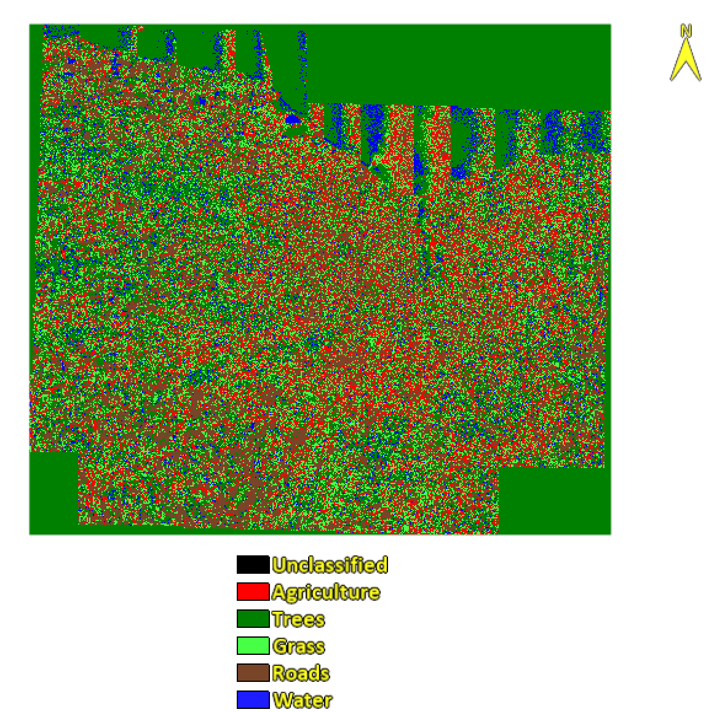
Figure 5. 2009 unsupervised Classification of Monroe County, NY

This figure shows the 2009 unsupervised classification of land in Monroe County, NY. Notice the intense pixel mixing that occurred for this classification. Pair-separation for this analysis shows the most confusion occurring between Roads and Agriculture.

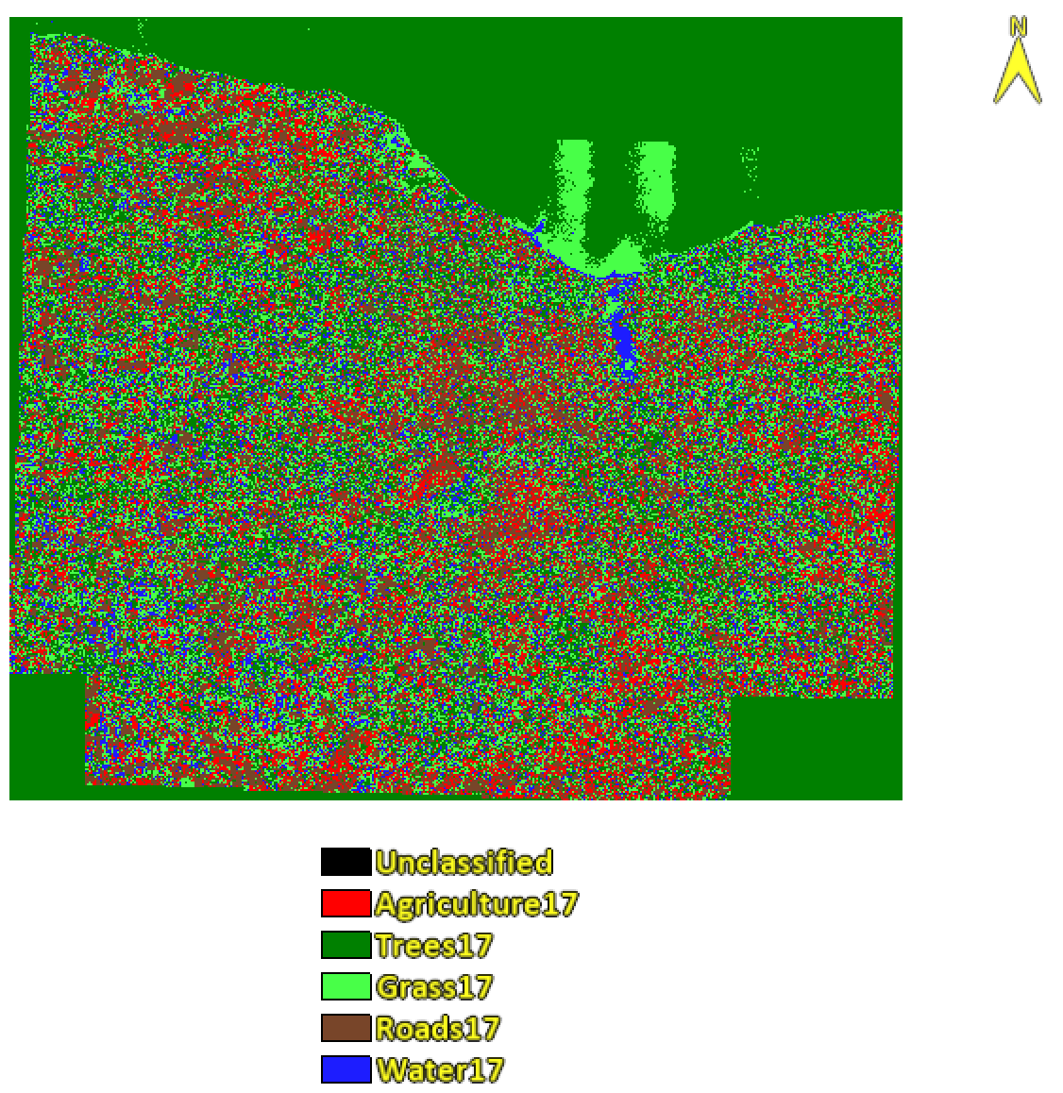
Figure 6. 2017 Unsupervised classification of Monroe County, NY

This figure shows the 2017 unsupervised classification of land in Monroe County, NY. Upon visual inspection of the 2009 (Figure 5) and the 2017 (Figure 6) unsupervised classification less visual difference can be observed between the two unsupervised classification.

