Title: A hierarchical Bayesian approach for analysing changes in species composition
Running headline: A Bayesian approach for comparing communities

Filipe S. Dias1,2, Michael Betancourt3, Patricia María Rodríguez-González4, Luís Borda-de-Água1,2

Affiliations
1. CIBIO/InBio, Centro de Investigação em Biodiversidade e Recursos Genéticos, Laboratório Associado, Universidade do Porto, Campus Agrário de Vairão, 4485-661 Vairão, Portugal

2. CIBIO/InBio, Centro de Investigação em Biodiversidade e Recursos Genéticos, Laboratório Associado, Instituto Superior de Agronomia, Universidade de Lisboa, Tapada da Ajuda, 1349-017 Lisbon, Portugal

3. Symplectomorphic, LLC., New York, USA

4. Centro de Estudos Florestais, Instituto Superior de Agronomia, Universidade de Lisboa, Tapada da Ajuda, 1349-017 Lisboa, Portugal

Corresponding author: Filipe S. Dias, CIBIO, Tapada da Ajuda, 1349-017 Lisbon, Portugal, (fsdias@isa.ulisboa,pt)

Abstract

1. Understanding how and why species composition changes across ecological communities is a crucial issue in ecology and conservation biology. Mantel tests and partial-Mantel tests are the most commonly used methods for analysing such changes, but recent studies have shown that these tests can produce invalid results and called for their replacement with more robust methods. In this work, we introduce a novel hierarchical Bayesian approach for modelling changes in species composition.

2. To analyse changes in species composition, we usually calculate community similarity indices (e.g. Sorensen index) and assess the relationship between those indices and environmental covariates. The problem is that community similarity indices are paired comparisons, which means that indices calculated with the same community are not independent. To solve this issue, we followed a model-based approach that consists of fitting a regression model of beta diversity indices and covariates that contains two varying intercepts that capture the heterogeneity corresponding to the communities compared by the index. Additionally, our approach allows the relationship between beta diversity indices and covariates to change across data clusters through the inclusion of varying effects, allows for different types of response variables (continuous or counts) and provides a clear pathway for model validation

3. We demonstrate our approach by modelling how the community similarity of 338 riparian plant communities changes across 11 river basins in Portugal. We used Sorensen indices to assess community similarities and assessed the effects of two covariates, network distance and precipitation difference. Since Bayesian methods may not be familiar to all readers, we provide a step by step guide for running the analysis and all the necessary code.

4. Our approach provides a robust and verifiable framework for analysing paired comparisons data that can be of particular interest to ecologists and evolutionary biologists.

Keywords: Beta diversity; community similarity; Mantel tests; riparian vegetation; Sorensen index;

1. Introduction

Understanding how species composition changes across space is crucial for understanding ecological processes, the impacts of human activities, and developing conservation plans (Legendre et al., 2005; Wilson et al., 2009). A common approach for modelling species composition changes consists of 1) calculating community similarity between pairs of communities using beta diversity indices (e.g. Sorensen index and Morisita Horn index) and 2) assess the relationship between those indices and environmental covariates. The main difficulty when analysing this type of data is that beta diversity indices are paired comparisons, which means that indices calculated with the same community are not independent. The most widely used strategy for analysing such data is transforming community composition data and environmental covariates into distance matrices and using matrix correlations or regression techniques (Legendre et al., 2005). Mantel tests and partial Mantel tests (Mantel, 1967) are the most popular techniques that employ this approach. The Mantel test examines the linear correlation between two distance matrices, a community similarity matrix and a covariate distance matrix. The resulting Mantel statistic can be regarded as a correlation coefficient, and its significance is assessed by randomly permuting the rows' order and columns of one matrix. When using large datasets, it is possible to transform the Mantel statistic into a t-statistic, whose significance is obtained from an asymptotic approximation of the t-test. The partial Mantel test is an extension of the original Mantel test, where a third matrix (or more) is held constant while the relationship between the other two is determined (Smouse et al., 1986). This test is performed by regressing the first two matrices' elements onto the third matrix and using the residuals from the regressions as the input for the standard Mantel test (Legendre, 2000).

The use of the Mantel and partial Mantel tests has been heavily criticised in the scientific literature. Guillot & Rousset (2013) conducted a simulation study that found that when spatial autocorrelation is present, both Mantel and partial Mantel tests produce an excess of small P-values. That is, both tests reject the null hypothesis of independence more often than they should, producing a high number of false positives. In partial-Mantel tests, this also happens when a third matrix with geographic distances is added to control for spatial autocorrelation. Legendre et al. (2015) used simulated data to show that in spatial analysis, the assumptions of linearity and homoscedasticity of the Mantel test generally do not hold, except when spatial correlation extends over the whole study area. The authors also argued that Mantel tests should not be used with data transformed into dissimilarity matrices, such as genetic or Euclidian distances. The results from both these studies suggest that many studies that used Mantel and partial-Mantel tests may have reported incorrect conclusions and highlight the need for their replacement with more robust methods.

Here we introduce a hierarchical Bayesian approach for analysing changes in species composition. Our approach consists of fitting a regression model of Beta diversity indices (e.g. Sorensen index) and a set of covariates. To deal with the dependence in the data, we add two varying intercepts that capture the heterogeneity corresponding to each of the communities compared by the index. This model-based approach also allows for varying effects, which allow the relationship between beta diversity indices and covariates to change across clusters. Our approach can also be adapted to work with different response variables (e.g., continuous or counts) and provides a clear pathway for performing model validation. We provide a detailed explanation of our approach and present a case study using riparian plant communities. Since Bayesian methods may not be familiar to all readers, we also provide a step by step guide for running the analysis and all the required code (Appendix 1).

2. Description of the Method

2.1 General overview

We start by providing a general introduction to our method by using linear regression as a starting point. Suppose we are modelling the effects of a variable C on another variable S. The traditional linear regression assumes that S is normally distributed and that there is a linear relationship between the expected value of S and C:

S ~ Normal (μ, σ)
μ = α + β.C

where μ and σ are the mean and the standard deviation of the normal distribution and α and β are the intercept and slope of the regression. One of the assumptions of regression models is that the observed S values are independent of each other for fixed covariate values. When S values result from paired comparisons (e.g., number of species in common or genetic distances), this assumption does not hold. Multiple S values are calculated using the same data, creating dependence among them. In order to overcome this problem, we added two varying intercepts αs for each of the samples involved in the calculation of S. Note that αs is a single set of intercepts that are added to the model depending on which communities are being compared by Sorensen indices. This approach works because each αs captures the heterogeneity corresponding to community 1 (comm. 1) and community 2 (comm. 2) by taking the same value whenever that community is used to calculate S. This procedure is used by Bradley-Terry models (Bradley & Terry, 1952), which were designed for modelling paired comparisons (e.g. outcome of sports matches). The model is, then:

S ~ Normal (μ, σ)
μ = α + α_{s[comm. 1]} + α_{s[comm. 2]} + βC.

As with any regression model, care is required with this approach. If we fit a model with just μ = α + α_{s[comm. 1]} + α_{s[comm. 2]} the αs intercepts will absorb any variation associated with the observed samples, including confounding variation that is not related to the samples themselves. To ensure that α_{s[comm. 1]} and α_{s[comm. 2]} capture only the behaviour common to each sample and can actually be interpreted as sample parameters, we need to explicitly model any other systematic variations that might be present by adding covariates to the model.

2.2 Model extensions

2.2.1 Using other statistical distributions

In the previous section, we assumed S followed a normal distribution, but we can replace it with any other family of density distributions with some location parameter (e.g., the mean). For instance, if S is overdispersed, we can replace the normal distribution with a Student's t distribution. If S values are counts (e.g. the number of species in common), we can use a suitable distribution for count data such as the Poisson or the negative binomial distribution. Below, we show how we can replace the normal distribution with a Student’s-t distribution:

S ~ Student’s-t (ν, μ, σ)
μ = α + α_{s[comm. 1]} + α_{s[comm. 2]} + β.C

where ν stands for degrees of freedom, μ for mean and σ for standard deviation:

2.2.2 Varying intercepts and slopes

This framework also permits the inclusion of varying intercepts (αc[cluster]) and slopes (β[cluster]), which allow the relationship between S and C to change across different clusters. Therefore, we take our previous model that already includes the community intercepts αs[comm. 1] and αs[comm. 2] and add these new parameters as follows:

S ~ Normal (μ, σ)
μ = α + α_{s[comm. 1]} + α_{s[comm. 2]} + α_{c[cluster]} + β_{[cluster]}.C

Varying intercept α_{c[cluster]} and slope β_{[cluster]} allow the model to capture cluster-specific behaviours that would otherwise be missed or inadvertently absorbed into other behaviours, thus providing better inferences.
3. Case study – Analysing changes in community similarity in riparian plant communities

3.1 Introduction

We demonstrate our approach by analysing how the community similarity of riparian plant communities changes as a function of network distance and precipitation difference. Our data consist of riparian vegetation inventories obtained between 2003 and 2006 (INAG 2008) in 338 sites distributed across continental Portugal, covering 11 river basins (Fig. 1).

3.2 Methods

To measure community similarity between pairs of sites, we selected the Sorensen similarity index:

$$SorensenIndex=\frac{2a}{2a+b+c}$$

where a is the number of shared species, b is the number of unique species to one of the sites, and c is the number of unique species to the other site. In other words, the Sorensen index corresponds to the number of species in common between two plots divided by their average number of species. A Sorensen index of 1 indicates that communities have the same composition, while 0 indicates that communities have no species in common. We calculated the Sorensen index with the package “vegan” (Oksanen et al., 2019) using R 4.0.4 (R Core Team, 2021).

In order to illustrate our method, we considered two covariates, the network distance and precipitation difference. The network distance is the distance between two sites along with the river network. Precipitation difference is the absolute value of the difference in mean annual precipitation between two sites using data between 1960 and 1990 from Monteiro-Henriques et al. (2016).

Since Sorensen indices are defined on the interval [0, 1], we chose a Beta distribution parameterised by the mean μ and sample size κ, which is probability distribution defined on the same interval (Kruschke, 2010). We wrote the model as follows:

Likelihood

Sorensen index ~ Beta distribution (μ, κ)
logit(μ) = α + α_{s[comm. 1]} + α_{s[comm. 2]} + α_{c[basin]} +
β_{1[basin]} Network distance + β_{2[basin]} Precipitation difference

Priors
α ~ Normal (0,0.3)
α_{s} ~ Normal (0,σs)
σ_{s}~ Exponential(1)
α_{c} ~ Normal (0,0.3)
β_{1[basin]} ~ Normal (μ_{distance}, σ_{distance})
β_{2[basin]} ~ Normal (μ_{precipitation}, σ_{precipitation})
μ_{distance}, μ_{precipitation} ~ Normal (0,0.3)
σ_{distance}, σ_{precipitation} ~ Exponential (1)
κ ~ Normal (0,50)

To incorporate sensitivity to the covariates while ensuring that μ is bounded between 0 and 1 we used the logit of μ in a linear model of the covariates. The term α is the baseline for characterising changes in Sorensen indices. The terms α_{s}[comm. 1] and α_{s}[comm. 2] are the additive varying intercepts that account for the dependence between Sorensen indices. The term α_{c} is a varying intercept with 11 levels corresponding to the river basins. The terms β_{1[basin]} and β_{2[basin]} are the varying slopes corresponding to network distance and precipitation differences. These slopes were sampled from a higher-order distribution (i.e., hyper prior) that generates parameters for each river basin. Parameter estimates obtained in this fashion are more precise at the river basin level and typically more robust to extreme observations (Betancourt, 2020; McElreath, 2020). We interpreted the posterior distribution of μ_{distance} and μ_{precipitation} (Fig. 3) as the average effect of the covariate on Sorensen indices if we could go into the field to repeat data collection an infinite number of times.

The above paragraph describes how we specified the model and, in particular, we introduced the main novelty of our approach. However, when performing a Bayesian analysis, we need to consider other things, as we now explain.

To improve model fit, we often need to transform independent variables. A common approach consists of subtracting the mean and dividing the result by its standard deviation. Here we adopt a different approach. Instead of using the mean and standard deviation, we use values determined by our domain expertise, which improves the interpretability and generalizability of the resulting inferences, as we show below. We transformed network distance values by subtracting 100 km to observed values and by dividing the resulting value by 100. Therefore, a slope of, for instance, -0.10 means that an increase of 1 km in the network distance beyond a baseline of 100 km will decrease Sorensen indices by -0.10. Concerning precipitation difference values, we applied a log(x+1) transformation because we detected a second maximum for larger values (see Appendix 1 – 4.1). Afterwards, we subtracted 5.71 ( log(300+1) = 5.71) and divided the resulting value by 5.71. Therefore, a slope of -0.1 indicates that if the precipitation difference increases by 1 mm beyond 300 mm (log(300 +1) = 5.71), the Sorensen index change by – 0.10.

In a Bayesian analysis, it is crucial to assess the validity of our choice of priors, that is, the prior model (Betancourt, 2020). The prior model expresses our beliefs about how community similarity changes across river basins before considering the evidence provided by the observed data. We believe most vegetation samples will share between 30 and 60% of species (Rodríguez-González et al., 2008). Conversely, few samples will share less than 30% or more than 60% of the species. As for the effects of covariates, we used weakly informative priors that allow for both positive and negative effects on community similarity. To check if the prior model reflects our beliefs, we generated and plotted simulated distributions of Sorensen indices from the prior predictive distribution.

Concerning the full model, we need to make sure that it captures the data's relevant structure. To that effect, we compared the observed distribution of the Sorensen indices with the posterior distribution of Sorensen indices and checked how well they matched. Then, 1) we plotted the differences between the posterior distribution and the observed Sorensen indices (i.e., error distributions) conditional on covariates, and 2) we plotted the posterior distribution of Sorensen indices against the covariates. We checked for any systematic deviations indicating structure in the data that our model was unable to capture. We assessed the relative importance of the covariates using two criteria, 1) by determining whether 95% of the parameter's posterior distribution was above or below 0 and 2) by assessing the parameter's magnitude.

We performed all calculations with Stan via the R package "rstan" version 2.18.3 (Stan Development Team, 2020). We run the models with four independent Markov chains to sample from, with 1000 warmup iterations and 2000 sampling iterations. To check if our Markov chains were stationary and enabled reasonable posterior expectation value estimators, we performed qualitative and quantitative diagnostics. In addition, to spot-checking traceplots we also verified that the split potential scale reduction factor, often called "Rhat", was consistent with 1 for all functions of interest and verified that there were no divergent transitions or Markov chains that saturated the maximum tree depth.

Throughout the text, we use the term "retrodictive" instead of "predictive" whenever we are referring to the process of comparing predicted results with observed data (Betancourt 2020).

3.3. Results and Conclusions

3.3.1 Prior predictive checks

We generated 1000 simulations of Sorensen indices from the prior model. From these, we observe that most of its probability mass is around 0.5, reflecting our prior belief that most vegetation samples share approximately 30 to 60% of the species (Fig. 2). Still, there is some probability mass close to 0 and 1, reflecting our belief that the number of samples that share very few or very high numbers of species is low, but not zero. Based on Figure 2, we conclude that our prior model is consistent with our knowledge of community similarity across river basins.

3..3.2 Model validation

The chains were stationary and well mixing with Rhat values of ~1. No iterations ended with divergences or saturated the maximum tree depth (Appendix 1 - 4.4.1).

The posterior retrodictive distribution of Sorensen indices closely matched the observed distribution of Sorensen indices except for values below 0.05, which are slightly overestimated, and values above 0.62, which are slightly underestimated (Fig. 2). We found no evidence of systematic deviations between our data and the model. We show all validation plots in Appendix S1.

3.3.3 Interpreting the effects of covariates on community similarity

Community similarity decreased with increasing network distance. Mean slope estimates range between -0.16 for the Douro basin and -0.76 for the Vouga basin. In the case of Mira and Minho basins, a small part of the 95% credibility intervals crosses zero, which means there is a small probability of the slope being zero or slightly positive (Fig. 4). The mean estimate for μ_{distance} is -0.33 with a 95% credibility interval [-0.50, -0.15]. We can interpret this estimate as follows, Sorensen indices decrease by -0.33 when network distances increase by 1 km beyond a baseline of 100 km.

Community similarity is lower between sites with higher precipitation differences. The mean estimates for precipitation difference slopes mainly were negative, with mean values between -0.58 and -0.12 (Fig. 3). In six out of the eleven basins, however, credibility intervals crossed zero, indicating the effect could also be positive with varying degrees of probability. For instance, over 30% of Mira's basin parameter distribution is on the right side of zero. The mean estimate for μ_{precipitation} is -0.40 with a 95% credibility interval [-0.73, -0.04], which can be interpreted as Sorensen indices decreasing by -0.4 whenever precipitation difference increases by 1 mm beyond a 400 mm baseline.

In Appendix 1, we provide a step-by-step guide with both R and Stan codes for reproducing the results.

4. Discussion

We introduced a hierarchical Bayesian approach designed to model changes in community similarity as a function of covariates that considers the dependence between Sorensen indices calculated with the same community. Our approach is based on the inclusion of two varying intercepts, one for each community, that capture the heterogeneity of the corresponding community. This approach is common in Bradley-Terry models, a family of models used for modelling paired comparisons, such as the outcome of football matches (Cattelan et al., 2013). Bradley-Terry models are not commonly used in ecology but are popular in sports science, psychology, economics (Agresti, 2012) and machine learning (Menke & Martinez, 2008).

Aside from the novel way of dealing with the data's dependence, our approach has four unique features. The first is that it adds varying intercepts and varying slopes, which allows the identification of cluster-specific behaviours concerning the relationship between dependent and independent variables. In the case study, we found that although all network distance slopes were reliably negatively, there was considerable variation across river basins. For instance, in the Vouga basin, community similarity declined with distance at a considerably higher rate than in the Douro basin (Fig. 3). The second is that our approach can also be adapted to work with different types of response variables. In the case study, we worked with Sorensen indices that are defined on the interval [0,1]. Accordingly, we used the Beta distribution, a continuous probability distribution defined between [0,1]. If our response variable were a count (e.g. number of species in common), we could select a distribution suitable for count data such as the Poisson or the negative binomial. The third is that the approach we developed provides a clear path for performing model validation. Bayesian models are generative, meaning that we can obtain predicted data from the posterior distribution and compare it with the observed data. This procedure allows us to determine if the model captures the data's relevant structure and improve it if necessary. Our approach provides users with a way of checking if the model is consistent with the observed data and provides several tools for checking the validity of the inferences. The fourth and final feature is that this approach leverages the power and flexibility of Stan's probabilistic programming language, which allows us to quickly write and modify models without having to rely on multiple software packages.

Our approach was designed to provide a robust alternative to Mantel tests, but we do not provide an explicit comparison between both methods. The Mantel test is based on the null hypothesis significance testing framework. Each test converts the observed data into a single statistic used to determine whether or not the samples being compared are different enough to warrant attention. The significance threshold for this determination is buried deep within the method, so too are the assumptions that characterise the method's performance. Indeed the empirical false discovery and true discover rates of Mantel tests in applied settings are notoriously fragile (e.g., Guillot & Rousset 2013, Legendre et al. 2015).

Here we avoid hypothesis testing entirely and instead focus on collecting information into inferences about the observed ecologies. This approach requires first modelling the measurement process that results in these paired comparisons and then quantifying which model configurations are consistent with the observed data. In particular, we want to capture the uncertainty in our inferences, that is, quantifying all of the model configurations consistent with the data and not just a select few. Although building a model instead of relying on an automated method requires more work, that work results in assumptions that are far more appropriate to each particular analysis and much more transparent.

Overall, we believe our approach provides a solid framework for analysing paired comparisons data that can be of interest to scientists who routinely work this type of data, such as community ecologists, evolutionary biologists and anthropologists.

6. Acknowledgments

FD, LBA and PMRG were financed by the Fundação para a Ciência e a Tecnologia (FCT). FD through project POCI-01-0145-FEDER-028729, LBA under the Norma Transitória – DL57/2016/CP1440/CT0022, and PMRG through Investigador FCT (IF/00059/2015) and CEEC (2020.03356.CEECIND).

7. Author’s contributions

FD, MB, PRG and LBA conceived the paper and designed methodology. PRG collected the data used in the case study. FD and MB analysed the data. FD led the writing of the manuscript. All authors contributed critically to the drafts and gave final approval for publication.

8. Data availability

The data and code for reproducing the analysis are avaible at: https://osf.io/u8e2d/

9. References

Agresti, A. (2012). Categorical Data Analysis (3rd edition). Wiley.

Betancourt, M. (2020). Hierarchical Modeling. Retrieved from https://github.com/betanalpha/knitr_case_studies/tree/master/hierarchical_modeling, commit 27c1d260e9ceca710465dc3b02f59f59b729ca43.

Bradley, R. A., & Terry, M. E. (1952). Rank Analysis of Incomplete Block Designs: I. The Method of Paired Comparisons. Biometrika, 39(3/4), 324–345. https://doi.org/10.2307/2334029

Cattelan, M., Varin, C., & Firth, D. (2013). Dynamic Bradley—Terry modelling of sports tournaments. Journal of the Royal Statistical Society. Series C (Applied Statistics), 62(1), 135–150.

Guillot, G., & Rousset, F. (2013). Dismantling the Mantel tests. Methods in Ecology and Evolution, 4(4), 336–344. https://doi.org/10.1111/2041-210x.12018

Kruschke, J. K. (2010). Doing Bayesian Data Analysis: A Tutorial with R and BUGS (1st edition). Academic Press.

Legendre, P. (2000). Comparison of permutation methods for the partial correlation and partial mantel tests. Journal of Statistical Computation and Simulation, 67(1), 37–73. https://doi.org/10.1080/00949650008812035
Legendre, P., Borcard, D., & Peres-Neto, P. R. (2005). Analysing Beta Diversity: Partitioning the Spatial Variation of Community Composition Data. Ecological Monographs, 75(4), 435–450. https://doi.org/10.1890/05-0549

Legendre, P., Fortin, M.-J., & Borcard, D. (2015). Should the Mantel test be used in spatial
analysis? Methods in Ecology and Evolution, 6(11), 1239–1247. https://doi.org/10.1111/2041-210X.12425

Mantel, N. (1967). The Detection of Disease Clustering and a Generalised Regression Approach. Cancer Research, 27(2 Part 1), 209–220.

McElreath, R. (2020). Statistical Rethinking: A Bayesian Course with Examples in R and Stan (2 edition). Chapman and Hall/CRC.

Menke, J. E., & Martinez, T. R. (2008). A Bradley–Terry artificial neural network model for individual ratings in group competitions. Neural Computing and Applications, 17(2), 175–186. https://doi.org/10.1007/s00521-006-0080-8

Oksanen, J., Blanchet, F. G., Friendly, M., Kindt, R., Legendre, P., McGlinn, D., Minchin, P. R., O’Hara, R. B., Simpson, G. L., Solymos, P., M. Henry H. Stevens, Szoecs, E., & Helene
Wagner. (2019). vegan: Community Ecology Package. https://CRAN.R-project.org/package=vegan

R Core Team. (2021). R: A Language and Environment for Statistical Computing (4.0.4)
[Computer software]. R Foundation for Statistical Computing. https://www.R-project.org/
Rodríguez-González, P. M., Ferreira, M. T., Albuquerque, A., Santo, D. E., & Rego, P. R. (2008). Spatial variation of wetland woods in the latitudinal transition to arid regions: A multiscale approach. Journal of Biogeography, 35(8), 1498–1511. https://doi.org/10.1111/j.1365-2699.2008.01900.x

Smouse, P. E., Long, J. C., & Sokal, R. R. (1986). Multiple Regression and Correlation Extensions of the Mantel Test of Matrix Correspondence. Systematic Zoology, 35(4), 627–632. https://doi.org/10.2307/2413122

Stan Development Team. (2020). RStan: The R interface to Stan. http://mc-stan.org/

Wilson, K. A., Cabeza, M., & Klein, C. J. (2009). Fundamental Concepts of Spatial Conservation Prioritization. In A. Moilanen, K. A. Wilson, & H. P. Possingham (Eds.), Spatial Conservation Prioritization: Quantitative Methods & Computational Tools (pp. 16–27). Oxford University Press, USA.

Figure 1 –Continental Portugal and the location of the vegetation plots in the eleven river basins studied (red dots).

Figure 2 – Density plot showing the observed distribution of Sorensen indices (thick line) against 1000 posterior distributions (thin lines).

Figure 3 – Posterior estimates of slope parameters for the covariates network distance (left) and precipitation difference (right) for each river basin. The parameter μ is the mean of the normal distribution where slopes are sampled from. Dark blue lines represent 95% credibility intervals. The thin light blue line represents the complete distribution of the parameters. The dot represents the marginal posterior mean.

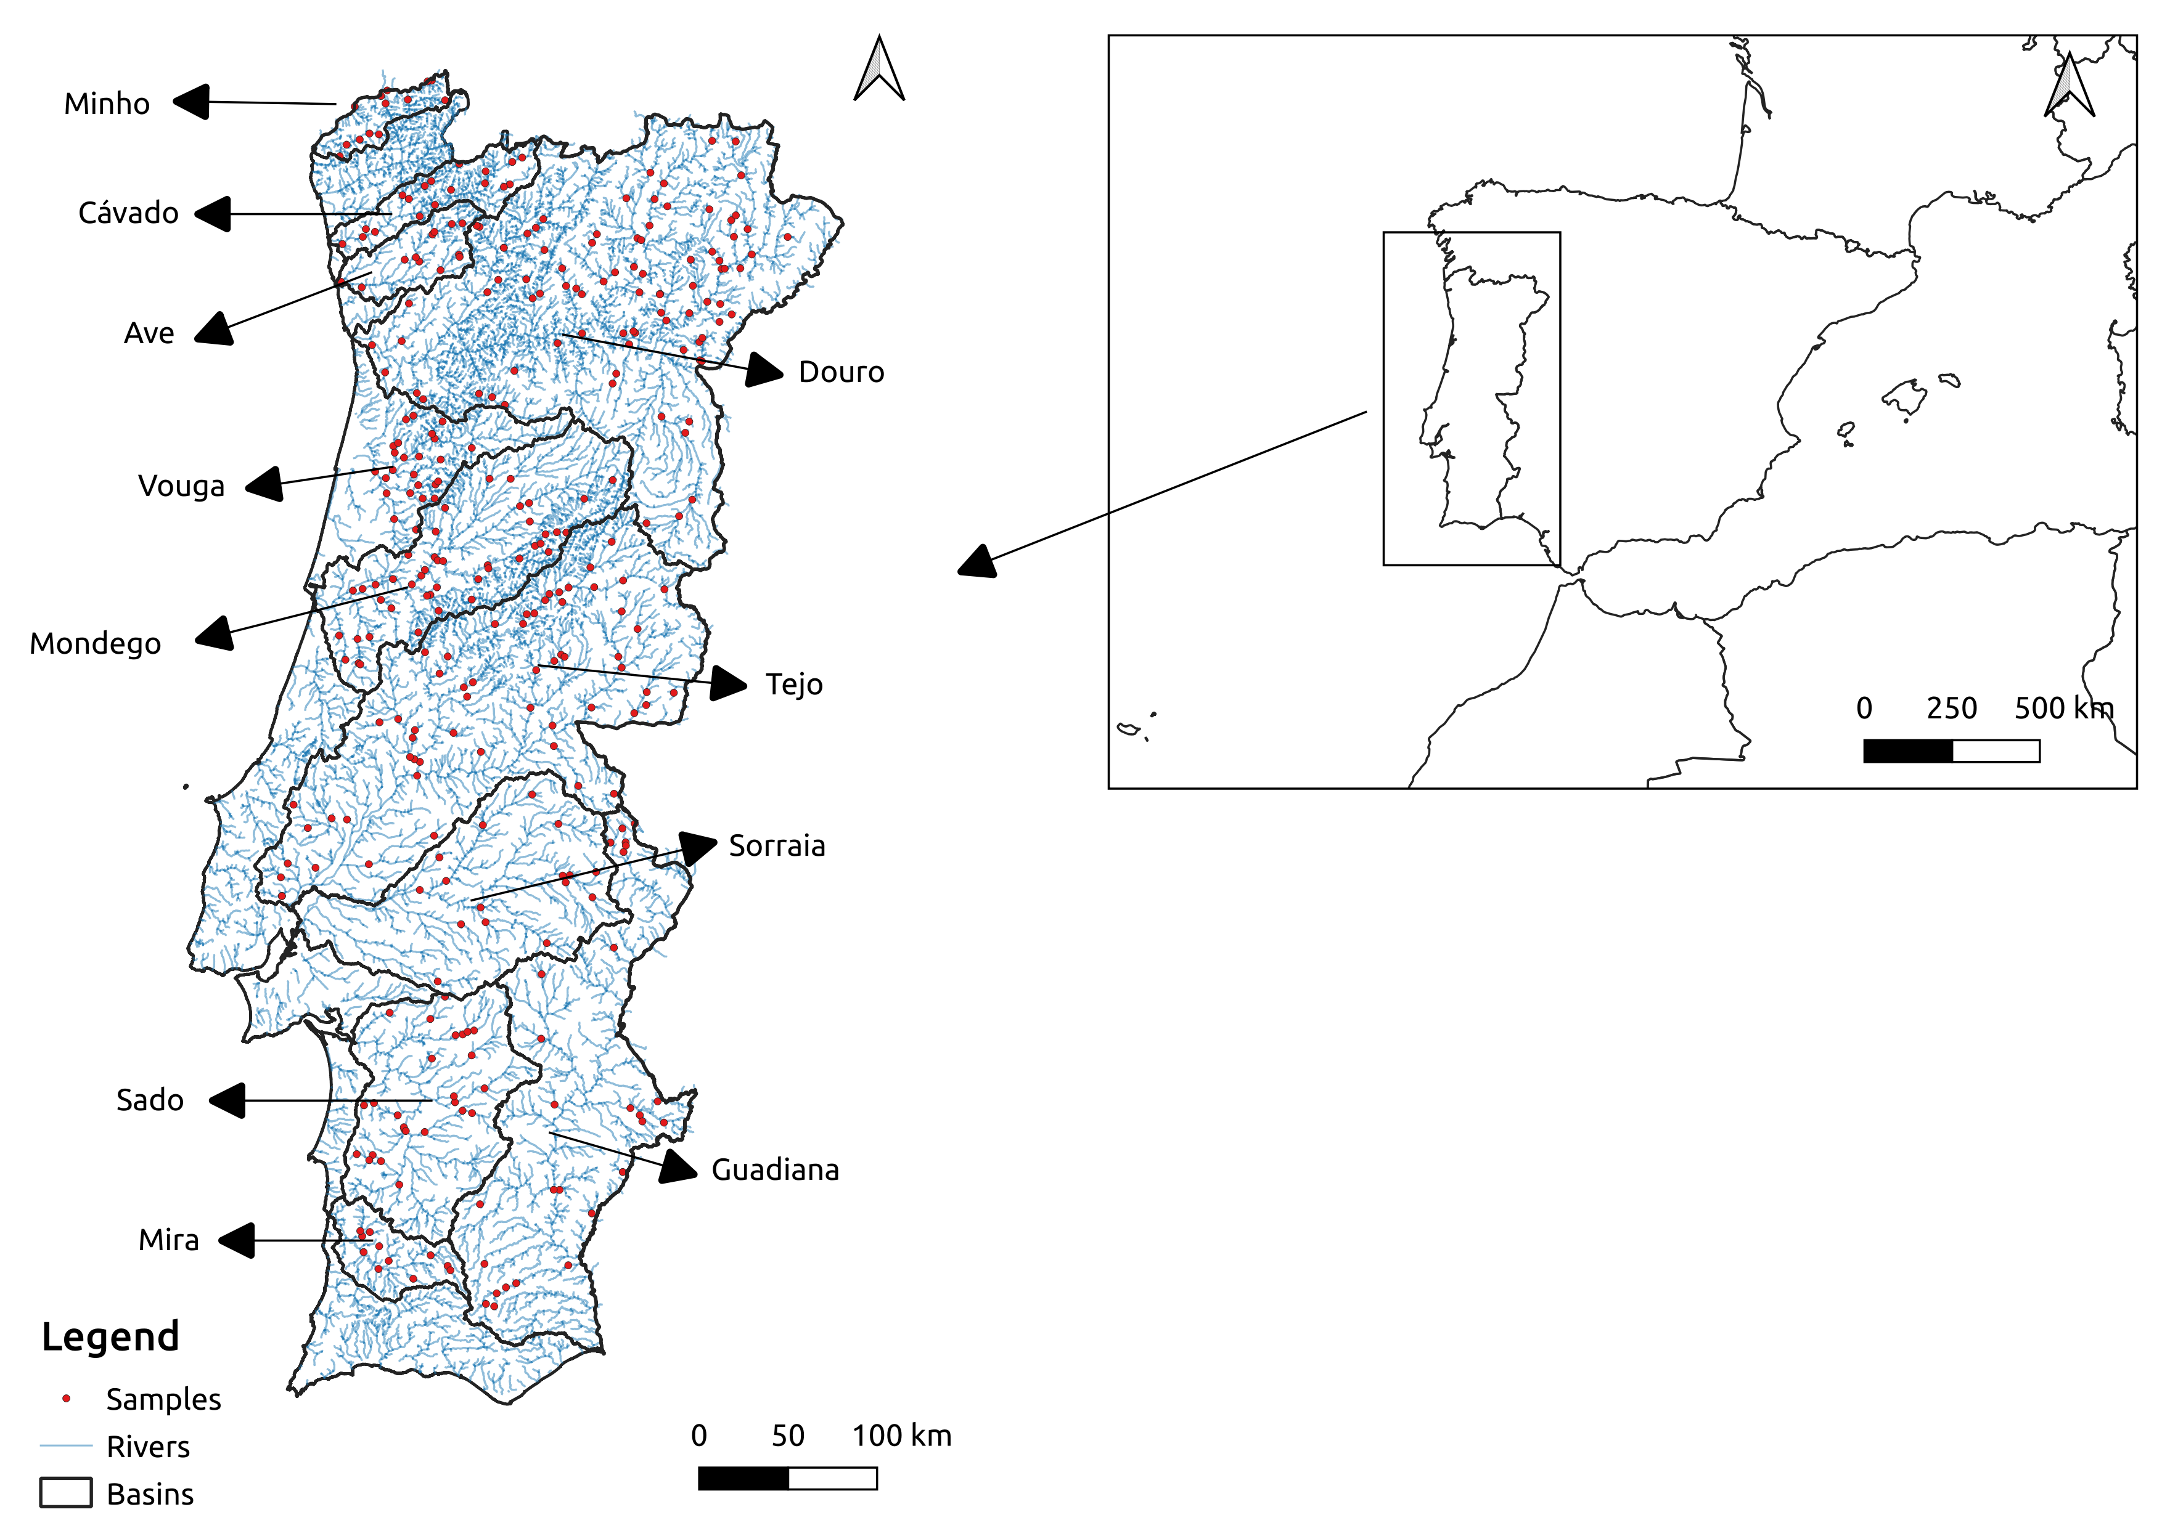
Figure 1 –Continental Portugal and the location of the vegetation plots in the eleven river basins studied (red dots).

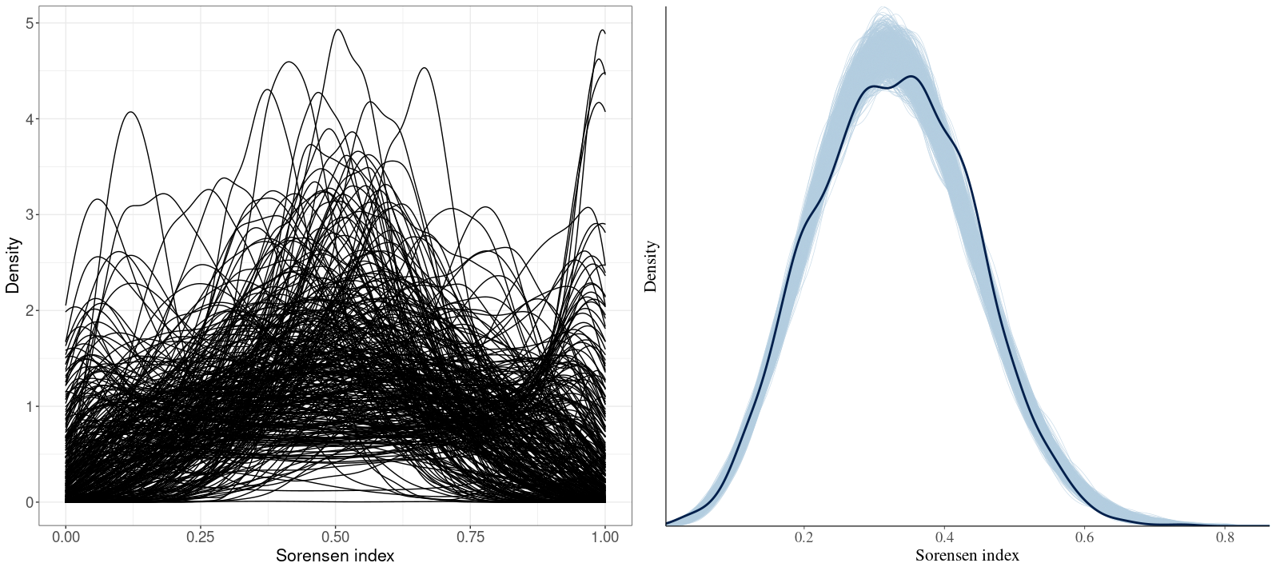
Figure 2 – Density plots showing prior predictive distribution (left) and the observed distribution of Sorensen indices (thick line) against 1000 posterior distributions (thin lines) (right).

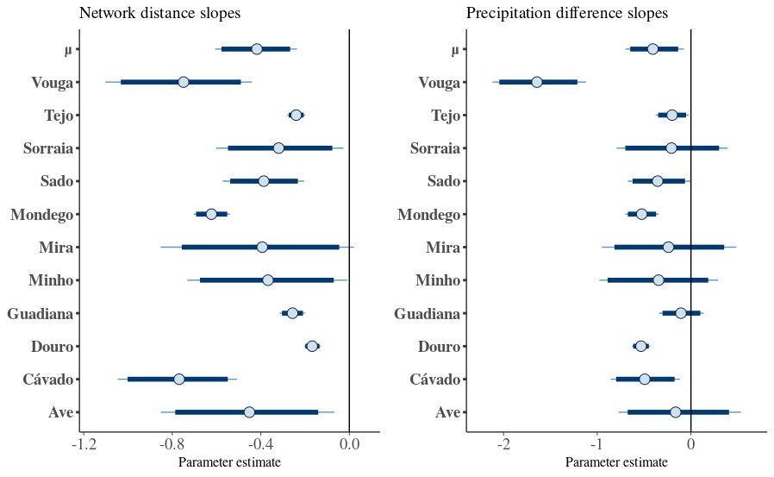

Figure 3 – Posterior estimates of slope parameters for the covariates network distance (left) and precipitation difference (right) for each river basin. The parameter μ is the mean of the normal distribution where slopes are sampled from. Dark blue lines represent 95% credibility intervals. The thin light blue line represents the complete distribution of the parameters. The dot represents the marginal posterior mean.

