Title: Beta-Bayes - A Bayesian approach for comparing ecological communities

Filipe S. Dias^{1,2,3,*}, Michael Betancourt⁴, Patricia María Rodríguez-González⁵, Luís Borda-de-Água^{1,2,3}

Affiliations
1. CIBIO/InBio, Centro de Investigação em Biodiversidade e Recursos Genéticos, Laboratório Associado, Universidade do Porto, Campus Agrário de Vairão, 4485-661 Vairão, Portugal
2. CIBIO/InBio, Centro de Investigação em Biodiversidade e Recursos Genéticos, Laboratório Associado, Instituto Superior de Agronomia, Universidade de Lisboa, Tapada da Ajuda, 1349-017 Lisbon, Portugal
3. BIOPOLIS Program in Genomics, Biodiversity and Land Planning, CIBIO, Campus de Vairão, 4485-661 Vairão, Portugal
4. Symplectomorphic, LLC., New York, USA
5. Centro de Estudos Florestais, Instituto Superior de Agronomia, Universidade de Lisboa, Tapada da Ajuda, 1349-017 Lisboa, Portugal

Abstract

Ecological communities change due to both natural and human factors. Distinguishing between the two is critical in conservation science. The most common approach for modelling species composition changes is to calculate Beta diversity indices and then relate index changes to changes in covariates. This approach's main difficulty is that indices calculated with the same community are not independent. We developed a model-based approach that consists of fitting a regression model of Beta diversity indices and covariates containing two varying intercepts that capture the dependence corresponding to the communities compared by the index. While this approach may superficially resemble a classic random-effects model, it has more in common with Bradley-Terry models, a family of models used for adversarial paired comparisons. We demonstrate how this approach works using simulations, explain how to perform model validation and discuss how it can be modified to work with different data types and how to incorporate varying effects. Although we developed this approach to model changes in community similarity, it can be used with other types of data that result from paired comparisons.

Keywords: Beta diversity; community similarity; pairwise comparisons; riparian vegetation; Bradley-Terry models

1. Introduction

Ecological communities change over time and space due to natural phenomena or human disturbances1,2. Distinguishing between the two is critical to both ecology and conservation science3,4. A common approach for modelling species composition changes is to calculate Beta diversity indices between pairs of communities (e.g., the Sorensen index5,6) and relate those changes to environmental and/or disturbance differences7. The main difficulty with these analyses is that Beta diversity indices are paired comparisons7, which means that indices calculated with the same community are not independent. For instance, if we calculate a Beta diversity index between three communities, A, B and C, the index corresponding to the comparison between A and B is not independent of the index corresponding to the comparison between B and C because they share community B. The most widely used approach to solve this problem is to transform community composition data and environmental covariates into distance matrices and then calculate matrix correlations (e.g. Mantel tests and partial Mantel tests)8,9.

Here we introduce a Bayesian approach for modelling changes in community composition measured by Beta diversity indices as a function of explanatory variables. We use simulations to demonstrate how this approach works, explain how to validate the results and discuss possible extensions.

2. Method

2.1 General overview

In order to introduce our approach, we start by examining the assumptions of a linear regression model. Suppose we are modelling the relation between a variable C and a variable S. The traditional linear regression approach assumes that there is a linear relationship between the expected value of S and C and that S is normally distributed. We can write this model as follows.
S ~ Normal (μ, σ)
μ = α + βC
σ ~ Exponential(1)
α ~ Normal(0,1)
β ~ Normal(0,1)

where μ and σ are the mean and the standard deviation of the normal distribution and α and β are the intercept and slope of the regression. Because we assume a Bayesian analysis of the data, we also introduce prior distributions that were selected for illustration purposes. A key assumption of this model is that, once the covariate C has been fixed, the observed values of S are independent. In other words, the residuals corresponding to any two observations have to be independent. This assumption does not hold if the observed S values arise from paired comparisons, such as Beta diversity indices. When we compare multiple ecological communities using Beta diversity indices, index values that were calculated using the same community are not independent. Therefore, we need to change the model to accommodate this dependence and incorporate the contribution from each ecological community to the corresponding Beta diversity indices.

Consider a set of Beta diversity indices, S_{ij}, calculated between n communities, where i and j denote two different communities and run from 1 to n. The combinations i=j are excluded, which means that no community is compared to itself. In order to capture the dependence between indices that share the same ecological community, we can add terms to the model that represent the contribution from each community to the Beta diversity indices, αs[i,j], resulting in a model like μ = α0+αs[i,j]+βC . The term αs[i,j] could in principle take several forms, but we need to impose two restrictions. First, we need to ensure the order in which the communities appear in the Beta diversity indices does not matter (i.e., symmetry of contributions). In other words, each community should have the same contribution to the Beta diversity index regardless of being coded as the first sample i or as the second sample j, that is αs[i,j]=αs[j,i]. Second, we need to assume the contributions from individual communities are independent. We can meet both these restrictions by choosing the following formulation, αs[i,j]=αs[i] + αs[j]. The parameter αs is a varying intercept that takes the same value whenever the corresponding community is used in the Beta diversity index. By adding two αs parameters, one for community i and another community j we ensure the contributions from the communities are both symmetric and independent. If instead of summing two αs we created two separate parameters for the communities that are being compared by the Beta diversity index and set αs[i,j] = αs1 + αs2, we would be violating the symmetry of contribution restriction we need to impose. While this approach may superficially resemble a classic random effects model10,11 it is not. A random effects model would model the index of each sample being compared with different parameters, (i.e., αs[i,j] = αs1 + αs2,), while our model uses the same parameter for two samples, (i.e., αs[i,j]=αs[i] + αs[j]). A better parallel are Bradley-Terry models12,13, which usually take the form αs[i,j] = αs1 - αs2, with the key difference being the sign in the comparison.. The corresponding model is then:

S_{ij} ~ Normal (μ, σ)
μ= α+α_{s[i]}+ α_{s[j]}+βC
σ ~ Exponential(1)
α_{s} ~ Normal(0,σ_{s})
β ~ Normal(0,1)
σ_{s} ~ Exponential(1)

2.2 Simulations

2.2.1 Generating the data

We simulated 100 communities and Beta diversity indices for all pairs of communities i and j, with i≠j, which leads to 4950 indices. Each community has an associated α_{s} sampled from a normal distribution with mean zero and standard deviation σ_{s}=2. The α_{s} parameter is unique to each community and its purpose is to introduce dependence between Beta diversity indices that share the same community. To make this simulation more realistic, we created a linear relationship between the Beta diversity indices y_{ij} and a covariate x_{ij}, using the following parameters α =10 and β=5 for the intercept and slope, respectively. In summary, we simulated the data as follows:

y_{ij} ~ Normal ( μ, σ);
μ = α + α _{s[i]} + α _{s[j]} + β x_{ij}
α = 10; β = 5; σ = 1;
α_{s} ~ Normal (0, σ_{s});
σ_{s}=2;

2.2.2 Three different models

To demonstrate how this approach works we fit three models to the simulated data to highlight three different aspects. We use the first model to show what happens when we try to model the data without taking into account the dependence that exists between Beta diversity indices calculated with the same community. Model 1 is a simple linear regression model that does not include any terms to deal with the dependence in the data:

y_{ij} ~ Normal (μ, σ).
μ = α + β x_{ij}
α ~ Normal(10,1)
β ~ Normal(5,1)
σ ~ Exponential(1)

Model 2 contains two terms to deal with the dependence in the data, but does not assume that the contribution from each community to the Beta diversity index is the same regardless of the order in which the communities appear (i.e., no symmetry of contribution). Therefore, Model 2 includes two different intercepts, α_{s1} and α_{s2}, one for each of the communities.

y_{ij} ~ Normal (μ_{j}, σ).
μ = α + α_{s1[i]} + α _{s2[j]}
α ~ Normal(10,1)
α_{s1} ~ Normal(0,1)
α_{s2} ~ Normal(0,1)
β ~ Normal(5,1)
σ ~ Exponential(1)
Finally, Model 3 is the one we introduced in section 2.1 and it includes a community-specific term that is added twice to the model to accommodate the dependence in the data, which ensures symmetry in the contribution. Note that its formula also closely resembles the way the data were generated:

y_{ij} ~ Normal (μ_{j}, σ).
μ =α + α_{s[i]} + α _{s[j]} + βx_{ij},
α ~ Normal(10,1)
α_{s} ~ Normal(0,σ_{s})
β ~ Normal(5,1)
σ ~ Exponential(1)
α_{s} ~ Normal (0, σ_{s});

We run the models with four independent Markov chains to sample from, with 1000 warmup iterations and 3000 sampling iterations. We performed all calculations with Stan14 in R 4.1.215 using the package cmdstanr 0.4016.

2.2.3 Simulation results

We compare the models' estimates from the three models with the values we used to generate the simulated data (see Table 1). The three models provide reasonable estimates for the parameters α and β. However, the estimates provided by Model 1 have smaller standard errors and narrower 95% credibility intervals compared to those of the other two models. This result is unsurprising given that Model 1 does not consider the paired comparisons' dependence. Thus, the credibility intervals terms for α and β do not correctly account for the uncertainty in the data and are then "optimistic".

Concerning the parameter σ, Model 2 and Model 3 provide reasonable estimates, but Model 1 does not, returning a 95% credibility interval that does not include the true value (Table 1). Moreover, the standard error of σ estimated by Model 1 is three times larger than those provided by the other two models. This happens because the lack of the term α_{s[i]} + α_{s[j]} does not allow the dependence of the samples to be considered on its own, which is reflected in the value of sigma.

The inability of Model 1 to capture the dependence of the samples can also be seen in the residuals (Fig 1). Figure 1 a) shows the residuals from Model 1 (black dots) plotted against the community indices. The vertical dashed lines delimit groups of residuals involving a point. Thus, the first group on the left shows paired comparisons between community 1 and the other 99 communities, corresponding to 99 points. The second group contains pairs involving sample 2, but because the pair [sample 1, sample 2] has already been considered, it only includes 98 points. The remaining groups were built in the same way until the residuals of all pairs are shown. The final point on the right corresponds to the paired comparison between sample 99 and sample 100. The numbers in red show the value used to simulate the data for the α_{s} corresponding to the point to which the residuals refer to, but to avoid cluttering the figure, we only show the α_{s} for the first 23 sample points. Recall that when a model is valid there should not be any systematic structure in the residuals, the latter being a sign that some contribution is not being included. Notice from Fig. 1 that the structure of the residuals introduced by α_{s} can be visually observed and related to the values of α_{s}. When α_{s} is positive the residuals tend to be negative, and vice-versa when α_{s} is negative. The residuals obtained with Model 2 and Model 3 do not exhibit such structure (Fig. 1b) because in these models the dependence of the samples is now absorbed by the α_{s} terms in the models.

The simulations clearly show that models Model 2 and Model 3 provide a much better fit than Model 1, however, there are considerable differences between these two models. To assess these differences, we need to analyze the posterior distribution of α_{s1} and α_{s2} from Model 2 and α_{s} from Model 3. We calculated the standard deviation for each posterior distribution and plotted the corresponding histograms (Fig. 2). Notice that the standard deviation of α_{s} is considerably smaller than that of α_{s1} and α_{s2}. We observe this because Model 2 assumes that the first and second samples behave differently. That is, the model assumes that each community has a different contribution to the Beta diversity index depending on whether that contribution is introduced in the first or the second place. This situation offers the model unneeded flexibility, which is reflected in the standard deviations. Moreover, this also means that the parameter a_{s1[n]} is informed by only those Beta diversity indices where the nth sample shows up first, while a_{s2[n]} is informed by only those indices where the nth sample shows up in second place. Model 3 treats the contribution from each community the same way and, therefore, can use both these comparisons to inform a_{s[n]}, which allows for much more precise inferences.

The code reproducing the simulation Appendix 1.

2.3 Model validation

One of the advantages of the Bayesian approach is that it provides a clear path for performing model validation. Bayesian models are generative, meaning that we can obtain predicted data from the posterior distribution, compare it with the observed data and check for consistency17,18. This procedure allows us to determine if the model captures the data's relevant structure and improve it if necessary.

We illustrate this procedure with Model 2. To check that our model captures the data’s relevant structure, we compared the observed distribution of Beta diversity indices with the corresponding posterior distribution (Fig. 3) . We 1) plotted the differences between the posterior distribution and the observed indices (i.e., error distributions) against the covariate “x” and 2) plotted the posterior distribution of indices against “x” and checked for systematic deviations. We also plotted the error distributions against the community indices and checks for any deviations (Fig. 4).We can conclude that there are no systematic deviations between model predictions and the observed data, which suggests the model fits the data well.

2.4 Effects of covariates

To assess the importance of the covariate “x” we can look at the value of the slope parameter and assess the relative position of the credibility interval (CI) in relation to zero. In this case, the mean estimate for the slope parameter and the corresponding 95% CI is 4.98 [4.96, 5]. The 95% threshold is merely an arbitrary choice meant only to provide summary of the estimate. If we look at the full distribution of the parameter we see that it does not contain zero and that is concentrated around 4.98, which suggests the model is quite confident about this estimate (Fig. 5).
2.5 Model extensions

2.5.1 Other types of response variables

In the previous section, we assumed that S followed a normal distribution, but this does not have to be the case. We can replace the normal distribution with any other family of distributions with some location parameter. For instance, if S is overdispersed, we can replace the normal distribution with a Student's t distribution:

S ~ Student’s-t (ν, μ, σ)
μ= α+α_{s[i]}+ α_{s[j]}+βC
σ ~ Exponential(1)
α_{s} ~ Normal(0,σ_{s})
β ~ Normal(0,1)
σ_{s} ~ Exponential(1)
ν ~ Gamma(2,0.5)

where ν stands for the degrees of freedom, μ for location and σ for scale.

If S values are counts, for example the number of species in common, then we can use a distribution for count data such as the Poisson and set an appropriate link function, in this case a log-link:

S ~ Poisson(λ)
log(λ)=μ= α+α_{s[i]}+ α_{s[j]}+βC
α_{s} ~ Normal(0,σ_{s})
β ~ Normal(0,1)
α_{s} ~ Normal (0, σ_{s});

2.5.2 Varying effects

We can modify this approach to allow for the relationship between S and C to change across different clusters. This can be useful if we think the relationship between Beta diversity indices and some environmental covariate may vary across different regions or study areas. We can implement this by adding varying intercepts α_{c[cluster]} and varying slopes β_{[cluster]} that take different values depending on the data cluster being considered.

S ~ Normal (μ, σ)
μ= α+ α_{s[i]}+α_{s[j]}+α_{c[cluster]}+β_{[cluster]}C
α ~ Normal(10,1)
α_{s} ~ Normal(0,σ_{s})
α_{c[cluster]}~Normal(0,1)
β_{[cluster]} ~ Normal(0,1)
α_{s} ~ Normal (0, σ_{s});

The varying intercept α_{c[cluster]} and slope β_{[cluster]} allow the model to capture cluster-specific behaviours that would otherwise be missed or inadvertently absorbed into other behaviours, thus providing more interpretable inferences. In another paper19, we used this approach to analyse the factors that are associated with changes in the similarity of riparian plant communities measured by Sorensen indices as a function of several covariates, one of those being the difference in precipitation. We worked with 338 communities located in 11 river basins. We used varying effects to allow the relationship between Sorensen indices and the difference in precipitation to change across river basins. Although the relationship between these two variables tends to be negative (i.e., community similarity is lower when differences in precipitation are higher), there is considerable variation across basins.

3. Discussion

We introduced a Bayesian approach for modelling species composition changes as a function of covariates that considers the dependency arising when we consider multiple pair comparisons involving the same communities. This approach is based on the inclusion of two varying intercepts, one for each community that is being compared by the Beta diversity index, that captures the dependence introduced by the fact that the same community can be a part of multiple Beta diversity indices. We emphasize that our approach is not a classic random-effects model10. Our approach has more in common with the Bradley-Terry models12, a family of models used for modelling adversarial paired comparisons, such as the outcome of football matches.

Our approach is useful in a wide range of situations, and we explain how to modify it to different types of data (e.g., counts) and how it can be adapted to allow for varying effects. We used simulations to demonstrate how this approach works and provide all the relevant code for reproducing the analysis (see the Supplementary Material). In addition, we included an example of the model implemented in Stan that other researchers can use as a starting point for running their analysis. Although we developed this approach with community ecology in mind, it can be used by scientists from other fields that regularly deal with paired comparisons, such as anthropologists and social scientists.

4. Acknowledgments

FD, LBA and PMRG were financed by the Fundação para a Ciência e a Tecnologia (FCT).FD through project POCI-01-0145-FEDER-028729, LBA under the Norma Transitória – L57/2016/CP1440/CT0022, and PMRG through Investigador FCT (IF/00059/2015) and CEEC (2020.03356.CEECIND).

6. Author contributions
FD, MB, PRG and LBA conceived the paper and designed methodology. FD, MB and LBA analyzed the data. FD led the writing of the manuscript. All authors contributed critically to the drafts and gave final approval for publication.

7. References
1. Chang, C. C. & Turner, B. L. Ecological succession in a changing world. J. Ecol. 107, 503–509 (2019).
2. Hubbell, S. The Unified Neutral Theory of Biodiversity and Biogeography (MPB-32). (Princeton University Press, 2001).
3. Magurran, A. E. et al. Divergent biodiversity change within ecosystems. Proc. Natl. Acad. Sci. 115, 1843–1847 (2018).
4. Pereira, H. M., Navarro, L. M. & Martins, I. S. Global Biodiversity Change: The Bad, the Good, and the Unknown. Annu. Rev. Environ. Resour. 37, 25–50 (2012).
5. Magurran, A. E. Ecological Diversity and Its Measurement. (Springer Netherlands, 1988). doi:10.1007/978-94-015-7358-0.
6. Jost, L., Chao, A. & Chazdon, R. Compositional similarity and beta diversity. in Biological Diversity: Frontiers in Measurement and Assessment (eds. Magurran, A. & McGill, B.) 66–84 (Oxford University Press, 2011).
7. Legendre, P., Borcard, D. & Peres-Neto, P. R. Analyzing Beta Diversity: Partitioning the Spatial Variation of Community Composition Data. Ecol. Monogr. 75, 435–450 (2005).
8. Legendre, P. Comparison of permutation methods for the partial correlation and partial mantel tests. J. Stat. Comput. Simul. 67, 37–73 (2000).
9. Mantel, N. The Detection of Disease Clustering and a Generalized Regression Approach. Cancer Res. 27, 209–220 (1967).
10. Pinheiro, J. & Bates, D. Mixed-Effects Models in S and S-PLUS. (Springer, 2009).
11. Zuur, A., Ieno, E. N., Walker, N., Saveliev, A. A. & Smith, G. M. Mixed Effects Models and Extensions in Ecology with R. (Springer, 2009).
12. Bradley, R. A. & Terry, M. E. Rank Analysis of Incomplete Block Designs: I. The Method of Paired Comparisons. Biometrika 39, 324–345 (1952).
13. Cattelan, M., Varin, C. & Firth, D. Dynamic Bradley—Terry modelling of sports tournaments. J. R. Stat. Soc. Ser. C Appl. Stat. 62, 135–150 (2013).
14. Stan Development Team. Stan Modeling Language Users Guide and Reference Manual, Version 2.2.4. (2020).
15. R Core Team. R: A Language and Environment for Statistical Computing. (R Foundation for Statistical Computing, 2021).
16. Gabry, J. & Češnovar, R. cmdstanr: R Interface to ‘CmdStan’. (https://mc-stan.org/cmdstanr, 2021).
17. Gabry, J., Simpson, D., Vehtari, A., Betancourt, M. & Gelman, A. Visualization in Bayesian workflow. J. R. Stat. Soc. Ser. A Stat. Soc. 182, 389–402 (2019).
18. Gelman, A. et al. Bayesian Data Analysis. (Chapman and Hall/CRC, 2013).
19. Dias, F. S., Betancourt, M., Rodríguez-González, P. M. & Borda-de-Água, L. Analysing the distance decay of community similarity in river networks using Bayesian methods. Sci. Rep. 11, 21660 (2021).

Fig 1 - a) This panel shows the residuals from Model 1 (black dots) plotted against sample codes. The vertical dashed lines delimit groups of residuals in groups of 98 points. The first group on the left shows paired comparisons between sample 1 and the other 99 samples, corresponding to 99 points. The second group contains pairs involving sample 2, but because the pair (sample 1, sample 2) has already been considered, there are only 98 points. The remaining groups were built in the same until the residuals of all pairs are shown. The final point on the right corresponds to the paired comparison between sample 99 and sample 100. The number in red is the value used to simulate the data, but to avoid cluttering the figure, we only show the α_{s} for the first 23 sample points. b) This panel shows the residuals of Model 1 (black dots) along with those of Model 2 (green dots) and Model 3 (red dots). Note that there is no apparent structure in the residuals of Model 2 and Model 3.

Fig 2 - The histograms of the standard deviation of the posteriors for a_{s} (Model 3) and a_{s1}, and a_{s2} (Model 2). Notice that the smaller values of the standard deviations of the a_{s} (Model 3) compared with those of a_{s1}, and a_{s2} (Model 2). The red curve was obtained with the function “density” from the R software that computes kernel density estimates. The full vertical lines correspond to the mean and the dashed lines 95% credibility intervals.

Fig 3 - a) Differences between the posterior distribution and the observed Beta diversity indices (i.e., error distributions) against the covariate “x”, b) Posterior distribution of Beta diversity indices indices against “x”, c) and d). Error distributions against the community indices (idx1 and idx2).

Fig 4 - a) Differences between the posterior distribution and the observed Beta diversity indices (i.e., error distributions) against the covariate “x”, b) Posterior distribution of Beta diversity indices indices against “x”, c) and d). Error distributions against the community indices (idx1 and idx2). Blue dots represent mean estimates and the blue vertical lines 95% credibility intervals.

Fig 5 - Posterior distribution of the slope parameter for the covariate “x”.

Table 1. Comparison of the parameter values for the three models using simulated data

Model | Parameter  (simulated value) | Mean | Standard error | Credibility intervals
 |  |  |  | 2.50% | 97.50%
Model 1 | α(10) | 9.95 | 0.08 | 9.79 | 10.11
Model 1 | β (5) | 4.97 | 0.01 | 4.94 | 5
Model 1 | σ (1) | 2.79 | 0.03 | 2.73 | 2.84
Model 2 | α(10) | 9.78 | 0.21 | 9.37 | 10.19
Model 2 | β (5) | 5 | 0.01 | 4.98 | 5.03
Model 2 | σ(1) | 1 | 0.01 | 0.98 | 1.02
Model 3 | α(10) | 9.91 | 0.25 | 9.42 | 10.4
Model 3 | β (5) | 4.98 | 0.03 | 4.91 | 5.04
Model 3 | σ (1) | 1 | 0.01 | 0.98 | 1.02

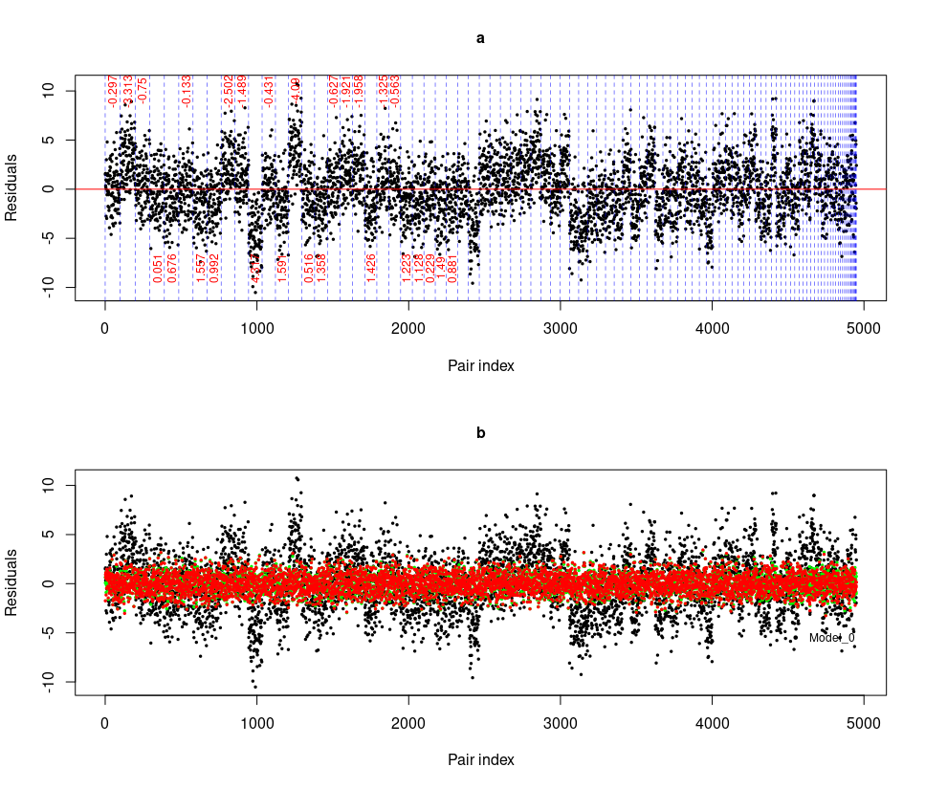

Fig 1 - a) This panel shows the residuals from Model 1 (black dots) plotted against sample codes. The vertical dashed lines delimit groups of residuals in groups of 98 points. The first group on the left shows paired comparisons between sample 1 and the other 99 samples, corresponding to 99 points. The second group contains pairs involving sample 2, but because the pair (sample 1, sample 2) has already been considered, there are only 98 points. The remaining groups were built in the same until the residuals of all pairs are shown. The final point on the right corresponds to the paired comparison between sample 99 and sample 100. The number in red is the value used to simulate the data, but to avoid cluttering the figure, we only show the α_{s} for the first 23 sample points. b) This panel shows the residuals of Model 1 (black dots) along with those of Model 2 (green dots) and Model 3 (red dots). Note that there is no apparent structure in the residuals of Model 2 and Model 3.

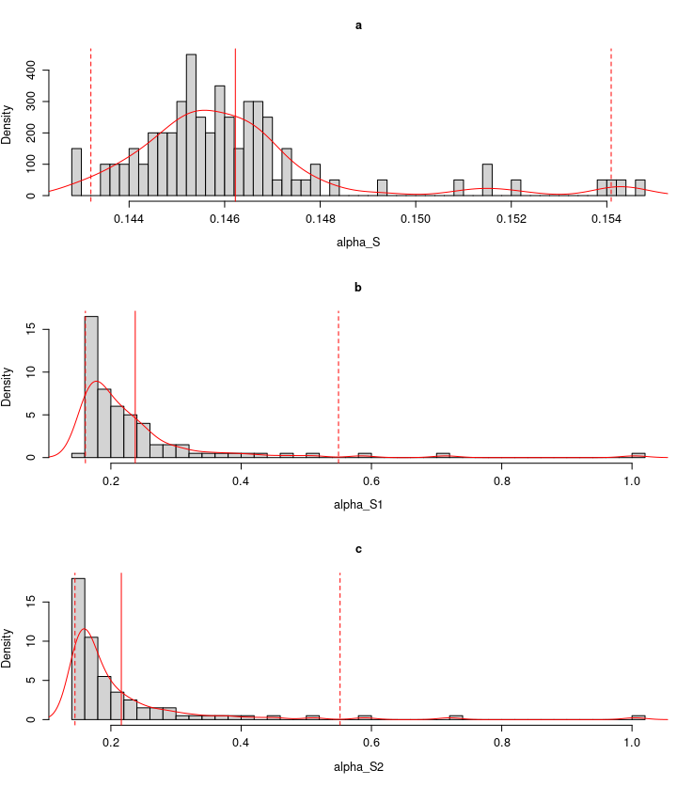
Fig 2 - The histograms of the standard deviation of the posteriors for a_{s} (Model 3) and a_{s1}, and a_{s2} (Model 2). Notice that the smaller values of the standard deviations of the a_{s} (Model 3) compared with those of a_{s1}, and a_{s2} (Model 2). The red curve was obtained with the function “density” from the R software that computes kernel density estimates. The full vertical lines correspond to the mean and the dashed lines 95% credibility intervals.

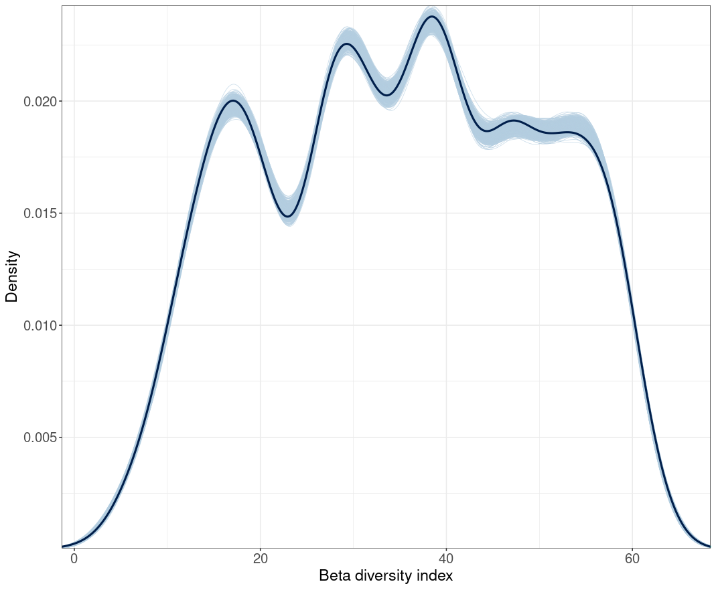

Fig 3 - Observed distribution of Beta diversity indices (dark blue line) plotted alongside 1000 posterior retrodictive predictions (light blue).

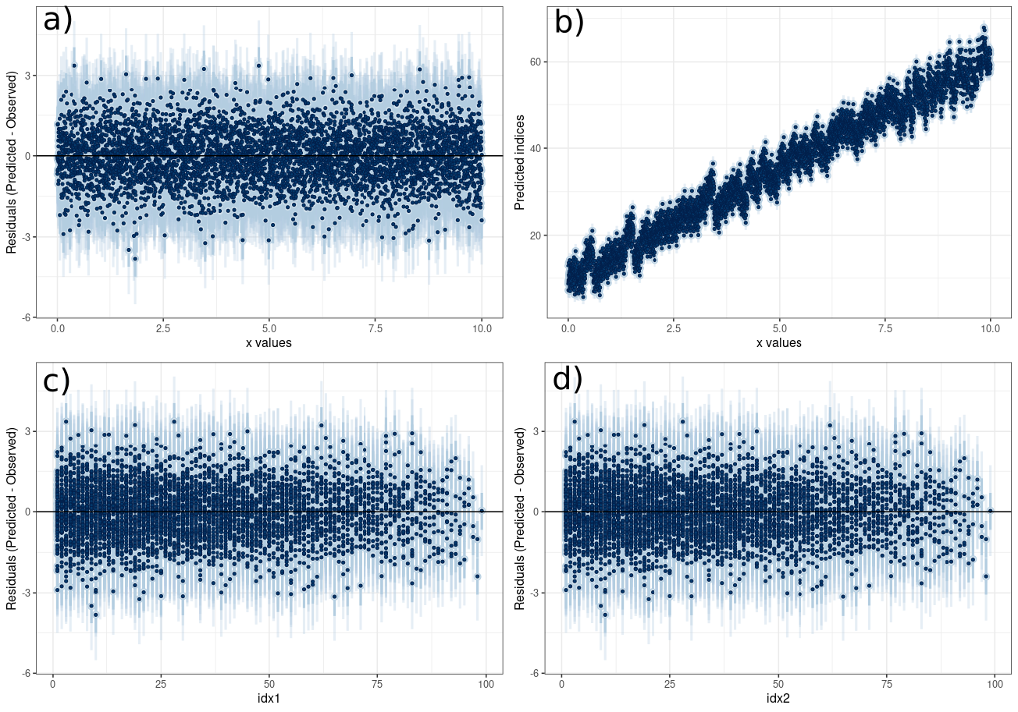
Fig 4 - a) Differences between the posterior distribution and the observed Beta diversity indices (i.e., error distributions) against the covariate “x”, b) Posterior distribution of Beta diversity indices indices against “x”, c) and d). Error distributions against the community indices (idx1 and idx2). Blue dots represent mean estimates and the blue vertical lines 95% credibility intervals.

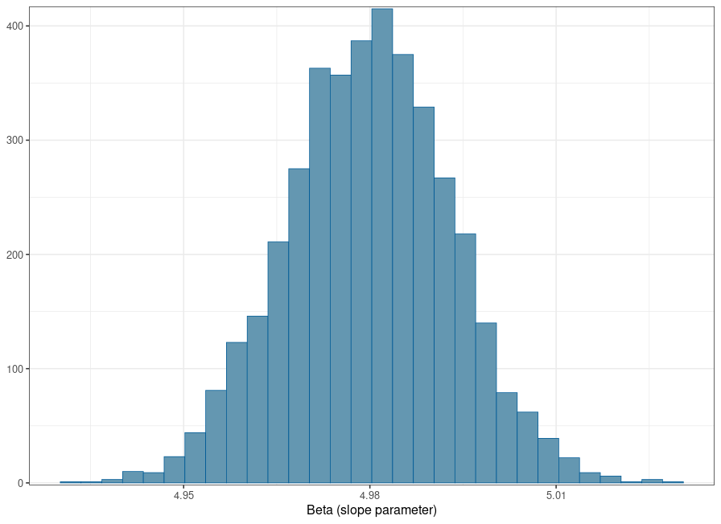
Fig 5 - Posterior distribution of the slope parameter for the covariate “x”.

