Title: BetaBayes - A Bayesian approach for comparing ecological communities

Filipe S. Dias^{1,2,3,*}, Michael Betancourt⁴, Patricia María Rodríguez-González^{5,6}, Luís Borda-de-Água^{1,2,3}

Affiliations
1. CIBIO/InBio, Centro de Investigação em Biodiversidade e Recursos Genéticos, Laboratório Associado, Universidade do Porto, Campus Agrário de Vairão, 4485-661 Vairão, Portugal
2. CIBIO/InBio, Centro de Investigação em Biodiversidade e Recursos Genéticos, Laboratório Associado, Instituto Superior de Agronomia, Universidade de Lisboa, Tapada da Ajuda, 1349-017 Lisbon, Portugal
3. BIOPOLIS Program in Genomics, Biodiversity and Land Planning, CIBIO, Campus de Vairão, 4485-661 Vairão, Portugal
4. Symplectomorphic, LLC., New York, USA
5. Centro de Estudos Florestais, Instituto Superior de Agronomia, Universidade de Lisboa, Tapada da Ajuda, 1349-017 Lisboa, Portugal
6. Laboratório Associado Terra, Instituto Superior de Agronomia, Universidade de Lisboa, Tapada da Ajuda, 1349-017 Lisboa, Portugal

Abstract

Ecological communities change due to both natural and human factors. Distinguishing between the two is critical to ecology and conservation science. One of the most common approaches for modelling species composition changes is calculating Beta diversity indices and then relating index changes to covariates changes. The main difficulty with these analyses is that Beta diversity indices are paired comparisons, which means indices calculated with the same community are not independent. Mantel tests and Generalised Dissimilarity Modeling are the most commonly used statistical procedures for analysing such data, dealing with the data's dependence using randomisation tests. Here we introduce a model-based approach called BetaBayes that requires first modelling the process that results in Beta diversity indices and then quantifying which model configurations are consistent with the observed data. This approach is based on Bradley-Terry model and consists of fitting a regression model containing two varying intercepts that capture the dependence in the data. We demonstrate the use of this approach by analysing a famous dataset collected in Panama that contains information on multiple 1-ha plots from the rain forests of Panama. Several studies have analysed this dataset using Mantel tests and Generalised Dissimilarity Modeling. We calculated the Bray-Curtis index between all pairs of plots and analysed the relationship between the index and two covariates, geographic distance and elevation. We compared the results of BetaBayes with those from the methods mentioned above. We show that BetaBayes provides a step towards consistently modelling community composition changes and discussing possible extensions and future directions.

Keywords: Beta diversity; community similarity; pairwise comparisons; riparian vegetation; Bradley-Terry models

1. INTRODUCTION

Ecological communities change over time and space due to natural phenomena and human disturbances [1,2]. Distinguishing between the two is critical to ecology and conservation science [3,4]. A common approach for modelling changes in species composition is to calculate Beta diversity indices between pairs of ecological communities (e.g., the Sorensen index [5,6]) and relate those changes to changes in environmental factors and disturbance [7]. For instance, if we calculate a Beta diversity index between three communities, A, B and C, the index corresponding to the comparison between A and B is not independent of the index corresponding to B and C because they share community B.

2. METHODS FOR MODELLING CHANGES IN COMMUNITY SIMILARITY AND DISSIMILARITY

The most popular statistical technique for analyzing community similarity and dissimilarity is the Mantel test [8], which examines the relationship between two distance matrices: a distance matrix of Beta diversity indices and a matrix of covariate values. The test is based on the Mantel statistic, which is given by the sum of the products of the corresponding elements of the matrices.

Typically this sum is then rescaled between -1 and 1 to provide some quantification of the pairwise correlation between elements from both matrices. If all of the elements in the two matrices are strongly correlated, then the rescaled sum will be close to 1, and if they are anticorrelated, then the rescaled sum will be close to -1. When the elements are uncorrelated, the individual summands will tend to cancel, leaving a total sum near zero.

The null hypothesis of the Mantel test is that "the distances among objects in matrix Y are not (linearly or monotonically) related to the corresponding distances in the matrix X" [9]. Because the individual elements in each matrix are not independent, calculating a significance is not trivial. The Mantel test uses a permutation test that evaluates the ensemble of statistics while randomly permuting the order of the elements within one of the input matrices. When the number of observations is high (n > 40), it is possible to transform the Mantel statistic into an approximate t-statistic and then apply an asymptotic approximation of the t-test.

The partial Mantel test is an extension of the original Mantel test, where a third matrix is held constant while the relationship between the other two is determined [9]]. This test is performed by regressing the first two matrices' elements onto the third matrix and using the residuals from the regressions as the input for the standard Mantel test [10]. Some studies have found that both Mantel and partial Mantel tests can underperform under some circumstances, mainly when the data are spatially structured [11–13].

Generalized dissimilarity modelling (GDM) is an alternative to Mantel tests, whose main advantage is that it considers two critical nonlinearities often found in pairwise dissimilarities [14,15]. First, Beta diversity indices measures are often constrained between 0 and 1 and therefore saturate at a maximum value of 1 once pairs of assemblages are entirely different. Therefore, the additional environmental distance between sites cannot increase dissimilarity beyond a value of 1. Second, change in assemblage composition can occur more rapidly at some points along environmental gradients than others [14–16]. GDM is a regression-based approach that models community dissimilarity between all pairs of communities as a function of environmental distances [14,15]. GDM uses a negative exponential link function that ensures expected dissimilarities (d_{ij}) increase and saturates with increased transformed environmental distance between sites (η).

The predicted ecological distance η is calculated as the sum across all predictor variables of the absolute differences in the model transformed predictor values f_{p}(x_{p}) between sites i and j in a pair [15]:

where b is the x-intercept added to consider the baseline dissimilarity, that is, the similarity between sites with zero environmental distances. To transform each predictor variable, GDM uses a linear combination of I-spline basis functions [17], fit using non-negative least squares regression. Therefore, each predictor's overall spline function f_{p}(x_{p}) is relatively flexible but constrained to increase monotonically. This constraint underlies a fundamental assumption of GDM that dissimilarity can grow only as sites become more different concerning predictor variables. The non-independence of dissimilarity is addressed by using permutation or Bayesian bootstrap methods to assess the importance of the covariates [18,19].

GDM provides several tools for performing model validation, such as the graphical comparison between the observed dissimilarity and the predicted dissimilarity and the percentage of explained deviance. We can plot the spline functions for each predictor variable to interpret model results. These functions convey two types of information. First, the maximum height reached by each function indicates the total amount of compositional turnover associated with the environmental gradient being evaluated, holding all other covariates constant. Spline functions that attain a higher maximum transformed value that is, the sum of the fitted coefficients, play a more substantial role in predicting changes in beta diversity. Second, each function's slope indicates the rate of compositional turnover and how this rate changes along the environmental gradient. A greater slope of the spline function at a given point along the environmental gradient indicates a more rapid increase in dissimilarity [14,15].

Compared to Mantel tests, GDM has several advantages, such as incorporating the nonlinearities found in pairwise dissimilarities and providing tools for performing model validation. However, it does not incorporate the non-independence of dissimilarity indices in the model, relying instead on a posteriori permutation tests performed on the covariates.

3. BETABAYES

3.1 General overview

Here we introduce a Bayesian approach for modelling changes in community similarity that explicitly includes the dependence between observations instead of relying on permutation tests. This approach requires first modelling the measurement process that results in paired comparisons and then quantifying which model configurations are consistent with the observed data. In order to introduce our approach, we start by examining the assumptions of a linear regression model. Suppose we are modelling the relationship between a variable C and a variable S. The traditional linear regression approach assumes a linear relationship between the expected value of S and C and that S is normally distributed. We can write this model as follows.

S ~ Normal (μ, σ)
μ = α + βC

where μ and σ are the mean and the standard deviation of the normal distribution and α and β are the intercept and slope of the regression. Because we use Bayesian methods, we need to introduce prior distributions for the parameters, which could be, for example:

σ ~ Exponential(1)
α ~ Normal(0,1)
β ~ Normal(0,1).

A fundamental assumption of this model is that, once the covariate C has been fixed, the observed values of S are independent. In other words, the residuals corresponding to any two observations have to be independent. However, this assumption is invalid if the observed S values arise from paired comparisons. When we compare multiple ecological communities using Beta diversity indices, index values calculated using the same community are not independent. Therefore we need to change the model to accommodate this dependence and incorporate the contribution from each ecological community to the corresponding Beta diversity indices.

Consider a set of Beta diversity indices, S_{ij}, calculated between n communities, where i and j denote two different communities and run from 1 to n. The combinations i=j are excluded, meaning no community is compared to itself. In order to capture the dependence between indices that share the same ecological community, we can add terms to the model that represent the contribution from each community to the Beta diversity indices, αs[i,j], resulting in a model like μ = α0+αs[i,j]+βC . The term αs[i,j] could, in principle, take several forms, but we need to impose two restrictions. First, we need to ensure that the order in which the communities appear in the Beta diversity indices does not matter (i.e., symmetry of contributions). In other words, each community should have the same contribution to the Beta diversity index regardless of being coded as the first sample i or as the second sample j, that is αs[i,j]=αs[j,i]. Second, we need to assume that the contributions from individual communities are independent. We can meet both these restrictions by choosing the following formulation, αs[i,j]=αs[i] + αs[j]. The parameter αs is a varying intercept that takes the same value whenever the corresponding community is used in the Beta diversity index. By adding two αs parameters, one for community i and another for community j we ensure the communities' contributions are symmetric and independent.

The corresponding model is then:

S_{ij} ~ Normal (μ_{ij}, σ)
μ_{ij}= α+α_{s[i]}+ α_{s[j]}+βC
σ ~ Exponential(1)
α_{s} ~ Normal(0, σ_{s})
β ~ Normal(0,1)
σ_{s} ~ Exponential(1)

Notice that the prior for αs is a function of the hyperparameter σ_{s}. This is a regularizing prior, meant to prevent overfitting, that learns the amount of regularization from the data itself [21]. Non-Bayesian methods call this procedure “penalized likelihood.”

This approach is partially based on Bradley-Terry models, which were developed for modelling the outcome of paired comparisons [20,21]. We can make this connection explicit with an example. Suppose we have N teams competing against each other and the model assigns team i a score p_{i,} with higher scores corresponding to more powerful teams. Given two teams, i and j, the model asserts that:

If we parameterize the scores by p_{i}=exp(α_{i}), the above model is equivalent to:

The final result, αi – αj, is similar to our model, the critical difference being the minus sign in the comparison.

3.2 Prior predictive checking

Prior to fitting a Bayesian model, we need to carefully select prior distributions for the parameters we are going to estimate that are compatible with our domain expertise. Prior predictive checking generates simulated data following the prior model to identify any behaviours that conflict with any available domain expertise [22,23]. In the case of a model whose response variable is a set of Beta diversity indices, the prior model should generate sensible distributions of those indices while leaving some room for more extreme situations.

3.3 Model validation and interpretation

Once we have constructed our model, we can introduce data and identify which parameter behaviours are compatible with both the data and the assumptions encoded in the model. Here we use Markov chain Monte Carlo as implemented in Stan [24] to fit the model and identify those compatible parameter values.

After fitting the model, we need to check if Markov chains were stationary and enabled reasonable posterior expectation value estimators. To that effect, we need to perform both qualitative and quantitative diagnostics. In addition, to spot-checking trace plots, we need to check that the split potential scale reduction factor (Rhat) is consistent with 1 for all functions of interest and verify that there were no divergent transitions or Markov chains that saturated the maximum tree depth.

We can validate that the model is sufficient to fit the data by comparing the observed distribution of Beta diversity indices against the corresponding posterior distribution and checking for patterns. We can plot the observed indices against the corresponding posterior distribution and assess how well they match. Additionally, we can plot the differences between the posterior distribution of the indices and observed values (i.e., error distributions) against the covariates and the community indices (α_{s}) and check for patterns (see Appendix 1 – Section X).

We interpret the results by examining the posterior distribution of the slope parameters β. We check the position of the credibility interval concerning zero and assess the absolute value of the parameter.

4. COMPARING BETABAYES WITH MANTEL TESTS AND GENERALIZED DISSIMILARITY MODELLING

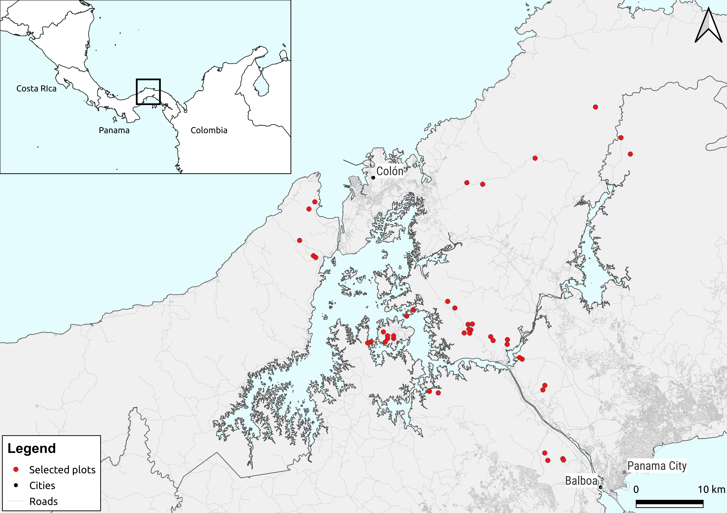
Figure 1 – The red dots represent the location of the 43 vegetation plots from Condit et al.[26] that were selected for this study.

To demonstrate the use of BetaBayes and compare its results with those from Mantel tests and Generalized Dissimilarity Modeling, we chose a dataset collected by Condit et al.[25], that is available as supplementary information on the publication's website. The dataset contains information on multiple 1-ha plots from rain forests of Panama, Ecuador and Peru, where all plants with a stem diameter higher than 10 cm were identified at the species level, but in our study, we use only data from Panama. Condit et al. [26] observed that community similarity measured by Sorensen's similarity index decays with distance. Subsequent studies analyzed parts of this dataset using Mantel tests and Generalized Dissimilarity modelling. Chust et al. [26] worked with 53 plots from Panama and used Mantel tests to assess the correlation between Jaccard and Steinhaus similarity indices, geographic distance, and environmental factors such as elevation, slope, and climate variables. They observed that community similarity declined with increasing geographic distance and differences in topographical and climate variables. Ferrier et al. [18] used 43 plots from Panama to exemplify the use of GDM, having found strong positive associations between community dissimilarity, geographic distance, and differences in elevation and precipitation. For this analysis, we selected 43 plots located in Panama at least 400 meters apart but no more than 60 km (Fig. 1). We calculated the Bray-Curtis index between all pairs of plots and selected two covariates, geographic distance and elevation.

4.1 Mantel test

To run Mantel tests we used the function mantel() from the R package “vegan”[27]. The results from the tests suggest there are significant positive correlations between Bray-Curtis dissimilarity indices, geographical distance (r= 0.586, p-value= 0.001) and differences in elevation (r=0.355, p=0.001).

4.2 Generalized Dissimilarity Modeling
We used the R package "gdm" [28] to implement Generalized Dissimilarity models. The resulting model explained 52.51% of the deviance, and there was a good match between observed and predicted compositional similarity (Fig 2b), which indicates the model fits the data well. The permutation tests returned p-values < 0.05 for both predictors, which suggests that the model considers them both significant even after accounting for the non-independence of Bray-Curtis indices. The spline function for geographical distance attained the highest maximum transformed value indicating it is the most important covariate. The sum of the coefficients was 1.37, which suggests it is an important predictor. The spline for elevation reached a slightly lower value than geographic distance, but the sum of the coefficients was only slightly smaller, 1.023, indicating it is also an important predictor. Overall, the model suggests compositional dissimilarity first grows rapidly as the ecological distance grows, then the growth decelerates (Fig 2a).
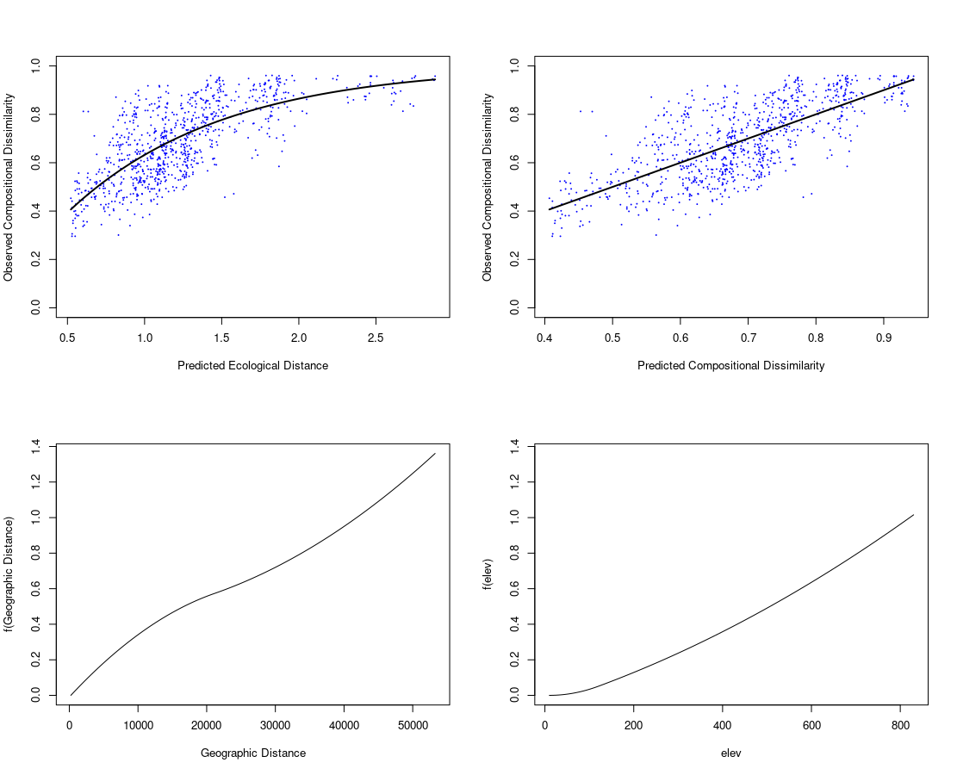

Figure 2 - a) Observed dissimilarity as a function of GDM-predicted ecological distance, with each pair of sites represented by a point. The dark line represents the GDM-predicted dissimilarity, b) Observed dissimilarity as a function of GDM-predicted dissimilarity, and a line with slope 1, c) Spline function for geographic distance and d) Spline function for elevation.

4.3 BetaBayes

To use BetaBayes, we need to make minor adjustments to our earlier model to exemplify our new method. Bray-Curtis indices are constrained between 0 and 1, so we need to replace the Normal distribution with a Beta distribution, a continuous probability distribution defined on the interval 0 and 1. We parameterized the Beta distribution with the mean (or location) μ and sample size κ [29]. To make sure the parameter μ is bounded between 0 and 1, we modelled the logit of μ in a linear model of the covariates. We implemented BetaBayes using Stan’s probabilistic programming language [24] using CmdStan, the software R 4.2 [30] the R package CmdStanR[28], which provides an R interface for CmdStan.

The model is then:

Beta diversity index_{i,j} ~ Beta distribution (μ_{ij}, κ)
logit(μ_{ij}) = α+α_{s,i}+ α_{s,j}+β_{1∗}Geographical distance + β_{2 ∗} Elevation difference
α ~ Normal (0,0.3)
α_{s} ~ Normal (0,σ_{s})
σ_{s}~ Exponential(1)
β₁,β₂~Normal (0,1)
κ ~ Half-Normal(0,50)

We chose a weakly informative prior model that assigns a slightly higher probability to distributions of Bray-Curtis indices centred around 0.5, but that also assigns considerably probability to more humped distributions (Fig 2A). We transformed both covariates to improve model fit, identifiability, and run time. We transformed geographical distance values by subtracting 10 km m from observed values and dividing the resulting value by 10 km. As for the difference in elevation, we subtracted 100 meters and then divided the result by 100 meters.

The chains were stationary and well mixing with Rhat values of ~ 1. No iterations ended with divergences or saturated the maximum tree depth. The posterior retrodictive distribution of Bray-Curtis indices closely matched the observed distribution, except for values below 0.39, which are slightly overestimated (Fig 2B, and Appendix 1). This result is probably caused by the regularizing prior we introduced for α_{s} that pulls more extreme predicted values towards the mean.

The posterior distributions of the slope parameters for geographical distance and elevation do not cross zero, suggesting a strong association between Bray-Curtis indices and these two covariates. The geographical distance slope had the highest mean value, 0.366, with a 95% credibility interval of [0.323, 0.381], which indicates it is the strongest predictor. This result means that when geographical distance increases by 1 meter beyond a threshold of 10 km, the Bray-Curtis index increases by 36.6%. The elevation slope had a mean estimate of 0.109 with a 95% credibility interval, indicating that beyond a threshold of 100 meters, the Bray-Curtis index grows by 10.9% for each 1-meter increase in elevation difference.

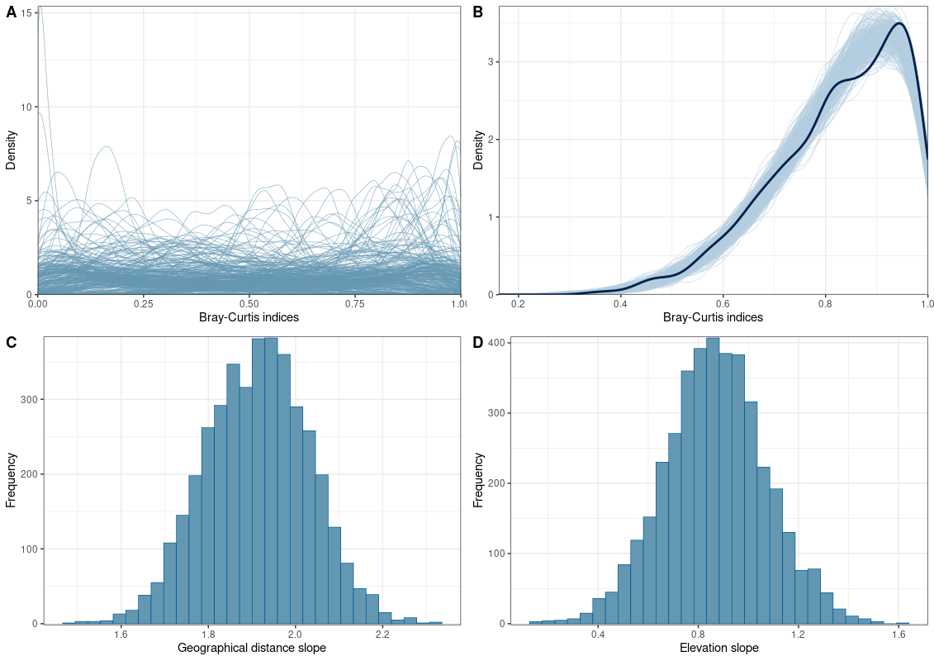

Figure 2 – A) Density plot showing 1000 prior predictive distributions, B) Density plot showing the observed distribution of Bray-Curtis indices (thick line) against 1000 posterior distributions (thin lines), C) Posterior distribution of the slope parameter corresponding to the geographical distance, and D) Posterior distribution of the slope parameter corresponding to the precipitation difference.

5. BETABAYES EXTENSIONS

One of the advantages of BetaBayes relative to Mantel tests and Generalized Dissimilarity Modeling is that the underlying model can be modified to account for structure in a particular measurement. For example, when the measurements are clustered, we can immediately extend BetaBayes to allow the relationship between Beta diversity indices and covariates to vary across those clusters. This feature may be helpful if we think the relationship between the indices and some environmental covariates may vary across different regions or study areas. We can implement this by adding varying intercepts α_{c[cluster]} and varying slopes β_{[cluster]} that take different values depending on the data cluster being considered so, for example, we can write the following model:

S ~ Normal (μ, σ)
μ= α+ α_{s[i]}+α_{s[j]}+α_{c[cluster]}+β_{[cluster]}C
α ~ Normal(10,1)
α_{s} ~ Normal(0,σ_{s})
α_{c[cluster]}~Normal(0,1)
β_{[cluster]} ~ Normal(0,1)
α_{s} ~ Normal (0, σ_{s});

In a recent paper [31], we used this approach to analyze how community similarity among riparian plant communities changes as a function of neutral and niche-based covariates. We worked with 338 communities located in 11 river basins. We added varying effects to the model, which allowed us to understand how the relationship between community similarity and covariates changes across different river basins.

We assumed linear relationships between the covariates and the Beta diversity indices in the above example and the previous sections. However, it is also possible to model curvilinear relationships in the context of BetaBayes. As in Generalized Dissimilarity Modelling, we can use splines, smooth functions built out of smaller component functions [32]. We exemplify this by using basis splines (B-splines). B-splines build up wiggly functions from simpler, less-wiggly components called basis functions. In short, B-splines divide the full range of a predictor variable into parts, assigning a parameter to each of those parts. These parameters are gradually switched on and off, making a wiggly curve. The model is, then:

S_{i} ~ Normal (μ, σ)
μ_{i}= α+ α_{s[i]}+α_{s[j]}+w₁B_{i,1}+ w₂B_{i,2}
w_{1,} w₂ ~ Normal(0,10)
α ~ Normal(0,1)
α_{s} ~ Normal(0,σ_{s})
σ ~ Exponential(1)

where B_{i,n} is the n-th basis function’s value on row i, and the w parameters are the correspond-
ing weights for each. The B parameters work like regular slopes, adjusting the influence of each basis
function on the mean μ_{i}.

6. FUTURE DIRECTIONS

Studies that model changes in Beta diversity indices as a function of covariates are common in the literature [10,12,15], and their number has grown rapidly over the past 15 years. BetaBayes provides a step towards consistently modelling community composition changes that improve upon GDM and Mantel tests. However, we think future research should focus on creating generative models for modelling dissimilarities consistent with the existing knowledge about species distributions across time and space.

One promising way of improving this type of study would be to develop models capable of modelling multiple-site similarity measures [33]. When we work with pairwise similarities or dissimilarities, we lose information on the identity of species shared across more than two sites. So, the average similarity across all sites does not express how the number of shared species changes. Moreover, this approach does not consider the covariance problem between similarities since some pairs must share the same site [33]. Pairwise comparisons of communities may be enough if the goal is to examine how species composition changes along an environmental gradient. However, we need to work with multiple-site similarity measures if our goal is to look at sites as if they were a random collection of samples from a larger region (e.g. island or a landscape) [34]. We plan to address this subject in the future.

7. REFERENCES

1. Chang, C.C.; Turner, B.L. Ecological Succession in a Changing World. J. Ecol. 2019, 107, 503–509, doi:10.1111/1365-2745.13132.
2. Hubbell, S. The Unified Neutral Theory of Biodiversity and Biogeography; Princeton University Press, 2001; ISBN 978-0-691-02128-7.
3. Magurran, A.E.; Deacon, A.E.; Moyes, F.; Shimadzu, H.; Dornelas, M.; Phillip, D.A.T.; Ramnarine, I.W. Divergent Biodiversity Change within Ecosystems. Proc. Natl. Acad. Sci. 2018, 115, 1843–1847, doi:10.1073/pnas.1712594115.
4. Pereira, H.M.; Navarro, L.M.; Martins, I.S. Global Biodiversity Change: The Bad, the Good, and the Unknown. Annu. Rev. Environ. Resour. 2012, 37, 25–50, doi:10.1146/annurev-environ-042911-093511.
5. Magurran, A.E. Ecological Diversity and Its Measurement; Springer Netherlands, 1988; ISBN 978-94-015-7360-3.
6. Jost, L.; Chao, A.; Chazdon, R. Compositional Similarity and Beta Diversity. In Biological Diversity: Frontiers in Measurement and Assessment; Magurran, A., McGill, B., Eds.; Oxford University Press, 2011; pp. 66–84.
7. Legendre, P.; Borcard, D.; Peres-Neto, P.R. Analyzing Beta Diversity: Partitioning the Spatial Variation of Community Composition Data. Ecol. Monogr. 2005, 75, 435–450, doi:10.1890/05-0549.
8. Mantel, N. The Detection of Disease Clustering and a Generalized Regression Approach. Cancer Res. 1967, 27, 209–220.
9. Smouse, P.E.; Long, J.C.; Sokal, R.R. Multiple Regression and Correlation Extensions of the Mantel Test of Matrix Correspondence. Syst. Zool. 1986, 35, 627–632, doi:10.2307/2413122.
10. Legendre, P. Comparison of Permutation Methods for the Partial Correlation and Partial Mantel Tests. J. Stat. Comput. Simul. 2000, 67, 37–73, doi:10.1080/00949650008812035.
11. Guillot, G.; Rousset, F. Dismantling the Mantel Tests. Methods Ecol. Evol. 2013, 4, 336–344, doi:10.1111/2041-210x.12018.
12. Legendre, P.; Fortin, M.-J.; Borcard, D. Should the Mantel Test Be Used in Spatial Analysis? Methods Ecol. Evol. 2015, 6, 1239–1247, doi:10.1111/2041-210X.12425.
13. Crabot, J.; Clappe, S.; Dray, S.; Datry, T. Testing the Mantel Statistic with a Spatially-Constrained Permutation Procedure. Methods Ecol. Evol. 2019, 10, 532–540, doi:10.1111/2041-210X.13141.
14. Ferrier, S.; Manion, G.; Elith, J.; Richardson, K. Using Generalized Dissimilarity Modelling to Analyze and Predict Patterns of Beta Diversity in Regional Biodiversity Assessment. Divers. Distrib. 2007, 13, 252–264, doi:10.1111/j.1472-4642.2007.00341.x.
15. Mokany, K.; Ware, C.; Woolley, S.N.C.; Ferrier, S.; Fitzpatrick, M.C. A Working Guide to Harnessing Generalized Dissimilarity Modelling for Biodiversity Analysis and Conservation Assessment. Glob. Ecol. Biogeogr. 2022, 31, 802–821, doi:10.1111/geb.13459.
16. Fitzpatrick, M.C.; Sanders, N.J.; Normand, S.; Svenning, J.-C.; Ferrier, S.; Gove, A.D.; Dunn, R.R. Environmental and Historical Imprints on Beta Diversity: Insights from Variation in Rates of Species Turnover along Gradients. Proc. Biol. Sci. 2013, 280, 20131201, doi:10.1098/rspb.2013.1201.
17. Ramsay, J.O. Monotone Regression Splines in Action. Stat. Sci. 1988, 3, 425–441, doi:10.1214/ss/1177012761.
18. Ferrier, S.; Drielsma, M.; Manion, G.; Watson, G. Extended Statistical Approaches to Modelling Spatial Pattern in Biodiversity in Northeast New South Wales. II. Community-Level Modelling. Biodivers. Conserv. 2002, 11, 2309–2338, doi:10.1023/A:1021374009951.
19. Woolley, S.N.C.; Foster, S.D.; O'Hara, T.D.; Wintle, B.A.; Dunstan, P.K. Characterising Uncertainty in Generalized Dissimilarity Models. Methods Ecol. Evol. 2017, 8, 985–995, doi:10.1111/2041-210X.12710.
20. Bradley, R.A.; Terry, M.E. Rank Analysis of Incomplete Block Designs: I. The Method of Paired Comparisons. Biometrika 1952, 39, 324–345, doi:10.2307/2334029.
21. Cattelan, M.; Varin, C.; Firth, D. Dynamic Bradley—Terry Modelling of Sports Tournaments. J. R. Stat. Soc. Ser. C Appl. Stat. 2013, 62, 135–150.
22. Gabry, J.; Simpson, D.; Vehtari, A.; Betancourt, M.; Gelman, A. Visualization in Bayesian Workflow. J. R. Stat. Soc. Ser. A Stat. Soc. 2019, 182, 389–402, doi:10.1111/rssa.12378.
23. Gelman, A.; Simpson, D.; Betancourt, M. The Prior Can Often Only Be Understood in the Context of the Likelihood. Entropy 2017, 19, 555, doi:10.3390/e19100555.
24. Stan Development Team Stan Modeling Language Users Guide and Reference Manual, Version 2.2.4; http://mc-stan.org, 2020;
25. Condit, R.; Pitman, N.; Leigh, E.G.; Chave, J.; Terborgh, J.; Foster, R.B.; Núñez, P.; Aguilar, S.; Valencia, R.; Villa, G.; et al. Beta-Diversity in Tropical Forest Trees. Science 2002, 295, 666–669, doi:10.1126/science.1066854.
26. Chust, G.; Chave, J.; Condit, R.; Aguilar, S.; Lao, S.; Pérez, R. Determinants and Spatial Modeling of Tree Β‐diversity in a Tropical Forest Landscape in Panama. J. Veg. Sci. 2006, 17, 83–92, doi:10.1111/j.1654-1103.2006.tb02426.x.
27. Oksanen, J.; Blanchet, F.G.; Friendly, M.; Kindt, R.; Legendre, P.; McGlinn, D.; Minchin, P.R.; O’Hara, R.B.; Simpson, G.L.; Solymos, P.; et al. Vegan: Community Ecology Package - Version 2.7-7; http://CRAN.R-project.org/package=vegan, 2021;
28. Fitzpatrick, M.; Mokany, K.; Manion, G.; Nieto-Lugilde, D.; Ferrier, S. Gdm: Generalized Dissimilarity Modeling; https://mfitzpatrick.al.umces.edu/gdm/, 2022;
29. Kruschke, J.K. Doing Bayesian Data Analysis: A Tutorial with R and BUGS; 1st edition.; Academic Press: Burlington, MA, 2010; ISBN 978-0-12-381485-2.
30. R Core Team R: A Language and Environment for Statistical Computing; R Foundation for Statistical Computing: Vienna, Austria, 2021;
31. Dias, F.S.; Betancourt, M.; Rodríguez-González, P.M.; Borda-de-Água, L. Analysing the Distance Decay of Community Similarity in River Networks Using Bayesian Methods. Sci. Rep. 2021, 11, 21660, doi:10.1038/s41598-021-01149-x.
32. McElreath, R. Statistical Rethinking: A Bayesian Course with Examples in R and Stan; 2 edition.; Chapman and Hall/CRC: Boca Raton, 2020;
33. Ødegaard, F.; Diserud, O.H.; Østbye, K. The Importance of Plant Relatedness for Host Utilization among Phytophagous Insects. Ecol. Lett. 2005, 8, 612–617, doi:10.1111/j.1461-0248.2005.00758.x.
34. Diserud, O.; Ødegaard, F. A Multiple-Site Similarity Measure. Biol. Lett. 2007, 3, 20–22, doi:10.1098/rsbl.2006.0553.

