Understanding determinants of the intention to purchase rhino horn in Vietnam through the Theory of Planned Behaviour and the Theory of Interpersonal Behaviour
By Dang Vu Hoai Nam^{1,2#} and Martin Reinhardt Nielsen¹
1: Department of Food and Resource Economics, Faculty of Science, University of Copenhagen; Address: Rolighedsvej 25, DK-1958 Frederiksberg C, Denmark
2: Social Marketing Initiatives, Hanoi, Vietnam
#: Corresponding author: dvhn@ifro.ku.dk

Abstract
Demand for rhino horn in Asian markets is driving a rhino poaching crisis in Africa. This study examined rhino horn demand using the theory of planned behaviour and the theory of interpersonal behaviour. We conducted a survey of 427 individuals in Hanoi, Vietnam, including 281 rhino horn users and 146 non-users. We empirically tested all constructs of the two theories predicting intention to purchase, including attitude, subjective norms, social factors, perceived behavioral control, facilitating conditions, affect, and habit using structural equation modelling. Perceived behavioral control and habit were the sole determinants of the intention to purchase rhino horn. Respondents with higher disposable income and better knowledge about how to purchase and use rhino horn and those with previous experience using rhino horn were more likely to intend to purchase this good. However, frequent users had a lower intention to purchase rhino horn in the near future than those having used rhino horn only once or a few times. We discuss the implications of our results for policy-making and the informed design of behaviour modification strategies to reduce rhino horn demand. Our study also highlights the benefit of combining different behavioral theories in studying sensitive behaviours such as the consumption of illegal luxury wildlife products.
Keywords
Rhino horn use; attitudes; beliefs; behavioural control; perceived consequences; social factors

- Introduction
Growing demand for rhino horn in Asian markets, especially Vietnam and China, is driving poaching in Africa, pushing the remaining rhino populations to the brink of extinction (Eikelboom et al., 2020). In Vietnam, the demand for rhino horn is driven by utilitarian and hedonic values (Dang & Nielsen, 2018). And rhino horn has been used in traditional medicine for centuries with perceived benefits in treating various diseases and health conditions (MacMillan et al., 2017; Milliken & Shaw, 2012; Nowell, 2012). Dang, Nielsen and Jacobsen (2021) revealed that body detoxification, hangover treatment, health tonic, and fever reduction were the most prevalent uses of rhino horn amongst high-income individuals in urban Hanoi. Consumers often purchase a small piece of rhino horn (one or a few hundred grams), which can be used for a long time - even years, grind it into a powder that is mixed with water to produce a drinkable liquid (Truong et al., 2015). Consumers also use rhino horn to display wealth and as a status gift to cultivate business and political relationship ('t Sas-Rolfes, 2012; Truong et al., 2015).
Reducing demand for rhino horn in Vietnam is challenging as consumers have little concern for rhino conservation (Dang & Nielsen, 2018). Despite the amendment of the Vietnamese Penal Code in 2015 providing recourse for increased legal sanctions, the consumption of rhino horn generally attracts no stigma and is often seen as a normative and socially-acceptable behaviour (Dang, 2021; Milliken & Shaw, 2012; Truong et al., 2015). Reducing rhino horn demand is further complicated by the strong peer-induced desire to increase social status in Vietnamese society by showing wealth through conspicuous consumption and appearance (Drury, 2011). In Confucian societies like the Vietnamese, individuals are under strong pressure to comply with norms and expectations of peers in the same wealth group (Ahuvia & Wong, 1998). As a result, consumers are influenced by normative beliefs to meet a certain standard of decency through the volume and quality of goods consumed (Dang & Nielsen, 2018). Nevertheless, few studies have explicitly examined which social-psychological factors are the most important drivers of demand for rhino horn using a sample including own-reported consumers of rhino horn.
Hence, this study evaluates the determinants of rhino horn demand in Hanoi based on a novel combination of the theory of planned behaviour (TPB) and the theory of interpersonal behaviour (TIB). The TPB has been used to study various wildlife-related behaviours over the past two decades (Miller, 2017). Notwithstanding its dominance in the literature (Yuriev et al., 2020), the TPB is often criticised for a paucity of research on the link between behavioural intentions and actual behaviours (Miller, 2017). Another criticism is a failure to include non-cognitive behavioural determinants such as habits (Russell et al., 2017). The TIB assesses a broader range of behavioural determinants but has so far received limited attention from researchers (Issock et al., 2020). To the best of our knowledge, the TIB has never been applied to behaviours related to illegal wildlife consumption. Here we test the effect of constructs of the TPB and the TIB combined to provide insights for informed policy-making and the design of behaviour modification campaigns to reduce rhino horn demand in Vietnam.

- Theoretical framework and review of literature
  - Theory of Planned Behaviour
Proposed by Icek Ajzen in 1985 as an extension of the Theory of Reasoned Action (Fishbein & Ajzen, 1980), the TPB posits that the three constructs: attitude towards the behaviour, subjective norm, and perceived behavioral control (PBC) of an action (e.g., using rhino horn) determine behavioural intention, and that intention is a direct antecedent of behaviour (Ajzen, 1991). In general, the more positive attitude and subjective norm favouring a behaviour, and the greater PBC, the more likely it is that an individual will perform that behaviour (Ajzen, 1991). In the TPB model (see Figure 1), attitude is operationalised as an individual’s evaluation of whether conducting a behaviour is favourable or not. Subjective norm is the perceived social pressure to perform (or not perform) that behaviour, while PBC reflects the ease (or difficulty) of performing the behaviour (Ajzen, 1991; Fishbein & Ajzen, 2010).
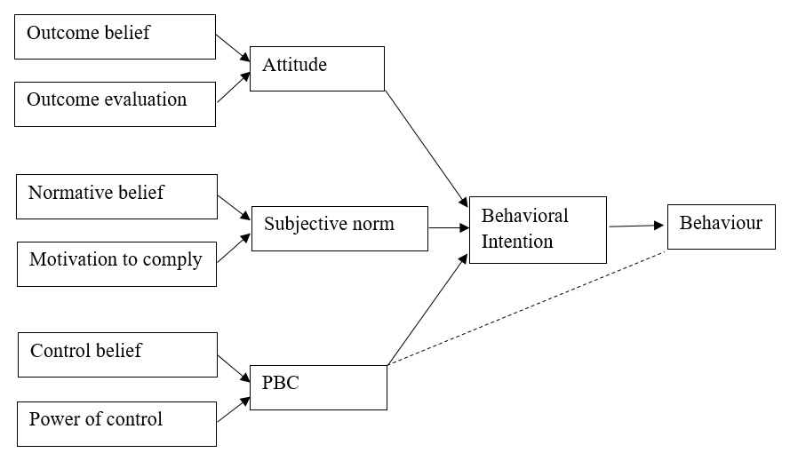
Figure 1. The Theory of Planned Behaviour, adapted from Ajzen (1991)
Each of the constructs can be further disaggregated into a number of indicators (Ajzen, 1991; Fishbein & Ajzen, 2010). Hence, attitude is composed of outcome beliefs (OB), which are individual’s beliefs about the consequences of the behaviour, and outcome evaluations (OE), which are evaluations of the desirability of those consequences. Subjective norm consists of normative beliefs (NB), which are beliefs about the normative expectations of significant ‘referents’ (e.g., family members, friends, or colleagues), and motivation to comply (MC), which is the degree of motivation to meet these referents’ normative expectations or approval of the behaviour. PBC is composed of control beliefs (CB), which are beliefs about the presence of factors that may facilitate and impede the performance of the behaviour, and the individual’s power of control (PC), which is the perceived ability to influence these factors (Ajzen, 1991; Fishbein & Ajzen, 2010).
The TPB has been used to predict human behaviours in various fields (Armitage & Conner, 2001; Hardeman et al., 2010; McDermott et al., 2015; Miller, 2017). For wildlife-related behaviours, the TPB has been used to predict intention to kill large predators in Latin America (Marchini & Macdonald, 2012; Amit & Jacobson, 2017), wild boars, sambars, pangolins, and tigers in Indonesia (St. John et al., 2018), deers in the United States (Hrubes et al., 2010; Shrestha et al., 2012), and willingness to consider wildlife management in routine cattle management activities (Willcox et al., 2012). Despite a great potential to provide insights for the development of behaviour change initiatives (Armitage & Conner, 2001; Hardeman et al., 2010; Rutter, 2000), the application of the TPB to predicting the intention to consume protected wildlife products is still limited.
  - Theory of Interpersonal Behaviour
The TIB (Triandis, 1977) adds several factors to the TPB constructs, namely social factor, affect, habit, and facilitating condition (see Figure 2). Apart from attitude, Triandis recognised the importance of social and emotional factors in forming intentions (Issock et al., 2020). Going beyond intentions as direct antecedents of behaviour, Triandis (1977) argued that behaviour is also mediated by the frequency of past behaviour – i.e., habit. And, both intention and habit are moderated by facilitating conditions (Triandis, 1977). The TIB, therefore, posits that any human behaviour can be predicted partly by the intention to perform that behaviour, partly by habit, and partly by the contextual constraints and conditions (Triandis, 1977, 1980). In the TIB, social factor refers to norms, roles, and self-concept. Norms encompass the social rules or expectations of others about what one should and should not do (Triandis, 1977). Roles are defined as ‘sets of behaviours that are considered appropriate for persons holding particular positions in a group’ (Triandis, 1977). Self-concept is a personal belief about one’s responsibility towards something (Shavelson et al., 1976). Some rhino horn consumers in Hanoi, for instance, considered it a responsibility to supply rhino horn to sick family members (Dang & Nielsen, 2018). Affect includes emotional factors, both positive and negative, that are distinct from rational thinking and may influence intentions (Triandis, 1980). Rhino horn consumers, for instance, considered being able to share rhino horn with business associates to reduce hangover at a party to bring them joy (Dang & Nielsen, 2018). Triandis (1977) emphasized the importance of habit, or past behaviours, in predicting future actions. Consumers who have often used rhino horn before may, for instance, be more likely to purchase this product again. Lastly, facilitating conditions refer to situational constraints or opportunities to perform a specific behaviour. If, for instance, you happen to know a rhino horn trader, this would be a facilitating condition for your intention to purchase this product.

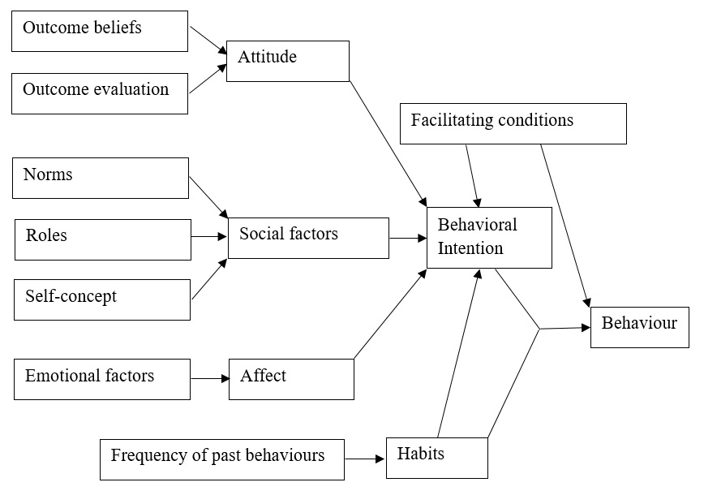
Figure 2. The Theory of Interpersonal Behaviour, adapted from Triandis (1980)
The application of the TIB has been limited compared to the TPB, although it appears to have better explanatory power (Egmond & Bruel, 2007). Turaga et al. (2010) asserted that the TIB can provide a broader theoretical framework for understanding environment-related behaviours. And according to Issock et al. (2020), there is still room to extend the theory.

- Methods
  - Study areas
We conducted a cross-sectional survey on individuals living in the larger area of Hanoi, Vietnam’s capital and second-largest city by population (GSOV, 2019). Hanoi has a total area of 3,358.6 square kilometres, with more than 8 million inhabitants (GSOV, 2019). The consumption of wild meat and other luxury wildlife products, including caterpillar fungus (cordyceps sinensis), bear bile, and tiger bone glue, is popular among high-income individuals in Hanoi (Drury, 2011). Hanoi has also been identified as a hotspot for the rhino horn trade, selling poached horns from Africa to local consumers and Chinese tourists (Stoner et al., 2017).
  - Questionnaire development
A preliminary questionnaire was developed through a literature review and focus group discussions and validated through an elicitation study. Adoption of the TPB and TIB were informed by Truong et al. (2015), Dang and Nielsen (2018), and Dang et al. (2020, 2021). We further followed Fishbein and Ajzen (1980) suggestion to use the elicitation method to identify potential additional factors that could contribute to predicting behavioural intention but have not been empirically validated, given that this is the first attempt to predict the intention to purchase rhino horn using these theories. Hence, we conducted three focus groups discussions. Each focus group consisted of 3-5 participants, including own-reported rhino horn consumers, intended consumers, and people with a history of trading this product. Willing participants were invited from previous studies (Dang & Nielsen, 2018; Dang et al., 2020, 2021). The discussion took departure in open questions about what factors affect, facilitate, and influence the intention to purchase rhino horn. The elicitation study provided two additional items for the PBC construct and one item for facilitating conditions.
We then conducted 30 pilot tests of the questionnaire on consumers in Hanoi. Adjustments of the questionnaire were made based on feedback from the focus groups and results of the pilot test. The final questionnaire contained several survey streams covering all constructs of the TPB and the TIB, as well as questions about respondents’ behaviours, beliefs, and knowledge about rhino horn. A five-point Likert scale ranging from “strongly disagree” (1) to “strongly agree” (5) was used to assess each statement of the following survey streams:
Attitudes toward the behaviour. Attitude was assessed using three scales adapted from Ajzen (2002) and informed by Truong et al. (2015) and Dang et al. (2021), including, e.g., “Rhino horn can help detoxify the body and/or reduce hangover.” Rhino horn is used for various medical purposes in Vietnam, but the most prevalent uses are for body detoxification and treating hangover (Truong et al., 2015). Dang et al. (2021) found that 32.7% of 345 respondents in their sample used rhino horn for general health benefits and treatment of high fever. Only a few respondents believed that rhino horn can treat terminal illnesses such as cancer (Dang et al., 2021). This use is thus not explicitly considered here.
Subjective norm. We assessed subjective norms using four scales measuring the influence of reference groups on consumers’ decision to purchase rhino horn. The scales were adopted from Ajzen (2002), informed by the results of Dang et al. (2020), who found that rhino horn consumers mostly listen to an informational reference group, which may consist of family members, friends, and colleagues with perceived expertise on the purchase and use of rhino horn. Utilitarian reference groups (i.e., individuals who have not used rhino horn but whose expectations consumers are often motivated to meet) also influence the rhino horn demand. In contrast, value-expressive reference groups (e.g., celebrities) have no influence (Dang et al., 2020). Hence, an example of a scale of normative belief (NB) was, “Most of my family members, friends, and colleagues supports that I should use rhino horn for medical purposes.”
Social factor. We measured social factors by three scales adapted from Issock et al. (2020). We asked respondents about their self-concept and role beliefs related to rhino conservation and the use of rhino horn. For instance, the scale role belief (RB) is, “I believe that it is my responsibility to contribute to conserving rhinos.” Since the social factor construct of the TIB is conceptually similar to the subjective norm construct of the TPB, especially normative beliefs (Pee et al., 2018), we only included scales measuring self-concept and role belief in this construct. Scales measuring normative beliefs are included in the subjective norm construct above.
Perceived behavioural control. We assessed perceived behavioural control by asking respondents about their confidence in the extent to which they could purchase rhino horn in the near future. Three scales were developed from the elicitation study, including, “I believe that I have enough resources (e.g., money, knowledge) to purchase and use rhino horn.”
Facilitating conditions. Dang et al. (2021) found that consumer preferences for rhino horn are influenced by the urgency of using this product (i.e., family members in need of rhino horn to treat diseases). However, consumers were also concerned about fake products when purchasing rhino horn (Dang & Nielsen, 2018). And obviously, price and the opportunity to share the costs of purchasing a piece of horn are facilitating conditions. Results of the focus groups furthermore indicated that consumers are more likely to purchase rhino horn if they are invited to do so by friends or have a good offer from traders (i.e., a bargain). We, therefore, used three scales to capture different aspects of facilitating conditions and as an example, asked respondents to rate the statement, “My family members are currently in need of rhino horn for medical purposes.”
Affect. We assessed factors affecting the intention to purchase rhino horn by two scales. Truong et al. (2015) found that rhino horn is often shared among high-income males as part of a search for pleasures. Hence, we used two scales to reflect affect, for instance, “I find it a pleasure to share rhino horn with my friends to reduce hangover after a party.”
Habit. Following previous research on determinants of pro-environmental behaviours (Fielding et al., 2012; Russell et al., 2017), we measured habits by asking the respondents if they had used rhino horn in the past, as well as their frequency of use. The habit scores were grouped into five categories: 1 (never), 2 (once), 3 (a few times), 4 (from time to time), and 5 (often).
Intentions. We used three scales adapted from Ajzen (2002) to assess a respondent’s intention to purchase rhino horn. First, we asked respondents to rate the statement, “I intend to purchase rhino horn for medicinal purposes in the near future.” Then we asked whether respondents had a specific plan to purchase this product and whether they would make a purchase if they had a good offer (e.g., a bargain price or a friend’s invitation to share the cost of a larger piece obtaining a price per unit advantage). In the analysis, the intention scales were averaged to create an overall intention score, with a higher score suggesting greater intention (Francis et al., 2004). Of these eight constructs, affect, habit, and intention were considered reflective because they were uni-dimensional and removing a scale did not change the construct meaning. Attitude, subjective norm, social factor, perceived behavioural control, and facilitating condition on the other hand were formative because the meaning of a construct was jointly determined by each scale and removing a scale could change the construct meaning (Pee et al., 2008).
  - Data collection
The survey was conducted on individuals with basic knowledge about rhino horn, including a large proportion having used rhino horn at least once. Respondents were selected from previous studies (Dang et al., 2021, 2020; Dang et al., 2018; Truong et al., 2015). We used snowballing to expand this initial sample, and more respondents were identified through the personal networks of the first author and four research assistants. Our pilot study with random consumers revealed that not everyone possessed knowledge about the potential use of rhino horn. As a result, they could not meaningfully contribute to the survey. We, therefore, started interviews with a screening question asking potential respondents, ‘Have you ever heard about the potential benefits of using rhino horn.’ If they answered ‘yes’, we invited them to participate in the survey. Data was collected over five months, from May to September 2020. Interviews lasted 25-30 minutes and were conducted face to face at a place convenient to the respondents.
  - Data analysis
We used Structural Equation Modelling (SEM) to evaluate the influence of the constructs of the two theories on the intention to purchase rhino horn. SEM is considered an extension of multiple regression combined with factor analysis (Hox & Bechger, 2011). SEM facilitates models with both latent and observed variables and enables examining the moderating influence of some variables on others. First, we estimate the TPB model and the TIB model separately. We then specify and estimate a third model combining all constructs of the TPB and the TIB (Figure 3).
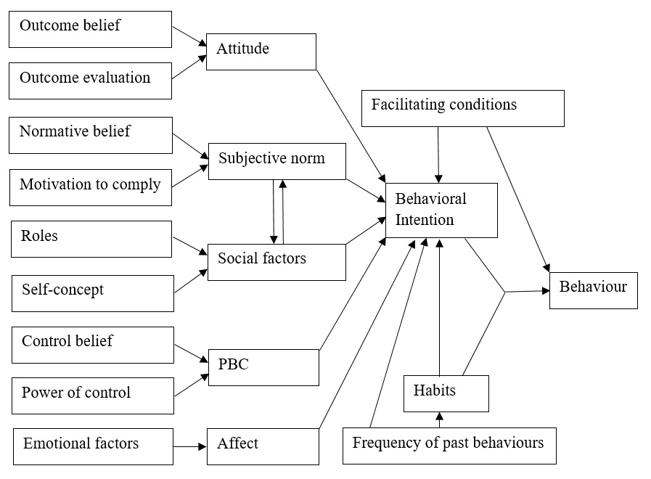
Figure 3. Proposed model combining constructs of the TPB and the TIB
In these models, behavioral intentions and behaviours (i.e., dependent variables) are determined either directly or indirectly by exogenous variables (i.e., independent variables), and some exogenous latent variables (e.g., outcome beliefs, reference group influences) may influence the values of endogenous variables (i.e., behavioral intentions) (Iacobucci, 2009). To prepare the collected data for the analysis, we checked for outliners and missing values, and assessed the assumptions of multivariate normality. Because the dependent variable – behavioral intention – had a negatively skewed distribution with a fat tail (see Figure 4, Appendix A, Supplementary materials), we applied a log transformation of this variable and used the maximum likelihood method to estimate the model parameters.
The analysis is composed of two main stages: (a) a confirmatory factor analysis (CFA) to assess the measurement model, which relates the variables to the constructs, and (b) a structural equation analysis to evaluate the path relationship among the constructs (Anderson & Gerbing, 1988). In the first stage, we used a number of indices to assess the extent to which the model fits the observed data, including the ratio of chi-square to degrees-of-freedom (χ²/d.f.), the Root-Mean-Square-Error of Approximation (RMSEA), the Standardized Root-Mean-Square-Residual (SRMR), the Goodness of Fit Index (GFI), the Tucker-Lewis Index (TLI), the Comparative Fit Index (CFI), and the Normal Fit Index (NFI). Hair et al. (2000) recommended a maximum value of 5.0 for χ²/d.f., while Kline (2005) recommended that a high GFI, TLI, CFI or NFI (≥0.90) and a low RMSEA or SRMR (≤0.10) would indicate a good model fit. To assess the reliability among items of each construct, we used the Cronbach’s alpha (CA), which has a recommended value of 0.7 (Nunnally, 1978). We evaluated construct validity through convergent and discriminant validity. Convergent validity includes factor loadings (FL), composite reliability (CR), and average variance extracted (AVE). The recommended minimum value for FL is 0.6 (Chin et al., 1997), CR is 0.6 (Bagozzi & Yi, 1988), and AVE 0.5 (Fornell & Larcker, 1981). Discriminant validity was assessed by comparing the square root values of the AVE across constructs. Finally, we used the R-squared to measure the explained variance of the endogenous variables. We used the bestNormalize package (Peterson & Cavanaugh, 2019) to assess the optimal data transformation and the lavaan package (Rosseel, 2012) for data analysis in Rstudio version 1.2.5042.
  - Ethical considerations
This study received ethical approval from the Research Ethics Committee for SCIENCE and SUND at the University of Copenhagen (Ref. 504-0069/19-5000) and the Ethical Review Board at the Hanoi University of Public Health (Ref. 461/2019/YTCC-HD3). Our study team complied with all policies and procedures of the authorising institutions' review boards. Given the sensitive nature of rhino horn use, the study team followed strict ethical guidelines and an informed consent policy. Potential respondents were informed of the study purposes, potential benefits and risks when participating in interviews and that they at any time could withdraw from the interview. Data from interviews were recorded using password-protected tablets, and collected data were uploaded immediately to an encrypted cloud server, the security of which was handled by the University of Copenhagen's IT department.

- Result
A total of 427 respondents participated in our survey. Of these, 281 had used rhino horn at least once (henceforth users), while 146 had not (henceforth non-users). The most prevalent uses of rhino horn were for body detoxification (70.5%) and hangover reduction (65.5%). A considerable proportion of respondents used rhino horn as a health tonic (18.5%) and for treatment of high fever (14.6%). Among users, 13.5% used rhino horn daily or whenever they had a reason such as a hangover, whereas more than two thirds (76.6%) had used rhino horn just once or a few times in their lives (see Appendix B, Supplementary materials). Mean respondent age was 48 and the median 46. The average individual monthly income was in the range of VND50-59 million (approx. US$2,100-2,800), which is about 15 times higher than the national average of VND3.76 million (approx. US$176) in 2018 (GSOV, 2018). Further information about respondent socio-demographics and their beliefs and knowledge about rhino horn are presented in Appendix C and Appendix D respectively (Supplementary materials).
  - Measurement models
We first estimated measurement models with all the scale items. Because the test of factor loadings revealed low loadings on items ATT3, ATT4, SN4, SF3, and PBC3, we omitted these items and reestimated the measurement models. The goodness-of-fit indices indicate an acceptable fit between the reestimated models and the observed data (Table 1). Of the three measurement models, the TIB model has the best fit. Reliability (CA) and convergent validity (FL, CR, AVE) measures are summarised in Table 2.
Table 1. Goodness-of-fit indices of the measurement models
 | χ²/d.f. | RMSEA | SRMR | GFI | TLI | CFI | NFI
Combined model | 3.43 | 0.07 | 0.06 | 0.93 | 0.85 | 0.90 | 0.87
TPB model | 6.36 | 0.11 | 0.07 | 0.96 | 0.83 | 0.91 | 0.90
TIB model | 1.57 | 0.04 | 0.04 | 0.98 | 0.97 | 0.98 | 0.96
Recommended value | ≤5.0 | ≤0.10 | ≤0.10 | ≥0.90 | ≥0.90 | ≥0.90 | ≥0.90

Table 2. Measurement model: reliability and convergent validity.
Constructs and variables | Statements | Combined model |  |  |  | TPB |  |  |  | TIB
Constructs and variables | Statements | FL | CA | CR | AVE | FL | CA | CR | AVE | FL | CA | CR | AVE
Attitude (ATT) |  |  | 0.63 | 0.63 | 0.46 |  | 0.63 | 0.63 | 0.46 |  | 0.63 | 0.63 | 0.46
ATT1 | Rhino horn can help detoxify the body and reduce hangover. | 0.66 |  |  |  | 0.65 |  |  |  | 0.66
ATT2 | Rhino horn has general health benefits. | 0.70 |  |  |  | 0.71 |  |  |  | 0.70
Subjective Norm (SN) |  |  | 0.71 | 0.78 | 0.57 |  | 0.71 | 0.81 | 0.63 |  | NA | NA | NA
SN1 | How much do you let the opinion of these knowledgeable individuals determine whether you will purchase rhino horn or not? | 0.64 |  |  |  | 0.59
SN2 | Most of my family members, friends, and colleagues supports that I should use rhino horn for medicinal purposes. | 0.57 |  |  |  | 0.52
SN3 | How much do you let the opinion of your family members, friends or colleagues determine whether you will purchase rhino horn or not? | 0.89 |  |  |  | 0.99
Social Factor (SF) |  |  | 0.70 | 0.70 | 0.53 |  | NA | NA | NA |  | 0.69 | 0.69 | 0.53
SF1 | As a Vietnamese citizen, it is appropriate for me to purchase and/or use rhino horn for health-related purposes. | 0.73 |  |  |  |  |  |  |  | 0.73
SF2 | I consider that using rhino horn is suitable for my age. | 0.73 |  |  |  |  |  |  |  | 0.73
Perceived Behavioral Control (PBC) |  |  | 0.70 | 0.70 | 0.53 |  | 0.68 | 0.68 | 0.52 |  | NA | NA | NA
PBC1 | If I want to, I am confident that I could purchase rhino horn in the near future. | 0.63 |  |  |  | 0.67
PBC2 | I believe that I have enough resources (e.g., money, knowledge) to purchase rhino horn. | 0.83 |  |  |  | 0.78
Facilitating Condition (FC) |  |  | 0.59 | 0.60 | 0.33 |  | NA | NA | NA |  | 0.59 | 0.60 | 0.33
FC1 | My family members, including me, currently need rhino horn to treat diseases or for general health benefits. | 0.61 |  |  |  |  |  |  |  | 0.61
FC2 | I know how to check whether a rhino horn is authentic. | 0.54 |  |  |  |  |  |  |  | 0.54
FC3 | I have friends with whom I can share the cost of the purchase of rhino horn. | 0.57 |  |  |  |  |  |  |  | 0.57
Affect (AFF) |  |  | 0.73 | 0.73 | 0.58 |  | NA | NA | NA |  | 0.73 | 0.75 | 0.60
AFF1 | It is pleasant to share rhino horn with friends to reduce hangover in a party. | 0.67 |  |  |  |  |  |  |  | 0.60
AFF2 | I would feel fulfilled when gifting rhino horn to my family members to treat diseases. | 0.88 |  |  |  |  |  |  |  | 0.97

The facilitating condition construct did not meet the recommended values of CA and AVE and was therefore not included in the structural model for the TIB. The attitude construct had good factor loadings and marginally met the criteria for convergent validity. Other constructs, incl. subjective norm, social factor, affect, and PBC, exceeded the recommended values for CA, CR, and AVE, suggesting that they are all reliable constructs.
To evaluate discriminant validity, we compared the square root values of the AVE across constructs. The value for each construct was greater than its correlations with other constructs suggesting that discriminant validity is satisfied (Fornell & Larcker, 1982)
  - Structural models
We estimated SEMs, which all meet the recommended threshold values and compared the results using the fit indices (Table 3). Of the TPB model presented in Figure 7, all the scales were significant in determining their constructs, but among the paths of the constructs, only PBC was significant. The model explained 86% of the variance in the respondents’ intention to purchase rhino horn (R² = 0.86).
Table 3. Goodness-of-fit indices of the structural models
 | χ²/d.f. | RMSEA | SRMR | GFI | TLI | CFI | NFI
Combined model | 2.08 | 0.05 | 0.02 | 0.99 | 0.99 | 0.99 | 0.99
TPB | 4.80 | 0.09 | 0.06 | 0.96 | 0.90 | 0.94 | 0.93
TIB | 1.59 | 0.04 | 0.02 | 0.99 | 0.98 | 0.99 | 0.98
Recommended value | ≤5.0 | ≤0.10 | ≤0.10 | ≥0.90 | ≥0.90 | ≥0.90 | ≥0.90

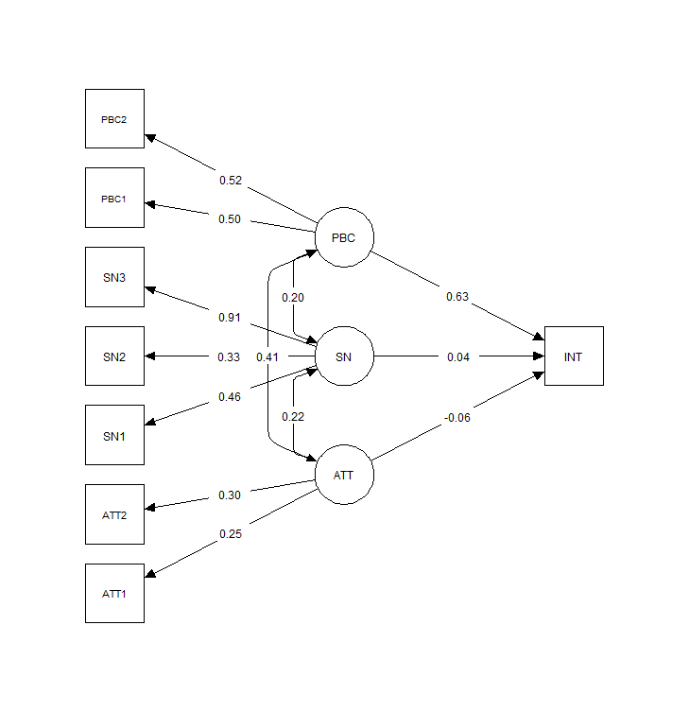
0.090***
0.003
-0.008
R² = 0.86
0.50***
0.53***
0.91***
0.33***
0.45***
0.30***
0.25***
Figure 7. Results of the structural model analysis for the TPB model (∗∗∗ indicates significance at 1% level).

In the TIB-based model, habit (HAB) did not have any significant effect. Thus, we removed habit and reestimated this model (Figure 8). All scales were significant in determining the corresponding constructs. The ATT construct was significant at the 0.1 level, while the SF construct and the AFF construct were significant at the 0.05 level and at the 0.01 level, respectively. The relationships between the three constructs and intention were all positive, indicating that the more positive ATT toward rhino horn, the more favourable SF, and the more pleasure and fulfilment it brings (i.e., AFF), the more likely one is to intend to purchase rhino horn. However, this model explained only 22% of the variance in intentions (R² = 0.22).
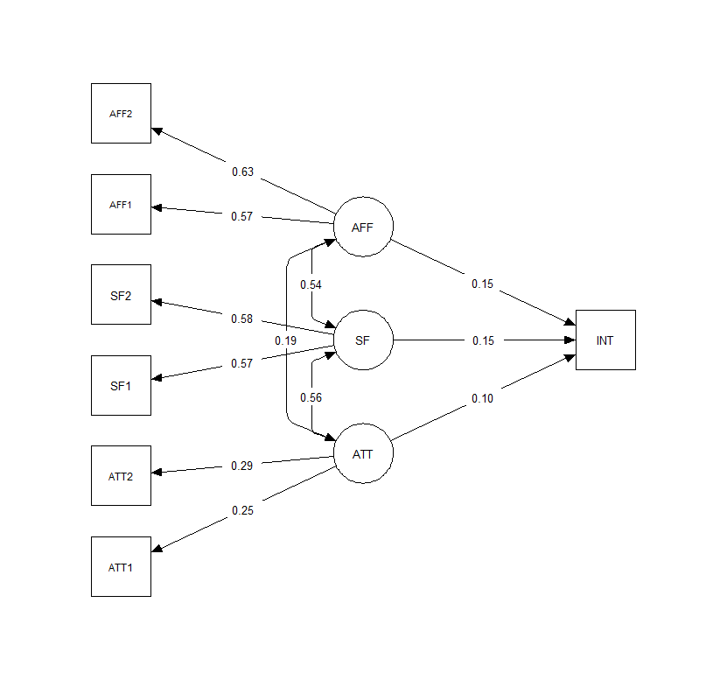
0.024***
0.016**
0.016*
R² = 0.22
0.63***
0.58***
0.58***
0.57***
0.29***
0.25***
Figure 8. Results of structural model analysis for the TIB model (∗∗∗, ∗∗, ∗ indicate significance at 1%, 5%, 10% level).
In the combined model, the four constructs ATT, SN, SF, and AFF were not significant. Hence we removed these constructs. We added a dummy for previous use of rhino horn (PRE) and reestimated the model (see Figure 9). All the scales and constructs were significant at the 0.01 level. PBC had a positive effect on intention, indicating that the stronger the perceived control of using rhino horn (i.e., respondents believed that they have the ability to purchase and know how to use rhino horn), the more likely one is to intend to purchase rhino horn. Respondents who had used rhino horn at least once in their lives also had a stronger intention to purchase rhino horn. However, the frequency of use negatively influenced the intention to purchase rhino horn in the near future. This model explained 87% of the variance in intentions (R² = 0.87).

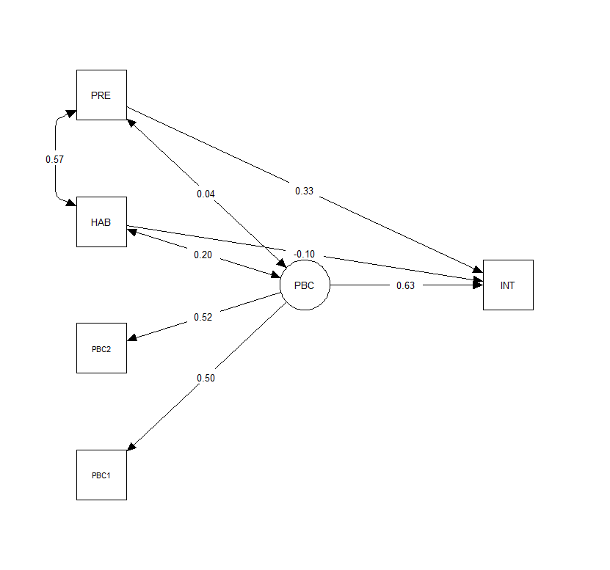
0.089***
0.046***
-0.014***
R² = 0.87
0.20**
0.57***
0.53***
0.50***
Figure 9. Results of structural model analysis for the combined model (∗∗∗ indicates significance at 1% level).
The three models are compared in Table 4. The models are statistically different (p-value<0.01, Vuong test). The TIB model had lowest predictive power while the combined model had the highest predictive power as well as best relative fit while being the most parsimonious model (judged by the values of AIC and BIC).
Table 4. Coefficients of the path relationships of the TPB, TIB, and combined model (stardard errors are in parentheses).
Pathway | TPB | TIB | Combined model
ATT → INT | -0.008 (0.005) | 0.016** (0.008) | N.A.
SN → INT | 0.003 (0.004) | N.A. | N.A.
SF → INT | N.A. | 0.016* (0.009) | N.A.
PBC → INT | 0.090*** (0.005) | N.A. | 0.089*** (0.004)
AFF → INT | N.A. | 0.024*** (0.007) | N.A.
HAB → INT | N.A. | N.A. | -0.014*** (0.005)
PRE → INT | N.A. | N.A. | 0.046*** (0.014)
R-square | 0.86 | 0.22 | 0.87
AIC | 3875.71 | 3475.49 | 1988.75
BIC | 3960.90 | 3552.57 | 2041.49
∗∗∗, ∗∗, ∗ indicate significance at 1%, 5%, 10% level.
PBC emerged as the strongest predictor of intention (β=0.089) across models, while previous use was the second strongest (β=0.046). We also tested the effect of socio-demographic variables. Only age had a significantly negative effect (p <0.05), indicating that older respondents were less likely to intend to purchase rhino horn (Appendix E, Supplementary materials).

- Discussion
Understanding socio-psychological factors determining the decision to purchase rhino horn is critical for designing behaviour modification campaigns to reduce rhino horn demand (Dang & Nielsen, 2020; Veríssimo et al., 2020). This study appears to be the first attempt to combine different behavioral theories to understand the determinants of the intention to purchase rhino horn. Testing the TPB, the TIB, and a combined model, we found that intention to purchase rhino horn in our sample in Hanoi was driven mainly by the two constructs - PBC and habit.
Of the three models, only the TPB and the combined model had high R² values and hence potential to predict intention . In the TPB model, PBC had a significantly positive effect on intention, while attitude and subjective norm had no significant effects. In the TIB model, the three constructs - attitude, social factor, and affect - were significant. But this model had low predictive power. The facilitation condition construct had low factor loadings, possibly because traditional medicine, including rhino horn, is often used preemptively rather than as a treatment. Hence, the urgency of using rhino horn was not a significant predictor of the intention to purchase rhino horn.
PBC emerged as the strongest determinant of intention in the TPB model and the combined model. Therefore, PBC and behavioural intentions could be used to directly predict behaviour (Ajzen, 1991). In our study, the intention to purchase rhino horn to a large extent relied on consumers’ beliefs about their control over this behaviour and particularly whether they have sufficient disposable income to purchase rhino horn, whether they know a trader and how to use rhino horn. This implies that campaigns need to be directed toward individuals with high disposable income and access to rhino horn traders or retailers through their networks.
The fact that attitude and subjective norm did not significantly predict intention may be explained by the general positive attitudes of Vietnamese consumers toward the use of traditional medicine including wildlife ingredients such as rhino horn, tiger bone glue, and bear bile (Dang et al., 2020; Milliken & Shaw, 2012). Beliefs in the medicinal efficacy of these products are deeply rooted in Vietnamese society (Dang & Nielsen, 2020). Hence, the reason why the effect of the attitude construct was insignificant in the TPB model and the combined model may simply be due to low variation between respondents (see Figure 5, Appendix A, Supplemantary Information). Similarly, the general acceptance of wildlife use, attracting no stigma in Vietnamese society, and the predisposition to comply with the norms and expectations of others may explain the lack of any effect of respondents normative beliefs about the opinions of significant others and motivations to comply with these groups may have caused similarly low variation and lack of effect of these measures (see Figure 6, Appendix E, Supplementary materials).
The two TIB constructs – social factor and affect – did not have any significant effects in the combined model. These results resonate with Dang and Nielsen (2018) and Truong et al. (2015), finding that using rhino horn is socially acceptable and that consumers are not concerned about the conservation of rhinos. Consumers generally find it a pleasure to share rhino horn with others in a party context (Truong et al., 2015) and feel fulfilled when gifting this product to their sick family members (Dang & Nielsen, 2018). Hence, the social factor (incl. self-concept, role belief) and affect scores did not vary much across the sample (see Appendix F, Supplementary materials). In the combined model, habit had a significant effect on intention. This finding adds empirical support to the importance of past experience and its frequency in determining the intention to purchase illegal wildlife products. Respondents having previously used rhino horn were more likely to intend to purchase this product in the future. This suggests that behaviour modification campaigns should target habitual users. However, the effect of frequency was negative, suggesting that the more often respondents use rhino horn, the less likely they intend to purchase this product again in the near future. There are at least two explanations for this result. First, frequent users may have possessed some rhino horn at the time of the interview, which, according to focus group discussions, can be used over a long time period. Alternatively, they could have used rhino horn sufficiently many times without experiencing the desired medicinal effect and realised that it was not worth the considerable investment. Respondents who had never used rhino horn or only tried it once had a stronger intention to purchase this product. A single direct experience using rhino horn could have positive effects on consumers by providing more reliable information about the good and by reducing perceived risks (de Groot et al. 2009). Even limited experience and trial would enable consumers to verify the lack of risk (e.g., unpleasant taste or side effects) without revealing the limited efficacy in treating various conditions. The fact that habit is the second strongest determinant of intention is consistent with findings on a range of subjects (Alhassan et al., 2018; Issock et al., 2020; Klӧckner, 2013; Russell et al., 2017; Fielding et al., 2012; Kupfer et al., 2019).
Our results suggested that the TPB and the TIB both have the potential to predict intentions to purchase and use of illegal luxury wildlife products. Each theory provided a significant predictor of intention, and the constructs can be used in combination to provide a broader framework for understanding the determinants of demand for wildlife products. Nevertheless, our results must be interpreted with caution due to inherent limitations. First, our respondents were mostly high-income individuals living in urban areas in Hanoi, representing the largest group of potential rhino horn consumers in Vietnam (Truong et al., 2015; Dang et al., 2021). Individuals of other profiles (e.g., those of lower income brackets) were less likely to participate in our survey. Respondents having no knowledge about the use of rhino horn in traditional medicine were excluded by default. Hence our findings cannot be generalised to the Vietnamese population. Second, some scales had low factor loadings and were removed from the model, including the whole facilitating condition construct. These scales were either developed from the elicitation study or adapted from prior studies on different behaviours but not validated on similar behaviours. This is unavoidable given that this is the first study to attempt to predict the intention to purchase rhino horn using these theories. Third, the relationship between intention and respondents’ past purchase of rhino horn was not significant. And, our study did not provide empirical evidence about the link between intention to purchase and actual purchase in the near future. This would require a randomised controlled trial or a temporally lagged design measuring intentions and behaviours at different points in time (e.g., Russell et al., 2017).

- Conclusions and recommendations
This study illustrates the potential of combining the TPB and the TIB to predict the intention to purchase rhino horn. Our findings indicate that PBC is the most important determinant, while habit is also a significant predictor of intention to purchase rhino horn. More frequent and older users are less likely to intend to purchase rhino horn in the near future. Attitude, subjective norm, social factor, and affect had no significant effects. These findings provide important implications for the development of policies and behaviour modification campaigns. Campaigns should focus on consumers with high disposable income, who have access to rhino horn traders and are knowledge about the use of rhino horn. The effect of habit suggests that consumers having used rhino horn only once or a few times should be targeted at as priority campaign audiences because they are more likely to intend to purchase rhino horn in the near future. Campaigns should also be directed at relatively younger individuals in this group who may have a less traditional mindset and be more responsive to campaign messages. Besides, efforts to enforce existing options for legal recurse through the Vietnamese penal code should be strengthened to reduce consumers' perceived ability to purchase rhino horn at no risk. Graduated sanctions increasing in magnitude with offender income should be considered to affect the utility of high income consumers. Overall the wildlife trade in Vietnam must be better controlled both in consideration of biodiversity conservation and in view of the potential risk of zoonoses transmission.

Acknowledgements
This study has received funding from the European Union’s Horizon 2020 research and innovation programme under the Marie Skłodowska-Curie grant agreement No. 801199. The Rufford Foundation and the People Trust for Endangered Species provided funding for data collection, for which the authors are grateful.

Authors’ Contributions
All authors contributed to the conceptualization of the project and the development of the survey and sampling procedures. D.V.H.N. and M.R.N. jointly designed the study. D.V.H.N. led the fieldwork, analysed the collected data, and wrote the first draft of the manuscript. All authors reviewed and edited the manuscript and gave final approval for publication.

Competing interests
The authors declare no competing interests.

Data availability
The dataset analysed in this study is available at Mendeley Data at https://doi.org/xxx.

Code availability
The R and NGENE script used in this analysis is available from the authors upon reasonable request.

References
Ahuvia, A. C, & Wong, N. Y. (1998). Personal taste and family face: Luxury consumption in Confucian and Western societies. Psychology and Marketing, 15(5), 423–441.
Ajzen, I. (1991). The Theory of Planned Behavior. Organizational Behavior and Human Decision Processes, 50, 179-211.
Ajzen, I. (2002). Constructing a TPB questionnaire: Conceptual and Methodological Considerations. Retrieved from http://citeseerx.ist.psu.edu/viewdoc/download?doi=10.1.1.601.956&rep=rep1&type=pdf
Alhassan, H., Asante, F.A., Oteng-Ababio, M., & Bawakyillenuo, S. (2018). Application of theory of planned behaviour to households’ source separation behaviour in Ghana. Management of Environmental Quality, 29(4), 704-721.
Amit, R., & Jacobson, S. K. (2017). Understanding rancher coexistence with jaguars and pumas: a typology for conservation practice. Biodiversity Conservation, 26, 1353-1374.
Anderson, J. C., & Gerbing, D. W. (1988). Structural equation modeling in practice: A review and recommended two-step approach. Psychological Bulletin, 103(3), 411–423.
Armitage, C. J., & Conner, M. (2001). Efficacy of the theory of planned behaviour: A meta-analytic review. British Journal of Social Psychology, 40(4), 471–499.
Bagozzi, R. P., & Yi, Y. (1988). On the evaluation of structural equation models. Journal of the Academy of Marketing Science, 16(1), 74–94.
Chin, W. W., Gopal, A., & Salisbury, W. D. (1997). Advancing the theory of adaptive structuration: the development of a scale to measure faithfulness of appropriation. Information Systems Research, 8(4), 342–367.
Dang, V. H. N. (2021). When Cheap Talk is not that cheap - interviewing the super-rich about illegal wildlife consumption. International Journal of Social Research Methodology, 1-6. DOI: 10.1080/13645579.2021.1904117
Dang, V. H. N., & Nielsen, M. R. (2018). Understanding utilitarian and hedonic values determining the demand for rhino horn in Vietnam. Human Dimensions of Wildlife, 23(5), 417-443. DOI: 10.1080/10871209.2018.1449038
Dang, V. H. N., & Nielsen, M. R. (2020). Evidence or delusion: A critique of contemporary rhino horn demand reduction strategies. Human Dimensions of Wildlife, 26(4), 1-11. DOI: 10.1080/10871209.2020.1818896
Dang, V. H. N., Nielsen, M. R., & Jacobsen, J. B. (2020). Reference group influences and campaign exposure effects on rhino horn demand: Qualitative insights from Vietnam. People and Nature, 2(4), 923-939. DOI: 10.1002/pan3.10121
Dang, V. H. N., Nielsen, M. R., & Jacobsen, J. B. (2021). Generating insights to reduce demand for rhino horn in Vietnam: An application of choice experiments. Manuscript submitted for publication.
De Groot, I. M., Antonides, G., Read, D., & van Raaij, W. F. (2009). The effects of direct experience on consumer product evaluation. The Journal of Socio-Economics, 38, 509-518.
Drury, R. (2011). Hungry for success: Urban consumer demand for wild animal products in Vietnam. Conservation and Society, 9(3), 247–257.
Egmond, C. & Bruel, R. (2007). Nothing is as practical as a good theory: Analysis of theories and a tool for developing interventions to influence energy behaviour. Scientific Reports produced within the BEHAVE Project. Evaluation of Energy Behavioural Change Programmes Intelligent Energy – Europe (IEE).
Eikelboom, J. A. J., Nuijten, R. J. M., Wang, Y. X. G., Schroder, B., Heitkonig, I. M. A., Mooij, W. M., van Langevelde, F., & Prins, H. H. T. (2020). Will legal international rhino horn trade save wild rhino populations? Global Ecology and Conservation, 23, e01145.
Fielding, K., Russell, S., Spinks, A., & Mankad, A. (2012). Determinants of household water
Fishbein, M., & Ajzen, I. (1980). Understanding attitudes and predicting social behavior. Eglewood Cliffs, NJ: Prentice-Hall.
Fishbein, M., & Ajzen, I. (2010). Predicting and changing behavior. The reasoned action approach. New York, NY: Psychology Press.
Fornell, C., & Larcker, D. F. (1981). Evaluating structural equation models with unobservable variables and measurement error. Journal of Marketing Research, 19(1), 39–50.
Francis, J. J., Eccles, M. P., Johnston, M., Walker, A. E., Grimshaw, J. M., Foy, R., et al. (2004). Constructing questionnaires based on the theory of planned behaviour. A manual for health services researchers. Newcastle upon Tyne, UK: Centre for Health Services Research, University of Newcastle upon Tyne.
General Statistics Office of Vietnam (2019). Socio-economic situation of Vietnam in 2018. Retrieved from https://www.gso.gov.vn/default.aspx?tabid=382&idmid=2&ItemID=19041
Hair, J. F., Anderson, R. E., Tatham, R. L., & Black, W. C. (1998). Multivariate Data Analysis. Upper Saddle River, NJ: Prentice Hall.
Hardeman , W., Johnston, M., Johnston, D., Bonetti, D., Wareham, N., & Kinmonth, A. N. (2002). Application of the Theory of Planned Behaviour in behaviour change interventions: A systematic review. Psychology & Health, 17(2), 123-158.
Hrubes, D., Ajzen, I., & Daigle, J. (2001). Predicting hunting intentions and behavior: An application of the theory of planned behavior. Leisure Sciences, 23(3), 165–178.
Issock, P. B. I., Roberts-Lombard, M., & Mpinganjira, M. (2020). Understanding household waste separation in South Africa: An empirical study based on an extended theory of interpersonal behaviour. Management of Environmental Quality, 31(3), 530-547.
Kline, R. B. (1998). Principles and Practice of Structural Equation Modeling. New York, NY: Guilford Press.
Klӧckner, C. A. (2013). A comprehensive model of the psychology of environmental behaviour – a meta-analysis. Global Environmental Change, 23(5), 1028-1038.
Kupfer, T. R., Wyles, K. J., Watson, F., La Ragione, R. M., Chambers, M. A., & Macdonald, A. S. (2019). Determinants of hand hygiene behaviour based on the Theory of Interpersonal Behaviour. Journal of Infection Prevention, 20(5), 232-237.
MacMillan, D., Bozzola, M., Hanley, N., Kasterine, A. & Sheremet, O. (2017). Demand in Viet Nam for rhino horn used in traditional medicine. Geneva, Switzerland: International Trade Center.
Marchini, S., & Macdonald, D.W. (2012). Predicting ranchers’ intention to kill jaguars: case studies in Amazonia and Pantanal. Biological Conservation, 147, 213–221.
McDermott, M. S., Oliver, M., Svenson, A., Simnadis, T., Beck, E. J., Coltman, T., Iverson, D., Caputi, P., & Sharma, R. (2015). The theory of planned behaviour and discrete food choices: a systematic review and meta-analysis. International Journal of Behavioral Nutrition and Physical Activity, 12, 162.
Miller, Z. D. (2017). The Enduring Use of the Theory of Planned Behavior. Human Dimensions of Wildlife, 22(6), 583-590.
Milliken, T., & Shaw, J. (2012). The South Africa – Viet Nam rhino horn trade nexus: A deadly combination of institutional lapses, corrupt wildlife industry professionals and Asian crime syndicates. Johannesburg, South Africa: TRAFFIC.
Nowell, K. (2012). Species Trade and Conservation. Rhinoceroses: Assessment of Rhino Horn as a Traditional Medicine. A report prepared for the CITES Secretariat. TRAFFIC.
Nunnally, J. (1978). Psychometric Theory. second ed. New York, NY: McGraw-Hill.
Pee, L. G., Woon, I. M. Y., & Kankanhalli, A. (2008). Explaining non-work-related computing in the workplace: A comparison of alternative models. Information and Management, 45, 120-130.
Peterson R. A., Cavanaugh, J. E. (2019). Ordered quantile normalization: a semiparametric transformation built for the cross-validation era. Journal of Applied Statistics, 47(13-15), 1-16.
Rosseel, Y. (2012). lavaan: an R package for structural equation modeling and more. Journal of Statistical Software, 48(2), 1-36. DOI: 10.18637/jss.v048.i02
Russell, S. V., Young, C. W., Unsworth, K. L., & Robinson, C. (2017). Bringing habits and emotions into food waste behaviour. Resources, Conservation and Recycling, 125, 107-114.
Rutter, D. R. (2000). Attendance and reattendance for breast cancer screening: A prospective 3-year test of the Theory of Planned Behaviour. British Journal of Health Psychology, 5, 1-13.
Shavelson, R. J., Hubner, J. J., & Stanton, G. C. (1976). Self-concept: Validation of construct interpretations. Review of Educational Research, 46(3), 407-441.
Shrestha, S. K., Burns, R. C., Pierskalla, C. D., & Selin, S. (2012). Predicting deer hunting intentions using the theory of planned behavior: A survey of Oregon big game hunters. Human Dimensions of Wildlife, 17, 129–140.
St. John, F. A. V. Linkie, M., Martyr, D. J., Milliyanawati, B., McKay, J. E., Mangunjaya, F. M., Leader-Williams, N., & Struebig, M. J. (2018). Intention to kill: Tolerance and illegal persecution of Sumatran tigers and sympatric species. Conservation Letters, 11, e12451.
Stoner, S., Verhij, P., & Wu, M. J. (2017). Illegal rhino horn trade dynamics in Nhi Khe, Viet Nam from a criminal perspective: A case study. Retrieved from https://wildlifejustice.org/wp-content/uploads/2018/08/BlackBusiness-2017.pdf
't Sas-Rolfes, M. (2012). The rhino poaching crisis: A market analysis. Retrieved from http://www.rhinoresourcecenter.com/pdf_files/133/1331370813.pdf
Triandis, H. C. (1977). Interpersonal Behavior. Monterey, CA: Brooks/Cole.
Triandis, H. C. (1980), “Values, attitudes, and interpersonal behavior”, in Howe, H.E. and Page, M.M. (Eds), Nebraska Symposium on Motivation 1979, University of Nebraska Press, Lincoln, pp. 195-259.
Truong, V. D., Dang, V. H. N., & Hall, C. M. (2015). The marketplace management of illegal elixirs: Illicit consumption of rhino horn. Consumption Markets & Culture, 19(4), 353-369.
Turaga, R. H. R., Howarth, R. B., & Borsuk, M. E. (2010). Pro-environmental behavior: Rational choice meets moral motivation. Annals of the New York Academy of Sciences, 1185, 211-224.
Veríssimo, D., ‘T Sas-rolfes, M., & Glikman, J. A. (2020). Influencing consumer demand is vital for tackling the illegal wildlife trade. People and Nature, 2(4), 872–876.
Willcox, A. S., Giuliano, W. M., & Monroe, M. C. (2012). Predicting cattle rancher wildlife management activities: An application of the Theory of Planned Behavior. Human Dimensions of Wildlife, 17(3), 159-173. DOI: 10.1080/10871209.2012.639043
Yuriev, A., Dahmen, M., Paillé, P., Boiral, O., & Guillaumie, L. (2020). Pro-environmental behaviors through the lens of the theory of planned behavior: A scoping review. Resources, Conservation and Recycling, 155, e104660.

The following text is read to respondents before asking this question: “Now, please think about the people or groups who influence your decision to buy or use rhino horn. This includes in particular people you consider having good knowledge about rhino horn and who you may want to consult when you intend to buy rhino horn. We call them “reference groups.”

