Terminology use in animal personality research: a self-report questionnaire and a systematic review

Alfredo Sánchez-Tójar^{1*$}, Maria Moiron^{2,3$}, Petri T. Niemelä^{4,5$}

$ All authors contributed equally to this work

¹Department of Evolutionary Biology, Bielefeld University, Germany
²CEFE, Univ Montpellier, CNRS, EPHE, IRD, Montpellier, France
³Institute of Avian Research, Wilhelmshaven, Germany
⁴Behavioral Ecology, Department of Biology, Ludwig-Maximillians University of Munich, Planegg-Martinsried, Germany
⁵Organismal and Evolutionary Biology Research Programme, University of Helsinki, Helsinki, Finland

*Author for correspondence: Alfredo Sánchez-Tójar (alfredo.tojar@gmail.com)

ORCIDs and email addresses:
Alfredo Sánchez-Tójar: 0000-0002-2886-0649; alfredo.tojar@gmail.com
Maria Moiron: 0000-0003-0991-1460; mariamoironc@gmail.com
Petri T. Niemelä: 0000-0002-7518-4057; petri.t.niemela@gmail.com

This preprint was updated after two rounds of peer-review in a single journal and involving two reviewers and two editors, whose comments and suggestions helped improving it.

Abstract
Whether animal personality studies provide insights of broader evolutionary and ecological relevance to the field of behavioural ecology is frequently questioned. One of the sources of controversy is the vast, but often vague terminology present in the field. From a statistical perspective, animal personality is defined as among-individual variance in behaviour. However, numerous conceptual definitions of animal personality are available in the literature. Here, we performed 1) a self-report questionnaire and 2) a systematic literature review to quantify how researchers interpreted conceptual and statistical definitions commonly used in animal personality research. We also compared whether data obtained from the questionnaire matched with data from the literature review. Among the 430 self-reported researchers that participated in our questionnaire, we observed discrepancies in key questions such as the conceptual definition of animal personality or the interpretation of repeatability. Furthermore, our literature review generally confirmed the global patterns revealed by the questionnaire. Overall, we identified common disagreements within the field of animal personality and discussed potential solutions. We advocate for adopting a terminology that avoids ambiguous interpretations and helps to make more explicit the widespread connotations implicit in the label “animal personality”.
1. Introduction
Labile traits such as behaviour and physiology are phenotypic traits whose expression can change as the environment changes (Scheiner, 1993). Labile traits can vary at multiple hierarchical levels: i) individuals can differ in their average trait expression (called among-individual variation) while at the same time, ii) individuals can change their trait expression from one instance to another (called within-individual variation, phenotypic flexibility or reversible plasticity; Forsman, 2015). Together, these two levels contribute to iii) variation in phenotypic expression - also called total phenotypic variation - of a labile trait. Studying among-individual variation in the expression of labile traits has become increasingly popular during the last two decades, particularly in the field of behavioural ecology (e.g., Dall et al., 2004; Dingemanse et al., 2010; Dingemanse and Réale, 2005; Réale et al., 2007; Schuett et al., 2010). The existence of repeatable among-individual variation in behaviour (i.e., termed “animal personality”) has been hypothesized and, subsequently, shown to have important consequences in ecology (population dynamics, survival, predator-prey interactions; e.g., Duckworth and Badyaev, 2007; Moiron et al., 2020), and evolution (social evolution, speciation, constraints on adaptive evolution; e.g., Dingemanse and Araya-Ajoy, 2015; Wolf and Weissing, 2012).
The ecological and evolutionary causes and consequences of among-individual variation in behaviour are relatively well investigated from a theoretical perspective (e.g., Dall et al., 2004; Dingemanse and Wolf, 2010; Rands et al., 2003; Sih et al., 2015). However, despite the important theoretical advances in the field and a series of highly-cited statistical articles providing guidelines for empiricists on how to test and interpret among- and within-individual variation in behaviour (e.g., Dingemanse and Dochtermann, 2013; Nakagawa and Schielzeth, 2010; van de Pol and Wright, 2009), animal personality researchers often do not empirically and statistically test those theories at the among-individual level, which is the level of variation of interest in animal personality research (Moiron et al., 2020; Niemelä and Dingemanse, 2018a, 2018b; Royauté et al., 2018). The current mismatch between theory, collected data and used statistical approaches may have arisen from different reasons. Empiricists might make the (informed or uninformed) decision of not collecting and/or using repeated behavioural measurements (the optimal sampling design for animal personality studies) and statistical methods (e.g., univariate and multivariate mixed-effects models) to answer questions related to among-individual differences. In such cases, empiricists are (knowingly or unknowingly) applying the “individual gambit”, i.e., assuming that the total phenotypic expression of a trait can be used as a proxy for among-individual variation in trait expression (Brommer, 2013; Dingemanse et al., 2012; Niemelä and Dingemanse, 2018b). Another potential reason for the mismatch between theory and its empirical testing might be that empiricists choose among a plurality of different conceptual definitions of animal personality from the literature, which might be then hard to connect to the statistical definition of animal personality. For example, the statistical definition of animal personality refers to the existence of among-individual variance or variance-standardized among-individual variance in behaviour, i.e., individual repeatability (Dingemanse and Dochtermann, 2013); however, conceptual definitions of animal personality often include terminology that refers to both among- and within-individual variance in behaviour (e.g., among-individual differences and limited plasticity in behavioural expression; Table 1 and S1).
Although an extensive amount of conceptual work on the field of behavioural ecology has aimed at clarifying the concepts and terminology used in animal personality research (Carter et al., 2013; David and Dall, 2016; Dingemanse and Wright, 2020; Kaiser and Müller, 2021; Niemelä and Dingemanse, 2018b; Roche et al., 2016; Sih et al., 2020; Stamps and Groothuis, 2010), no study has quantified the diversity and preference in the used conceptual terminology. Our work focuses on filling this knowledge gap, quantifying the diversity of definitions and interpretations of key terminology used in the field of animal personality, and exploring how conceptual definitions match with their associated statistical definitions. To do so, we combine a 1) systematic literature review and a 2) self-report questionnaire. Finally, without generating new terminology, we make suggestions on how to unify the already-in-use concepts.
2. Methods
2.1. Literature review
We performed a systematic literature search across all years in Web of Science Core Collection (details in Figure S1) using the search string TS=("animal personalit*") on the 3rd of June 2019, and obtained 1,223 references. Our main interest was not to perform a comprehensive review of the entire field, but rather have a standardized subsample of the recent literature on this topic, i.e., “animal personality”, which is why we intentionally decided to avoid searching for related terms such as “behavioural syndrome” or “coping style” (Coppens et al., 2010; Dingemanse et al., 2012; Sih et al., 2004b, 2004a). The search was used to: (a) compile email addresses from a broad sample of animal personality researchers to whom forward the questionnaire to (full search used); (b) review the animal personality terminology of the most cited articles in the field (full search used); and (d) review the interpretation and use of “repeatability” (i.e., the most often used statistical metric to define the existence of “animal personality”) in the recent literature (records published since 2015; more below).
To review the interpretation and use of “repeatability” in the literature, we selected the ten most represented journals in our search (i.e., Animal Behaviour (149), Behavioral Ecology (94), Behavioral Ecology and Sociobiology (78), Ethology (53), Proceedings of the Royal Society B (53), PLoS ONE (50), Behaviour (41), Behavioural Processes (41), Applied Animal Behaviour Science (28), Current Zoology (26)) and downloaded all those 613 full records for subsequent screening. Titles and abstracts were screened using the software Rayyan (Ouzzani et al., 2016). The three authors performed the title-and-abstract screening using a decision tree (Figure S2) and 22% of the records (n = 135) were screened by two observers to increase the reproducibility and reliability of the process. Conflicting decisions were discussed and resolved collectively. We then randomly selected half of the studies published since 2015 that passed the title-and-abstract screening (n = 154 references), and extracted our variables of interest related to the interpretation and use of repeatability (see below). We did not attempt to extract data from all the studies that passed the title-and-abstract screening because our goal was not to perform a fully comprehensive review, but to explore the levels of agreement between the results of the self-report questionnaire and the literature review. We used 2015 as a reference year based on two reasons: 1) we wanted to make the results of the literature review and the self-report questionnaire, which we consider to reflect researchers’ current opinions on the topic, more comparable regarding their time scale and 2) the publication of Cleasby et al. (2015), which, while it is not a foundational paper for animal personality research, it does provide an extensive framework about the differences between repeatability, consistency and predictability. Additionally, using 2015 as a reference year is in line with the publication of two other highly relevant studies in the field (Stamps, 2016; Westneat et al., 2015). The three authors performed data extraction, and data from 25% of the records (n = 39) were independently extracted by two observers to increase the reproducibility and reliability of the process. Conflicting decisions between observers were discussed and resolved collectively. Subsequently, each observer revised all decisions in their data subset, and a single observer (AST) performed a full database double-check to ensure overall data quality and consistency throughout (all corrections are detailed in the provided data file). After excluding those articles that did not estimate repeatability, our final database for the systematic literature review included a total of 88 articles (PRISMA diagram provided in Figure S3; Moher et al., 2009; O’Dea et al., 2021). Noticeably, our sample size of 88 included studies is above the mean number of studies included in systematic reviews and/or meta-analyses in our (and other) field(s) (e.g., 45 studies in ecology and evolution meta-analyses, Jennions and Møller, 2002; 63 studies in plant ecology meta-analyses, Koricheva and Gurevitch, 2014).
From each of the articles included in our final database, we extracted information about the interpretation of repeatability estimates. Specifically, we noted: (i) whether repeatability was interpreted at the among- and/or within-individual level; (ii) whether repeatability was interpreted as individual consistency and/or predictability in behaviour; (iii) whether repeatability estimates between different groups (i.e., different treatments or groups of animals) within the same study were compared to each other, and if so, (iv) whether that comparison was interpreted at the among- and/or within-individual level; and (v) whether unstandardized variances were reported within the focal study. For the purpose of our review, we defined among-individual level interpretations as those referring to interpretations based on average behavioural differences among individuals, whereas within-individual level interpretations referred to interpretations based on behavioural flexibility (also known as reversible plasticity). We considered an interpretation as “both” whenever the repeatability interpretation referred to both among- and within-individual levels, including those articles interpreting repeatability as “consistent individual differences” (see all decisions in the provided data). We also ran a sensitivity test and showed that conclusions remained qualitatively similar when interpreting “consistent individual differences” as only among- rather than both within- and among-individual levels (Appendix S3). To extract the information of interest from each focal article, we focused on the sections: “Title”, “Abstract”, “Statistical analyses” (or alike), “Results” and “Discussion”. We did not extract data from the “Introduction” or any “Methods” sections except the “Statistical analyses” because we were specifically interested in the authors’ own interpretations of their results. The intraclass correlation coefficient (ICC) was considered as a synonym of repeatability, unless stated otherwise in the article (Cleasby et al., 2015; Nakagawa and Schielzeth, 2010; Wolak et al., 2012).
2.2. Self-report questionnaire
We used the 30 most cited articles - according to Web of Science - from the literature search described above to obtain a tentative list of conceptual definitions of “animal personality”, which we used in our questionnaire (Table 1). One author (AST) screened the titles and abstracts of those 30 articles and excluded all empirical studies. Articles that passed the title-and-abstract screening (n = 26) were subsequently read by two authors (AST, MM) to extract animal personality definitions. We compiled five definitions of animal personality that were deemed to represent the whole spectrum of conceptual definitions found in those 26 highly-cited articles, and presented them in the self-report questionnaire (full list available in https://github.com/ASanchez-Tojar/animal_personality_terminology).
The self-report questionnaire was anonymous, and consisted of three questions aimed at compiling personal information about the participant, and eight questions - and a “comments” section - aimed at understanding how participants interpreted and applied common terminology used in the field of animal personality (questionnaire available in Supplementary Information 2). We advertised the questionnaire on Twitter and ResearchGate on the 8th of January 2020, and shared the link with colleagues at multiple institutions. In addition, we compiled a list of 919 unique email addresses from the corresponding authors of all 1,223 references found by our search (see section ‘Literature review’), and sent them an email on the 16th of January 2020 to encourage their participation in our questionnaire (email template available in Appendix S1). Participation in the questionnaire was possible until the 8th of February 2020 (i.e., one month after we first advertised it).
Percentage estimates are provided with 95% confidence intervals calculated using the “agrestic-coull” method (Agresti and Coull, 1998) implemented in the function ‘binom.confint()’ from the R package ‘binom’ v.1.1-1 (Dorai-Raj, 2014) in R v.4.1.1 (R Core Team, 2021).
3. Results
3.1. Literature review
Our full-text screening of 154 papers identified 88 articles published in 9 journals (Animal Behaviour: 25, Behavioral Ecology: 15, Behavioral Ecology and Sociobiology: 10, Ethology: 9, Proceedings of the Royal Society B: 7, PLoS ONE: 1, Behaviour: 8, Behavioural Processes: 9, Current Zoology: 4) from 2015 to 2019 (2015: 14, 2016: 23, 2017: 25, 2018: 20, 2019: 6) that quantified repeatability for behavioural traits and were therefore considered in our analyses.
After excluding those articles that did not interpret repeatability (n = 2) or for which the interpretation was ambiguous (n = 2), we found that 70.2% (95%CI = [59.7,79.0]) of the articles (n = 59) interpreted repeatability as reflecting both within- and among-individual level processes, whereas 25.0% (95%CI = [16.9,35.3]; n = 21) and 4.8% (95%CI = [1.5,12.0]; n = 4) interpreted repeatability only at the within-individual or only at the among-individual level, respectively (see also the sensitivity test in Appendix S3). Additionally, 48.8% (95%CI = [38.4,59.3]) of the articles (n = 41) interpreted repeatability as a proxy of individual consistency and/or predictability in behaviour.
24 studies compared repeatability estimates between two or more treatments or groups of animals within the same study. After excluding those articles that did not interpret that comparison (n = 5) or for which the interpretation was ambiguous (n = 2), 52.9% (95%CI = [31.0,73.8]; n = 9) of the remaining studies interpreted repeatability differences between groups as being caused by changes in both within- and among-individual level, whereas 35.3% (95%CI = [17.2,58.8]; n = 6) and 11.8% (95%CI = [2.0,35.6]; n = 2) interpreted repeatability differences between groups as being caused by changes only at the within-individual or only at the among-individual level, respectively. Finally, our literature review showed that only 30.7% (95%CI = [22.0,41.0]; n = 27 out of 88) of articles calculating repeatability and 47.1% (95%CI = [26.2,69.0]; n = 8 out of 17) of articles unambiguously interpreting the repeatability estimates between groups reported the unstandardized estimates for both within- and among-individual variances.
3.2. Self-report questionnaire
A total of 440 participants took part in our self-report questionnaire. Among them, 6.1% (n = 27) identified themselves as Master students, 28.6% (n = 126) as PhD researchers, 24.1% (n = 106) as early-career researchers (defined as having completed their doctorate degree within the past 5 years), 38.9% (n = 171) as senior researchers (defined as having completed their doctorate degree more than 5 years ago), and 0.02% (n = 10) did not identify as researchers and were therefore excluded from all subsequent analyses. From the remaining 430 participants, 57.9% (n = 249) reported to have been the leading, corresponding and/or senior author in at least one publication related to animal personality, whereas 14.7% (n = 63) reported to have been co-authors in such publications, and 25.8 % (n = 111) and 0.02 % (n = 7), respectively, reported to have not published on questions related to animal personality or being unsure about it. Here, we present the results of the self-reported questionnaire based on all 430 participants who self-identified as researchers, but see Appendix S2 for the results based on only those researchers who reported to have (co)authored at least one publication related to animal personality (n = 312). Our questionnaire reached a wide geographic distribution in terms of self-reported country of affiliation (n = 38 countries, Figure S4), with USA (n = 73), Germany (n = 64), United Kingdom (n = 53), and Spain (n = 46) together accounting for 54.9% of all participations (Figure S5).
3.2.1. Personality definition and interpretation
Our questionnaire showed that the preferred definition of animal personality from the selection of definitions available in our questionnaire was “Consistent between-individual differences in behaviour across time and/or contexts” (43.5%, 95%CI = [38.9,48.2]; n = 187) with the other four available definitions being selected between 4.9% (95%CI = [3.2,7.4]) and 17.7% (95%CI = [14.3,21.6]) of the times (Table 1). Furthermore, the preferred interpretation of what animal personality represents biologically was “Individual differences in average behavioural expression in a sample of individuals” (46.7%, 95%CI = [42.1,51.5]; n = 201), closely followed by a combination of this interpretation and “limited phenotypic plasticity in behavioural expression in a sample of individuals” (38.6%, 95%CI = [34.1,43.3]; n = 166; Table 2).

Table 1. List of animal personality definitions available and selected in a self-report questionnaire about animal personality terminology.
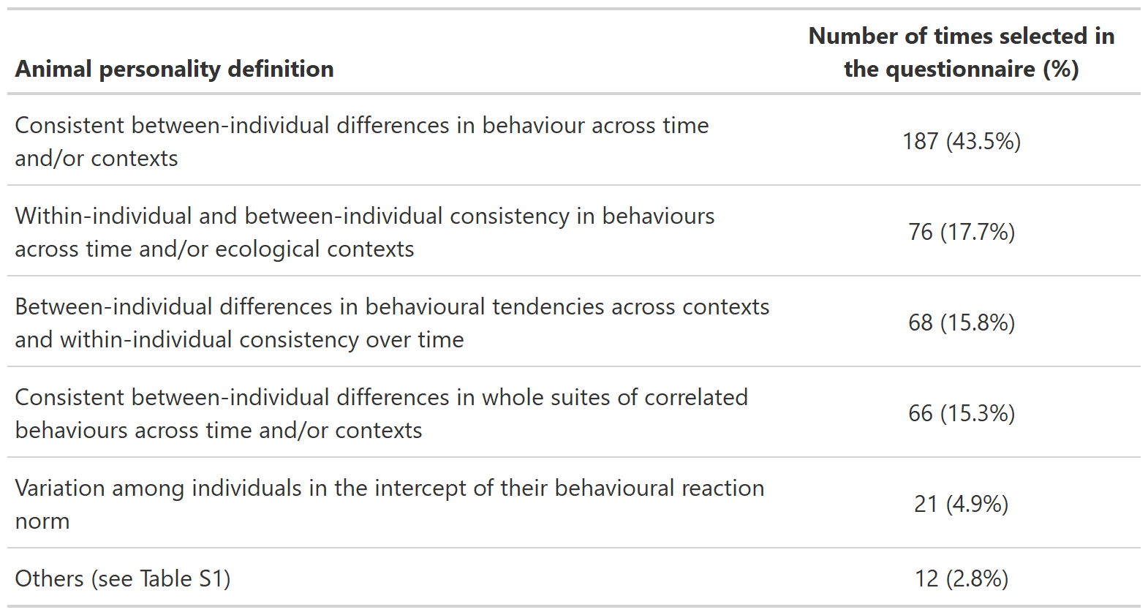
Table 2. List of biological interpretations of animal personality available and selected in a self-report questionnaire about animal personality terminology.
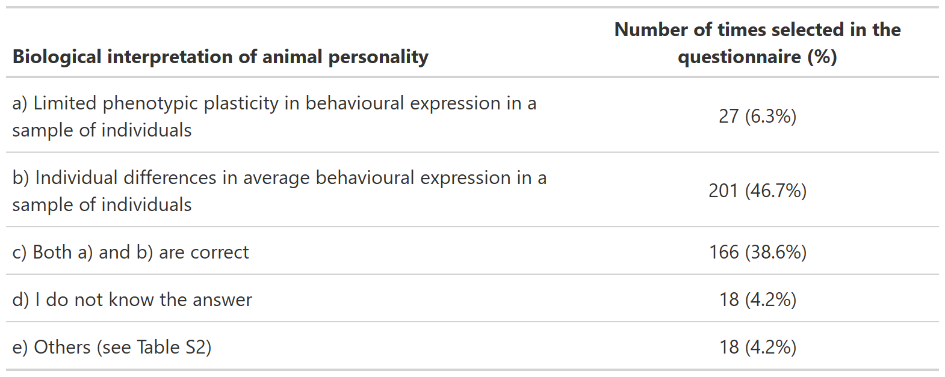
3.2.2. Repeatability definition and interpretation
Most participants interpreted estimates of repeatability as the “(Relative) amount of individual differences in average trait expression in a sample of individuals” (43.3%, 95%CI = [38.7,48.0]; n = 186; Table 3). However, 38.1% (95%CI = [33.7,42.8]; n = 164) of participants also considered the “(Relative) amount of phenotypic plasticity in trait expression in a sample of individuals” either as the single interpretation of behavioural repeatability (16.5%, 95%CI = [13.3,20.3]; n = 71) or in combination with the former interpretation (21.6%, 95%CI = [18.0,25.8]; n = 93; Table 3). Additionally, 69.1% (95%CI = [64.5,73.3]) of the participants (n = 297) reported that repeatability provides an estimate of individual consistency and/or predictability in behaviour, while 19.5% (95%CI = [16.1,23.6]; n = 84) considered that it does not; and 11.4% (95%CI = [8.7,14.8]; n = 49) reported not to know the answer to this question.
Furthermore, when asked about the biological interpretation of one group of individuals (Group A) expressing higher repeatability than other group of individuals (Group B), all suggested choices obtained a rather similar share of preference (range = 17.7% (95%CI = [14.3,21.6]) to 33.3% (95%CI = [29.0,37.8]), with 5.8% (95%CI = [3.9,8.5]) reporting not to know the answer; Table 4). The preferred choice was nevertheless that no interpretation can be drawn about whether the two groups differ in relative plasticity or in the relative amount of individual differences in average trait expression (33.3% (95%CI = [29.0,37.8]), n = 143; Table 4).

Table 3. List of repeatability interpretations available and selected in a self-report questionnaire about animal personality terminology.
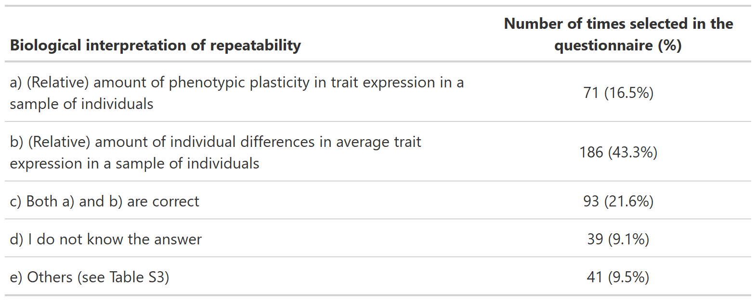
Table 4. List of interpretations available and selected for a comparison of repeatability estimates between two groups in a self-report questionnaire about animal personality terminology. Specifically, the question from the questionnaire was: “What biological interpretation can one make when one only knows that a group of individuals “A” expresses higher repeatability than a group of individuals “B”?”
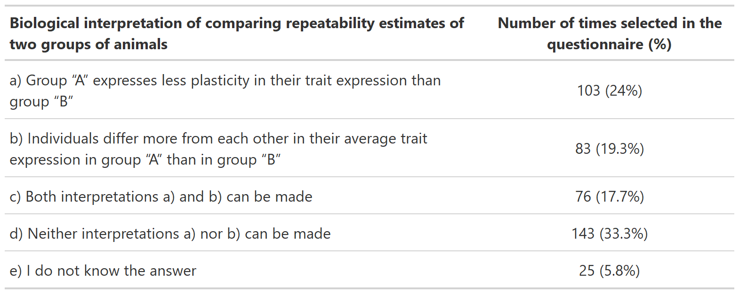
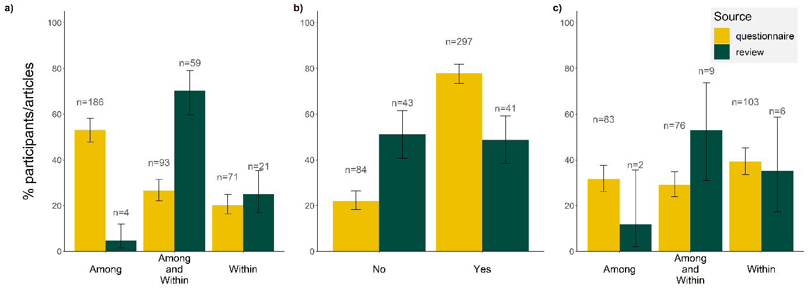
Figure 1. Comparison between the results of a literature review and a self-report questionnaire aimed at understanding how repeatability was interpreted by researchers. Panel a) shows the percentage of participants and articles that interpreted repeatability at each of the three levels of variation. Panel b) shows the percentage of participants and articles that interpreted (or not) repeatability as individual consistency and/or predictability in behaviour. Panel c) shows the percentage of participants and articles that interpreted differences in repeatability estimates between groups at each of the three levels of variation. Labels “Among” and “Within” refer to the among- and within-individual levels of variation, respectively. Contrary to how results were presented in the tables above, the percentages in this figure were calculated after having excluded NA’s and the questionnaire’s categories “Others” and “I do not know the answer” to facilitate the comparison between the results of the literature review and the questionnaire. Errors bars represent 95% confidence intervals.
4. Discussion
From a statistical point of view, animal personality is captured by the among-individual variance component in a repeated measured data sampling design (Dingemanse and Dochtermann, 2013). However, the use of the statistical definition of animal personality is not ubiquitous among researchers, and numerous conceptual definitions of the biological meaning of animal personality are available in the literature. By combining a literature review and a self-report questionnaire, we observed discrepancies among researchers in how concepts commonly used in the field of animal personality are defined and interpreted. Particularly, our study showed that statistical and conceptual definitions did not always agree, which suggest that conceptual definitions are sometimes not in accordance with research objectives, data sampling design and/or the applied statistical approach.
Insights from the questionnaire and comparison with the literature review
While the self-report questionnaire showed that “Consistent between-individual differences in behaviour across time and/or contexts” was the preferred conceptual definition of animal personality, the questionnaire also identified a lack of consensus on the preferred biological interpretation of animal personality. About half of the participants (47%, 95%CI = [42,52]) interpreted animal personality as “Individual differences in average behavioural expression in a sample of individuals”, and an additional 39% (95%CI = [34,43]) considered that interpretation to be correct when also considering “Limited phenotypic plasticity in behavioural expression” (Table 2). These results evidenced that, although most participants interpreted animal personality at least partially at the among-individual level (85%, 95%CI = [82,88]), about half of them (45%, 95%CI = [40,50]) interpreted it also at the within-individual level (i.e., 45% interpreted animal personality also as phenotypic flexibility or reversible plasticity), highlighting a lack of general agreement among the questionnaire participants on what animal personality means biologically.
Participants did not agree on the biological interpretation of repeatability either. The questionnaire showed that repeatability was most often interpreted at the among-individual level either by itself (43%, 95%CI = [39,48]) or in combination with the within-individual level (22%, 95%CI = [18,26]). In relative terms, these results are similar to those about the biological interpretation of animal personality, although repeatability was interpreted at the within-individual level relatively more often (17%, 95%CI = [13,20]) than for the definition of animal personality (6%, 95%CI = [4,9]; Tables 2 and 3). Interestingly, we also found discrepancies between the literature review and the questionnaire. While evidence from the literature review and the questionnaire showed similar percentages in terms of interpreting repeatability at the within-individual level, there were substantial differences at the other levels (i.e., at among-individual level and both levels combined; Figure 1). Hence, participants reported an interpretation of repeatability that was not reflected in the published literature. Filtering during the peer-reviewing process, whether from co-authors or other peers, may partially explain the disagreement between our literature review and the questionnaire. Finally, although we interpreted the discrepancy between the literature review and the questionnaire as true differences, we cannot discard the possibility that the observed differences were, in part, due to different subsets of researchers. While plausible, we deemed this option less likely because of the large coverage of our questionnaire and the high percentage of researchers that reported to have worked in animal personality (73%).
Another important insight from our questionnaire was that it showed differences among participants regarding how to interpret the comparison of repeatability estimates between groups (Table 4). Although the preferred answer was that no biologically-meaningful interpretation can be made about whether the two groups differ in amount of plasticity or in amount of individual differences in average trait expression (33%, 95%CI = [29,38]), the other options still obtained substantial support (range = 18% (95%CI = [14,22]) to 24% (95%CI = [20,28]); Table 4). These differences among researchers were similar to those observed in the published literature. Of the 24 studies that compared repeatability estimates between groups, 17 interpreted the difference in repeatability estimates, with 53% (95%CI = [31,74]) interpreting repeatability differences between groups as being caused by changes in both within- and among-individual variation, whereas 35% (95%CI = [17,59]) and 12% (95%CI = [2,36]) interpreted repeatability differences between groups as being caused by changes only at the within-individual or only at the among-individual variation, respectively.
To determine the biological mechanism(s) underpinning differences in repeatability between groups, researchers would need to know both the within- and among-individual variance components from which the repeatability was calculated: repeatability estimates can differ due to changes in variance at the among-individual level, within-individual level or both (Dochtermann et al., 2015; Dochtermann and Royauté, 2019; Hansen et al., 2011; Houle, 1992; Niemelä and Dingemanse, 2018b; Royauté and Dochtermann, 2021; Wilson, 2018). There is, however, an exception to this interpretation. If researchers collect and analyse data with a binomial error structure, which requires to restrict the residual variance to a fixed value (i.e., π²/3 for a binomial model with logit link, and 1 for a binomial model with probit link: Nakagawa and Schielzeth 2010), then the differences in repeatability, by definition, represent differences at the among-individual level of variation. However, this is only true in the specific case that the model contains no other random effects than individual identity. Our literature search revealed that only 12.5% of the included articles modelled data with a binomial error structure and, at the same time, used a random effect structure that contained only individual identity. Nevertheless, comparing actual variance components across groups (instead of repeatabilities) is optimal mainly within studies. This is because researchers would need to measure the same trait(s) for each group in an equivalent manner, and have implemented the statistical models with exactly the same random and fixed effects structure, so that the comparison of variances are biologically meaningful. One solution to tackle this problem would be to apply a mean standardization (e.g., coefficient of variation) in addition to the variance standardization (e.g., repeatability) to variance components (Dochtermann and Royauté, 2019; Hill and Mulder, 2010; Holtmann et al., 2017; Houle, 1992). Mean-standardizing variance metrics such as the coefficient of variation report variance per unit of a trait value for each variance component (i.e., among and within-individual variance) separately, partially solving the abovementioned problem. As such, for a deeper understanding of differences between individual variances across, e.g., groups, treatments or populations, it would be beneficial to quantify both, variance- and mean-standardized metrics, as both metrics provide different but complementary insights.
Finally, our questionnaire revealed that the vast majority of researchers (78%, 95%CI = [74,82]; Figure 1) considered repeatability to be a metric of individual consistency and/or predictability in behaviour, with repeatability estimates being interpreted as evidence of individuals behaving similarly from one time to another. Although larger, this finding generally agreed with our literature review, which showed that repeatability was interpreted as individual consistency and/or predictability in behaviour in approximately half of the studies. If we combine these results with those of the biological meaning of repeatability from our questionnaire, it suggests that researchers often consider individual differences in the average behavioural expression (i.e., animal personality) as “consistency”. Consistency is a very widespread term in the field of animal personality and it is used to refer to several biological phenomena such as individual differences in average trait expression and within-individual plasticity within- and among-environments. Cleasby et al. (2015) considered consistency (and predictability) as a within-individual level metric, whose variability estimation requires more sophisticated statistical tools (i.e., double-hierarchical mixed effects models) compared to the simple repeatability estimate. Nevertheless, repeatability is the proportion of total phenotypic variance explained by the among-individual variance component, and as such, both among- and within-individual variances affect repeatability estimates. Thus, regardless of whether consistency is defined as among- or within-individual variation, it will affect the repeatability estimate. To avoid further confusion between terms and metrics, we encourage researchers to clearly define the terms consistency and predictability whenever they use them in their work.
Potential reasons for the observed diversity of interpretations and further steps towards a more unified field
Historically, animal personality research has been broadly divided into researchers that apply a more “behavioural ecologist”-oriented framework (i.e., among-individual variation in a behavioural trait, Dingemanse et al., 2010; Dingemanse and Wright, 2020; Gosling, 2001; Réale et al., 2007; Sih et al., 2004) and researchers that adopt a more “personality psychologist”-oriented approach (i.e., characterization of the different behavioural axis of personality, e.g., by using correlations or principal component analysis, such as the ﬁve factor model of personality, John and Srivastava, 1999; Nettle and Penke, 2010), with a whole spectrum of researchers and research falling in-between the two frameworks. This somewhat stereotyped dichotomy has a large potential to generate basal differences in how the concept of animal personality is being studied and discussed, and what sampling designs and statistical tools are required and applied. Another historical reason for the existence of such a large diversity of terminology is that there is no consensus about the concept of animal personality among the most-cited conceptual articles (see extracted terminology in the provided data). Some of these conceptual articles, which were pioneers and became important cornerstones for the entire field, defined animal personality as high among-individual variation, while others defined animal personality as both high among-individual variation and low within-individual variation. Indeed, “limited plasticity” was often mentioned as a key component of animal personality (see extracted terminology in the provided data), even though limited (potential or realized) plasticity is not necessarily required for the existence of among-individual differences in average trait expression: Individuals might differ in their average trait expression even when all of them can express the whole spectrum of behavioural variation. Nevertheless, even in the case that the concept of animal personality would be collectively decided to be a biological phenomenon involving both among- and within-individual variation, this would not change the fact that researchers would still need to explicitly express which level of variation they are aiming at studying within each study, and to apply the necessary statistical frameworks specific for each level.
Overall, in this study, we do not aim to yet create another definition of animal personality, but to advocate for the usage of a common definition, which ultimately would help to unify and clarify the field. In the light of our findings, we encourage researchers to avoid the use of vague conceptual definitions that can be interpreted at multiple levels of biological organization. One possible solution, albeit not perfect if there is no collective agreement on the applied terms, would be to use a more statistically-oriented terminology that directly express which level of variation any given study focuses on: among- or within-individual level variation. We believe this approach would leave less room for misinterpretations of the used terminology.
Data requirements in animal personality research
Generally, our questionnaire evidenced that researchers were generally aware of the need of recording multiple observations (i.e., behavioural measurements) per individual to estimate among-individual variance in labile traits. However, there was still a relatively large proportion of researchers who did not agree with this requirement and/or who were not applying it. Indeed, 31% (95%CI = [26,37]) of researchers who self-reported having published in the field of animal personality also reported having used single measurements of behaviour(s) per individual (i.e., non-repeated measurements per individual). Furthermore, 27% (95%CI = [22,31]) of researchers answered that although repeated measurements per individual are necessary to study patterns at the among-individual level, single behavioural measurements per individual can be used as long as the focal behaviour is repeatable. However, this argument would only apply when the repeatability of the focal behaviour is 1; in such a case, the focal behaviour would be a fixed trait (instead of a labile trait) and would, by definition, vary at the among-individual level only (Niemelä and Dingemanse, 2018b). Moreover, there is a recurrent argument in the literature in favour of single measurements of “personality traits”, which is perhaps the most acceptable, albeit debatable. This argument postulates that those behaviours that change meaning when assessed repeatedly, should be better measured once than confounding the behaviour interpretation by repeated assessment. Some of such traits are exploration of novel environments or boldness. In the empirical quantification of both traits, arguably, the second time an individual is confronted with the novel environment or object, the response might be different than the first time, confounding the metric. However, this argument does not consider that researchers have ways to (partly) control for this potential order artefact, e.g., by modelling the sequence of observations or by using different novelty stimulation in each subsequent behavioural trial. Altogether, we hope this study encourages researchers to closely consider these data requirements for future studies of animal personality (more in Dingemanse and Dochtermann, 2013; Dingemanse and Wright, 2020; Niemelä and Dingemanse, 2018b).

Limitations of this study
A major perceived limitation of our study may be related to the set of choices given in the questionnaire. In the comments section of our questionnaire, 3.7% (16 out of 430) of the participants were critical about the wording of one or more questions (see provided data). While we believe this is a general concern in any self-report questionnaire, it might have been especially problematic in the context of our study since the field of animal personality uses multiple definitions, interpretations and approaches to address the same research questions, as pointed out in this work. With this issue in mind, we had designed the questions using a combination of statistical terms adapted to their biological meaning, and actual definitions existent in the published literature. Furthermore, prior to publishing the questionnaire, we asked several experts in the field of animal personality to provide suggestions on how to improve our questionnaire.
Conclusions
If estimates at the total phenotypic level can be used to study among-individual differences in behaviour, then any animal behaviour study could be labelled as “animal personality” research. Often researchers working in animal personality, however, do aim to understand among-individual level processes (rather than total phenotypic level processes). We hope that our study will raise awareness about the extent of variation in terminology usage in animal personality research, helping the entire field to move towards a more unified research framework.

Data and code availability section
Data and code to reproduce the results are available from: https://github.com/ASanchez-Tojar/animal_personality_terminology. Upon eventual acceptance of this manuscript, data and code will be hosted at Zenodo and provided with a doi.
Author contribution
AST, MM and PN contributed to conceptualization, methodology, investigation, writing - both original draft preparation and review and editing, project administration, and funding acquisition. AST also contributed to software, formal analysis, data curation and visualization. MM also contributed to validation. All authors contributed equally to this work.
Acknowledgments
We are grateful to Niels Dingemanse, Raphaël Royauté, Stephen Salazar and Alastair J. Wilson for their comments on a previous version of the questionnaire, and to everybody that took part in the questionnaire and/or helped to disseminate it. We are also grateful to Alastair J. Wilson for insightful discussions about some of the concepts presented in our study, and to Niels Dingemanse, Marie I. Kaiser and Holger Schielzeth for their comments on a previous version of this manuscript. Last, we thank two reviewers and two editors for further improving this manuscript.
Funding
AST was funded by the German Research Foundation (DFG: Deutsche Forschungsgemeinschaft) as part of the SFB TRR 212 (NC3)—Project numbers 316099922 and 396782608. MM was funded by a Marie Curie Individual Fellowship (PLASTIC TERN, Grant Agreement Number 793550). PTN was funded by the German Research Foundation (DFG; NI 1539/2-1).
Competing interests
Authors declare no competing interests.

References
Agresti, A., Coull, B.A., 1998. Approximate is Better than “Exact” for Interval Estimation of Binomial Proportions. The American Statistician 52, 119–126. https://doi.org/10.1080/00031305.1998.10480550
Brommer, J.E., 2013. On between-individual and residual (co)variances in the study of animal personality: are you willing to take the “individual gambit”? Behav Ecol Sociobiol 67, 1027–1032. https://doi.org/10.1007/s00265-013-1527-4
Carter, A.J., Feeney, W.E., Marshall, H.H., Cowlishaw, G., Heinsohn, R., 2013. Animal personality: what are behavioural ecologists measuring? Biological Reviews 88, 465–475. https://doi.org/10.1111/brv.12007
Cleasby, I.R., Nakagawa, S., Schielzeth, H., 2015. Quantifying the predictability of behaviour: statistical approaches for the study of between-individual variation in the within-individual variance. Methods in Ecology and Evolution 6, 27–37. https://doi.org/10.1111/2041-210X.12281
Coppens, C.M., de Boer, S.F., Koolhaas, J.M., 2010. Coping styles and behavioural flexibility: towards underlying mechanisms. Philosophical Transactions of the Royal Society B: Biological Sciences 365, 4021–4028. https://doi.org/10.1098/rstb.2010.0217
Dall, S.R.X., Houston, A.I., McNamara, J.M., 2004. The behavioural ecology of personality: consistent individual differences from an adaptive perspective. Ecology Letters 7, 734–739. https://doi.org/10.1111/j.1461-0248.2004.00618.x
David, M., Dall, S.R.X., 2016. Unravelling the Philosophies Underlying ‘Animal Personality’ Studies: A Brief Re-Appraisal of the Field. Ethology 122, 1–9. https://doi.org/10.1111/eth.12445
Dingemanse, N.J., Araya-Ajoy, Y.G., 2015. Interacting personalities: behavioural ecology meets quantitative genetics. Trends in Ecology & Evolution 30, 88–97. https://doi.org/10.1016/j.tree.2014.12.002
Dingemanse, N.J., Dochtermann, N.A., 2013. Quantifying individual variation in behaviour: mixed-effect modelling approaches. Journal of Animal Ecology 82, 39–54. https://doi.org/10.1111/1365-2656.12013
Dingemanse, N.J., Dochtermann, N.A., Nakagawa, S., 2012. Defining behavioural syndromes and the role of ‘syndrome deviation’ in understanding their evolution. Behav Ecol Sociobiol 66, 1543–1548. https://doi.org/10.1007/s00265-012-1416-2
Dingemanse, N.J., Kazem, A.J.N., Réale, D., Wright, J., 2010. Behavioural reaction norms: animal personality meets individual plasticity. Trends in Ecology & Evolution 25, 81–89. https://doi.org/10.1016/j.tree.2009.07.013
Dingemanse, N.J., Réale, D., 2005. Natural selection and animal personality. Behaviour 142, 1159–1184. https://doi.org/10.1163/156853905774539445
Dingemanse, N.J., Wolf, M., 2010. Recent models for adaptive personality differences: a review. Philosophical Transactions of the Royal Society B: Biological Sciences 365, 3947–3958. https://doi.org/10.1098/rstb.2010.0221
Dingemanse, N.J., Wright, J., 2020. Criteria for acceptable studies of animal personality and behavioural syndromes. Ethology 126, 865–869. https://doi.org/10.1111/eth.13082
Dochtermann, N.A., Royauté, R., 2019. The mean matters: going beyond repeatability to interpret behavioural variation. Animal Behaviour 153, 147–150. https://doi.org/10.1016/j.anbehav.2019.05.012
Dochtermann, N.A., Schwab, T., Sih, A., 2015. The contribution of additive genetic variation to personality variation: heritability of personality. Proceedings of the Royal Society B: Biological Sciences 282, 20142201. https://doi.org/10.1098/rspb.2014.2201
Dorai-Raj, S., 2014. binom: Binomial Confidence Intervals For Several Parameterizations.
Duckworth, R.A., Badyaev, A.V., 2007. Coupling of dispersal and aggression facilitates the rapid range expansion of a passerine bird. PNAS 104, 15017–15022. https://doi.org/10.1073/pnas.0706174104
Forsman, A., 2015. Rethinking phenotypic plasticity and its consequences for individuals, populations and species. Heredity 115, 276–284. https://doi.org/10.1038/hdy.2014.92
Gosling, S.D., 2001. From mice to men: What can we learn about personality from animal research? - PsycNET. Psychological Bulletin 127, 45–86. https://doi.org/10.1037/0033-2909.127.1.45
Hansen, T.F., Pélabon, C., Houle, D., 2011. Heritability is not Evolvability. Evol Biol 38, 258. https://doi.org/10.1007/s11692-011-9127-6
Hill, W.G., Mulder, H.A., 2010. Genetic analysis of environmental variation. Genetics Research 92, 381–395. https://doi.org/10.1017/S0016672310000546
Holtmann, B., Lagisz, M., Nakagawa, S., 2017. Metabolic rates, and not hormone levels, are a likely mediator of between-individual differences in behaviour: a meta-analysis. Functional Ecology 31, 685–696. https://doi.org/10.1111/1365-2435.12779
Houle, D., 1992. Comparing evolvability and variability of quantitative traits. Genetics 130, 195–204.
Jennions, M.D., Møller, A.P., 2002. Publication bias in ecology and evolution: an empirical assessment using the ‘trim and fill’ method. Biological Reviews 77, 211–222. https://doi.org/10.1017/S1464793101005875
John, O.P., Srivastava, S., 1999. The Big Five trait taxonomy: History, measurement andtheoretical perspectives, in: Handbook of Personality: Theory Andresearch. Guilford Press, New York, pp. 102–138.
Kaiser, M.I., Müller, C., 2021. What is an animal personality? Biology & Philosophy 36, 1. https://doi.org/10.1007/s10539-020-09776-w
Koricheva, J., Gurevitch, J., 2014. Uses and misuses of meta-analysis in plant ecology. Journal of Ecology 102, 828–844. https://doi.org/10.1111/1365-2745.12224
Moher, D., Liberati, A., Tetzlaff, J., Altman, D.G., Group, T.P., 2009. Preferred Reporting Items for Systematic Reviews and Meta-Analyses: The PRISMA Statement. PLOS Medicine 6, e1000097. https://doi.org/10.1371/journal.pmed.1000097
Moiron, M., Laskowski, K.L., Niemelä, P.T., 2020. Individual differences in behaviour explain variation in survival: a meta-analysis. Ecology Letters 23, 399–408. https://doi.org/10.1111/ele.13438
Nakagawa, S., Schielzeth, H., 2010. Repeatability for Gaussian and non-Gaussian data: a practical guide for biologists. Biological Reviews 85, 935–956. https://doi.org/10.1111/j.1469-185X.2010.00141.x
Nettle, D., Penke, L., 2010. Personality: bridging the literatures from human psychology and behavioural ecology. Philosophical Transactions of the Royal Society B: Biological Sciences 365, 4043–4050. https://doi.org/10.1098/rstb.2010.0061
Niemelä, P.T., Dingemanse, N.J., 2018a. Meta-analysis reveals weak associations between intrinsic state and personality. Proceedings of the Royal Society B: Biological Sciences 285, 20172823. https://doi.org/10.1098/rspb.2017.2823
Niemelä, P.T., Dingemanse, N.J., 2018b. On the usage of single measurements in behavioural ecology research on individual differences. Animal Behaviour 145, 99–105. https://doi.org/10.1016/j.anbehav.2018.09.012
O’Dea, R.E., Lagisz, M., Jennions, M.D., Koricheva, J., Noble, D.W.A., Parker, T.H., Gurevitch, J., Page, M.J., Stewart, G., Moher, D., Nakagawa, S., 2021. Preferred reporting items for systematic reviews and meta-analyses in ecology and evolutionary biology: a PRISMA extension. Biological Reviews 96, 1695–1722. https://doi.org/10.1111/brv.12721
Ouzzani, M., Hammady, H., Fedorowicz, Z., Elmagarmid, A., 2016. Rayyan—a web and mobile app for systematic reviews. Systematic Reviews 5, 210. https://doi.org/10.1186/s13643-016-0384-4
R Core Team, 2021. R: A language and environment for statistical computing. R Foundation for Statistical Computing, Vienna, Austria.
Rands, S.A., Cowlishaw, G., Pettifor, R.A., Rowcliffe, J.M., Johnstone, R.A., 2003. Spontaneous emergence of leaders and followers in foraging pairs. Nature 423, 432–434. https://doi.org/10.1038/nature01630
Réale, D., Reader, S.M., Sol, D., McDougall, P.T., Dingemanse, N.J., 2007. Integrating animal temperament within ecology and evolution. Biological Reviews 82, 291–318. https://doi.org/10.1111/j.1469-185X.2007.00010.x
Roche, D.G., Careau, V., Binning, S.A., 2016. Demystifying animal ‘personality’ (or not): why individual variation matters to experimental biologists. Journal of Experimental Biology 219, 3832–3843. https://doi.org/10.1242/jeb.146712
Royauté, R., Berdal, M.A., Garrison, C.R., Dochtermann, N.A., 2018. Paceless life? A meta-analysis of the pace-of-life syndrome hypothesis. Behav Ecol Sociobiol 72, 64. https://doi.org/10.1007/s00265-018-2472-z
Royauté, R., Dochtermann, N.A., 2021. Comparing ecological and evolutionary variability within datasets. Behav Ecol Sociobiol 75, 127. https://doi.org/10.1007/s00265-021-03068-3
Scheiner, S.M., 1993. Genetics and Evolution of Phenotypic Plasticity. Annual Review of Ecology and Systematics 24, 35–68. https://doi.org/10.1146/annurev.es.24.110193.000343
Schuett, W., Tregenza, T., Dall, S.R.X., 2010. Sexual selection and animal personality. Biological Reviews 85, 217–246. https://doi.org/10.1111/j.1469-185X.2009.00101.x
Sih, A., Bell, A., Johnson, J.C., 2004a. Behavioral syndromes: an ecological and evolutionary overview. Trends in Ecology & Evolution 19, 372–378. https://doi.org/10.1016/j.tree.2004.04.009
Sih, A., Bell, A.M., Johnson, J.C., Ziemba, R.E., 2004b. Behavioral Syndromes: An Integrative Overview. The Quarterly Review of Biology 79, 241–277. https://doi.org/10.1086/422893
Sih, A., Mathot, K.J., Moirón, M., Montiglio, P.-O., Wolf, M., Dingemanse, N.J., 2015. Animal personality and state–behaviour feedbacks: a review and guide for empiricists. Trends in Ecology & Evolution 30, 50–60. https://doi.org/10.1016/j.tree.2014.11.004
Sih, A., Munson, A., Pollack, L., 2020. Animal Personalities, in: The Wiley Encyclopedia of Personality and Individual Differences. John Wiley & Sons, Ltd, pp. 117–122. https://doi.org/10.1002/9781119547143.ch21
Stamps, J., Groothuis, T.G.G., 2010. The development of animal personality: relevance, concepts and perspectives. Biological Reviews 85, 301–325. https://doi.org/10.1111/j.1469-185X.2009.00103.x
Stamps, J.A., 2016. Individual differences in behavioural plasticities. Biological Reviews 91, 534–567. https://doi.org/10.1111/brv.12186
van de Pol, M., Wright, J., 2009. A simple method for distinguishing within- versus between-subject effects using mixed models. Animal Behaviour 77, 753–758. https://doi.org/10.1016/j.anbehav.2008.11.006
Westneat, D.F., Wright, J., Dingemanse, N.J., 2015. The biology hidden inside residual within-individual phenotypic variation. Biological Reviews 90, 729–743. https://doi.org/10.1111/brv.12131
Wilson, A.J., 2018. How should we interpret estimates of individual repeatability? Evolution Letters 2, 4–8. https://doi.org/10.1002/evl3.40
Wolak, M.E., Fairbairn, D.J., Paulsen, Y.R., 2012. Guidelines for estimating repeatability. Methods in Ecology and Evolution 3, 129–137. https://doi.org/10.1111/j.2041-210X.2011.00125.x
Wolf, M., Weissing, F.J., 2012. Animal personalities: consequences for ecology and evolution. Trends in Ecology & Evolution 27, 452–461. https://doi.org/10.1016/j.tree.2012.05.001

