Title: The economic value of fisheries, blue carbon, and nutrient cycling in global marine forests
Abstract: Underwater kelp forests have provided valuable ecosystem services for millennia. However, the global economic value of those services is largely unresolved. Kelp forests are also diminishing globally and efforts to manage these valuable resources are hindered without accurate estimates of the services kelp forests provide to society. We present the first global economic estimation of services - fisheries production, nutrient cycling, and carbon removal - provided by four major forest forming kelp genera (Macrocystis, Nereocystis, Ecklonia, and Laminaria). Each of these genera provides between $135,200 and $177,100/ ha/ year. Collectively, they contribute $684 billion/year worldwide. These values are primarily driven by fisheries and nitrogen removal, but kelp forests also have the potential to sequester 2.7 megatons of carbon from the atmosphere/year and may be considered blue carbon systems valuable for climate change mitigation. These findings highlight the value of kelp forests to society and will enable informed marine management decisions.
Keywords: kelp forests, ecosystem services, ecological economics, fisheries, carbon, nutrient cycling (6-10)
Introduction
“The number of living creatures of all Orders, whose existence intimately depends on the kelp is wonderful.” – Charles Darwin 1845
Vast underwater forests of kelp (brown macroalgae in the order Laminariales) along polar to subtropical coastlines have been of enormous value to peoples across continents and eras. Archaeological excavations show how kelp forests facilitated southward travel for early peoples in the Americas some 20,000 years ago. During this great migration, people relied on the food provided by kelp forests to survive ¹. Subsequently, ecological management of kelp forests has occurred since approximately 3000 BCE in the NE Pacific, with peoples regulating harvest and transplanting kelp to enhance growth and trap fish roe ². In the NW Pacific, kelp harvesting has played an important role in Japanese, Korean, and Chinese economies since the 8th century, where it is eaten as food and supports a myriad of associated plants and animals, many of which are also harvested. In Europe, kelp has been used for many centuries to fertilize soil and increase crop yields, treat illnesses caused by iodine deficiency and, for many centuries, as the base in the production of soda ash ³. In the 20th and 21st century kelp forests have become the main source of alginate, a common food and medical additive ⁴. Globally, kelp forests provide habitat for important fisheries of abalone, lobsters, and an array of fishes ⁵. Additionally, through their prolific productivity, kelp forests draw carbon from the atmosphere, release oxygen, and help reduce nutrient pollution in our oceans ⁶. Long before Charles Darwin wrote his essay on the towering Patagonian kelp forests, kelp forests provided and continue to provide essential services for human society.
That kelp forests have socioeconomic value is not disputed, but the actual value of these ecosystems is poorly understood. Relevant research on kelp forests to date has grouped kelp with other marine habitats as “coastal systems” ⁷, treated values from limited genera as representative of not just kelps but all macroalgae ⁸, or has not assigned a monetary value to the services provided ⁹. This knowledge gap leads to an underappreciation of their contribution to nature and to people. As the economic value of ecosystems is increasingly a major consideration for conservation and natural resource management, the lack of value estimates for kelp ecosystems is a barrier to effective management and policy ¹⁰.
Societies are increasingly considering active kelp forest restoration and management strategies to combat regional declines in kelp forests ^{11,12}. However, restoration may not be pursued if costs outweigh perceived benefits ¹³. Furthermore, while kelp forests are unarguably of value to ocean users, they are not perceived to be high-value ecosystems to the public ^{14,15}, which can limit public support for kelp conservation and restoration ^{16,17}. Practically, quantifying and valuing ecosystem services provided by marine ecosystems is relevant in the context of the UN Decade of Ocean Sciences, achieving the UN Sustainable Development Goals, growing the field of ocean accounting, and cost-benefit analyses ^{18–20}.
Regional valuations of kelp forests which have incorporated various ecosystems services (e.g. harvest, fisheries, and tourism) have estimated kelp forests to be worth between $290 million (e.g. Ecklonia and Laminaria forests from South Africa) and $540 million USD per year (e.g. Lessonia and Macrocystis forests from Central-Northern Chile) ^{21,22}. In Australia, Bennett et al. (2016), valued the ~71, 000 km² of ‘The Great Southern Reef’, including the lobster and abalone fisheries largely supported by Ecklonia and Phyllospora habitat, at ~ $7.3 billion USD per year; though this value included all marine habitats, not only kelp. None of these numbers were standardized per area and did not directly link fisheries production within kelp forests to their final value. Consequently, there are currently no quantitative estimates of the area-adjusted economic value of major kelp genera worldwide.
Here we summarize economically important ecosystem services provided by four dominant kelp genera across the world (Macrocystis, Nereocystis, Ecklonia, and Laminaria). While the order Laminariales comprises 13 genera, which provide similar ecosystem functions, we focussed on kelp genera with the most widespread distributions and available data. These genera are distributed across the Northern and Southern Pacific, Northern and Southern Atlantic, and parts of the Southern Ocean, and encompass most of global kelp distribution ⁶. Within these genera we focussed on three services for which direct market values can be assigned: fisheries (i.e., secondary) production, carbon capture, and nutrient cycling, which past studies suggest comprise the majority of the market services provided by kelp forests ^{14,21,22}. We assigned market values to each service and generated a range of economic values provided by each genus in each region, per unit of area, per year. Our analysis provides the first global economic assessment of dominant forest forming kelp and situates these values among other marine ecosystems.
Results
We included 1079 fish and-or invertebrate surveys at distinct times and locations across the four different kelp genera in five different ocean regions (North Pacific, South Pacific, North Atlantic, South Atlantic and Southern Ocean).
We also collected 55 measures of net primary production (NPP), 23 measures of carbon composition, 29 measures of nitrogen composition, and five measures of phosphorus composition. These values were collected from the five ocean regions, though some regions had larger sample sizes than others (Appendix 1).
Fisheries production economic value
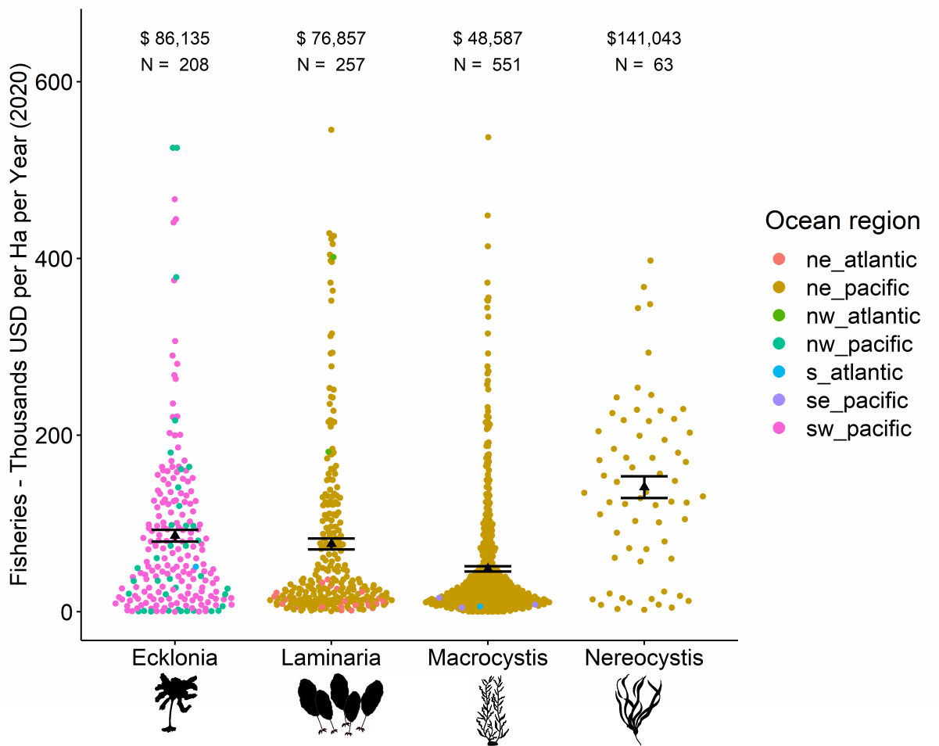
Fig. 1: Site (unique time and location) value of fisheries production per hectare per year. The values are represented for each kelp genus, colours represent the ocean region, the black triangle and number values represent the mean value for the genus, the error bars are the standard error.
We found substantial variation both between and within genus annual fisheries values. The lowest mean annual fisheries production rate was $5,900/ Ha/ year, for Macrocystis in the Southern Atlantic. Whereas the highest mean value was $291, 200 /Ha /year for Laminaria in the Northwest Atlantic. The mean value for each genus across ocean regions was $86,100, $76,900, $48,600, and $141,000 for the genera Ecklonia, Laminaria, Macrocystis, and Nereocystis respectively (Figure 1, Appendix 2).
A relatively small number of genera comprised the bulk of the fisheries value at our sites. Indeed, only 35 genera from a total 172 contributed more than 5% to a site’s economic fisheries production and 74 genera contributed more than 1%. Notably, the most valuable genera at individual sites were invertebrate species (nine out of the top ten). These included lobsters (Panulirus, Jasus), abalone (Haliotis), urchins (Centrostephanus, Heliocidaris), and gastropods in the genus Turbo (Figure 2). The most valuable fishes were the pollack (Pollachinus), giant seabass (Stereolepis), and lingcod (Ophiodon).
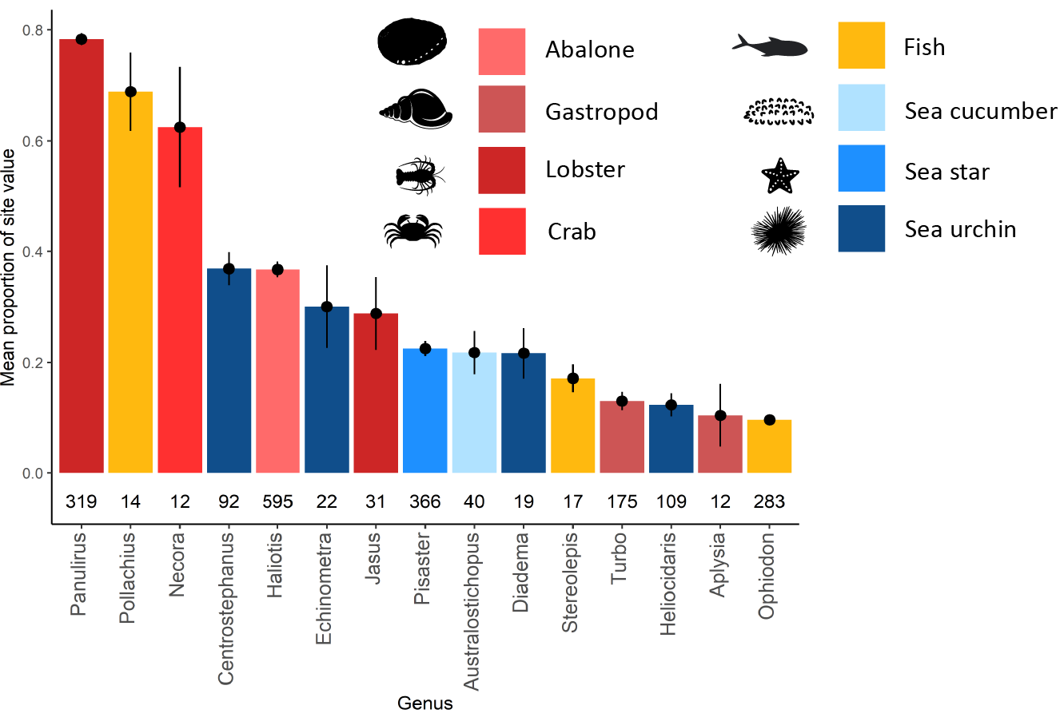
Fig. 2: The mean proportion each genus contributed to a site’s overall fisheries value per year, the lines represent plus and minus one standard error. Values below the bars represent the number of surveys a genus appeared in, only genera that appeared in more than 10 surveys are represented.
Nutrient removal and carbon sequestration values
We found variation in the economic value for bioremediation and carbon sequestration among the different genera and ocean regions considered. The mean value per hectare per year for the removal of all carbon, nitrogen, and phosphorus is $49,300 for Ecklonia, $93,600 for Laminaria, $95,600 for Macrocystis, and $36,100 for Nereocystis (Figure 3 split by ocean region). Of the three elements, nitrogen removal provided the highest economic value per hectare per year (mean = $72,000), followed by phosphorus removal (mean = $2,990), and lastly carbon capture (mean = $349) (Appendix 2).
Carbon sequestration rates (see Methods) across genera or region varied by an order of magnitude. The minimum regional average of carbon sequestration per m² per year was 14.4 g (Laminaria in the South Atlantic) while the maximum was 213.5 g (Macrocystis in the Southern Ocean). Across genera, the average value (g/m²/year) per genus was 79 (Ecklonia), 88 (Laminaria), 119 (Macrocystis), 35 (Nereocystis). These values are heavily dependent on the amount of NPP sequestered. If we assume a range of 1 and 20% of NPP sequestered, these values range from 8 – 158 (Ecklonia), 9 – 176 (Laminaria), 12 – 237 (Macrocystis), and 4 – 71 (Nereocystis). Considered globally over 30 years (to 2050), kelp forests thus sequester between 17 and 329 megatons of carbon (Appendix 10).

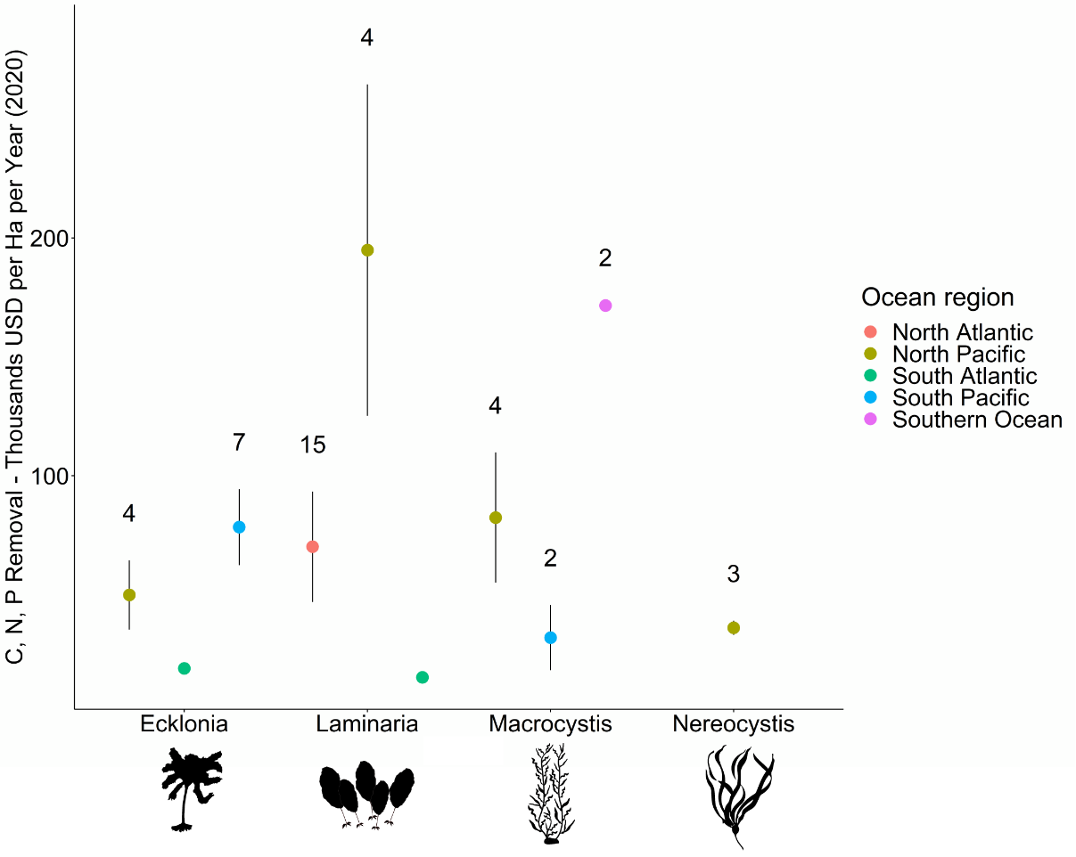
Figure 3: The mean yearly economic value per hectare of nutrient cycling and carbon sequestration services. The values are represented for each genus, colours represent the ocean region. The dots represent the mean value for the genus, the error bars are the standard error, and the currency is in thousands of USD for the year 2020. Sample sizes (unique location-time measurement) are presented above each point, no number indicates a sample size of one.
Combined values
The average combined value per hectare per year of carbon storage, nutrient removal, and fisheries services varied but only over a three-fold range: $70k (Ecklonia, South Atlantic), $139,000 (Ecklonia, North Pacific), $164,000, (Ecklonia, South Pacific), $222,000, (Laminaria, North Atlantic), $275,000, (Laminaria, North Pacific), $131,000, (Macrocystis, North Pacific), $177,000, (Nereocystis, North Pacific). Based on the kelp distributions in these areas (Appendix 3), the regional value of kelp forests thus ranged from $1 – 512 billion per year (Fig. 4). Globally, the evaluated kelp forests produce an estimated $684 billion per year with an NPV of 10.2 trillion USD over the next 20 years.
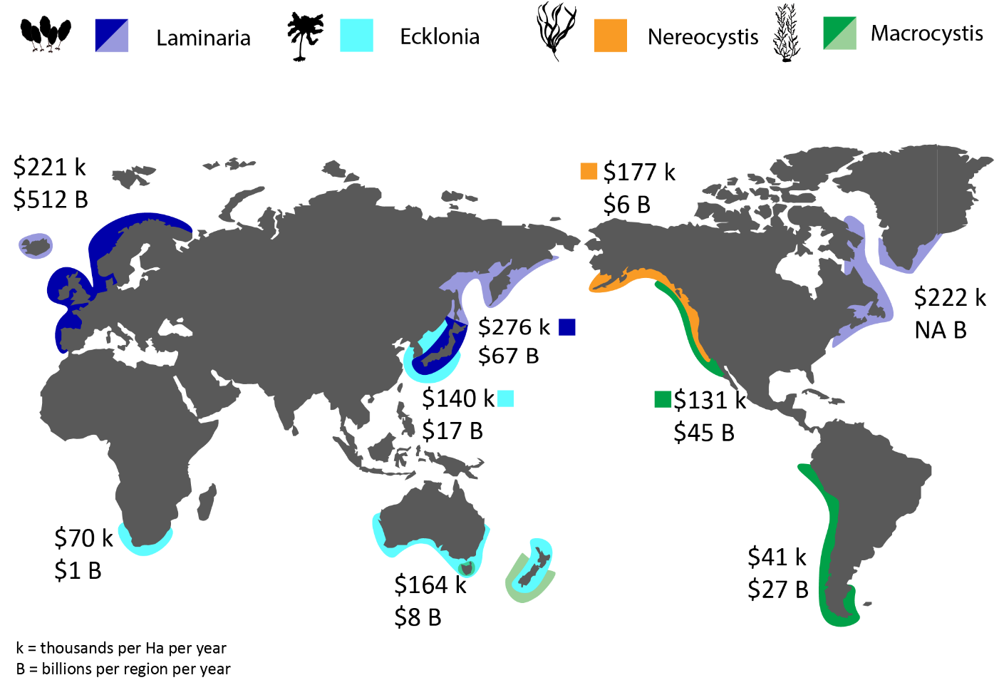
Figure 4: Map of kelp distribution, total economic value per m² per year (k), regional value (B). Transparent colours are for regions where distribution estimates were not available.

Discussion
Global kelp forests generate considerable economic benefits across the world’s oceans. These benefits vary according to the service being considered, the kelp genus, and the ocean region. In areas with available data, we found that four genera generate annually between $1 and $512 billion per year regionally, and $684 billion globally. On a per-area basis, these values ranged from $135,100 to $177,100/hectare/year, with an overall average value of $156,700. Previous work by Costanza et al. (2014), which considered nine ecosystem services, estimated that combined, seagrass and algae were valued at ~$36,000/Ha/year. As such, our estimate, which only considers kelp, and only four ecosystem services, is at least a five-fold increase from the previous, widely adopted economic value of global kelp forests. These estimates are likely to increase when more services are considered.
We combined data on the spatial coverage of kelp forests to provide the first global economic estimate of the value of kelp forests. While most regional estimates varied between $1 and 67 billion per year, Laminaria in the North-eastern Atlantic was an exception to these values and was estimated to contribute $512 billion per year. The high value of Laminaria forests in the North Atlantic can be attributed in part to the high value of the regional lobster industry. For instance, in Canada alone, lobster landings are valued at almost $1 billion per year ²³. Laminaria also has a large global distribution, covering 23,000 km² in Europe alone (Appendix 3). Contextualizing these values against national economic production, we found that Ecklonia produces $3.9 billion/year in Australia or approximately 0.34% of the annual GDP ²⁴. Not all these dollars are converted to production (i.e., not all the fisheries production is removed and sold in a year), but these values represent a significant contribution to the country’s economy.
Fisheries value
The value generated by fisheries production in kelp forests is substantial, with one hectare of underwater forest producing $48,600 – $141,000 per year. These values only consider economically exploited species and do not consider the numerous kelp-associated organisms that support other economically exploited components of the food web ⁵. Invertebrate species such as lobster and abalone contributed the most fisheries value to kelp forests, often accounting for over 25% of the value of a site’s fisheries. In general, only 35 genera of invertebrates and fish substantially contributed to the economic value of a kelp forest. Fisheries targeting these species can therefore have significant impacts on kelp forest community composition. Indeed, commercially valuable predators within kelp forests have been repeatedly overharvested and their stocks depleted ^{25,26}.
Our values represent the potential fisheries values at the scale of 1 m² but many countries report at nation and state-wide levels. These records provide an opportunity to examine how much of the service (secondary productivity) in kelp forests is being actively converted into a benefit (dollars). Such fisheries production estimates are available for some of the larger fisheries in areas with accurate records. For instance, the total value of wild fisheries in Australia are estimated to be worth $1,470 million/year (2020) ²⁷, whereas we estimated the median fisheries production value of Ecklonia forests in Australia at $3, 928 million/year (2020). Similarly, wild fisheries in California are evaluated at $250 million/year (Sea Grant California, 2020) but we calculated that fisheries services for Macrocystis forests in the state are worth $499 million/year. Our estimated values are roughly double the reported production values for all fisheries because they represent the total potential production for that year, not the harvested production. Lobster and abalone fisheries in Australia set exploitation rates at between 15 and 47% ^{28,29}, which if applied to our sum totals, produce similar economic outputs. Further, our work only quantifies those species that are directly consumed or sold by humans. It does not place a value on the species which play an important role in supporting the food web (e.g., forage fish) or on juvenile species that are not found within kelp forests as adults. Obtaining accurate values for these services will be difficult but should further increase the fisheries value of biodiversity in kelp forests once calculated.
Carbon sequestration
Using a sequestration rate of 10% ⁸, we found that the four kelp genera sequester between 14 and 214 g of carbon per m² per year. This rate of carbon sequestration is similar to other ecosystems. Terrestrial forest ecosystems report burial values of 54 – 120 g/m²/year ³⁰, seagrasses report ~83 g/m²/year ³¹, mangroves ~174 g/m²/year, and salt marsh ~150 g/m²/year ³². While the exact values are subject to change dependent on the year, location, and other local conditions, these general comparisons suggest that kelp forests, which do not provide below ground carbon burial, are comparably desirable as contributors to carbon sequestration in marine systems.
These values are, however, wholly contingent on multiple mechanisms that influence carbon sequestration rate of kelp, such as consumption or decomposition after detachment ³³, biotic interactions ³⁴, prevailing winds, ocean currents and local topographies such as coastal marine canyons ³⁵. If the sequestration rate were reduced to 1%, the potential for carbon capture in kelp forests would be significantly reduced to averages between 4 and 12 g/m²/year depending on the kelp genus, alternatively, if the sequestration rate were increased to 20%, kelp forests would be some of the best habitat for naturally capturing carbon, ranging, on average between 71 and 237 g/m²/year. Further research addressing the fate and transport of kelp species to other habitats is needed to decrease the uncertainty associated with this range of potential sequestration values.
Putting these numbers into context shows that kelp forests sequester between 4,000 and 1.5 million tons of carbon per year depending on the region considered. Because the area estimates we used are likely underestimates and, in some instances, we could not obtain distribution data (e.g., Laminaria for Eastern North America), these values are conservative. Together, these four genera of kelp are estimated to sequester at least 2.7 megatons of carbon (0.0027 Gigatons) from the atmosphere, roughly equivalent to the carbon emissions of Cameroon (ranked 35th in the world). Taken over 30 years (e.g. 2050, a common climate goal), these kelp forests will sequester between 17 and 329 megatons of carbon (1 – 20% sequestration, Appendix 9). Filbee-Dexter & Wernberg (2020) recorded a much higher potential (e.g. 1.3 megatons C/year for Australia alone) for carbon sequestration. This mismatch is likely due in part to the differences in estimated areal distributions, as they assumed all rocky habitat as kelp forest. The other major study ⁸ estimated 173 megatons but accounted for yet unmapped deep sea kelp forests and considered all macroalgae in their estimates, resulting in values that are therefore not directly comparable to ours.
Interestingly, despite the high per m² capture potential of kelp forests, the economic value of this ecosystem service in our study was exceptionally low. The mean economic value of carbon capture was only $35 per hectare per year even though we used the social cost of carbon ($50/ton, Nordhaus, 2017) in our evaluation, which is one of the highest estimates for a price on carbon. Previous work suggests that even the social cost of carbon underestimates the true value of carbon capture ³⁷. Nevertheless, even if the price of carbon were to increase ten-fold to $500/ton, the resulting economic value of carbon capture in kelp forests would remain relatively low at $350/ hectare/year. This outcome suggests caution in using carbon capture as a purely economic incentive for restoring or protecting kelp forests or indeed other marine ecosystems.
Nutrient removal
At an average value of $72,000/hectare/year, nitrogen removal from the water column was a more valuable service compared to elemental drawdown of carbon or phosphorus. The high value is partly attributed to the proportionally high uptake of nitrogen compared to phosphorus, the high dollar value allocated to nitrogen removal, and the fact that nitrogen and phosphorus do not need to be transported to the deep sea to be effectively removed. We obtained estimates of nutrient trading schemes from the Eastern United States, Southern Australia, and Europe. These schemes are based on the replacement cost of the service, that is, how much it would cost to build a water treatment plant to remove the same amount of nitrogen as the kelp. Our approach equates the ocean-based removal of these nutrients with these numbers. While there are inherent mechanistic differences between upstream and ocean-based removal, these equivalencies are necessary in the absence of market-based values for these processes. Additionally, the removal of nitrogen and phosphorus is only valuable in areas with excessive nutrients, typically near estuaries, agricultural regions, and urban areas ³⁸. While not evaluated here, kelp forests in these zones would also help reoxygenate the environment, a carry on effect of nutrient pollution ³⁹. Further incorporating these discrepancies would increase the accuracy of our evaluations. Until that is possible, we suggest that the nutrient removal services only be considered in cost-benefit analyses conducted in areas with elevated nutrients. We include these services in our approximation of kelp forests to a coastline as they represent the potential value of kelp to a region, should those services be needed. Indeed, Froehlich et al. (2019) found that 77 countries suitable for macroalgae growth have hypoxic, eutrophic, or acidic waters, signally a high potential for the use of these services.
Drivers of variation
We found substantial variation in ecosystem service values described in this study. This variation was found within and across genera and ocean region and was related to the services themselves and the areal distribution of kelp forests. Some of this variation relates to variation in fisheries species present in an area, market prices, and NPP. Explaining the rest of the variation will be a key next step in predicting the value of a kelp forest. The services considered in our study are based on production, first of the kelp and second of its associated biodiversity. At the regional scale, we expect this production to be driven by nutrients, temperature, and photoperiod ^{41,42}, while smaller scale differences maybe driven by salinity, wave exposure, biotic pressures, and human stressors ^{15,43,44}. In an era of dynamic change due to impacts such as warming oceans, coastal development, it is crucial to evaluate the expected alterations to ecosystem services based on system-level drivers and pressures, addressing their consequences from both ecological and economic perspectives.
The exact distribution of kelp forests is also likely to be updated and improved upon with advances in remote sensing and extension of monitoring programs globally. We used existing datasets to approximate the area covered by different kelp genera distributed across global ocean regions. While some of these estimates are precise, such as the estimates for Macrocystis which relies on satellite remote sensing data, other estimates were based on multiple assumptions. For instance, Ecklonia coverage in Australia was approximated using the area covered by rocky reef and the average kelp percent cover from the Reef Life Survey data set ⁴⁵. As such, we could not obtain coverage estimates for all genera in all ocean regions. Notably, we could not find estimates of Laminaria coverage in North America (east or west). As the areal distributions of forests are improved upon, our estimates of kelp’s economic value to society will be refined.
Conclusion
As kelp forests become increasingly threatened ⁶ it is imperative that we understand their considerable economic contribution to human society. Our results represent the first global economic assessment of ecological and marketable kelp forest services. This evaluation is not intended to wholly commodify kelp forests, which support immense arrays of life, but rather draw attention to their importance, and help inform policy and management decisions where cost-benefits may be an important factor. We found that kelp forests are at least five times more valuable than previously acknowledged and expect these evaluations to increase as more market and non-market services are assessed. For instance, canopy forming kelps can provide coastal protection ^{46,47}, decrease pH and facilitate other organisms ⁴⁸, as well as provide recreational opportunities ⁴⁹. Though unassessed in our study, it is also likely that kelp farms are likely to offer similar ecosystems services and could be considered in future regional and global accounts. While climate mitigating services will continue to be an important field, we found that the greatest economic value of kelp forests was from fisheries production and uptake of nitrogen. As a result, we present these services as the best economic motivators for kelp conservation and restoration. These values also situate the value of kelp forests among other marine ecosystems while providing a template for conducting similar analyses in unassessed ecosystems. As the field advances, it will be important to expand on these approximations and work to explain the variation documented in our baseline study.
Methods
Literature search and data collection
We conducted genera-specific literature searches to compile densities for fisheries species, as well as net primary production (NPP, i.e., the amount of biomass accumulated in one year) and elemental composition (percent composition of carbon, nitrogen, and phosphorus) values for the four kelp genera (Appendix 4). The first searches were conducted on Scopus Web of Science. We read selected papers in their entirety to ensure that they met our inclusion criteria, namely that they recorded the density of a commercially relevant species, measured the average annual production or net primary production for the kelp species or reported a year averaged elemental composition of the same genera. If a paper met our criteria, we first assigned it to an oceanographic region, either North Eastern/Western Pacific, South Eastern/Western Pacific, the Northern/Southern Atlantic, or the Southern Ocean. From each paper we recorded the mean density of fish or invertebrate associated with each genus, the mean net primary production, and the mean carbon, nitrogen, or phosphorus composition. Fisheries species were collected at any time during the year while NPP and percent elemental composition were collected as annual averages (Appendix 1 and 5). Fish surveys were collected between the years of 1988 - 2020, came from 12 countries, ranging from 55° S to 71° N.
We collected additional biodiversity and NPP data from online repositories such as Reef Life Survey, Reef Check California, and the Hakai institute. Because there were limited publicly available data in some regions, we sought out additional unpublished datasets directly from researchers in Australia, Chile, Korea, the North Atlantic, South Africa, and Japan.
Fisheries calculations
We established the secondary production of fish and invertebrates by using published values on species’ length and weights (Appendix 6). Because most studies did not report a species’ length or size, we first estimated a species’ length at 50% of its recorded maximum length ⁵⁰. We opted to use the 50% reduction because not all species observed in each survey would have been the maximum size. We then calculated a species weight (grams) using established length-weight relationships ⁵⁰. If a species had no length or weight-length relationship values, we first looked for the values from species in the same genera or family. If there was no value available in the same genus or family, we searched for published biomass estimates. If biomass estimates were unavailable, we took averages from the species’ class, order, or phyla. After we obtained a species’ biomass, we converted this value into production (grams per year) using a validated productivity-biomass relationship ⁵¹.
We conducted repeated literature searches to find fisheries values for the different species. We first checked FishBase to see if a species was used by humans ⁵⁰. We considered all potential fisheries including commercial, recreational, and artisanal (Appendix 6). If no fishery market value was reported on Fishbase, we conducted additional web searches to confirm this find. If after 50 Google and Google Scholar search results, we could not find a market value or indication of an active fishery, we considered that species to have no fisheries market value. If we found evidence of a fishery but could not find a value, we applied the same taxonomic averaging approach as described for obtaining biomass. All species market values are recorded in the supplement (Appendix 7). The fisheries values were then currency converted into USD/ kg and adjusted for inflation to the year 2020. If we found multiple values for a species, we took the average value. Ultimately, we found market values for 498 species of fish and invertebrates. The per kilo prices ranged from under $0.01 to $635 and were collected from 30 countries. We then obtained the annual fisheries value of kelp habitat by multiplying the species-specific productivity by the species-specific market value. Finally, we assessed the minimum, maximum, mean, median, and standard errors for the site values per ocean region.
Carbon sequestration and nutrient removal
We used the average elemental composition of each genera in each region as reported in the literature to convert NPP into the average amount of carbon, nitrogen, and phosphorus absorbed from the water each year (Appendix 1). Because not all fixed carbon is permanently removed from the water column, we used a tentative estimate that 10% of kelp NPP is exported to the deep sea and effectively removed from the system ^{8,52}. Therefore, this value represents the amount of carbon that is removed from the atmosphere over a prolonged period (> 100 years). It is the value that is most relevant to carbon trading schemes and for mitigating anthropogenic climate change. Because the exact sequestration value is undetermined, we also ran a sensitivity to account for alternative sequestration values (1 – 20% sequestration, Appendix 8).
We collected market prices for the social cost of carbon and nutrient trading schemes from around the world (Appendix 9). The social cost of carbon reflects the environmental damage that is caused by carbon being released into the atmosphere and is used by various governments around the world to set a more realistic price on carbon ^{36,37}. The value of nitrogen and phosphorus removal were calculated as the mean of the price for removal of a kilogram of that element (Appendix 9). The prices themselves are calculated by determining how much a society would have to invest in infrastructure to prevent a kilogram of nitrogen or phosphorus from entering the ocean and are reflective of nutrient trading schemes in the USA, Australia, and Europe ^{53–55}.
We then multiplied the yearly amount of carbon, nitrogen, and phosphorus removed by the averaged dollar costs to obtain the value of these ecosystem services. As with the fisheries values, we assessed the minimum, maximum, and median site value per ocean region.
All dollar values are considered in US dollars for the year 2020 unless stated otherwise.
Net present value
The net present value was calculated using a 3% discount rate and represents the current present value of 20 years of services provided by 1 hectare of kelp forest (i.e., potential economic value from 2021 – 2041).

References
1. Erlandson, J. M. et al. The kelp highway hypothesis: marine ecology, the coastal migration theory, and the peopling of the Americas. J. Isl. Coast. Archaeol. 2, 161–174 (2007).
2. Thornton, T. F. The ideology and practice of Pacific herring cultivation among the Tlingit and Haida. Hum. Ecol. 43, 213–223 (2015).
3. Kain, J. M. & Dawes, C. P. Useful European seaweeds: past hopes and present cultivation. in Twelfth International Seaweed Symposium 173–181 (Springer, 1987).
4. Peteiro, C. Alginate production from marine macroalgae, with emphasis on kelp farming. in Alginates and their biomedical applications 27–66 (Springer, 2018).
5. Steneck, R. S. et al. Kelp forest ecosystems: biodiversity, stability, resilience and future. Environ. Conserv. 29, 436–459 (2002).
6. Wernberg, T., Krumhansl, K., Filbee-Dexter, K. & Pedersen, M. F. Status and trends for the world’s kelp forests. in World seas: An environmental evaluation (ed. Sheppard, C.) 57–78 (Elsevier, 2019). doi:10.1016/b978-0-12-805052-1.00003-6
7. Costanza, R. et al. Changes in the global value of ecosystem services. Glob. Environ. Chang. 26, 152–158 (2014).
8. Krause-Jensen, D. & Duarte, C. M. Substantial role of macroalgae in marine carbon sequestration. Nat. Geosci. 9, 737–742 (2016).
9. Bertocci, I., Araújo, R., Oliveira, P. & Sousa-Pinto, I. Potential effects of kelp species on local fisheries. J. Appl. Ecol. 52, 1216–1226 (2015).
10. Carpenter, S. R. et al. Science for managing ecosystem services: Beyond the Millennium Ecosystem Assessment. Proc. Natl. Acad. Sci. 106, 1305–1312 (2009).
11. Morris, R. L. et al. Key principles for managing recovery of kelp forests through restoration. Bioscience 70, 688–698 (2020).
12. Eger, A. M. et al. Financial and institutional support are important for large-scale kelp forest restoration. Front. Mar. Sci. 7, (2020).
13. Grabowski, J. H. et al. Economic valuation of ecosystem services provided by oyster reefs. Bioscience 62, 900–909 (2012).
14. Bennett, S. et al. The ‘Great Southern Reef’: social, ecological and economic value of Australia’s neglected kelp forests. Mar. Freshw. Res. 67, 47–56 (2016).
15. Coleman, M. A. & Wernberg, T. Forgotten underwater forests: The key role of fucoids on Australian temperate reefs. Ecol. Evol. 7, 8406–8418 (2017).
16. Pearson, R. G. Reasons to conserve nature. Trends Ecol. Evol. 31, 366–371 (2016).
17. Kareiva, P. & Marvier, M. Conservation for the people. Sci. Am. 297, 50–57 (2007).
18. Global Ocean Accounts Partnership. Technical Guidance on Ocean Accounting for Sustainable Development. (United Nations, 2019).
19. United Nations. System of Environmental-Economic Accounting 2012: Central Framework. (United Nations Publications, 2014).
20. The World Bank. ProBlue 2019 Annual Report. (2019).
21. Vasquez, J. A. et al. Economic valuation of kelp forests in northern Chile: values of goods and services of the ecosystem. J. Appl. Phycol. 26, 1081–1088 (2014).
22. Blamey, L. K. & Bolton, J. J. The economic value of South African kelp forests and temperate reefs: Past, present and future. J. Mar. Syst. 188, 172–181 (2018).
23. Greenan, B. J. W. et al. Climate change vulnerability of American lobster fishing communities in Atlantic Canada. Front. Mar. Sci. 6, 579 (2019).
24. Australia Unlimited. Why Australia Benchmark Report 2019. (2019).
25. Hamilton, S. L. & Caselle, J. E. Exploitation and recovery of a sea urchin predator has implications for the resilience of southern California kelp forests. Proceedings. Biol. Sci. 282, 20141817 (2015).
26. Ling, S. D., Johnson, C. R., Frusher, S. D., & Ridgway, K. R., Ling, S. D., Johnson, C. R., Frusher, S. D. & Ridgway, K. R. Overfishing reduces resilience of kelp beds to climate-driven catastrophic phase shift. PNAS 294, 3124–3130 (2010).
27. Mobsby, D., Steven, A., Curtotti, R. & Dylewski, M. Australian fisheries and aquaculture: Outlook to 2025-26. (2021). doi:https://doi.org/10.25814/vrza-aa56
28. Caputi, N., de Lestang, S., Reid, C., Hesp, A. & How, J. Maximum economic yield of the western rock lobster fishery of Western Australia after moving from effort to quota control. Mar. Policy 51, 452–464 (2015).
29. Department of Primary Industries. Total Allowable Catch CommitteeReport and Determination for 2015. (2015).
30. Toochi, E. C. Carbon sequestration: how much can forestry sequester CO2. For. Res. Eng. Int. J. 2, 148–150 (2018).
31. Laffoley, D. & Grimsditch, G. D. The management of natural coastal carbon sinks. (Iucn, 2009).
32. Alongi, D. M. Carbon sequestration in mangrove forests. Carbon Manag. 3, 313–322 (2012).
33. Pedersen, M. F., Filbee-Dexter, K., Frisk, N. L., Sárossy, Z. & Wernberg, T. Carbon sequestration potential increased by incomplete anaerobic decomposition of kelp detritus. Mar. Ecol. Prog. Ser. 660, 53–67 (2021).
34. Wernberg, T. & Filbee-Dexter, K. Grazers extend blue carbon transfer by slowing sinking speeds of kelp detritus. Sci. Rep. 8, 1–7 (2018).
35. Harrold, C., Light, K. & Lisin, S. Organic enrichment of submarine‐canyon and continental‐shelf benthic communities by macroalgal drift imported from nearshore kelp forests. Limnol. Oceanogr. 43, 669–678 (1998).
36. Nordhaus, W. D. Revisiting the social cost of carbon. Proc. Natl. Acad. Sci. 114, 1518–1523 (2017).
37. Pearce, D. The social cost of carbon and its policy implications. Oxford Rev. Econ. policy 19, 362–384 (2003).
38. Kitsiou, D. & Karydis, M. Coastal marine eutrophication assessment: a review on data analysis. Environ. Int. 37, 778–801 (2011).
39. Howarth, R. et al. Coupled biogeochemical cycles: eutrophication and hypoxia in temperate estuaries and coastal marine ecosystems. Front. Ecol. Environ. 9, 18–26 (2011).
40. Froehlich, H. E., Afflerbach, J. C., Frazier, M. & Halpern, B. S. Blue Growth Potential to Mitigate Climate Change through Seaweed Offsetting. Curr. Biol. 29, 3087-+ (2019).
41. Chavez, F. P., Messié, M. & Pennington, J. T. Marine primary production in relation to climate variability and change. (2010).
42. Smale, D. A. et al. Environmental factors influencing primary productivity of the forest-forming kelp Laminaria hyperborea in the northeast Atlantic. Sci. Rep. 10, 1–12 (2020).
43. Wernberg, T. et al. Biology and ecology of the globally significant kelp Ecklonia radiata. Oceanogr. Mar. Biol. (2019).
44. Schiel, D. R. & Foster, M. S. The biology and ecology of giant kelp forests. (Univ of California Press, 2015).
45. Edgar, G. J. & Stuart-Smith, R. D. Systematic global assessment of reef fish communities by the Reef Life Survey program. Sci. Data 1, 1–8 (2014).
46. Jackson, G. A. Internal wave attenuation by coastal kelp stands. J. Phys. Oceanogr. 14, 1300–1306 (1984).
47. Løvås, S. M. & Tørum, A. Effect of the kelp Laminaria hyperborea upon sand dune erosion and water particle velocities. Coast. Eng. 44, 37–63 (2001).
48. Krause-Jensen, D. et al. Long photoperiods sustain high pH in Arctic kelp forests. Sci. Adv. 2, e1501938 (2016).
49. Hynes, S., Chen, W., Vondolia, K., Armstrong, C. & O’Connor, E. Valuing the ecosystem service benefits from kelp forest restoration: A choice experiment from Norway. Ecol. Econ. 179, 106833 (2021).
50. Froese, R. & Pauly, D. FishBase. (2010).
51. Jenkins, D. G. Estimating ecological production from biomass. Ecosphere 6, 1–31 (2015).
52. Wilmers, C. C., Estes, J. A., Edwards, M., Laidre, K. L. & Konar, B. Do trophic cascades affect the storage and flux of atmospheric carbon? An analysis of sea otters and kelp forests. Front. Ecol. Environ. 10, 409–415 (2012).
53. Newell, R. I. E., Fisher, T. R., Holyoke, R. R. & Cornwell, J. C. Influence of Eastern Oysters on Nitrogen and Phosphorus Regeneration in Chesapeake Bay, USA. in The Comparative Roles of Suspension-Feeders in Ecosystems (eds. Dame, R. F. & Olenin, S.) 93–120 (Springer Netherlands, 2005).
54. Molinos-Senante, M., Hernández-Sancho, F. & Sala-Garrido, R. Economic feasibility study for wastewater treatment: A cost-benefit analysis. Sci. Total Environ. 408, 4396–4402 (2010).
55. Pollack, J. B., Yoskowitz, D., Kim, H.-C. & Montagna, P. A. Role and value of nitrogen regulation provided by oysters (Crassostrea virginica) in the Mission-Aransas Estuary, Texas, USA. PLoS One 8, e65314 (2013).

